Regional Growth Plan

Background Report

Acknowledgement of Country
The Gippsland Local Government Network and the Department of Transport, Planning and Local Infrastructure acknowledge Aboriginal Traditional Owners within the region, their rich culture and spiritual connection to Country. We also recognise and acknowledge the contribution and interest of Aboriginal people and organisations in land use planning, land management and natural resource management.

Authorised and published by the Victorian Government, 1 Treasury Place, Melbourne
Printed by Finsbury Green, Melbourne
If you would like to receive this publication in an accessible format, please telephone 1300 366 356.
This document is also available in Word format at www.dtpli.vic.gov.au/regionalgrowthplans
Unless indicated otherwise, this work is made available under the terms of the Creative Commons Attribution 3.0 Australia licence.
To view a copy of the licence, visit creativecommons.org/licences/by/3.0/au
It is a condition of this Creative Commons Attribution 3.0 Licence that you must give credit to the original author who is the State of Victoria.
Disclaimer
This publication may be of assistance to you, but the State of Victoria and its employees do not guarantee that the publication is without flaw of any kind or is wholly appropriate for your particular purposes and therefore disclaims all liability for any error, loss or other consequence which may arise from you relying on any information in this publication.
March 2014

Table of contents
ACRONYMS i
Preface ii
1. REGIONAL ECONOMY 1
1.1 REGIONAL CONTEXT 1
1.2 AGRICULTURE AND FORESTRY 15
1.3 TOURISM 28
1.4 COMMERCIAL CENTRES 43
1.5 EARTH RESOURCES AND ENERGY 61
2. ENVIRONMENT AND HERITAGE 72
2.1 ENVIRONMENT AND HERITAGE ASSETS 72
2.2 NATURAL HAZARDS AND RISKS 87
3. LIVING IN THE REGION 97
3.1 POPULATION FORECASTS 97
3.2 SETTLEMENT FRAMEWORK 103
3.3 URBAN PROFILE 126
4. REGIONAL INFRASTRUCTURE 130
4.1 TRANSPORT 130
4.2 UTILITIES 145
5. APPENDICES 151
Appendix 1: Cultural heritage assets of the Gippsland region 152
Appendix 2: Potential salinity threat near Sale in 2032 153
Appendix 3: Planning considerations for Gippsland 154
Appendix 4: Planning considerations for each centre 155
6. REFERENCES 166
Tables:
Table 1: Headline indicators 3
Table 2: Working age population 4
Table 3: Melbourne’s peri-urban area - state significant land uses 8
Table 4: Potential drivers of regional growth and future prosperity – Gippsland 13
Table 5: Small rural lots in the Gippsland region 22
Table 6: Summary of tourism planning policy and strategies by Local Government Area 31
Table 7: High level analysis against strategic tourism investment area criteria 33
Table 8: Locations of significant brown coal reserves in excess of one billion tonnes 62
Table 9: Total population 1996 to 2011 97
Table 10: Towns and settlements in the Gippsland region 105
Table 11: Service provision 113
Table 12: Constraints on growth 116
Table 13: Suitability for growth 119
Table 14: Projected change of household types 2011 to 2031 127
Table 15: Gippsland’s airports 134
Table 16: Included towns and local government areas 147
Table 17: Project stakeholders 147
Table 18: Utility status legend 150

Figures:
Figure 1: Proportion of population by age 4
Figure 2: Unemployment rate Gippsland 2000 to 2011 5
Figure 3: Gross Regional Product/hours worked by employee – Average growth rate 2001-11 6
Figure 4: Sectoral contribution to employment – Gippsland 2011 7
Figure 5: Metropolitan Employment Options Accessible from Gippsland 10
Figure 6: Industry employment performance forecast by percentage share, 2011 to 2031 11
Figure 7: Population forecast, regional Victoria 2011 to 2031 12
Figure 8: Agriculture and forestry – areas of strategic significance 16
Figure 9: Agriculture and forestry areas of strategic significance - Cluster 1 16
Figure 10: Agriculture and forestry areas of strategic significance - Cluster 2 17
Figure 11: Agriculture and forestry areas of strategic significance - Cluster 3 17
Figure 12: Gippsland value of commodities produced 18
Figure 13: Bunyip Food Belt Potential Areas of Interest 21
Figure 14: Productive and prime productive agricultural land in Gippsland 25
Figure 15: Productive and prime productive land for forestry 26
Figure 16: Dairy strategic industry cluster 27
Figure 17: Forestry industry cluster 28
Figure 18: Gippsland strategic tourism investment areas 30
Figure 19: Phillip Island Strategic Tourism Investment Area 35
Figure 20: Gippsland Lakes Strategic Tourism Investment Area 36
Figure 21: Australian Alps Strategic Tourism Investment Area 38
Figure 22: Wilsons Promontory Strategic Tourism Investment Area 39
Figure 23: Bunurong Coast Strategic Tourism Investment Area 40
Figure 24: Croajingolong Strategic Tourism Investment Area 41
Figure 25: Tarra Bulga Strategic Tourism Investment Area 42
Figure 26: Geothermal resources 65
Figure 27: Wind farms 66
Figure 28: Grantville - Lang Lang sand resources 67
Figure 29: Trafalgar sand resources 68
Figure 30: Base metals 69
Figure 31: Mining and extractive industries, tenements and licences 71
Figure 32: Bataluk Cultural Trail sites 73
Figure 33: Highest value terrestrial habitat assets in relation to public land 76
Figure 34: Major rivers and important wetlands of the Gippsland region 79
Figure 35: Declared water supply catchments and essentially natural catchments 81
Figure 36: Public land in the Gippsland region 84
Figure 37: Marine national parks in the Gippsland region 86
Figure 38: Flood overlays 89
Figure 39: Bushfire management overlays 91
Figure 40: Potential coastal acid sulfate soils in West Gippsland 94
Figure 41: Age structure by region 2010 (ABS 2010 estimated resident population) 99
Figure 42: Age structure by LGA 2010 (ABS 2010 estimated resident population) 100
Figure 43: Total population by Statistical Local Area 2011 to 2041 102
Figure 44: Annual population change by Statistical Local Area 2011 to 2041 103
Figure 45: Regional settlement framework for Victoria 104
Figure 46: Existing settlement pattern 2011 111
Figure 47: Change in population 2011-2041 111
Figure 48: Gippsland future directions for settlement 125
Figure 49: LGA population change 2001 to 2006 and 2006 to 2011 129
Figure 50: Strategic assets for transport 131
Figure 51: Gippsland’s V/Line operated public transport network 133
Figure 52: Traffic count data points, Gippsland region 135
Figure 53: Gippsland two-way traffic data, compound growth rates 2006 to 2010 136
Figure 54: Normal Gippsland weekday rail patronage (estimate) by station 136
Figure 55: V/Line bus patronage by route – 2012 137
Figure 56: Current transport infrastructure projects 140
Figure 57: Transport network and key industries 144

ACRONYMS
ABS | Australian Bureau of Statistics
CASS | Coastal Acid Sulfate Soils
CBD | Central Business District
CCS | Carbon Capture and Storage
CMA | Catchment Management Authority
DEEWR | Department of Education, Employment and Workplace Relations
DOT | Department of Transport
DTPLI | Department of Transport, Planning and Local Infrastructure
DPI | Department of Primary Industries (now Department of Environment and Primary Industries)
DSE | Department of Sustainability and Environment (now Department of Environment and Primary Industries)
GILUP | Gippsland Integrated Land Use Plan (wherever referred to, means the Gippsland Regional Growth Plan)
GRP | Gross Regional Product
GVA | Gross Value Added
ICT | Information and Communications Technology
LGA | Local Government Area
NBN | National Broadband Network
SLA | Statistical Local Area
STN | Sub Transmission Network
SWS | Sustainable Water Strategy
VIF | Victoria In Future

Preface
This background report sets out information and data that has been used to prepare the Gippsland Regional Growth Plan. It comes from a number of sources and includes reports from specially commissioned consultants, and reports prepared internally by the Department of Transport, Planning and Local Infrastructure, and the Department of Environment and Primary Industries.
- REGIONAL ECONOMY

REGIONAL CONTEXT

Overview
Key elements of this overview have been provided by Regional Development Victoria in the Regional Economic Profile Gippsland (February 2013).
Over the past decade, the Gippsland region has grown in line with regional Victoria but behind the rest of the state in economic growth. Some parts of the region have experienced relatively high economic growth rates but the Latrobe Valley has lagged behind the rest of the region.
The sources of regional growth were similar between areas. Most growth was driven by increases in labour utilisation with rates above the state average. Population growth was the second strongest driver, and especially contributed to local government areas in the peri-urban area to the west of the region. Labour productivity growth was low and in Gippsland South and Gippsland Latrobe a decline in productivity detracted from potential growth rates.
The region has experienced higher rates of structural change than regional Victorian averages. Latrobe experienced high rates in the 1990s due to the privatisation of the electricity sector which saw a substantial reduction in the proportion of employment in this sector. East Gippsland has seen fluctuating employment levels over the past two decades in its main employing industry of Agriculture, Forestry and Fishing. Recently it has seen a rise in construction jobs related to large-scale gas projects. South Gippsland has experienced the highest structural change as it adjusts to high levels of population growth and the emphasis on construction related to new residential developments and the desalination plant project near Wonthaggi in Bass Coast Shire.
Agriculture, Forestry and Fishing, food-related manufacturing and utilities are still among the most significant contributors to the region’s economy in terms of Gross Regional Product. This reflects the region’s abundance of rich agricultural land and forests, as well as its commercial fishing operations and electricity and gas generation facilities. In terms of employment, Healthcare, Social Assistance and Retail Trade are bigger contributors than the manufacturing and utilities sectors.
Mining, especially the brown coal resources of the Latrobe Valley and off-shore oil and gas extraction in the Shire of Wellington is a strong contributor to Gross Regional Product, but due to its capital intensiveness is a relatively small employer. Research and development initiatives to progress application of carbon capture and storage technology have the potential to be a major new industry and generator of employment in the region. Other earth resources such as iron, gold and base metals could become viable under appropriate economic conditions.
The largest growth driver by far of the larger sectors between 2001 and 2011 was construction. However, construction is forecast to return to longer-term trend levels as a number of gas and oil projects and the desalination plant are now complete.
The Gippsland region’s spread of industries is relatively diverse although when combined, the resource sectors make a strong contribution to Gross Regional Product. The region has strong comparative advantages for developing sustainable energy, agricultural and food processing industries.
The region can position itself to deliver on the state government’s policy position of doubling food and fibre production by 2030 by expanding its value-adding and food processing capabilities. The region also has strong comparative advantages for the development of sustainable energy industries.
In order to expand and further diversify its industry base, the region faces challenges in terms of developing and retaining a skilled workforce, providing access to more efficient and increased-capacity freight and passenger services and continuing to provide for secure and affordable energy. Structural change is occurring that will affect energy industries and there is a need to secure greater reserves of gas to meet growing demand and exploit the opportunities this presents for Gippsland. The region will also need to address negative productivity growth across all sectors and lower levels of workforce participation in some areas.

Historical influences
The key historical influences on the development of the economy include:
- Although Gippsland was settled in the 1840s by squatters, development didn’t accelerate until the construction of the railway line from Melbourne in the 1870s which opened south and west Gippsland to more intensive agricultural development.
- The region had an ideal climate to facilitate the growth of dairy, beef and vegetable production for Melbourne. In turn, urban settlements in the region, such as Warragul, Moe, Morwell, Traralgon and Sale, grew along the railway line to service this agricultural hinterland.
- As the railway line was progressively extended to Orbost this pattern of development was repeated and enabled the further development and expansion of the forestry industry in East Gippsland.
- Access to the region was further improved by the construction of the Princes Highway from the 1920s which enhanced access for industry and households to Melbourne and southern New South Wales.
- During the 19th century significant brown coal deposits were discovered in the Latrobe Valley but the technology didn’t exist to safely transport or exploit this resource. At this time Victoria relied on black coal from New South Wales for its energy needs.
- After World War I, the State Government established the State Electricity Commission of Victoria, led by Sir John Monash, to develop the infrastructure and technology required to generate electricity.
- The development of the energy industry accelerated after World War II with the construction of Hazelwood power station and the attraction of workers from Britain, Italy and Greece to develop the power industry and the subsequent growth of Moe and Morwell in particular. By the 1960s, 90 per cent of Victoria’s electricity supply came from the Latrobe Valley.
- At this time exploration began for offshore oil in Bass Strait. Significant reserves of oil and gas were found off the coast from Sale, which was enough to meet Australia’s domestic needs.
- There are now 23 offshore oil and gas platforms and supporting infrastructure for processing, with the most notable being the Longford gas processing and oil stabilisation plant near Sale.
- Food and fibre production continues to be vital to the economy of Gippsland. A third of Victoria’s dairy production and a quarter of Victoria’s beef production occur in the region. The central area of the region is important for vegetable production including potatoes, carrots, broccoli and sweet corn. Value-adding is also important, particularly in terms of dairy products.
- Since the 1970s the economy of Gippsland has diversified from its agricultural and resource extraction base through the development of tourism-related services. Significant tourism destinations include Wilsons Promontory National Park, Alpine areas, Lakes Entrance and the wilderness areas of East Gippsland.
These historical conditions provide a platform for contemporary growth trends in the region.

Contemporary growth trends
The Gippsland region is a strong contributor to regional and state gross product. However, its contribution fell slightly over the last decade. Its share of regional Victoria’s Gross Regional Product declined marginally but still remained above 18 per cent for the period 2001 to 2011. As a proportion of state output, Gippsland’s share dropped from 4.2 per cent to 3.7 per cent, which suggests the region grew slower than other areas.
The region’s Gross Regional Product per capita of approximately $37,200 in 2011 is lower than the state rate but higher than regional Victoria ($48,700 and $35,900 respectively). The region grew relatively slower than the rest of regional Victoria during the period 2001 to 2011 (Table 1).
Table 1: Headline indicators
Gross Regional Product Annual Average Growth Rate (AAGR) 2001-2011*
- Gippsland: 2%
- Regional Victoria: 2.2%
- Victoria: 3.5%
Total Number of Employed Persons (AAGR) 2001-2011
- Gippsland: 0.7%
- Regional Victoria: 0.6%
- Victoria: 1%
Labour Force Participation Rate, 2011 Census
- Gippsland: 56%
- Regional Victoria: 58.5%
- Victoria: 61.4%
Population
- Gippsland: 0.8%
- Regional Victoria: 0.7%
- Victoria: 1.4%
*National Institute of Economic and Industry Research (NIEIR)
Source: Regional Development Victoria, 2013
Over the past decade the Gippsland region’s Gross Regional Product grew at an annual average rate of two per cent which was equivalent to regional Victoria but below the state average of 3.5 per cent. Average annual Gross Regional Product per capita growth was 1.19 per cent, well below the state average of 2.02 per cent for 2001 to 2011.

Structural drivers of regional growth
The three structural drivers of growth in the economy are productivity, labour force participation and population. Gippsland’s population growth rate over the past decade has been less than the state average but higher than other regional areas. Unemployment rates improved greatly over the last decade but labour force participation has remained low. The region has performed comparatively poorly in terms of productivity, experiencing a decline in the last decade.

Population growth and change
The region’s population has grown at an annual average rate of 0.8 per cent from 2001 to 2011. This is higher than the regional Victorian average but less than the state average of 1.4 per cent. The region’s share of the state population has fallen slightly from 2001 to 2011, from five per cent to 4.7 per cent, but has risen against regional Victoria from 18 per cent to 18.2 per cent.
Compared to the rest of the state, Gippsland has an older population profile. The percentage of the population aged 65 and over was 17.7 per cent in 2010, whereas the state average was 13.7 per cent. The proportion of older residents rose by 1.4 per cent during the period 2005 to 2010 whereas the proportion of youth (under 15) fell by 1.7 per cent (Figure 1). There is a noticeable difference in the proportion of 20-39 year-olds in Gippsland when compared to the state as a whole.
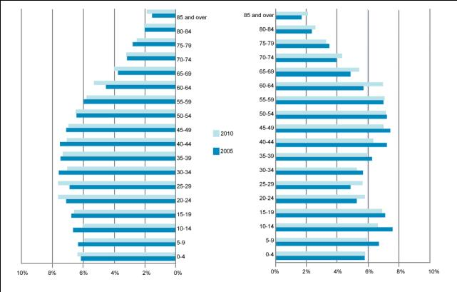
Figure 1: Proportion of population by age
Source: Australian Bureau of Statistics, 2010
Gippsland’s working age population, which is the population aged between 15 and 64, is below the rates for both regional Victoria and the state as a whole (Table 2).
Table 2: Working age population
Gippsland
- 2005: 63.7%
- 2010: 64%
Regional Victoria
- 2005: 64%
- 2010: 64.5%
Victoria
- 2005: 67.5%
- 2010: 68%
Source: Australian Bureau of Statistics, 2010

Labour force indicators
The Gippsland region’s unemployment rate in the early 2000s was much higher than state and regional Victorian averages. The region has experienced cyclical shocks during the past decade but the general trend for unemployment has been downwards. In fact, Department of Education, Employment and Workplace Relations data highlights how recent unemployment rates have been equivalent to, or below, the state average (Figure 2).
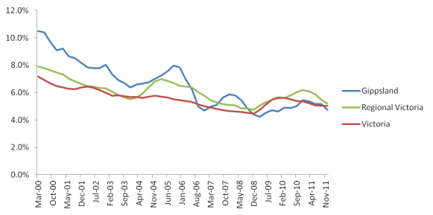
Figure 2: Unemployment rate Gippsland 2000 to 2011
Source: Department of Education, Employment and Workplace Relations Small Area Data 2012
The region’s labour force participation rate is markedly lower than the state average with 55.5 per cent in 2006 compared to the state rate of 60.4 per cent. It also showed no improvement during the three Census periods (2001, 2006 and 2011).

Regional productivity
Productivity is a measure of how efficiently inputs are converted into outputs and is typically measured by expressing output as a ratio of inputs used. At the sub-regional level, there is generally a lack of data on productivity. In determining the productivity profile for Gippsland, the definition of Gross Regional Product/hour worked will be used as the main indicator of labour productivity.
Gross Regional Product/hour worked in Gippsland is below that of the state and regional Victoria. It has also been declining at an average rate of 0.7 per cent from 2001 to 2011, whereas the state average annual growth rate was 1.5 per cent and regional Victoria’s was 0.6 per cent (Figure 3).
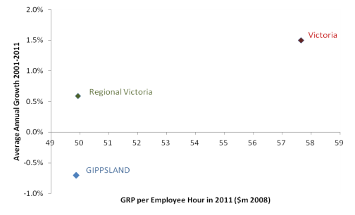
Figure 3: Gross Regional Product/hours worked by employee – Average growth rate 2001-11
Source: Regional Development Victoria 2013

Industry and employment structure
Agriculture, forestry, fishing and construction are the two most significant economic sectors in the Gippsland region, making up 16.4 per cent and 12.5 per cent respectively of the region’s Gross Value Added. In 2011 this was equivalent to $2.7 billion of the region’s $9.3 billion Gross Value Added. In contrast, at the state level, construction contributes seven per cent of Gross Value Added and agriculture, forestry and fishing only three per cent.
Four sectors employ over 10 per cent of the region’s workforce (Figure 4). Employment proportions also highlight the over-representation of construction, agriculture, forestry and fishing, with the first employing 14 per cent of the region’s workers compared to 9 per cent of the state’s workforce, and the second employing 13.4 per cent in Gippsland compared to only 2.6 per cent at the state level.
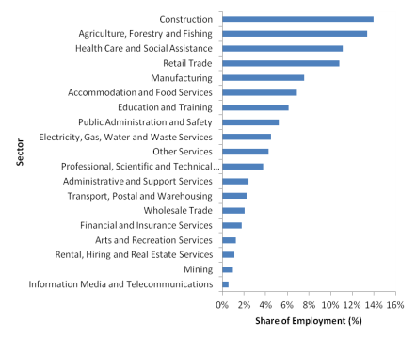
Figure 4: Sectoral contribution to employment – Gippsland 2011
Source: Regional Development Victoria, 2013

Melbourne’s peri-urban hinterland
Peri-urban literally means the area around a settlement. Melbourne’s peri-urban area extends roughly 100 kilometres from the centre of Melbourne to the outskirts of the regional cities of Ballarat, Bendigo, Geelong and Latrobe City (comprising the grouping of Traralgon, Morwell, Moe and Churchill). As Melbourne has grown, its influence on its peri-urban area has also increased, bringing into focus the importance of assets in supporting the functioning of the urban area. At the same time there has been continual investment in transport infrastructure that has significantly improved access from Melbourne to regional centres and interstate, and has improved mobility within the peri-urban region.
There are a number of ‘state significant’ land uses present within this region that may be regarded as assets to the functioning of metropolitan Melbourne and Victoria as a whole (see Table 3). These may be classified as resources, infrastructure, environmental and cultural. However these land uses are not exclusive to separate locations within the peri-urban region. In many cases, as with Gippsland, multiple state significant land uses are found in the one place, for example transport infrastructure. Where land uses do not complement one another, the challenge for planning is to provide sufficient direction to enable trade-off decisions to be made.
Gippsland’s peri-urban region contains a variety of landscapes, from flat alluvial plains that have been substantially cleared of vegetation, to the undulating coastal areas stretching across the Bass Coast and the South Gippsland shires.
It contains large areas consisting of a peaty clay soil that is an essential input to highly productive agricultural land uses. Agriculture and supporting rural industries, for example food processing, abattoirs, shearing, irrigation supplies and stock feed producers, not only service Melbourne’s local economy, but are a critical export industry for Victoria.
Agricultural land within Gippsland’s peri-urban area is under threat due to competing land uses, such as residential, because of its high amenity landscapes and its accessibility via the key road and rail corridors between Melbourne, the Latrobe Valley and Gippsland. Determining an appropriate balance between uses, such as rural versus residential land uses, is not easily achieved. While farming practices, technologies and approaches are changing, the loss of fertile soil is an irreversible consequence.
The security of primary production and the economic value of food industries into the future need to be realised through the Gippsland Regional Growth Plan so that land is not lost permanently from productivity. Opportunities to maximise Victoria’s competitive advantage in the agricultural sector over other cities within Australia and the Asia-Pacific region in driving Victoria and Australia’s productivity growth should be recognised.
The coastal locations along Gippsland’s coast, such as Phillip Island, are also attractors of growth due to their amenity attributes. These centres, particularly during peak season, experience a significant number of visitors that place pressure on services and infrastructure.
Table 3: Melbourne’s peri-urban area - state significant land uses

State significant land uses
Resources
- Extractive
- Why these land uses are considered significant – The cost of transporting stone and sand products over long distances can account for a substantial proportion of product price at the construction site. Sourcing construction materials from local quarries within the peri-urban region enables cost efficiencies and energy savings.
- Forestry
- Why these land uses are considered significant – A number of state forest reserves are located in the peri-urban region. They provide for a variety of uses, including timber for sustainable forestry, biodiversity and landscape conservation, protection of water catchments and opportunities for recreation.
- Productive agriculture
- Why these land uses are considered significant – Prime agricultural land provides food and fibre to the Victorian community, and supports employment and businesses. It also supports associated rural industries, such as food processing, abattoirs, shearing, irrigation supplies and stock feed producers that contribute to Victoria’s economy.
Infrastructure
- Transport
- Why these land uses are considered significant – The peri-urban region is traversed by an extensive arterial road and rail transport network linking major centres of population and industry across Victoria. Progressive transport expansion and safety improvements continue to influence land use activities and are likely to further improve travel times, reducing the commuting time and improving access between peri-urban areas and Melbourne.
- Utilities
- Why these land uses are considered significant – Utilities infrastructure that require extensive landholdings or buffers, which are often unable to be provided within an urban area, are located within the peri-urban region and are critical to the functioning of urban areas. This includes water treatment plants, as well as electricity, gas and waste management facilities, pipelines and transmission corridors, and associated buffer areas.
Environment
- Biodiversity
- Why these land uses are considered significant – Strong natural systems with a diversity of natural habitats for native plant and animals are important for the health and wellbeing of people living in urban areas. Opportunities for close connections with the natural world have high social, economic and educational value.
- Landscapes
- Why these land uses are considered significant – Landscapes help define the areas in which we live and work, and provide a connection with place and culture. They also provide respite from urban living.
- Parks and reserves
- Why these land uses are considered significant – There are many parks and reserves in the peri-urban region surrounding Melbourne. These areas provide ecological, environmental, cultural heritage and aesthetic value and the opportunity for leisure and recreation.
- Water catchments/wetlands and rivers
- Why these land uses are considered significant – Peri-urban catchments and storages remain essential to provide water for human and livestock consumption and for food production. The filtering action of the forested surrounds of many of our reservoirs avoids the need for expensive water treatment facilities. Careful management of land use within open potable water catchments is important to protect water quality and yield. Waterways and wetlands areas provide important habitat for flora and fauna and contribute to the landscape values of the peri-urban region.
Cultural
- Heritage
- Why these land uses are considered significant – There are various places, sites, structures, relics and flora of heritage significance in the peri-urban region. Cultural heritage assets generate social benefits, such as a sense of identity, direct user benefits through tourism, and the benefits stemming from the intrinsic value of preserving these assets for future generations to appreciate and enjoy.
- Tourism
- Why these land uses are considered significant – The peri-urban region provides key day and overnight trip destinations for residents and visitors from interstate and overseas. Attracting visitors to the peri-urban region also results in indirect employment and additional spend in ‘downstream’ industries such as retail suppliers, food production and construction.
Source: Department of Transport, Planning and Local Infrastructure
The influence of Melbourne’s outer eastern suburbs on Gippsland is strongly influenced by the transport network and the main existing and developing employment zones. These characteristics enable people to choose to live in Gippsland for lifestyle and housing affordability reasons while having convenient access to employment options both within the region and in the metropolitan area (Figure 5).
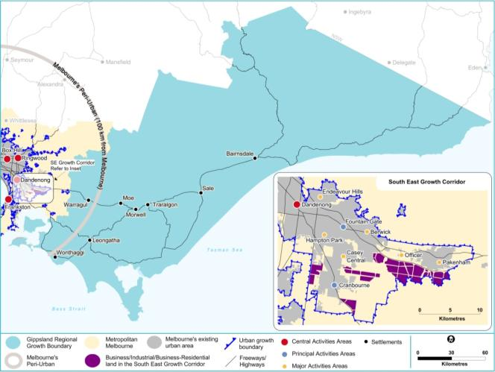
Figure 5: Metropolitan Employment Options Accessible from Gippsland
Source: Department of Transport, Planning and Local Infrastructure

Growth outlook
The following sections provide a forecast of likely economic and population changes and how these might be distributed across the region.

Regional economic and employment forecasts
Based on historical trends, growth in the region will not be distributed evenly. Regional centres such as Latrobe City, Sale and Bairnsdale will most likely have the bulk of absolute employment and output growth in the region. However, the rate of growth in the peri-urban shires of Baw Baw and Bass Coast will continue to be strong, as they are likely to be increasingly integrated with the metropolitan economy.
It is projected that the shift in the economy towards service sectors will continue over the next decade. Some traditional sectors, such as agriculture, forestry and fishing, manufacturing, and electricity, gas water and waste services, will still be included in the largest sectors in terms of Gross Value Added (by 2031). However, it is anticipated that energy produced from coal using current technology will reduce its value-add potential as the region transitions to a low-carbon economy and construction will return to long-term trends after the completion of recent high-value projects. Becoming more important to the region’s economy will be financial, insurance, professional, scientific and technical services. The top six sectors are projected to account for 58 per cent of the regional Gross Regional Product by 2031 and of these high value sectors, the highest growth is projected to be in the service sectors:
- Healthcare and Social Assistance (3.7 per cent per annum)
- Professional Scientific and Technical Services (2.5 per cent per annum)
- Finance and Insurance Services (1.2 per cent per annum).
The leading value-added sectors in 2011 are all projected to experience relatively low annual average growth with Agriculture, Forestry and Fishing expected to only grow by 0.8 per cent per annum, Manufacturing by 0.4 per cent and Utilities likely to decline.
From 2011 to 2031, the regional employment profile is projected to be even more concentrated in the Services sector with large numbers of employment in Healthcare and Social Assistance, Retail Trade and Accommodation and Food Services. Traditional sectors such as Agriculture, Fisheries and Forestry and Manufacturing will still figure in the top six employing sectors; however Construction is anticipated to return to long-term trends. By 2031 these top sectors are projected to account for 67 per cent of total employment in the region.
The projected high-performing employment growth sectors will be Healthcare and Social Assistance, Accommodation and Food, and Arts and Recreation Services. In contrast, Manufacturing, Construction and Utilities employment is forecast to decline over the same period (Figure 6).
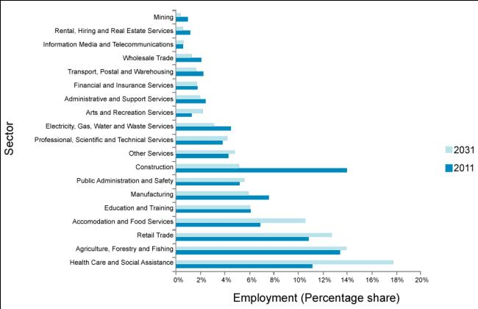
Figure 6: Industry employment performance forecast by percentage share, 2011 to 2031
Source: Regional Development Victoria, 2013
Invest Victoria and the Latrobe Valley Industry and Employment Roadmap identify other potential growth industries as follows:
- intensive and organic agricultural production and food processing
- horticulture
- forestry and timber
- coal derivative research and development and technology
- renewable energy research and development and technology including biofuel and bioenergy
- commercial fishing and other marine industries
- commercial and recreational boat manufacturing including mechanical, electronic, engineering and technical services
- tourism.

Population forecast
The region’s population is expected to grow at a rate approximately equivalent to the rest of regional Victoria and the state annual average growth rate (Figure 7). From 2011 to 2031 the forecast annual average population growth rate for the region is 1.25 per cent which is mid-range with regard to all non-metropolitan regions.
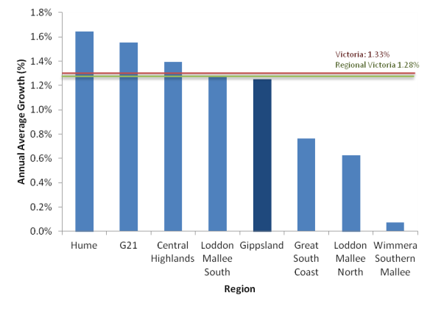
Figure 7: Population forecast, regional Victoria 2011 to 2031
Source: Victoria in Future 2012
Growth is anticipated to be relatively evenly spread across Gippsland, although at the local government area level there are some differences. The Bass Coast and Baw Baw shires are expected to have the fastest population growth rate, largely due to their close proximity to metropolitan Melbourne. In contrast, Wellington Shire is expected to grow by only 0.6 per cent per annum over the next 20 years.

Summary

Growth trends and forecasts
At a regional scale the structural drivers of growth in the economy were:
- the population growth rate kept pace with the average for regional Victoria but was below the state average
- labour force participation declined over the period from 1996 to 2006
- productivity declined at an average annual rate of -0.7 per cent (2001 to 2011) compared to the average growth rate for regional Victoria of 0.6 per cent and the state average of 1.5 per cent
- the region’s Gross Regional Product growth rate of 3.1 per cent was higher than the average for regional Victoria of 2.2 per cent but below the state average of 3.5 per cent.
At an industry level, the region has strong comparative advantages for developing sustainable energy, infrastructure and natural resources, and agricultural and food processing industries based on the region’s skills base (see Table 4).
Table 4: Potential drivers of regional growth and future prosperity – Gippsland
Industry Trends:
High growth sectors
- Mining
- Financial and Insurance Services
- Accommodation and Food Services
- Arts and Recreation Services
- Professional Scientific and Technical Services
Low growth sectors
- Agriculture, Forestry and Fishing
- Information Media and Telecommunications
- Wholesale Trade
- Manufacturing
Industry Outlook:
High growth sectors
- Financial and Insurance Services
- Retail Trade
- Healthcare and Social Assistance
- Education and Training
Low growth sectors
- Manufacturing
- Agriculture, Forestry and Fishing
Source: Regional Development Victoria, 2013

Critical growth factors and constraints
Two of the defining features of Gippsland are its resource-based economy, incorporating agriculture, forestry and energy production, and the large areas of land used for forestry and national parks and reserves. Approximately 67 per cent of the land in Gippsland is occupied by state-owned forests, national parks and reserves and native freehold forests.
The Gippsland region is strongly associated with coal mining and electricity generation in the western part of the region, and with forestry and agriculture (dry land and irrigated) in the eastern part of the region. It is also known for its offshore oil and gas production in the Gippsland Basin.
The region has aspirations to diversify from a coal region to a region that produces low emissions energy resources and technology; and from an agricultural commodities region to a region that increasingly value-adds to its commodities for domestic and export markets. In particular, the region wants to grow its food production capacity. In comparison to other regions, Gippsland’s road and rail infrastructure connections to Melbourne’s port and airports have less capacity. Growing new markets for low emission energy resources and food will rely on improved freight and logistics services and upgrades to water infrastructure.
To support the transition of the region from a brown coal energy region to a sustainable energy region, Federation Australia University’s Gippsland Centre for Sustainable Industries is focussed on improving the efficiency of brown coal and reducing greenhouse gas emissions. New technologies are also being developed and tested for carbon capture and storage, such as geo-sequestration. Other work is examining the potential for new export products derived from coal including dried coal, methanol, ammonia and diesel. The Australian and Victorian governments are supporting the CarbonNet project to investigate the potential for carbon capture and storage in the Gippsland Basin which is recognised as having the greatest potential for a project of this kind in Australia.
Gippsland can further develop its tourism infrastructure and services in order to attract a greater share of domestic and international visits based around its key assets of the Gippsland Lakes, a range of national parks, Phillip Island and 700 kilometres of coastline.
In terms of human capital, the Latrobe Valley is expected to experience workforce challenges in the medium- to longer-term due to:
- an ageing population
- weak growth in the working age population
- a high proportion of certificate-level and trade qualification workers
- skills shortages in key occupations
- lower workforce participation than the state average.
The region lacks a centre of sufficient size to drive the agglomeration benefits of growth in advanced services and knowledge intensive jobs. The region’s links to Melbourne are also not as strong as regions to the north and west of Melbourne.
Gippsland can position itself to deliver on the state government’s policy position of doubling food and fibre production by 2030 and expand its value-adding and food processing. Industry, government and research and development organisations can also work to be at the forefront of the development of new technologies for sustainable energy production. The growth of the region’s industries will rely on:
- improved freight and passenger transport connecting the region to Melbourne and the Port of Hastings
- increased research and development to support sustainable use of resources in a low-carbon global economy
- greater take-up of innovation to increase productivity across all industry sectors
- increased participation in higher education and training
- increased labour force participation by improving access to education and training, matched to industry needs.

AGRICULTURE AND FORESTRY

Overview
A review of the Gippsland agriculture and forestry industries found that they are nationally and regionally significant. It has particular strengths in dairy production and processing, paper manufacture and meat production evidenced by the extent of production of raw product and investment in the processing sector.
Criteria for identifying strategically significant agriculture and forestry areas (see Figures 8, 9, 10 and 11) were drawn from a review of literature and input from industry stakeholders, and were applied to private land across the region. Objectives and strategies for implementation of the agriculture and forestry areas of strategic significance are outlined in this report.

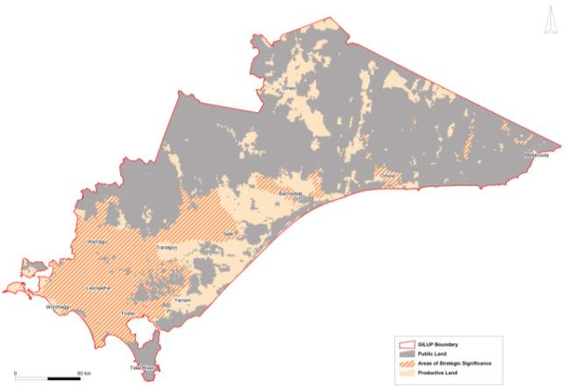
Figure 8: Agriculture and forestry – areas of strategic significance
Source: RM Consulting Group, 2013
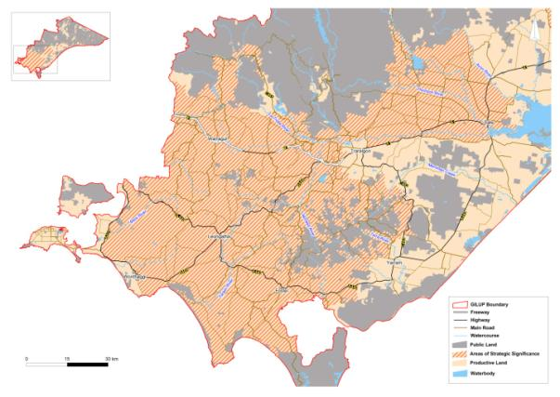
Figure 9: Agriculture and forestry areas of strategic significance - Cluster 1
Source: RM Consulting Group, 2013
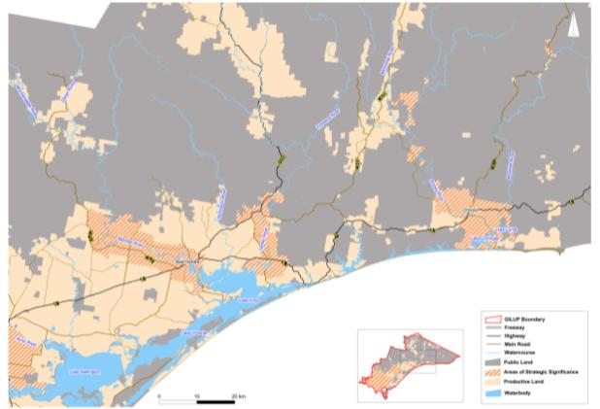
Figure 10: Agriculture and forestry areas of strategic significance - Cluster 2
Source: RM Consulting Group, 2013
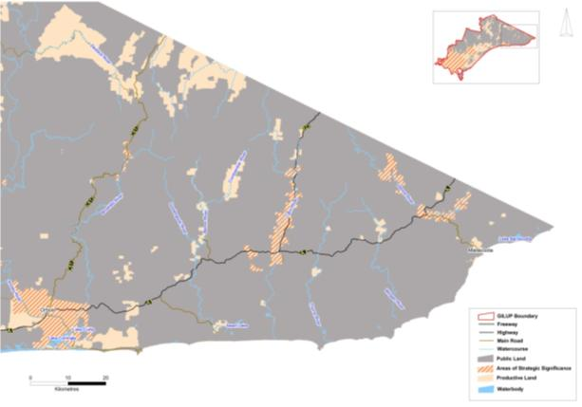
Figure 11: Agriculture and forestry areas of strategic significance - Cluster 3
Source: RM Consulting Group, 2013
The agricultural and forestry sector, including both primary and secondary production, is one of the pillars of the Gippsland economy. The size and scale of the agricultural sector is underpinned by extensive agricultural land, highly fertile soil and relatively high rainfall. Harvesting of plantation timber and native forests supplies significant quantities of soft wood and hardwood timber supporting a significant pulp and paper manufacturing sector. The main agricultural sectors in terms of economic importance and extent of land use are dairy, beef, horticulture and forestry (Figure 12).
The impacts of climate change on agriculture and forestry may be having a significant effect on Gippsland by 2040. A Technical Report on Climate Change Adaption in Agriculture was published by the former Department of Primary Industries in February 2013. It indicated that Victoria is likely to see shorter winters, longer summers and less winter/spring rainfall and that the magnitude and frequency of extreme weather events is likely to increase. There will be impacts across all agricultural sectors although these have not yet been modelled for all sectors, or for all regions. The impacts may not be entirely negative and Gippsland farmers may in fact benefit, particularly if they can adapt over time and increase their productivity, and if commodity prices grow because of global food demand.
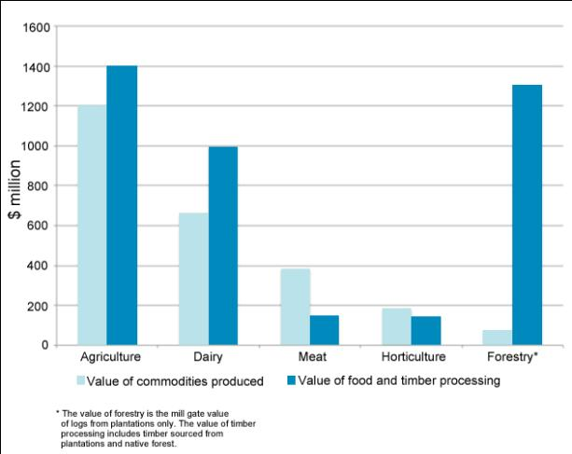
Figure 12: Gippsland value of commodities produced
Source: RM Consulting Group, 2013

Dairy
Gippsland produces approximately one-third of Victoria’s and 20 per cent of Australia’s dairy production. The dairy industry is the largest contributor to economic output from the region and alone represents over 50 per cent of total Gippsland agriculture value.
Dairying is located mainly in south, west and central Gippsland. A key competitive advantage for dairying in Gippsland is its high and reliable rainfall. Irrigated dairy is also important, with 30 per cent of dairy farms located in the Macalister Irrigation District. The latter will benefit from the recent (May 2013) announcement of a $32m upgrade to save water and to increase efficiencies which could increase milk production by 24 million litres a year.
Sixteen dairy companies source Gippsland milk for processing and manufacturing. In the region, dairy processing is valued at close to $1 billion. The industry employs around 6800 people on-farm and in processing.

Meat
Meat production generates around 30 per cent of Gippsland’s total agricultural value, primarily as beef and some lamb, and comprises around 25 per cent of Victoria’s, but less than five per cent of Australia’s, meat production. Production is focused around west Gippsland with most processing undertaken outside the region. The industry employs around 3500 people, not including poultry and eggs.

Horticulture
Vegetable production in Gippsland is concentrated in a number of locations, including Thorpdale and Lindenow which have very high versatility soils. There has been a recent trend in conversion of dairy farms to horticulture in the Macalister Irrigation District. The sector generates around 14 per cent of Gippsland’s value of agricultural production and comprises nine per cent of Victoria’s horticulture. Vegetable processing operates in the east of the region and the industry employs around 880 people.
The Bunyip Food Belt project may also provide prospects for economic synergies and benefits for Gippsland. The project will use recycled water from Melbourne’s Eastern Treatment Plant to irrigate important horticultural areas around Western Port Bay and there may be opportunities to extend the irrigation into adjoining areas of Gippsland or to develop joint processing facilities (see Figure 13).

Forestry
Around half the value of Gippsland’s forestry production comes from plantations on leased land or land operated under licence, essentially private land. Together with the supply of hardwood timber from public native forests, forestry production supports a significant timber, pulp and paper manufacturing sector. Twenty three per cent of Victoria’s plantation estate is located in Gippsland and approximately half of the state’s public native forests. The industry employs around 3400 people and with an employment multiplier of 5-6 new jobs for every direct job, the industry is an important economic driver for the region. As well as these economic impacts, there can be other benefits from the forest industry in relation to forest and fire management which should be considered.
Timber processing is focused in central Gippsland with the plantation estate also located predominantly in central Gippsland.

Fisheries
The Victorian fishing catch was valued at approximately $40 million in 2010–11 and the Gippsland catch provided approximately $17 million (42 per cent) of this statewide total. The abalone catch provides by far the greatest share of this value, with abalone from the Tamboon-Eden area (including Mallacoota) comprising over 30 per cent of the Victorian total catch and value by port of landing for selected species groups during 2007–08 and 2010–11. In addition, recreational fishing is an important contributor to many Gippsland towns, such as those around the Gippsland Lakes (Lakes Entrance, Paynesville and Metung) as well as Marlo, Mallacoota, and Phillip Island.

Trends, strengths and challenges
Short- to medium-term trends indicate strong demand for Gippsland’s food and timber both domestically and internationally. The Australian Government’s National Food Plan Green Paper and Plantations for Australia 2020, and the State Government’s research and development program demonstrate a strong commitment to capturing a share of global food and fibre demand. Gippsland will need to make a significant contribution to the State Government’s aim of doubling food and fibre production in Victoria by 2030.
Trends in Australian agriculture include: fewer and larger farms in terms of both physical and economic size, increased concentration of output with a relatively small proportion of farms producing a large percentage of total output, more intensive farming and closer integration in the agri-food chain. The increased concentration of output has accentuated the dualistic nature of the agriculture sector, where a small number of large-scale commercial farms produce the majority of output, while a large number of small-scale or boutique farms account for only a small proportion of output.
A secure supply of consistent quality product is critical for the processing sector to ensure operation at optimum capacity. Processors therefore are increasingly reliant on larger businesses that can meet supply and quality requirements. Small-scale commercial farms sometimes focus on production of very high quality, niche products for specific markets, such as organics and restaurants.
Gippsland’s strengths in primary production come from extensive farmland, versatile soils, above state average rainfall and irrigation development, enabling production of high-value products including milk, meat and vegetables. While climate change will impact on the region, CSIRO modelling suggests the impact may be slightly less significant than on northern Victoria and could feasibly create growth opportunities. The region’s primary production, accessibility to services and skilled labour, and proximity to Melbourne’s markets and ports underpins a significant food and timber processing sector.
The region can also benefit from and share in opportunities created as part of the ongoing development of the neighbouring Bunyip Food Belt. The councils and water authorities in this area are keen to protect and support the growth of this area as a key food producing district for Melbourne.
Figure 13: Bunyip Food Belt Potential Areas of Interest
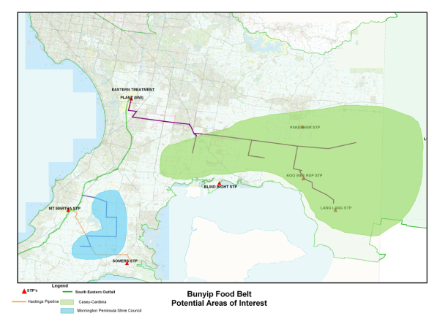
Source: Shire of Cardinia
Financial markets, global trade, consumer trends and policy settings are constant challenges for all businesses and primary producers and the industry is continually adapting and restructuring in response to these challenges. Land use planning, while not able to affect financial markets, can influence the capacity of primary producers to adapt and respond to changes in market conditions and provide a degree of confidence to make necessary long-term investments in business improvements.
Competition for agricultural land from non-primary producers is emerging as a significant issue in Gippsland. Competition comes from:
- demand for rural lifestyle, particularly in west Gippsland due to the high amenity landscapes and proximity to Melbourne
- demand for expansion of urban settlements, particularly along major transport routes to accommodate an increasing population
- demand for coal and other natural resources for the power and construction industry.
In terms of land use planning, the needs of the primary production sector are therefore:
- a supply of land, unencumbered by non-agriculture related dwellings and in productive sizes to enable flexibility to respond to financial and market trends and adoption of new technology
- separation from sensitive land uses to secure the ability of primary producers to operate machinery and undertake farm and plantation management activities without impediment
- certainty for the industry to make long-term business and investment decisions that accommodate trends and change, and minimise speculation in the land market
- required infrastructure, such as transport, energy and water (quality and volume), to ensure the industry can adopt new technology and remain globally competitive
- planning policy guidance where land use conflict or competition may occur.

Small rural lots
The schedule to the Farming Zone provides an opportunity for a planning authority to specify a minimum lot size for subdivision and a minimum lot size below which a planning permit is required for a dwelling. In the absence of an established methodology for determining lot size minima, many planning schemes revert to the default of 40 hectares. Table 5 shows the distribution of small lots in the Gippsland region.
The purpose of setting a minimum subdivision size is to provide land parcels of appropriate size for farm growth and transfer between farming businesses, to allow for adoption of efficient management and production practices, and to avoid fragmentation of rural land so that the landscape remains viable for farming.
The purpose of setting a minimum lot size below which a permit is required for a dwelling is to afford councils the opportunity to assess whether a dwelling is genuinely required for the agricultural use of the land and to ensure that dwelling development does not compromise the agricultural future of the land.
Lot size minima should aim to:
- facilitate farm growth and expansion
- prevent proliferation of dwellings not associated with agriculture
- maintain land in parcels with productive and management potential
- recognise that most farm units are comprised of multiple lots.
Table 5: Small rural lots in the Gippsland region
Bass Coast
- No. lots in the rural zones: 5760
- No. rural lots under 4 ha: 3761
- No. rural lots between 4 and 40 ha: 1297
- Total no. of small lots in the rural zones: 5078
Baw Baw
- No. lots in the rural zones: 10,384
- No. rural lots under 4 ha: 4966
- No. rural lots between 4 and 40 ha: 4242
- Total no. of small lots in the rural zones: 9208
East Gippsland
- No. lots in the rural zones: 14,748
- No. rural lots under 4 ha: 6061
- No. rural lots between 4 and 40 ha: 5463
- Total no. of small lots in the rural zones: 11,524
French Island
- No. lots in the rural zones: 908
- No. rural lots under 4 ha: 737
- No. rural lots between 4 and 40 ha: 108
- Total no. of small lots in the rural zones: 845
Latrobe
- No. lots in the rural zones: 6528
- No. rural lots under 4 ha: 3976
- No. rural lots between 4 and 40 ha: 1828
- Total no. of small lots in the rural zones: 5804
South Gippsland
- No. lots in the rural zones: 14,485
- No. rural lots under 4 ha: 7971
- No. rural lots between 4 and 40 ha: 4140
- Total no. of small lots in the rural zones: 12,111
Wellington
- No. lots in the rural zones: 24,347
- No. rural lots under 4 ha: 13,931
- No. rural lots between 4 and 40 ha: 6770
- Total no. of small lots in the rural zones: 20,701
TOTAL
- No. lots in the rural zones: 77,160
- No. rural lots under 4 ha: 41,423
- No. rural lots between 4 and 40 ha: 23,848
- Total no. of small lots in the rural zones: 65,271
Source: Department of Transport, Planning and Local Infrastructure
In order to break the nexus between subdivision and dwellings and in recognition of bullet point four, it is recommended that different lot size minima be specified for subdivision and dwellings. In most cases, the minimum lot size below which a permit is required for a dwelling will be substantially higher than the minimum lot size for subdivision.

Strategically significant agricultural land
At the scale of this report, productive agricultural land was assessed based on soil types, climate and access to water and irrigation. The vast majority of Gippsland’s agricultural land is considered to be productive.
Prime productive agricultural land is land that is generally more versatile and capable of producing a greater range of agricultural commodities. For the purposes of the regional growth plan, prime productive agricultural land is Class 1 or Class 2 agricultural versatility, has access to irrigation water and is in an area where the future climate is not likely to have a significant impact on future agricultural production options.
Consideration of natural attributes alone does not capture the full range of attributes that gives an area a competitive advantage for an agricultural or forestry industry. Considering the economic and social benefits these industries may bring to a region allows for a more balanced comparison with competing uses. To incorporate economic and social benefits, a further analysis of the region was undertaken to:
- identify concentrations of enterprises supporting an industry of national or state significance
- identify significant public and private sector investment in industry
- establish the economic scale of primary production and secondary processing, and employment opportunities these provide.
Areas that ranked highly against these attributes have been identified as industry clusters.

Strategically significant forestry land
While similar guidance does not exist with respect to identifying land suitable for plantation timber production as for productive agricultural land, the forestry industry generally uses soil types, rainfall and proximity to processors, to identify land capability for plantation production, and these measures were used in this report.
For this report, prime productive forestry land is land with high productivity capability, greater than 26 cubic metres/hectare/year, minimal slope restrictions and the future climate is unlikely to have a significant impact on future forestry production. As for agriculture, to incorporate consideration of wider social and economic benefits, a further analysis of the region was undertaken to:
- identify concentrations of enterprises supporting an industry of national or state significance
- identify significant public and private sector investment in industry
- establish the economic scale of primary production and secondary processing, and employment opportunities these provide - analysis included consideration of the economic value of timber and timber products harvested on public and private land.
Areas that ranked highly against these attributes have been identified as industry clusters.

Prime productive agricultural/forestry land
Identifying prime productive agricultural land relied primarily on the work of Swan and Volum, which was the only resource that provided a consistent assessment across the region (Figure 14 ). The report assessed the agricultural versatility of the land at a scale of 1:250,000 using the following factors:
- soils - arability, moisture status, fertility, effective rooting depth, rockiness, erodibility
- topography - slope
- climate - rainfall, evaporation and temperature.
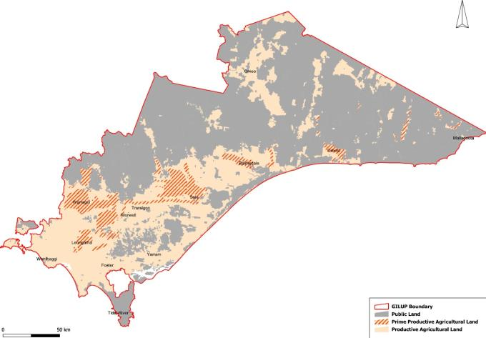
Figure 14: Productive and prime productive agricultural land in Gippsland
Source: RM Consulting Group, 2013
The assessment of productive forestry land drew on work by the former Department of Primary Industries and the Plantation Information Network that identified the productive potential of private land for forestry and plantation capability slope classes.
The assessment of agricultural versatility and productive potential for forestry was combined with a ranking for climate resilience. Prime productive agricultural land is shown in Figure 14 and prime productive forestry land in Figure 15.
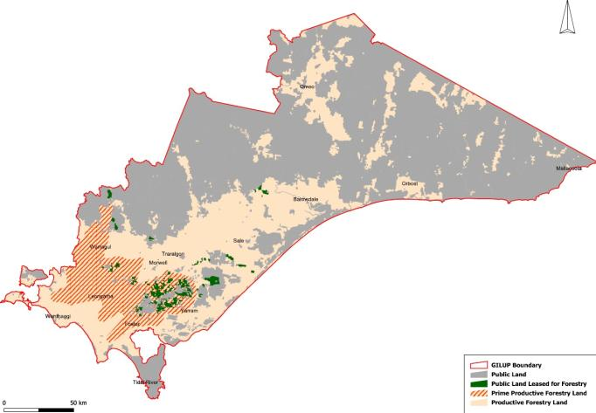
Figure 15: Productive and prime productive land for forestry
Source: RM Consulting Group, 2013

Industry cluster
Work to identify industry clusters drew primarily on Australian Bureau of Statistics 2006 data including the gross value of agricultural and forestry production, the gross value of food/timber processing, employment on-farm and in secondary processing sectors.
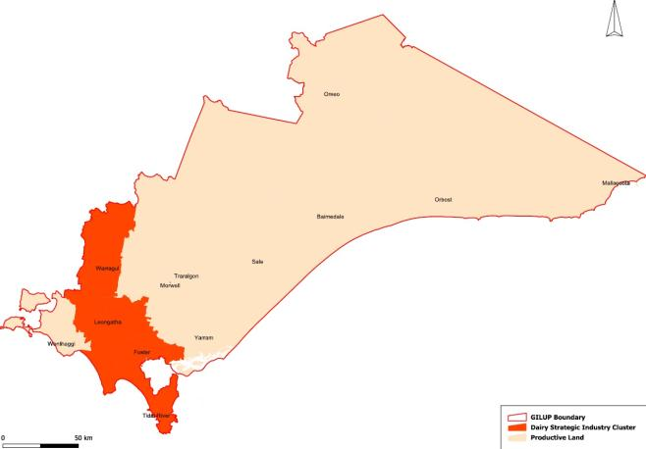
Figure 16: Dairy strategic industry cluster
Source: RM Consulting Group, 2013
Data on investment in industry infrastructure was provided by the Department of Transport, Planning and Local Infrastructure. The data was initially analysed statistically and then each Statistical Local Area in the region was assigned a ranking for each attribute. A Statistical Local Area that scored highly across all attributes rated as an area of high economic and social significance. The industry cluster map shows Statistical Local Area boundaries and includes some public land, although not all land where industry activities take place. The map serves to highlight where there is a concentration of production and processing. The dairy industry cluster is shown in Figure 16 and the forestry industry cluster in Figure 17.
Timber industry stakeholders have also noted the area of public land leased for forestry is more extensive than what is shown on the forestry industry cluster map (see Figure 17). This map shows softwood plantation on public land in 2009. Hardwood plantation data was not available.
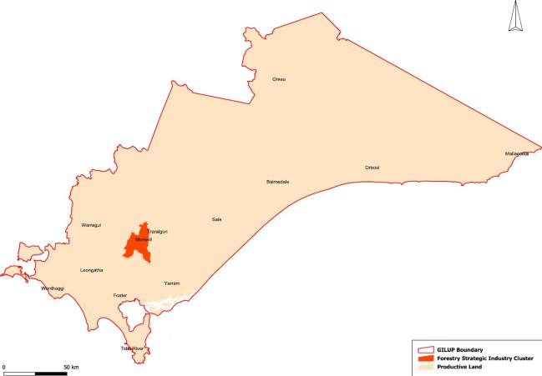
Figure 17: Forestry industry cluster
Source: RM Consulting Group, 2013

Strategically significant agriculture and forestry areas
Areas of prime productive agricultural land and prime forestry land were combined with industry cluster areas to provide a map of agriculture and forestry – areas of strategic significance (see Figure 8).

TOURISM

Overview
Tourism policy, strategies and action plans of relevance to all or parts of Gippsland were reviewed. The main findings showed strong support for Gippsland’s tourism sector across national, state, regional and local strategies. Common elements included:
- new direction for nature-based tourism linked to environmental assets, such as national and state reserves, coasts and waterways
- new direction for rural-based tourism associated with scenic drives, agriculture, food and wine
- consolidation of tourism associated with existing products, such as Phillip Island, Gippsland Lakes and Walhalla.
There are also strong strategic directions and principles to ensure planning for tourism considers the impacts of development on natural resources, landscapes and agriculture such as:
- directing urban development on the coast to appropriate areas within existing settlements and activity centres
- ensuring coastal development is dependent on a coastal location
- ensuring development responds to existing or preferred coastal character and is appropriately designed and sited
- preserving non-urban areas between settlements
- directing development away from sensitive areas and significant landscapes.
Tourism in Gippsland is generally modest in terms of the overall regional economy, although it is an important economic sector in Bass Coast Shire. Most visitors to the region come from the domestic market for holidays and to visit friends and relatives. Gippsland’s natural environment is considered its greatest tourism asset and includes national parks, coasts, waterways and areas of significant landscape value and amenity. Phillip Island is a nationally important tourism icon with over 1.7 million visitors annually. Other significant tourism assets include National Parks at Wilsons Promontory, Croajingolong and Morwell, the Gippsland Lakes, Walhalla and the East Gippsland and Great Southern rail trails. Tourism activities associated with these areas include boating, hiking, observing native flora and fauna, and family holidays.
There is an opportunity to develop tourism in Gippsland and capitalise on the range of environmental and cultural heritage assets, including those on public land and the rural farmed landscape. Agriculture also provides opportunities for complementing nature-based tourism experiences. Gippsland’s tourism opportunities can be defined in three categories:
- new investment to rejuvenate existing product and expand existing opportunities
- further investment to meet unmet demand
- new investment to facilitate new tourism opportunities.
Criteria for identifying strategic tourism investment areas were developed and applied to the Gippsland region. The outcomes of this assessment and subsequent consultation with key stakeholders resulted in strategic tourism investment areas being identified at Phillip Island, Gippsland Lakes, the Australian Alps, Wilsons Promontory, Bunurong Coast, Croajingolong and Tarra Bulga (see Figure 18).
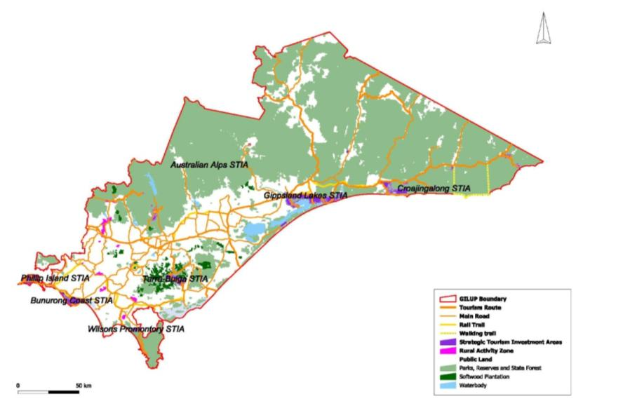
Figure 18: Gippsland strategic tourism investment areas
Source: RM Consulting Group, 2012

Purpose of strategic tourism investment areas
A key goal is to facilitate regionally important tourism investment in Gippsland. To this end strong policy support is needed to facilitate investment proposals that rejuvenate, expand or develop appropriate tourism product within strategic tourism investment areas and to encourage complementary investment. Strategic tourism investment areas have been broadly identified. Specific sites or proposals will need to be assessed on merit. Where the proposed investment is to be of at least regional standard, coordinated government decision-making will be required.

Tourism in Gippsland
Tourism in Gippsland is estimated to generate around $850 million annually, representing around three per cent of total regional output and 10 per cent of tourism in Victoria. The industry employs around 4800 people or five per cent of total regional employment. Most visitors to the region come from the domestic market for holidays and to visit friends and relatives.
Each of the region’s local councils has undertaken studies to assess and promote tourism opportunities within their municipal area (see Table 6). This work has subsequently been incorporated into local planning schemes.
Table 6: Summary of tourism planning policy and strategies by Local Government Area
Bass Coast
- Tourism strategy: Rural Tourism Development Strategy
- Municipal Strategic Statement: Encourage tourism investment in locations compatible with environmental, agricultural and landscape values
- Zones for tourism: Rural Activity and Special Use
- Overlays: Significant Landscape
Baw Baw
- Tourism strategy: Nature Based Tourism Strategy
- Municipal Strategic Statement: Support tourism that capitalises on agricultural, natural values and public land assets where it is consistent with sustainable land management and infrastructure provision.
- Zones for tourism: Rural Activity and Special Use
- Overlays: Significant Landscape
East Gippsland
- Tourism strategy: East Gippsland Strategic Tourism Plan
- Municipal Strategic Statement: Encourage tourism, particularly accommodation with strong links to the areas natural assets
- Zones for tourism: Special Use
- Overlays: Significant Landscape
Latrobe
- Tourism strategy: Tourism Product Audit
- Municipal Strategic Statement: Strengthen the area as a conference and major events destination
- Zones for tourism:
- Overlays:
South Gippsland
- Tourism strategy: Rural Tourism Development Strategy
- Municipal Strategic Statement: Encourage ecologically sustainable tourism development that complements the area’s natural assets and agricultural assets
- Zones for tourism: Rural Activity
- Overlays: Significant Landscape
Wellington
- Tourism strategy: Economic Development and Tourism Strategy
- Municipal Strategic Statement: Encourage ecologically sustainable tourism development that complements the area’s natural assets and agricultural assets
- Zones for tourism:
- Overlays: Significant Landscape
Source: RM Consulting Group, 2012
Tourism routes such as the Great Alpine Road, Grand Ridge Road and through Wilsons Promontory, mining heritage areas and the Alpine areas will play an increasing role as Victoria’s population grows.

Trends, strengths and challenges
The international tourism market is highly competitive. Australia’s tourism strengths include its environmental assets and cultural heritage offering, particularly Aboriginal culture. The Australian Government’s marketing focus includes:
- international marketing to China, New Zealand, United Kingdom, United States and India, with the goal of increasing tourism trade from future growth markets such as Asia
- promotion of domestic tourism and local holidays
- corporate business tourism
- reviewing the capacity of current programs to develop Aboriginal tourism products.
National parks and coastal areas in close proximity to Melbourne have been Gippsland’s traditional tourism strengths.

Identifying Gippsland strategic tourism investment areas
Gippsland’s strategic tourism investment areas were identified by applying a number of criteria to private land in the Gippsland region. The criteria were synthesized from an analysis of key strategic documents and agreed to by the Gippsland Regional Growth Plan Project Steering Committee. The criteria included:
- land located in close proximity to existing tourism products and infrastructure nodes or in a location which exhibits tourism development potential nominated in a tourism strategy
- land located in proximity to national or state parks, coastal parks or ocean beaches or that is linked to a touring route or major access route identified in a tourism strategy
- land that provides easy access to a major road, highway or touring route
- land that provides an attractive setting, either rural or coastal, with significant views of natural landmarks and landforms in coastal areas
- land that is not subject to predictable adverse environmental processes and effects including storm surges, river and coastal flooding, landslip or geotechnical risk, including acid sulfate soils.
Available data was compiled for an initial high-level analysis. The data included:
- significant tourist routes
- rail trails
- public land
- locations identified in national, state or regional tourism strategies
- directions from state strategies including the Victorian Coastal Strategy, Coastal Spaces Landscape Assessment Study and Future Coasts.
This analysis identified candidate areas. Table 7 summarises the findings of the high level analysis against the criteria for each candidate area. These candidate areas were further refined and included consideration of natural hazards, particularly sea level rise in coastal locations and directions from the Victorian Coastal Strategy, Coastal Spaces Landscape Assessment Study and integrated coastal planning for Gippsland.
The Gippsland strategic tourism investment areas include Phillip Island, Gippsland Lakes, the Australian Alps, Wilsons Promontory, Bunurong Coast, Croajingolong and Tarra Bulga (Figure 18).
Table 7: High level analysis against strategic tourism investment area criteria
Phillip Island
- Strategic support in tourism strategies:
National: Yes
State: Yes
Regional: Yes
- Existing tourism product: Yes
- Proximity to tourism product on public land, coasts: Yes
- Accessible from major tourism routes, highways: Yes
Gippsland Lakes
- Strategic support in tourism strategies:
National: No
State: Yes
Regional: Yes
- Existing tourism product: Yes
- Proximity to tourism product on public land, coasts: Yes
- Accessible from major tourism routes, highways: Yes
Australian Alps
- Strategic support in tourism strategies:
National: Yes
State: Yes
Regional: Yes
- Existing tourism product: Yes
- Proximity to tourism product on public land, coasts: Yes
- Accessible from major tourism routes, highways: Yes
Wilsons Promontory
- Strategic support in tourism strategies:
National: No
State: Yes
Regional: Yes
- Existing tourism product: Yes
- Proximity to tourism product on public land, coasts: Yes
- Accessible from major tourism routes, highways: Yes
Bunurong Coast
- Strategic support in tourism strategies:
National: No
State: Yes
Regional: Yes
- Existing tourism product: Yes
- Proximity to tourism product on public land, coasts: Yes
- Accessible from major tourism routes, highways: Yes
Croajingolong
- Strategic support in tourism strategies:
National: Yes
State: Yes
Regional: Yes
- Existing tourism product: Yes
- Proximity to tourism product on public land, coasts: Yes
- Accessible from major tourism routes, highways: Yes
Tarra Bulga
- Strategic support in tourism strategies:
National: No
State: No
Regional: Yes
- Existing tourism product: Yes
- Proximity to tourism product on public land, coasts: Yes
- Accessible from major tourism routes, highways: Yes
Source: RM Consulting Group, 2012

Phillip Island
Phillip Island, widely acknowledged as one of Victoria’s premier tourist destinations, has significant domestic and international tourism markets and is the focus of national and state tourism strategies. It is a well-established tourism area based on family beach holidays, the penguin parade and Grand Prix circuit. Key tourism products on Phillip Island include:
- nature based - boating, swimming sailing, surfing and beachcombing, Phillip Island Nature Parks, Penguin Parade, Koala Conservation Centre, Churchill Island Heritage Farm, Nobbies Centre (seals)
- accommodation - holiday homes, camping and caravanning, hotels, cabins
- motor sports.
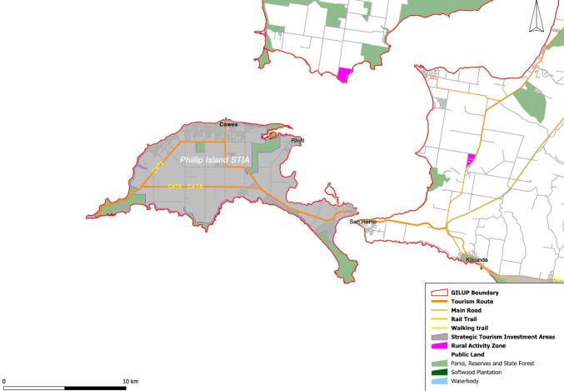
Figure 19: Phillip Island Strategic Tourism Investment Area
Source: RM Consulting Group, 2012
The island also has a long history of agriculture, which has left a legacy of rural farmed landscapes that provide green breaks between towns that are important to the overall amenity and attractiveness of the island. While some commercial agriculture continues, large parts of the island’s rural landscape are primarily farmed for lifestyle purposes (see Figure 19).

Gippsland Lakes
In addition to water-based activities, the Gippsland Lakes provide access to the Lakes National Park, Ninety Mile Beach and Loch Sport. Tourism product in the area includes:
- nature-based - boating, swimming, sailing, surfing, fishing and beachcombing
- accommodation - camping and caravanning, hotels, cabins, motels.
A significant tourism opportunity, which is currently in its infancy, is Aboriginal cultural tourism, with significant Aboriginal cultural heritage around the Gippsland Lakes.
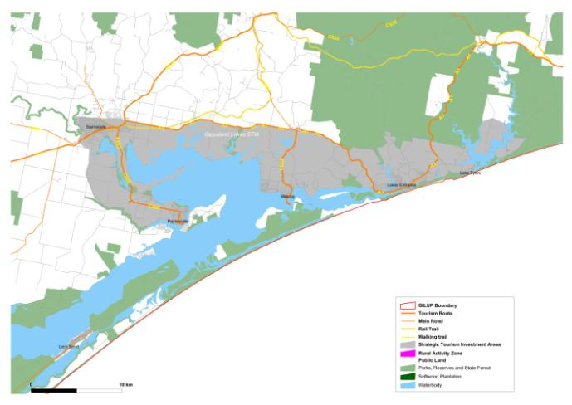
Figure 20: Gippsland Lakes Strategic Tourism Investment Area
Source: RM Consulting Group, 2012
The sewering of Loch Sport provides a number of opportunities to increase its role as a destination in conjunction with the Gippsland Lakes strategic tourism investment area. Sewering will provide opportunities to upgrade boating services such as fuel and sullage disposal as well as expansion of accommodation facilities and restaurants.
Tourism Australia is actively promoting the Melbourne to Sydney Coastal Drive, which runs through the area. State and regional strategies identify investment opportunities for the Gippsland Lakes such as upgrading boating facilities. This would include the development of key sites and tie-up points, particularly towards the western end of the Lakes, with supporting infrastructure, accommodation and services (see Figure 20).

Australian Alps
The Australian Alps strategic tourism investment area comprises a number of tourism nodes across Victoria’s high country, including the historic Walhalla village and the high country gateway towns of Dargo, Licola, Omeo and Buchan. Tourism product in the area includes:
- nature-based/mountains - alpine cross-country and downhill skiing, tobogganing, hiking, camping, mountain-bike riding, 4WD touring
- heritage - gold mining history
- accommodation - bed and breakfast, self-contained cottages, historic homes, motels and hotels.
State tourism strategies identify Walhalla and Mount Baw Baw National Park as key tourism locations, primarily for their heritage values, hiking and skiing activities. Walhalla is featured as one of 26 towns in Tourism Victoria’s Villages of Victoria campaign and an adventure zip line has been proposed for the town. Erica and Rawson are in close proximity to Walhalla and around one hour from Mount Baw Baw Alpine Resort. These towns provide the only opportunity for development on freehold land close to the Mount Baw Baw National Park. Rural land around both towns was recently rezoned to provide for future tourism development.
There is an opportunity to value add to the existing tourism product and capitalise on the area’s access to public land for a wider range of nature-based activities such as 4WD touring and fishing. Erica and Rawson are suitably located to provide a gateway from which to explore the nearby national and state reserves.
There are also opportunities to build on locally important tourism products, including food and wine, farm stays and accommodation in rural activity precincts at Noojee, Neerim, Rokeby, Brandy Creek and Yarragon. There may also be scope to build on touring routes, such as the Grand Ridge Road, and connections to the Yarra Valley and the proposed Two Ranges Drive.
Locally important tourism towns such as Licola, Dargo, Omeo and Buchan currently perform gateway functions to the wider alpine region. There is an opportunity to further develop their roles with appropriate tourism investment, particularly accommodation, and to leverage the touring market through touring routes, such as the Great Alpine Way which connects Bairnsdale to Omeo, Bright and Wangaratta (see Figure 21).
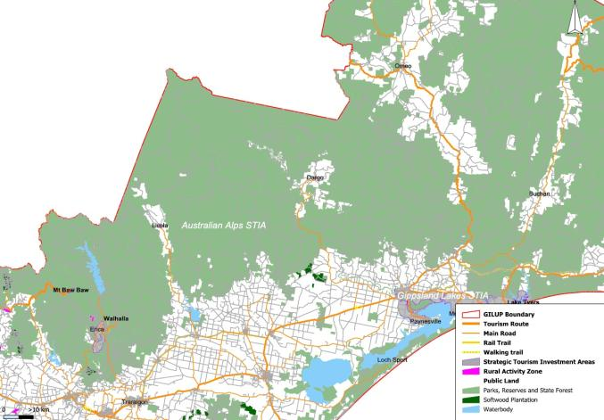
Figure 21: Australian Alps Strategic Tourism Investment Area
Source: RM Consulting Group, 2012

Wilsons Promontory
Wilsons Promontory National Park (see Figure 22) is accessed from Melbourne by the M1 Freeway and the South Gippsland Highway. ‘The Prom’ has a long history as a tourism destination, particularly for family camping holidays at Tidal River and for hiking. The key tourism product is the national park, which includes:
- nature-based - boating, swimming, sailing, surfing, beachcombing and hiking
- accommodation - camping and caravanning, cabins.
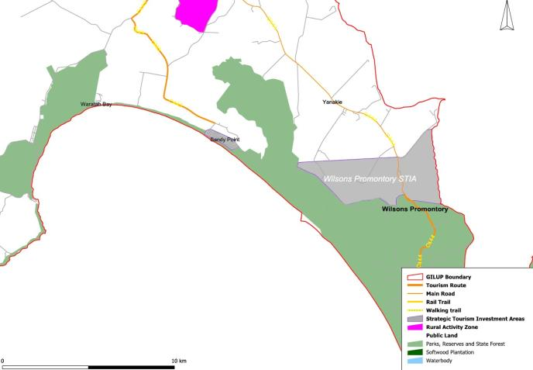
Figure 22: Wilsons Promontory Strategic Tourism Investment Area
Source: RM Consulting Group, 2012
Wilsons Promontory National Park is recognised in national, state and regional tourism strategies. There is significant tourism infrastructure centred on Tidal River providing for holiday-makers and day-trippers, and there are also proposals for an interpretative centre and world-class experiences area.
Outside the national park, tourism product seeks to meet demand for accommodation linked to ‘the Prom’ experience. This is mainly in the form of bed and breakfasts, farm stays and caravan parks at Waratah Bay and Yanakie. An area of land at Yanakie is also zoned for significant tourism investment.
There are a number of complementary tourism attractions in the wider area which include the Great Southern Rail Trail, Coal Creek Heritage Village, and food and wine in Koonwarra and Leongatha. Rural-based tourism has been provided for in areas zoned Rural Activity, enabling tourism development that complements the area’s natural attractions and agriculture.

Bunurong Coast
The Bunurong Coast includes the towns of Wonthaggi and Inverloch and smaller settlements at Kilcunda, Cape Paterson and Venus Bay (see Figure 23). Until recently, tourism has been low-key and seasonal focusing on family coastal holidays but there has been significant development in and around Inverloch, including the RACV resort, holiday homes and cafes. The trend has also been experienced to a lesser degree in surrounding smaller settlements, such as Cape Paterson. The key tourism asset is the coastline which provides for:
- nature-based - boating, swimming, sailing, surfing, fishing and beachcombing
- accommodation - camping and caravanning, cabins, motels, holiday homes and holiday rentals.
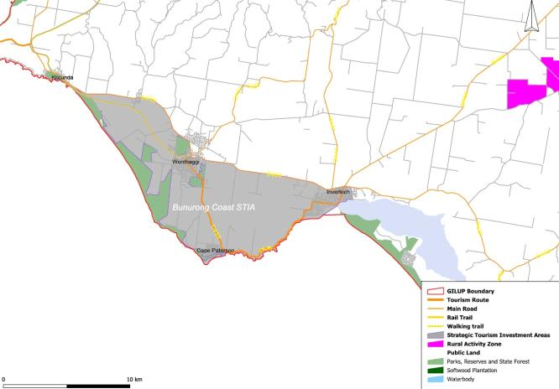
Figure 23: Bunurong Coast Strategic Tourism Investment Area
Source: RM Consulting Group, 2012
As the availability of affordable coastal holiday homes close to Melbourne declines, demand for holiday homes in the area is likely to increase.
Other tourism assets include the Bass Coast Rail Trail between Kilcunda and Wonthaggi, which has the potential to be extended in the longer term to Nyora.
The area has spectacular views of the ocean and, combined with the rural farmed landscape of the hinterland, is an area of very high amenity. Touring, walking and cycling trails are a feature of tourism in the area and particular attention should be paid to protect landscape values.

Croajingolong
The major towns within the Croajingolong strategic tourism investment area include Orbost, Cann River and Mallacoota, with smaller settlements such as Buchan, Nowa Nowa, and Genoa (see Figure 24). The area is distinguished by significant public land assets including the Croajingolong National Park, Cape Conran Coastal Park and Mallacoota Inlet with associated forests, lakes, rivers and coastline. Tourism product in the area includes:
- nature-based - bushwalking, wildlife, boating, swimming, sailing, surfing, beachcombing, fishing
- accommodation - camping and caravanning, cabins, motels.
A challenge for tourism is to increase access to the ample supply of nature-based product and to develop tourism products on private land that integrate with attractions on public land.
Tourism Australia is actively promoting the Melbourne to Sydney Coastal Drive, which runs through the area and there are opportunities at Cann River, which is the first Victorian town providing services to travellers after they leave Eden in New South Wales.
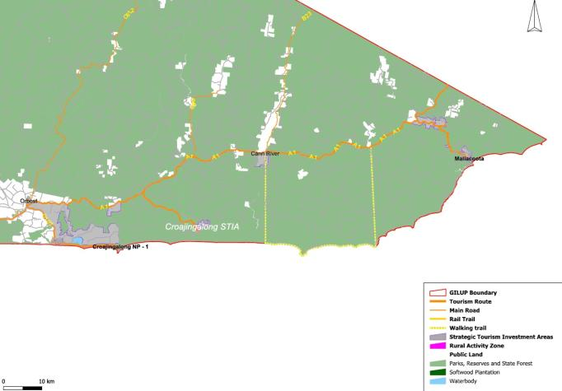
Figure 24: Croajingolong Strategic Tourism Investment Area
Source: RM Consulting Group, 2012
Other tourism investment opportunities include ocean access for boats at Mallacoota and nature-based accommodation on public land associated with the Coastal Wilderness Walk in the Croajingolong National Park.

Tarra Bulga
Key tourism assets are the Tarra Bulga National Park, Grand Ridge Road and Grand Strzelecki Walking Track (see Figure 25). Tourism products include:
- nature based - hiking
- accommodation - camping, caravanning.
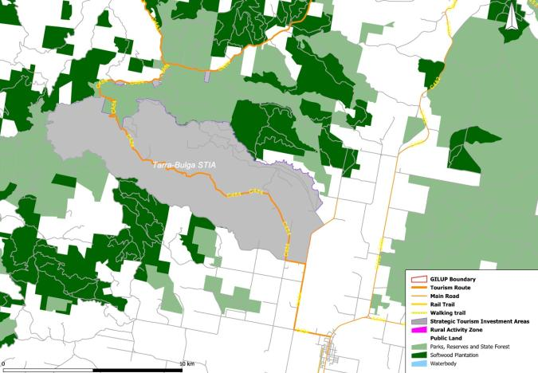
Figure 25: Tarra Bulga Strategic Tourism Investment Area
Source: RM Consulting Group, 2012
There is an opportunity to add to the existing tourism product and capitalise on the area’s natural attributes with a wider range of accommodation. The area is also accessible from other strategic tourism investment areas including Traralgon, Wilsons Promontory, the Australian Alps, and the Melbourne to Sydney Coastal Drive.

Key strategic elements
Tourism is an important component of the Gippsland regional economy. There is an opportunity to increase this by rejuvenating and expanding existing tourism product and attracting investment into new and emerging tourism destinations and experiences.
The region contains a number of tourism assets of national significance, including Phillip Island and areas covered by the National Significant Landscapes program, the Australian Alps and coastal wilderness in East Gippsland. Currently, tourism is strongest in West Gippsland, primarily due to its proximity and accessibility to Melbourne.
The region’s natural environment is considered Gippsland’s greatest tourism asset and includes public land, the rural farmed landscape, coasts and waterways. This is consistent with national and state tourism strategies that are focused on promoting nature-based tourism and Aboriginal culture.
Tourism development should complement these environmental assets but not come at the expense of environmental and landscape values and, where possible, should seek to enhance natural values.
The region’s other economic strengths, power generation, agriculture and fisheries, provide opportunities for tourism that complement nature-based tourism experiences.

COMMERCIAL CENTRES

Context
Gippsland’s towns, regional centres and related highway commercial areas provide important contributions to the economic wellbeing of the region’s communities. Towns and regional centres are the most significant generators of the services economy and provide a wide range of important services to the resource, energy and tourism industries that form the region’s economic base.
On the basis of current state planning policy:
- Traralgon, Morwell and Moe are referred to as a major regional city cluster
- Bairnsdale and Sale are regional cities and centres
- Cowes, Drouin, Inverloch, Korumburra, Lakes Entrance, Leongatha, Warragul and Wonthaggi are regional towns.
In addition to the towns and regional centres, Gippsland has a number of highway commercial areas located along major roads. The key highway commercial precincts include Traralgon, Morwell, Sale, Warragul, Wonthaggi and Bairnsdale. These precincts are typically the most identifiable gateways to each commercial centre.

Issues and opportunities
There are a number of issues that have overarching significance and provide an important context for the future planning and development of the major regional city and the regional centres and towns in the Gippsland region. These include: demographic change and social needs; economic development and prospects based on catchments; seasonal variations in the resident population; online commerce and impacts on regional demand; and highway commercial precinct planning.

Demographic change
Forecasts of the Victorian population indicate that the Gippsland region is projected to have steady long-term growth, marginally below the forecast levels for regional Victoria and metropolitan Melbourne. The region is forecast to grow at approximately 1.1 per cent per annum for the period 2011 to 2031. The regional population is forecast to increase to 345,900 people by 2031, an absolute increase in excess of 76,000 people over the 20-year period to 2031.
The most significant areas of ongoing population growth in the region are focused on the corridor east of metropolitan Melbourne, at Warragul and Drouin in Baw Baw Shire, and at several of the major regional centres and towns, Traralgon, Bairnsdale, Wonthaggi and Sale, together with a number of tourist and retirement areas, including Cowes. Areas of relatively low population growth include the Moe and Morwell statistical local areas in the Latrobe Valley and a number of rural areas.
The ageing of Gippsland’s population is significant and is forecast to proceed at a higher rate than in regional Victoria as a whole or in metropolitan Melbourne. The ageing of the population should be viewed as a key agent for change with an impetus for new opportunities in health, education, community services and public transport.

Economic development and prospects based on catchments
The range of retail, commercial, professional, educational, health and community services requirements of regional towns and major urban areas generally reflect the sizes and ongoing growth of their trade catchments. In broad terms, only two centres have regional level catchments: Traralgon and Mid Valley Shopping Centre, Morwell. The major regional city and several regional centres and towns have catchments in the range of 35,000 to 55,000 people. Warragul, Bairnsdale and Wonthaggi are in the upper range and Leongatha, Churchill, Sale, Moe and Morwell are in the lower range. Small catchments of less than 16,000 people include Korumburra, Lakes Entrance, Drouin, Cowes and Inverloch.
The Traralgon Central Business District and Mid Valley Shopping Centre serve catchment populations estimated to be in excess of 160,000 people. These are the most significant higher order catchments in the Gippsland region by an order of magnitude. Although the long-term forecast population growth rates for both catchments are of the order of one per cent per annum over the period 2011 to 2031, this will be sufficient to take both catchments to over 200,000 people.
Warragul, Wonthaggi and Bairnsdale are a group of high growth towns each with a current catchment population of the order of 40,000 to 50,000 people and long-term annual growth in the range 1.5 to 1.9 per cent per annum. The long-term forecast population growth rates for these towns are well in excess of forecast growth for regional Victoria or the Melbourne metropolitan area. The regional town-sized catchments and significant long-term population growth of these towns underpins the likelihood of significant long-term real growth for a broad range of retailing, commercial, professional and community services.
A group of low growth catchment areas comprise the Latrobe Valley towns of Moe, Morwell and Churchill and the regional town of Sale. The long-term growth rate of the trade catchment areas of these towns averages approximately 0.6 per cent per annum. This is approximately half the growth rate of the Gippsland region, regional Victoria and the Melbourne metropolitan area. This together with the moderate size catchments, in the range of 30,000 to 50,000 people, limits demand prospects for retailing and commercial services.
Leongatha and Korumburra form a third group of regional towns. These have limited catchments, Korumburra approximately 16,000 people, and Leongatha approximately 34,000 people, with long-term growth rates less than one per cent per annum.
Lakes Entrance has a catchment of less than 13,000 people and a long-term population growth rate of approximately 1.4 per cent per annum, marginally above the long-term rates for the Melbourne metropolitan area, regional Victoria and the Gippsland region. Its limited catchment population together with uncertainty on policy responses to climate change which have particular effect at Lakes Entrance will limit commercial investment development prospects in the immediate future.

Seasonal variations in the resident population
An important characteristic of a number of areas in the Gippsland region is the incidence of significant seasonal fluctuations in the resident populations of a number of coastal towns including Cowes, Lakes Entrance and Inverloch. This is a background condition for a number of centres which provides both opportunities in terms of peak summer demands and challenges in terms of underutilised accommodation facilities and impacts on stores and services during the winter season.

Online commerce and impacts on regional demand
Online retailing and commerce is a significant phenomenon world-wide, characterised by rapid growth and the development of a mass consumer market. The differentially higher growth observed for online retailing, compared to traditional retailing, is likely to continue for the foreseeable future. Longer term retail expenditure forecasts indicate that online purchases of household goods and bulky goods which in 2010–11 comprised less than eight per cent of these broader category purchases will likely exceed 15 per cent of these categories by 2021.
The rise of online shopping presents a number of challenges and some opportunities for the Gippsland region:
- The ongoing rapid growth of online retailing is likely, with rising proportions of retail trade, forecast to be attracted to online sites. In the absence of countervailing actions by local traders and communities this will likely result in increased levels of escape expenditure from regional towns and cities.
- The consequential effect is likely to be reflected in lower demand for retail floor space and tenancies and downward pressures on specialty rents, particularly for discretionary goods. Conservatively in excess of 15 per cent of discretionary retail expenditures may need to be discounted in regional localities when assessing sustainable floor space requirements.
- It is the case that the mass adoption of online retailing will generate additional demands for logistics and distribution facilities but it is not clear how regional Victoria will fare in competing for these demands.
- Online shopping represents a transformational change in the application of digital technology and the empowering of consumers with consequential effects on search, shopping and purchase patterns. It provides the consumer instant affordable access to a wide, perhaps worldwide, market for almost all goods and a broad range of services. It is difficult to see how stores, particularly discretionary goods stores and services, will be able to maintain their long-term viability in the absence of an effective online presence.
- There is a clear opportunity for local chambers of commerce and regional communities to provide a framework for traders to market their goods and services on high profile interactive online sites where costs of establishment may be shared, and benefits leveraged for individual businesses. This approach may also improve the profile and recognition of regional towns and communities to a wider regional, national and international audience.
- In broad terms the pervasive effect of online retailing is to sharply increase product and price knowledge for almost all products and a broad range of services, to a universal level. This radically changes the competitive market for almost all discretionary good and services in both metropolitan Melbourne and regional markets.
- The quality of the shopping environment, where the experience of shopping is enhanced as a lifestyle choice, in a high quality unique destination will be increasingly important. Making towns and centres in the Gippsland region unique and attractive, with high quality public spaces, will likely remain one area that cannot be replicated on the internet. Where place differentiation forms part of the shopping and service environment, this will be a competitive advantage for the region.

Highway commercial precinct planning
From a commercial planning standpoint there are four key issues related to highway commercial activities. These are:
- Highway commercial activities tend to be higher order in nature and reflect regional level activities. This limits the number of regional cities, regional centres and towns where there is likely to be a realisable highway activity demand. In the foreseeable future it is likely that demand for highway commercial sites will be limited to the major regional centres and towns of Traralgon, Morwell, Bairnsdale, Sale and Wonthaggi.
- There has been a common policy response in the provision of highway commercial precincts to cater for emerging and future needs in several regional centres and towns. At Bairnsdale, Sale, Warragul and Wonthaggi councils have identified a preferred location for highway commercial precincts located well away from the existing town centre at the highway approaches to the respective towns.
- There is a need to provide for future highway commercial activities to meet the needs of Morwell and Traralgon.
- There is a need to develop a common approach for the physical planning and development of future highway commercial precincts. This should be directed to achieve attractive gateways to the major regional city, regional centres and towns through consistent landscaping, signage, lighting and urban design treatments. It should also ensure precincts are designed as safe highway environments with the need to maintain visibility, highway access and safety.

Summary of centres: role, catchments and forecast growth

Traralgon
Role of Traralgon
Regional role that supports:
- weekly and discretionary retail shopping
- retail and professional services
- highway commercial precinct, Argyle Street.
Includes the following stores/services:
- discount department stores (2)
- supermarkets (3)
- major banks (4)
- national retail stores and services (152).
Forecast population/catchment growth for Traralgon
- Population for the statistical local area Latrobe (City) – Traralgon is forecast to grow by over 10,000 people from 2011 to 2031 to 41,600 people.
- The indicative catchment population for Traralgon is forecast to grow from approximately 39,000 people to 50,000 people in the primary catchment.
Source: Renaissance Planning, 2012

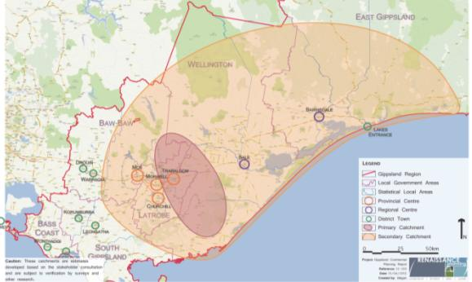

Morwell (including Mid Valley Shopping Centre)
Role of Morwell
Regional role that supports:
- weekly and discretionary retail shopping
- retail and professional services
- highway commercial precinct, Princes Drive.
Includes the following stores/services:
- discount department stores (2)
- supermarkets (4)
- major banks (3)
- national retail stores and services (86).
Forecast population/catchment growth for Morwell
- Population for the statistical local area Latrobe (City) – Morwell which includes the major urban centres of Morwell and Churchill is forecast to experience modest growth of an additional 1350 people from 2011 to 2031 to 24,750 people.
- The indicative catchment population for Morwell, including Mid Valley Shopping Centre, is forecast to grow from approximately 73,000 people to 86,000 people in the primary catchment.
Source: Renaissance Planning, 2012
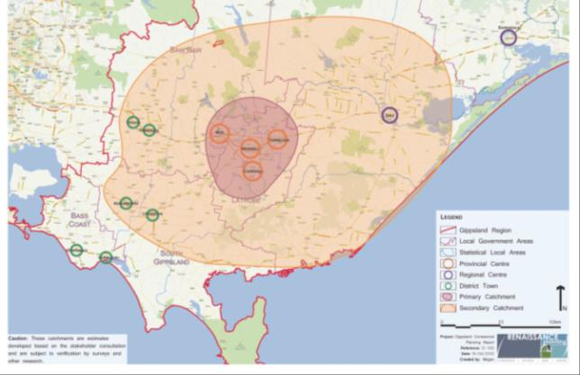
Mid Valley Catchment
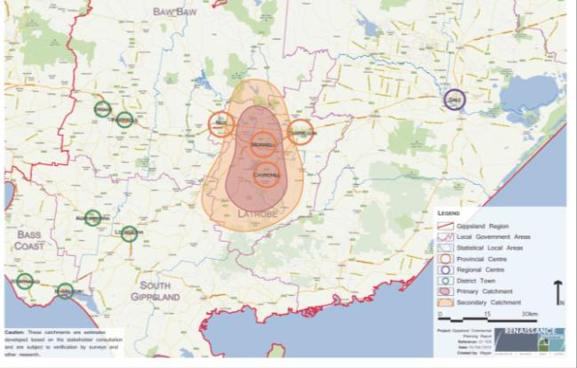
Morwell

Moe
Role of Moe
Neighbourhood role that supports:
- weekly retail needs
- limited supporting retail and professional services.
Includes the following stores/services:
- discount department stores (1)
- supermarkets (3)
- major banks (5)
- national retail stores and services (35).
Forecast population/catchment growth for Moe
- Population for the statistical local area Latrobe (City) – Moe is forecast to grow by approximately 16,000 people from 2011 to 2031 to 21,000 people.
- The indicative catchment population for Moe is forecast to grow from approximately 28,000 people to 31,000 people in the primary catchment.
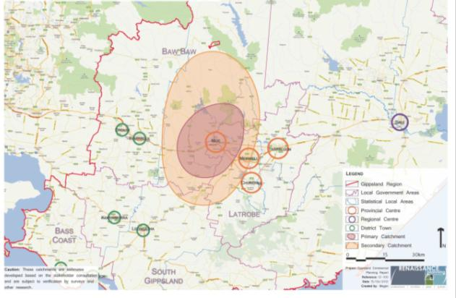
Source: Renaissance Planning, 2012

Churchill
Role of Churchill
Local role that supports:
- weekly retail shopping needs
- limited supporting retail and professional services.
Includes the following stores/services:
- supermarkets (2)
- major banks (1)
- national retail stores and services (8).
Forecast population/catchment growth for Churchill
- Population for the statistical local area Latrobe (City) – Morwell which includes the major urban centres of Morwell and Churchill is forecast to experience modest growth of an additional 1350 people from 2011 to 2031 to 24,750 people.
- The indicative catchment population for Churchill is forecast to grow from approximately 9000 people to 10,000 people in the primary catchment.
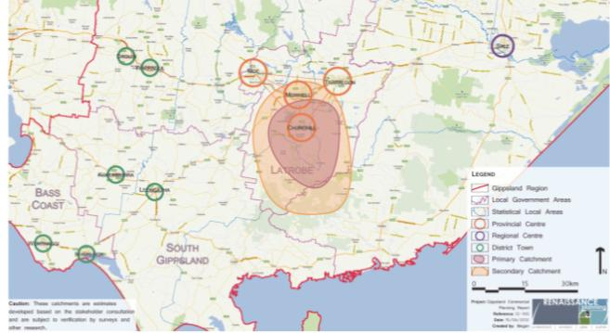
Source: Renaissance Planning, 2012

Bairnsdale
Role of Bairnsdale
Regional role that supports:
- weekly and discretionary retail shopping
- retail and professional services
- highway commercial precinct, Princes Highway/Main Street.
Includes the following stores/services:
- discount department stores (2)
- supermarkets (3)
- major banks (5)
- national retail stores and services (80).
Forecast population/catchment growth for Bairnsdale
- Population for the statistical local area East Gippsland (Shire) – Bairnsdale which includes the major urban centres of Bairnsdale and Lakes Entrance is forecast to grow by over 11,000 people from 2011 to 2031 to 39,800 people.
- The indicative catchment population for Bairnsdale is forecast to grow from approximately 22,000 people to 31,000 people in the primary catchment.
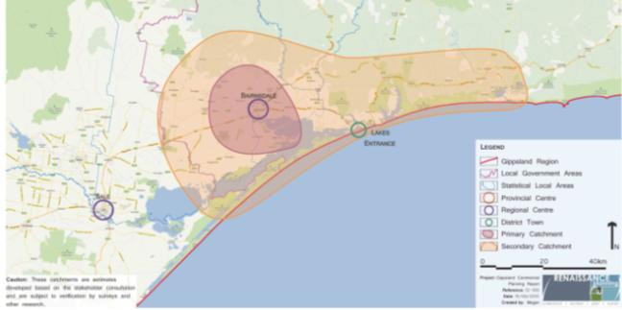
Source: Renaissance Planning, 2012

Sale
Role of Sale
Regional role that supports:
- weekly and discretionary retail shopping
- retail and professional services
- highway commercial precinct, Princes Highway/York Street.
Includes the following stores/services:
- discount department stores (1)
- supermarkets (4)
- major banks (4)
- national retail stores and services (35).
Forecast population/catchment growth for Sale
- Population for the statistical local area E Gippsland (Shire) – Sale is forecast to grow by approximately 2500 people from 2011 to 2031 to 17,300 people.
- The indicative catchment population for Sale is forecast to grow from approximately 26,000 people to 30,000 people in the primary catchment.
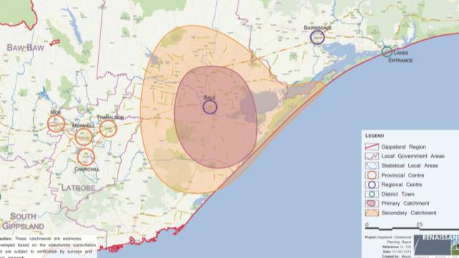
Source: Renaissance Planning, 2012

Cowes
Role of Cowes
Neighbourhood role that supports:
- weekly retail needs
- limited supporting retail and professional services.
Includes the following stores/services:
- supermarkets (3)
- major banks (4)
- national retail stores and services (25).
Forecast population/catchment growth for Cowes
- Population for the statistical local area Bass Coast (Shire) – Phillip Island is forecast to grow by approximately 4700 people from 2011 to 2031 to 14,700 people.
- The indicative catchment population for Cowes is forecast to grow from approximately 10,000 people to 15,000 people in the primary catchment.
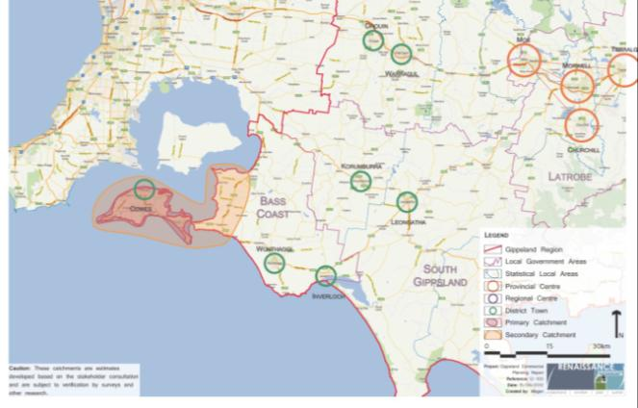
Source: Renaissance Planning, 2012

Inverloch
Role of Inverloch
Local role that supports:
- day-to-day retail shopping needs.
Includes the following stores/services:
- supermarkets (1)
- major banks (3)
- national retail stores and services (12).
Forecast population/catchment growth for Inverloch
- Population for the statistical local area Bass Coast (Shire) – Balance which includes the towns of Wonthaggi and Inverloch is forecast to grow by over 13,000 people from 2011 to 2031 to 35,000 people.
- The indicative catchment population for Inverloch is forecast to grow from approximately 5000 people to 8000 people in the primary catchment.
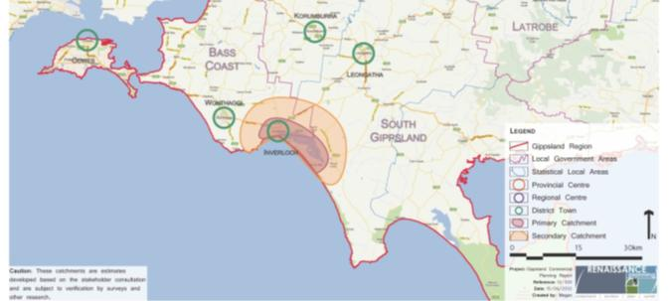
Source: Renaissance Planning, 2012

Wonthaggi
Role of Wonthaggi
Regional role that supports:
- weekly and discretionary retail shopping
- retail and professional services
- highway commercial precinct (Bass Highway/McKenzie Street).
Includes the following stores/services:
- discount Department Stores (2)
- supermarkets (4)
- major banks (6)
- national retail stores and services (31).
Forecast population/catchment growth for Wonthaggi
- Population for the statistical local area Bass Coast (Shire) – Balance which includes the towns of Wonthaggi and Inverloch is forecast to grow by over 13,000 people from 2011 to 2031 to 35,000 people.
- The indicative catchment population for Wonthaggi is forecast to grow from approximately 16,000 people to 24,000 people in the primary catchment.
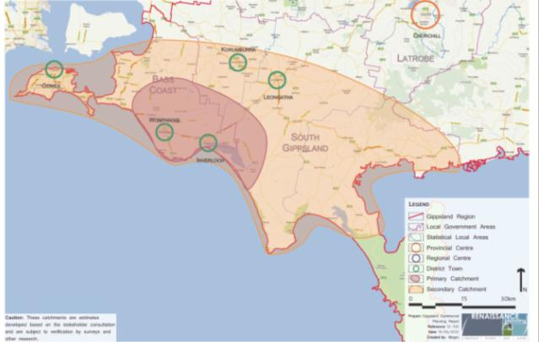
Source: Renaissance Planning, 2012

Drouin
Role of Drouin
Neighbourhood role that supports:
- weekly retail shopping needs
- limited supporting retail and professional services.
Includes the following stores/services:
- supermarkets (2)
- major banks (4)
- national retail stores and services (20).
Forecast population/catchment growth for Drouin
- Population for the statistical local area Baw Baw (Shire) – Part B West which includes the towns of Drouin and Warragul is forecast to grow by over 17,500 people from 2011 to 2031 to 52,100 people.
- The indicative catchment population for Drouin is forecast to grow from approximately 9000 people to 13,000 people in the primary catchment.
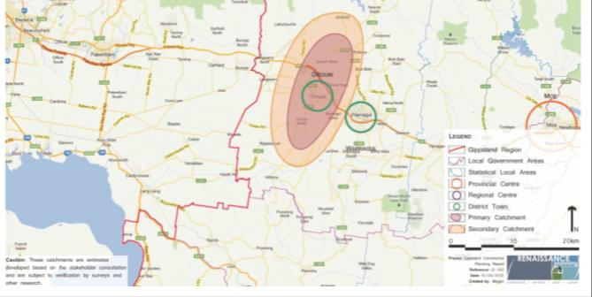
Source: Renaissance Planning, 2012

Warragul
Role of Warragul
Neighbourhood role that supports:
- weekly retail shopping needs
- limited supporting retail and professional services.
Includes the following stores/services:
- discount department stores (1)
- supermarkets (3)
- major banks (5)
- national retail stores and services (60).
Forecast population/catchment growth for Warragul
- Population for the statistical local area Baw Baw (Shire) – Part B West which includes the towns of Drouin and Warragul is forecast to grow by over 17,500 people from 2011 to 2031 to 52,100 people.
- The indicative catchment population for Warragul is forecast to grow from approximately 35,000 people to 52,000 people in the primary catchment.
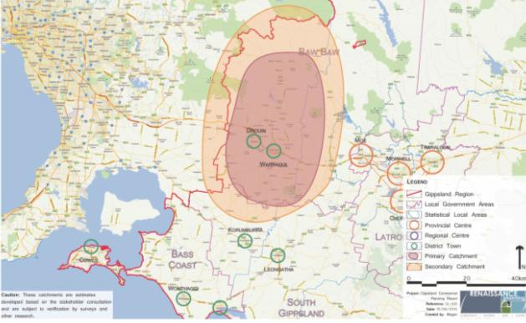
Source: Renaissance Planning, 2012

Lakes Entrance
Role of Lakes Entrance
Neighbourhood role that supports:
- weekly retail shopping needs
- limited supporting retail and professional services.
Includes the following stores/services:
- discount department stores (1)
- supermarkets (2)
- major banks (3)
- national retail stores and services (25).
Forecast population/catchment growth for Lakes Entrance
- Population for the statistical local area East Gippsland (Shire) – Bairnsdale which includes the towns of Bairnsdale and Lakes Entrance is forecast to grow by over 11,000 people from 2011 to 2031 to 39,800 people.
- The indicative catchment population for Lakes Entrance is forecast to grow from approximately 11,000 people to 14,000 people in the primary catchment.
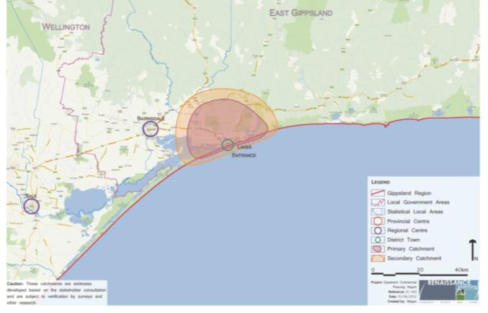
Source: Renaissance Planning, 2012

Korumburra
Role of Korumburra
Local role that supports:
- day-to-day retail shopping needs.
Includes the following stores/services:
- supermarkets (1)
- major banks (3)
- national retail stores and services (12).
Forecast population/catchment growth for Korumburra
- Population for the statistical local area South Gippsland (Shire) – West is forecast to grow by over 1500 people from 2011 to 2031 to 10,200 people.
- The indicative catchment population for Korumburra is forecast to grow from approximately 7000 people to 8000 people in the primary catchment.
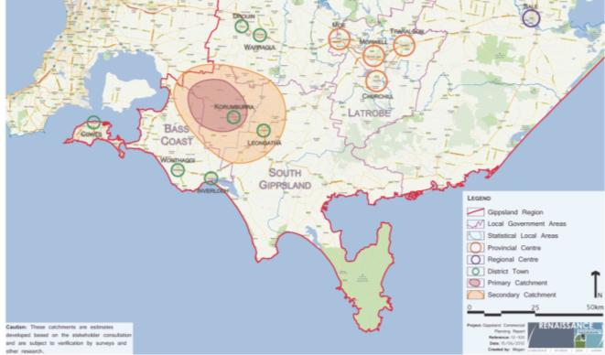
Source: Renaissance Planning, 2012

Leongatha
Role of Leongatha
Neighbourhood role that supports:
- weekly retail shopping needs
- limited supporting retail and professional services.
Includes the following stores/services:
- discount department stores (1)
- supermarkets (3)
- major banks (5)
- national retail stores and services (41).
Forecast population/catchment growth for Leongatha
- Population for the statistical local area South Gippsland (Shire) – Central is forecast to grow by approximately 2000 people from 2011 to 2031 to 15,900 people.
- The indicative catchment population for Leongatha is forecast to grow from approximately 10,000 people to 11,000 people in the primary catchment.
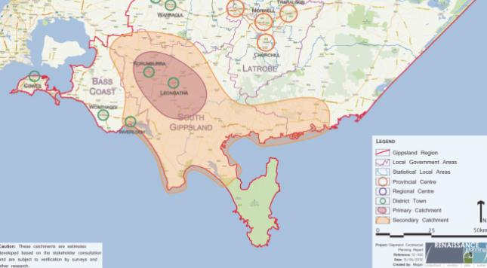
Source: Renaissance Planning, 2012

EARTH RESOURCES AND ENERGY

Overview
Gippsland brown coal provides the energy source for over 90 per cent of Victoria’s electrical power, while the Bass Strait oil and gas fields provide for the bulk of Victoria’s natural gas supply and is a net exporter of gas via interconnector pipelines to New South Wales and Tasmania. In the future, the brown coal resources of the Latrobe Valley could also provide the basis for dried coal products, liquid fuels, hydrogen and fertiliser industries, securing Gippsland’s heavy industry economy.
Geothermal resources are known to be present in the Latrobe Valley and within the western part of the Gippsland Lakes and may provide a long-term energy resource for heating and energy for residential or industrial uses.
Sand and gravel resources near Grantville and Nyora make a significant contribution to the production of construction materials for the building industry of metropolitan Melbourne and also for the rapidly growing western areas of the Bass Coast and Baw Baw shires.
Gold was one of the major drivers for the early development of Gippsland, with goldfields in places such as Walhalla, Grant, Dargo and Swifts Creek. There may be opportunities for gold mining at some point given favourable economic conditions. There are also identified resources of iron and base metals that have been worked historically and mining could similarly become viable under the appropriate economic conditions or through further discoveries. There are also prospects for extraction of mineral sands such as zircon, rutile and titanium with recent finds of 38 million tonnes of heavy mineral sand resources near Glenaladale.

Brown coal
The economic value of brown coal to Gippsland and Victoria is immense. The Victorian Government in partnership with the Australian Government and Gippsland’s local governments has completed the Latrobe Valley Industry and Employment Roadmap to provide a long-term plan to assist economic diversification and transition in response to a national price on carbon. The Roadmap estimates the Latrobe Valley contributes $10.3 billion to the Gross Regional Product out of a total Gross Regional Product of $13.3 billion for Gippsland as a whole. The Roadmap also recognises the link between the energy sector and employment beyond the Latrobe Valley with modelling that suggests each job in the Latrobe Valley energy sector generates an additional 4 or 5 jobs in the wider regional economy.
Gippsland also hosts key scientific, research and educational initiatives, such as the Advanced Lignite Demonstration Program which support Victoria's claim to be a preferred investment location for research and development. This initiative and others, such as CarbonNet, which aims to capture carbon emissions from power plants and then store the gas underground in geological formations, and the Federation Australia University partnership, create opportunities to keep the Gippsland region on the global research and development map.
The Latrobe Valley has an estimated potential economic brown coal resource of up to 65 billion tonnes. This is about 1000 times the annual production of around 65 million tonnes which has been reasonably constant since 1998. The resource can make a substantial contribution to the state’s energy needs for several hundred years, even with significantly higher production rates.
The Latrobe Valley has open cut mines operating at Yallourn, Hazelwood and Loy Yang which have several decades of on-going production capacity at current extraction rates. Other significant brown coal fields are shown in
Table 8.
Table 8: Locations of significant brown coal reserves in excess of one billion tonnes
East of the operating Yallourn coal field:
- Estimated quantity of brown coal resource: 4.7 billion tonnes
West of Morwell and west of the Hazelwood mine:
- Estimated quantity of brown coal resource: 3.1 billion tonnes
East of the existing Loy Yang Field:
- Estimated quantity of brown coal resource: 8.8 billion tonnes
South west of Traralgon:
- Estimated quantity of brown coal resource: 5.4 billion tonnes
Gelliondale:
- Estimated quantity of brown coal resource: 5 billion tonnes
Alberton, near Yarram:
- Estimated quantity of brown coal resource: 4.8 billion tonnes
Source: Department of Environment and Primary Industries
Brown coal has been used for generation of electricity since the 1920s with production of briquettes for domestic and industrial heating as a replacement for local and imported black coal. Approximately two billion tonnes of coal have been mined in the Latrobe Valley since 1923.
Existing brown coal power generators produce electricity with a thermal efficiency of less than 35 per cent and with carbon dioxide emissions of about 1.3–1.5 tonnes/megawatt hour of electricity produced. New power stations can significantly reduce these outputs with European proposals to have thermal efficiencies of around 43 per cent with carbon dioxide emissions of between 0.95 and 1.1 tonnes/megawatt hour. By contrast, gas turbines generate carbon dioxide emissions of around 0.4 tonnes/megawatt hour of electricity produced.
However, local brown coal resources are abundant and not subject to international price or supply competition and so the construction of new brown coal power stations cannot be discounted, particularly if alternative sources of electrical power are too expensive or carbon reduction technology improves in terms of carbon capture and sequestration.
Some interest has been shown in the development of very deep coal seams, 100 to 700 metres underground with thicknesses of 10-70 metres through a process called underground coal gasification. This process could potentially access coal resources that were otherwise unviable to mine.

Land use planning and policy context
Planning provisions to protect the brown coal resource are expressed through zones and overlays in the Latrobe Planning Scheme. They are based on government strategies set out in the Latrobe Region Framework for the Future 1986 and the Land over Coal and Buffer Area Study 1988 which were based on anticipated township growth and the staged development of coal resources.
These strategies have served the community well, but they are now 25 years old and do not provide the level of guidance necessary for future development of the brown coal resource or the Latrobe Valley towns. A new Gippsland Coalfields Planning and Investment Framework is needed which looks at industry and community needs, appropriate planning controls, and which incorporates the Latrobe Valley Industry and Employment Roadmap.
Various proposals to produce liquid fuels derived from brown coal have been raised over several decades, potentially providing a reliable long-term substitute for liquid fuels. A pilot plant is being developed near the Yallourn power station which will produce liquid fuels and other products.
Brown coal gasification to produce urea fertiliser and other petro-chemical by-products is a further option with one proposal producing 1.2 million tonnes of urea fertiliser per annum using brown coal from the Loy Yang mine.

Oil and gas
Oil and gas has been produced from Bass Strait’s Gippsland basin for over 40 years, most notably through the multi-billion dollar investment by Esso/BHP which has 21 offshore platforms and a network of over 600 kilometres of underwater pipelines linking offshore fields to the mainland. The oil and gas is piped on shore and processed at the Longford plant. Over 90 per cent of Victoria’s natural gas supplies and around 14 per cent of Australia’s oil needs are derived from the Gippsland Basin.
Victoria’s gas demand is projected to double by 2030, partially driven by the expected increase in the use of gas to generate electricity, although there is concern among energy market regulators and forecasters about future supplies. Gas could be a critical energy source in the transition to a low emissions economy and there is a need to secure greater reserves to meet growing demand. The known Gippsland offshore gas reserves are projected to be depleted sometime between 2025 and 2030 but this may create opportunities for Gippsland through exploration for new gas supplies. The likely sources of new local gas supply to replace the depleted reserves are:
- new conventional offshore gas fields to exploit deeper, unquantified gas accumulations
- shale gas and tight gas from onshore
- onshore gas from coal seam deposits
- importing gas at marginal cost or at a premium above international market prices.
Oil production in Bass Strait peaked at around 450,000 barrels/day in 1985 and has been in decline, with production in 2006 being around 80,000 barrels/day. Further prospective oil fields may yet prove to be commercial, but these are likely to be further offshore and smaller than those already in production.
The estimated remaining resources in the Gippsland Basin have been estimated at 600 million barrels of liquids and five trillion cubic feet of gas. Production to date from the Gippsland fields has been approximately four billion barrels of oil and seven trillion cubic feet of gas.

Coal seam gas
Coal seam gas is another form of natural gas trapped by water pressure in coal seams. There is currently no coal seam gas production in Victoria, however some exploration licences have been granted to examine the feasibility of extraction. Gippsland, with its extensive coal reserves could potentially be a significant region in Victoria for such exploration and extraction.
The planning and regulation of the coal seam gas industry is overseen by state and federal governments. At a national level, the Standing Council on Energy and Resources has endorsed a National Harmonised Regulatory Framework for Natural Gas from Coal Seams (May 2013). The Framework delivers on a commitment by Australian governments to put in place leading practice principles, to provide guidance to regulators in the management of natural gas from coals seams, and to ensure that regulatory regimes are robust, consistent and transparent across all Australian jurisdictions. The Victorian Government has endorsed the National Harmonised Framework. A moratorium on coal seam gas mining in Victoria will remain until a decision is made as to whether to add to regulations set out in the national framework.
Coal seam gas exploration and production in Victoria is regulated under the Mineral Resources (Sustainable Development) Act 1990. The regulations stipulate that the community must be kept informed and provide strict requirements for licensing and approval. Licensees are subject to regulator monitoring and companies must adhere to the regulations or their licence may be revoked.
In order to undertake exploration activities, a company must apply for an exploration licence. Exploration activities are predominantly desk-based, reviewing existing data and information, collecting and analysing rock samples or airborne geotechnical surveys. While exploration licences allow for low impact activities, ground intrusive works such as drilling, trenching or costeaning are subject to further approvals and conditions. The Department of State Development, Business and Industry is the regulatory authority for issuing of licences and for enforcing compliance with licence conditions. Conditions are specific to each licence and are statutorily referred to other relevant agencies such as the Department of Environment and Primary Industries, the Environmental Protection Authority and water corporations for input prior to being finalised.
The mining licence application process and the planning process provide for detailed environmental investigation and further opportunities for public input and comment.

Carbon sequestration
Carbon capture and storage is the process by which large amounts of carbon dioxide that have been emitted by power stations or other large industries are captured and transmitted for secure permanent storage underground. The process involves capturing carbon dioxide exhaust gases and compressing them to very high pressures and injecting the carbon dioxide fluid into a suitable geological formation. Gippsland’s depleted oil and gas fields have potential for carbon dioxide storage for several reasons:
- oil and gas has been trapped for millions of years and this indicates geological integrity
- there has been considerable research of the geology and this allows accurate predictions of how carbon dioxide might migrate once injected
- existing infrastructure may be able to help inject carbon into the geological formation.
The CarbonNet Project is investigating the deployment of a large-scale carbon capture and storage infrastructure network in the Gippsland region. The project is at an early stage but if proved economically viable, then carbon capture and storage could present an innovative new industry to secure jobs, boost skills and attract investment while strengthening Victoria’s energy security in a low carbon future.

Renewable energy

Geothermal resources
Geothermal energy uses the heat generated by rocks or water bodies deep underground and can be converted into electricity, or can be used directly to heat buildings or for industrial purposes. It can provide a continuous and controllable supply of base load energy more cheaply than other sources of renewable energy.
Information confirming the potential of Gippsland’s geothermal resources is limited but from investigations to date, it appears the Lakes Entrance coastal fringe region may offer good prospects for geothermal resources (Figure 26).
The Latrobe Valley region potentially may provide a long-term market for geothermal energy because of existing transmission infrastructure, or by using the energy directly to heat buildings or commercial greenhouse operations.
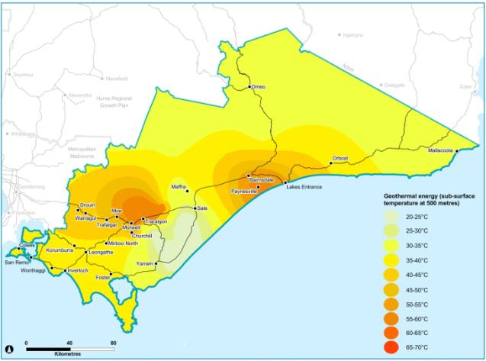
Figure 26: Geothermal resources
Source: Department of Planning, Transport and Local Infrastructure, using Department of Environment and Primary Industries data

Wind
Gippsland currently has two operating wind farms, Toora and Wonthaggi, and a third wind farm, Bald Hills, currently under construction (Figure 27). Existing installed peak generation capacity within the Wonthaggi and Toora wind farms is 12 and 21 megawatts respectively. The Bald Hills wind farm will have a peak generation capacity of 104 megawatts.
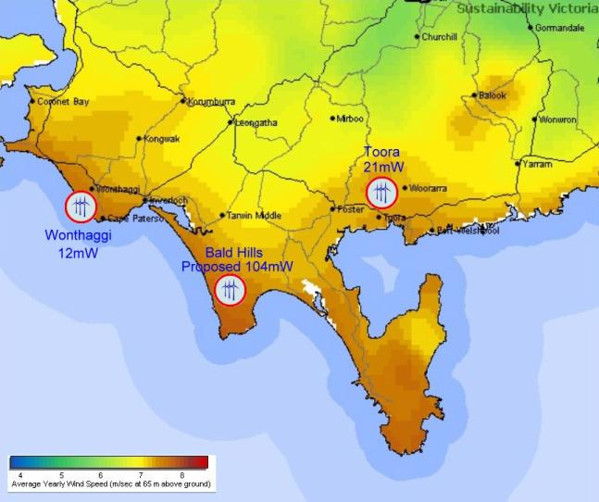
Figure 27: Wind farms
Source: Sustainability Victoria
Significant buffers are required to minimise the impacts of wind farm projects on nearby dwellings, and there is a five kilometre coastal buffer for development west of Wilsons Promontory. These restrictions may limit large-scale development of wind energy in Gippsland.

Extractive industries

Sand resources
Gippsland is a major supplier of Melbourne’s construction sand and gravel, particularly from the Grantville - Lang Lang supply area (Figure 28), which is important because of its proximity to Melbourne. However, the extractive industry anticipates a supply shortfall within 10 years due to diminishing supplies and increased demand from Melbourne, which will increase costs for building and construction industries. West Gippsland will therefore become increasingly important for the supply of sand and hard rock resources as increased urbanisation pushes extractive industries eastward.
An important supply of sand at Trafalgar has been identified as a state-significant resource and has been safeguarded through the Baw Baw Planning Scheme (see Figure 29). Extraction of this resource will become increasingly viable and vital to Melbourne’s construction industry, as the Grantville - Lang Lang deposits diminish.
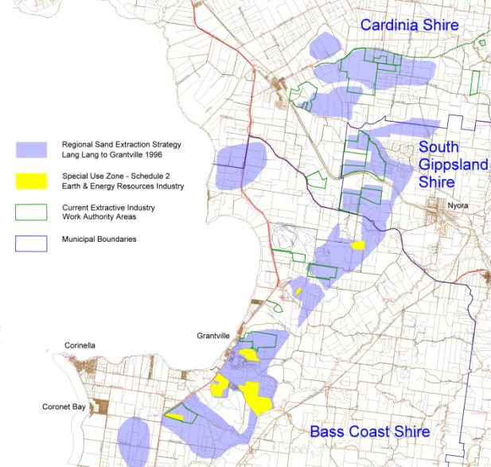
Figure 28: Grantville - Lang Lang sand resources
Source: Department of Transport, Planning and Local Infrastructure
Due to its importance to the metropolitan construction industry and the high costs of transportation, where information is available, prospective sand extraction areas need to be identified and considered in local planning. This should be a high priority for both the industry and for local government and could be carried out through a review of the Regional Sand Extraction Strategy 1996 which would update estimates of the extent, volume and value of sand resources and include recommended planning controls to protect identified areas.
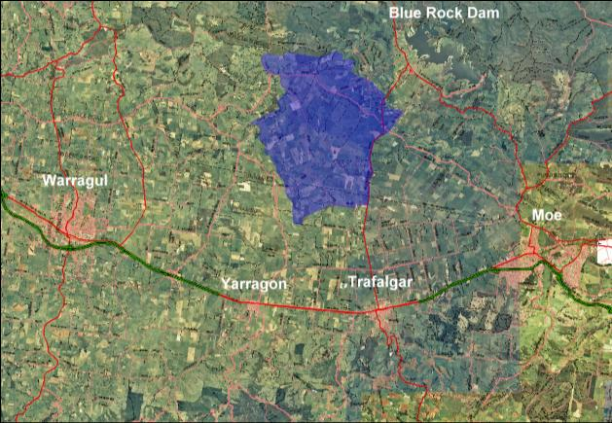
Figure 29: Trafalgar sand resources
Source: Department of Transport, Planning and Local Infrastructure

Hard rock
Hard rock is used to produce three main products:
- crushed rock for the base of roads, car parks etc
- aggregates for concrete, asphalt, sprayed seal road surfacing and drainage applications
- chemical products such as high grade limestone for metallurgical and other industrial processes.
Gippsland hard rock resources are well distributed across the region with sufficient supplies available for several decades given current demand profiles, and providing the resource is protected through regulatory controls.
As with sand resources (above) hard rock resources need to be identified and considered in any land use planning decisions (where information is available) because of their importance to the metropolitan construction industry and their high costs of transportation.

Other minerals
While current mining activity in Gippsland is limited, apart from brown coal mining in the Latrobe Valley, there are notable deposits of significant minerals in East Gippsland which may become viable with changed economic circumstances or improved commodity prices, and advances in technology. The best prospects are for copper, lead, silver and zinc at the Wilga and Currawong deposits in the Benambra area, and for mineral sands in the Glenaladale area, north of Bairnsdale.

Base metals
Gippsland does not have any commercially significant base metal mines operating at present but mines have operated in the past near Walhalla and East Gippsland and may do so in the future. The most likely future base metal mine is proposed east of Benambra, exploiting the Wilga and Currawong deposits. Copper, tin, iron, lead and zinc deposits are all found in Gippsland and most of these have been mined commercially in the past. If economic circumstances change, mining of base metals may become commercially viable again (see Figure 30).
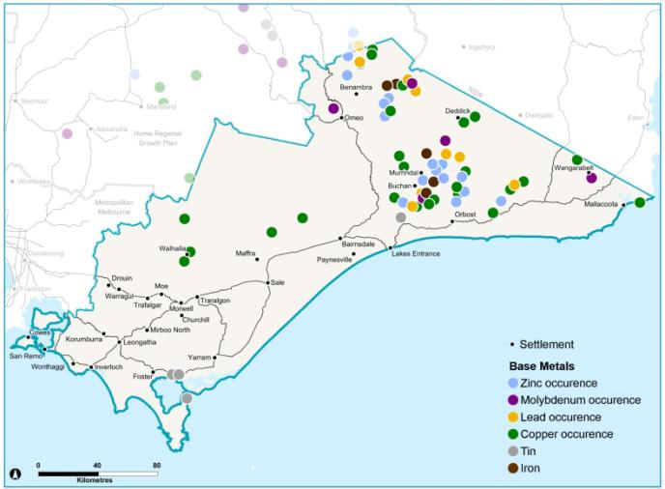
Figure 30: Base metals
Source: Department of Transport, Planning and Local Infrastructure, using Department of Environment and Primary Industries data

Precious metals
Gippsland currently has no mines of significant size extracting precious metals despite having been a major source of Victorian gold production in the late 19th and early 20th centuries. Current price strength for precious metals has heightened interest for exploration of new deposits and for re-examination of known fields that have been productive in the past. Gold still offers the best prospects for commercial mining, although there are also minor deposits of silver and platinum.

Mineral sands
Gippsland is considered to have good prospects for mineral sands with exploration activity being undertaken in the area north of Bairnsdale. Mineral sands, such as rutile, zircon, and titanium, have a high dollar value/tonne, and could be suitable for export from local ports.

Mineral exploration and project developments
In May 2012, the Economic Development and Infrastructure Committee of the Parliament of Victoria tabled the results of its inquiry into the benefits and drivers of, and possible barriers to, greenfields mineral exploration and project developments in Victoria. The Victorian Government’s response to the Inquiry was released in May 2013, supporting all recommendations. Key aspects of the response include:
- establish Minerals Development Victoria as a single point of entry for investors dealing with Government on their projects
- actions to reduce regulatory burden imposed in legislation
- actions to build community confidence through greater engagement and clearer communication of information
- additional funding for geosciences research and greater investment attraction
- steps to improve mechanisms to maintain appropriate access to extractive resources while supporting ongoing development and optimum land use.
While it is important to acknowledge these and other aspects of the response, it is beyond the scope of the regional growth plans to deal with the majority of the commitments and they will need to be addressed through other suitable government initiatives. The response did include a commitment to incorporate existing extractive industry interest areas into regional growth plans. The plan recognises these areas accordingly.
Current minerals and extractive industry activities, along with the extractive industry interest areas and other potential resources that occur with the region are shown in Figure 31.
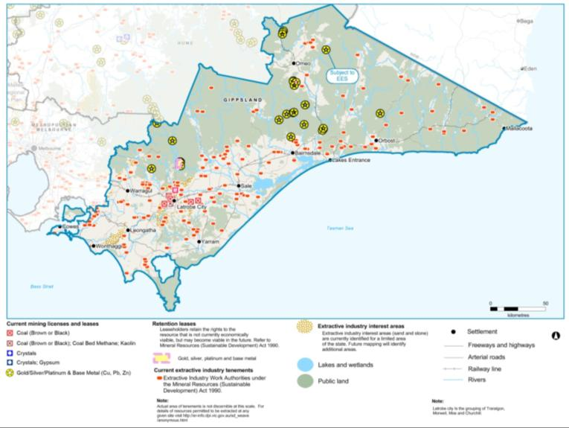
Figure 31: Mining and extractive industries, tenements and licences
Source: Department of Environment and Primary Industries.
- ENVIRONMENT AND HERITAGE

ENVIRONMENT AND HERITAGE ASSETS
Environment and heritage assets are often co-located in the landscape, with many Aboriginal cultural heritage and historic heritage sites located in close association with waterways, wetlands, forested areas and public land. Many environmental assets overlap within the landscape and interact across the landscape. For example, rivers run through forested areas and agricultural areas, and are impacted upon by the land use activities on the land they run through. These rivers carry water downstream to wetlands, estuaries and marine environments, which can in turn affect those environmental assets. This background report discusses cultural heritage and different types of environmental assets separately to highlight their values to the region and the considerations for planning associated with those assets. The regional growth plan integrates these considerations in its future directions and strategies.
Regional catchment strategies and their sub-strategies, such as regional waterway strategies, identify priorities for investment in protecting and enhancing high value environmental assets. Each catchment management authority uses different methods to identify their high value environmental assets. The regional growth plans across the state use a consistent approach to mapping environmental assets. These assets align with those identified by catchment management authorities, though they may be mapped to a different scale.

Cultural heritage assets
The Gippsland region has a rich and diverse representation of heritage values capturing both Aboriginal cultural heritage and historic heritage. Gippsland Regional Plan 2010 highlights the opportunities to more strongly link natural and heritage tourism in the region and the opportunities this provides for the potential growth in tourism in the region. These tourism opportunities are discussed in Section 1.3 of this report.
Traditional inhabitants of the Gippsland region were the Gunaikurnai people. Swan Reach was the central corroboree point for the five clans of the Kurnai. Existing cultural tourism experiences in the region include the Bataluk Cultural Trail in East Gippsland, which follows significant traditional routes used by the Gunaikurnai for over 30,000 years. The Bataluk Cultural Trail (see Figure 32) contains cultural places that highlight aspects of Gunaikurnai history and culture, including dreamtime stories, traditional lifestyles, European invasion and settlement and present day life.
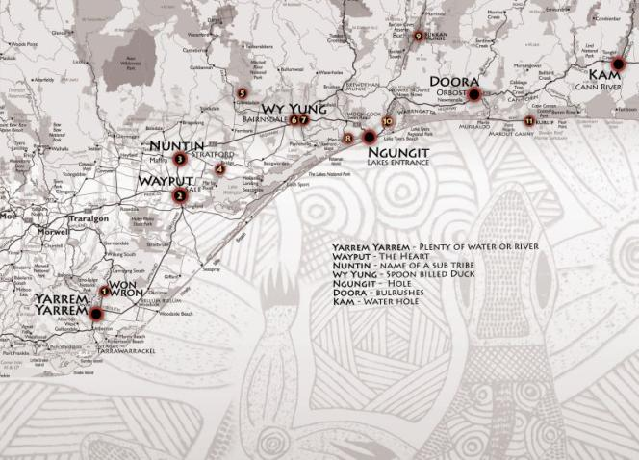
Figure 32: Bataluk Cultural Trail sites
Source: http://www.batalukculturaltrail.com.au/index.php
Historic heritage is also rich throughout the region, linked to gold mining, coal mining and maritime history. Well known sites include the State Coal Mine in Wonthaggi and the gold mining precincts associated with Walhalla, Omeo and Toombon. There are also significant historic heritage places associated with the region’s agricultural heritage.
Some regionally significant heritage assets were identified during the development of the plan, and are listed and mapped in Appendix 1. It is acknowledged this list is not exhaustive and many other places of significance occur throughout the region. These points represent some of the more well known locations and have been supplied by the Office of Aboriginal Affairs Victoria and Heritage Victoria.
Cultural heritage is protected under the Aboriginal Heritage Act 2006 and the Heritage Act 1995. The Planning and Environment Act 1987 requires that state and local government planning take cultural heritage and its management into account by acknowledging necessary covenants under the Heritage Act 1995 in planning schemes and permit applications.
Regional planning considerations related to cultural heritage assets include:
- in planning for growth and future land use, cultural heritage is an asset – in community, economic and social terms
- many tourists seek heritage tourism experiences
- cultural heritage attractions and services contribute to regional economies and employment
- Aboriginal cultural heritage and historic heritage assets should be protected from disturbance and degradation, in recognition of their cultural value and significance to the whole community, as well as enabling their tourism potential can be realised
- The individual places identified in the background report, as well as others, are seen as important for the region and will continue to form a key part of the region’s heritage and tourism base
- Opportunities to develop cultural, historic and other tourism opportunities throughout the region should be supported through continued strategic planning.

Significant landscapes
Landscapes may be deemed significant for a combination of historic, aesthetic, scientific, religious and social reasons, where these landscapes are deemed integral to the amenity of the area. There are many significant landscapes in the Gippsland region. Where associated with the coast, these have been identified through the Coastal Spaces Landscape Assessment Study (Department of Sustainability and Environment, 2006) and in local planning schemes.
The objective of the Coastal Spaces study was to assess the visual character and significance of the landscape in order to prepare planning guidance with a view to retaining and respecting landscape values. Broad landscape areas were examined in detail and assessed for their cultural landscape values. This led to the designation of some landscapes as regionally significant and others as of state significance or higher.
There has been no coordinated, consistent assessment of significant landscapes for the rest of the Gippsland region. Landscape features such as alpine areas and extensive wilderness areas, tourism routes such as the Great Alpine Road and Grand Ridge Road and the strategic tourism investment areas provide an indication of the potential for significant landscapes and views in inland areas of the Gippsland region.
Consultation during the development of the plan highlighted the need to retain the current character of the landscape, while consolidating growth within existing settlements. This included maintaining discrete settlements and ensuring that the open space breaks between settlements are maintained, both for character and to protect important agricultural land. It also included limiting the spread of rural living.
Regional planning considerations related to significant landscapes include:
- The Coastal Spaces Landscape Assessment Study was completed in 2006. All councils have adopted the recommendations in this report and amended (or are in the process of amending) their planning schemes to reflect these landscapes in their planning tools, including Significant Landscape Overlays.
- Gippsland’s environmental assets and landscapes have been identified as a key attractor for tourism in the region. The Gippsland Strategic Tourism Investment Areas Final Report has recommended that an assessment of landscapes in the rest of Gippsland occur, using a similar methodology to the Coastal Spaces Landscape Assessment Study. This would result in incorporation of recommendations into planning schemes to protect the landscape values of the region.
- Maintaining significant landscapes and coastal spaces is critical to the region’s tourism future and regional identity. Retaining breaks between settlements can assist with retaining this character.
- The development pressures within some highly valued landscapes need to be carefully managed so that the landscape values of the region are protected, along with other environmental assets in the same area such as water supply catchments, terrestrial habitat and waterways. West Gippsland in particular is located within Melbourne’s peri-urban region and is experiencing increased development pressures.
- Consideration should be given to identifying where rural living opportunities could be supported and where other factors, such as significant landscapes and agricultural land uses, should be prioritised over non-related residential development.

Terrestrial habitat
Native vegetation and habitats (terrestrial habitats) are important as they provide a range of environmental services, such as filtering nutrients, habitat regeneration and climate regulation, that underpin the health of land and water, flora and fauna and natural communities. Native vegetation and habitats help provide clean water, carbon storage, timber, firewood and the health of soils. They also provide important spiritual and aesthetic values at various scales and are a key to many of the recreation and tourism values in the region.
Clearing of native vegetation along with other threatening processes from urban and rural activities has been, and continues to be, a significant threat to native vegetation and habitats across Victoria.
There are numerous individual threatened species that occur in the Gippsland region. However, their locations are too specific to be mapped at a regional scale, and are best addressed in more localised planning assessments. Threatened species and communities are recognised through NaturePrint mapping, which is used as part of the regional growth plans and appropriately covers these issues at a regional scale. Therefore there are no future directions or land use planning actions established in the plan to address the Gippsland region’s threatened species and communities issues. Finer scale planning, such as precinct structure plans or individual planning assessments, needs to give appropriate consideration to threatened species and communities.
The catchment management authorities in the region have identified the highest value native vegetation and habitat assets within each of their boundaries. Each catchment management authority across Victoria has identified their highest value terrestrial habitat assets using different methodologies. For statewide consistency in all of the regional growth plans, the Department of Transport, Planning and Local Infrastructure in consultation with the Department of Environment and Primary Industries, has used the highest three levels of NaturePrint v2.0 mapping to identify significant clusters of vegetation (see Figure 33). This captures threatened species and communities to an appropriate level for regional scale planning.
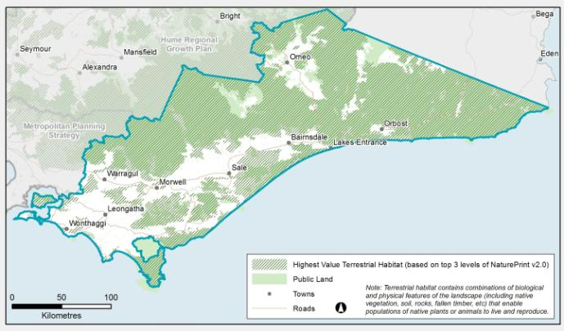
Figure 33: Highest value terrestrial habitat assets in relation to public land
Source: Department of Transport, Planning and Local Infrastructure, using Department of Sustainability and Environment NaturePrint data
Regional planning considerations related to terrestrial habitat assets include:
- Future natural resource management activities within the region may comprise actions to protect the high value habitat assets in the region, along with waterway, wetland and soil assets and to establish large scale vegetation corridors. These activities may involve actions on both public and private land and are likely to use agreements and tailored land management plans with relevant land owners.
- Natural resource management activities in the region may also involve actions to increase the vegetation within the region by creating vegetation corridors in strategic areas. The preferred locations for these corridors may overlap with areas that experience a future change in land use or a change in industry. Planning for such activities will need to consider any potential increase in natural hazards as a result of such activities. This is particularly relevant to any changes in landscape, bushfire and flood risks that may result from increasing treed vegetation cover, especially where occurring in close proximity to settlements.
- There are also emerging economic opportunities on private land centred on environmental values, such as in carbon markets, payments for ecosystem services and offset markets. There is the opportunity to work with catchment management authorities, community groups and landholders to coordinate planning for the preferred locations of these activities to maximise the benefits gained from them.
- Local government or the Department of Transport, Planning and Local Infrastructure are unlikely to lead many of the activities mentioned in the previous three points, but there are benefits in collaborations that might determine preferred locations to target natural resource management initiatives. Careful consideration will need to be given to the preferred locations of vegetation corridors in light of other regional plans, such as the regional growth plan. This includes consideration of the balance of values and the natural hazards that may change as a result of these corridors being established, such as increasing bushfire or flood risk. Strategically locating such activities could also provide flow-on economic benefits to the region, for example by improving the visual amenity of tourism routes.
- Planning tools, such as the Environmental Significance Overlay and Vegetation Protection Overlay are used across the region to identify areas where the development of land may be affected by environmental constraints, to protect environmental values, including significant native vegetation, and to ensure that development is compatible with identified environmental values. These may need updating as new information is made available on environmental assets across the region.

Waterways (rivers, wetlands and floodplains)
Waterways, rivers, wetlands and floodplains, provide the region with its water supply. This water is critical to supporting the region’s towns, industry and agriculture, as well as the environmental values within and adjacent to rivers, wetlands and floodplains. Rivers and wetlands are also the centre of many social, tourism and recreational activities and often are associated with Aboriginal cultural heritage sites and historical settlement patterns. Many such areas are also subject to development pressures, such as around the Gippsland Lakes. The major rivers and important wetlands in the region are shown in Figure 34.

Rivers and floodplains
The Gippsland region spans the Great Dividing Range and includes significant parts of the following catchment areas: Bunyip River, East Gippsland, Latrobe River, Mitchell River, Snowy River, South Gippsland, Tambo River, Thomson River, and the Upper Murray River. It also contains very small areas of the Goulburn River, Kiewa River, Ovens River and the Yarra River catchments. Some of the region can experience significant flooding from these rivers, impacting on both rural and urban areas. Flooding is discussed under the natural hazards section below.
Nine rivers or reaches of rivers within Gippsland are designated as Heritage Rivers under the Victorian Heritage Rivers Act 1992:
- Mitta Mitta River heritage area
- Genoa River heritage area
- Bemm, Goolengook, Arte and Errinundra rivers heritage areas
- Snowy River heritage area
- Suggan Buggan and Berrima rivers heritage area
- Upper Buchan River heritage area
- Mitchell and Wonnangatta rivers heritage area
- Thomson River heritage area
- Aberfeldy River heritage area.

Wetlands
Specific wetlands in Australia are protected under the Environment Protection and Biodiversity Conservation Act 1999. These include wetlands listed on the Ramsar Convention and on the Commonwealth’s Directory of Important Wetlands in Australia. The Gippsland Lakes, Corner Inlet and Western Port are listed Ramsar sites within the region (Figure 34). There are also several wetlands that fall within the East Asian-Australasian Flyway sites which are mapped in the plan. Detailed listings of the individual bird species occur at these sites can be found at http://www.environment.gov.au/biodiversity/migratory/publications/shorebirds-east-asia
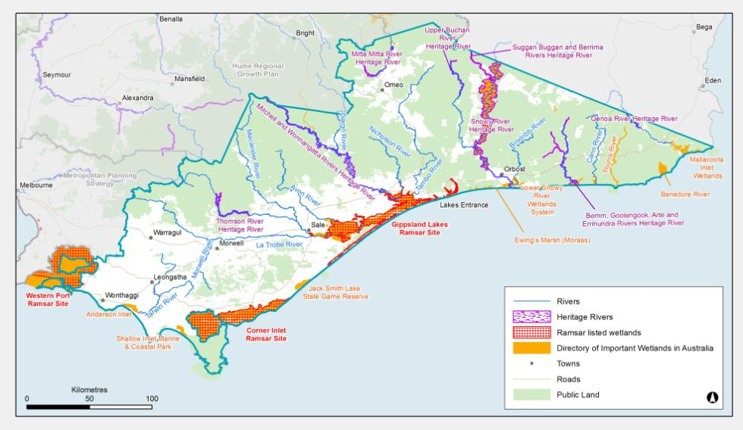
Figure 34: Major rivers and important wetlands of the Gippsland region
Source: Department of Transport, Planning and Local Infrastructure
Regional planning considerations related to waterway assets include:
- Protecting and improving waterways in Victoria is a long-term goal of the Victorian Government. The management and improvement of waterway assets generally falls to catchment management authorities and public land managers, often in partnership with private landholders. Many natural resource management activities are aimed at improving the health of waterways. Much of this activity is focused on improving land management practices.
- Land use change can also significantly affect the values of waterways, either positively or negatively. Appropriate land use planning can help minimise threats to rivers and wetlands from inappropriate catchment development, urban stormwater runoff, waste and wastewater, and reduced wetland connectivity.
- Some planning mechanisms, such as overlays, can be used to detail specific considerations around regionally and locally important waterway assets. This is of particular relevance for wetlands, given the prominence of private land surrounding wetlands in the region. The East Gippsland Catchment Management Authority has identified objectives and management actions to increase the coordination between agencies to better plan for the future of the Gippsland Lakes. The plan recognises the benefits to applying appropriate planning tools, which could include overlays, to protect wetlands across the Gippsland region, in particular around the Gippsland Lakes which are under increasing development pressures.
- The Gippsland Lakes are an important part of Gippsland’s regional economy generating benefits through their amenity and landscape value, commercial and recreational fisheries, and tourism. They also are a central part of Gippsland’s identity and provide important links to Aboriginal cultural heritage and historic heritage. The Gippsland Lakes Environmental Strategy sets a vision for the Gippsland Lakes: ‘In 2032 the Gippsland Lakes are widely recognised and cherished for their outstanding natural beauty, environmental, social and economic values’. The strategy includes an initiative to prepare a ‘sustainable development plan’ for the Gippsland Lakes and foreshores to identify appropriate development around the lakes, integrate management of water and land based activities, protect sensitive areas, and provide greater certainty for development.
- The Gippsland Lakes also require ongoing catchment management activities to protect and improve their water quality. Suitable land use planning mechanisms will be adopted by the region to assist in protecting these key assets.

Catchment health

Protecting water quality and supply
Some catchments are designated for the specific purpose of supplying water and are protected under the Catchment and Land Protection Act 1994. These declared water supply catchments have significant values as a source of water supply both for domestic and for stock and domestic use. They need specific protection, including land use and subdivision controls, to protect water supply and quality. Guidelines exist to guide planning decisions in these catchments, where they are considered to be open, as in open to the public, yet generally contain private land.
There are over 30 declared water supply catchments in the Gippsland region, with many providing significant water supply to Melbourne (see Figure 35). These declared water supply catchments are listed and described on the Victorian Resources Online website. Special area plans have been prepared for some of the declared water supply catchments. These plans specify where certain land uses and development may be undertaken and the conditions that apply to any such land uses. The purpose of these plans is to minimise any adverse effects on water-related values.
Groundwater is also a significant water resource for the region.
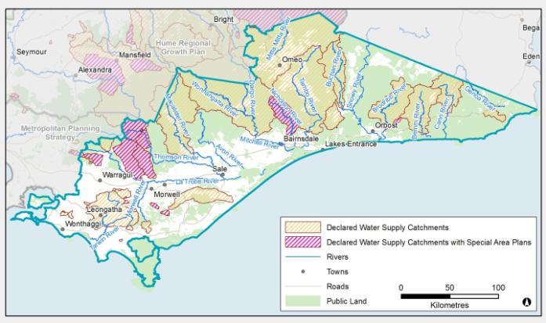
Figure 35: Declared water supply catchments and essentially natural catchments
Source: Department of Transport, Planning and Local Infrastructure
The Gippsland Region Sustainable Water Strategy identified the potential need for land use in certain catchment areas to be restricted to protect water supply into the future. This approach may result in changes to the Water Act 1989. These potential controls would create intensive management areas by introducing land use controls relating to the amount of vegetation that can be planted within a catchment area, thereby ensuring surface water flows and groundwater supplies are maintained. Potential intensive management areas have not yet been identified for Gippsland. Higher priorities exist in the west of the state. However, the Gippsland Region Sustainable Water Strategy does acknowledge the importance of forestry as an industry in parts of Gippsland, and such controls may be needed in the future to manage forestry and water resources.
Domestic and stock water use continues to be an ‘as of right’ use if used for the purposes defined in the Water Act 1989. However, in 2009 the state introduced policies to improve the management of such uses by, among other measures, requiring the registration of new or altered domestic and stock dams within rural residential areas. These policies aim to monitor interception activities and ultimately reduce the impact of small catchment dams on overall water availability. Domestic and stock use could undermine the reliability of supply for all water users, particularly in dryer conditions when these dams intercept a greater percentage of rainfall.

Natural catchment areas
Some specific catchment areas in Victoria are designated as natural catchment areas, or ‘essentially natural’ catchments, under the Victorian Heritage Rivers Act 1992. This Act includes some allowances and restrictions for land and water uses in these catchment areas that are relevant for future land use planning. An ‘essentially natural’ catchment is one with no urbanisation, clearing, intensive agriculture, mining, extractive industries, water storages, water diversions, river engineering works, or roads parallel and immediately adjacent to streams.
Sixteen essentially natural catchments exist throughout the Gippsland region with the main ones shown on Figure 35. They vary in size across the region quite significantly, and all occur on public land.
Regional planning considerations related to catchment health include:
- The declared water supply catchments within the Gippsland region are predominantly on public land. They occur generally in mountainous, forested areas of the region, but some do occur on private cleared, agricultural areas where there are settlements. These areas are mostly in the west of Gippsland, which may experience increased rural residential development pressures.
- Designated water supply catchments need to be considered when proposing land use change, particularly when considering significant unsewered subdivision and the number of dwellings that can be built in these areas. The guidelines for planning permit applications in open, potable water supply catchment areas 2012 are designed to assist with such considerations.
- Councils within these catchment areas may need to update their domestic wastewater management plans in line with the guidelines for planning permit applications in open, potable water supply catchment areas 2012.
- The key directions in the plan highlight the importance of the timber industry to the region’s future. As the implications of declaring catchment areas as intensive management areas emerge, the plan may need to re-assess the most appropriate location for any expansion of the timber industry in the region.

Soils
Soils in the Gippsland region vary depending on the geological and land formation history they have experienced. Soil provides the foundation for much of the economic activity within the region, especially for primary production enterprises, such as agriculture and timber production.
Soil, along with water, vegetation and fauna, is defined as an integral part of land under the Catchment and Land Protection Act 1994. Private landholders have primary day-to-day management responsibility for soil health on their property and must take all reasonable steps to conserve soil and avoid doing anything that would cause or contribute to land degradation on someone else’s land. Governments can play a role where markets fail to encourage the long-term preservation of soils and the values and services they provide.
Given the significance of primary production and natural values to the future of the region’s economy, ongoing maintenance and improvement in soil within the region is essential. However soil can also pose a risk to other environmental assets. This is discussed further under soil health threats in Section 2.2. of this report, Natural hazards and risks.
Soil issues often result from a mismatch between land use and management and the inherent capability of the soils. Land capability is a commonly used measure of the value of soil for agricultural production, although it is not the only indicator or driver of the productive capacity of land. Sometimes proximity or security of feed, roads, processors, power and water can be more important considerations. Not all agriculture requires good soil or water to be productive for agricultural purposes, therefore soil capability should not be the only indicator of potential farmland, nor should soil capability be used to discriminate between different types of legitimate agricultural land uses in rural areas. The identification of strategically significant agricultural land takes these factors into account (refer to section 1.2).
The catchment management authorities have identified the need to protect soil health to maintain the productivity and stability of agricultural land, and to consider the implications of climate change on agricultural land. The West Gippsland Catchment Management Authority has existing strategies for managing soil erosion and salinity issues within the region. The release of the former Department of Sustainability and Environment’s Soil Health Strategy in 2012 could mean that each catchment management authority will need to develop or review regional soil health strategies. Land use planning interactions should be considered in these plans as they are developed.
Various overlays are used by individual local councils across the region to manage some soil issues, such as the Erosion Management Overlay and the Salinity Management Overlay. Soil health threats and acid sulfate soils are discussed in section 2.2, Natural hazards and risks.
Regional planning considerations related to soils include:
- The catchment management authorities have proposed initiatives to continue development of information to support decision-making, such as regional soil plans and capability mapping and other initiatives identified in their respective catchment management strategies. These will be important to enable growth in productive agriculture and settlements into the future.
- Consideration of carbon market opportunities will also help inform future decisions about protecting and improving soils.
- Land use planning can specify how agricultural production should be protected or which land should be protected from inappropriate development. The plan has considered strategically important agricultural areas to identify which areas should be given higher levels of protection from housing and urban development, to protect the soil and production assets of the region, and to enable its economic growth.
- Land use planning can assist in the protection of the state’s soil resource by promoting that land use change does not disturb soils to a level that could result in deterioration of the soil assets within each region, or further contribute to pollution of waterways in any significant volume. One example of a land use tool might be the Erosion Management Overlay. Consideration could be given to how adequately and consistently these planning tools have been applied across the region, and if they need to be improved.

Public land
There is an extensive network of public land reserves in the Gippsland region that protects numerous heritage, environmental, economic and social assets and values. These values include conserving plants and animals, protecting landscapes, protecting archaeological and historic sites, providing timber and firewood, and providing recreational and educational opportunities. Public land in the region is shown in Figure 36.
There are significant, nationally and internationally recognised areas of public land in the Gippsland region, such as Wilsons Promontory, Mount Baw Baw, and Croajingolong, Alpine and Snowy River national parks. These and other public land areas are the key to the tourism future of the region, as well as creating reserves which protect environmental and heritage assets and values. Many of these areas are recognised as strategic tourism investment areas.
Opportunities are emerging for private sector investment in tourism developments in national parks. Guidelines have been released by the Victorian Government to assist in planning such developments. Once any proposals are submitted, councils may be required to take part in the statutory approvals process.
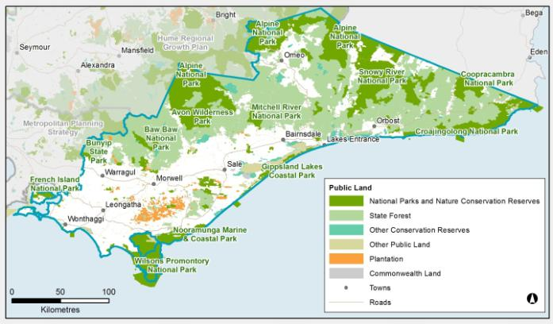
Figure 36: Public land in the Gippsland region
Source: Department of Transport, Planning and Local Infrastructure
Regional planning considerations related to public land include:
- Public land is an important asset in the region to protect ecosystems, and to provide amenity benefits to the region, especially through recreation and tourism. Public land also generates income through sustainable forestry and natural resource extraction.
- Opportunities will be supported for tourism development associated with or linked to public land that will promote growth and diversification within the region. This is particularly relevant around Phillip Island, the Gippsland Lakes, the Australian Alps, Wilsons Promontory, Bunurong Coast, Croajingolong and Tarra Bulga. These areas are further explored for their tourism values in the Gippsland Strategic Tourism Investment Areas Final Report, which was developed to inform the regional growth plan. Such development will need to occur in balance with the environmental assets and natural hazards within each area, and investigated fully prior to any approvals being granted. Directing tourism development into existing settlements and activity centres that are close to these tourism assets wherever possible will help maintain character and values of those assets.
- Consideration of facilities in towns with the support of established local communities with access to the tourism assets should be undertaken as a first step.

Coasts, estuaries and marine assets
Coastal areas in the Gippsland region contribute significantly to the economic, cultural, environmental and recreational life of the region’s residents and visitors. Coastal and marine environments are highly valued. The coastal zone contains rich environment and heritage assets along with ports and industry. Many areas of the coast are under pressure for development and much of the coast is at risk from natural hazards, such as coastal inundation, discussed in section 2.2, Natural hazards and risks.

Coasts
The majority of the coast in the Gippsland region is public land, with a limited amount in private ownership. The width and type of the public land varies greatly, with large national parks in some areas and narrow foreshore reserves adjoining some towns.
The Gippsland Coastal Board oversees strategic coastal and marine planning issues, for the Gippsland coast between San Remo and the New South Wales border. It also undertakes activities to investigate and protect the marine assets adjacent to the region. The Gippsland Coastal Board has developed coastal action plans to manage key issues and areas along its coast including for Gippsland Lakes (1999), Integrated Coastal Planning (2002), Estuaries (2006) and Boating (2012). Coastal action plans enable the broader principles and priorities of the Victorian Coastal Strategy 2008 to be further developed and applied at a regional or local level, or for particular issues.
Gippsland’s coasts will be affected by sea level rises caused by changes in climate. Sea levels may rise by 0.5-1.1 metres by 2100. Storm tides which are currently forecast at 1 in 100-year frequency could occur every year or two in the same timeframe. Low-lying towns, such as Inverloch, Lakes Entrance and Paynesville, would be particularly vulnerable to such changes and land use planning must take account of these changes. Climate change is discussed further in section 2.2, Natural hazards and risks.

Estuaries and marine life
Estuaries, bays and inlets are important for fish spawning or as nursery grounds. Saltmarshes, mangroves and wetlands are important nesting and feeding grounds for a broad range of significant waterbirds and waders including migratory species. Ecosystems along the coast vary greatly, and they also vary greatly as they progress inland from the beach.
There are a total of 41 identified estuarine ecosystems in the Gippsland region.
Significant marine ecosystems exist along the Gippsland coast, including those listed under the Environment Protection and Biodiversity Conservation Act 1999, such as the Giant Kelp Marine Forests of South-east Australia. Some significant marine ecosystems are protected in marine national parks (see Figure 37). There are also significant natural resources associated with the marine environment, including Bass Strait energy resources which are a key to the region’s economic future. Knowledge of the marine environment and in particular threats to the marine environment from terrestrial land uses is still developing. Developments in this field will inform future strategic planning.
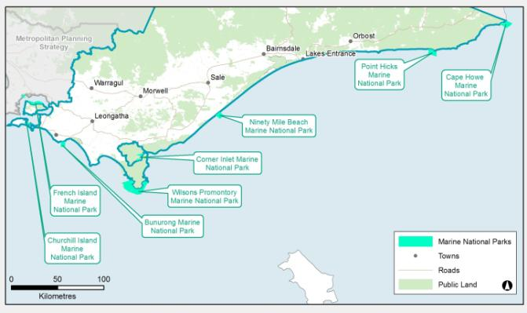
Figure 37: Marine national parks in the Gippsland region
Source: Department of Transport, Planning and Local Infrastructure
Estuaries are the interface between fresh and salt-water environments, providing important habitat for native plants and animals, nursery and breeding grounds for aquatic fauna, and are also a valuable recreational, commercial and tourism resource. Estuaries are particularly sensitive to inappropriate activities within catchments and are often used to gauge the health of the catchment to which they belong.
In order to protect and enhance estuaries, the Gippsland Coastal Board has developed the Gippsland Estuaries Coastal Action Plan. Its purpose is to provide a strategic framework to improve the quality, consistency and efficiency of planning and management decisions affecting estuaries in the Gippsland region.
Catchment management authorities for the region note population growth and subsequent development as threats to coastal assets. Some management measures are proposed in their regional catchment strategies to assist in managing these threats, including supporting the development of the plan and further developing knowledge on marine assets in the region.
Regional planning considerations related to coasts, estuaries and marine assets include:
- The plan will support appropriate planning controls to assist in planning around coastal and estuary assets. Public land management has a significant role to play given the extent of public land in these environments.
- There are many opportunities associated with coastal and estuary assets for the region, particularly around recreation and tourism. The plan will support appropriate tourism development within or associated with the coastal areas of the region, in particular in the strategic tourism investment areas, and ensure such development considers the various assets and natural hazards in these areas. This will be consistent with relevant coastal management plans, such as Victorian Coastal Strategy 2008 and the relevant coastal action plans of coastal management boards.
The catchment management authorities have identified the need to better understand the catchment-based threats to marine assets. As this understanding develops, the Gippsland region may need to assess if there is a need to apply planning tools to enable and promote growth while protecting marine assets.

NATURAL HAZARDS AND RISKS

Climate change
Climate change will alter global and local climates. While the implications of climate change on specific economic, environmental and social assets are hard to predict, the general consensus of scientists is that certain trends are most probable.
Predicted changes for the Gippsland region in rainfall, temperature and evaporation as a result of climate change suggest that the Gippsland region will be hotter and drier than today. Bushfire risk is expected to increase and although rainfall is expected to decline, the intensity of heavy rainfall is likely to rise, potentially resulting in more severe floods.
This will have long-term consequences for the region, including:
- implications for water supply and reliability, within and outside the region, due to reduced rainfall and increased bushfire frequency and intensity
- increased water demand
- shorter drier winters impacting alpine environments and reducing snow cover
- damage to infrastructure, industries and agriculture from severe weather events and environmental hazards
- potential increase in erosion and reduction in water quality
- pressures on natural ecosystems
- implications for communities, such as human health, energy use, housing needs and service provision
- sea level rise accompanied with increased coastal hazards
- rising sea levels that expose the existing vulnerability of coastal towns and infrastructure in the Gippsland region.
The Gippsland Lakes, including Ninety Mile Beach and Corner Inlet, represent one of the most vulnerable coastal areas to climate change in Australia.
Climate change also presents many opportunities within the Gippsland region, particularly for diversification in agricultural enterprises. The dairy industry has already identified a series of opportunities within Gippsland, including that warmer winters and fewer frosts will likely result in increased pasture growth rates in winter. Some current fisheries sectors could flourish in Gippsland as a result of expected changes to fisheries for some species. The commercial viability of forestry, including plantations, may change in distribution due to altered climatic conditions and increased frequency of bushfires.
Built assets and infrastructure as well as environmental and heritage assets may be at risk along the coast due to more severe coastal storms, sea level rise, coastal erosion and inundation. This could result in losses of commercial and residential properties, services and damage to roads. Areas most vulnerable to inundation are the immediate foreshore and low-lying coastal areas. This may have flow on effects to the region’s recreation and tourism markets, as well as other economic sectors and settlements.
There is already research underway to better understand the potential risks and opportunities arising from climate change in Gippsland, including on agriculture and tourism. Coastal hazard mapping is being undertaken to assist in the risk management of coastal dependent developments, discussed further in this section under the heading Coastal Hazards.
In terms of supporting the region’s resilience, key considerations for the region include:
- As commodities shift, what effect might this have on the supporting industries and freight task within the region?
- What land use implications might these changes have?
- What implications might these potential changes have on the settlements in the region?
These questions are not answered by the plan but instead could help inform future coordinated strategic planning in the region around climate change adaptation.
Regional planning considerations related to climate change include:
- For the Gippsland region, increased coastal hazards caused by climate change are a key consideration when planning future land use change in the regional context. Some of these hazards can be quantified to an extent and are discussed in the coastal hazards section below.
- For many other implications related to climate change, the key consideration for the plan isn’t necessarily the magnitude of the change, but rather how land use planning can help improve the region’s resilience and adaptability to change as its impacts emerge. For example, land use in rural areas will still predominantly be agricultural within the Farming Zone, but commodities that can successfully be cultivated on that land may change as climates change. Economic diversification may also occur to include other commodities and industries, including those related to national action to reduce greenhouse gas emissions, such as carbon farming, renewable energy production or other new industries.
- Strategic planning should consider any likely increase in exposure to natural hazards and reductions in water availability as a result of climate change.
- Regional and local planning should respond to opportunities for innovation and industry development arising from climate change and national action to reduce greenhouse gas emissions, and where appropriate remove barriers to such action.
- Consideration should be given to the appropriate design of urban areas to address potential risks of climate change on regional centres, such as increased urban heat island effects.
- There are numerous research projects underway across the Gippsland region to further develop the understanding of the potential impacts of climate change, such as a project investigating what a climate-adapted Australian settlement would look like, which is utilising Gippsland as a study area. There is also climate change adaptation planning underway in the region, such as the Gippsland Climate Change Impacts and Adaptation Project run by the former Department of Primary Industries and the University of Melbourne, in collaboration with local councils. The outcomes of research and adaptation planning should inform planning decisions and future revisions of the regional growth plan.

Flood
Flooding is an important natural process, although it can be highly disruptive to the community and the economy. Flooding is a significant issue within the Gippsland region, evidenced by numerous major flood events in the last decade. Of particular note are the 2007 floods, which isolated numerous communities and had wide ranging impacts on production and the population. The areas subjected to flooding risk within the region are often close to settlements. The existing flood overlays for the region can be seen in Figure 38. The extent of flood overlays across the region may need to be reviewed as new information is released on flood hazard over time.
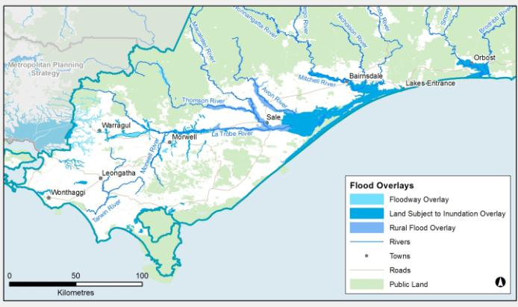
Figure 38: Flood overlays
Source: Department of Transport, Planning and Local Infrastructure
The devastation caused by the 2007 floods is clearly described on the Australian Emergency Management Institute’s website:
“In late June 2007, the Gippsland area received record rainfall associated with an intense low pressure system. The substantial rain event followed the Great Divide Bushfires, when 1.2 million hectares of public and private land were burnt and large areas of soil were left exposed. The storm in June 2007 resulted in major flooding and widespread damage. Seven rivers burst their banks causing millions of dollars of damage to homes, businesses and farms, as well as a significant loss of public and private assets. The rapidly rising floodwaters forced dozens of rescues and evacuations. One person died as a result of the flood waters. During 48 hours of torrential rain more than 1000 emergency service staff worked to save homes and shops in towns throughout Gippsland. Relief centres were set up at Bairnsdale, Lakes Entrance, Paynesville, Sale, Lucknow and Loch Sport and housed up to 360 evacuees. Volunteers also provided medical aid and catering with other organisations such as the Lions Club.
The State Government established a Flood Recovery Ministerial Taskforce, which assessed community need and planned the recovery program. The Taskforce announced a $60 million Flood Recovery Initiative covering, among other things, the cost of work on some 400 roads, bridges and 80 walking tracks spanning hundreds of kilometres as well as clearing debris from the region’s water supplies, catchments and recreation areas.
The Insurance Council of Australia estimated the 2007 damage at $15 million, with the 2011 estimate normalised cost of $18 million.”
Given the likely increase in intensity of flooding, and bushfire, in the region over time as a result of climate change, these impacts and costs are likely to increase as well. Land use planning will continue to consider this potential increase in flooding as part of responsible planning decisions for the region. The development of flood mapping is continuing by the Department of Environment and Primary Industries, the Department of Transport, Planning and Local Infrastructure and catchment management authorities that will address changing risk profiles.
Regional planning considerations related to flooding include:
- Catchment management authorities in the region indicate that land use and management of floodplains, and response to flooding, could be improved by addressing inappropriate development and land use, among other factors. There are a number of localised flood studies in the region, which may need to be reviewed in light of the Victorian Flood Review and the State Government’s implementation plan developed in response to the review. Although the review was initiated in response to flooding in other areas of the state, its findings still apply to the Gippsland region, with many examples from Gippsland used throughout the report.
- Land use planning is considered to be an effective means of reducing future risks and damages from flooding (Victorian Government, 2012). The regional growth plan, considers the implications of flooding on growth, particularly settlement growth. The plan considers and maps where flood issues must be considered in more detailed settlement growth planning. It provides growth frameworks for key regional centres, with indicative flood risk based on current flood overlays. Flooding is also an issue across the broader landscape.
- Climate change predictions indicate that more extreme flood events may occur in the future (Victorian Government, 2013). Existing flood risk assessments do not take account of these likely increases in the intensity of storm and flood events. The increase in flood risk should be monitored and considered in future strategic planning.
- Flood provisions in planning schemes should be used consistently across the region to avoid inappropriate development, or redevelopment. They should also be used to require appropriate development responses and apply design responses through the building code (Victorian Government, 2012).
- New development will be directed away from areas of floodplain hazard and development should not be supported if it increases the flood risk for other sensitive areas or development.

Bushfire
The Gippsland region has areas of significant bushfire hazard. Many of the landscapes most attractive to residents and tourists in the region are also areas of high bushfire hazard. The existing Bushfire Management Overlay for the region is shown in Figure 39.
Regional bushfire planning assessments provide extra information about areas, referred to as ‘identified areas’, where a range of land use planning matters intersect with a bushfire hazard to influence the level of risk to life and property from bushfire. The regional bushfire planning assessments map where a significant bushfire hazard may affect land use planning and identify features such as settlements, urban interfaces and single access roads. This information should be considered as part of strategic land use and settlement planning at the regional, municipal and local levels.
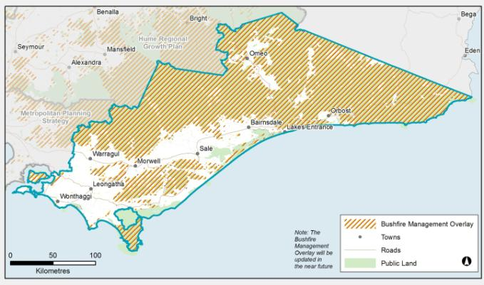
Figure 39: Bushfire management overlays
Source: Department of Transport, Planning and Local Infrastructure
Regional planning considerations related to bushfire include:
- Pressures to develop in highly attractive, bushfire prone areas in the region are likely to continue, such as near the foothills and in the valleys leading up to the Great Dividing Range. This presents significant challenges for land use planning. In line with 2009 Victorian Bushfires Royal Commission recommendations, new development should be substantially restricted in the areas of highest bushfire risk, while giving due consideration to biodiversity conservation. The region must apply the precautionary principle in decision-making and minimise risk to human life. This is particularly problematic with respect to nature-based tourism activities.
- Areas such as the secluded river valleys and timber towns are of particular concern to planners and emergency response agencies, where there are extreme bushfire hazards, high concentrations of people and limited road capacity for large-scale evacuation. The regional bushfire planning assessment for Gippsland identifies numerous locations as having limited access and egress including Baw Baw Village, Walhalla, Bullumwaal, Lake Tyers, Bemm River, Tamboon, Mallacoota and Bundara. The regional bushfire planning assessment for Gippsland should be referred to for a comprehensive understanding of access issues to these and other settlements.
- Strategies are proposed to consider the potential increase in bushfire threat proposed by some of the future directions in the regional growth plan and where these should be located most appropriately considering settlement growth.
- The settlement frameworks for the major settlements have explicitly considered bushfire risk in determining future areas for new development. Bushfire hazard will need to be assessed to a finer level in conjunction with detailed planning at a municipal level.

Threats to soil health
Threats to soil health that are of relevance to the Gippsland region vary with soil type across the landscape. The catchment management authorities have defined the threats to soil health within the region very clearly. The main threats across the region are soil erosion and in some lower areas, salinity.
Salinity within the Gippsland region can relate to dry land, irrigated or ocean-induced causes, each requiring different management methods through catchment management authority land and water management programs. Approaches include managing and living with threats to agricultural production, water quality, soil quality and native species.
Salinity impact in urban areas is an important consideration for Gippsland, considering the current known and predicted future extent of salinity. The West Gippsland Urban Salinity Risk Assessment has identified and mapped known or potential salinity issues in the towns of Rosedale, Maffra, Sale, Seaspray, Inverloch, Leongatha, Port Albert, Port Welshpool and Yarram. The West Gippsland Salinity Management Plan has identified potential future salinity risk to 2032 (see Appendix 2).
Soil erosion is also a significant risk in the Gippsland region and its assets, particularly agricultural land, water quality, and infrastructure. The likelihood and risk of different types of erosion has been modelled for West Gippsland in the 2008 Soil Erosion Management Plan. The plan highlighted that its information could be used to update planning overlays.
Landslip is a significant hazard in parts of Gippsland, and in particular in the Strzelecki Ranges in Baw Baw and South Gippsland shires. There have been numerous landslips and road closures in recent years in these shires and planning controls are in place in South Gippsland through the Environmental Significance Overlay Schedule 5 (Areas Susceptible to Erosion). Regional planning considerations related to threats to soil health include:
- The extent of threats to soil health in Gippsland is not reflected fully in planning overlays, for example there is no salinity management overlay related to Sale, despite the known salinity considerations.
- The extent and accuracy of overlays related to soil health threats could be assessed across the region to enable planning decisions to be made on the best available information and to inform future reviews of the regional growth plan.

Acid sulfate soils
Acid sulfate soils occur naturally in coastal and inland settings. These soils can cause significant harm to human health and damage infrastructure. The potential for coastal acid sulfate soils has been mapped within the Gippsland region. An example is shown in Figure 40. These maps are used to inform local government planning processes. There is a low probability of acid sulfate soils occurring over non-coastal areas, although there is a high probability of acid sulfate soils occurring in many of the wetlands across the region.
Acid sulfate soils are acknowledged as a threat to agricultural production and human health within the Gippsland region and is a consideration for land use planning. The Victorian Best Practice Guidelines for Assessing and Managing Coastal Acid Sulfate Soils (Department of Sustainability and Environment, 2010) has been produced to guide landowners, developers, planners and decision-makers through a risk identification approach that will assist them to make decisions about the assessment and management of coastal acid sulfate soils.
More information on the location of acid sulfate soils in the region can be found on the Victorian Resources Online website.
Regional planning considerations related to acid sulfate soils include:
- Acid sulfate soils should remain undisturbed.
- It is important that land use planners and managers can identify areas where development is best avoided due to acid sulfate soils. Already, there are many examples of costly mistakes in Australia involving considerable damage to land, buildings and waterways as a result of disturbing acid sulfate soils.
- Inland acid sulfate soils are often associated with saline wetland environments, and should be considered as a possibility when any development occurs around wetlands within the region.
- The location of potential acid sulfate soils should be considered when identifying suitable locations for future opportunities and land use change.
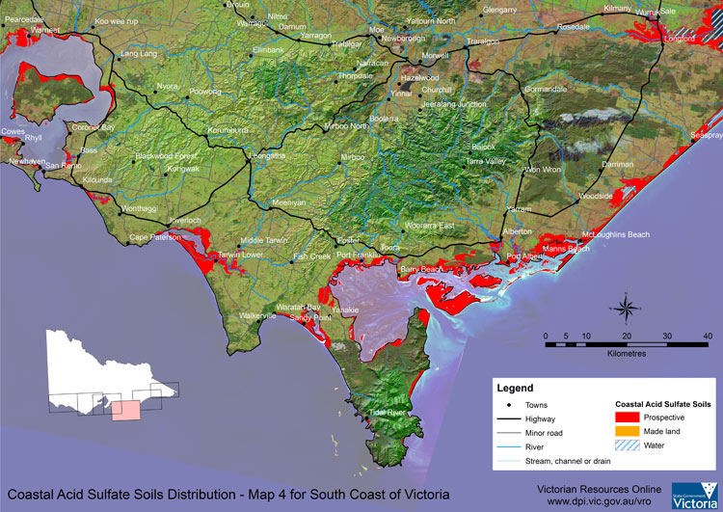
Figure 40: Potential coastal acid sulfate soils in West Gippsland
Source: Department of Environment and Primary Industries

Coastal hazards
The Future Coasts Program of the Victorian Government has developed the Victorian Coastal Inundation Dataset, which provides a high level indication of the implications of potential risks from sea level rise and storm surge at a statewide to regional scale for four different time periods (2009, 2040, 2070 and 2100). The Victorian Coastal Inundation Dataset is intended to be used at a regional scale to assist strategic planning and risk management, including in regional growth plans. The maps for the Gippsland region can be found on the Future Coasts Victorian Coastal Inundation Dataset website.
Potential coastal hazards for Victoria are clearly defined in the Victorian Coastal Hazard Guide. Coastal hazards that may be experienced in the Gippsland region include coastal inundation, saline intrusion, coastal erosion and damage to infrastructure, all of which may be more severe as a result of climate change.
The Victorian Coastal Hazard Guide notes that climate change is not expected to create any new coastal hazards, but at many locations it has the potential to make existing coastal hazards worse. Climate change may affect the rate of change and the mean level of the sea, the frequency and elevation of extreme sea levels, the height of waves, and the frequency and intensity of rainfall, and thus catchment flooding.
Population growth and urban development along the coast, as well as the effects of climate change, are likely to increase the risks that coastal hazards present to Victorians. An increase in severity of coastal hazards could have wide ranging effects on the community and the economy, related to factors such as increased rates of coastal erosion, more extensive and frequent coastal flooding, and changing water quality in estuaries and aquifers.
Parts of the Gippsland coast may be inundated to an extent requiring protection or relocation of assets, including dwellings and commercial buildings. Potential environmental impacts of climate change in Gippsland include increased flooding and erosion in important estuaries, altered inundation frequencies in estuaries, changed beach and dune formations and changes to animal species mixes. Infrastructure impacts may include undermining or deterioration of roads, sea walls, essential services, private houses, public reserves and port facilities. Inundation of coastal areas may also result in the loss of cultural heritage places and recreation and tourism areas.
Under the Victoria Planning Provisions and planning schemes, planning authorities must plan for sea level rise. Local coastal hazard assessments are underway in Gippsland for Western Port and Gippsland Lakes/90 Mile Beach. These assessments will produce information and data to assist decision makers, such as by informing settlement and land use plans, informing infrastructure asset planning, and potentially assisting with the development of statutory tools.
Regional planning considerations related to coastal hazards include:
- A greater understanding of potential coastal hazards for the region is needed in light of climate change. The Victorian Coastal Hazard Guide contains a risk management process that provides a framework for examining the likelihood and ramifications of a specified coastal hazard event occurring and the possible response options, while accounting for local factors, stakeholder input, complexity and uncertainties. The local coastal hazard assessments underway for Western Port and Gippsland Lakes/Ninety Mile Beach will help develop this understanding. There are numerous other research projects underway across the region to better understand coastal hazards and the implications of climate change better such as the Gippsland Lakes Inundation and Adaptation Management Plan – Lakes Entrance Pilot Project by East Gippsland Shire supported by government.
- There are challenges for Gippsland regarding the long-term planning and management of coastal hazards, which may include strategic retreat, development constraints, and infrastructure maintenance.

Note: Implications for planning
The map in Appendix 3: Planning considerations for Gippsland, demonstrates how environment and heritage assets and natural hazards/risks impact on planning across the Gippsland region. The map indicates that land with ‘significant planning considerations’, such as public land, national parks and conservation reserves, and land identified with current known risk from bushfire and flood, comprises 76 per cent of the region. Land affected by ‘medium level planning considerations’, including declared water supply catchments, environmental significance overlays, and mining licences, comprises a further 15 per cent. The remaining land may be suitable for development subject to local constraints and demand. The levels of planning consideration are important considerations for identifying areas for growth and development, and indicate the level of planning complexity that may be involved in planning for development in these areas.

- LIVING IN THE REGION

POPULATION FORECASTS
Gippsland’s settlement patterns are well established with the Latrobe Valley forming the major economic and population centre of the region. The Latrobe Valley is comprised of the four townships of Traralgon, Moe, Morwell and Churchill, which are seen as a collective agglomeration or ‘networked city’. Gippsland’s other major centres of Bairnsdale, Sale, Lakes Entrance, Drouin and Warragul are located along the major transport corridor that runs east-west through the region.
Outside of this corridor, the townships of Leongatha, Korumburra, Wonthaggi and Inverloch are at the south west end of the region. While Gippsland has clearly defined centres, much of the population is spread across the region, with around 40 per cent of the population located in villages and settlements of less than 500 people. Along the coastline many areas are subject to significant seasonal population fluctuations, and many settlements will need to address the impacts of inundation linked to climate change in the future.

Recent population trends
The Gippsland region has experienced a period of sustained population growth, adding over 35,000 people in the period 1996 to 2011. This represents an average annual growth rate of one per cent, and takes the population of the region to approximately 270,000 as of 2011. This growth rate is on par with that of regional Victoria, but less than Victoria as a whole over the same period (Table 9).
Table 9: Total population 1996 to 2011
Bass Coast (Shire)
- 1996: 21,543
- 2001: 25,631
- 2006: 27,502
- 2011: 31,634
- 1996-2011 Growth rate: 2.6%
Baw Baw (Shire)
- 1996: 34,470
- 2001: 36,399
- 2006: 38,600
- 2011: 44,025
- 1996-2011 Growth rate: 1.6%
South Gippsland (Shire)
- 1996: 25,488
- 2001: 26,159
- 2006: 26,672
- 2011: 28,283
- 1996-2011 Growth rate: 0.7%
Latrobe (City)
- 1996: 71,115
- 2001: 70,643
- 2006: 72,003
- 2011: 76,890
- 1996-2011 Growth rate: 0.5%
Wellington (Shire)
- 1996: 41,545
- 2001: 41,462
- 2006: 41,528
- 2011: 43,880
- 1996-2011 Growth rate: 0.4%
East Gippsland (Shire)
- 1996: 39,094
- 2001: 39,439
- 2006: 41,388
- 2011: 44,700
- 1996-2011 Growth rate: 0.9%
Gippsland
- 1996: 233,255
- 2001: 239,733
- 2006: 247,693
- 2011: 269,412
- 1996-2011 Growth rate: 1.0%
Regional Victoria
- 1996: 1,276,877
- 2001: 1,333,101
- 2006: 1,383,525
- 2011: 1,487,304
- 1996-2011 Growth rate: 1.0%
Victoria
- 1996: 4,559,082
- 2001: 4,804,726
- 2006: 5,126,540
- 2011: 5,636,808
- 1996-2011 Growth rate: 1.4%
Source: SGS Economics & Planning, 2012
However, while the region as a whole has not grown as fast as Victoria, certain local government areas within the Gippsland region have experienced significantly higher levels of growth. The two local government areas that border metropolitan Melbourne, Baw Baw (1.6 per cent) and particularly Bass Coast (2.6 per cent) have experienced growth above the state average. Latrobe, the largest local government area in the region in terms of total population, experienced some of the slowest growth in the region, growing by 0.5 per cent per annum between 1996 and 2011. Notably, unlike other regions of Victoria, there were no parts of Gippsland that experienced a decline in population over the period.
As of 2011, the largest urban population areas, based on statistical local area boundaries, in Gippsland were Traralgon (31,196 people), Bairnsdale (28,565), Morwell (23,442), Moe (19,305), and Sale (14,686).
The population of Gippsland is ageing, as is the case across Australia. The number of people aged 65 and over increased from 12.3 per cent of the population in 1996 to 17.7 per cent of the population in 2010, a rise of 14,500 people.
Gippsland had, as of 2010, a notably higher proportion of retirees, 65 and over, than the Victorian average, and more people aged between 45 to 64 years of age. There are proportionately significantly less people aged 15-44 in Gippsland than Victoria (see Figure 41).
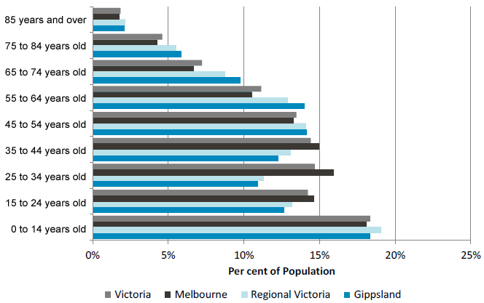
Figure 41: Age structure by region 2010 (ABS 2010 estimated resident population)
Source: Australian Bureau of Statistics, 2012
Within the Gippsland region the age structure of individual local government areas varies. Relatively speaking, Baw Baw and Latrobe have the youngest populations, while Bass Coast and East Gippsland have the oldest populations (see Figure 42). Notably, Latrobe, which contains some of the largest urban centres in the region, has a relatively higher proportion of people aged 25-44.
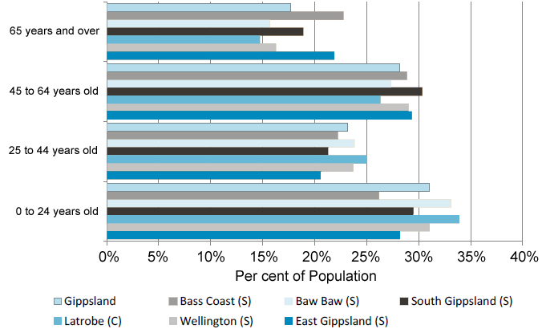
Figure 42: Age structure by LGA 2010 (ABS 2010 estimated resident population)
Source: Australian Bureau of Statistics, 2012
Migration in and out of Gippsland varies greatly by age. There is a long established trend of school leavers migrating out of Gippsland for Melbourne and other cities, and young families, and those reaching or having already reached retirement, migrating into the Gippsland region.

Key growth drivers

Peri-urban migration pressures
The largest inward migration of new residents to Gippsland comes from Melbourne, with approximately 4000 people making the move between 2001 and 2006. The fastest growing municipalities in regional Victoria are those that are located directly beyond the metropolitan Melbourne boundary. From 1996 to 2011, 95 per cent of Victoria’s population growth has been within 150 kilometres of Melbourne’s central business district. Within the 150 kilometre radius from Melbourne, the non-metropolitan part is known as Melbourne’s peri-urban hinterland, defined as the areas immediately beyond metropolitan Melbourne and approximately within 100 kilometres of central Melbourne. Gippsland settlements particularly affected by peri-urban pressures include Warragul and Drouin, Korumburra, Wonthaggi and San Remo.
The attractiveness of peri-urban locations relative to suburban growth is leading to development essentially ‘jumping’ the metropolitan green wedges and urban growth boundary and settling in the centres of regional Victoria with reasonably good access to Melbourne. There will be further pressures for this process to accelerate as nearby growth areas in the municipalities of Casey and Cardinia generate new jobs and develop their employment areas, for instance at the Monash University Berwick campus and the Cardinia Employment Corridor which designates 25 square kilometres for future employment land.

Housing affordability
Much of this peri-urban growth can be attributed to housing affordability issues in Melbourne. House price inflation has run ahead of average growth in wages and welfare benefits, spurred by strong demand and an undersupply of housing. This in turn has been driven by shortfalls in development capacity, increasing development and planning costs, extended delays in reform processes and the provision of infrastructure.
Importantly, peri-urban growth is already being experienced in Gippsland’s western extent and is likely to continue, with or without intervention. Planning has a role in directing and controlling the nature of peri-urban growth. In addition, the South-East Growth Corridor, comprising Casey and Cardinia councils, is nearing capacity, with the corridor earmarked for closure in the coming decades. The 2010 Urban Development Program stated that the south-east growth corridor has a supply of 90,000 additional lots, with 40,000 to be ready over the next 15 years. This is approximately 60 per cent of the supply identified in the northern and western growth corridors. As the south-east corridor reaches capacity this is likely to contribute to greater demand for greenfield sites and housing in the peri-urban regions of Gippsland.

Sea /tree change migration
In recent years strong population growth has occurred across Australia in coastal getaway and picturesque commuter communities. Sea and tree change, or amenity migration, is where people move for lifestyle rather than employment opportunities seeking natural amenity, climate, recreation and affordable housing.
Coastal areas and regional towns that are within a three to four hour drive from capital cities are relatively affordable, particularly against the sharp rise in house prices within metropolitan areas. As a result, these settlements draw a high proportion of their migrants from capital cities. The affordability of sea/tree change towns has attracted many seeking an alternative lifestyle where quality of housing is a key factor.
The Gippsland region offers a wide variety of locations with natural beauty. With its vast coastline, rolling hills and high country, Gippsland is well placed to attract those looking for an alternative lifestyle to Melbourne or other cities. Western Gippsland is in close proximity to Melbourne, allowing a degree of interaction with the metropolitan area, yet the region’s housing is considerably more affordable.

Connectivity and transport infrastructure
Transport infrastructure allows people to access jobs, family, friends, recreation and retail and a wide range of other services. It helps businesses attract customers and employees, receive supplies and distribute products. It requires significant public investment, yet ultimately sets the tone and direction for future land use development. Transport investments can take the form of new infrastructure or improvements to existing service level provision, both of which can have quite significant impacts on settlement patterns.
The growth of Gippsland is highly dependent on access to employment, education, services and recreational opportunities. Good transport increases choice and communities with strong inter-connections are much more resilient to economic conditions, such as unemployment, low income and limited education.

Population scenarios

Victoria in Future
Victoria in Future 2012 (VIF 2012) is the official state government population and household projections. VIF 2012 represents the most likely population outcome for the Gippsland region in the context of the rest of Victoria’s recent and likely future population growth.
VIF 2012 is based on current trends through an analysis of historical changes in economic and social structures and other drivers of demographic trends to indicate possible future populations. The assumptions that underpin the projections are based on established, migration, demographic and social trends continuing in the future. The projections take into account the current population, future birth and death rates, and future net migration. Given the rather predictable nature of birth and death rates, the level of net migration is the significant variable that impacts on alternative future population outcomes. The VIF 2012 projections assume a small net inward migration into the Gippsland region.

Current trend results
Under VIF 2012, Gippsland is forecast to increase in population by approximately 115,000 from 2011 to 2041, reaching a total population of approximately 385,000 people by 2041. It is expected to become the third largest Victorian region and will be of a similar size to what the Barwon-South West is currently.
Compared to the other Victorian regions, Gippsland’s growth over this 30 year period is expected to be mid range. The average annual growth rate for Gippsland between 2011 and 2041 is approximately 1.2 per cent per annum. By 2041 it is anticipated to be the fastest growing region of regional Victoria by a small margin.
Within the Gippsland region, the extra 115,000 anticipated residents are projected to largely be distributed in the peri-urban areas of Bass Coast and Baw Baw shires, and the larger centres of Traralgon and Bairnsdale (see Figure 43). The statistical local areas neighbouring Melbourne see the largest growth rates, with the statistical local areas of Baw Baw (Shire) - Part B West and Bass Coast (Shire) - Balance adding approximately 25,000 and 21,000 people respectively to 2041. Traralgon and Bairnsdale are forecast to increase by approximately 15,000 people each to 2041. This growth is spatially illustrated on an average annual basis in Figure 44.
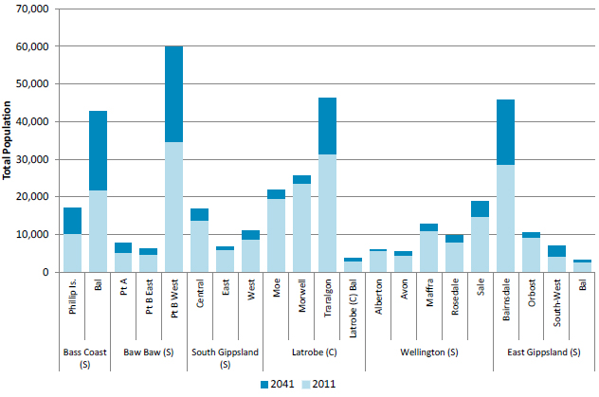
Figure 43: Total population by Statistical Local Area 2011 to 2041
Source: Department of Planning and Community Development, 2012
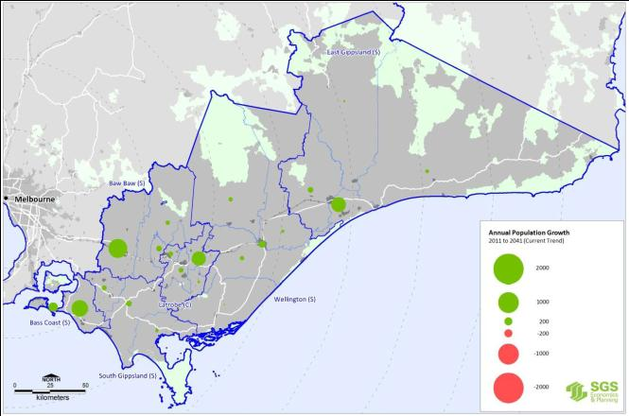
Figure 44: Annual population change by Statistical Local Area 2011 to 2041
Source: SGS, 2012a

SETTLEMENT FRAMEWORK

Introduction
The purpose of this section is to identify a settlement framework for Gippsland to accommodate future population growth and support its vision to attract economic investment and protect its environmental assets. It also aims to provide a more detailed regional layer to help inform the framework for Victoria.
The settlement framework for Gippsland will be consistent with the objectives for Victoria which is expressed through the State Planning Policy Framework (Clause 11) in the following terms:
- to promote the sustainable growth and development of regional Victoria through a network of settlements
- to manage growth in Melbourne’s hinterland within 100 kilometres of the Melbourne central business district.
Figure 45 shows the Regional Settlement Framework for Victoria which is included in the State Planning Policy Framework and which shows Traralgon-Moe-Morwell as a ‘major regional city’.
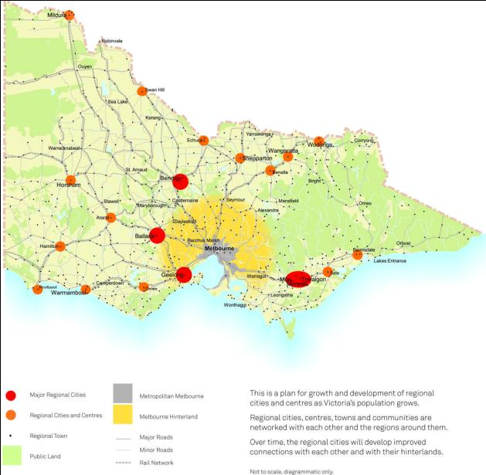
Figure 45: Regional settlement framework for Victoria
Source: Victoria Planning Provisions
Strategies to achieve the above objectives involve directing urban growth into major regional cities including ‘... the Moe, Morwell and Traralgon cluster’, and supporting the sustainable development of regional cities and centres, including Bairnsdale and Sale.
Other strategies require that:
- coastal settlements should have a clear settlement boundary to protect coastal values and reduce urban sprawl
- ribbon development within rural landscapes is to be avoided and rural land and natural features are to be protected and preserved
- development will avoid impacts on high biodiversity values, landscape amenity, water conservation values, food production and energy production capacity, extractable resources and minerals, cultural heritage and recreation values
- siting and design of new development will minimise risk to life from natural hazards, such as bushfire and flooding.
There is also positive guidance for the sufficient supply of appropriately located residential, commercial, and industrial land across a region, and that growth will be directed to locations where utilities, transport, commercial and social infrastructure are available or can be provided.
Within the overall regional settlement framework for Victoria, this settlement framework for Gippsland provides a further level of detail.
The methodology for identifying a settlement framework for Gippsland involved a number of steps:
- existing centres, towns and settlements with an estimated population of 1000 or more were identified and mapped
- the existing role and services for identified towns were identified, including government offices, education facilities, health and emergency services
- population and household growth to 2041 for the identified settlements was estimated using data from VIF 2012 including an assessment of higher growth possibilities
- an assessment was made of the supply of urban land available to accommodate growth at each settlement, based on data from structure plans, planning schemes and local authorities
- constraints on growth for each settlement were then examined covering environmental considerations such as the risk of flooding and bushfire, biodiversity and brown coal resources
- various pressures and demands for growth were then considered, including proximity to Melbourne and larger centres, and a settlement framework was developed highlighting how future growth in Gippsland should be accommodated.
The following sections reflect these steps.

Existing settlements
All existing towns with over 1000 people, or an expected population of more than 1000 by 2041, were identified and recorded. These towns are shown in Table 10. They are ranked according to their population size in 2011.
Table 10: Towns and settlements in the Gippsland region
Traralgon
- Council: Latrobe
- Growth Rate per annum 1981-2011: 1.0 %
- 2011 Population: 25,285
- Assumed Growth Rate per annum 2011-41: 1.2 %
- Assumed 2041 Population: 35,800
Moe/Newborough
- Council: Latrobe
- Growth Rate per annum 1981-2011: -0.4 %
- 2011 Population: 16,761
- Assumed Growth Rate per annum 2011-41: 0.5 %
- Assumed 2041 Population: 19,300
Morwell
- Council: Latrobe
- Growth Rate per annum 1981-2011: -0.7 %
- 2011 Population: 14,725
- Assumed Growth Rate per annum 2011-41: 0.8 %
- Assumed 2041 Population: 18,400
Sale
- Council: Wellington
- Growth Rate per annum 1981-2011: -0.1 %
- 2011 Population: 14,670
- Assumed Growth Rate per annum 2011-41: 0.7 %
- Assumed 2041 Population: 17,900
Warragul
- Council: Baw Baw
- Growth Rate per annum 1981-2011: 1.6 %
- 2011 Population: 13,611
- Assumed Growth Rate per annum 2011-41: 1.8 %
- Assumed 2041 Population: 22,800
Bairnsdale
- Council: East Gippsland
- Growth Rate per annum 1981-2011: 0.7 %
- 2011 Population: 12,618
- Assumed Growth Rate per annum 2011-41: 1.4 %
- Assumed 2041 Population: 18,900
Drouin
- Council: Baw Baw
- Growth Rate per annum 1981-2011: 3.0 %
- 2011 Population: 8662
- Assumed Growth Rate per annum 2011-41: 2.0 %
- Assumed 2041 Population: 16,000
Wonthaggi
- Council: Bass Coast
- Growth Rate per annum 1981-2011: 1.4 %
- 2011 Population: 7486
- Assumed Growth Rate per annum 2011-41: 1.9 %
- Assumed 2041 Population: 13,300
Lakes Entrance
- Council: East Gippsland
- Growth Rate per annum 1981-2011: 2.0 %
- 2011 Population: 6103
- Assumed Growth Rate per annum 2011-41: 1.2 %
- Assumed 2041 Population: 8800
Cowes
- Council: Bass Coast
- Growth Rate per annum 1981-2011: 3.3 %
- 2011 Population: 5231
- Assumed Growth Rate per annum 2011-41: 2.9 %
- Assumed 2041 Population: 11,000
Leongatha
- Council: South Gippsland
- Growth Rate per annum 1981-2011: 0.8 %
- 2011 Population: 5125
- Assumed Growth Rate per annum 2011-41: 1.1 %
- Assumed 2041 Population: 6900
Churchill
- Council: Latrobe
- Growth Rate per annum 1981-2011: -0.2 %
- 2011 Population: 4938
- Assumed Growth Rate per annum 2011-41: 0.6 %
- Assumed 2041 Population: 6000
Inverloch
- Council: Bass Coast
- Growth Rate per annum 1981-2011: 3.8 %
- 2011 Population: 4679
- Assumed Growth Rate per annum 2011-41: 2.8 %
- Assumed 2041 Population: 10,700
Maffra
- Council: Wellington
- Growth Rate per annum 1981-2011: 0.1 %
- 2011 Population: 4402
- Assumed Growth Rate per annum 2011-41: 0.7 %
- Assumed 2041 Population: 5300
Paynesville
- Council: East Gippsland
- Growth Rate per annum 1981-2011: 2.2 %
- 2011 Population: 3995
- Assumed Growth Rate per annum 2011-41: 2.1 %
- Assumed 2041 Population: 6800
Korumburra
- Council: South Gippsland
- Growth Rate per annum 1981-2011: 0.4 %
- 2011 Population: 3499
- Assumed Growth Rate per annum 2011-41: 0.9 %
- Assumed 2041 Population: 4500
Trafalgar
- Council: Baw Baw
- Growth Rate per annum 1981-2011: 1.1 %
- 2011 Population: 2625
- Assumed Growth Rate per annum 2011-41: 2.2 %
- Assumed 2041 Population: 5600
Orbost
- Council: East Gippsland
- Growth Rate per annum 1981-2011: -0.6 %
- 2011 Population: 2177
- Assumed Growth Rate per annum 2011-41: 0.0 %
- Assumed 2041 Population: 2200
Stratford
- Council: Wellington
- Growth Rate per annum 1981-2011: 1.3 %
- 2011 Population: 1687
- Assumed Growth Rate per annum 2011-41: 1.2 %
- Assumed 2041 Population: 2400
Yarram
- Council: Wellington
- Growth Rate per annum 1981-2011: -0.7 %
- 2011 Population: 1653
- Assumed Growth Rate per annum 2011-41: 0.4 %
- Assumed 2041 Population: 2000
Mirboo North
- Council: South Gippsland
- Growth Rate per annum 1981-2011: 1.6 %
- 2011 Population: 1616
- Assumed Growth Rate per annum 2011-41: 0.4 %
- Assumed 2041 Population: 1900
Heyfield
- Council: Wellington
- Growth Rate per annum 1981-2011: -0.4 %
- 2011 Population: 1540
- Assumed Growth Rate per annum 2011-41: 1.0 %
- Assumed 2041 Population: 2000
San Remo
- Council: Bass Coast
- Growth Rate per annum 1981-2011: 3.0 %
- 2011 Population: 1139
- Assumed Growth Rate per annum 2011-41: 1.7 %
- Assumed 2041 Population: 2000
Rosedale
- Council: Wellington
- Growth Rate per annum 1981-2011: 0.3 %
- 2011 Population: 1180
- Assumed Growth Rate per annum 2011-41: 0.6 %
- Assumed 2041 Population: 1400
Foster
- Council: South Gippsland
- Growth Rate per annum 1981-2011: 0.0 %
- 2011 Population: 1126
- Assumed Growth Rate per annum 2011-41: 0.6 %
- Assumed 2041 Population: 1400
Mallacoota
- Council: East Gippsland
- Growth Rate per annum 1981-2011: 1.2 %
- 2011 Population: 987
- Assumed Growth Rate per annum 2011-41: 1.1 %
- Assumed 2041 Population: 1400
Cape Paterson
- Council: Bass Coast
- Growth Rate per annum 1981-2011: 4.7 %
- 2011 Population: 779
- Assumed Growth Rate per annum 2011-41: 2.1 %
- Assumed 2041 Population: 1500
Source: Australian Bureau of Statistics and Department of Transport, Planning and Local Infrastructure demographic research

The identified towns are also shown in Figure 46 and Figure 47 which show the existing settlement pattern and forecast change in population for 2011-2041.
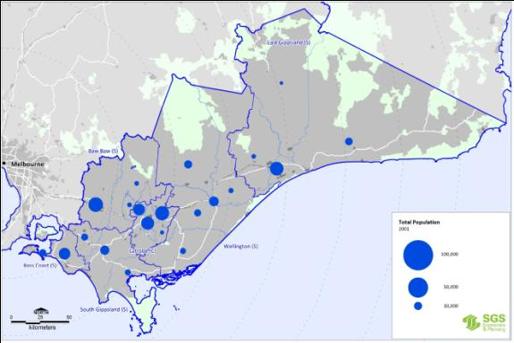
Figure 46: Existing settlement pattern 2011
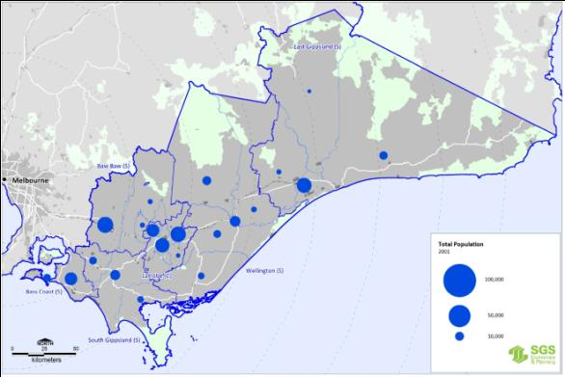
Source: SGS, 2012a
Figure 47: Change in population 2011-2041
Source: SGS, 2012a

Current role
The range of services and facilities available in each town and settlement were then assessed in order to better understand their current role and function. Information from the Regional Mapping Project: Gippsland Region was used to inform Table 11 which shows the level of service provision for 27 centres. It indicates that the Latrobe City grouping of Traralgon, Morwell, Moe and Churchill, and Wonthaggi, Sale, Bairnsdale and Warragul are the centres which currently offer the highest level of services in Gippsland.
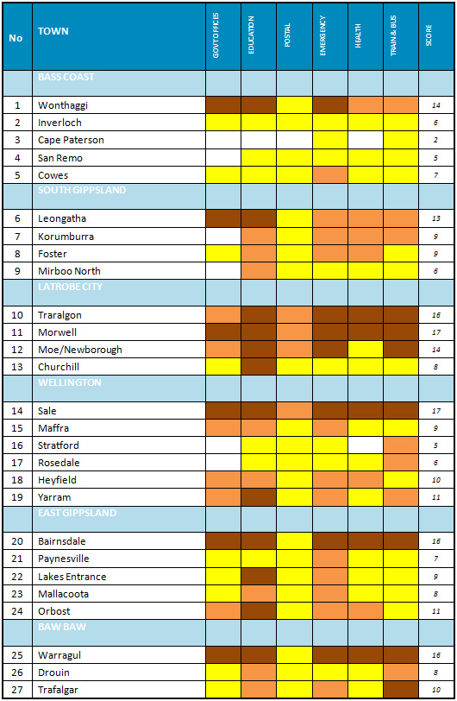
Table 11: Service provision
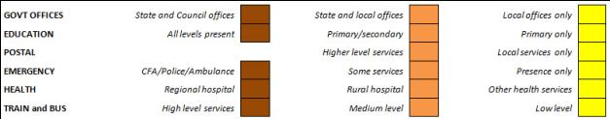
NOTES:
- Based on the role and function table (Appendix A) in the Regional Mapping Project: Gippsland Region, (Planisphere 2009). Train and bus services are based on an analysis of train, V/Line coach, and local bus services.)
- The score is an overall indicator of service provision which allocates three points for a high (brown) level, two points for a medium (orange) level, and one point for a low (yellow) level of service.
Source: Department of Transport, Planning and Local Infrastructure

Estimated growth
Gippsland is forecast to increase in population by approximately 115,000, reaching a total population of approximately 385,000 people by 2041. It is expected to become the third largest Victorian region. Compared to the other regions, Gippsland’s growth is expected to be mid range with an average annual growth rate of approximately 1.2 per cent per annum, although by 2041 it is anticipated to be the fastest growing region in regional Victoria.
Highest levels of growth are forecast for towns and settlements closest to Melbourne, such as Drouin, coastal settlements, such as Paynesville, or centres which are both close to Melbourne and on the coast, such as Inverloch, Cape Paterson and Cowes. Housing growth normally aligns with population growth, but in coastal centres where many people are expected to live permanently in existing houses which are currently ‘weekenders’, a lower rate of household growth is expected. These areas include Inverloch, Cape Paterson, San Remo, Cowes, Paynesville and Lakes Entrance.
Population forecasts and estimates are based on trends, existing growth rates and local capacity. While this is a sound basis for land use planning and service delivery, forecasts can be wrong. For instance, in the early 1990s, Victoria’s population reduced over a number of years, whereas from 2001 to 2006 population growth was significantly higher than forecast.
With this in mind, it is wise to recognise that growth can be higher or lower than expected and land use planning should provide flexibility to accommodate a range of future population levels. While lower than anticipated growth can be accommodated without difficulty in terms of land supply, higher growth scenarios will need an accelerated program of land releases. A scenario of population growth of an additional 20 per cent above current projections can be used as an upper level for the regional growth plan.

Constraints on growth
Each centre was assessed in terms of its constraints on growth, and in particular environmental constraints which will prevent or hinder urban development. Such constraints are identified in the State Planning Policy Framework and include areas of high landscape value, areas with natural resources, such as brown coal deposits, environmental assets including high biodiversity value, and areas at risk from flooding, coastal inundation or bushfire. Other constraints include areas affected by airport operations, heritage sites, and areas with soil conditions which affect development. Some of these constraints are more important than others. For example, areas affected by flooding and brown coal deposits pose a greater constraint than soil conditions that may require modified building standards but do not prevent development. High quality agricultural land is also a significant constraint.
Maps for 22 towns were prepared showing land affected by these constraints. The maps include the planning scheme overlays for each of the above constraints but do not show any grading to reflect the importance of each constraint. For example, Mirboo North and Foster appear to have no potential for growth because of the Environmental Significance Overlay – schedule 5 which effectively surrounds these towns. Environmental Significance Overlay – schedule 5 shows ‘Areas Susceptible to Erosion’ where special requirements are in place but where development is usually permitted subject to special conditions to reduce the likelihood of landslip or erosion.
Information about these constraints is summarised in Table 12 which shows that Cape Paterson, Lakes Entrance and the Latrobe Valley towns of Moe, Morwell and Traralgon appear to be faced with the most constraints on growth. On the other hand, Bairnsdale, Sale, Warragul, Leongatha, Korumburra, Drouin, Wonthaggi, San Remo, Maffra and Stratford appear to be relatively unconstrained. The maps, which are all at the same scale, are included in Appendix 4.
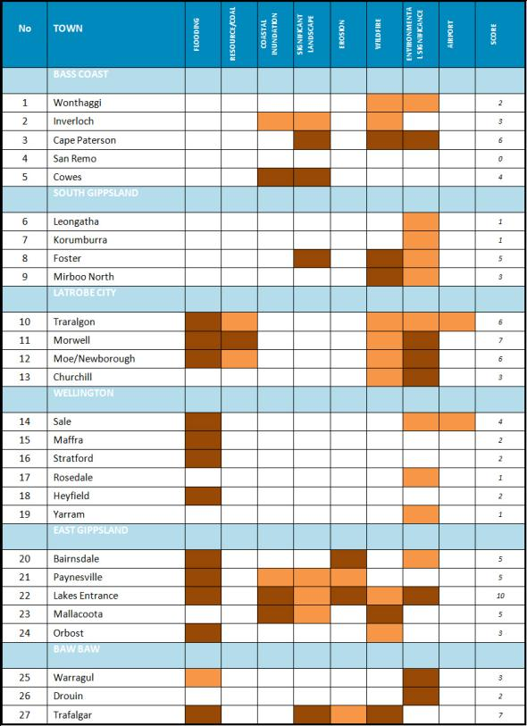
Table 12: Constraints on growth
NOTES:
- Based on planning scheme overlays for land subject to inundation/rural floodway (flooding), state resource (coal), Victorian coastal inundation SLR2040 (coastal inundation), Significant Landscape Overlay, Erosion Management Overlay, Wildfire Management Overlay, Environmental Significance Overlay and Airport Environs Overlay.
- The ‘score’ is an overall indicator of constraints which allocates two points for a higher (brown) level constraint and one point for a lower (orange) level constraint.
Source: Department of Transport, Planning and Local Infrastructure

Land availability
The availability of residential land to accommodate anticipated growth to 2041 has been assessed for the identified centres through the state-wide Urban Development Program in conjunction with local authorities. The results, in terms of housing lots available compared to annual housing growth, show that most towns have in excess of 30 years supply of housing land and that some centres have in the order of 100 years supply or more such as Moe, Churchill, Leongatha and Foster. Planning and industry benchmarks are typically in the order of 15-25 years supply. Phasing the release of this land is recommended so that it can still be used productively for agricultural and other rural purposes until it is needed for urban development and housing.
Only Traralgon, Bairnsdale and Lakes Entrance appear to be short of housing land but it is noted that these shortages are being addressed through an amendment to the planning scheme (Lakes Entrance), a growth areas review (Traralgon), and a report on land availability for Bairnsdale.

Discussion
This section has considered the policy context for growth, the existing settlement pattern and factors affecting each town’s ability to accommodate growth. The latter factors include environmental constraints, residential land supply, level of service provision, and estimated demand. These factors are now discussed with a view to proposing a future settlement framework for Gippsland which accommodates projected growth in the most efficient and sustainable manner and in accordance with estimated demand.

Drivers for growth and the regional city
The main purpose of the plan is to consider how growth in Gippsland can be supported, and where projected growth can be accommodated. At this point in time, the main drivers of growth are peri-urban development pressures and sea change related urban growth. These are generally found within two hours travel from metropolitan Melbourne, although other drivers, such as housing affordability and employment opportunities are also important. These drivers are expected to draw more people from Melbourne and other locations.
An important aspiration of the Gippsland Regional Plan 2010 is to further develop the region’s network of vibrant town centres with a strong regional city, based around the Latrobe City cluster of towns and underpinned by a growing and job generating regional economy. The Latrobe City cluster would comprise the urban centres of Traralgon, Moe, Morwell and Churchill based on a diverse economy linked to the region’s economic strengths and with high levels of accessibility between the regional city and the rest of the region. This would require a proactive management and investment response to:
- secure improved and potentially transformative transport infrastructure
- grow and diversify the economy and local jobs base
- develop a network of regional centres with a vibrant regional city.
With improved and better connected town centres and more jobs, Gippsland will draw more people from Melbourne and other regions and encourage more people to stay. On the basis of such a proactive management and investment approach, a higher growth population scenario could be achieved with growth up to 20 per cent higher than forecast. This could result in a total population of 460,000 by 2041 rather than the projected level of 385,000.
Without a regional response, growth is likely to be primarily focused on areas influenced by sea/tree change drivers, including Melbourne’s peri-urban region and Gippsland’s coastal areas. However, a more balanced regional growth option is preferred which will see a greater share of growth directed towards the regional city. This in turn would act as a catalyst for growth in central and eastern Gippsland and could help generate the synergies necessary to develop a more diversified economy and attract necessary investment from high growth industry sectors, such as professional services, finance, and the knowledge industries. This strategic objective for a strong regional city to drive regional growth, as well as growth in central and eastern Gippsland, will inform the proposed settlement framework.

Suitability for growth
The proposed settlement framework, which indicates where projected growth should be located, will be based on a number of considerations including the following:
- higher level services such as government offices, health and education services (Table 11)
- projected demand for growth, such as population and housing growth estimates
- constraints and priorities which limit urban growth options for some towns (Table 12 and Appendix 4).
These factors are summarised in the first three columns of Table 13. The fourth column, suitability for growth, provides a summary score for each town which is a composite of the scores in the first three columns for each town’s level of services, estimated housing growth to 2041, and constraints on growth.

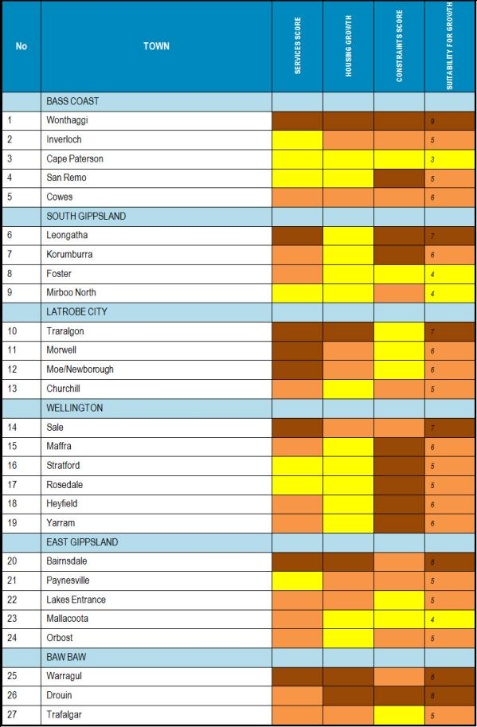
Table 13: Suitability for growth
NOTE:
- The score for ‘suitability for growth’ is an overall indicator of suitability which allocates three points for high (brown) suitability, two points for medium (orange) suitability, and one point for low (yellow) suitability, for example, high level of services, high housing growth and low constraints = high suitability).
Source: Department of Transport, Planning and Local Infrastructure

Locations for growth
The policy response to the above analysis indicates that growth should be directed to those towns which have a combination of high levels of services, high demand for housing growth and limited constraints on growth. Four growth policy responses or ‘descriptors’ have been identified for Victoria’s regional growth plans, namely:
- promote growth
- support growth
- sustainable change
- contain growth.
For Gippsland, it is proposed that three of the descriptors be applied to settlements as follows:
Promote growth:
- Bairnsdale
- Churchill
- Drouin
- Leongatha
- Moe/Newborough
- Morwell
- Sale
- Traralgon
- Warragul
- Wonthaggi
Support growth:
- Cape Paterson
- Cowes
- Heyfield
- Inverloch
- Korumburra
- Lakes Entrance
- Maffra
- Orbost
- Paynesville
- Rosedale
- San Remo
- Stratford
- Trafalgar
- Yarram
Sustainable change:
- Foster
- Mallacoota
- Mirboo North
Those towns where growth is to be ‘promoted’ have the most positive scores in terms of service provision, housing growth and constraints on development. Moe, Morwell and Churchill are also identified because they are part of the Latrobe City grouping which will be an important driver for regional growth.
Growth at towns where growth is to be ‘supported’ also have relatively high scores.
Foster, Mallacoota and Mirboo North, with lower scores, are identified as places for ‘sustainable change’. Such settlements can accommodate only a limited level of growth and change, which would typically be limited to small-scale development for the services necessary to provide for a more sustainable community. Generally this would involve adding or extending township zones or urban zones.

A network of integrated and prosperous settlements
The region is planning for strong population growth across Gippsland, but with most growth focused on the regional city of Latrobe City, and the regional centres and the major towns. In this way, there will be a network of centres offering higher order jobs and services for people across the region which will offer benefits as follows:
- larger towns can support higher productivity, a more diverse economy, and a more dynamic business environment
- surrounding areas will have access to higher order services and more diverse job opportunities
- better use of existing infrastructure and services with lower public costs
- more attractive setting for young people and skilled workers
- reduced pressures on rural and coastal areas.
Local councils have completed strategic planning for all the region’s major centres and have identified locations to accommodate their projected growth. In many places, the major centres are located close to or paired with other centres, and in these circumstances there are benefits in planning these networks or clusters together, rather than separately.
Planning for this integrated approach will be particularly important in and around the places expected to experience the strongest growth pressures: Bairnsdale, Warragul/Drouin, Traralgon and Wonthaggi.

The settlement framework
The above analysis has informed the Gippsland regional settlement framework. It proposes a network of settlements to accommodate projected population growth and promotes the Latrobe City cluster as the location for regional level services, and for driving growth in central and eastern Gippsland. The regional settlement framework comprises:
Regional city:
- Latrobe City comprising Traralgon, Moe, Morwell and Churchill
Regional centres:
- Bairnsdale
- Leongatha
- Sale
- Warragul
- Wonthaggi
Towns:
- Cowes
- Drouin
- Inverloch
- Korumburra
- Heyfield
- Lakes Entrance
- Maffra
- Mirboo North
- Paynesville
- Orbost
- Trafalgar
- Yarram
Small towns:
- Cape Paterson
- Foster
- Mallacoota
- Rosedale
- San Remo
- Stratford

A review of journey to work patterns indicates that these networks are already operating.
Place of usual residence
- Bairnsdale
Main workplace location & travel percentage
- Bairnsdale 80.8%
- Bruthen – Omeo 3%
- Lakes Entrance 2.6%
- Paynesville 1.8%
Place of usual residence
- Paynesville
Main workplace location & travel percentage
- Bairnsdale 50.8%
- Paynesville 31.6%
Place of usual residence
- Warragul
Main workplace location & travel percentage
- Warragul 57.8%
- Drouin 7.6%
Place of usual residence
- Drouin
Main workplace location & travel percentage
- Drouin 28.8%
- Warragul 26.9%
Place of usual residence
- Sale
Main workplace location & travel percentage
- Sale 66.5%
- Maffra 4.8%
(including Stratford and surrounds)
Place of usual residence
- Maffra
Main workplace location & travel percentage
- Maffra 49.4%
- Sale 28.2%
Place of usual residence
- Stratford
Main workplace location & travel percentage
- Sale 40.6%
- Maffra 31.5%
Place of usual residence
- Leongatha
Main workplace location & travel percentage
- Leongatha 70.6%
- Wonthaggi – Inverloch 7.2%
- Korumburra 6.7%
Place of usual residence
- Korumburra
Main workplace location & travel percentage
- Korumburra 48.6%
- Leongatha 20.6%
Place of usual residence
- Wonthaggi
Main workplace location & travel percentage
- Wonthaggi – Inverloch 80.1%
Place of usual residence
- Inverloch
Main workplace location & travel percentage
- Wonthaggi – Inverloch 63.5%
Place of usual residence
- Cape Paterson
Main workplace location & travel percentage
- Wonthaggi – Inverloch 76.4%
The following centres were not included in the above analysis but are also regarded as ‘small towns’: Boolarra, Briagolong, Bruthen, Buchan, Cape Woolamai, Cann River, Corinella, Coronet Bay, Dalyston, Darnum, Eagle Point, Erica, Glengarry, Golden Beach/Paradise Beach, Grantville, Kilcunda, Lake Tyers Beach, Lindenow, Loch, Loch Sport, Longwarry, Marlo, Meeniyan, Metung/Kings Cove, Neerim South, Newhaven, Newlands Arm, Nilma, Noojee, Nowa Nowa, Nyora, Omeo, Pioneer Bay, Poowong, Port Albert, Port Welshpool, Rawson, Rhyll, Sandy Point, Seaspray, Sunderland Bay, Swifts Creek, Tarwin Lower, Thorpdale, Toongabbie, Toora, Tyers, Venus Bay, Waratah Bay, Welshpool, Willow Grove, Yallourn North, Yarragon and Yinnar.
The following are classed as rural settlements: Bass, Cowwarr, Honey Suckles, McLoughlins Beach, Port Franklin, Robertson Beach, Smiths Beach, Surf Beach, The Gurdies, Ventnor, Woodside Beach and Yanakie.
The policy response for each town is as set out in the sub-sections above headed: Drivers for growth and the regional city, Suitability for growth and Locations for growth, and when combined with the settlement type comprises the settlement framework for Gippsland which is shown in Figure 48.
The framework is included in the plan with only two minor variations:
- Omeo has been added as an important service centre for the High Country even though it has a population of less than 500.
- the growth descriptor for Churchill has been revised to ‘support growth’ rather than ‘promote growth’ based on considerations of accessibility and the absence of a direct rail connection, thereby lessening the rationale for growth in Churchill as compared to the centres of Moe, Morwell and Traralgon.
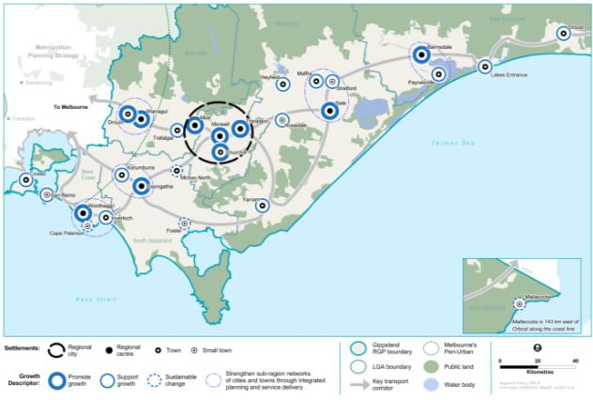
Figure 48: Gippsland future directions for settlement
Source: Department of Transport, Planning and Local Infrastructure

URBAN PROFILE

Population
With Gippsland region projected to grow from approximately 259,000 residents in 2011 to approximately 385,000 people in 2041, not only will Gippsland be home to many more people but the population will be significantly more diverse in age and household type.
Family structures are projected to change with significant increases in the number of smaller households, including single people, couples without children and lone parent households. In Gippsland, 28.9 per cent of households consist of single people (lone person households), compared with 25.6 per cent of Victorian households. This group is the fastest growing household type in Gippsland and is projected to make up 33 per cent of household types by 2031. This trend toward smaller household sizes is mainly a result of ageing.
Social and demographic profiles vary widely between towns across the region. A higher number of young families are present in the peri-urban areas of Gippsland due to housing affordability and relative access to metropolitan Melbourne. Coastal areas tend to have a higher percentage of retired and elderly people.
In many towns along the Gippsland coast there is a higher part-time or non-permanent population than permanent population, such as in Cowes and Inverloch. This is caused by a significant increase in homes owned by residents who divide their time between a city and a coastal retreat, or people who work from home for part of the week and travel to city offices at other times. The population of many Gippsland communities therefore varies on a weekly basis as well as a seasonal one. The permanent and non permanent populations can have different expectations and demands for services.
In 2006, 145,000 people in the region lived in the 26 towns with a population more than 1000. A further 12,500 people lived in the 16 towns with a population of 500 to 1000 people, 12,500 lived in small towns with a population of less than 500, and 65,000 people lived in rural areas. These dispersed small towns and rural areas are highly dependent on the network of larger centres and district towns for essential infrastructure and services.

Housing growth
As the population in many Gippsland towns continues to grow and household size decreases, the demand for housing accelerates. Councils in the region have sought to capture and use data relating to projected population and housing trends to plan for growth. An appropriate supply of housing will be one factor to help ensure the housing market remains affordable and there are a range of housing options for the growing population.
There has been a noticeable increase in the number of residents moving to Gippsland seeking a coastal or rural lifestyle. This combined with a rise in holiday, weekender or second home ownership, has resulted in fluctuating populations in many high amenity and coastal towns, such as Neerim South and Inverloch.
Outward expansion of some towns, such as Venus Bay is limited by environmental constraints and the availability of infrastructure. Other towns, such as Traralgon, face longer-term land constraints due to proximity to flood prone land and highly valued brown coal resources. Future development may therefore need to be either directed elsewhere or achieved through higher density and diversity of housing type in order to provide for the projected growth.
Currently new residential development across Gippsland is occurring at an average of 10 lots per hectare. This is a relatively low density when compared to other regional towns with centres, such as Ballarat achieving densities for new areas of 15 lots per hectare. These medium densities are providing a more diverse range of housing and responding to changing household size and composition.

Housing type
Changing population demographics are fuelling a change in housing demand. These household changes have implications for the type of housing stock planned for new developments.
Over the next 20 years there will be a significant increase in the number of ‘single person’ and ‘couple without children’ households in Gippsland (see Table 14). These changes are likely to result in increased demand for one and two bedroom houses.
Table 14: Projected change of household types 2011 to 2031
Bass Coast
- Couple with children: 991
- Couple without children: 3644
- 1-parent with children: 754
- Other family: 47
- Single person household: 3614
- Group household: 172
- All households: 9222
East Gippsland
- Couple with children: 441
- Couple without children: 3297
- 1-parent with children: 565
- Other family: 22
- Single person household: 3194
- Group household: 92
- All households: 7611
Wellington
- Couple with children: -570
- Couple without children: 1501
- 1-parent with children: 219
- Other family: 4
- Single person household: 2119
- Group household: 11
- All households: 3284
Baw Baw
- Couple with children: 1529
- Couple without children: 3359
- 1-parent with children: 1018
- Other family: 67
- Single person household: 3335
- Group household: 133
- All households: 9441
South Gippsland
- Couple with children: -280
- Couple without children: 1172
- 1-parent with children: 159
- Other family: 7
- Single person household: 1413
- Group household: 19
- All households: 2490
Latrobe
- Couple with children: 44
- Couple without children: 2812
- 1-parent with children: 836
- Other family: 21
- Single person household: 3768
- Group household: 31
- All households: 7512
Total Gippsland
- Couple with children: 2155
- Couple without children: 15,785
- 1-parent with children: 3551
- Other family: 168
- Single person household: 17,443
- Group household: 458
- All households: 39,560
Source: Victoria in Future 2012
Housing stock in Gippsland consists predominantly of single storey detached three bedroom homes on blocks of 600 to 800 square metres. Building statistics show the type of houses built in Gippsland continue to be mainly single storey detached homes of three to four bedrooms on slightly smaller blocks. There is a mismatch between household types and the size of dwellings being built and this will limit housing options for small households.

Liveability
People are attracted to Gippsland partly due to the unique characteristics and attributes of its towns and their surrounds which contribute to the liveability of a town. People may choose to live in Lakes Entrance because of its coastline and lakes, Warragul because of its rural setting and access to the ski fields, or Leongatha because of its rolling hills.
Each town in Gippsland holds a unique set of characteristics that defines the town and attracts people. There is a need to identify these characteristics and attributes to ensure they are protected and enhanced through urban design and character studies.
In some areas, growth has occurred in a linear manner along the entrances to towns. There is a need to prioritise urban design outcomes for town entrances to create important gateways that define the town.
The population growth shown in Figure 49 will increase demand for provision of population driven services like education, health care, community services and sports and recreation. A problem for several towns in Gippsland is that population driven services have not kept up with population growth. Other risks of rapid population growth include pressure being placed on local infrastructure beyond its service capacity, and stress on transport systems as new residents seek to access jobs and services.
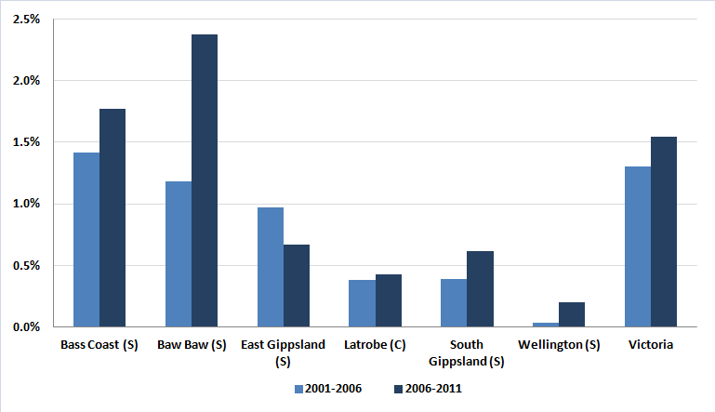
Figure 49: LGA population change 2001 to 2006 and 2006 to 2011
Source: Victoria in Future 2012
Service and infrastructure provision is particularly challenging where a community is affected by seasonal fluctuations. There may not be sufficient permanent population to sustain facilities and services, such as medical centres and swimming pools throughout the year, but there may be strong demand during peak months.
An anticipated but not fully quantified consideration is that of part-time, second home and holiday home owners who may seek to permanently reside in the region in the future. Retirement age of the post-war baby-boomers and their children will be an influencing factor in this number. Studies in Mansfield and Queenscliff found that about one-third of second home owners might make such a move in the future but it is unclear whether these findings will be applicable to Gippsland. Parts of west Gippsland are likely to experience such inflows and this may have significant ramifications for the supply of services. Impacts would be mixed and might include higher expectations for services and amenity, but also provide new skills and diversity for local communities.
- REGIONAL INFRASTRUCTURE

TRANSPORT

Introduction
Gippsland’s transport network allows the community to visit their friends and family and to access employment, services and recreational activities. It allows the region’s businesses to deliver their product to market and profit from tourism.
Planning to ensure the region’s transport system remains efficient, and improving its connectivity and reliability, is critical to the social wellbeing and economic prosperity of the Gippsland community. Improving connectivity to local, interstate and international markets promotes the growth of Gippsland’s businesses by providing the opportunity to capitalise on reduced freight costs. An efficient and accessible transport system also increases the liveability of the region by allowing the community to conveniently access employment and service opportunities, such as education and health. Providing increased active transport opportunities in the region, such as walking and cycling, and public transport, promotes vibrancy and healthy living, as well as alleviating traffic congestion and reducing environmental emissions.

Overview of Gippsland’s transport system

Significant transport infrastructure
Gippsland’s transport system is an integrated system of walking, cycling, public transport and commercial transport on road and rail, commercial water transport through ports and private motor vehicles. Figure 50 illustrates Gippsland’s regionally significant transport networks.

Road and rail
Gippsland’s road and rail networks connect Gippsland’s communities and freight throughout the region and beyond. Significant to Gippsland’s economic development was the creation of the rail corridor in 1886 which provided transport for farm produce in the Warragul/Traralgon corridor to growing metropolitan markets. Generally these transport networks have largely been determined by geographic features, such as the Great Dividing Range to the north and the Strzelecki Ranges to the south, as well as early access to the region via ports and transport to the east Gippsland goldfields.
In managing access to markets, the Victorian Government has identified a heavy vehicle freight network, in Gippsland which includes:
- Princes Freeway/Highway - Melbourne to New South Wales border and east coast
- Melbourne to Bairnsdale rail line
- the proposed intermodal terminals at Morwell and Bairnsdale
- South Gippsland Highway to Leongatha.
This network consists of railways and key roads connecting commercial ports, airports, intermodal terminals and major industrial areas. These road and rail links are the region’s main connectors and provide efficient access to Melbourne, commercial ports and other states. Importantly these links also provide the core network for transporting the Gippsland community to Melbourne and through the region.
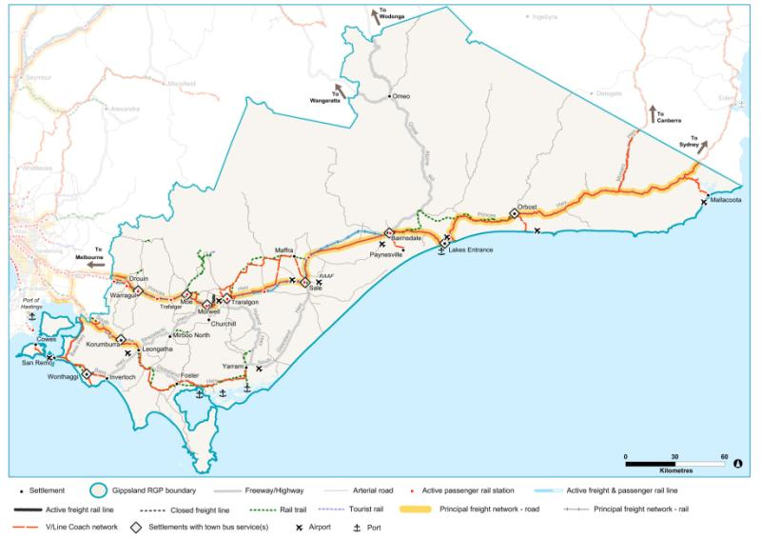
Figure 50: Strategic assets for transport
Source: Department of Transport, Planning and Local Infrastructure
The Princes Highway corridor consists of both the Princes Highway and the V/Line train service. It is the backbone of Gippsland’s transport network and provides crucial east-west transportation through the region, connecting Melbourne to four of Gippsland’s local government areas and to settlements including Drouin, Warragul, Moe, Morwell, Traralgon, Sale and Bairnsdale, as well as the Gippsland Lakes.
The Princes Highway from Melbourne to Sale is a crucial component of the Australian Government’s National Land Transport Network and as such attracts Commonwealth funding in recognition of its national importance.
The Melbourne to Traralgon rail line is a broad gauge line with double track between Caulfield and Moe, except for a small section of single track where the line crosses the Bunyip River. Beyond Moe, the line is single track with four passing loops at Hernes Oak, Morwell, Traralgon and Sale. A private siding east of Morwell Railway Station runs to the Australian Paper facility at Maryvale. At the Melbourne end, direct rail access into the Port of Melbourne is provided.
The South Gippsland Highway connects three of Gippsland’s local government municipalities and its communities south of the Strzelecki Ranges to Melbourne as well as its freight activities and tourism drawcards. The road directly connects the towns of Korumburra, Leongatha, Yarram and Sale and also regionally significant tourist destinations, such as Wilsons Promontory.
Branching off South Gippsland Highway, the Bass Highway provides access to Wonthaggi and other popular beach areas including Phillip Island and Inverloch.
The re-opening of the existing intermodal freight terminals at Morwell, and potentially Bairnsdale, are being planned by their respective local governments. Latrobe City Council is implementing its strategy to develop the Gippsland Logistics Precinct at Morwell which may facilitate the movement of coal and its associated products from the region. Bairnsdale intermodal terminal has been identified for re-opening by East Gippsland Shire Council to facilitate the transport of freight from East Gippsland.
North-south road links facilitate the movement of the community, local freight, public transport and tourists throughout the region. The Strzelecki and Hyland highways and Healesville-Koo Wee Rup Road are significant links between the Princes and South Gippsland highways, the Great Alpine Road links Gippsland to Omeo, Dinner Plain, Wangaratta and southern New South Wales, and the Monaro Highway connects Canberra.

Public transport
Figure 51 identifies key Gippsland V/Line passenger service routes operated, including:
- Melbourne to Bairnsdale by rail, with coach connections at Traralgon servicing a number of towns including Heyfield and Maffra
- coach services from Bairnsdale servicing towns in East Gippsland Shire, including Lake Tyers Beach, Orbost, Cann River, Paynesville, Mallacoota
- Melbourne to Yarram, including South Gippsland towns such as Leongatha and Welshpool
- Melbourne to Cowes and Inverloch, servicing Bass Coast communities including Wonthaggi.
Approximately 35 passenger train services operate each day between Traralgon and Melbourne and three each way between Bairnsdale and Melbourne.
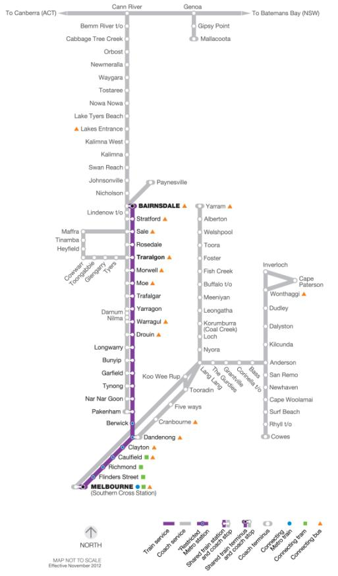
Figure 51: Gippsland’s V/Line operated public transport network
Source: Department of Transport, Planning and Local Infrastructure

Airports
The region’s local airports (see Table 15) are predominantly used for freight and passenger light aircraft charter, recreational purposes and agricultural spraying. The Latrobe Regional Airport provides operating facilities for air ambulance and rescue, and aerial fire fighting aircraft. East Sale hosts the Royal Australian Air Force base and the associated pilot training facility.
There are currently no scheduled air freight services operating out of Gippsland, although West Sale Airport provides important supply and personnel access to the Bass Strait off-shore oil and gas platforms. Small-scale, charter-based air freight already exists as required.
Gippsland is therefore reliant on access to Melbourne Airport for international and domestic flights and also to Avalon Airport for some domestic services. However, the new metropolitan planning strategy, Plan Melbourne, provides for identification of the needs for a new third airport to serve the growing needs of south east Melbourne and Gippsland and identify and appropriate site.
Table 15: Gippsland’s airports
Latrobe City Airports:
- Morwell - Latrobe Regional Airport
Bass Coast Shire Airports:
- Phillip Island - Newhaven
Wellington Shire Airports:
- West Sale Airport
- RAAF Base East Sale (Defence purposes only)
- Yarram
South Gippsland Shire Airports:
- Leongatha
East Gippsland Shire Airports:
- Bairnsdale
- Great Lakes - Kepper Field
- Lakes Entrance
- Orbost
- Gelantipy
- Mallacoota
Source: Department of Transport, Planning and Local Infrastructure

Gippsland ports
Gippsland lacks a commercial trading port and relies on access to the commercial Victorian ports of Melbourne, Hastings and Geelong as well as the Port of Eden in New South Wales to export its goods. There is no identified deep-water port opportunity in the Gippsland region given the geography of its coastline.
However, the Victorian Government is committed to develop the Port of Hastings as Victoria's second container port with $110 million in funding allocated for the 2013-2017 period. The funding will enable detailed planning for the new port which will eventually complement the Port of Melbourne and cater for the growth of container movements which are projected to quadruple at the Port of Melbourne over the next 25 years. The privately-owned Barry Beach Marine Terminal at Corner Inlet handles offshore oil and gas provisioning. Other ports include Lakes Entrance, Port Welshpool, San Remo, Port Franklin and Port Albert which provide for fishing fleets.

Travel in Gippsland
Gippsland is a large land area with dispersed communities and well endowed with natural resources and productive farming land. The Gippsland transport system sustains transport dependent activities of regional and state significance. It supports moving Gippsland’s communities to employment and services as well as its significant natural resources and agricultural products to local production facilities and markets outside the region. This subsection identifies some of the current regionally significant trip generators.

Road and rail use data
Figure 52 and Figure 53 illustrate that most of Gippsland’s major roads are experiencing significant ongoing growth, particularly in South Gippsland.
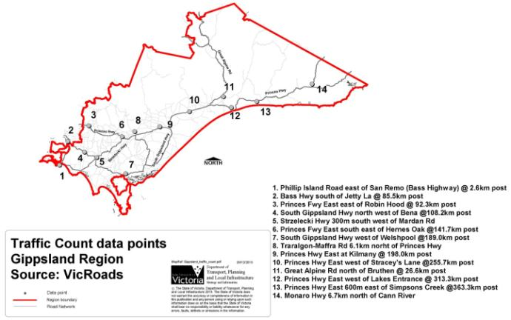
Figure 52: Traffic count data points, Gippsland region
Source: VicRoads
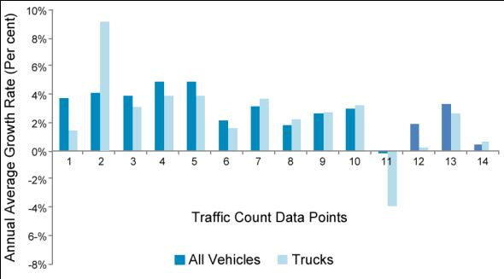
Figure 53: Gippsland two-way traffic data, compound growth rates 2006 to 2010
Source: Department of Transport, Planning and Local Infrastructure
1) Phillip Island Road | 4) South Gippsland Highway | 7) South Gippsland Highway | 10) Princes Highway | 13) Princes Highway
2) Bass Highway | 5) Strzelecki Highway | 8)Traralgon-Maffra Road | 11) Great Alpine Road North  of Bruthen | 14) Monaro Highway
3) Princes Freeway | 6) Princes Freeway | 9) Princes Highway East at  Kilmany | 12) Princes Highway
Figure 54 and Figure 55 show estimated rail and bus patronage. Figure 54 shows that rail patronage has grown steadily at regional stations west of Traralgon between the 2005–06 and 2010–11 periods, with patronage at some stations more than doubling. This growth was leveraged from improved rail infrastructure and increased services to the region between Melbourne and Traralgon. Growth has been less significant to the east of Traralgon.
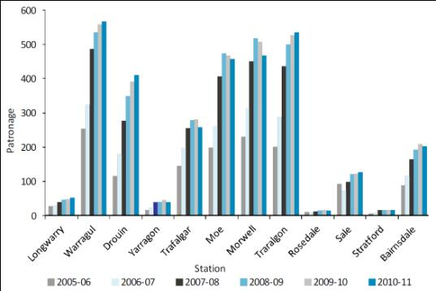
Figure 54: Normal Gippsland weekday rail patronage (estimate) by station
Source: Department of Transport, Planning and Local Infrastructure
Figure 55: V/Line bus patronage by route – 2012
Source: Department of Transport, Planning and Local Infrastructure

Gippsland’s communities
Latrobe City, comprised of the grouping of Traralgon, Morwell, Moe and Churchill, is the regional city for Gippsland. It is a regionally significant trip generator offering significant higher order services, such as Federation Australia University (Monash University), the Latrobe Regional Hospital and important retail and employment opportunities, such as Australian Paper and power generating plants. Other important regional centres, such as Bairnsdale and Sale, provide high level services including education and health, and employment opportunities that generate passenger movements. A wider network of communities including Wonthaggi, Leongatha, Lakes Entrance and Cowes also provide important hubs for services and activity that generate demand for movement within Gippsland, and to destinations outside the region.

Tourism
The region is home to significant tourist destinations which generate considerable income and employment for Gippsland businesses. A significant amount of tourist activity is based around coastal areas including Phillip Island, which hosts the annual Motor Grand Prix and the renowned Penguin Parade, Wilsons Promontory, Ninety Mile Beach and the Gippsland Lakes district. Other tourist attractions include the Mount Baw Baw ski fields, Alpine National Parks, food and wine, major events, activity-based tourism and heritage towns, such as Walhalla. Each of Gippsland’s councils has completed local tourism strategies to identify and leverage tourism opportunities – refer to section 1.3 Tourism.
The overwhelming majority of visitation is from people travelling in private cars, principally for convenience but also as a result of limited public transport to nature-based and coastal destinations.

Freight
The core freight tasks in the Gippsland region include cartage of agriculture product and livestock, bulk materials and general freight, and are predominantly moved by road vehicles. A rail freight service runs between Australian Paper at Maryvale and the Port of Melbourne. There is scope for additional rail freight services as the rail network only recently discontinued transporting logs from Bairnsdale and formerly general freight was transported from a rail siding in Morwell.
The Melbourne-Sale Corridor Strategy (2007) identifies significant freight transport around towns, such as Warragul, Moe and Morwell which produce dairy products, timber and paper. The Princes Highway between Traralgon and Sale supports quarrying, agriculture, timber, gas and services industries, as well as the Royal Australian Air Force base at Sale.
A further study, the Timber Industry Road Evaluation Study: Road Needs Study 2011-2015, considers the road needs of the timber industry across the state. Gippsland is one of the four regions evaluated and the study identifies priorities with costings for road upgrades for the region. The findings from the study can be used to inform strategic transport planning for the region.
The major regional export sectors are agriculture, forestry and fishing, electricity, gas, water, waste and manufacturing. These outputs provided three quarters of Gippsland’s exports in 2011. The agriculture, forestry and fishing sector is also experiencing significant growth. The state aims to double food and fibre exports by 2030, and Gippsland will be a significant contributor to this goal.

Transport policy context
Key Victorian and Australian government transport policies, which are relevant to Gippsland, are described below.
Plan Melbourne, the new metropolitan planning strategy (2013)
The new metropolitan planning strategy, Plan Melbourne, was completed in 2013. It will guide metropolitan, peri-urban and regional city connectivity on planning, development and transport.
The Victorian Freight and Logistics Plan (2013)
This plan was released in August 2013. The plan looks at ways to increase freight efficiency and productivity across metropolitan and regional areas in Victoria, and improvements to interstate and international connections.
Cycling into the Future 2013-2023
This strategy recognises the growing importance of cycling in meeting the transport needs of Victorians and supporting vibrant, healthy urban communities in all of Victoria. There a number of projects that will be taken forward through the life of the plan which are of relevance to Gippsland:
- progressing work to extend the Great Southern Rail Trail from Foster to Welshpool
- upgrading the Glengarry to Cowwarr section of the Gippsland Plains Rail Trail.
The National Airports Safeguarding Framework 2012
The State Government agreed to implement the National Airports Safeguarding Framework into Victoria’s planning system. The framework aims to ensure that future airport operations and their economic viability are not constrained by incompatible residential development. It includes guidance on the following:
- measures for managing impacts of aircraft noise
- managing the risk of building generated windshear and turbulence at airports
- managing risk of wildlife strikes in the vicinity of airports
- managing the risk of wind turbines as physical obstacles to air navigation
- managing the risk of intrusions into the protected airspace of airports.
Walking, Riding and Access to Public Transport: Draft Report for Discussion, October 2012
This report explores how a national approach might help encourage and support active transport forms as part of the transport system in Australia’s cities and towns.

State Government’s transport infrastructure projects
This section identifies state government transport initiatives and planned investments that relate to the Gippsland region and also regional transport priorities advocated by local government and other organisations.
There are currently projects underway to enhance key transport links both within Gippsland and to destinations beyond (Figure 56). When completed, these projects will provide key infrastructure for transport connectivity, efficiency and safety in the region and are vital for promoting Gippsland as a place to invest, work and live.
Victoria’s submission to Infrastructure Australia, August 2012 (State Government of Victoria)
The State Government submitted a number of projects to Infrastructure Australia in 2011. The 2012 submission updated the 2011 submission. It included a number of projects to progress the State Government’s strategic frameworks, which have arisen out of the development of Plan Melbourne, regional growth plans and the Victorian Freight and Logistics Plan. Projects submitted to Infrastructure Australia relevant to the Gippsland region include:
- East West Link
- Port of Hastings
- Dandenong Rail Corridor
- Melbourne Metro
- Princes Highway East duplication, Traralgon to Sale
- Princes Highway East, Nar Nar Goon to Longwarry.
.
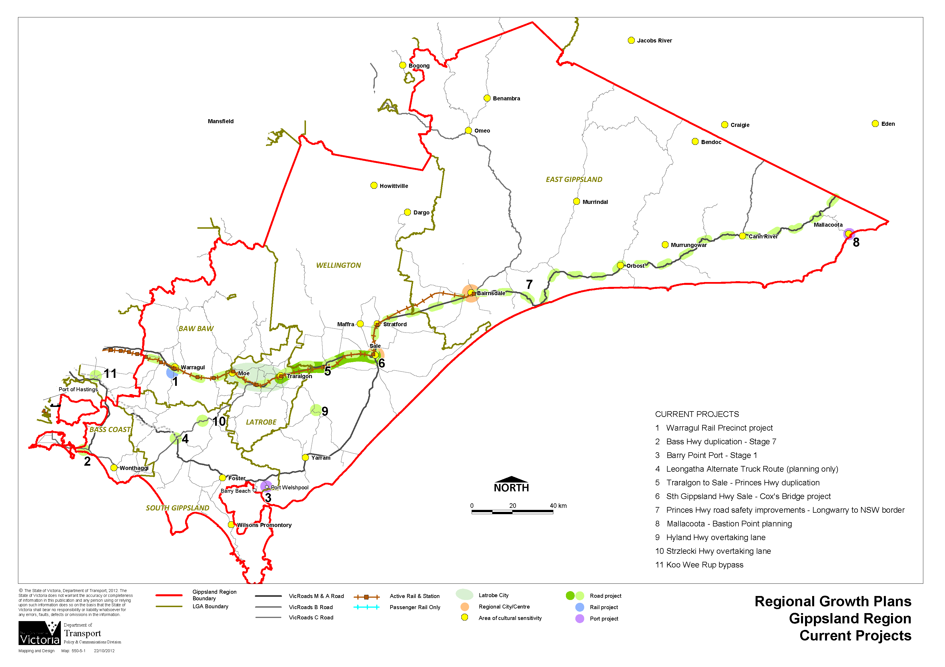
Figure 56: Current transport infrastructure projects

Source: Department of Transport, Planning and Local Infrastructure
Latrobe Valley Industry and Employment Roadmap 2012
The Latrobe Valley Industry and Employment Roadmap 2012 identifies the importance of upgrading Gippsland’s rail and road connectivity, both intra-regionally and to Melbourne’s ports and airports to better position the region to capitalise on diversification opportunities.
New transport initiatives and opportunities identified in the road map include:
- Warragul Station Precinct Project - $22.7 million in state government funding to upgrade the Warragul Station Precinct, including car parking, bus interchange and road and rail underpass. This will provide an alternate route for freight vehicles and motorists to the east of the station and central business area.
- Support of Port Anthony - The State Government has implemented the necessary preliminary planning to support Port Anthony to potentially operate as a bulk commodities export and import terminal. It is an important investment for enhancing the region’s connectivity to export markets associated with the region’s focus on energy and food sector development over the medium- to long-term.
- Strzelecki and Hyland highways overtaking lanes - $7.1 million to improve north-south connectivity between the Latrobe Valley and South Gippsland for improved freight movement, travel times, business cost and market access.
- Koo Wee Rup Bypass - increasing the recent $50 million investment by an additional $16 million to duplicate the Healesville-Koo Wee Rup Road, which will be a critical link for north-south travel within Gippsland and the south-east metropolitan Melbourne growth areas.
- Gippsland Logistics Precinct - the State Government will work with Latrobe City Council and the private sector to identify an appropriately credentialed terminal operator to run the proposed facility, which will provide local freight users access to high capacity bulk and container rail freight services.
- Expanding public transport services - the State Government will investigate viable service expansions for the Latrobe Valley, such as more services from Traralgon to the east of the region, in recognition of the region’s growing population and the increasing need for intra-regional movement, particularly relating to education and job opportunities.

Guiding future transport opportunities
There are differing needs for freight and people movement in the Gippsland region. These will require differing solutions, and the future directions of the transport network will need to be considered in this light as part of the regional growth plan. It will be important to enhance and build on existing infrastructure to ensure access and connectivity. Points that have been raised to support the inclusion of the future directions are included in this section.

People movement

Network capacity
As key settlements, such as Warragul, Drouin, Moe, Morwell, Traralgon, Sale and Bairnsdale grow there may be a need to mitigate any negative impacts that traffic and congestion could cause. Good walking and cycling networks providing access to and from developments into key employment nodes could be considered as an alternative to car use. Equally, improved public transport access within urban centres could also play a role and assist in mitigating any traffic impacts.
There are a number of demand management measures that can contribute to improved liveability in towns and centres including park ’n’ ride facilities, parking restrictions, bus lanes and shared zones for example.

Access and connectivity
The Gippsland region’s transport network provides for accessible travel, particularly to the main towns and to Melbourne. These connections will be crucial into the future as they will provide access to employment and a range of services and facilities, such as health and education for those in the Gippsland region. Improvements to enable access to the Federation Australia University campus in Churchill will be required into the future to encourage settlement in the region.
Equally, the region has a number of widely dispersed smaller communities. Smaller towns provide services and facilities for rural communities. Larger urban centres, such as Warragul, Traralgon and Bairnsdale provide these smaller settlements with access to high order services and facilities including train services to Melbourne.
Some smaller towns are not identified to receive major growth and, from a regional perspective, some may even decline into the future. With this in mind it will be important for transport links to keep pace with growth and changing demographics to ensure accessibility to key services and facilities.

A safe, reliable and resilient network
Economic development scenarios that allow for the development of a thriving tourism industry, coupled with an enhanced cycling network, will be important to ensure a vibrant economy. In order to achieve this, the transport network needs to offer a safe and reliable network to both passengers and freight vehicles and therefore needs to be able to withstand disasters and emergencies such as bushfires.

Technological advancements
Information and communications technology will improve into the future. For example, the rollout of the NBN will provide access to faster and more reliable internet connections. The health and education sectors are leading the way for people to access services and facilities online from distant locations. Online courses in education and rehabilitation in the health sectors are some examples. As the population ages into the future, distant service provision will become critical, particularly in rural and remote areas. Improved information and communications technology may also result in people no longer needing or wanting to travel either long distances or frequently. The NBN may provide a mix and match communication style, where train journeys are required on some days but internet access is sufficient for other days.

Amenity and useability
The Gippsland transport network is used by a variety of people for both business and pleasure. Ensuring the network is maintained to an efficient and functioning standard will be important into the future. There is a need to consider facilities, such as rest areas, that tourists require as they travel through the region as well as for regular commuters to and within the region. The role of scenic and functional roads will help support tourism and a more diverse economy making best use of tourism products and opportunities.

Freight movement

Freight and logistics precincts
The Gippsland region is heavily reliant on its natural resources to support its economy. Agriculture and mining are important resources that are exported and carried within the region. The development of a freight and logistic precinct in Morwell, close to the existing non-operational intermodal terminal, may create new opportunities for the cartage of commodities and value-added products. Figure 57 provides an overview of key industries in the region and their proximity to the transport network.

Freight network capacity
The importance of the Princes Highway cannot be underestimated as the major link between Gippsland and Melbourne, and as the primary link to international markets via the ports of Melbourne and Geelong, and Eden to the east. Road and rail within the Princes Highway corridor between Melbourne and Bairnsdale is crucial to the economy of Gippsland. Indeed most of the region’s major settlements and employment nodes are along the Princes Highway corridor. The construction of the East West Link would enhance reliability in accessing the Port of Melbourne through the Princes and South Gippsland highways.
The South Gippsland Highway provides important freight access to significant freight generators in Bass Coast and South Gippsland shires. This includes Murray Goulburn in Leongatha which produces dairy products for Australian and international markets and is one of the largest export shipping container users at the Port of Melbourne. Road improvements to the South Gippsland Highway from Bena to Koonwarra are being considered and planned, as is an alternate truck route to take most of the heavy vehicle traffic out of Leongatha’s central business district.

Connectivity for freight
It is important to ensure freight access for Gippsland’s commodities. The creation of a network of logistics precincts with various facilities, such as intermodal terminals, would create opportunities for the carriage and distribution of freight both within the region, with other regions and interstate. The development of the Port of Hastings as a future key container terminal port may alleviate capacity issues on the Princes Highway if coal exporting is realised. Planning for the future of the Port of Hastings should consider bulk export needs and transport access from the Gippsland region. The port would provide an opportunity for Gippsland’s freight to access a commercial port without travelling through metropolitan Melbourne.
Development at the Port of Hastings, including road and rail transport corridors, will require detailed environmental impact assessments to consider the broader implications of a fully developed port. The environmental baseline studies will be carried out over at least a two-year period and will commence in the next twelve months.

A safe, reliable and resilient network
The Gippsland region has a number of rural areas with business-related activities, such as those related to horticulture and milk production, that require initial freight access via the local road network. This means that in many circumstances local roads are used by heavy trucks to collect and distribute the commodities created. This puts a strain on the maintenance of local roads. The advent of larger and potentially heavier trucks into the future, and the consolidation of farming practices, may mean that local road designations need to be reviewed in order to allow for continued freight access.

Understand and ensure efficient supply chains
Into the future it will be important to understand the nature of the freight task in order to ensure connections to the region are protected and enhanced. Opportunities exist to expand and use some regional airports, such as Latrobe Regional Airport, to carry perishable freight products to markets. Likewise, opportunities exist to create and develop a network of freight and logistics precincts to provide export opportunities for commodities, such as coal. Potential links to the Port of Hastings will require future consideration to ensure efficient supply chains and a vibrant economy in the region.
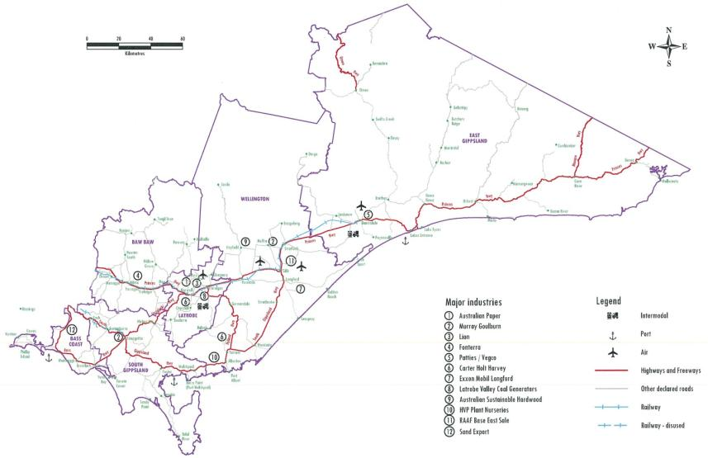
Figure 57: Transport network and key industries
Source: Department of Transport, Planning and Local Infrastructure

UTILITIES

Water supply
Victoria has an integrated and adaptive water supply planning framework, which ensures urban water customers and the broader community have secure supplies of high quality water. These supplies support drinking and non-drinking needs, such as healthy recreational facilities, parks and gardens.
The State Government’s Living Victoria program was launched in April 2012 and has direct implications for water and urban planning across the state. Although the immediate focus of Living Victoria is on the metropolitan Melbourne region, its overarching directions are intended to apply more broadly across the state over time. As this occurs, the plans and strategies produced under this program will gradually supersede and replace existing strategies.
The Living Victoria program responds to the recognition that:
- water needs to be better integrated into urban landscapes
- the community needs to be better engaged in water planning
- improved evaluation frameworks capable of capturing a broader range of costs and benefits are needed to effectively assess the wide array of options for the provision of urban water services.
Through implementing the Living Victoria program, the Office of Living Victoria will develop and coordinate new integrated urban and water planning frameworks and develop tools which will apply across the state, such as changes to the Victoria Planning Provisions.
At present, the key plans and strategies that guide urban water planning in regional Victoria are:
- water supply demand strategies, which will be superseded by integrated water cycle strategies
- regional sustainable water strategies
- drought response plans.
Water supply demand strategies were initially released in 2007. These strategies evaluated future water supply and demand scenarios and identified the mix of water supply and demand management measures needed to secure safe and reliable town water supplies, with a 50-year outlook. Urban water corporations released updated strategies in early 2012, which included new features to increase their alignment with the Living Victoria program including an Alternative Water Atlas and an annual Water Security Outlook.
Integrated water cycle strategies will identify the best mix of measures to:
- maintain a balance between the demand for water and the supply of water in cities and towns
- facilitate efficient investment in all water cycle services, including recycling sewage or trade waste, stormwater capture and re-use, and demand management
- improve the resilience of water supply systems, including fit-for purpose, through scenario-based planning and adaptive management having regard to risk and uncertainty.
Regional sustainable water strategies take a long-term view of water resource planning, considering all sources of water and the needs of towns, industry, agriculture and the environment at a regional scale. They identify threats to reliability of water supply and quality of water, and ways to improve supply and quality of supply for existing and future consumptive users. They also identify ways to protect and increase environmental water reserves. Regional sustainable water strategies have been implemented to varying degrees across the state, and some new programs have meant the older strategies are being refined to meet new priorities. The Gippsland Region Sustainable Water Strategy was completed in November 2011 and included proposals for increasing certainty for water users and the environment, promoting sustainable water use and protecting and improving waterway health.
Drought response plans manage temporary water shortages due to prolonged periods of below average rainfall or other causes such as poor water quality. They outline a range of options to balance supply and demand, which may include imposing water restrictions. The water restriction framework was reviewed in late 2011 to meet community expectations and to apply consistent restriction rules across the state.
Water supply throughout the region will have a strong influence on the type of industries that can operate in both rural and urban areas, and on the sustainability of settlements into the future. Water supply to rural areas is changing as part of water reform across the state, which should provide a more secure water future for the region for the next 30 years and beyond.
The main water corporations in the region are Southern Rural Water, a rural water authority, and Westernport Water, South Gippsland Water, Gippsland Water and East Gippsland Water, urban water authorities.

Waste management
Effective waste and resource recovery management is an essential service that protects environmental and public health. The Victorian waste management system includes waste generation, collection and transport, sorting and processing, recycling and reprocessing, export, reuse and disposal. The waste management system operates across all activities in the region, including household or municipal, commercial and industrial, and construction and demolition waste.
The State Government is responsible for policy development and regulation around waste management, and for promoting environmental sustainability. Local governments are responsible for providing waste collection, transport and reprocessing or disposal to landfill services. Regional waste management groups are responsible for planning and coordinating the management of municipal solid waste for local governments within their regions, as well as helping them to reduce waste, maximise recovery and reduce environmental harm. Regional waste management groups are responsible for planning and managing solid waste by preparing waste management plans now and into the future.
There are many existing and emerging industries in waste management, particularly in terms of recovery, reuse and recycling of waste. Energy generation from waste is an expanding industry in the state.
Victoria’s waste generation is expected to increase by about four per cent per annum. The plan needs to consider how it will provide for and manage waste associated with proposed growth.
Waste management activities within the region may need to expand to accommodate expected population and industry growth. The need for new landfills can be reduced by diverting waste. Regional opportunities to reduce, recover, reuse and recycle waste should be supported. Any future waste and resource recovery facilities in the region should be part of effective structure planning, including protecting buffer zones, to minimise impacts of these facilities on more sensitive land uses nearby.
There are opportunities to encourage and support investment into advanced technology that can convert waste into energy or fuel products in the region. The plan and local planning should encourage and enable such developments, where appropriate. The region should consider an integrated and coordinated approach to waste management into the future as the region grows.

Assessment of infrastructure capacity
Existing infrastructure was analysed to identify any constraints or opportunities and to determine the ability of the existing networks to accommodate predicted residential, commercial and industrial growth. This will assist state government to plan for growth by receiving advice and information from utility providers. For the purpose of this assessment, utilities are defined as:
- council stormwater drainage and road assets
- water supply
- sewerage
- gas supply
- electricity
- telecommunications.
Towns that have been included in this assessment and their associated local government areas are included in Table 16.
Table 16: Included towns and local government areas
Bass Coast Shire:
- Cowes, Cape Paterson, Inverloch, San Remo, Wonthaggi
Baw Baw Shire:
- Drouin, Trafalgar, Warragul, Yarragon
East Gippsland Shire:
- Bairnsdale, Lakes Entrance, Mallacoota, Metung, Orbost, Paynesville
Latrobe City:
- Churchill, Moe, Morwell, Traralgon
South Gippsland Shire:
- Foster, Korumburra, Leongatha, Mirboo North, Nyora
Wellington Shire:
- Maffra, Rosedale, Sale, Yarram
For the purposes of this assessment, the organisations listed in Table 17 are considered stakeholders.
Table 17: Project stakeholders
Stormwater and flooding/roads:
- Bass Coast Shire Council, Baw Baw Shire Council, East Gippsland Shire Council, Latrobe City Council, South Gippsland Shire Council, Wellington Shire Council
Water supply and sewerage:
- East Gippsland Water, Gippsland Water, South Gippsland Water, Southern Rural Water, Westernport Water
Gas supply:
- APA Networks, MultiNet Gas
Electricity:
- SP AusNet
Telecommunications:
- NBN Co, Telstra

Findings

Council infrastructure
Councils have reported that, historically, growth has occurred without adequate consideration of infrastructure needs which can frequently result in existing infrastructure being inadequate or undersized. The major constraints that appear common across most local government areas are related to flooding experienced in many towns, as well as the availability of satisfactory funding required for existing and new infrastructure.
Generally, provision of council road and stormwater infrastructure is in response to development. In addition, councils report they have planning and development strategies for the majority of the towns included in this assessment. Councils typically have short-term capital works plans which make allowance for required infrastructure works and renewal activities. Longer term plans have been prepared to a varying degree.

Water
The Gippsland Region Sustainable Water Strategy suggests that Gippsland is well placed to meet its water supply needs through the development and implementation of each regional urban water authority’s water supply demand strategies. Technological developments and market fluctuations play a major part in the ability of major industrial customers to reduce water consumption.
Water trading is a perceived opportunity for Gippsland which would allow water resources to be transferred to their most productive uses. There are differing levels of support for recycled water for non-potable use amongst councils and water authorities.
The State Planning Policy Framework encourages the re-use of waste water, including urban run-off, treated sewage effluent and run-off from irrigated agricultural land.

Sewerage
Each regional urban water authority collects and treats wastewater via a shared reticulation system. The only town included in this assessment that does not have a reticulated sewerage network is Nyora, although final approvals have been received for the new Poowong, Loch and Nyora sewerage scheme, which will be provided by 2017 by South Gippsland Water.
Upgrade works to sewerage treatment plants to cater for growth are included in the water plan for each regional urban water authority.

Electricity
Overall, there is little spare capacity in the Gippsland region as the method of network planning allows electricity networks to be loaded to economical optimums.
The Gippsland region is supplied by three sub transmission networks. All three have existing constraints and will require augmentation works to support growth. The South Gippsland sub transmission networks is of particular concern as it is one of the most constrained networks in SP AusNet’s distribution area.
Demand management, non-network solutions and utilising existing supply where possible, such as the dedicated supply to the Wonthaggi Desalination Plant, should be considered in determining which augmentation options are most viable in the long term.
Generally, development close to power generation is easier and less expensive to service. In the Gippsland region, the terminal station is located in Morwell. East Gippsland is particularly constrained due to the nature of the radial supply to the east of Bairnsdale and the distance of many East Gippsland towns from the electricity source. Solar generation may prove an alternative local energy source.

Gas supply
The Moe, Morwell, Traralgon and the Sale to Maffra transmission pipeline supply systems do not have the overall capacity to support the high population growth scenario, that is, the VIF 2012 projection plus an additional 20 per cent, using the infrastructure currently in place.
While the cost for customers is less with reticulated gas supply, compared with road transportation of compressed natural gas to township storage, the infrastructure required for extension and reticulation of gas to towns in the Gippsland region may not be economically viable for gas distribution businesses, particularly those towns that are remote from existing gas infrastructure.
Considering the viability of a local township gas storage facility may be an alternative arrangement if reticulating gas from the existing network to the town is not viable.

Telecommunications
The NBN rollout, which will connect 93 per cent of Australian homes, schools and businesses to a high-speed fibre optic network, will significantly enhance telecommunications capacity and service levels.
The Gippsland region has a very high proportion of communities in towns of less than 1000 people that are dispersed throughout the region’s coastal and rural areas. As such the region would benefit from the earliest possible rollout of the NBN to the region to ensure adequate coverage. NBN providers should be consulted in planning for growth to ensure they allocate adequate capacity to the region.

Infrastructure capacity by town
Table 18 gives a snapshot of the status of the utility networks in each town considered in the assessment.

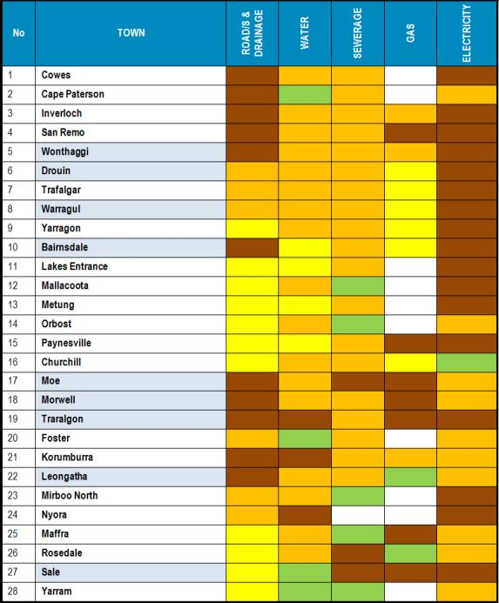
Table 18: Utility status legend
Key
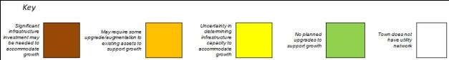
- APPENDICES

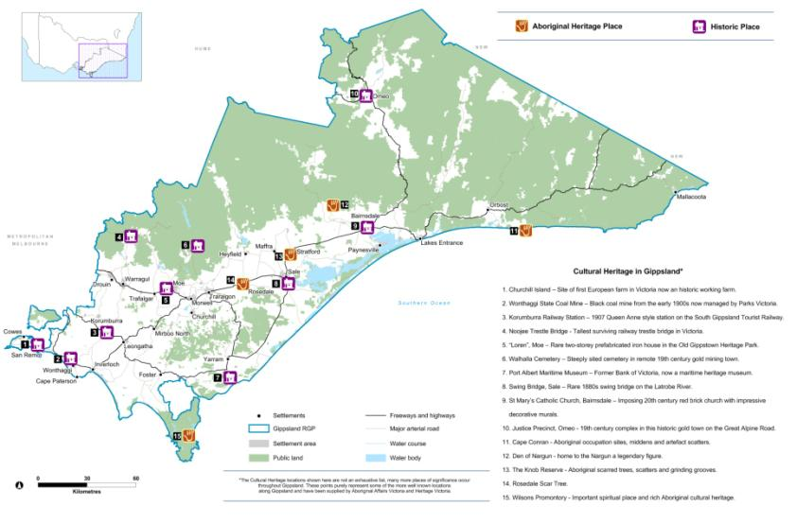
Appendix 1: Cultural heritage assets of the Gippsland region

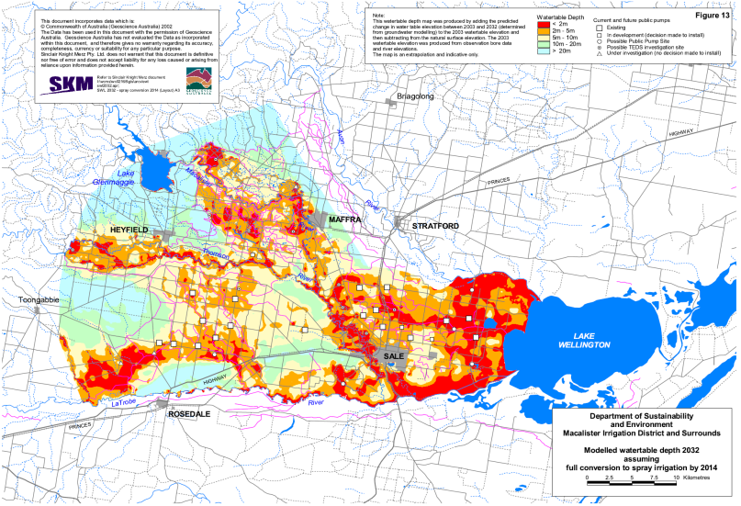
Appendix 2: Potential salinity threat near Sale in 2032
Source: West Gippsland Salinity Management Plan 2005

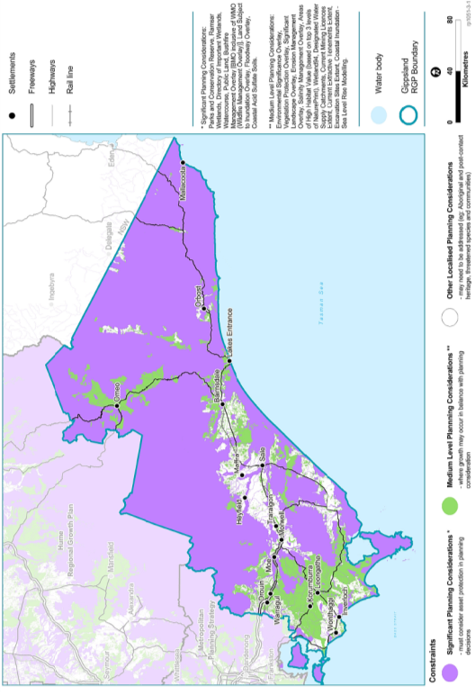
Appendix 3: Planning considerations for Gippsland

Source: Department of Transport, Planning and Local Infrastructure
Appendix 4: Planning considerations for each centre
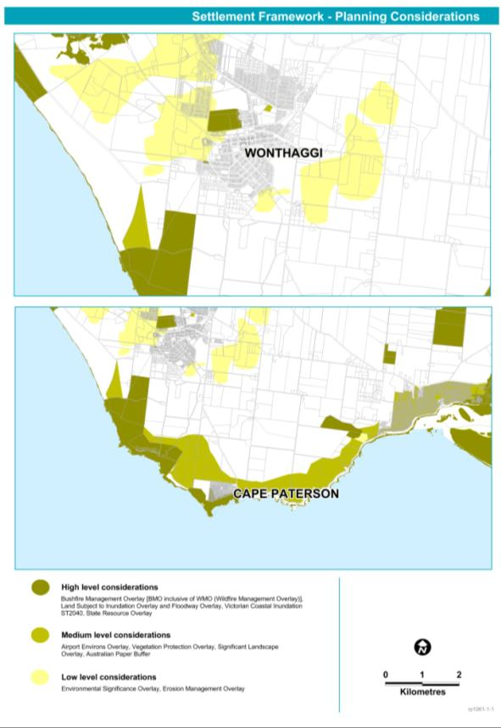
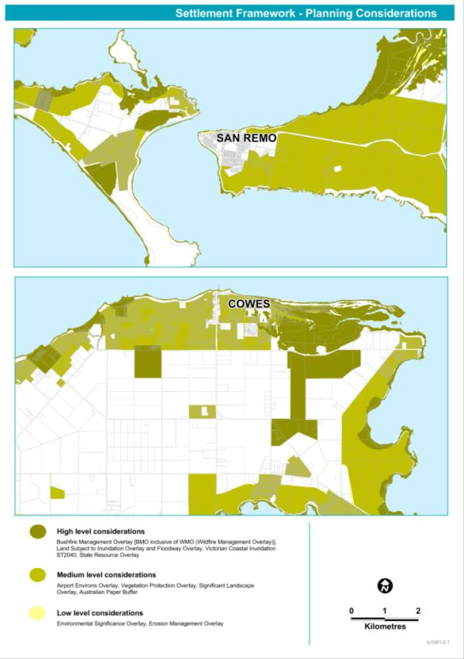
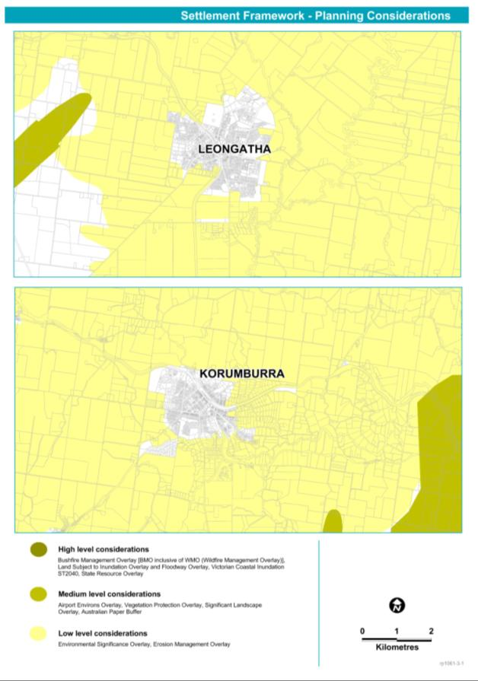
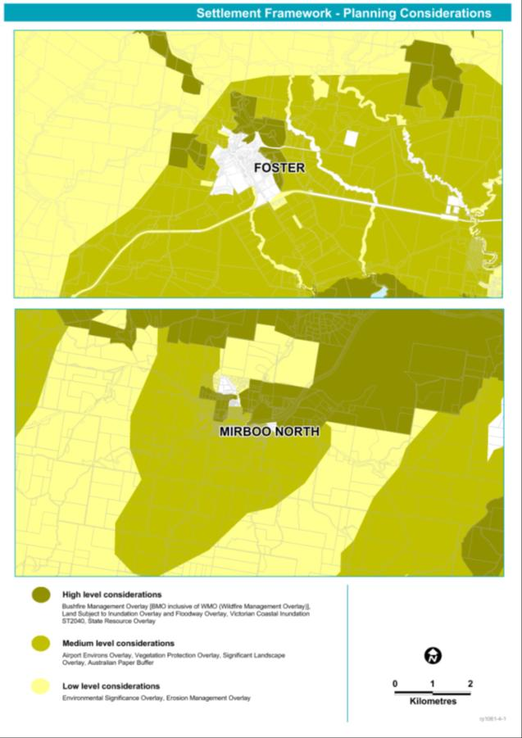
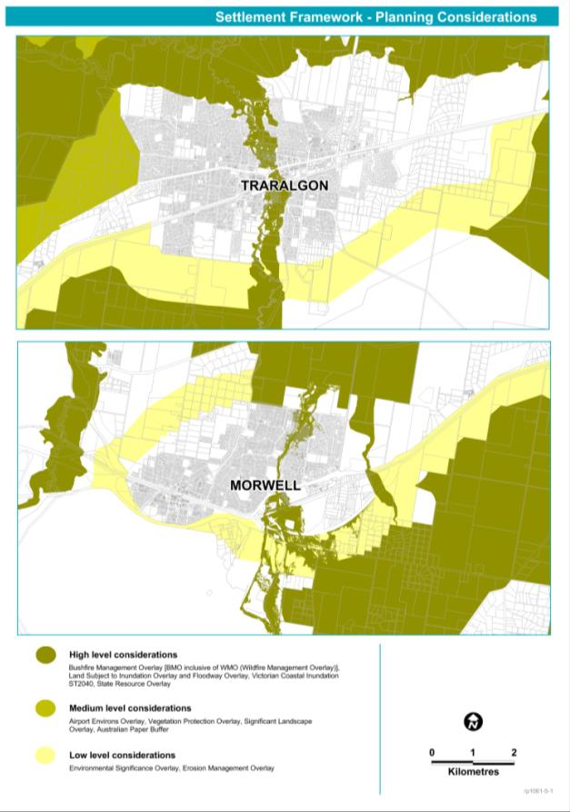
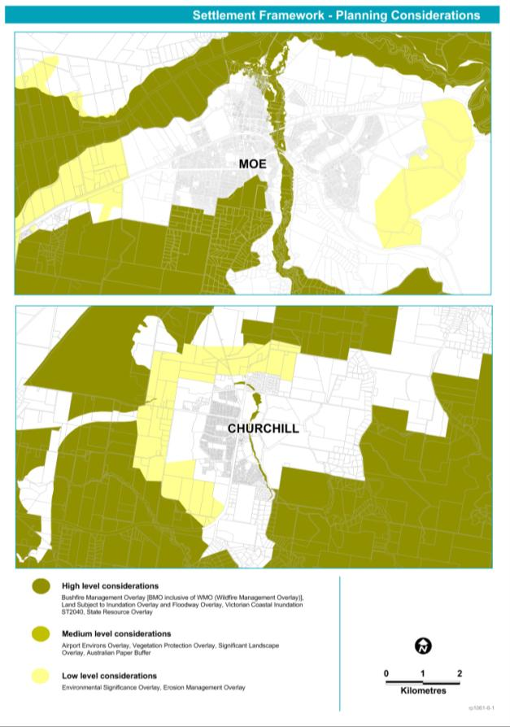
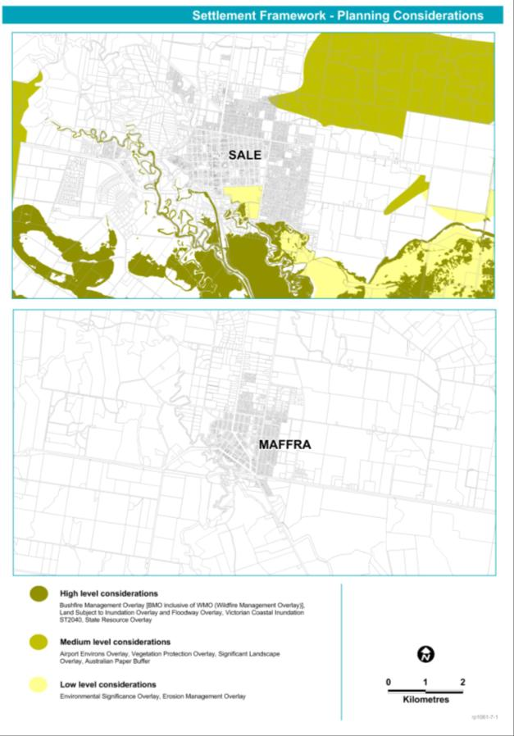
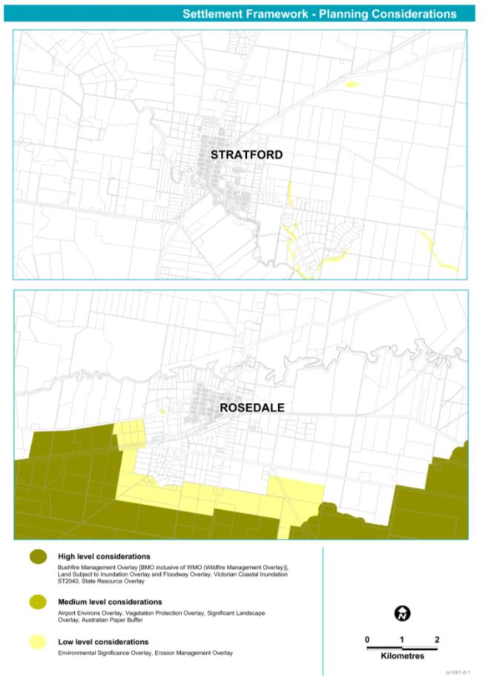
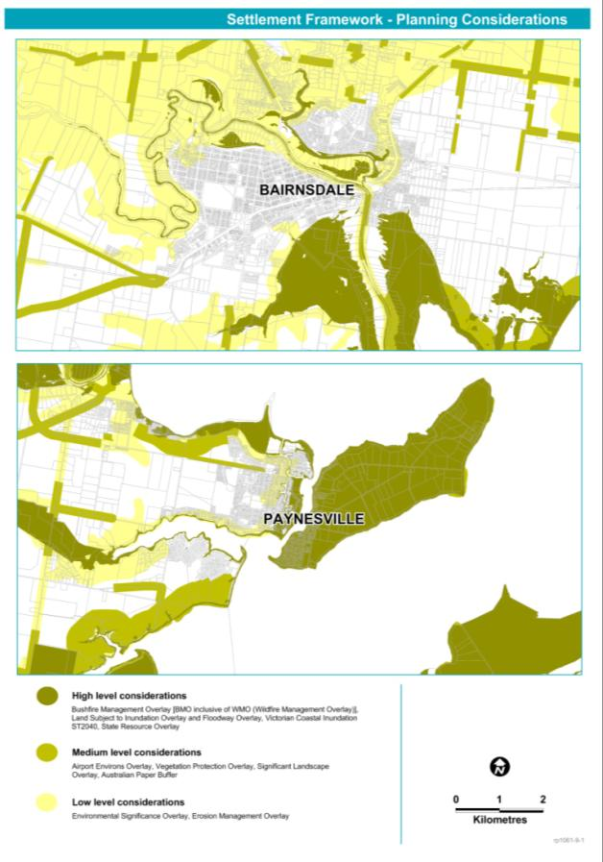
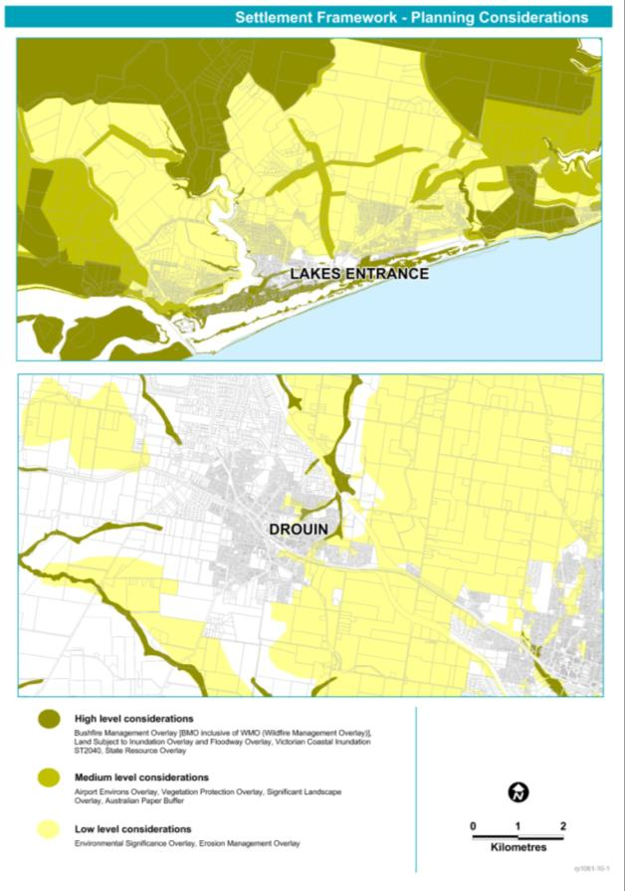
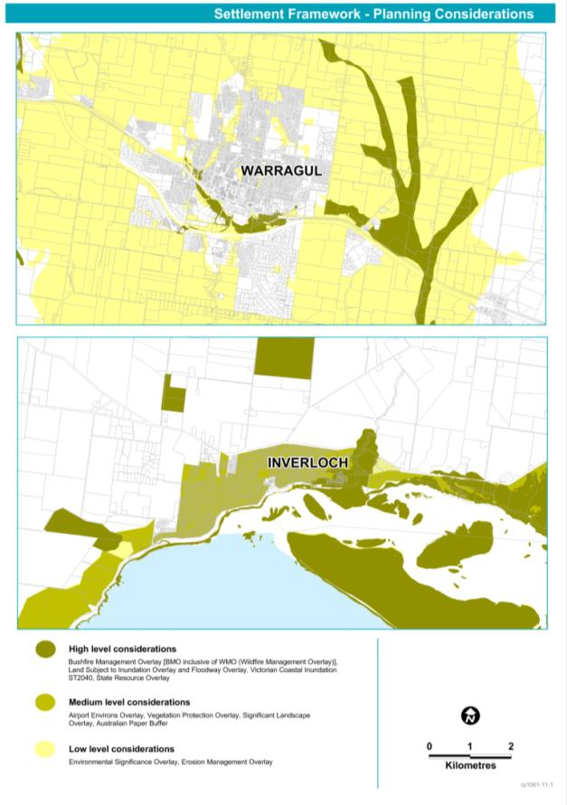
- REFERENCES
Regional economy
- Department of Planning and Community Development (2012) Earth Resources and Energy; December 2012
- Department of Environment and Primary Industries (2013) Department of Primary Industry - Earth Resources website http://www.depi.vic.gov.au/earth-resources/stone-sand-and-clay/construction
- Regional Development Victoria (2013) Regional Economic Profile (unpublished) January 2013
- RM Consulting Group (2012) Gippsland Strategic Tourism Investment Areas Final Report to Department of Planning and Community Development, October 2012
- RM Consulting Group (2013) Agriculture and Forestry – Areas of Strategic Significance Final Report to Department of Planning and Community Development, January 2013
- Renaissance Planning (2012) Gippsland Commercial Planning Report; prepared for Department of Planning and Community Development November 2012
- Regional Development Victoria (2012) The Latrobe Valley Industry and Employment Roadmap, Regional Development Victoria July 2012
- Victorian Government (2013) Economic Development and Infrastructure Committee, Inquiry into greenfields mineral exploration and project development in Victoria – Government response, Victorian Government May 2013
Environment and heritage
- 2009 Victorian Bushfires Royal Commission (2010), Final Report Summary, Parliament of Victoria Melbourne, July 2010
- ASRIS (2011), ASRIS – Australian Soil Resource Information System. http://www.asris.csiro.au. Accessed 1 November 2012
- Department of Planning and Community Development (2012), Regional Bushfire Planning Assessment: Gippsland Region, Victorian Government Melbourne, April 2012
(available at: http://www.dpcd.vic.gov.au/planning/plansandpolicies/bushfire-planning-and-building-resource/bushfire-planning-provisions-and-resources/regional-bushfire-planning-assessments)
- Department of Sustainability and Environment (2013) Tourism Investment Opportunities of Significance in National Parks: Guidelines, Victorian Government, Melbourne, April 2013
- Department of Sustainability and Environment (2012a) Improving Our Waterways: An overview of the draft Victorian Waterway Management Strategy, Victorian Government, Melbourne, October 2012
- Department of Sustainability and Environment (2012b) Planning permit applications in open, potable water supply catchment areas November 2012, Victorian Government, Melbourne, November 2012
- Department of Sustainability and Environment (2012c) Report on Climate Change and Greenhouse Gas Emissions in Victoria: As required under Section 17 of the Climate Change Act 2010, Victorian Government, Melbourne, March 2012
- Department of Sustainability and Environment (2012d) Victorian Coastal Hazard Guide, Victorian Government Melbourne, June 2012
- Department of Sustainability and Environment (2012e) Soil Health Strategy - Protecting soil health for environmental values on public and private land July 2012, Victorian Government, Melbourne, July 2012
- Department of Sustainability and Environment (2011a) Gippsland Region Sustainable Water Strategy, Victorian Government, Melbourne, November 2011
- Department of Sustainability and Environment (2011b) Western Region Sustainable Water Strategy, Victorian Government, Melbourne, November 2011
- Department of Sustainability and Environment (2010) Victorian Best Practice Guidelines for Assessing and Managing Coastal Acid Sulfate Soils, Victorian Government Melbourne, October 2010
- Department of Sustainability and Environment (2008a) Climate Change in East Gippsland, Department of Sustainability and Environment, Melbourne, June 2008
- Department of Sustainability and Environment (2008b) Climate Change in West Gippsland, Department of Sustainability and Environment, Melbourne, June 2008
- Department of Sustainability and Environment (2006) Coastal Spaces Recommendations, April 2006
- Department of Sustainability and Environment (2012) Gippsland Environment and Heritage Concepts Department of Sustainability and Environment December 2012 (internal memo)
- East Gippsland Catchment Management Authority (2013) East Gippsland Regional Catchment Strategy 2013-2019, East Gippsland Catchment Management Authority, Bairnsdale, May 2013
- Gippsland Coastal Board (2006) Gippsland Estuaries Coastal Action Plan 2006, Gippsland Coastal Board, Bairnsdale, August 2006
- Gippsland Lakes Ministerial Advisory Committee (2013) Gippsland Lakes Environmental Strategy, GLMAC, Bairnsdale, Victoria
- Port Phillip and Westernport Catchment Management Authority (2013) Port Phillip and Western Port Regional Catchment Strategy, available at http://www.ppwrcs.vic.gov.au/
- SKM (2005) West Gippsland Urban Salinity Risk Assessment, Sinclair Knight Merz, Maffra, August 2005
(Available at: http://www.wgcma.vic.gov.au/images/stories/PDF/Programs/REGIONAL_PROGRAMS/LAND/west_gippsland_urban_salinity_risk_assessment_.pdf)
- Victorian Government (2013) Victorian Climate Change Adaptation Plan, Victorian Government Melbourne, March 2013
- Victorian Government (2012) Victorian Government’s response to the Victorian Floods Review: Improving flood warning systems implementation plan, Victorian Government Melbourne, November 2012
- West Gippsland Catchment Management Authority (2013) West Gippsland Regional Catchment Strategy 2013-2019, West Gippsland Catchment Management Authority, Traralgon
- West Gippsland Catchment Management Authority (2008) West Gippsland Catchment Management Authority Soil Erosion Management Plan 2008, West Gippsland Catchment Management Authority Traralgon, June 2008 (Available at: http://www.wgcma.vic.gov.au/images/stories/PDF/Programs/REGIONAL_PROGRAMS/LAND/soil_erosion_management_plan.pdf)
- West Gippsland Catchment Management Authority (2005) West Gippsland Salinity Management Plan 2005, (Available at: http://www.wgcma.vic.gov.au/images/stories/PDF/Programs/REGIONAL_PROGRAMS/LAND/west_gippsland_salinity_management_plan_2005.pdf)
Living in the region
- Department of Planning and Community Development (2012) Victoria In Future 2012, April 2012
- Regional Mapping Project – Gippsland Region; Planisphere November 2009
- SGS (2012a) Gippsland Integrated Land Use Plan – Population Assessment, SGS Economics and Planning, July 2012
- SGS (2012b) Advancing Latrobe City (Draft Report); SGS Economics and Planning, December 2012
Regional Infrastructure
- GHD (2012) Gippsland Infrastructure Needs Analysis, October 2012
- Regional Development Australia (2012) Gippsland Region Priority Areas and Projects; Regional Development Australia et al, March 2012
- Department of Planning and Community Development, 2007-2012 Urban Development Program.
Others references
- Regional Development Australia et al (2010) Gippsland Regional Plan 2010
- Department of Planning and Community Development (2012) Gippsland Integrated Land Use Plan - Urban Profile, October 2012
- Department of Planning and Community Development (2012) Gippsland Integrated Land Use Plan - Draft Issues Paper, May 2012

Agriculture includes crops, livestock slaughtering, livestock products and is the total gross value of agricultural production for Gippsland.
The value of forestry is the mill gate value of logs from plantations only. The value of timber processing includes timber sourced from plantations and native forest.
Department of Environment and Primary Industries website
Department of Environment and Primary Industries
Department of Environment and Primary Industries, 2013
Greenfields sites are those areas without known mineral deposits
NaturePrint v2.0 conveys information on relative habitat value for all areas in Victoria (excluding marine), not just those with native vegetation. In its most commonly used form, NaturePrint is illustrated as a map showing relative habitat value (Strategic Natural Values map) showing areas that most contribute to biodiversity conservation. Further information on NaturePrint can be found at http://www.depi.vic.gov.au/conservation-and-environment/biodiversity/natureprint
Providing ecosystem services through market based approaches (including competitive tenders such as EcoTender and BushTender), can provide farmers with income for undertaking environmental works that conserve and enhance the environment.
The Heritage Rivers Act 1992 makes provision for Victorian Heritage Rivers by providing for the protection of public land in certain parts of rivers and river catchment areas in Victoria which have significant nature conservation, recreation, scenic or cultural heritage attributes. http://www.austlii.edu.au/au/legis/vic/consol_act/hra1992171/sch1.html
In March 1996, an international program was established to protect migratory shorebirds along the East Asian-Australasian Flyway, known as the East Asian-Australasian Shorebird Site Network.
Department of Sustainability and Environment, 2012a
Gippsland Lakes Ministerial Advisory Committee, 2013)
http://vro.dpi.vic.gov.au/DPI/Vro/map_documents.nsf/pages/vic_dwsc
Department of Sustainability and Environment, 2011a
Department of Sustainability and Environment, 2011b
Department of Sustainability and Environment, 2012b
Department of Sustainability and Environment, 2013
Department of Sustainability and Environment, 2012c
Gippsland Coastal Board, 2006
Department of Sustainability and Environment 2008a, 2008b
http://climatecommission.gov.au/wp-content/uploads/Gippsland_impacts.pdf
Victorian Government, 2013
Victorian Government, 2013
http://www.emknowledge.gov.au/resource/?id=18
Recommendation 39 of the 2009 Victorian Bushfires Royal Commission report
Department of Planning and Community Development, 2012
Sinclair Knight Merz (SKM) 2005
West Gippsland Catchment Management Authority, 2005
West Gippsland Catchment Management Authority, 2008
Australian Soil Resource Information System (ASRIS), 2011)
http://vro.dpi.vic.gov.au/dpi/vro/vrosite.nsf/pages/soil_acid_sulfate_soils
http://www.climatechange.vic.gov.au/adapting-to-climate-change/future-coasts/victorian-coastal-inundation-dataset
Department of Sustainability and Environment, 2012d
Planisphere 2009

