Request for Further Information Response Preparation Guide

Why did I receive a request for further information (RFI)
You may receive a Request for Further Information (RFI) when your Council Planner has reviewed your application and determined that more information is needed about your proposal to properly assess it.
The RFI will include:
- Further information council requires to assess your application
- A lapse date that the information must be provided by.
You must provide the requested further information by the lapse date in order for Council to assess your application. This date will be set based on the level of information you need to submit. If you need more time to provide the requested information within the specified timeframe, you must request an extension.
Your RFI may also include:
- Preliminary concerns that Council may have about your proposal
- Referral comments from other Council departments
You should respond to council’s preliminary concerns, however it is not mandatory for you to do so.
The flowchart below provides a visual overview of the RFI process:
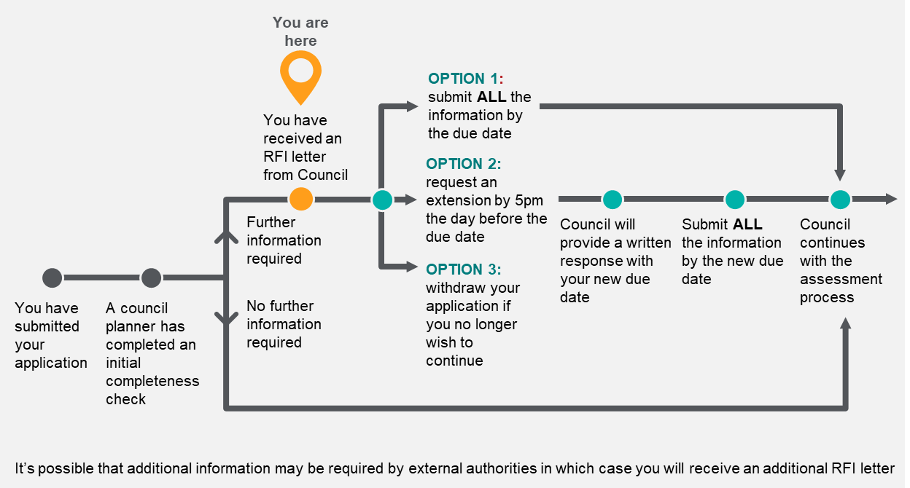
Implementation note: (delete after updating document)
If you need to update the process diagram, there is an Powerpoint pack with an editable version together with alt text.

What are my options?
You have three options:
- Change your application to address the concerns | Prepare the requested further information and amend your application to address the preliminary concerns. Submit your response by the due date.  If you need more time, request an extension before the lapse date (see FAQ below).
- Progress your application as it stands | Submit the further information by the due date.  If you need more time, request an extension before the lapse date (see FAQ below).
- Withdraw your application | If you no longer wish to proceed with this application, let Council know at [insert contact method]. No further action will be required of you. You will not be eligible for a fee reimbursement.

What happens if I miss the lapse date?
If you do not provide us with all the requested information by the lapse date, Council has no choice but to lapse your application under the Planning and Environment Act 1987. If your application lapses, you will need to lodge a new application and pay the fees again.

How do I request an extension?
If you need more time to prepare the further information response, you can request an extension of time by contacting your planner. You must do this by 11:59pm the day before the lapse date (if you submit the response by email) or by 5:00pm the business day before the lapse date (if you submit the request in person).
Your request:
- Must be in writing
- State the reasons why you need more time
- Specify a revised date for when you will provide the information
Under the Planning and Environment Act 1987, Council cannot accept a request to extend the lapse date if you make your request on or after the lapse date. If you submit the requested information before the lapse date, please include the sentence ‘If this further information response is deemed insufficient, I respectfully request more time’.
We will review requests for extensions and provide a written response confirming the new due date. If we refuse your extension request, we will give you 14 days from the day we issue the refusal for you to respond to the RFI.

How will the RFI impact the timing of my application?
When you lodge a completed planning permit application, the number of days that it will take to determine the outcome of the application will depend on the type of planning permit application:
- For standard applications, Council has 60 statutory days to determine the outcome. Where Council asks for further information within the first 28 days, the statutory clock stops and will reset to zero days from the date the information is submitted.
- For VicSmart applications, Council has 10 business days to determine the outcome. Where Council asks for further information within the first 5 business days, the count of days stops and will reset to zero days from the date the information is submitted.
This count of days is used in two ways:
- To encourage Council to make timely determinations, and
- To allow for review of Council’s failure to make a timely determination. If further information is requested after the 28th day, the count of days continues from lodgement.
In either case, the sooner the requested information is provided, the sooner a determination can be made.

Where can I get more information about how to respond to an RFI?
For guidance on how to prepare different types of requests for information, you can visit our website at [insert webpage].
Common FAQs are available via [insert webpage].
You can contact the planner assigned to your application by via the details provided on the RFI letter.
Implementation notes: (delete after updating document)
Update this section to reflect the resources available on Council’s website and the methods available to contact the Council planner.

How do I respond to an RFI or request an RFI extension?
You can submit your further information or request for an RFI extension:
By email to [insert email address].
By Council’s online portal [insert link].
By post to [insert postal address]. You must post the information in time for Council to receive the RFI response by the lapse date.
Council's Planning Department prefers to receive correspondence and documents electronically. This helps improve processing times and reduce paper use.
Implementation notes: (delete after updating document)
Update this section to reflect your council’s submission methods.

