This version of Planning Practice Note 64: Local Planning for Bushfire Protection has been prepared for use with screen reader software. The printed publication contains illustrations and design features that have been necessarily omitted from this version. In other respects this document contains identical text to that in the PDF version of the document which is available at www.delwp.vic.gov.au/planning .

Planning Practice Note 64
September 2015
Local planning for bushfire protection

The purpose of this practice note is to:
- provide guidance about local planning for bushfire protection
- assist councils to tailor the Local Planning Policy Framework in response to bushfire matters where necessary
- provide guidance on how to prepare schedules to the Bushfire Management Overlay.

Background
Many parts of Victoria are affected by bushfire. Economic development, population growth and the demand for living in environmentally appealing areas are ongoing pressures that planning schemes are seeking to manage in conjunction with the risks from bushfire.
The State Bushfire Plan 2014 prepared by Emergency Management Victoria identifies that the bushfire risk in Victoria is increasing. Factors contributing to this include Victoria’s large areas of highly flammable dry eucalypt forests, expanses of highly flammable grasslands, a climatic pattern of mild, moist winters followed by hot dry summers, and protracted droughts.
Understanding the bushfire hazard and managing risks to an acceptable level are important components of local planning for bushfire.

Policy context
The State planning policy for bushfire seeks to strengthen community resilience to bushfire through planning decisions. Its overarching strategy is to prioritise the protection of human life over other policy considerations when assessing the risk from bushfire. Key strategies to guide strategic and settlement planning include ensuring that the risk from bushfire is reduced to an acceptable level.
Ministerial Direction No. 11 Strategic Assessment of Amendments applies to planning scheme amendments. It is supported by Planning Practice Note 46: Strategic Assessment Guidelines for preparing and evaluating planning scheme amendments. In preparing a planning scheme amendment a planning authority must address any relevant bushfire risk and determine whether the changes proposed will result in any increase to the risk to life, property and community infrastructure from bushfire.

Bushfire hazard
The bushfire hazard is determined by vegetation, topography and weather. Identifying the bushfire hazard is a factual and evidence-based process. Local planning for bushfire protection should consider all bushfire hazards that can be potentially harmful, including grasslands and vegetation outside of land subject to the Bushfire Management Overlay. Matters such as land tenure and type of development are not relevant factors to determine the bushfire hazard.
There are three forms of bushfire attack:
- ember attack which occurs when small burning twigs, leaves and bark are carried by the wind
- radiant heat which can ignite houses and other assets
- flame contact involving burning vegetation directly touching a house or other asset.

When to consider bushfire?
Bushfire should be considered wherever there is a bushfire hazard that may impact on planning objectives. This includes when preparing strategic plans and policies for settlements, towns and rural areas, when preparing planning scheme amendments and when considering development proposals. Considering bushfire as part of strategic planning ensures that bushfire matters are identified and addressed early and facilitates strategies and directions which have bushfire considerations embedded within them. Engagement with the relevant fire authority on strategic planning is essential.
Planning authorities can draw on a range of information to determine if bushfire will be a factor in local planning activities and to help establish the bushfire context. Appendix 1 provides more information which can assist with establishing the context.
TIP: The Bushfire Management Overlay should not be used as the sole indicator of where bushfire matters need to be considered.

Assessing the risk from the bushfire hazard
Risk is the likelihood of being exposed to a hazard and its consequences. Bushfire risk should be considered in terms of life, property and community infrastructure. Bushfire is a dynamic hazard and the way it may impact on a community can vary considerably. There will therefore be varying responses in different locations. Central to local planning for bushfire is determining the level of risk and whether the risk has been reduced to an acceptable level.
Directing development to the lowest risk locations is the most effective way to prioritise the protection of human life. This should be the key strategy to enhance resilience to bushfire. Alongside this is the need to avoid future development in extreme risk locations. Due to the devastating impacts of bushfire there are some locations where the bushfire risk cannot be reduced to an acceptable level. Decision making for other areas should be informed by a thorough understanding of bushfire as part of local planning activities.
Appendix 1 sets out a simple four-step approach to understand the bushfire risk and decide whether the risk has been reduced to an acceptable level.
Appendix 2 sets out ways that the bushfire risk can be minimised in conjunction with new subdivisions.

Planning scheme reviews
Planning authorities must regularly review their planning schemes to ensure the planning scheme makes effective use of State provisions and gives effect to State planning policy objectives. Planning authorities should consider:
- the relevant Regional Bushfire Planning Assessment
- the way in which the planning scheme assists to strengthen community resilience to bushfire and supports bushfire prevention and management. This includes whether the application of zones and overlays is compatible with the bushfire hazard and ensuring planning schemes prioritise the protection of human life
- any relevant change to land included in the Bushfire Management Overlay or designated as bushfire prone under the building regulations
- where there is development pressure that may potentially conflict with the bushfire hazard
- the outcomes of Planning Panels Victoria and Victorian Civil and Administrative Tribunal consideration of bushfire-related issues
- the views of the relevant fire authority and public land managers.
Section 12B (5) of the Planning and Environment Act 1987 requires that, on the completion of the review, council reports the findings of the review to the Minister for Planning. The review may include recommendations on changes to the planning scheme and the need for further strategic work to be undertaken.

Bushfire in the Municipal Strategic Statement
The Municipal Strategic Statement (MSS) establishes the strategic direction for the municipality and should show how it supports and implements the State Planning Policy Framework. It sets out the local strategic direction of a planning scheme. An outcome of a planning scheme review may be the need to make changes to the MSS.
Appendix 3 outlines how the MSS could include bushfire-related matters, including how to spatially map bushfire considerations.

Bushfire in a Local Planning Policy
A Local Planning Policy guides decision making in relation to specific discretion in a zone or overlay. It helps the responsible authority and other users of the scheme to understand how a particular discretion is likely to be exercised. Where possible, the MSS, schedules to zones and overlays and particular provisions should be used instead of local policies to express local policy objectives.
Whether a specific Local Planning Policy is required on bushfire should be determined by each council in consultation with the department’s regional offices. Preference should initially be given to integrating bushfire considerations into other parts of the planning scheme. Given the unique local factors that may influence a local planning policy there is no model approach that can be taken.
The provisions of Clause 44.06 Bushfire Management Overlay and Clause 52.47 Planning for bushfire should not be repeated in a local planning policy. Clause 52.47 specifies approved measures and alternative measures to meet bushfire planning objectives. A local planning policy cannot modify a measure in Clause 52.47. Only a schedule to the Bushfire Management Overlay can modify a measure in Clause 52.47, where justified. A local policy can support the exercise of discretion in decision making.
TIP: Local policies that may be most effective are those that address bushfire issues spatially, identifying how bushfire affects particular locations and what the planning scheme response to this is.

Schedules to the Bushfire Management Overlay
The Bushfire Management Overlay may be supported by an associated schedule. A schedule can vary specified requirements of Clause 44.06 (including permit requirements, and notice/referral requirements) and modify the measures and application requirements in Clause 52.47. Where no schedule is in place the statewide provisions apply.

When would a schedule be appropriate?
Due to the local conditions that influence bushfire behaviour a schedule will apply to a discrete local area rather than a whole municipality. A schedule could address a particular neighbourhood, township or rural settlement. A schedule could be appropriate in the following circumstances:
- A schedule replicates the outcome that would be achieved if each site was assessed individually through a planning permit application under the Bushfire Management Overlay. Assessing a number of sites or a wider area where a consistent outcome is appropriate can streamline decision making and enhance certainty for landowners, responsible authorities and relevant fire authorities. This may be of particular assistance when preparing planning scheme amendments which seek to rezone land for urban purposes where the Bushfire Management Overlay applies.
- A local analysis of bushfire behaviour demonstrates how an area varies from the ‘assumed’ bushfire behaviour supporting the statewide measures. It will include an analysis of the bushfire hazard (vegetation, topography, weather and fire history) on a local and landscape scale, assess the potential exposure of a location to this hazard, and develop an understanding of what this means for the measures in Clause 52.47. Assessing bushfire behaviour is a technical process and must be undertaken by suitably qualified professionals.
- Implementing policy decisions on how bushfire considerations are to apply. This may include the consideration of the bushfire risk on a landscape scale or the role of existing or planned state, regional or local bushfire management and prevention actions on the level of risk.
A schedule for a specific location may involve elements of more than one of the above.
TIP: A range of tools are available at the planning scheme amendment stage that can support a tailored response to bushfire, such as building envelopes, section 173 agreements, native vegetation precinct plans and overlays such as the Development Plan Overlay.

Information that may inform a schedule
A schedule that seeks to modify the measures in Clause 52.47 requires a clear justification and must be able to demonstrate that the modified measures continue to give effect to the objectives in Clause 52.47. The justification will be included in the explanatory report for any planning scheme amendment which seeks to introduce a schedule. A schedule is not an appropriate tool to reduce bushfire measures where inconsistent with prioritising human life.
Modified measures must be informed by a bushfire analysis, usually in the form of a technical report, bushfire study or research project. Such work should include:
- Reviewing the types of development to which modified measures could apply. Different development can be impacted by bushfire in different ways, such as dwellings, subdivisions and vulnerable uses. The scope of any analysis can be more clearly defined by deciding early the type of development being investigated.
- An explanation of why the relevant measure in Clause 52.47 is not appropriate having regard to the characteristics of the local area and justification for how the modified measure meets the relevant objective in Clause 52.47.
- Any necessary ‘ground truthing’, particularly to determine the spatial extent of land where the modified measures are appropriate. This should involve both planning and fire prevention professionals from council and fire authorities and may include support from public land managers.
- A risk assessment of what the modified measures mean for mitigating the bushfire risk in conjunction with new development and how the bushfire risk is reduced to an acceptable level.
- The views of the relevant fire authority and whether they agree to the modified measures.
Where a schedule is simply replicating what a planning permit would require if each lot were individually assessed against the measures in Clause 52.47, the supporting information need only illustrate this.
TIP: The form and content of a schedule to the Bushfire Management Overlay provides a menu of relevant sub-clauses that can be used to detail the strategic directions and requirements of a schedule.

Will modified measures be enabling or mandatory?
When preparing modified measures it is important to consider whether they are enabling or mandatory. An enabling modified measure provides flexibility for landowners to choose for themselves whether to access the modified measure or the relevant measure in Clause 52.47. Compliance with either will meet the relevant objective. A mandatory modified measure replaces the relevant measure in Clause 52.47 and must be used.
Whether a modified measure is enabling or mandatory will depend on the strategic basis for the schedule and what it is trying to achieve.

Varying relevant requirements of Clause 44.06
Varying the relevant requirements of Clause 44.06 will implement decisions linked to either modified measures in Clause 52.47 or policy decisions about how bushfire protection measures can be delivered through planning schemes (including provisions other than the Bushfire Management Overlay).
A schedule may vary the Bushfire Management Overlay by:
- specifying additional permit exemptions in Clause 44.06-1, particularly where bushfire matters are addressed in other parts of the planning scheme or following a risk assessment of development where other measures are in place to reduce the risk to an acceptable level
- reducing or waiving the application requirements in Clause 52.47, particularly where modified measures avoid the need for site-based assessments to be undertaken and submitted as part of planning applications
- including additional permit conditions in Clause 44.06-3
- modifying referral and notice requirements in Clauses 44.06-4 and 44.06-5
- including additional decision guidelines for exercising discretion in Clause 44.06-6.

Appendix 1: Considering the bushfire risk in local planning activities
Risk management is guided by the Australian and New Zealand Standard for Risk Management (AS/NZS ISO 31000). This provides a structured approach to risk identification and management that is used widely across Victoria. A structured approach to risk management will provide decision makers with information to determine whether the bushfire risk has been reduced to an acceptable level.

Four-step approach to considering bushfire
STEP 1: Establish the context.
STEP 2: Identify the risks from bushfire.
STEP 3: Analyse and evaluate the risks.
STEP 4: Translate risk mitigation into planning scheme provisions.

Step 1 – Establish the context
Establishing the context provides factual information which will be important when thinking about the way bushfire considerations may impact on local planning decisions. It will also support discussions with the relevant fire authority and seeking authorisation to proceed with a planning scheme amendment. The following information will help establish the bushfire context:
- a locality and site description
- the location of the settlement or site in the surrounding landscape (use 20km, 10km and 1km radius from a settlement or planning proposal site)
- the relevant Regional Bushfire Planning Assessment which provides a high level analysis of locations where the bushfire hazard may impact on planning objectives
- whether an area is included in the Bushfire Management Overlay
- whether an area is a designated Bushfire Prone Area under the Building Regulations 2006 (regulation 810)
- relevant fire history in the local and wider area
- Municipal Fire Prevention Plans
- the surrounding road network and the availability of strategic access to safer locations
- the Victorian Fire Risk Register
- the way in which existing settlement patterns, site coverage, lot size, density, development structure and vegetation patterns may impact on bushfire behaviour
- reasonably assumed future development scenarios and how this may impact on the implementation of bushfire protection measures.
An important part of establishing the context is to identify and respond to strategic planning considerations. Planning Practice Note 46: Strategic Assessment Guidelines for preparing and evaluating planning scheme amendments provides a useful framework to evaluate the planning context. Sections on why an amendment is required can provide a useful checklist of considerations that should be documented as part of establishing the context.
Presenting the information spatially on maps may be a helpful way to communicate the context for a local planning activity.
TIP: Older plans and strategies that seek to justify planning proposals will need to be carefully considered if the State planning policy for bushfire impacts on the suitability of their content.

Step 2 – Identify the risks from bushfire
Risk is the likelihood of being exposed to a hazard and its consequences. For bushfire the risk is to life, property and community infrastructure from a bushfire event. Step 2 involves considering the following:

Bushfire behaviour
- the characteristics of the bushfire hazard including the type, area and location of vegetation
- the topography of the land and its potential impact on the intensity and severity of bushfire
- the likely bushfire behaviour at both the local and broader scale. This should include an assessment of the forms of bushfire attack to be expected (direct flame contact, radiant heat, embers).
Assessing bushfire behaviour is a technical process and must be undertaken by suitably qualified professionals.

Features of the location or site that affect the level of risk
- access and egress both to the location or site within it
- proximity to established urban or township areas
- vegetation on site that planning schemes seek to protect.

Risks arising from the proposal itself
- identify the risks arising from the proposed design and layout, occupancy or proposed uses or any other features of the proposal
- quantify the risks which will arise if the proposal proceeds (for instance, how many more people will be exposed to bushfire and/or what is the nature of the proposed occupancy).
TIP: Speaking to the Municipal Fire Prevention Officer will be important when understanding the bushfire risks in a local area and the way in which non-land use planning tools and programs are being used to enhance community resilience to bushfire.

Step 3 – Analyse and evaluate the risks
Risk analysis provides a key input into decision making on whether the risk has been reduced to an acceptable level, particularly where choices must be made and different risk mitigation options are available. The level of detail will depend on the risk, available information and the balance between quantitative and qualitative analysis. The risk analysis should be documented on a plan wherever possible.
Once the risks are known, decision makers are in a much stronger position to understand the way bushfire may affect the proposal. Considering whether the risks can be avoided (either by not proceeding with the proposal or changing it) and the effectiveness of any possible risk treatments will be necessary. Consideration of planning schemes will be important to ensure any necessary risk treatments can be practically implemented through the correct use of the Victoria Planning Provisions.
The outcome of Step 3 is understanding what the residual risk is (that is, that part of the risk which cannot be mitigated and which will need to be accepted in proceeding with the proposal) and deciding whether the risk has been reduced to an acceptable level. For a proposal forming part of a planning scheme amendment a planning panel or advisory committee may be an appropriate way to test the conclusions of Step 3.

Step 4 – Translate risk mitigation into planning scheme provisions
Consider how the necessary risk mitigation is accommodated in proposed planning scheme provisions. Some mitigation can be secured through subsequent permit approvals (for instance, planning permits for subdivision) but essential bushfire protection measures should be secured at the planning scheme amendment stage and not deferred for subsequent consideration. It is also important to ensure that the planning scheme provisions which apply to land clearly set out the expectations for future development and do not create conflicts between the provisions that apply.
Planning scheme provisions should:
- identify the bushfire protection steps that make a proposal acceptable. This includes incorporating essential design features and including buffers between the bushfire hazard and new development
- identify the extent of vegetation management that is necessary to make a proposal acceptable such as creating defendable space. This may require the preparation of a native vegetation precinct plan (Clause 52.16 of planning schemes) and/or the modification of environmental overlays (and their schedules).
Other planning scheme controls should be made consistent with the bushfire mitigation measures which will be required. For instance, any requirement for landscaping plans (including for open spaces) should give effect to necessary bushfire protection.
Where bushfire protection measures are required for areas not included in the Bushfire Management Overlay, application of the Bushfire Management Overlay or a section 173 agreement should be considered.
Future development, such as larger subdivisions, should take a holistic approach to a site in terms of the delivery of bushfire protection measures. A package of required mitigation should be identified in Step 3 with the most effective means of implementation established.

Appendix 2: Mitigating bushfire risk outside the Bushfire Management Overlay
This appendix supports consideration of bushfire in planning scheme amendments and subdivision design where the Bushfire Management Overlay does not apply.
Subdivision design is an important way to manage bushfire risk. Subdivision design can establish passive risk mitigation that ensures new development is not exposed to direct flame contact or excessive levels of radiant heat. It can also ensure that fire authorities are able to establish control lines, effectively attack a bushfire and implement fuel management strategies such as prescribed burning.
Outside of the Bushfire Management Overlay, areas that are subject or likely to be subject to bushfire are included in the Bushfire Prone Area designated under the Building Regulations 2006 (regulation 810). In Bushfire Prone Areas planning scheme amendments and planning permit applications to subdivide land should consider the risk from bushfire. You can view the Bushfire Prone Area map at http://services.land.vic.gov.au/maps/bushfire.jsp
Passive risk mitigation through subdivision design can be achieved by establishing a buffer between the bushfire hazard and urban development. A perimeter road, water bodies and open spaces managed in a minimal fuel state are examples of effective buffers.
Buffer distances may be determined using AS3959-2009 Building in bushfire prone areas (Standards Australia). The Australian Standard uses vegetation type and the slope of the land to determine minimum distances between a bushfire hazard and new development. A buffer distance equivalent to a bushfire attack level of 12.5 for new development should be used. Note that for land subject to the Bushfire Management Overlay different buffer distances apply.
The following examples illustrate approaches that can be taken. Where such approaches are adopted the bushfire risk should usually be considered to have been reduced to an acceptable level.

Implementation
For land proposed to be rezoned for urban purposes, the proposed planning scheme provisions should require a buffer to be established to all areas of permanent bushfire hazard. Such a requirement can be secured through an overlay such as the Development Plan Overlay or Design and Development Overlay.
For land already zoned for urban purposes Clause 56 of planning schemes applies to an application to subdivide land for residential development. Clause 56.01-1 requires a site and context description to be prepared and this should identify the bushfire hazard. The design response should incorporate buffers in response to this hazard.
For land in Melbourne’s growth areas, detailed arrangements for bushfire are set out in the Urban Growth Zone and the relevant precinct structure plans.

Using perimeter roads to deliver bushfire protection in new subdivisions
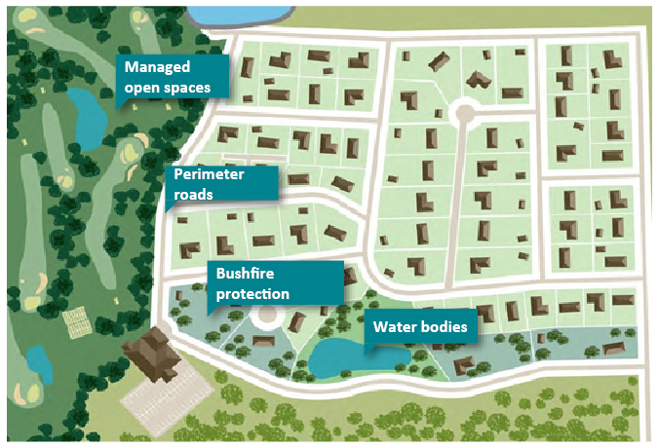

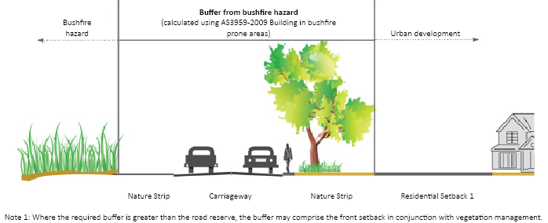

Appendix 3: Tips for including bushfire matters into the MSS

Municipal profile
Include an outline of the bushfire hazard that affects the municipality. This should include the local characteristics that create the bushfire hazard, such as vegetation extent and topography, and where it correlates with key features, such as settlements.

Example
Nearly half of Gumnut Shire is significantly affected by bushfire hazard. This includes the north-east of the Shire containing extensive areas of national park, state forest and plantation, Gumnut Valley where smaller rural-living lots are heavily vegetated, and the settlement of Gumnut Town which interfaces with Gumnut State Forest, areas of unmanaged private land and heavily vegetated coastal reserves.

Key issues and influences
Set out the key bushfire issues that the planning scheme must address in response to bushfire.

Example

Managing urban growth and settlement
The continued growth of Gumnut Town, both within existing urban areas and outward expansion, needs to be undertaken in a way that is compatible with the bushfire risks to the existing and future community.

Managing development outside defined settlements
The need to manage development pressures in rural and heavily vegetated parts of the Shire with the bushfire hazard that affects these areas.

Rural economy
Rural areas need to support farm diversification and the growth of tourism related to the rural economy, including the need for further accommodation, farm-gate sales and tourist facilities.

Vision and strategic framework plan
Set out the type of place the council seeks to create. This should reflect the need to assist strengthening community resilience to bushfire. On the strategic framework plan, illustrate areas where environmental risks, including the bushfire hazard, need to be managed.
A locally distinct vision should be developed that considers the role of bushfire in the future strategic development of the area.

Themes
The MSS should be grouped into themes. Some of these themes may include the need to consider bushfire. For each theme, consider the relevant issues that would provide a basis for the objectives and strategies of that theme. It is preferable that bushfire considerations be integrated with other policy areas in addition to being specifically addressed under an ‘environmental risks’ theme.

Example

Gumnut Town – Issues
- Directing the outward growth of Gumnut Town away from areas most at risk from bushfire.
- Consolidating development in the east of Gumnut Town so as not to increase the risk to life, property and community infrastructure from bushfire.
- Managing development pressures in the north of Gumnut Town which is at significant risk from bushfire.

Residential development outside of settlements – Issues
- Protecting vegetation and biodiversity qualities in non-urban areas with undeveloped small lots.
- Strengthening community resilience to bushfire for developed small rural lots.

Rural Economy - Issues
- Managing increased farm diversification and tourism growth in the rural economy with the bushfire hazard.

Objectives, strategies and implementation
Objectives are the council’s aims for land use and development. Strategies are ways of achieving the objectives and are accompanied by a means to implement the strategy.

Example
Objective: To develop Gumnut Town as the Shire’s key urban centre and location for accommodating residential development.
Strategy 1: Direct the expansion of Gumnut Town to the south and west which are at less risk from bushfire.
Strategy 2: Manage the on-going consolidation of the eastern areas of Gumnut Town where compatible with the bushfire risk to these communities.
Strategy 3: Restrict further intensification of development in the northern areas of Gumnut Town where the risk to life, property and community infrastructure cannot be managed.

Policy guidelines
- Ensure that the extreme bushfire risk arising from Gumnut State Forest and unmanaged private land informs planning decisions under the Bushfire Management Overlay in areas in and to the north of Gumnut Town.
- Ensure that essential bushfire protection measures are accommodated in the structure planning phase of expanding Gumnut Town to the west.
- Ensure that the consolidation and intensification of eastern Gumnut Town only occurs where environmental values and the character of the area is not significantly affected by the implementation of bushfire protection measures.

Scheme implementation
- Apply a schedule to the Bushfire Management Overlay to existing residential areas in eastern Gumnut Town to provide tailored bushfire protection measures in response to the coastal vegetation, and prepare a Vegetation Precinct Plan to manage the creation of defendable space for existing and redeveloped sites.
- Apply the Restructure Overlay to lots on the northern fringes of Gumnut Town where they abut Gumnut State Forest and where single road access only is available.

Other implementation
- Prepare a structure plan for the growth of Gumnut Town to the west.
- Consider a collective offset program for Gumnut Town as part of the wider management of vegetation for bushfire protection purposes.
- Strengthen community resilience to bushfire for northern areas of Gumnut Town through Municipal Fire Prevention Planning and associated activities undertaken by Council and the Country Fire Authority.
TIP: Using a plan to draw contextual information together may assist to better understand the way bushfire considerations affect an area spatially. An example of this is included below.

GUMNUT SHIRE BUSHFIRE ISSUES MAPPED SPATIALLY
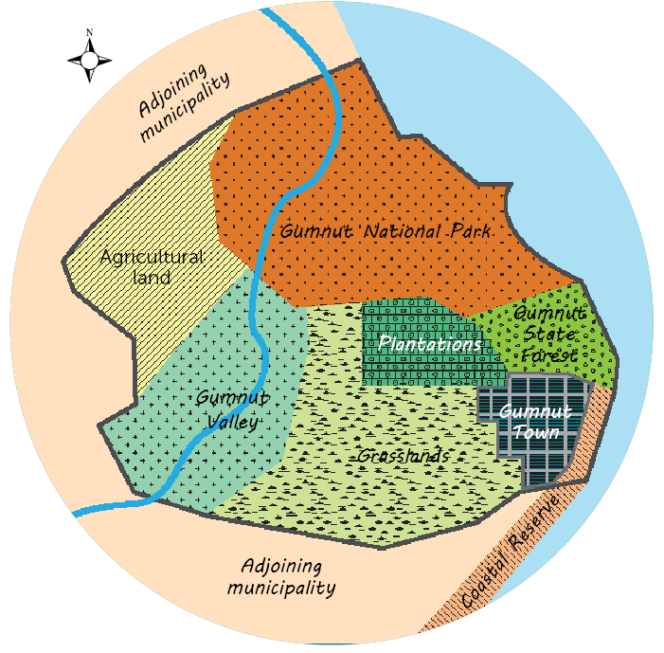

GUMNUT TOWN
- Significant hazard interface to the north with Gumnut State Forest and plantations and to the east with the coastal reserve.
- Promotion of urban consolidation in the eastern part of the town potentially conflicts with managing the bushfire risk.

GUMNUT VALLEY
- Very high quality vegetation.
- Extensive developed and undeveloped lots.
- Regional Bushfire Planning Assessment identified single road access to many rural lots which hinder evacuation to a safer place.

AGRICULTURAL LAND
- Demand for farm diversification, farm-gate sales and increased tourist accommodation.
- Significant bushfire hazard to the north-east (Gumnut National Park) and south-east (Gumnut Valley).

GRASSLANDS
- Some risk of grassland fires, particularly from embers.
- Development pressure from Gumnut Town adjoining unmanaged grasslands.

ADJOINING MUNICIPALITY
- Consider bushfire hazards in surrounding areas and the impact this may have on the level of risk for Gumnut Shire.

© The State of Victoria Department of Environment, Land, Water and Planning 2015
This work is licensed under a Creative Commons Attribution 4.0 International licence. You are free to re-use the work under that licence, on the condition that you credit the State of Victoria as author. The licence does not apply to any images, photographs or branding, including the Victorian Coat of Arms, the Victorian Government logo and the Department of Environment, Land, Water and Planning (DELWP) logo. To view a copy of this licence, visit http://creativecommons.org/licenses/by/4.0/
ISBN 978-1-921940-19-4 (pdf)

Disclaimer
This publication may be of assistance to you but the State of Victoria and its employees do not guarantee that the publication is without flaw of any kind or is wholly appropriate for your particular purposes and therefore disclaims all liability for any error, loss or other consequence which may arise from you relying on any information in this publication.

Accessibility
If you would like to receive this publication in an alternative format, please telephone DELWP Customer Service Centre 136 186, email customer.service@delwp.vic.gov.au, via the National Relay Service on 133 677 www.relayservice.com.au . This document is also available in accessible Word format at www.delwp.vic.gov.au/planning

DOCUMENT ENDS

