Marinus Link project

Environment Effects Statement (EES)
Scoping Requirements FAQ’s February 2023
- What is the Marinus Link project?
Marinus Link is a proposed electricity and telecommunications interconnector between Tasmania and Victoria. The project is located between Heybridge in northwest Tasmania and the Latrobe Valley in Victoria (Figure 1).
In Victoria, the project would involve the construction and operation of subsea cables (from the 3 nautical mile limit in Victorian waters) to a shore crossing at Waratah Bay, a transition station near Waratah Bay, underground cables continuing approximately 90km northwards to the Latrobe Valley and a convertor station in the greater Hazelwood area.
- What is the purpose of the EES scoping requirements?
Marinus Link Pty Ltd (the proponent) is preparing an environment effects statement (EES) for the Marinus Link project.
The scoping requirements set out the matters to be investigated and documented within the EES. The EES will include a description of the proposed project, rigorous assessment of its potential effects on the environment and approaches to manage those effects.
The EES scoping requirements have been issued by the Minister for Planning and are available on the Planning website:
https://www.planning.vic.gov.au/environment-assessment/browse-projects/projects/marinus-link
- Did the public have an opportunity to comment on the scoping requirements?
Yes. Draft scoping requirements for the EES were exhibited on the Engage Victoria website from 24 August to 19 September 2022. Notice of the draft scoping requirements’ exhibition was advertised in metropolitan and local newspapers.
Nine submissions were received during the public exhibition period, including from individuals, the Gunaikurnai Land and Waters Aboriginal Corporation, the Victorian Farmers Federation and Marinus Link Pty Ltd.
Submissions received have been provided to Marinus Link Pty Ltd to inform the ongoing development of the EES.
- What issues were raised in public submissions on the draft scoping requirements?
Key issues raised by submitters included:
- concern about impacts to farmland and farming practices, biosecurity and engagement with landowners;
- concern about Aboriginal cultural heritage, engagement with Traditional Owners and opportunities to better reflect Traditional Owner values and perspectives;
- impacts on the marine environment from the offshore component of the project including from electromagnetic fields generated by the electricity cables, underwater noise and potential impacts on marine mammals; and
- impacts from the land (onshore) component of the project including on waterways, from waterway crossings, native vegetation and soils and challenges for restoration.
- What revisions have been made to the draft scoping requirements in response to public submissions?
Amendments have been made to the scoping requirements to address issues raised by submitters that had not been well considered in the draft scoping requirements. These amendments clarify the matters that are to be addressed in the EES. These amendments included updates to:
- recognise likely effects on agriculture, clarify farming aspects to be assessed in the EES and that the EES include approaches to engaging with landowners;
- better integrate Traditional Owner values and perspectives into EES scoping, including that:
- Traditional Owners be engaged during the preparation of the EES;
- Traditional Owner country plans be considered as relevant strategies in the assessments of potential effects and reference to ‘healing country’ as a key evaluation principle;
- Aboriginal Heritage Act 2006 requirements and intangible cultural heritage values be addressed;
- that land subject to native title and Indigenous Land Use Agreements should be identified in relation to land uses; and
- cultural landscapes in relation to landscape and visual values be recognised.
- specify that the EES should examine any known migratory pathways for marine mammals;
- clarify the required content of the Environmental Management Framework, mitigation measures and the role of any proposed performance requirements; and
- improve readability and consistency.
- What happens now the Minister has issued the final scoping requirements?
Marinus Link Pty Ltd will address the matters set out in the scoping requirements through investigating environmental impacts, gathering information and preparing EES documents, in consultation with the Department of Transport and Planning (formerly the Department of Environment, Land, Water and Planning) and a technical reference group. The technical reference group is comprised of representatives from government agencies with a statutory or policy interest in the project and its effects.
Marinus Link Pty Ltd will also engage the public and stakeholders about the environmental effects of the project and its investigations and provide opportunities for input and feedback to inform the EES. Marinus Link Pty Ltd.’s EES consultation plan can be viewed, once ready, at: https://www.planning.vic.gov.au/environment-assessment/browse-projects/projects/marinus-link#overview
When the EES has been completed in accordance with the scoping requirements, the Minister for Planning will authorise the EES for exhibition and public comment, typically for a period of 30 business days.
The Minister will appoint an inquiry under the Environment Effects Act 1978 to consider the EES and submissions received. The inquiry may hold a formal hearing where the proponent and submitters can speak and present expert witnesses to inform a report to the Minister. The Minister will then make an assessment of the project’s environmental effects.
After the Minister has made an assessment, the inquiry report and the Minister’s assessment will be published on the Planning website.
The Minister’s assessment will be considered by statutory decision-makers responsible for the project’s approvals.
- What about Commonwealth and Tasmanian environmental assessment processes?
The project was also referred to the Australian Government under the Commonwealth’s Environment Protection and Biodiversity Conservation Act 1999 (EPBC Act). The delegate for the former Minister for the Environment determined in November 2021 that the project is a ‘controlled action’ requiring assessment and approval under the EPBC Act. The provisions for the Australian Government’s controlled action decision under the EPBC Act are:
- listed threatened species and communities (sections 18 & 18A);
- listed migratory species (sections 20 & 20A); and
- Commonwealth marine areas (sections 23 & 24A).
As the project is located both within Victoria and outside of Victoria (in Commonwealth waters and Tasmania) the Commonwealth cannot accredit the EES process as the sole means for assessing EPBC Act matters. As such, the Minister for the Environment’s delegate determined the project will be assessed under the EPBC Act by an environment impact statement (EIS).
The project also requires assessment under the Tasmanian Environmental Management and Pollution Control Act 1994.
The Victorian Department of Transport and Planning, the Commonwealth Department of Climate Change, Energy, Environment and Water and the Tasmanian Environment Protection Authority have agreed to coordinate the three assessment processes where possible. The proponent is also intending to combine its Victorian EES, Tasmanian EIS and Commonwealth EIS studies and documentation where possible, to address requirements for the three jurisdictions. This consolidated manner of examining matters and presenting information will assist stakeholders to access and engage with the project, its issues, potential impacts and mitigation, and help minimise duplication of process.
- When does Marinus Link Pty Ltd expect to publicly exhibit its EES?
The EES is expected to be on public exhibition in early 2024. During this period, the public can make submissions on the EES.
- Why is an EES required for the Marinus Link project?
In December 2021, the former Minister for Planning determined that an EES is required for the Marinus Link project. This was because the project has the potential for a range of significant effects relating to:
- Native vegetation, habitat of threatened terrestrial and aquatic species and water environments;
- Aboriginal cultural heritage values;
- the local and regional socioeconomic environment; and
- landscape values.
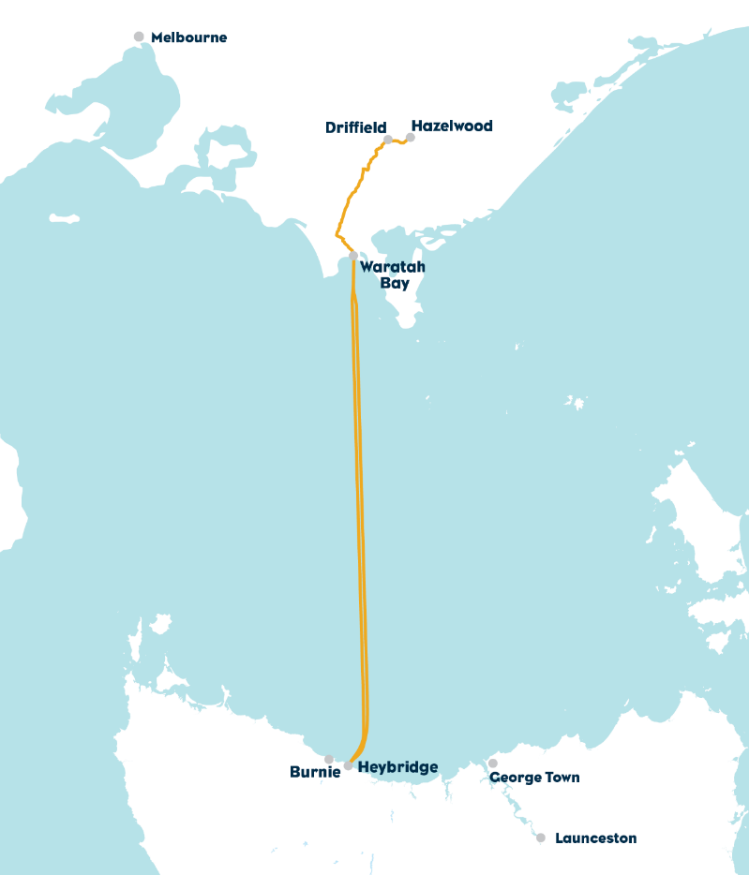
An EES is the most comprehensive and robust assessment process available in Victoria. The EES will provide an integrated and transparent examination of the proposed project and its environmental effects.
Figure 1: Project overview (Marinus Link Pty Ltd)

