Plan Melbourne 2017-2050

Draft Inner South East Metro

Land Use Framework Plan

Summary

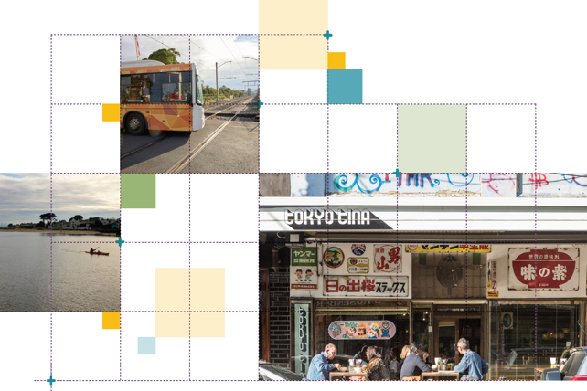

Great cities aren’t born. They’re made.
Melbourne is a great city. It’s a great place to live, work and raise a family. It’s a great place for investment and creativity. It’s a great place to visit and enjoy.
The Victorian Government has developed land use framework plans for each of the six metropolitan regions that are all about ensuring Melbourne remains a great city as it grows.
These plans mark a new era in the planning of Melbourne, building on the efforts of generations of Victorians to shape the way land is used around Port Phillip Bay.
The Inner South East Metro Land Use Framework Plan is a 30-year strategy for action across four local government areas – Bayside, Boroondara, Glen Eira and Stonnington.
It’s about making the long-term plans and investments that protect and enhance local areas and communities while ensuring Melbourne’s inner city grows more prosperous, liveable, affordable and sustainable.
The Inner South East Metro Land Use Framework Plan is also about maximising the social, economic and environmental benefits of transformational city-shaping investments such as Metro Tunnel, West Gate Tunnel, Melbourne Airport Rail and Suburban Rail Loop.
This plan is all about keeping inner south east Melbourne marvellous – from its parks and laneways to its rivers and bayside beaches to its innovative industries and dynamic culture. It’s also about building the best possible future for the Inner South East Metro region.
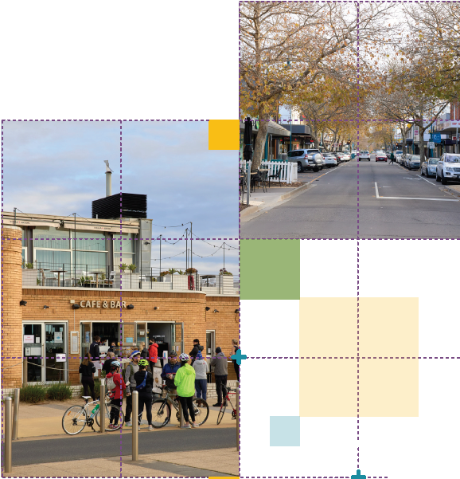

What the Inner South East Metro Region Land Use Framework Plan means for you

Productivity
- You will see a vibrant network of activity centres providing business, employment and housing opportunities with great public places for people to gather and enjoy what the region has to offer.
- You will see that Monash University’s Caulfield campus and Swinburne University’s Hawthorn campus will be centres of research and business development.
- You will see more jobs in employment hubs such as the Bayside Business District, Prahran/South Yarra/Windsor, Glenferrie, Caulfield and Carnegie.

Housing Choice
- You will see that the heritage and character of local areas is protected, with medium- and higher-density housing focused around well-connected activity centres, urban renewal areas, and education precincts.

Liveability
- You will see more trees, and healthier waterways and biodiversity.
- You will see an expanded, connected open space network.

Sustainability and Resilience
- You will see cooler and greener urban spaces, and increased use of recycled water.

Strong Communities
- You will see a network of 20-minute neighbourhoods with affordable housing, local jobs, accessible health and education services and community hubs.

Integrated Transport
- You will see a public transport network that links residents to opportunities across metropolitan Melbourne.
- You will see more trails to connect people and places by walking and cycling.

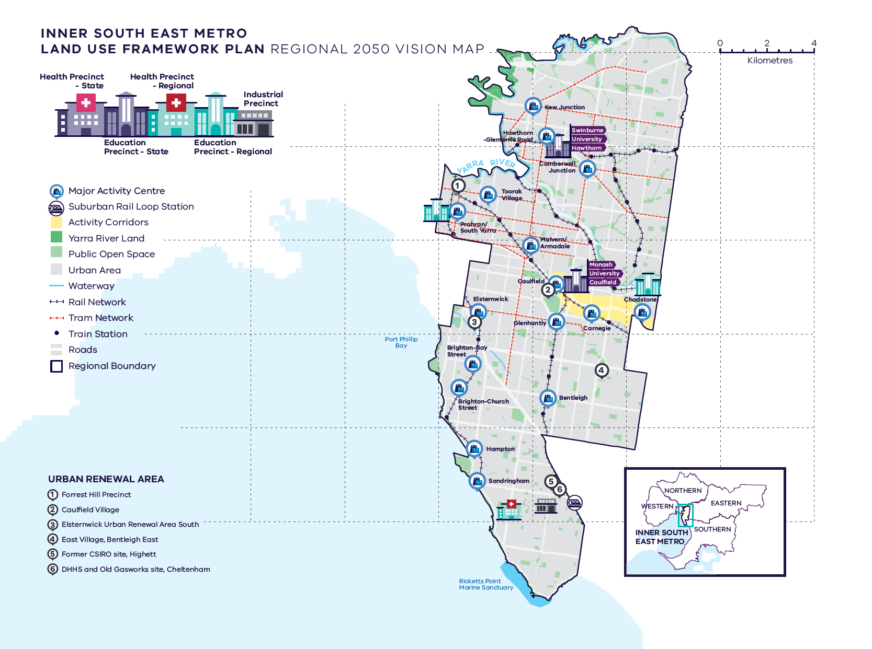
Inner South East Metro Region – Regional 2050 Vision

A schematic map of the Inner South East Metro Region in 2050 showing:

- The region’s boundary and established urban areas.

- Locations for growth and investment, including:

- The regionally-significant Bayside Business District in the south of the region
- The network of major activity centres predominantly located on the rail and road network
- State- and regionally-significant health and/or education precincts, highlighting those at Hawthorn, Caulfield, Prahran, Chadstone, and Sandringham
- The six urban renewal areas of:

Forrest Hill Precinct
Caulfield Village
Elsternwick Urban Renewal Area South
East Village, Bentleigh East
Former CSIRO site, Highett
DHHS and Old Gasworks site, Cheltenham

- An activity corridor between Caulfield and Chadstone Major Activity Centre which continues to the Monash NEIC.

- Key transport linkages and movement network, including:
- The rail and tram network
- The road network including the state-significant Eastern Freeway running east-west across the north of the region and the Monash Freeway running north-west to south-east through the centre of the region parallel to the Glen Waverley rail line and Gardeners Creek trail.

- State and regional natural and cultural assets, including:
- Yarra River Land in the north of the region
- Other public open space dispersed through the urban area, including creek trails and along some coastal areas.

What is the Inner South East Metro Land Use Framework Plan?
The Inner South East Metro Land Use Framework Plan is an extension of Plan Melbourne 2017-2050.
Plan Melbourne is a blueprint to ensure Melbourne grows more sustainable, productive and liveable as its population approaches 8 million by 2050. It includes nine principles that outline the Victorian Government’s vision for the future of the city that Melbourne will continue to be a global city of opportunity and choice.
- A distinctive Melbourne
- A globally connected and competitive city
- A city of centres linked to regional Victoria
- Environmental resilience and sustainability
- Living locally in 20-minute neighbourhoods
- Social and economic participation
- Strong and healthy communities
- Infrastructure investment that supports balanced city growth
- Leadership and partnership.
Plan Melbourne also divides the city into six metro regions:
- Inner
- Inner South East
- Eastern
- Southern
- Western
- Northern
The Department of Environment, Land, Water and Planning (DELWP) is leading the development of land use framework plans. The purpose of the plans is to guide the application of Plan Melbourne’s nine principles, seven outcomes, 32 directions and 90 policies at a regional and local level.
The plans will support a regional approach to planning across state and local government.
This document summarises how the Inner South East Metro region Land Use Framework Plan will:
- Shape population and industry growth
- Inform plans for service and infrastructure development
- Guide public and private investment
- Protect the distinctive and historic characteristics of the Inner South East Metro region
- Improve environmental resilience.
The plan covers six themes:
- Productivity
- Housing
- Integrated transport
- Liveability
- Strong communities
- Sustainability and resilience.
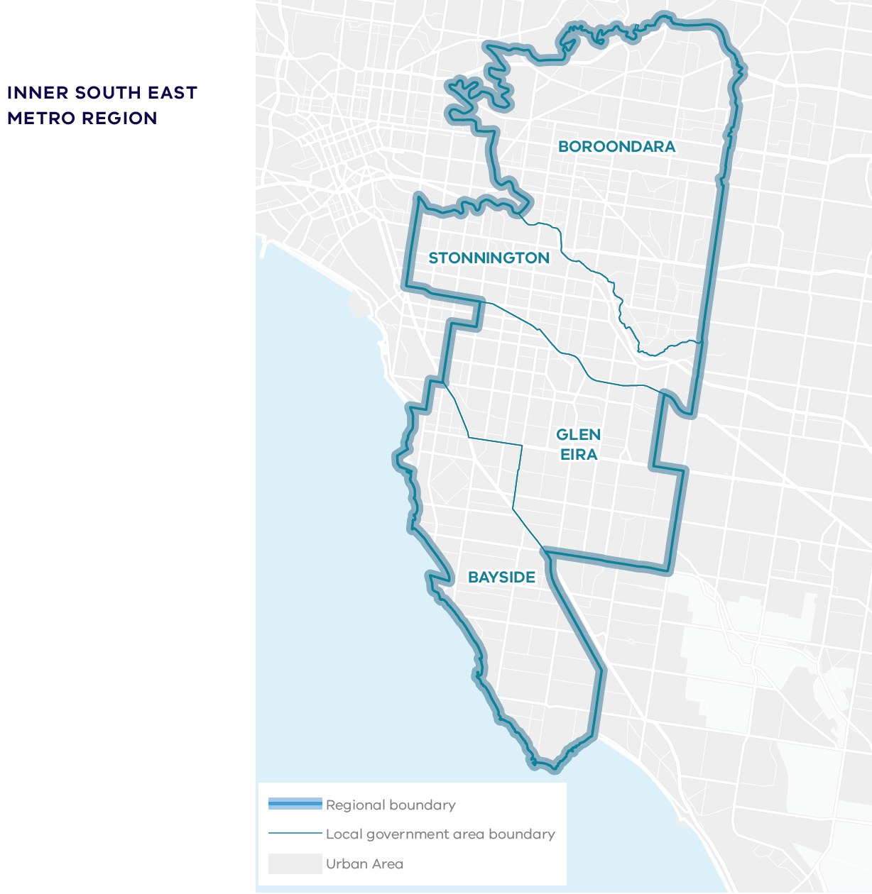

About the Inner South East Metro Region
The Wurundjeri Woi Wurrung and Bunurong peoples of the Kulin Nation are the Traditional Owners of the Inner South East Metro region.
The Inner South East Metro region is defined by the Yarra River to the north, undulating terrain to the east and the coastline of Port Phillip Bay.
It has state-significant education precincts in Hawthorn (Swinburne University) and Caulfield (Monash University) and a regionally-significant industrial precinct in Bayside.
It has 16 major activity centres and is famous for its commercial and retail strips such as Chapel Street in South Yarra/Prahran, High Street in Armadale and Glenferrie Road in Hawthorn. It has a rich heritage of Victorian and Edwardian architecture in many of the region’s most established suburbs, such as Camberwell, Kew, Hawthorn, Elsternwick, Brighton and Toorak.
And it will be the southern gateway to the Suburban Rail Loop (SRL) with Cheltenham SRL station at the interchange with Southland Station on the Frankston line, adjacent to Bayside Local Government Area.
Urban areas include:
- Established areas with higher-density development, such as South Yarra, Prahran, Caulfield
- Other neighbourhoods with a more suburban character, such as Camberwell, Brighton, Bentleigh
- Caulfield Racecourse and Chadstone Shopping Centre
- Rail corridors to the east (Lilydale, Belgrave, Alamein and Glen Waverley) and south (Sandringham, Frankston, Cranbourne and Pakenham) and an extensive tram network
- Monash Freeway and Eastern Freeway.
The Monash National Employment and Innovation Cluster (NEIC) is just outside the region to the east.
By 2051, the Inner South East Metro region’s population is projected to increase by 38 per cent from around 567,000 to 784,000 and the number of dwellings is projected to increase from 225,260 in 2016 to 344,430 in 2051. By 2031, employment is projected to increase from 220,500 to 293,500 jobs.

Geographically
its footprint covers 2 per cent of metropolitan Melbourne, and it is a fully established urban area, without green wedge or greenfield growth areas.

Demographically
almost 11 per cent of Melburnians, 567,390 people, live in the Inner South East Metro region.

Economically
it generates $35 billion a year in economic activity and employs 220,500 people.

Environmentally
it has 5.4 per cent of metropolitan Melbourne’s open space and 17.4 per cent urban tree canopy cover.

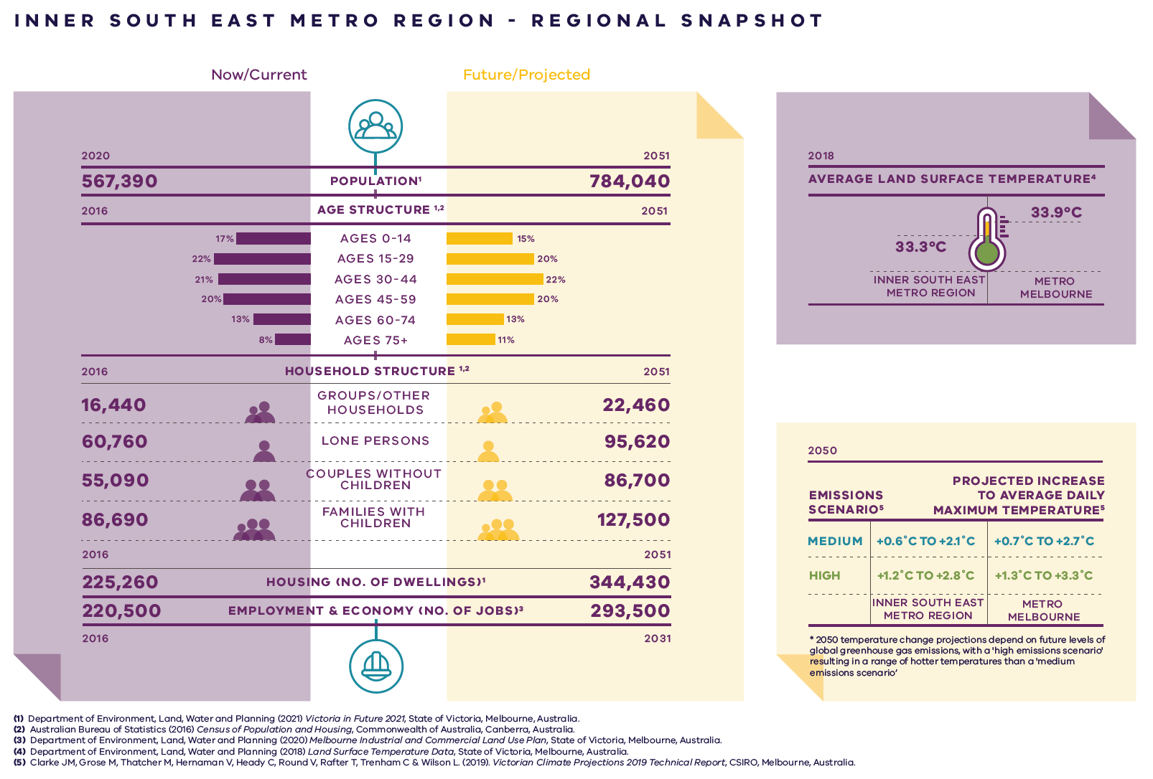
Inner South East Metro Region – Regional Snapshot

Inner South East Metro Region population  Sources:  Australian Bureau of Statistics (2021) Regional Population 2019-20 financial year, Commonwealth of Australia, Canberra, Australia.  Department of Environment, Land, Water and Planning (2019) Victoria in Future 2019, Department of Environment, Land, Water and Planning, Melbourne, Australia. | 2020:  567,390 inhabitants | 2051:  784,040 inhabitants
Inner South East Metro Region age structure  Sources:  Department of Environment, Land, Water and Planning (2019) Victoria in Future 2019, Department of Environment, Land, Water and Planning, Melbourne, Australia.  Australian Bureau of Statistics (2016) Census of Population and Housing, Commonwealth of Australia, Canberra, Australia. | 2016:  17 per cent – Ages 0 to 14  22 per cent – Ages 15 to 29  21 per cent – Ages 30 to 44  20 per cent – Ages 45 to 59  13 per cent – Ages 60 to 74  8 per cent – Ages 75 plus | 2051:  15 per cent – Ages 0 to 14  20 per cent – Ages 15 to 29  22 per cent – Ages 30 to 44  20 per cent – Ages 45 to 59  13 per cent – Ages 60 to 74  11 per cent – Ages 75 plus
Inner South East Metro Region household structure  Sources:  Department of Environment, Land, Water and Planning (2019) Victoria in Future 2019, Department of Environment, Land, Water and Planning, Melbourne, Australia.  Australian Bureau of Statistics (2016) Census of Population and Housing, Commonwealth of Australia, Canberra, Australia. | 2016:  Groups/other households – 16,440  Lone persons – 60,760  Couples without children – 55,090  Families with children – 86,690 | 2051:  Groups/other households – 22,460  Lone persons – 95,620  Couples without children – 86,700  Families with children – 127,500
Inner South East Metro Region housing (number of dwellings)  Source:  Department of Environment, Land, Water and Planning (2019) Victoria in Future 2019, Department of Environment, Land, Water and Planning, Melbourne, Australia. | 2016:  225,260 dwellings | 2051:  344,430 dwellings
Inner South East Metro Region employment and economy (number of jobs)  Source:  Department of Environment, Land, Water and Planning (2020) Melbourne Industrial and Commercial Land Use Plan, State of Victoria, Melbourne, Australia. | 2016:  220,500 jobs | 2031:  293,500 jobs
2018 average land surface temperature  Source:  Department of Environment, Land, Water and Planning (2018) Land Surface Temperature Data, State of Victoria, Melbourne, Australia. | Inner South East Metro Region:  33.3 degrees Celsius | Metro Melbourne:  33.9 degrees Celsius
2050 projected increase to average daily maximum temperature  *2050 temperature change projections depend upon future levels of global greenhouse gas emissions, with a ‘high emissions scenario’ resulting in hotter temperatures than a ‘medium emissions scenario’  Source:  Clarke J.M., et al. (2019). Victorian Climate Projections 2019 Technical Report, CSIRO, Melbourne, Australia. | Inner South East Metro Region:  Medium emissions scenario – plus 0.6 to plus 2.1 degrees Celsius  High emissions scenario – plus 1.2 to plus 2.8 degrees Celsius | Metro Melbourne:  Medium emissions scenario – plus 0.7 to plus 2.7 degrees Celsius  High emissions scenario – plus 1.3 to plus 3.3 degrees Celsius

City-shaping projects
The Victorian Government is currently implementing the largest transport infrastructure program in the state’s history.
City-shaping projects include:
- The West Gate Tunnel – creating a second river crossing to link the Western Metro region with the Port of Melbourne, CityLink and the CBD, and taking traffic pressures off the West Gate Bridge
- Level crossing removals including along the Frankston and Dandenong railway lines, reducing congestion and unlocking land for development
- Metro Tunnel – linking Melbourne’s south-east and Gippsland to the Sunbury line in Melbourne’s west and north-west
- North East Link – connecting Melbourne’s south-east to the Eastern Freeway, the Western Ring Road and Hume Freeway
- Melbourne Airport Rail – connecting Melbourne Airport to Victoria’s regional and metropolitan train network
- Suburban Rail Loop – connecting every major passenger railway line in Melbourne from the Frankston line in the south to the Werribee line in the west.
These city-shaping projects will improve access to jobs, education and social opportunities for residents in the Inner South East Metro region by better connecting the region with other areas of Melbourne and Victoria. They will create opportunities to maximise social, economic and environmental benefits.
Socially – bring jobs, services and leisure opportunities closer to where people live.
Economically – reduce transport congestion, boost productivity and create jobs.
Environmentally – cut commuting times, reduce transport emissions, promote public and active transport use, and create 20-minute neighbourhoods.
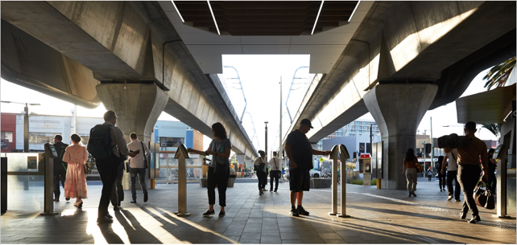

Inner South East Metro Region strengths and challenges
Productivity | The Inner South East Metro region has a vibrant local economy, with a network of major activity centres and health and education precincts. Protection of employment land is key, given that the region does not have greenfield sites or substantial areas of industrial land. New opportunities to expand, intensify and diversify employment activity need to be provided within the existing urban context.
Housing Choice | The region’s neighbourhoods are well established, with good services and infrastructure and the potential for higher-density housing around activity centres. More housing is needed to keep up with the growing population as well as more affordable and adaptable housing to meet housing needs of a diverse and aging population.
Integrated Transport | The region is well-served by existing road and public transport networks, and will benefit from planned transport investments. However, congestion is increasingly an issue. That is why infrastructure must be upgraded and pedestrian and cycling made more attractive to enable people to get around the region more easily.
Liveability | Established networks of open spaces and walking and cycling paths exist in the region, but the network needs to be expanded and improved. The region is renowned for its built heritage which needs to be protected. Traditional Owners will play a bigger role in protecting and managing Country into the future.
Strong Communities | The region is well placed to create a strong network of 20-minute neighbourhoods. It already has most of the services, facilities and infrastructure in place. But there is a need to create more places where people can go to relax, play sport and be active.
Sustainability and Resilience | Parts of the region have excellent tree canopy cover. To prepare for climate change, more green infrastructure needs to be built, more trees must be planted, and the risks of flood, storm surge and sea level rise will need to be addressed.

Planning for the Inner south east Metro Region

Productivity
- Retain existing commercial zoned land and identify areas for future commercial floorspace and investment.
- Encourage development along the Dandenong Road/Princes Highway activity corridor (between Caulfield, Chadstone and the Monash NEIC).
- Develop Monash University’s Caulfield campus and Swinburne University as major employment precincts.
- Maximise the economic potential of major activity centres and urban renewal precincts.

Housing Choice
- Secure a 15-year supply of housing across the Inner South East Metro region.
- Encourage new housing in identified locations for housing growth close to jobs, transport and services.
- Ensure new housing is well-designed, high-quality, climate change resilient and in keeping with neighbourhood character.
- Deliver a pipeline of social and affordable housing near jobs, transport and services – and deliver student and key-worker accommodation close to education and health precincts.
- Develop a mix of medium- and higher-density dwellings suitable for singles, older residents and families – and facilitate alternative developments such as co-housing, build-to-rent and car-free housing.
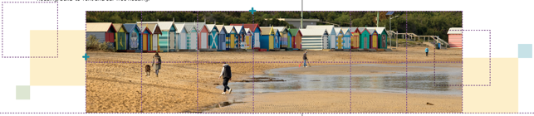

Integrated Transport
- Improve the road network – making more room for cycling and public transport.
- Improve road, public and active transport connections and services.
- Create a network of walking and cycling tracks that link to public transport.
- Make regional freight movements more efficient.
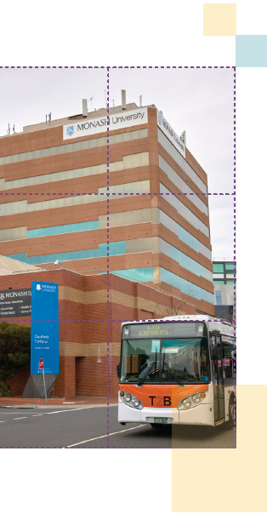

Liveability
- Create great civic spaces that reflect the region’s environment and history – including the heritage of Aboriginal communities.
- Protect waterways and the Port Phillip Bay coastline.
- Expand the network of open spaces and trails – using linear parks to connect people to destinations and public transport.
- Support improvements and access to existing open space assets such as Caulfield Racecourse Reserve.
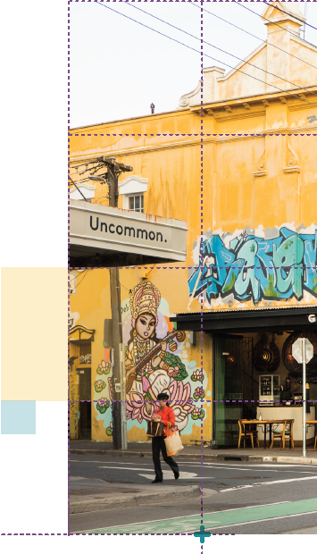

Strong Communities
- Invest in libraries, cultural centres and community hubs.
- Expand the network of health and education facilities and precincts.
- Continue to develop 20-minute neighbourhoods around activity centres.
- Map all schools, golf courses, tertiary campuses and large land holdings – identifying opportunities for shared-use agreements.
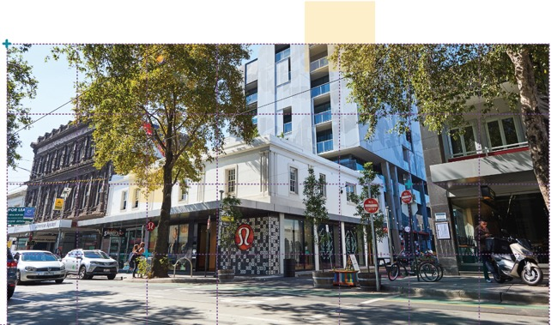

Sustainability and Resilience
- Expand the tree canopy coverage across the region to 30 per cent by 2050, to help with urban cooling and greening.
- Harvest and reuse stormwater to irrigate the region’s increased tree canopy – and help reduce the risk of floods.
- Plan for sea level rises in coastal environments, prepare local communities and limit land use change in places vulnerable to coastal inundation.

© The State of Victoria Department of Environment, Land, Water and Planning 2021
This work is licensed under a Creative Commons Attribution 4.0 International licence. You are free to re-use the work under that licence, on the condition that you credit the State of Victoria as author. The licence does not apply to any images, photographs or branding, including the Victorian Coat of Arms, the Victorian Government logo and the Department of Environment, Land, Water and Planning (DELWP) logo. To view a copy of this licence, visit http://creativecommons.org/licenses/by/4.0/
ISBN 978-1-76105-651-2 (pdf/online/MS word)

Disclaimer
This publication may be of assistance to you but the State of Victoria and its employees do not guarantee that the publication is without flaw of any kind or is wholly appropriate for your particular purposes and therefore disclaims all liability for any error, loss or other consequence which may arise from you relying on any information in this publication.

Credits
Green Scribble (graphic design); Tim Bell Studio (photos) and Department of Jobs, Precincts and Regions (photos).

Accessibility
If you would like to receive this publication in an alternative format, please telephone the DELWP Customer Service Centre on 136 186, email customer.service@delwp.vic.gov.au or via the National Relay Service on 133 677 www.relayservice.com.au. This document is also available on the internet at www.delwp.vic.gov.au
Submissions can be made online at engage.vic.gov.au
For any questions or assistance please contact lufp@delwp.vic.gov.au

