Outcome 5

MELBOURNE IS A CITY OF INCLUSIVE, VIBRANT AND HEALTHY NEIGHBOURHOODS
Melbourne has always been a city of neighbourhoods ever since the days of Little Lon and the establishment of the city’s first suburb, Fitzroy.
Neighbourhoods have varied in size and character and socio-demographic composition and have changed from generation to generation. They represent the most appropriate scale and basic building blocks for social sustainability, as shown in Figure 11.
Ultimately, people create the character of a neighbourhood. Where planning comes into the picture is to ensure that the fundamentals of a strong and sustainable neighbourhood—from shops to schools to parks to local facilities to local jobs—are all in place and easily accessible by walking and cycling paths or public transport. Strong and sustainable communities enjoy good access to local services, jobs, amenities and social infrastructure, a rich social and cultural life, voice and influence, and room to grow.
Figure 11 Building blocks for social sustainability
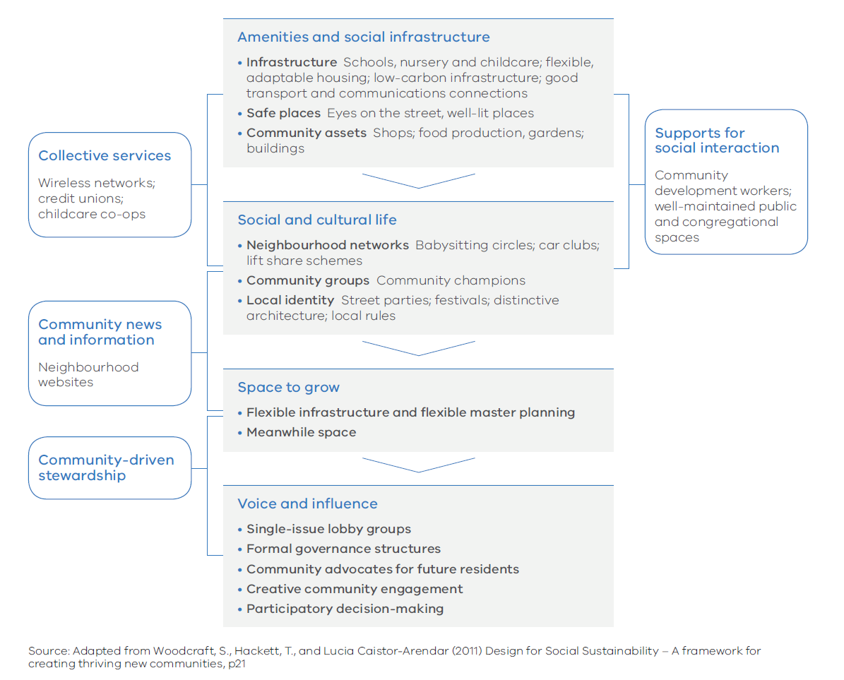

Melbourne’s Plan

Direction 5.1 Create a city of 20-minute neighbourhoods
Research undertaken by the Heart Foundation (Victoria) for the Victorian Government identifies hallmarks of a 20-minute neighbourhood.
A 20-minute neighbourhood must:
- be safe, accessible and well connected for pedestrians and cyclists to optimise active transport
- offer high-quality public realm and open space
- provide services and destinations that support local living
- facilitate access to quality public transport that connects people to jobs and higher-order services
- deliver housing/population at densities that make local services and transport viable
- facilitate thriving local economies.
The 20-minute neighbourhood is all about ‘living locally’—giving people the ability to meet most of their everyday needs within a 20-minute walk, cycle or local public transport trip of their home. If 20-minute neighbourhoods existed across Melbourne, it could reduce travel by nine million passenger kilometres and cut Melbourne’s daily greenhouse gas emissions by more than 370,000 tonnes.
Neighbourhood activity centres are an integral part of the city’s vibrant community life and critical to the creation of 20-minute neighbourhoods. These high streets and specialised strips of shops, cafes, small supermarkets, service businesses, community services and public spaces serve the needs of the surrounding community and provide a focus not only for local jobs but also for social interaction and community participation.
A 20-minute neighbourhood can create a more cohesive and inclusive community with a vibrant local economy—reducing social exclusion, improving health and wellbeing, promoting a sense of place, reducing travel costs and traffic congestion, and reducing carbon emissions across the city as a whole.
Due to the specialised and diverse nature of many people’s work, access to employment will often be outside the 20-minute neighbourhood.

Figure 12 The 20-minute neighbourhood
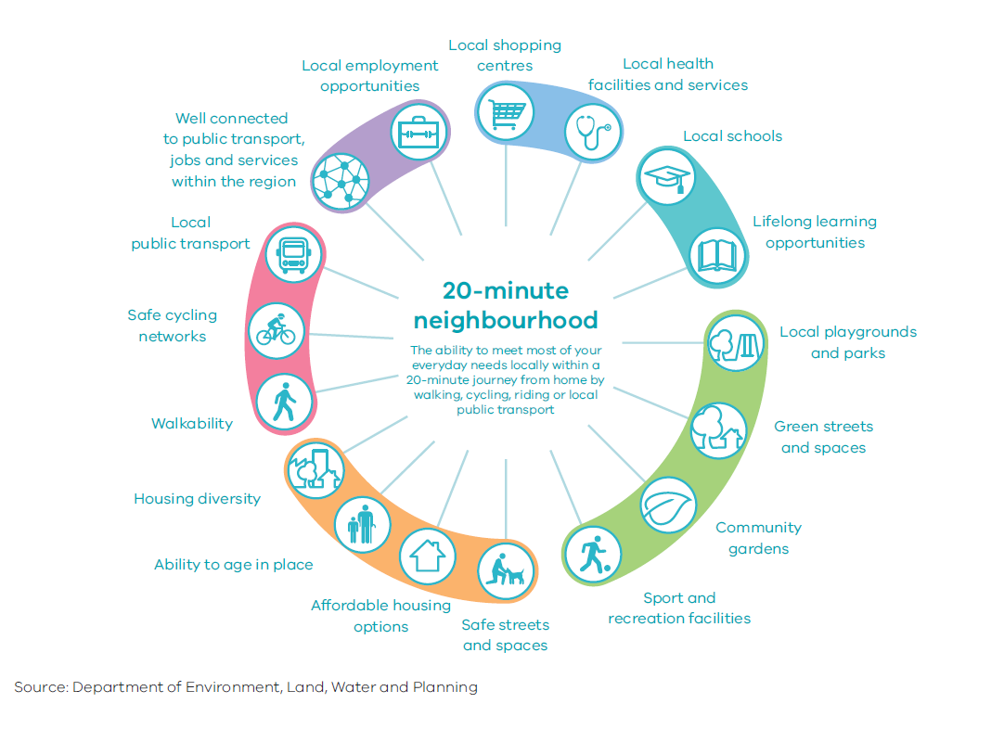

Policy 5.1.1 Create mixed-use neighbourhoods at varying densities
Neighbourhoods need to offer more choice in housing so they can accommodate a more diverse population, create opportunities for local businesses and new jobs, and deliver better access to local services and facilities.
Local government is best placed to understand and apply local solutions. The Victorian Government has a role in providing a supporting framework, including overarching strategies (such as for housing needs and metropolitan open space), to enable local government to better deliver local solutions for all residents.
The application of zones, such as the Residential Growth Zone and the Mixed Use Zone, can facilitate diverse housing and a greater mix of uses at varying densities.

Policy 5.1.2 Support a network of vibrant neighbourhood activity centres
The attributes of and opportunities for neighbourhood activity centres at the local level vary across Melbourne. That is why local communities should lead the planning of their own centres.
Where centres are well established or communities are seeking to protect the unique character of their centres (such as protecting heritage buildings or access to public land or open space to achieve community benefit), they should be assisted in determining the desired built form outcomes.
Local governments will be supported to prepare structure plans for their neighbourhood activity centres to help deliver 20-minute neighbourhoods.

Direction 5.2 Create neighbourhoods that support safe communities and healthy lifestyles
Increasingly, councils are taking a whole-of-population approach to health planning, particularly through municipal public health and wellbeing plans.
Likewise, many councils are focusing on factors that create the conditions for good health, ranging from the re-design of local neighbourhood parks and streets through to the development of new neighbourhoods and town centres. These include applying Crime Prevention Through Environmental Design (CPTED) principles in the design of public spaces.
Urban renewal precincts, greyfield redevelopment areas and transit-oriented development areas (such as railway stations) are enablers in the development of an integrated transport system. Well-designed infrastructure for walking and cycling are critical elements.
The Victorian Government will work with local governments and other stakeholders to create neighbourhoods that support safe and healthy communities.
Policy 5.2.1 Improve neighbourhoods to enable walking and cycling as a part of daily life
Internationally, New York City’s Active Design Guidelines and the World Health Organization’s Age Friendly Cities guide reflect the movement towards embedding health and wellbeing principles in urban design.
The National Heart Foundation has also developed tools to help local governments plan for better health and community wellbeing across a range of local government policy areas, including the Healthy by Design guidelines.
These guidelines encourage walking and cycling through good footpaths and connectivity, opportunities for physical activity, neighbourhood amenity, sustainability, accessibility, transport and community safety.
Principles for promoting cycling and walking should be embedded in precinct planning guidelines for new suburbs, urban renewal precincts, greyfield redevelopment areas and transit-oriented development areas (such as railway stations). The ultimate aim must be to promote cycling and walking. These guidelines need to inform the design of new neighbourhoods and the assessment of planning applications.

Direction 5.3 Deliver social infrastructure to support strong communities
It takes more than good land-use and transport planning to build good neighbourhoods. The economic and social benefits of providing social infrastructure can outweigh the costs of provision and result in a positive net return on investment. Social infrastructure encompasses all the facilities, services and networks that help families, groups and communities to meet their social, health, education, cultural and community needs. Space and resources are also needed for community meeting places, learning centres, neighbourhood houses, volunteer centres and welfare providers.
Social infrastructure should be designed to be accessible to all members of the community and, in growth areas, must be delivered early. Both the public and private sectors have key roles to play in this, as well as in the operation and maintenance of community facilities. In some cases there may be opportunities to make the most of existing public facilities, such as using school buildings outside school hours and co-locating aged-care and childcare centres.
Early provision of active open space and sports fields in neighbourhoods supports healthy communities. Some recreational and cultural facilities need to be provided in locations that service multiple neighbourhoods to optimise the value of investment and maximise accessibility to communities.
Many social services are delivered by not-for-profit organisations, which can find it hard to secure affordable floor spaces in new suburbs.
Cemeteries and crematoria need to be provided in sensitively chosen locations. It is important to cater for all faiths when planning for cemeteries and crematoria. The requirement for additional burial spaces needs to be reviewed on a regular basis.

Policy 5.3.1 Facilitate a whole-of-government approach to the delivery of social infrastructure
Delays in the delivery of social infrastructure can undermine the ability of a new neighbourhood to form strong social networks—entrenching car-dependent travel patterns that make the 20-minute neighbourhood unachievable.
Growth areas require the facilities and services that bring communities together—schools, kindergartens, early years centres, parks and playgrounds—early in the development process and in the right locations.
Initially, temporary spaces or buildings can be used for community service delivery, including developer display homes or demountables, pop-up parks (as in central Dandenong) and outreach service facilities. Local government could work with developers so that neighbourhood-based community liaison staff can operate out of temporary facilities.
Future school development needs to be linked with local sports infrastructure to maximise the use and the benefits gained from co-location.
Within established areas, better use of existing community infrastructure is required—such as the conversion of former town halls to libraries and other community uses. Community places and buildings must be planned and designed so that they can adapt as the population changes. Gaps or capacity issues in the provision of sporting facilities need to be addressed and integrated with planning for open space.

Policy 5.3.2 Create health and education precincts to support neighbourhoods
All neighbourhoods need good access to local and regional health services, primary and secondary schools, as well as tertiary education institutions within their metropolitan region. Major regional services and facilities must be provided in locations that are accessible to all members of the community, including those with disabilities.
In Victoria, almost 70 per cent of health services are provided by the private sector. The delivery of health and education precincts allows for more tailored planning of community services—including private services—at a local level.
Neighbourhood health and community wellbeing precincts will be supported where health and community wellbeing services—such as general practitioners, allied-health services, community health facilities and not-for-profit health providers—are co-located with good public transport access and are close to community infrastructure.
Communities also need access to regional health and community wellbeing precincts. That is why hospitals, allied-health services and not-for-profit health providers must be co-located within larger precincts well serviced by public transport and other community services.
To achieve these outcomes, the Precinct Structure Planning guidelines will be amended to include planning for health precincts located in or close to town centres in new suburbs.

Policy 5.3.3 Support not-for-profit community services to build social capital and stronger communities
Key community services are often delivered by not-for-profit community organisations. These organisations offer services and support, build social capital and strong communities, and create education and local work opportunities. The work of not-for-profit organisations provides many long-term benefits, such as reducing the future costs of disadvantage and poor health.
Not-for-profit organisations will be supported to operate in both established and growing neighbourhoods. This will be achieved by facilitating access to affordable space, by reducing project costs, and ensuring that the planning system supports the establishment of services and delivery of integrated responses with other service providers.

Policy 5.3.4 Provide and protect land for cemeteries and crematoria
Across Victoria, demand for new cemeteries and crematoria is increasing as existing facilities reach capacity. The Department of Health and Human Services has found that some local government areas no longer have capacity for burials, and others are expected to exhaust capacity before 2035. Suitable sites for future cemeteries and crematoria will be identified across Melbourne, particularly in growth areas, outer-metropolitan and regional areas. Planning provisions that protect and maintain the new sites will be put in place.

Direction 5.4 Deliver local parks and green neighbourhoods in collaboration with communities
Greening Melbourne’s neighbourhoods enhances beauty and amenity and provides more places where people can meet, exercise and relax. They give city dwellers a chance to enjoy natural environments, support biodiversity, and improve the quality of air, water and soil.
Residents should be included in community landscaping and revegetation opportunities such as community gardens, vegetable patches, play areas for children and greening streetscapes with tree planting and nature strip gardens. Communities can also convert disused public land into parkland to green their neighbourhoods and increase public open space.

Policy 5.4.1 Develop a network of accessible, high-quality, local open spaces
Open space provision must be fair and equitable with the aim of providing access that meets the needs of all members of the community, regardless of age, gender, ability or a person’s location. Urban redevelopment projects will provide opportunities to plan for new local open space. In some areas, practical solutions (such as using school grounds out of school hours) will add to the availability of open space and sport and recreation facilities. Similarly, schools will be supported to utilise existing public open space if their grounds are limited.

Policy 5.4.2 Support community gardens and productive streetscapes
Melbourne has more than 50 community gardens, with more planned. Establishing more community gardens will give Melburnians opportunities to share skills and learn from their neighbours’ food-growing knowledge, increase social interaction and community partnerships, produce local food for personal consumption or sale at local farmers’ markets, and promote healthy eating.
Another way to enhance the food production capability of the city is to plant productive trees along streets and in parklands. Planting trees that produce fruit and nuts freely available for anyone to pick and eat extends the concept of using public land to produce public food. However, care will be required to select appropriate locations within the public realm where factors such as biosecurity risk and public safety from effects such as pesticide sprays can be addressed.

Kelly, J.F., Breadon, P., Mares, P., Ginnivan, L., Jackson, P., Gregson, J. and Viney, B. (2012) Tomorrow’s Suburbs, Grattan Institute
National Growth Areas Alliance 2012, Community Infrastructure for Growth Areas, Technical Report (Elton Consulting)

