This version of the Five-Year Implementation Plan for Plan Melbourne 2017-2050 has been prepared for use with screen reader software. The printed publication contains various design features that have been necessarily omitted from this version. In other respects, this document contains identical text to that in the PDF version of the document which is available at planmelbourne.vic.gov.au

  - FIVE-YEAR
  - IMPLEMENTATION PLAN

PLAN MELBOURNE

2017-2050

© The State of Victoria Department of Environment, Land, Water and Planning 2017
This work is licensed under a Creative Commons Attribution 4.0 International licence. You are free to re-use the work under that licence, on the condition that you credit the State of Victoria as author. The licence does not apply to any images, photographs or branding, including the Victorian Coat of Arms, the Victorian Government logo and the Department of Environment, Land, Water and Planning (DELWP) logo. To view a copy of this licence, visit http://creativecommons.org/ licenses/by/4.0/
Printed by Impact Press, Brunswick
ISBN 978-1-76047-501-7 Print
ISBN 978-1-76047-502-4 Online (pdf / word)
Disclaimer
This publication may be of assistance to you but the State of Victoria and its employees do not guarantee that the publication is without flaw of any kind or is wholly appropriate for your particular purposes and therefore disclaims all liability for any error, loss or other consequence which may arise from you relying on any information in this publication.

Contents
Introduction 3
Partnerships for Melbourne’s future growth 4
Putting the plan into action 7
Planning for metropolitan regions 8
Outcome 1 Melbourne is a productive city that attracts investment, supports innovation and creates jobs. 9
Outcome 2 Melbourne provides housing choice in locations close to jobs and services. 14
Outcome 3 Melbourne has an integrated transport system that connects people to jobs and services and goods to market. 19
Outcome 4 Melbourne is a distinctive and liveable city with quality design and amenity. 24
Outcome 5 Melbourne is a city of inclusive, vibrant and healthy neighbourhoods. 29
Outcome 6 Melbourne is a sustainable and resilient city 31
Outcome 7 Regional Victoria is productive, sustainable and supports jobs and economic growth 37
Providing infrastructure and services to communities 40
Monitoring, reporting and review 42
Acronyms of departments and agencies 45
Appendix Metropolitan Melbourne Regions 46

Introduction
Plan Melbourne builds on the legacy of values that have made Melbourne one of the most liveable cities in the world. It is a long-term plan to accommodate Melbourne’s future growth in population and employment.
It contains an agenda to protect the character of the city while tackling the challenges of affordable housing, congestion, access to jobs and services, and climate change. Delivering Plan Melbourne’s actions is critical to achieving its vision to continue to be a global city of opportunity and choice.
Plan Melbourne is structured around seven outcomes:
- Melbourne is a productive city that attracts investment, supports innovation and creates jobs
- Melbourne provides housing choice in locations close to jobs and services
- Melbourne has an integrated transport system that connects people to jobs and services and goods to market
- Melbourne is a distinctive and liveable city with quality design and amenity
- Melbourne is a city of inclusive, vibrant and healthy neighbourhoods
- Melbourne is a sustainable and resilient city
- Regional Victoria is productive, sustainable and supports jobs and economic growth

Delivering Plan Melbourne
Integrating actions across government will be critical for the successful delivery of Plan Melbourne.
Plan Melbourne takes a whole-of-government approach to metropolitan planning implementation by embedding actions across state government departments, authorities, agencies and local government.
The plan focuses on the area comprising the 31 metropolitan municipalities, plus the part of Mitchell Shire that is located within the urban growth boundary. It also covers important issues for municipalities outside metropolitan Melbourne, particularly peri-urban areas and regional cities, and key transport corridors.
The Victoria Planning Provisions and all planning schemes will be updated to give effect to Plan Melbourne. This includes amendments to the State Planning Policy Framework, to which local planning schemes will be aligned.

Reviewing implementation progress
Plan Melbourne’s implementation will be reviewed every five years, with the first review in 2022.
The Department of Environment, Land, Water and Planning will undertake annual monitoring and reporting in consultation with other government departments and agencies.
Annual reporting will include updates to the status of actions, including changes to timeframes for completion and lead agencies or implementation partners.
New actions that are state-led and deliver on Plan Melbourne’s outcomes will be added as part of the annual update, as approved by the Minister for Planning in consultation with other relevant ministers. This includes any updates from the government’s response to Infrastructure Victoria’s 30-year strategy in 2017.

Partnerships for Melbourne’s future growth
Plan Melbourne will continue to contribute to a 21st-century city that is distinctive, globally-connected and competitive—a city designed to encourage social and economic participation, with strong and healthy communities and a resilient environment.
A new era of partnership has emerged where government, businesses and the community are working together to plan for the future. Implementing Plan Melbourne in a partnership approach will require a sustained and committed effort from everyone.

Lead agencies and partners
As part of creating a platform for action, the government has made a number of essential organisational changes.
Established in January 2015, the Department of Environment, Land, Water and Planning (DELWP), connects all parts of the planning — environment, water, land-use planning and development. DELWP coordinates the whole-of-government approach to the implementation of Plan Melbourne.
Established in July 2019, the Department of Jobs, Precincts and Regions (DJPR) drives economic development and job creation across Victoria with a focus on building thriving places, investment attraction, trade, innovation, regional development and small business.
Also established in July 2019, the Department of Transport coordinates Victoria’s transport system, delivers major projects and plans for the network’s future. Other key agencies with a critical role to play in the planning and delivery of Plan Melbourne outcomes include Development Victoria, VLine, Rail Projects Victoria and the Level Crossing Removal Authority.
These departments, together with the Victorian Planning Authority (VPA), provide the framework for Plan Melbourne’s implementation and will lead delivery of its actions.
The VPA will deliver integrated land-use and infrastructure planning in key urban renewal areas, national employment and innovation clusters, growth areas, regional centres and regional areas undergoing transition. Its role in delivering Plan Melbourne involves promoting the supply of housing, encouraging resilient development, and facilitating the delivery of infrastructure and services for communities.
Other implementation partners include the Department of Health and Human Services (DHHS) and Department of Education and Training (DET), alongside heritage agencies, land managers, water authorities and councils.

Connecting with other strategies, plans and policies
Delivery of Plan Melbourne will occur within a network of interconnected activities guided by state and local strategies, plans and policies that are already underway. These are outlined in the ‘initiatives underway’ section of each outcome.
This includes the development of Infrastructure Victoria’s 30-year infrastructure strategy, which will inform the government’s five-year infrastructure plan for Victoria.
Infrastructure Victoria is an independent authority which provides advice on Victoria’s infrastructure needs and priorities. Plan Melbourne’s actions will align with the government’s priority infrastructure projects and funding.

Local government partnerships
Local government shares responsibilities with the Victorian Government in planning for Melbourne’s future, especially for housing, delivering community infrastructure critical to 20-minute neighbourhoods, and ensuring community involvement in planning.
Local government, in partnership with DELWP and other government agencies, will focus on:
- participating in Metropolitan Partnerships and other metropolitan regional governance arrangements to support Plan Melbourne implementation
- undertaking local planning actions to implement Plan Melbourne.
Further engagement on partnership arrangements for Plan Melbourne implementation will occur with local government starting in early 2017.

Metropolitan regional planning
A new ministerial portfolio of Suburban Development has been established within DELWP. The portfolio will develop five-year plans for jobs, services and infrastructure, with new governance arrangements for each of the six metropolitan regions.
There was strong support for a regional approach to metropolitan planning in Plan Melbourne refresh submissions to focus state and local government activities on regional priorities. The Metropolitan Melbourne Regions are shown at Map 1. These align with the new boundaries for the Metropolitan Partnerships and include a new Inner South East Region and Maribyrnong is now included in the Western Region.
Metropolitan regional planning groups based on these metropolitan regions will be re-established to support the collaborative implementation of many of Plan Melbourne’s actions and input into the respective Metropolitan Partnerships.
MAP 1 Metropolitan Melbourne regions
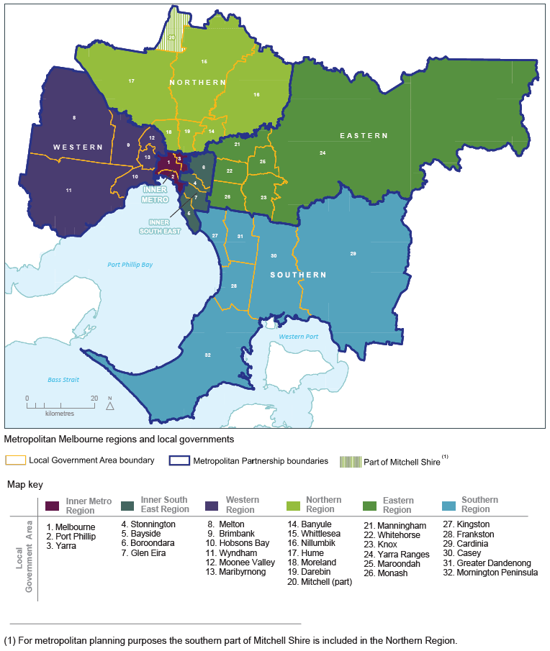
Source: Department of Environment, Land, Water and Planning

Putting the plan into action
This plan sets out 112 new actions to implement Plan Melbourne. These build on initiatives already underway. Each action identifies the Plan Melbourne direction it delivers.
The indicative timeframes for completing actions are:
- Short term: by the end of 2018 (0-2 years)
- Medium term: by the end of 2021 (2-5 years)
- Long term: beyond 2021 (more than 5 years)
A small number of actions are identified as ‘ongoing’ rather than having a fixed timeframe for completion as they provide essential services for metropolitan planning.
Each action is allocated to a lead agency (or agencies) with primary responsibility for delivering the action. Many actions also have identified implementation partners critical to the delivery of the action, due to their core responsibilities or area of expertise. Other stakeholders will be involved in delivering Plan Melbourne actions as projects are further scoped.
The list of actions is publicly available on the Plan Melbourne website.

Decision-making processes to support the delivery of Plan Melbourne
Plan Melbourne is a statement of policy intent. Detailed decisions about the implementation and timing of actions and infrastructure delivery will be made in line with the normal government policy and budget processes.
The government will continue its commitment to rigorous decision-making about initiatives that require funding, statutory amendments or new regulations in line with its economic and fiscal strategy, including the government’s long-term financial management objectives.
In particular, all projects and initiatives requiring budget funding will be carefully assessed against budget capacity, with rigorous business cases and cost-benefit analyses applied as part of their economic impact assessment.
For infrastructure projects, this will include ensuring consistency with the government’s Investment Lifecycle and High Value / High Risk Guidelines. For all other initiatives and actions, implementation and timing will be subject to consideration of their evidence base and likely net benefits.

Planning for metropolitan regions
To better align state and local planning and the development of local planning strategies over the next five years, the metropolitan regional planning groups will develop land-use framework plans for each metropolitan region. This work will inform the review and update of local planning schemes to align with Plan Melbourne.
Maps providing more detail for each of the six regions are in the Appendix. These provide the base for further work to be undertaken by the metropolitan regional planning groups.
Land-use framework plans for each of the metropolitan regions
In consultation with the Metropolitan Partnerships, the metropolitan regional planning groups will prepare a land-use framework plan for each of the six metropolitan regions. The land-use framework plans will include strategies for population growth, jobs, housing, infrastructure, major transport improvements, open space and urban forests.
The plans will identify:
- land to be set aside primarily for business and employment-generating purposes
- precincts and activity centres where a mix of higher-density residential, commercial and other activities are encouraged
- urban renewal precincts and sites where medium- and higher-density housing and mixed-use development will be encouraged
- transit-oriented development opportunities that arise from major transport infrastructure projects such as the Metro Tunnel, level crossing removals and the Regional Rail Link
- an access framework that ensures that activity centres and urban renewal, employment and tourism precincts are supported by walking, cycling, public transport and night travel options
- additional regional-scale community, health, education, recreation, sporting and cultural facilities
- additional regional open space networks and enhancements and greening initiatives.
Plan Melbourne directions | Multiple
Timeframe | Medium
Lead agency | DELWP
Implementation partners | Councils, VPA, DJPR, DHHS, DET

Outcome 1 Melbourne is a productive city that attracts investment, supports innovation and creates jobs

Initiatives underway
Making Victoria number one in employment and economic growth by attracting global talent and investment through initiatives like the international Victorian Government Business Office network, providing support for globally connecting business and creating a business events fund.
The government has committed $236.9 million in the 2016–17 budget.
Growing our future industries and gaining a competitive advantage by facilitating key sectors such as medical technology and pharmaceuticals, new energy technology, food and fibre processing, transport, defence and construction technology, international education and professional services.
$111.4 million is allocated in the 2016–17 budget.
Creating jobs of the future through a range of government initiatives including the Investment Attraction and Assistance Program, the Smart Planning Program and the Premier’s Jobs and Investment Fund.
$184.7 million is allocated for these initiatives in the 2016–17 budget.
Delivering a new approach to training through the Skills First initiative to reform the TAFE system and deliver high-quality public and private training that students and industry can trust. Under the initiative courses most likely to get people into high-skilled, well-paid work will be prioritised.
Establishing the Victorian Heart Hospital at Monash University, Clayton. An Australian first, the hospital will bring together leading organisations to deliver world-class research, education and public health in the treatment and prevention of cardiovascular disease.
$135.0 million is committed in the 2016–17 budget In addition to $15 million in the 2015-16 budget.
Planning for better access to health and jobs. The Travis Review recommended the development of a plan to assess risks for co-locating hospitals, allied health services and not-for-profit providers in larger precincts as a way of better matching capacity and demand.
The first healthcare Statewide Strategic Services and Infrastructure Plan will be published in 2017.
Recasting the vision for Fishermans Bend Urban Renewal Precinct, which includes a 205-hectare employment precinct. Capitalising on its strategic location between the Melbourne Central Business District and the Port of Melbourne, Fishermans Bend will attract international investment and provide 60,000 jobs and housing for 80,000 people.
The Fishermans Bend Taskforce released the Fishermans Bend Vision in September 2016.
Leading Arden’s urban renewal with significant opportunities to accommodate future population and employment growth in the central city. It is envisioned that Arden will be a base for 34,000 jobs and 15,000 residents by 2051.
The Victorian Planning Authority released the Draft Arden Vision and Framework in September 2016.

What’s next
Central city planning
In consultation with the Cities of Melbourne, Port Phillip and Yarra, develop a whole-of-government approach to planning for the central city that:
- establishes a program for the timing and staging of development across different urban renewal precincts within the central city to identify the particular investments required to support such growth, and the timeframe anticipated for its delivery
- outlines an access framework that connects all employment precincts to the CBD and to the wider metropolitan transport system. The framework will identify new, strategic transport connections and identify transport-management strategies including walking, cycling, public transport and night-time travel options
- determines the specialised economic functions of individual precincts across the central city and the infrastructure necessary to support growth
- identifies opportunities to establish and expand creative industries, small businesses and tourism
- identifies opportunities to improve the public realm, open space, social, cultural and recreational facilities that support the central city’s economic functions
- recommends utility improvements to accommodate growth
- makes recommendations about whether special governance arrangements will be necessary to coordinate matters such as investment facilitation, infrastructure delivery and development approvals.
Plan Melbourne direction | 1.1
Timeframe | Short
Lead agencies | DELWP and DJPR
Implementation partners | VPA, Cities of Melbourne, Port Phillip and Yarra
Central city urban renewal precincts
Prepare long-term land-use and infrastructure plans for the state-significant urban renewal precincts in the central city identified in Plan Melbourne, including Arden, Macaulay, E-Gate, Fishermans Bend, Docklands, Dynon and the Flinders Street Station to Richmond Station Corridor.
These plans will:
- develop a vision for each urban renewal precinct
- define the mix of land uses such as residential, commercial, employment, education, health and community services and open space
- identify public realm improvements to enable high-quality urban environments
- consider the sequencing of infrastructure to maximise development potential.
Plan Melbourne direction | 1.1
Timeframe | Short - medium
Lead agencies | VPA and DJPR
Implementation partners | DELWP, councils
Land-use and infrastructure plans for the national employment and innovation clusters
Work in partnership with local governments, major institutions, utility providers, land owners and investors to prepare long-term land-use and infrastructure plans for national employment and innovation clusters (NEICs). Current work on Sunshine, Monash and La Trobe will be followed by Dandenong, Parkville and Werribee.
For each NEIC these plans will:
- develop a shared vision and desired outcomes statement
- define its specialised activities and capacity to expand over time
- identify constraints on employment and business growth, and the preconditions necessary to facilitate investment
- define the planning boundary
- evaluate whether existing planning controls provide effective planning frameworks.
See Action 22 regarding Fishermans Bend NEIC.
Plan Melbourne direction | 1.1
Timeframe | Medium
Lead agency | VPA
Implementation partners | DELWP, DJPR, councils
Business investment strategies for NEICs
Develop business investment strategies for each NEIC as each land-use and infrastructure plan is developed, to identify and define outcomes and preconditions for investment.
Plan Melbourne direction | 1.1
Timeframe | Medium
Lead agency | DJPR
Implementation partners | VPA, councils
Health and education precincts
Review planning provisions for health and education precincts to support their continued effective operation and their future growth and expansion, including in the case of health precincts, for associated allied health services.
Many health and education precincts are within NEICs, metropolitan or major activity centres, so may be included in planning for these locations.
Plan Melbourne direction | 1.1
Timeframe | Short – medium
Lead agency | VPA
Implementation partners | DHHS, DET, DELWP, DJPR, councils
Tertiary education opportunities in the west
Plan for additional tertiary education offerings in the west, focusing on the Sunshine and Werribee NEICs. This will improve the distribution of higher education services across metropolitan Melbourne.
Plan Melbourne direction | 1.1
Timeframe | Medium
Lead agencies | DJPR and DET
Implementation partners | DELWP, VPA, councils
Significant industrial precincts
Work with local government to strengthen regionally significant industrial precincts in established urban areas for employment-generating activities by:
- ensuring that sufficient land is zoned for employment purposes and that sensitive land uses such as housing are not permitted to be established in them
- retaining larger industrial precincts for local manufacturing, service industries, warehousing and distribution
- promoting the renewal of older industrial areas that are no longer well suited to industrial activities for alternative employment activities such as offices, creative industries and other employment-generating activities
- facilitating improved information and communications technology infrastructure, access and amenity within these areas
- reviewing planning, building and environmental regulations to ensure that these are not barriers to the affordable conversion of designated industrial areas for alternative employment-generating activities
- identifying areas no long required for employment activities.
Plan Melbourne direction | 1.1
Timeframe | Short
Lead agency | DELWP
Implementation partners | VPA, DJPR, councils
Planning for activity centres
Work with metropolitan regional groupings of councils to review the opportunities and constraints of the activity centre network and individual activity centres in implementing Plan Melbourne. This may include identifying priority activity centres for future planning, developing a program to prepare or update structure plans, reviewing local planning policy and streamlining planning provisions. The current list of activity centres is in the Appendix.
Plan Melbourne direction | 1.2
Timeframe | Medium
Lead agency | DELWP
Implementation partners | DJPR, VPA, councils
Activity centre performance review
Undertake a review of the performance of activity centres according to an agreed set of criteria that monitors the success of structure plans against future employment and housing needs. This will inform the further development of activity centre policy for the five-year review of Plan Melbourne.
Plan Melbourne direction | 1.2
Timeframe | Medium
Lead agency | DELWP
Implementation partners | DJPR, VPA
Guidelines on new activity centres
Develop a practice note for identifying and establishing new activity centres based on the following criteria. New activity centres should:
- be well served by a range of transport options (including public transport), with priority given to new centres that are based on transit-oriented development principles
- have capacity to establish a wider mix of uses
- increase the density and diversity of housing in a walkable area
- meet an identified market need
- contribute to delivering a network of 20-minute neighbourhoods.
Plan Melbourne direction | 1.2
Timeframe | Medium
Lead agency | DELWP
Implementation partners | DJPR, VPA
Planning for future employment growth
Assist councils to plan for future employment needs by:
- addressing how metropolitan regional employment demand forecasts can be translated into floorspace requirement, land-use and zoning frameworks
- providing direction for assessing the ongoing suitability of established industrial and commercial areas for different types of employment purposes
- providing direction about when such areas should be retained for employment purposes and when they should be considered for rezoning to mixed-use or residential.
Plan Melbourne direction | 1.2
Timeframe | Short
Lead agency | DELWP
Implementation partners | DJPR, VPA
Employment opportunities in growth areas
Designate substantial employment precincts through the Precinct Structure Plan (PSP) process. Work with developers and councils to find ways to create a greater diversity of employment opportunities in growth areas such as through allocating space to small businesses, access to conference facilities or shared meeting spaces.
Plan Melbourne direction | 1.2
Timeframe | Short
Lead agency | VPA
Implementation partners | Councils, DJPR, DELWP
Economic development and employment outcomes in growth areas
Monitor and analyse the economic development and employment outcomes in growth areas to inform future economic policy development and precinct structure planning.
Plan Melbourne direction | 1.2
Timeframe | Short
Lead agency | DELWP
Implementation partners | Councils, DJPR, VPA
Review planning for telecommunications infrastructure
Undertake the following to support the provision of telecommunications infrastructure:
- Review the Code of Practice for Telecommunications Facilities in Victoria 2004 to ensure it meets the needs of service users and providers.
- Ensure adequate telecommunications pathways in new buildings, particularly multi-unit dwellings, shopping centres and office buildings.
- Ensure that all areas identified as significant employment centres (e.g. NEICs, metropolitan activity centres, major commercial and industrial areas and major urban renewal precincts) include early planning for fibre-ready facilities and telecommunications infrastructure.
Plan Melbourne direction | 1.2
Timeframe | Medium
Lead agencies | DELWP and DJPR
Implementation partner | VPA
Urban renewal pipeline of projects across Melbourne
Identify and plan a pipeline of transit-oriented development and urban renewal opportunities that deliver mixed-use neighbourhoods with high levels of amenity and connectivity for future residents and workers.
Plan Melbourne direction | 1.3
Timeframe | Short
Lead agency | VPA
Implementation partners | DJPR, DELWP, councils
Support strategic planning for agriculture
Improve planning decision-making to support sustainable agriculture by identifying areas of strategic agricultural land in Melbourne’s green wedges and peri-urban areas. This will give consideration to climate change, soils and landscape, access to water, integration with industry and significant government investment in agricultural infrastructure. It will also protect the right to farm in key locations within green wedges and peri-urban areas.
Plan Melbourne direction | 1.4
Timeframe | Short
Lead agency | DELWP
Implementation partner | DJPR
Management of extractive industry
Protect the extractive industry and future extractive-resource assets from incompatible land uses by adopting planning options consistent with the findings of the Extractive Resources in Victoria, Demand and Supply Study, 2015–2050.
Plan Melbourne direction | 1.4
Timeframe | Short
Lead agency | DELWP
Implementation partner | DJPR

Outcome 2 Melbourne provides housing choice in locations close to jobs and services

Initiatives underway
Giving Victorians access to safe, affordable and secure housing through the Victorian Government’s housing strategy, Homes for Victorians. Initiatives under the strategy will help to ensure housing supply can meet growing demand, promote home ownership and a sustainable rental market, increase the supply of social and affordable housing and provide better support services for vulnerable people.
The strategy includes a number of funded programs which are complementary to Plan Melbourne.
Ensuring amenity, liveability and sustainability of apartments through the Better Apartments initiative led by DELWP and with input from the Office of the Victorian Government Architect (OVGA).
Public feedback has been used to shape the Better Apartments Design Standards that will be introduced into the Victoria Planning Provisions and local planning schemes.
Reviewing the application of residential zones in metropolitan Melbourne and the regional cities of Bendigo, Ballarat, Geelong and Latrobe, including a public consultation and hearing process by the Managing Residential Development Advisory Committee and taskforce.
The Residential Zones State of Play reports and a List of Suggested Improvements were released in January 2016.
Unlocking the potential of greyfield areas by creating tools to help identify, consult on and implement greyfield urban renewal precincts for medium-density housing development.
The government is a key sponsor of Swinburne University’s work on greyfield development through the Cooperative Research Centre for Spatial Information. Councils will be encouraged to identify potential greyfield areas as part of implementing Plan Melbourne.
Delivering essential research on population and housing trends to inform decision-making. Information is provided through DELWP’s Urban Development Program, Housing Development Data and the annual Victoria in Future report.

What’s next
Metropolitan regional housing plans to guide housing growth
In consultation with the Metropolitan Partnerships, the metropolitan regional planning groups will prepare metropolitan regional housing plans to implement Plan Melbourne and inform updates to local housing strategies and planning schemes.
For each metropolitan region, these plans will:
- assess the existing capacity to accommodate more dwellings over the period to 2051, as well as the infrastructure enhancements required to support growth
- identify the preferred locations for the delivery of medium- and higher-density housing, consistent with Plan Melbourne directions
- determine the additional aggregate housing supply that can be delivered
- identify the particular housing diversity and affordability issues that need to be addressed, including in areas of social inequality and disadvantage
- assess what policy, statutory planning and infrastructure frameworks will be required to realise this housing capacity
- identify short-term priorities in relation to housing supply, affordability and diversity, and actions to address them.
Plan Melbourne direction | 2.1
Timeframe | Short
Lead agency | DELWP
Implementation partners | Councils, VPA, DJPR
Precinct Structure Planning Guidelines
Update the Precinct Structure Planning Guidelines to incorporate learnings from previous Precinct Structure Plans (PSPs) in growth areas, and to align with Plan Melbourne and extend their application to urban renewal areas and regional areas.
This will include undertaking an independent assessment of the outcomes of the existing PSPs in consultation with growth area councils, communities and the development industry.
Key Plan Melbourne elements for incorporation in PSP guidelines are:
- creating 20-minute neighbourhoods
- applying the residential zones and Mixed Use Zone to encourage a diversity of lot sizes and housing types in the short and long term
- providing for residential densities of 25 or more dwellings per hectare close to activity centres and adjacent to train stations and high-quality public transport in growth areas
- providing for a greater diversity of employment uses, including small businesses
- promoting walking and cycling in the design of new suburbs, particularly to schools
- planning for health and/or education precincts
- facilitating future renewable and low-emission energy-generation technologies
- greening in both the public and private realm, focusing on increasing vegetation on properties, transport corridors and public lands
- considering options for creating space for not-for-profit organisations in activity centres and shared space in community centres
- applying planning provisions in growth area PSPs and settlement planning in peri-urban areas to best manage natural hazards
- providing for waste and resource recovery infrastructure in line with the Metropolitan Waste and Resource Recovery Implementation Plan.
Plan Melbourne directions | Multiple
Timeframe | Short
Lead agencies | VPA and DELWP
Implementation partners | Councils, DJPR, DHHS, DET
A clear sequence for growth area development
Prepare a sequencing strategy for PSPs in growth areas for the orderly and coordinated release of land and the alignment of infrastructure plans to deliver basic community facilities with these staged land-release plans. This will include the following tasks:
- Monitor land supply and infrastructure delivery, as well as forecast development patterns and population growth rates across each of the five growth areas.
- Plan for the delivery of the state and local infrastructure identified in PSPs needed to support new communities.
- Identify the timing of funding available from various funding sources. Arrangements with developers such as ‘works-in-kind’ can assist in bringing forward infrastructure investments.
Plan Melbourne direction | 2.2
Timeframe | Short
Lead agency | VPA
Implementation partners | DELWP, councils
Fishermans Bend as Australia’s largest urban renewal area
Deliver world-class urban renewal for Fishermans Bend. This includes:
- developing and finalising precinct plans for the Lorimer, Montague, Sandridge and Wirraway neighbourhoods and a framework for the Fishermans Bend employment precinct
- reviewing and updating planning provisions
- finalising transport and community infrastructure plans
- identifying funding models and potential opportunities for delivering additional public open space
- interpreting Aboriginal and European culture and history associated with the area
- embedding the Green Star-Communities requirements into the precinct plans and framework.
Plan Melbourne direction | 2.2
Timeframe | Short
Lead agency | DELWP
Implementation partners | DJPR, VPA, Cities of Melbourne and Port Phillip
Redevelopment of greyfield areas
Support councils to identify greyfield areas suitable for redevelopment for medium-density housing and lot consolidation.
Plan Melbourne direction | 2.2
Timeframe | Medium
Lead agency | DELWP
Implementation partners | Councils
Planning system reforms for social and affordable housing
Reform the planning system to facilitate the supply of social and affordable housing. Reforms should:
- develop and implement definitions of social and affordable housing into the planning system
- formally recognise and give statutory effect to the delivery of social and affordable housing as a legitimate planning outcome in Victoria. This will enable the development of new planning provisions or tools to deliver social and affordable housing including exploring inclusionary zoning and mechanisms to capture and share value created through planning controls
- develop a streamlined planning approval process for social housing projects.
Plan Melbourne direction | 2.3
Timeframe | Short
Lead agency | DELWP
Implementation partners | Councils
Surplus government land for social housing
Identify underutilised and surplus government land that has potential to deliver additional social housing. Undertake pilot projects to demonstrate how planning mechanisms can deliver more social and affordable housing.
Plan Melbourne direction | 2.3
Timeframe | Short
Lead agency | DELWP
Implementation partner | DHHS
Voluntary tool for affordable housing decisions
Develop a voluntary tool and best-practice guidance to provide certainty and ease of delivery where affordable housing outcomes have been agreed between local government and the applicant.
This voluntary tool could be used by councils pursuing affordable housing, or as planning concessions to developers in exchange for affordable housing.
Plan Melbourne direction | 2.3
Timeframe | Short
Lead agency | DELWP
Implementation partners | DHHS, councils
Value capture tool for delivery of affordable housing
Develop a tool to share the uplift in land value from rezoning, with that value shared between the land owner, council and the delivery of affordable housing.
Plan Melbourne direction | 2.3
Timeframe | Short
Lead agency | DELWP
Implementation partners | DHHS, councils
Review residential development provisions
Review the residential development provisions in the Victoria Planning Provisions to increase the supply of housing in established areas and streamline the planning approvals process for developments in locations identified for housing change. This will include:
- reviewing the VicSmart provisions
- establishing measures to develop a codified process for the approval of medium-density housing in identified locations.
Plan Melbourne direction | 2.4
Timeframe | Medium
Lead agency | DELWP
Implementation partners | Councils
Remediation of contaminated land
Improve the processes for assessing and remediating contaminated sites to reduce the uncertainty of clean-up requirements and bring land to market sooner.
Plan Melbourne direction | 2.4
Timeframe | Medium
Lead agency | DELWP
Implementation partner | EPA
Better Apartments Design Standards
Implement the finalised apartment design standards to ensure that new apartments are environmentally sustainable, have amenity and quality functional layouts.
Plan Melbourne direction | 2.5
Timeframe | Short
Lead agency | DELWP
Implementation partner | OVGA
Streamline the approvals process for specific housing types
Develop and implement a streamlined approvals process for specific housing types that address local housing gaps such as aged-care accommodation, secondary dwellings and student housing.
Plan Melbourne direction | 2.5
Timeframe | Short
Lead agency | DELWP
Implementation partner | DHHS
Planning for shared housing, community care units and crisis accommodation
Reform planning provisions for shared housing, community care units and crisis accommodation to clarify rules, exemptions and definitions so that these forms of housing continue to be facilitated through the planning system.
Plan Melbourne direction | 2.5
Timeframe | Short
Lead agency | DELWP
Implementation partner | DHHS

Outcome 3 Melbourne has an integrated transport system that connects people to jobs and services and goods to market

Initiatives underway
Building the $10.9 billion Metro Tunnel to create a new metro-style, end-to-end rail line from Sunbury in the west to Cranbourne and Pakenham in the south east, with high-capacity trains and five new underground stations at Arden, Parkville, CBD North, CBD South and Domain.
Delivering a vital second river crossing through the $5.5 billion Western Distributor Project. Offering an alternative to the West Gate Bridge, the proposed project includes the Western Distributor, the Monash Freeway upgrade and access improvements to Webb Dock.
The government has committed $1.46 billion over the forward estimates to the project.
Removing 50 of Melbourne’s most dangerous and congested level crossings with an eight-year project overseen by the Level Crossing Removal Authority. Removing the crossings will improve safety, travel times and access for all users, and revitalise local communities.
The government has committed $5-6 billion to the Level Crossing Removal Program. This includes removing all of the remaining level crossings between Dandenong and the city as part of the Caulfield to Dandenong Level Crossing Removal and Line Upgrade project. The project also involves building five new stations and power and signalling upgrades.
Leading ongoing adaptive transport planning for significant places, interchanges and metropolitan transport corridors across Melbourne including national employment and innovation clusters, major urban renewal precincts and activity centres to build capacity across the transport system. Planning will draw on options identified by Infrastructure Victoria’s 30-year infrastructure strategy.
Public transport improvements currently budgeted for include:
- $875 million for additional new High Capacity Metro Trains
- $105.2 million to purchase additional X’Trapolis trains
- $274 million for an additional 20 E-class trams to add to the 50 E-class trams which are currently being rolled out across the network
- $596.7 million towards the Mernda rail extension to support new communities in Melbourne’s northern growth areas and support the development of a new town centre in Mernda
- $518.4 million for the duplication of the Ballarat line to Melton, to increase the frequency of services for the Ballarat region and Melbourne’s growing outer west
- $140.2 million for the duplication of a section of the rail line between Heidelberg and Rosanna as part of the Hurstbridge line upgrade, to improve the frequency and reliability of services
- $100 million to improve Victoria’s bus networks by adding more routes, increasing frequencies, restoring cut services and fixing the missing links in Melbourne’s growth areas.
The government is also delivering a range of improvements to public transport interchanges and station precincts including:
- $63.1 million for the Frankston station precinct redevelopment
- $8.2 million for the Huntingdale station precinct upgrade
- $4 million upgrade to Broadmeadows station as part of a $14.3 million rejuvenation of the activity centre
- two new stations at Caroline Springs and Southland.
A further $6.2 billion has been committed to improve and upgrade Victoria’s metropolitan road and freeway networks and arterial road connections across Melbourne, including:
- $437 million to upgrade Thompsons Road, Yan Yean Road, O’Hearns Road, Hoddle Street and Bolton Street, Eltham (in addition to $23 million allocated to these projects in the 2015-16 budget)
- $228 million to duplicate sections of Dohertys Road and Hallam Road, and widen Plenty Road, reducing travel times on these key arterial roads in the outer suburbs
- $10 million to plan the next stage of expanding the outer suburban arterial road network to meet the growing demand and reduce congestion in growth areas across Melbourne.
$114.5 million is allocated in the 2015-16 budget to upgrade the Chandler Highway bridge over the Yarra River, easing congestion for the thousands of motorists who use it daily.
Encouraging more Victorians to walk and cycle through the Traffic Accident Commission $100 million Safer Cyclists and Pedestrian Fund and improvements to Melbourne cycling routes in the updated Victorian cycling strategy. Additional projects to extend on-road and off-road bike lanes and safety measures are being investigated for funding.
The government has committed $3.3 million over three years to Active Transport Victoria to increase participation in walking and cycling and focus on safety.

What’s next
Metro-style rail system
Plan for future improvements that continue the transition to a metro-style rail system, such as identifying lines for high-capacity signalling upgrades, simpler timetables with ‘turn up and go’ frequency, comfortable and efficient interchange opportunities and adding further capacity across the network.
Plan Melbourne direction | 3.1
Timeframe | Short – medium
Lead agency | DJPR
Implementation partner | DoT
Integrated transport strategy for Fishermans Bend
Produce an integrated transport strategy for Fishermans Bend including developing road and street alignments that complement planning for public transport and cycling and walking links that can be implemented immediately and strengthened over time as the precinct develops.
Plan Melbourne direction | 3.1
Timeframe | Short
Lead agency | DJPR
Implementation partners | Councils, DoT
Improvements in the metropolitan bus and tram network
Implement further improvements across the metropolitan bus and tram network including:
- improving connections to and between NEICs and urban renewal precincts, including Parkville, Monash, Sunshine and La Trobe NEICs; as well as Fishermans Bend, Arden and Macaulay urban renewal precincts
- improving efficiency of the tramway network with additional trials of new treatments to enhance tram priority across the network, such as continuing the roll out of the successful tramway treatments on existing peak hour tram lanes
- investigating changes to the road-space allocation to prioritise bus and tram movements in priority locations
- progressively updating existing bus service plans to better link people to job-rich areas and community and service centres, following bus network consultation across metropolitan Melbourne
- expanding the availability of real-time public transport information across all public transport modes both to internet-based services and at key transport hubs.
Plan Melbourne directions | 3.1 3.2
Timeframe | Short – medium
Lead agency | DJPR
Implementation partner | DoT
Incorporation of the Principal Public Transport Network (PPTN) into planning schemes
Provide up-to-date transport information to guide land-use decision-making by:
- incorporating the current PPTN into planning schemes as an interim PPTN in early 2017
- revising and updating the PPTN in planning schemes by December 2017 in consultation with local government and the community.
Plan Melbourne directions | 3.1 3.2
Timeframe | Short
Lead agency | DELWP
Implementation partners | DJPR, DoT
Motorway network improvements
Implement initiatives that improve the efficiency of the motorway network including:
- delivering the Western Distributor to provide an alternative route to the West Gate Bridge and improve connections to the Port of Melbourne
- delivering Intelligent Transport Systems across the motorway network, such as the lane-use management signs, automatic incident detection and electronic freeway management systems being implemented on the M80 and the M1 motorways
- analysing and assessing the next required enhancements to the motorway network, following consideration of Infrastructure Victoria’s assessment and 30-year infrastructure strategy.
Plan Melbourne directions | 3.1 3.2
Timeframe | Medium
Lead agency | DJPR
Implementation partner | DoT
North East Link
Commence planning work for the North East Link to improve freight and other connectivity between south-east Victoria and central and western Victoria including removing freight from local roads.
Plan Melbourne direction | 3.1
Timeframe | Short
Lead agency | DJPR
Implementation partner | VicRoads
Integrated transport planning
Undertake integrated planning in significant metropolitan transport corridors, places and interchanges to deliver improved transport and land-use outcomes.
Plan Melbourne directions | 3.1 3.2
Timeframe | Short – medium
Lead agency | DJPR
Implementation partners | DELWP, VPA, councils
Land for future transport
Apply planning protection and progressively acquire land for future transport infrastructure such as road, rail, port, intermodal freight terminal reservations and tram and train stabling, and promote and support interim alternative uses for this land that can provide benefit to the community.
Plan Melbourne directions | 3.1 3.2
Timeframe | Ongoing
Lead agency | DJPR
Implementation partner | PTV
Initiation of a referral process review across transport agencies
Review planning referrals and transport impacts from recent developments. This would lead into a review for strengthening and updating the current planning referrals process and investigating ways to streamline the use and impact of these referrals.
Plan Melbourne direction | 3.1
Timeframe | Short
Lead agency | DJPR
Implementation partner | DELWP
Strategic cycling corridors
Develop strategic cycling corridors, beginning with links across the central city to enable more people to access jobs by bike from inner and middle suburbs.
Future developments to close critical gaps and progress the delivery of the strategic plan for cycle routes will be considered in future budgets.
Plan Melbourne directions | 3.1 3.2
Timeframe | Short
Lead agency | DJPR
Implementation partners | VicRoads, councils
Safe, efficient and accessible pedestrian networks
Work with councils to develop safe, efficient and accessible pedestrian networks using the Principal Pedestrian Network guidelines, and identify and enhance major pedestrian links, including those that intersect with the state road network.
Plan Melbourne direction | 3.3
Timeframe | Medium
Lead agency | DJPR
Implementation partners | Councils
Local networks of cycling links
Work with councils to create local networks of cycling links including:
- identifying on- and off-road cycling links
- fixing missing links in the network
- improving local cycling network connections.
Plan Melbourne direction | 3.3
Timeframe | Medium
Lead agency | DJPR
Implementation partners | Councils
Local transport forums
Trial local transport forums in metropolitan and regional Victoria to identify innovative and flexible ways to improve local transport options and enhance local mobility.
These forums will operate at a local level to address local movements within communities, including how transport assets and resources are used.
Plan Melbourne direction | 3.3
Timeframe | Short
Lead agency | DJPR
Implementation partners | Councils
Accessible justice services
Work with developers and councils to accommodate growth in justice services in metropolitan Melbourne and regional centres in locations with good access to existing public transport.
Plan Melbourne direction | 3.3
Timeframe | Medium
Lead agency | DJCS
Implementation partners | Councils
Strategy for landside access to Melbourne Airport
Develop a new strategy for landside access to Melbourne Airport to support both employment areas and visitor access. This should include investigating:
- upgrading airport bus services and regional private bus services
- improving Metro Smart Bus services from the northern and western regions
- retaining the rail reservation and station location to enable a future airport rail link when demand warrants it.
Plan Melbourne direction | 3.4
Timeframe | Short
Lead agency | DJPR
Implementation partner
Strategy for future gateways
Protect options for future air and sea ports and intermodal terminals through appropriate planning frameworks.
This must ensure sufficient capacity to meet future bulk and container needs beyond the capacity of the Port of Melbourne, and plan for sufficient air freight and passenger landside access for Victoria.
This should include decisions on the relative priorities for investment in:
- Bay West or the Port of Hastings
- Western Interstate Freight Terminal and/or the Beveridge Interstate Freight Terminal
- Avalon Airport and a potential South-East Airport.
Plan Melbourne direction | 3.4
Timeframe | Medium
Lead agency | DJPR
Implementation partners | PTV, VicRoads
Plan for a possible airport in the South East Region
Finalise a preferred site for a possible future airport beyond Koo Wee Rup, should demand warrant this beyond 2030. Preserve this future option by incorporating planning protection for flight paths and noise contours and the alignment for a connection to the rail line at Clyde.
Plan Melbourne direction | 3.4
Timeframe | Medium
Lead agency | DELWP
Implementation partner | DJPR
Incorporation of the Principal Freight Network following stakeholder engagement in planning schemes
Engage with stakeholders to confirm the Principal Freight Network and prepare guidelines to be incorporated into planning schemes by December 2017.
Plan Melbourne direction | 3.4
Timeframe | Short
Lead agency | DJPR
Implementation partners | Councils
Identification and protection of key corridors for High-Productivity Freight Vehicles (HPFV)
Identify and protect key corridors for the movement of HPFV and strengthen the network at key locations to accommodate HPFV movements as a subset of the Principal Freight Network.
Plan Melbourne direction | 3.4
Timeframe | Medium
Lead agency | DJPR
Implementation partner

Outcome 4 Melbourne is a distinctive and liveable city with quality design and amenity

Initiatives underway
Protecting the Yarra River’s amenity and significance by working on introducing legislation, stronger planning controls and an independent ministerial advisory committee to manage this valuable asset for the benefit and enjoyment of future generations.
Amendment VC121 to the State Planning Policy Framework and all planning schemes was gazetted in December 2015, strengthening Yarra River protection policy. Interim planning controls were implemented to protect the Yarra River within the City of Yarra in January 2016.
Amendment C48 has introduced stronger planning controls from Punt Road (Richmond) to Warrandyte to protect the Yarra and its land from inappropriate development.
The Yarra River Action Plan, unveiled in February 2017, outlines 30 actions including the creation of the Birrarung Council, which comprises Traditional Owners and representatives from environmental, farming and community bodies. The Council will provide independent advice to the government and ensure the community’s voice is heard on all matters concerning the Yarra River.
The government has committed $1 million in the 2015–16 budget.
Generating productivity, income, jobs and export earnings for Victoria’s creative industries. Creative State – Victoria’s first creative industries strategy 2016–2020 was released in 2016. It recognises the value creative industries bring to Victoria to benefit the wider community and economy.
The government has allocated $114.95 million in the 2016–17 budget.
Supporting the repair and conservation of ‘at risk’ heritage places and objects included in the Victorian Heritage Register through the Living Heritage Grants Program.
The government has committed $30 million over four years. Funds of up to $200,000 per project will be available.
The Victorian Heritage Act 1995 is being reviewed to provide a transparent, modern, streamlined legislative framework.
Supporting Victoria’s Aboriginal cultural heritage management and protection through reforms to the Aboriginal Heritage Act 2006.
The Aboriginal Heritage Amendment Act 2016 commenced operation on 1 August 2016.
$1 million is committed in the 2016–17 budget for this initiative.
Securing the future of Victoria’s major stadia and arenas by establishing a ministerial working group, headed by the Premier of Victoria, to oversee a Major Stadia Strategy to ensure that Victoria’s network of stadia and arenas continues to provide a world-class experience.
The strategy will provide a strategic framework to guide planning and investment decisions relating to major stadia and arenas in both metropolitan and regional Victoria. A draft strategy will be released for public comment in the second quarter of 2017 with a final strategy to be launched in the third quarter of 2017.

What’s next
Community participation in planning
Increase community participation early in the planning of urban renewal precincts and areas undergoing change to improve the effectiveness of the planning process.
Plan Melbourne direction | 4.6
Timeframe | Short
Lead agency | DELWP
Implementation partners | VPA, councils
Place-making for public places
Work with local government to improve planning, design and management of public places across Melbourne, including public squares, parks, laneways and pedestrian malls. This includes identifying opportunities for new public places as part of planning for activity centres, urban renewal precincts and other strategic locations.
A more focused place-making approach will be adopted to strengthen the design quality of public spaces, accessibility and the interfaces between private developments and the public domain.
Plan Melbourne direction | 4.1
Timeframe | Medium
Lead agency | DELWP
Implementation partners | DJPR, OVGA, VPA, councils
Exemplary design outcomes from city-shaping infrastructure projects
Implement measures to ensure new transformative and city-shaping infrastructure projects, such as the Metro Tunnel and level crossing removals, deliver exemplary design outcomes and opportunities for new public spaces and connections that will add to Melbourne’s vitality.
Plan Melbourne direction | 4.1
Timeframe | Medium
Lead agency | DJPR
Implementation partners | DELWP, OVGA, VPA, councils
Excellence in built environment design
Promote excellence in how Victoria’s built environment is designed and constructed by:
- embedding design review in the assessment of significant development projects to ensure the highest possible design outcomes are achieved on major public- and private-sector projects. This will apply to:
  - significant government or funded (including local government) projects
  - projects that impact on places on the Victorian Heritage Register
  - significant private-sector projects referred by local government
- strengthening design understanding and capabilities within all levels of government.
Plan Melbourne direction | 4.3
Timeframe | Ongoing
Lead agency | OVGA
Implementation partners | DELWP, VPA, DJPR, councils
Urban design guidelines
Update existing urban design guidelines for Victoria to support community wellbeing via development that encourages physical activity and community interaction.
Plan Melbourne direction | 4.3
Timeframe | Short
Lead agency | DELWP
Implementation partners | OVGA, councils
Urban design advisory service to local government
Partner with local government to establish a three-year pilot urban design advisory service (modelled on the successful heritage advisory service).
Plan Melbourne direction | 4.3
Timeframe | Medium
Lead agency | DELWP
Implementation partners | VPA, councils
Data and design technology
Consider using advanced data and design technology to inform how to best plan and design Melbourne.
Create an information technology platform that brings together 3D models of Melbourne’s form and a variety of city data sets relating to the built environment to inform the future planning and design of buildings, streets and spaces.
Plan Melbourne direction | 4.3
Timeframe | Short
Lead agency | DELWP
Implementation partner | VPA
‘Movement and Place’ road management framework
Embed the ‘Movement and Place’ road management framework in the planning of Melbourne’s transport network. This is a new transport planning approach that optimises the relationship between the transport network and the people and places that this network serves.
Plan Melbourne direction | 4.1
Timeframe | Short
Lead agency | DJPR
Implementation partners | DELWP, VicRoads, councils
Improved streetscapes
Finalise and implement a long-term metropolitan strategy for streetscapes, including boulevards, and encourage local measures to improve streetscapes, accessibility and local amenity.
Plan Melbourne direction | 4.1
Timeframe | Short
Lead agency | DELWP
Implementation partners | VicRoads, DJPR, VPA, councils
Great Yarra Parklands
Establish the Great Yarra Parklands from the crown land reserves along the metropolitan Yarra River (from Warrandyte to Port Phillip, excluding reserves for the port) as a state urban parkland. This will provide the basis for an integrated, strategic approach to guiding the many committees of management along the river in their management and development plans.
Plan Melbourne direction | 4.1
Timeframe | Short
Lead agency | DELWP
Implementation partners | Parks Victoria, Melbourne Water, councils
Planning provisions for the Yarra and Maribyrnong Rivers and other major waterways
Protect the natural landscape settings of Melbourne’s major waterways by finalising stronger planning controls along the Yarra River corridor and consider expanding them to other major waterways including the Maribyrnong River.
Plan Melbourne direction | 4.1
Timeframe | Medium
Lead agency | DELWP
Implementation partners | Councils, Parks Victoria, Melbourne Water
Waterway corridor master plans
Prepare waterway corridor master plans for priority waterways to ensure that Traditional Owner and community values of waterways, such as access, amenity and connection to nature, are protected and improved.
Plan Melbourne direction | 4.1
Timeframe | Medium
Lead agency | DELWP
Implementation partners | VPA, Melbourne Water, councils
Affordable spaces for creative industries
Identify opportunities for emerging creative industries to access affordable spaces to pursue cultural production and expression by removing regulatory barriers, and brokering and facilitating cultural development programs.
Plan Melbourne direction | 4.2
Timeframe | Medium
Lead agency | DJPR
Implementation partners | Councils
Tourism infrastructure
Identify land-use, transport and infrastructure requirements for growing the tourism market, including appropriate locations and delivery timelines. Build on existing strategies for central Melbourne’s future tourism to capitalise on its strengths as a tourist destination.
Plan Melbourne direction | 4.2
Timeframe | Medium
Lead agency | DJPR
Implementation partners | Councils, DELWP
Sporting facilities
Plan for ready access to quality, multi-use sporting facilities, as well as major venues close to public transport for major spectator events.
Plan Melbourne direction | 4.2
Timeframe | Medium
Lead agency | DHHS
Implementation partners | DET, DJPR, VPA
Golf statewide facilities plan
Work with the golf industry and local government to develop a strategic metropolitan-wide facilities plan that will meet the future needs of the sport, given the increasing pressures for some golf courses to be rezoned for residential use.
Plan Melbourne direction | 4.2
Timeframe | Short
Lead agency | DELWP
Implementation partners | DHHS, councils, DJPR, VPA
Lead by example in design services procurement for state government projects
Investigate opportunities to improve design services procurement policy for the delivery of government projects.
Plan Melbourne direction | 4.3
Timeframe | Medium
Lead agency | OVGA
Implementation partners | DJPR, DTF
Heritage planning initiatives
Ensure that Melbourne’s heritage assets and distinctive historic precincts are protected, enhanced and celebrated by:
- working with local governments to enhance and improve local heritage planning policies, controls and assessment processes
- developing guidelines in relation to the conservation of cultural heritage
- ensuring heritage conservation values are considered in urban renewal precincts and other places across the city
- using innovative ways to communicate and celebrate Melbourne’s history for residents and visitors alike
- promoting and supporting development of heritage tourism opportunities
- recognising the diverse ways in which people celebrate their heritage through arts and culture projects.
Plan Melbourne direction | 4.4
Timeframe | Medium
Lead agency | DELWP
Implementation partners | Councils, DPC, Victorian Heritage Council, Victorian Aboriginal Heritage Council
Recognition and protection of Aboriginal cultural heritage values
Work with Traditional Owners to ensure Aboriginal cultural heritage is recognised, and to celebrate Aboriginal culture in the planning and development of Melbourne. This will be achieved through continuing a program of country mapping to improve understanding, recognition and protection of Aboriginal cultural heritage places.
Plan Melbourne direction | 4.4
Timeframe | Short
Lead agency | DPC
Implementation partner | DELWP, VPA, Victorian Aboriginal Heritage Council
Actively involve Aboriginal people in cultural heritage management
Create opportunities for Aboriginal people to be actively involved in the identification, protection, rehabilitation and ongoing management of cultural heritage places across Melbourne, working with Traditional Owners, Aboriginal community organisations, councils and others.
Plan Melbourne direction | 4.4
Timeframe | Ongoing
Lead agency | DPC
Implementation partners | Councils, VPA, Victorian Aboriginal Heritage Council
Review green wedge planning provisions
Review green wedge planning provisions to ensure they support Plan Melbourne outcomes for green wedges.
Plan Melbourne direction | 4.5
Timeframe | Medium
Lead agency | DELWP
Implementation partners | Councils
Green Wedge Management Plans
Support local government to complete and implement green wedge management plans to protect and enhance the agricultural, biodiversity, environmental, natural resource, tourism, landscape and other values of each of Melbourne’s green wedges by:
- introducing a legislative requirement in the Planning and Environment (Metropolitan Green Wedge Protection) Act 2003 for local government to prepare and review Green Wedge Management Plans
- investigating options to support local governments in implementing adopted Green Wedge Management Plans.
Plan Melbourne direction | 4.5
Timeframe | Medium
Lead agency | DELWP
Implementation partners | DJPR, Parks Victoria, councils
Localised planning statements for distinctive areas and landscapes
Finalise localised planning statements for the Macedon Ranges and Yarra Valley and prepare localised planning statements for other distinctive areas within Melbourne’s green wedges and peri-urban areas.
The recent process for the preparation of a Macedon Ranges Localised Planning Statement will be used as a model for developing others.
Plan Melbourne direction | 4.5
Timeframe | Medium
Lead agency | DELWP
Implementation partners | Councils

Outcome 5 Melbourne is a city of inclusive, vibrant and healthy neighbourhoods

Initiatives underway
Ensuring Melbourne’s fastest growing suburbs remain great places to live and work by establishing a new ministerial portfolio of Suburban Development within the Department of Environment, Land, Water and Planning (DELWP).
The portfolio will develop five-year plans for jobs, services and infrastructure, with new governance arrangements for metropolitan regions through Metropolitan Partnerships.
Keeping Melbourne’s communities strong and liveable by delivering essential services in education, health and public safety. Scores of Victorian schools will be refurbished, maintained and rebuilt as part of the Education State initiative led by the Department of Education and Training.
The 2016–17 budget has allocated $895 million for school building projects.
Putting wellbeing at the heart of healthy communities through the Victorian Public Health and Wellbeing Plan 2015–2019, prepared by the Department of Health and Human Services. The plan will drive investment and promote standards of health and participation at every age.
$1 billion has been allocated in the 2016–17 budget to enable health services to respond to growing demand in all areas of patient care.
Bringing vital infrastructure to outer Melbourne communities through the Growing Suburbs Fund. Funds will accelerate the delivery of critical infrastructure in Melbourne’s fastest growing outer suburbs, contributing to local job creation, addressing social disadvantage and building healthy and liveable communities.
$50 million has been invested in 2016–17 and is administered by DELWP.
Supporting the development of community sports and events through infrastructure initiatives administered by the Department of Health and Human Services. Initiatives will deliver new sporting facilities in Melbourne and regional Victoria to boost local grassroots participation in sports.
The 2016–17 budget has committed $46.4 million to community sports and events.
Providing targeted support for disadvantaged communities through a Community Renewal and Rebuilding Fund established by the Department of Premier and Cabinet. The fund will support locally driven interventions and place-based projects in disadvantaged communities.
Funding of $12 million has been committed from the 2016–17 budget.
Ensuring public open space in the new communities of Fishermans Bend by acquiring land enabled by a $12.9 million commitment in the 2015–16 budget.

What’s next
Whole-of-government approach to 20-minute neighbourhoods
Embed the 20-minute neighbourhood concept as a key goal across government. Key steps are to:
- identify and undertake flagship 20-minute neighbourhood projects with the metropolitan regions and the private sector to focus planning and implementation work
- provide guidance to local government on embedding the 20-minute neighbourhood concept into local planning schemes
- build community partnerships to help deliver 20-minute neighbourhoods
- improve information and research to be shared with local government.
Plan Melbourne direction | 5.1
Timeframe | Short
Lead agency | DELWP
Implementation partners | Councils, DHHS, DJPR, DoT, VPA
Action 75 - 1 20-Minute Neighbourhood Program *new
Support delivery of 20-minute neighbourhoods across Melbourne and support delivery of the recommendations from the 20-minute neighbourhoods – Creating a more liveable Melbourne report 2019.
The recommendations are grouped into the following themes:
- Policy — Embedding 20-minute neighbourhoods in decision-making
- Place — Guidance to design liveable places
- Partnerships — Connecting government, industry and communities.
Plan Melbourne direction | 5.1
Timeframe | Long
Lead agency | DELWP
Implementation partners | DPC, DHHS, DJCS, DJPR, DoT, VPA, Councils
Metropolitan-wide ‘neighbourhoods index’
Create a metropolitan-wide ‘neighbourhoods index’ that identifies the key characteristics of Melbourne’s neighbourhoods (such as activity centres, schools, public transport, housing density and diversity, walkability and tree cover).
This index will be a building block for establishing a more comprehensive, metropolitan-wide database of neighbourhoods for use in future planning and monitoring activities.
Plan Melbourne direction | 5.1
Timeframe | Medium
Lead agency | DELWP
Implementation partners | Councils, VPA
Neighbourhood health and community wellbeing precincts and education services
Plan for existing and new neighbourhood health and community wellbeing precincts and education services, particularly in areas that have service gaps and/or are easily accessible by public transport to communities in need. Ensure adequate land is zoned for the future development and growth of these facilities which will be accessible to all.
Plan Melbourne direction | 5.3
Timeframe | Short
Lead agency | DHHS
Implementation partners | Councils, VPA, DET, DELWP
Not-for-profit community service providers
Investigate whether there are planning impediments to the establishment and operation of not-for-profit community service providers, particularly in growth areas, to ensure key community services can be delivered through these providers.
Plan Melbourne direction | 5.3
Timeframe | Short
Lead agencies | VPA and DHHS
Implementation partner | DELWP
Locations for cemeteries and crematoria
Work with cemetery trusts to identify and secure locations for cemeteries and crematoria and put the appropriate planning provisions in place.
Plan Melbourne direction | 5.3
Timeframe | Short
Lead agency | DHHS
Implementation partner | DELWP

Outcome 6 Melbourne is a sustainable and resilient city

Initiatives underway
Committing Victoria to reducing greenhouse gas emissions by setting a long-term target of net zero emissions by 2050. Reducing emissions will be supported by five-yearly interim reduction targets and a pledging system for all levels of government, business and community.
Driving the uptake of renewable energy by setting renewable energy generation targets of 25 per cent by 2020 and 40 per cent by 2025. The targets will drive an estimated $2.5 billion of investment and an additional 4,000 jobs in Victoria’s renewable energy sector.
The government is developing a Renewable Energy Action Plan.
$12.1 million from the Sustainability Fund will support the implementation of the Renewable Energy Action Plan.
Strengthening environmental policy and strategy through reviews of the Climate Change Act 2010 and developing new policy platforms including the second Climate Change Adaptation Plan and Victorian Climate Change Framework. From 2020, a five-yearly Climate Change Strategy will be developed for Victoria, replacing the requirements for a Climate Change Adaptation Plan.
Delivering an energy efficient and productive economy for Victoria through the Energy Efficiency and Productivity Strategy that will provide improved energy efficiency outcomes, reduce greenhouse gas emissions and reduce energy price pressures on homes and businesses.
Strengthening the strategic response to natural hazards by implementing risk-mitigation strategies. The government’s strategies to keep Victorians safe from hazards such as bushfires and floods are outlined in the Victorian Emergency Management Strategic Action Plan 2015–2018, the Victorian Floodplain Management Strategy 2016, Melbourne Water’s Flood Management Strategy – Port Phillip and Westernport, Critical Infrastructure Resilience Strategy and Safer Together: A new approach to reducing the risk of bushfire in Victoria.
$74 million is committed from the 2016–17 budget for bushfire preparedness and response activities.
Setting the strategic direction for water management in Victoria for decades to come through the government’s new water plan, Water for Victoria. Developed through extensive community consultation, it is a plan for managing Victoria’s precious water resources and responds to the impact of climate change and a growing population.
The implementation of Water for Victoria, released in October 2016, is being funded through the Environmental Contributions Levy.
Growing Melbourne’s network of green spaces through a range of programs and projects such as Living Links, Greening the West and other initiatives by the People and Parks Foundation. The Resilient Melbourne strategy brings these initiatives together as part of a metropolitan urban forest strategy for all of Melbourne.
The City of Melbourne, the government and the 202020 Vision have also produced the How to Grow an Urban Forest guide for local governments.
Improving the energy efficiency of existing government buildings and infrastructure through the Greener Government Buildings program. Investment in new lighting technologies, heating and cooling systems and solar power will save energy and reduce greenhouse emissions across a number of government buildings and infrastructure.
$33 million is committed to this initiative.
Developing a new biodiversity strategy to improve the natural environment, including protecting Victoria’s plants and animals, tackling weeds and working with communities to protect threatened species and improve their habitats.
A draft biodiversity plan, Protecting Victoria’s Environment – Biodiversity 2036, was released for public comment in mid-2016 and a summary of submissions report published.
$54.5 million is allocated over four years.
Managing key issues that affect the bays and coasts by developing an Environmental Management Plan for Port Phillip Bay, a new Marine and Coastal Act and reviewing the State Environment Protection Policy (Waters of Victoria) and State Environment Protection Policy (Groundwaters of Victoria).
Introducing stronger air quality standards by adopting a nation-leading standard for limiting air pollution. The Environment Protection Authority will monitor and report against these new standards, with results set to inform the government’s future policy formulation and regulation.
The government is allocating $6.2 million for air quality monitoring and smoke detection infrastructure in the Latrobe Valley.
Identifying priority actions to reduce waste to landfill and improve recycling rates. The Metropolitan Resource and Waste Recovery Implementation Plan identifies priority actions to reduce the amount of waste going to landfill, improve recycling rates and plan for Melbourne’s growth and future sustainability.
The government is committing $21 million over four years to create jobs and drive innovation in the waste and resource recovery sector.

What’s next
Review of planning and building systems to support environmentally sustainable development outcomes
Review the Victorian planning and building systems to support environmentally sustainable development outcomes for new buildings to consider their energy, water and waste management performance.
Plan Melbourne direction | 6.1
Timeframe | Short
Lead agency | DELWP
Implementation partner
Lead by example on environmentally sustainable development
Lead by example by establishing minimum energy, water and waste performance standards for the construction and upgrade of government buildings, including public housing.
Plan Melbourne direction | 6.1
Timeframe | Medium
Lead agency | DELWP
Implementation partners | DTF, DHHS
Energy efficiency of existing buildings
Improve the energy efficiency of existing housing (including rental properties) and non-residential buildings to meet Victoria’s net zero emissions target by 2050. This includes the Greener Government Buildings Program and roll-out of the Residential Efficiency Scorecard, to enable homeowners to understand and improve the energy performance of their homes, and a strengthened and expanded Victorian Energy Efficiency Target Scheme.
Plan Melbourne direction | 6.1
Timeframe | Medium
Lead agencies | DELWP and DTF
Implementation partners | Councils
Higher building energy efficiency standards
Advocate for higher building energy efficiency standards through national forums that are consistent with broader energy efficiency policy.
Plan Melbourne direction | 6.1
Timeframe | Short
Lead agency | DELWP
Implementation partner
Renewable energy technologies to achieve Victorian renewable energy targets of 25 per cent by 2020 and 40 per cent by 2025
Facilitate the uptake of renewable energy technologies by:
- establishing a whole-of-government policy framework for the deployment and operation of renewable energy technologies and facilitate opportunities for local electricity generation in growth areas and strategic sites
- promoting the use of battery storage technology, such as through a regulatory framework
- investigating opportunities and constraints for precinct-scale use of renewable resources
- investigating opportunities for renewable energy initiatives in Melbourne’s green wedges and peri-urban areas
- partnering with others to deliver renewable energy demonstration projects
- leading by example by implementing renewable energy and energy efficiency initiatives in government projects, including large-scale public buildings, roads and public transport projects
- establishing a renewable energy auction scheme.
Plan Melbourne direction | 6.1
Timeframe | Medium
Lead agency | DELWP
Implementation partners | Councils
Improvement of natural hazard, climate change and environmental adaptation and risk-mitigation strategies in planning schemes
Review, update and improve the implementation of natural hazard, climate change and environmental adaptation and risk-mitigation strategies in the Victoria Planning Provisions and planning schemes to:
- ensure the right identification of the hazard through agreed technical criteria with data custodians
- ensure a consistent statewide policy approach targeted to relevant natural hazards and climate change impacts
- improve the approach to settlement resilience in areas exposed to high natural hazard and climate change risk
- ensure provisions remain current and based on the best available climate change science
- influence growth and settlement patterns to avoid and reduce long-term risk.
Plan Melbourne direction | 6.2
Timeframe | Short
Lead agency | DELWP
Implementation partners | VPA, councils
Whole-of-settlement adaptation and risk-mitigation strategies
Prepare whole-of-settlement adaptation and risk-mitigation strategies to improve community resilience for inclusion in local planning schemes. This will also include providing best-practice guidance for responsible authorities on taking risk-mitigation principles into consideration in the preparation and assessment of development applications.
Plan Melbourne direction | 6.2
Timeframe | Medium
Lead agency | DELWP
Implementation partners | VPA, councils
Coastal hazard assessment
Complete local coastal hazard assessments and associated risk analysis for Port Phillip Bay and Western Port.
Plan Melbourne direction | 6.2
Timeframe | Medium
Lead agency | DELWP
Implementation partners | Parks Victoria, Port Phillip and Westernport Catchment Management Authority, councils
Incorporate climate change risks into infrastructure planning
Prepare guidance to support local government on the application of the Australian Standard Climate change adaptation for settlements and infrastructure – A risk based approach to the planning, design and ongoing management of settlement and infrastructure.
Plan Melbourne direction | 6.2
Timeframe | Short
Lead agency | DELWP
Implementation partners | Councils
Integrated water management planning
Work with Melbourne Water, water corporations and councils to undertake integrated water management planning at the catchment and local scale. This will address the needs and values of the local community and support efficient, coordinated investment in water-related liveability outcomes.
Plan Melbourne direction | 6.3
Timeframe | Short
Lead agency | DELWP
Implementation partners | Melbourne Water, water corporations, councils, VPA
Protecting water and sewerage infrastructure
Determine land area and buffer requirements for water and sewerage infrastructure assets and review planning provisions to ensure the ongoing protection of the environment, public health and safety.
Plan Melbourne direction | 6.3
Timeframe | Medium
Lead agency | DELWP
Implementation partners | Water corporations, VPA
Whole-of-government approach to cooling and greening Melbourne
Create urban forests throughout the metropolitan area by:
- assembling and disseminating spatial data on the green space network, existing tree cover and surfaces. This data will be the baseline for modelling future greening strategies and their impacts on amenity of our urban areas including cooling effects
- working with local government to establish greening targets for each of the metropolitan regions
- liaising with water corporations to identify opportunities for use of alternative water supply to support greening strategies
- supporting development of municipal urban forest strategies using a coordinated approach with VicRoads, private road operators and other public land owners and managers
- preparing greening strategies for state-owned public land, including schools, parkland, road, rail and utility corridors, achieving an appropriate balance between asset protection and urban greening
- investigating a targeted grants program to support innovation and actions for greening neighbourhoods
- investigating demonstration projects including green roofs, green walls and landscapes
- preparing new guidelines and regulations that support greening new subdivisions and developments via landscaping, green walls, green roofs and increase the percentage of permeable site areas in developments.
Plan Melbourne direction | 6.4
Timeframe | Short – medium
Lead agency | DELWP
Implementation partners | VicRoads, water corporations, councils, Port Phillip and Westernport Catchment Management Authority, VPA
Funding processes for alternative water sources
Develop funding processes to enable use of alternative water sources to support urban cooling and greening including recycled water for sports fields and key urban landscapes during periods of drought.
Plan Melbourne direction | 6.4
Timeframe | Short
Lead agency | DELWP
Implementation partners | Water corporations, councils
Metropolitan open space strategy
Prepare a metropolitan open space strategy that enhances recreation, amenity, health and wellbeing, species diversity, sustainable water management and urban cooling across Melbourne. The strategy will include measures to:
- protect and enhance existing open spaces, underpinned by improved and accessible spatial data
- plan for an increase in open space, particularly in areas identified as lacking access to open space, areas undergoing substantial population growth, and areas where the network of green spaces could be expanded or improved
- enhance the role, function and overall community value of currently underutilised public land assets (e.g. utility easements, school grounds) in contributing to the open space network
- better coordinate the delivery and management of open space across state and local government, including identifying management objectives for different parts of the network and developing standard agreements to manage land
- provide improved network planning and provision guidance for both state and local government.
Plan Melbourne direction | 6.4
Timeframe | Medium
Lead agency | DELWP
Implementation partners | VPA, councils, Port Phillip and Westernport Catchment Management Authority
Protecting the health of waterways from stormwater run-off
Protect the health of waterways from stormwater run-off by:
- reviewing the Victoria Planning Provisions to improve stormwater management and related outcomes for all urban development
- developing a framework for setting place-based outcome targets to further inform the application of planning and building provisions and stormwater management decisions
- identifying the best mix of legislative, regulatory, financial and market-based incentives to complement the application of planning provisions and building regulations.
Plan Melbourne direction | 6.5
Timeframe | Medium
Lead agency | DELWP
Implementation partners | Melbourne Water, councils
Environmental protection for coastlines and waters of Port Phillip Bay and Western Port
Improve environmental protection for Melbourne’s coasts and the waters of Melbourne’s bays (including Western Port’s sensitive Ramsar wetlands) through local planning schemes.
Plan Melbourne direction | 6.5
Timeframe | Medium
Lead agency | DELWP
Implementation partners | Melbourne Water, Port Phillip and Westernport Catchment Management Authority, EPA, Parks Victoria, councils
Improve air quality
Investigate further opportunities to improve air quality in Melbourne, focusing on pollutants and sources predicted to have greater future impacts. This will include assessing market-based incentives, greater use of differential registration and/or road pricing.
Plan Melbourne direction | 6.6
Timeframe | Medium
Lead agency | DELWP
Implementation partners | EPA, DJPR
Guidelines for noise impact in new developments
Investigate ways to reduce the impacts of noise in new developments in a cost-effective manner. These will focus on ensuring that new developments meet their responsibility of mitigating noise impacts such as those from transport, industry and entertainment.
Plan Melbourne direction | 6.6
Timeframe | Medium
Lead agency | DELWP
Implementation partners | EPA, DJPR
Review and update guidelines for separation distances for sensitive uses
Review and update relevant guidelines to inform the location of and separation distances for sensitive uses and, where appropriate, provide planning, building and urban design advice about how air emissions and noise exposure can be reduced.
Plan Melbourne direction | 6.6
Timeframe | Medium
Lead agency | DELWP
Implementation partners | EPA, VPA, councils
Forward planning for waste and resource recovery infrastructure
Determine the capacity of existing landfill and resource recovery facilities and undertake forward planning for new or expanded waste facilities to ensure Melbourne has the infrastructure it needs in the right locations. This will include:
- identifying opportunities for co-location of resource recovery infrastructure with complementary infrastructure such as wastewater treatment or industrial activities
- developing strategies to maximise the recovery of waste materials
- ensuring forward planning for new or expanded waste facilities is embedded in the planning system.
Plan Melbourne direction | 6.7
Timeframe | Short
Lead agency | DELWP
Implementation partners | Councils, VPA, Metropolitan Waste and Resource Recovery Group
Planning around waste facilities
Review the planning tools and regulations that protect waste facilities and manage the interface with surrounding land uses. Improve management of buffers around waste and resource recovery facilities to provide certainty to operators and ensure communities and the environment are protected. This will be achieved by:
- reviewing planning tools and regulations to ensure the visibility of buffers for waste management and resource recovery facilities
- updating Environment Protection Authority environmental standards to clarify separation distances between waste and resource recovery facilities and sensitive land uses
- ensuring best-practice operations and continuous improvement at waste and resource recovery facilities to reduce environmental impacts on adjoining communities.
Plan Melbourne direction | 6.7
Timeframe | Short – medium
Lead agency | DELWP
Implementation partners | EPA, councils
Waste collection and resource recovery for medium- and high-density development
Review and streamline planning provisions for waste management and resource recovery for medium- and high-density residential and mixed-use developments, including investigating and encouraging precinct-wide innovations in waste management and resource recovery.
Plan Melbourne direction | 6.7
Timeframe | Short
Lead agency | DELWP
Implementation partners | VPA, councils

Outcome 7 Regional Victoria is productive, sustainable and supports jobs and economic growth

Initiatives underway
Supporting a brighter future for regional Victoria by growing jobs and boosting infrastructure. Victoria’s Regional Statement follows an extensive review of regional economic development and service delivery. It outlines the government’s commitments and investments for regional Victoria.
The government released Victoria’s Regional Statement in November 2015.
Working with Regional Partnerships established through Victoria’s Regional Statement. This includes developing and implementing Regional Growth Plans aligned to the nine Regional Partnerships in rural and regional Victoria. The Regional Growth Plans look at housing and employment growth opportunities, areas with urban renewal and infill development potential, and filling gaps in available infrastructure.
Establishing the Victorian Planning Authority to facilitate integrated infrastructure and land-use planning and to support local governments with planning work in regional cities and towns. This includes supporting planning and growth in regional cities like Geelong, Ballarat and Bendigo.
The 2016–17 budget committed to providing $4.2 million of targeted assistance to regional and metropolitan councils to support priority strategic and statutory planning work, and build capability and skills of council planners. Councils will also be supported to overcome planning backlogs and ensure smooth delivery of new subdivisions.
Growing Geelong as Victoria’s second city by prioritising land-use strategies that position the G21 region for accelerated growth and becoming a centre of employment, and re-energising the central business precinct and waterfront zone through the Revitalising Central Geelong Action Plan.
The government appointed the Geelong Authority in August 2015 to get projects, jobs and growth moving.
Planning for the non-urban break between Melbourne and Geelong. The Avalon Corridor Strategy will provide direction for land-use planning that addresses landscape and environmental issues as well as long-term planning protection for Avalon Airport, the potential development of a port facility at Bay West and state-significant transport corridors.
This is a joint initiative between the Cities of Greater Geelong and Wyndham, with support from Regional Development Victoria.
The government is committed to boosting jobs and growth across regional areas. Initiatives include:
- $40 million for job programs in the Latrobe Valley
- $13.8 million in the 2016–17 budget for the Latrobe Valley Regional Rehabilitation Strategy
- $123.3 million for upgrades to regional irrigation infrastructure, connecting towns in South Gippsland and protecting Bendigo’s farming industries
- $174.87 million for the Revitalising Central Geelong Action Plan following the closure of Ford and Alcoa's Point Henry aluminium smelter.
Enhancing the state’s decision-making for significant developments by increasing the critical planning capacity of DELWP. In order to boost jobs and local economies, the Minister for Planning has become the decision-maker for significant developments such as those in the Geelong CBD and Moolap waterfront precinct. DELWP provides this service for the Minister for Planning.
$3 million has been allocated in the 2016–17 budget to support the Minister for Planning’s role in decision-making.
Promoting the attractions of regional Victoria and delivering regional tourism events through the Victorian Visitor Economy Strategy and Regional Tourism Infrastructure Fund. These initiatives are designed to enhance Victoria’s world-class nature-based tourism destinations.
The government has committed $101 million in the 2016–17 budget to the Regional Tourism Infrastructure Fund.
Setting the vision for improving regional transport connections in the Regional Network Development Plan. Released in June 2016, the plan outlines a 10-year vision for delivering more services, and improving reliability and safety.
The government has committed $1.3 billion in upgrades to regional rail transport in the 2016–17 budget. This includes:
- $280 million to purchase 27 VLocity carriages and deliver stabling infrastructure
- $198 million to maintain V/Line service levels and standards
- $131 million to deliver more than 170 additional regional train services
- $10 million in development funding for Next Generation Regional Rolling Stock.
In addition, $220 million is allocated in the 2015-16 budget to deliver the $440 million Murray Basin Rail Project, which is a rail freight initiative.

What’s next
Growth frameworks for regional cities
Partner with Victoria’s major regional cities to establish growth frameworks to support housing and employment growth, including identifying employment precincts and urban renewal and infill opportunities. This will include implementing township boundaries to manage growth.
Plan Melbourne direction | 7.1
Timeframe | Medium
Lead agencies | VPA and DJPR
Implementation partners | Councils, DELWP
Peri-urban town strategies
Support councils to assess potential for growth and, where appropriate, prepare strategies for townships in peri-urban areas identified in the Regional Growth Plans as having potential for growth. See Action 74 regarding peri-urban and green wedge localised planning statements.
Plan Melbourne direction | 7.1
Timeframe | Medium
Lead agency | VPA
Implementation partners | Peri-urban councils, DELWP
Better linkages across regional Victoria and with Melbourne
Identify the infrastructure required for better links across regional Victoria and with Melbourne through the initiatives outlined in the Regional Network Development Plan for public transport and regional roads planning.
Plan Melbourne direction | 7.2
Timeframe | Short
Lead agency | DJPR
Implementation partners | Councils
Improving telecommunications networks across Victoria
Provide optic fibre along the regional corridors to provide connectivity for government, regional and community initiatives.
Plan Melbourne direction | 7.2
Timeframe | Medium
Lead agency | VicTrack
Implementation partner
Improving regional freight networks
Undertake infrastructure upgrades to strengthen regional freight, including linking a network of terminals by efficient road and rail connections in consultation with relevant freight and community stakeholders.
Plan Melbourne direction | 7.2
Timeframe | Medium
Lead agency | DJPR
Implementation partners | Councils

Providing infrastructure and services to communities
Melbourne’s population is growing and changing in its make-up and age profile. This growth and change presents significant challenges, particularly for providing community services and infrastructure.
Managing the demands of our growing city will require us to maximise our use of existing assets, including surplus and underutilised government land and existing funding sources, and explore financing opportunities to address infrastructure needs, while also considering broader strategies and options.

Better use of existing assets
Better use of government-owned land
Identify surplus and underutilised government-owned land that has potential to deliver on the outcomes of Plan Melbourne.
Land Use Victoria will progressively review existing land holdings and develop its strategic capabilities by:
- developing a new GIS-based data set that provides accurate and timely information on the location and use of government land
- providing a strategic assessment framework that includes criteria and approval processes to review underutilised land holdings.
Plan Melbourne directions | Multiple
Timeframe | Medium
Lead agency | DELWP
Implementation partner | DTF

Existing ways of funding infrastructure and services
Infrastructure contributions: Provided by developers to fund local infrastructure that new and growing communities need, including roads, community facilities, parks and sporting facilities.
Open space contributions: A funding source that helps councils provide new open space or improve existing open space resulting from the subdivision of land.
Growth Areas Infrastructure Contributions: A charge on vendors of rezoned land designed to contribute to the funding of essential state infrastructure in Melbourne’s growth areas.
Metropolitan Planning Levy: A levy from developments valued over $1 million, used to fund the Victorian Planning Authority and to deliver better state and metropolitan strategic planning.
Section 173 Agreements: An agreement between a council and landowner that sets out restrictions or conditions on the use or development of land, or to achieve other planning objectives.
Growing Suburbs Fund: A dedicated fund to support the infrastructure needs of communities in Melbourne’s diverse and fast-growing outer suburbs.
Plan Melbourne Background Paper 1 – Managing Growth outlines a range of funding mechanisms to provide infrastructure and services to growth area communities.
Federal Government and local governments also make significant financial commitments.

Review of infrastructure funding
Undertake a review of infrastructure funding opportunities and constraints across the metropolitan area of Melbourne to ensure that the infrastructure required to support existing and future communities will be provided.
Plan Melbourne directions | Multiple
Timeframe | Short
Lead agency | DELWP
Implementation partners | DPC, DTF, VPA
Infrastructure contributions for strategic development areas
Introduce an infrastructure contributions system for strategic development areas within the established areas of Melbourne.
Strategic development areas include urban renewal areas, brownfield sites, activity centres and areas identified for substantial housing or employment growth.
Plan Melbourne directions | Multiple
Timeframe | Short
Lead agency | VPA
Implementation partners | DELWP, councils
Value capture and creation opportunities
Investigate value capture and creation opportunities to support Plan Melbourne outcomes and deliver broader public benefits including:
- applying value capture and creation mechanisms to major infrastructure projects
- coordinating government efforts to facilitate development of land, including surplus and underutilised government land.
Plan Melbourne directions | Multiple
Timeframe | Short
Lead agency | DTF
Implementation partners | DPC, DJPR, DELWP, VPA

Monitoring, reporting and review
Plan Melbourne’s monitoring, reporting and review framework will provide transparent information to all Victorians about implementation progress, ensuring we continue to benefit from reviewing and updating the actions.
The monitoring, reporting and review cycle for Plan Melbourne is summarised in Figure 1.
Plan Melbourne will be monitored in two ways:
- A set of 15 outcome indicators will measure achievement against Plan Melbourne’s seven outcomes. An overview of the proposed indicators is provided in Figure 2.
- A progress report will show the status of actions (whether an action has been ‘completed’, is ‘in progress’ or ‘not started’ against specified timeframes).

Figure 1 Monitoring, reporting and review cycle for Plan Melbourne

Proposed outcome indicators
Many of the core concepts in Plan Melbourne — such as liveability, and place and identity — are difficult to measure. As such, the approach to monitoring is to measure a focused list of outcome indicators that provides a snapshot of progress towards achieving Plan Melbourne’s outcomes and directions.
Identifying these proposed indicators is an important starting point for monitoring Plan Melbourne. Work will be undertaken in the short term to test and refine the indicators to ensure that they are robust and meaningful.
In addition to reporting that will be undertaken as part of the outcomes monitoring framework, the Minister for Planning will table an annual statement of progress in parliament that outlines progress on implementation of Plan Melbourne actions. A process will be put in place for a five-yearly review of Plan Melbourne and its Implementation Plan.
Figure 2 Proposed Plan Melbourne outcomes monitoring framework and indicators
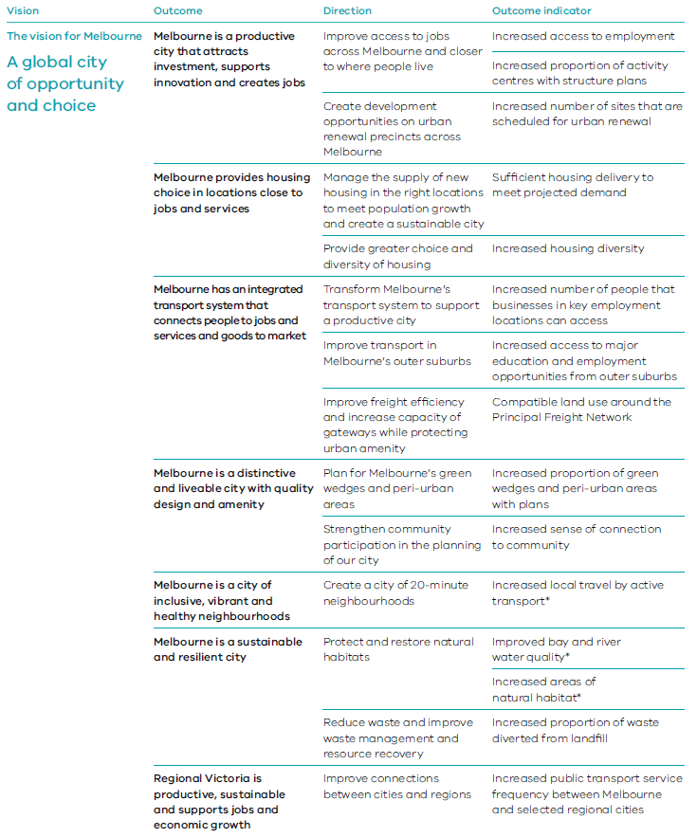
Notes:
The draft framework is not intended to contain indicators of all Plan Melbourne directions. Additional publicly reportable indicators may be introduced for other directions over time.
*Denotes links to United Nations Sustainable Development Goals

Land-supply monitoring and data
The government will provide local government, developers and the community with up-to-date, useable information to inform regional and local strategic planning and investment decision-making.
DELWP currently provides information through Victoria in Future publications, Housing Development Data and the Urban Development Program. The Plan Melbourne monitoring, reporting and review framework will also provide information on the progress towards achieving Plan Melbourne outcomes.
Future population scenarios
Develop alternative population and land-use scenarios to demonstrate the potential outcomes of defined policy options and analyse the impacts of various distributions of population and dwellings.
Plan Melbourne directions | Multiple
Timeframe | Short
Lead agency | DELWP
Implementation partners | VPA, councils
Monitoring residential and employment land requirements
Undertake monitoring activities that include:
- employment land supply and demand, focusing on activity centres, employment precincts, industrial land and urban renewal precincts
- residential land supply and construction, focusing on activity centres, employment precincts and urban renewal precincts.
Plan Melbourne directions | Multiple
Timeframe | Ongoing
Lead agency | DELWP
Implementation partners | Councils

Acronyms of departments and agencies
DJPR Department of Jobs, Precincts Regions
DoT Department of Transport
DET Department of Education and Training
DELWP Department of Environment, Land, Water and Planning
DHHS Department of Health and Human Services
DJCS Department of Justice and Community Safety
DPC Department of Premier and Cabinet
DTF Department of Treasury and Finance
EPA Environment Protection Authority
OVGA Office of the Victorian Government Architect
VPA Victorian Planning Authority

Appendix Metropolitan Melbourne regions
The following maps provide a more detailed view of key elements in Plan Melbourne as they apply to each of the six metropolitan Melbourne regions. The metropolitan regional planning groups will develop more detailed land-use framework plans for each region using this information as the base (see Action 1).
MAP 2 Inner Metro Region
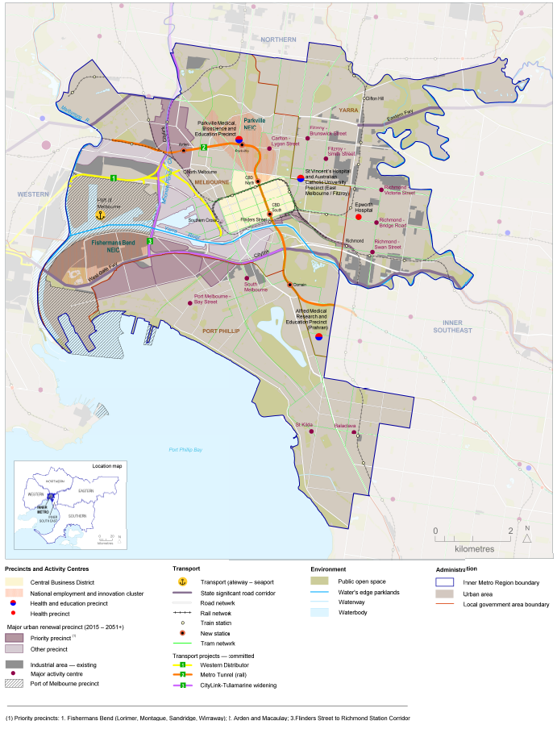
Source: Department of Environment, Land, Water and Planning

Inner Metro Region
Based on a growing mix of capital city functions — including government, business, tourism, social, cultural and recreational institutions and assets — the central city ‘core’ now extends well beyond the Hoddle Grid into St Kilda Road, Southbank and the Docklands. Planning for growth and change in Melbourne’s Inner Metro Region will help consolidate Melbourne’s position as a highly competitive global city and maintain the high standards of liveability, distinctiveness and character that make it special.
Municipalities
Melbourne, Port Phillip, Yarra
Recent population growth (estimated resident population¹)  2011  276,000 | Recent population growth (estimated resident population¹)  2015  325,000 | Recent population growth (estimated resident population¹)  GROWTH  49,000
Future population (Victoria in Future (VIF) 2016²)  2031  495,000 | Future population (Victoria in Future (VIF) 2016²)  2051  695,000 | Future population (Victoria in Future (VIF) 2016²)  GROWTH  370,000
Current and projected increase in number of jobs³  2015  619,000 | Current and projected increase in number of jobs³  2015–2031  233,000
Scenario 1 (Net dwelling additions 2016–2051 – VIF 2016)⁴  Housing distribution between established and growth areas  Total  215,000 | Scenario 1 (Net dwelling additions 2016–2051 – VIF 2016)⁴  Housing distribution between established and growth areas  Established  215,000 | Scenario 1 (Net dwelling additions 2016–2051 – VIF 2016)⁴  Housing distribution between established and growth areas  Growth areas  0
Scenario 2 (Net dwelling additions 2016–2051 – 70/30 aspiration)⁵  Housing distribution between established and growth areas  Total  230,000 | Scenario 2 (Net dwelling additions 2016–2051 – 70/30 aspiration)⁵  Housing distribution between established and growth areas  Established  230,000 | Scenario 2 (Net dwelling additions 2016–2051 – 70/30 aspiration)⁵  Housing distribution between established and growth areas  Growth areas  0
Places of state significance
Central city
National employment and innovation clusters — Parkville, Fishermans Bend
Transport gateway — Port of Melbourne
Health and/or education precincts — Parkville Medical, Bioscience and Education Precinct, St Vincent’s Hospital and Australian Catholic University Precinct (East Melbourne/Fitzroy), Epworth, Alfred Medical Research and Education Precinct (Prahran)
Major urban renewal precincts — Docklands, Fishermans Bend (Lorimer), Fishermans Bend (Montague), Fishermans Bend (Sandridge), Fishermans Bend (Wirraway), Arden, Macaulay, E-Gate, Dynon, Flinders Street Station to Richmond Station Corridor
Places of local significance
Major activity centres — Balaclava, Carlton-Lygon Street, Fitzroy-Brunswick Street, Fitzroy-Smith Street, Port Melbourne-Bay Street, Richmond-Bridge Road, Richmond-Swan Street, Richmond-Victoria Street, South Melbourne, St Kilda
Transport projects⁶
CityLink-Tullamarine widening — funded – in delivery
Metro Tunnel (rail) — funded
Western Distributor — funded

Notes:
1. The estimated resident population is the official ABS estimate of the Australian population.
2. VIF 2016 is the official state government projection of population and households.
3. Department of Economic Development, Jobs, Transport and Resources, internal analysis 2016.
4. Scenario 1 is based on VIF 2016 projections, which assume continuation of current trends.
5. Scenario 2 shows an aspirational distribution based on achieving a 70/30 (established/growth area) split of net dwelling additions.
6. All transport projects requiring budget funding will be carefully assessed in relation to budget capacity.
MAP 3 Western Region
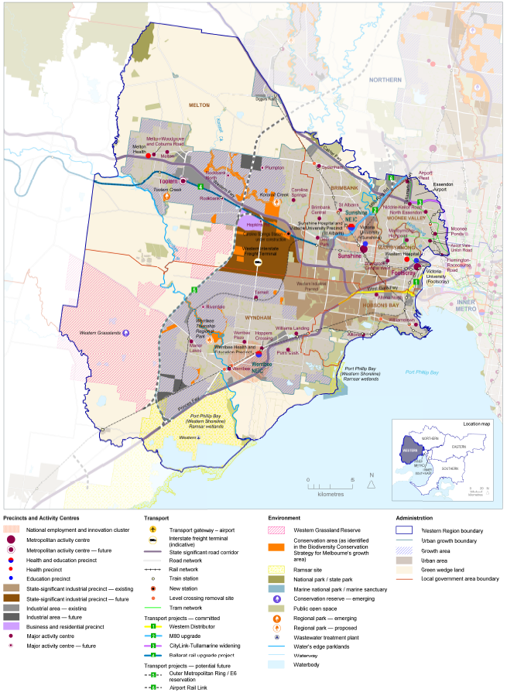
Source: Department of Environment, Land, Water and Planning

Western Region
With the necessary infrastructure and support for development of new employment opportunities in Werribee and Sunshine, the Western Region can leverage its existing strengths and better connect the residents of the west to employment and education opportunities. Melbourne’s west will continue to develop its civic, cultural and environmental assets, and be the city’s fastest growing region into the middle of this century.
Municipalities
Brimbank, Hobsons Bay, Maribyrnong, Melton, Moonee Valley, Wyndham
Recent population growth (estimated resident population¹)  2011  746,000 | Recent population growth (estimated resident population¹)  2015  838,000 | Recent population growth (estimated resident population¹)  GROWTH  92,000
Future growth to 2051 (Victoria in Future (VIF) 2016²)  2031  1,238,000 | Future growth to 2051 (Victoria in Future (VIF) 2016²)  2051  1,758,000 | Future growth to 2051 (Victoria in Future (VIF) 2016²)  GROWTH  920,000
Current and projected increase in number of jobs³  2015  277,000 | Current and projected increase in number of jobs³  2015–2031  113,000
Scenario 1 (Net dwelling additions 2016–2051 – VIF 2016)4  Housing distribution between established and growth areas  Total  385,000 | Scenario 1 (Net dwelling additions 2016–2051 – VIF 2016)4  Housing distribution between established and growth areas  Established  150,000 | Scenario 1 (Net dwelling additions 2016–2051 – VIF 2016)4  Housing distribution between established and growth areas  Growth areas  235,000
Scenario 2 (Net dwelling additions 2016–2051 – 70/30 aspiration)5  Housing distribution between established and growth areas  Total  365,000 | Scenario 2 (Net dwelling additions 2016–2051 – 70/30 aspiration)⁵  Housing distribution between established and growth areas  Established  160,000 | Scenario 2 (Net dwelling additions 2016–2051 – 70/30 aspiration)⁵  Housing distribution between established and growth areas  Growth areas  205,000
Places of state significance
National employment and innovation clusters — Sunshine, Werribee
Metropolitan activity centres — Footscray, Sunshine, Toolern (future)
State-significant industrial precinct — Western Industrial Precinct
Transport gateway — Essendon Airport
Health and/or education precincts — Western Hospital , Victoria University (Footscray), Sunshine Hospital and Victoria University Precinct (St Albans), Werribee Health and Education Precinct, Melton Health, Victoria University (Sunshine)
Places of local significance
Major activity centres — Airport West, Altona, Altona North, Ascot Vale-Union Road, Braybrook-Central West, Brimbank Central, Caroline Springs, Deer Park, Flemington-Racecourse Road, Hopkins Road (future), Hoppers Crossing, Manor Lakes, Maribyrnong-Highpoint, Melton, Melton-Woodgrove and Coburns Road, Moonee Ponds, Niddrie-Keilor Road, North Essendon, Plumpton (future), Point Cook, Riverdale (future), Rockbank (future), Rockbank North (future), St Albans, Sydenham, Tarneit, Werribee, Werribee Plaza, Williams Landing, Williamstown
Transport projects⁶
CityLink-Tullamarine widening — funded – in delivery
M80 Upgrade — funded – in delivery
Caroline Springs station — funded – in delivery
Metro Tunnel (rail) — funded
Western Distributor — funded
Ballarat rail upgrade project — funded – in delivery
Potential Western Interstate Freight Terminal — planning phase
Level crossing removal projects: Aviation Road, Laverton; Buckley Street, Essendon; Cherry Street, Werribee; Ferguson Street, Williamstown; Furlong Road, St Albans; Kororoit Creek Road, Williamstown North; Main Road, St Albans; Melton Highway, Sydenham; Werribee Street, Werribee

Notes:
1. The estimated resident population is the official ABS estimate of the Australian population.
2. VIF 2016 is the official state government projection of population and households.
3. Department of Economic Development, Jobs, Transport and Resources, internal analysis 2016.
4. Scenario 1 is based on VIF 2016 projections, which assume continuation of current trends.
5. Scenario 2 shows an aspirational distribution based on achieving a 70/30 (established/growth area) split of net dwelling additions.
6. All transport projects requiring budget funding will be carefully assessed in relation to budget capacity.
MAP 4 Northern Region
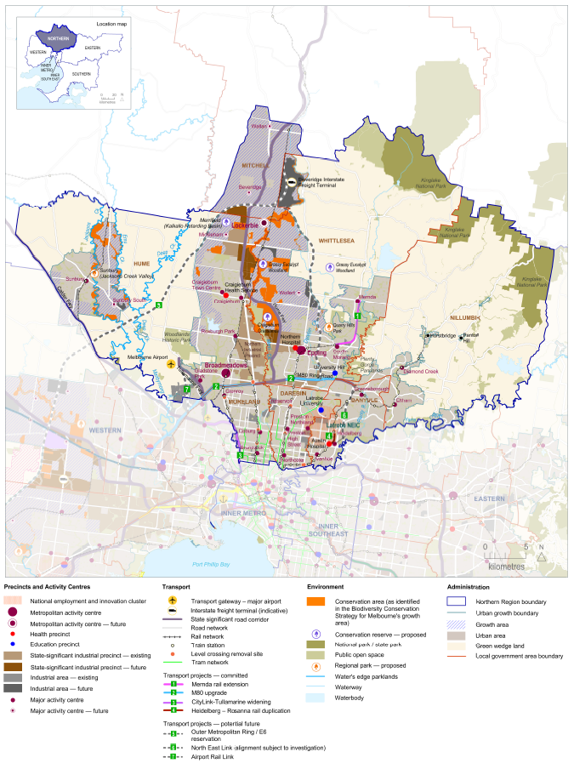
Source: Department of Environment, Land, Water and Planning

Northern Region
A key focus for the Northern Region will be to continue to develop a diverse industry base linked to its key transport infrastructure and educational, technology and research capabilities. It will grow its outer areas into vibrant, well-serviced communities including through improved transport linkages and the La Trobe National Employment and Innovation Cluster.
Municipalities
Banyule, Darebin, Hume, Mitchell (part), Moreland, Nillumbik, Whittlesea
Recent population growth (estimated resident population¹)  2011  853,000 | Recent population growth (estimated resident population¹)  2015  912,000 | Recent population growth (estimated resident population¹)  GROWTH  59,000
Future population (Victoria in Future (VIF) 2016²)  2031  1,282,000 | Future population (Victoria in Future (VIF) 2016²)  2051  1,742,000 | Future population (Victoria in Future (VIF) 2016²)  GROWTH  830,000
Current and projected increase in number of jobs³  2015  305,000 | Current and projected increase in number of jobs³  2015–2031  111,000
Scenario 1 (Net dwelling additions 2016–2051 – VIF 2016)⁴  Housing distribution between established and growth areas  Total  355,000 | Scenario 1 (Net dwelling additions 2016–2051 – VIF 2016)⁴  Housing distribution between established and growth areas  Established  175,000 | Scenario 1 (Net dwelling additions 2016–2051 – VIF 2016)⁴  Housing distribution between established and growth areas  Growth areas  180,000
Scenario 2 (Net dwelling additions 2016–2051 – 70/30 aspiration)⁵  Housing distribution between established and growth areas  Total  340,000 | Scenario 2 (Net dwelling additions 2016–2051 – 70/30 aspiration)⁵  Housing distribution between established and growth areas  Established  180,000 | Scenario 2 (Net dwelling additions 2016–2051 – 70/30 aspiration)⁵  Housing distribution between established and growth areas  Growth areas  160,000
Places of state significance
National employment and innovation cluster — La Trobe
Metropolitan activity centres — Broadmeadows, Epping, Lockerbie (future)
State-significant industrial precinct — Northern Industrial Precinct
Transport gateway — Melbourne Airport
Health and/or education precincts — Austin Hospital, Northern Hospital, Craigieburn Health Service, La Trobe University, University Hill (includes RMIT Bundoora campuses)
Places of local significance
Major activity centres — Beveridge (future), Brunswick, Coburg, Craigieburn, Craigieburn Town Centre, Diamond Creek, Eltham, Gladstone Park, Glenroy, Greensborough, Heidelberg, Ivanhoe, Mernda, Mickleham (future), Northcote, Preston-High Street, Preston-Northland, Reservoir, Roxburgh Park, South Morang, Sunbury, Sunbury South (future), Wallan (future), Wollert (future)
Transport projects⁶
CityLink-Tullamarine widening — funded – in delivery
M80 Upgrade — funded – in delivery
Mernda rail extension — funded – in delivery
Heidelberg-Rosanna rail duplication — funded – in delivery
Potential Beveridge Interstate Freight Terminal (future) — planning phase
Level crossing removal projects: Bell Street, Coburg; Bell Street, Preston; Camp Road, Campbellfield; Glenroy Road, Glenroy; Grange Road, Alphington; High Street, Reservoir; Lower Plenty Road, Rosanna; Moreland Road, Brunswick

Notes:
1. The estimated resident population is the official ABS estimate of the Australian population.
2. VIF 2016 is the official state government projection of population and households.
3. Department of Economic Development, Jobs, Transport and Resources, internal analysis 2016.
4. Scenario 1 is based on VIF 2016 projections, which assume continuation of current trends.
5. Scenario 2 shows an aspirational distribution based on achieving a 70/30 (established/growth area) split of net dwelling additions.
6. All transport projects requiring budget funding will be carefully assessed in relation to budget capacity.
MAP 5 Eastern Region
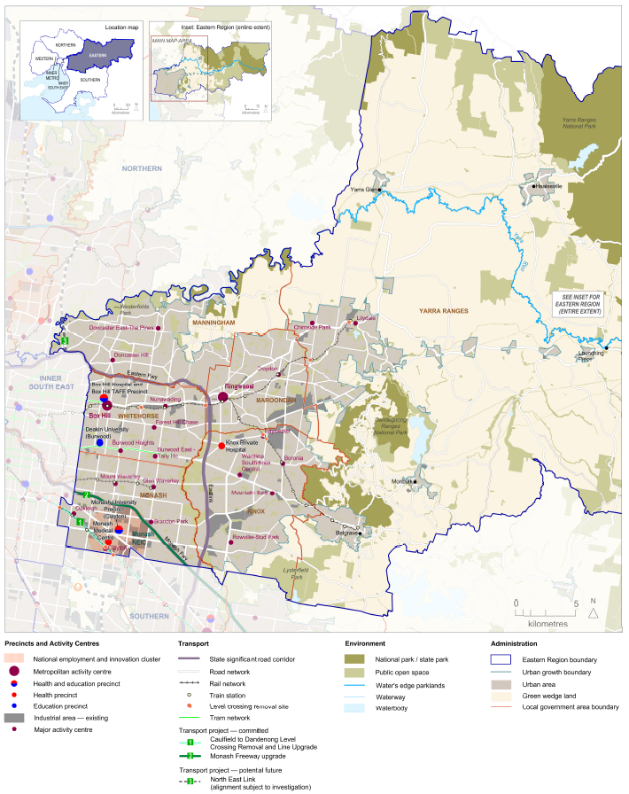
Source: Department of Environment, Land, Water and Planning

Eastern Region
A key focus for the Eastern Region will be consolidating its future growth in targeted areas (including in the Monash National Employment and Innovation Cluster, Box Hill and Ringwood). Opportunities for transport upgrades include potential road and rail links.
Municipalities
Knox, Manningham, Maroondah, Monash, Whitehorse, Yarra Ranges
Recent population growth (estimated resident population¹)  2011  862,000 | Recent population growth (estimated resident population¹)  2015  892,000 | Recent population growth (estimated resident population¹)  GROWTH  30,000
Future population (Victoria in Future (VIF) 2016²)  2031  1,032,000 | Future population (Victoria in Future (VIF) 2016²)  2051  1,282,000 | Future population (Victoria in Future (VIF) 2016²)  GROWTH  390,000
Current and projected increase in number of jobs³  2015  368,000 | Current and projected increase in number of jobs³  2015–2031  68,000
Scenario 1 (Net dwelling additions 2016–2051 – VIF 2016)⁴  Housing distribution between established and growth areas  Total  175,000 | Scenario 1 (Net dwelling additions 2016–2051 – VIF 2016)⁴  Housing distribution between established and growth areas  Established  175,000 | Scenario 1 (Net dwelling additions 2016–2051 – VIF 2016)⁴  Housing distribution between established and growth areas  Growth areas  0
Scenario 2 (Net dwelling additions 2016–2051 – 70/30 aspiration)⁵  Housing distribution between established and growth areas  Total  190,000 | Scenario 2 (Net dwelling additions 2016–2051 – 70/30 aspiration)⁵  Housing distribution between established and growth areas  Established  190,000 | Scenario 2 (Net dwelling additions 2016–2051 – 70/30 aspiration)⁵  Housing distribution between established and growth areas  Growth areas  0
Places of state significance
National employment and innovation cluster — Monash
Metropolitan activity centres — Box Hill, Ringwood
Health and/or education precincts — Box Hill Hospital and Box Hill TAFE Precinct, Monash Medical Centre, Deakin University (Burwood), Swinburne University (Hawthorn), Monash University Precinct (Clayton), Knox Private Hospital
Places of local significance
Major Activity centres — Bayswater, Boronia, Brandon Park, Burwood East-Tally Ho, Burwood Heights, Chirnside Park, Clayton, Croydon, Doncaster East-The Pines, Doncaster Hill, Forest Hill Chase, Glen Waverley, Lilydale, Mount Waverley, Mountain Gate, Nunawading, Oakleigh, Rowville-Stud Park, Wantirna South-Knox Central
Transport projects⁶
Caulfield to Dandenong Level Crossing Removal and Line Upgrade — funded – in delivery
Monash Freeway upgrade — funded – in delivery
Level crossing removal projects: Blackburn Road, Blackburn; Clayton Road, Clayton; Centre Road, Clayton;
Heatherdale Road, Ringwood; Manchester Road, Mooroolbark; Maroondah Highway, Lilydale;
Mountain Highway, Bayswater; Scoresby Road, Bayswater

Notes:
1. The estimated resident population is the official ABS estimate of the Australian population.
2. VIF 2016 is the official state government projection of population and households.
3. Department of Economic Development, Jobs, Transport and Resources, internal analysis 2016.
4. Scenario 1 is based on VIF 2016 projections, which assume continuation of current trends.
5. Scenario 2 shows an aspirational distribution based on achieving a 70/30 (established/growth area) split of net dwelling additions.
6. All transport projects requiring budget funding will be carefully assessed in relation to budget capacity.
MAP 6 Inner South East Region
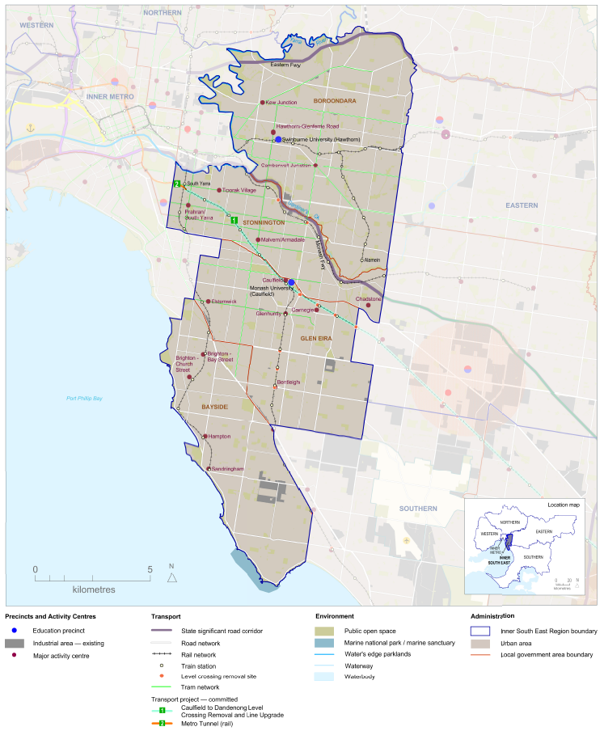
Source: Department of Environment, Land, Water and Planning

Inner South East Region
A key focus for the Inner South East Region will be accommodating its future growth within established areas and maintaining access to jobs and services. Opportunities for transport upgrades include potential road and rail links and level crossing removals.
Municipalities
Bayside, Boroondara, Glen Eira, Stonnington
Recent population growth (estimated resident population¹)  2011  499,000 | Recent population growth (estimated resident population¹)  2015  531,000 | Recent population growth (estimated resident population¹)  GROWTH  32,000
Future population (Victoria in Future (VIF) 2016²)  2031  621,000 | Future population (Victoria in Future (VIF) 2016²)  2051  761,000 | Future population (Victoria in Future (VIF) 2016²)  GROWTH  230,000
Current and projected increase in number of jobs³  2015  213,000 | Current and projected increase in number of jobs³  2015–2031  60,000
Scenario 1 (Net dwelling additions 2016–2051 – VIF 2016)⁴  Housing distribution between established and growth areas  Total  110,000 | Scenario 1 (Net dwelling additions 2016–2051 – VIF 2016)⁴  Housing distribution between established and growth areas  Established  110,000 | Scenario 1 (Net dwelling additions 2016–2051 – VIF 2016)⁴  Housing distribution between established and growth areas  Growth areas  0
Scenario 2 (Net dwelling additions 2016–2051 – 70/30 aspiration)⁵  Housing distribution between established and growth areas  Total  125,000 | Scenario 2 (Net dwelling additions 2016–2051 – 70/30 aspiration)⁵  Housing distribution between established and growth areas  Established  125,000 | Scenario 2 (Net dwelling additions 2016–2051 – 70/30 aspiration)⁵  Housing distribution between established and growth areas  Growth areas  0
Places of state significance
Health and/or education precinct — Monash University (Caulfield)
Places of local significance
Major activity centres —Bentleigh, Brighton-Bay Street, Brighton-Church Street, Camberwell Junction, Carnegie, Caulfield, Chadstone, Elsternwick, Glenhuntly, Hampton, Hawthorn-Glenferrie Road, Kew Junction, Malvern/Armadale, Prahran/South Yarra, Sandringham, Toorak Village
Transport projects⁶
Caulfield to Dandenong Level Crossing Removal and Line Upgrade — funded – in delivery
Monash Freeway upgrade — funded – in delivery
Level crossing removal projects: Burke Road, Glen Iris; Centre Road, Bentleigh; Grange Road, Carnegie; Koornang Road, Carnegie; Murrumbeena Road, Murrumbeena; North Road, Ormond; McKinnon Road, McKinnon; Poath Road, Hughesdale; Toorak Road, Kooyong

Notes:
1. The estimated resident population is the official ABS estimate of the Australian population.
2. VIF 2016 is the official state government projection of population and households.
3. Department of Economic Development, Jobs, Transport and Resources, internal analysis 2016.
4. Scenario 1 is based on VIF 2016 projections, which assume continuation of current trends.
5. Scenario 2 shows an aspirational distribution based on achieving a 70/30 (established/growth area) split of net dwelling additions.
6. All transport projects requiring budget funding will be carefully assessed in relation to budget capacity.
MAP 7 Southern Region
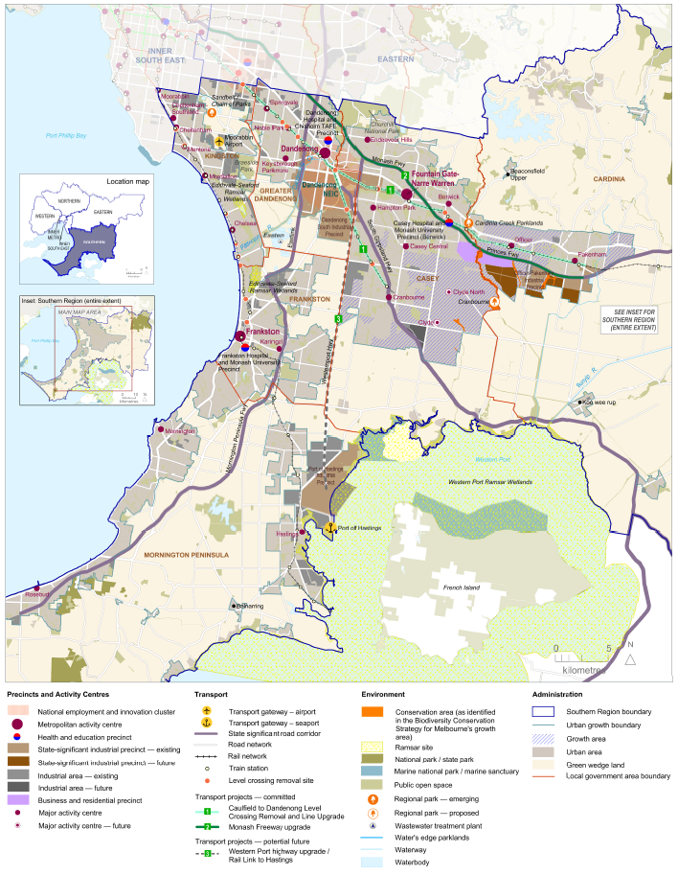
Source: Department of Environment, Land, Water and Planning

Southern Region
A key focus for the Southern Region will be better transport links to the city along the Dandenong rail corridor and planning for future road and rail connections to the Port of Hastings.
Municipalities
Cardinia, Casey, Frankston, Greater Dandenong, Kingston, Mornington Peninsula
Recent population growth (estimated resident population¹)  2011  907,000 | Recent population growth (estimated resident population¹)  2015  982,000 | Recent population growth (estimated resident population¹)  GROWTH  75,000
Future population (Victoria in Future (VIF) 2016²)  2031  1,312,000 | Future population (Victoria in Future (VIF) 2016²)  2051  1,672,000 | Future population (Victoria in Future (VIF) 2016²)  GROWTH  690,000
Current and projected increase in number of jobs³  2015  357,000 | Current and projected increase in number of jobs³  2015–2031  105,000
Scenario 1 (Net dwelling additions 2016–2051 – VIF 2016)⁴  Housing distribution between established and growth areas  Total  310,000 | Scenario 1 (Net dwelling additions 2016–2051 – VIF 2016)⁴  Housing distribution between established and growth areas  Established  185,000 | Scenario 1 (Net dwelling additions 2016–2051 – VIF 2016)⁴  Housing distribution between established and growth areas  Growth areas  125,000
Scenario 2 (Net dwelling additions 2016–2051 – 70/30 aspiration)⁵  Housing distribution between established and growth areas  Total  300,000 | Scenario 2 (Net dwelling additions 2016–2051 – 70/30 aspiration)⁵  Housing distribution between established and growth areas  Established  195,000 | Scenario 2 (Net dwelling additions 2016–2051 – 70/30 aspiration)⁵  Housing distribution between established and growth areas  Growth areas  105,000
Places of state significance
National employment and innovation cluster — Dandenong
Metropolitan activity centres — Dandenong, Frankston, Fountain Gate-Narre Warren
State-significant industrial precincts — Southern Industrial Precinct, Port of Hastings Industrial Precinct, Officer-Pakenham Industrial Precinct
Transport gateways — Port of Hastings, Moorabbin Airport
Health and/or education precincts — Frankston Hospital and Monash University Precinct (Frankston), Casey Hospital and Monash University Precinct (Berwick), Dandenong Hospital and Chisholm TAFE Precinct
Places of local significance
Major activity centres — Berwick, Casey Central, Chelsea, Cheltenham, Cheltenham-Southland, Clyde (future), Clyde North (future), Cranbourne, Endeavour Hills, Hampton Park, Hastings, Karingal, Keysborough-Parkmore, Mentone, Moorabbin, Mordialloc, Mornington, Noble Park, Officer, Pakenham, Rosebud, Springvale
Transport projects⁶
Caulfield to Dandenong Level Crossing Removal and Line Upgrade — funded – in delivery
Monash Freeway upgrade — funded – in delivery
Southland station — funded – in delivery
Level crossing removal projects: Abbotts Road, Dandenong South; Balcombe Road, Mentone; Chandler Road, Noble Park; Charman Road, Cheltenham; Clyde Road, Berwick; Corrigan Road, Noble Park; Edithvale Road, Edithvale; Eel Race Road, Carrum; Hallam Road, Hallam; Heatherton Road, Noble Park; Seaford Station Street/Bondi Road, Bonbeach; Skye/Overton Road, Frankston; South Gippsland Highway, Dandenong; Station Street, Carrum; Seaford Road, Seaford; Thompsons Road, Lyndhurst

Notes:
1. The estimated resident population is the official ABS estimate of the Australian population.
2. VIF 2016 is the official state government projection of population and households.
3. Department of Economic Development, Jobs, Transport and Resources, internal analysis 2016.
4. Scenario 1 is based on VIF 2016 projections, which assume continuation of current trends.
5. Scenario 2 shows an aspirational distribution based on achieving a 70/30 (established/growth area) split of net dwelling additions.
6. All transport projects requiring budget funding will be carefully assessed in relation to budget capacity.

DOCUMENT ENDS

