

Change and disadvantage in the Grampians region, Victoria

Department of Planning and Community Development

March 2011



Prepared by:

Jeanette Pope, Policy and Strategy, Department of Planning and Community Development (DPCD). (03) 92083849 or jeanette.pope@dpcd.vic.gov.au

March 2011

Acknowledgement of data source

DPCD gratefully acknowledges the Department of Health and its two data collation products from which most of the data for this report has been drawn:
- 2009 Local Government Area Statistical Profiles (DHS 2009)
- Town and Community Profiles 2008 (DHS 2009)

A note of the limitations of data to describe disadvantage

There is a significant paucity of data to describe disadvantage, particularly at the small area level, in Australia. Measuring disadvantage in individuals requires measuring the wide range of factors that contribute to standard of living (Figure 10). Most surveys do not collect this detail. Only a few composite measures exist that combine a range of variables, notably, the Australian Bureau of Statistics’ (ABS) five Socio-economic Indices for Areas (SEIFA) (that combine information about income, education, occupation, wealth and living conditions) (ABS 2006). In addition, some disadvantaged population groups are very small, or are hard to identify, and are not routinely detected in population surveys (for example, Indigenous Victorians, refugees and people with a disability). These issues mean there are significant data gaps in this report.

Acronyms

ABS | Australian Bureau of Statistics
AEDI  ATSI | Australian Early Development Index  Aboriginal & Torres Strait Islander
DPCD | Department of Planning and Community Development
LGA | Local Government Area
SEIFA | Socio-economic Indices for Areas
SEIFA RSD | Index of Relative Socio-economic Disadvantage

Copyright & Disclaimer
The materials presented in this report are for information purposes only. The information is provided solely on the basis that readers will be responsible for making their own assessments of the matters discussed and are advised to verify all relevant representations, statements and information and obtain independent advice before acting on any information contained in or in connection with this report.

While every effort has been made to ensure that the information is accurate the Department of Planning and Community Development will not accept any liability for any loss or damage which may be incurred by any person acting in reliance upon the information.

Contents

Introduction and summary 4
Change in the Grampians region as a backdrop to disadvantage 6
What is disadvantage and who does it affect? 13
Disadvantage in Grampians 17
Ararat LGA 20
Ballarat LGA 22
Golden Plains LGA 24
Hepburn LGA 26
Hindmarsh LGA 28
Horsham LGA 30
Moorabool LGA 32
Northern Grampians LGA 34
Pyrenees LGA 36
West Wimmera LGA 38
Yarriambiack LGA 40
Conclusion and what can be done 42
Appendix A. The full list of relatively disadvantaged towns in the Grampians region 43
References 45

Introduction and summary

This report describes change and disadvantage in the Grampians government region (Figure 1). It has been compiled to assist agencies better assess disadvantage and plan collaborative strategies to address it.

Figure 1. The Grampians government region.
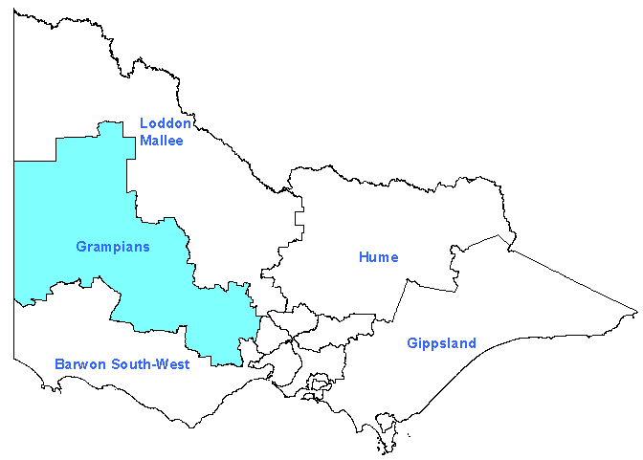
Including the LGAs of …

Ararat
Ballarat
Golden Plains
Hepburn
Hindmarsh
Horsham
Moorabool
Northern Grampians
Pyranees
West Wimmera
Yarriambiack

The first section provides a brief introduction to the widespread economic and demographic changes in regional Victoria that provide the backdrop to disadvantage. It shows that the economy is restructuring in different ways across the region and this is causing the purpose of many regional towns to change (for example from agricultural service towns to tourist towns). As a result, many places also have changing population compositions, with some localities experiencing decline and aging and others growth from new populations moving from Melbourne (weekenders, commuters, “downshifters”, affluent retirees and non-affluent retirees, welfare recipients and small numbers of new Australian migrants).

This section demonstrates localities are experiencing economic and demographic change differently and disadvantage therefore looks different in different places. Three major changes are discussed: 1. the process of economic restructuring that is decreasing economic opportunities for some residents (creating skilled work environments where there are predominantly unskilled workers); 2. shifting population compositions that are resulting in a need for services and business to restructure (as needs change or as services become unviable); and 3. rising house prices that are resulting in some populations becoming concentrated in low service/economic opportunity areas.

This background highlights the need for collaborative planning – that can find solutions specific to a locality’s economy, demography, needs and interests – to address disadvantage in regional localities.

The second section defines disadvantage as occurring when an individual, family or community is deprived of resources or opportunities – enjoyed by all other Victorians – that underpin social and economic wellbeing. Disadvantage exists on a continuum with some people experiencing mild disadvantage, while others experience deprivation so severe as to be unacceptable to community standards. This includes those that cannot afford medical and dental treatment, who do not have safe and secure housing, and who cannot afford activities for their children. This section shows that around 10% of the Australian population are significantly disadvantaged and clustered in particular geographic localities. Some population groups are consistently overrepresented in data about disadvantage and this section identifies these in Australia as:
- aged persons;
- public housing renters;
- Aborigines and Torres Strait Islanders;
- one parent families;
- people with non-English speaking backgrounds;
- the unemployed;
- private renters; and
- people with a disability (Australian Government 2009; Saunders & Wong 2009).

The section concludes with a description of the size of these groups in the Grampians region (Table 5).

The third section examines disadvantage in the Grampians region. For each Local Government Area (LGA) it provides a map of the most disadvantaged localities and a table describing the population composition of these areas using the categories identified above. The tables show different towns have different population compositions. Some are dominated by older people, some by working populations experiencing high levels of unemployment and single parent families, some by public housing tenants and welfare recipients, some with a significant multicultural mix. This section reinforces the need for strategies that take into consideration both the economic and demographic changes in different localities and their different population mix.

A full list of all localities highlighted in the LGA maps is provided at Appendix A. Some of the towns on this list additionally contribute to the most disadvantaged 10% of the population in Australia and these are shown in Table 1 as a summary.

Table 1. Localities in Grampians that are relatively disadvantaged in Victoria and that also contribute to the most disadvantaged 10% of the population in Australia

Population size
Large >3000 | 1000 - 3000 | Small < 1000
Ballarat Suburbs (6516) | Horsham / Horsham West (1166)  Stawell (1015) | Beaufort and its Rural Catchment (632)  Bacchus Marsh (524)  Daylesford (470)  Warracknabeal (409)  Avoca (393)  Jeparit (374)  St Arnaud (385)  Beulah (220)  Apsley (162)
Note: population numbers are less than total town populations – the latter can be found in the LGA sections

The final section examines what can be done. The complex and multidimensional nature of disadvantage means that many agencies can contribute to reducing it or lessening its impacts and this section outlines some of the areas under different agencies control. Because of its complexity, however, reducing disadvantage will require collaboration. No single agency controls all the levers.

This paper has been provided to begin a discussion about priority disadvantaged localities, population groups or issues (education and early childhood development, housing, etc) that may be impacted on by collaborative action.
Change in the Grampians region as a backdrop to disadvantage

Regional Victoria is changing – both economically and demographically.

In Grampians the economy has been substantially restructuring. The primary industry of agriculture is transforming from one dominated by many small family run farms to one characterised by larger corporate ones run with new production methods to increase productivity (Barr 2009). Large towns built on gold mining, have become reliant on manufacturing, tourism and service provision (DIIRD 2010). Manufacturing in some places is in decline.

An illustration of the magnitude of the change across regional Victoria can be seen in change in jobs over one year (2007/8 to 2008/9) in Table 2. Jobs were lost in several industries including Manufacturing and Education and Training (highlighted pink), but gained in others including, Health Care and Social Assistance and Agriculture, Forestry and Fishing (highlighted green). Figure 2 provides another example from the Grampians city of Ballarat over the last 20 years (1986 to 2006). It shows the decline in manufacturing jobs, and the rise of jobs in retail and service provision.

Table 2. Change in employment (number of jobs), Victoria, 2007/08 to 2008/09 (in order for regional Victoria) (SGS Economic and Planning 2010)

 | Regional Victoria | Melbourne
Health Care and Social Assistance | 7 000 | 9 000
Agriculture, Forestry and Fishing | 5 000 | -3 000
Electricity, Gas, Water and Waste Services | 3 000 | 1 000
Transport, Postal and Warehousing | 3 000 | 13 000
Accommodation and Food Services | 2 000 | 6 000
Public Administration and Safety | 2 000 | 14 000
Wholesale Trade | 1 000 | 3 000
Administrative and Support Services | 0 | 1 000
Retail Trade | -1 000 | -7 000
Mining | -1 000 | 2 000
Rental, Hiring and Real Estate Services | -1 000 | -3 000
Arts and Recreation Services | -1 000 | 5 000
Financial and Insurance Services | -2 000 | -11 000
Construction | -3 000 | 5 000
Information Media and Telecommunications | -3 000 | 2 000
Professional, Scientific and Technical Services | -3 000 | -8 000
Education and Training | -5 000 | 4 000
Manufacturing | -5 000 | -14 000
Other Services | -10 000 | 1 000
Total number of jobs | -12 000 | + 20 000

Figure 2: Proportion of employed persons, by selected industry, Ballarat, 1986-2006 (DPCD 2010b)
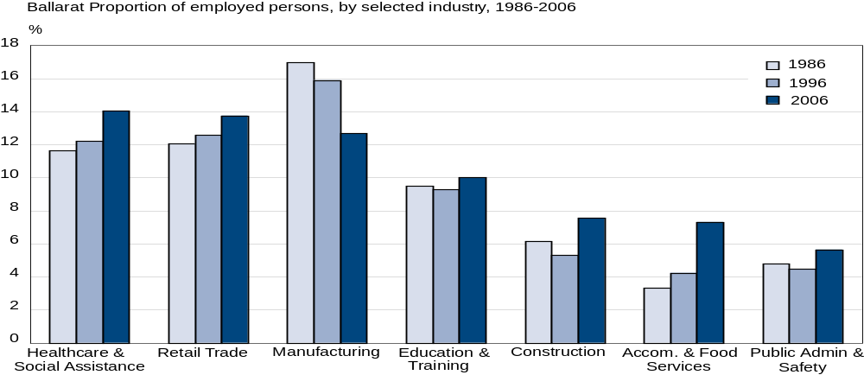

In Grampians population compositions are also changing. Structural aging is occurring as farmers get older, young people migrate to cities in search of better economic prospects (the migration of young women is double the rate of young men), and older people retire to regional Victoria from metropolitan Melbourne (Figures 3 & 4 and LGA snapshot 1, page 9 & 10).

Some high amenity areas are also experiencing a significant influx of “amenity migrants” moving from Melbourne seeking a rural lifestyle (Barr 2009). The new types of people moving to regional Victoria include:
- Weekenders (some LGAs now have significant non-resident populations – see Figure 5);
- Commuters and those that share their time between a city and a regional household;
- “Downshifters”;
- Affluent retirees; and
- Non-affluent retirees, welfare recipients and small numbers of new Australian migrants moving to areas where there is cheaper housing (AHURI 2005; Barr 2009; DHS 2009).

Figure 3. Net migration between regional Victoria and Melbourne between 2001 and 2006, by age (ABS 2006)
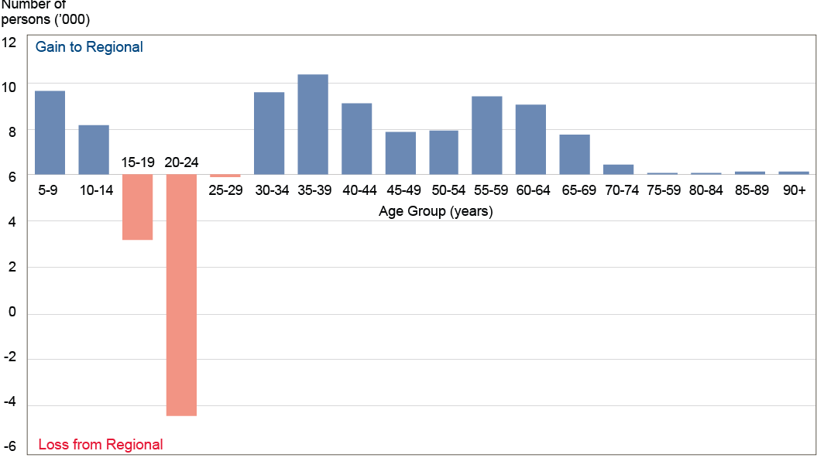

LGA snapshot 1
Older people (60+) percentage of population, 2006 (ABS 2006)
and projected population aging in 2026 (DPCD 2008)
 | 2006 |  | 2026
 | % | (n) | % | (n)
Yarriambiak | 29 | 2244 | 47 | 2938
West Wimmera | 26 | 1174 | 43 | 1488
Hindmarsh | 30 | 1845 | 42 | 2138
Northern Grampians | 24 | 2973 | 41 | 4545
Pyrenees | 26 | 1740 | 40 | 3162
Ararat | 25 | 2878 | 35 | 4298
Hepburn | 23 | 3341 | 34 | 5835
Horsham | 22 | 4119 | 32 | 6742
Moorabool | 16 | 4191 | 28 | 9857
Ballarat | 19 | 16691 | 28 | 33630
Golden Plains | 14 | 2417 | 26 | 6295

Figure 4. Population aged 75 years and over, Statistical Local Areas, 2006 (ABS 2006)

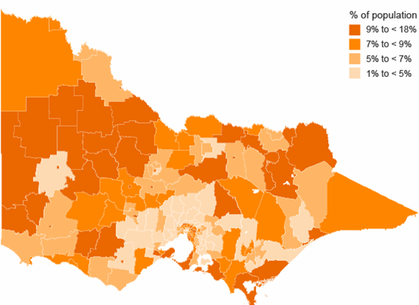

Changing economies and population compositions mean the purpose of many regional towns is changing (Barr 2009). For example, towns that once provided service support to farming communities no longer have this function. Some have reinvented themselves with a different purpose. For example, Daylesford has been transformed by amenity migrants into a tourism destination (Barr 2009). The changing purpose of towns impacts on whether they grow or decline and this will in turn impact on the viability and appropriateness of their services, business and industry. It will also impact on levels of disadvantage if some people get “left behind”.

Figure 5. Non-resident ratepayers by Local Government Area 2007 (DPCD 2007)
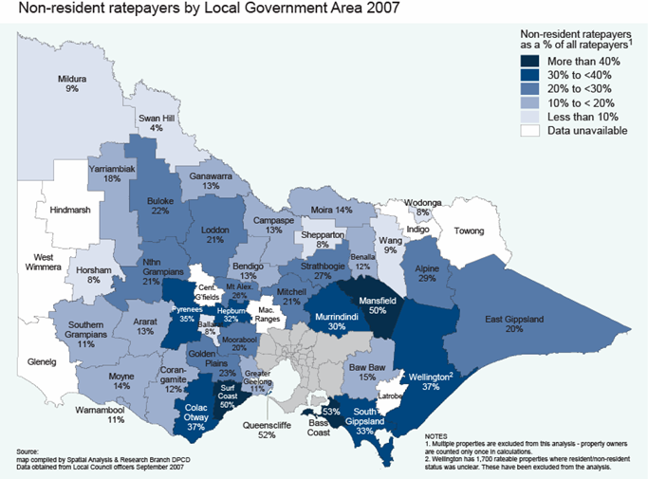

The three maps on the next page show the overall patterns of growth and decline in towns across Grampians from 1981 to 2006. They examine two types of landscapes – those that still have a predominantly agricultural land base – and those where the land has become attractive to amenity migrants (Barr 2009).

Figure 6 shows in red the areas that still have a predominantly agriculture land base. In these areas farm size is increasing while the number of farms (and therefore the size of farming communities) is decreasing (Barr 2009). In Grampians these areas include the LGAs of (from west to east): West Wimmera, Hindmarsh and Yarriambiak. Figure 7 shows this landscape is associated with the decline of many small towns that would have once been agricultural service towns (the red dots), but growth in a few larger ones that now fill that niche in the new production environment (eg Horsham) (the blue dots).

Figure 8 shows in blue the areas where there is an amenity pressure on land use (where farms may be subdivided and sold to amenity migrants willing to pay a higher price for land) (Barr 2009). In Grampians these include the LGAs of (from west to east) Pyrenees, Golden Plains, Ballarat, Hepburn and Moorabool. Amenity migration is the most likely way smaller regional towns have avoided decline in the Grampians region (Barr 2009) and Figure 7 shows the many towns that have grown as a result (the blue dots).
Figure 6. The Production landscape of Victoria (from ABS census data, Statistical Local Area boundaries and Victorian land transaction data). The deeper the red, the deeper the production influence on the landscape (Barr 2009)
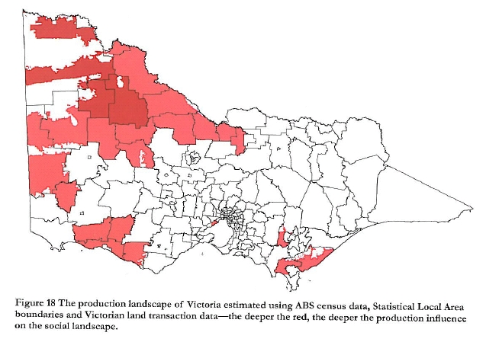

Figure 7. Population change in Victorian Towns 1981-2006 (DPCD 2008a)

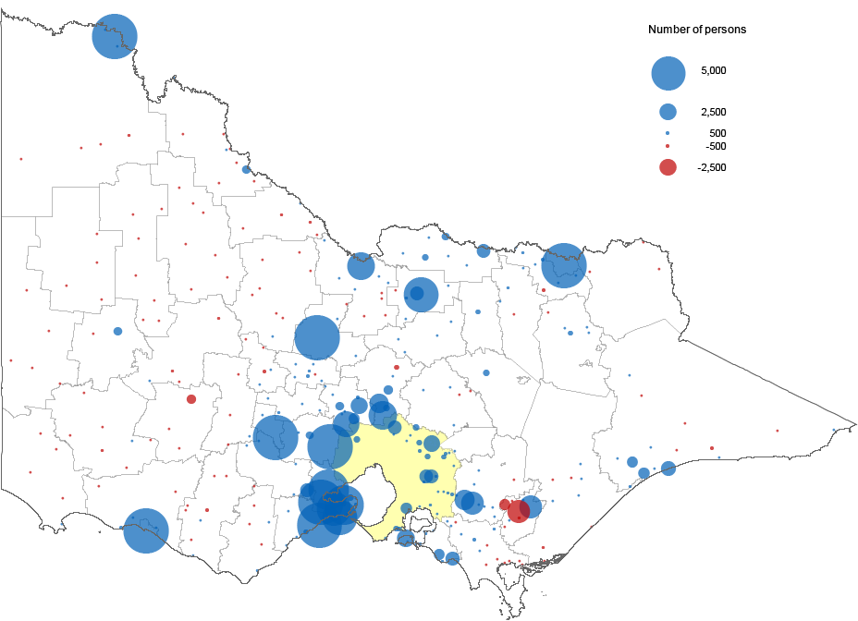

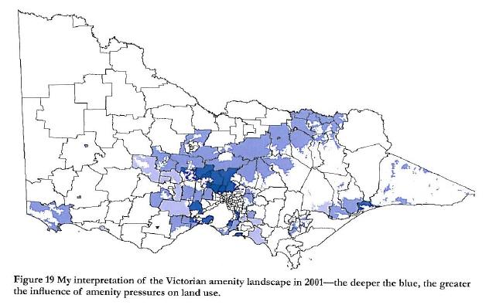
Figure 8. Neil Barr’s (DPI) interpretation of the Victorian amenity landscape in 2001. the deeper the blue, the greater the amenity pressures on land use (Barr 2009).

Many towns and populations have adapted, and will continue to adapt, to the economic and demographic changes occurring in the region. This report is concerned with those that may be left behind by change. Three major changes should be kept in mind as background to discussion about disadvantage.

1. The first change is economic restructure that results in decreased economic opportunities for some residents. This is particularly significant because some areas in Grampians have high unemployment (LGA snapshot 4, page 26) and around one in five workers are unskilled or semi skilled (LGA snapshot 6, page 35). Research has shown that skilled workers have portable skills and can deal well with change, while others (for example, from manufacturing) have limited specific skills and find it difficult to find employment in other industries (SGS Economic and Planning 2010). In addition, regional Victoria has less diversity of employment options (Figure 9) and this makes unskilled workers vulnerable when industries restructure, particularly as there is also less opportunity to retrain in regional Victoria. The issue of a mismatch between unskilled workers and increasingly skilled work could perpetuate in regional Victoria given it has a significant proportion of children entering school developmentally vulnerable (Regional Victoria is 12% compared to 10% in metropolitan Melbourne, LGA snapshot 3, page 26), more young people not staying at school through years 10 to 12 (23% compared to 15% in metropolitan Melbourne) and more young people aged 15 to 19 who are not engaged in school, work or further education/training (up to 21% in Grampians LGAs) (LGA snapshot 5, page 32).

Figure 9. Economic diversity*, Statistical Local Areas, 2001 (DSE 2005)
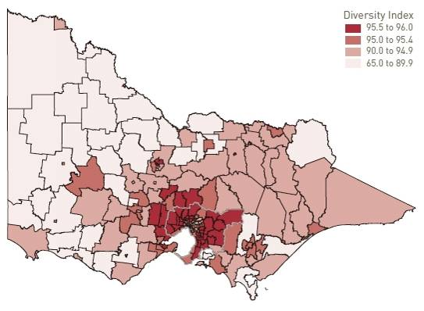
* Index score of 100 = complete diversification with employment spread evenly across all industry types.
Index score of 0 = employment concentrated in a single area.

2. The second change is shifting population compositions that result in the need for services and business to restructure. This will affect both towns in growth and decline. Towns that are growing may experience pressure on their existing services or have a need for new or different services. Towns in decline may have difficulty keeping their services and facilities viable (schools, health services, sporting clubs, etc). This may mean residents have to travel for services and this may become an increasing problem as they age or if they have transport limitations. The issue of service access is of particular importance to disadvantaged people who are more likely to have a greater range of service needs due to worse physical and mental health, lower assets and incomes, etc.

In all towns there will be a need to attract staff to run services. Some areas in regional Victoria have trouble attracting skilled workers because of lower incomes, lack of premium housing or low perceived amenity in particular areas (DIIRD 2010). Table 3 shows the current skill shortages in the Grampians region and subsequently the services affected. This problem is likely to be exacerbated by the out migration of young people leaving fewer people to replace retiring workers and to work in areas of increasing demand as the population ages (such as health care). In some areas however, the loss of young people may be compensated for by the in-migration of amenity migrants.

Table 3. Skills shortages in the Grampians Region (DIIRD 2010)

Accountants  Cabinetmakers  Carpenters and joiners  Civil engineers  Cooks  Counsellors  General fabrication engineering tradespeople  Fibrous plasterers  General electricians  General medical practitioners  Human resource managers  Mechanical engineers | Metal fitters and turners  Metal machinists  Motor mechanics  Painters and decorators  Plumbers  Registered nurses  Sales, marketing and advertising professionals  Social welfare professionals  Social workers  Specialist medical practitioners  Structural steel and welding tradespeople  Wood machinists and turners

3. The third change is rising house prices that result in some populations becoming concentrated in low service areas. Three groups will be affected. The first is residents who move into low service areas from high amenity areas as house prices rise (particularly as amenity migration has generally not resulted in new houses being built (Barr 2009)). The second is those existing residents in low service areas who are unable to move to more expensive serviced localities when their need for services increases (for example, as they age, become disabled, or need to access the labour market) (Barr 2009). This will include social housing tenants who live in low serviced areas away from labour markets. The third is the group of welfare recipients or underfunded retirees who move into low service areas because of the cheaper housing (Barr 2009). For example, in 2000 a net of 9500 welfare recipients moved to regional Victoria for the housing (AHURI 2005). While housing is cheaper in general in regional Victoria (both rents and purchase) people will still be at risk of housing stress if their incomes do not keep pace with house prices or rent. This will include those on pensions and benefits and lower paid single workers.

This brief background demonstrates that different economic and demographic changes are occurring in different places in Grampians. As a consequence, disadvantage is likely to look different in different localities. In some communities disadvantage will be characterised by an aging population, in others by a working population that is precariously employed, in others by a diverse group of welfare recipients. In addition, all changing communities in Grampians, whether disadvantaged or not, will need to restructure their services to meet their changing needs. This background highlights the importance of collaborative planning that examines solutions matched to disadvantaged locality’s economy, assets, demographics, needs and interests.

Disadvantage exists against a backdrop of economic and demographic change in regional Victoria that is affecting localities differently

