

Victoria’s regional centres – a generation of change

Overview

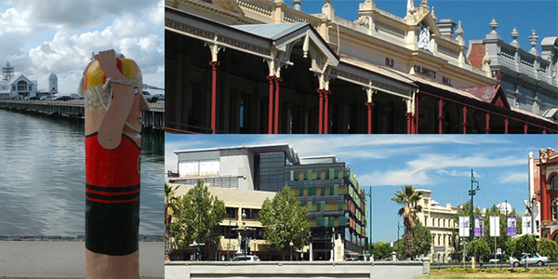

Simone Alexander,
Spatial Analysis and Research Branch,
Strategic Policy, Research and Forecasting Division
April 2010

Executive summary

The population dynamics of regional centres and their suburbs remain largely under-researched in Australia. This is despite their important historic, economic and social legacies, as well as their dominance in the urban hierarchy outside the state capital cities. Within Victoria, the largest regional centres are Geelong, Ballarat and Bendigo. As regional centres, they provide services for a wide catchment, but at the same time they fall within a Melbourne, and increasingly, national and international catchment. They have experienced significant demographic change over the period 1981-2006, trends which are driven by a synergy of economic and social factors. They have diversifying economic bases and increasingly well qualified workforces that are required by modern businesses for the efficient delivery of region wide services. Their range of cultural and entertainment opportunities is growing. Their links with Melbourne and the global economy are facilitated by improvements to transport and communications infrastructure. They are achieving the economies and advantages of scale that augur well for their future.

Planning and managing Melbourne’s growth increasingly requires a wider regional perspective. As a successful modern city, Melbourne is under intense pressure from the forces of urbanisation which attract people and businesses to large cities. Improved linkages with Melbourne are drawing these centres more and more into its economic and social catchment. Each of the local councils has undertaken strategic research and planning but rarely have they been put together, compared and had their broader strategic relationship with Melbourne and regional Victoria put under the microscope. This series of papers aims to fill a research gap and improve the understanding of the population dynamics driving change in Geelong, Ballarat and Bendigo.

The key points arising from this research are:

- Strong, but volatile, population growth. This growth has been strongest in the last ten years, but was flat or declining during the early 1990s recession.
- The scale of change has been greatest in Geelong, for two main reasons. Firstly, there has been a major change in the industrial base with a move away from the dominance of the manufacturing sector towards services. Secondly, the population of inner Geelong has increased after years of decline, due to redevelopment of key sites, especially along the waterfront. These types of changes have not been evident in Ballarat and Bendigo.
- Population growth in towns around the regional centres has not been uniform – it was strong around Geelong, but more localised around Ballarat and Bendigo. The strong growth around Geelong reflects its wider catchment, the growing importance of commuter towns and the sea-change/tree-change phenomenon. These aspects are present, but less obvious around the smaller inland centres.
- There has been considerable ageing of the population, as shown by the increase in both the number and proportion of persons aged 75 years and over. Conversely, the proportion of younger persons has declined. The proportion of aged persons has been consistently higher than that recorded in Melbourne.
- Despite fluctuating population growth, the number of dwellings recorded consistent growth across the period 1981-2006. This was accompanied by a decline in average household size, a trend mirroring that which is occurring across much of Australia. Separate houses remain the dominant form of dwelling type in these towns, with little growth in medium density housing.
- Labour force growth was strongest in the period 1996-2006 as the economy rebounded from the early 1990s recession. Unemployment has been consistently higher than Melbourne’s for a combination of reasons such as a narrower economic base and the possible inability of the labour market to absorb in-migration from surrounding regions.
- The economies of these towns have moved towards a service based one. Employment growth in retail, health and education has been considerable, but not unexpected given the increase in population. While there has been some growth in knowledge economy industries, it has not matched that occurring in Melbourne.
- Geelong has experienced the most significant change in its labour force as a result of the restructuring of the manufacturing sector. Employment in manufacturing has declined significantly in volume and as a proportion of the workforce. Regardless, in terms of output, it is still an important industry.
- The shift to a service-based economy has been accompanied by growth in knowledge economy industries. However, as a proportion of employed persons, the level is below that recorded in Melbourne.
- There has been an increase in the proportion of persons with university qualifications in line with the demands of the labour market for higher skills, but again, the proportion still lags behind Melbourne. From a spatial perspective, there is a strong relationship between persons employed in knowledge economy industries and the proportion of persons with university qualifications.
- The ethnic composition of the population in these towns is very different from that of Melbourne, where overseas born persons comprise about one-quarter of the population. In Geelong, Ballarat and Bendigo they are more likely to come from English speaking countries. The proportion of overseas born persons is highest in Geelong, but even in this town the proportion has declined over time. In Ballarat and Bendigo, the proportion of overseas born persons is around 8%.

The inbuilt population and economic momentum present in Geelong, Ballarat and Bendigo places them in a good position to meet the challenges they will face in the future. The demographic information provided in these papers provides an evidence base for urban planners and policy makers alike.

1. Introduction

This series of papers utilises data from DPCD’s “In Time” products to examine demographic trends in the three largest regional centres in Victoria – Geelong, Ballarat and Bendigo – over the period 1981 to 2006. With a combined population of 283,500 in 2006, they are “the big three” in regional Victoria (hereafter referred to as GBB). About one in five persons in regional Victoria lives in one of these towns. Furthermore, between 2001 and 2006, they comprised 29% of population growth in regional Victoria. They attract people from other parts of regional Victoria as well as from Melbourne and are growing strongly. As large regional centres, they also have significant service and employment functions not only for their residents, but their influence also extends into the surrounding region and increasingly wide service catchments.

The aim of this research is to provide the evidence base for demographic change in GBB. Very little research has been undertaken on the drivers of demographic change in these towns. Furthermore, the availability of suburb level data for GBB permits a level of geographic analysis which has not previously been undertaken. It is important to note that from a geographic perspective, this paper focuses on towns as opposed to Local Government Areas (LGAs). There are cases where LGA geography is used, and in those cases it is specified.

The main data source for this report was DPCD’s “In Time” products – Towns in Time and Suburbs in Time. These products consist of a compendium of Census statistics for towns and suburbs for the six Censuses from 1981 to 2006. The strength of the product is that the geography and variables are standardised to allow comparison over time. Other Census data are used in some instances where it was not available in the “In Time” products, eg journey to work.

This series of papers is organised in the following way – an overview report which looks at several aspects of change in GBB – demographic, dwellings, labour force and education and concludes with an examination of prospects and challenges for the future. It is accompanied by a set of three supplementary reports focussing on aspects of suburban change in each of the towns.

2. The evidence base

    - Location and settlement pattern

Victoria has a distinctive urban hierarchy with very few large towns outside of Melbourne and large distances between towns with significant populations (Figure 1). Geelong, with a 2006 population of 136,520, is the only town outside of Melbourne with a population over 100,000. Ballarat and Bendigo are next in rank but are about half the size of Geelong with 2006 populations of 75,020 and 71,940 respectively. Other regional centres in Victoria are half the size again – Mildura, Shepparton, Warrnambool and Wodonga each have populations of around 30-35,000 persons. The Latrobe Valley is distinctive with its string of medium sized regional centres situated in close proximity along the Princes Highway. However, together the towns of Traralgon, Morwell and Moe have a combined population of 49,810.

Figure 1: Towns by population size, 2006

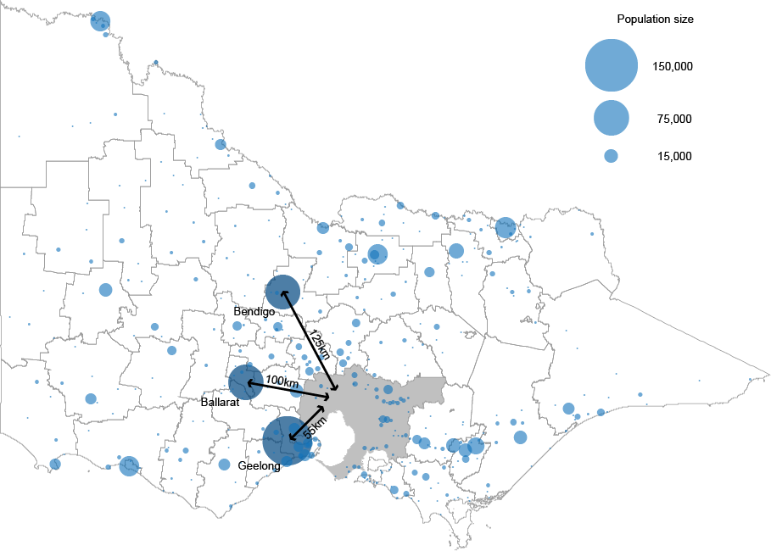

Of GBB, Geelong is located closest to Melbourne, around 55km southwest of the state capital as the crow flies. Ballarat and Bendigo are further away, the former located 100km west of Melbourne and the latter 125km northwest.

2.1.2 Population change, 1981-2006

Table 1 and Figure 2 (below) show that GBB demonstrated different patterns of population change over the period 1981-2006. While all three were considerably larger in 2006 compared to 1981, this did not mean that they grew consistently over the twenty five years. A common theme is the lower annual average growth rates in the period 1991-1996, when the Victorian economy was in recession. Restructuring of the global economy meant that this recession hit regional Victoria particularly hard, especially in towns that were more reliant on the manufacturing sector, such as Geelong and Ballarat. During this time, Geelong’s population declined and Ballarat recorded minimal change. Overall, Bendigo grew more rapidly over the twenty five years and it also recorded the largest volume of growth (16,270 persons), despite being the smallest of the large regional centres.

Table 1: Population (enumerated) of regional centres, 1981-2006

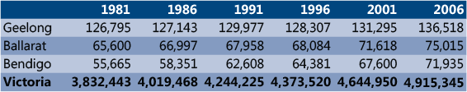

Figure 2: Average annual population growth, regional centres and Victoria, 1981-86 to 2001-06

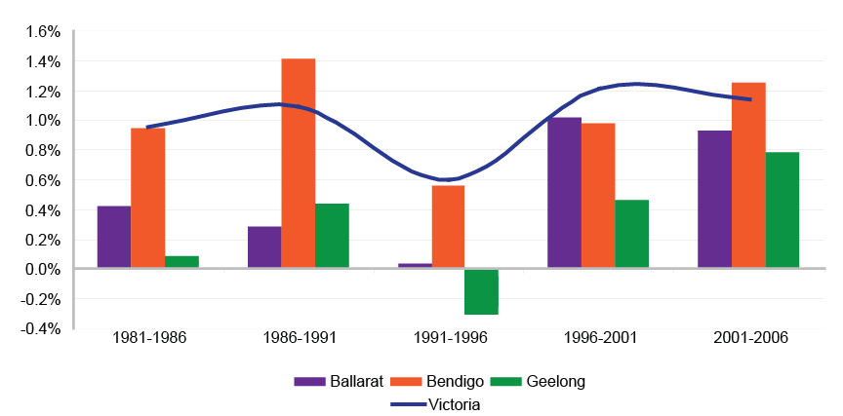

2.1.3 Peri-urban growth

Data on population change in GBB only tells part of the story. Their influence is not contained within their geographic boundaries – one of their key characteristics is the extent to which they have a “sphere of influence” over their hinterlands. This is largely due to their role as major service providers and as places of employment. Moreover, increasing mobility in recent years has reduced the need for people to live close to their place of employment, and this, coupled with increasing wealth and desire for rural residential living, has contributed to the growth around regional centres of smaller towns and selected rural locations with high amenity – the so-called “peri-urban” region. These areas grow to the extent that they essentially act as satellite suburbs within the catchment of large regional centres.

Table 2: Population change, LGAs and towns, 2001-2006
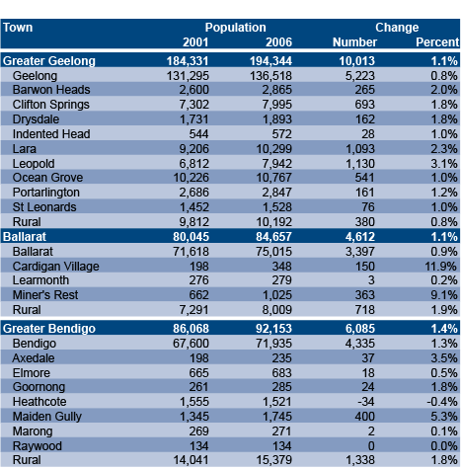

Sources: DPCD, Towns in Time (2008),
ABS, Census of Population and Housing, Time Series Community
Profile, Table T01
Table 2 shows that population growth between 2001 and 2006 was positive across the LGAs in which GBB are located – both in the surrounding towns and the rural areas. Only one town, Heathcote, located about 45km from Bendigo, recorded population decline in this time period, and this consisted of just 34 persons or -0.4% per annum.

Population growth was particularly strong in the towns in Greater Geelong, some of which are suburban in nature and have large greenfield development sites. Towns such as Lara and Leopold grew by over 1,000 people, recording annual average growth of 2.3% and 3.1% respectively, far higher than Geelong itself. Relatively cheap land and housing are attracting families to these smaller towns which offer the benefits of a semi-rural lifestyle as well as access to employment in services in Geelong. Furthermore, there are towns in neighbouring LGAs which also grew strongly and share characteristics with the aforementioned towns – examples of these include Torquay and Bannockburn.

Population growth was very strong in some towns around Ballarat and Bendigo, but these were from much smaller bases. The small town of Cardigan Village, located west of Ballarat, almost doubled its population over the five years (11.9% per annum), but still only had a 2006 population of 348 persons. Miner’s Rest, north of Ballarat, also recorded strong growth as new land was made available for development. This growth should continue into the future as it is a designated growth area.

Similarly, around Bendigo, the town of Maiden Gully recorded strong growth (5.3% per annum) as a designated growth area. However, many of the towns in Greater Bendigo, especially in the north, recorded minimal growth. The role of these towns is more closely tied to agricultural production which has been impacted in recent years by prolonged drought. They do not offer the same rural amenity lifestyle attributes as the region immediately surrounding the Bendigo urban area and hence have different drivers influencing demographic change.

2.1.4 Population change - projected

Strong population growth in GBB is expected to continue into the future. Population projections prepared by DPCD (2008) do not produce data for towns, but they do provide an indication of expected growth at the municipal level. This confirms that population growth rates are expected to be highest in the short term, and thereafter decline (Figure 3). This is in common with the trend for Victoria. After 2011-16 population growth rates in GBB are projected to be higher than that for the state as a whole. This is due to the continuing attraction of GBB and their hinterlands as places to live, as well as other factors such as higher levels of service provision (compared to more rural areas), more affordable housing options (compared to metropolitan Melbourne) and strategic planning policies implemented by both the Victorian State Government and local councils.

Figure 3: Average annual population growth rates, actual and projected

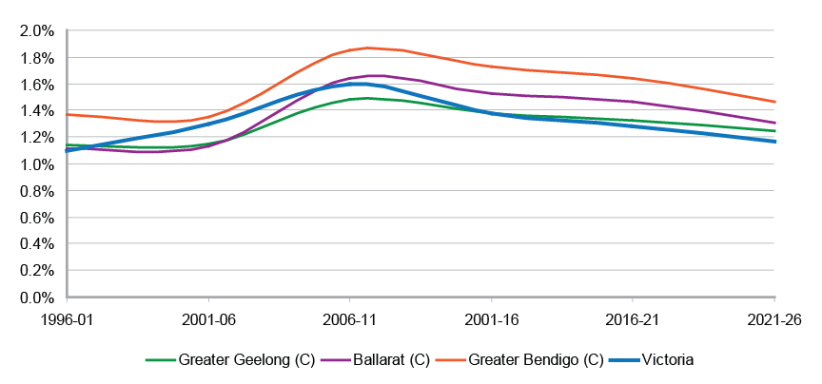
Source: ABS, Regional Population Growth (Cat. no. 3218.0) and DPCD, Victoria in Future (2008)

2.2 Age structure

Changes in the age structure of the population are important from a planning perspective, because a great deal of service provision is age dependent eg education and health. One of the most significant demographic trends in recent years has been the ageing of the population, as measured both by the number and proportion of persons in the older age cohorts. The regional centres have not been immune to this trend, and the changes in their age structure demonstrate a great deal of similarity over the period 1981-2006. In general, the main pattern has been one of a decline in the proportion, but not necessarily the number of young persons (ie 0-17 years), and a rapid increase in both the number and proportion of persons aged 65 years and over.

As shown in the Figure 4, GBB witnessed a shift towards older persons in that the proportion of 65 plus year olds increased over time. This trend is consistent with that of many towns across Australia, as well as the nation as a whole. The proportion of older persons in GBB has also been consistently higher than that recorded in Melbourne. Geelong recorded the largest increase in persons aged 65 years and over, from 11.4% of the population in 1986 to 15.9% in 2006. At the same time, the number of persons in this age group increased by almost 50%. Increases in the number and proportion of older persons raises issues of health services provision and, at the upper end of the age spectrum, aged care accommodation.

The ageing of the population has occurred along side a decline in the proportion of younger persons in the population, defined in Figure 4 as persons aged 0-17 years. This has implications for the delivery of education services, particularly schools. The decline was most pronounced in Geelong – in 1986, 28.9% of the population were in this age group, but by 2006 this had declined to 23.3%. In numerical terms, this represented a decline of almost 14%, or just over 5,000 persons. In recent years there have been examples of school closures and mergers in response to this trend.

In Bendigo the number of persons aged 0-17 years increased slightly over the twenty years, from 16,987 in 1986 to 17,552 in 2006. This occurred despite a decline in the proportion of persons in this age group and is a reflection of the strong overall population growth in this town.

The changing age structure also has implications for the labour force. Unsurprisingly, persons aged 18-64 years comprise the bulk of the population in each town and their share has increased slightly over the twenty year period. Much of this increase is due to the effects of the baby boomers (those born from 1946 to the early 1960s) and the size of this cohort as it passes through the age spectrum. As this cohort ages in coming years it will increase the number and proportion of persons in the older age groups and have a dampening effect on the growth of the labour force.

Figure 4: Age structure, by town, 1986-2006

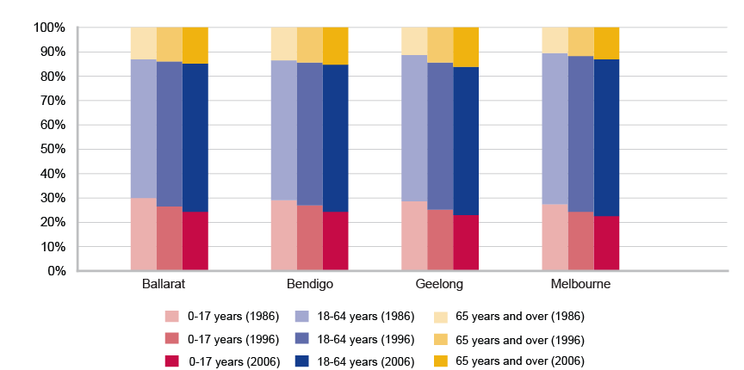

2.3 Disability and ageing

The 2006 Census included a question pertaining to the need for assistance with core activities, and as such, provides an indication as to the level of disability in the community. Core activities include eating, dressing, as well as mobility and communication tasks. Unfortunately there is no comparable historical data, so analysis is restricted to the most recent Census. However, the key issue is the strong relationship between advancing age and the need for assistance with core activities, as shown in Figure 5 below. After the age of 75 years, about one in five persons require assistance with core activities, but this increases significantly after the age of 85 years, where the ratio is less than one in two. The implications of this trend are increasing demands for high level health care (including hospitals and nursing homes), which are major budgetary items for governments and comprise an increasing proportion of expenditure.

Figure 5: Proportion of population with a need for assistance with core activities, by LGA

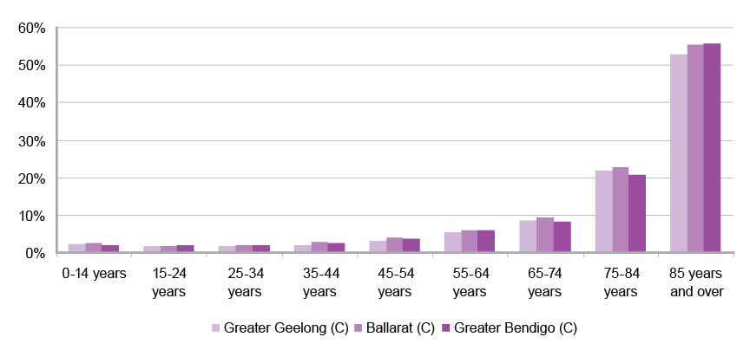
Source: ABS, Census of Population and Housing (2006)

2.4 Overseas born

Although Victoria is often referred to as a “multi-cultural society”, overseas born persons, particularly those from non-English speaking backgrounds, mainly live in Melbourne. Almost 90% of Victoria’s overseas born population live in the Melbourne Statistical Division (MSD). Furthermore, over 90% of overseas migrants to Victoria between 2001 and 2006 settled in the MSD (ABS, 2006). As a result, most areas of regional Victoria have very low proportions of overseas born persons and they tend to be from English speaking countries, particularly the United Kingdom and New Zealand. Over the period 1986-2006, the degree of change in GBB with respect to their overseas born population has varied considerably, as shown in Figure 6.

The proportion of overseas born increased slightly in Ballarat and Bendigo, but there was a clear decline in Geelong, from 20% in 1986 to 18% in 2006. This was primarily an outcome of ageing ethnic communities, particularly in the major migrant groups of the 1950s and 1960s. These migrant groups, such as Italians and Greeks, were instrumental in supplying labour for manufacturing firms. However, these people are now elderly and are declining in number. For example, in 1986 there were 2,240 Italian born persons in Geelong, but by 2006 this figure was 1,570, representing a decline of almost 30%.

Figure 6: Proportion of persons born overseas, 1986-2006

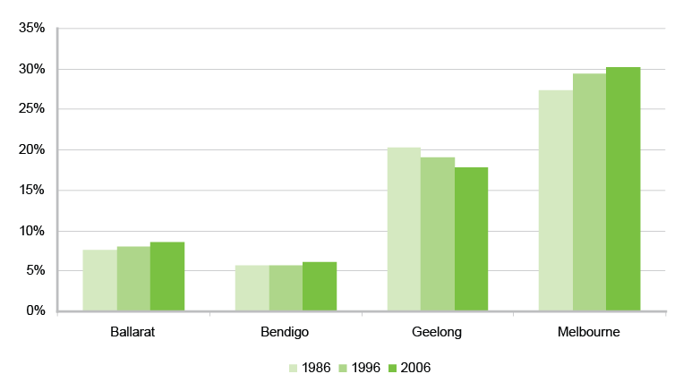
Despite the low proportions of overseas born persons living in Ballarat and Bendigo, the absolute increase in this population has been quite rapid, particularly in more recent years. For example, between 1996 and 2006, there was a 20% increase in the number of persons born overseas living in Bendigo, which was a higher amount than that recorded in Melbourne (13%). However, the main overseas born communities were the United Kingdom and New Zealand, as opposed to non-English speaking countries.

The low proportion of overseas born persons has implications for future population growth. Overseas migrants tend to be of child bearing age and given that the majority of them settle in Melbourne, it follows that they will have their children there as well. If this imbalance in the settlement pattern of overseas migrants continues, this will favour the growth of Melbourne over GBB and regional Victoria generally.

2.5. Dwellings

Despite variations in population growth, the number of dwellings in the regional centres has grown steadily over the twenty five year period. The main reason for this is the increased demand for housing as a result of societal change. These include population ageing (older women in particular live alone), declining fertility (smaller families) and family breakdown (which tends to create two households from a family unit). The result of these changes is a decline in average household size and is evident in the growth of lone person households and the decline in the number of family unit households.

Figure 7 below shows that the trend towards smaller households is clear in GBB. In 1981, average household size was 3 persons in Geelong, and slightly lower in Ballarat and Bendigo. Over time, the average household size has steadily declined, reaching 2.4 persons in all three towns in 2006.

Figure 7: Average household size and proportion of lone person households, 1981-2006

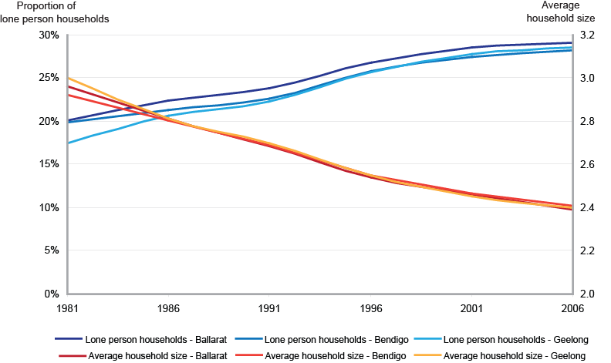

At the same time, the proportion of lone person households has increased considerably. In Geelong, the increase was from 17% in 1981 to 29% in 2006. Ballarat and Bendigo increased from 20% in 1981 to 29% and 28% respectively in 2006. This has occurred due to the factors described above.

A distinctive feature of the urban fabric in regional Victoria, regardless of the size of the town, is the overwhelming dominance of the separate house. This creates low density urban forms, as there are very few apartments, units, or other forms of medium density housing. Despite growing awareness of the problems associated with urban sprawl and the trend towards smaller households, Australians display a strong cultural preference for the separate house on a suburban block as a means of settlement. This has resulted in extremely low settlement densities, often quoted as being amongst the lowest in the world. In addition, ABS data indicates that by floor area, Australia now has the largest new homes in the world (CommSec, 2009). This low density form of urban development however has sustainability implications in terms of car dependency and loss of productive agricultural land.

Table 3 shows the proportion of separate houses in GBB over the period 1981-2006. This has decreased slightly over the twenty five years, but it remains the dominant form of housing, and is still well above the figures recorded in Melbourne. A continuing process of rezoning areas at the fringe of GBB suggests that this form of urban development will continue into the future. In Ballarat and Bendigo in particular, the imposition of heritage overlays over much of the inner areas may act as a deterent for redevelopment, particularly when there are greenfield sites in close proximity. The Ballarat Residential Infill Opportunities Study (2009) identified a number of parcels within the existing urban area that could be redeveloped for housing, but it is unclear whether the housing market would support this.

Table 3: Proportion of separate houses by town, 1981-2006

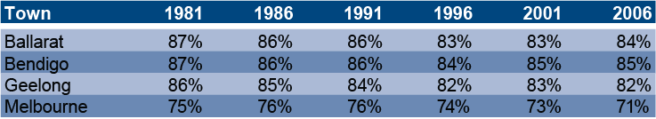

2.6 Labour force

Victoria’s economy has changed significantly over the period 1981-2006, resulting in marked shifts in the type of work being conducted. These changes have resulted from global economic forces creating increased competition, along with new technologies that have made some jobs obsolete, but have opened up new fields and types of work that were largely unimagined in the early 1980s. It has often been described as a shift from an industrial to a post-industrial society, evidenced by a move from manufacturing to information based production – the “knowledge economy”.

The figures reported in this section refer to the residential workforce rather than employed persons, ie those living in the towns, rather than those working in the towns. Table 4 below shows the labour force status of the regional centres over the period 1986-2006. The notable feature is the extremely high unemployment, as measured by the number of persons and the rate, in all three regional centres in 1996. At this time the Victorian economy was still suffering from the effects of the early 1990s recession, which hit regional Victoria longer and harder than it did in Melbourne. However, over the period 1986-2006 the large regional centres consistently recorded higher unemployment rates than Melbourne. The reasons for this are not clear and it is thought to be a combination of a number of factors.

Firstly, labour markets in GBB, by virtue of their smaller size and narrower economic base, respond to different stimuli when compared to Melbourne. For instance, they may be more vulnerable to economic shocks. Secondly, in-migration to GBB from surrounding rural areas may also contribute to higher unemployment, with the economy taking more time to absorb the influx. There is evidence to suggest that young people in particular have difficulties in obtaining employment, and it is this group that comprises the bulk of in-migration to GBB. This issue was raised by respondents in a study about youth migration and tertiary institutions in relation to Bendigo (DPDC, 2009: 10). Finally, the rapid change in Geelong’s economy over the last twenty years is thought to have created a degree of structural unemployment, whereby low skilled former manufacturing workers, particularly older males, struggle to find alternative employment.

By 2006 strong economic growth over a number of years resulted in employment growth, and a subsequent reduction in both the number and rate of unemployment. In all three regional centres, the unemployment rate was lower than in 1986, but still higher than that recorded in Melbourne. The participation rate, although consistently lower than Melbourne’s, also increased over time. The increase was particularly strong in Ballarat (55% in 1986, 62% in 2006) and Bendigo (56% in 1986, 62% in 2006).

Table 4: Labour force status by town, 1986-2006



