How to create an account
Development Facilitation Portal
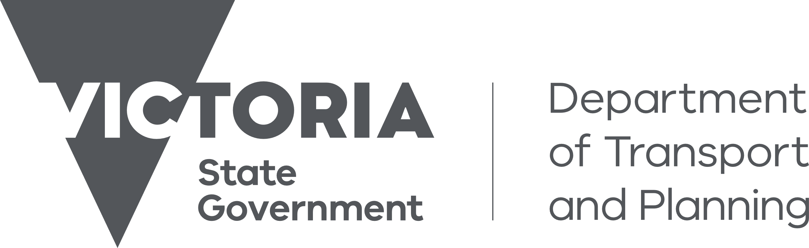
Purpose
The following guide steps applicants through how to create an account to access the Development Facilitation Portal. By creating an account, the applicant will be able to:
- Save and resume an application
- Track the progress of an application
- Share an application with other collaborators
- Withdraw their application via the portal
- Respond to any requests for further information
- Provide additional supporting documentation

We use Atlassian’s software to collect forms and manage the process for Development Facilitation. The portal can be used to lodge requests for Priority Projects or Facilitation Assistance. When signing up, you agree to Atlassian’s Privacy Policy and Notice and Disclaimer

Create an account
- Go to: https://priorityprojects.atlassian.net/servicedesk/customer/user/login?destination=portals
- Select Sign Up
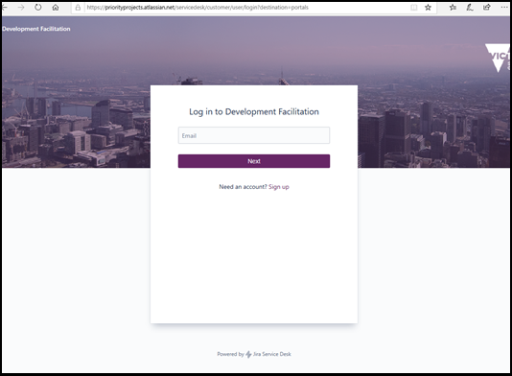
2
- Enter your email address to have an activation link sent to you.
- Select Send Link.
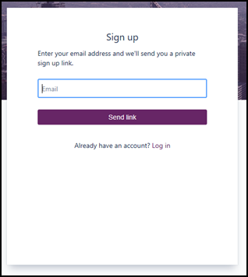
3
4
- Check your email and open the email from Development Facilitation titled ‘Finish signing up to Development Facilitation’.

- Select Sign Up.
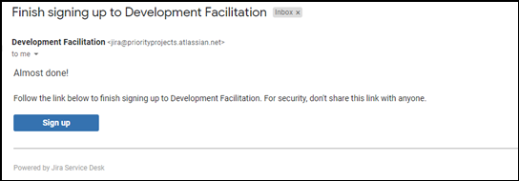
6
- At the signup screen, enter your full name.
- Enter a strong password.
- Refer to the Privacy Policy and Notice and Disclaimer information pages to ensure you agree with the policies.
- Select Sign up.
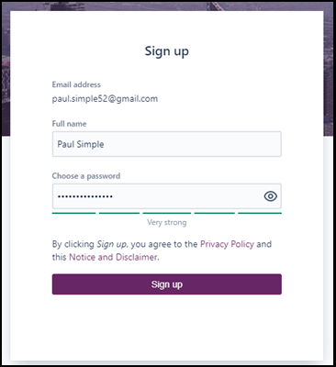
7
10
9
8

It is recommended that you further secure your account using multi-factor authentication. Instructions are available from Atlassian.

Need further help?
If you require further assistance with your request, please contact the Development Facilitation team at development.facilitation@delwp.vic.gov.au .

