Planning permit enquiry triage and conversation guide

Contents
1. Pre-application enquiry triage principles 2
2. Enquiries commonly misplaced to planning that should be directed to other council departments 3
3. Enquiry conversation guide 4
4. Enquiry triage examples 6

We are leaders in local government innovation and are responsive to the community.
The Planning Department have taken on board Community requests to have simple planning information readily available. We have undertaken the Better Planning Approvals Process and implemented processes to assist in making information open and accessible where possible.
The purpose of this guide is to ensure customer-facing council staff consistently and effectively triage customer planning permit pre-application enquiries to the appropriate council resource or service. It should be used during induction and refresher training and be available for staff allocated to customer-facing services.
With greater and more accessible planning permit information available online, it is critical to ensure this information is effectively utilised. The guide provides principles for council staff to effectively triage pre-application enquiries, how to triage certain enquiries, as well as conversation prompts to ensure customers are triaged appropriately.
Implementation Note: (to be deleted once updated)
Update branding to your local council branding
- Pre-application enquiry triage principles
Triage principles guide how council staff respond to a customer pre-application enquiry about planning permits. The six principles, outlined below, are applicable regardless of the channel (email, phone-call, customer service counter) or staff member by whom the pre-application enquiry is received.
Customer Service are aware of the triage and conversation guide to ensure consistent application
Customers with general enquiries are directed to the council planning webpage
Self Service options are offered to Customers
Specific enquiries are triaged to relevant departments and logged in merit
Specific planning enquiries are connected to the duty planner as per the roster
Enquiries of substantial nature are encouraged to make appointments with relevant officers
Implementing these triage principles is critical to providing a consistent, timely and high-quality customer experience, while also optimally leveraging council’s digital information resources and ensuring efficient use of staff time.

Implementation Note: Common enquiry categories should be reviewed and revised to suit each council
- Enquiries commonly misplaced to planning that should be directed to other council departments
Query | Correct Department
I'd like a copy of my building plans | Building
They’re demolishing my house next door (report + consent) | Building
Property Information Report | Building
Report + Consent  (Report and Consent application available on website) | Building
Swimming Pool, Fence or Spa | Building
Is there asbestos? | Building/WorkSafe
Building setbacks and height | Building
Drainage/Sewage Plans | Engineering
Legal point of discharge | Engineering
Someone is removing/cutting down trees | Compliance
Illegal works being undertaken | Compliance
The footpath outside my house is broken | Operations
Remove Tree from Nature Strip | Works Operations
Street Number Allocations | Rates
I need a street closure permit; for an event | Tourism
I need a street closure permit; for works in the road reserve or road works | Works operations
Crossovers | Engineering/Assets
Asset Protection | Engineering/Assets
- Enquiry conversation guide
Triage questions are ordered in logical sequence, and includes prompts for counter and phone conversations in order to help identify pre-application enquiries and support triaging to the appropriate resource or service.
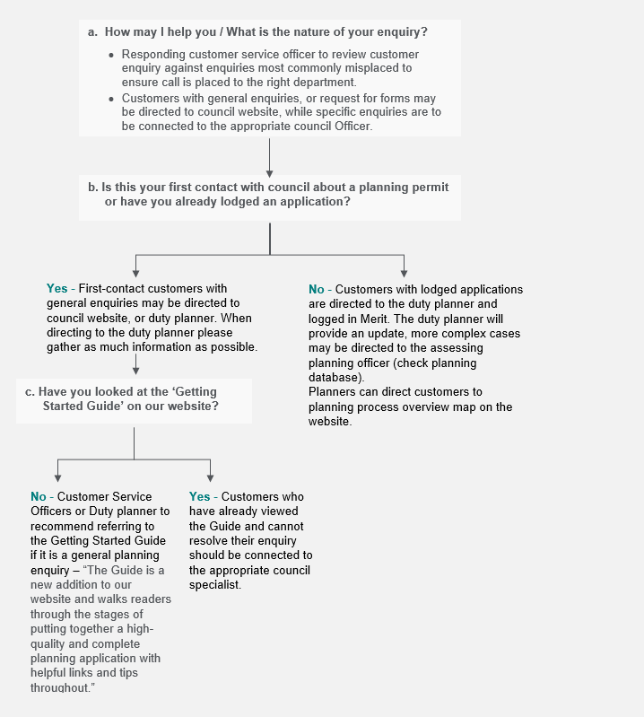
- Enquiry triage examples
Implementation Note: The below can be tailored as a guide for new planners tasking calls.

Connect customer to the Duty Planner:
If customer is a business owner and has a specific planning enquiry, connect customer to Duty Planner.
Identify whether customers are calling for the first time or if they are following up on a matter, or existing planning application - Ask for the application reference number (Pxxxx-xxx), or address.
Examples of general and specific customer enquiries, and how to triage, are defined in the table below.
General planning permit enquiry | Specific planning permit enquiry
Direct customer to council planning permit webpage where possible:  - I want to learn more about the planning permit process. Where do I start? What are the steps?  - Who else do I need to talk to?  - How do I apply for a planning permit? I need an application form.  - How long will it take to receive a permit?  - How much are the application fees? | Connect customer to the Duty Planner:  - Do I need a planning permit for this property? To build a shed, deck, or porch?  - Could I receive feedback on my proposal?  - Am I allowed to remove this vegetation?  - What is my neighbour building next door?  - I’m a property developer and would like feedback or information on my upcoming development.  Enquiries about an active planning permit application should be directed to the assessing officer. If they are unavailable, direct to the Duty Planner.

