Scope for the environment report under EPBC Act Bilateral (Assessment) Agreement 2014 and EE Act
  - Gunbower National Park and Guttrum-Benwell Forests Floodplain Restoration Projects
July 2021

1 Introduction
The Victorian Murray Floodplain Restoration Project (VMFRP) consists of nine discrete environmental works projects across a range of floodplain environments of the Murray River in Victoria. Lower Murray Urban and Rural Water Corporation (LMW) (the proponent) is required to prepare an environment report for both the proposed Gunbower National Park Floodplain Restoration Project (Gunbower) and Guttrum-Benwell Forests (Guttrum-Benwell) Floodplain Restoration Project (the projects), under the Environment Effects Act 1978, to examine potentially significant environmental impacts and intended benefits. The two projects propose to return a more natural flood regime to 632 hectares (ha) of high-ecological-value Murray River floodplain within the Gunbower National Park and approximately 1,149 ha of high ecological value floodplain within Guttrum-Benwell State Forests. The VMFRP is being implemented as part of Victoria’s obligations under the Murray Darling Basin Plan (Basin Plan). The VMFRP allows Basin Plan objectives to be met without further water purchases.

Statutory Context
LMW submitted referrals for Gunbower National Park Floodplain Restoration Project and Guttrum-Benwell Forests Floodplain Restoration Project under the Environment Effects Act 1978 (EE Act) (EES referral 2020-R17 and 2020-R15, respectively) and under the Environment Protection and Biodiversity Conservation Act 1999 (EPBC Act) (EPBC 2020/8771 and EPBC 2020/8754, respectively).
On 6 December 2020, the Victorian Minister for Planning decided under the EE Act that an environment effects statement (EES) was not required for the two projects. Each of the decisions to not require an EES were subject to conditions being met, to appropriately assess and manage specific potentially significant environmental impacts (see Appendices A and B for the Minister’s decisions). The conditions set for each project require an environment assessment process (in lieu of an EES), including the preparation of an environmental report in consultation with DELWP and relevant agencies and departments (as directed by DELWP), completed to the satisfaction of the Minister for Planning and advertised for public comment. The conditions also require preparation of an environmental management framework (EMF), native flora and fauna management plan, construction environmental management plan (CEMP) and operating plan informed by the findings and conclusions of the environment report, prior to the commencement of works.
On 2 October 2020 (Gunbower) and 21 September 2020 (Guttrum-Benwell), the projects (actions) were determined to be ‘controlled actions’ under the EPBC Act by the Commonwealth Minister for the Environment’s delegate, as they are likely to have a significant impact on matters of national environmental significance (MNES) protected under Part 3 of the EPBC Act . The relevant controlling provisions for MNES were listed threatened species and communities (sections 18 and 18A) for both the Guttrum-Benwell and Gunbower projects, and declared Ramsar wetlands (sections 16 and 17B) for the Gunbower project.

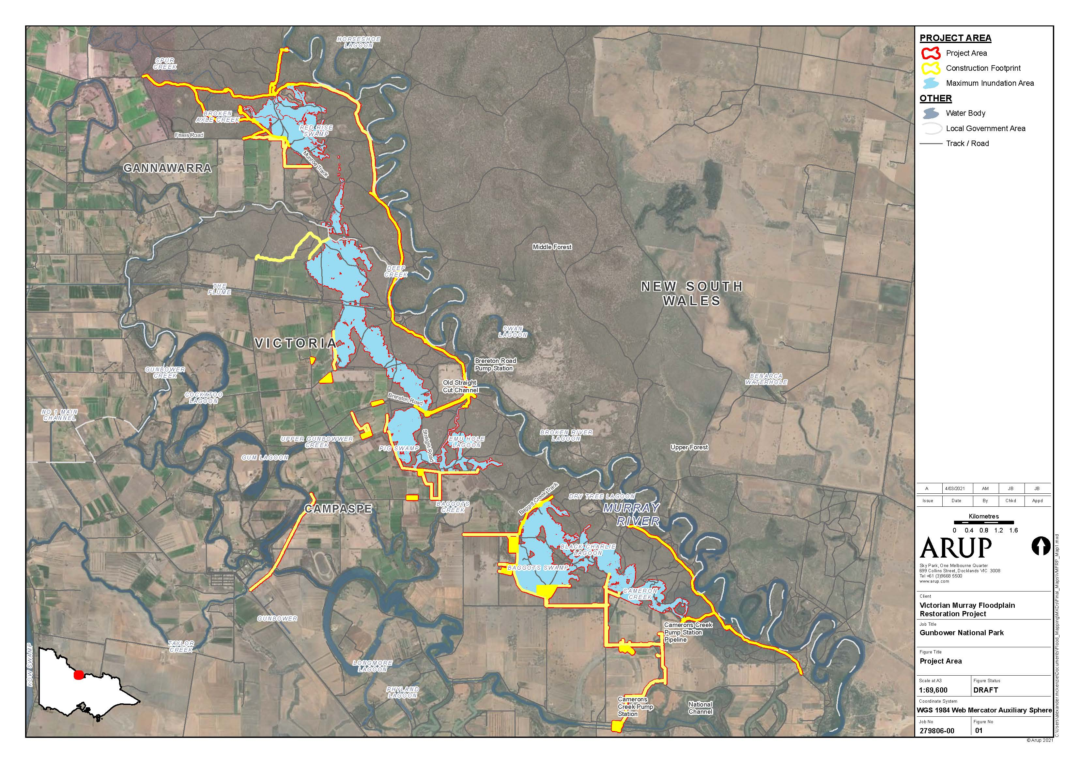
Figure 1: Location of the Gunbower National Park Floodplain Restoration Project (source: Arup)

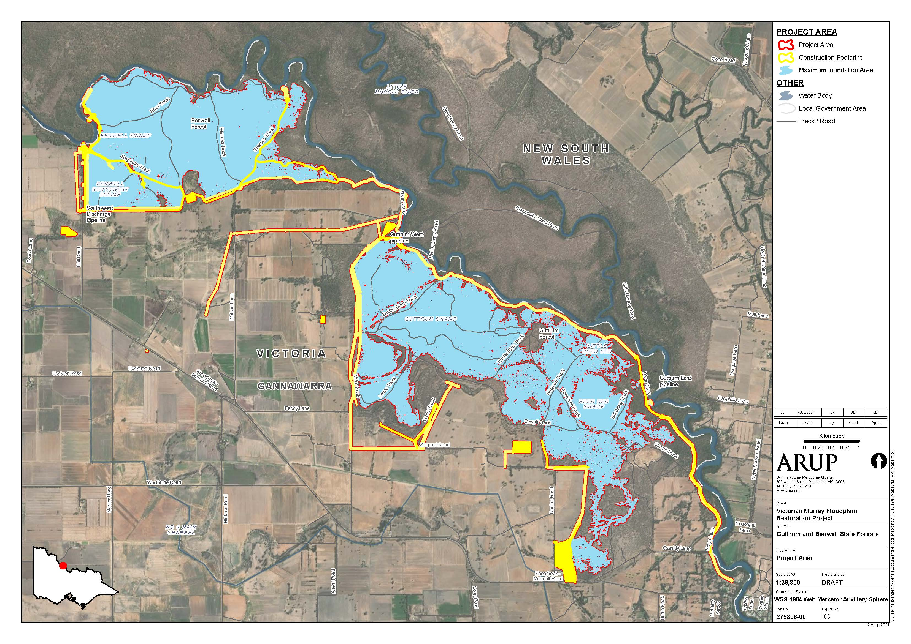
Figure 2: Location of the Guttrum-Benwell State Forest Floodplain Restoration Project (source: Arup)

Further to this, on 18 December 2020 (Gunbower) and 23 December 2020 (Guttrum-Benwell) the delegate for the Commonwealth Minister for the Environment’s determined under section 87(4) of the EPBC Act that the projects would be assessed by the State using accredited state assessment processes under the EE Act (i.e. environmental report process, as set out in Schedule 1, item 2.1(c) of the Bilateral (Assessment) Agreement). The Commonwealth will rely upon the outputs of the environmental report processes administered by the state. Use of an accredited state assessment process helps avoid process duplication and enable integrated and efficient consideration of impacts on relevant Commonwealth and Victorian environmental matters, as well as improve alignment of the mitigation and approval requirements under the relevant Commonwealth and Victorian laws. As such, the report required under the EE Act will need to meet assessment requirements set out by the Minister for Planning’s conditions under the EE Act (set out in more detail below), together with the relevant Commonwealth matters identified for these controlled actions.
Following LMW’s completion of the environment report (addressing all matters set out within this scope), to the satisfaction of the Victorian Minister for Planning, LMW will need to advertise the environment report for public comment, consistent with requirements of the state accredited assessment.
Any submissions from the public on the advertised documentation must be addressed by LMW (such as in an addendum to the environment report) in order for that to considered and used to inform the Minister for Planning’s assessment of the project’s impacts.
At the conclusion of the accredited state process, the Victorian Minister for Planning will provide this ‘Assessment’ of impacts to the Commonwealth Government Minister for the Environment. The Commonwealth Minister or delegate will decide whether the project is approved, approved with conditions or refused under the EPBC Act, after having considered the Minister for Planning’s Assessment Report, which will also be considered by Victorian Government decision makers.

Outline of Projects
The Gunbower project involves the construction of: 12 small regulators; one fishway; four pipelines; two pump stations; associated power supply; one channel upgrade; three drop structure; two culvert crossings; one drainage outlet; access track upgrades ; erosion control works; and a series of containment banks to divert, retain and release water in the upper and middle areas of Gunbower National Park.
The Guttrum-Benwell project involves the construction of: one large regulator; six small regulators; four pipelines; three drop structures; three pump stations and associated power supply; one floodrunner works; erosion control works; a series of containment banks to facilitate managed inundation of the Murray River floodplain; and establishment of temporary coffer dams and dewatering storage, pump hardstands, construction laydown areas and access track construction/upgrade and maintenance.
Project components yet to be confirmed include the extent of levee works required, power supply infrastructure and the location of borrow pits.

2 Purpose of Environmental Report
LMW needs to prepare an environment report that sufficiently describes the two projects and assesses their respective likely relevant effects/impacts as well as assessing any feasible alternatives and mitigation measures that could avoid or reduce relevant impacts for each of the project. The Minister for Planning’s decisions/conditions under the EE Act (appendices A and B) have set the core scope of assessment required for the environment reports. In summary, the environment report needs to examine and document the following for both the construction and proposed inundation areas for the two projects respectively:
- the expected benefits and ecological objectives of the project, with measurable indicators for monitoring and thresholds for action, including for specific species and ecological communities;
- assessment of predicted effects (direct and indirect) on native vegetation, large trees, habitats and biodiversity values particularly associated with listed species and communities (under the Flora and Fauna Guarantee Act 1988 and EPBC Act), as well as threatening processes.
- identification of project design alternatives to avoid and minimise adverse environmental effects, including options for the project layout, siting of infrastructure, extent and timing of inundation events;
- assessment of predicted effects on listed nationally and internationally important wetlands (Gunbower only);
- assessment of predicted effects on hydrogeology and groundwater quality;
- assessment of predicted effects on Aboriginal cultural heritage;
- integrated assessment of alternatives and/or refinements, to further avoid and minimise adverse environmental effects; and
- assessment of potential cumulative effects of the project and other sub-projects of the VMFRP and other existing or planned projects in the area.
The report will also need to address matters relevant to the requirements of the accredited assessment under the EE Act, such that it examines all relevant impacts on MNES for each project /action, relating to controlling provisions sections 18 and 18A (listed threatened species and communities) for both projects and sections 16 and 17B (declared Ramsar wetlands) for the Gunbower project.
Preparation of the environment report should be consistent with the principles of a systems approach and a risk-based approach, so that a greater level of effort is directed at investigating and addressing those matters that pose a relatively higher risk of adverse effects/ impacts. The environment report should put forward a sound rationale for the level of assessment and analysis undertaken for any environmental effect or combination of environmental effects/ impacts arising from construction and operational stages of the project.

3 Technical Reference Group
DELWP has convened a technical reference group (TRG) of state and commonwealth government agencies, registered Aboriginal parties and local councils. A single TRG has been established to cover all nine sub-projects which form part of the broader VMFRP and will be used for the environment report process to facilitate the provision of advice from relevant agencies to DELWP and the proponent on:
- applicable policies, strategies and statutory provisions;
- the scope for the environment report;
- the design and adequacy of technical studies for the environment report;
- the proponent’s public information and stakeholder consultation program for the environment report;
- the technical adequacy and completeness of draft environment report documentation; and
- coordination of statutory processes.

4 General content, format and style
A single environment report needs to be prepared to cover both the Gunbower National Park Floodplain Restoration Project and Guttrum-Benwell Forests Floodplain Restoration Project. The report needs to present clear and specific impact assessment and conclusions for each project, to inform relevant statutory considerations and subsequent decisions for each.
The environment report needs to be ‘stand alone’ such that interested stakeholders and decision-makers can readily understand the assessment and significance of environmental impacts of each of the proposed developments, in particular on matters of regional, state and national environmental significance, without needing to search through supplementary technical reports, documents and references. Any information provided within the referral documentation can be incorporated as appropriate and all supporting technical reports and other documents/ appendices need to be clearly referenced within the environment report.
The environment report needs to be written so that any conclusions reached by LMW can be independently checked i.e., the information and analysis is to be objective, clear, succinct and, where appropriate, supported by maps, plans, diagrams or other descriptive detail. It also needs to include a concise executive summary. Detailed technical information, studies or investigations necessary to support the main text and assessment of relevant impacts are to be attached as appendices.
Documentation needs to be prepared using a format and style that it is appropriate for publication on the internet to support easy access by the public during its public exhibition.
The documentation must use active, clear language and commitments (e.g. ‘must’ and ‘will’).

5 Plans, policies, guidelines and instruments
It is the proponent’s responsibility to ensure that relevant documents, plans, policies and guidelines are identified, reviewed, analysed and their implications taken into account when analysing impacts in the environment report. These include but are not limited to:
- Victoria’s native vegetation removal regulations including the Guidelines for the removal, destruction or lopping of native vegetation (DELWP, 2017) and Procedure for the removal, destruction or lopping of native vegetation on Crown land (DELWP, 2018).
- Flora and Fauna Guarantee Act 1988 – Ecological community descriptions (Department of Environment, Land, Water and Planning, 2018) and action statements.
- Planning and Environment Act 1987 – Conservation work exemption application process guidance (DELWP, 2018).
- Commonwealth Government documents including listing advice, conservation advice, recovery plans and threat abatement plans for each relevant listed threatened species or community.
- EPBC Act Significant Impact Guidelines 1.1 - Matters of National Environmental Significance (Australian Government Department of the Environment, 2013).
- EPBC Act Environmental Offsets Policy (Department of Sustainability, Environment, Water, Population and Communities, 2012).
- Aboriginal Heritage Act 2006 – guides to preparing a cultural heritage management plan (CHMP). An approved CHMP will be required for each project.
- Water Act 1989 – works on waterways permit guidelines.
- North Central Regional Catchment Management Strategy.
- Environment and Protection Act 1970 – applicable regulations and guidelines.
From 1 July 2021, the Environment Protection Act 2017, as amended by the Environment Protection Amendment Act 2018 has come into effect, superseding the Environment Protection Act 1970. Environment Protection Regulations (regulations) and Environment Reference Standard (standards) are being developed to support the new laws. The project will need to be carried out in a manner consistent with the measures and principles of the new Act, including adherence to the General Environmental Duty (GED). Under the GED, the project activities will need to be undertaken in a manner that reduces the risk of harm to human health and the environment from pollution or waste as far as reasonably practicable. Any management and mitigation measures implemented will need to be cognisant of the GED.
The proponent also needs to consider relevant documents, plans, policies and guidelines under New South Wales legislation as the project proposes works located within the border of New South Wales.

6 Description of the project
The environment report needs to include details about the proposed projects: their title, the name and postal address of the designated proponent, project objectives, background to the developments, relationship to statutory policies, plans and strategies, including the justification for need for the projects, how they relate to any other existing or proposed projects, their current status and implications of the project not proceeding.
The environment report must describe the projects in sufficient detail to allow an understanding of all components, processes and development stages, and to enable assessment of their likely potential environmental effects. This should include the precise location of all works to be undertaken (including plans and maps) in relation to potentially affected environmental assets and elements of the project that may have impacts on matters of state or national environmental significance or social or economic impacts.
The report needs to include mapping that clearly illustrates the full extent of works and inundation areas, as well as key environmental assets to be avoided (e.g. no-go zones).
The description of the project must also include details on how the works are to be undertaken (including staging, methods and timing for construction, commissioning and operation) and design parameters for those aspects of the structures, elements or operation that may have impacts.

7 Integrated assessment of alternatives
The environment report needs to document the proponent’s identification and assessment of alternatives, including the preferred alternative(s) and design. This will need to encompass an explanation of how and why specific alternatives were selected for detailed evaluation within the environment report. The environment report needs to document the likely environmental effects of feasible alternatives, particularly where these offer a potential to minimise and/or avoid significant environmental effects whilst meeting the objectives of the project. The assessment of feasible alternatives and their effects is required to include:
- description project design alternatives considered in the project design process to avoid and minimise adverse environmental effects, including for the project layout, extent of inundation, siting of infrastructure, management measures, project staging, timing and extent of inundation events;
- identification of methods and environmental criteria for selection of preferred alternatives;
- assessment and comparison of the technical feasibility and environmental implications of alternative options considered;
- the basis for selecting the proposed project layout and design, particularly where the project footprint is located within areas of particularly high conservation value;
- description of how information arising during the environment report process was used to refine the preferred project layout and other project alternatives.
This assessment needs to be an integrated assessment of the impacts of the project design alternatives and/or refinements, including consideration of potentially competing discipline-specific environmental priorities and predicted effectiveness of proposed mitigation and management measures.
The assessment of environmental effects of design, layout and inundation alternatives is to address the matters set out in the subsequent sections of this document as appropriate, with the depth of investigation of different alternatives being proportionate to their potential to minimise potentially significant adverse effects.

8 Description of the environment
The environment report needs to provide a description of the existing environment of the project sites, including inundation areas, and surrounding areas that may be affected by the projects. The information provided in the report should be detailed enough to provide a sound understanding of the existing environments and the methods used to characterise these, as detailed below.

Ecological benefits and objectives
- Characterise the ecological, hydrological, cultural and socio-economic settings of the floodplain and their interrelationships.
- Characterise the significance of the conservation values in the project areas at the local, regional, state and national levels, including in the context of future climate change scenarios.

Biodiversity and habitats
- Describe survey methods, areas and timing, and present data and historical records used to identify and assess the environmental values on site. Survey data must be provided for the matters of state or national environmental significance.
- Describe the methods used to predict potential environmental impacts and benefits including discussing uncertainty associated with these predictions or estimates.
- Describe the biodiversity habitat values (critical components, processes and services) associated with the ecological character of the Gunbower Ramsar site and NSW Central Murray State Forests Ramsar site and limits of acceptable change.
- Characterise the type, distribution and condition of native vegetation (including large trees, very large trees and hollow-bearing trees), terrestrial and aquatic habitat and habitat corridors or linkages that could be impacted by the project. This must include the quality and type of habitat impacted and quantification of the total direct and indirect impact areas from the proposed project and must be informed as appropriate by targeted surveys undertaken in accordance with the appropriate Commonwealth and/or DELWP survey guidelines and scientific best practice. Information must include maps indicating the location of native vegetation, large trees, and distribution of matters of state or national environmental significance and associated habitat.
- Characterise existing flows (where relevant) and surface water temperatures in relation to aquatic faunal species requirements.
- Identify the existence or likely presence of species and communities listed under the EPBC Act, Flora and Fauna Guarantee Act and DELWP advisory lists, as well as environmental weeds, pathogens and pest animals.
- Characterise baseline conditions for the species and communities listed under the EPBC Act, Flora and Fauna Guarantee Act and/or DELWP advisory lists. This characterisation is to be supported by seasonal or targeted surveys where necessary.

- Describe the conservation areas/reserves in the vicinity of the project, including the conservation and biodiversity values of the Gunbower National Park, Guttrum State Forest and Benwell State Forest.
- Characterise the potentially threatening processes that are likely to be present and exacerbated by the projects (including those listed under the Flora and Fauna Guarantee Act 1988 and Environment Protection and Biodiversity Conservation Act 1999).
- Describe existing management activities undertaken to manage existing threats to biodiversity values.

Surface water and groundwater
- Describe survey methods, areas and timing, and present data and historical records used to identify and assess the surface and groundwater values on site. Describe modelling methods including type of model and parameters used.
- Identify and describe nearby waterways, waterbodies, wetlands and floodplains that could be affected by the project.
- Describe downstream aquatic environments and the associated beneficial uses that could be affected by changed water quality or hydrology due to the project.
- Describe the ecological character of the Gunbower Ramsar site and NSW Central Murray State Forests Ramsar site, and related hydrological and environmental values protected under the EPBC Act, including their limits of acceptable change.
- Characterise the current groundwater conditions based on data, literature and appropriate surveys (where required), including any associated beneficial uses and environmental values and identify any groundwater dependent ecosystems that could be affected by the project.
- Characterise the interaction between surface water and groundwater within the project and broader area.

Aboriginal cultural heritage
- Review and assess previous studies, registers, landform and land use history to identify areas of known Aboriginal cultural heritage and prepare predictive models of areas with potential to contain Aboriginal cultural heritage.
- Review and assess records of reported Aboriginal ancestral remains within the project areas and inundation areas.
- Describe survey methods, areas and timing, and present data and historical records used to identify and assess the cultural values on site.
- Describe the extent, nature and significance of any Aboriginal cultural heritage sites or areas of sensitivity potentially impacted by the project areas (including associated infrastructure or ancillary works and inundation areas) through consultation and investigations to the satisfaction of the relevant Registered Aboriginal Party (or Traditional Owners in the absence of a Registered Aboriginal Party) and First Peoples - State Relations, ensuring adequate field assessments are conducted to verify the findings of any desktop studies.
- Identify any known or previously unidentified intangible Aboriginal cultural heritage values associated with the project areas.

9 Assessment of environmental effects
The environmental report must include assessment of all the relevant predicted and foreseeable environmental effects of the projects, focusing in particular on the state and MNES matters outlined below. Impacts during the construction, commissioning and operational phases of the project must be explicitly addressed in the environment report.

Benefits and ecological objectives
- Identify communities and species (particularly those species listed under the EPBC Act, Flora and Fauna Guarantee Act and/or DELWP advisory lists) expected to benefit from the projects and describe the reasons for the expected improvement.
- Quantify (wherever possible) the size of the area expected to benefit, and detail what vegetation components (e.g. understorey diversity, tree canopy cover) are expected to benefit.
- Detail actions that will improve the ecosystem function and predict improvements to ecosystem function in terms of:
  - elements or parts of the ecosystem that will be improved;
  - importance of the element(s) to the overall ecosystem function;
  - longevity of the improvements; and
  - level of certainty that the actions or improvements will be delivered.
- Assess expected ecological benefits for MNES, specific species and ecological values and how they relate to the predicted adverse effects on those species and biodiversity values. The report needs to examine this for each project and the relevant specific species and ecological communities listed under the EPBC Act, Flora and Fauna Guarantee Act and DELWP advisory list.
- Conduct direct comparison between the potential ecological benefits of the project and identified ecological impacts (see Biodiversity and habitats), including for specific species and communities.
- Present detailed evidence that supports the predicted benefits of the project, with explicit consideration of uncertainties associated with predictions made.

Biodiversity and habitats
- Assess likely adverse direct and indirect adverse effects on native vegetation (including large trees, very large trees and hollow-bearing trees), ecological communities as well as fauna and flora species listed under the EPBC Act, Flora and Fauna Guarantee Act and/or DELWP advisory lists.
- Assess the tolerable water regimes for the vegetation communities present within the inundation areas and the effects of proposed operating regimes on these communities.
- Assess the potential for the projects to impact/alter groundwater dependent ecosystems or for changes to groundwater to impact native vegetation communities for habitat.
- Amongst other species and communities, for both projects, the report needs to cover potential impacts on Silver Perch (Bidyanus bidyanus), Murray Cod (Maccullochella peelii) and Superb Parrot (Polytelis swainsonii).
- For the Gunbower project, amongst other species and communities, the report needs to cover potential impacts on Australasian Bittern (Botaurus poiciloptilus) Trout Cod (Maccullochella macquariensis), and Grey Box (Eucalyptus microcarpa) Grassy Woodlands and Derived Native Grasslands of South-Eastern Australia ecological community.
- Assessment of potential effects on species needs to take into account the likelihood of occurrence (habitat presence and condition) and the effectiveness of proposed avoidance and mitigation measures and also needs to consider relevant conservation or listing advices, action statements, recovery plans and threat abatement plans. Where surveys do not identify a listed species, but past records and/or habitat analysis suggest that it may occur locally, justification is to be provided if further investigations or further mitigation measures are not proposed.
- Assess impacts on habitats and conservation values within the Gunbower Ramsar site and NSW Central Murray State Forests Ramsar site, Gunbower National Park, Guttrum State Forest and Benwell State Forest, as well as other conservation areas.
- Identify and assess potential impacts and benefits for wetland habitats and conservation values associated with Gunbower Ramsar site and NSW Central Murray State Forests Ramsar site, in the context of their ecological character descriptions.
- Provide an assessment of residual effects of the projects (assuming proposed mitigation measures have been implemented), including for all protected matters under the EPBC Act impacted by the project.
- Assess likely cumulative effects on biodiversity-related values that might result from the projects in conjunction with other projects or actions taking place or proposed nearby, as well as with threatening processes in the broader region (e.g. bushfire impacts).

Surface water and groundwater
- Assess likely adverse direct and indirect effects of the projects on groundwater and surface water, including potential effects on beneficial water uses downstream.
- Evaluate the likely extent, magnitude and duration of changes to water quality, water level, temperature, inundation areas or flow paths during construction and operation, considering appropriate climate change scenarios.
- Assess the impacts of the construction and operation of the project on the NSW Central Murray State Forests Ramsar site and Gunbower Ramsar site, in particular any potential substantial and/or measurable change to the hydrological regime, in the context of their ecological character descriptions.
- Assess potential cumulative effects of the projects on matters of state and national environmental significance in conjunction with other sub-projects of the Victorian Murray Floodplain Restoration Project and any other existing or planned projects in the area, particularly in relation to downstream aquatic environments and beneficial water uses.

Aboriginal cultural heritage
- Assess the potential direct and indirect effects of the projects on Aboriginal cultural heritage sites, within the project area (including inundation areas), and whether they can be avoided.
- Consider the potential for indirect impacts to cultural heritage sites located in proximity to the construction footprints and inundation areas which may result from increased public access and visitation to project areas.
- Assess the potential direct or indirect effects on any intangible Aboriginal cultural heritage values associated with the project areas.

10 Proposed avoidance and mitigation measures
The environment report must present design and mitigation measures that could substantially reduce and/or mitigate the likelihood, extent and/or duration of potential effects. All design and mitigation measures must apply the mitigation hierarchy, with justification of why higher order measures cannot be applied:
- Avoidance - measures taken to avoid creating adverse effects on the environment from the outset, such as careful spatial or temporal placement of infrastructure or disturbance.
- Minimisation - measures taken to reduce the duration, intensity and extent of impacts that cannot be avoided.
- Rehabilitation/restoration - measures taken to improve a degraded environment following exposure to impacts that cannot be completely avoided or minimised.
- Offsets - measures taken to compensate for any residual, adverse impacts after full implementation of the previous three steps of the mitigation hierarchy.
The environment report must provide specific and detailed descriptions of the proposed avoidance and mitigation measures to be implemented during project construction, commissioning and operation, based on best available practices and must include:
- Identification of potential and proposed design options and measures that could avoid, minimise, mitigate or manage significant direct and indirect adverse effects to:
  - vegetation, such as restricting removal to the minimum extent practicable, particularly where this supports habitat for matters of state or national environmental significance.
  - large trees and hollow bearing trees, to the maximum extent practicable.
  - other biodiversity values including any listed ecological communities or flora and fauna species and their habitat.
  - Aboriginal cultural heritage sites and other values.
- Identification of management measures that, in addition to the project design, could assist in maximising potential project benefits to ecological values.
- Assessment of the expected effectiveness of avoidance and mitigation measures, including reduced environmental impacts.
- Provision of further management measures where avoidance and mitigation measures do not adequately address effects on environmental assets, including specific details of how the measures address any relevant policies.
- Evaluation of the feasibility and limitations (including affordability) of implementing mitigation measures proposed and describe and justify the level of uncertainty associated with whether they are expected to achieve their desired outcomes.
- Thresholds for action, location and timing for implementation of mitigation measures.
- Evaluation of the approach to monitor impacts and verify benefits, with specific, measurable, attainable, relevant, time-based indicators for monitoring and thresholds for action and expected timeframes and oversight for benefits/improvements to be achieved, including for specific species and ecological communities.
- Identification of proposed contingency measures to be implemented in the event of adverse residual effects on flora, fauna or community values (including for the Ramsar listed wetlands) or if risks to achieving project benefits/objectives are identified and require further management.
- Details of any statutory or policy basis for the measures proposed.

11 Residual impacts and offsets
The environment report must include:
- Predicted residual impacts on environmental values, including on matters of state and national environmental significance, after the proposed avoidance and mitigation measures are taken into account (including consideration of magnitude, extent and duration of impacts).
- Analyse the nature, extent and significance of direct, indirect and cumulative residual impacts on environmental values including matters of state or national environmental significance. For MNES, refer to the Significant Impact Guidelines 1.1 - Matters of National Environmental Significance for guidance on the various types of impact that need to be considered.
- Assess the significance of residual impacts of the proposed projects on environmental values, including matters of state or national environmental significance, at the local, regional, state and national scale.
- The reasons why further avoidance or mitigation of impacts cannot reasonably be achieved.
- Any impacts that are likely to be unknown, unpredictable or irreversible.
- Justify all conclusions based on the best available information, including applicable conservation advices, recovery plans, threat abatement plans and guidance documents.
- Assess biodiversity offset requirements in relation to state and commonwealth policies.
- Prepare an application and associated management plan in line with DELWP guideline: Conservation Works Exemption – Application process.
- If offsets are required, prepare an offset strategy that sets out and includes evidence of the offsets that can be secured or are proposed to satisfy Commonwealth and Victorian offset policy or guideline requirements.

12 Environmental management framework and management plans
Inadequate environmental management of the project during project construction and operation will not realise the necessary environmental outcomes, statutory requirements or stakeholder confidence. Hence, the proponent will need to provide an environmental management framework (EMF) and the following management plans prior to the commencement of works:
- Native flora and fauna management plan.
- Construction environmental management plan (CEMP).
- Operating plan.
The EMF and management plans above need to be prepared as stand-alone documents and will be informed by the findings and conclusions of the environment report. The documents must be prepared in consultation with DELWP and other agencies as directed by DELWP. The EMF also needs to specify the relevant approval requirements for each management plan.
Further requirements for these documents are specified in Appendices A and B.

13 Other approvals and conditions
The environment report must include information on any other requirements for approval or conditions that apply, or that the proponent reasonably believes are likely to apply, to the proposed project. This must include:
- Details of any Victorian planning scheme or other statutory plan, policy or strategy relevant to the proposed project, including:
  - what environmental assessment of the proposed project is required under the scheme, plan, policy or strategy;
  - how the scheme, plan, policy or strategy provides for the prevention, minimisation and management of any relevant impacts;
  - requirements of Clause 52.16 and 52.17 Native Vegetation of the Victorian Planning Provisions; and
  - the environmental overlays that apply to the land (such as ESO1 and 4, FO, LSIO, BMO, VPO1and any others), the vegetation required to be removed in these overlay areas and whether this vegetation removal would normally trigger a planning permit. If a planning permit would normally be required for the vegetation removal then an assessment against the objectives of the overlay and response to the decision guidelines as applicable is required.
- A description of any project approval that has been obtained from a Commonwealth or Victorian government agency or authority, including any conditions that apply to the project.
- A statement identifying any additional approvals that are required.

14 Consultation
The environment report must include information relating to any consultation undertaken about the project, including:
- Details of consultation activities undertaken, including outcomes of consultations and how they have informed the preparation of the environment report.
- Identification of affected parties, including a statement mentioning any communities that may be affected and describing their views.
- Proposed ongoing consultation for the project.

15 Conclusion
The environment report must provide an overall conclusion as to the expected residual impacts and benefits of the proposal and their significance, including for each of the specific protected matters/species under the EPBC Act impacted by the project. Reasons that justify undertaking the proposal in the manner proposed should also be outlined.

16 Information sources provided in the environment report
For information provided or referenced in the environment report, state the date and source of the information as well as any uncertainties you are aware of.

Appendix A No EES Conditions for Guttrum-Benwell
On 6 December 2020 the Minister for Planning has decided that an Environment Effects Statement (EES) is not required for the Guttrum and Benwell Forests Floodplain Restoration Project, as described in the referral accepted on 4 September 2020, subject to the following conditions:

- An environment report for the project must be prepared in consultation with DELWP and relevant agencies and departments as directed by DELWP and be completed to the satisfaction of the Minister for Planning. The report needs to examine and document the following, for both the construction and inundation areas:
  - the expected benefits and ecological objectives of the project, with measurable indicators for monitoring and thresholds for action, including for specific species and ecological communities;
  - assessment of predicted effects (direct and indirect) on habitats and biodiversity values particularly associated with:
    - listed species and communities (under the Flora and Fauna Guarantee Act 1988 and Environment Protection and Biodiversity Conservation Act 1999)
    - native vegetation including large trees, very large trees and hollow-bearing trees
    - threatening processes (under the Flora and Fauna Guarantee Act 1988 and Environment Protection and Biodiversity Conservation Act 1999)
    - listed nationally and internationally important wetlands;
  - assessment of effects (direct and indirect) on Aboriginal cultural heritage;
  - assessment of effects on hydrogeology and groundwater quality;
  - integrated assessment of project design alternatives and refinements to further avoid and minimise adverse environmental effects, including options for the project layout, siting of infrastructure, management measures, project staging and timing of inundation events. The assessment needs to examine and document the following:
    - consideration of the findings i. to iv.
    - consideration of potentially competing discipline-specific management priorities; and
    - assessment of the predicted effectiveness of proposed mitigation and management measures;
  - selection of a preferred project configuration from those considered under condition (a)(v);
  - potential cumulative effects of the project and other Victorian Murray Floodplain Restoration Project projects and other existing or planned projects in the area, particularly in relation to downstream aquatic environments and beneficial water uses;
  - proposed native vegetation offset strategy accounting for the findings of items i to vii; and
  - mapping that clearly illustrates the full extent of works and inundation areas, as well as key environmental assets to be avoided (e.g. no-go zones).
- The environmental report, required under condition (a), will need to inform the final project design and planning and approval processes, particularly under the Planning and Environment Act 1987.
- Prior to any works and the removal of any native vegetation, a native flora and fauna management plan, informed by the final environment report, must be prepared for the project to the satisfaction of the Secretary of DELWP. The plan must include detailed measures and procedures intended to avoid, minimise and mitigate potential impacts during construction and operation on native flora, fauna and large trees within the construction and inundation areas.
- An environmental management framework (EMF), informed by the findings and conclusions of the environment report, must be completed by the proponent to the satisfaction of the Secretary of DELWP prior to the commencement of works. The EMF needs to be prepared in consultation with DELWP and include a statement of all environmental commitments for the project, including details of the required content and review process for additional management and monitoring plans to be developed.
- A construction environmental management plan (CEMP), informed by the findings and conclusions of the environment report, must be completed by the proponent to the satisfaction of the Secretary of DELWP prior to the commencement of works. The CEMP must be prepared in consultation with DELWP and other relevant agencies including Parks Victoria, Heritage Victoria, Aboriginal Victoria, the Environmental Protection Authority, and the North Central Catchment Management Authority. The CEMP will document all avoidance and mitigation measures to be implemented for the project during construction, and responsibilities for implementation.
- An operating plan, informed by the findings and conclusions of the environment report, must be completed by the proponent to the satisfaction of the Secretary of DELWP prior to the commencement of construction works. The operating plan must be prepared in consultation with DELWP and other relevant agencies including Parks Victoria, Heritage Victoria, Aboriginal Victoria, the Environmental Protection Authority, and the Mallee Catchment Management Authority. The operating plan will document all avoidance and mitigation measures to be implemented for the project during operations (including the planned timing of inundation events), as well as responsibilities for implementation.

Appendix B No EES Conditions for Gunbower
On 6 December 2020 the Minister for Planning has decided that an Environment Effects Statement (EES) is not required for the Gunbower National Park Floodplain Restoration Project, as described in the referral accepted on 9 April 2020, subject to the following conditions:

- An environment report for the project must be prepared in consultation with the Department of Environment, Land, Water and Planning (DELWP) and relevant agencies and departments as directed by DELWP. The report needs to be completed to the satisfaction of the Minister for Planning. The report needs to examine and document for both the construction and proposed inundation areas:
  - the expected benefits and ecological objectives of the project, with measurable indicators for monitoring and thresholds for action, including for specific species and ecological communities;
  - assessment of project design alternatives to avoid and minimise adverse environmental effects, including options for the project layout and timing of inundation events;
  - assessment of predicted effects on biodiversity values particularly associated with:
- listed species and communities (under the Flora and Fauna Guarantee Act 1988 and Environment Protection and Biodiversity Conservation Act 1999);
- native vegetation including large trees; and
- threatening processes (under the Flora and Fauna Guarantee Act 1988 and Environment Protection and Biodiversity Conservation Act 1999).
  - assessment of predicted effects on hydrogeology and groundwater quality;
  - assessment of predicted effects on Aboriginal cultural heritage;
  - integrated assessment of project design alternatives and/or refinements, to further avoid and minimise adverse environmental effects, including for the project layout, siting of infrastructure, management measures, project staging and timing of inundation events, also including consideration of potentially competing disciplines-specific environmental priorities and predicted effectiveness of proposed mitigation and management measures;
  - assessment of potential cumulative effects of the project and other sub-projects of the Victorian Murray Floodplain Restoration Project and other existing or planned projects in the area, particularly in relation to downstream aquatic environments and beneficial water uses;
  - proposed native vegetation offset strategy accounting for the findings of items i to vi; and ix. mapping that clearly illustrates the full extent of works and inundation areas, as well as key environmental assets to be avoided (e.g. no-go zones).
- The environment report, required under condition (a), will inform the final project design and subsequent planning and approval processes, particularly under the Planning and Environment Act 1987.
- Prior to any works and the removal of any native vegetation, a native flora and fauna management plan, informed by the final environment report, must be prepared for the project to the satisfaction of the Secretary of DELWP. The plan must include detailed measures and procedures intended to avoid, minimise and mitigate potential impacts on native flora and fauna within the project site and inundation area during construction and operation.
- An environmental management framework (EMF), informed by the findings and conclusions of the environment report, must be completed by the proponent to the satisfaction of the Secretary of DELWP prior to the commencement of works. The EMF needs to be prepared in consultation with DELWP and include a statement of all environmental commitments for the project, including details of the required content and review process for additional management and monitoring plans to be developed.
- A construction environmental management plan (CEMP), informed by the findings and conclusions of the environment report, must be completed by the proponent to the satisfaction of the Secretary of DELWP prior to the commencement of works. The CEMP must be prepared in consultation with DELWP and relevant agencies and departments as directed by DELWP. The CEMP will document all avoidance and mitigation measures to be implemented for the project during construction, and responsibilities for implementation.
- An operating plan, informed by the findings and conclusions of the environment report, must be completed by the proponent to the satisfaction of the Secretary of DELWP prior to the commencement of works. The operating plan must be prepared in consultation with DELWP and other relevant agencies and departments as directed by DELWP. The operating plan will document all avoidance and mitigation measures to be implemented for the project during operations (including the planned timing of inundation events), as well as responsibilities for implementation.

Under the EPBC Act, projects are considered as “actions”. For the purposes of this document the term “project” also means “the action”.
Note that what are generally termed ‘effects’ under the EE Act and Ministerial Guidelines correspond to ‘relevant impacts’ defined in section 82 of the EPBC Act.
See definition of ‘relevant impact’ in section 82 of the EPBC Act.
Ministerial Guidelines for assessment of environmental effects under the EE Act (p. 14).
Effects include direct, indirect, combined, facilitated, short and long-term, beneficial, adverse and cumulative effects.
For critical components of the environment report studies, peer review by an external, independent expert (or panel of experts) may be appropriate.
Including consideration of recently proposed changes to listings – see: https://www.environment.vic.gov.au/conserving-threatened-species/conservation-status-assessment-project (applies to all mentions of FFG Act in this document)
These can be accessed at: http://www.environment.gov.au/cgi-bin/sprat/public/sprat.pl
Native vegetation mapping is to be of suitable standard to meet the requirements of the ‘Guidelines for the removal, destruction or lopping of native vegetation’ (DELWP 2017).

