This version of Outbuildings in the Bushfire Management Overlay has been prepared for use with screen reader software. The printed publication may contain various photographs, captions and design features that have been necessarily omitted from this version. In other respects this document contains identical text to that in the PDF version of the document which is available at www.planning.vic.gov.au
October 2017

Outbuildings in the Bushfire Management Overlay
The Bushfire Management Overlay includes streamlined bushfire protection requirements for outbuildings.
Small outbuildings with a floor area of less than 100 square metres do not require a planning permit.
Outbuildings with a floor area of 100 square metres or more have preset bushfire protection measures to make preparation and assessment of these applications simpler.
Preset bushfire protection measures can be applied to outbuildings that:
- have a floor area of 100 square metres or more,
- are not used for accommodation, and
- are associated with and normal to a dwelling. Note: large outbuildings may not be considered to meet this test.
Using preset bushfire protection measures means an application will not need an individual Bushfire Attack Level (BAL) assessment, prepare a bushfire management statement or be referred to the CFA.
You do not have to use the preset bushfire protection measures. However an application that does not meet all of the preset bushfire protection measures will be assessed through the standard Bushfire Management Overlay (BMO) process.
There are three steps:
- STEP 1 Find out if your land is in the BMO and if you need a planning permit.
- STEP 2: Prepare a planning permit application that includes a Bushfire Management Plan showing the preset bushfire protection measures.
Check if the application meets the criteria for non-referral to the CFA.
- STEP 3: Discuss with your council and lodge your application.

STEP 1: Find out if your land is in the BMO and if you need a permit
Use Planning Maps Online or contact your council to find out if your land is in the BMO.

Permit Exemptions
The BMO includes an exemption from applying for a planning permit for the construction of certain outbuildings not used for accommodation, such as a shed or garage, if less than 100 square metres.
Note: An outbuilding may still require a building permit. You should contact your council for advice.

STEP 2: Prepare a planning permit application

Prepare a Bushfire Management Plan
Prepare a plan that details the following:
- Property boundaries
- Orientation
- Location of the proposed outbuilding
- Location and type of buildings on the site
- Separation distance between the proposed outbuilding and dwelling
- Location and type of buildings on adjoining land
- Bushfire mitigation measures including any conditions below.
Examples of plans are shown overleaf. Templates are available at www.planning.vic.gov.au/bmo

Show the preset bushfire protection measures on the plan

Defendable space condition
Defendable space must be created for a distance of 10 metres around the proposed outbuilding or to the property boundary, whichever is the lesser. Defendable space is an area where vegetation (and other flammable materials) must be managed in accordance with the following:
  - Grass must be short cropped and maintained during the declared fire danger period.
  - All leaves and vegetation debris must be removed at regular intervals during the declared fire danger period.
  - Within 10 metres of a building, flammable objects must not be located close to the vulnerable parts of the building.
  - Plants greater than 10 centimetres in height must not be placed within 3metres of a window or glass feature of the building.
  - Shrubs must not be located under the canopy of trees.
  - The canopy of each tree within the defendable space is separated by at least 2 metres.
  - Individual and clumps of shrubs must not exceed 5 sq. metres in area and must be separated by at least 5 metres.
  - Trees must not overhang or touch any elements of the building.
  - There must be a clearance of at least 2 metres between the lowest tree branches and ground level.
Note: You must include the defendable space condition on your plan (refer to example overleaf).

Fire separation permit conditions for outbuildings less than 10 metres from dwelling
If the outbuilding is less than 10 metres from any existing dwelling used for accommodation the following additional conditions will be included on the Bushfire Management Plan and on the planning permit by the responsible authority.

Fire separation condition
The proposed outbuilding is separated from the adjacent building by a wall that extends to the underside of a non-combustible roof covering and:
- has a Fire Resistance Level (FRL) of not less than 60/60/60 for loadbearing walls and -/60/60 for non-load bearing walls when tested from the attached structure side, or
- is of masonry, earth wall or masonry-veneer construction with the masonry leaf of not less than 90 millimetres in thickness.
Any openings in the wall shall be protected in accordance with the following:
- Doorways – by FRL -/60/30 self-closing fire doors
- Windows – by FRL -/60/- fire windows permanently fixed in the closed position
- Other openings – by construction with an FRL of not less than -/60/-
Note: Control and construction joints, subfloor vents, weepholes and penetrations for pipes and conduits need not comply with Item iii.
Note: You must include the above condition on the plan.

Fire resistance level (FRL)
The FRL is a nominal grading period, in minutes, that is determined by subjecting a building element to a standard time temperature as set out in AS 1530.4-2005 to specify – Structural adequacy/Integrity/Insulation.
Note: Australian Standard - Methods for fire tests on building materials, components and structures
A Bushfire Management Plan must include the above condition and will form part of the planning permit. Subsequent building approvals must be in accordance with the planning permit conditions.

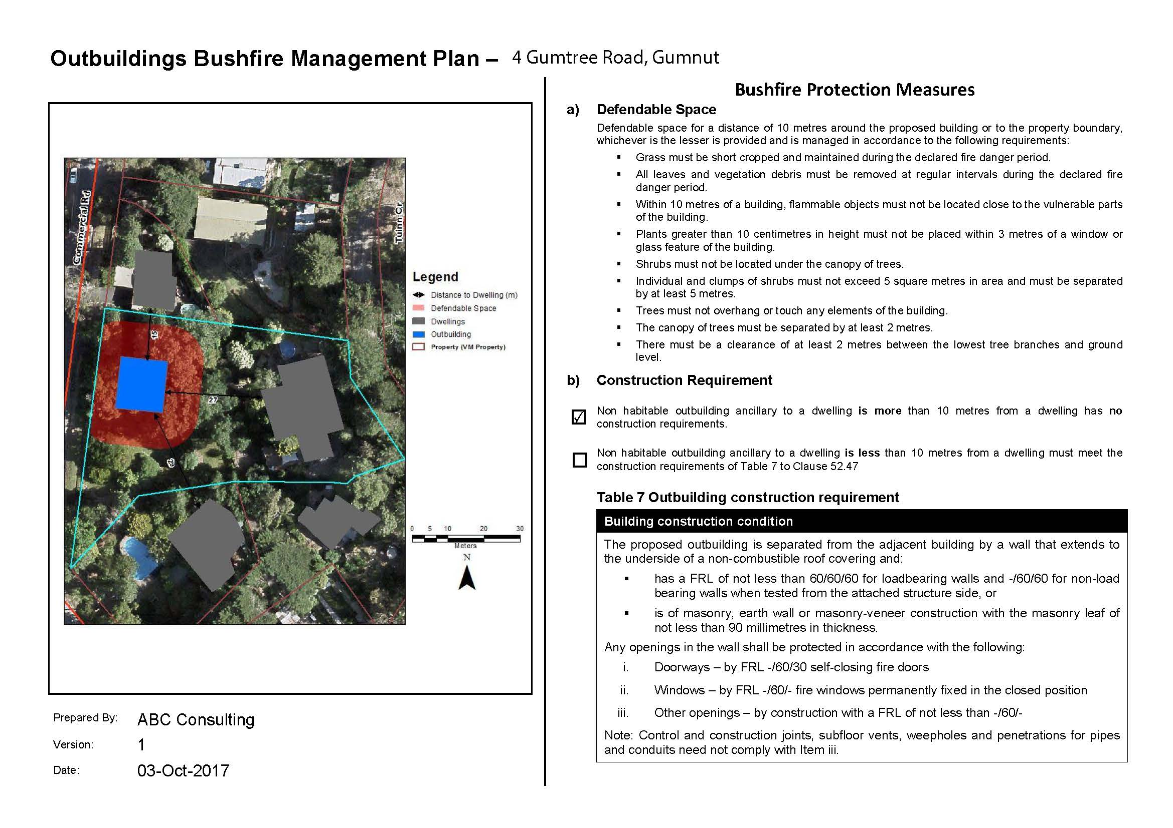
Example showing defendable space only

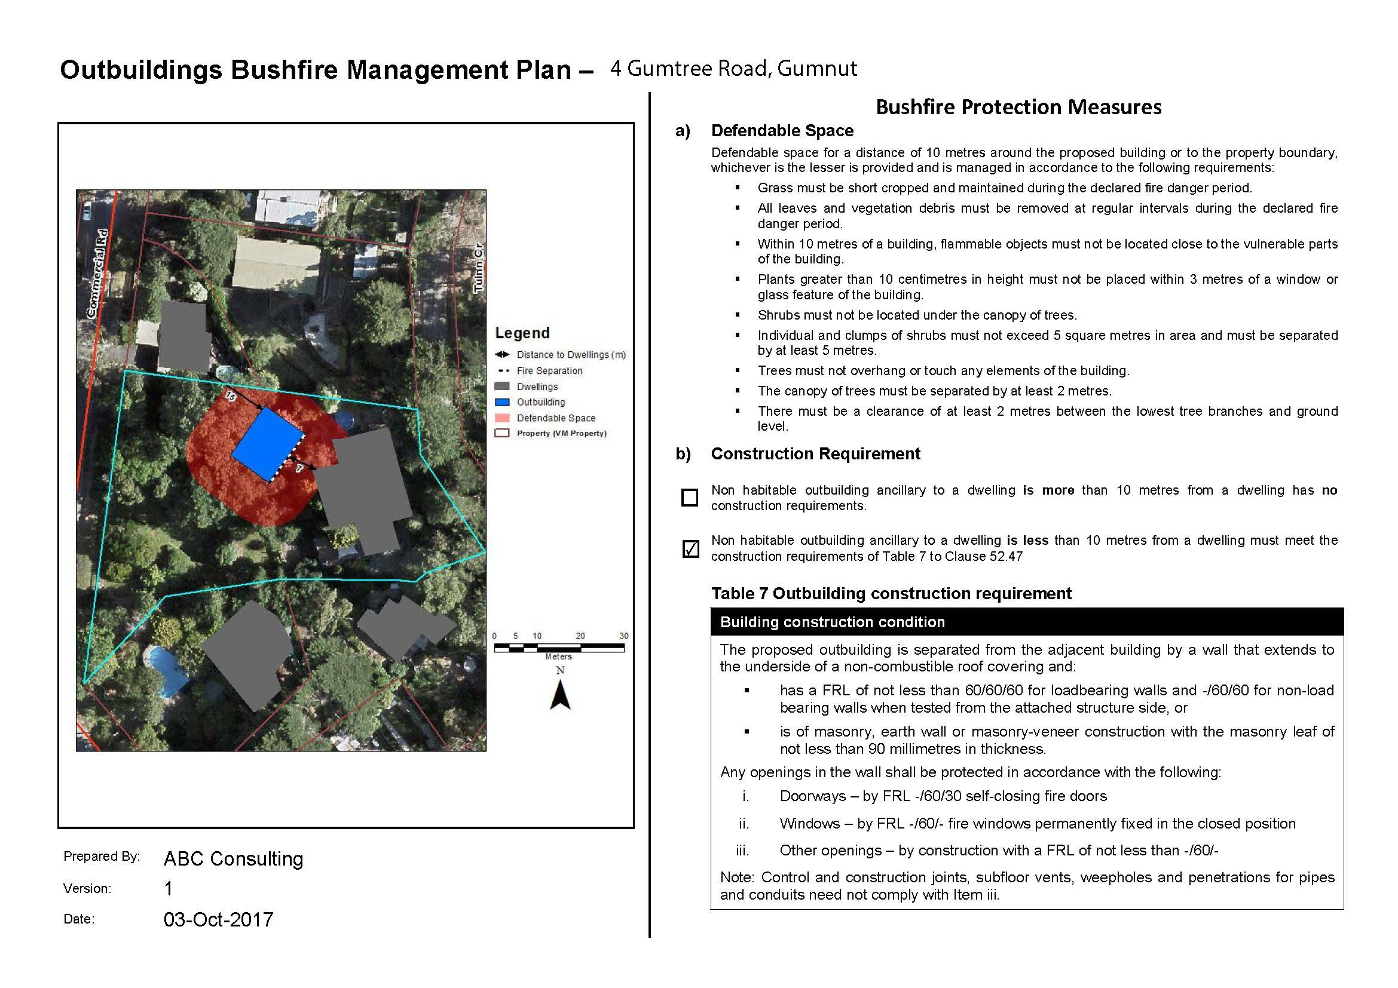
Example showing defendable space and fire separation requirements

Templates for use by applicants are available on the DELWP website.

STEP 3: Discuss with your council and then lodge the application
Before preparing the final documents and lodging an application, complete the Bushfire Management Plan checklist below and discuss your proposal with a council planning officer.

Bushfire Management Plan Checklist
THE PLAN SHOWS:  Site details and proposal  Property boundaries | CHECKLIST  Tick or mark as not applicable
THE PLAN SHOWS:  Site details and proposal  Orientation | CHECKLIST  Tick or mark as not applicable
THE PLAN SHOWS:  Site details and proposal  Location and type of buildings on the site | CHECKLIST  Tick or mark as not applicable
THE PLAN SHOWS:  Site details and proposal  Location of the proposed outbuilding | CHECKLIST  Tick or mark as not applicable
THE PLAN SHOWS:  Site details and proposal  Separation distance between the proposed outbuilding and dwelling | CHECKLIST  Tick or mark as not applicable
THE PLAN SHOWS:  Site details and proposal  Location and type of buildings on adjoining land | CHECKLIST  Tick or mark as not applicable
THE PLAN SHOWS:  Preset bushfire protection measures including any conditions  - 10 metres of defendable space shown on plan | CHECKLIST  Tick or mark as not applicable
THE PLAN SHOWS:  Preset bushfire protection measures including any conditions  - Defendable space condition included on plan | CHECKLIST  Tick or mark as not applicable
THE PLAN SHOWS:  Preset bushfire protection measures including any conditions  - If outbuilding less than 10 metres from dwelling, fire separation condition included on plan | CHECKLIST  Tick or mark as not applicable

The council planning officer will check that the bushfire management plan meets all of the preset bushfire protection measures. If it does, your application does not need to be referred to the CFA.
If council approves a planning permit, the bushfire management plan is approved and becomes part of the planning permit.
If your application does not meet all of the preset bushfire protection measures it will be assessed under the standard BMO process, using the bushfire protection measures in Clause 52.47 of the relevant planning scheme. Referral to the CFA will be required.

© The State of Victoria Department of Environment, Land, Water and Planning 2017
This work is licensed under a Creative Commons Attribution 4.0 International licence. You are free to re-use the work under that licence, on the condition that you credit the State of Victoria as author. The licence does not apply to any images, photographs or branding, including the Victorian Coat of Arms, the Victorian Government logo and the Department of Environment, Land, Water and Planning (DELWP) logo. To view a copy of this licence, visit http://creativecommons.org/licenses/by/4.0/
ISBN 978-1-76047-632-8 (Print)
ISBN 978-1-76047-633-5 (pdf/online)
Disclaimer
This publication may be of assistance to you but the State of Victoria and its employees do not guarantee that the publication is without flaw of any kind or is wholly appropriate for your particular purposes and therefore disclaims all liability for any error, loss or other consequence which may arise from you relying on any information in this publication.
Accessibility
If you would like to receive this publication in an alternative format, please telephone DELWP Customer Service Centre 136 186, email customer.service@delwp.vic.gov.au, via the National Relay Service on 133 677 www.relayservice.com.au .
This document is also available in Portable Document Format at www.planning.vic.gov.au/bmo

DOCUMENT ENDS

