This version of Plan Melbourne 2017-2050 has been prepared for use with screen reader software. The printed publication contains various design features that have been necessarily omitted from this version. In other respects this document contains identical text to that in the PDF version of the document which is available at planmelbourne.vic.gov.au

Plan Melbourne

2017-2050

Metropolitan planning strategy

The Minister for Planning
Victoria is one of the most diverse and liveable places in the world.
The foundation of our success has been our people. We would not be as prosperous as we are today without the wealth of new people and new ideas that came through migration – particularly during the boom times of the 1850s Gold Rush and 1950s post-War years.
Now, as Victoria experiences its third population boom, we need to grow in the right places and in the right ways.
Population growth will give us the critical mass of people and skills we need to build better infrastructure for our cities, suburbs and towns; deliver services to our ageing population; transition to a low-carbon economy; and profit from the opportunities of the Asian Century.
We need to see this population boom as an opportunity for Victoria to grow more liveable, more sustainable and more prosperous.
For that to happen, we need to grow in controlled ways.
That means stopping Melbourne’s urban sprawl, ensuring our regional cities remain affordable and liveable, making smart investments in infrastructure that encourage job growth outside the CBD, and giving local communities across the state support to put together their own plans for development.
Plan Melbourne is designed to give Victoria the certainty it needs to grow stronger and fairer. We will keep listening to local people and we will keep working with local communities to ensure everyone has a fair say and a fair go.
We will be guided by the men and women of Victoria because we believe they have a right to live the life that suits their circumstances–and their family. And we believe that every citizen–whether they are Victorian by birth or choice–is equal.
Plan Melbourne is all about building a better future for all Victorian families.

The Hon. Richard Wynne MP
Minister for Planning

Aboriginal acknowledgement
The Victorian Government proudly acknowledges Victoria’s Aboriginal community and their rich culture and pays respect to their Elders past and present.
We acknowledge Aboriginal people as Australia’s first peoples and as the Traditional Owners and custodians of the land and water on which we rely. We recognise and value the ongoing contribution of Aboriginal people and communities to Victorian life and how this enriches us. We embrace the spirit of reconciliation, working towards the equality of outcomes and ensuring an equal voice.

Contents

Introduction 4
Outcome 1
MELBOURNE IS A PRODUCTIVE CITY THAT ATTRACTS INVESTMENT, SUPPORTS INNOVATION AND CREATES JOBS 22
Outcome 2
MELBOURNE PROVIDES HOUSING CHOICE IN LOCATIONS CLOSE TO JOBS AND SERVICES 55
Outcome 3
MELBOURNE HAS AN INTEGRATED TRANSPORT SYSTEM THAT CONNECTS PEOPLE TO JOBS AND SERVICES AND GOODS TO MARKET 81
Outcome 4
MELBOURNE IS A DISTINCTIVE AND LIVEABLE CITY WITH QUALITY DESIGN AND AMENITY 95
Outcome 5
MELBOURNE IS A CITY OF INCLUSIVE, VIBRANT AND HEALTHY NEIGHBOURHOODS 113
Outcome 6
MELBOURNE IS A SUSTAINABLE AND RESILIENT CITY 121
Outcome 7
REGIONAL VICTORIA IS PRODUCTIVE, SUSTAINABLE AND SUPPORTS JOBS AND ECONOMIC GROWTH 142
Implementation: Delivering strong leadership to shape the city 150
Glossary 153
Maps and Figures 160
Endnotes 162

Introduction

The vision for Melbourne
Melbourne will continue to be a global city of opportunity and choice

A planning strategy for Melbourne
Melbourne is one of the world’s most distinctive, liveable cities. It is a marvellous place, made—and remade—by the work of generations of Victorians, including countless generations of Aboriginal Victorians.
It is now the turn of this generation of Victorians to remake Melbourne in their image. The challenge is clear. How do we ensure Melbourne remains not just liveable, but sustainable and accessible? How do we ensure our suburbs develop jobs and services? How do we ensure that the Melbourne that was founded in the 19th century and renewed in the second half of the 20th century continues to flourish in the 21st century?
Plan Melbourne seeks to answer those questions. It is our plan to manage growth in the city and suburbs to the year 2050. It seeks to integrate long-term land use, infrastructure and transport planning, and, in doing so, meet the city’s future environmental, population, housing and employment needs.
It is a document of transformational ideas and generational aspiration. It is a document designed to manage, adapt to and harness change for the social, economic and environmental benefit of future generations of Victorians.

Key elements of Plan Melbourne
Plan Melbourne is a long-term plan to accommodate Melbourne’s future growth in population and employment. It includes:
- 9 principles that underpin a long-term vision for Melbourne
- 7 outcomes to drive Melbourne as a competitive, liveable and sustainable city
- 32 directions setting out how these outcomes can be achieved
- 90 policies outlining how each outcome will be approached, delivered and achieved.
A separate five-year implementation plan has been developed as a companion document to Plan Melbourne. The Implementation Plan sets out how Plan Melbourne will be delivered, with particular focus on the short-term actions essential for successful implementation. More information on the Implementation Plan, including the governance framework and metropolitan regions, is available in the Implementation chapter at the end of this document.

How Melbourne has grown
Before European settlement in 1835, Aboriginal people had lived on the land now called Melbourne for at least 40,000 years. Since then, Melbourne has seen waves of growth-led transformations, with each wave leaving lasting impressions on the city’s landscape, structure and identity. Map 1 shows Melbourne’s growth over stages of its history.
Melbourne’s early structure and character were defined through the Hoddle Grid and the Gold Rush, which saw the city’s population triple between 1851 and 1854. In the decades leading up to the 1890s depression, Victoria was the wealthiest colony in the British Empire. Consequently, that era created a rich legacy of public and private buildings, distinctive boulevards and high streets, civic recreational facilities, and expansive inner-city parks and gardens.
In the late 19th and early 20th centuries, Melbourne expanded with the development of mass-transit train and tram systems. Mechanised transport enabled Melburnians to escape the crowding and congestion of the city centre for the space of the suburbs. Melbourne’s distinctive high-street shopping strips were established during this period.
The next wave of major growth came after the Second World War. Between 1947 and 1966, Melbourne’s population increased by 83 per cent—jumping from 1.2 million to 2.2 million people. It was by far the biggest change in the city’s demographics since the Gold Rush, making Victoria a multicultural society.
That demographic change was transformational—driving structural changes in the economy by giving Victoria the muscle to become the heart of Australia’s manufacturing sector. The rise in private car ownership, investment in roads, better access to housing finance and a shift of manufacturing to suburban locations saw Melbourne expand and become a city of suburbs.
Over the past two decades, Melbourne has been in the midst of a third great demographic change that rivals the Gold Rush and the post-War boom. This new wave of growth is driving a population boom in inner-city places such as Southbank and Docklands, as well as outer-suburban development in the west, north and south-east.
In the process, Melbourne has become a global city: a diverse, multicultural home to more than 4.5 million people that covers approximately 9,000 square kilometres—and Melbourne’s third wave of growth is not yet finished.
The challenge is to manage this third wave of growth so all Melburnians can benefit from the prosperity and choice it brings—well into the 21st century.
Map 1 Melbourne's urban growth
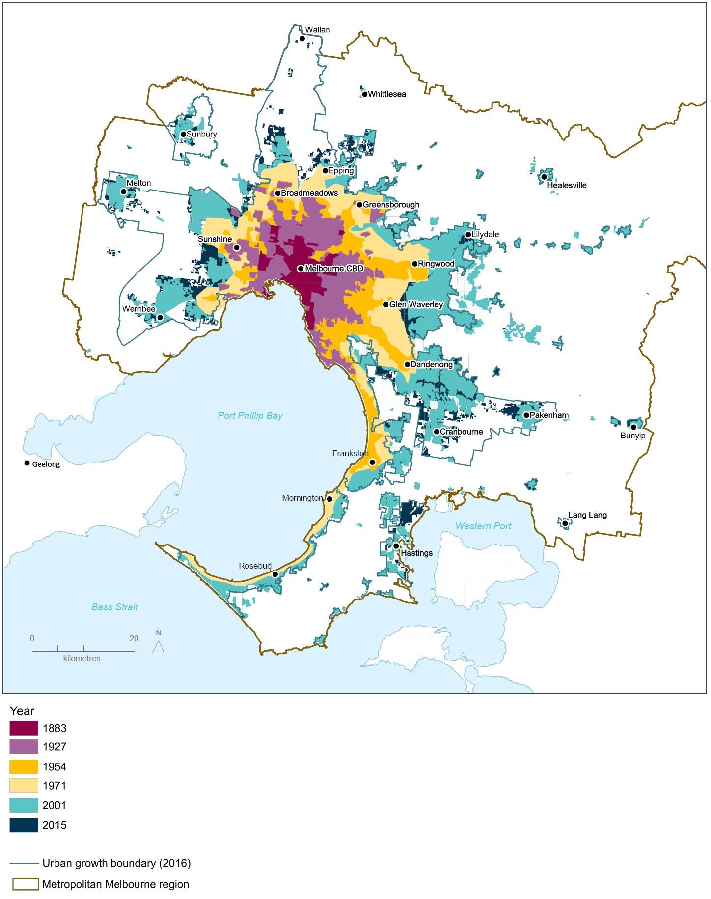
Source: Department of Environment, Land, Water and Planning

Melbourne’s key challenges and opportunities

A growing population
Over the past decade, Melbourne has added more than 800,000 new residents. While natural population increases are still significant, many of these new residents have come to Melbourne from interstate and overseas—attracted by a range of education and employment opportunities as well as housing choices.
As identified in Melbourne’s planning policies by successive governments, to remain liveable the city must avoid the temptation to sprawl as it grows. The more the city sprawls, the greater the risk it will become an unsustainable city divided by disadvantage and inequity.
Planning must serve the current and future needs of Melburnians.
Housing must be available in locations that capitalise on existing infrastructure, jobs, services and public transport. Access to these needs to be better in many areas, particularly in Melbourne's west and outer areas.
Melbourne’s green wedges and peri-urban areas must be properly managed so that valued features and attributes are protected. A balance must be maintained between the needs of the community, the economy and the environment.
Melbourne’s growth
The demographic changes facing Melbourne are profound. Between 2015 and 2051 Melbourne is projected to grow by 3.4 million people, from a population of 4.5 million to almost 8 million. During the same period, Victoria’s total population will reach 10.1 million. A population increase of that magnitude would require another 1.6 million dwellings and 1.5 million jobs. According to projections, Melbourne is experiencing its greatest population boom since the post-War era.
By 2051, the percentage of Melbourne’s population aged over 65 is projected to increase from 13.8 per cent to 20.5 per cent. This demographic change will present significant challenges for community services and infrastructure.
There will also be a greater proportion of lone-person and couple-only households, although families with children are expected to continue to be the most common household type. The city will also need to keep up with the needs of the young, with Melbourne’s school-age population projected to grow by around 500,000 by 2051.
Figure 1 shows Victoria’s projected population and demographic change from 2015 to 2051 and Figure 2 shows the growth in household types.

Figure 1 Victoria's projected population growth
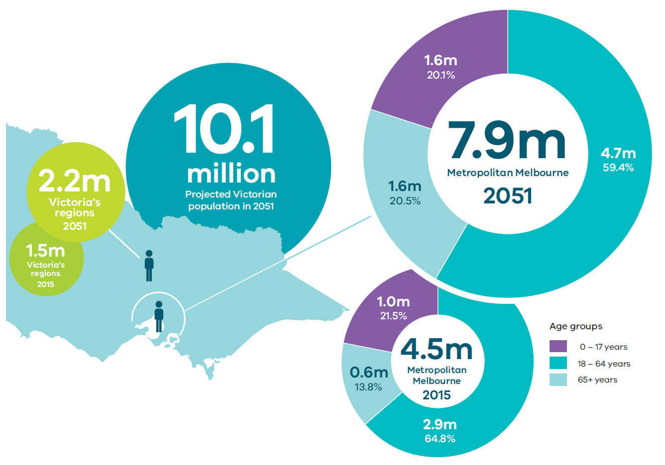
Source: Victoria in Future 2016

Remaining competitive in a changing economy
The global economy has changed rapidly in the past two decades, becoming more digital and mobile through digital disruption, more competitive through the further industrialisation of nations such as China, and more uncertain through the impact of climate change. In years to come, those changes are expected to accelerate, testing the capabilities of nations and states with ageing populations.
Melbourne is well placed to respond to these changes. After all, the city has a highly skilled workforce with strong international business, educational, research and cultural connections.
However, to remain competitive there is a need to boost productivity, and support growth and innovation across all industries and regions. New technologies—such as self-driving cars, the development of energy storage technologies and artificial intelligence—will change the ways people live and work between now and 2050. Plan Melbourne will need to be adapted over time to accommodate those changes.
To grow jobs and create accessible, affordable and attractive neighbourhoods, Melbourne needs to take advantage of the land it has available for renewal in the city and suburbs. Increasing the number and diversity of jobs closer to where people live—in places such as suburban employment clusters, health and education precincts and industrial precincts—will help make Melbourne more productive and competitive.
In short, Melbourne has the people, places and potential to build the knowledge-based industries and service industries that will drive economic growth in the 21st century.
Surplus and underutilised government land
Government land is an important resource for delivering services to Victorians, including places to live, work and learn.
The government regularly reviews its land assets to ensure that they are being used efficiently. Land that is considered to be underutilised or surplus can then be considered for community or other government purposes or be disposed of. Any proceeds can then be reinvested into other important infrastructure.
More efficient use of land owned by government can help facilitate Plan Melbourne outcomes and deliver social, economic and environmental benefits.

Housing that is affordable and accessible
It is difficult to predict what types of housing people will want in 20 years. The challenge, as Melbourne grows, will be to ensure that people have affordable and accessible housing choices in places where they want to live.
Many of Melbourne’s established suburbs are already unaffordable for middle- and low-income households looking to buy or rent. This is a major concern because these suburbs often have good access to jobs, services and transport. By contrast, although new housing in outer suburbs is more affordable, it often lacks good access to jobs, services and transport.
Without strategies to provide more housing choice, Melbourne will become less affordable and liveable—risking social equity and cohesion, and slowing economic growth.

Figure 2 Households by household type, metropolitan Melbourne
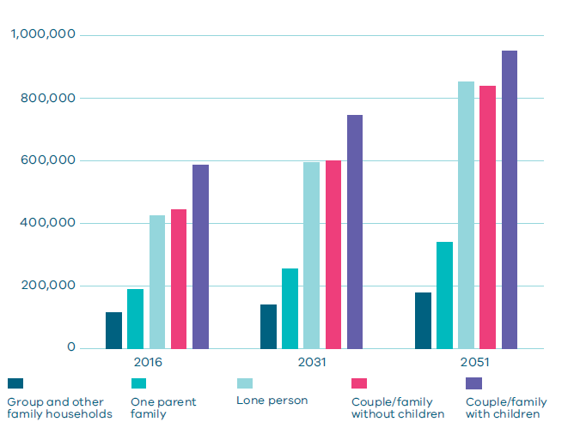
Source: Victoria in Future, 2016

Keeping up with the growing transport needs of the city
Melbourne’s transport system includes modern port, airport, road, rail, tram, bus, cycling and walking infrastructure. The city has an extensive freeway and arterial road network, a rail network that provides radial access to the central city and activity centres throughout the suburbs, as well as the world’s largest tram network.
The Port of Melbourne is Australia’s largest port, with links to national road and rail networks. The city’s main airport is curfew-free and expanding, and is supported by Avalon airport near Geelong and two general aviation airfields at Essendon and Moorabbin.
Although the city’s transport system has sound foundations, it is coming under increased pressure from growth. By 2050, Melbourne’s transport network will need to handle an extra 10.4 million trips per day. Congestion and overcrowding is already an issue on parts of the road and public transport network, particularly at peak times. Major investment in transport infrastructure will boost rail and road capacity to meet the transport challenge, boost productivity, conserve energy, curb greenhouse gas emissions and protect liveability.
Landmark infrastructure projects such as the Metro Tunnel will expand the capacity of the city’s transport network, but Victoria also needs to make existing infrastructure smarter and more efficient.

Climate change—the need for both mitigation and adaptation
Climate change is an economic, social, environmental and public health issue.
Climate modelling shows that Victoria is becoming hotter and drier, facing more periods of extreme heat (days over 35°C) and drought, reductions in annual rainfall and increases in intense rainfall events, and an increased risk of extreme weather events such as flood and bushfire.
Vulnerable groups—such as the elderly, the chronically ill and low-income households—are more likely to be affected by the economic and social impacts of climate change, including rising food prices and increased demand for essential services. Adapting to a changing climate is about taking deliberate steps to manage and mitigate these potential impacts.
Australians are among the highest emitters of greenhouse gases, per capita, in the developed world—refer to Figure 3. Taking steps to transform Melbourne into a low-carbon city is both necessary and an opportunity. That’s why Victoria aims to reduce greenhouse gas emissions to net zero emissions by 2050—an initiative that will create a low-carbon economy, generate new jobs, drive innovation within new and traditional industries, and improve the city’s liveability.

Figure 3 Australia's greenhouse gas emissions per capita
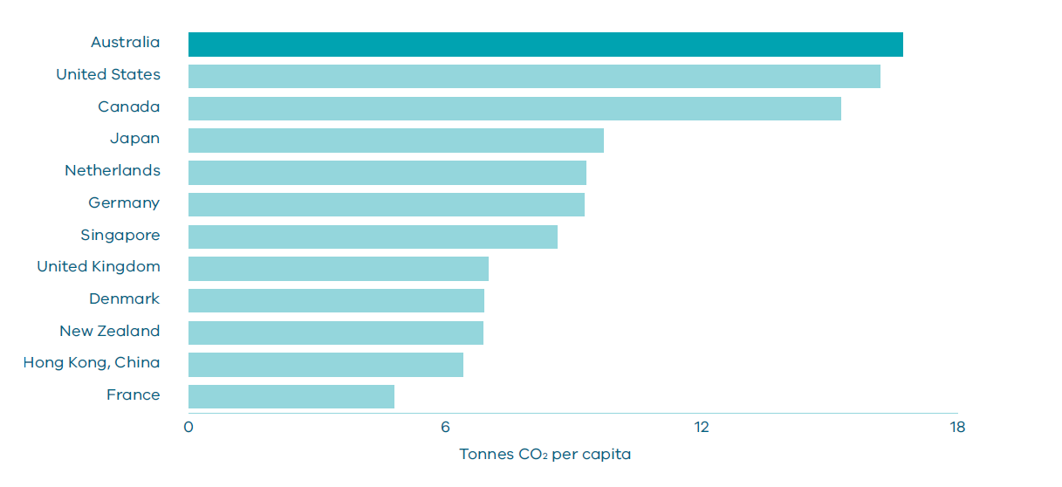
Source: International Energy Agency (2014) CO₂ emissions from fuel combustion highlights. Paris: OECD/IEA.

The vision for Melbourne

A global city of opportunity and choice
Our vision is that Melbourne will continue to be a global city of opportunity and choice.
Plan Melbourne’s vision for the city is guided by nine principles.

Principle 1: A distinctive Melbourne
Melbourne has an enviable natural environment, important Aboriginal cultural heritage values, a rich inheritance of open space, and landmark buildings and streets created during the population booms of the Gold Rush and post-War period. To ensure Melbourne remains distinctive, its strengths will be protected and heritage preserved while the next generation of growth is planned to complement existing communities and create attractive new neighbourhoods.

Principle 2: A globally connected and competitive city
Melbourne will develop and deliver infrastructure to support its competitive advantages in sectors such as business services, health, education, manufacturing and tourism. Employment, research, retail, cultural and sporting precincts will also be supported to ensure Melbourne remains attractive and liveable.

Principle 3: A city of centres linked to regional Victoria
The central city will remain the focus for global business and knowledge-intensive industries linked to an extensive network of clusters, centres, precincts and gateways. These physical, social and economic links will be strengthened, turning Melbourne into a city of centres linked to regional Victoria—creating social and economic opportunities across the state.

Principle 4: Environmental resilience and sustainability
Protecting Melbourne’s biodiversity and natural assets is essential for remaining a productive and healthy city. There is an urgent need for Melbourne to adapt to climate change and make the transition to a low-carbon city.

Principle 5: Living locally—20-minute neighbourhoods
Creating accessible, safe and attractive local areas where people can access most of their everyday needs within a 20-minute walk, cycle or local public transport trip, will make Melbourne healthier and more inclusive. Due to the specialised and diverse nature of work, many people will still need to travel outside of this 20-minute neighbourhood for their jobs.

Principle 6: Social and economic participation
Social mobility is essential for social cohesion. Victoria’s challenge is to make it easier for every citizen—regardless of their race, gender, age, sexuality or ability—to attain the skills they need to fully participate in the life and economy of the city and state.

Principle 7: Strong and healthy communities
To remain a city of diverse, healthy and inclusive communities, Melbourne needs to ensure its neighbourhoods and suburbs are safe and walkable. Strong communities need affordable, accessible housing; local health, education and community services; access to recreation spaces; and healthy food.

Principle 8: Infrastructure investment that supports balanced city growth
Smart infrastructure investment and better utilisation of existing infrastructure is the key to creating new jobs and driving population growth in the right places. It is also vital for the social, economic and environmental wellbeing of the city. That’s why there needs to be a pipeline of projects and initiatives that make Melbourne more sustainable, accessible and prosperous.

Principle 9: Leadership and partnership
Melbourne’s growth relies on effective governance, strong leadership and collaborative partnerships. Maintaining strong working relationships between all spheres of government, the public and private sectors and the wider community will ensure that all Melburnians share the benefits and the responsibilities of putting plans into practice.

Melbourne’s 2050 plan
Plan Melbourne’s vision for the city is guided by nine principles.
To support those principles seven outcomes have been set, together with the policy directions that will be taken to reach those outcomes.

The vision for Melbourne

A global city of opportunity and choice
outcome 1 Melbourne is a productive city that attracts investment, supports innovation and creates jobs
Direction 1.1 Create a city structure that strengthens Melbourne’s competitiveness for jobs and investment
Direction 1.2 Improve access to jobs across Melbourne and closer to where people live
Direction 1.3 Create development opportunities at urban renewal precincts across Melbourne
DIRECTION 1.4 Support the productive use of land and resources in Melbourne’s non-urban areas
outcome 2 Melbourne provides housing choice in locations close to jobs and services
Direction 2.1 Manage the supply of new housing in the right locations to meet population growth and create a sustainable city
Direction 2.2 Deliver more housing closer to jobs and public transport
Direction 2.3 Increase the supply of social and affordable housing
Direction 2.4 Facilitate decision-making processes for housing in the right locations
Direction 2.5 Provide greater choice and diversity of housing
outcome 3 Melbourne has an integrated transport system that connects people to jobs and services and goods to market
Direction 3.1 Transform Melbourne’s transport system to support a productive city
Direction 3.2 Improve transport in Melbourne’s outer suburbs
Direction 3.3 Improve local travel options to support 20-minute neighbourhoods
Direction 3.4 Improve freight efficiency and increase capacity of gateways while protecting urban amenity
outcome 4 Melbourne is a distinctive and liveable city with quality design and amenity
Direction 4.1 Create more great public places across Melbourne
Direction 4.2 Build on Melbourne’s cultural leadership and sporting legacy
Direction 4.3 Achieve and promote design excellence
Direction 4.4 Respect Melbourne’s heritage as we build for the future
Direction 4.5 Plan for Melbourne’s green wedges and peri-urban areas
Direction 4.6 Strengthen community participation in the planning of our city
outcome 5 Melbourne is a city of inclusive, vibrant and healthy neighbourhoods
Direction 5.1 Create a city of 20-minute neighbourhoods
Direction 5.2 Create neighbourhoods that support safe communities and healthy lifestyles
Direction 5.3 Deliver social infrastructure to support strong communities
Direction 5.4 Deliver local parks and green neighbourhoods in collaboration with communities
outcome 6 Melbourne is a sustainable and resilient city
Direction 6.1 Transition to a low-carbon city to enable Victoria to achieve its target of net zero greenhouse gas emissions by 2050
Direction 6.2 Reduce the likelihood and consequences of natural hazard events and adapt to climate change
Direction 6.3 Integrate urban development and water cycle management to support a resilient and liveable city
Direction 6.4 Make Melbourne cooler and greener
Direction 6.5 Protect and restore natural habitats
Direction 6.6 Improve air quality and reduce the impact of excessive noise
Direction 6.7 Reduce waste and improve waste management and resource recovery
outcome 7 Regional Victoria is productive, sustainable and supports jobs and economic growth
Direction 7.1 Invest in regional Victoria to support housing and economic growth
Direction 7.2 Improve connections between cities and regions

Places of state significance that will be the focus for investment and growth

CENTRAL CITY
Purpose: To provide for the continued growth of knowledge-intensive and high-skilled firms in the central city while continuing to be a major area for tourism, retail, residential, entertainment, sporting and cultural activities (includes St Kilda Road corridor).

NATIONAL EMPLOYMENT AND INNOVATION CLUSTERS
Purpose: To improve the growth and clustering of business activity of national significance, particularly in knowledge-based industries.
These areas are to be developed as places with a concentration of linked businesses and institutions providing a major contribution to the Victorian economy, with excellent transport links and potential to accommodate significant future growth in jobs and in some instances housing.
Locations: Monash, Parkville, Dandenong, Fishermans Bend, La Trobe, Sunshine, Werribee

METROPOLITAN ACTIVITY CENTRES
Purpose: To provide a diverse range of jobs, activities and housing for regional catchments that are well served by public transport.
These centres will play a major service delivery role, including government, health, justice and education services, as well as retail and commercial opportunities.
Locations: Dandenong, Footscray, Fountain Gate–Narre Warren, Epping, Sunshine, Ringwood, Broadmeadows, Box Hill, Frankston. Future – Toolern, Lockerbie

STATE-SIGNIFICANT INDUSTRIAL PRECINCTS
Purpose: To provide strategically located land for major industrial development linked to the Principal Freight Network and transport gateways.
They will be protected from incompatible land uses to allow continual growth in freight, logistics and manufacturing investment.
Locations: Western Industrial Precinct, Northern Industrial Precinct, Southern Industrial Precinct, Officer–Pakenham Industrial Precinct, Port of Hastings Industrial Precinct

TRANSPORT GATEWAYS
Purpose: To secure adequate gateway capacity for moving passengers and freight into and out of Victoria and support future employment and economic development opportunities at major ports, airports and interstate terminals.
They will be protected from incompatible land uses but adjacent complementary uses and employment-generating activity will be encouraged.
Locations: Port of Melbourne, Port of Geelong, Port of Hastings, Melbourne Airport, Avalon Airport, Moorabbin Airport, Essendon Airport. Proposed – Beveridge Interstate Freight Terminal, Western Interstate Freight Terminal, Possible South-East Airport, Possible Bay West Seaport

HEALTH AND EDUCATION PRECINCTS
Purpose: To support health and education services that are well served by public transport in a range of locations across Melbourne.
Their specialised economic functions will be reinforced, and they should provide opportunity for ancillary health and education services, retail, commercial and accommodation uses.
Locations:
Health: Austin Hospital, Melton Health, Northern Hospital, Craigieburn Health Service, Monash Medical Centre, Knox Private Hospital, Epworth, Western Hospital
Education: Deakin University (Burwood), University Hill (includes RMIT Bundoora campuses), La Trobe University, Victoria University (Footscray), Victoria University (Sunshine), Swinburne University (Hawthorn), Monash University (Caulfield)
Health and education: Alfred Medical Research and Education Precinct (Prahran), Monash University Precinct (Clayton), Parkville Medical, Bioscience and Education Precinct, Werribee Health and Education Precinct, St Vincent’s Hospital and Australian Catholic University Precinct (East Melbourne/Fitzroy), Sunshine Hospital and Victoria University Precinct (St Albans), Frankston Hospital and Monash University Precinct (Frankston), Casey Hospital and Monash University Precinct (Berwick), Dandenong Hospital and Chisholm TAFE Precinct, Box Hill Hospital and Box Hill TAFE Precinct

MAJOR URBAN RENEWAL PRECINCTS
Purpose: To take advantage of underutilised land close to jobs, services and public transport infrastructure, to provide new housing, jobs and services.
Major urban renewal precincts will play an important role in accommodating future housing and employment growth and making better use of existing infrastructure.
Locations: Docklands, Fishermans Bend (Lorimer), Fishermans Bend (Montague), Fishermans Bend (Sandridge), Fishermans Bend (Wirraway), Arden, Macaulay, E-Gate, Dynon, Flinders Street Station to Richmond Station Corridor

Map 2 Melbourne 2050 Plan
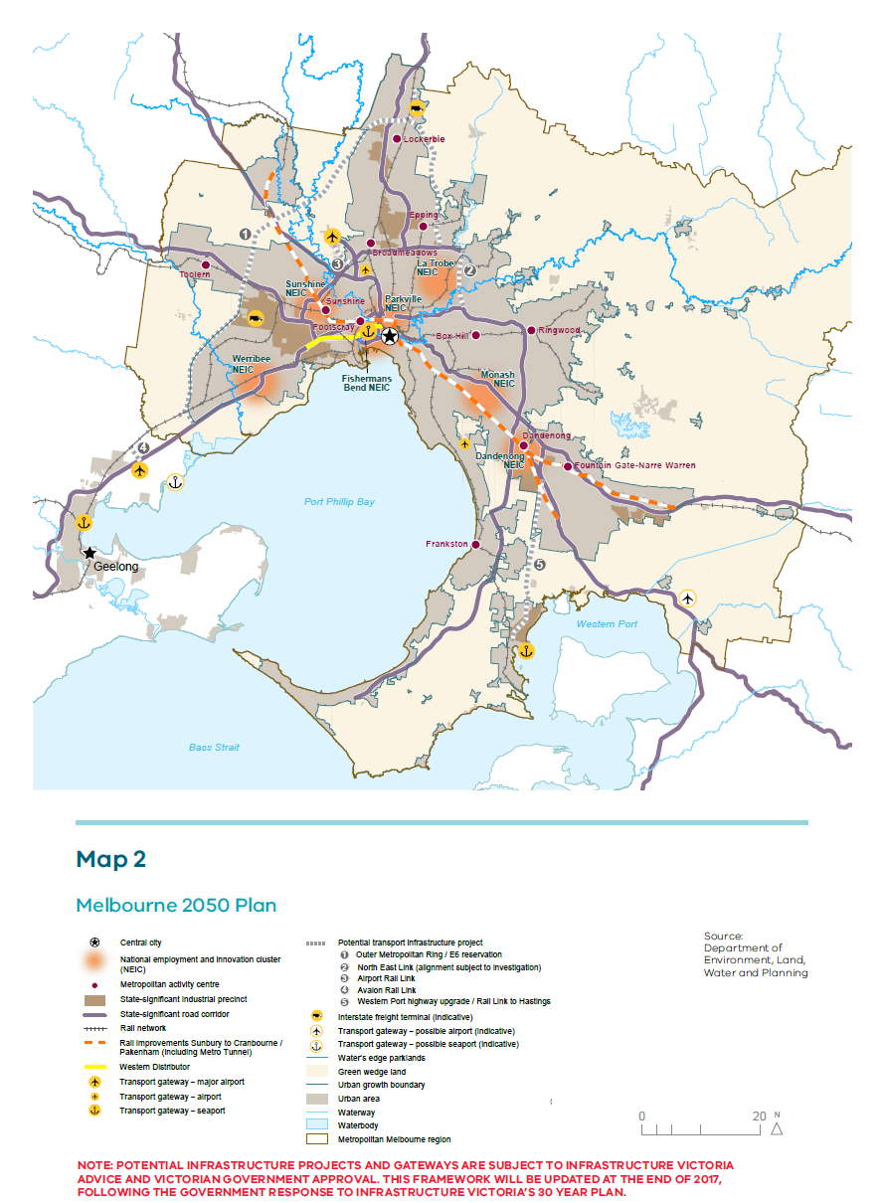Source: Department of Environment, Land, Water and Planning

Independent assessment of programs and projects
Infrastructure Victoria was established in 2015. It provides independent expert advice to government on infrastructure plans and investment decisions, ensuring that projects are properly vetted and informed by rigorous, evidence-based advice.
In late 2016, Infrastructure Victoria released its 30-year strategy to the Victorian Government. The Victorian Government has 12 months to respond and deliver its own five-year plan. This plan will inform decision-making on smart infrastructure projects and new services for delivery over the short, medium and long term—and influence the five-year review of Plan Melbourne. It is in the interests of all Victorians to ensure future infrastructure projects are chosen on merit.
Alignment with Suburban Development
The Minister for Suburban Development will contribute to the ongoing development of Melbourne as one of the world’s most liveable cities. Suburban Development will develop five-year plans for jobs, services and infrastructure and establish new governance arrangements for metropolitan regions through Metropolitan Partnerships.
This will ensure that five-year plans complement and include the key strategies contained in Plan Melbourne, and that the newly established Metropolitan Partnerships are engaged in the medium- and long-term planning to keep Melbourne liveable.

Outcome 1

MELBOURNE IS A PRODUCTIVE CITY THAT ATTRACTS INVESTMENT, SUPPORTS INNOVATION AND CREATES JOBS
Melbourne will need 1.5 million new jobs over the next 35 years.
What those jobs are and where those jobs go will define Melbourne’s future as a globally connected and competitive city.
Currently, the city has around 2.1 million jobs. As Melbourne’s population heads towards 8 million, the number of jobs is estimated to reach 2.8 million by 2031 and 3.6 million by 2051. Figure 4 shows Melbourne’s estimated employment growth from 2015 to 2031 by region.
Figure 4 Projected employment growth, metropolitan Melbourne, 2015–2031
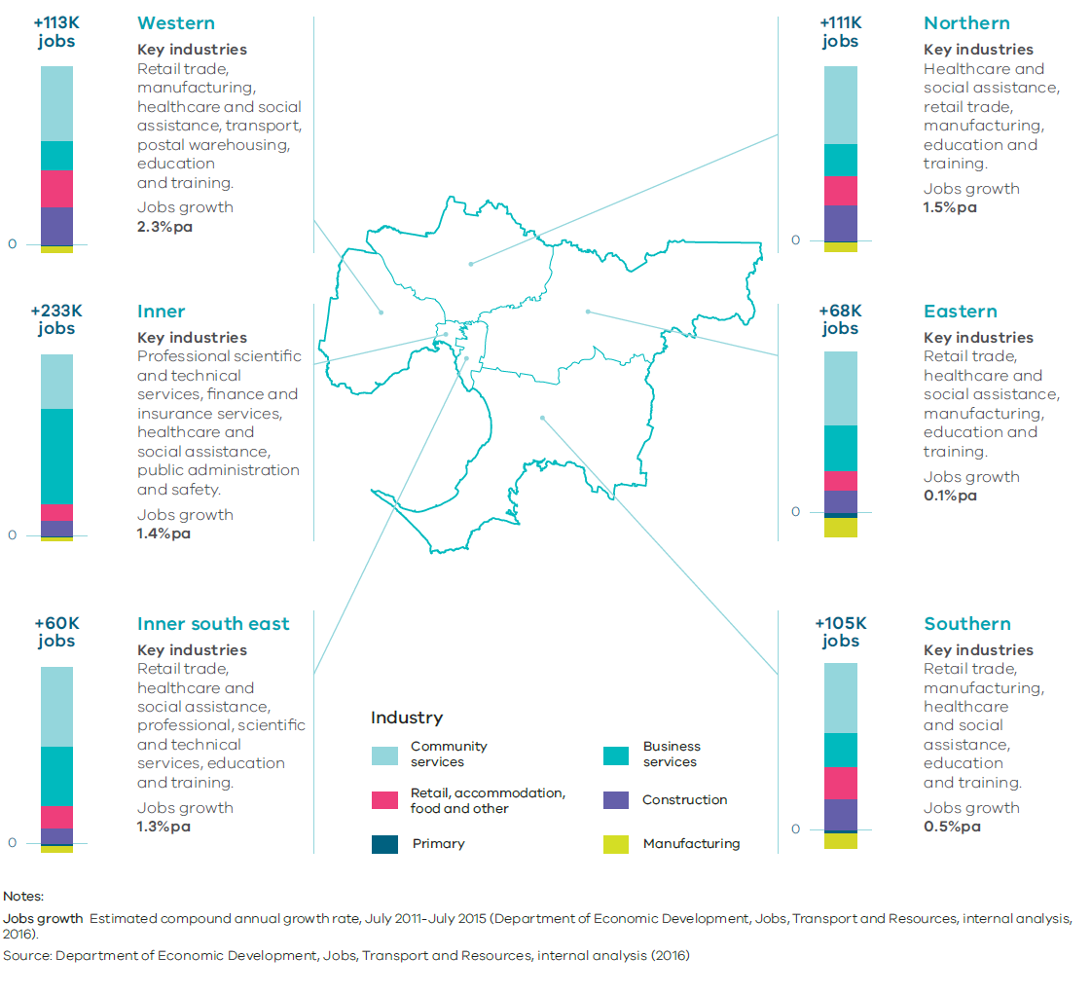

Melbourne has a number of competitive advantages that can create a diverse, flexible and resilient economy. These include world-class industries, a highly skilled workforce, a multicultural population, close proximity and links to the fast-growing Asian region, world-renowned liveability and tourist destinations, good transport networks, and access to productive agricultural land and earth and energy resources.
Priority sectors have been identified that have the potential to attract and deliver significant growth and investment, and make Melbourne and Victoria global leaders.
The priority sectors are:
- medical technology and pharmaceuticals
- new energy technologies
- food and fibre
- transport technologies
- defence technologies
- construction technologies
- international education
- professional services.
With targeted investment, these sectors could drive up to $70 billion in additional economic output by 2025—creating more than 400,000 new jobs for Victorians.
Melbourne has the opportunity to position itself as one of the world’s foremost new knowledge economies, powering the next generation of productivity and economic growth in Australia. To achieve that ambition, Melbourne must develop a series of interconnected learning, working and living precincts across the city.
The Metro Tunnel will significantly transform Melbourne. For the first time, key living, learning and work precincts will be linked by a high-capacity train network. National employment and innovation clusters at Sunshine, Parkville, Monash and Dandenong will be linked to each other as well as other significant precincts such as Footscray, Arden, Domain, St Kilda Road, Caulfield, Oakleigh and Chadstone. This investment in public transport will open up new job opportunities for Melbourne’s citizens and enhance the city’s productivity and liveability (Figure 5).
Melbourne’s key employment areas for jobs and investment are identified on Map 3.
State and local governments must work collaboratively to develop long-term plans for creating jobs and investment in metropolitan regions.
Figure 5 Key living, learning and work precincts linked by a high-capacity train network.
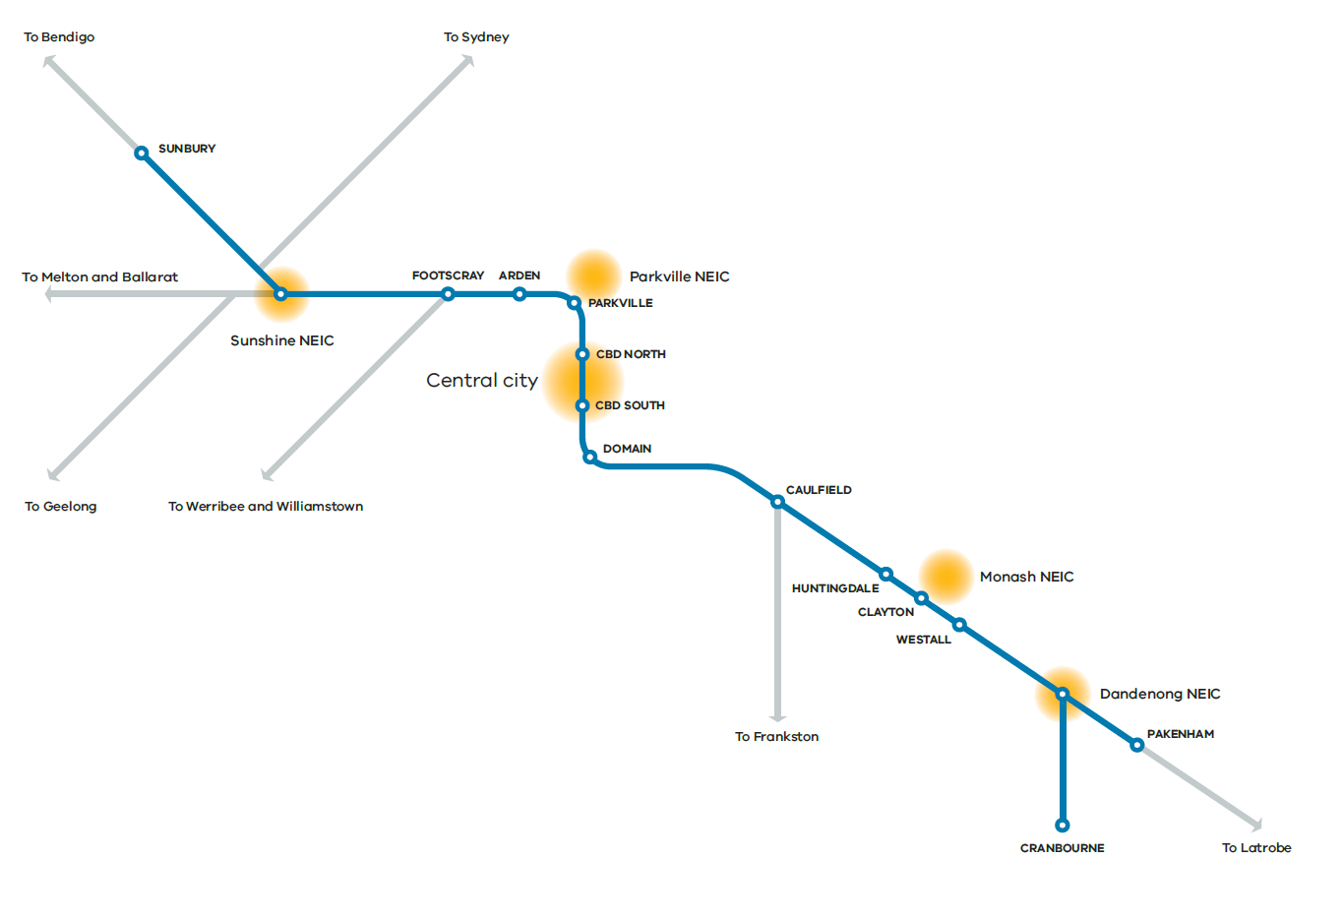

Map 3 Jobs and investment
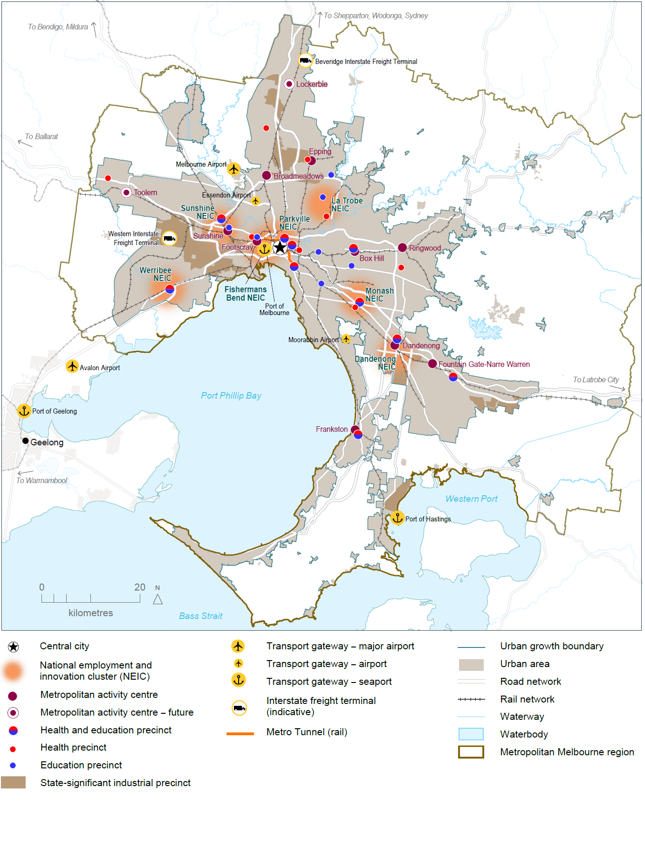
Source: Department of Environment, Land, Water and Planning

Melbourne’s plan

Direction 1.1 Create a city structure that strengthens Melbourne’s competitiveness for jobs and investment
To remain prosperous Melbourne must remain attractive to investment.
That means ensuring well-priced commercial and industrial land is available in locations that support and strengthen key growth industries. In the longer term, Melbourne’s northern and western regions will need to create job opportunities—particularly for high-value, knowledge-based jobs—to support expected population growth.
That means understanding the scale of employment growth and land-use requirements across the city; ensuring business locations are investment-ready and productive, with capacity to grow; and making smart investments in infrastructure projects that accelerate local investment and job creation for suburban and outer areas and stimulate economic growth.

Policy 1.1.1 Support the central city to become Australia’s largest commercial and residential centre by 2050
The central city has some of Australia’s largest and most globally connected financial and professional services businesses (particularly in the CBD, Docklands, Southbank and St Kilda Road). It has a highly diverse economic base, with strengths in health and medical research, education, retail, creative industries, tourism and port-related activities.
Over the past two decades, employment has grown significantly in the central city, with office floor space increasing by 1.4 million square metres since 2000. Docklands has seen much of this growth. Residential growth has also increased in the central city.
This growth in office and residential space delivers a range of benefits such as reduced commuting and transport costs for people living and working in the central city.
For the central city to remain a desirable destination for business investment and a major destination for tourism, new space must be found for office, retail, education, health, entertainment and cultural activities. Creating new opportunities and infrastructure, particularly in major urban renewal precincts, can help support this. The capacity of transport networks will also need to be increased to enable people from middle and outer suburbs to access employment opportunities in inner-city precincts.

Policy 1.1.2 Plan for the redevelopment of major urban renewal precincts in and around the central city to deliver high-quality, distinct and diverse neighbourhoods offering a mix of uses
Major urban renewal precincts such as Southbank and Docklands have created opportunities for the city to grow and accommodate more jobs and housing. Opportunities still exist in Southbank and Docklands as well as other priority precincts such as Fishermans Bend, Arden and Macaulay.
These major urban renewal precincts can accommodate a significant amount of residential and jobs growth over the next 35 years. Their availability gives Melbourne greater flexibility, particularly around timing and land use, with different areas having the potential to cater for different uses. A number of former industrial and other sites—including government landholdings—are also underutilised and could be redeveloped.
The timing of land release in these precincts needs to be in sync with policy drivers, market demand and the delivery of infrastructure and services. If developed properly, the precincts will become a network of connected places, linking to each other and their surrounding neighbourhoods and developing diverse uses and characteristics.

Map 4 Key features in and around Melbourne's central city
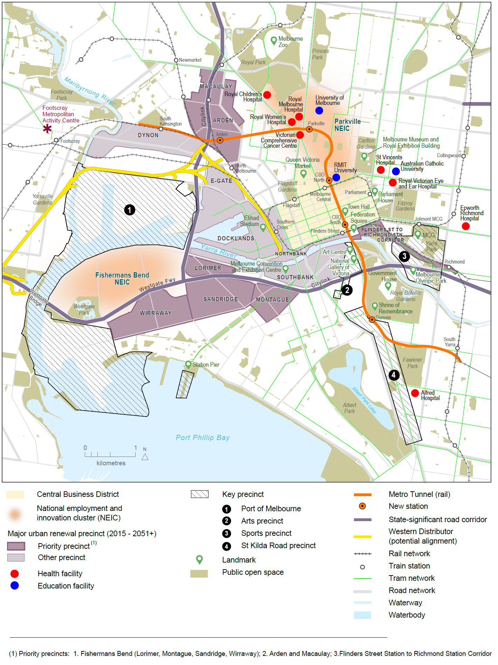
Source: Department of Environment, Land, Water and Planning

Policy 1.1.3 Facilitate the development of national employment and innovation clusters
Melbourne needs to create jobs close to where people live.
Seven national employment and innovation clusters have been identified across metropolitan Melbourne. Each is anchored by a specialised activity (such as a university, research facility, medical facility or manufacturing enterprise) that has seeded its growth. These clusters are Monash, Parkville, Fishermans Bend, Dandenong, La Trobe, Sunshine and Werribee.
The national employment and innovation clusters are focused on knowledge-based businesses that locate close to each other for knowledge and resource sharing. The clusters are distributed throughout Melbourne and along high-capacity transport networks to provide greater access to high-productivity jobs.
The Monash and Parkville clusters are already established and have significant potential to keep growing and diversifying. Other clusters are at various stages of development but possess the fundamentals needed to become strong centres for innovation and jobs growth.
Each cluster has a unique profile. For instance, Monash and Sunshine have the potential to attract a broader range of businesses, including office, retail services and entertainment, as well as residential development. In Dandenong and Fishermans Bend, the key will be to enhance manufacturing productivity with a focus on research and development.
Each cluster is different and approaches to support their growth will vary—depending on their profiles, competitive strengths, roles and stages of development.
However, there are some common requirements. Each cluster will need high levels of amenity to attract businesses and workers—including public transport, and walking and cycling paths. Each cluster needs to be investment-ready for knowledge-intensive firms and jobs. To support the development of clusters, effective governance arrangements—including key stakeholders and landowners—are required.

Map 5 Monash National Employment and Innovation Cluster
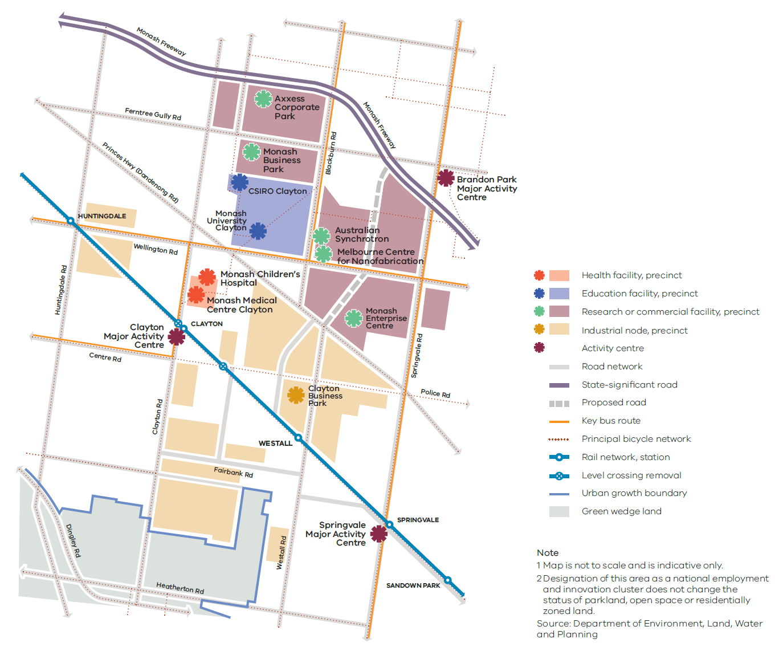

Monash National Employment and Innovation Cluster
Strengths: The cluster has leading education, health, research and commercialisation facilities.
Jobs: Monash is Melbourne’s largest established national employment and innovation cluster, with a mix of education, research and industry organisations. It has approximately 75,000 jobs and is the largest concentration of employment outside the central city.
Key attributes: The cluster has a critical mass of leading education, health and research facilities, including Australia’s largest university (Monash University), the Australian Synchrotron, the Melbourne Centre for Nanofabrication, Monash Medical Centre, a new Monash Children’s Hospital, CSIRO’s largest site in Victoria and the Monash Enterprise Centre. Its mix of education, research and commercial facilities creates a unique environment for innovation and world-leading research, which will continue to contribute significantly to Melbourne’s economy. This unique blend of knowledge- and research-based activity will help existing businesses, such as the manufacturing sector, and produce products and services that are competitive in the global market.
Key partners for the future of this cluster include the City of Monash, City of Kingston, City of Greater Dandenong, Monash University, Monash Medical Centre, Australian Synchrotron, CSIRO (Commonwealth Government) and Monash Enterprise Centre.

Map 6 Parkville National Employment and Innovation Cluster
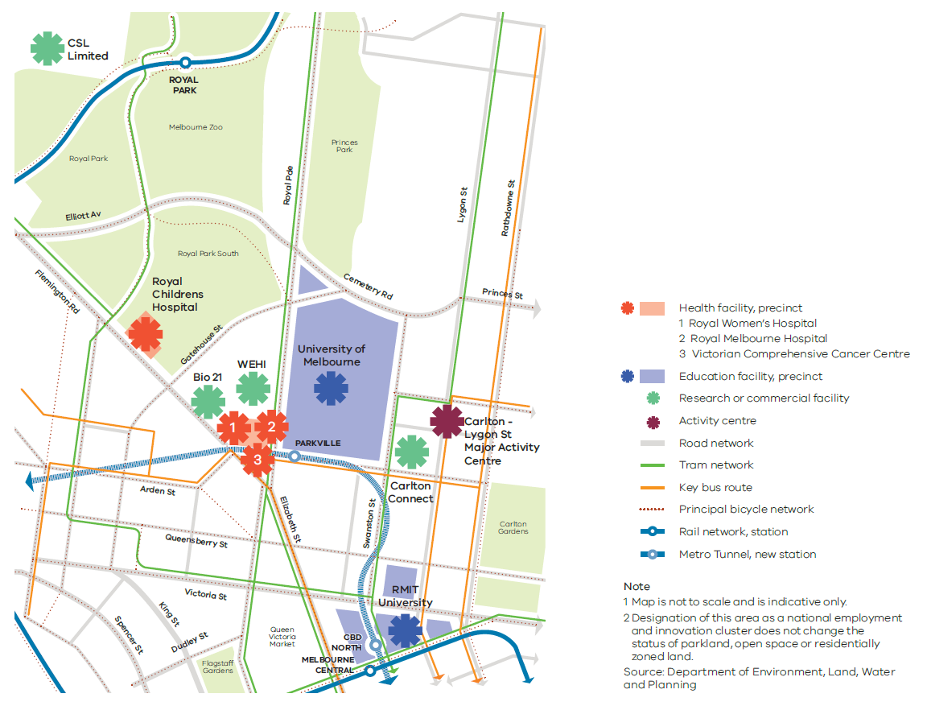

Parkville National Employment and Innovation Cluster
Strengths: The cluster has education, research, health, professional and technical industries as well as significant parkland.
Jobs: The cluster is an established, internationally renowned research centre on the doorstep of the CBD. It is centrally located, has access to a wide catchment of workers across metropolitan Melbourne and employs 40,100 people.
Key attributes: The cluster has a critical mass of leading institutions and organisations, including Australia’s highest ranking university (the University of Melbourne), Victoria’s second-largest university (RMIT University), Monash University’s Faculty of Pharmacy and Pharmaceutical Sciences, the Walter and Eliza Hall Institute of Medical Research, global biotherapy industry leader CSL Limited, the Royal Melbourne Hospital, the Royal Children’s Hospital, the Royal Women’s Hospital, the Victorian Comprehensive Cancer Centre, the Australian Medical Association and the Bio21 Institute.
Many of Parkville’s institutions and organisations are expanding, or plan to expand. Melbourne University and RMIT are also expanding their facilities to incorporate greater collaboration and joint projects with industry. This will drive innovation, research and business development.
The cluster has a high level of public transport access, with tram routes via Swanston and Elizabeth streets. Accessibility will be improved with the establishment of a new, state-of-the-art train station as part of the Metro Tunnel. The frequency and capacity of this service will make it possible for more people to access Parkville.
Key partners for the future of this cluster include the City of Melbourne, the University of Melbourne, RMIT, the CSIRO (Commonwealth Government), the Royal Melbourne Hospital, the Royal Women’s Hospital and the Royal Children’s Hospital.

Map 7 Fishermans Bend National Employment and Innovation Cluster
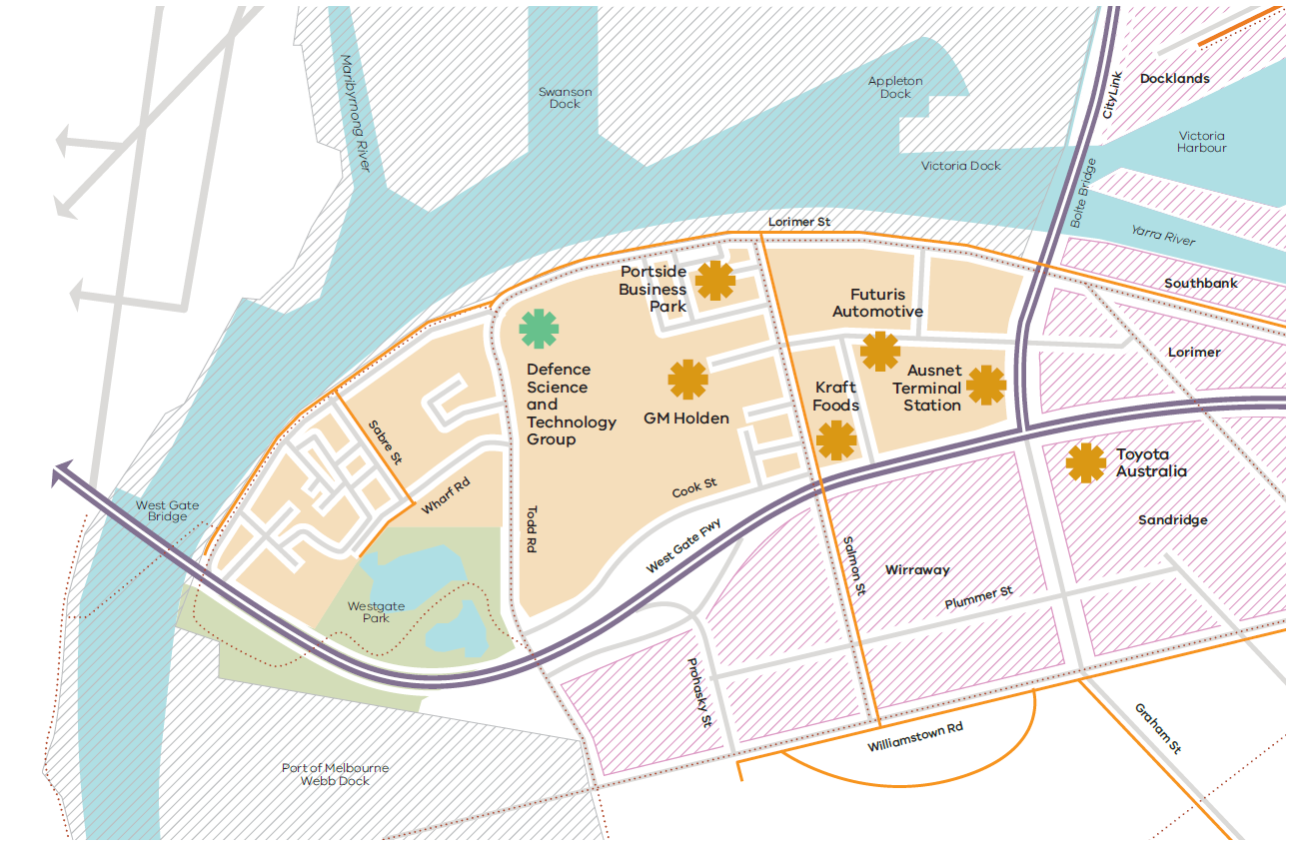

Fishermans Bend National Employment and Innovation Cluster
Strengths: Fishermans Bend specialises in aerospace, defence research, manufacturing and transport and logistics industries.
Jobs: The cluster is an established industrial area on the doorstep of the CBD and employs about 12,200 people.
Key attributes: The cluster has a range of specialist industries, including Boeing Aerostructures Australia, the Defence Science and Technology Group, GM Holden, Toyota Australia, Futuris Automotive and Kraft Foods. The area is close to the Port of Melbourne, the CBD and major arterials—making it easy for businesses to access global markets and workers from across Melbourne.
The cluster is adjacent to the Fishermans Bend urban renewal area. Planning is currently underway for public transport, public space and community infrastructure improvements across Fishermans Bend, including the cluster. This has identified opportunities to further develop the cluster’s design and engineering and advanced manufacturing, and attract complementary education and research organisations.
Key partners for the future of this cluster include the City of Melbourne, the City of Port Phillip, Boeing Aerostructures Australia, the Department of Defence (Commonwealth Government), Kraft Foods, the Port of Melbourne and GM Holden.

Map 8 Dandenong National Employment and Innovation Cluster
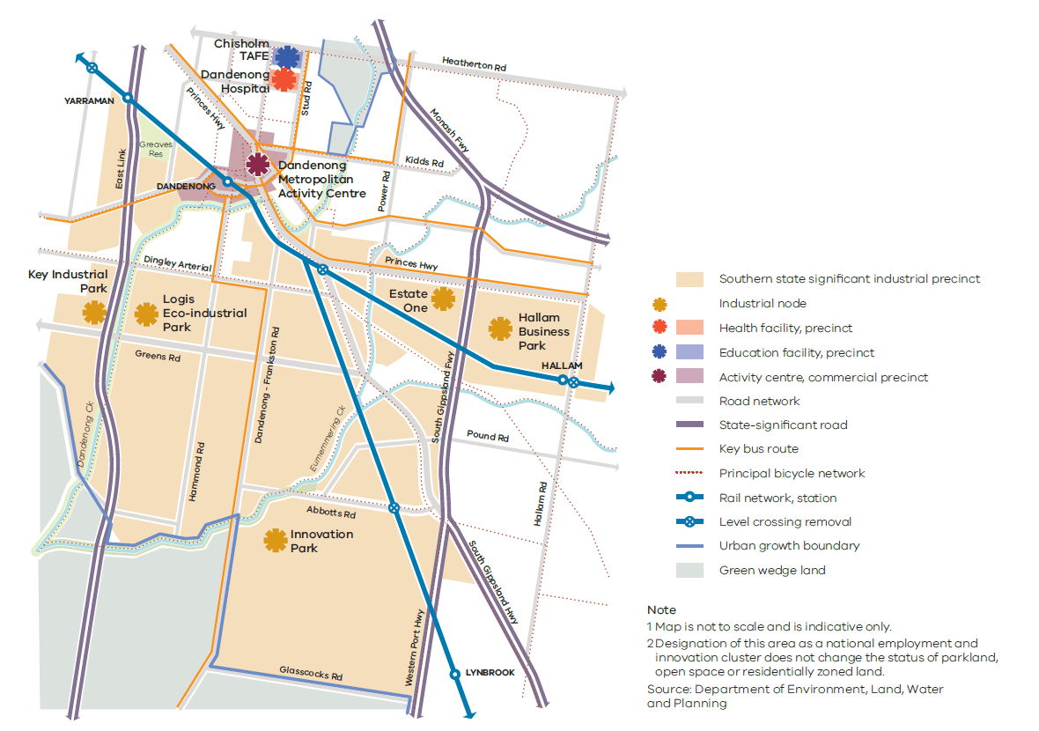

Dandenong National Employment and Innovation Cluster
Strengths: The cluster has strengths in advanced manufacturing, health, education, wholesale trade, retail and transport, postal services and warehousing.
Jobs: The cluster employs more than 66,300 people , including many workers from surrounding municipalities.
Key attributes: Located near the Monash Freeway, the Princes Highway and EastLink, this cluster is part of one of Australia’s most significant and productive manufacturing areas. It has strong links to the other nearby employment areas of Braeside, Carrum Downs, Pakenham and Knox/Bayswater—an industrial network that supports around 148,000 jobs.
Manufacturing activities in the cluster are becoming increasingly knowledge based. Reflecting this, the cluster is now home to Victoria’s first eco-industrial park, LOGIS, which includes the 74-hectare Innovation Park. A growing list of major international and local businesses (such as Kraft Foods, Cadbury, Ascent Pharmaceuticals, Mercury Marine, Moondara Cheese, Terex Australia and Cabrini Health) have based their businesses at LOGIS. Other major firms in the cluster include Jayco, Bombardier Transportation Australia, Corex Plastics, IVECO Trucks Australia, Viridian Glass and Advanced Polymer Technologies. The cluster also includes the Hallam Business Park, the Innovation Park and the Key Industrial Park.
The cluster has the Dandenong Metropolitan Activity Centre to the north. This has a substantial retail presence and a major medical and education precinct based around the Dandenong Hospital and Chisholm TAFE.
Key partners for the future of this cluster include the City of Greater Dandenong, Dandenong Hospital and Chisholm TAFE.

Map 9 La Trobe National Employment and Innovation Cluster
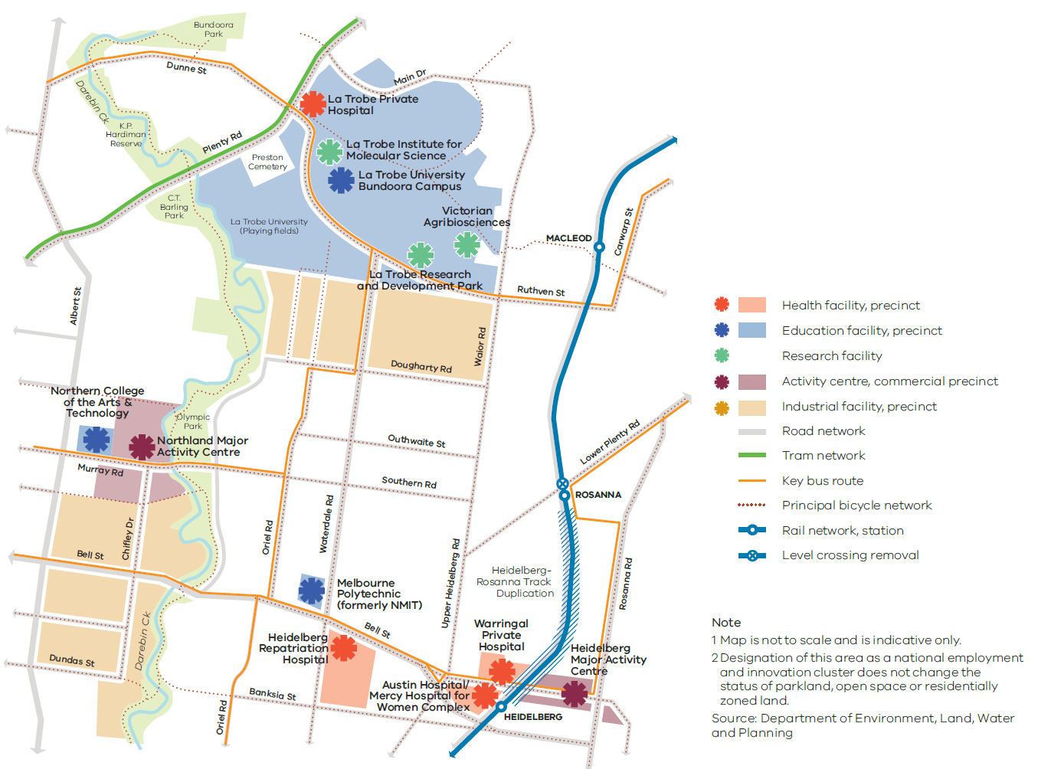

La Trobe National Employment and Innovation Cluster
Strengths: The cluster has strengths in education, research, health and retail.
Jobs: There are around 28,700 jobs in the cluster. Each location in the cluster has different strengths, but together they represent an opportunity to increase the number and diversity of jobs in the region.
Key attributes: The cluster includes a number of significant employment activities (such as La Trobe University and its industrial surrounds, the Northland Shopping Centre and the Austin Biomedical Alliance Precinct) as well as a concentration of other health, research, commercial and retail activities in and around the Heidelberg Major Activity Centre.
La Trobe University has an expanding education and research role, including a growing student and research population and the recently completed AgriBio Centre. The Heidelberg precinct has a significant presence of health services, training and research institutions such as the Melbourne Brain Centre. Austin Health—comprising the Austin Hospital and the Heidelberg Repatriation Hospital—is located in the cluster and operates 980 beds, making it Victoria’s largest provider of training for specialist physicians and surgeons.
The Olivia Newton-John Wellness and Cancer Centre is within the cluster and has 92 beds. Also within the cluster is the Mercy Hospital for Women, which is a specialist hospital for maternity, gynaecology and neonatal services.
La Trobe University plans to grow its research activities (especially in the biosciences) and encourage the commercialisation of research and the evolution of existing businesses. Land around the Northland Shopping Centre also has significant capacity to accommodate new jobs and housing.
Key partners for the future of this cluster include Banyule City Council, Darebin City Council, La Trobe University and Austin Health.

Map 10 Sunshine National Employment and Innovation Cluster
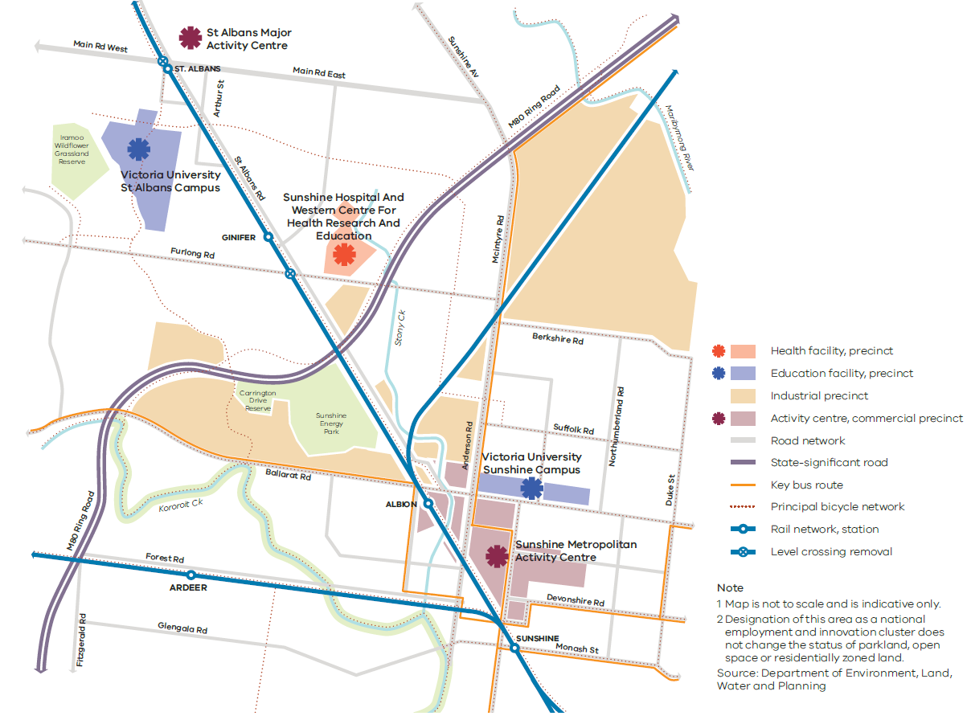

Sunshine National Employment and Innovation Cluster
Strengths: The cluster has the potential to build a critical mass of tertiary education, health-related training, health care, and retail and professional services, as well as facilitate private investment.
Jobs: There are around 14,600 jobs in the cluster.
Key attributes: The cluster is well placed to tap into the growing municipalities of Melbourne’s west and diversify its education, research and health-related activities.
The cluster is centrally located between the CBD and two western growth areas. It also has access to major road and rail networks.
The cluster’s connectivity will increase with the completion of the Metro Tunnel. The Metro Tunnel will provide a 15–20 minute train commute to the CBD and a direct link from the cluster to the south-eastern suburbs. Level crossing removals will further improve access to the cluster, and regional train services from Geelong, Ballarat and Bendigo will pass through the cluster at Sunshine railway station.
There is an opportunity for the cluster to be a central location for the increased provision of health and education services. For instance, Sunshine Hospital is an acute and sub-acute teaching hospital with approximately 600 beds (including mental health beds managed by North West Mental Health). In addition, the Western Centre for Health, Research and Education is a collaborative project between Victoria University, the University of Melbourne and Western Health, where training and research will be carried out. Victoria University has two campuses in the cluster, and other facilities to be developed in the cluster include the Joan Kirner Women’s and Children’s Hospital and the Sunshine Private Hospital.
The cluster also includes the Sunshine Metropolitan Activity Centre and the St Albans Major Activity Centre.
Key partners for the future of this cluster include Brimbank City Council, the University of Melbourne, Victoria University and Western Health.

Map 11 Werribee National Employment and Innovation Cluster
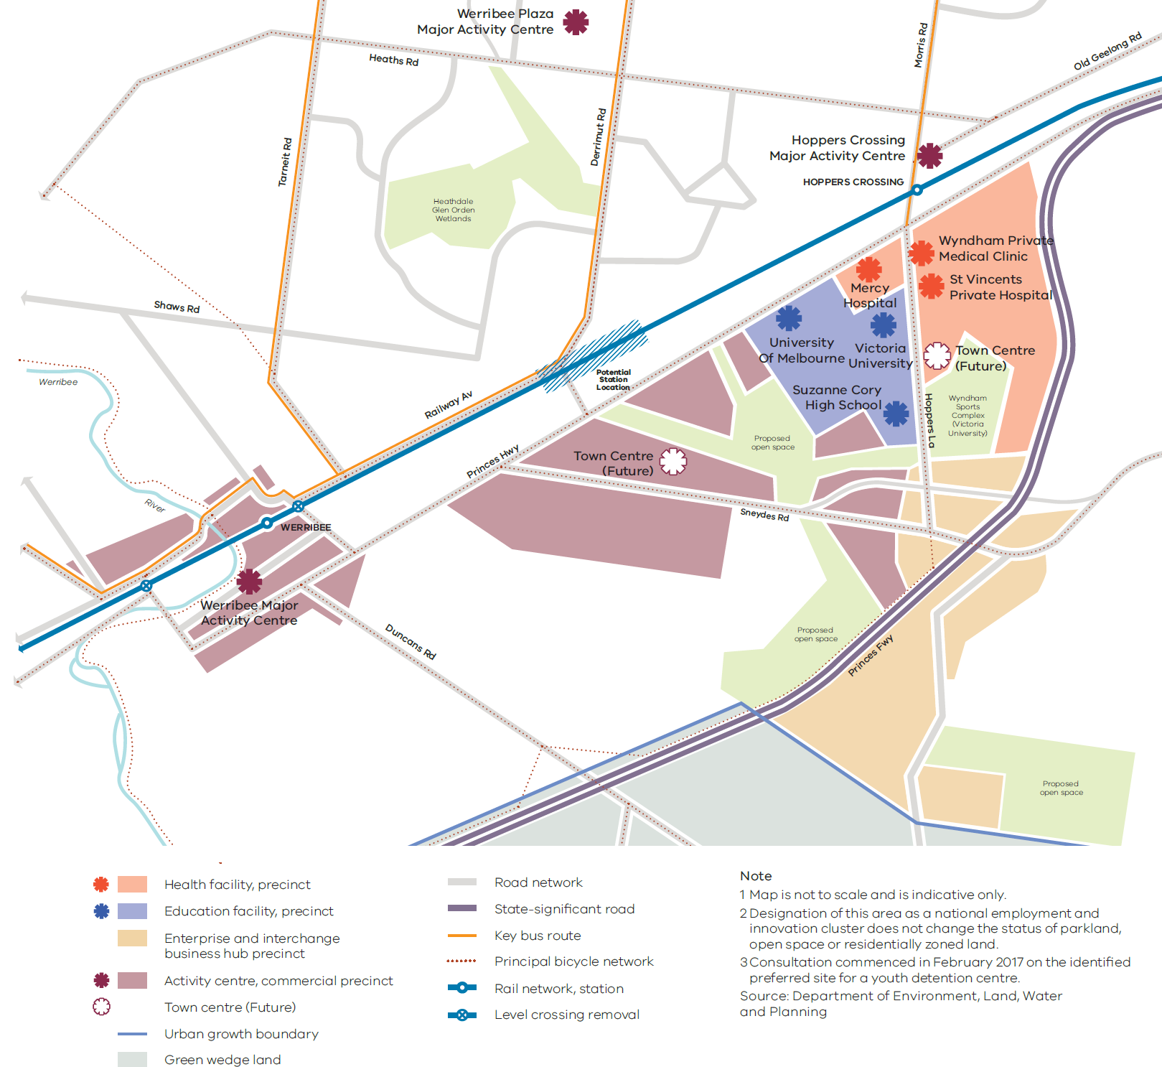

Werribee National Employment and Innovation Cluster
Strengths: The cluster can build on its existing health, education and high-tech research jobs on the site of the former State Research Farm.
Jobs: The cluster is currently home to around 8,400 jobs and could ultimately support more than 50,000 predominantly white-collar jobs in health, education and high-tech research.
Key attributes: The cluster includes the University of Melbourne Veterinary Hospital, the University of Notre Dame, Victoria University, the Werribee Mercy Hospital, the Wyndham Private Medical Centre, the CSIRO, the Suzanne Cory High School and a range of high-tech research companies in the food and agricultural industries. Many of these white-collar job providers have significant expansion plans for the next 20 years. A site for a new hospital has also been purchased within the cluster by St Vincent’s Private Hospital.
Key partners for the future of this cluster include Wyndham City Council, the University of Melbourne, Victoria University and Mercy Hospital.

Policy 1.1.4 Support the significant employment and servicing role of health and education precincts across Melbourne
Victoria has an international reputation in health and medical research. It is also a leading provider of high-quality international education and home to two of five Australian universities ranked in the world’s top 100 tertiary institutions.
The core of the international education sector is largely located in the city, Bundoora, Burwood, Caulfield, Clayton, Footscray, Hawthorn, Parkville and Sunshine. Almost 90,000 international students are linked along these corridors—more than any other city in Australia.
Parkville is an anchor point for health and medical research, with other key medical precincts including the Alfred Medical Research and Education Precinct, the Austin Biomedical Alliance Precinct and the Monash Medical Centre.
Major health and education precincts across metropolitan Melbourne have been identified for further services and jobs growth. These precincts stimulate innovation, create employment and are of fundamental importance to the emerging knowledge economy and surrounding communities.
Planning for the growth of these precincts will need to focus on improving access—particularly via public transport—and diversifying job choices. Co-location of facilities (for example, a university with a hospital) will make better use of existing infrastructure and support the growth of associated businesses and industries. Specialised economic functions should be reinforced, but there should also be opportunities to provide ancillary retail, commercial, accommodation and supporting services.
Health and education precincts
Health precincts
Austin Hospital, Melton Health, Northern Hospital, Craigieburn Health Service, Monash Medical Centre, Knox Private Hospital, Epworth, Western Hospital
Education precincts
Deakin University (Burwood), University Hill (includes RMIT Bundoora campuses), La Trobe University, Victoria University (Footscray), Victoria University (Sunshine), Swinburne University (Hawthorn), Monash University (Caulfield)
Health and education precincts
Alfred Medical Research and Education Precinct (Prahran), Monash University Precinct (Clayton), Parkville Medical, Bioscience and Education Precinct, Werribee Health and Education Precinct, St Vincent’s Hospital and Australian Catholic University Precinct (East Melbourne/Fitzroy), Sunshine Hospital and Victoria University Precinct (St Albans), Frankston Hospital and Monash University Precinct (Frankston), Casey Hospital and Monash University Precinct (Berwick), Dandenong Hospital and Chisholm TAFE Precinct, Box Hill Hospital and Box Hill TAFE Precinct

Policy 1.1.5 Support major transport gateways as important locations for employment and economic activity
Melbourne’s transport gateways and associated road and rail networks are critical to the state’s economy. They provide access to local, national and international markets and are key areas for employment and economic activity.
Melbourne Airport is Victoria’s primary gateway for air passengers and air-freight exporters. It handles around 30 million passengers a year and accounts for almost a third of Australia’s air freight. Melbourne Airport is directly responsible for 14,300 jobs—an employment figure that is expected to grow to 23,000 by 2033. Its curfew-free status is a competitive advantage that must be protected. Additionally, the airport’s central location—between three of Melbourne’s major growth areas—means it is well placed to capitalise on growing labour markets. Together with Essendon Airport’s expanding regional services, this airport corridor has the potential to become one of Australia’s leading transport and logistics hubs.
The Port of Melbourne is Australia’s largest container and general cargo port, handling more than a third of the nation’s container trade and supporting more than 15,000 jobs. Container movements at the Port of Melbourne are expected to grow in coming decades.
For Melbourne to remain the logistics supply base for south-eastern Australia, freight-reliant industries and major transport gateways need efficient access to a range of transport options, including an arterial network that provides reliable connections.
Designated ports, airports, freight terminals and their surrounds will be protected from incompatible land uses to ensure they keep generating economic activity and new jobs. Adjacent complementary uses and employment-generating activities will be encouraged.
State-significant transport gateways
- Port of Melbourne
- Port of Geelong
- Port of Hastings
- Melbourne Airport
- Avalon Airport
- Moorabbin Airport
- Essendon Airport
Proposed
- Beveridge Interstate Freight Terminal
- Western Interstate Freight Terminal
- Possible South-East Airport
- Possible Bay West Seaport

Policy 1.1.6 Plan for industrial land in the right locations to support employment and investment opportunities
Melbourne currently has almost 26,000 hectares of land zoned for industrial purposes. Of this, more than 7,000 hectares are vacant, with approximately 4,660 hectares of vacant land located within state-significant industrial precincts. In addition, 6,275 hectares of unzoned land has been identified through growth corridor plans and previous strategic plans. Over the past five years, demand for new industrial land has averaged around 205 hectares a year, with demand driven by freight, logistics and manufacturing.
Melbourne’s major industrial areas have become more attractive through recent investments in Victoria’s transport network and hubs. Unlike many other cities, Melbourne is well positioned to absorb additional growth near major transport gateways and freight terminals.
Ensuring there is enough industrial land available for development near transport gateways—particularly in outer-suburban areas—will be critical if Melbourne is to remain globally competitive and attract new investments and jobs.
State-significant industrial precincts will be protected from incompatible land uses to allow for their future growth. Future industrial land will need to be identified in strategic locations to ensure there is sufficient land available for major industrial development linked to the Principal Freight Network and transport gateways and networks.
Melbourne has five state-significant industrial precincts
- Western Industrial Precinct
- Northern Industrial Precinct
- Southern Industrial Precinct
- Officer–Pakenham Industrial Precinct
- Port of Hastings Industrial Precinct

Policy 1.1.7 Plan for adequate commercial land across Melbourne
Population growth will continue to drive demand for well-located and competitively priced commercial land. Growth could create demand for an additional 8 million square metres of stand-alone office floor space and 8 million square metres of retail floor space by 2051.
An adequate supply of commercial land needs to be secured to accommodate this growth, as well as a range of services, entertainment and civic activities in suburban locations.
Increasingly, there is desire for activity centres and commercial areas to allow mixed-use development, including retail, commercial and residential. While this approach supports greater flexibility of uses, it can also lead to residential uses competing with commercial uses and employment opportunities. Once a commercial site is converted for a residential use, it is likely to be permanently lost to that market. Consideration needs to be given to ways in which commercial and residential development can be developed together.
To ensure Melbourne maintains a competitive commercial market and is able to facilitate local access to employment, future commercial land requirements need to be quantified by region. There is also a need to estimate the likely distribution of future job growth and commercial land requirements within the network of national employment and innovation clusters and activity centres.

Direction 1.2 Improve access to jobs across Melbourne and closer to where people live
The distribution of jobs across Melbourne is uneven. Outer suburbs and growth areas generally have less access to jobs than middle and inner Melbourne. For example, in the outer west and outer south-east there are about five jobs for every 10 employed residents. In other areas of Melbourne there are about 11 jobs for every 10 employed residents. Job density across Melbourne is shown at Map 12.
Supporting investment and job creation across the city will drive productivity and economic growth and accommodate employment in designated locations across the city.
In particular, national employment and innovation clusters, metropolitan activity centres and major activity centres will ensure employment growth occurs outside of the central city. Projects such as the Metro Tunnel and level crossing removals will better connect people to job opportunities in key areas, particularly in Melbourne’s west and south-east.

Policy 1.2.1 Support the development of a network of activity centres linked by transport
Activity centres have been a part of Melbourne’s pattern of development for decades. They fill diverse roles—including housing, retail, commercial and civic services—and are a focus for services, employment and social interaction. In recent times some activity centres have become a focus for higher-density development. They often have significant public transport infrastructure and have benefited from other public and private investment.
Metropolitan activity centres are critical to growth across a regional catchment—giving communities good access to a range of major retail, community, government, entertainment, cultural and transport services.
Nine existing and two future metropolitan activity centres across Melbourne will be focuses for growth as they continue to cater to the needs of their wider regional population and offer access to a broad range of goods and services. They will also be hubs for public transport services and play a major service delivery role, attracting broad investment in education, health and housing at higher densities.
Plans for metropolitan activity centres will need to accommodate significant growth and infrastructure, while increasing amenity and connectivity for a regional catchment.
Metropolitan activity centres are supported by a network of major and neighbourhood activity centres of varying size, role and function. These can range in size and intensity of use from large shopping centres to small local strip-shopping centres.
All activity centres have the capacity to continue to grow and diversify the range of activities they offer. Opportunities to partner with the private sector to enable future diversification, investment and employment growth should be explored and, where appropriate, facilitated through planning provisions.
Diversification will give communities access to a wide range of goods and services, provide local employment and support local economies and the development of 20-minute neighbourhoods. In many activity centres, this growth will include housing, particularly at higher densities.
To capture and to accommodate future growth opportunities activity centres will need greater flexibility in planning controls than surrounding residential areas. Local plans undertaken in consultation with the community will identify the scope and nature of future growth within each activity centre.
Metropolitan Activity Centres
- Box Hill
- Broadmeadows
- Dandenong
- Epping
- Footscray
- Fountain Gate–Narre Warren
- Frankston
- Ringwood
- Sunshine
Future
- Lockerbie
- Toolern

Map 12 Jobs across Melbourne
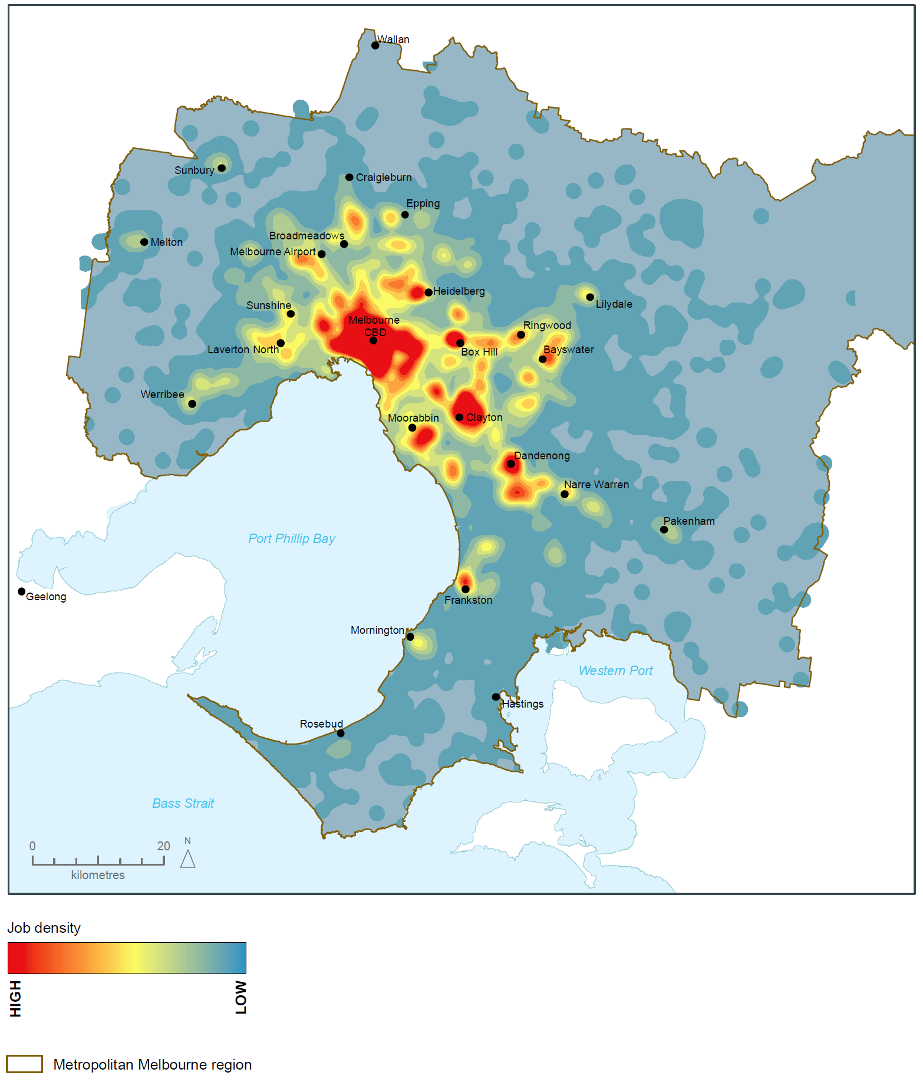
Source: Department of Environment, Land, Water and Planning

Policy 1.2.2 Facilitate investment in Melbourne’s outer areas to increase local access to employment
There is a need to support investments that create jobs in outer suburbs and growth areas. There is also a need to make it easier for people to access jobs—particularly high-value knowledge jobs—in established middle and inner areas from these locations.
Improving connections to national employment and innovation clusters can increase access to high-value knowledge jobs from outer areas and create job opportunities for people in outer areas.
There are also opportunities to support the establishment of start-ups and small and medium enterprises in outer suburbs and growth areas. Facilities such as business incubators can provide tenants with flexible work and meeting spaces where they can access a range of support services and networks to establish and grow their businesses. Local and the Victorian Government can also prioritise local jobs and businesses when procuring suburban infrastructure works.
Planning for outer suburbs and growth areas must ensure there is sufficient zoned land to support future development and job creation. This will provide for strong local economies and ease pressure on transport infrastructure by providing employment close to home.

Policy 1.2.3 Support the provision of telecommunications infrastructure
Next-generation communications—from fixed and wireless broadband, cloud computing, augmented reality applications and social media—are changing the way people live and work.
These changes have made telecommunications infrastructure as fundamental to commercial enterprises as electricity. The absence of telecommunications pathways can hinder or delay the provision of services and increase costs.
To remain globally competitive, Melbourne’s employment areas must support high-quality telecommunications infrastructure. That is why employment, urban renewal and growth area precincts need to include early planning for fibre-ready facilities and wireless infrastructure—eliminating the need for the costly and time-consuming retrofitting of telecommunications pathways.

Direction 1.3 Create development opportunities at urban renewal precincts across Melbourne
Identifying and creating opportunities for development on urban renewal sites and precincts across Melbourne can ease pressure on established areas and provide greater certainty for residents, investors, and the construction and development industry.
Some opportunities will come from investment in major transport infrastructure, such as the Metro Tunnel, level crossing removals, and associated land development. Other opportunities will come from brownfield sites, former industrial areas or underutilised or surplus government land.
Renewal of these sites offers the opportunity to improve local amenity, accommodate more housing and offer a greater mix of uses to support local communities.

Policy 1.3.1 Plan for and facilitate the development of urban renewal precincts
Significant opportunity exists across Melbourne for urban renewal precincts to accommodate future growth. By concentrating development within urban renewal precincts, other residential areas can be protected.
Urban renewal precincts should be developed as mixed-use neighbourhoods that offer a range and choice of housing as well as other services. They should offer high levels of amenity and connectivity and integrate into surrounding neighbourhoods.
An example of an urban renewal precinct is the former Amcor Paper Mill site in Alphington, which is set to be developed into a major residential precinct with shops, offices, open spaces and community facilities as well as commercial and retail spaces. The site—which includes affordable housing—will create local jobs and provide up to 2,500 homes for around 5,000 residents.
A number of former industrial and other sites—including government sites—around Melbourne are currently underutilised. Local planning authorities should identify and plan for ways these sites can be repurposed to create jobs and accommodate growth.

Policy 1.3.2 Plan for new development and investment opportunities on the existing and planned transport network
Melbourne has a significant network of existing and planned transport infrastructure. It will be important to maximise the benefits of this infrastructure by identifying related land-development and investment opportunities.
A number of new railway stations will be built over the next decade. These new stations will need to maximise public value by taking a precinct-wide approach that encourages integrated land development around stations.
Planning will need to identify land-use opportunities—particularly for jobs and employment—that can leverage off major transport investments.

Direction 1.4 Support the productive use of land and resources in Melbourne’s non-urban areas
Melbourne’s green wedges and peri-urban areas are immensely important to the state’s economy, community and environment and support a wide range of non-urban land uses and activities. For instance, some of Victoria’s most productive agricultural land is located within these areas. Other productive non-urban land uses include natural resource extraction, tourism, airports, sewage plants and waste and resource recovery operations.
These areas also accommodate businesses that need buffers from residential and incompatible land uses. Non-urban land uses in the green wedges and peri-urban areas should be carefully planned and managed to avoid irreversible land-use change and support their ongoing productivity.

Policy 1.4.1 Protect agricultural land and support agricultural production
Agricultural production in green wedges and peri-urban areas is vital to Melbourne’s long-term food security due to its proximity to markets, access to infrastructure and labour, and quality soils. Agricultural areas are also important agrifood tourism destinations as well as acting as green buffers for urban areas.
In green wedges and peri-urban areas, competing land uses (such as urban development and rural living) threaten agricultural production. Councils need support to maintain the long-term economic and social value of agricultural production.
Agricultural land in green wedges and peri-urban areas should be retained for productive use so it is not permanently lost.

Policy 1.4.2 Identify and protect extractive resources (such as stone and sand) important for Melbourne's future needs
Melbourne’s demand for extractive resources is expected to almost double by 2051. This demand will be driven largely by sustained growth in the residential sector—including Melbourne’s growth corridors—and strategic projects such as Fishermans Bend, the Metro Tunnel and major road upgrades.
Extractive industry resources in green wedges and peri-urban areas need to be protected and carefully planned to provide for Melbourne's needs without impacting on local amenity. Effective strategic planning for these resources will increase industry certainty and improve community confidence.
There are a small number of extractive industry interest areas within Melbourne’s urban growth boundary—such as Boral at Ravenhall. The sequencing of urban development in growth areas should allow strategic resources such as stone and sand to be extracted ahead of establishing urban areas, with provision for these areas to proceed outside defined buffer zones that can be subsequently in-filled by other urban land uses.
If not managed, urban encroachment, rural residential expansion and other incompatible development will constrain the operations of existing quarries and curtail future supplies of extractive resources—endangering Melbourne’s medium- to long-term growth prospects. To secure a long-term supply of extractive resource materials at competitive prices, current extractive industries must be protected and future extractive resource areas must be identified.

Outcome 2

MELBOURNE PROVIDES HOUSING CHOICE IN LOCATIONS CLOSE TO JOBS AND SERVICES
Melbourne will need 1.6 million new homes over the next 35 years.
Issues that need to be addressed include: housing affordability, the types of housing available to cater for different household needs and lifestyles, and the provision of medium- and higher-density housing close to jobs and services. Another pressing issue is the growing number of homeless people and households waiting for public housing.
To grow strong and healthy communities, Melbourne must remain affordable and accessible. That will require building the types of dwellings people want and need in locations where they want to live.
Melbourne’s housing stock is made up mainly of detached housing. However, there has been a significant shift in the type of housing built across Melbourne in recent years, with an increase in the proportion of medium- and higher-density housing, particularly in middle-ring suburbs such as Doncaster and Box Hill.
Figure 6 Annual building approvals by selected type and location, metropolitan Melbourne (year ending March)
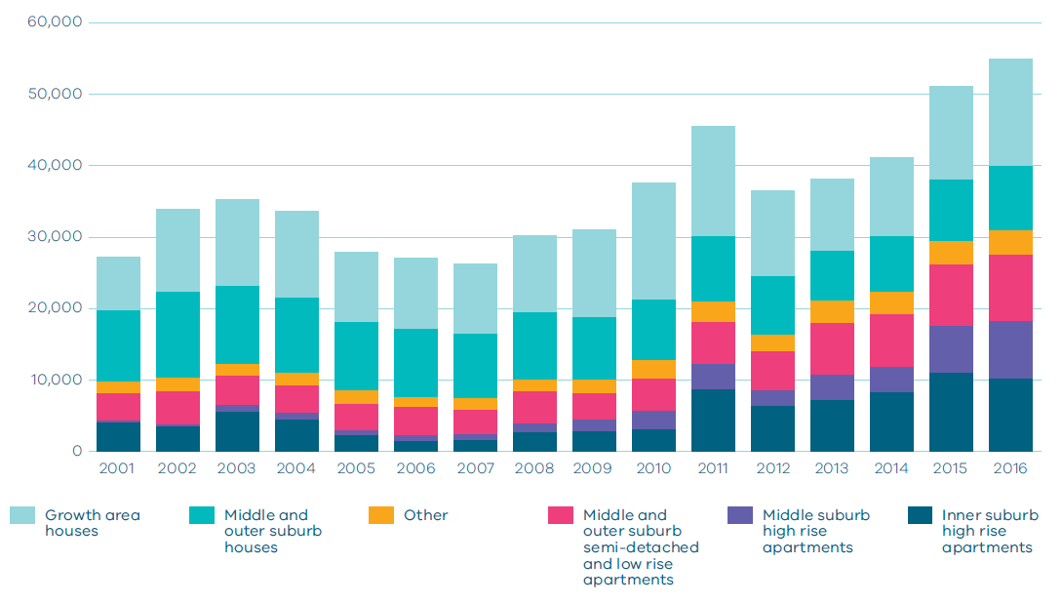
Source: DELWP analysis of ABS Building approvals, cat. no. 8731.0
For Melbourne to become more equitable and accessible, local residents need to have a choice of housing within their neighbourhood.
Growth needs to be planned and managed in a way that maintains the city’s liveability. Growth areas require public transport, schools, roads, hospitals and jobs. Middle-ring suburbs are well served with jobs and services and can provide greater housing choices in these locations, but development must be carefully managed. Areas in and around the central city offer significant urban renewal opportunities to develop as new places for people to live and work but need supporting community infrastructure and public spaces.
Metropolitan Melbourne has at least a 25-year supply of greenfield land available for residential development on its urban fringe. It is unsustainable to keep expanding Melbourne’s outer-urban growth areas. If the city continues to expand, the natural environment will be impacted, commute times to employment and services will grow longer, and socioeconomic disparities across the city will increase.
The new residential suburbs being created in growth areas are guided by the Precinct Structure Planning Guidelines. To ensure Melbourne does not recreate the ‘dormitory’ suburbs of the post-War boom the guidelines support planning for local jobs, local town centres rather than car-based shopping centres, better access by walking and bikes, and a healthy environment.
Melbourne will benefit from population growth—if plans are made and actions are taken. Without adequate planning, the city will become less affordable and liveable—risking social cohesion and economic growth.

Melbourne’s plan

Direction 2.1 Manage the supply of new housing in the right locations to meet population growth and create a sustainable city
The social, economic and environmental benefits of creating a more compact, sustainable city are profound. Some of the benefits of compact, higher-density neighbourhoods are as follows:
Social: It encourages positive social interaction and diversity, improves the viability of (and access to) community services and enables more (and better integrated) housing.
Economic: It enhances the economic viability of development, improves the economic viability of infrastructure delivery and utilises existing infrastructure.
Transport: It creates sustainable demand for more transport options—including public transport, walking and cycling—and can reduce overall travel time.
Environmental: It creates opportunities for efficient use of resources and materials, creates less pollution through the promotion of sustainable transport, preserves and helps fund the maintenance of public open space, creates new public open space, reduces overall demand for development land, and avoids expanding suburbs without supporting services.
Strategies need to be put in place that articulate clear goals and objectives for housing and:
- outline the needs of different household types
- provide a greater understanding of the range of housing needed
- provide a stronger understanding of opportunities and constraints
- identify preferred housing outcomes
- help clarify and communicate housing required across metropolitan Melbourne and its metropolitan regions
- address housing diversity, design, quality and energy efficiency
- seek to locate at least 65 per cent of new housing in established areas of Melbourne and no more than 35 per cent in growth areas in line with current levels of development and Victoria in Future projections.

Policy 2.1.1 Maintain a permanent urban growth boundary around Melbourne to create a more consolidated, sustainable city
Maintaining a permanent urban growth boundary sends a clear message about the long-term development priorities for Melbourne and Victoria. Those priorities include:
- reducing urban sprawl
- increasing metropolitan housing densities in the right places
- ensuring Melbourne’s established suburbs accommodate a greater share of Melbourne’s growth
- creating a more consolidated city of 20-minute neighbourhoods with good access to public transport and services
- protecting the values of non-urban land, opportunities for productive agricultural land and significant landscapes.
A permanent urban growth boundary will be maintained to contain Melbourne’s outward growth.

Policy 2.1.2 Facilitate an increased percentage of new housing in established areas to create a city of 20-minute neighbourhoods close to existing services, jobs and public transport
Victoria in Future projections indicate that around 65 per cent of all new dwellings will be in Melbourne’s established areas, with 35 per cent in growth area greenfield sites. Figure 7 provides likely housing distribution figures from 2015–2051 based on Victoria in Future 2016. It also provides an alternate aspirational scenario of housing distribution if 70 per cent of new housing was to be provided within Melbourne’s established areas.
To remain liveable and become more productive and sustainable, Melbourne must build on this current trend.
Since 2014 around 70 per cent of all new housing built has been in established areas.
Planning will be undertaken to ensure that the best parts of Melbourne are maintained and the benefits experienced in established inner and middle suburbs of Melbourne from compact, walkable neighbourhoods can also be realised in middle and outer areas.
This approach will support greater housing diversity and offer better access to services and jobs. It will also encourage the right mix of housing by enabling local residents to downsize or upsize without leaving their neighbourhood.

Figure 7 Housing distribution between established areas and growth area greenfields
Scenario 1 VIF 2016
Net Dwelling Additions 2015-51
Region  Inner Metro | Total  215,000 | Established 215,000 | Greenfields  0
Region  Western | Total  385,000 | Established 150,000 | Greenfields 235,000
Region  Northern | Total  355,000 | Established 175,000 | Greenfields 180,000
Region  Inner South East | Total  110,000 | Established 110,000 | Greenfields  0
Region  Eastern | Total  175,000 | Established 175,000 | Greenfields  0
Region  Southern | Total  310,000 | Established 185,000 | Greenfields 125,000
 | Total Melbourne 1,550,000  100% | Total Melbourne Established 1,010,000  65% | Total Melbourne Greenfields 540,000  35%
Scenario 2 Aspirational scenario
Net Dwelling Additions 2015-51
Region  Inner Metro | Total  230,000 | Established 230,000 | Greenfields  0
Region  Western | Total  365,000 | Established 160,000 | Greenfields 205,000
Region  Northern | Total  340,000 | Established 180,000 | Greenfields 160,000
Region  Inner South East | Total  125,000 | Established 125,000 | Greenfields  0
Region  Eastern | Total  190,000 | Established 190,000 | Greenfields  0
Region  Southern | Total  300,000 | Established 195,000 | Greenfields 105,000
 | Total Melbourne 1,550,000  100% | Total Melbourne Established 1,080,000  70% | Total Melbourne Greenfields 470,000  30%

NOTE: Housing distribution figures have been developed to show distribution between established areas and greenfield areas based on two scenarios. Scenario 1 is based on VIF 2016 projections which assume continuation of current trends. Scenario 2 shows an aspirational distribution based on achieving a 70/30 split of net dwelling additions. For the purpose of these figures, greenfield areas include land in a growth area council that is either currently under development or identified for future development.
Source: Department of Environment, Land, Water and Planning

Policy 2.1.3 Plan for and define expected housing needs across Melbourne’s regions
Planning for housing at a regional level will help identify planned residential change across Melbourne, including areas identified for residential growth, moderate housing growth and areas of limited change.
Metropolitan regions should facilitate a housing market that creates ongoing and substantial new housing opportunities near jobs, services and transport. Local governments need to consider housing policy and planning in the context of their own municipal boundaries as well as the broader housing objectives of their region.
Regional planning must make adequate provisions for future housing needs and ensure:
- defined housing change areas, as well as redevelopment sites and areas, are identified to support long-term housing growth, choice and diversity for a range of household types
- planning for residential change areas facilitates ongoing investment and creates relatively high levels of housing opportunity
- new development is directed to areas with appropriate infrastructure, and greater density is supported where it optimises the value of existing infrastructure
- a spectrum of minimal, incremental and high-change residential areas are allowed to balance the need to protect valued areas with the need to ensure choice and growth in housing markets across the metropolitan area
- information is collected and reported in relation to changes to household types, housing needs and population growth—thereby informing future planning decisions.

Policy 2.1.4 Provide certainty about the scale of growth in the suburbs
There is a need to provide greater certainty and facilitate long-term growth and housing choice in the right locations.
Local government and the community also need confidence that the built form objectives they sign up to will be adhered to.
The review of residential zones will give greater certainty to the community by strengthening mandatory height provisions and site coverage requirements in each of the residential zones.
In areas where greater change is expected—such as urban renewal precincts and mixed-use and activity centre areas—requirements to adhere to preferred heights will also be strengthened. This will be achieved by improving the way height in strategic locations is managed and decisions are made.
Managing residential development
The residential zones introduced in 2013 have been reviewed by the Managing Residential Development Advisory Committee and amended to better reflect the balance between protection of neighbourhood character and well designed developments. The new zones were the Neighbourhood Residential Zone, General Residential Zone and Residential Growth Zone. The underlying principles of the zones were sound, however the zones have been applied in different ways and through different processes across councils. The Managing Residential Development Advisory Committee found that the inconsistencies in the way the zones had been implemented resulted in a lack of clarity, transparency and consistency.
To provide greater consistency and certainty about growth in the suburbs and the built form outcomes being sought, the residential zones have been reviewed and updated to provide consistent and strengthened mandatory height controls and building coverage requirements. This will provide greater certainty to communities about the level of development that can occur and enable Melbourne to develop in a way that is sustainable and does not detract from the character of the suburbs.

Map 13 Metropolitan Melbourne regions
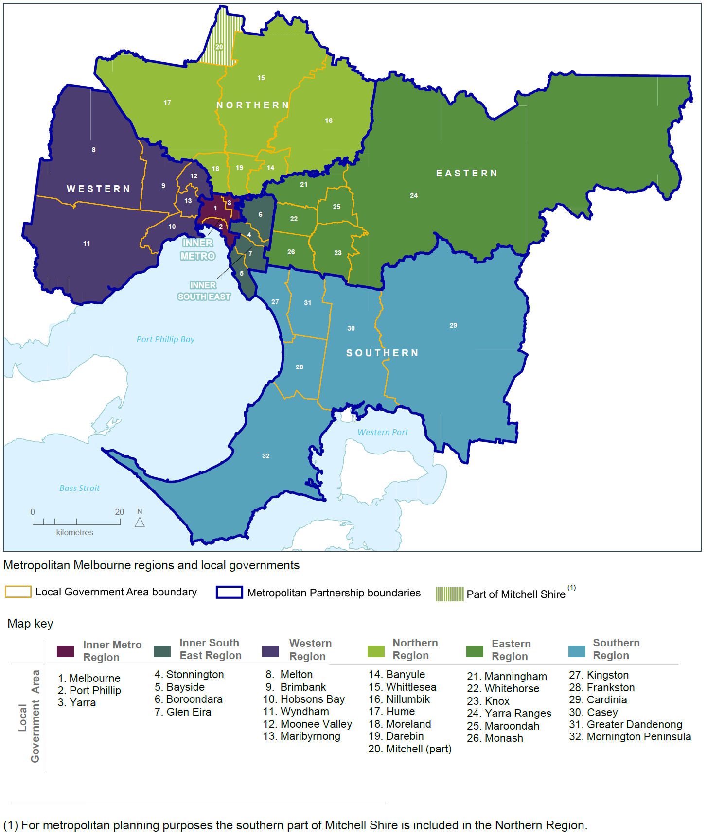
Source: Department of Environment, Land, Water and Planning

Direction 2.2 Deliver more housing closer to jobs and public transport
Locating medium- and higher-density development near services, jobs and public transport supports the objectives of consolidation and housing choice.
For this direction to be achieved, the standards of higher-density housing need to be raised.
There are significant opportunities for housing development in and around the central city. There are also opportunities for more medium- and higher-density development in middle suburbs close to jobs and services including:
- urban renewal precincts
- areas identified for residential growth
- areas identified for greyfield renewal
- areas designated as national employment and innovation clusters
- metropolitan activity centres and major activity centres
- neighbourhood activity centres—especially if they have good public transport connections
- areas near existing and proposed railway stations that can support transit-oriented development.
Encouraging mixed-use developments and greater housing diversity and density near employment and transport will create opportunity and choice for medium- and low-income households.

Map 14 Metropolitan and major activity centres
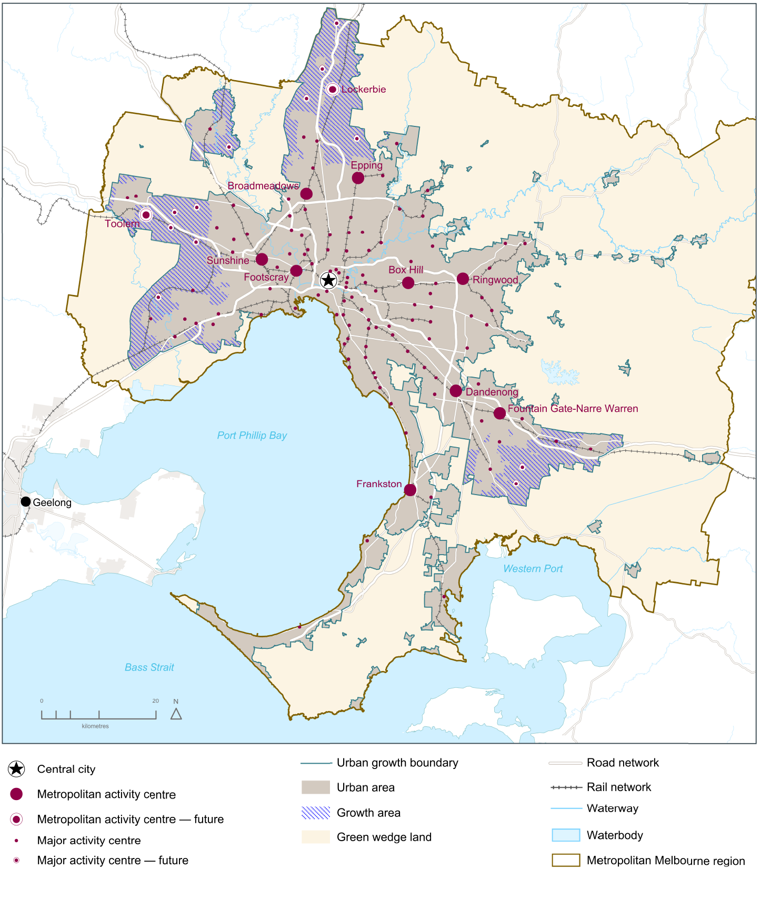
Source: Department of Environment, Land, Water and Planning

List of activity centres
Central City
- Melbourne
Metropolitan Activity Centres
- Box Hill
- Broadmeadows
- Dandenong
- Epping
- Footscray
- Fountain Gate-Narre Warren
- Frankston
- Ringwood
- Sunshine
Future Metropolitan Activity Centres
- Lockerbie
- Toolern
Major Activity Centres*
- Airport West
- Altona
- Altona North
- Ascot Vale-Union Road
- Balaclava
- Bayswater
- Bentleigh
- Berwick
- Boronia
- Brandon Park
- Braybrook-Central West
- Brighton-Bay Street
- Brighton-Church Street
- Brimbank Central
- Brunswick
- Burwood East-Tally Ho
- Burwood Heights
- Camberwell Junction
- Carlton-Lygon Street
- Carnegie
- Caroline Springs
- Casey Central
- Caulfield
- Chadstone
- Chelsea
- Cheltenham
- Cheltenham-Southland
- Chirnside Park
- Clayton
- Coburg
- Craigieburn
- Craigieburn Town Centre
- Cranbourne
- Croydon
- Deer Park
- Diamond Creek
- Doncaster East-The Pines
- Doncaster Hill
- Elsternwick
- Eltham
- Endeavour Hills
- Fitzroy-Brunswick Street
- Fitzroy-Smith Street
- Flemington-Racecourse Road
- Forest Hill Chase
- Gladstone Park
- Glen Waverley
- Glenhuntly
- Glenroy
- Greensborough
- Hampton
- Hampton Park
- Hastings
- Hawthorn-Glenferrie Road
- Heidelberg
- Hoppers Crossing
- Ivanhoe
- Karingal
- Kew Junction
- Keysborough-Parkmore
- Lilydale
- Malvern/Armadale
- Manor Lakes
- Maribyrnong-Highpoint
- Melton
- Melton-Woodgrove and Coburns Road
- Mentone
- Mernda
- Moonee Ponds
- Moorabbin
- Mordialloc
- Mornington
- Mount Waverley
- Mountain Gate
- Niddrie-Keilor Road
- Noble Park
- North Essendon
- Northcote
- Nunawading
- Oakleigh
- Officer
- Pakenham
- Point Cook
- Port Melbourne-Bay Street
- Prahran/South Yarra
- Preston-High Street
- Preston-Northland
- Reservoir
- Richmond-Bridge Road
- Richmond-Swan Street
- Richmond-Victoria Street
- Rosebud
- Rowville-Stud Park
- Roxburgh Park
- Sandringham
- South Melbourne
- South Morang
- Springvale
- St Albans
- St Kilda
- Sunbury
- Sydenham
- Tarneit
- Toorak Village
- Wantirna South-Knox Central
- Werribee
- Werribee Plaza
- Williams Landing
- Williamstown
Future Major Activity Centres
- Beveridge
- Clyde
- Clyde North
- Hopkins Rd
- Mickleham
- Plumpton
- Riverdale
- Rockbank
- Rockbank North
- Sunbury South
- Wallan
- Wollert
* Each of these centres has different development potential and is subject to local strategic planning.

Policy 2.2.1 Facilitate well-designed, high-density residential developments that support a vibrant public realm in Melbourne's central city
Directing population and housing growth into defined change areas will enable the Victorian Government to work with local governments, developers and stakeholders to create sustainable, liveable and attractive places that appeal to a range of households—including families with children and older- and single-person households.
A number of major urban renewal precincts have been identified in the central city (as shown on Map 4). Maximising development opportunities of these precincts will minimise the need to increase residential densities in other parts of the city. The sequencing of infrastructure within these precincts will maximise their development potential and provide timely services and amenities for residents.
There is a need to find ways to give the market some flexibility to maximise development opportunities. For instance, additional development rights could be granted in exchange for the provision of additional amenity in the central city and other key urban renewal and structure plan areas.

Policy 2.2.2 Direct new housing and mixed-use development to urban renewal precincts and sites across Melbourne
The redevelopment of urban renewal precincts and sites will create more diversity in the housing market—including opportunities for affordable and social housing—as well as more jobs and community services. Urban renewal precincts will be major sources of medium- and higher-density mixed-use development.
Additional urban renewal opportunities need to be identified through regional planning in partnership with the local government sector.
Local governments will be supported to deliver outcomes at identified local urban renewal precincts and sites, particularly if they have complex issues that need to be addressed such as site contamination.

Policy 2.2.3 Support new housing in activity centres and other places that offer good access to jobs, services and public transport
To support increased housing supply in established areas, it will be necessary to define locations best able to support increased densities.
Activity centres are usually well served with public transport and offer access to a range of services and facilities. Many activity centres can support additional housing growth and will need flexibility, particularly where there is a significant population and household growth forecast.
Activity centres with the greatest potential to attract investment and support more medium- and higher-density housing need to be identified. This should also include opportunities for the creation of new activity centres. Once identified, appropriate policies, provisions and guidelines must be developed and put in place to encourage and support planned growth.

Policy 2.2.4 Provide support and guidance for greyfield areas to deliver more housing choice and diversity
Greyfield sites are residential areas where building stock is near the end of its useful life and land values make redevelopment attractive. Melbourne has many residential areas that qualify as greyfield sites, particularly in established middle and outer suburbs.
These areas often have low-density, detached housing on suburban-sized allotments that have good access to public transport and services.
Up until now, the redevelopment of these areas has been generally uncoordinated and unplanned. That must change. Greyfield areas provide an ideal opportunity for land consolidation and need to be supported by a coordinated approach to planning that delivers a greater mix and diversity of housing and provides more choice for people already living in the area as well as for new residents.
Methods of identifying and planning for greyfield areas need to be developed. A more structured approach to greyfield areas will help local governments and communities achieve more sustainable outcomes.

Policy 2.2.5 Require development in growth areas to be sequenced and staged to better link infrastructure delivery to land release
Growth areas have a significant role to play in how Melbourne's growth is managed and provide affordable housing options to residents. As Figure 8 shows, Melbourne’s greenfield lots are the second cheapest among Australia’s capital cities. Comparative prices in Sydney are more than double Melbourne’s prices.
Melbourne’s growth areas have at least 25 years supply of greenfield residential land (undeveloped land on the fringe of the city). Of this, approximately 15 years land supply is ‘development ready’, being either zoned or having approved Precinct Structure Plans. Residential densities in recent years have increased from 15 dwellings per hectare to around 18 dwellings per hectare. If average densities continue to increase, this supply will last beyond 2050.
Although Melbourne’s greenfield housing market performs strongly, the models for coordinating the delivery of land supply and supporting infrastructure can be improved. Poorly managed releases of land can result in higher living costs for residents, as well as limiting access to workforce opportunities and education and health services.
An integrated approach to land-use and transport planning helps ensure infrastructure and essential services are delivered as areas develop. Initiatives such as growth areas infrastructure contributions to help fund substantial state infrastructure and improved transport services, including the Regional Rail Link and reservation for future transport corridors, can help deliver sustainable new communities.
In the future, planning and development of growth areas should:
- provide around 15 years supply of land approved for development
- over time, seek an overall increase in residential densities to more than 20 dwellings per hectare
- be sequenced to ensure new precincts are contiguous with previously approved precincts.
This approach will link infrastructure delivery to land release, ensuring residents in new communities receive the services and infrastructure they need sooner. Coordinated planning such as this will help create stronger, healthier communities.
Figure 8 Median lot price by market, September 2016

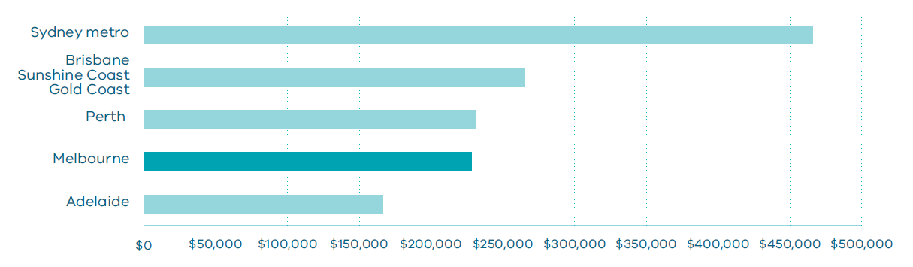
Source: National Land Survey Program (NLSP) by Charter Keck Cramer and Research 4.

Direction 2.3 Increase the supply of social and affordable housing
The planning system alone cannot address all of the issues related to the provision of social and affordable housing. A range of programs and measures across all levels of government are required, but it is important that the planning system makes it easier—rather than harder—to deliver social and affordable housing.
In recent years, housing prices have risen faster than incomes, making home ownership increasingly unattainable for many citizens. As a result, many households may remain in the private rental market indefinitely unless they are prepared to buy in locations with poorer access to services and jobs.
The most severe and chronic housing affordability problems are experienced by lower-income households in the private rental market, particularly those reliant on statutory incomes such as Centrelink. In addition, levels of homelessness have increased in Victoria, with more than 22,000 people recorded as homeless on Census night in 2011.
For Melbourne to remain liveable for all its citizens, the supply of social and affordable housing needs to be increased. A range of housing types need to be developed within suburbs across Melbourne—not just in outer areas—to improve local affordability for homeowners and renters.
What is affordable housing and what is social housing?
Affordable housing is housing that is appropriate for the needs of a range of very low to moderate income households, and priced (whether mortgage repayments or rent) so these households are able to meet their other essential basic living costs.
Social housing is a type of rental housing that is provided and/or managed by the government (public housing) or by a not-for-profit organisation (community housing). Social housing is an overarching term that covers both public housing and community housing.

Map 15 Lower-cost housing in metropolitan Melbourne 1995 and 2015
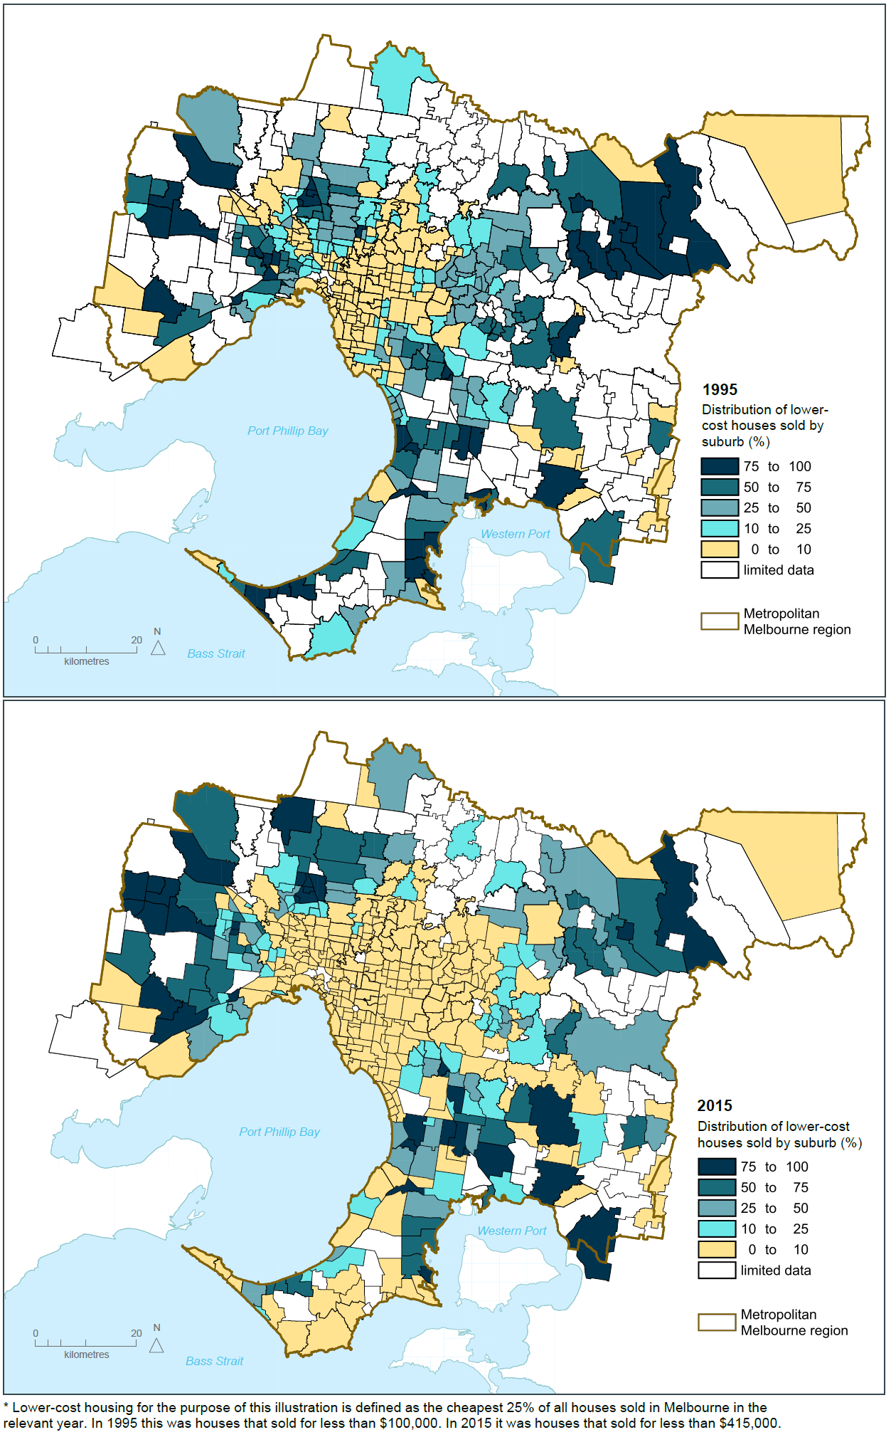
Source: Department of Environment, Land, Water and Planning

Policy 2.3.1 Utilise government land to deliver additional social housing
The Victorian Government holds valuable land assets that can contribute to the delivery of additional social and affordable housing.
The Victorian Government will increase the supply of social and affordable housing through identifying surplus government land suitable for housing. Sites identified as being surplus to government requirements need to be re-used in ways that deliver broad community benefits—such as boosting the supply and spread of social and affordable housing. Opportunities to increase overall supply through the regeneration of existing public housing also need to be identified.
The government is taking a strategic approach to accelerating the development of well-located surplus government land. A pilot program has been developed for a number of sites suitable for affordable housing. Other opportunities to leverage surplus government land to deliver social housing while maximising the opportunity to deliver planning uplift and certainty will be investigated, including local government land and surplus land held by other agencies.

Policy 2.3.2 Streamline decision-making processes for social housing proposals
Delays in approvals can result in additional holding costs and make social-housing developments harder to deliver.
Streamlined approval processes for the government and the community-housing sector can help facilitate the supply of social housing.
To support an increase in the supply of social housing, a new streamlined approval process will be developed for social-housing projects. This will facilitate faster delivery of social-housing projects with lower holding costs and greater planning certainty.

Policy 2.3.3 Strengthen the role of planning in facilitating and delivering the supply of social and affordable housing
There is a pressing need to increase the supply of social and affordable housing for households unable to afford market-rate housing.
The supply of social and affordable housing is largely dependent on the availability of subsidies to cover the gap between what very low income households can pay and the cost of providing housing. However, the land-use planning system can be reformed and strengthened to help support and facilitate the delivery of more social and affordable housing.
There are currently several planning-related barriers to the delivery of more social and affordable housing—including a lack of clarity in legislation and planning provisions on what constitutes affordable housing, and the absence of clear planning tools or mechanisms to require the provision of social or affordable housing as part of the planning process. Current approaches (such as requiring section 173 Agreements under the Planning and Environment Act 1987 or applying requirements through tools such as Development Plan Overlays) have been criticised for not being sufficiently robust and inequitably applied.
The planning system will be reformed to facilitate the delivery of more social and affordable housing. These reforms will clearly define social and affordable housing, create a clear head of power for affordable housing contributions, and clarify the role the planning system has to play in the delivery of new housing. Reforms will also include new planning provisions or tools to deliver social and affordable housing. These reforms will explore inclusionary zoning and mechanisms to capture and share value created through planning controls.
New provisions or tools will be developed in consultation with the community-housing sector, the residential-development industry and local government.

Policy 2.3.4 Create ways to capture and share value uplift from rezonings
There is an increasing need to encourage the development of more affordable housing, including the integration of social and affordable housing options within major urban renewal developments.
There is scope to capture some of the value created by the rezoning process for policy priorities such as social and affordable housing.
Urban renewal precincts and sites offer significant opportunities to deliver tangible broader public benefit through their rezoning for social or affordable housing, as well as local assets such as open space and community facilities.
Consideration needs to be given to developing a new requirement that when land is rezoned to allow for higher value uses, a proportion of the value uplift should be contributed to the delivery of broader public benefit outcomes such as social and affordable housing

Direction 2.4 Facilitate decision-making processes for housing in the right locations
Many sites identified for future housing face lengthy decision-making processes. This can make it time consuming to develop new housing, driving up housing costs.
Many sites across Melbourne have a legacy of environmental contamination as a result of the city’s industrial and manufacturing heritage. For some sites, the cost of remediation may limit re-use options.
Developments allowing more than a single dwelling can also be subject to lengthy assessment processes and appeals even if they are in areas where change is envisaged. Contested applications generally arise where performance-based requirements exist instead of clearer, more prescriptive requirements.
The uncertainty in the system needs to be reduced, particularly for development in areas defined for change and housing growth.

Policy 2.4.1 Support streamlined approval processes in defined locations
Attracting population and housing growth to the most suitable, well serviced areas will be assisted by providing clear approval processes for preferred areas and quality housing developments that appeal to a range of households on different incomes.
A streamlined, codified approval process will be developed and implemented for defined change areas. Under this process, proposals could be required to achieve a set of premium development standards related to dwelling design, open space and residential amenity and demonstrate delivery of good urban design outcomes for the locality.
A codified approval process will speed up decision-making in defined locations and provide local governments, the community and the housing sector with greater certainty. If a proposal does not meet the set standards for codified approval, then a normal approval process would apply.

Policy 2.4.2 Facilitate the remediation of contaminated land, particularly on sites in developed areas of Melbourne with potential for residential development
Policy frameworks and controls for managing contaminated environments must support safe redevelopment. They also need to allow for innovative approaches that maximise redevelopment opportunities for residential uses.
That is why the integration of land-use planning and environmental processes for assessment and remediation of contaminated sites must improve. The uncertainty of investigation and clean-up requirements for potentially contaminated land must also be reduced, so that land can be brought to market sooner.

Direction 2.5 Provide greater choice and diversity of housing
Housing diversity relates to the size, cost, number of bedrooms, character and age of dwellings. It also extends to other types of housing, such as low-cost rental aged care, supported accommodation for people with disability, rooming houses, student accommodation and social housing.
Creating greater choice and diversity of housing across the city has clear benefits—such as improved access to jobs, services and transport. For newly formed households, providing a diversity of housing may enable them to remain within a preferred location. For older couples, housing diversity may enable them to downsize to more compact accommodation within their neighbourhood.

Policy 2.5.1 Facilitate housing that offers choice and meets changing household needs
Melbourne needs a greater mix of housing. Alternate forms of housing, such as secondary dwellings, can offer opportunity for small-scale development in established areas—creating opportunities for extended families to live together or older couples to downsize.
Internal design can also increase the flexibility and adaptability of dwellings. For example, universal design ensures homes are accessible to people with disability—accessibility will become more important as the population ages. A flexible internal design can also help accommodate adult children remaining or returning home as well as the addition of elderly parents to a household.
The planning system will be amended to cater for different types of housing and accommodation.
Secondary dwellings
A number of states across Australia allow the development of a secondary dwelling.
A secondary dwelling—sometimes referred to as a granny flat or bedsitter—is an additional self-contained dwelling developed on the same land as a principal dwelling. It is limited in size and can be located within, beside, behind, below or above the principal dwelling.
A range of development standards are generally required to be met to be classified as a secondary dwelling, such as site area requirements, building heights and setbacks, landscaping and services. If development standards are met, a fast-track approval process applies.
In some areas, there are limitations on the secondary dwelling being occupied by persons who form one household with the principal dwelling.

Policy 2.5.2 Provide a range of housing types in growth areas
In growth areas, there needs to be a move away from uniform-sized housing lots towards providing both higher and lower densities within each precinct.
Planning for growth areas must deliver a variety of lot sizes and housing types. This can be achieved through both larger lots (to provide a sizeable backyard for those families that desire it), as well as options for townhouses, low-rise apartments, and aged-care housing close to shopping centres and community facilities.

Outcome 3

MELBOURNE HAS AN INTEGRATED TRANSPORT SYSTEM THAT CONNECTS PEOPLE TO JOBS AND SERVICES AND GOODS TO MARKET
Melbourne’s transport system needs the capacity to cope with an additional 10.4 million trips a day by 2050—up from the current figure of 12.5 million trips a day.
To achieve that, Melbourne needs a huge, well planned investment that enables the city to grow whilst meeting the transport challenges.
Through the review of Infrastructure Victoria’s 30-year strategy, plans for development of the transport network are being assessed and prioritised to overcome historic backlogs and provide for future needs as land use changes.
For Melbourne to continue to be a globally connected and competitive city with strong and healthy communities and higher social and economic participation, the share of trips by public transport, as well as active transport modes such as walking and cycling, must increase.
Melbourne needs one reliable, connected transport network where services are regular and easy to use, timetables are integrated, and major interchanges work better.
That means land use and transport needs to support and encourage convenient trip options so that more people can meet most of their needs locally and be less reliant on private vehicles.

Map 16 Existing rail and road transport infrastructure
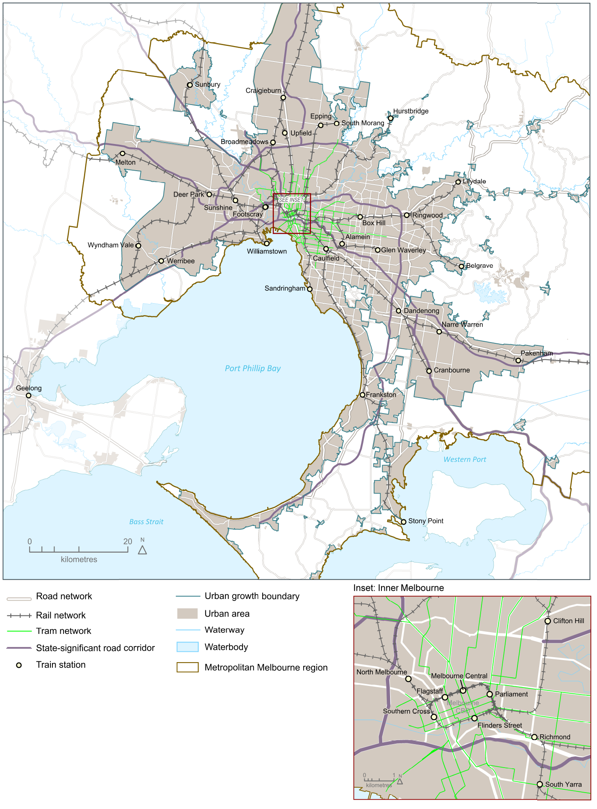

Source: Department of Environment, Land, Water and Planning

Melbourne’s plan

Direction 3.1 Transform Melbourne’s transport system to support a productive city
Melbourne’s transport networks link people to jobs and businesses to markets—making the city productive and liveable.
Major transport projects, or city-shaping projects, significantly influence the way in which the city develops.
The transport network will continue to be managed and developed in ways that balance access (including movements through and between places) with the creation of liveable communities. In doing so, improved road networks and effective public transport connections are needed to support growth in capacity.

Policy 3.1.1 Create a metro-style rail system with ‘turn up and go’ frequency and reliability
Melbourne’s rail network must grow so it can continue to support the productivity of Melbourne and service the needs of a growing population. The Metro Tunnel, to be completed by 2026, is a critical step towards evolving the train network into a metro-style system.
A metro-style rail system will have a strong focus on passengers, delivering:
- simpler timetables with a ‘turn up and go’ frequency and consistent stopping patterns
- frequent services that facilitate easy interchange with other train lines as well as trams and buses
- separate train fleets, maintenance and stabling facilities for each line
- stand-alone, end-to-end lines that prevent service disruptions on one line from affecting other lines
- modern signalling technology to maximise the number of trains that can operate on each line
- high-capacity metro trains designed to minimise boarding and alighting times
- separated road and rail crossings.

Figure 9 Metro Tunnel wider benefits—capacity benefits over two-hour peak period
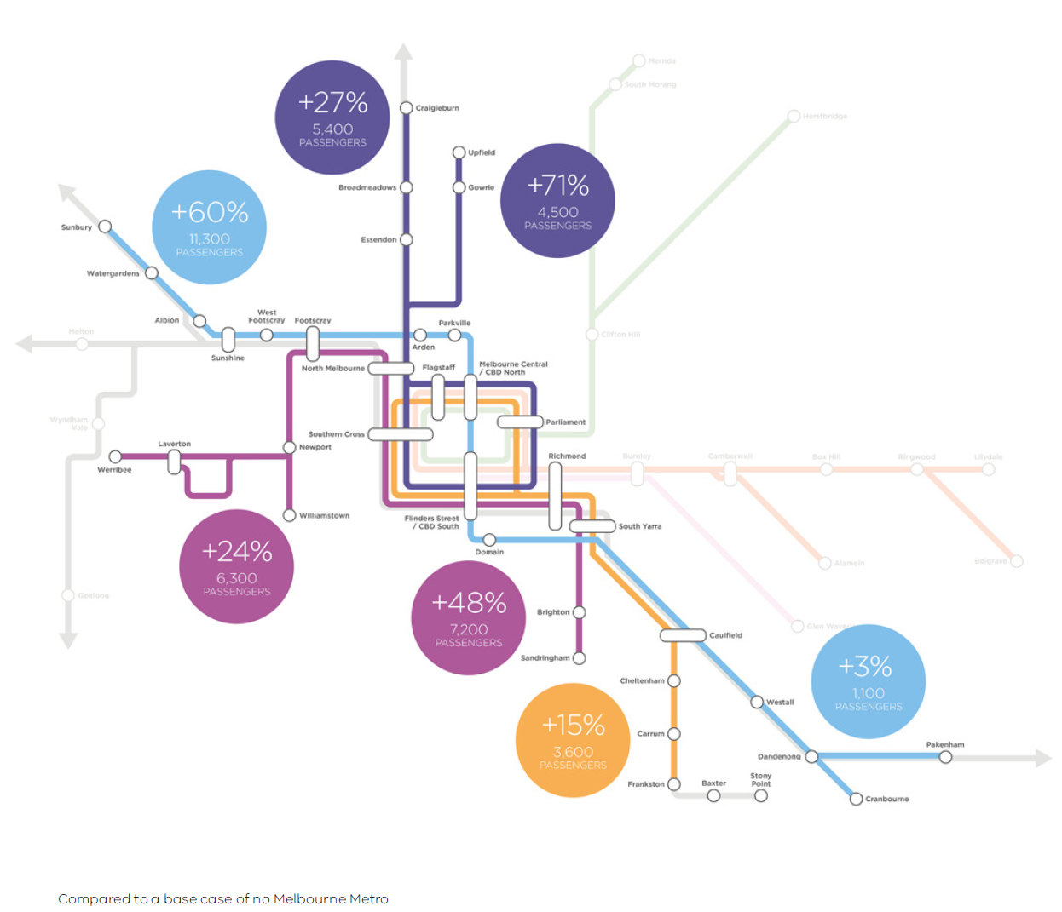
Source: Melbourne Metro business case
Map 17 Improvements to transport infrastructure – committed and potential
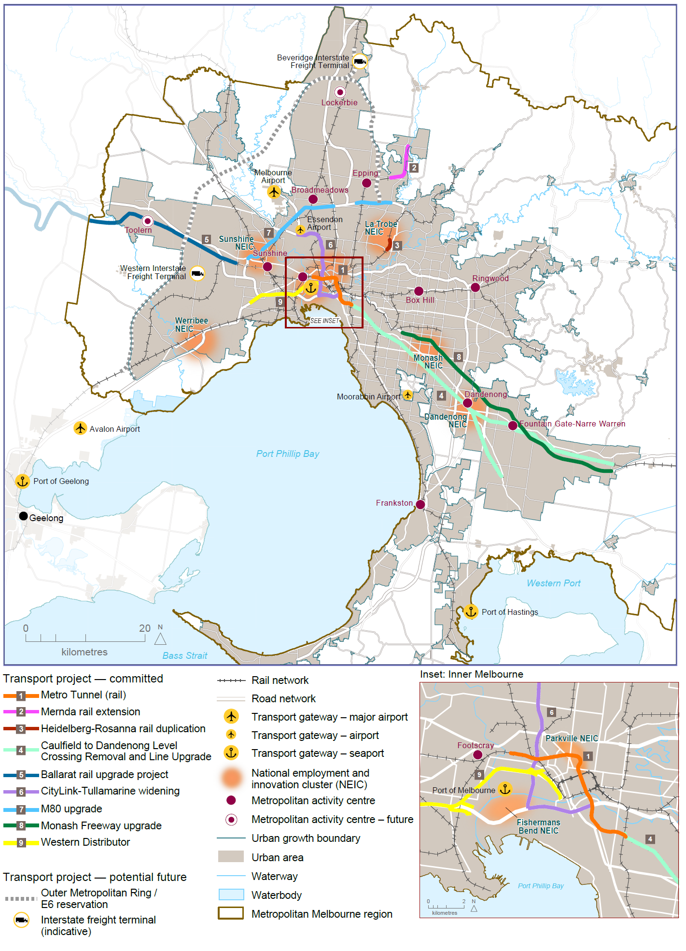

Source: Department of Environment, Land, Water and Planning

Policy 3.1.2 Provide high-quality public transport access to job-rich areas
The efficiency and simplicity of the network, and the quality of connections between public transport modes can make a major difference to people’s willingness to use public transport and expand the range of jobs and services they access.
In many parts of the city, buses provide a high-quality transport service and are likely to play a greater role in the future. The best performing services are typically those where buses connect as part of an integrated public transport network. Where improvements to bus networks have already been delivered, there have been substantial increases in patronage. This approach will continue as the city develops and demand grows.
Priorities to improve the public transport system include modernising and strengthening the tram and bus network by:
- improving connections to the national employment and innovation clusters and urban renewal precincts—particularly those in the expanded central city and other job-rich areas—will increase business and employee work-choice location and improve business-to-business and business-to-consumer transactions
- extending tram lines, improving tram travel times, reliability and capacity to support major movements of people by gradually transforming to a light-rail system with increased right-of-way, more accessible, low-floor, high-capacity vehicles, and level-access stops
- progressively upgrading the bus network, with a focus on increased frequency, increased priority and right-of-ways and reliability, and improved travel times and connectivity
- providing more real-time information for users to enable better trip planning and improve user confidence, choice and satisfaction with the service.

Policy 3.1.3 Improve arterial road connections across Melbourne for all road users
The arterial road network is the foundation of transport across our suburbs, supporting the movement of private vehicles, public transport, cycling, walking and freight.
The ongoing development and maintenance of the network will support national employment and innovation clusters, metropolitan activity centres, major activity centres and other areas with high or growing job densities.
The existing road network creates a number of challenges and constraints. Trade-offs between different road users are often required. For example, on arterial roads the primary focus will be supporting reliable and efficient movement and mitigating amenity impacts on nearby communities. However, roads that service more intense land use will prioritise walking, cycling and public transport. Figure 10 shows the concept of improved road use.
The removal of level crossings improves the efficiency and safety on the arterial road network. They can also create opportunities for urban renewal and development.
Figure 10 Improved road use
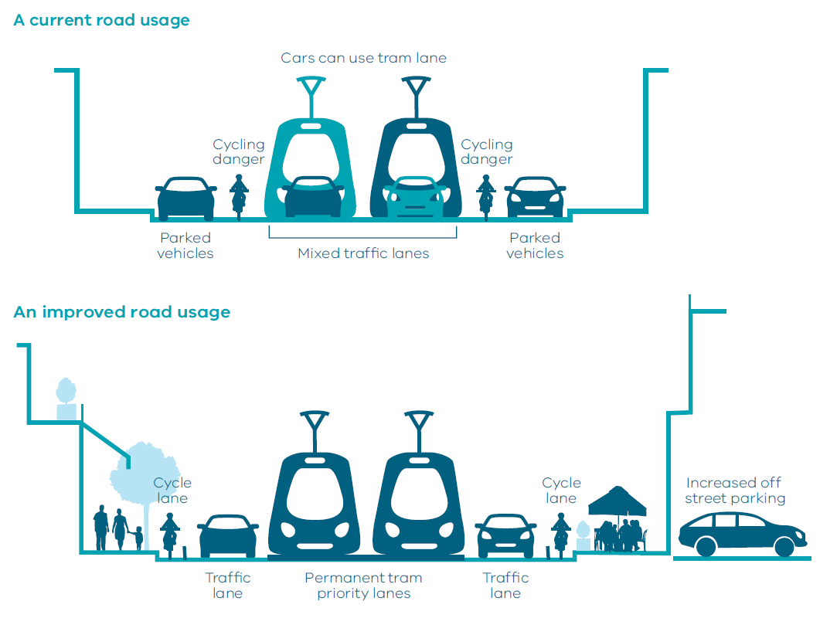

Map 18 Level crossing removals
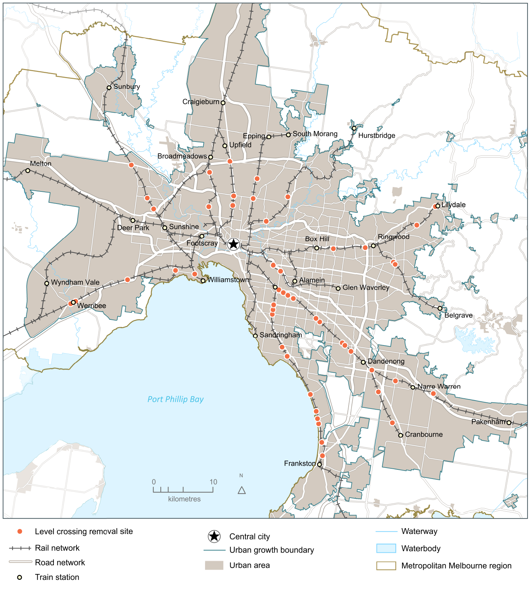
Source: Department of Environment, Land, Water and Planning

Policy 3.1.4 Provide guidance and certainty for land-use and transport development through the Principal Public Transport Network and the Principal Freight Network
Principal transport networks, such as the Principal Public Transport Network (PPTN) and the Principal Freight Network (PFN), provide clarity for state and local governments and communities in land-use planning and decision-making.
The PPTN outlines the routes where high-quality public transport services are or will be provided. Increased diversity and density of developments is encouraged on the PPTN, particularly at interchanges, activity centres and where principal public transport routes intersect. This may also include maximising government land assets around transport nodes and on the PPTN.
The existing PPTN will be incorporated into planning schemes. There will be an ongoing consultation process with local government and other stakeholders to confirm future candidate routes.
The PFN will help direct land-use decisions to minimise uses that might conflict with areas expected to have intense freight activity, helping improve freight efficiency and minimise amenity impacts. The PFN will be updated, following a consultation and engagement process, and, subsequently, will be incorporated into planning schemes.

Policy 3.1.5 Improve the efficiency of the motorway network
Motorways (including both freeways and toll roads) and heavy rail contribute to productivity and liveability by efficiently moving high volumes of people and goods over longer distances.
The motorway network supports productivity by:
- connecting and providing access to major seaports, airports, freight transport gateways, and other freight-generating areas
- providing state-significant links that connect and serve dispersed major suburban residential areas with key destinations and providing access to lower-density employment areas in Melbourne
- linking Melbourne with major regional cities, major interstate locations and other key locations that are important to the economy along major national and state corridors.
The motorway network supports liveability by providing strategic bypasses that minimise freight- and car-based traffic across Melbourne.
Optimisation of the existing motorway network will be achieved through the use of technology and new and upgraded connections, including consideration of how to fill the missing North East Link on the Metropolitan Ring Road.

Policy 3.1.6 Support cycling for commuting
Cycling is a growing means of transportation around inner Melbourne. Journeys to work by bicycle almost doubled between 2001 and 2011. This compares to an increase in journeys to work of 25 per cent across all modes. It should be noted that the increase in bicycle commuting started from a small base.
Strategic cycling corridors have been identified and are progressively being developed as the key, direct cycling links across metropolitan Melbourne.

Direction 3.2 Improve transport in Melbourne’s outer suburbs
The provision of transport services and infrastructure—such as arterial roads must—keep up with population growth in outer Melbourne. It is critical that land uses and transport are integrated to support each other. Increasing density of development, particularly around transport nodes, creates the critical mass essential to make a range of services viable.

Policy 3.2.1 Improve roads in growth areas and outer suburbs
There will be ongoing development and maintenance of the arterial road network to support improved travel times, safety and reliability for people living in growth areas and outer suburbs, and businesses located in these areas. A focus will be ensuring access to the places where people work as well as services such as education, health care, shopping and recreation. There is a particular need for priority bus services that link destinations via the growth area road network.
The development of the arterial road network in growth areas and outer suburbs will ensure access for businesses to nearby national employment and innovation clusters, metropolitan activity centres, major activity centres and other areas with high or growing job densities.

Policy 3.2.2 Improve outer-suburban public transport
Many outer suburbs need to be better served by public transport.
The sequencing of development in Melbourne's growth areas will be improved along with increasing the diversity and density of development along the PPTN and near stations. This helps enable the timely delivery of services.
The consultation program to update the PPTN will have a particular focus on Melbourne’s outer- suburban growth areas so that land use and development integrates with high-quality public transport. The government will plan and deliver high-quality public transport in line with the rate of development in outer areas.

Direction 3.3 Improve local travel options to support 20-minute neighbourhoods
Local travel is different to journey-to-work travel. It relates to service, recreational and social activities—such as sport and shopping—as well as personal business and education. It occurs throughout the day, rather than just at peak times. It is important to ensure all residents, regardless of age and ability, can access the local services they need in their community.
Neighbourhood design and the development of destinations influence local travel, dictating how much people walk and cycle. Short neighbourhood daily trips enable people to have choices other than the private car.

Policy 3.3.1 Create pedestrian-friendly neighbourhoods
Research shows that people walk more when they have access to pedestrian routes and connections that are safe, direct and pleasant to use. Improving the pedestrian environment in existing areas can be achieved by creating quality pedestrian links and short cuts. There is also a correlation between increased walking and increased public transport patronage.
High-quality pedestrian infrastructure like footpaths and crossings are also important to ensure communities, businesses and services are accessible to people with mobility limitations and to parents with prams.
Priority should be given to pedestrian movements in neighbourhoods. Continuous, high-quality walking routes need to be developed and streets need safe, pleasant and attractive walking routes. This approach will be particularly important in neighbourhood centres, but the needs of pedestrians should be a priority in all urban environments.

Policy 3.3.2 Create a network of cycling links for local trips
The growth of cycling in suburban Melbourne is being encouraged and facilitated.
Cycling should be a more attractive option for short trips. Local infrastructure, such as cycle routes and bike parking, can support cycling in local streets, neighbourhoods and to public transport, as well as catering for longer-distance commuter and recreation trips.
Creating safer, bicycle-friendly environments will encourage groups currently under-represented—including women, families and school-age children—to consider cycling.

Policy 3.3.3 Improve local transport choices
Improving local transport choices will help people meet most of their everyday needs within their local neighbourhoods. In the process, this policy helps create more inclusive communities. Initiatives include supporting safe, more innovative, flexible and demand-responsive forms of transport, particularly in locations with specific social needs or which are not connected by traditional bus services.

Policy 3.3.4 Locate schools and other regional facilities near existing public transport and provide safe walking and cycling routes and drop-off zones
Decisions about the location of regional infrastructure, including schools, health and justice services, need to take into account how people access those facilities.
Site selection should align with the existing public transport network to ensure that wherever possible its use is maximised and local communities are connected to their nearest regional community infrastructure. The full cost of providing access to the site should be considered as part of the development of business cases.
This ensures proper integration between land use and transport and considers the safety and health of the community, particularly of children, at the earliest stage of planning. Examples of this integration include provision of safe walking and cycling routes and drop-off zones.
The government has set an education target for the proportion of students doing physical activity for an hour a day, five times a week, to grow by 20 per cent. Walking and cycling to and from school is an excellent opportunity to increase the number of students incorporating physical activity into their daily lives.

Direction 3.4 Improve freight efficiency and increase capacity of gateways while protecting urban amenity
Melbourne has a range of competitive advantages in freight and logistics, including a strong supply of well-priced industrial land, efficient and well-located freight precincts with good transport links, an efficient capital city port with capacity to grow, and a curfew-free international airport.
The Port of Melbourne is critical to Melbourne’s leadership in freight and logistics. Enhancements that support the Port of Melbourne, such as the Western Distributor and the port-capacity project, will play a vital role in the Victorian economy and ensure Victoria remains Australia’s freight and logistics capital.
Air freight is playing an increasing role in facilitating Melbourne’s trade, particularly for high-value, time-sensitive commodities such as fresh produce bound for growing Asian markets.
Melbourne must protect its curfew-free airport and support its expansion, support Avalon serving Geelong and western Melbourne, plan for a possible future airport to serve the long-term needs of south-east Melbourne and Gippsland, and provide efficient access to each airport.

Policy 3.4.1 Support sufficient gateway capacity with efficient landside access
Victoria must secure adequate interstate terminal capacity, both in regional areas and metropolitan Melbourne, beyond 2050.
Further consideration will take into account all relevant advice (including from Infrastructure Victoria) on:
- evaluating the most appropriate site for a second container port that will be developed at the right time, in line with demand
- working with private sector proponents to facilitate necessary approvals and put in place appropriate land use controls for a potential future airport to serve the needs of south-east Melbourne and Gippsland.
Modest investment in the current interstate rail terminals located at Dynon in West Melbourne will improve their efficiency and extend their capacity for some years. However, in the medium term it is proposed to relocate this function away from the port and inner-city area in order to improve operational efficiency.
The proposed Western Interstate Freight Terminal will significantly improve the capacity of interstate freight transport connecting to and from Melbourne. It will allow the eventual creation of an interstate rail bypass of central Melbourne to relieve road and rail congestion pressures on the inner parts of the transport network.
The proposed Beveridge Interstate Freight Terminal is a freight, logistics and related-industry gateway. The site represents an ideal location for the facility, based on its location alongside the Melbourne–Sydney–Brisbane rail line, Hume Freeway and proposed Outer Metropolitan Ring Road.
Continuous improvement of the freight network is critical to the maintenance of an efficient and effective network. Projects such as the completion of the Dingley Road corridor, supporting the growing industrial area of Dandenong South, and the national employment and innovation cluster are important ongoing improvements. Long-term future projects, such as North East Link and the Outer Metropolitan Ring Road, may form part of the expanse of the freight network.
Melbourne’s airports are vital to the vibrancy and growth of the city. In coming decades, Avalon Airport will increase its role as an international and domestic passenger and freight gateway serving Melbourne, Geelong and western Victoria.

Policy 3.4.2 Increase the volume of freight carried on rail
Interstate terminals enable freight to be transferred easily from rail to road or road to rail, using the most efficient mode for different parts of the freight journey.
The government will continue to work with the private sector to encourage initiation of interstate system services, including confirmation of preferred terminal sites, rail network connections and access, an efficient and reliable port interface, and the provision of adequate land zoned to allow high-volume freight customers to locate adjacent to interstate terminals.

Policy 3.4.3 Avoid negative impacts of freight movements on urban amenity
The government will continue to work with industry to identify and prioritise key routes for protection and investment on the Principal Freight Network.
A more consistent and informed approach to land-use planning in freight precincts and corridors—such as protecting buffer zones—is required to protect residents from unacceptable amenity impacts.
As well as upgrading roads, innovative tools such as managed motorways have been used very successfully in the M1 and M80 Ring Road upgrades. These have incorporated a number of active traffic management tools such as ramp metering, lane-use management, variable speed limits and traveller information.

Outcome 4

MELBOURNE IS A DISTINCTIVE AND LIVEABLE CITY WITH QUALITY DESIGN AND AMENITY
Melbourne has always been a place defined and designed by its people.
Countless generations of Aboriginal people of the Kulin nations laid the foundations of what became Melbourne and Victoria—using, among many other ingenious techniques, fire to turn their corner of Australia into a land of abundance. Many of the first Europeans to settle in Victoria wrote about the then colony’s manicured appearance, including the city’s first surveyor, Robert Hoddle. Port Phillip was, Hoddle said, ‘picturesque and park-like country’.
The challenge ahead of this generation is to design a version of the city and state that, while protecting the best aspects of the natural and built environment, supports social and cultural diversity and economic activity and creates a sense of place.
An identifiable sense of place emerges from a unique set of characteristics and quality—visual, cultural, environmental and social. Communities with a high level of attachment to their cities also tend to have a high rate of Gross Domestic Product growth.
Place-making is a conscious strategy designed to promote people’s health, happiness, prosperity and wellbeing. It brings together a range of factors and disciplines, including economic development, urban design and environment, culture, community engagement, finance and governance. Place-making can apply to whole regions or individual neighbourhoods. In all cases it aims to capitalise on local assets, inspiration and potential.

Enhancing our city’s liveability
Melbourne is the world’s most liveable city. It offers residents and visitors a wide range of options for employment, entertainment, education, recreation and living. Melbourne also has a history of outstanding public works—formal parks, attractive public spaces, grand boulevards and atmospheric laneways.
Melbourne’s liveability and reputation draw on its cultural and sporting events and precincts. Iconic venues such as the Melbourne Cricket Ground and the Melbourne Arts Centre are integral to the city’s identity. The combinations of the city’s stadiums, business conference and convention facilities, libraries, museums, galleries, performing-arts venues, parks and open spaces, and the busy year-round calendar of events and festivals they enable are what make Melbourne such a vibrant and creative city.
This legacy needs to be maintained and extended to make all parts of the metropolis more liveable within the context of their existing and future character and form.

A city of diversity
Melbourne is a city of distinctive centres and neighbourhoods, from the high-density, inner-urban areas of the central city to the leafy neighbourhoods of the east to the foothills of the Dandenong Ranges to the bayside beaches to the new growth areas to the south-east, north and west. Together these places create an accessible and inclusive city with living options that cater for people across all life stages.
Melbourne’s cultural diversity adds to the city’s vitality and creates economic and cultural benefits as well as a stronger understanding of the world. About 45 per cent of Victorians were born overseas or have at least one parent born overseas. Melburnians have family origins in more than 230 countries, follow 120 religions and speak more than 200 languages.
The more that is done to strengthen Melbourne’s distinctive feel and identity, the more people will want to come here to live or to visit. Enhancing important aspects of Melbourne’s ‘heart and soul’ will add to its appeal as a destination of choice.

Melbourne’s green wedges and peri-urban areas
Melbourne’s green wedges and peri-urban areas support Melbourne through food production, critical infrastructure (such as water supply catchments and airports), sand and stone supply, biodiversity, recreation and tourism. Green wedges and peri-urban areas provide opportunities for the community to connect with nature, improving health outcomes, as well as maintaining the ecosystem services that underpin Victoria’s prosperity. Protecting the green wedges and peri-urban areas will make the state’s food supply more secure in the face of increasing climate pressures on food production.
Melbourne’s green wedges and peri-urban areas
Melbourne’s green wedges and peri-urban areas are the non-urban areas outside Melbourne’s urban growth boundary.
Green wedge areas were first set aside in the 1970s to conserve rural activities and significant natural features and resources between the growth areas of metropolitan Melbourne as they spread out along major road and rail links. Since 2002, green wedge land has been defined under the Planning and Environment Act 1987. New planning zones and stronger regulations were also introduced at this time to better control the subdivision and use of green wedge land. There are 12 designated green wedge areas situated within the 17 metropolitan-fringe local government areas. Municipalities with significant proportions of both urban and green wedge land have also formed a group known as the Interface Councils to represent their shared interests and challenges.
Peri-urban areas beyond the green wedges are made up of local government areas with a predominantly rural character, located all or partially within a 100-kilometre radius of Melbourne and overlap with parts of Geelong’s peri-urban area. A subset of these councils, the Peri Urban Group of Rural Councils (the Bass Coast, Baw Baw, Golden Plains, Macedon Ranges, Moorabool, Murrindindi and Surf Coast shire councils), has led research into planning issues affecting peri-urban areas. As a consequence of population growth, the group has advocated for better planning and infrastructure development.

Melbourne’s Plan

Direction 4.1 Create more great public places across Melbourne
By adopting a place-making approach, the standard of urban design of public places can be raised across Melbourne’s suburbs.
A more focused approach will be adopted to strengthen the design quality of public spaces and the interfaces between private development and the public domain.
Improvements to public spaces and more thoughtful integration of new development can make a measurable difference to the amenity, economic vitality and the cultural and social life of Melbourne.
To achieve a consistently high standard of place-making across Melbourne, the planning system will strengthen the design quality of public spaces and the interfaces between private development and the public domain.

Policy 4.1.1 Support Melbourne’s distinctiveness
Melbourne is a mosaic of diverse natural landscapes and urban places, which contribute to the city’s distinctiveness. Places that contribute to the city’s distinctiveness—including places that are part of ongoing Aboriginal culture—need to be preserved.
The Victoria Planning Provisions contain clauses to protect aspects of distinctiveness, but can be improved to specify what Melbourne’s distinctive aspects are, or how they should influence new development. This will encourage the creation of memorable, well-designed places that build on our city’s legacy of distinctiveness and liveability.

Policy 4.1.2 Integrate place-making practices into road-space management
Streets are both places to pass through and destinations. There is a need to balance the competing demands of movement and place in defining the priority functions of streets. This will help create a sense of place and structure across the city.
VicRoads is applying a new transport-planning approach, based on principles relating to ‘movement and place’, to better engage with the community in considering how streets should perform their movement and place function. This will help the government work with the community to determine what types of movement should be prioritised in each location, and encourage greater interaction between people and places.
This approach will define the ways in which transport problems are understood, future needs are considered and the outcomes for active transport and place-making are identified and support the development of liveable and thriving communities.
There is an opportunity to incorporate the movement and place principles into the planning system to support improved place-making outcomes within the metropolitan road network.

Policy 4.1.3 Strengthen Melbourne’s network of boulevards
Melbourne’s grand boulevards—such as St Kilda Road, Victoria Parade and Royal Parade—are wide, generous, tree-lined spaces that serve multiple uses and can accommodate relatively tall buildings. Melbourne should aim to create contemporary boulevards that enhance the city’s distinctiveness, extending these into parts of the metropolis that lack boulevards.
Many local governments have been working to create local boulevards. These have taken different forms and use different styles, such as bush boulevards or avenues of honour.
New boulevards will be progressively developed and will include planning for the urban growth area as well as transforming a network of selected existing road corridors across Melbourne.

Policy 4.1.4 Protect and enhance the metropolitan water’s edge parklands
The Yarra River and its parklands shaped the development of Melbourne and are essential to the identity, liveability and prosperity of the city. The magnificent natural riverscape and network of parklands are a legacy of protection and planning decisions of the past.
Other significant water’s edge parklands include the Maribyrnong and Werribee rivers and parklands and open spaces around Port Phillip Bay. These parklands are essential to the health and wellbeing of local communities. They also attract tourists and events that generate significant revenue streams for businesses and are the source of considerable historical and cultural importance to Aboriginal Victorians.
As Melbourne’s population grows, it will be vital to protect and enhance Melbourne's major water’s edge parklands. As a first step, the establishment of the Great Yarra Parklands will be considered, encompassing 2,450 hectares stretching from Warrandyte to the Bay.
Stronger planning controls will also be put in place to protect water’s edge parklands from intrusion and encroachment of development that impacts on open space and diminishes their natural landscape setting.

Direction 4.2 Build on Melbourne’s cultural leadership and sporting legacy
Melbourne’s reputation as a vibrant, creative city depends on the combination of its stadiums, business conference facilities, libraries, museums, galleries and performing-arts venues, as well as a year-round calendar of events and festivals.
Many of Melbourne’s iconic venues are located in the heart of the city, including the MCG, Melbourne Tennis Centre, Melbourne Arts Precinct, Federation Square, the National Gallery of Victoria, and the Princess, Comedy, Her Majesty’s and Regent theatres. Other important venues—such as the city’s racecourses, sand-belt golf courses and art galleries—are distributed across the metropolitan area.
Sport and culture also thrive at a community level. The city’s suburban sporting venues and community arts facilities give residents opportunities to participate in a wide range of sporting and cultural activities.
Designated cultural precincts and community infrastructure have been established in many parts of Melbourne, including the Lonsdale Street and Little Bourke Street precincts in the Central Business District; Lygon Street, Carlton; Victoria Street, Richmond; Oakleigh’s Eaton Mall; the Thomas Street Afghan Bazaar in Dandenong; the Chinese Museum in Melbourne’s Chinatown; the Greek Cultural Centre in Melbourne’s Greek precinct; the African Australian Community Centre in Footscray; the Islamic Museum of Australia in Thornbury; and the National Jewish Library in Caulfield.
Melbourne’s distinctiveness as a leading cultural and sporting city needs to be maintained and strengthened.
To maintain Melbourne’s position of cultural and sporting leadership, it is important to refresh and expand its world-class sporting and cultural infrastructure.

Policy 4.2.1 Strengthen Melbourne’s civic legacy of great places
As the city grows, major cultural and sporting precincts and venues will be expanded, with new developments that add to the array of major cultural and sporting attractions in the city.
Urban redevelopment projects will provide opportunities to plan for additional regionally significant cultural and sporting facilities.
The delivery of these regional-level facilities will be coordinated with local governments and other stakeholders through metropolitan partnership arrangements.

Policy 4.2.2 Support the growth and development of Melbourne’s cultural precincts and creative industries
The city’s dynamic arts culture will be supported and facilitated—ensuring spaces and facilities are created that encourage cultural innovation and new forms of artistic expression throughout the metropolitan area. This policy will help Victoria’s cultural precincts and creative industries remain sustainable and attract investment, reinforcing Melbourne’s multicultural diversity through a commitment to cultural events and programs and associated infrastructure and creative business opportunities.

Policy 4.2.3 Plan and facilitate private-sector tourism investment opportunities
Consistent with the long-term national tourism strategy and the Victorian Visitor Economy Strategy, Victoria aims to increase visitor spending to $36.5 billion by 2025.
The Australian Government’s Tourism Forecasting Committee indicates that Victoria’s number of visitor nights will increase to 82 million (or 13.9 per cent of the national total) by 2020–21, worth an estimated $17.7 billion in overnight tourism expenditure. This growth will drive demand for short-stay accommodation and new or enhanced tourism experiences.
Melbourne’s challenge is to create innovative tourism experiences, encourage investments that meet tourism demand, and ensure that transport and aviation networks can support the growth in tourism. Tourism services need to be located appropriately—such as positioning internationally branded accommodation in the inner city catering to international leisure and business travellers.

Direction 4.3 Achieve and promote design excellence
Melbourne is a design capital—thanks to its well-preserved heritage buildings, strong and distinctive architectural character, street art, and thriving museums. However, more can be done to strengthen Melbourne’s credentials as a creative and artistic city.

Policy 4.3.1 Promote urban design excellence in every aspect of the built environment
The quality of Melbourne’s built environment, public spaces and amenity depends on high-quality urban design. Plan Melbourne will ensure urban design principles and guidelines are considered when assessing the design and built form of development and infrastructure to create places that are:
- accessible, safe and diverse
- enjoyable, engaging and comfortable to be in and move around
- accommodating of people of all abilities, ages and cultures
- celebrations of the city’s social, cultural and natural heritage.
As the largest procurer of design services in Victoria, the Victorian Government can lead by example—setting a high design standard in its own projects. There are also opportunities to improve its design procurement practices.
An independent, expert, design review can add significantly to the quality of project outcomes for significant development projects. Embedding a formal and accountable design review process from the earliest stages of projects has been proven to improve outcomes, ensure best value, expedite decision-making and ensure that all relevant interests are taken into consideration.
More sophisticated design understandings and capabilities will help support local governments in their capacity to act as design advisers and assessors in the development approvals process. Promotion of the inclusion of Aboriginal urban design perspectives will be improved as part of this.

Direction 4.4 Respect Melbourne’s heritage as we build for the future
Heritage will continue to be one of Melbourne’s competitive strengths, contributing to its distinctiveness and liveability and attracting visitors, new residents and investors. Heritage is an important component of Victoria’s tourism industry and benefits the economy.
Aboriginal cultural heritage, including important landscapes and places, must be protected and conserved. Custodianship of country, as well as contemporary Aboriginal cultural heritage values associated with residents of places, must be respected.
In time, new development will add to Melbourne’s rich legacy of heritage places. The process of building a new legacy is important, just as it is vital that current assets are protected.
Innovative approaches to the creative re-use of heritage places need to be adopted, ensuring good urban design both preserves and renews historic buildings and places.

Policy 4.4.1 Recognise the value of heritage when managing growth and change
With all three levels of government sharing responsibility for protecting Melbourne’s post-settlement cultural heritage, decision-making must be consistent and credible and be based on clear and widely accepted heritage conservation principles and practices.
Realising the community benefit of heritage will require careful management of the ongoing processes of change to the urban environment. Decisions must be based on an appreciation of Melbourne’s past as well as an understanding of its future needs.
There will need to be continuous identification and review of currently unprotected heritage sites and targeted assessments of heritage sites in areas identified as likely to be subject to substantial change.

Policy 4.4.2 Respect and protect Melbourne’s Aboriginal cultural heritage
Victoria’s landscape holds the imprint of countless generations of Aboriginal people.
With the arrival of Europeans, new and very different sites of Aboriginal cultural heritage significance were created—including places of first contact between Europeans and Traditional Owners, missions, pastoral properties where Aboriginal workers played vital roles, places associated with the Aboriginal rights movement, and contemporary sites with ongoing uses and associations. Traditional Owners have unique responsibilities for managing and protecting this heritage.
In 2012, the Victorian Parliamentary Inquiry into the Establishment and Effectiveness of Registered Aboriginal Parties recommended developing a statewide program of country mapping to improve the available knowledge about areas of cultural heritage sensitivity. The country-mapping program needs to be undertaken in conjunction with local government, Registered Aboriginal Parties and land owners/managers.

Policy 4.4.3 Stimulate economic growth through heritage conservation
Melbourne’s heritage is fundamental to its cultural economy. That is why we must invest in our heritage, and in places that contribute to Melbourne’s identity and distinctiveness.
Regeneration of heritage assets through adaptive re-use can deliver unique and exciting places that can be used well into the future. Rehabilitating old buildings and places also creates opportunities for new investment and jobs.
In some instances, public benefits flow from private-sector developments involving significant heritage assets. Examples of this include the conversion of Melbourne’s former General Post Office into a landmark retail complex, and the adaptation of the former Abbotsford Convent into a community and arts precinct.

Policy 4.4.4 Protect Melbourne’s heritage through telling its stories
There is more to heritage than place. The stories of Melbourne—including stories from before European settlement—help citizens understand the places where they live and work. They also help create a sense of belonging and community by encouraging tolerance and respect.
Supporting new and innovative ways to tell Melbourne’s stories will create opportunities for community building through arts, heritage and cultural projects and support built and natural heritage conservation and place-making for new and existing communities.

Direction 4.5 Plan for Melbourne’s green wedges and peri-urban areas
As Melbourne grows, planning for Melbourne’s green wedges and peri-urban areas is required to:
- protect biodiversity assets, including national and state parks, Ramsar wetlands and coastal areas
- support existing and potential agribusiness activities, forestry, food production and tourism
- protect major state infrastructure and resource assets, including water supply dams and water catchments and waste management and recycling facilities
- support renewable energy sources such as wind and solar farms
- protect extractive industries
- provide a recreational resource, which contributes to public health outcomes for all Victorians.
These valued features, assets and industries should be prioritised before other land uses.
Melbourne’s green wedges and peri-urban areas are identified on Map 19. Future growth in the green wedges and peri-urban areas will be managed to protect productive land, strategic economic resources, heritage and biodiversity assets, while accommodating additional housing and employment in established towns in the outer peri-urban areas that have the capacity for growth. Many towns in green wedges have limited growth potential.
Consistent with Plan Melbourne and the Regional Growth Plans, planning for green wedge and peri-urban areas should:
- define and protect areas that are strategically important to the metropolitan area and the state, for the environment, biodiversity, landscape, open space, water, agriculture, energy, recreation, tourism, environment, cultural heritage, infrastructure, extractive and other natural resources
- protect and manage the value of green wedges consistent with green wedge management plans
- avoid development in locations where there is risk to life, property, the natural environment and infrastructure from natural hazards such as bushfire and flooding
- accommodate additional housing and employment in established towns that have the capacity for growth
- provide for non-urban breaks between urban areas.

Map 19 Melbourne's green wedges and peri-urban areas
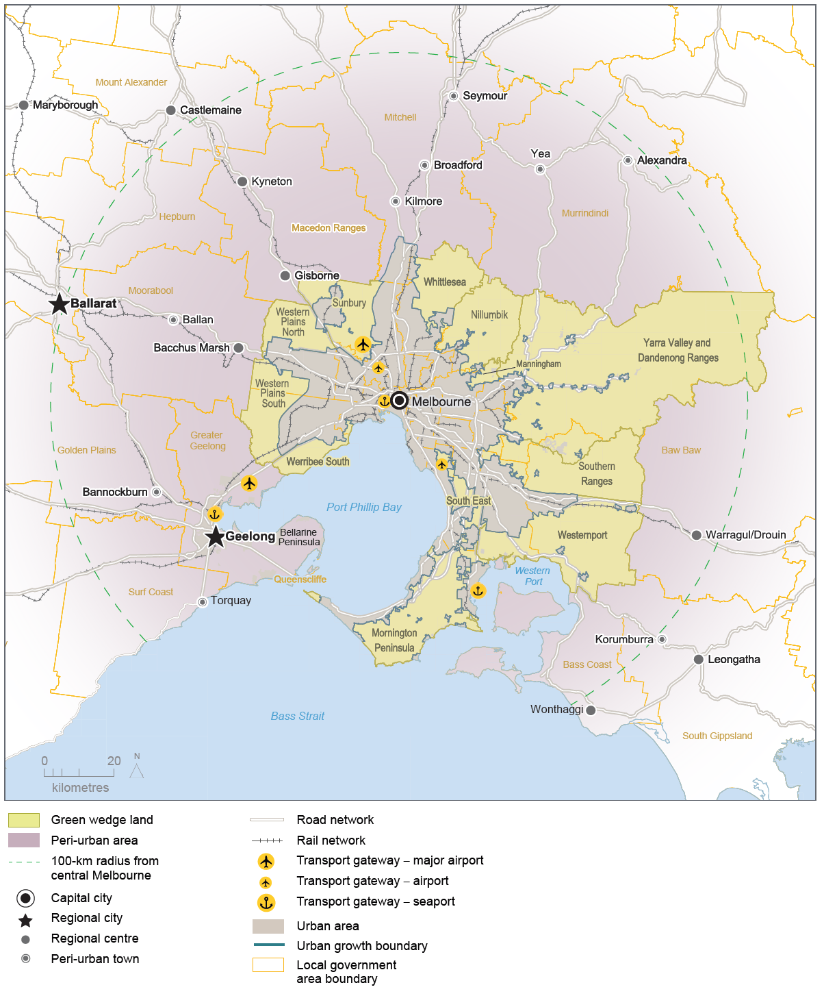
Source: Department of Environment, Land, Water and Planning

Policy 4.5.1 Strengthen protection and management of green wedge land
Planning tools that protect green wedge land include:
- regulations requiring ratification by both Houses of Parliament for planning scheme amendments that alter the urban growth boundary or green wedge subdivision controls
- Core Planning Provisions for Metropolitan Green Wedge Land (Clause 57), which set out prohibited land uses and subdivision provisions
- green wedge zones, which primarily include the Green Wedge Zone, the Green Wedge A Zone and the Rural Conservation Zone
- Green Wedge Management Plans, which are council-adopted strategies that identify a vision, objectives and actions for the sustainable use and development of each green wedge.
The 2013 reform of Victoria’s planning zones broadened the range of uses permitted in green wedges and reduced permit limitations, particularly with respect to the Rural Conservation Zone. There is a need to ensure the planning controls in place for Melbourne’s green wedges are robust and can deliver ongoing environmental, cultural and health and wellbeing benefits to the community, while supporting agricultural businesses and jobs.
Planning controls, however, can only go so far. Green Wedge Management Plans must be in place to support achievement of desired green wedge outcomes. Progress with the development and implementation of plans has been varied across local government areas and several green wedges do not have a plan in place.
Requirements for preparing Green Wedge Management Plans must be strengthened, and measures must be put in place to periodically review and update these plans to ensure they address emerging planning and land management issues.

Policy 4.5.2 Protect and enhance valued attributes of distinctive areas and landscapes
Green wedges and peri-urban areas contain landscapes that have significant geographic and physical features. Localised planning statements have been prepared for distinctive areas such as the Bellarine Peninsula and the Mornington Peninsula. Statements are also being developed for the Yarra Valley and Dandenong Ranges, and the Macedon Ranges. These areas have strong economic bases driven by tourism, recreation, agribusiness and lifestyle—and are close to Melbourne.
Other areas within Melbourne’s green wedges and peri-urban areas are increasingly experiencing pressure for change. This could potentially undermine the long-term natural or non-urban uses of land in these areas and must be carefully managed.
Planning for identified distinctive areas within green wedges and peri-urban areas needs to identify the valued attributes of these areas (as summarised on the following pages) and ensure they are protected and enhanced for ongoing use by present and future generations.
Desired planning outcomes for green wedges and peri-urban areas
Environmental and biodiversity assets
Protect and enhance environmental and biodiversity assets, such as coastal areas, wetlands, rivers and creeks, forests and grasslands. Key features of international and national significance include Ramsar-listed wetlands (Westernport, Edithvale–Seaford wetlands, Port Phillip Bay [Western Shoreline] and Bellarine Peninsula), the Western Grassland Reserve, the UNESCO Mornington Peninsula and Westernport Biosphere Reserve, and a range of national and state parks.
Maintain and enhance the diversity of indigenous flora and fauna habitats and species and achieve a net gain in the quantity and quality of native vegetation.
Landscape and open space
Protect significant views, maintain non-urban breaks between urban areas, and conserve the cultural significance, tourism appeal and character of scenic rural landscapes. Recognised high-value landscape features include open farmed landscapes, sites of geological significance, ranges, hills and ridges and open coastal spaces. Iconic landscapes, such as the Great Ocean Road, Bellarine Peninsula, Macedon Ranges, Western Port, Phillip Island, Mornington Peninsula, the Yarra Valley and the Dandenong Ranges, attract high numbers of local and overseas visitors each year.

Water supply catchments
Manage and protect catchments (including Special Water Supply Catchments), groundwater, water infrastructure and storages, and waterways to improve water quality, protect the environment and provide a reliable and secure water supply.
Minimise any negative impacts from sedimentation or water pollution on the Port Phillip and Western Port coastal ecosystems.
Natural hazards
Avoid development in areas that are subject to high risk from bushfire or flooding and inundation so as to minimise potential risk to life, property and the environment.
Recognise, understand and prepare for the projected impacts of climate change and rising sea levels.
Avoid significant land disturbance, reduce the occurrence and impact of soil erosion and salinity and manage potentially contaminated land.
Agricultural land
Protect agricultural land from incompatible uses, maintain farm size, promote the continuation of farming and provide a secure long-term future for productive and sustainable agriculture. Key agricultural areas include the Mornington Peninsula, the Yarra Valley and Dandenong Ranges, Werribee South, Keilor, Western Port and the Macedon Ranges.
Recreation
Provide land for a range of open space functions to meet community needs for active and passive recreation and for protection of the environment. State and metropolitan parks provide a focus for a range of recreation opportunities and include the Yarra River, Warrandyte, Lysterfield and Dandenong Police Paddocks Reserve, and Churchill and Bunyip national parks.
Tourism
Facilitate sustainable year-round tourism, and new tourism development (including diverse attractions, accommodation and eating establishments) that maintains the integrity of the natural environment, provides social benefits for communities and visitors and contributes to local economies.
Cultural heritage
Provide for the protection and management of sites of Aboriginal and post–European settlement cultural heritage to ensure that links with the past are preserved for present and future generations to appreciate. A wide range of cultural-heritage assets are found in buildings, structures, scattered relics, trees and gardens, landscapes and geological formations, archaeological and fossil sites and areas associated with historical events.
State-significant infrastructure
Protect regionally significant assets such as metropolitan landfills (for example, Clayton South and Wollert), wastewater management facilities (for example Eastern and Western Treatment Plants), industrial areas and related odour and safety buffers (for example, Dandenong South), airports and flightpaths (Melbourne, Avalon and Moorabbin), and ports (Port of Hastings).
Provide opportunities for renewable energy generation.
Mineral, stone and sand resources
Protect designated mineral resource areas such as the coal reserves in central and western Gippsland.
Protect sand and stone resources for future extraction to ensure a continuous supply of construction material.
Economy
Maintain a strong, dynamic economy and employment base by building on the comparative advantages in agriculture, timber, transport, tourism, education, manufacturing, the service industry and commerce.
Population, settlements and local infrastructure
Plan and manage sustainable urban growth that is concentrated in and around major towns within Melbourne’s peri-urban area so as to provide employment, infrastructure, services and community facilities to new and established urban areas in an equitable manner.
Manage the growth and sustainable development of green wedge townships and settlements, having regard for their distinct character and environmental and servicing constraints.
Create socially sustainable communities and support an active community working towards reducing greenhouse gases and responding to climate change.
Protect and enhance the existing character, presentation and form of towns, including their main road entrances.
Rural living
Manage rural living to prevent negative impacts on agriculture, biodiversity and landscape values.
Transport and accessibility
Provide a high-quality road and rail transport network with a range of sustainable, efficient, accessible and affordable transport options that readily connect neighbourhoods, workplaces, community facilities, services and enable people to participate in community life.
Facilitate improvements to transport networks and facilities that support tourism, such as airports.
Planning and governance
Facilitate integrated and balanced forward planning, involving all agencies, and having regard to the needs and aspirations of current and future generations.
Source: Green Wedge Management Plans, Localised Planning Statements and Council Municipal Planning Statements

Direction 4.6 Strengthen community participation in the planning of our city
Planning for places undergoing change can be improved by considering a wide range of viewpoints from existing, as well as future, communities (such as the people that would like to live in these places at some time in the future). Community participation and engagement can strengthen community resilience, increase knowledge and understanding of change, and empower local groups to be part of shaping the city’s future.
For instance, the acknowledgement and respect of Aboriginal culture, values and practices is at the heart of successful engagement with Aboriginal people—and helps counter racism and ignorance. The contribution of Aboriginal values and perspectives needs to be embedded in the planning of Melbourne’s built and natural environments through ongoing partnerships with Traditional Owners, local communities and others involved with planning, design and natural resource management.
Melburnians deserve a system offering mature participation in planning decision-making. For that to occur, planning processes must be improved, streamlined and made more inclusive. Metropolitan Partnerships will also provide the community and local businesses with opportunities to identify planning priorities in their local area.

Policy 4.6.1 Create diverse opportunities for communities to participate in planning
Putting communities at the centre of shaping plans can be achieved through deliberative community engagement. Public participation processes should be designed and implemented in partnership with communities, consistent with community engagement principles.
The design of community engagement processes for new communities will support a shift in emphasis to public involvement in setting the principles for land use and development. This will be complemented by an expedited process for development proposals consistent with these principles.
The Victorian Government supports improved community engagement processes through the application of principles such as the International Association for Public Participation’s Public Participation Spectrum, the Public Participation in Government Decision-Making—Better Practice Guide prepared by the Victorian Auditor-General’s Office and the Victorian Government Aboriginal Inclusion Framework.

Outcome 5

MELBOURNE IS A CITY OF INCLUSIVE, VIBRANT AND HEALTHY NEIGHBOURHOODS
Melbourne has always been a city of neighbourhoods ever since the days of Little Lon and the establishment of the city’s first suburb, Fitzroy.
Neighbourhoods have varied in size and character and socio-demographic composition and have changed from generation to generation. They represent the most appropriate scale and basic building blocks for social sustainability, as shown in Figure 11.
Ultimately, people create the character of a neighbourhood. Where planning comes into the picture is to ensure that the fundamentals of a strong and sustainable neighbourhood—from shops to schools to parks to local facilities to local jobs—are all in place and easily accessible by walking and cycling paths or public transport. Strong and sustainable communities enjoy good access to local services, jobs, amenities and social infrastructure, a rich social and cultural life, voice and influence, and room to grow.
Figure 11 Building blocks for social sustainability
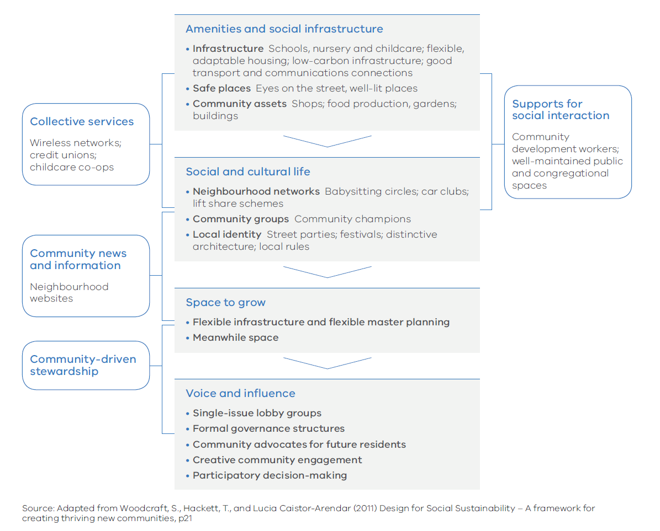

Melbourne’s Plan

Direction 5.1 Create a city of 20-minute neighbourhoods
Research undertaken by the Heart Foundation (Victoria) for the Victorian Government identifies hallmarks of a 20-minute neighbourhood.
A 20-minute neighbourhood must:
- be safe, accessible and well connected for pedestrians and cyclists to optimise active transport
- offer high-quality public realm and open space
- provide services and destinations that support local living
- facilitate access to quality public transport that connects people to jobs and higher-order services
- deliver housing/population at densities that make local services and transport viable
- facilitate thriving local economies.
The 20-minute neighbourhood is all about ‘living locally’—giving people the ability to meet most of their everyday needs within a 20-minute walk, cycle or local public transport trip of their home. If 20-minute neighbourhoods existed across Melbourne, it could reduce travel by nine million passenger kilometres and cut Melbourne’s daily greenhouse gas emissions by more than 370,000 tonnes.
Neighbourhood activity centres are an integral part of the city’s vibrant community life and critical to the creation of 20-minute neighbourhoods. These high streets and specialised strips of shops, cafes, small supermarkets, service businesses, community services and public spaces serve the needs of the surrounding community and provide a focus not only for local jobs but also for social interaction and community participation.
A 20-minute neighbourhood can create a more cohesive and inclusive community with a vibrant local economy—reducing social exclusion, improving health and wellbeing, promoting a sense of place, reducing travel costs and traffic congestion, and reducing carbon emissions across the city as a whole.
Due to the specialised and diverse nature of many people’s work, access to employment will often be outside the 20-minute neighbourhood.

Figure 12 The 20-minute neighbourhood
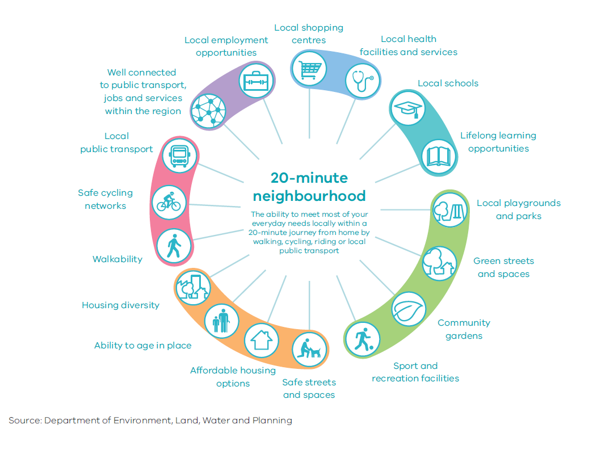

Policy 5.1.1 Create mixed-use neighbourhoods at varying densities
Neighbourhoods need to offer more choice in housing so they can accommodate a more diverse population, create opportunities for local businesses and new jobs, and deliver better access to local services and facilities.
Local government is best placed to understand and apply local solutions. The Victorian Government has a role in providing a supporting framework, including overarching strategies (such as for housing needs and metropolitan open space), to enable local government to better deliver local solutions for all residents.
The application of zones, such as the Residential Growth Zone and the Mixed Use Zone, can facilitate diverse housing and a greater mix of uses at varying densities.

Policy 5.1.2 Support a network of vibrant neighbourhood activity centres
The attributes of and opportunities for neighbourhood activity centres at the local level vary across Melbourne. That is why local communities should lead the planning of their own centres.
Where centres are well established or communities are seeking to protect the unique character of their centres (such as protecting heritage buildings or access to public land or open space to achieve community benefit), they should be assisted in determining the desired built form outcomes.
Local governments will be supported to prepare structure plans for their neighbourhood activity centres to help deliver 20-minute neighbourhoods.

Direction 5.2 Create neighbourhoods that support safe communities and healthy lifestyles
Increasingly, councils are taking a whole-of-population approach to health planning, particularly through municipal public health and wellbeing plans.
Likewise, many councils are focusing on factors that create the conditions for good health, ranging from the re-design of local neighbourhood parks and streets through to the development of new neighbourhoods and town centres. These include applying Crime Prevention Through Environmental Design (CPTED) principles in the design of public spaces.
Urban renewal precincts, greyfield redevelopment areas and transit-oriented development areas (such as railway stations) are enablers in the development of an integrated transport system. Well-designed infrastructure for walking and cycling are critical elements.
The Victorian Government will work with local governments and other stakeholders to create neighbourhoods that support safe and healthy communities.
Policy 5.2.1 Improve neighbourhoods to enable walking and cycling as a part of daily life
Internationally, New York City’s Active Design Guidelines and the World Health Organization’s Age Friendly Cities guide reflect the movement towards embedding health and wellbeing principles in urban design.
The National Heart Foundation has also developed tools to help local governments plan for better health and community wellbeing across a range of local government policy areas, including the Healthy by Design guidelines.
These guidelines encourage walking and cycling through good footpaths and connectivity, opportunities for physical activity, neighbourhood amenity, sustainability, accessibility, transport and community safety.
Principles for promoting cycling and walking should be embedded in precinct planning guidelines for new suburbs, urban renewal precincts, greyfield redevelopment areas and transit-oriented development areas (such as railway stations). The ultimate aim must be to promote cycling and walking. These guidelines need to inform the design of new neighbourhoods and the assessment of planning applications.

Direction 5.3 Deliver social infrastructure to support strong communities
It takes more than good land-use and transport planning to build good neighbourhoods. The economic and social benefits of providing social infrastructure can outweigh the costs of provision and result in a positive net return on investment. Social infrastructure encompasses all the facilities, services and networks that help families, groups and communities to meet their social, health, education, cultural and community needs. Space and resources are also needed for community meeting places, learning centres, neighbourhood houses, volunteer centres and welfare providers.
Social infrastructure should be designed to be accessible to all members of the community and, in growth areas, must be delivered early. Both the public and private sectors have key roles to play in this, as well as in the operation and maintenance of community facilities. In some cases there may be opportunities to make the most of existing public facilities, such as using school buildings outside school hours and co-locating aged-care and childcare centres.
Early provision of active open space and sports fields in neighbourhoods supports healthy communities. Some recreational and cultural facilities need to be provided in locations that service multiple neighbourhoods to optimise the value of investment and maximise accessibility to communities.
Many social services are delivered by not-for-profit organisations, which can find it hard to secure affordable floor spaces in new suburbs.
Cemeteries and crematoria need to be provided in sensitively chosen locations. It is important to cater for all faiths when planning for cemeteries and crematoria. The requirement for additional burial spaces needs to be reviewed on a regular basis.

Policy 5.3.1 Facilitate a whole-of-government approach to the delivery of social infrastructure
Delays in the delivery of social infrastructure can undermine the ability of a new neighbourhood to form strong social networks—entrenching car-dependent travel patterns that make the 20-minute neighbourhood unachievable.
Growth areas require the facilities and services that bring communities together—schools, kindergartens, early years centres, parks and playgrounds—early in the development process and in the right locations.
Initially, temporary spaces or buildings can be used for community service delivery, including developer display homes or demountables, pop-up parks (as in central Dandenong) and outreach service facilities. Local government could work with developers so that neighbourhood-based community liaison staff can operate out of temporary facilities.
Future school development needs to be linked with local sports infrastructure to maximise the use and the benefits gained from co-location.
Within established areas, better use of existing community infrastructure is required—such as the conversion of former town halls to libraries and other community uses. Community places and buildings must be planned and designed so that they can adapt as the population changes. Gaps or capacity issues in the provision of sporting facilities need to be addressed and integrated with planning for open space.

Policy 5.3.2 Create health and education precincts to support neighbourhoods
All neighbourhoods need good access to local and regional health services, primary and secondary schools, as well as tertiary education institutions within their metropolitan region. Major regional services and facilities must be provided in locations that are accessible to all members of the community, including those with disabilities.
In Victoria, almost 70 per cent of health services are provided by the private sector. The delivery of health and education precincts allows for more tailored planning of community services—including private services—at a local level.
Neighbourhood health and community wellbeing precincts will be supported where health and community wellbeing services—such as general practitioners, allied-health services, community health facilities and not-for-profit health providers—are co-located with good public transport access and are close to community infrastructure.
Communities also need access to regional health and community wellbeing precincts. That is why hospitals, allied-health services and not-for-profit health providers must be co-located within larger precincts well serviced by public transport and other community services.
To achieve these outcomes, the Precinct Structure Planning guidelines will be amended to include planning for health precincts located in or close to town centres in new suburbs.

Policy 5.3.3 Support not-for-profit community services to build social capital and stronger communities
Key community services are often delivered by not-for-profit community organisations. These organisations offer services and support, build social capital and strong communities, and create education and local work opportunities. The work of not-for-profit organisations provides many long-term benefits, such as reducing the future costs of disadvantage and poor health.
Not-for-profit organisations will be supported to operate in both established and growing neighbourhoods. This will be achieved by facilitating access to affordable space, by reducing project costs, and ensuring that the planning system supports the establishment of services and delivery of integrated responses with other service providers.

Policy 5.3.4 Provide and protect land for cemeteries and crematoria
Across Victoria, demand for new cemeteries and crematoria is increasing as existing facilities reach capacity. The Department of Health and Human Services has found that some local government areas no longer have capacity for burials, and others are expected to exhaust capacity before 2035. Suitable sites for future cemeteries and crematoria will be identified across Melbourne, particularly in growth areas, outer-metropolitan and regional areas. Planning provisions that protect and maintain the new sites will be put in place.

Direction 5.4 Deliver local parks and green neighbourhoods in collaboration with communities
Greening Melbourne’s neighbourhoods enhances beauty and amenity and provides more places where people can meet, exercise and relax. They give city dwellers a chance to enjoy natural environments, support biodiversity, and improve the quality of air, water and soil.
Residents should be included in community landscaping and revegetation opportunities such as community gardens, vegetable patches, play areas for children and greening streetscapes with tree planting and nature strip gardens. Communities can also convert disused public land into parkland to green their neighbourhoods and increase public open space.

Policy 5.4.1 Develop a network of accessible, high-quality, local open spaces
Open space provision must be fair and equitable with the aim of providing access that meets the needs of all members of the community, regardless of age, gender, ability or a person’s location. Urban redevelopment projects will provide opportunities to plan for new local open space. In some areas, practical solutions (such as using school grounds out of school hours) will add to the availability of open space and sport and recreation facilities. Similarly, schools will be supported to utilise existing public open space if their grounds are limited.

Policy 5.4.2 Support community gardens and productive streetscapes
Melbourne has more than 50 community gardens, with more planned. Establishing more community gardens will give Melburnians opportunities to share skills and learn from their neighbours’ food-growing knowledge, increase social interaction and community partnerships, produce local food for personal consumption or sale at local farmers’ markets, and promote healthy eating.
Another way to enhance the food production capability of the city is to plant productive trees along streets and in parklands. Planting trees that produce fruit and nuts freely available for anyone to pick and eat extends the concept of using public land to produce public food. However, care will be required to select appropriate locations within the public realm where factors such as biosecurity risk and public safety from effects such as pesticide sprays can be addressed.

Outcome 6

MELBOURNE IS A SUSTAINABLE AND RESILIENT CITY
This generation of Victorians has a responsibility to protect the state’s natural environment for future generations.
Victoria's social, economic and environmental sustainability depends on the protection and conservation of Melbourne and the state’s biodiverse natural assets, or natural capital.
Natural capital includes geology, soil, air, water and all living things—and Melbourne depends on it to function. Examples of public benefits derived from healthy ecosystems include clean air and water, food, productive soils, natural pest control, pollination, flood mitigation, carbon sequestration and waste decomposition. These benefits are commonly referred to as ecosystem services.
Melbourne’s natural environment is also deeply valued and enjoyed by many people for recreation, cultural and spiritual reasons, and for the health and wellbeing benefits that come from being connected with nature. For thousands of years, generations of Aboriginal Victorians have relied on nature for their survival, prosperity and culture.
The city’s growth, in combination with climate change, is testing the resilience of Melbourne’s natural and built environment, causing habitat loss and biodiversity decline, higher urban temperatures, reduced rainfall, more frequent and extreme weather events, increased consumption of resources and more waste and pollution.
By 2050, Melbourne will need to be a more sustainable and resilient city that manages its land, biodiversity, water, energy and waste resources in a much more integrated way. To respond to the challenge of climate change and ensure Melbourne becomes more sustainable as it grows, a green economy needs to emerge—built around renewable energy, environmentally sustainable development and resource recovery.

Melbourne’s Plan

Direction 6.1 Transition to a low-carbon city to enable Victoria to achieve its target of net zero greenhouse gas emissions by 2050
It is widely acknowledged internationally that major industrialised countries need to reduce carbon emissions substantially by mid-century to keep global temperature increases within two degrees Celsius. This is why Victoria has committed to reduce its greenhouse gas emissions to net zero emissions by 2050. Figure 13 shows the main sources of Victoria’s greenhouse gas emissions.
To transition to a low-carbon city, Melbourne must reduce energy demand, improve energy efficiency and increase the share of renewable energy. Victoria has set a target of deriving 25 per cent of electricity generated by renewable sources by 2020—with that figure to increase to 40 per cent by 2025. Melbourne has the knowledge, skills and technologies to meet its building energy needs in a sustainable way, using a range of renewable energy resources such as solar photovoltaic systems, solar hot water, geothermal and biogas. At a local level, greenhouse gas emissions from energy consumption can be reduced through precinct-scale initiatives that combine renewable energy and energy efficiency solutions.
To encourage a wider application of distributed energy technologies, Plan Melbourne will embed renewable energy and energy efficiency considerations in the land-use planning system and precinct structure planning process.

Figure 13 Victoria's greenhouse gas emissions (2014)
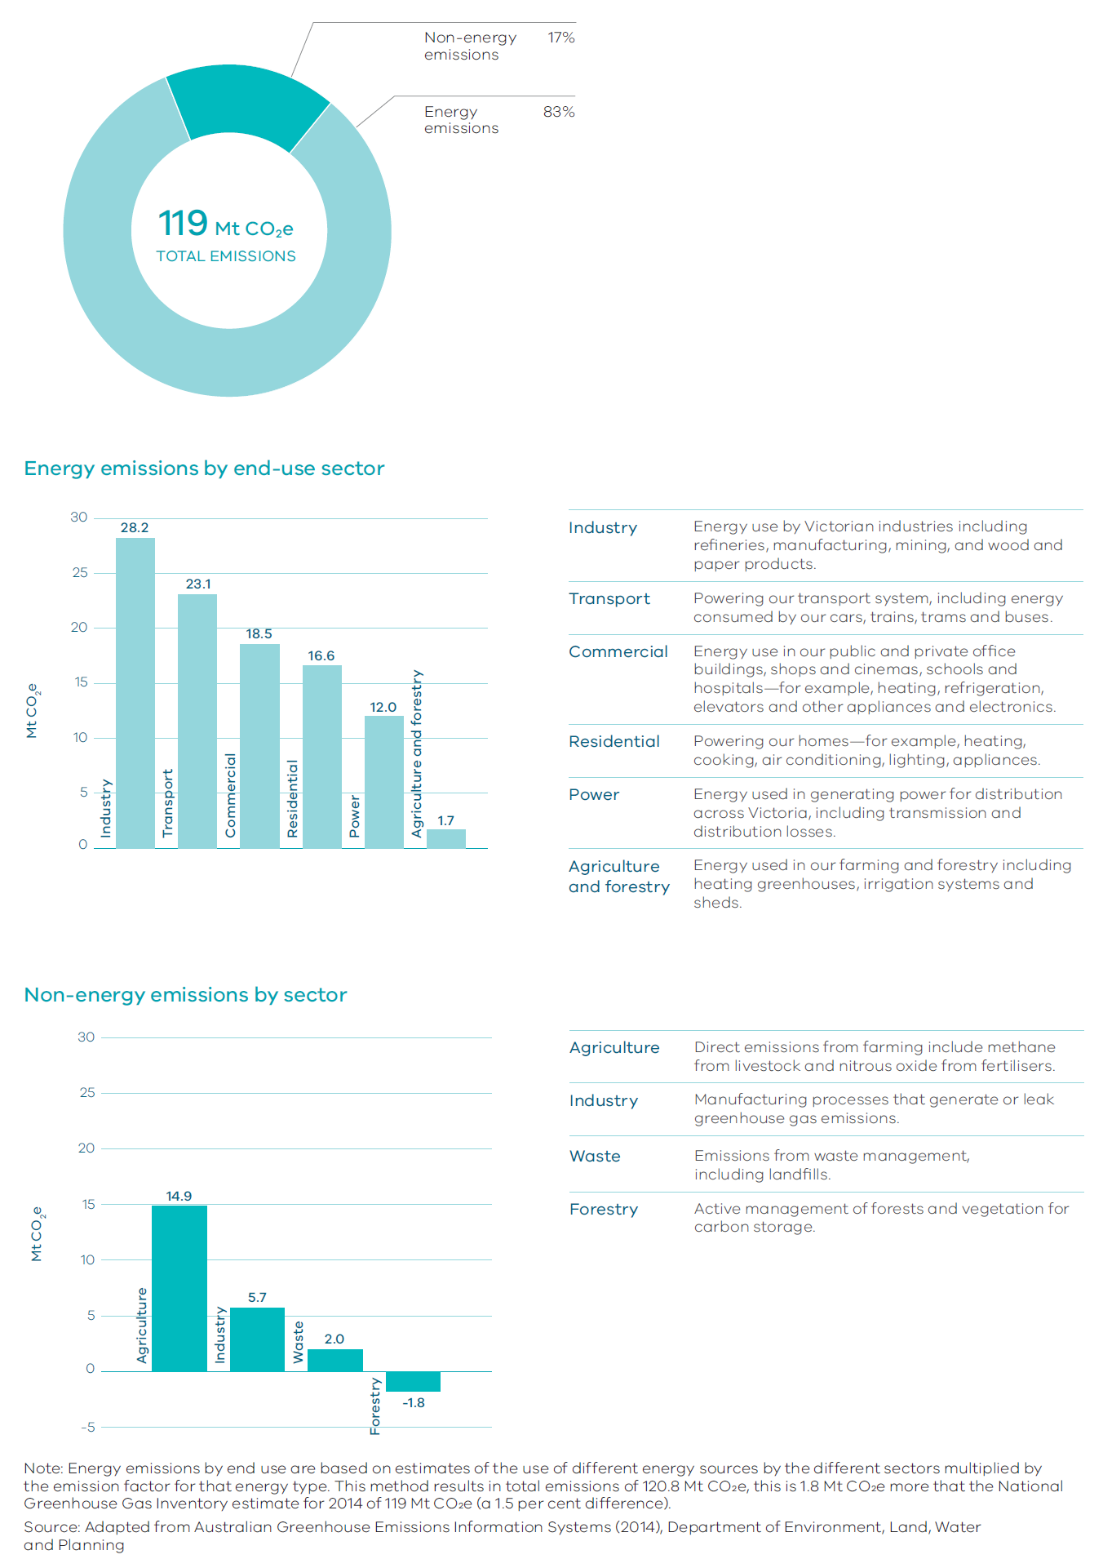

Policy 6.1.1 Improve energy, water and waste performance of buildings through environmentally sustainable development and energy efficiency upgrades
Energy use in buildings accounts for around a quarter of Australia’s greenhouse gas emissions. On Australia’s hottest days, air conditioners consume approximately 20 per cent of all electricity generated.
Environmentally sustainable development, including energy efficiency and renewable energy, can help deliver cost-effective environmental outcomes and major emissions reductions, improve health and comfort, and support a lower cost of living. Passive design measures—such as building orientation, layout, window design, thermal mass, shading and ventilation—can significantly reduce the need for active heating and cooling. Other measures that can be adopted to improve the environmental performance of new and existing buildings involve a mix of lighting, appliance and, in some cases, building shell upgrades. Figure 14 shows some of the measures that can be implemented to make a house more sustainable and efficient.
Many local councils are already incorporating environmentally sustainable development considerations into their planning processes. However, there is a need for a statewide approach to achieve greater consistency and simplicity.
Options to strengthen planning and building frameworks will be reviewed to determine the most cost-effective approach for lifting the efficiency of both new and existing building stock and requiring early consideration of sustainability in the planning, design and building process.

Figure 14 Resource efficient house
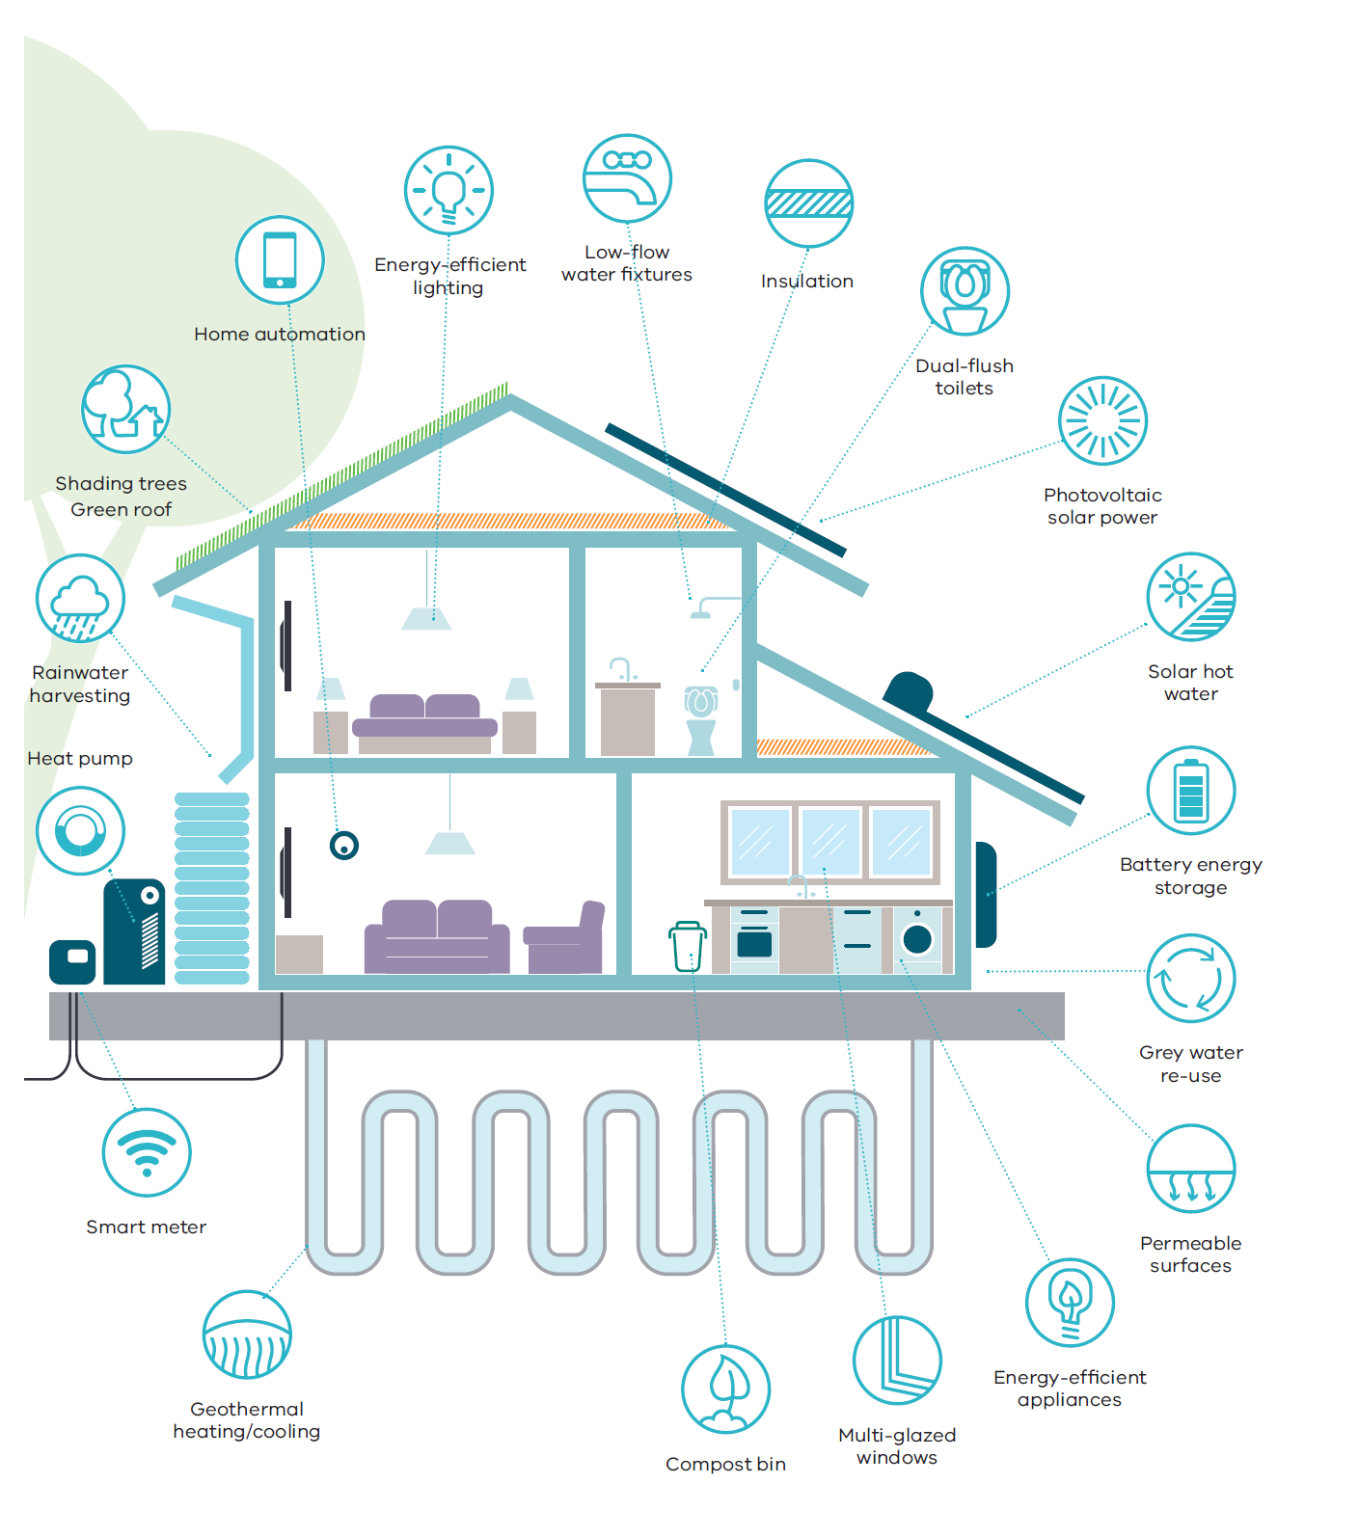
Source: Department of Environment, Land, Water and Planning

Policy 6.1.2 Facilitate the uptake of renewable energy technologies
Developing local energy solutions is important for addressing climate change, supporting job creation and economic development, reducing consumers’ energy bills and reducing reliance on the grid.
Falling technology costs and easier installation processes, particularly for solar photovoltaic systems, have helped facilitate growth in renewable energy. Rapid advances in battery storage technology will also accelerate the uptake of distributed energy generation.
The renewable energy industry will continue to create opportunities for individual households, neighbourhoods, cities and the state as a whole over the next 40 years.
To support the government’s targets for renewable energy generation, planning policy and controls will be strengthened to remove barriers and increase the uptake of renewable energy on a site-by-site and neighbourhood level. This will include giving consideration to renewable energy opportunities during the master planning of new communities and investigating opportunities for renewable energy initiatives in Melbourne’s green wedges and peri-urban areas.

Direction 6.2 Reduce the likelihood and consequences of natural hazard events and adapt to climate change
There is a need to ensure that people, the environment and the city’s infrastructure are all prepared for the impacts of climate change. By working together, Melbourne can build its resilience to acute shocks and stressors, ensuring capacity of communities and the systems and structures that support them to adapt and grow.
As Melbourne develops and populations increase, there is a risk that more people are likely to be exposed to natural hazards. Map 20 shows areas subject to key natural hazards.
Land-use planning and building provisions play a key role in reducing a community’s level of exposure to a natural hazard by influencing where and how development occurs.
New development should be located away from extreme risks. Where risk is unavoidable, such as in existing settlements, land-use planning should reduce risk and ensure planning controls do not prevent risk-mitigation or risk-adaptation strategies from being implemented.
The approach set out in Plan Melbourne runs parallel with actions developed as part of Victoria’s second climate change adaptation plan and builds on the work of local government and emergency management agencies to build safer and more resilient communities.
Map 20 Natural hazards
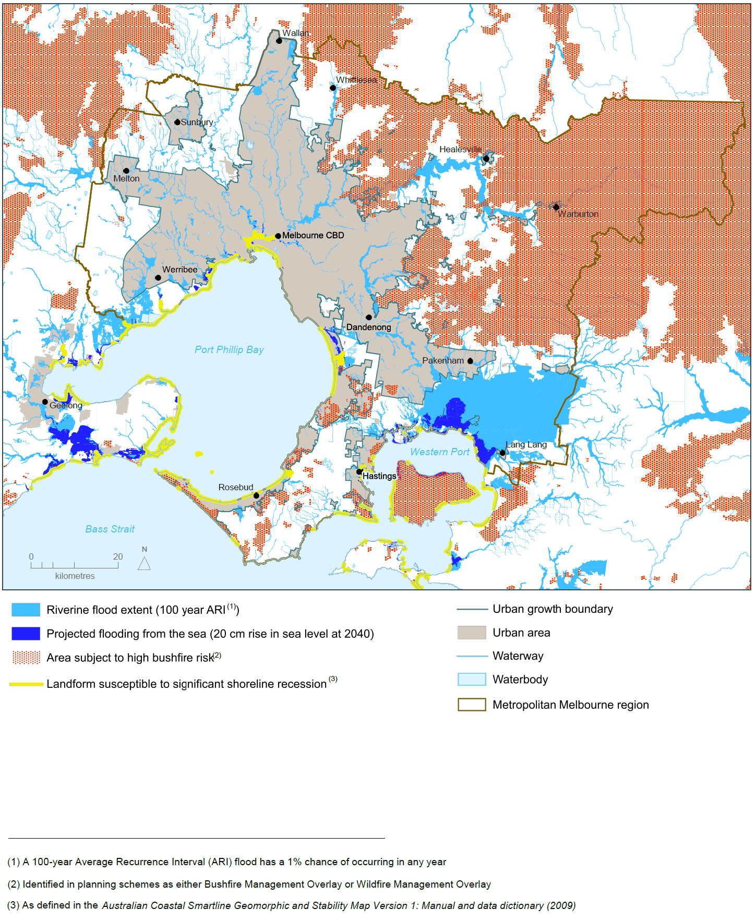
Source: Department of Environment, Land, Water and Planning

Policy 6.2.1 Mitigate exposure to natural hazards and adapt to the impacts of climate change
Following recent natural disasters there has been an increased focus on improving community resilience to natural hazards. Key approaches that have underpinned Victoria’s reforms include:
- building community resilience to deal with major shocks.
- adopting an all-communities, all-emergencies approach that recognises that communities are at the centre of decision-making.
- applying risk-assessment decision-making frameworks based on agreed methodologies to inform appropriate risk-mitigation measures.
- increasing strategic effort in planning for a disaster—thereby maximising risk avoidance and reduction.
Addressing risk mitigation through land-use planning is a key action in the Victoria Emergency Management Strategic Action Plan 2015–2018 and has been identified as a priority by the State Crisis and Resilience Council.
Although planning schemes already contain a range of responses to risks associated with most natural hazards, more can be done to improve community safety.
Strategic land-use planning to manage future growth must be strengthened and integrated with emergency management decision-making to reduce the likelihood, effect and consequences of natural hazards. At-risk areas will be identified using the best available climate change science and planning and building provisions will be updated to respond to those risks.

Policy 6.2.2 Require climate change risks to be considered in infrastructure planning
Major infrastructure projects must be sited, designed and constructed so that they can withstand a range of major shocks and help reduce the state’s carbon footprint.
The Victorian Government has amended the Emergency Management Act 2013 to help build the resilience of Victorian critical infrastructure. Supporting this change is the Critical Infrastructure Resilience Strategy. At a local level, many councils are integrating climate change considerations into their decision-making processes.
Strong supporting policy within the planning system will strengthen consideration of natural hazard risks on infrastructure.

Direction 6.3 Integrate urban development and water cycle management to support a resilient and liveable city
Plan Melbourne supports the implementation of Victoria’s water plan—Water for Victoria—by protecting water assets and influencing how development occurs across new and established urban areas.
Planning controls will be updated to require consideration of the whole water cycle early in the planning and design of new urban areas to improve the water performance of new buildings and precincts.
By considering the whole water cycle when planning for urban areas, we can improve wastewater management and recycling, support urban greening and cooling, protect waterways, minimise the impact of flooding and improve water security.

Policy 6.3.1 Reduce pressure on water supplies by making the best use of all water sources
Climate change will affect water security through reduced rainfall, increased evaporation, increased flood risk and increased risk of bushfires in forested water catchments.
The Victorian Desalination Project provides a rainfall-independent water source to supplement Melbourne’s drinking-water supply.
Greater resilience and adaptability in water supplies can also be provided through improved demand management and a more diverse supply of water.
Figure 15 shows the water supply mix in 2015, as well as the potential need for a more diverse mix of supply options in 2050 to meet projected water demand under different catchment inflow scenarios. It highlights the need to create climate-resilient sources of water.
Plan Melbourne supports the use of all water sources, including stormwater, rainwater and recycled water, to ensure the city remains liveable and sustainable and to reduce reliance on drinking-water supplies. This approach has a range of benefits—such as improving waterway health, reducing flood risk, effective management of wastewater, sustaining agricultural areas and supporting cooler and greener urban landscapes.
Planning provisions and the precinct structure planning process can be strengthened to promote innovative and cost-effective approaches to urban water cycle management that support better use of all water sources at the household scale as well as precinct-wide solutions.

Figure 15 Water supply scenarios to 2050
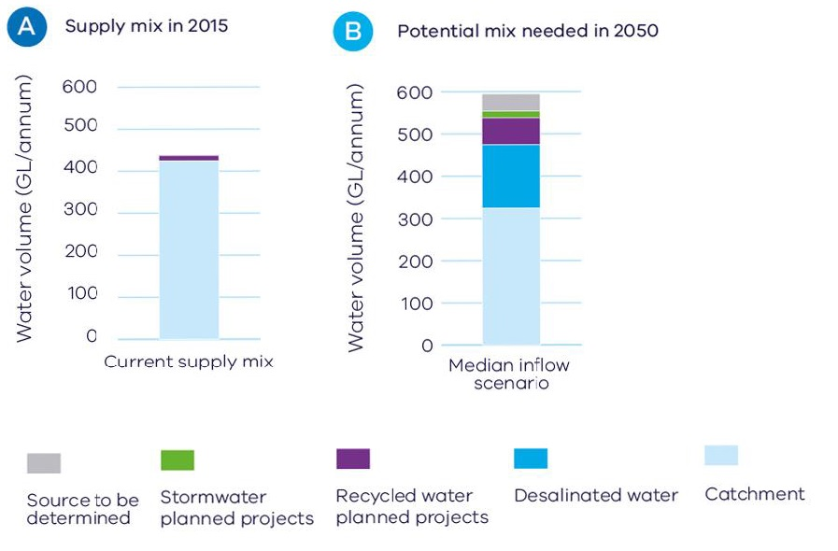
Source: Adapted from Water for Victoria

Policy 6.3.2 Improve alignment between urban water management and planning by adopting an integrated water management approach
Aligning water planning and land-use planning is fundamental to managing flood risk, protecting our waterways and efficiently sequencing water, sewerage and drainage infrastructure. Integrated water management forums will identify and prioritise places that would most benefit from the development of a place-based integrated water management plan. In metropolitan Melbourne, these forums will be based on five waterway catchments.
Melbourne needs to change the way urban areas are designed, built and maintained by applying integrated water management planning in all development. The earlier integrated water management is considered in urban planning, the better the outcomes for the environment and communities.

Policy 6.3.3 Protect water, drainage and sewerage assets
Parts of Melbourne’s drinking-water catchments and storages, such as the Mid-Yarra Catchment system and the Silvan and Cardinia reservoirs, are vulnerable to pollution and public health risks due to changes in land use and development.
Significant metropolitan water, drainage and sewerage infrastructure assets, including sewerage treatment plants, are under pressure from encroaching sensitive and incompatible land uses, including urban encroachment.
Land area buffers around these assets need to be appropriately managed to ensure these assets are protected from urban encroachment.

Direction 6.4 Make Melbourne cooler and greener
The urban heat-island effect is created by the built environment absorbing, trapping and, in some cases, directly emitting heat. This effect can cause urban areas to be up to four degrees Celsius hotter than surrounding non-urban areas. Figure 16 shows the urban heat-island profile of Melbourne.
Within the City of Melbourne alone, the urban heat-island effect is projected to result in health costs of $280 million by 2051.
Urban intensification will add to the urban heat-island effect unless offsetting measures are implemented. Greening the city can provide cooling benefits and increase the community’s resilience to extreme heat events. Temperature decreases of between one degree Celsius and two degrees Celsius can have a significant impact on reducing heat-related morbidity and mortality. Figure 17 summarises the wide range of benefits provided by urban greening.
To mitigate the impacts of increased average temperatures, Melbourne needs to maintain and enhance its urban forest of trees and vegetation on properties, lining transport corridors, on public lands, and on roofs, facades and walls. Other methods of cooling the city include the use of special heat-reflective coatings for dark building surfaces to reduce the amount of heat absorbed.
Figure 16 Urban heat-island profile of Melbourne
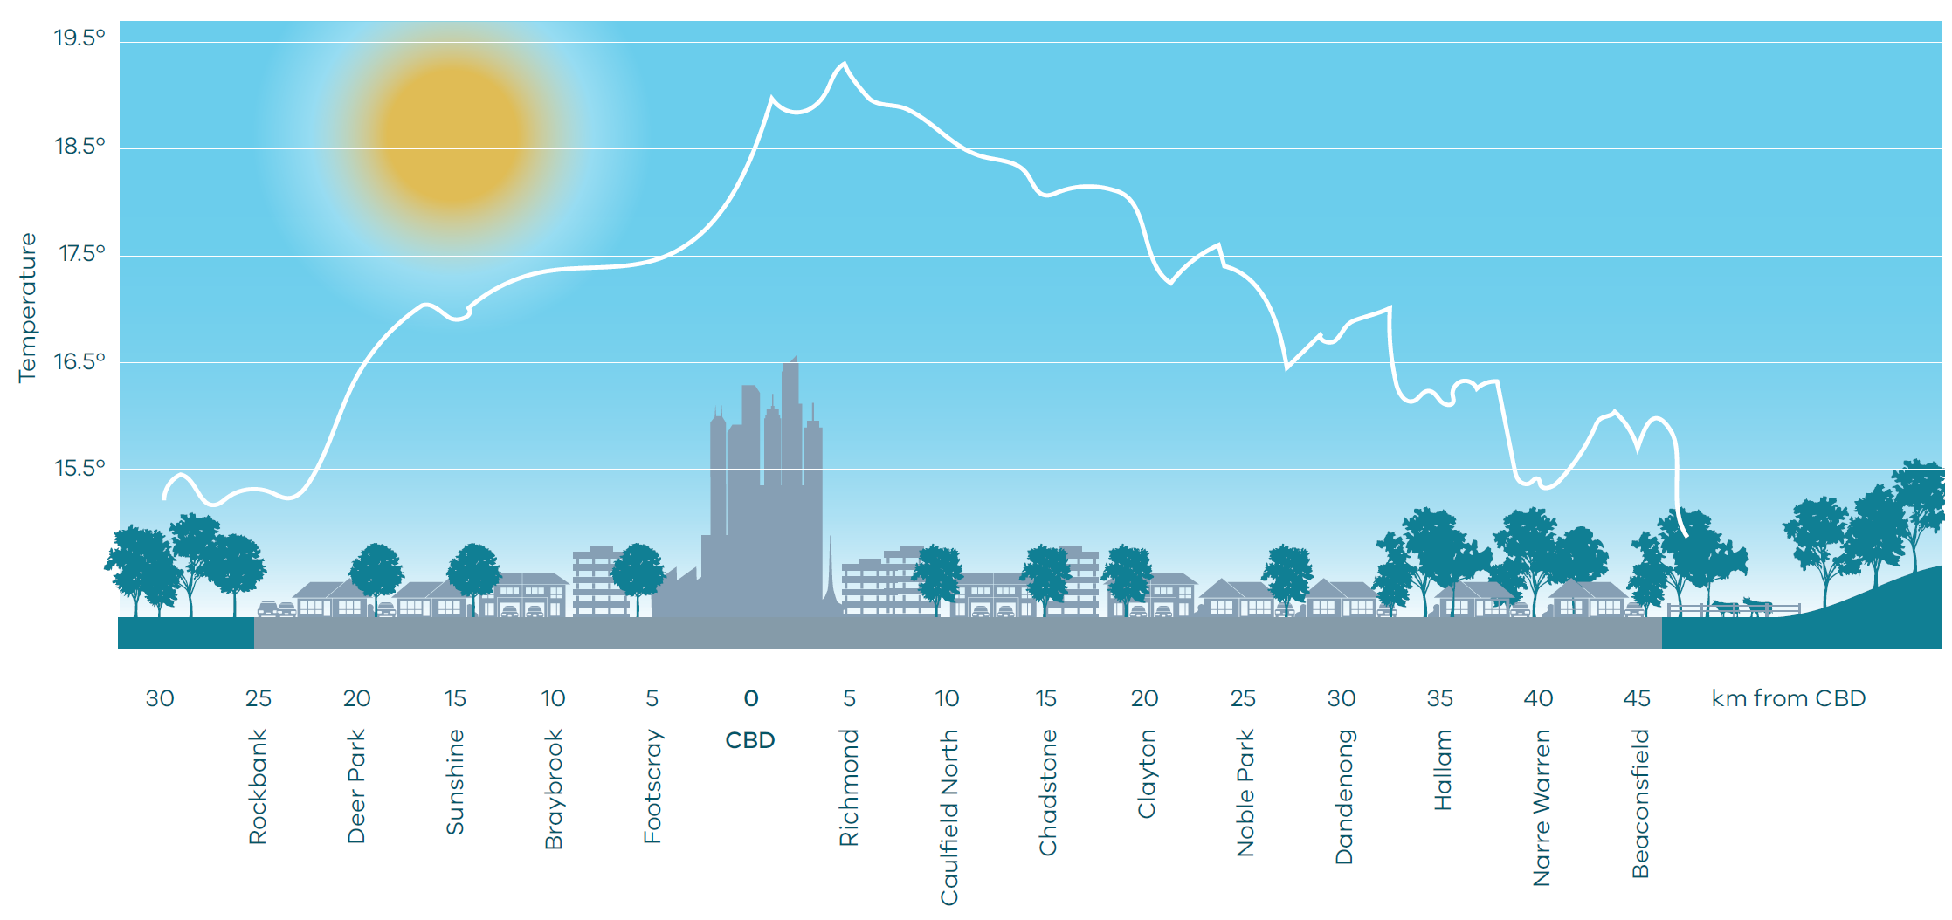
Source: Adapted from ‘Changing Urban Climate and CO₂ Emissions: Implications for the Development of Policies for Sustainable Cities’
Figure 17 Benefits of urban greening
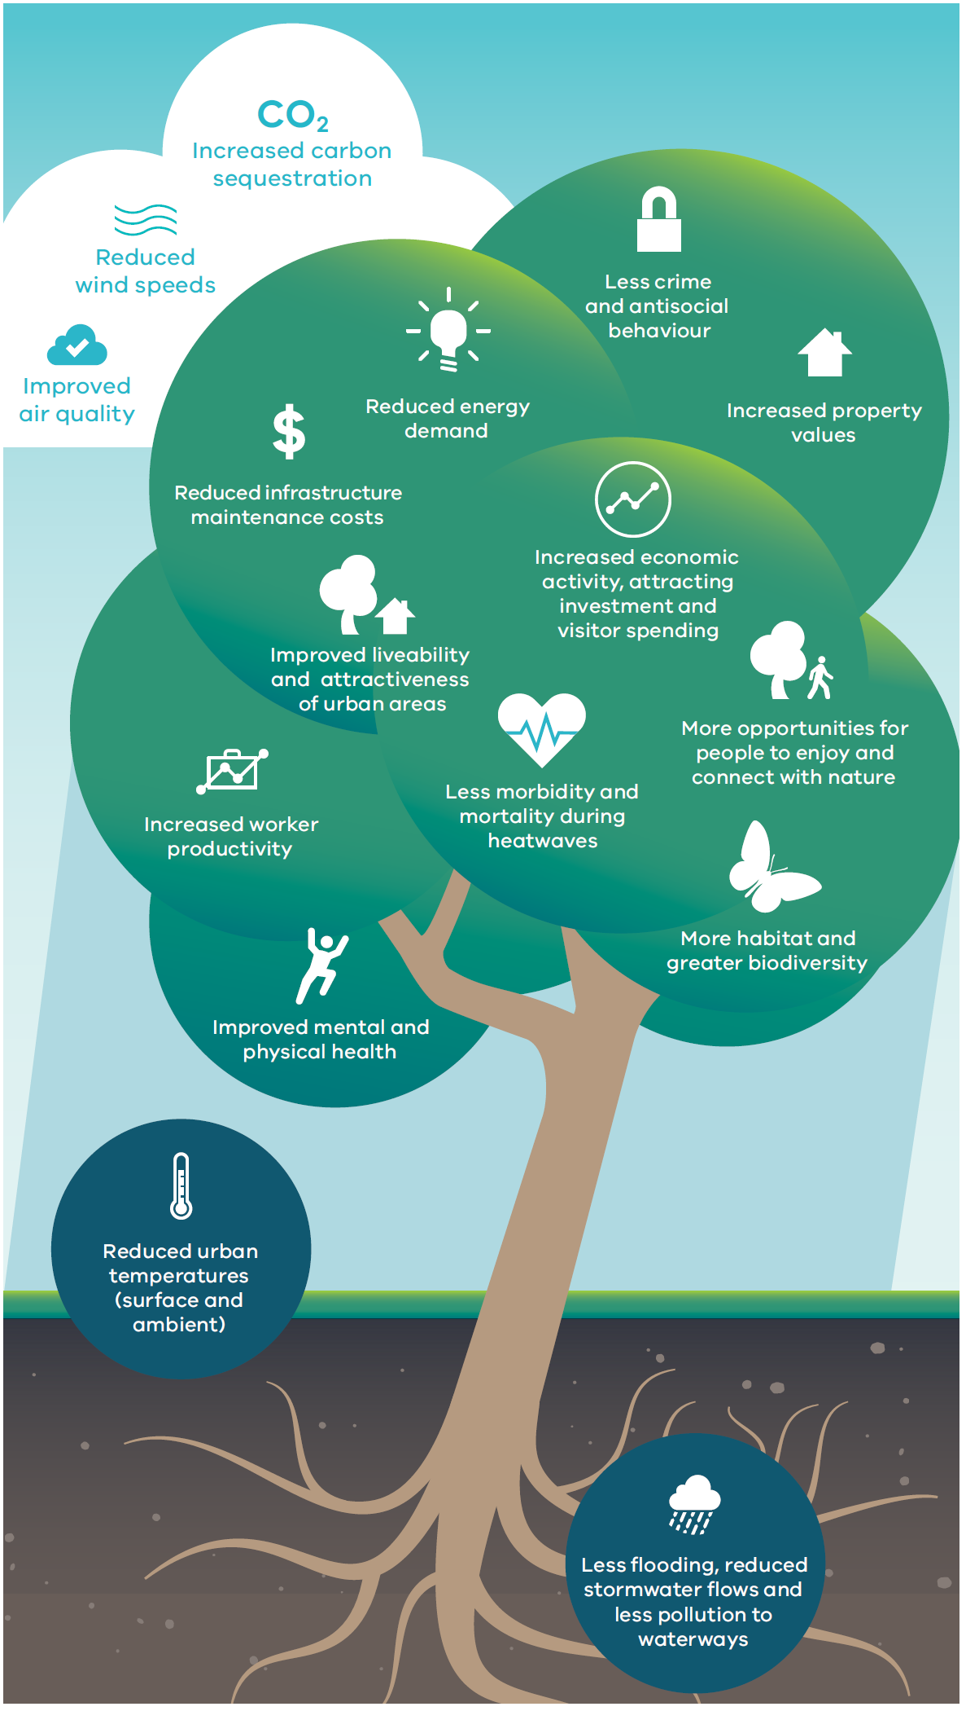
Source: Department of Environment, Land, Water and Planning

Policy 6.4.1 Support a cooler Melbourne by greening urban areas, buildings, transport corridors and open spaces to create an urban forest
A number of local councils are already promoting urban greening through actions such as developing urban forest strategies.
Greening must be integrated into planning frameworks and balanced with safety risk priorities. Too often, trees and greening are an afterthought in the planning and design of urban areas. In some cases, such as along transport corridors, concerns about the safety risks presented by trees can result in tree pruning and removal or the limitation of new plantings. In other cases, such as in established areas, tree canopy is lost through the process of replacing single dwellings and multi-dwelling redevelopment.
Residential development provisions must be updated to mitigate against the loss of tree canopy cover and permeable surfaces as a result of urban intensification.
The city must establish and maintain canopy trees along transport corridors, green buildings (roofs, facades and walls) and plant up open spaces—including parks, waterway corridors, school grounds and utility easements—together with the provision of a public open space network across Melbourne.
The drought from 1995 to 2009 (the Millennium Drought) highlighted the importance of water in providing a liveable, cooler, greener city. Adopting water-sensitive urban design will maximise alternative water use in vegetated areas and support the growth of healthy trees and vegetation.

Policy 6.4.2 Strengthen the integrated metropolitan open space network
Better planning, design and use of new and existing public open space is critical. Developing innovative approaches to access and making use of other types of public land, such as waterways, school grounds and utility easements, are also important parts of delivering an integrated open space network that responds to Melbourne’s projected population growth.
Open space provision must also be fair and equitable with the aim of providing access that meets the needs of all members of the community, regardless of age, gender, ability or a person’s location.
In Melbourne’s growth areas, new metropolitan parks will be delivered. Opportunities for additions to existing parks have also been identified through planning schemes.
A new metropolitan open space strategy will be developed to ensure Melbourne’s growing population is provided with, and has access to, quality open space. Map 21 shows Melbourne’s open space network.

Map 21 Open space
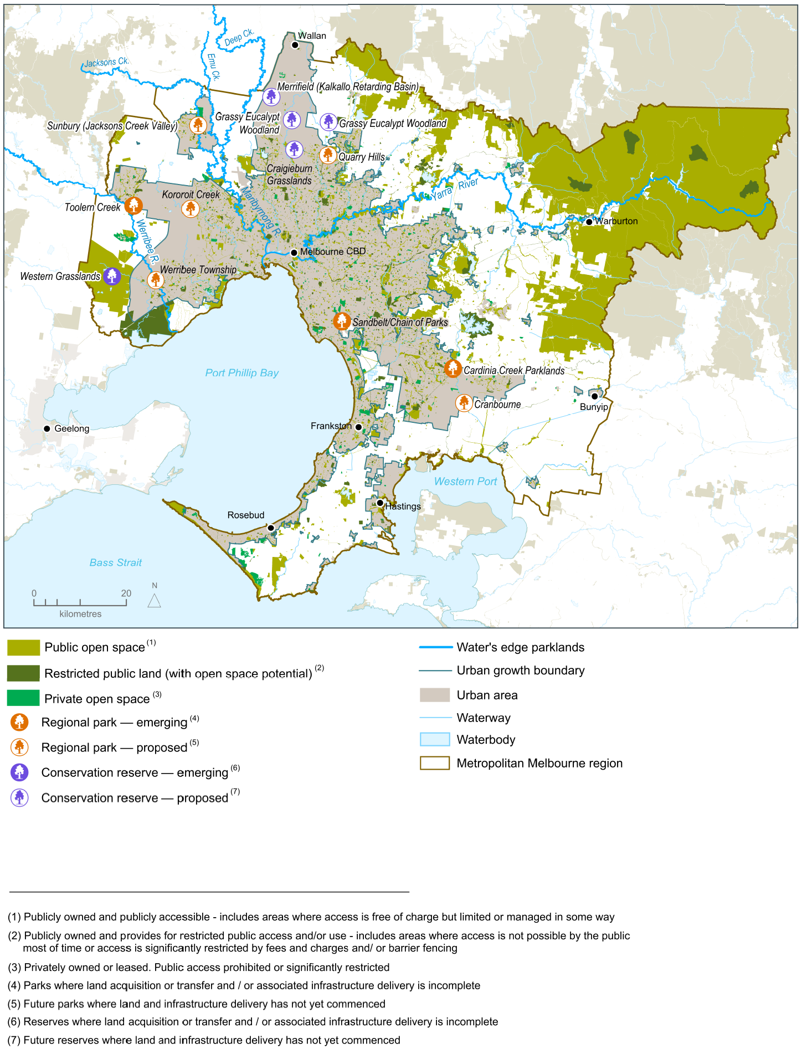
Source: Department of Environment, Land, Water and Planning

Direction 6.5 Protect and restore natural habitats
Melburnians are lucky to share their urban environment with an array of wildlife. However, as Melbourne grows, habitat loss and waterway degradation can pose a significant threat to native flora and fauna populations. As habitat becomes smaller and more fragmented through development, wildlife faces threats, such as lack of habitat to disperse to or barriers to dispersal.
There is a critical need to maintain and improve the overall extent and condition of natural habitats, including waterways. Natural habitats need to better protect native flora and fauna, enhance the community’s knowledge and acceptance of wildlife in areas they live, enhance access to nature and recreational opportunities across urban areas and make Melbourne an attractive place to live and visit. Map 22 shows Melbourne’s biodiversity conservation and natural features.
This direction should be read in conjunction with the Biodiversity Conservation Strategy for Melbourne’s Growth Corridors, which aims to manage the impacts of development for the next 30–40 years.

Policy 6.5.1 Create a network of green spaces that support biodiversity conservation and opportunities to connect with nature
Melbourne’s network of green spaces provides important areas of habitat for biodiversity conservation as well as opportunities for people to enjoy frequent contact with nature in urban environments. It includes a range of public and private green spaces, from parks and reserves to backyards and gardens as well as waterway and transport corridors that provide important green linkages. Existing green spaces need to be protected and new green spaces need to be created to improve landscape connectivity and resilience.
Government and community groups need to work in partnership to map Melbourne’s network of green spaces, investigate where the network could be improved and support the development of the metropolitan urban forest strategy.
Clearly articulating the spatial extent and management objectives of each part of the green network will guide land-use decision-making and investment as well as direct the conservation efforts of government departments and agencies, community groups and landholders.

Map 22 Biodiversity conservation and natural features
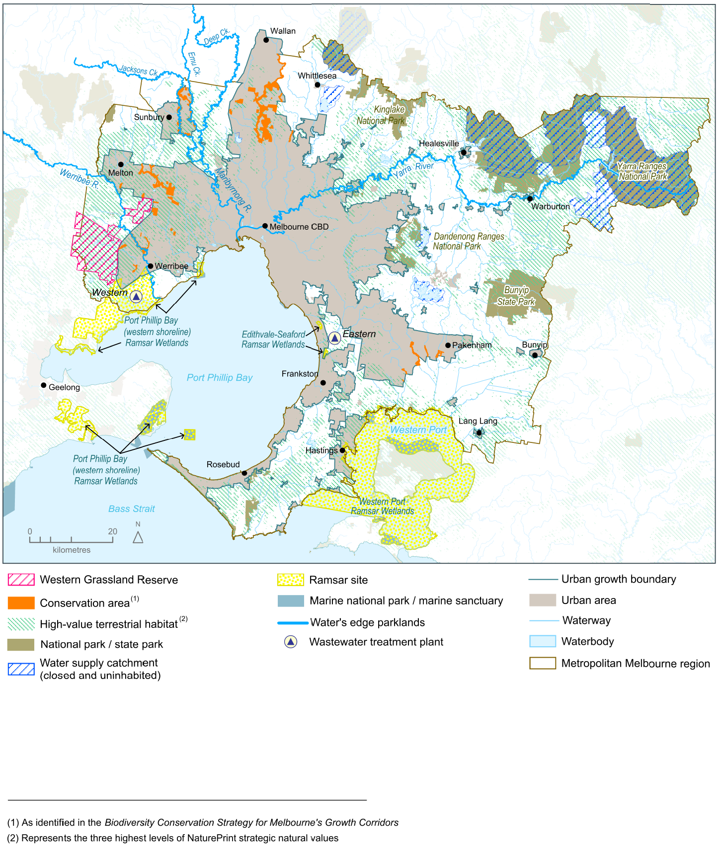
Source: Department of Environment, Land, Water and Planning

Policy 6.5.2 Protect and enhance the health of urban waterways
Melbourne has 8,400 kilometres of waterways—including the Yarra, Maribyrnong and Werribee rivers.
The impacts of climate change—combined with urban development from Melbourne’s growing population—influence the quantity, velocity and quality of urban stormwater run-off and pose a number of challenges for the health of Melbourne’s waterways.
Stormwater run-off from roads, roofs and pavements picks up pollutants (such as nutrients, heavy metals and litter) and discharges directly into our urban waterways and bays, impacting on water quality and ecosystem health and increasing flood risk. It is estimated that stormwater washes 37,000 tonnes of sediment and 1,400 tonnes of nutrients (such as nitrogen from fertiliser) into the Yarra River each year, as well as litter, heavy metals and pathogens.
Retaining stormwater in the landscape through water-sensitive urban design and stormwater harvesting is necessary to secure the health of the city’s waterways and bays. It will also reduce flood risks, improve landscapes and amenity, and create a greener city.
Objectives and performance standards within planning schemes must be strengthened to minimise the impacts of stormwater.

Policy 6.5.3 Protect the coastlines and waters of Port Phillip Bay and Western Port
Melbourne has more than 600 kilometres of coast, including Port Phillip Bay and Western Port.
This coastline includes places of significant environmental value (such as Ramsar sites) and places of significant social value (such as recreational beaches).
The State Environment Protection Policy (Waters of Victoria) provides the overarching framework for protecting and sustainably managing Victoria’s water environment, including setting environmental quality objectives.
A careful balance needs to be struck between supporting a variety of coastal land uses and minimising risks to ensure we do not love our beaches into decline. Planning will play an important role by focusing development in areas already developed or in areas with high resilience that can tolerate more intensive use and ensuring development effectively manages stormwater.

Direction 6.6 Improve air quality and reduce the impact of excessive noise
Melbourne’s air quality compares well with cities worldwide, but there are occasional days of poor air quality.
Air pollution is detrimental to human health, causing respiratory and cardiovascular disease and mortality, bronchitis, asthma, and exacerbation of chronic obstructive pulmonary disease. It is estimated to account for more deaths than the nation’s road toll.
Children are particularly susceptible to air pollution because their lungs and immune system are still developing. The elderly are also more likely to be adversely affected by pollution.
The Environment Protection Act 1970 allows for the establishment of standards for the management of air pollution emissions and noise through state environment protection policies and waste management policies. These standards must be upheld. After all, air quality is as important to public health as safe food or clean drinking water.
Air quality and noise impacts should be a fundamental consideration in the design and assessment of all new developments.

Policy 6.6.1 Reduce air pollution emissions and minimise exposure to air pollution and excessive noise
As urban renewal progresses, more people could be exposed to air and noise pollution in mixed-use areas, along major roads, at intersections, in popular entertainment areas and near industrial areas. In addition, predicted higher temperatures and more frequent bushfires and dust storms will add to the pressures on air quality.
The location of sensitive uses—such as childcare centres, schools, residential areas, aged-care facilities, hospitals and community facilities—require careful consideration and technical guidance early in the development application process.
Appropriate planning measures, building standards and urban design play a key role in minimising urban noise and air pollution and safeguarding community health and amenity.
Transport-oriented development and walkable neighbourhoods will assist in encouraging a mode shift away from cars and reducing vehicle emissions. Land-use interface issues and buffer distances between emission sources and sensitive uses must also be managed to mitigate exposure to air and noise pollution.

Direction 6.7 Reduce waste and improve waste management and resource recovery
Waste management and resource recovery is an essential community service that protects the environment and public health and recovers valuable resources.
By 2042, it is projected that waste volumes in metropolitan Melbourne will grow by 63 per cent to 16.5 million tonnes a year.
Melbourne needs to reduce the amount of waste it produces by avoiding, re-using and recycling waste. Infrastructure also needs to be located to ensure waste management and recovery is timely, efficient and cost effective.
The recovery of valuable resources from waste will create jobs and add value to the Victorian economy. It is estimated that recycling employs 9.2 people for every 10,000 tonnes of waste processed, compared to 2.8 people when the same amount of waste is sent to landfill.
Waste and resource recovery infrastructure planning must be effectively integrated with land-use planning to provide long-term certainty and to manage potential conflicts with incompatible nearby land uses.
Maintaining full operational capacity and output of waste and resource recovery facilities relies on a number of factors, such as securing and maintaining land separation distances. It is vital that facilities are sited, designed, built and operated to the highest standards so that the environment and public health benefits Victorians expect are achieved.

Policy 6.7.1 Improve the economic recovery of waste and reduce reliance on landfill
There are significant opportunities to grow this industry. For instance, Melbourne sends around 805,000 tonnes of food and garden waste to landfill each year. This breaks down and generates methane—a potent greenhouse gas—and causes odour issues for surrounding communities. Recovering this material could produce compost or energy. The government has set a target for Melbourne to have access to 600,000 tonnes of organic-processing capacity to manage municipal, commercial and industrial food-and-garden waste by 2026. There are also opportunities to recover more e-waste, plastic, polystyrene, timber, textiles and other materials.
There are also opportunities to provide integrated solutions to waste, water and energy issues such as converting waste to energy. There are already small-scale facilities in Victoria—including wastewater utilities, hospitals and agricultural-waste generators—producing their own electricity, steam and heating from their waste.
By 2026, the government wants 25 per cent of municipal residual waste collected through the Metropolitan Waste and Resource Recovery Group procurements to be recovered and managed through efficient, advanced technologies. This target is a major change for Melbourne as there are currently no residual facilities that accept municipal waste operating in the metropolitan region.
The Victorian Waste and Resource Recovery Infrastructure Planning Framework will be integrated into planning schemes to ensure that resource recovery facilities are appropriately planned for and located. This will help ensure the long-term viability of resource recovery infrastructure and ultimately facilitate the increased recovery of resources, reduce reliance on landfills, improve liveability, create jobs and reduce the environmental footprint of the city.

Policy 6.7.2 Improve waste and resource recovery systems to meet the logistical challenges of medium- and higher-density developments
Most high-rise residential and mixed-use developments, and some medium-density residential developments, lack appropriate waste and resource recovery infrastructure and services.
Owners’ corporations currently contract for the provision of waste services on an individual site basis. This often means all collected waste goes to landfill. The average diversion rate across multi-unit developments is 22 per cent—more than 10 per cent lower than general metropolitan household diversion rates.
This needs to change. The government has set a target for at least 95 per cent of all new multi-unit developments to accommodate resource recovery collections by 2026.
To achieve this target, waste and resource recovery infrastructure and waste service requirements need to be appropriately addressed within planning provisions for medium- and higher-density residential and mixed-use developments.

Policy 6.7.3 Protect waste management and resource recovery facilities from urban encroachment and assess opportunities for new waste facilities
Waste and resource recovery facilities need to remain fully operational and productive over the life of the investment. This relies, in part, on land and separation distances being secured, and on appropriate zoning of land within designated separation distances surrounding landfill sites and resource recovery sites.
Co-locating new waste-related infrastructure with complementary activities provides an opportunity to share existing separation distances and facilitate the integration of waste, water and energy management.
Waste-to-energy technologies are an example of advanced resource recovery infrastructure that can be co-located with complementary infrastructure.
Melbourne will create direct links between waste and resource recovery infrastructure planning and land-use planning. This will be achieved by applying clearer policy guidance to identify and protect waste and resource recovery sites and maintaining recommended separation distances with appropriate statutory measures to manage their off-site impacts.

Outcome 7

REGIONAL VICTORIA IS PRODUCTIVE, SUSTAINABLE AND SUPPORTS JOBS AND ECONOMIC GROWTH
Regional Victoria will deliver choice and opportunity for all Victorians and help build effective networks to the global economy.
Today, regional Victoria is home to 25 per cent of Victoria’s population. By the census year of 2051, the population of Victoria’s regions is expected to grow from 1.5 million to 2.2 million, with Melbourne growing from 4.5 million to almost 8 million (refer to Figure 18). However, growth in regional Victoria will not be evenly spread. Between 2011 and 2031, regional Victoria’s largest local government areas by population—Greater Geelong, Greater Bendigo and Ballarat—are projected to account for 50 per cent of all population growth outside Melbourne. Growth in peri-urban areas beyond metropolitan Melbourne will attract about 32 per cent of regional Victoria’s population in the same period.
Overall, regional Victoria is growing but not as fast as Melbourne. If current trends continue, the proportion of Victorians living outside of Melbourne will decline. In some towns and regions, communities are actively looking for opportunities to reverse population decline in order to keep local businesses, services and community organisations. If regional Victoria is to share in the benefits of the population boom and take on a greater proportion of residential and jobs growth than is projected under the ‘business as usual’ scenario, then we need to plan for better connections to infrastructure and services. However, planning for growth in regional Victoria must be led locally and acknowledge the diverse range of opportunities and challenges that exist in different locations.
Figure 18 Estimated Resident Population (ERP) - Melbourne, regional cities, Melbourne's peri-urban areas and regional Victoria balance, 2011–2051
Population  Regional Victoria | 2011  1,417,000 | 2015  1,461,000 | 2031  1,749,000 | 2051  2,168,000 | Average annual % change 2011-2015  0.77% | Average annual % change 2015-2051  1.10%
Population  Regional cities (1) | 2011  716,000 | 2015  749,000 | 2031  933,000 | 2051  1,199,000 | Average annual % change 2011-2015  1.12% | Average annual % change 2015-2051  1.32%
Population  Peri-urban areas[2) | 2011  269,000 | 2015  286,000 | 2031  376,000 | 2051  502,000 | Average annual % change 2011-2015  1.48% | Average annual % change 2015-2051  1.58%
Population  Regional Victoria balance | 2011  432,000 | 2015  427,000 | 2031  441,000 | 2051  467,000 | Average annual % change 2011-2015  -0.28% | Average annual % change 2015-2051  0.25%
Population  Metropolitan Melbourne(3) | 2011  4,121,000 | 2015  4,480,000 | 2031  5,984,000 | 2051  7,918,000 | Average annual % change 2011-2015  2.11% | Average annual % change 2015-2051  1.59%
Population  Victoria | 2011  5,538,000 | 2015  5,941,000 | 2031  7,733,000 | 2051  10,086,000 | Average annual % change 2011-2015  1.77% | Average annual % change 2015-2051  1.48%
- Includes the Local Government Areas of Greater Geelong, Greater Bendigo, Ballarat, Greater Shepparton, Latrobe City, Wodonga, Warrnambool, Mildura, Wangaratta and Horsham.
- Includes the Local Government Areas of Bass Coast, Baw Baw, Golden Plains, Hepburn, Macedon Ranges, part of Mitchell outside the urban growth boundary, Moorabool, Murrindindi, South Gippsland and Surf Coast.
- Includes the 31 municipalities that make up metropolitan Melbourne, plus part of Mitchell Shire within the urban growth boundary.
Source: Victoria in Future 2016

Growing regional Victoria’s economy
Regional Victoria provides 30 per cent of the state’s exports. As traditional economic delineations change, regional Victoria and Melbourne’s economic linkages are becoming increasingly important.
The government has identified priority industry sectors with potential for remarkable growth. Collectively, these sectors have the potential to drive up to $70 billion in additional economic output by 2025 and create more than 400,000 new jobs for Victorians. Regional Victoria is well placed to benefit from future growth and export development in a number of these sectors.
Like most of the world, Victoria is moving towards becoming a low-carbon economy, which brings both big challenges and big opportunities. Regional Victoria is well positioned to take advantage of the significant job opportunities expected to emerge in the new energy industries that will drive the state’s transition to a net zero emissions economy. However, the government also recognises that challenges of transition are being felt particularly acutely at the frontline of the energy sector—for example in places such as the Latrobe Valley. Communities experiencing the challenges of economic transition are also looking to industries of the future, including knowledge-based services and advanced manufacturing and processing.
In 2015–16, Victoria’s food-and-fibre exports were valued at $11.9 billion, with 27 per cent of exports sent to China. Long-term growth in Asia is expected to accelerate demand for beef, lamb, wheat and dairy products as well as processed foods.
Tourism is another major economic driver for regional Victoria. The industry contributes $11.5 billion to the regional Victorian economy (GRP) and generates 114,400 jobs. It contributes 13.4 per cent of total GRP and 13.4 per cent of employment. Nature-based tourism visitors represented 70 per cent of all international overnight visitors to the state in 2013–14. Domestic nature-based visitors had approximately 4.3 million day trips to and within Victoria.
With new investment in infrastructure and improvements to marketing, product development and the visitor experience, there are huge opportunities for regional Victoria to increase its share of the tourism market.
International education has been Victoria’s largest services export industry for more than a decade, generating $5.6 billion for the state and supporting 30,000 jobs in 2014. Regional education providers can offer niche expertise and significant industry expertise in fields of global significance, such as food and agriculture, soil and water, energy and resources, and the environment.
The population services sector (such as the healthcare and social-assistance industries) is expected to drive strong employment growth in regional Victoria, particularly as a result of Victoria’s ageing population. The opportunities for growth in these industries has already been demonstrated with the establishment of the National Disability Insurance Scheme headquarters in central Geelong.

Planning for growth and change in regional Victoria
Victoria’s 10 regional cities—Greater Geelong, Greater Bendigo, Ballarat, Greater Shepparton, Latrobe City, Wodonga, Warrnambool, Mildura, Wangaratta and Horsham—are important urban settlements with diverse economies and strong communities that operate as service hubs for many smaller communities. Development of individual cities and towns should be in keeping with their character and balanced with the protection of the productive land, economic resources and biodiversity assets that are critical to the state’s economic and environmental sustainability.
Victoria’s Regional Statement clearly articulates that government investment and decision-making in regional Victoria will reflect the strategic priorities regional communities have identified for themselves—across economic, social and environmental issues. The nine new Regional Partnerships across the state provide the mechanism for this dialogue to occur. The approach taken by Plan Melbourne will be consistent with this approach, acknowledging regional differences and local and regional ambitions.

Victoria’s Plan

Direction 7.1 Invest in regional Victoria to support housing and economic growth
Investing in regional Victoria will support housing and economic growth and bring significant social and lifestyle benefits to regional communities.
The Victorian Government will:
- work with the nine Regional Partnerships and local governments to support the growth of housing and employment in regional cities and towns
- ensure the right infrastructure and services are available to support the growth and competitiveness of regional and rural industries and their access to global markets.

Policy 7.1.1 Stimulate employment and growth in regional cities
The government will continue to make improvements to infrastructure and services to stimulate employment and growth in the state’s 10 largest regional cities.
Building on the Regional Growth Plans and work undertaken by Regional Cities Victoria, this approach will require development strategies that reflect the individual growth opportunities and priorities of each regional city, including the identification of urban renewal and infill opportunities to optimise infrastructure investment and surplus government land.
Regional city railway stations and their surrounds need to be targeted for potential growth opportunities, including transit-oriented development and improved housing diversity in regional cities. Increased housing diversity is needed to encourage international students and young professionals to work, study and live in regional areas.
The Victorian Planning Authority, Regional Development Victoria and other key agencies will work with regional cities on the preparation of development strategies.

Policy 7.1.2 Support planning for growing towns in peri-urban areas
A number of towns in peri-urban areas have capacity for more housing and employment-generating development without impacting on the economic and environmental roles that surrounding non-urban areas serve. Those towns include Warragul–Drouin, Bacchus Marsh, Torquay–Jan Juc, Gisborne and Kyneton. Other towns identified by Regional Growth Plans as having potential for growth include Wonthaggi, Kilmore, Broadford, Seymour and Ballan.
Peri-urban towns can provide an affordable and attractive alternative to metropolitan living. However, strategies need to be developed for the timely delivery of state and local infrastructure to support growth and protect their significant amenity.
Most importantly, development in peri-urban areas must also be in keeping with local character, attractiveness and amenity. Growth boundaries should be established for each town to avoid urban sprawl and protect agricultural land and environmental assets.
Map 23 Victoria’s connected cities and regions
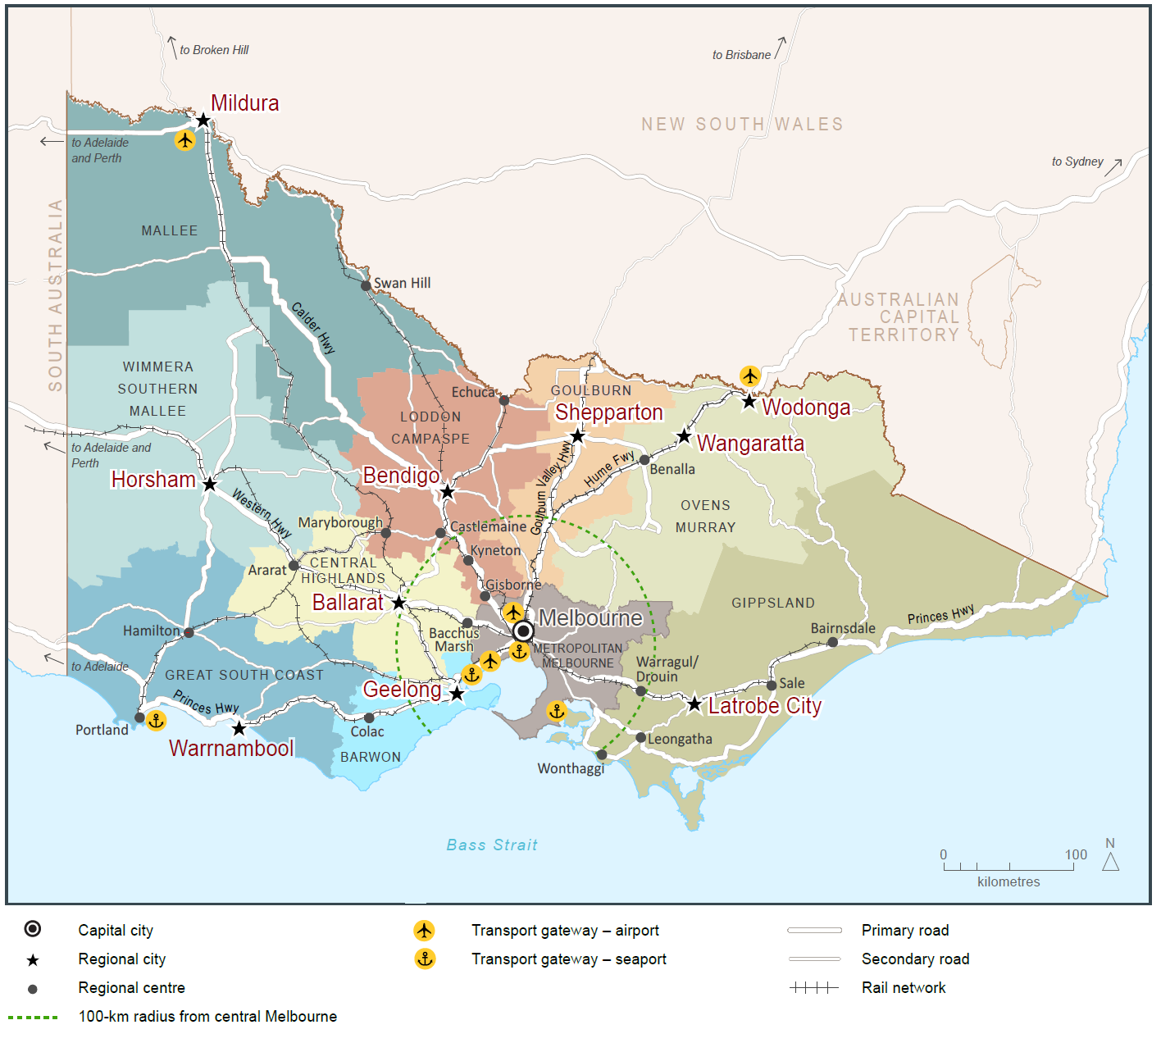
Source: Department of Environment, Land, Water and Planning

Direction 7.2 Improve connections between cities and regions
Regional cities and towns need to be connected by efficient and safe road and rail transport corridors.
Strong links, both within the regions to major hub destinations as well as back to Melbourne, make it easier to live and do business in regional areas.
Better public transport connections (including rail, long-distance coach, and school and town buses) are critical for the movement of people to jobs and services. The Regional Network Development Plan is the Victorian Government's long-term plan for transport investment in regional Victoria. It will deliver a modern commuter-style service for the growth areas of Geelong, Bendigo, Ballarat, Seymour and Traralgon, and service improvements to outer regional areas.
Victoria’s freight task is projected to triple by 2050—much of it is destined for Melbourne or export.
Infrastructure that connects rural producers to state-significant corridors—as well as the Port of Melbourne, Melbourne Airport and other regional ports—must be improved to support the economies of regional cities and regional industries.
Digital connectivity is fundamental to business and jobs growth and critical for accessing services. In particular, the health and education sectors highlight the potential of providing services online.

Policy 7.2.1 Improve transport and digital connectivity for regional Victoria
State-significant transport corridors connect regional cities to each other, to Melbourne and to key gateways such as Melbourne Airport.
Responses to growing transport demand in regional Victoria will be assessed and prioritised. All potential solutions and interventions will be reviewed to ensure the capacity of existing infrastructure is being optimised.
Improvements to public transport will enable a more integrated labour market with higher-income jobs to spread throughout Victoria. They will reduce inequity of access between regions, especially the regions that are more remote from Melbourne. Planning will identify infrastructure and service priorities to better link regional Victoria and Melbourne and support regional city growth.
Opportunities will be identified to leverage expansion of the digital economy to support increased regional economic and population growth. Improvements to digital connectivity will continue to be sought, working closely with the Federal Government.

Policy 7.2.2 Strengthen transport links on national networks for the movement of commodities
Victoria’s economy depends on its ability to move goods between state-significant places (such as regional cities and Melbourne) and to interstate and international markets.
Transport network planning must ensure that industries such as Victoria’s food and fibre industry remain viable and competitive. This should include identification of key freight corridors and interstate freight terminals.
For example, the Avalon corridor near Geelong contains nationally significant economic assets, including airport, road, rail and waste facilities. This corridor must be safeguarded for state infrastructure opportunities and complementary development in the future, as well as maintaining a settlement break between Melbourne and Geelong. Land-use buffers for infrastructure and Avalon Airport and areas of high biodiversity value, including Ramsar conservation areas, must be protected.

Implementation: Delivering strong leadership to shape the city
Metropolitan planning is complex. With responsibilities for metropolitan planning and delivery shared across three levels of government, a key challenge for Plan Melbourne is to ensure it is properly implemented at a statewide, regional and local level.
That is why Plan Melbourne has a separate five-year implementation plan. The Implementation Plan—which will be overseen by the Department of Environment, Land, Water and Planning—contains actions that need to be taken to realise Plan Melbourne’s outcomes. The Implementation Plan’s actions are allocated to government departments and agencies. Detailed decisions about the implementation and timing of actions and infrastructure delivery will be made in line with the normal government policy and budget processes.
Further information on funding, delivery and decision-making processes around Plan Melbourne commitments can be found in the Implementation Plan.

Governance and partnerships
Implementing Plan Melbourne will require sustained, coordinated action by all levels of government, the private sector and the community.
As Melbourne grows, planning at a regional scale will help achieve a better balance between jobs and population growth across the city and provide a regional basis for collaboration with (and between) local governments.
Metropolitan regional planning groups will support the implementation of many of Plan Melbourne’s actions, including engagement with local communities about their priorities.

Monitoring and review
A monitoring and reporting framework has been developed to track the progress of the implementation of Plan Melbourne.
Progress reports will be publicly available. The monitoring and reporting framework may also inform delivery and investment decisions by all levels of government. It will also provide an opportunity to consider how Plan Melbourne performs against the United Nations Sustainable Development Goals (refer to Figure 19).
As a part of the implementation process, the Victorian Government will also regularly publish data and information about Melbourne’s growth and change.
Plan Melbourne and its Implementation Plan will be formally reviewed every five years.
Figure 19 United Nations Sustainable Development Goals

United Nations Sustainable Development Goals
The United Nations Sustainable Development Goals define the 2030 Agenda for Sustainable Development, signed by all 193 member states of the United Nations.

The key pillars underpinning the goals (economic prosperity, social inclusion and environmental sustainability) are consistent with the vision, outcomes and directions of Plan Melbourne and the objectives of planning in Victoria as specified under section 4 of the Planning and Environment Act 1987, namely: ‘to provide for the fair, orderly, economic and sustainable use and development of land’.

The Plan Melbourne monitoring framework provides an opportunity to track the plan’s progress towards achieving the Sustainable Development Goals. It will include indicators that are matched to the goals, which could also be used by other Australian cities.

The United Nations Sustainable Development Goals
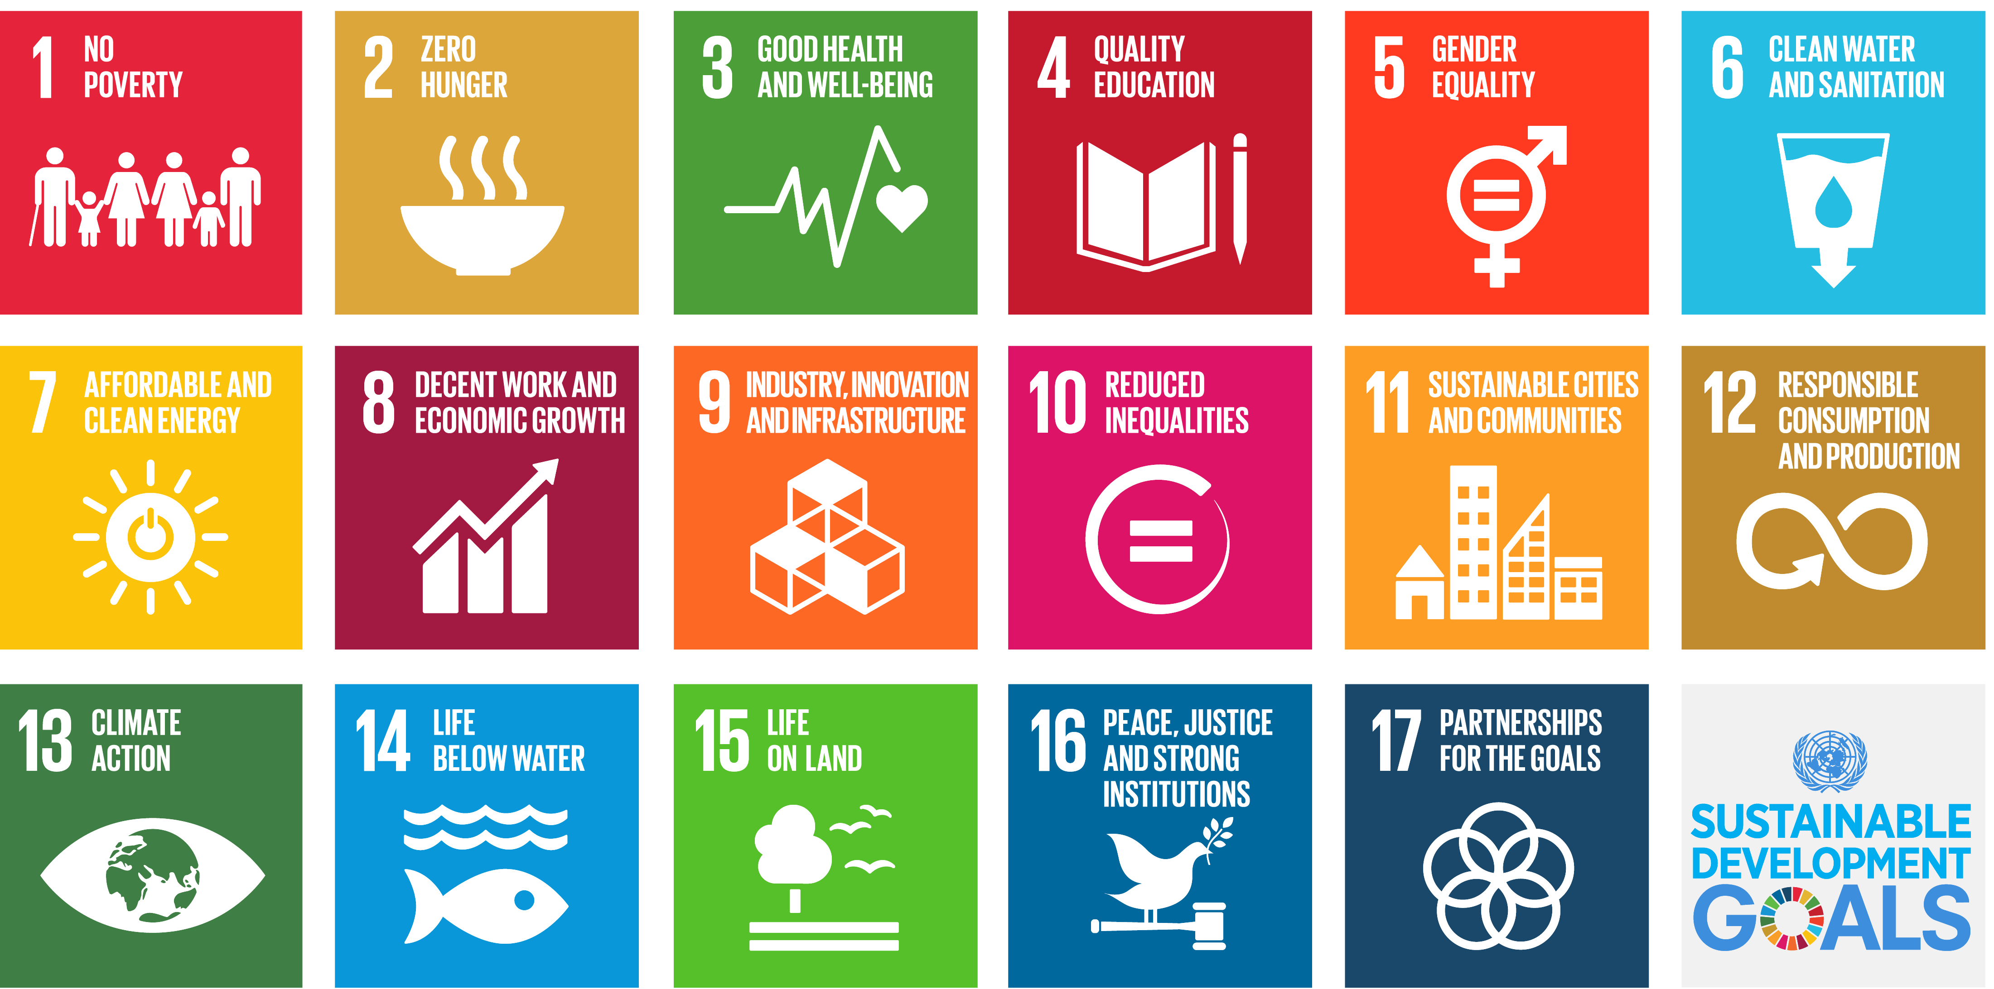
Source: United Nations Department of Economic and Social Affairs, 2015
Sustainable Development Goals alignment with Plan Melbourne
Sustainable Development Goal  Good health and wellbeing | Relevant Plan Melbourne directions  Direction 5.3 Deliver social infrastructure to support strong communities
Sustainable Development Goal  Clean water and sanitation | Relevant Plan Melbourne directions  Direction 6.3 Integrate urban development and water cycle management to support a resilient and liveable city
Sustainable Development Goal  Affordable and clean energy | Relevant Plan Melbourne directions  Direction 6.1 Transition to a low-carbon city to enable Victoria to achieve its target of net zero greenhouse gas emissions by 2050
Sustainable Development Goal  Decent work and economic growth | Relevant Plan Melbourne directions  Direction 1.1 Create a city structure that strengthens Melbourne’s competitiveness for jobs and investment
Sustainable Development Goal  Sustainable cities and communities | Relevant Plan Melbourne directions  Direction 5.1 Create a city of 20-minute neighbourhoods  Direction 5.2 Create neighbourhoods that support safe communities and healthy lifestyles
Sustainable Development Goal  Responsible consumption and production | Relevant Plan Melbourne directions  Direction 6.1 Transition to a low-carbon city to enable Victoria to achieve its target of net zero greenhouse gas emissions by 2050  Direction 6.7 Reduce waste and improve waste management and resource recovery
Sustainable Development Goal  Climate action | Relevant Plan Melbourne directions  Direction 6.1 Transition to a low-carbon city to enable Victoria to achieve its target of net zero greenhouse gas emissions by 2050  Direction 6.2 Reduce the likelihood and consequences of natural hazard events and adapt to climate change
Sustainable Development Goal  Life below water | Relevant Plan Melbourne directions  Direction 6.5 Protect and restore natural habitats
Sustainable Development Goal  Life on land | Relevant Plan Melbourne directions  Direction 6.4 Make Melbourne cooler and greener  Direction 6.5 Protect and restore natural habitats

Glossary

Active transport: Transport requiring physical activity, typically walking and cycling.
Activity centres: Areas that provide a focus for services, employment, housing, transport and social interaction. They range in size and intensity of use from smaller neighbourhood centres to major suburban centres and larger metropolitan centres.
Affordable housing: Housing that is appropriate for the needs of a range of very low to moderate income households, and priced (whether mortgage repayments or rent) so these households are able to meet their other essential basic living costs.
Agglomeration: The location of businesses in close proximity to each other, which allows them to get productivity and efficiency gains through large customer bases, knowledge sharing and access to skilled workers.
Biodiversity: The variety of all life forms, the different plants, animals and microorganisms, the genes they contain and the ecosystems of which they form a part.
Carbon footprint: A measure of the greenhouse gases emitted into the atmosphere as a result of the activities of an individual, company, city or country.
Central Business District (CBD): Melbourne's original ‘Hoddle Grid’ street layout bounded by the Yarra River, Spring Street, La Trobe Street and Spencer Street, as well as the triangular area to the north bounded by Victoria, Peel and La Trobe streets.
Central city: The area within the inner region that contains key capital city functions and civic facilities, as well as several precincts identified for major and strategic change. It is a larger area than the Melbourne CBD.
Climate change: A long-term change of the earth’s temperature and weather patterns, generally attributed directly or indirectly to human activities such as fossil fuel combustion and vegetation clearing and burning.
Climate change adaptation: Actions that prevent or minimise the impacts of climate change.
Climate change mitigation: Actions that prevent or reduce emissions of greenhouse gases that contribute to climate change.

Community housing: Refers to a type of not-for-profit social housing. Community housing offers secure, affordable, rental housing for people on very low to moderate income households with a housing need.
Distributed energy: Electricity that is generated locally and fed back into the electricity distribution network.
Eastern Region: Includes the municipalities of Knox, Manningham, Maroondah, Monash, Whitehorse and Yarra Ranges.
Ecosystem services: The benefits people obtain from healthy ecosystems. These include provisioning services such as food and water; regulating services such as flood and disease control; cultural services such as spiritual, recreational, and cultural benefits; and supporting services such as nutrient cycling that maintain the conditions for life on earth.
Environmentally sustainable development: An approach to development that seeks to meet the needs of the present without compromising the ability of future generations to meet their own needs. It has economic, social and environmental dimensions.
Established urban areas: Areas of Melbourne that have been urbanised for at least several decades.
Greater Melbourne Capital City Statistical Area: An Australian Bureau of Statistics standard statistical definition that differs from the boundary of Melbourne as used in Plan Melbourne. It represents the functional extent of the city, including people who live within the urban area of the city as well as people who regularly socialise, shop or work within the city, but live in small towns and rural areas surrounding the city. It extends as far as Bacchus Marsh in the west, Lancefield and Kinglake to the north, and Warburton and Lang Lang in the east.
Green economy: An economy in which economic growth and the health of our natural resources sustain each other, and market, business and government better reflect the value of nature.
Green wedges: Defined under Part 3AA of the Planning and Environment Act 1987 as ‘land that is described in a metropolitan fringe planning scheme as being outside an urban growth boundary’. There are 12 defined green wedges spanning parts of 17 municipalities.
Greenfield land: Undeveloped land identified for residential or industrial/commercial development, generally on the fringe of metropolitan Melbourne.
Greenhouse gas emissions: Atmospheric gas that absorbs and emits infrared or heat radiation, giving rise to the greenhouse effect. Typical greenhouse gases include carbon dioxide, methane, nitrous oxide and refrigerants.

Greyfield: Residential areas where the building stock is near or has ended its useful life and land values make redevelopment attractive.
Growth areas: Locations on the fringe of metropolitan Melbourne designated in planning schemes for large-scale transformation, over many years, from rural to urban use.
Health and education precincts: Locations to cluster synergistic health and/or education services to improve access to integrated service provision, improve outcomes, develop the health and education workforce and deliver economic benefits (such as innovation and job creation). These precincts may provide solely health, solely education, or a combination of health and education services.
Hoddle Grid: The grid pattern of streets making up Melbourne’s CBD bounded by the Yarra River, Spring Street, La Trobe Street and Spencer Street, as well as the triangular area to the north bounded by Victoria, Peel and La Trobe streets. The grid was designed by Robert Hoddle in 1837.
Housing density: The number of dwellings in an urban area divided by the area of the residential land they occupy, expressed as dwellings per hectare.
Infill: Development of unused or underutilised land in existing urban areas.
Infrastructure: Basic facilities and networks needed for the functioning of a local community or broader society.
Inner Region: Includes the municipalities of Melbourne, Port Phillip and Yarra City.
Inner South East Region: Includes the municipalities of Bayside, Boroondara, Glen Eira and Stonnington.
Integrated water management: An approach to planning that brings together all facets of the water cycle including sewage management, water supply, stormwater management and water treatment, ensuring environmental, economic and social benefits.
Interstate freight terminal: A location for the transfer of freight from one transport mode to another: for example between road and rail.
Knowledge economies: Production and services based on knowledge-intensive activities that contribute to an accelerated pace of technical and scientific advancement. Their key characteristic is a greater reliance on intellectual capabilities than on physical inputs or natural resources.

Liveability: A measure of a city’s residents’ quality of life, used to benchmark cities around the world. It includes socioeconomic, environmental, transport and recreational measures.
Localised planning statement: Long-term policies for the future planning and development of areas identified as having significance to the broader Victorian community.
Low-carbon city: A city based on low-carbon power sources that has a minimal output of greenhouse gas emissions.
Major activity centres: Suburban centres that provide access to a wide range of goods and services. They have different attributes and provide different functions, with some serving larger subregional catchments. Plan Melbourne identifies 121 major activity centres.
Metropolitan activity centres: Higher-order centres with diverse employment options, services and housing stock, supported by good transport connections. Existing centres include Box Hill, Broadmeadows, Dandenong, Epping, Footscray, Fountain Gate/Narre Warren, Frankston, Ringwood and Sunshine. Future centres will include Lockerbie and Toolern.
Metropolitan Melbourne: The 31 municipalities that make up metropolitan Melbourne, plus part of Mitchell Shire within the urban growth boundary.
National employment and innovation clusters: Designated concentrations of employment distinguished by a strong core of nationally significant knowledge sector businesses and institutions that make a major contribution to the national economy and Melbourne’s positioning in the global economy.
Natural capital: Geology, soil, air, water and all living things.
Natural hazard: A natural event that has potential to cause harm to people, property or the environment, including climate change, bushfire, flooding and sea level rise.
Neighbourhood activity centres: Local centres that provide access to local goods, services and employment opportunities and serve the needs of the surrounding community.
Northern Region: Includes the municipalities of Banyule, Darebin, Hume, Mitchell (part), Moreland, Nillumbik and Whittlesea.
Open space: Includes land reserved for natural landscape, parklands, recreation and active sports, as well as waterways and bays.

Peri-urban areas: Are beyond the green wedges and are made up of local government areas with a predominantly rural character, located all or partially within a 100-kilometre radius of Melbourne.
Precinct structure plans: Detailed master plans for future growth corridor developments, informed by growth corridor plans. The plans identify alignments of transport routes, town centres, open space networks, densities of residential areas, and areas for industry and employment.
Principal Public Transport Network (PPTN): A statutory land-use planning tool that supports integrated land-use and transport planning by providing certainty to land-use planners and developers around locations that are and will be served by high-quality public transport.
Principal Freight Network (PFN): Part of the larger transport network over which the movement of heavy freight will be concentrated.
Productivity: The economic value produced for an hour of work or a dollar of investment. Increasing productivity is a key source of economic growth and competitiveness.
Public housing: Long-term rental housing that is owned by the government. Its purpose is to accommodate very low to moderate income households that are most in need.
Ramsar wetlands: Wetlands listed as internationally significant under the Convention on Wetlands held in Ramsar, Iran in 1971.
Regional Growth Plans: Plans providing a broad regional planning direction for land use and development across eight regions in Victoria, developed through partnerships between local governments and state agencies and authorities.
Regional Victoria: Includes all municipalities outside metropolitan Melbourne (except part of Mitchell Shire within the urban growth boundary).
Renewable energy: Energy that comes from resources which are naturally replenished on a human timescale such as sunlight, wind, rain, tides, waves, and geothermal heat.
Resilience: The capacity of individuals, communities, institutions, businesses, systems and infrastructure to survive, adapt and grow, no matter what chronic stresses or shocks they encounter.
Resource recovery: Extraction of useful material or energy from a waste stream.
Secondary dwelling: An additional self-contained dwelling developed on the same land as the principal dwelling.

Social capital: The networks of relationships among individuals, groups and communities that facilitate coordination and cooperation for mutual benefit.
Social housing: A type of rental housing that is provided and/or managed by the government or by a not-for-profit organisation. Social housing is an overarching term that covers both public housing and community housing.
Social infrastructure: Encompasses all the facilities, services and networks that help families, groups and communities to meet their social, health, education, cultural and community needs.
Southern Region: Includes the municipalities of Cardinia, Casey, Frankston, Greater Dandenong, Kingston and Mornington Peninsula.
Surplus government land: Sites identified as being surplus to government requirements.
State-significant industrial precincts: Strategically located land available for major industrial development linked to the Principal Freight Network and transport gateways.
Traditional Owners: People who, through membership of a descent group or clan, are responsible for caring for particular Country. A Traditional Owner is authorised to speak for Country and its heritage as a senior Traditional Owner, an Elder or, in more recent times, a registered native title claimant.
Transit-oriented development: Compact, walkable, mixed-use communities centred around high-quality train systems. Transit-oriented development assists in addressing the growing problems of climate change and global energy security by creating dense, walkable communities that greatly reduce the need for driving and energy consumption.
Transport gateway: Ports, airports and interstate terminals that serve as key locations for moving passengers and freight into and out of Victoria and also play a significant economic and employment-generating role.
Urban forest: All of the trees and other vegetation in a city as well as the soil and water that supports it.
Urban greening: Growing plants wherever possible in cities to contribute to urban vegetation coverage, and providing a connection to nature.
Urban growth boundary: The geographic limit for the future urban area of Melbourne.
Urban heat-island effect: When the built environment absorbs, traps, and in some cases directly emits heat, causing urban areas to be significantly warmer than surrounding non-urban areas.

Urban renewal: The process of planning and redeveloping underutilised medium and large-scale urban areas, precincts or sites for mixed land-use purposes.
Urban water cycle: The cycle of water through urban environments. Distinguished from the natural urban water cycle by the transfer of water through built infrastructure and the high run-off rates generated by impervious surfaces.
Value uplift: The uplift in future economic and social value created by the construction of significant infrastructure or rezoning land. Value uplift is often referred to in the context of capturing some of the value to deliver broader public benefits.
Western Region: Includes the municipalities of Brimbank, Hobsons Bay, Maribyrnong, Melton, Moonee Valley and Wyndham.
Water’s edge parklands: The network of parklands along Melbourne’s major river corridors including the Yarra, Maribyrnong and Werribee rivers and parklands and open spaces around Port Phillip Bay.
Water-sensitive city: Resilient, liveable, productive and sustainable cities that interact with the urban water cycle to provide water security, healthy watercourses and wetlands, mitigate flood risk, create healthy spaces and contribute to biodiversity, urban heat-island reduction and carbon sequestration.
Water-sensitive urban design: Integrating the urban water cycle into urban design to minimise environmental damage and improve recreational and aesthetic outcomes.

Maps and Figures

Maps
Map 1 Melbourne's urban growth 6
Map 2 Melbourne 2050 Plan 20
Map 3 Jobs and investment 25
Map 4 Key features in and around Melbourne's central city 28
Map 5 Monash National Employment and Innovation Cluster 30
Map 6 Parkville National Employment and Innovation Cluster 32
Map 7 Fishermans Bend National Employment and Innovation Cluster 34
Map 8 Dandenong National Employment and Innovation Cluster 36
Map 9 La Trobe National Employment and Innovation Cluster 38
Map 10 Sunshine National Employment and Innovation Cluster 40
Map 11 Werribee National Employment and Innovation Cluster 42
Map 12 Jobs across Melbourne 50
Map 13 Metropolitan Melbourne regions 62
Map 14 Metropolitan and major activity centres 64
Map 15 Lower-cost housing in metropolitan Melbourne 1995 and 2015 75
Map 16 Existing rail and road transport infrastructure 82
Map 17 Improvements to transport infrastructure – committed and potential 85
Map 18 Level crossing removals 88
Map 19 Melbourne's green wedges and peri-urban areas 106
Map 20 Natural hazards 127
Map 21 Open space 134
Map 22 Biodiversity conservation and natural features 136
Map 23 Victoria’s connected cities and regions 147

Figures
Figure 1 Victoria's projected population growth 8
Figure 2 Households by household type, metropolitan Melbourne 10
Figure 3 Australia's greenhouse gas emissions per capita 12
Figure 4 Projected employment growth, metropolitan Melbourne, 2015 - 2031 22
Figure 5 Key living, learning and work precincts linked by a high-capacity train network. 24
Figure 6 Annual building approvals by selected type and location, metropolitan Melbourne (year ending March) 55
Figure 7 Housing distribution between established areas and growth area greenfields 59
Figure 8 Median lot price by market, September 2016 73
Figure 9 Metro Tunnel wider benefits—capacity benefits over two-hour peak period 84
Figure 10 Improved road use 87
Figure 11 Building blocks for social sustainability 113
Figure 12 The 20-minute neighbourhood 115
Figure 13 Victoria's greenhouse gas emissions (2014) 123
Figure 14 Resource efficient house 125
Figure 15 Water supply scenarios to 2050 130
Figure 16 Urban heat-island profile of Melbourne 131
Figure 17 Benefits of urban greening 132
Figure 18 Estimated Resident Population (ERP) - Melbourne, regional cities, Melbourne's peri-urban areas and regional Victoria balance, 2011 - 2051 142
Figure 19 United Nations Sustainable Development Goals 151

Endnotes

Victoria in Future 2016
Department of Environment, Land, Water and Planning, internal analysis, estimated employed persons derived from Victoria in Future 2016
Victorian Integrated Survey of Travel and Activity 2016 and Victoria in Future 2016 population projections
Bureau of Meteorology and CSIRO (2014) State of the Climate 2014
See International Energy Agency (2014) CO2 emissions from fuel combustion highlights. Paris: OECD/IEA. Retrieved from: www.iea.org/publications/freepublications/publication/CO2EmissionsFromFuelCombustionHighlights2014.pdf (pp. 84–85).
Department of Economic Development, Jobs, Transport and Resources, internal analysis (2016).
Department of Environment, Land, Water and Planning, internal analysis, estimated employed persons derived from Victoria in Future 2016.
Victoria’s Future Industries, Future Industries Fact Sheet, March 2016.
Department of Environment, Land, Water and Planning internal analysis based on Aggregations of Destination Zones from the ABS Census 2011 and ABS Labour Force Survey.
Department of Environment, Land, Water and Planning internal analysis based on aggregations of Destination Zones from the ABS Census 2011 and ABS Labour Force Survey.
Department of Environment, Land, Water and Planning internal analysis based on aggregations of Destination Zones from the ABS Census 2011 and ABS Labour Force Survey.
Department of Environment, Land, Water and Planning internal analysis based on aggregations of Destination Zones from the ABS Census 2011 and ABS Labour Force Survey.
Department of Environment, Land, Water and Planning internal analysis based on aggregations of Destination Zones from the ABS Census 2011 and ABS Labour Force Survey.
Department of Environment, Land, Water and Planning internal analysis based on aggregations of Destination Zones from the ABS Census 2011 and ABS Labour Force Survey.
Department of Environment, Land, Water and Planning internal analysis based on aggregations of Destination Zones from the ABS Census 2011 and ABS Labour Force Survey.
Metropolitan Planning Authority, East Werribee Employment Precinct, Precinct Structure Plan, September 2013 (Amended June 2014).
Melbourne Airport, Melbourne Airport Master Plan 2013.
Port of Melbourne Corporation, Port Development Strategy 2035 Vision, August 2009 and Port of Melbourne Fact Sheet Economic Impact 2012-13, October 2014.
Department of Environment, Land, Water and Planning, Urban Development Program, 2015.
Department of Transport, Planning and Local Infrastructure, Plan Melbourne, Metropolitan Planning Strategy, 2014
Department of Economic Development, Jobs, Transport and Resources (2016) Extractive Resources in Victoria: Demand and Supply Study 2015-2050, Final Report (prepared by Price Water House Cooper)
City of Melbourne, 2013, Future Living: A discussion paper identifying issues and options for housing our community.
In Victoria allocations to public housing are around 2,500 per annum. The current waiting list is in excess of 34,000 households.
Australian Bureau of Statistics, 2012, Census of Population and Housing: Estimating Homelessness 2011.
In NSW a secondary dwelling can be independently rented out. In contrast, Logan City Council in Queensland requires a secondary dwelling to be occupied by persons who form one household with the primary dwelling.
Victorian Integrated Survey of Travel and Activity 2016 and Victoria in Future 2016 population projections
Victorian Integrated Survey of Travel and Activity 2012–13
Victorian Integrated Survey of Travel and Activity 2012–13
Education State Targets, Department of Education and Training 2015.
Gammage, B. (2011) The Biggest Estate on Earth – How Aborigines Made Australia, Allen & Unwin, Australia, p49
Peopleperhour (Meagan Crawford), The Rise of the Creative Economy, July 2015, p1 – referenced in Victorian Government “Creative State Global City”, Creative Industries Taskforce Report, November 2015
The term ‘country’ refers to the traditional lands of Aboriginal Traditional Owners, including all living things, the seasons, stories and creation spirits. Country is both a place of belonging and a way of believing. Source: Aboriginal Arts Australia http://aboriginalart.com.au/culture/tourism2.html
Victorian Government Aboriginal Inclusion Framework, 2011, p2
Kelly, J.F., Breadon, P., Mares, P., Ginnivan, L., Jackson, P., Gregson, J. and Viney, B. (2012) Tomorrow’s Suburbs, Grattan Institute
National Growth Areas Alliance 2012, Community Infrastructure for Growth Areas, Technical Report (Elton Consulting)
The Allen Consulting Group, 2010, Report for the Australian Sustainable Built Environment Council, The Second Plank Update: A review of the contribution that energy efficiency in the buildings sector can make to greenhouse gas emissions abatement
Department of Economic Development, Jobs, Transport and Resources (2015), Victoria’s Renewable Energy Roadmap
Emergency Management Victoria (2015) Victorian Emergency Management Strategic Action Plan 2015-2018
Voogt, JA 2002, ‘Urban heat island’, in I Douglas (ed.), Encyclopedia of global environmental change, John Wiley and Sons, New York
AECOM, 2012, Economic Assessment of the Urban Heat Island Effect, prepared for City of Melbourne
Cities as water supply catchments, 2014, CRC for Water Sensitive Cities, Green cities and microclimate
A. Coutts, J. Beringer, and N. Tapper (2010) Changing Urban Climate and CO2 Emissions: Implications for the Development of Policies for Sustainable Cities, Urban Policy and Research
Jacobs and Hydronumerics (forthcoming publication), Integrated modelling for development of the new Port Phillip Bay Environmental Management Plan: Port Phillip Catchments to Bay Model Scenarios Report, Report prepared for Melbourne Water Dec 2015.
Draft Variation to the National Environment protection (Ambient Air Quality) Measure Impact Statement, Prepared for: National Environment Protection Council, July 2014
Begg, S., et al., The burden of disease and injury in Australia 2003, in AIHW cat. no. PHE 82.2007, Australian Institute of Health and Welfare: Canberra.
World Health Organization (2005) Effects of air pollution on children’s health and development – a review of the evidence
Metropolitan Waste and Resource Recovery Group, 2016, Metropolitan Waste and Resource Recovery Implementation Plan
Metropolitan Waste and Resource Recovery Group, 2016, Metropolitan Waste and Resource Recovery Implementation Plan
Metropolitan Waste and Resource Recovery Group, 2016, Metropolitan Waste and Resource Recovery Implementation Plan
Metropolitan Waste and Resource Recovery Group, 2016, Metropolitan Waste and Resource Recovery Implementation Plan
Metropolitan Waste and Resource Recovery Group, 2016, Metropolitan Waste and resource recovery Implementation Plan
GHD (2015) Multi-Unit Development Waste & Resource Recovery Research report, commissioned by the Metropolitan Waste and Resource Recovery Group
Metropolitan Waste and Resource Recovery Group, 2016, Metropolitan Waste and Resource Recovery Implementation Plan
Department of Economic Development, Jobs, Transport & Resources (2015), Victorian Food and Fibre Export Performance Report 2015-16
Tourism Victoria (2015) Value of Tourism to Victoria’s regions 2013-14
Department of Economic Development, Jobs, Transport and Resources, International visitation – International Visitors Survey results, year ending March 2016, Tourism Victoria website
Victorian Government (2016) International Education Sector Strategy Accessibility If you would like to receive this publication in an alternative format, please telephone the DELWP Customer Service Centre on 136 186, email customer.service@delwp.vic.gov.au, or via the National Relay Service on 133 677 www.relayservice.com.au. This document is also available on the internet at www.delwp.vic.gov.au © The State of Victoria Department of Environment, Land, Water and Planning 2017 This work is licensed under a Creative Commons Attribution 4.0 International licence. You are free to re-use the work under that licence, on the condition that you credit the State of Victoria as author. The licence does not apply to any images, photographs or branding, including the Victorian Coat of Arms, the Victorian Government logo and the Department of Environment, Land, Water and Planning (DELWP) logo. To view a copy of this licence, visit http://creativecommons.org/licenses/by/4.0/ Printed by Impact Digital, Brunswick ISBN 978-1-76047-499-7 Print format ISBN 978-1-76047-500-0 Online (pdf / word) format Disclaimer This publication may be of assistance to you but the State of Victoria and its employees do not guarantee that the publication is without flaw of any kind or is wholly appropriate for your particular purposes and therefore disclaims all liability for any error, loss or other consequence which may arise from you relying on any information in this publication. DOCUMENT ENDS

