In this issue …
Welcome to Issue 70 of Research Matters, the Department of Environment, Land, Water & Planning’s quarterly planning research bulletin, featuring DELWP research and analysis, news about recently released data, and research from other sources. If you have any questions or comments, you can contact us at:
spatialanalysis.research@dtpli.vic.gov.au

Contents
1 In this issue …

2 Victoria’s residential boom continues with unprecedented numbers of town house and apartment developments

3 The role of planning in economic development – a case study of the Laverton North industrial area
This issue of Research Matters contains articles on housing and industrial development.
On the housing front, Melbourne’s construction boom shows little sign of slowing. What has changed, however, is the type of housing being built with a rapid increase in the numbers of townhouses and apartments being developed.
For readers interested in the relationship of urban planning to economic development, this issue’s case study report on Laverton North provides an important insight into the way in which long term planning can facilitate economic growth.
Since the last edition of Research Matters, the branch has released the 2014 Urban Development Program (UDP) report. The UDP for metropolitan Melbourne's residential market provides an annual report on the pipeline of supply of broadhectare residential land and residential redevelopment projects in established areas. View it online at: http://www.dtpli.vic.gov.au/planning/plans-and-policies/urban-development-program

Melbourne’s residential boom continues with unprecedented numbers of town house and apartment developments
Melbourne’s housing boom
Within the last decade, Melbourne has experienced a residential building boom and an unprecedented shift in the types of dwellings being built. This shift has happened quickly and shows no sign of slowing.
Until about 2007, Melbourne’s residential construction industry was fairly predictable. Detached houses in growth areas and largely on remnant broadhectare lots in outer suburbs made up about two thirds of about 30,000 dwellings approved each year. There was a smaller steady supply of small blocks of flats and townhouses in the middle and outer suburbs, and a similar volume of supply – although a more volatile one – of high rise apartments, almost entirely confined to the CBD, Docklands and Southbank (figure 1).

Figure 1: Annual number of building approvals by selected dwelling type and location, Melbourne 2001-2007
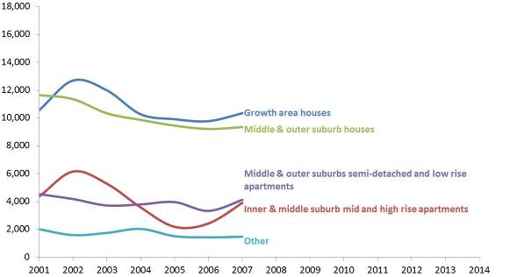
Source: ABS Building Approvals, cat. no. 8731.0
Residential development after 2008
In 2008, approvals started increasing and accelerated to reach a record high of 45,000 approvals in 2010. This was driven by a boom in growth area supply and growth in the number of apartments (largely high-rise, high density) being approved in the central city.
Since 2010 apartment development has spread beyond the central city to increasing numbers of middle ring suburbs. The year 2014 saw a new approvals record which was almost entirely due to the approval of medium- to high-rise apartments in inner and middle suburbs and, to a lesser extent, an increase in the number of small blocks of flats and townhouses in the middle and outer suburbs.
In 2014, the number of dwellings approved in small infill developments was more than double the average of the early 2000s and made up 20 per cent of all approvals (figure 2).
Since 2010 growth-area approvals have slowed but still make up a substantial proportion of Melbourne’s new housing.
Figure 2: Annual number of building approvals by selected dwelling type and location, Melbourne 2001-2014
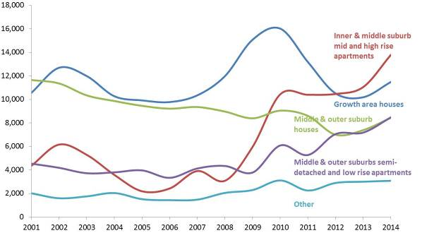
Source: ABS Building Approvals, cat. No. 8731.0
The role of planning in economic development:
a case study of the Laverton North industrial area
Introduction
This article presents a time-series analysis of industrial land consumption in Laverton North, from the early 1990s to today, to illustrate the impact of long term planning and investment on economic development.
Over the past 25 years, strategic planning has provided the preconditions for Laverton North to realise economic benefits from infrastructure investment and changes in market conditions.
Planning has seeded development through the zoning of suitable (relatively flat) land and by providing market certainty through long-term strategic plans (including plans for future road connections).
Long-term certainty and major Government investment in the Western Ring Road, coupled with changes in market conditions, unlocked the potential of Laverton North for development.
Key market changes include:
- Changes to the logistics industry: As the size of logistics enterprises has increased, demand for larger pieces of land has grown. Access to gateways and markets also became more important for many industrial enterprises. This included access to the Port of Melbourne (the largest container port in Australia) and to interstate road networks. Such access has enabled a number of companies to develop national distribution systems from Melbourne’s west.
- The rise of Real Estate Investment Trusts (REITs): REITs have allowed industrial land users to use purpose-built facilities without the need to purchase property. This has provided greater flexibility for firms by not being locked into a particular site and freeing up capital or funds that would otherwise have been used to buy property.

Figure 1: Laverton North Industrial area 1989-90

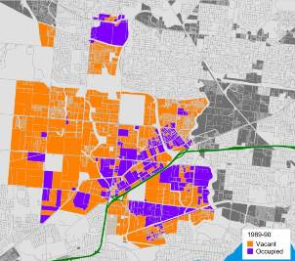Source: Urban Development Program

Figure 2: Laverton North Industrial area 1994-95
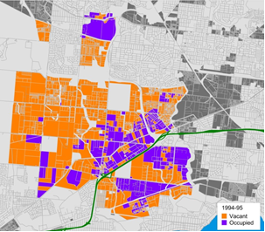
Source: Urban Development Program

Figure 3: Laverton North Industrial area 1999-2000

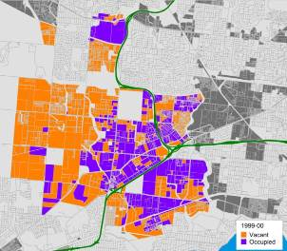
Source: Urban Development Program
Laverton North before the Ring Road
Figures 1 and 2 show Laverton North in the early and mid-1990s, before the construction of the Western Ring Road. Much of this land had been zoned industrial several decades earlier in the 1954 Metropolitan Melbourne Plan.
The Western Ring Road was included in transport plans from the late 1960s. Prior to the construction of the Western Ring Road, approximately 20-30 additional hectares of industrial land was used per year.
Laverton North after the Ring Road
Figures 3 and 4 show Laverton North in the late-1990s and mid-2000s after construction of the Western Ring Road. Government investment in the Ring Road led to Laverton North’s increased accessibility, unlocking the value of the area. Once the road was complete, land use levels increased to around 80 additional hectares per year (about 20 MCGs worth of land each year).
During the early to mid-2000s, Laverton North continued to attract industrial users as the market started to mature. Aldi and Murray Goulburn opened large distribution centres that could not be accommodated in other established areas.

Figure 4: Laverton North Industrial area 2004-05

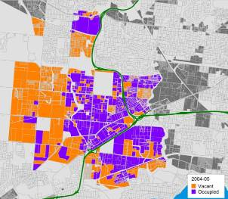Source: Urban Development Program

Figure 5: Laverton North Industrial area 2009-10

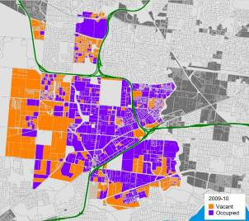Source: Urban Development Program

Figure 6: Laverton North Industrial area 2013-14

Source: Urban Development Program
Addition of the Deer Park Bypass
Figure 5 shows Laverton North in 2004-5, after the Deer Park Bypass was constructed. This bypass created additional access and efficiencies to freight movement, resulting in additional consumption of industrial land in Laverton North. Consumption peaked at 100 hectares in 2008 just prior to the Global Financial Crisis (GFC). Since the GFC, land use rates declined markedly and have only recently recovered to the longer term average of 80 hectares per year (Figure 6).
Conclusion
The series of figures shown above highlight that the planning decision to zone the land in Laverton North was made many years before its actual development. This was followed by planning for the Western Ring Road in the late 1960s.
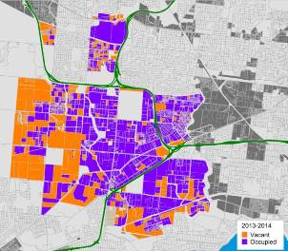Construction of the Western Ring Road unlocked the value of Laverton North for industrial users, particularly large logistics companies. The market outcome showed how the market follows these planning and infrastructure investments, establishing a significant location of economic activity.

