Victoria's Historic Population Growth: European Settlement to Present
1836 – 2011

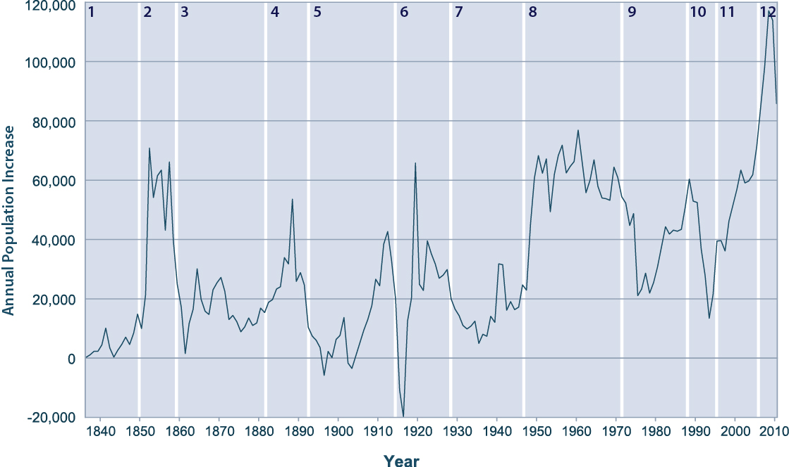

The above graph shows Victoria’s historic annual population growth for the period 1836 – 2011. This period is divided up into smaller periods, each of which is accompanied by a brief description of the factors that contributed to the patterns of population growth at this time. Each period is numbered from 1 to 12 on the chart and explained in the text below.

The data is sourced from the Australian Bureau of Statistics and the text commentary is from the Spatial Analysis & Research Team at the Department of Planning & Community Development.

1. First Permanent White Settlement in Victoria, 1836 - 1851
Permanent settlement established. White settler population grows to 100,000 in first 15 years. Indigenous population is not included in official population statistics until 1960s.

2. The Gold Rush, 1851 - 1858
Migrants flock to Victoria following the discovery of gold. Victoria’s population increases fivefold in seven years. By 1858 half of Australia’s population is in Victoria. Melbourne, Geelong, Ballarat and Bendigo become major centres.

3. The Resources Boom, 1858 - 1882
The ‘resources boom’ extends into agriculture, wool growing becomes a highly profitable export industry and stimulates population growth through most of Victoria.

4. Marvellous Melbourne, 1882 - 1892
Land prices boom and development accelerates rapidly in the 1880s, leading to very high growth. The speculative bubble bursts spectacularly in 1891-92.
5. The Crash and the Slow Recovery, 1892 - 1914
After the crash of 1892, Melbourne’s population growth slows from 20,000 per year to 2,000 per year. Just as a recovery begins, World War 1 breaks out in Europe.

6. World War 1 and the 1920s, 1914 - 1929
Population growth dips into the negative as servicemen join the allied war effort in Europe. The population grows rapidly when the war ends and servicemen start new families on their return.

7. The Great Depression and WW2, 1929 - 1945
High unemployment slows growth significantly during the 1930s – both overseas migration and fertility rates fall. Slow population growth continues through the war years.

8. The Long Boom, 1946 - 1970
World War II ends, and large numbers of returned servicemen start new families (the baby boom). Immigration from war-torn Europe is also significant as the economy grows strongly through a long period of virtually full employment.

9. Decline in Fertility and Volatile Economic Cycles, 1971 - 1990
The number of births peaks in 1971 but then increased use of contraception leads to a significant drop in fertility in the 70s. Volatile economic conditions – oil shocks, inflation and manufacturing moving offshore - lead to fluctuating levels of population growth. Significant population losses interstate are attributed to ‘sunbelt’ migration.
10. The Recession We Had to Have, 1991 - 1995
Again, poor economic conditions slow population growth, particularly in Victoria. Overseas migration falls to low levels as unemployment soars above 10%.

11. Recovery and the Knowledge Economy, 1995 - 2006
Victoria’s, and particularly Melbourne’s, economy recovers. Overseas migration increases as unemployment falls. Interstate population losses turned into net gains.

12. Record Population Growth, 2006 - 2011
A strong Australian economy and attractive lifestyle lead to strong population growth – fertility rates rise and there is a surge of overseas migration, particularly long term temporary migrants such as international students, as Australia weathers the Global Financial Crisis better than most.

