Resource 11: Final report example
Table 11.1 shows a potential structure of the final report for a legacy heritage study review. It is followed by two attachments:
- Attachment 11.1 shows a potential structure for the ‘master list’ heritage place summary in Appendix A of the final report
- Attachment 11.2 shows examples of HO mapping changes

Table R11.1 – Legacy review final report structure
Potential chapter | Potential sections | Notes
1 Introduction | 1.1: Purpose  1.2: Background  1.3: Acknowledgements  1.4: Study team | This chapter outlines the purpose of the study as set out in the brief.  Section 1.2 is an optional section if further detail is required to explain the background to the study.  Section 1.3 acknowledges people who assisted with the study, which could include the steering committee, community reference group, property owners and local historical societies.
2 Approach and methodology | 2.1: Introduction  2.2: Project management  2.3: Stakeholder engagement  2.4: Place assessment and documentation | Section 2.2 can include details of the project plan and the steering committee.  Section 2.3 should outline the approach to stakeholder engagement.  Section 2.4 describes the methodology used for place assessment with specific reference to VLHG and how they have been applied to establish the threshold of local significance.
3 Key findings | 3.1: Existing HO places  3.2: Recommended HO places  3.3: Potential heritage places  3.4: Not significant  3.5: Stakeholder consultation | This provides a concise summary of the findings of study.  Having regard to the methodology in Chapter 2, this section should clearly identify the places that are of local significance (or contribute to a heritage precinct), places of potential significance requiring future assessment and properties found not to be significant at the local level.  Section 3.5 should provide a summary of the key issues raised by submissions and the changes made to heritage citations (and recommended planning controls, if relevant) in response.
4 Recommendations | 4.1: Changes to the HO schedule and maps  4.2: Future work | This chapter provides a concise explanation of the proposed planning scheme changes arising from the study. It does not describe every change, but provides a summary of changes that are listed fully in Appendix A including:  - Updates (corrections, additions and deletions) to the HO schedule (tracked changes shown in Appendix D)  - Updates to the HO maps, including addition of new HO maps, if required (see also Appendix C).  Section 4.2 includes recommendations for the future assessment of places of potential heritage significance and any other issues arising from the study. For example, one heritage review identified that a council-owned building was in poor condition and in need of urgent conservation works. The recommendation in the study led to urgent repairs being carried out and provides the basis for the development of a business case for future work.
5 References | - | Lists the references used in the preparation of the study. (Note that the sources used in preparing place and precinct histories are listed in the associated heritage citation, only.)
Appendix A – Heritage place assessment summary | Existing heritage places (included in HO)  New heritage places (proposed for HO) | This provides a ‘master list’ for each heritage place, which identifies whether an on-site inspection was carried out, the SoS name and if changes are recommended to the HO schedule and maps. It is intended to be a ‘checklist’ when preparing amendment documentation.  See Attachment 11.1 for an example.
Appendix B – Stakeholder consultation | - | Includes copies of materials used for consultation such as FAQ sheets.
Appendix C – HO mapping | Changes to current HO precincts  Changes to current HO places  Proposed HO extent of new places | This includes a combination of plans and text to clearly describe the changes required for current and recommended HO places.  This document can be uploaded to the DTP map preparation service portal to request planning scheme amendment maps to support Step 3, see Resource 12: Planning scheme amendment.  See Attachment 11.2 for examples.
Appendix D – HO schedule changes | - | A ‘tracked changes’ version of the HO schedule showing the proposed changes.
Appendix E – Heritage guidelines | - | If required, insert new heritage guidelines here.
Appendix F – Potential heritage places | - | Insert list of potential heritage places here if it is longer than one page (otherwise, it could form part of section 3.3).
Appendix G – Not significant | - | Insert list of not-significant properties here if it is longer than one page (otherwise, it could form part of section 3.4).
Appendix H – Heritage citations (current HO places) | Precincts  GTS listings  Individual places  (or could be listed by locality) | There are separate sections for the citations for current and proposed HO places to avoid confusion about what is currently included in the HO and what is proposed to be added.
Appendix I – Heritage citations (recommended HO places) | As above | As above

Attachment 11.1 – Heritage place assessment ‘master list’ example
This would be Appendix A in the study report. It is ordered by locality and then by HO number (or, if no HO, order could be by street address).
Appendix C refers to the plans and text showing the HO mapping changes (see Attachment 11.2 for examples).
No. | HO | Name | Address | Fieldwork | SoS name | HO schedule changes? | HO map changes?
 |  | EMERALD
1. | HO1 | Emerald Primary School No.1372 | Hindmarsh Street | External inspection only | Emerald Primary School No.1372, Statement of Significance | Yes, change Solar energy systems apply? to ‘No’. | No
2. | HO2 | Emerald Railway Station | Hindmarsh Street & 36 Hindmarsh Street | As above | Emerald Railway Station, Statement of Significance | Yes, change External paint controls apply? and Solar energy systems apply? to ‘No’. | Yes, see Appendix C
3. | HO3 | Emerald Post Office | 65 & 67 Lloyd Street, 17 Wimmera Street | As above | Emerald Town Centre Heritage Precinct, Statement of Significance | Delete HO3 from the HO schedule | Remove 65 & 67 Lloyd St from HO3 and include within HO34.  Remove HO3 from 17 Wimmera St
4. | HO4 | Emerald Anglican Church | 37 Smith Street | As above | St Peters Anglican Church Complex, 37 Smith Street, Emerald Statement of Significance | Yes, change Solar energy systems apply? to ‘Yes, church only’. | No
5. | HO5 | Emerald Shire Hall | 101 Lloyd Street | Internal and external inspection | Emerald Shire Hall, 101 Lloyd Street, Emerald Statement of Significance | Yes, apply Internal alteration controls to the ceiling and marble plaque in hall | Yes, see Appendix C

Attachment 11.2 – Plans showing HO map changes examples

Existing HO places
HO30 House, 25 Gumnut Street, Emerald
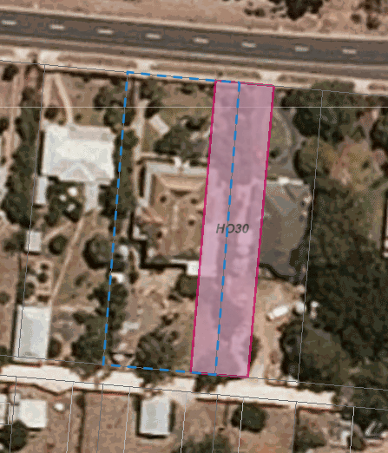
Currently, HO30 applies partly to 25 and partly to 23 Gumnut Street.
Recommended change: Correctly apply HO30 to 25 Gumnut Street, which is the property outlined in the blue dotted line.

HO36 Settlers Cottage and Memorial, Victoria Street, Emerald
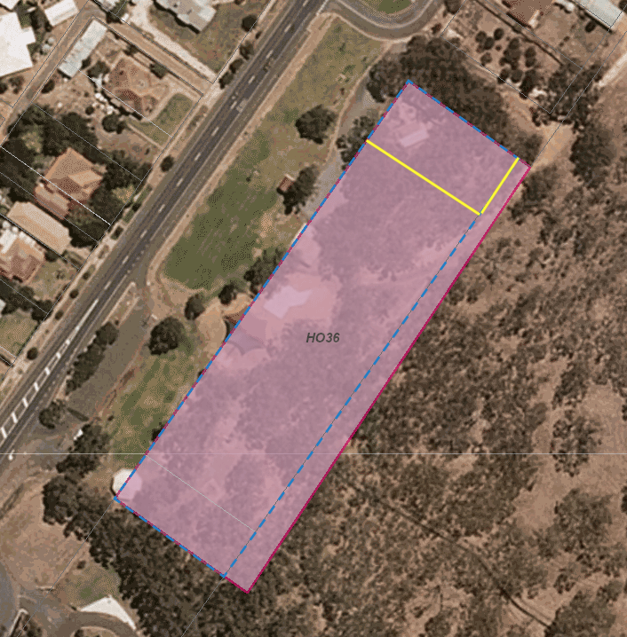
Currently, HO36 includes a large area of large that contains no heritage features.
Recommended change: Reduce HO36 to include only the cottage and a small curtilage as indicated by the yellow lines.
HO41 Road Bridge
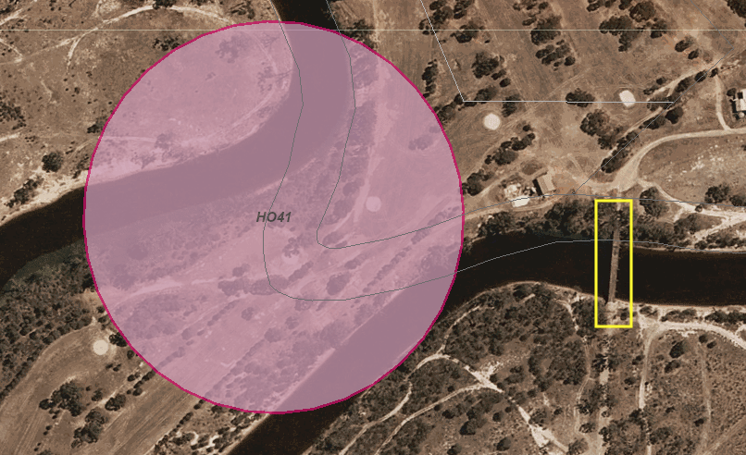
Currently, HO41 is in the wrong location and is too large.
Recommended change: Reduce and relocate as indicated in yellow to apply to the bridge and a small curtilage.

HO42 Emerald River Weir
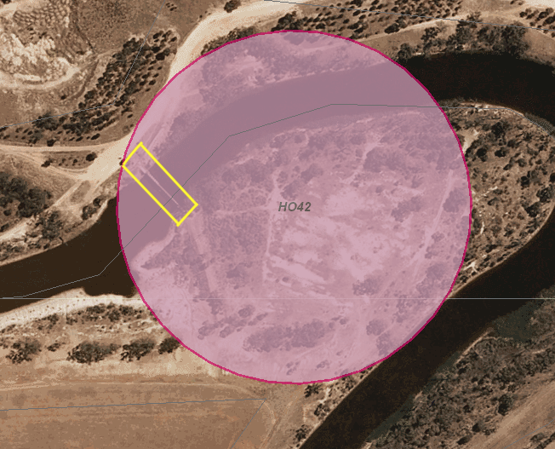
Currently, HO42 is too large.
Recommended change: Reduce as indicated in yellow to apply to the weir and a small curtilage.

Recommended new HO places

HO47 Emerald War Memorial Avenue
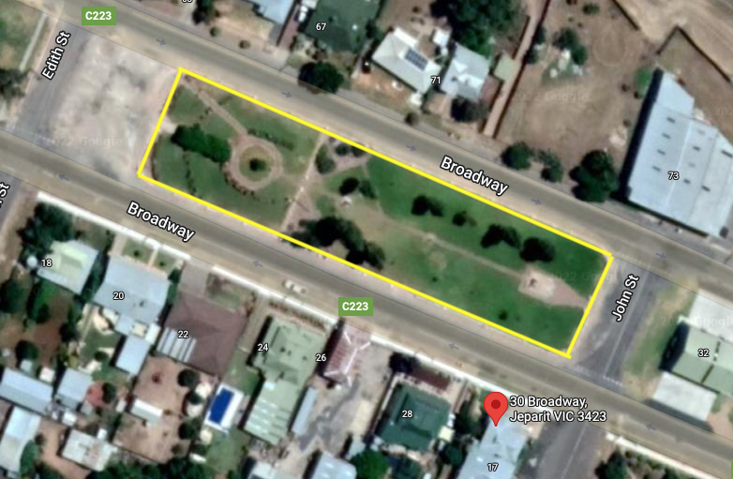
Apply HO47 to the land included within the yellow line.

HO46 Emerald Railway Bridge
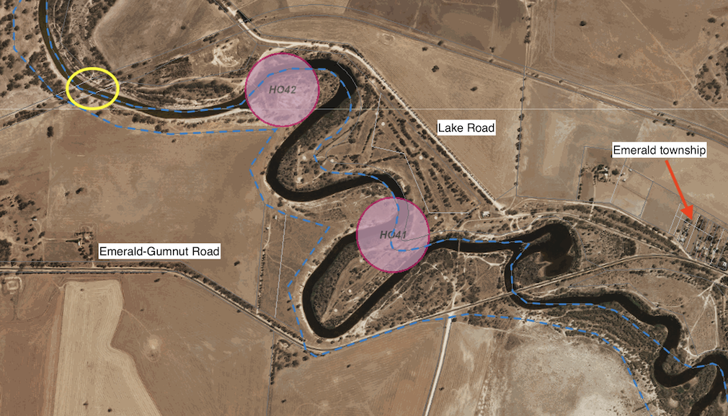
Emerald Railway Bridge locality plan

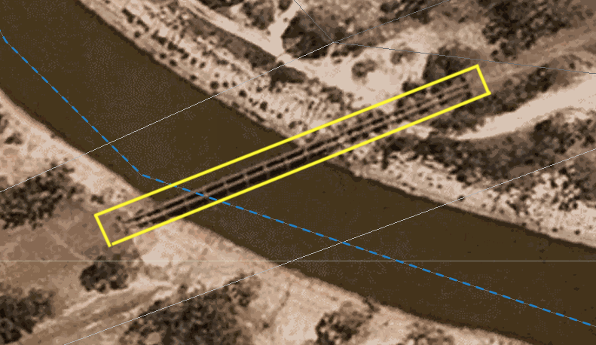
Emerald Railway Bridge HO extent – bridge and including a minimum of 5m from the edge on each side to form curtilage.

HO49 Emerald Shire War Memorial and HO50 Band Rotunda
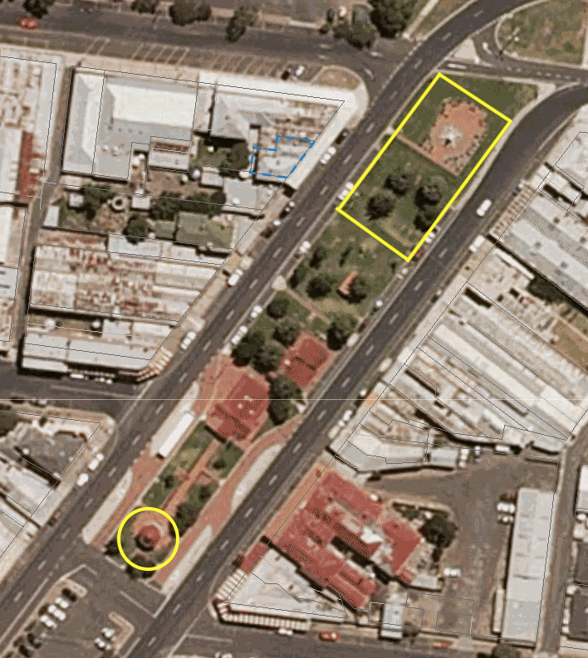
HO49 Emerald Shire War Memorial and Canary Island palms is at top outlined in yellow. Boundaries follow edge of carriageway on long sides, approximately in line with edge of paving on north side (top of page) and a minimum of 5m from the nearest palm tree on the south side.
HO50 Band Rotunda is at bottom, outlined in yellow – boundary a minimum of 5m from the edge of the rotunda.

