REFERRAL OF A PROJECT FOR A DECISION ON THE NEED FOR ASSESSMENT UNDER THE ENVIRONMENT EFFECTS ACT 1978

REFERRAL FORM

The Environment Effects Act 1978 provides that where proposed works may have a significant effect on the environment, either a proponent or a decision-maker may refer these works (or project) to the Minister for Planning for advice as to whether an Environment Effects Statement (EES) is required.

This Referral Form is designed to assist in the provision of relevant information in accordance with the Ministerial Guidelines for assessment of environmental effects under the Environment Effects Act 1978 (Seventh Edition, 2006). Where a decision-maker is referring a project, they should complete a Referral Form to the best of their ability, recognising that further information may need to be obtained from the proponent.

It will generally be useful for a proponent to discuss the preparation of a Referral with the Department of Planning and Community Development (DPCD) before submitting the Referral.

If a proponent believes that effective measures to address environmental risks are available, sufficient information could be provided in the Referral to substantiate this view. In contrast, if a proponent considers that further detailed environmental studies will be needed as part of project investigations, a more general description of potential effects and possible mitigation measures in the Referral may suffice.

In completing a Referral Form, the following should occur:
- Mark relevant boxes by changing the font colour of the ‘cross’ to black and provide additional information and explanation where requested.
- As a minimum, a brief response should be provided for each item in the Referral Form, with a more detailed response provided where the item is of particular relevance. Cross-references to sections or pages in supporting documents should also be provided. Information need only be provided once in the Referral Form, although relevant cross-referencing should be included.
- Responses should honestly reflect the potential for adverse environmental effects. A Referral will only be accepted for processing once DPCD is satisfied that it has been completed appropriately.
- Potentially significant effects should be described in sufficient detail for a reasonable conclusion to be drawn on whether the project could pose a significant risk to environmental assets. Responses should include:
- a brief description of potential changes or risks to environmental assets resulting from the project;
- available information on the likelihood and significance of such changes;
- the sources and accuracy of this information, and associated uncertainties.
- Any attachments, maps and supporting reports should be provided in a secure folder with the Referral Form.
- A CD or DVD copy of all documents will be needed, especially if the size of electronic documents may cause email difficulties. Individual documents should not exceed 2MB.
- A completed form would normally be between 15 and 30 pages in length. Responses should not be constrained by the size of the text boxes provided. Text boxes should be extended to allow for an appropriate level of detail.
- The form should be completed in MS Word and not handwritten.

The party referring a project should submit a covering letter to the Minister for Planning together with a completed Referral Form, attaching supporting reports and other information that may be relevant. This should be sent to:

Postal address Couriers

Minister for Planning Minister for Planning
PO Box 500 Level 17, 8 Nicholson Street
EAST MELBOURNE VIC 3002 EAST MELBOURNE VIC 3002
In addition to the submission of the hardcopy to the Minister, separate submission of an electronic copy of the Referral via email to ees.referrals@dpcd.vic.gov.au is encouraged. This will assist the timely processing of a referral.

______________________________________________________________
PART 1 PROPONENT DETAILS, PROJECT DESCRIPTION & LOCATION

1. Information on proponent and person making Referral

Name of Proponent: | Tourism Victoria (for the State of Victoria)
Authorised person for proponent: | Mr Peter Watkinson
Position: | Executive Director, Public Land  Department of Sustainability and Environment, Victoria
Postal address: | PO Box 500, East Melbourne 3002
Email address: | Peter.watkinson@dse.vic.gov.au
Phone number: | (03) 9637 8401
Facsimile number:
Person who prepared Referral: | (Ms) Jo Connellan
Position: | Senior Project Officer
Organisation: | Department of Sustainability and Environment
Postal address: | PO Box 500, East Melbourne 3002
Email address: | Jo.connellan@dse.vic.gov.au
Phone number: | (03) 9637 8069
Facsimile number:
Available industry & environmental expertise: (areas of ‘in-house’ expertise & consultancy firms engaged for project) | CEE Consultants P/L  Birdon Group  CMS Marine Engineers

2. Project – brief outline

Project title:
ex HMAS Canberra proposed dive site
Project location: (describe location with AMG coordinates and attach A4/A3 map(s) showing project site or investigation area, as well as its regional and local context)
The proposed disposal site is in Bass Strait situated between Port Lonsdale and Barwon Heads Victoria. It is approximately 2 to 3 km offshore from the dune coastline of Ocean Grove, 4.2 km from the mouth of the Barwon River and 6.2 km from Point Lonsdale. Vicroads reference Map 455 B12

The coordinates of the 300m x 100m grid, into which the vessel will be centrally scuttled, is as follows:
SITE | DATUM | Latitude | Longitude | Map | Easting | Northing
NW4 | WGS84 | S38 | 17.872 | E144 | 32.593 | 55H2851605758280
SW4 | WGS84 | S38 | 18.034 | E144 | 32.593 | 55H2851685757980
NE4 | WGS84 | S38 | 17.872 | E144 | 32.661 | 55H2852605758283
SE4 | WGS84 | S38 | 18.034 | E144 | 32.661 | 55H2852685757983

Refer Attachment 1A and 1B for additional location details.

Short project description (few sentences):
The Commonwealth Government has gifted the ex HMAS Canberra to the State of Victoria to be utilised as a dive attraction off the Victorian Coast.

The HMAS Canberra is the second of four FFG-7 Class Guided Missile Frigates built for the Royal Australian Navy in the USA. It was commissioned in 1981 and decommissioned in 2005.

The vessel has a total length of 138.1 metres and a beam at the widest point of 13.7 metres with an overall displacement of 4,100 tonnes. In service, her overall height from keel to top of the mast was approximately 39 metres. Once prepared for scuttling her height will be reduced to approximately 22 metres with the removal of radar equipment, aerials, and shortening of the masts.

The vessel is currently being prepared for scuttling. The Birdon Group have a contract with the Commonwealth Government to undertake the preparation works to the required standards, to tow the prepared artificial reef to the site and to scuttle it.

- Project description

Aim/objectives of the project (what is its purpose / intended to achieve?):
The aim of the project is to provide a major recreational dive site, sited near other dive attractions including historic wrecks, off the Victorian coast.

The project is expected to attract interstate and international recreational divers and visitors, and increase local diver participation and activity. This is expected to realise significant economic benefits to the Victorian economy and provide a major boost for the local dive industry.

The project will be managed and maintained it as a dive site for 20 to 50 years.

The project is supported by both the State and Commonwealth Governments.

Background/rationale of project (describe the context / basis for the proposal, eg. for siting):
The purpose of the project is to provide a high quality dive attraction off the Victorian Coast that will attract local, interstate and international divers. Key features in the siting selection were
- In an area with little of no seabed flora, and with sufficient sand depth to ensure the vessel will be stable once scuttled;
- In water depths that allow the maximum number of divers to access the site (30m or less);
- Outside the Port of Melbourne area, and outside commercial shipping areas; and
- In an area where similar dive wrecks are, so enhancing the tourism potential of the area.
- In close enough proximity to emergency facilities (Alfred Hospital decompression unit)

An assessment of potential sites along the Victorian coast in 2006, including a preliminary on-site survey, concluded that this was the area that best met most of these criteria.

The historic wrecks - current dive attractions in the area - are the result of past scuttling exercises with the primary purpose being disposal only. Consequently, many of them are located in very deep water, which makes them accessible to a limited number of divers. This project will greatly enhance the diving experience within the area, and cater for a wider range of divers.

The concept of utilising a former naval vessel for a dive site is not new. Around the Australian coast in recent years there have been several such dive sites created, and they have been generally successful.

Main components of the project (nature, siting & approx. dimensions; attach A4/A3 plan(s) of site layout if available):
The main component of the project is the reef itself. The vessel has a total length of 138.1 metres and a beam at the widest point of 13.7 metres with an overall displacement of 4,100 tonnes. The height will be approximately 22 metres.

Refer to Attachment 1 for location details of the site. The vessel will be scuttled within the 300x100m area, with the optimal result being the vessel resting on the sea floor in the centre of the area. Some deviation from this may occur in the scuttling process.

Attachment 2 shows the expected profile of the ex-HMAS Canberra when settled on the sea floor.
Ancillary components of the project (eg. upgraded access roads, new high-pressure gas pipeline; off-site resource processing):
There will be moorings around the site – the exact number is yet to be determined, but it is anticipated that it will be between 4 and 6. It is expected that four will mark the corners of the 300m x 100m grid which will be the ‘no take’ zone for fishing. They will be the only components of the project visible above the water.

Key construction activities:
The main construction activities will occur as part of the vessel preparation phase.

Once the preparation works are approved as part of the Environment Protection (Sea Dumping) Act 1981(C’wlth) permit, the vessel will be towed to the site and scuttled when weather and ocean conditions are not adverse.

A scuttling plan has been prepared as part of the Environment Protection (Sea Dumping) Act 1981(C’wlth) permit application, with scuttling not permitted until that plan has been approved. The current version of that plan is shown as Attachment 3.

Key operational activities:
Once in place, the reef will be used for recreational diving activities. It will be managed by Parks Victoria, and maintained in accordance with the Long Term Monitoring and Management Plan. (LTMMP) Attachment 4. Environmental monitoring is detailed in Section 11 of Attachment 5.
Key decommissioning activities (if applicable):
The project is not decommissioned per se, but over time it will disintegrate. Attachment 4 and Section 11, Attachment 5 details how that will be managed to minimise impacts.
Is the project an element or stage in a larger project?
No, the project is a single stage project.
Is the project related to any other past, current or mooted proposals in the region?
No. this project is the first of its kind undertaken in Victoria.

4. Project alternatives

Brief description of key alternatives considered to date (eg. locational, scale or design alternatives. If relevant, attach A4/A3 plans):
N/A

Brief description of key alternatives to be further investigated:
In the event that this site is not approved, alternate sites within Port Phillip Bay will be considered. A new EES referral would be prepared for any an alternate site.

5. Proposed exclusions

Statement of reasons for the proposed exclusion of any ancillary activities or further project stages from the scope of the project for assessment:
N/A

6. Project implementation

Implementing organisation (ultimately responsible for project, ie. not contractor):
Responsibility for the vessel transfers to the Department of Sustainability and Environment (DSE), on behalf of the State of Victoria, when the vessel settles on the seabed, and a compliance certificate as required under the Environment Protection (Sea Dumping) Act 1981(C’wlth) has been issued by the Commonwealth Department of Environment, Water, Heritage and the Arts. (DEWHA). The DSE is delegating management of the site to Parks Victoria.

Implementation timeframe:
It is anticipated that scuttling will occur in the second half of 2009. The earliest likely date is August.

Proposed staging:
N/A

7. Description of proposed site or area of investigation

Has a preferred site for the project been selected?
Yes
General description of preferred site, (including aspects such as topography/landform, soil types/degradation, drainage/ waterways, native/exotic vegetation cover, physical features, built structures, road frontages; attach ground-level photographs of site, as well as A4/A3 aerial/satellite image(s) and/or map(s) of site & surrounds, showing project footprint):
Attachment 5 details the general description of the site.

The key features of the seabed in this general area of Bass Strait are;
- Submerged river valleys filled with sand
- Sand seabed
- Extensive areas of rubble; and
- reef outcrops

The proposed site for the reef is within the submerged river valley of the old Barwon River, which is mostly comprised of fine sand, with areas of slightly coarser sand. Parts of the river bed include rubble, particularly along the edges. The main valley is 150 to 200m wide and is bound by relatively steep sides as it deepens from 24m in the north to 34m a further 1500m to the south

Photographs across the site and surrounding areas are shown below.

No plants or animals were observed attached to the sandy seabed, and very few fish were observed. The sediments were clean and aerated and therefore likely to have low organic content, Hence in fauna are likely to be sparse.

The bathymetry of the site is shown below

Preferred
site
sandy seabed.

No attached flora or fauna

The sediment depth & character at the preferred site is 1.5m over most of the site, with a small strip of shallower sand along the east and southern boundaries (Refer Fig 14, Attachment 5). Sand waves are small, less than 20cm tall, and present as small perturbations rather than continuous waves. The sediment was fine to medium grained sands with small shell fragments.

Wave conditions at the site are a combination of waves generated by local and regional winds and ocean swell travelling into Bass Strait and the Southern Ocean. The significant wave height is less than 1.5m for 20 percent of the time, with the maximum wave height of 6m occurring about 10 times a year. Divers at the site will be influenced by wave surge most of the time.

The depth of the site (27-28m), and the relative depth of the surrounding reefs (21m) will generate a net onshore flow of water over the reefs and a net offshore flow of water at the depth of the submerged reef during major storms. The net flow down the river channel will carry sand past the reef.

Near shore, there is a net movement of sand from west to east along the coast, with most of the transport occurring inshore of the 12m contour.
Site area (if known):
3Ha (hectares)
Route length (for linear infrastructure)
N/A
Current land use and development:
On shore are the coastal towns of Barwon Heads (west), Ocean Grove and Point Lonsdale(east). Ocean Grove is the closest town to the site, with parts of it elevated and overlooking the site.

The coastline is predominantly sandy, surf beaches baked by vegetated dunes.

The off shore area is not of particular importance to either recreational or commercial fishing, although there are a few lobster and abalone fishers who utilised the reef areas.

The site is outside the Port of Melbourne area and hence an area of commercial shipping. recreational boating is limited by wind conditions and sea conditions which combine to limit the general accessibility of the site.

Description of local setting (eg. adjoining land uses, road access, infrastructure, proximity to residences & urban centres):
The site is approximately 2 kilometres off shore between Barwon Heads and Point Lonsdale. Access is from the Barwon River or from Queenscliff harbour and Portsea/Sorrento area, with most commercial diving and fishing charters operating out of the Port Phillip Bay access points.

The only structure visible above the water will be moorings, which will be difficult to see from onshore.

Planning context (eg. strategic planning, zoning & overlays, management plans):
The area is not within any municipal planning scheme, so no permits are required. A Long Term Management and Monitoring Plan (Attachment 4) has been prepared as part of the Environment Protection (Sea Dumping) Act 1981 (C’wlth) permit application.

Local government area(s):
N/A

8. Existing environment

Overview of key environmental assets/sensitivities in project area and vicinity (cf. general description of project site/study area under section 7):
The main environmental assets and sensitivities in the onshore and offshore areas close to the site include the following
- Marine Flora and Fauna (Attachment 5, Section 4)
The project is located in the Central Victorian Marine Bioregion of the Interim Marine and Coastal Regionalisation for Australia (MCRA 2006) where the marine fauna and flora are typically cool temperate. The flora and fauna varies with the seabed habitats – reefs, areas of rock rubble and sandy – with greater quantity and diversity found in the reef areas and very limited quantity and diversity found in the sandy areas. The proposed site is bare sand with no flora or fauna attached, and very little floating through.
- Protected Species (Attachment 5 Section 5)
Attachment 5 details all the listed and/or protected species that are known to potentially inhabit or migrate through this area. Key species are the Blue Whale (Balaenoptera musculus), the Southern Right Whale (Eubalaena australis), the Humpback Whale (Megaptera novaengliae), the Great White Shark (Carcharodon carcharias), the Australian Grayling (Prototroctes maraena) and School Shark (Galoerhinus galeus), the Brydes Whale (Balaenoptera edeni), the Pygmy Right Whale (Caperea marginate), the Killer Whale (Orcinus orca) and the Dusky Dolphin (Lagenorhynchus obscurus).
- Barwon Bluff Marine Sanctuary and Port Phillip Heads Marine National Park – Point Lonsdale (Attachment 5 Section 6)
Barwon Bluff Marine Sanctuary, about 4km to the west of the site, is small and extends to about 400m offshore to the south and east. It consists of intertidal and subtidal seabed which is a mixture of sandstone, basalt boulders, reef platforms and sandy beaches. A variety of typical flora and fauna are present.
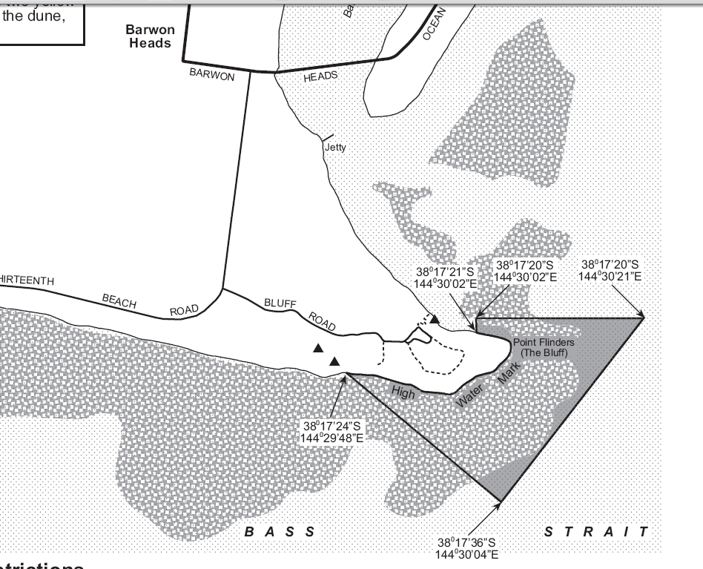
Figure 1. Location of Barwon Bluff Sanctuary
The Port Phillip Heads Marine National Park, about 6km east of the site, consists of 415 Ha of intertidal and subtidal seabed. It is highly valued for the diversity of habitats including subsea canyons, and has a corresponding diversity in marine flora and fauna. The diversity of the red algal seaweed flora is recognised worldwide
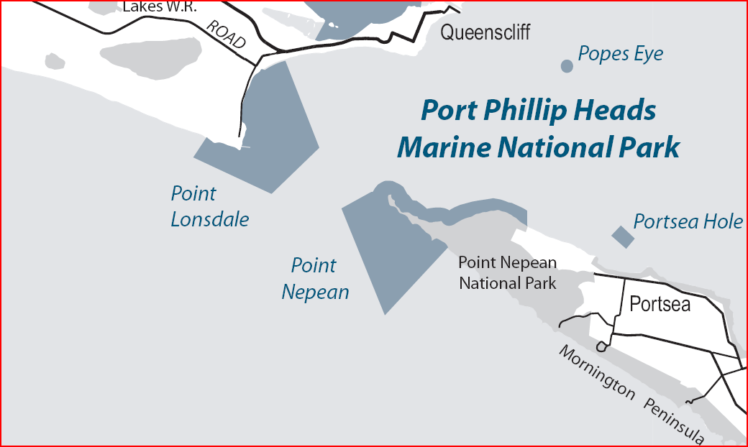
To dive site
Figure 2. Port Phillip Heads Marine National Park
- Fishing (Attachment 5 Section 7)
Commercial and recreational fishing in the vicinity of the proposed site is relatively low in intensity. Commercial fishing is limited to rock lobster fishing and abalone collection, both of which occur on nearby reefs. The general conditions on the site – wind, wave and low fish numbers – make it a generally low use area for recreational users. The installation of the reef is expected to increase the fish in the area, although it is not known whether that will increase actual numbers or simply attract the fish to the specific location.
- Recreation (Attachment 5 Section 8)
- Swimming and surfing occur within the region, within the 200m zone from shore. Recreational diving is popular in the region, mostly within Port Phillip Bay and the entrance. More experienced divers visit the various wrecks outside the bay in the deeper waters, including in the vicinity of the proposed site. The following figures show the location of historic wrecks close to the proposed site and in the general region.
Wreck site
Figure 3. Shipwrecks in vicinity of exHMAS Canberra site

Figure 4. Location of “Ships' Graveyard”, southwest of exHMAS Canberra site
- Other
AAV advise that there are no obligations for the activity in relation to the Aboriginal Heritage Act 1995.
Visual amenity. The only objects potentially visible from onshore will be the moorings, but given the distance from the nearest onshore location, it is unlikely they will be easily visible.

9. Land availability and control

Is the proposal on, or partly on, Crown land?
The project will be on reserved Crown land.
Current land tenure (provide plan, if practicable):
The dive site is owned by the State of Victoria.
Intended land tenure (tenure over or access to project land):
The dive will be reserved under the Crown Land (Reserves) Act 1978 and a Committee of Management (Parks Victoria) established to manage the site.
Other interests in affected land (eg. easements, native title claims):
N/A

10. Required approvals

State and Commonwealth approvals required for project components (if known):
- Coastal Management Act (CMA) consent is required.
- Environment Protection (Sea Dumping) Act 1981(C’wlth) permit is required
Have any applications for approval been lodged?
- EPBC Act referral is probably not necessary- being confirmed.
- CMA consent has been sought.
Approval agency consultation (agencies with whom the proposal has been discussed):
The following agencies have been consulted:

Marine Safety Victoria, Victorian Regional Channels Authority, Port of Melbourne Corporation, Parks Victoria, Port of Barwon Heads/Barwon Heads CoM, Heritage Victoria, Victorian Coastal Council, EPA, Western Coastal Board, Australian Maritime Safety Authority, City of Greater Geelong, Melbourne Water, Australian Hydrographic Office, Australian Fisheries Management Authority.
State Departments of
- Primary Industries – Aquaculture & Fisheries
- Innovation, Industry & Regional Development – Tourism Victoria
- Transport – Ports and Marine
- Planning and Community Development – Sport and Recreation
- Planning and Community Development - AAV

Other agencies consulted:
The following stakeholders were consulted, including an invitation to attend a community workshop;
- Commercial and recreational divers
- Commercial and recreational fishers
- Charter operators
- Traders groups
- Local and regional tourism associations
- Surf Life Saving Clubs
- Residents Associations
- Volunteer Coast Guard
- Port Phillip Sea Pilots

PART 2 POTENTIAL ENVIRONMENTAL EFFECTS

11. Potentially significant environmental effects

Overview of potentially significant environmental effects (identify key potential effects and comment on their significance and likelihood, as well as key uncertainties):
Attachment 5 discusses the likely environmental impacts of the project.

Marine Impacts

The impacts on water quality and the local marine environment are predicted to be minimal provided the vessel is prepared properly and to the standards required to obtain a permit under the Environment Protection (Sea Dumping) Act 1981(C’wlth). ie the vessel, when scuttled, needs to be clean and free from any hazardous or toxic substances before the permit is issued. DEWHA, as part of the assessment for this permit, have undertaken several inspections of the vessel during the preparation work, and verbally advised that it is the most well prepared vessel that they have inspected to date. A final inspection will occur prior to towing the vessel to the site to ensure the scuttled vessel is clean.

Once scuttled the vessel will slowly deteriorate, a process that will be monitored to ensure there are no adverse impacts for the life of the project.

As described in section 7 above, divers at the site will be influenced by wave surge most of the time. The reef will need to be ballasted to resist the forces due to currents and wave induced currents in the design storm. Commercial Marine Solutions (CMS) 2009 reviewed the stability of the vessel at the proposed site, taking existing wave conditions and anticipated state of the prepared vessel at time of scuttling (ballast, weight etc) and concluded that it would be stable. DEWHA have reviewed this report, and concurred.

The depth of the site (27-28m), and the relative depth of the surrounding reefs (21m) will generate a net onshore flow of water over the reefs and a net offshore flow of water at the depth of the submerged reef during major storms. The net flow down the river channel will carry sand past the reef, but the reef is not expected to block or change this net movement of sand, although it may have some localised effects. The reef is not expected to have a significant effect on beach conditions or the net longshore transport of sand to the east along the coast.

The marine environment at the site, with its bare sandy substrate, has no attached plants and no attached or mobile animals were present during investigations. (Fig 19, Attachment 5). Consequently, minimal impact is expected on the marine environment of the site.

Exclusion zones

A condition of the scuttling plan is that an exclusion zone is established around the site that will ensure any larger marine life (whales, dolphins etc) will be protected during the scuttling exercise

Once operating, exclusion zones will be established in the area directly above the reef to exclude fishing. While essentially used to ensure diver safety, it will have the added benefit of providing a ‘no take’ zone for fish. The extent to which the reef is colonised will determine the management methods over time. If the initial proposal to have a ‘no take’ zone around the reef only proves to be too narrow, then the ‘no take’ zone can be expanded.

Flora and Fauna

Attachment 5 provides advice on flora and fauna within the area, and concludes that the project will have insignificant impact with respect to the requirements of the Environment Protection and Biodiversity Act 1996 (C’wlth), the Flora and Fauna Guarantee Act 1988 and the Fisheries Act 1995.

Video evidence of the site, appendices of Attachment 5, demonstrates that the site is sandy and largely free of biota.

12. Native vegetation, flora and fauna

Native vegetation
Is any native vegetation likely to be cleared or otherwise affected by the project?
A very small amount of vegetation may be affected in the scuttling process, but any effect will not be long term. Vegetation within the area is minimal and common along the Victorian coast.
The first individual referral criteria in the Ministerial Guidelines for assessment of environmental effects under the Environment Effects Act 1978- potential clearing of 10ha or more of native vegetation – is not meet with this project
What investigation of native vegetation in the project area has been done?
Refer to Attachments 5 for details of native vegetation both on the site and within the region.
What is the maximum area of native vegetation that may need to be cleared?
N/A
How much of this clearing would be authorised under a Forest Management Plan or Fire Protection Plan?
N/A
Which Ecological Vegetation Classes may be affected? (if not authorised as above)
N/A

Have potential vegetation offsets been identified as yet?
N/A
Other information/comments? (eg. accuracy of information)

Flora and fauna
What investigations of flora and fauna in the project area have been done?
Extensive investigations have been undertaken as detailed in Attachment 5. These include desktop research on the likely and typical flora and fauna to be located in the vicinity, and several on-site surveys including many hours of towed video evidence.
Have any threatened or migratory species or listed communities been recorded from the local area?
Section 5 of Attachment 5 details the threatened, listed and migratory species that have been recorded or could be expected to be present within the area of the site.
Listed threatened species and communities are the Blue Whale (Balaenoptera musculus), the Southern Right Whale (Eubalaena australis), the Humpback Whale (Megaptera novaengliae), the Great White Shark (Carcharodon carcharias), the Australian Grayling (Prototroctes maraena) and School Shark (Galoerhinus galeus).
Listed migratory species are the Blue Whale (Balaenoptera musculus), the Southern Right Whale (Eubalaena australis), the Humpback Whale (Megaptera novaengliae), the Great White Shark (Carcharodon carcharias), the Brydes Whale (Balaenoptera edeni), the Pygmy Right Whale (Caperea marginate), the Killer Whale (Orcinus orca) and the Dusky Dolphin (Lagenorhynchus obscurus)
If known, what threatening processes affecting these species or communities may be exacerbated by the project? (eg. loss or fragmentation of habitats) Please describe briefly.
N/A
Are any threatened or migratory species, other species of conservation significance or listed communities potentially affected by the project?
The scuttling process include consideration of the possible impacts on migratory species and provides for an exclusion zone for the scuttling process as detailed in Attachment 3
Section 5.51.5 of Attachment 5 summaries the potential impacts of the project on any of these species. Examination of the general distribution, migration patterns, aggregation areas and breeding behaviour of these listed protected species revealed that the near shore marine environment at Ocean Grove has no particular significance to any of these species. Some species are more likely to occur in the area than others, such as the Great White Shark, Killer Whales and School Shark, but there is no apparent pathways in the installation or operation of the exHMAS Canberra proposal that are likely to have significant impact on any species according to the significant impact guidelines provided by DEWHA. In addition, vessels visiting the wreck site will be required to comply with the Victorian Wildlife (Whales) Regulations 1998 which prescribe requirements for all vessels within 300m of a whale or dolphin, and the Environment Management Plan for scuttling will require provision of avoidance of interaction of the scuttling process with whales and dolphins.
The second individual referral criteria in the Ministerial Guidelines for assessment of environmental effects under the Environment Effects Act 1978- potential long term loss of a significant proportion of knowing remaining habitat or population of threatened species within Victoria – is not meet with this project
Is mitigation of potential effects on indigenous flora and fauna proposed?
N/A. By introducing a reef into an area with limited flora and fauna, a potential impact of this project is to increase flora and fauna within the area.
Other information/comments? (eg. accuracy of information)

13. Water environments

Will the project require significant volumes of fresh water (eg. > 1 Gl/yr)?
N/A
Will the project discharge waste water or runoff to water environments?
N/A

Are any waterways, wetlands, estuaries or marine environments likely to be affected?
There will be some impact on the marine environment in placing a vessel on the seabed. Because a permit is required under the Environment Protection (Sea Dumping) Act 1981(C’wlth), which has stringent requirements that must be meet in the preparation of the vessel, those impacts will be minimal. One of the key requirements to obtain a permit under this Act is for the vessel to be well prepared – ie it is cleaned of all potentially toxic, hazardous, environmentally damaging materials.

Are any of these water environments likely to support threatened or migratory species?
No, they do not support migratory species, but some species pass through the area as part of their seasonal migration.
Blue Whale – Their migratory paths are not properly understood, but may pass through the area in autumn and spring. If that occurs, it would be more likely to be a considerable distance off shore from the coastline
Southern Right Whale – It’s migratory habits include arriving along the Victorian Coast in May/June and staying until October/November. Although found all along the coast, they are only intermittently found in the central Bass Coast region.
Humpback Whales – The proposed site is not in the usual migratory path for the Humpback Whales.
Brydes Whale – This species is typically found in the warmer waters in northern Australia, and is unlikely to occur in the vicinity of the proposed site.
Pygmy Right Whale – It may be common in the area from time to time, but do not appear to have seasonal migrations.
Dusky Dolphin – Their occurrence has not been documented in Bass Strait. They inhabit cool southern waters and migrate southward in summer.
Killer Whale – Small pods have been observed in Bass Strait from time to time, including in the vicinity of the proposed site.
Great White Shark - A highly mobile species, following no known migratory path, which has been observed in the vicinity of the site. They typically stay in one area only for a few days.
Are any potentially affected wetlands listed under the Ramsar Convention or in 'A Directory of Important Wetlands in Australia'?
N/A.
Could the project affect streamflows?
N/A
Could regional groundwater resources be affected by the project?
N/A
Could environmental values (beneficial uses) of water environments be affected?
The beneficial uses to be protected are:
- primary and secondary contact for recreation – the reef will result in a positive impact in both primary and secondary contact of the water for recreation within the vicinity because it will increase the number of people accessing the site.
- aesthetic enjoyment – there will be an impact on the visual aspects of the area because some moorings will be included in what is now an open site. These will be unlikely to impact negatively on the aesthetics from a shore based perspective, because they will be very difficult to see.
- indigenous, cultural and spiritual values – there are no known values associated with the waters at this site, and this project will not change that.
- non indigenous, cultural and spiritual values - there are no known values associated with the waters at this site, and this project will not change that.
- aquaculture – there is no aquaculture in the vicinity at the moment, nor is there any plans for the future.
- industrial and commercial use – there are 2 or 3 lobster fishers in the vicinity, who are aware of the position of the project and the location of the ‘no take’ zone which will have minimal impact on their activities because lobsters are found in the reef areas outside the proposed site.
- fish, crustacean and molluscs for human consumption – the preparation of the vessel prior to scuttling includes the removal of all materials and substances that may impact on the environment including fauna. There are no known impacts on this value.

Could aquatic, estuarine or marine ecosystems be affected by the project?
Whilst there is some potential for local marine ecosystems to experience some minor effects, it is not anticipated that the any ecosystems will be affected significantly. The marine ecosystems in the exact area proposed for the wreck is bare sandy substrate, with no attached plants and animals. A few mobile animals and plants were observed passing through the site during investigations which, if there at the time of scuttling, will be destroyed. Given the general bareness of the site, and the absence of any significant flora and fauna, and the commonness of the flora and fauna that is present, minimal impact beyond the initial scuttling and settling period is expected.
Coastal processes will be affected by the placement of this wreck, as the out flowing sand along the former river bed will now have the reef in its path which may cause some accumulation of sand on the northward side of the vessel and some scouring on the southward side. This isn’t of significance because the proposed orientation of the reef will provide some clearance on both sides of the reef that will enable the outward flow of sand to continue.
The wave climate in the vicinity of the reef will be minimally affected if at all, and with the reef provided with sufficient ballast to maintain stability, this is not significant.
Is there a potential for extensive or major effects on the health or biodiversity of aquatic, estuarine or marine ecosystems over the long-term?
Potential extensive or major effects on the health or biodiversity of marine over the long term due to this project is very unlikely because the preparation of the vessel prior to scuttling needs to be of a standard to meeting the requirements for obtaining a permit under the Environment Protection (Sea Dumping) Act 1981. All hazardous and toxic materials are stripped from the vessel, so that a clean and effectively non reactive lump of material is placed in the site.
The slow breakdown of the reef over time, with the reef being steel, aluminium, concrete, lead ballast and fibrous insulation, is expected to have minimal impact on the substrate and water quality as per the findings of R.K Johnston et.al .
The effect on coastal processes is described in the previous question as not significant, and this is expected to continue to be the case in the longer term.
Is mitigation of potential effects on water environments proposed?
There are potentially some immediate effects on the water environment due to the Scuttling process. Mitigation of these effects is included in the Scuttling Plan. Any floating debris will be collected and properly disposed of on shore. Floating hydrocarbons may also be present, and they will be collected and disposed of onshore.
A regular monitoring program will be undertaken over the life of the project. The focus of the monitoring is to inform management actions to minimise potential risks to the users of the reef and the environment. This will include monitoring of fauna and flora, including the potential introduction of pest species, and the impacts of the artificial reef on the nearby natural reefs.
Other information/comments? (eg. accuracy of information)

14. Landscape and soils

Landscape
Has a preliminary landscape assessment been prepared?
N/A.
Is the project to be located either within or near an area that is:
- Subject to a Landscape Significance Overlay or Environmental Significance Overlay?
No
- Identified as of regional or State significance in a reputable study of landscape values?
No
- Within or adjoining land reserved under the National Parks Act 1975 ?
The project is located within the vicinity of the Barwon Bluff Sanctuary and the Port Phillip Heads Marine National Park, but its not expected to impact on either or them. Refer Attachment 5
- Within or adjoining other public land used for conservation or recreational purposes?
Yes – it is within land reserved under the Crown Land (Reserves) act for public purposes.
Is any clearing vegetation or alteration of landforms likely to affect landscape values?
N/A
Is there a potential for effects on landscape values of regional or State importance?
N/a
Is mitigation of potential landscape effects proposed?
N/A
Other information/comments? (eg. accuracy of information)

Soils
Is there a potential for effects on land stability, acid sulphate soils or highly erodible soils?
No
Are there geotechnical hazards that may either affect the project or be affected by it?
No
Other information/comments? (eg. accuracy of information)

15. Social environments

Is the project likely to generate significant volumes of road traffic, during construction or operation?
N/A
Is there a potential for significant effects on the amenity of residents, due to emissions of dust or odours or changes in visual, noise or traffic conditions?
N/A
Is there a potential for exposure of a human community to health or safety hazards, due to emissions to air or water or noise or chemical hazards or associated transport?
Potential extensive or major effects on the health safety and well being of a human community due to emissions is not likely. The requirements for obtaining a permit under the Environment Protection (Sea Dumping) Act 1981, including the details of the Scuttling Plan and the Long Term Management and Monitoring Plan, ensure that these exposures will not arise.
Is there a potential for displacement of residences or severance of residential access to community resources due to the proposed development?
N/A
Are non-residential land use activities likely to be displaced as a result of the project?
N/A
Do any expected changes in non-residential land use activities have a potential to cause adverse effects on local residents/communities, social groups or industries?
The reef will impose some access constraints on the few lobster fishers who use the reef areas round the site for fishing. This will be managed as part of the site management plan, and has been discussed with the fishers involved. The areas where lobsters are found are the natural reef areas outside the proposed site, so minimal impacts are expected.
The area is outside the main shipping channels, and is used very much for recreational boating at present. That will change when the vessel becomes a dive site. A navigation aid will be installed at the site, and markers (moorings) will delineate that area of the ‘no take’ zone to ensure diver safety. The prevailing wind and wave conditions will, as they do now, mostly limit the site to larger vessels.
Is mitigation of potential social effects proposed?
N/A
Other information/comments? (eg. accuracy of information)

Cultural heritage
Have relevant Indigenous organisations been consulted on the occurrence of Aboriginal cultural heritage within the project area?
Aboriginal Affairs Victoria has confirmed that there are no items of cultural significance on the registry
What investigations of cultural heritage in the project area have been done?
(attach details of method and results of any surveys for the project & describe their accuracy)
In 2006 DSE commissioned a report - “Preliminary Site Investigation for Potential Ship Wreck in Victoria, Final Draft Report (September 2006)” by CEE. This detailed the location of shipwrecks in the vicinity of the site. The location of know shipwrecks in the vicinity of the site is shown above, including the location of the Ships Graveyard to the south west of the site.
Heritage Victoria has been advised of the proposed site. The known heritage shipwrecks in the area are mapped, and are a reasonable distance away from this site – not impact on known wrecks is anticipated.
Is any Aboriginal cultural heritage known from the project area?
Aboriginal Affairs Victoria has confirmed that there are no items of cultural significance on the registry.
Are there any cultural heritage places listed on the Heritage Register or the Archaeological Inventory under the Heritage Act 1995 within the project area?
Heritage Victoria has raised no objection to the location of the proposed site, and has detailed the location of the historic shipwrecks within the vicinity which will not be affected by this project.
Is mitigation of potential cultural heritage effects proposed?
N/A
Other information/comments? (eg. accuracy of information)

16. Energy, wastes & greenhouse gas emissions

What are the main sources of energy that the project facility would consume/generate?
N/A
What are the main forms of waste that would be generated by the project facility?
N/A
What level of greenhouse gas emissions is expected to result directly from operation of the project facility?
The only greenhouse gas emissions are those associated with the boats accessing the site.

17. Other environmental issues

Are there any other environmental issues arising from the proposed project?
There are no other environment issues arising.

18. Environmental management

What measures are currently proposed to avoid, minimise or manage the main potential adverse environmental effects? (if not already described above)
Siting: The proposed site is on the old, submerged river bed of the Barwon River. It will be scuttled onto a bare, sandy seabed with no attached flora and fauna, away from the reef areas which are where the higher ecological values are with in this broader marine environment.
Design: The ex HMAS Canberra is being transformed from a vessel to a diving reef. This has involved the removal of all hazardous and toxic materials, and the stripping of all features within the vessel that could be a safety hazard to divers. In addition, holes have been cut into the vessel so that all cavities have at least two entrances/exits. The finally prepared vessel will be examined as part of the application for a permit under the Environment Protection (Sea Dumping) Act 1981 which has stringent requirements regarding what is appropriate prior to permitting the scuttling to proceed.
Other: Environmental management: A Long Term Management and Monitoring Plan as required under the Environment Protection (Sea Dumping) Act 1981(C’wlth) has been prepared – Refer Attachment 4. This has been discussed above, and includes monitoring structural integrity, and ecological changes over time, in particular for the purpose of monitoring for the establishment of marine pests.
Add any relevant additional information.

19. Other activities

Are there any other activities in the vicinity of the proposed project that have a potential for cumulative effects?
None that are known or anticipated.

20. Investigation program

Study program
Have any environmental studies not referred to above been conducted for the project?
No
Has a program for future environmental studies been developed?
Yes – refer to Attachment 5, Section 11.

Consultation program
Has a consultation program conducted to date for the project?
Yes. There has been consultation with commercial fishing operators, recreational fishing interests, boating and dive interests, and the local community. Relevant government agencies have been informed of the project and asked to express any concerns – none have done so.
Has a program for future consultation been developed?
Not as such, but regular consultation with the dive industry will be a component of the site management plan.

Attachment 1A and 1B – Location
Attachment 2 – Profile of the exHMAS Canberra when settled on seafloor
Attachment 3 – Scuttling Plan
Attachment 4 – Long Term Monitoring and Management Plan. (LTMMP)
Attachment 5 – CEE Report 2009 – Marine Environmental Considerations

Authorised person for proponent:
I, Peter Watkinson (full name),
Executive Director, Public Land (position), confirm that the information contained in this form is, to my knowledge, true and not misleading.

Signature _________________________

Date

Person who prepared this referral:
I, Josephine Connellan (full name),
Senior Project Officer (position), confirm that the information contained in this form is, to my knowledge, true and not misleading.

Signature _________________________

Date

R.K. Johnston, et.al. Assessing the Ecological Risk of Creating Artificial Reefs from ex-Warships.

