This version of the New exemptions for native vegetation removal in planning schemes Advisory Note has been prepared for use with screen reader software. The printed publication contains various photographs, captions and design features that have been necessarily omitted from this version. In other respects this document contains identical text to that in the PDF version of the document which is available at www.dpcd.vic.gov.au/planning .

Advisory Note

September 2008
New exemptions for native vegetation removal in planning schemes
This advisory note provides information about the exemptions for native vegetation removal introduced into the Victoria Planning Provisions (VPP) and planning schemes on 15 September 2008 as part of Amendment VC49.
The new exemptions can be viewed in full via the links to the clauses below or at
www.dpcd.vic.gov.au/planning
- Clause 52.17 – Native Vegetation
- Clause 42.01 – Environmental Significance Overlay
- Clause 42.02 – Vegetation Protection Overlay
- Clause 42.03 – Significant Landscape Overlay
- Clause 44.01 – Erosion Management Overlay
- Clause 44.02 – Salinity Management Overlay
These provisions require that a planning permit be obtained to remove, destroy or lop native vegetation. Each provision also includes specific exemptions that enable native vegetation to be removed without the need for a planning permit if it is related to certain activities.
Native vegetation is critical for maintaining the health of Victoria’s land and catchments as well as protecting the habitats of the State’s threatened flora and fauna.
The Government’s approach to managing native vegetation seeks to maintain ecological security and minimise economic costs.
A strategic approach to native vegetation management and the three steps of avoid, minimise and offset is encouraged. A strategic approach enables significant native vegetation to be identified and planned for early in strategic and regional planning processes. Structure plans, native vegetation precinct plans and property vegetation plans are key tools for managing native vegetation at a strategic level.
Clauses 11 and 15.09 in the State Planning Policy Framework provide the framework for considering native vegetation issues in the planning system. These clauses require planning and responsible authorities to have regard to Victoria’s Native Vegetation Management – A Framework for Action, which establishes the strategic direction for the protection, enhancement and revegetation of native vegetation across Victoria.

Exemptions

Why do we have exemptions?
Exemptions are provided in a range of circumstances including where:
- vegetation removal is necessary to maintain existing activities, structures and infrastructure
- the requirement to obtain a permit is impractical (e.g. where there is an immediate risk of injury)
- the costs of not clearing the native vegetation clearly outweigh the benefits of retaining it (e.g. weed management or fire hazard reduction)
- there are other specific overriding legal obligations (e.g. occupational health and safety obligations)
- the removal of native vegetation is assessed and managed through another approval process (e.g. extractive industries works approval).

Why have the exemptions been changed?
Native vegetation controls and exemptions were introduced into planning schemes in 1989. Since then, the Government has introduced a new native vegetation policy and a new approach to managing native vegetation in the planning system.
In 2005 the Minister for Planning established an advisory committee under section 151 of the Planning and Environment Act 1987 to review the exemptions.
The advisory committee made recommendations for improving the operation and scope of the existing exemptions.
The Government has supported most of the recommendations which improve the operation of the exemptions. In some cases an alternate approach has been taken that provides more clarity for land managers and better environmental outcomes.
These new exemptions:
- provide clarity for land managers about what can and cannot be cleared and under what circumstances a permit is required to remove native vegetation
- improve the efficiency of the planning system by cutting the administrative burden and costs associated with applying for and processing planning permits to remove native vegetation in specific circumstances.
The new exemptions have been designed to:
- help reduce clearing of potentially significant vegetation and habitat that occurs without proper assessment or provision of offsets
- where possible, quantify the extent of clearing permitted without planning approval
- enable resources to be directed to proposals that have significant implications for native vegetation, rather than routine actions with minimal consequences.

The Advisory Committee Terms of Reference
  - Examine the impacts of the existing exemptions on the State Government’s policy for native vegetation management, farming practices, natural resource management, the ongoing activities of individuals and organisations (such as farmers, councils, and timber and mining companies), and any other relevant matter.
  - Review the basis for providing exemptions from the vegetation controls in Clause 52.17 and including consistency and implications for relevant overlays (Environmental Significance Overlay, Significant Landscape Overlay, Wildfire Management Overlay, Vegetation Protection Overlay, Salinity Management Overlay, Erosion Management Overlay) and Clause 52.18 (Timber Production). Take into account the impacts identified in task 1, the impacts on state and local government planning resources, and compliance costs for landowners.
  - Review the list of exemptions to identify actions or native vegetation that should be added, deleted or modified.
  - Review the statutory drafting of existing exemptions and, where necessary, redraft to ensure that the exemptions are clear, precise, user-friendly and achieve the desired outcome.

The new exemptions are based on the following principles:

Avoid where practical
Several exemptions will not apply where there is a practical opportunity to site the buildings and works to avoid the removal, destruction or lopping of native vegetation. Land owners and land managers should always carefully assess the location of new buildings and works to avoid impacts on native vegetation where it is practical to do so.
This requirement implements the first step (avoid) of the three step approach to native vegetation management.

Minimum extent necessary
All exemptions operate on the basis that the removal, destruction or lopping of native vegetation is to be undertaken to the minimum extent necessary. Where the removal, destruction or lopping of native vegetation under an exemption cannot be avoided, the extent and impacts of clearing must be minimised through the planning, design and carrying out of activities, buildings and works.
This requirement implements the second step (minimise) of the three step approach to native vegetation management.
There should be certainty about the extent or type of native vegetation which can be removed, destroyed or lopped.
Several exemptions now include a limit on the extent or type of vegetation which can be removed, destroyed or lopped without a planning permit.

Clause 52.17 – Native Vegetation
Some of the new exemptions under Clause 52.17 are outlined below:

Lopping and pruning for maintenance
This exemption permits the lopping and pruning of native vegetation provided that no more than 1/3 of the foliage is removed from any individual plant. This exemption does not apply to pruning or lopping of the trunk of a tree or shrub.

Grasses
This exemption permits the mowing or slashing of native grasses. Where grass does not form part of lawn, garden or other planted area, the grass must be maintained at a height of at least 100 millimetres above ground level. This is to ensure the ongoing health of the grasses.

Regrowth
This exemption permits the removal of native vegetation regrowth which has naturally established or regenerated on land lawfully cleared of naturally established native vegetation and which is:
- less than 10 years old; or
- within the boundary of a timber plantation.
This exemption does not apply to land on which native vegetation has been cleared or otherwise destroyed or damaged as a result of flood, fire or other natural disaster.

Dead vegetation
This exemption has been changed so that it does not apply to the removal of large standing dead trees. A large tree has a diameter of 40 centimetres or more at a height of 1.3 metres above ground level. This change recognises that dead vegetation, and large dead trees and tree hollows in particular, provide important habitat and should not be removed without assessment.
Dead vegetation can provide nesting sites for many bird species, shelter for bats and small marsupial species. In some areas dead vegetation represents the most important habitat attribute and is an important part of the ecosystem, providing a substrate for fungi and invertebrates.

Weeds
This exemption permits native vegetation removal in association with the removal of certain weeds.
There are limits on the extent and type of native vegetation that can be removed under this exemption. A planning permit is required to exceed these limits.
The previous exemption for native vegetation proclaimed as a noxious weed and bracken has been removed. Bracken can now be removed without approval under the regrowth exemption. If native vegetation is proclaimed as a noxious weed it can be exempted by a planning authority by listing it in the Schedule to Clause 52.17. This provides for locally specific noxious weeds to be identified.

Pest animal burrows
This exemption permits native vegetation removal in association with the removal of pest animal burrows in the Farming and Rural Activity Zones.
There are limits on the extent and type of native vegetation that can be removed under this exemption. This limit can only be exceeded with the written agreement of the Department of Sustainability and Environment.

Planted vegetation
This exemption has been changed so that it does not apply if public funding was provided to assist in planting or managing the native vegetation and the terms of the funding did not anticipate removal or harvesting of the vegetation.

Emergency works
This exemption has been changed so that only that part of the native vegetation which presents the immediate risk of personal injury or damage to property can be removed. For example, if a tree branch has been damaged in a storm but the remainder of the tree is unaffected, only the branch which poses the immediate risk can be removed.

Utility installations
Removal of vegetation for the construction and maintenance of a Utility installation is now exempt if undertaken in accordance with a code of practice approved by the Secretary of the Department of Sustainability and Environment, incorporated into the planning scheme and listed in the Schedule to Clause 52.17.

Public roads and railways
These exemptions permit the removal of native vegetation to maintain the safe and efficient function of an existing public road or railway in accordance with the written agreement of the Secretary of the Department of Sustainability and Environment.

Buildings and works
Under the previous building exemption native vegetation could be removed, destroyed or lopped in any location to enable the construction of any type of building, including ancillary buildings and works.
The removal, destruction and lopping of native vegetation to enable the construction or maintenance of buildings or works is now only exempt in the following circumstances:
- For a building that was constructed or approved to be constructed by a planning permit or building permit granted before the introduction of Amendment VC49 on 15 September 2008.
- For buildings or works used for Agricultural production in the Farming and Rural Activity Zones.
- For dwellings in the Farming and Rural Activity Zones.
There are limits on the extent and type of native vegetation that can be removed under these exemptions. A planning permit is required to exceed these limits.

Fences
This exemption permits the removal, destruction and lopping of native vegetation to enable the construction of a fence on a boundary between properties in different ownership or to enable the operation or maintenance of an existing fence.
The combined maximum width of clearing must not exceed 4 metres (see Figure 1). Vegetation can be cleared any distance either side of the fence provided the combined width does not exceed 4m.
This exemption does not apply to the construction of fences internal to a property in one ownership.
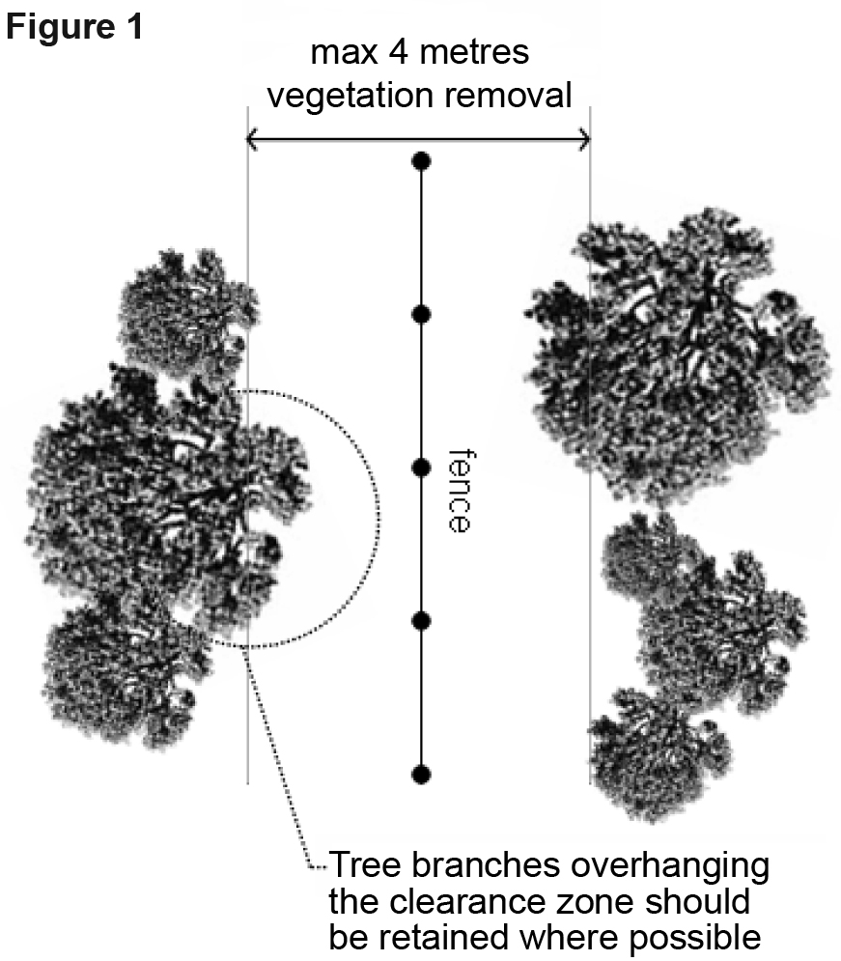

Vehicle access from public roads
This exemption permits the removal, destruction and lopping of native vegetation for the construction or maintenance of a vehicle access across a road reserve from a property boundary to a public road.
Only properties which share a common boundary with the road reserve can remove vegetation under this exemption.
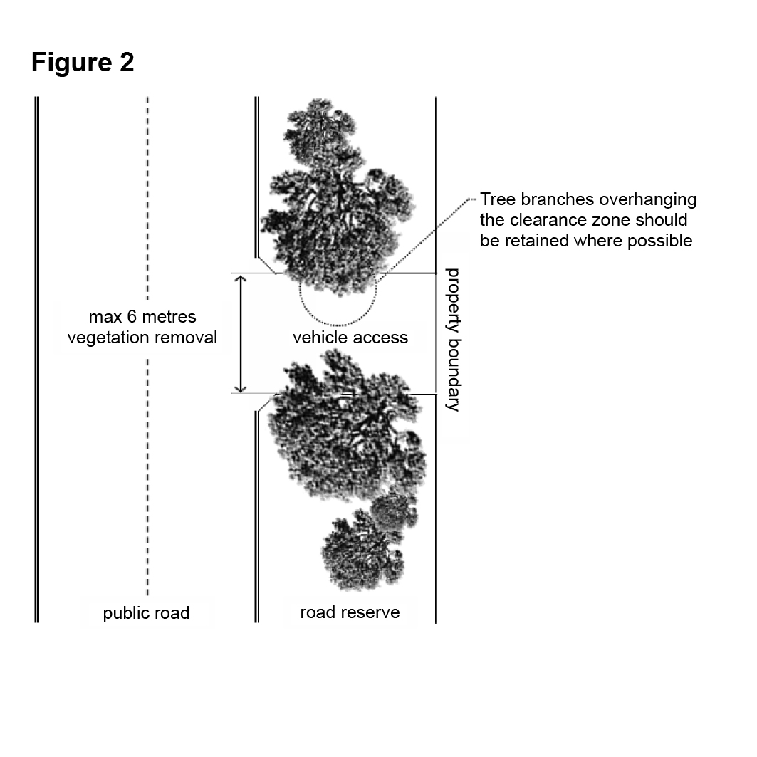
The maximum total width of native vegetation permitted to be cleared under this exemption is 6 metres (see Figure 2). Authorisation from the relevant public land manager must always be obtained before any works, including vegetation removal, can be undertaken in a public road reservation.

Personal use
This exemption has been changed so that it does not apply to the removal of:
- Standing living and dead trees with a trunk diameter of 40 centimetres or more at a height of 1.3 metres above ground level.
- Living native vegetation on contiguous land in the same ownership with an area less than 10 hectares.

Search for stone
This exemption permits the removal of native vegetation associated with the search for stone. This exemption does not apply to costeaning and bulk sampling activities.
There are limits on the extent and type of native vegetation that can be removed under this exemption. A planning permit is required to exceed these limits.
This exemption reflects existing State Planning Policy that planning schemes must allow the use and development of land for search for stone without planning approval.

Clause 52.18 – Timber Production
The exemptions for regrowth, weeds and bracken have been moved to Clause 52.17.

Overlays
In some cases the exemptions in the overlays have been modified to be consistent with the equivalent exemptions in Clause 52.17.
The exemptions under the overlays have been extended to include the removal, destruction and lopping of native vegetation:
- which is in accordance with a Native Vegetation Precinct Plan incorporated into the planning scheme
- to enable the carrying out of extractive industry
- to enable the search for stone. The same limits on the extent of vegetation which can be removed, destroyed or lopped under Clause 52.17 apply
- to maintain the safe and efficient function of roads and railways in accordance with the written agreement of the Department of Sustainability and Environment.

Dead Vegetation
A specific requirement for a planning permit to remove dead vegetation has been introduced into Clause 52.17 and the Environmental Significance Overlay. Previously there was an exemption for removing all dead vegetation under Clause 52.17. However, it was not clear that the planning permit requirement to remove, destroy and lop native vegetation applied to dead vegetation. This has now been clarified.

Fire Protection
Exemptions for the removal of native vegetation near buildings used for accommodation and to manage risks to life and property from fire have been retained. A new exemption for fire fighting access tracks has been introduced.

Native vegetation precinct plans
The planning scheme provisions applying to Native Vegetation Precinct Plans (NVPPs) have also been changed. In particular:
- A new provision, Clause 52.16, sets out the requirements for native vegetation in areas where an NVPP applies. The provision sets out plan content requirements, planning permit requirements and exemptions, application requirements and decision guidelines. The native vegetation removal exemptions are fewer in number than those available under Clause 52.17 and through the NVPP can be further tailored to suit the purpose of the plan and the nature of development expected in the precinct.
- Clause 52.17 has been amended so that this clause does not apply to land where an NVPP applies.
These changes will make the NVPP a more flexible tool, strengthen the weight given to NVPPs when councils are deciding on permit applications for native vegetation removal, and reduce the need for complex overlay controls.
The VPP Practice Note Preparing a native vegetation precinct plan has been updated to reflect the new provisions.
A series of practice notes that explain the operation of the native vegetation planning provisions are available. The practice notes are available at www.dpcd.vic.gov.au/planning
- Managing native vegetation in the planning system – how to plan for the protection and removal of native vegetation using native vegetation precinct plans and property vegetation plans.
- Preparing a native vegetation precinct plan – when a precinct plan can be used and how to prepare a precinct plan to manage native vegetation.
- Assessing applications involving native vegetation removal – how to assess a planning permit application for native vegetation removal.
ISBN 978-1-921331-84-8
Published by the Victorian Government Department of Planning and Community Development Melbourne, September 2008.
© The State of Victoria, Department of Planning and Community Development 2008.
This publication is copyright. No part may be reproduced by any process except in accordance with the provisions of the Copyright Act 1968.
Authorised by the Victorian Government, 8 Nicholson Street, East Melbourne.
This publication may be of assistance to you but the State of Victoria and its employees do not guarantee that the publication is without flaw of any kind or is wholly appropriate for your particular purposes and therefore disclaims all liability for any error, loss or other consequence which may arise from you relying on any information in this publication.
www.dpcd.vic.gov.au/planning

