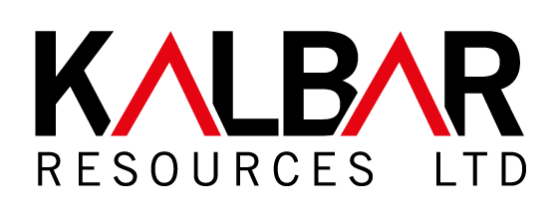

Fingerboards Mineral Sands Project

Environment Effects Statement Consultation Plan

May 2017

This page is intentionally left blank
Contents
1 Introduction 1
1.1 Background 1
1.2 About this Plan 1
1.3 Project location and area 2
1.4 Project description 4
1.5 Objectives of the Plan 6
1.6 Consultation principles 6
1.7 The EES Process 6
1.8 Preparation of the Plan 9
2. Stakeholder Identification and Analysis 11
2.1 Stakeholder Classification 11
2.2 Community and Stakeholder Values, Attitudes and Issues 12
2.3 Summary of Key Issues 18
3. Engagement methods and activities 19
3.1 Overview 19
3.2 Stakeholder Positions and Engagement Methods 19
3.3 Engagement Activities 21
3.4 Engagement Activities by Stakeholder Group 23
3.5 Communications 25
3.5.1 Communications principles 25
3.5.2 Media 25
3.5.3 Communication material 25
3.6 Engagement Action Plan 26
3.7 Engagement schedule 29
4 Implementation and Monitoring 30
4.1 Documenting engagement outcomes 30
4.2 Monitoring 30
4.3 Evaluation and Reporting 31
4.4 Updating the Consultation Plan 31

Figures
Figure 1.1: Project location …………………………………………………………………………………..2
Figure 1.2: Project boundaries ..………………………………………………………………….......……..3
Figure 1.3: Project area and features ………………………………….………………………………...…3
Figure 1.4: Ore processing schematic ………………………………………………………………...…...5

Figure 1.5: Mine rehabilitation schematic …………………………………………………………………5

Figure 1.7: EES Process………………………………………………..……………………………………..8

Tables
Table 2.1: Stakeholder classification …………………………………………………………..…………11
Table 2.2: Community and stakeholders – values, attitudes and issues ………………..………...13

Table 2.3: Description of key issue/interest …………………………………………………..…………18

Table 3.2: Stakeholder positions on key issues and level of engagement…………….….………..19

Table 3.3 Engagement activities ……………………………………………………………….….……….21

Table 3.4 Engagement activities by stakeholder group………………………………….…………….23

Table 3.6: Engagement Action Plan……………..………………………………………….………….….26

Table 3.7: Engagement schedule ………………………………………….………………...……….……29

Appendices
Appendix 1: Summary of Community Engagement to Date ………………………………………….32

1 Introduction

1.1 Background
This Consultation Plan sets out the measures to be undertaken by Kalbar Resources Ltd. (Kalbar) to actively engage and involve all stakeholders during preparation of the Environment Effects Statement (EES) for the Fingerboards Mineral Sands Project (the project).

It sets out how Kalbar will:
- inform stakeholders about the proposed project and program of EES studies;
- seek targeted input from stakeholders during the preparation of the EES to identify issues of potential concern, draw on local knowledge of existing conditions, understand perceptions of potential effects, and gain feedback on mitigation and management measures proposed in response to reasonable to stakeholder concerns (including potential refinement to the proposal);
- respond to stakeholder input and document consultation outcomes.
Consultation is a key aspect of the environment assessment process in Victoria. It helps build understanding around the issues and implications of projects, and enables stakeholders’ knowledge and views to be considered in both project planning and formal decision-making.
The Plan has been developed in accordance with the Environment Effects Advisory Note, January 2011 (DPCD), the Community Engagement Guidelines for Mining and Mineral Exploration in Victoria (DEDJTR) and incorporates public participation concepts developed by the International Association for Public Participation (IAP2).
A Technical Reference Group (TRG), convened by the Department of Environment, Land, Water and Planning (DELWP) with membership drawn from government agencies, local government and regional authorities, has been appointed to provide advice to DELWP and the proponent on preparing an EES, including the design and implementation of the EES Consultation Plan.
Kalbar intends to meet and exceed the statutory requirements for consultation to fully engage stakeholders during the preparation of the EES. It is in the mutual interests of Kalbar and stakeholders for the EES consultation process to be open, inclusive and productive.

1.2 About this Plan
The Consultation Plan has four key components:
1. Stakeholder identification.
2. Stakeholder analysis, including identification of stakeholder groups, values and issues.
3. Consultation methods and schedule of activities, outlining the consultation activities to be undertaken and how they relate to stakeholder groups and the stages of the EES process.
4. Recording, monitoring and reporting - outlining how stakeholder input will be recorded and addressed in the preparation of the EES and how this will be reported to DELWP, the TRG and community. This includes a program for evaluating stakeholder involvement to enable improvements to the Plan to be made as the EES progresses.

1.3 Project location and area
The project is located approximately 20 kilometres west of Bairnsdale in East Gippsland.
The project area is the area to be potentially disturbed by proposed project activities. This includes the establishment of infrastructure, removal of topsoil and overburden, ore removal, processing of mined ore, management of mining by-products and progressive rehabilitation.
The project location, boundaries and key features are shown in Figures 1.1 and 1.2 and 1.3.
Figure 1.1: Project location

Figure 1.2: Project boundaries
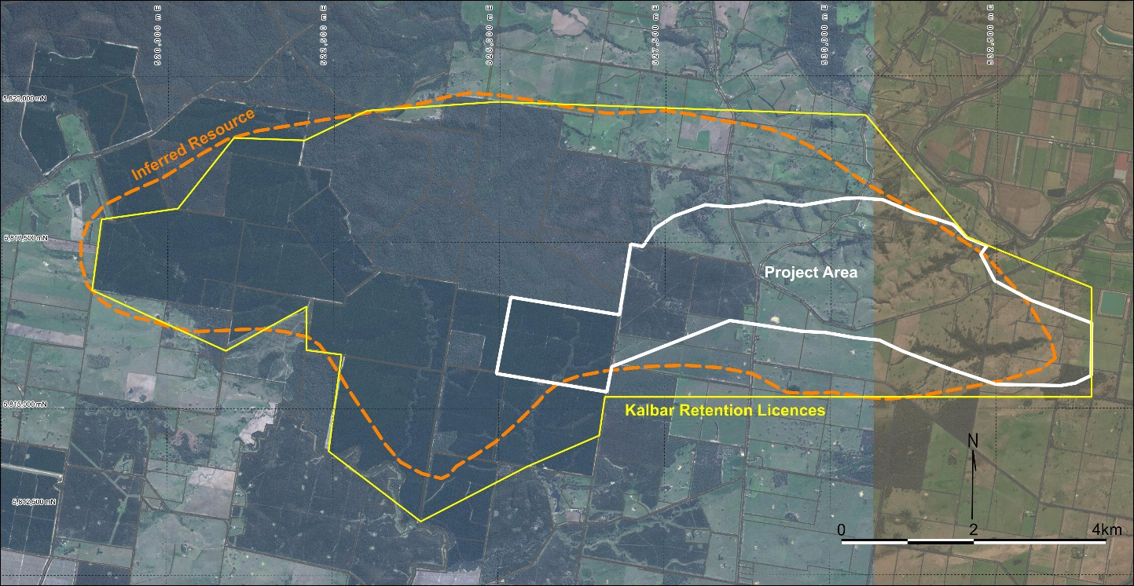

Figure 1.3: Project area main features
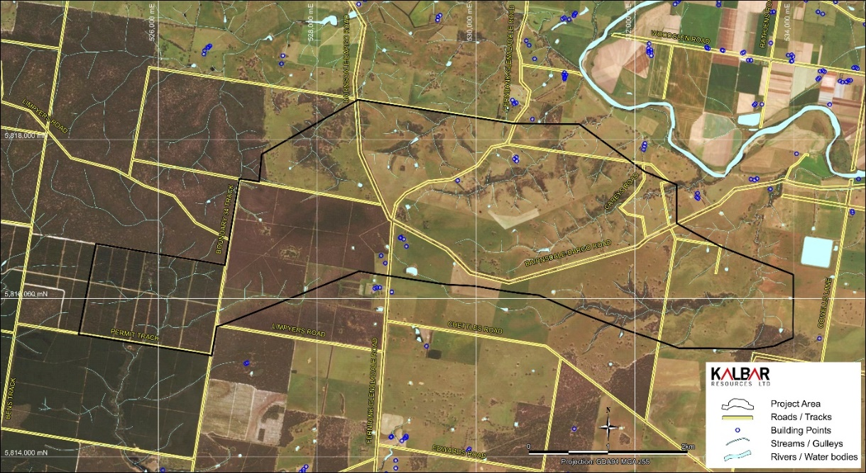

1.4 Project description
The proposed Fingerboards Mineral Sands Project has an approximate area of 1,400 hectares (ha) and is in the eastern part of the Glenaladale mineral sands deposit, in East Gippsland, Victoria.
The deposit contains an estimated 36 Mt of Heavy Mineral (HM) including around 7 Mt of zircon. Kalbar proposes to use open cut mining methods, extracting about 200Mt of ore to produce about 5Mt of heavy mineral concentrate over 20 years.
The ore will be fed to a mining unit plant (MUP) for slurrying and pumping to the wet concentrator plant (WCP). The heavy mineral is separated from the mining by-products (clay and quartz) using gravity separation equipment (screens, spirals, cyclones, and classifiers).
The minerals will be exported for further processing into commercial products such as zircon and rutile.
It is estimated that the project will require between 2-3 GL of water per annum. Potential sources include ground water and/or winter fill from the Mitchell River. Neither source would compete with local farming’s water needs.
The proposed mine pit will have an average depth of approximately 23 metres and will not intersect ground water.
Mining is proposed to be conducted 24 hours/day and 365 days/year, subject to any requirements or conditions to avoid or mitigate any potential impacts on local amenity caused by noise, dust, etc.
The proposal includes the development of the mineral sands mine, mining unit plant, wet concentrator plant (comprising mineral separation processing and tailings thickening and disposal plant), water supply infrastructure, tailings storage facility and additional site facilities, such as a site office, warehouse, workshop, loading facilities and fuel storage.
Mine products are proposed to be transported via road or rail for export overseas.
Approximately 96% of the mined ore will be returned to the mine void in a continuous rehabilitation process. All overburden will be returned to the void, with the majority directly returned as mining progresses, without stockpiling.
Mining by-products and non-economic minerals will be placed in the mined-out void and in an off-path storage facility. Topsoil is then returned to the mined area in preparation for restoration and revegetation.
Rehabilitation will commence in the early stages of the project and will occur progressively on the reinstated land surface behind the advancing open cut.
It is estimated that 110 permanent jobs will be created, working directly in the mining operation. In addition, it is expected that the project will require a construction workforce averaging 150 people and peaking at 250 people.

The schematic ore processing and mine rehabilitation process are shown in Figures 1.4 and 1.5.
Figure 1.4: Ore processing schematic

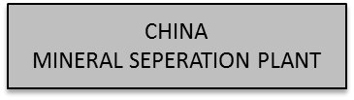
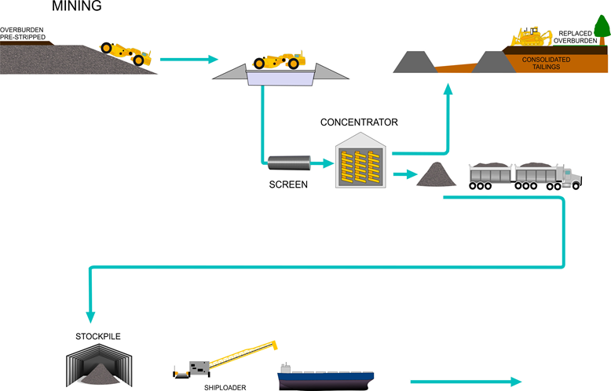

Figure 1.5: Mine rehabilitation schematic

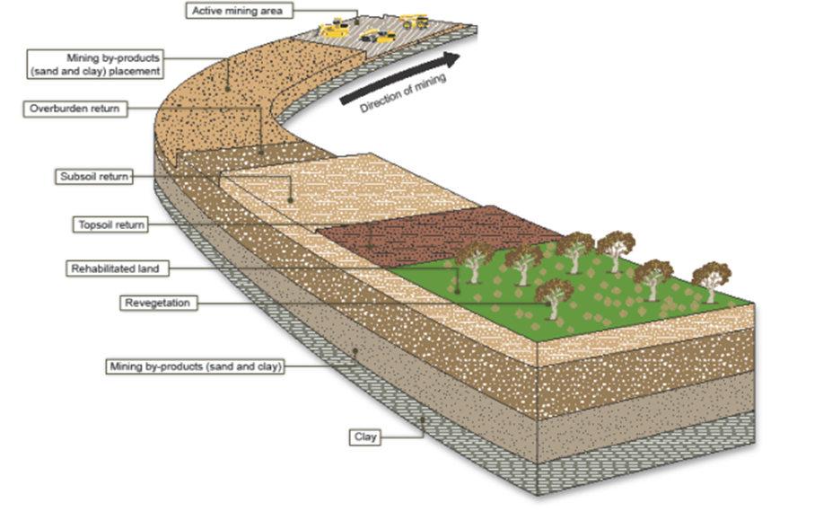

1.5 Objectives of the Plan
The objectives of this Plan are:
- To deliver effective stakeholder engagement and consultation through the EES process for the project.
- To ensure affected stakeholders and interested parties are informed, consulted and involved in the EES process and their values, priorities and issues are acknowledged and addressed.
- To encourage participation and input in the EES process, so that local knowledge, priorities and expertise can contribute to the process and outcome.
- To provide timely, consistent, and open engagement with stakeholders throughout the EES process.

1.6 Consultation principles
The following principles will guide Kalbar’s consultation activity to ensure it is purposeful, timely and proactive.
In its community consultation, Kalbar will:
- Demonstrate a commitment to engaging with all community and stakeholder interests.
- Foster mutual respect by recognising and responding to the rights, values and interests of all stakeholders.
- Show transparency by documenting community issues and input in a timely, open and effective manner.
- Clearly communicate the purpose of consultation activities throughout the EES process so that stakeholders can participate meaningfully.
- Promote inclusiveness by encouraging and supporting a diverse representation of community participation in consultation.
- Clearly document and share information on how stakeholder feedback contributes to the assessment process.

1.7 The EES Process
The Minister for Planning has determined that the project requires preparation of an environment effects statement (EES) under the Environment Effects Act 1978. An EES is required for projects likely to have a significant impact on social, economic or environmental values.
The reasons for the decision are:
- The project has the potential for a range of significant environmental effects. In particular, the project as proposed is likely to have effects on:
- A very large extent of native vegetation and associated biodiversity values, including listed and threatened species and communities;
- Surface water and groundwater (i.e. hydrology, quality and availability) and protected beneficial uses;
- Existing land uses, amenity and landscape values and of the project area and those associated with the broader area including the Mitchel River National Park; and
- Aboriginal cultural heritage values.
- An integrated assessment is necessary to ensure the range of likely adverse effects and related uncertainties are sufficiently investigated, in terms of both their extent and significance, and how significant effects can be avoided and minimise to acceptable levels.
- An EES would enable a transparent and rigorous process for consideration of potentially significant adverse effects of the project prior to any relevant statutory decision-making including under the Mineral Resources (Sustainable Development) Act 1990, Aboriginal Heritage Act 2006 and Water Act 1989.
During the EES process there are formal opportunities for stakeholders to make submissions about the project’s potential environmental effects to DELWP. DELWP will seek public comment via submissions on behalf of the Minister for Planning.

The formal public review process of an EES includes:
• A public notice releasing the Draft Scoping Requirements for the EES for 15 business days for public comment.
• Receipt and consideration of written submissions on the Draft Scoping Requirements by DELWP before the Scoping Requirements are finalised and issued to the proponent.
• A public notice in local and metropolitan newspapers on exhibition of the EES documentation for 30 business days and lodgement of public comment via written submission to DELWP.
• Receipt and consideration of written submission on the EES by the Minister for Planning.
• Public Inquiry into the EES which may take a form of a formal hearing (at which the proponent and submitters can make presentations), a roundtable conference with submitters, or a desktop review of written submissions.
To promote active community participation in the EES process, Kalbar proposes a consultation approach that facilitates community information, consultation or involvement at each key stage of the process, in parallel with expert review undertaken through the TRG.

The engagement activities outlined in this Plan are aligned to the key steps in the EES process:
- EES referral
- Scoping Requirements for the EES
- EES preparation
  - Baseline studies
  - Impact assessment
  - EES Main Report
- EES Exhibition
- Public Review

The EES Process and associated project development and Commonwealth approvals process are outlined in Figure 1.7.

Figure 1.7: EES Process
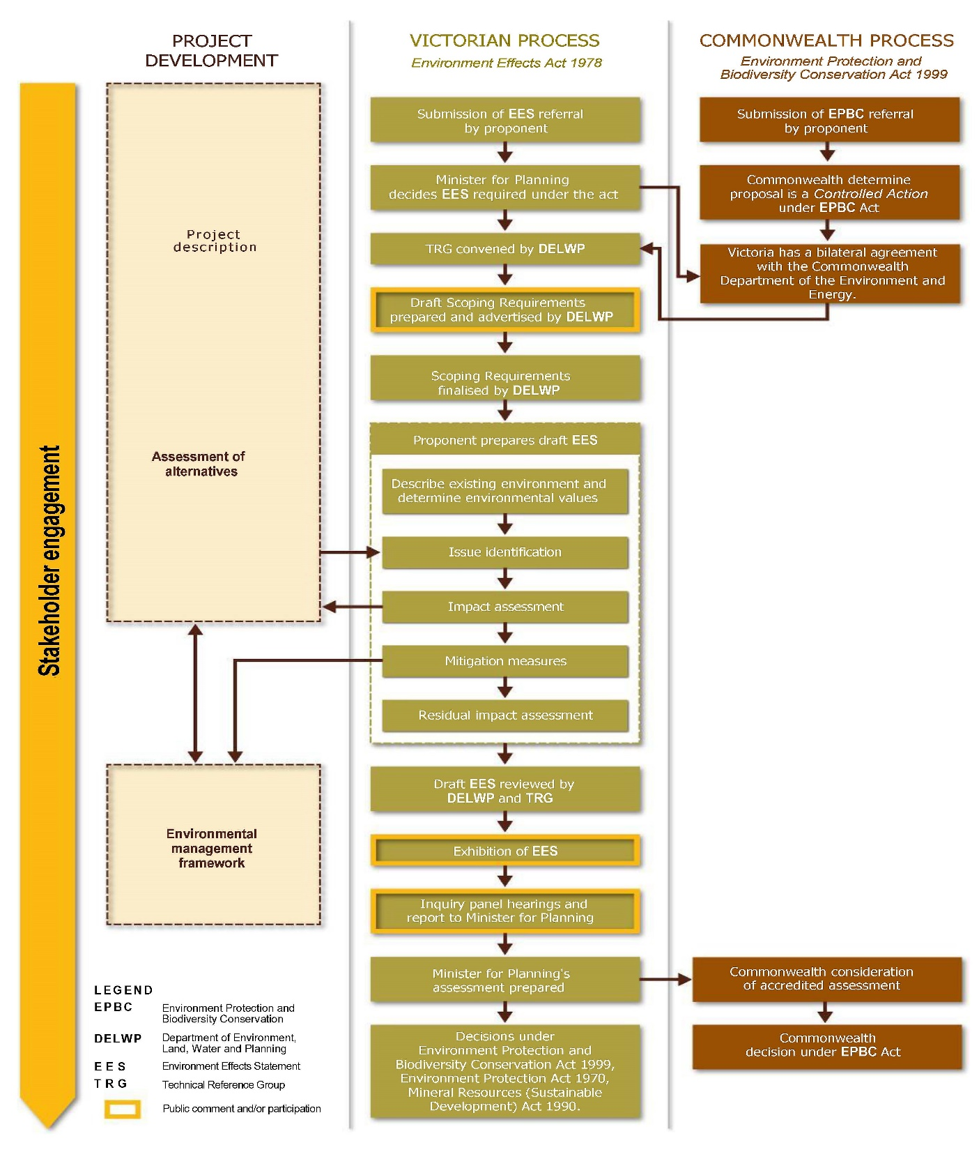

1.8 Preparation of the Plan
The steps undertaken to assist in developing the consultation plan are:

- Stakeholder identification.

Since 2014, Kalbar has compiled a database of project stakeholders, through responses to mail box drops, widely advertised community meetings and information sessions, and informal conversations and email exchanges.

Individuals affected by the project include landowners within the project area, and landowners and residents in the broader Glenaladale and Lindenow district and surrounds.

Community meetings and information sessions held in 2015 and 2016 were publicised through local media and direct e-mail, providing the opportunity for all other interested community members to attend and register their contact details.

Relevant government representatives, agencies, industry and community groups have been identified and contacted by Kalbar’s stakeholder engagement team.

Kalbar now has a database of over 300 individual community contacts and continues to add to the database as community members respond to on-going public communications.

2. Stakeholder Analysis.

Kalbar has actively sought to solicit stakeholder attitudes and issues through preliminary consultation activities undertaken at the targeted and broad level. The consultation undertaken to date is described in Appendix 1.

Kalbar has established and maintained communication with affected landowners through the initial project stages for access, licensing, drilling programs, flora and fauna surveys and has documented the views, issues and priorities of landowners, both in respect to the immediate impacts and broader implications of the project.

Kalbar has engaged in a series of briefings and meetings with representatives of community interests, including local government and Members of Parliament, relevant agencies and authorities, business groups, community service groups, tourism, agriculture and economic development interests.

These briefings have also enabled identification and discussion of community values, potential project benefits and impacts on the community, and any specific expectations or requirements from that agency or group’s perspective.

Many local community members’ views have been publicly expressed and documented through a series of public meetings, drop-in and information sessions held in 2014, 2015 and 2016. These sessions have devoted considerable time and attention to soliciting the views of community members in relation to the project assessment and approval processes and the project development itself.

Those sessions were widely promoted and well-attended, enabling the airing of views by community members, including those who have concerns about a range of potential impacts of the project, citing and describing lifestyle and environmental values in considerable detail.

Community members clearly expressed their expectations of Kalbar as the project proponent, and their expectations of the project assessment and approval processes. In turn, Kalbar could outline and clarify its responsibilities and obligations through the mining exploration, approval and operating processes and inform community members of its community consultation obligations for the EES process.

Values and attitudes towards the project have been documented in detail in meeting notes and summarised in the stakeholder analysis.

Many stakeholders have made direct follow-up contact with Kalbar, seeking further information or clarification, providing their views on various aspects of the project and responding to notifications provided regularly by Kalbar to its e-mail database.

Initial assessment of issues or perceived issues for affected stakeholders and communities is included in the Stakeholder Analysis.

3. Determine consultation methods and activities.

The Plan sets out a range of stakeholder engagement methods and identifies how and when those methods will be used and which stakeholders are targeted.

The methods have been chosen according to:
- the purpose and level of engagement as identified for this project.
- the engagement preferences of the community or stakeholder group.
- the stage of the EES process.

The engagement methods provide a range of formats and channels for stakeholder engagement, including direct communication, community information sessions, technical forums, newsletters, information sheets, on-line information and media communications.

4. Establish systems for recording, monitoring and reporting on consultation activities.

A key aspect of the consultation process is the documentation of consultation outcomes, so that stakeholders can see how their input has been considered in the preparation of the EES.
Monitoring of the process also allows it to be modified or improved and for the outcomes of the consultation to be summarised and reported in the EES main report.
Systems for recording, monitoring and reporting on consultation activities include:
- Establishment of an engagement log for documenting contact with stakeholders.
- Regular reporting of consultation activities and outcomes to DELWP and the Technical Reference Group.
- Posting of ‘consultation updates’ on the Kalbar web site.
- Surveys of stakeholders to record perceptions of the effectiveness of consultation activities.
- Feedback to all stakeholders informing them of the response to their input.
- Reporting of consultation outcomes in the EES main report.

2. Stakeholder Identification and Analysis

2.1 Stakeholder Classification
A detailed list of stakeholder groupings is outlined in Table 2.2.
Stakeholders have been listed comprehensively to include community, business, government and non-government interests.
The individuals and groups listed include parties who represent a direct or indirect interest as an individual or a broader community interest.
Community stakeholders encompass the following categories:
- Community of place – communities in and surrounding the project area location, such as neighbouring properties.
- Community of interest – communities of similar practice, such as local community groups, sports groups, residents' associations, service clubs, farmers' groups, rate payers' associations, local businesses, sports clubs, tourist or seasonal groups and other associated groups.
- Community of standing – communities that have a special or legal interest in the land, such as Indigenous communities or some environmental groups.
Within each stakeholder group, there will be differences in stakeholder perceptions and attitudes that will need to be explored through the EES consultation process. The aim of this stakeholder identification is to provide a general guide to stakeholder interests, values and issues, not to rigidly classify stakeholders.
For a stakeholder classification exercise, primary stakeholders were defined as those who have the potential to be impacted by the Project. Secondary stakeholders are defined as those with an interest/influence in the Project.
Stakeholders have been allocated across four levels to differentiate between high and low levels of potential impact and high and low levels of interest/influence as below in Table 2.1.
This may change subject to the nature of the activity/issue and is used only as a guide to different levels of impact among stakeholders.
Table 2.1: Stakeholder Classification

Level 1: | Level 2: | Level 3: | Level 4:
Primary Stakeholders (high impact) with high levels of interest/influence | Secondary Stakeholders (low impact) with high levels of interest/influence | Primary Stakeholders (high impact) with low levels of interest | Secondary Stakeholder (low impact) with low levels of interest

2.2 Community and Stakeholder Values, Attitudes and Issues
Table 2.2 lists the community and stakeholder values and issues identified through initial engagement with key stakeholders, feedback at community and stakeholder meetings, briefings and drop-in sessions, one-one-one conversations and via desktop research of similar mineral sands projects in Victoria.

The guidelines for preparation of the EES Consultation Pan require an initial identification of stakeholder views for broadly understanding the values, attitudes and issues that require attention during the consultation process.

This summary does not purport to comprehensively describe stakeholder views, but it serves as an indicator of the values, attitudes and issues expressed by stakeholders during the consultation that has been conducted and based on experience with similar projects.

Stakeholders will be provided with many opportunities to further elaborate and clarify their views throughout the EES process.

Table 2.2: Community and Stakeholders – Values, Attitudes and Issues

Stakeholder group and Impact | Supporting values/attitudes | Challenging values/attitudes | Issues
Directly Affected Landowners (DAL)  Landholders and residents within the project area | Desire for financial security or retirement from farming  Project offers economic benefits.  Employment  Supply of goods and services.  Diversification of income  Social/community  benefits – investment in social infrastructure  Willingness to work with Kalbar | Attitudes to mining – perceived  competition with farming  Attitudes to the land; legacy for the future; sustainable management of resources  Attitudes to community and lifestyle – community cohesion; family history;  country lifestyle  Fear and uncertainty over project – project viability; project components and layout; financial compensation  Opposition to land access  Avoidance of community conflict  Distrust of Kalbar and/or approvals process | Impact on farming operations  Property access  Legal arrangements  Perceived relationship with Kalbar  Lifestyle and amenity  Impacts on water resources  Land values and compensation  Rehabilitation  Increased heavy vehicle traffic  Native flora and fauna  Employment  Social fabric  Visual, dust (including radiation) and noise impacts  Community services and infrastructure  Safety and human health impacts
Nearby Landowners (NL)  Landholders and residents adjacent to and near the project area | Project offers economic benefits  · Employment  · Supply of goods and services  · Diversification of income  Social/community  benefits – investment in social infrastructure  Desire for detailed information about the project and its potential impacts | Attitudes to mining – perceived  competition with farming  Attitudes to the land; legacy for the future; sustainable management of resources  Attitudes to community and lifestyle – community cohesion; family history; erosion of community values  Land access/community rights – lack of compensation despite potential impacts Distrust of Kalbar and/or approvals process | Impact on rural land use  Lifestyle and amenity  Impacts on water resources  Land values and compensation  Rehabilitation  Increased heavy vehicle traffic  Native flora and fauna  Employment  Social fabric  Visual, dust (including radiation) and noise impacts  Community services and infrastructure  Safety and human health impacts
Local Communities (LC)  Community members within the local communities of Glenaladale, Lindenow, Fernbank, Lindenow South, Walpa and Flaggy Creek | Project offers economic benefits.  Employment  Supply of goods and services.  Diversification of income  Social/community  benefits – investment in social infrastructure  Willingness to reserve judgement  Desire for accurate information | Attitudes to mining - perceived  competition with farming and tourism  Attitudes to the land; legacy for the future; sustainable management of resources  Attitudes to community and lifestyle – community cohesion; family history; country lifestyle; erosion of community values  Land access/community rights – lack of compensation  Opposition to mining activity  Distrust of Kalbar and/or approvals process | Impact on rural land use  Lifestyle and amenity  Water requirements and potential impacts on water resources  Land values and compensation.  Rehabilitation  Increased heavy vehicle traffic  Native flora and fauna  Employment  Social fabric  Visual, dust (including radiation) and noise impacts  Community services and infrastructure  Safety and human health impacts
Broader Community (BC)  The broader regional community, not resident in the immediate area | Economic and employment benefits  Supply of goods and services  Diversification of income  Social/community  benefits – investment in social infrastructure  Willingness to reserve judgement | Attitudes to mining – in competition with farming and tourism  Attitudes to the land – legacy for the future; sustainable management of resources | Impact on image of the region  Water requirements and potential impacts on water resources  Environmental impacts on surrounding areas, water bodies, etc.  Employment  Community services and infrastructure
Local Members of Parliament (MP)  MLA Gippsland East  MLA Gippsland South  MHR Gippsland  MLCs Eastern Victoria | State Government policy  Need for regional economic growth  Employment  Community infrastructure | Pressure from community  Potential for lack of bilateral support for the project  Adverse media coverage  Pressure from lobby groups | Employment opportunities  New industry for Gippsland adding to economic diversity  Increased heavy vehicle traffic  Transport options and routes  Water resources  Environmental impacts  Social fabric
State Government Ministers (SG)  All relevant Ministers | State Government policy  Need for regional economic growth  Need for assessment of project’s effect on the environment  Employment  Community infrastructure  Mineral royalties  Sustainable resource development | Pressure from community  Internal disagreement on support for the project  Adverse media coverage  Pressure from lobby groups | Employment opportunities  New industry for Gippsland adding to economic diversity  Transport options and routes  Water resources  Environmental impacts  Social fabric
State Government agencies (SGA)  All relevant agencies and statutory authorities | State Government policy  Adequate information to inform statutory decisions  Need for economic growth  Employment  Community infrastructure  In charge of investment facilitation, regulation and approvals  Technical understanding of mineral sands, environmental and planning requirements  Opportunity for royalties and to attract new investment  Opportunities for effective approvals process  Support for community engagement  Opportunities for biodiversity offsets  Opportunities for investment in  environmental monitoring | Under resourced and variable detailed technical expertise  Conflicting inter-departmental priorities  Pressure from lobby groups  Community expectations  Complex accountabilities | Accountabilities  Complexity of approvals process  Increased heavy vehicle traffic  Transport options and routes  Amenity of neighbouring landholders  Water requirements and potential impacts on water resources and designated waterways  Rehabilitation  Native flora and fauna  Social fabric  Lifestyle and visual impact  Community services and infrastructure  Safety and health  Employment
Local Government (LG)  East Gippsland, Wellington and South Gippsland Shire Councils | Attract new investment and industries  Attract new residents  Support for statutory processes and strong community engagement | Alignment with community interests, influenced by community angst  Capacity and capability of planning and economic development staff  Lack of experience with similar projects | Land use and planning  Transport options and routes  Increased heavy vehicle traffic  Road maintenance  Water resources  Community services and infrastructure  Employment  Native flora and fauna  Social fabric  Lifestyle and visual impact  Safety and health
Traditional owners (TO)  Gunaikurnai Land and Waters Aboriginal Corporation  Gunaikurnai Traditional Owners Land Management Board | Protection of cultural heritage  Involvement in cultural heritage management  Employment opportunities | Attitudes to the land – connection to country; legacy for the future; sustainable management of resources  Fear of unknown/limited knowledge of mining  Poorly resourced and not well funded  Distracted by other issues and priorities | Cultural heritage  Connection to country  Employment opportunities  Impact on water resources  Environmental impacts  Appropriate methods of engagement
Community groups  (CG)  Lindenow Progress Association  Lindenow Lions Club  Rotary Club of Bairnsdale  Lindenow Football and Netball Club  Others | Economic benefits  Employment  Supply of goods and services  Social/community benefits – investment in social infrastructure  Support for local business and investment  Willingness to reserve judgement | Attitudes to mining - perceived  competition with farming;  Attitudes to community and lifestyle – community cohesion; family history; country lifestyle; community values  Potential for community conflict. Opposition to mining activity | Community services and infrastructure  Community lifestyle and cohesion  Employment  Community support  Increased heavy vehicle traffic  Transport routes  Impact on water resources  Native flora and fauna
Infrastructure and  asset owners  (IO)  VicRoads  East Gippsland Water  Southern Rural Water  Power utility providers | Electricity supply requires  upgrading  Road condition  Available capacity at Port Anthony  Water security for Lindenow Valley  Water security for town water supply | Road safety issues  Increased complaints along transport route  Road capacity and condition  Disruption of power supply to other users  Protection of assets and services | Infrastructure capacity  Increased heavy vehicle traffic  Infrastructure upgrading requirements  Potential infrastructure relocation  Potential impacts on groundwater and surface water for potable supply
Emergency services  (ES)  Ambulance Victoria, SES, CFA, Victoria Police | Support for emergency planning and preparedness | Potential impact on resourcing or planning requirements | Community services and infrastructure.  Roads  Water resources  Mine safety  Impact on resources
Local and regional businesses  (LB)  Local business, primary producers, services providers, contractors | Available capacity to grow  Employment and investment creation  Good understanding of locals/local environment  Goodwill of local community | Unfamiliar with mining – don’t understand mineral sands; not aware of requirements for supply of goods and services to mining industry – upskilling required  May not be able to scale up to meet demand.  Perceived impact on existing businesses | Impact of mine on local farming.  Water availability  Impact on tourism image  Employment  Supply of services
Special interest groups (SI)  Wildlife Victoria  East Gippsland Landcare Network  Mine-Free Glenaladale  Greening Australia | Interest in community awareness-raising  Specialist local knowledge  Support for improved environmental data and monitoring  Willingness to provide input | Potential unwillingness to engage with Kalbar and distrust of regulatory/approvals process  Use of social media  Perception of mining processes  Established positions against the project | Impact on rural land use  Lifestyle and amenity  Potential impacts on water resources  Land values and compensation  Rehabilitation  Increased heavy vehicle traffic  Traffic and transport routes  Native flora and fauna  Visual, dust (including radiation) and noise impacts  Community services and infrastructure  Safety and human health impacts
Business Groups (BG)  Bairnsdale Chamber of Commerce  Business and Tourism East Gippsland  Agribusiness Gippsland  Irrigators Association  Committee for Gippsland  East Gippsland Marketing Inc. | Support for regional growth  Support development and investment in region  Positive links with government | Diverse membership and values may not align with the project objectives  Perceptions of Kalbar’s credentials and operating experience  Reputational values  Reflect community concerns or opposition | Business impacts – positive and negative.  Local employment  Environmental impact  Impact on food production and tourism  Supply of services  Impacts on water resources
Industry Groups (IG)  Minerals Council of Australia  Victorian Farmers Federation  East Gippsland Food Cluster | Economic development benefits  Long history of safe mining practices co-existing with agriculture  Established industry sector in Victoria  Employment opportunities | Protection of water and environmental resources  Mine operation associated with radioactivity and waste  Perceived impact on agriculture  Legacy stakeholder issues with other operators | Business impacts – positive and negative  Local employment  Environmental impact  Impact on food production and tourism  Supply of services  Potential impact on water resources
Media  (M)  ABC Gippsland  Weekly Times  Bairnsdale Advertiser/EG News Gippsland News  Gippsland Times  Stock and Land | Interest in providing information to the community  Aim to provide balanced views  Accessibility | Publication of inaccurate or false claims  Interest in issues of community conflict | Community interests  Appropriate community consultation  Kalbar support for local community  Perceived conflicts between community and Kalbar

2.3 Summary of Key Issues
Issues identified through initial community engagement and stakeholder feedback have been grouped into areas of focus to enable an evaluation of impact on each stakeholder group and inform the consultation methods to be used in addressing these priority issues.

As the consultation process occurs, there will be further detailed exploration of these issues and the priority given by stakeholders to the investigation and management of project impacts.

Table 2.3: Description of Key Issue/Interest
Issue/Interest Description
Environmental Issues | Includes issues relating to air quality (including dust), flora, fauna, water quality, impacts on water bodies, erosion, noise, vibration, radiation, waste, chemicals, light and rehabilitation.
Public Amenity | Includes issues relating to land use (during operations), nuisance, dust, radiation, noise, traffic, safety and visual amenity.
Mine Closure | Issues regarding end land use and rehabilitation.
Land Use | Issues associated with changes in land use (agriculture to mining).
Land Ownership | Issues relating to land access and operations impacting farming land.
Infrastructure | Includes issues relating to water supply, power supply, roads, transport, fire, ancillary mine infrastructure.
Social | Issues associated with social and personal impacts, community cohesion, community services and lifestyle.
Indigenous | Management of land, cultural awareness, artefacts and opportunities for Indigenous people.
Economic | Issues including employment, regional development, local business opportunities, economic impacts on other industries.
Regulations | Includes issues relating to project approvals, monitoring and reporting.
Engagement and Communications | Access to information, transparency, two‐way communication and responsiveness.
Regional image | Issues associated with the perception of the region, tourism and the region’s natural image.

3. Engagement methods and activities

3.1 Overview
This section details the proposed methods and activities for engaging with community stakeholders.
The methods and communications materials used will be chosen according to the purpose and level of engagement as appropriate to each stage of the EES process.

3.2 Stakeholder Positions and Engagement Methods
The following Table 3.2 is a qualitative summary of stakeholders’ interest and influence in relation to the identified issues, as informed by previous consultation and understanding of community perceptions. It is used only as a guide in choosing the most appropriate engagement methods.

The purpose is to identify the corresponding strategy and engagement methods to be used to match stakeholder positions and perceptions. Over time, these issues may change and the stakeholder positions and responses may vary.

Table 3.2 Stakeholder positions on key issues and level of engagement

Key
l | Influence on issue (high impact)
○ | Interest in issue (low impact)
C | Input not required (no impact)
 | Unlikely to be interested in issue (empty cell)

Level | Stakeholder | Position and Issue |  |  |  |  |  |  |  |  |  |  |  | Engagement Level
 |  | Environmental  Issues | Public Amenity | Mine Closure | Land Use | Land Ownership | Infrastructure | Social | Economic | Indigenous | Regulations | Engagement and  Communications | Regional image
1 | Directly affected landowners (DAL) | l | l | l | l | l | ○ | l | ○ | ○ | ○ | l | ○ | Involve
1 | Nearby landowners (NL) | l | l | l | l | l | ○ | l | ○ | ○ | ○ | l | ○ | Involve
1 | Local communities (LC) | l | l | ○ | ○ | C | l | l | ○ | ○ | ○ | l | ○ | Involve
2 | Broader community (BC) | ○ | l | ○ | ○ | C | l | l | ○ |  | ○ |  |  | Consult
2 | Local Members of Parliament (MP) | ○ | ○ | ○ | ○ | C | ○ | ○ | ○ | ○ | ○ | l | l | Consult
2 | State Government Ministers (SG) | l | l | ○ | ○ | C | ○ | ○ | ○ | ○ | l | l | ○ | Inform
1 | State Government Agencies/Authorities (SGA) | l | l | l | l | l | l | l | l | l | l | l | ○ | Involve
1 | Local Government (LG) | ○ | l | ○ | l | l | l | l | ○ | ○ | l | l | l | Involve
2 | Traditional Owners (TO) | l | ○ | ○ | ○ | ○ |  | ○ | ○ | l | l | l | ○ | Involve
4 | Community Groups (CG) | l | l | ○ | ○ | ○ | ○ | l |  | ○ |  | l | ○ | Consult
1 | Infrastructure and asset owners (IO) | ○ |  |  |  | C | l |  | l |  | l | ○ |  | Involve
4 | Emergency Services (ES) |  |  | l |  | C | ○ |  |  |  | l | l |  | Consult
3 | Local and regional businesses (LB) | l | ○ | ○ |  | C | ○ | ○ | ○ |  |  | ○ | ○ | Consult
2 | Special interest groups (SI) | l | l | l | l | ○ | l | l | ○ | ○ | l | l | l | Involve
3 | Business Groups (BG) | ○ |  | ○ | ○ | C | ○ |  | l |  | ○ | ○ | l | Consult
1 | Industry Groups (IG) | ○ |  | ○ | ○ | C | ○ |  | l |  | ○ | l | l | Consult
3 | Media (M) | ○ | ○ | ○ | ○ | C | ○ | l | ○ | ○ |  | l | l | Inform

Notes:
Inform: Provide stakeholders with balanced and objective information to assist them in understanding the project, EES process, technical issues and management options and solutions.
Consult: Obtain public feedback on consultation processes, technical issues, project options and/or decisions.
Involve: Work directly and pro-actively with stakeholders to ensure that concerns, preferences and values are understood and considered in the EES process.

3.3 Engagement Activities
The consultation activities are chosen according to the stage of the EES process and the purpose of the engagement activity.

Information will be provided to ensure that stakeholders are made aware of:
- The purpose of the engagement activity and how it fits into the EES process.
- The opportunities for input and/or feedback and how the feedback will be used.
- How the outcome of the consultation activity is to be communicated.
In the initial stages of the EES, community consultation focuses on communication of information about technical aspects of the project and opportunities for community comment on project scope, technical reports and studies.

Consultation will include the stakeholder engagement activities as detailed below in Table 3.3.

Table 3.3 Engagement Activities

Activity | Description
Key stakeholder briefings | Key stakeholder groups directly are offered regular updates on the project. They include elected local, State and Federal representatives, government agencies and authorities, and representative industry and community groups. The briefings enable detailed discussion of project status and issues, seek feedback on the project, answer questions and, where appropriate, seek views on broader stakeholder engagement strategies.
Personal meetings | Personal one-on-one meetings maintain close communication with key stakeholders. They provide informal opportunities to explain the project and for stakeholders to express their views directly and openly to Kalbar. This method is used in liaising with directly affected landholders and is an important way to engage with directly affected individuals and stakeholder group representatives.
Direct communications | Written correspondence (letters, emails, enquiries on website), verbal correspondence (phone calls, face‐to‐face meetings and informal discussions that require actions/follow‐up) with stakeholders.
Community Information Meetings | Community information meetings provide a single forum when important information is required to be delivered to the wider community, often from experts, enabling the community to hear and ask questions with a shared audience.
E-mail distribution | The e-mail distribution list enables Kalbar to provide timely updates and information to stakeholders, particularly to notify community stakeholders of upcoming activities, milestones, approval and public consultation activities and opportunities to comment.
‘Open house’ community information sessions | ‘Open house’ Community information and feedback sessions are effective in providing project information to many stakeholders in an efficient and accessible manner. They are particularly relevant during the approvals process. The sessions are relatively informal, with stakeholders invited to drop in and discuss the project, ask questions of Kalbar personnel and technical specialists. The sessions are held in local public venues and include display information about the project.  The purpose of the sessions is to allow stakeholders to easily access information, discuss specific issues in detail have their input documented for response.
Site tours | Site tours for key stakeholders can provide a valuable insight into the project area, physical features and potential impacts. Site tours will be organised at appropriate times during the assessment process and may include local community members, reference groups, referral agencies and emergency service providers.
Technical Information Sessions | At various times during the EES process, Technical Information Sessions will be held for interested stakeholders to be briefed on technical studies and assessments. Attendees can hear from technical experts about the purpose and methodology of the technical investigations, key findings and proposed actions. Technical experts can answer questions and take on board local knowledge and views relevant to the investigation.
Information Sheets | A series of information sheets outlining the key steps and milestones in the EES process will be used during the consultation process. Information sheets contain factual information about the project and the EES process for general consumption.
Project Bulletins | Project bulletins and newsletters will be prepared for to provide updates on progress with the project and to publicise the activities being undertaken by Kalbar.
Web site | The Fingerboards Project website will provide project information, contacts and feedback opportunities, including an overview of the project, answers to frequently asked questions, updates, contact details and links to relevant government sites.  It has a routinely monitored feedback form/email inquiry service to enable comment on aspects of the EES process.
Frequently asked questions | Frequently asked questions (FAQs) sheets provide brief responses to address anticipated questions from stakeholders regarding the EES process. They cover all aspects of the process, technical studies and opportunities for input. FAQs are informed by stakeholder issues and questions raised during initial engagement activities.
Project Newsletters | From time to time, Kalbar will produce and distribute a project newsletter to provide general updates on the project, company information, and items of interest to the broader community and stakeholders. A summary version of the newsletter will be published in paid local advertising for general consumption.
Surveys | Surveys will be conducted recurrently to gauge community and stakeholder attitudes and perceptions of the project and to identify areas of concern that require action. On-line surveys provide an efficient and accessible means to gauge attitudes and opinions and obtain feedback on community priorities.
Media Releases | Media releases provide the opportunity for information to be circulated widely in the community at key points in the EES process. They are particularly effective in alerting the public to significant decisions or consultation opportunities.
Advertising | Advertising provides notification to the broad community at key milestones in the EES process (i.e. the EES scoping and public review of the EES) to alert the public about opportunities to obtain information and the EES documentation, as well as to provide written submissions on the EES or prepare for the public review. This method is not a substitute for the statutory advertising responsibilities of government agencies.

3.4 Engagement Activities by Stakeholder Group
Table 3.4 outlines the activities that will be undertaken to engage with the identified stakeholder groups.

Table 3.4: Engagement activities by stakeholder group

Group | Stakeholder briefings | Personal meetings | Direct Communications | Community Information Meetings | E-mail distribution | Open house | Site tours | Technical Sessions | Information Sheets | Project Bulletins | Web site | FAQs | Project Newsletters | Surveys | Media releases | Advertising
Directly affected landowners (DAL) |  | l | l | l | l |  | l | l | l | l |  | l | l
Nearby landowners (NL) |  | l | l | l | l | l | l | l | l | l |  | l | l | l | l | l
Local communities (LC) |  |  |  | l | l | l | l | l | l | l | l | l | l | l | l | l
Broader community (BC) |  |  |  | l |  | l |  | l | l | l | l | l | l | l | l | l
Local Members of Parliament (MP) | l | l | l |  |  |  | l |  |  | l |  | l | l
State Government Ministers (SG) | l | l | l |  |  |  |  |  |  | l |  |  | l
State Government Agencies/ Authorities (SGA) | l | l | l |  | l |  | l | l |  | l | l |  | l
Local Government (LG) | l | l | l | l | l |  | l | l | l | l | l | l | l
Traditional Owners (TO) | l | l | l |  | l |  | l |  |  | l |  |  | l
Community Groups (CG) | l |  |  | l | l | l | l |  |  | l | l | l | l |  | l | l
Infrastructure and asset owners (IO) | l | l | l |  |  |  | l | l |  | l |  |  | l
Emergency Services (ES) | l | l | l |  |  |  | l | l | l | l | l | l | l
Local and regional businesses (LB) |  | l | l | l | l | l |  |  | l | l | l | l | l | l | l | l
Special interest groups (SI) | l | l | l | l | l | l | l | l | l | l | l | l | l | l | l | l
Business Groups (BG) | l | l | l |  |  |  |  |  | l | l | l | l | l |  | l | l
Industry Groups (IG) | l | l | l |  |  |  |  |  |  | l | l | l | l |  | l | l
Media (M) |  |  |  | l |  | l |  |  | l | l | l | l | l |  | l

3.5 Communications

3.5.1 Communications principles
All stakeholder communication will be kept concise, easy to understand and aim for clear and consistent messages.

Throughout the engagement process Kalbar will aim to:
- Clarify expectations about the EES process and the purpose of the engagement activities at each stage.
- Provide timely and comprehensive information for community and stakeholder feedback.
- Make technical or scientific information accessible to stakeholders.
- Avoid making unrealistic commitments for the project; any commitments that are made need to be reported to DELWP and the TRG and documented in the EES.
- Respond to all stakeholder concerns and provide mechanisms for documenting and addressing them.
- Provide feedback to stakeholders to demonstrate that their input has been considered.
- Provide information in a range of formats.

3.5.2 Media

The project has a media strategy addressing three aspects described below.

Proactive media engagement
The project will adopt a proactive media strategy to maintain public information on the EES and announcing key milestones in the assessment process and to ensure the public are aware of opportunities for participation.

Reactive media management
As the project progresses through the EES process, it is likely that media interest will be generated. Kalbar has establish an agreed approach, responsibilities and process for responding to media enquiries. Kalbar does not engage on social media or respond to Letters to the Editor.
Advertising
Kalbar will purchase advertising space in local media to inform the community at key milestones in the EES process. The purpose of the advertising will be to keep the public informed of project issues, investigations and consultation opportunities being undertaken for the project.

3.5.3 Communication material
Communication material for the community consultation process will be concise and factual. It will seek to provide a snapshot of key issues, investigations, approval processes and feedback from stakeholder consultation. This material will primarily be made available on the project website, but will also be available in printed form at key milestones and for distribution at public meetings and information sessions.

3.6 Engagement Action Plan
A detailed action plan for each activity in the consultation process is included in Table 3.6 to assist with planning, logistics, preparation of consultation materials, communication and resourcing.

Table 3.6: Consultation Action Plan

Engagement Activity | Purpose | Stakeholder Group | Timing
Key stakeholder briefings | Schedule and undertake briefings outlining current project status and opportunities for input.  Prepare briefing materials relevant to target group.  Seek informal feedback and undertake to follow-up any concerns or opportunities. | MP, SG, SGA, LG, TO, CG, SI, BG, IG | As required
Personal Meetings | Schedule personal meetings and maintain open invitation for direct contact.  Respond to requests for meetings.  Document meeting outcomes and action. | DAL, NL, LC, BC, MP, SG, CG, IO, ES | As required
Direct Communications | Maintain open invitation for direct contact.  Monitor and respond to calls to the 1800 number.  Respond to e-mails and personal contacts and register all communications in engagement log. | All stakeholders | As required
Community Information Meetings | Schedule community information meetings for key milestones requiring presentation of draft scoping requirements, technical studies, assessments, etc.  Provide at least two weeks’ notice of meetings, publicised through local media, web site and e-mail distribution. | DAL, NL, LC, BC, MP, LG, CG, LB, SI, IG, M | June 2017, September 2017  Feb 2018
E-mail distribution | Provide e-mail updates to stakeholders at all key project milestones.  Notify stakeholders of formal project outputs and consultation opportunities.  Continually add to e-mail distribution group. | DAL, NL, LC, MP, SGA, LG, CG, LB, SI, BG, IG | Bi-monthly or quarterly
‘Open House’ Information Sessions | Undertake ‘open house’ information sessions to gather community feedback on project scope, baseline and technical studies, issues assessment and results of investigations.  Prepare materials and handouts for information sessions during the EES exhibition.  Document stakeholder issues and comments. | DAL, NL, LC, BC, CG, LB, SI | June, September 2017  Feb 2018
Site tours | Undertake site tours for key stakeholders to demonstrate site values, potential impacts and options for the project. | DAL, NL, MP, SGA, LG, TO, ES, SI, IG | May-December 2017
Technical Information Sessions | Invite interested stakeholders to technical presentations by experts outlining technical issues, options and implications.  Invite active participation in identifying key issues, options and responses. | DAL, NL, LC, BC, SGA, LG, IO, SI, IG | May-September 2017
Information Sheets | Provide comprehensive information on key aspects of the project and EES process.  Prepare information sheets to inform stakeholders of the EES progress, including results of technical investigations, options being considered, etc.  Regularly review and update information sheets on the web site. | All stakeholders | As required
Project Bulletins | Prepare project bulletins to provide an overall summary of project status at key milestones and remind stakeholders of upcoming engagement opportunities. | All stakeholders | Monthly
Web site | Maintain comprehensive information regarding the project and EES process.  Regularly update web content to reflect the EES stages and milestones.  Provide all key reports and studies, baseline monitoring data and community engagement outputs.  Monitor and respond to web enquiries. | All stakeholders | At all times
FAQs | Develop FAQs at each key stage.  Monitor community issues and questions to guide FAQ needs. | All stakeholders | As required to update key information
Project Newsletters | Publish project newsletters to maintain stakeholder awareness of company activities and matters of interest. | All stakeholders | Quarterly
Surveys | Seek stakeholder feedback on consultation process and stakeholder satisfaction.  Design and undertake community surveys to gauge attitudes, awareness and perceptions of the project and the consultation process. | DAL, NL, LC, BC, SI, BG, IG | April-May, October 2017  April 2018
Media Releases | Provide media releases at key milestones to publicise newsworthy information on project status, technical investigations, emerging issues and key decisions. | All stakeholders | As required
Advertising | Prepare and provide formal public notification through local newspapers of project status, new information and upcoming EES consultation activities. | All stakeholders | As required

3.7 Engagement schedule
The consultation schedule in Table 3.7 has been designed to assign the appropriate engagement methods to each stage of the EES process and to ensure that community and stakeholder groups identified in the stakeholder analysis are actively consulted at the appropriate stages.

Table 3.7: Community Engagement Schedule

 | Nov-Dec 2017 | Apr-July 2017 | Mar-Aug 2017 | Jun-Dec 2017 | Jan-Mar 2018 | Mar-Apr 2018 | Apr-Oct 2018
Activity | EES Referral | Scoping Requirements | Technical Reports | Impact Assessment | EES Report Exhibition | Public Review | Ministerial Assessment
Key stakeholder briefings | l | l | l | l | l | l | l
Personal Meetings | l | l | l | l | l | l | l
Direct Communications | l | l | l | l | l | l | l
Community Information Meetings | l | l |  |  | l
E-mail distribution | l | l | l | l | l | l | l
‘Open House’ Information Sessions | l | l |  | l | l
Site tours | l | l | l |  |  | l
Technical Information Sessions |  | l | l | l
Information Sheets | l | l | l | l | l | l | l
Project Bulletins | l |  | l |  | l |  | l
Web site | l | l | l | l | l | l | l
FAQs | l | l | l | l | l | l
Project Newsletters | l |  | l |  | l |  | l
Surveys |  | l |  | l | l
Media Releases | l | l | l | l | l | l | l
Advertising | l | l | l | l | l | l

4 Implementation and Monitoring

Throughout the EES process, inputs from stakeholders will be documented for consideration in the preparation of the EES and supporting technical studies.

Summary reports of stakeholder input will be produced during the preparation of the EES and presented to DELWP and the TRG for consideration to ensure that relevant issues have been considered and addressed in the draft EES.

A program for evaluating stakeholder involvement will also be undertaken to identify any issues or barriers to consultation and to enable improvements to the consultation process to be made as the project progresses.

4.1 Documenting engagement outcomes
The information obtained from all forms of engagement will be documented in an engagement log to include details regarding:
    - Locations, dates and lists of participants at workshops and meetings.
    - Direct communications received – e-mails, correspondence, phone calls.
    - Summary of issues raised.
    - Project responses to issues raised and the method of communication back to the stakeholders.
A database of information will be created for reference throughout the project, and will amalgamate all data collected at communication points, such as face-to-face meetings, personal and group feedback, calls to the 1800 number, email and online communications and survey results.
Reports will be generated from this database for regular review by the Kalbar project team, DELWP and TRG. Issues raised through the consultation process will be summarised in the EES main report.
Stakeholder inputs at the key steps in the EES process will be summarised and published on the project web site for community information, including information on how the inputs have contributed to the preparation of the EES.
Through the publication of these consultation updates, Kalbar will demonstrate that the engagement process for the development of the project has been thorough, stakeholders have had an opportunity to express their views and, where appropriate, those views have been considered and acted upon.

4.2 Monitoring
Throughout the project, engagement monitoring will be carried out to ensure that engagement activities are meeting the objectives of this plan.
Engagement outcomes monitoring will include the establishment of performance measures.
Monitoring will include:
- Regular review of the engagement log to ensure that stakeholders are being provided with appropriate and timely responses.
- Stakeholder surveys and feedback forms to receive feedback on effectiveness and timeliness of engagement activities.
- Community surveys to gauge awareness of the project and the suitability of consultation methods and information publicly provided.
- Reporting on community consultation outcomes as part of the EES documentation.

4.3 Evaluation and Reporting
Reports on consultation issues raised and action taken will be prepared at each stage of the EES and presented to DELWP and the TRG for consideration in the context of draft EES documentation. The reports will include details of the issue raised and how it has been addressed in the draft documentation.

Regular summaries of consultation outcomes will be provided on the project web site for community information.

The Final EES main report will include a summary of the community input and details of how it has been addressed through the impact assessment process.

Evaluation of the timeliness and effectiveness of community engagement activities will also be undertaken, based on feedback from stakeholders participating in the process.

4.4 Updating the Consultation Plan
The Consultation Plan may be modified and updated as the EES preparation progresses. This will ensure that consultation is tailored to address any emerging issues, engagement opportunities or community preferences.
Factors leading to modification of the plan may include:
- Feedback from stakeholders on the value/need for additional or varied consultation activities;
- Emergence of new issues that require more detailed community engagement and input;
- Opportunities for additional or varied consultation identified by the TRG at each stage of the EES process;
- Changes in the engagement schedule due to unforeseen delays.
Appendix 1: Summary of Community Engagement to date

Date | Engagement activity | Engagement type | Stakeholder group | Details
28/29 April 2017 | East Gippsland Field Days | Drop-in and display | Public | Stand with exhibition material about project, manned with Kalbar staff for two days. Fact sheets available introducing Kalbar, the project and mineral sands mining. Panning demonstration. Visited by approx. 400 people.
26 April 2017 | Notice to landowners | Letter | Landowners within the project area | Letters outlining technical studies and seeking permission to enter land for background data collection
27 April 2017 | East Gippsland Marketing Inc. Business Breakfast | Presentation | Local businesses | Project overview to approximately 70 attendees from local business
26 April 2017 | Direct communication | E-mail | Mine Free Glenaladale | Response to e-mail declining meeting invitation from Kalbar
21 April 2017 | Project update | Briefing | Darren Chester MHR | Overview of EES process and related issues
11 April 2017 | Direct communication | E-mail | Mine Free Glenaladale | Request for meeting between MFG representatives and Kalbar to seek input on community consultation process
30 March 2017 | Project update | Briefing | Tim Bull MP | Overview of EES process and related issues
17 March 2017 | Direct communication | E-mail | E-mail database | Notice of drilling program
17 March 2017 | Advertisement | Newspaper | Public | Notice of drilling program
22 February 2016 | Project update | Briefing | East Gippsland Catchment Management Authority | Project update and discussion
21 December 2016 | EES notification | Media release | All community stakeholders | Notice of Minister’s decision requiring an EES
20 December 2016 | Project update | Briefing | East Gippsland Shire Council | Project update
29 November 2016 | Drop-in session and community meeting | One-on-one and public meeting | Glenaladale and Lindenow community | Public drop-in session and community meeting – attended by approximately 60 people
28 November 2016 | Drop-in session and community meeting | One-on-one and public meeting | Glenaladale and Lindenow community | Public drop-in session and community meeting – attended by approximately 70 people
28 November 2016 | Community meetings | Radio interview | All stakeholders | Interview outlining the project and purpose of the community meetings
14 November 2016 | Notice of Community meetings | Media release | All stakeholders | Notice of community meetings
14 November 2016 | Project outline and notice of community meetings | Full page advertorial | All stakeholders | Description of the project and information regarding the purpose of the drop-in sessions and community meetings
9 November 2016 | Project update | Briefing | East Gippsland Food Cluster | Project status update and discussion
9 November 2016 | Project outline | Briefing | Sunrise Rotary | Introduction and outline of the project and seeking questions or concerns
7 November 2016 | Notice of community meetings | Email | Glenaladale and Lindenow Community | Notice of drop-in sessions and community meetings
9 October 2016 | Briefing | Stakeholder briefing | Tim Bull MP | Status update and notice of community meeting
23 September 2016 | Notice of flora and fauna surveys | Media release | All stakeholders | Information regarding spring flora and fauna surveys
16 September 2016 | Notice of flora and fauna surveys | Letter and e-mail | Affected landowners | Notice of flora and fauna survey and permission to enter property
29 August 2016 | Retention License | Media release | All stakeholders | Notice of granting of retention license
25 July 2016 | Community meeting | Meeting | Glenaladale community | Meeting to discuss concerns with stakeholder process
18 May 2016 | Community update | Email | Glenaladale community | Notification of license applications EL6027, 6048, 6021 and RL6049.
17 May 2016 | Land access request | Letter | 20-year footprint landowners | Letter send to all footprint landowners requesting access for flora and fauna study
29-30 April 2016 | East Gippsland Field Days | Drop in | East Gippsland regional community | Stand with exhibition material about project, manned with Kalbar staff for two days. Fact sheets available introducing Kalbar, the project and mineral sands mining. Panning demonstration.  Visited by approx. 400 people.
19 April 2016 | East Gippsland Shire Council | Presentation | East Gippsland regional community | Presentation to introduce the project to all Council members.
17 April 2016 | Invitation to East Gippsland Field Days stand | Email | Glenaladale community
22 and 25 April 2016 | Invitation to East Gippsland Field Days stand | Advert | Bairnsdale regional community | Advert in Bairnsdale Advertiser inviting community to visit Kalbar’s stand at East Gippsland Field Days
December 2015 | Community update | Email | Glenaladale community | Notification of land purchase
June 2015 | Community update | Email | Glenaladale community | Notification of granting of RL2023
May 2015 | Community update | Email | Glenaladale community | Update on recent drilling activities
11 April 2015 | Community information morning,  Glenaladale Hall. | Drop in morning | Glenaladale community | Drop in morning with information available about Kalbar’s exploration activities including fact sheet on mineral sands. Panning demonstration  Attended by 80 people
March 2015 | Invitation to community information morning | Letterbox drop  Email | Glenaladale community
January 2015 | Community update | Email | Glenaladale community | Notification of license application EL5539
10 December 2014 | Community meeting,  Glenaladale Hall | Town Hall meeting | Glenaladale community | Attended by 100 people
17 November 2014 | Community meeting,  Mossiface Hall | Town Hall meeting | Mossiface community | Attended by 80 people
October 2014 | Community update | Email | Mossiface community | Update on Kalbar’s activities in Mossiface
June 2014 | Notification of drilling | Letterbox drop | Mossiface community | Information about upcoming drilling (Mossiface)
March 2014 | East Gippsland Shire Council | Presentation | East Gippsland regional community | Presentation at mining day outlining Kalbar’s strategy for the Gippsland heavy mineral sands deposit

