Outcome 1

MELBOURNE IS A PRODUCTIVE CITY THAT ATTRACTS INVESTMENT, SUPPORTS INNOVATION AND CREATES JOBS
Melbourne will need 1.5 million new jobs over the next 35 years.
What those jobs are and where those jobs go will define Melbourne’s future as a globally connected and competitive city.
Currently, the city has around 2.1 million jobs. As Melbourne’s population heads towards 8 million, the number of jobs is estimated to reach 2.8 million by 2031 and 3.6 million by 2051. Figure 4 shows Melbourne’s estimated employment growth from 2015 to 2031 by region.
Figure 4 Projected employment growth, metropolitan Melbourne, 2015–2031
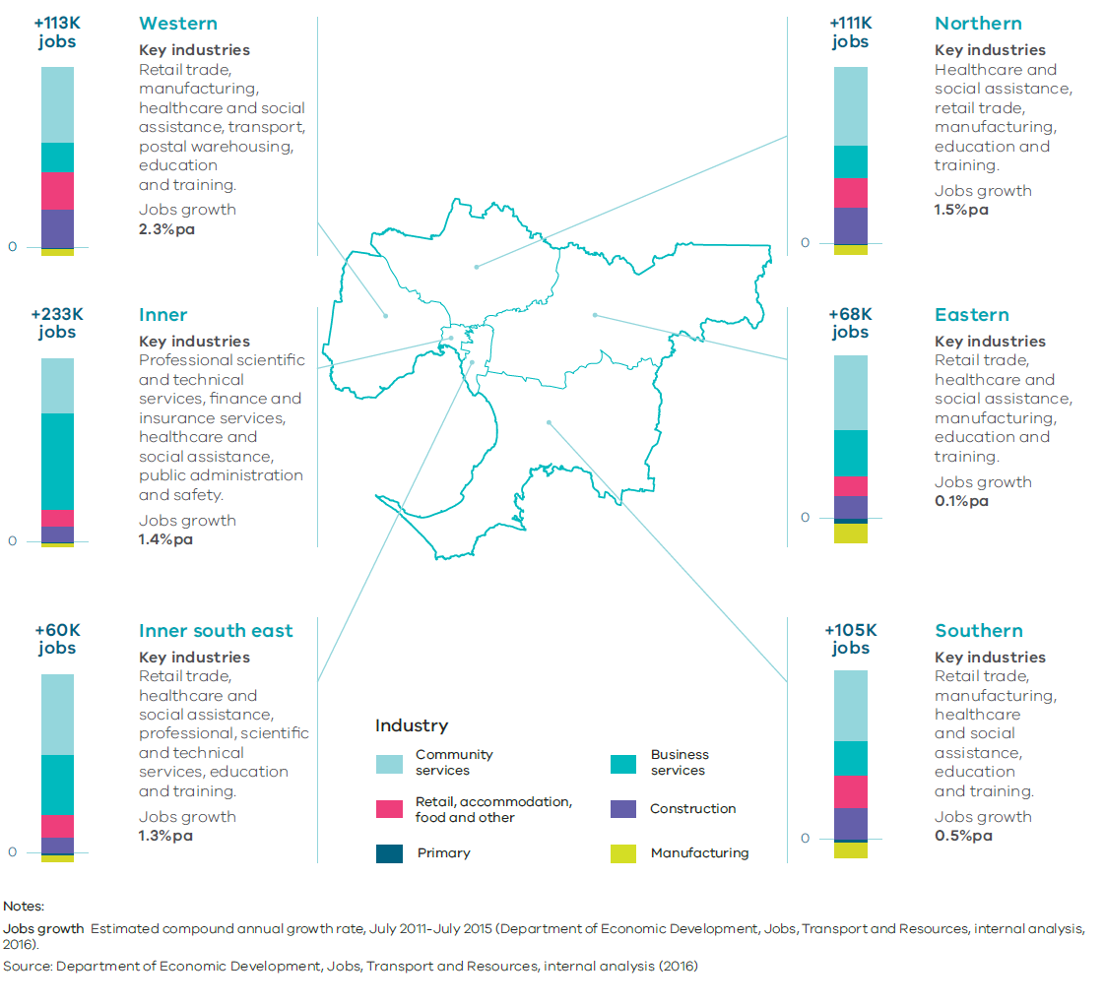

Melbourne has a number of competitive advantages that can create a diverse, flexible and resilient economy. These include world-class industries, a highly skilled workforce, a multicultural population, close proximity and links to the fast-growing Asian region, world-renowned liveability and tourist destinations, good transport networks, and access to productive agricultural land and earth and energy resources.
Priority sectors have been identified that have the potential to attract and deliver significant growth and investment, and make Melbourne and Victoria global leaders.
The priority sectors are:
- medical technology and pharmaceuticals
- new energy technologies
- food and fibre
- transport technologies
- defence technologies
- construction technologies
- international education
- professional services.
With targeted investment, these sectors could drive up to $70 billion in additional economic output by 2025—creating more than 400,000 new jobs for Victorians.
Melbourne has the opportunity to position itself as one of the world’s foremost new knowledge economies, powering the next generation of productivity and economic growth in Australia. To achieve that ambition, Melbourne must develop a series of interconnected learning, working and living precincts across the city.
The Metro Tunnel will significantly transform Melbourne. For the first time, key living, learning and work precincts will be linked by a high-capacity train network. National employment and innovation clusters at Sunshine, Parkville, Monash and Dandenong will be linked to each other as well as other significant precincts such as Footscray, Arden, Domain, St Kilda Road, Caulfield, Oakleigh and Chadstone. This investment in public transport will open up new job opportunities for Melbourne’s citizens and enhance the city’s productivity and liveability (Figure 5).
Melbourne’s key employment areas for jobs and investment are identified on Map 3.
State and local governments must work collaboratively to develop long-term plans for creating jobs and investment in metropolitan regions.
Figure 5 Key living, learning and work precincts linked by a high-capacity train network.
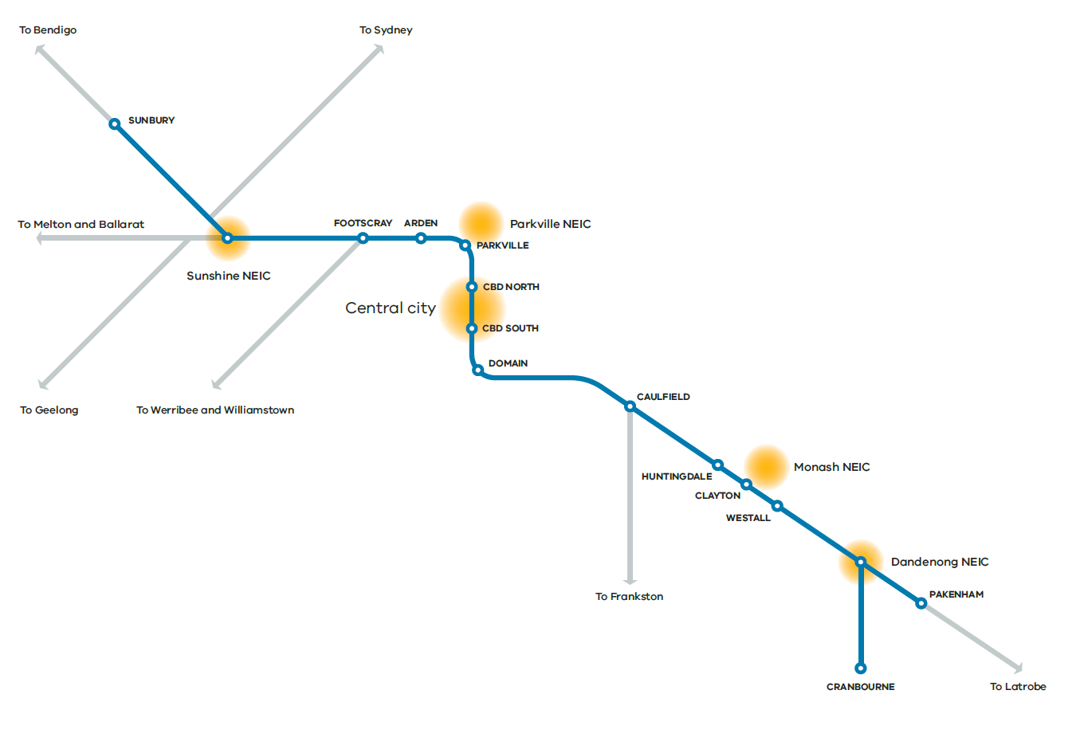

Map 3 Jobs and investment
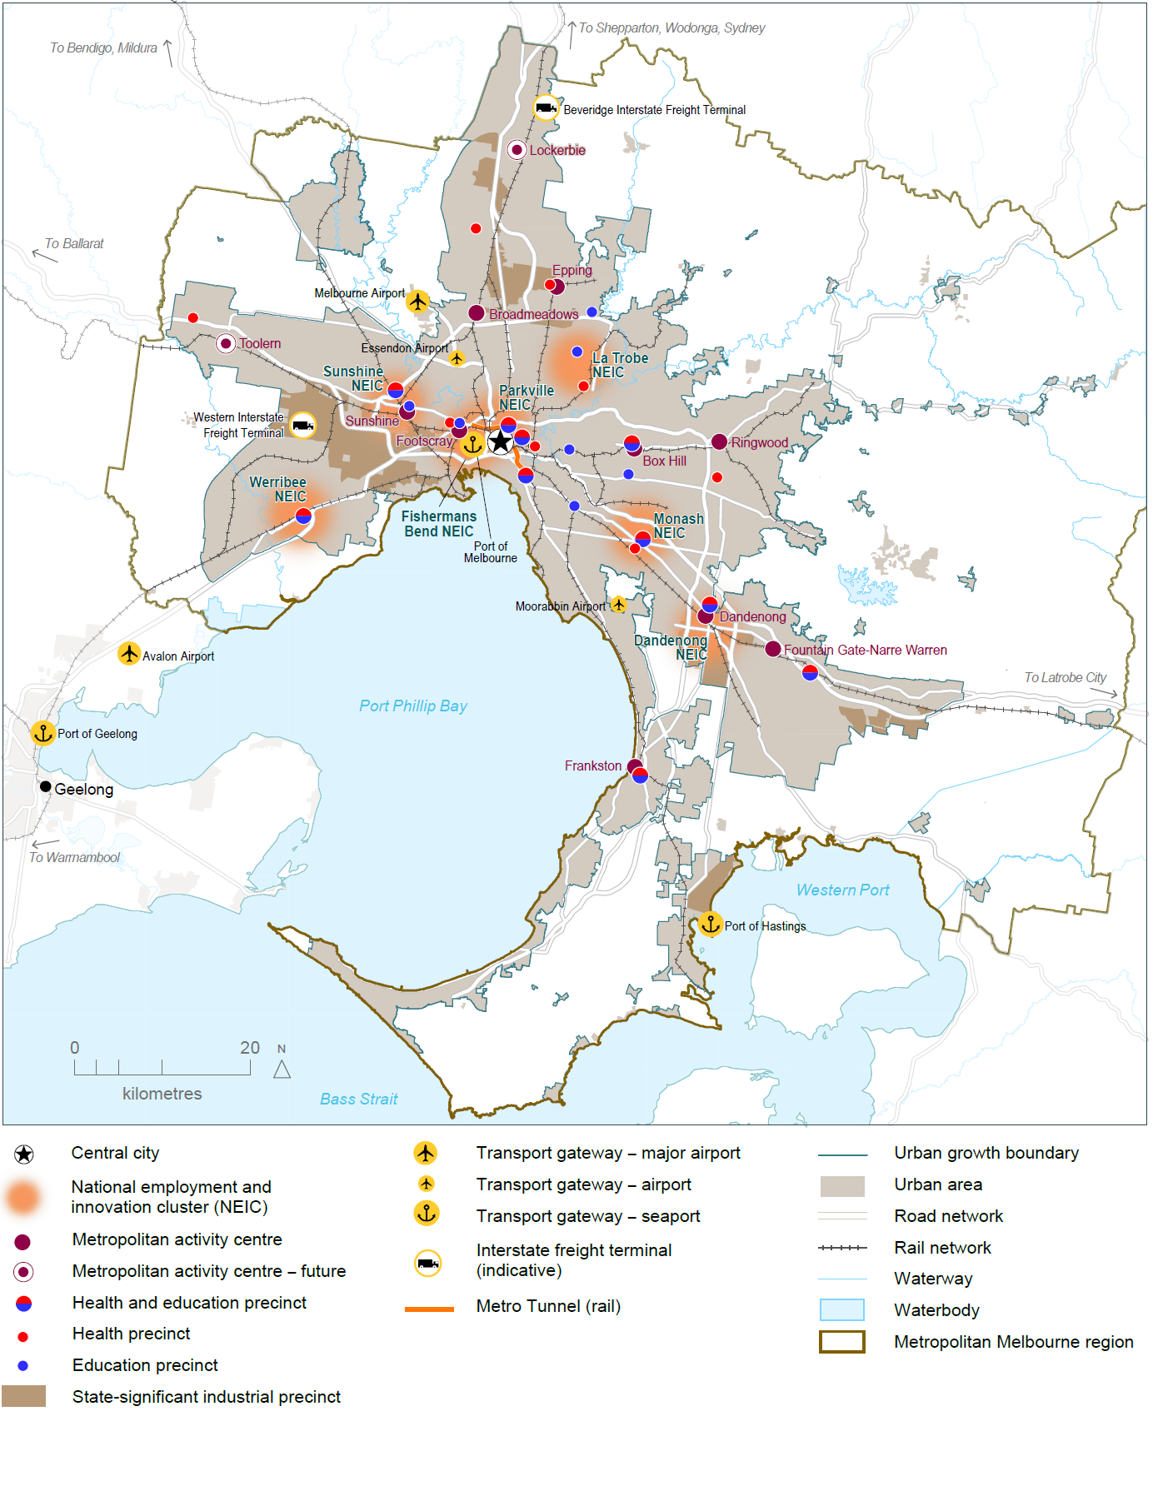
Source: Department of Environment, Land, Water and Planning

Melbourne’s plan

Direction 1.1 Create a city structure that strengthens Melbourne’s competitiveness for jobs and investment
To remain prosperous Melbourne must remain attractive to investment.
That means ensuring well-priced commercial and industrial land is available in locations that support and strengthen key growth industries. In the longer term, Melbourne’s northern and western regions will need to create job opportunities—particularly for high-value, knowledge-based jobs—to support expected population growth.
That means understanding the scale of employment growth and land-use requirements across the city; ensuring business locations are investment-ready and productive, with capacity to grow; and making smart investments in infrastructure projects that accelerate local investment and job creation for suburban and outer areas and stimulate economic growth.

Policy 1.1.1 Support the central city to become Australia’s largest commercial and residential centre by 2050
The central city has some of Australia’s largest and most globally connected financial and professional services businesses (particularly in the CBD, Docklands, Southbank and St Kilda Road). It has a highly diverse economic base, with strengths in health and medical research, education, retail, creative industries, tourism and port-related activities.
Over the past two decades, employment has grown significantly in the central city, with office floor space increasing by 1.4 million square metres since 2000. Docklands has seen much of this growth. Residential growth has also increased in the central city.
This growth in office and residential space delivers a range of benefits such as reduced commuting and transport costs for people living and working in the central city.
For the central city to remain a desirable destination for business investment and a major destination for tourism, new space must be found for office, retail, education, health, entertainment and cultural activities. Creating new opportunities and infrastructure, particularly in major urban renewal precincts, can help support this. The capacity of transport networks will also need to be increased to enable people from middle and outer suburbs to access employment opportunities in inner-city precincts.

Policy 1.1.2 Plan for the redevelopment of major urban renewal precincts in and around the central city to deliver high-quality, distinct and diverse neighbourhoods offering a mix of uses
Major urban renewal precincts such as Southbank and Docklands have created opportunities for the city to grow and accommodate more jobs and housing. Opportunities still exist in Southbank and Docklands as well as other priority precincts such as Fishermans Bend, Arden and Macaulay.
These major urban renewal precincts can accommodate a significant amount of residential and jobs growth over the next 35 years. Their availability gives Melbourne greater flexibility, particularly around timing and land use, with different areas having the potential to cater for different uses. A number of former industrial and other sites—including government landholdings—are also underutilised and could be redeveloped.
The timing of land release in these precincts needs to be in sync with policy drivers, market demand and the delivery of infrastructure and services. If developed properly, the precincts will become a network of connected places, linking to each other and their surrounding neighbourhoods and developing diverse uses and characteristics.

Map 4 Key features in and around Melbourne's central city
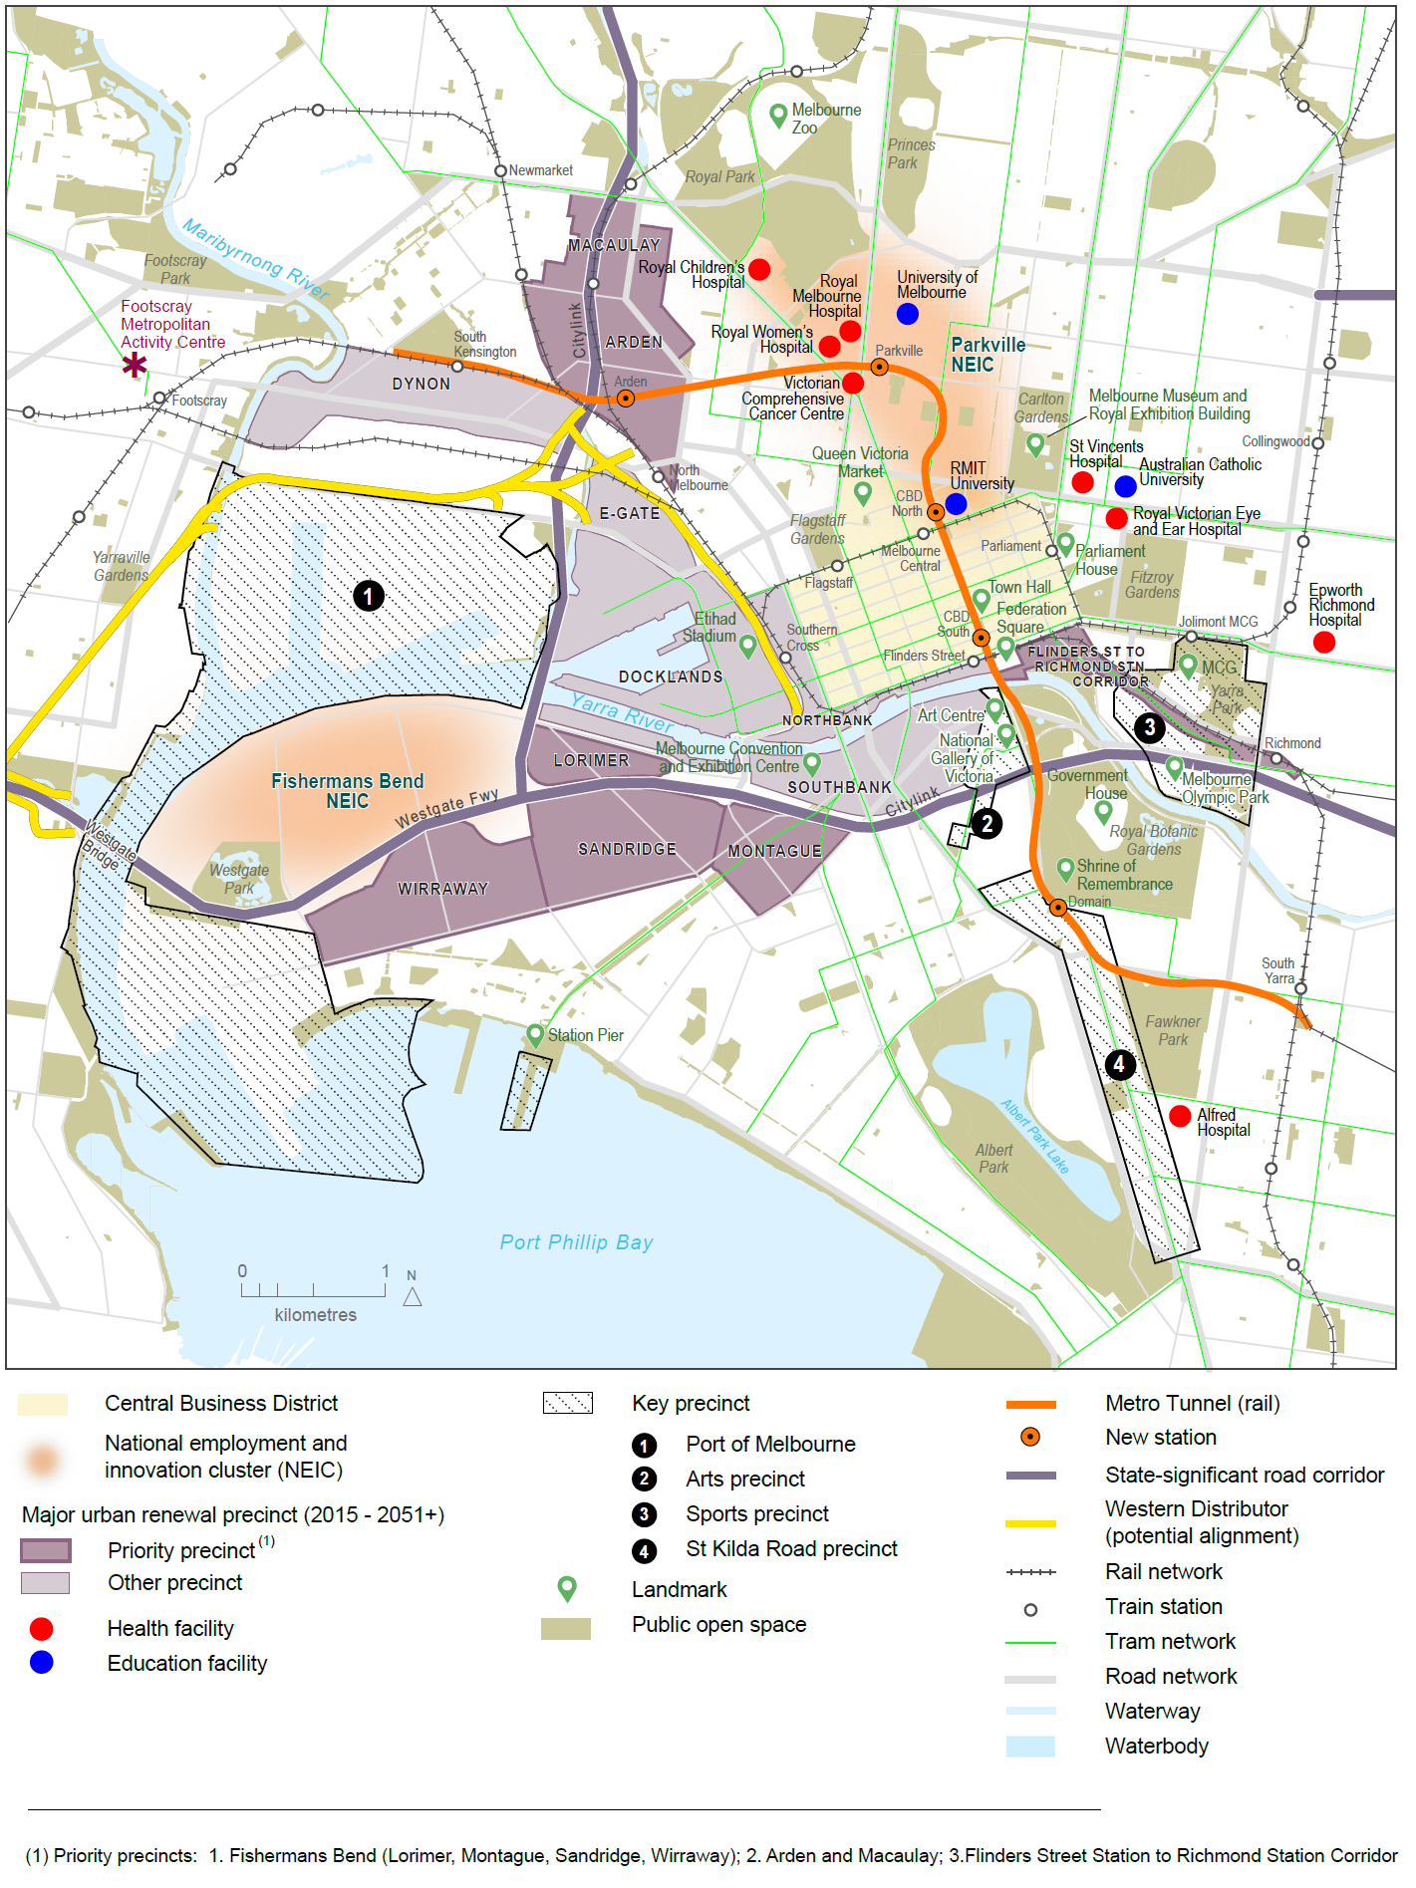
Source: Department of Environment, Land, Water and Planning

Policy 1.1.3 Facilitate the development of national employment and innovation clusters
Melbourne needs to create jobs close to where people live.
Seven national employment and innovation clusters have been identified across metropolitan Melbourne. Each is anchored by a specialised activity (such as a university, research facility, medical facility or manufacturing enterprise) that has seeded its growth. These clusters are Monash, Parkville, Fishermans Bend, Dandenong, La Trobe, Sunshine and Werribee.
The national employment and innovation clusters are focused on knowledge-based businesses that locate close to each other for knowledge and resource sharing. The clusters are distributed throughout Melbourne and along high-capacity transport networks to provide greater access to high-productivity jobs.
The Monash and Parkville clusters are already established and have significant potential to keep growing and diversifying. Other clusters are at various stages of development but possess the fundamentals needed to become strong centres for innovation and jobs growth.
Each cluster has a unique profile. For instance, Monash and Sunshine have the potential to attract a broader range of businesses, including office, retail services and entertainment, as well as residential development. In Dandenong and Fishermans Bend, the key will be to enhance manufacturing productivity with a focus on research and development.
Each cluster is different and approaches to support their growth will vary—depending on their profiles, competitive strengths, roles and stages of development.
However, there are some common requirements. Each cluster will need high levels of amenity to attract businesses and workers—including public transport, and walking and cycling paths. Each cluster needs to be investment-ready for knowledge-intensive firms and jobs. To support the development of clusters, effective governance arrangements—including key stakeholders and landowners—are required.

Map 5 Monash National Employment and Innovation Cluster
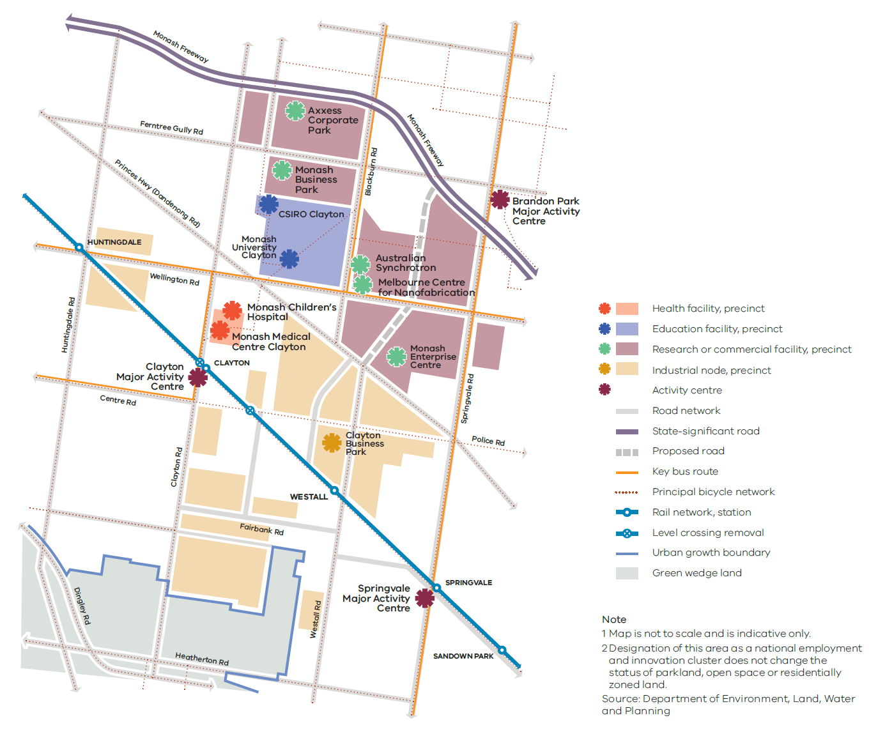

Monash National Employment and Innovation Cluster
Strengths: The cluster has leading education, health, research and commercialisation facilities.
Jobs: Monash is Melbourne’s largest established national employment and innovation cluster, with a mix of education, research and industry organisations. It has approximately 75,000 jobs and is the largest concentration of employment outside the central city.
Key attributes: The cluster has a critical mass of leading education, health and research facilities, including Australia’s largest university (Monash University), the Australian Synchrotron, the Melbourne Centre for Nanofabrication, Monash Medical Centre, a new Monash Children’s Hospital, CSIRO’s largest site in Victoria and the Monash Enterprise Centre. Its mix of education, research and commercial facilities creates a unique environment for innovation and world-leading research, which will continue to contribute significantly to Melbourne’s economy. This unique blend of knowledge- and research-based activity will help existing businesses, such as the manufacturing sector, and produce products and services that are competitive in the global market.
Key partners for the future of this cluster include the City of Monash, City of Kingston, City of Greater Dandenong, Monash University, Monash Medical Centre, Australian Synchrotron, CSIRO (Commonwealth Government) and Monash Enterprise Centre.

Map 6 Parkville National Employment and Innovation Cluster
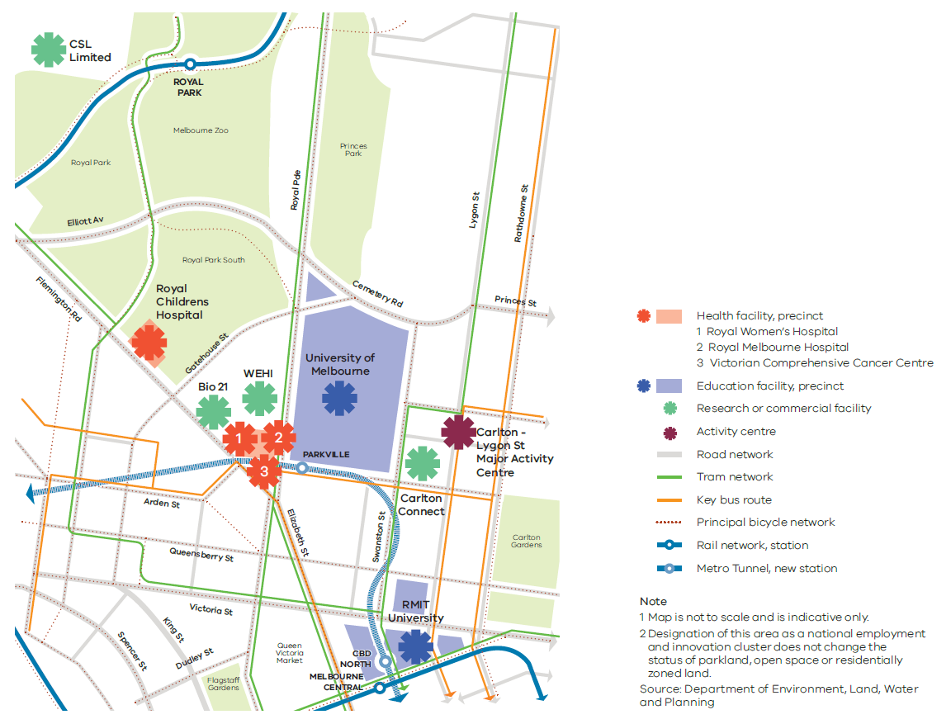

Parkville National Employment and Innovation Cluster
Strengths: The cluster has education, research, health, professional and technical industries as well as significant parkland.
Jobs: The cluster is an established, internationally renowned research centre on the doorstep of the CBD. It is centrally located, has access to a wide catchment of workers across metropolitan Melbourne and employs 40,100 people.
Key attributes: The cluster has a critical mass of leading institutions and organisations, including Australia’s highest ranking university (the University of Melbourne), Victoria’s second-largest university (RMIT University), Monash University’s Faculty of Pharmacy and Pharmaceutical Sciences, the Walter and Eliza Hall Institute of Medical Research, global biotherapy industry leader CSL Limited, the Royal Melbourne Hospital, the Royal Children’s Hospital, the Royal Women’s Hospital, the Victorian Comprehensive Cancer Centre, the Australian Medical Association and the Bio21 Institute.
Many of Parkville’s institutions and organisations are expanding, or plan to expand. Melbourne University and RMIT are also expanding their facilities to incorporate greater collaboration and joint projects with industry. This will drive innovation, research and business development.
The cluster has a high level of public transport access, with tram routes via Swanston and Elizabeth streets. Accessibility will be improved with the establishment of a new, state-of-the-art train station as part of the Metro Tunnel. The frequency and capacity of this service will make it possible for more people to access Parkville.
Key partners for the future of this cluster include the City of Melbourne, the University of Melbourne, RMIT, the CSIRO (Commonwealth Government), the Royal Melbourne Hospital, the Royal Women’s Hospital and the Royal Children’s Hospital.

Map 7 Fishermans Bend National Employment and Innovation Cluster
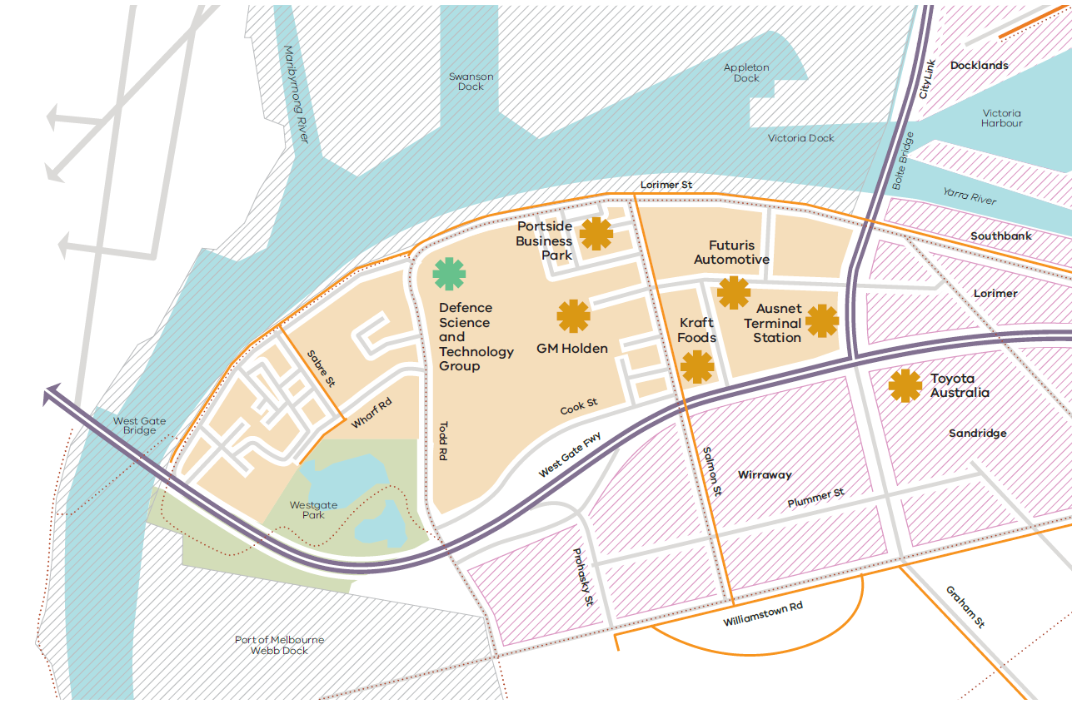

Fishermans Bend National Employment and Innovation Cluster
Strengths: Fishermans Bend specialises in aerospace, defence research, manufacturing and transport and logistics industries.
Jobs: The cluster is an established industrial area on the doorstep of the CBD and employs about 12,200 people.
Key attributes: The cluster has a range of specialist industries, including Boeing Aerostructures Australia, the Defence Science and Technology Group, GM Holden, Toyota Australia, Futuris Automotive and Kraft Foods. The area is close to the Port of Melbourne, the CBD and major arterials—making it easy for businesses to access global markets and workers from across Melbourne.
The cluster is adjacent to the Fishermans Bend urban renewal area. Planning is currently underway for public transport, public space and community infrastructure improvements across Fishermans Bend, including the cluster. This has identified opportunities to further develop the cluster’s design and engineering and advanced manufacturing, and attract complementary education and research organisations.
Key partners for the future of this cluster include the City of Melbourne, the City of Port Phillip, Boeing Aerostructures Australia, the Department of Defence (Commonwealth Government), Kraft Foods, the Port of Melbourne and GM Holden.

Map 8 Dandenong National Employment and Innovation Cluster
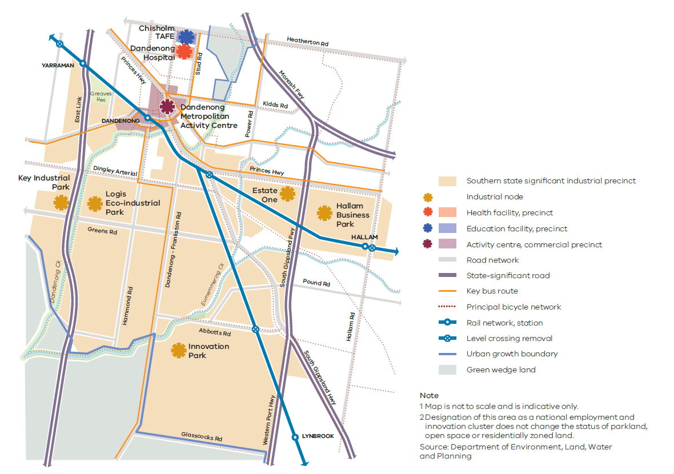

Dandenong National Employment and Innovation Cluster
Strengths: The cluster has strengths in advanced manufacturing, health, education, wholesale trade, retail and transport, postal services and warehousing.
Jobs: The cluster employs more than 66,300 people , including many workers from surrounding municipalities.
Key attributes: Located near the Monash Freeway, the Princes Highway and EastLink, this cluster is part of one of Australia’s most significant and productive manufacturing areas. It has strong links to the other nearby employment areas of Braeside, Carrum Downs, Pakenham and Knox/Bayswater—an industrial network that supports around 148,000 jobs.
Manufacturing activities in the cluster are becoming increasingly knowledge based. Reflecting this, the cluster is now home to Victoria’s first eco-industrial park, LOGIS, which includes the 74-hectare Innovation Park. A growing list of major international and local businesses (such as Kraft Foods, Cadbury, Ascent Pharmaceuticals, Mercury Marine, Moondara Cheese, Terex Australia and Cabrini Health) have based their businesses at LOGIS. Other major firms in the cluster include Jayco, Bombardier Transportation Australia, Corex Plastics, IVECO Trucks Australia, Viridian Glass and Advanced Polymer Technologies. The cluster also includes the Hallam Business Park, the Innovation Park and the Key Industrial Park.
The cluster has the Dandenong Metropolitan Activity Centre to the north. This has a substantial retail presence and a major medical and education precinct based around the Dandenong Hospital and Chisholm TAFE.
Key partners for the future of this cluster include the City of Greater Dandenong, Dandenong Hospital and Chisholm TAFE.

Map 9 La Trobe National Employment and Innovation Cluster
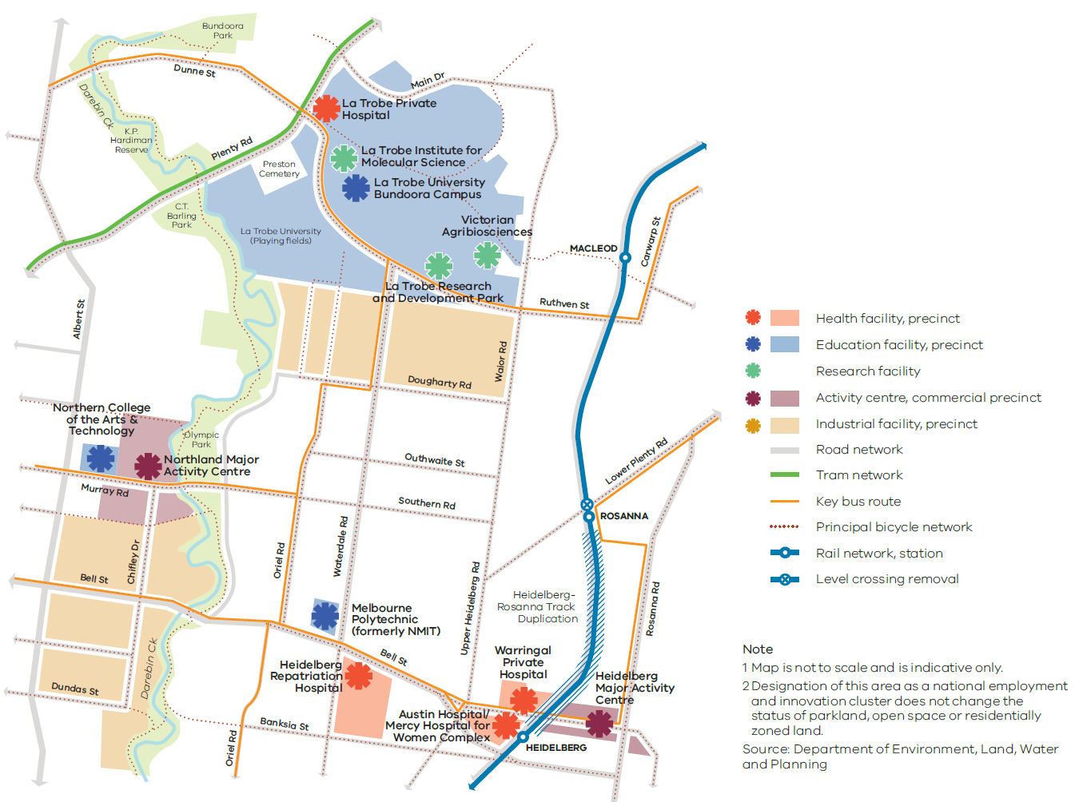

La Trobe National Employment and Innovation Cluster
Strengths: The cluster has strengths in education, research, health and retail.
Jobs: There are around 28,700 jobs in the cluster. Each location in the cluster has different strengths, but together they represent an opportunity to increase the number and diversity of jobs in the region.
Key attributes: The cluster includes a number of significant employment activities (such as La Trobe University and its industrial surrounds, the Northland Shopping Centre and the Austin Biomedical Alliance Precinct) as well as a concentration of other health, research, commercial and retail activities in and around the Heidelberg Major Activity Centre.
La Trobe University has an expanding education and research role, including a growing student and research population and the recently completed AgriBio Centre. The Heidelberg precinct has a significant presence of health services, training and research institutions such as the Melbourne Brain Centre. Austin Health—comprising the Austin Hospital and the Heidelberg Repatriation Hospital—is located in the cluster and operates 980 beds, making it Victoria’s largest provider of training for specialist physicians and surgeons.
The Olivia Newton-John Wellness and Cancer Centre is within the cluster and has 92 beds. Also within the cluster is the Mercy Hospital for Women, which is a specialist hospital for maternity, gynaecology and neonatal services.
La Trobe University plans to grow its research activities (especially in the biosciences) and encourage the commercialisation of research and the evolution of existing businesses. Land around the Northland Shopping Centre also has significant capacity to accommodate new jobs and housing.
Key partners for the future of this cluster include Banyule City Council, Darebin City Council, La Trobe University and Austin Health.

Map 10 Sunshine National Employment and Innovation Cluster
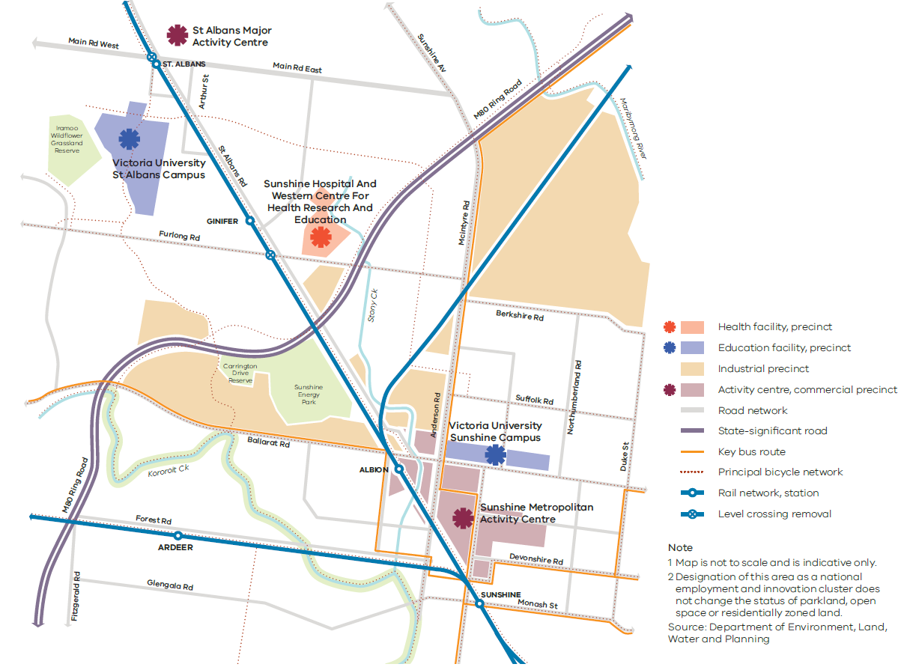

Sunshine National Employment and Innovation Cluster
Strengths: The cluster has the potential to build a critical mass of tertiary education, health-related training, health care, and retail and professional services, as well as facilitate private investment.
Jobs: There are around 14,600 jobs in the cluster.
Key attributes: The cluster is well placed to tap into the growing municipalities of Melbourne’s west and diversify its education, research and health-related activities.
The cluster is centrally located between the CBD and two western growth areas. It also has access to major road and rail networks.
The cluster’s connectivity will increase with the completion of the Metro Tunnel. The Metro Tunnel will provide a 15–20 minute train commute to the CBD and a direct link from the cluster to the south-eastern suburbs. Level crossing removals will further improve access to the cluster, and regional train services from Geelong, Ballarat and Bendigo will pass through the cluster at Sunshine railway station.
There is an opportunity for the cluster to be a central location for the increased provision of health and education services. For instance, Sunshine Hospital is an acute and sub-acute teaching hospital with approximately 600 beds (including mental health beds managed by North West Mental Health). In addition, the Western Centre for Health, Research and Education is a collaborative project between Victoria University, the University of Melbourne and Western Health, where training and research will be carried out. Victoria University has two campuses in the cluster, and other facilities to be developed in the cluster include the Joan Kirner Women’s and Children’s Hospital and the Sunshine Private Hospital.
The cluster also includes the Sunshine Metropolitan Activity Centre and the St Albans Major Activity Centre.
Key partners for the future of this cluster include Brimbank City Council, the University of Melbourne, Victoria University and Western Health.

Map 11 Werribee National Employment and Innovation Cluster
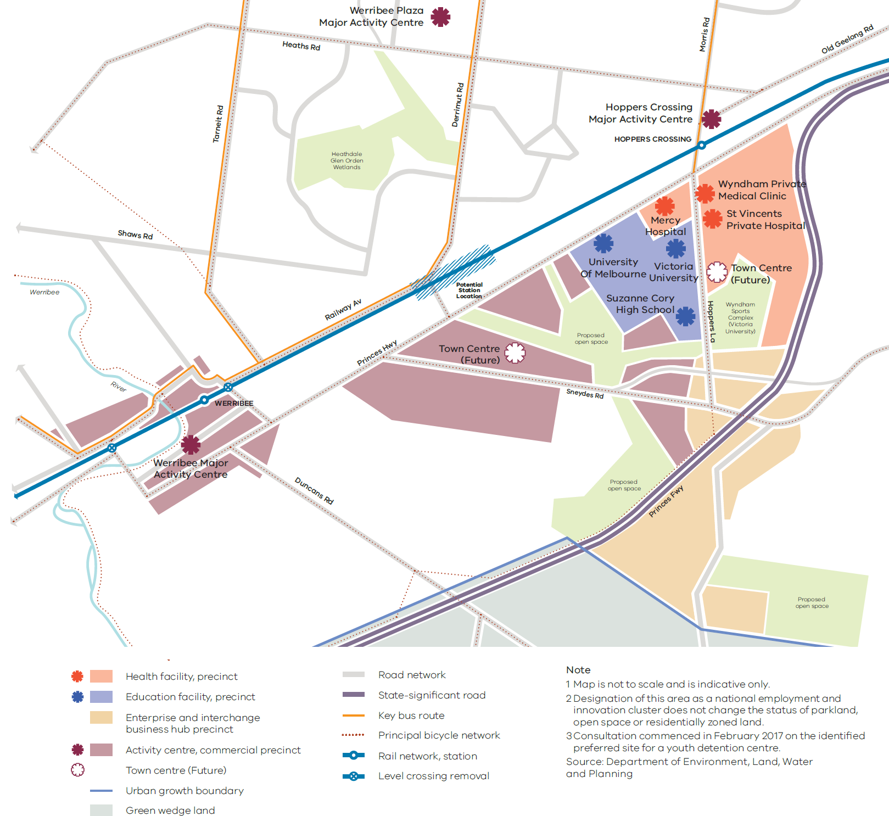

Werribee National Employment and Innovation Cluster
Strengths: The cluster can build on its existing health, education and high-tech research jobs on the site of the former State Research Farm.
Jobs: The cluster is currently home to around 8,400 jobs and could ultimately support more than 50,000 predominantly white-collar jobs in health, education and high-tech research.
Key attributes: The cluster includes the University of Melbourne Veterinary Hospital, the University of Notre Dame, Victoria University, the Werribee Mercy Hospital, the Wyndham Private Medical Centre, the CSIRO, the Suzanne Cory High School and a range of high-tech research companies in the food and agricultural industries. Many of these white-collar job providers have significant expansion plans for the next 20 years. A site for a new hospital has also been purchased within the cluster by St Vincent’s Private Hospital.
Key partners for the future of this cluster include Wyndham City Council, the University of Melbourne, Victoria University and Mercy Hospital.

Policy 1.1.4 Support the significant employment and servicing role of health and education precincts across Melbourne
Victoria has an international reputation in health and medical research. It is also a leading provider of high-quality international education and home to two of five Australian universities ranked in the world’s top 100 tertiary institutions.
The core of the international education sector is largely located in the city, Bundoora, Burwood, Caulfield, Clayton, Footscray, Hawthorn, Parkville and Sunshine. Almost 90,000 international students are linked along these corridors—more than any other city in Australia.
Parkville is an anchor point for health and medical research, with other key medical precincts including the Alfred Medical Research and Education Precinct, the Austin Biomedical Alliance Precinct and the Monash Medical Centre.
Major health and education precincts across metropolitan Melbourne have been identified for further services and jobs growth. These precincts stimulate innovation, create employment and are of fundamental importance to the emerging knowledge economy and surrounding communities.
Planning for the growth of these precincts will need to focus on improving access—particularly via public transport—and diversifying job choices. Co-location of facilities (for example, a university with a hospital) will make better use of existing infrastructure and support the growth of associated businesses and industries. Specialised economic functions should be reinforced, but there should also be opportunities to provide ancillary retail, commercial, accommodation and supporting services.
Health and education precincts
Health precincts
Austin Hospital, Melton Health, Northern Hospital, Craigieburn Health Service, Monash Medical Centre, Knox Private Hospital, Epworth, Western Hospital
Education precincts
Deakin University (Burwood), University Hill (includes RMIT Bundoora campuses), La Trobe University, Victoria University (Footscray), Victoria University (Sunshine), Swinburne University (Hawthorn), Monash University (Caulfield)
Health and education precincts
Alfred Medical Research and Education Precinct (Prahran), Monash University Precinct (Clayton), Parkville Medical, Bioscience and Education Precinct, Werribee Health and Education Precinct, St Vincent’s Hospital and Australian Catholic University Precinct (East Melbourne/Fitzroy), Sunshine Hospital and Victoria University Precinct (St Albans), Frankston Hospital and Monash University Precinct (Frankston), Casey Hospital and Monash University Precinct (Berwick), Dandenong Hospital and Chisholm TAFE Precinct, Box Hill Hospital and Box Hill TAFE Precinct

Policy 1.1.5 Support major transport gateways as important locations for employment and economic activity
Melbourne’s transport gateways and associated road and rail networks are critical to the state’s economy. They provide access to local, national and international markets and are key areas for employment and economic activity.
Melbourne Airport is Victoria’s primary gateway for air passengers and air-freight exporters. It handles around 30 million passengers a year and accounts for almost a third of Australia’s air freight. Melbourne Airport is directly responsible for 14,300 jobs—an employment figure that is expected to grow to 23,000 by 2033. Its curfew-free status is a competitive advantage that must be protected. Additionally, the airport’s central location—between three of Melbourne’s major growth areas—means it is well placed to capitalise on growing labour markets. Together with Essendon Airport’s expanding regional services, this airport corridor has the potential to become one of Australia’s leading transport and logistics hubs.
The Port of Melbourne is Australia’s largest container and general cargo port, handling more than a third of the nation’s container trade and supporting more than 15,000 jobs. Container movements at the Port of Melbourne are expected to grow in coming decades.
For Melbourne to remain the logistics supply base for south-eastern Australia, freight-reliant industries and major transport gateways need efficient access to a range of transport options, including an arterial network that provides reliable connections.
Designated ports, airports, freight terminals and their surrounds will be protected from incompatible land uses to ensure they keep generating economic activity and new jobs. Adjacent complementary uses and employment-generating activities will be encouraged.
State-significant transport gateways
- Port of Melbourne
- Port of Geelong
- Port of Hastings
- Melbourne Airport
- Avalon Airport
- Moorabbin Airport
- Essendon Airport
Proposed
- Beveridge Interstate Freight Terminal
- Western Interstate Freight Terminal
- Possible South-East Airport
- Possible Bay West Seaport

Policy 1.1.6 Plan for industrial land in the right locations to support employment and investment opportunities
Melbourne currently has almost 26,000 hectares of land zoned for industrial purposes. Of this, more than 7,000 hectares are vacant, with approximately 4,660 hectares of vacant land located within state-significant industrial precincts. In addition, 6,275 hectares of unzoned land has been identified through growth corridor plans and previous strategic plans. Over the past five years, demand for new industrial land has averaged around 205 hectares a year, with demand driven by freight, logistics and manufacturing.
Melbourne’s major industrial areas have become more attractive through recent investments in Victoria’s transport network and hubs. Unlike many other cities, Melbourne is well positioned to absorb additional growth near major transport gateways and freight terminals.
Ensuring there is enough industrial land available for development near transport gateways—particularly in outer-suburban areas—will be critical if Melbourne is to remain globally competitive and attract new investments and jobs.
State-significant industrial precincts will be protected from incompatible land uses to allow for their future growth. Future industrial land will need to be identified in strategic locations to ensure there is sufficient land available for major industrial development linked to the Principal Freight Network and transport gateways and networks.
Melbourne has five state-significant industrial precincts
- Western Industrial Precinct
- Northern Industrial Precinct
- Southern Industrial Precinct
- Officer–Pakenham Industrial Precinct
- Port of Hastings Industrial Precinct

Policy 1.1.7 Plan for adequate commercial land across Melbourne
Population growth will continue to drive demand for well-located and competitively priced commercial land. Growth could create demand for an additional 8 million square metres of stand-alone office floor space and 8 million square metres of retail floor space by 2051.
An adequate supply of commercial land needs to be secured to accommodate this growth, as well as a range of services, entertainment and civic activities in suburban locations.
Increasingly, there is desire for activity centres and commercial areas to allow mixed-use development, including retail, commercial and residential. While this approach supports greater flexibility of uses, it can also lead to residential uses competing with commercial uses and employment opportunities. Once a commercial site is converted for a residential use, it is likely to be permanently lost to that market. Consideration needs to be given to ways in which commercial and residential development can be developed together.
To ensure Melbourne maintains a competitive commercial market and is able to facilitate local access to employment, future commercial land requirements need to be quantified by region. There is also a need to estimate the likely distribution of future job growth and commercial land requirements within the network of national employment and innovation clusters and activity centres.

Direction 1.2 Improve access to jobs across Melbourne and closer to where people live
The distribution of jobs across Melbourne is uneven. Outer suburbs and growth areas generally have less access to jobs than middle and inner Melbourne. For example, in the outer west and outer south-east there are about five jobs for every 10 employed residents. In other areas of Melbourne there are about 11 jobs for every 10 employed residents. Job density across Melbourne is shown at Map 12.
Supporting investment and job creation across the city will drive productivity and economic growth and accommodate employment in designated locations across the city.
In particular, national employment and innovation clusters, metropolitan activity centres and major activity centres will ensure employment growth occurs outside of the central city. Projects such as the Metro Tunnel and level crossing removals will better connect people to job opportunities in key areas, particularly in Melbourne’s west and south-east.

Policy 1.2.1 Support the development of a network of activity centres linked by transport
Activity centres have been a part of Melbourne’s pattern of development for decades. They fill diverse roles—including housing, retail, commercial and civic services—and are a focus for services, employment and social interaction. In recent times some activity centres have become a focus for higher-density development. They often have significant public transport infrastructure and have benefited from other public and private investment.
Metropolitan activity centres are critical to growth across a regional catchment—giving communities good access to a range of major retail, community, government, entertainment, cultural and transport services.
Nine existing and two future metropolitan activity centres across Melbourne will be focuses for growth as they continue to cater to the needs of their wider regional population and offer access to a broad range of goods and services. They will also be hubs for public transport services and play a major service delivery role, attracting broad investment in education, health and housing at higher densities.
Plans for metropolitan activity centres will need to accommodate significant growth and infrastructure, while increasing amenity and connectivity for a regional catchment.
Metropolitan activity centres are supported by a network of major and neighbourhood activity centres of varying size, role and function. These can range in size and intensity of use from large shopping centres to small local strip-shopping centres.
All activity centres have the capacity to continue to grow and diversify the range of activities they offer. Opportunities to partner with the private sector to enable future diversification, investment and employment growth should be explored and, where appropriate, facilitated through planning provisions.
Diversification will give communities access to a wide range of goods and services, provide local employment and support local economies and the development of 20-minute neighbourhoods. In many activity centres, this growth will include housing, particularly at higher densities.
To capture and to accommodate future growth opportunities activity centres will need greater flexibility in planning controls than surrounding residential areas. Local plans undertaken in consultation with the community will identify the scope and nature of future growth within each activity centre.
Metropolitan Activity Centres
- Box Hill
- Broadmeadows
- Dandenong
- Epping
- Footscray
- Fountain Gate–Narre Warren
- Frankston
- Ringwood
- Sunshine
Future
- Lockerbie
- Toolern

Map 12 Jobs across Melbourne
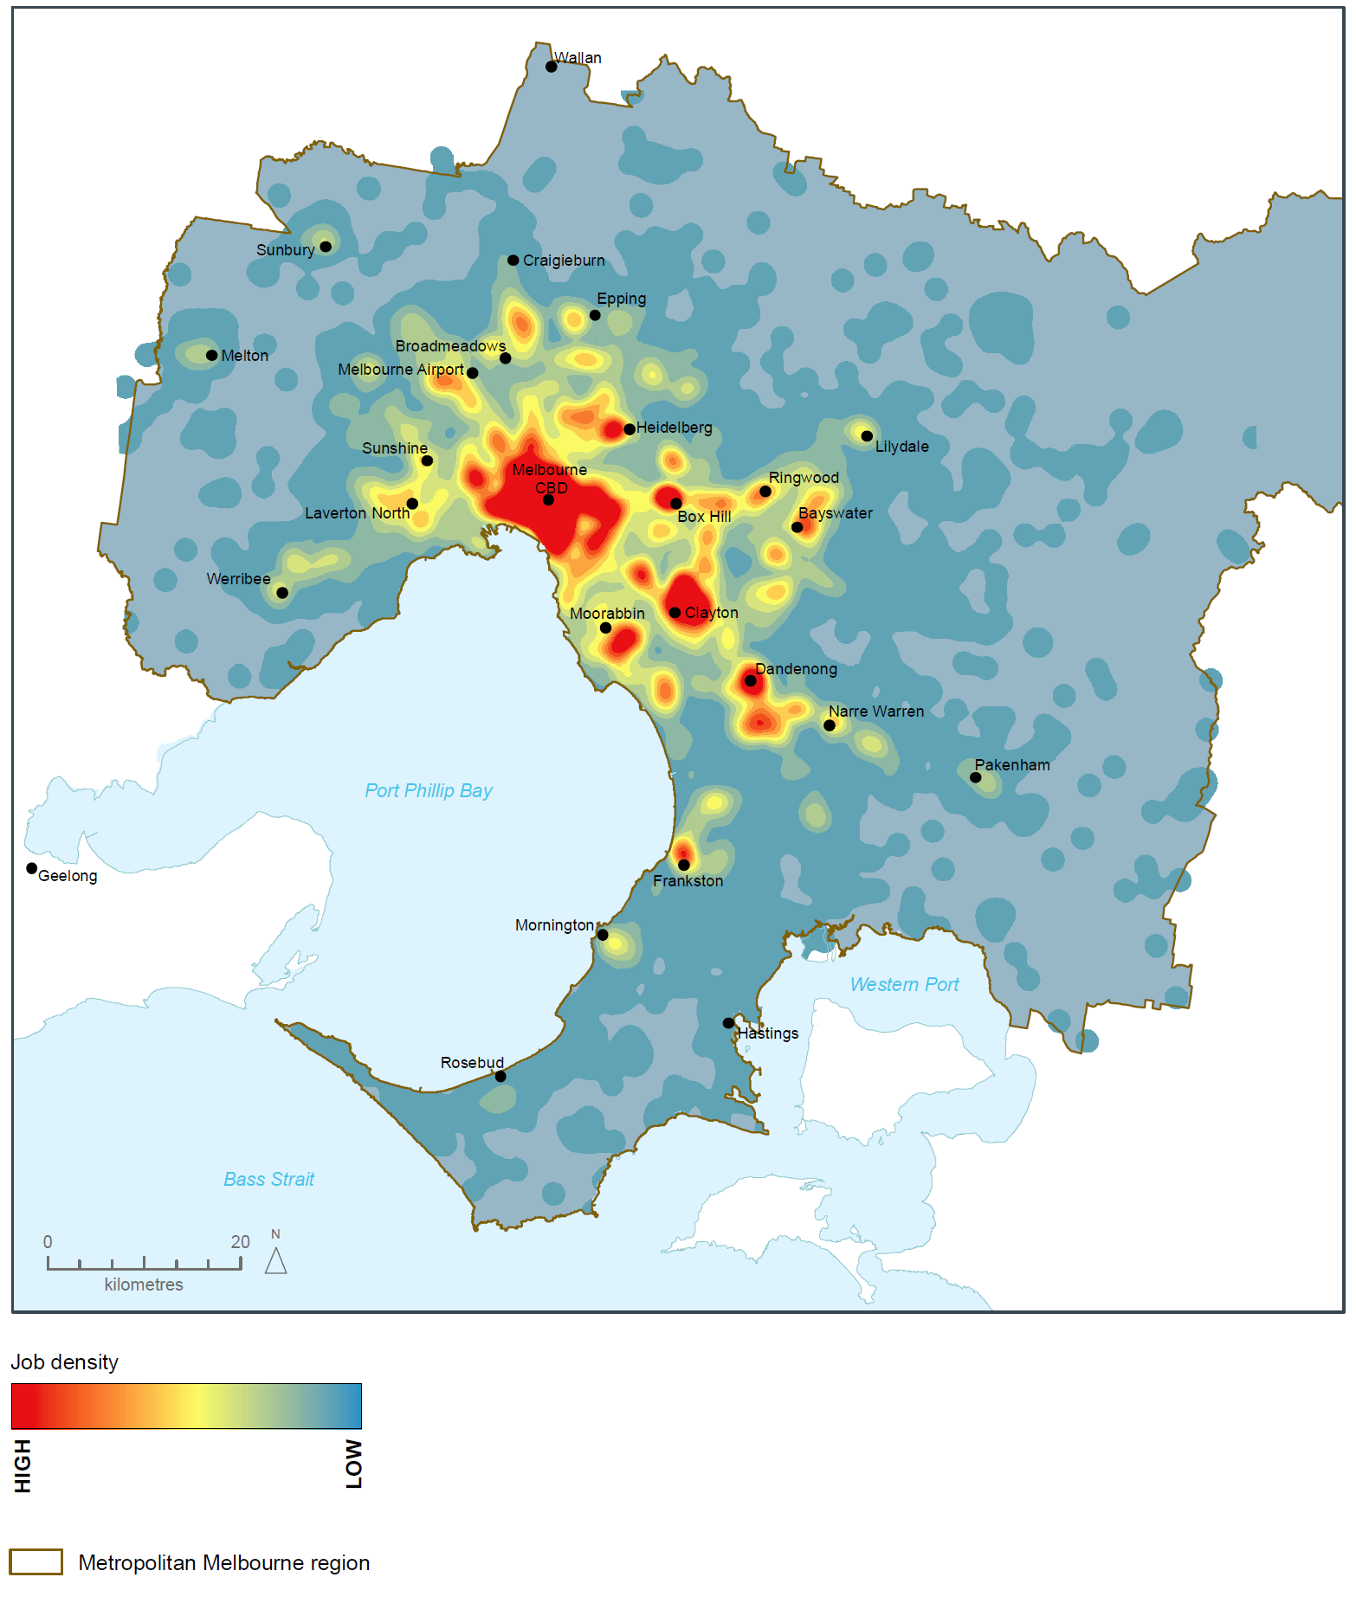
Source: Department of Environment, Land, Water and Planning

Policy 1.2.2 Facilitate investment in Melbourne’s outer areas to increase local access to employment
There is a need to support investments that create jobs in outer suburbs and growth areas. There is also a need to make it easier for people to access jobs—particularly high-value knowledge jobs—in established middle and inner areas from these locations.
Improving connections to national employment and innovation clusters can increase access to high-value knowledge jobs from outer areas and create job opportunities for people in outer areas.
There are also opportunities to support the establishment of start-ups and small and medium enterprises in outer suburbs and growth areas. Facilities such as business incubators can provide tenants with flexible work and meeting spaces where they can access a range of support services and networks to establish and grow their businesses. Local and the Victorian Government can also prioritise local jobs and businesses when procuring suburban infrastructure works.
Planning for outer suburbs and growth areas must ensure there is sufficient zoned land to support future development and job creation. This will provide for strong local economies and ease pressure on transport infrastructure by providing employment close to home.

Policy 1.2.3 Support the provision of telecommunications infrastructure
Next-generation communications—from fixed and wireless broadband, cloud computing, augmented reality applications and social media—are changing the way people live and work.
These changes have made telecommunications infrastructure as fundamental to commercial enterprises as electricity. The absence of telecommunications pathways can hinder or delay the provision of services and increase costs.
To remain globally competitive, Melbourne’s employment areas must support high-quality telecommunications infrastructure. That is why employment, urban renewal and growth area precincts need to include early planning for fibre-ready facilities and wireless infrastructure—eliminating the need for the costly and time-consuming retrofitting of telecommunications pathways.

Direction 1.3 Create development opportunities at urban renewal precincts across Melbourne
Identifying and creating opportunities for development on urban renewal sites and precincts across Melbourne can ease pressure on established areas and provide greater certainty for residents, investors, and the construction and development industry.
Some opportunities will come from investment in major transport infrastructure, such as the Metro Tunnel, level crossing removals, and associated land development. Other opportunities will come from brownfield sites, former industrial areas or underutilised or surplus government land.
Renewal of these sites offers the opportunity to improve local amenity, accommodate more housing and offer a greater mix of uses to support local communities.

Policy 1.3.1 Plan for and facilitate the development of urban renewal precincts
Significant opportunity exists across Melbourne for urban renewal precincts to accommodate future growth. By concentrating development within urban renewal precincts, other residential areas can be protected.
Urban renewal precincts should be developed as mixed-use neighbourhoods that offer a range and choice of housing as well as other services. They should offer high levels of amenity and connectivity and integrate into surrounding neighbourhoods.
An example of an urban renewal precinct is the former Amcor Paper Mill site in Alphington, which is set to be developed into a major residential precinct with shops, offices, open spaces and community facilities as well as commercial and retail spaces. The site—which includes affordable housing—will create local jobs and provide up to 2,500 homes for around 5,000 residents.
A number of former industrial and other sites—including government sites—around Melbourne are currently underutilised. Local planning authorities should identify and plan for ways these sites can be repurposed to create jobs and accommodate growth.

Policy 1.3.2 Plan for new development and investment opportunities on the existing and planned transport network
Melbourne has a significant network of existing and planned transport infrastructure. It will be important to maximise the benefits of this infrastructure by identifying related land-development and investment opportunities.
A number of new railway stations will be built over the next decade. These new stations will need to maximise public value by taking a precinct-wide approach that encourages integrated land development around stations.
Planning will need to identify land-use opportunities—particularly for jobs and employment—that can leverage off major transport investments.

Direction 1.4 Support the productive use of land and resources in Melbourne’s non-urban areas
Melbourne’s green wedges and peri-urban areas are immensely important to the state’s economy, community and environment and support a wide range of non-urban land uses and activities. For instance, some of Victoria’s most productive agricultural land is located within these areas. Other productive non-urban land uses include natural resource extraction, tourism, airports, sewage plants and waste and resource recovery operations.
These areas also accommodate businesses that need buffers from residential and incompatible land uses. Non-urban land uses in the green wedges and peri-urban areas should be carefully planned and managed to avoid irreversible land-use change and support their ongoing productivity.

Policy 1.4.1 Protect agricultural land and support agricultural production
Agricultural production in green wedges and peri-urban areas is vital to Melbourne’s long-term food security due to its proximity to markets, access to infrastructure and labour, and quality soils. Agricultural areas are also important agrifood tourism destinations as well as acting as green buffers for urban areas.
In green wedges and peri-urban areas, competing land uses (such as urban development and rural living) threaten agricultural production. Councils need support to maintain the long-term economic and social value of agricultural production.
Agricultural land in green wedges and peri-urban areas should be retained for productive use so it is not permanently lost.

Policy 1.4.2 Identify and protect extractive resources (such as stone and sand) important for Melbourne's future needs
Melbourne’s demand for extractive resources is expected to almost double by 2051. This demand will be driven largely by sustained growth in the residential sector—including Melbourne’s growth corridors—and strategic projects such as Fishermans Bend, the Metro Tunnel and major road upgrades.
Extractive industry resources in green wedges and peri-urban areas need to be protected and carefully planned to provide for Melbourne's needs without impacting on local amenity. Effective strategic planning for these resources will increase industry certainty and improve community confidence.
There are a small number of extractive industry interest areas within Melbourne’s urban growth boundary—such as Boral at Ravenhall. The sequencing of urban development in growth areas should allow strategic resources such as stone and sand to be extracted ahead of establishing urban areas, with provision for these areas to proceed outside defined buffer zones that can be subsequently in-filled by other urban land uses.
If not managed, urban encroachment, rural residential expansion and other incompatible development will constrain the operations of existing quarries and curtail future supplies of extractive resources—endangering Melbourne’s medium- to long-term growth prospects. To secure a long-term supply of extractive resource materials at competitive prices, current extractive industries must be protected and future extractive resource areas must be identified.

Department of Economic Development, Jobs, Transport and Resources, internal analysis (2016).
Department of Environment, Land, Water and Planning, internal analysis, estimated employed persons derived from Victoria in Future 2016.
Victoria’s Future Industries, Future Industries Fact Sheet, March 2016.
Department of Environment, Land, Water and Planning internal analysis based on Aggregations of Destination Zones from the ABS Census 2011 and ABS Labour Force Survey.
Department of Environment, Land, Water and Planning internal analysis based on aggregations of Destination Zones from the ABS Census 2011 and ABS Labour Force Survey.
Department of Environment, Land, Water and Planning internal analysis based on aggregations of Destination Zones from the ABS Census 2011 and ABS Labour Force Survey.
Department of Environment, Land, Water and Planning internal analysis based on aggregations of Destination Zones from the ABS Census 2011 and ABS Labour Force Survey.
Department of Environment, Land, Water and Planning internal analysis based on aggregations of Destination Zones from the ABS Census 2011 and ABS Labour Force Survey.
Department of Environment, Land, Water and Planning internal analysis based on aggregations of Destination Zones from the ABS Census 2011 and ABS Labour Force Survey.
Department of Environment, Land, Water and Planning internal analysis based on aggregations of Destination Zones from the ABS Census 2011 and ABS Labour Force Survey.
Metropolitan Planning Authority, East Werribee Employment Precinct, Precinct Structure Plan, September 2013 (Amended June 2014).
Melbourne Airport, Melbourne Airport Master Plan 2013.
Port of Melbourne Corporation, Port Development Strategy 2035 Vision, August 2009 and Port of Melbourne Fact Sheet Economic Impact 2012-13, October 2014.
Department of Environment, Land, Water and Planning, Urban Development Program, 2015.
Department of Transport, Planning and Local Infrastructure, Plan Melbourne, Metropolitan Planning Strategy, 2014
Department of Economic Development, Jobs, Transport and Resources (2016) Extractive Resources in Victoria: Demand and Supply Study 2015-2050, Final Report (prepared by Price Water House Cooper)

