The Changing Patterns of Housing Prices in Melbourne

1. Introduction
This graphic shows how house prices in different suburbs of Melbourne have changed over recent decades.
House prices have been broken into quartiles (or quarters) by year - ie - the most expensive quartile, the least expensive quartile, and the two quartiles in between.
Looking at quartiles is useful because, unlike with median prices alone, they demonstrate the relative distribution of houses across different price points.
For example, when house sales in a suburb are concentrated in the top two Melbourne quartiles, this indicates that there are very limited opportunities for less wealthy home buyers to purchase in this suburb.
The geographical distribution of relatively low and high cost house sales has changed significantly in this period. This has occured in the context of general price increases.
A graph shows changes in the 25th, 50th, and 75th percentiles of Melbourne house prices, using data from the Victorian Valuer General. All have increased significantly.
The house sales in the highest quartile are those that are above the 75th percentile, and sales records in the lowest quartile are those below the 25th percentile for Melbourne in that year.
Figure 1: Screenshot - Introduction Page
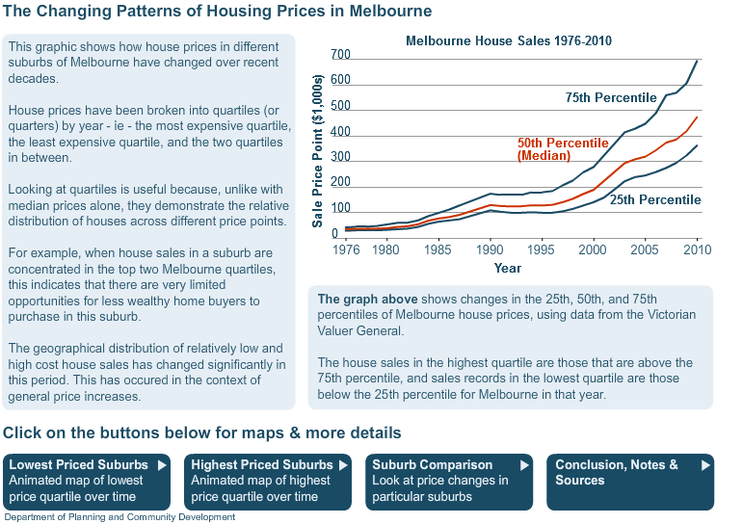

2. Examples of Suburbs and trends
This page provides a number of examples of suburbs with a summary of trends and a time-series stacked bar chart showing the composition of sales between different price quartiles for census years from 1976 to 2009.

Altona
Throughout most of the study period, Altona has been a fairly mixed price suburb, with house sales across all Melbourne price quartiles. Altona has however tended to increase in price, relative to the rest of Melbourne, over the study period. In 1976, 33% of house sales in Altona were in the top two Melbourne price quartiles. This proportion has increased particularly from 2001 onwards. In 2009, 73% of sales in Altona were above the Melbourne median. The proportion of sales in the lowest quartile has decreased from 35% in 1976 to only 4% in 2009.

Armadale
Through its history, Armadale has always been an area of comparatively high cost housing. The predominance of high cost housing in the suburb has increased over the study period, with Armadale becoming increasingly high cost relative to the rest of Melbourne. In 1986, the majority (78%) of sales in Armadale were in the top quartile, increasing to essentially all (94%) sales in 2009. The corresponding trend has been the disappearance of sales in the second and third price quartiles.

Broadmeadows
Much of Broadmeadows was initially developed during the 1970s by the Housing Commission of Victoria. Through the study period house sales in Broadmeadows have always been relatively low cost, with over half of sales in the lowest Melbourne quartile. During the 1990s and 2000s, over 90% of sales in Broadmeadows were in the lowest Melbourne quartile (up from 56% in 1976). In recent years, between 2006 and 2009, the proportion of Broadmeadows house sales in the lowest quartile decreased sharply to 59%, suggesting the suburb may be being discovered by a new market of home buyers.

Brunswick
Brunswick has traditionally been home to lower to middle cost housing. As in many other inner northern and western suburbs, however, gentrification has altered the housing market in Brunswick, which is particularly apparent in Brunswick during the 1990s. In 1976, 65.9% of house sales in Brunswick were in the lowest Melbourne price quartile. This percentage dropped to 51.3% by 1986 and to only 9.7% in 1996. Since 2001, only a very small proportion (less than 5%) of Brunswick house sales has been in the lowest price quartile. There are also very few opportunities in the second quartile of sales. Since 2007, over 90% of house sales in Brunswick have been in the top two Melbourne price quartiles.

Camberwell
Through its history, Camberwell has consistently been an area of comparatively high cost housing. In this sense, the housing market in Camberwell has changed relatively little over the study period since 1976. In 1976, 57.3% of houses in Camberwell were in the top Melbourne quartile. This figure increased to 86.9% by 1991 and to 94.5% in 2009. As Camberwell has become increasingly higher cost relative to the rest of Melbourne, the corresponding trend has been a disappearance of sales in the second and, more noticeably, third price quartile. In 1976, 27.4% of Camberwell houses sold in the third quartile and 12.1% in the second quartile. By 2009 this percentage was negligible, at 3.0%.

Carrum Downs
Carrum Downs in Melbourne’s south east was developed over the 1980s and 1990s. The suburb has always had low proportions of sales above the Melbourne median. An increasing proportion of its house sales have been in the lowest Melbourne price quartile, up from 28.3% in 1986 to 71.8% in 2009.

Deer Park
Deer Park has always had the majority of its sales below the Melbourne median. However whereas in the 1970s and 1980s the suburb was more mixed, with sales in the second quartile, over time the suburb has become predominantly low cost. The proportion of sales in the lowest quartile increased steadily from 22% to the majority of sales, 74%, in 2006. However in recent years, between 2006 and 2009, the proportion of Deer Park house sales in the lowest quartile decreased. Given trends in nearby Sunshine the suburb may be being discovered by a new market of home buyers.

Doveton
Parts of the urban fringe, developed in the interwar or immediate post war period, have always been home to relatively low cost housing. These areas are sometimes located in proximity to industrial areas, have high proportions of public housing, and have tended to be popular destinations for migrant groups. Doveton has consistently had a very high proportion of its house sales in the lowest price quartile. This proportion increased to 98% in 2001, but has since decreased to 88.3%.

Essendon
Since the early 1980s, house sales in Essendon have tended to be in the higher two price Melbourne price quartiles. Over time the proportion in the top price quartile has increased, with fewer middle priced sales. In 1981 the proportion of top Melbourne price quartile was 33.5%, increasing to 79.5% in 2009.

Footscray
Suburbs in the west such as Footscray saw some decreases in lower cost housing in the 1990s, with this decrease excelarating from the late 1990s. The same steep drop in the proportion of sales in the lowest quartile is seen as in gentrification of inner and northern suburbs, but at differing points of time. Through the earlier parts of the study period over 75% of house sales in Footscray were in the lowest Melbourne price quartile. This dropped off from 1996 onwards, to 3.8% in 2009. Most (63.2%) house sales in Footscray are in the third quartile of Melbourne prices.

Frankston
In the 1970s and 1980s Frankston was a comparatively mixed price suburb, with sales fairly evenly distributed across Melbourne price quartiles. Over time the proportion of sales below the Melbourne median (quartiles 1 and 2) increased in Frankston, with a corresponding decrease of relatively higher cost sales. By 2001, 63% of Frankston house sales were in the lowest Melbourne price quartile. Since 2001, however, the proportion of sales in the lowest quartile has steadily decreased, down from 63% to 52%, suggesting that the suburb may be being discovered by a new market of home buyers.

Hampton Park
In 1976 and 1981 the majority of sales in Hampton Park were in the second Melbourne price quartile, with some sales in the higher price quartiles. Over time, the proportion of sales in the lowest Melbourne price quartiles has increased in Hampton Park to account for the majority of sales in the suburb, from 18% in 1976 and up to 84% in 2006.

Hastings
Partly as a function of the large area that is defined as the Melbourne Statistical Division, much of the lower cost housing in Melbourne is situated in peri-urban areas such as the Yarra Ranges, and around Westernport Bay. Hastings is a peri-urban township on Westernport side of the Mornington Peninsula. In 2009, 66.2% of house sales in Hastings were in the lowest Melbourne price quartile.

Ivanhoe
Through the study period Ivanhoe has always been a comparatively higher cost suburb, with few sales in the lowest Melbourne price quartile. Over time Ivanhoe has become increasingly high cost relative to the rest of Melbourne, with decreasing proportions of sales in the middle (second and third) price quartiles. Sales in the top quartile have steadily increased from 46% in 1976 to 80% in 2009.

Mill Park
Mill Park in Melbourne’s north was developed in the 1980s and 1990s. Predominantly a middle cost suburb, the price profile of Mill Park has shifted over time from being mainly in the third quartile (above the Melbourne median), to being mainly in the second quartile (below the Melbourne median). In 1986, 59.7% of sales in Mill Park were in the third Melbourne price quartile and 30.6% were in the second. By 2009 this had reversed, with sales in the suburb mainly (78%) in the lower two Melbourne quartiles.

Narre Warren
Narre Warren was developed mainly through the 1990s and early 2000s. Since this time, sales in the top two Melbourne price quartiles have decreased. Sales in the lowest price quartile now make up 50.1% of house sales in the suburb.

Northcote
Northcote has moved from being a predominantly low cost suburb to having predominantly high cost housing, with gentrification particularly apparent in the late 1980s and early 1990s. In 1986, 43% of house sales in Northcote were in the lowest price quartile for Melbourne. This proportion fell to 18% in 1991 and then to 6% in 1996. Northcote has seen a corresponding increase of house sales in the top Melbourne quartile, increasing from only 15% in 1991 to 64% of house sales in 2009.

Port Melbourne
Port Melbourne has shifted from being a suburb of predominantly lower cost housing, to being one of predominantly very high cost housing. This process of gentrification took place particularly during the 1980s, The proportion of house sales in the lowest Melbourne price quartile fell from 55% in 1976 to 9% in 1991 to essentially none in 2009. The proportion of sales in the highest Melbourne price quartile increased from 6.8% in 1976 to 39.8% in 1991 and to over 90% in 2009.

Richmond
The process of gentrification was already underway in some inner suburbs by the start of the study period. By 1976 the former ‘slum’ areas of Carlton and Fitzroy did not have disproportionately high proportions of low cost housing. However Richmond as at 1976 was still a predominantly low cost suburb, with 61.1% of its sales in the lowest quartile. Richmond gentrified - experienced rapid reduction in lower cost sales - during the 1980s. The majority (75.3%) of sales in Richmond are now in the top Melbourne price quartile.

Roxburgh Park
Roxburgh Park to the north of Melbourne is a newer suburb, with the main development period in the late 1990s and 2000s. Roxburgh Park seems to be following similar price patterns to suburbs developed in earlier decades. The proportion of Roxburgh Park sales in the top price quartiles has decreased and the proportion of sales in the lowest price quartile has increased, from 16.8% in 2001 to 41.2% in 2009.

Sandringham
In 1976 the beachside suburb of Sandringham was a relatively mixed suburb in terms of housing prices, although with most sales in the top two quartiles (each accounting for 35.8% of sales). However the proportion of sales in the top Melbourne price quartile increased consistently over time, to 70.7% in 1991 and to 85.5% in 2001. By 2009, essentially all (95.6%) sales in Sandringham were in the top Melbourne price quartile.

Toorak
Toorak has traditionally been Melbourne’s most expensive suburb and this has changed little over time. In each of the study years, over 95% of house sales in Toorak have been in the top Melbourne price quartile.

Williamstown
Williamstown experienced gentrification at a similar time to the inner and northern suburbs, with rapid decreases in lower cost houses in the 1980s and 1990s. In 1976, 50% of house sales in Williamstown were in the lowest price quartile for Melbourne. This proportion decreased through the 1980s and early 1990s as the suburb gentrified, falling to 10% in 1991 and to 4% in 1996. Williamstown has seen a corresponding increase of house sales in the top Melbourne quartile, increasing from only 20% in 1976 to the majority of sales (81%) in 2009.
Figure 2: Screenshot - graph for Brunswick
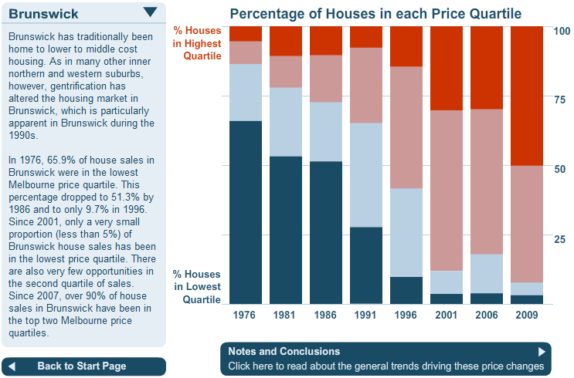
Figure 3: Screenshot - graph for Broadmeadows
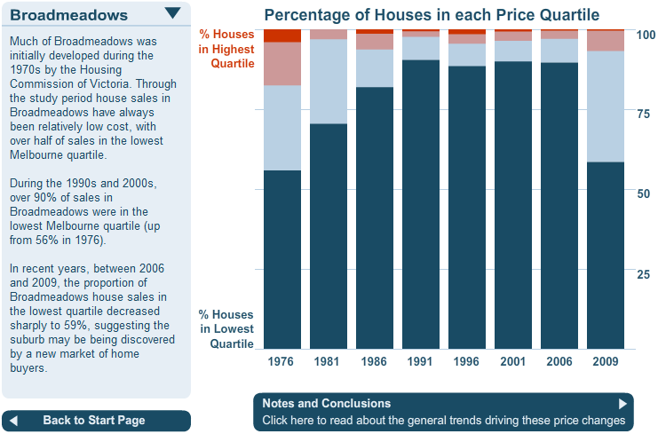

3. Sales in the Highest Price Quartile by Suburb
This animated map demonstrates changing patterns in higher cost housing. Since 1976, house sales in inner and eastern Melbourne have been increasingly concentrated the highest quartile. Nearly all properties in inner Melbourne or in the southern and eastern middle ring suburbs are now above the 75th percentile of Melbourne house prices. The user can use the Play and Pause Buttons to view changes over time and click on the timeline to jump to any year.
Figure 4: Screenshot - map of concentration of property sales in the highest quartile, 1976
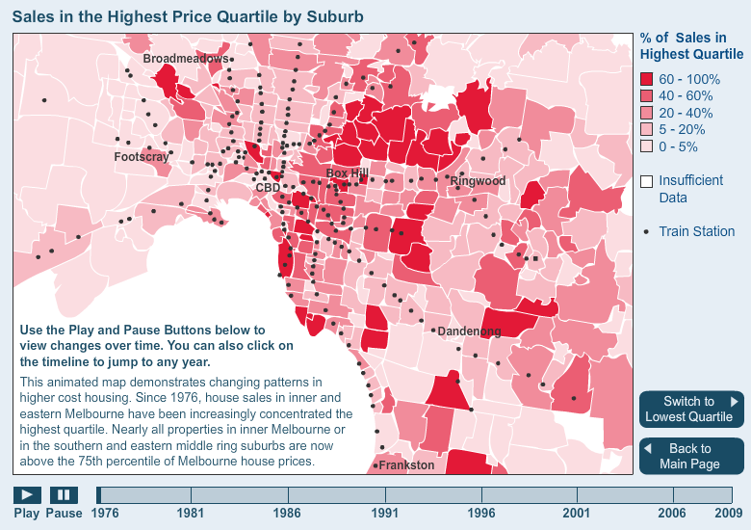
Figure 5: Screenshot - map of concentration of property sales in the highest quartile, 2009
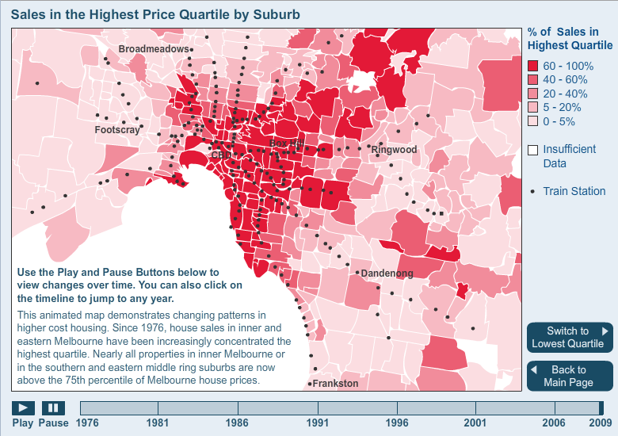

4. Sales in the Lowest Price Quartile by Suburb
This animated map demonstrates changing patterns in lower cost housing. Since 1976, the proportion of houses sales in inner and middle Melbourne that were in the lowest quartile for Melbourne has reduced sharply, while relatively low cost housing has instead become more concentrated in the outer suburbs. The user can use the Play and Pause Buttons to view changes over time and click on the timeline to jump to any year.
Figure 6: Screenshot - map of concentration of property sales in the lowest quartile, 1976
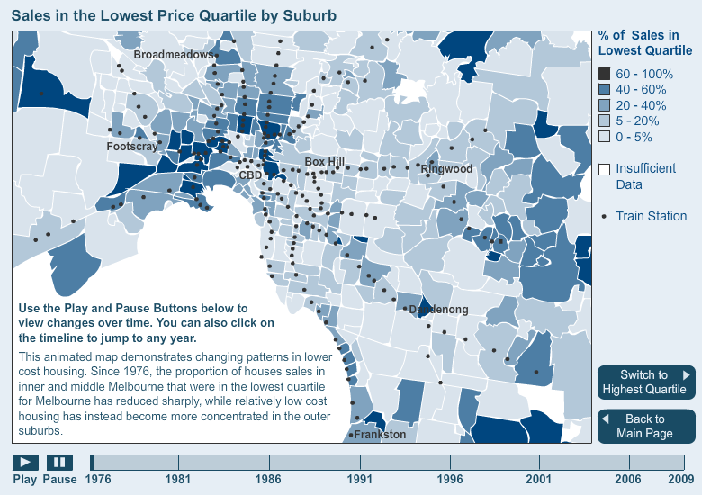
Figure 7: Screenshot - map of concentration of property sales in the lowest quartile, 2009
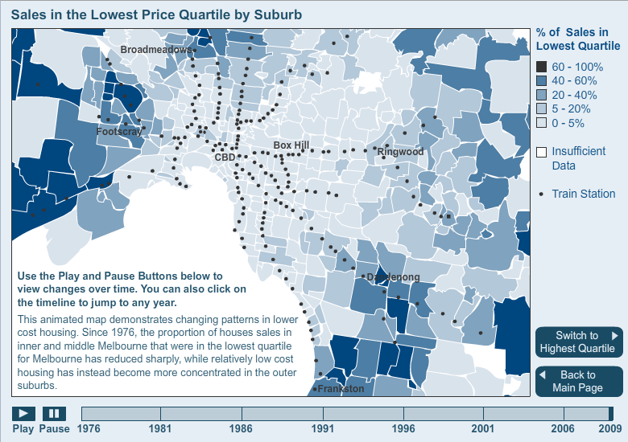

5. Conclusion
This research reveals three main groups that suburbs fall into.
Gentrification has affected many formerly lower-priced suburbs, particularly in the inner north and west. The proportion of houses in these areas in the lowest price quartile has decreased rapidly, while the proportion in the top quartile has grown. This process tends to occur gradually in waves, with each wave displacing some earlier resident groups. This process occurred decades ago in suburbs such as Fitzroy and Carlton, with other suburbs such as Brunswick, Northcote, and Footscray gentrifying more recently.
Filtering down of prices has occurred in some suburbs that were subdivided two or three decades ago and began as middle priced suburbs, with higher prices paid for newly built houses. As the houses age, they become comparatively less expensive compared to houses in other areas.
Increasingly homogenous higher prices can be found in traditionally higher priced suburbs that have continued to be highly sought after. Since 1976, sales in these suburbs became even further concentrated in the highest price quartile, with very few sales in any other price quartiles.
The full Research Document can be accessed here ????????????
Method & Sources
This research uses Victorian Valuer General unit-record level residential sales data covering the period 1976-2010.
Sale records in Melbourne have been mapped and then ranked and put into four equal count groups (quartiles) for each year of sale.
The proportions of house sales in each Melbourne suburb that were in each price quartile in different years are examined.
The advantage of this approach is that it identifies patterns of spatial distribution and concentration which can be masked when using aggregate or median data.
Research and graphic production by Spatial Analysis and Research Team of the Department of Planning and Community Development.
Figure 8: Screenshot - Conclusion, Notes, and References.
