Accessing a title framework

What is a Certificate of Title?
A Certificate of Title is an official record of land ownership which can include information about mortgages, covenants (restrictions), caveats and easements.
It is issued by Land Victoria after each registration that affects the interests the land. For example, a Certificate of Title would be issued following the registration of land transfer or mortgage.

What must a Certificate of Title look like?
A complete Certificate of Title must include a description of the land; easement information; registered owners; and covenants or encumbrances to show any other interests in the land.

Figure 1 | Example of a Certificate of Title page 1
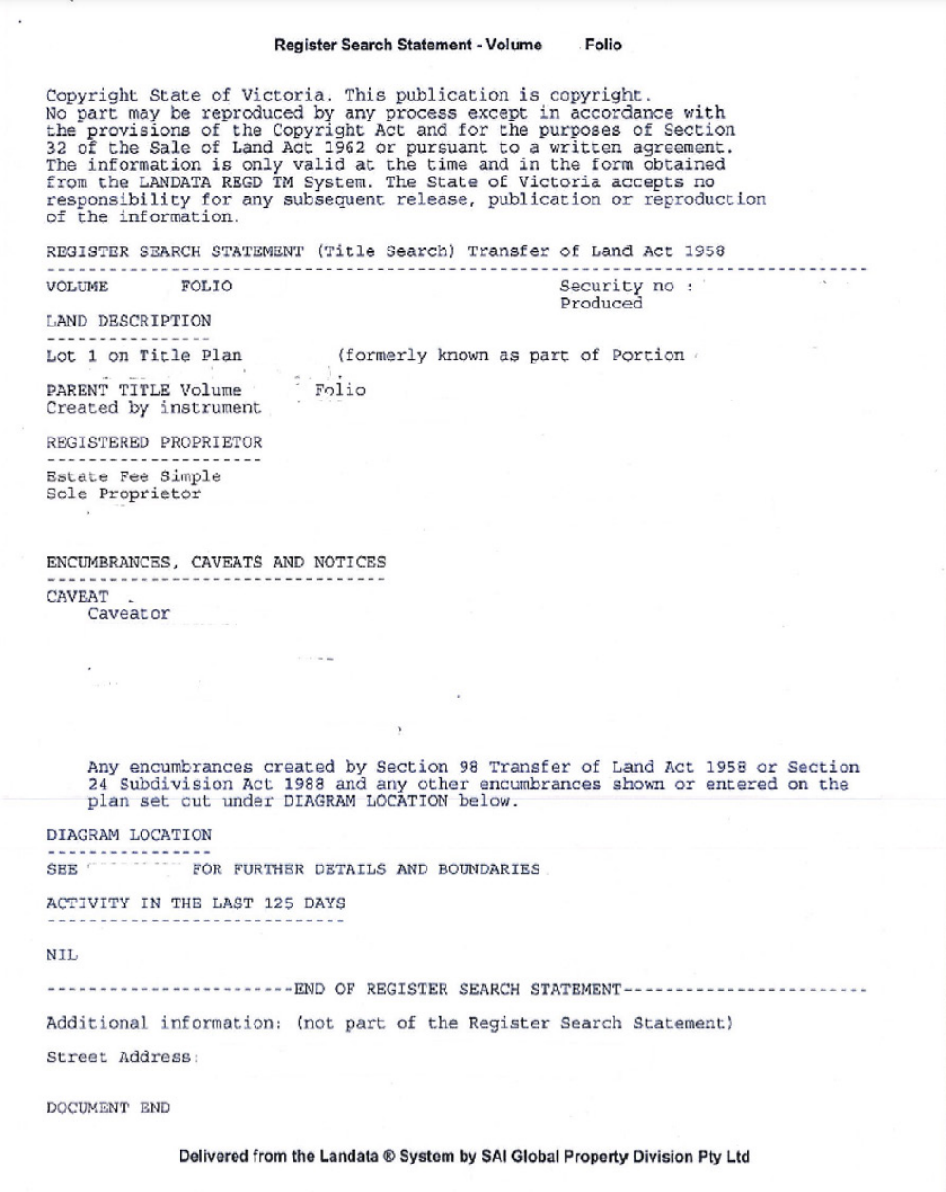
Figure 2 | Example of a Certificate of Title page 2
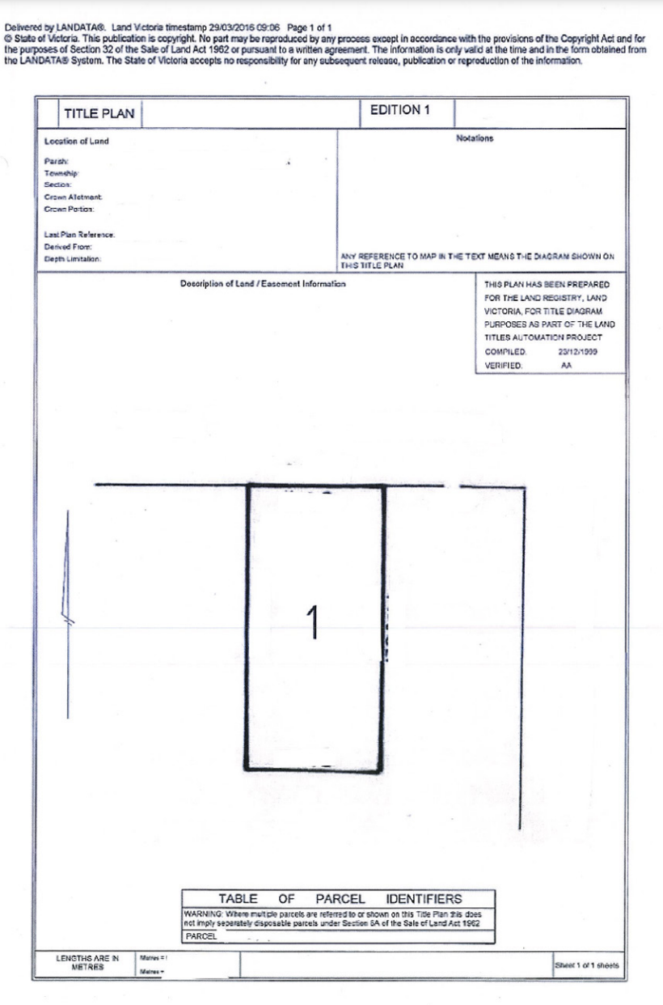

What do I need to consider when getting a Certificate of Title?
For town planning applications, the Certificate of Title must current. To be current it must be less than three months old. The Certificate of Title included in a Section 32 is not reliable and may be out of date.

How do I access a Certificate of Title?
The easiest way to access a Certificate of Title is to log onto the Land Data website at www.landata.vic.gov.au
Before you start your search, it is important to have this information if it is available:
- Site Street Address
- Volume Folio Number
- Lot on Plan
- Council Property Number from your rates notice
- Crown allotment details
There are five steps to this process.

Step 1 – Specify the property details
- Click on Titles & property certificates
- Enter the site street address
Figure 3 | Screenshot of Landata website
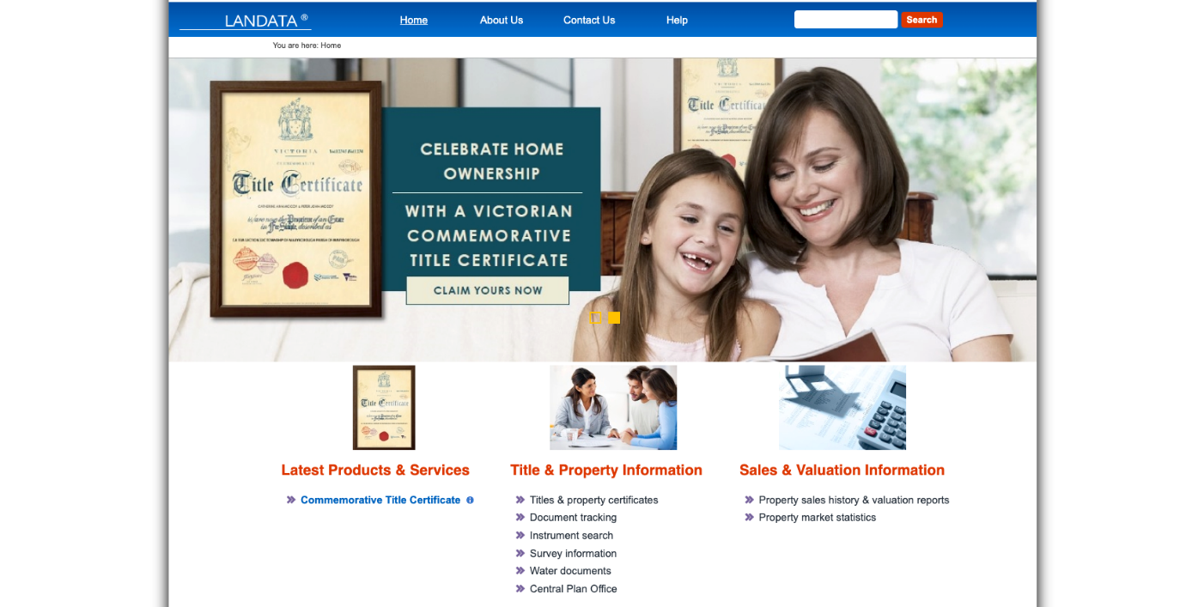
Figure 4 | Screenshot of Title and property Certificates page
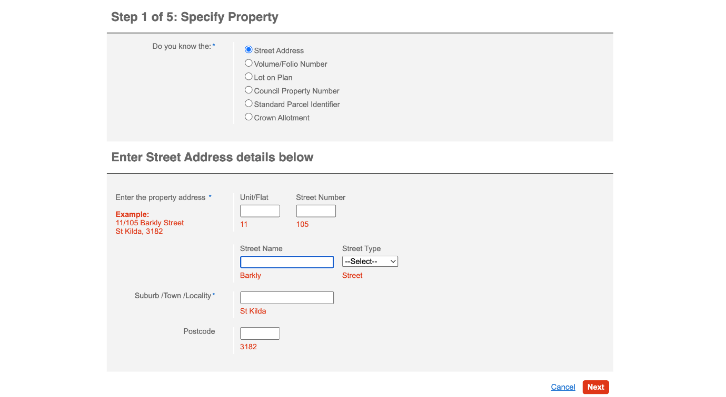

Step 2 – Confirm the property details
- Follow the prompt to confirm the property details
- Use the link to ‘View and Confirm’ the property address on the map
- Check the correct Lot is highlighted
- If it is incorrect, move the cursor to correct Lot and click to highlight
- Click ‘Confirm Property Detail’ when correct site is selected
Figure 5 | Screen shot of ‘Confirm property’’ page
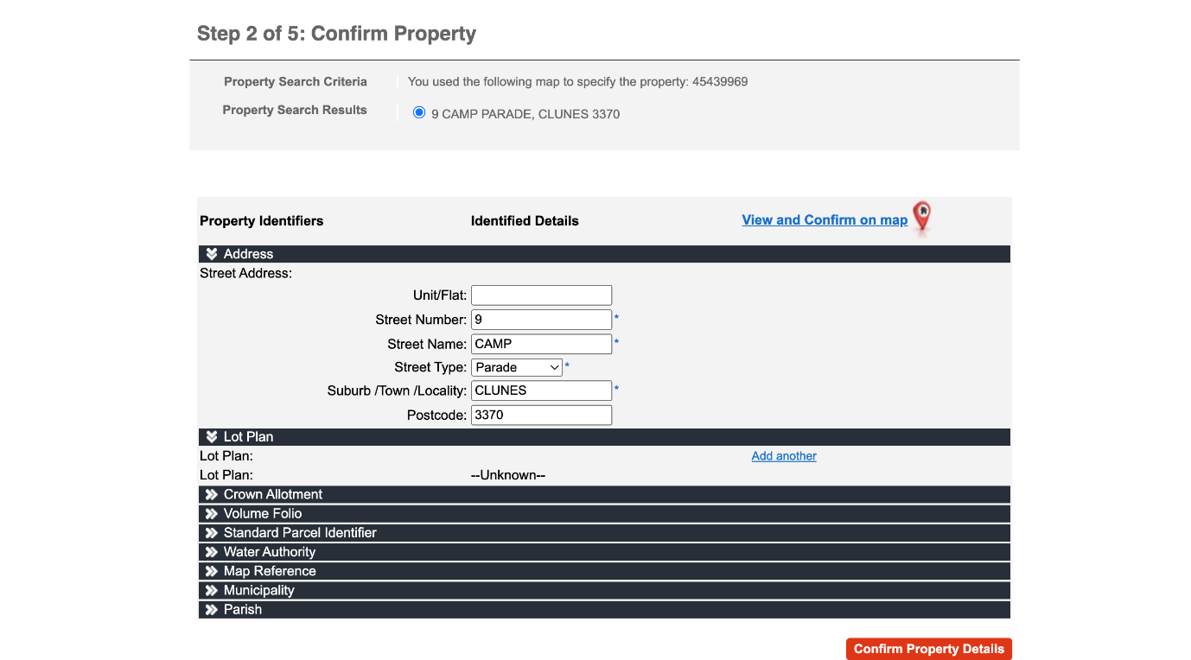
Figure 6 | Screenshot of map
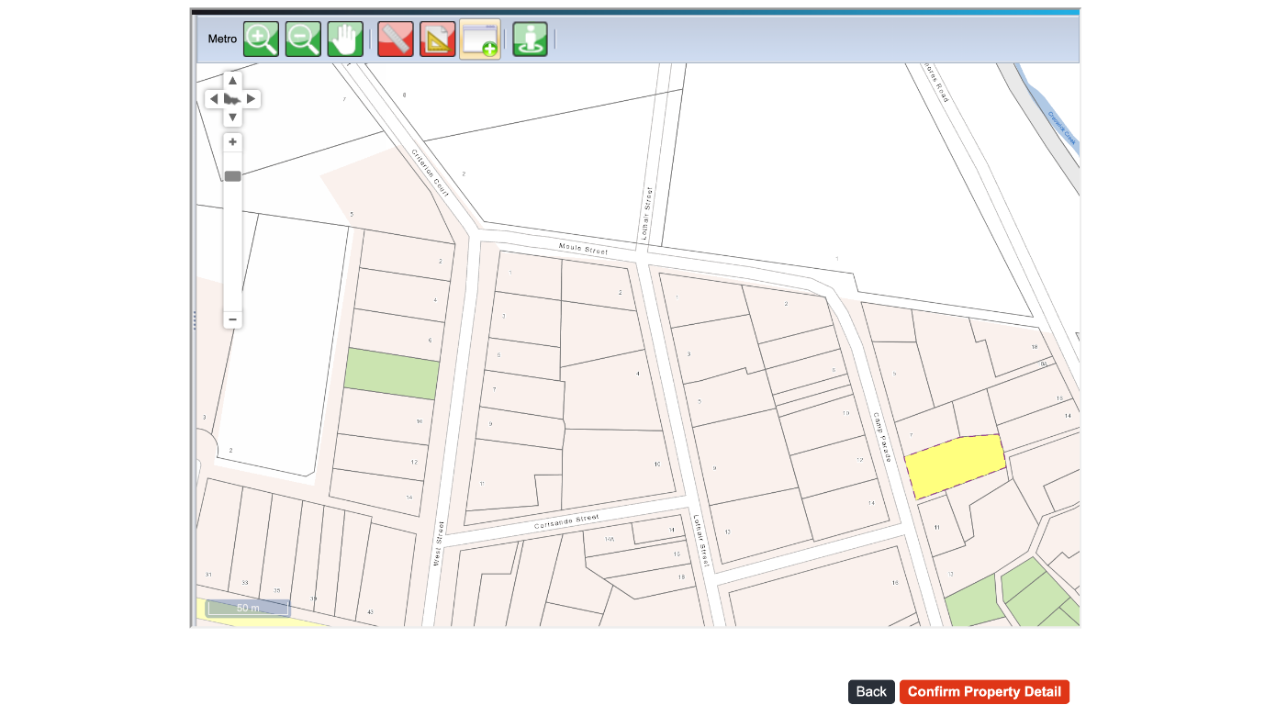

Step 3 – Select Certificates
- Once the property address is confirmed you can select the required certificates.
- Select the following as they may all be required by Council:
  - Registered search statement (Copy of Title)
  - Instrument Search (Transfer.) A copy of any relevant restriction if applicable (such as a covenant or Section 173 Agreement, or other).
  - Instrument Search (Mortgage)
  - Copy of plan
Instrument Searches could be titled with any or all of the following:
- Mortgage
- Transfer
- Covenant
- Section 173 Agreement
Click all boxes that have the word ‘Instrument’ in the title.
Figure 7 | Screenshot of page with list of certificates available for the property
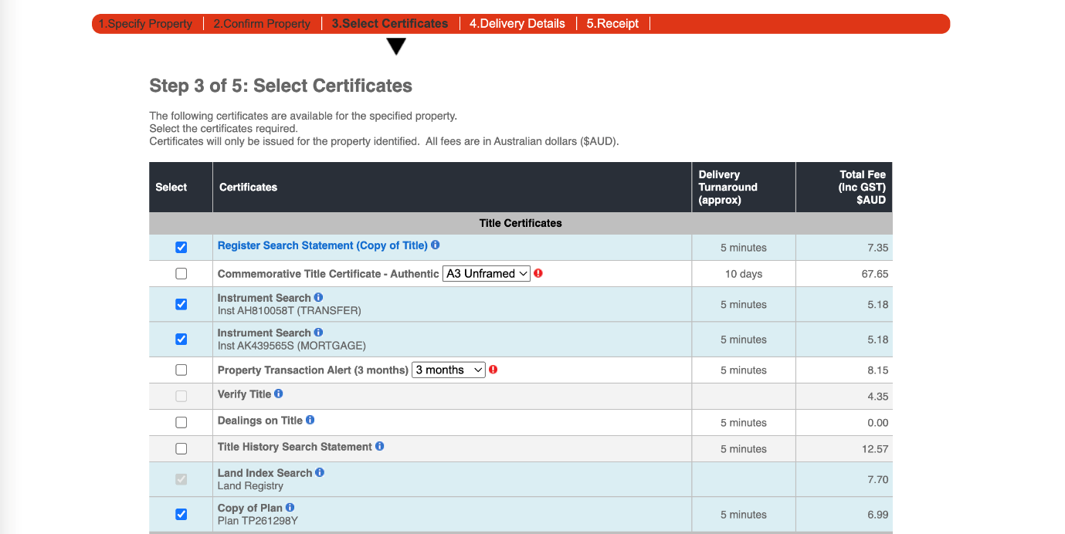

Step 4 – Delivery Details & Payment
- Follow the prompts to register as a user or login if you have a profile
- Pay by credit card
Figure 9 | Screenshot of pop window to Register or Login
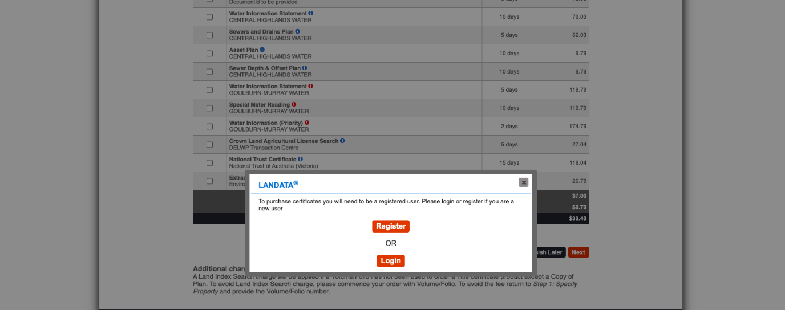
Figure 10 | Screenshot of Registration form
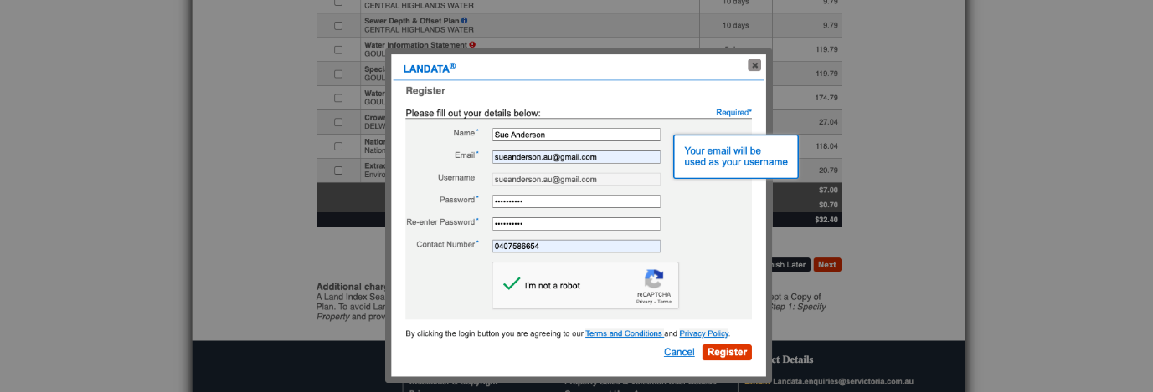
Figure 11 | Screenshot of payment page
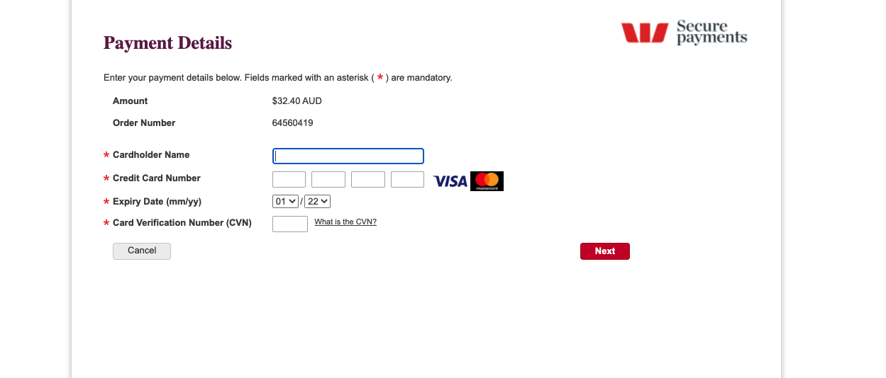

Step 5 – Receipt
- Receive confirmation of payment
- The reports and attachments will be emailed to you.
Figure 12 | Screenshot of the confirmation of payment
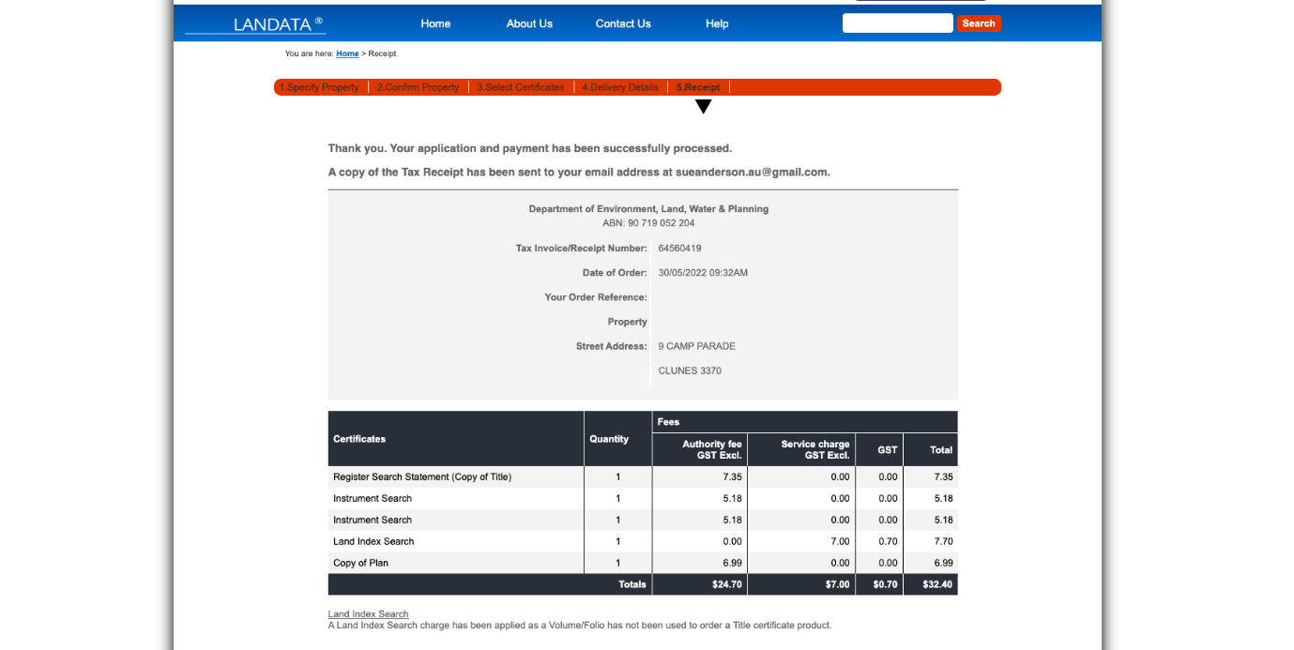
If you have any questions, you can contact Landata on 8636 2456 or email landata.enquiries@dse.vic.gov.au. You can visit the Land Information Centre in person at Level 10, 570 Bourke Street Melbourne. You can also engage a conveyancer or solicitor to obtain a copy of title for you.

You will also need to do an instrument search

Restrictive Covenant
A Restrictive Covenant is a written agreement between the seller and purchaser of a piece of land restricting what the land can be used for. For example, restricting the type of building material the purchaser can use. If there is a Registered Restrictive Covenant listed on the Registered Search Statement, a copy of the Covenant must be provided.

Covenant Declaration
If a Restrictive Covenant applies to a subject site, and the grant of a permit will not breach the Covenant, a Covenant Declaration form will need to be provided with your application. For further information regarding Restrictive Covenants, refer to the Restrictive Covenant information sheet.
Figure 13 | Screenshot of confirmation of payment for the Instrument search
