Environment Effects Act 1978
AMENDMENT OF ORDER UNDER SECTION 3(1)
The declaration of the Melbourne Metro Rail Project (“the Project”) to be “public works” by Order of the Minister for Planning under section 3(1) of the Environment Effects Act 1978 (gazetted on 3 September 2015) (“the Order”), is amended by inserting the following:
The "public works” to which the Order relates broadly comprise the following:
- two nine-kilometre rail tunnels from South Kensington to South Yarra to connect the Sunbury and Cranbourne-Pakenham railway lines, to be used by electric trains and generally following an alignment passing:
  - approximately west to east to Grattan Street; then
  - along the vicinity of Swanston Street, Queen Victoria Gardens, St Kilda Road, Fawkner Park and Toorak Road;
- western portals generally in the vicinity of South Kensington Station, with realignment of the existing Sunbury Line tracks to form an at-grade junction with the Project tunnel tracks;
- new underground stations at:
  - Arden, proposed to be located east of CityLink;
  - Parkville, proposed to be located generally in the Grattan St road reserve, near the intersection of Royal Parade, and including train-tram interchange:
  - CBD North, proposed to be located generally under the Swanston Street road reserve, generally between Franklin Street and Latrobe Street, and including interchange with Melbourne Central Station;
  - CBD South, proposed to be located generally under the Swanston Street road reserve generally between Collins Street and Flinders Street, and including interchange with Flinders Street Station; and
  - Domain, proposed to be located generally under the road reserve of St Kilda Road and Albert Road, and including train-tram interchange;
- eastern portals generally in the vicinity of South Yarra Station, with the project tunnel tracks tying into the existing Cranbourne-Pakenham Line tracks west of Chapel Street; and
- relevant ancillary temporary and permanent works to support the construction and operation of the tunnels, stations and interchanges, including turnbacks and emergency access shafts for safety purposes in a number of locations as required, which may include Fawkner Park and the Domain parklands.
Figure 1 is a schematic diagram of key Project elements.
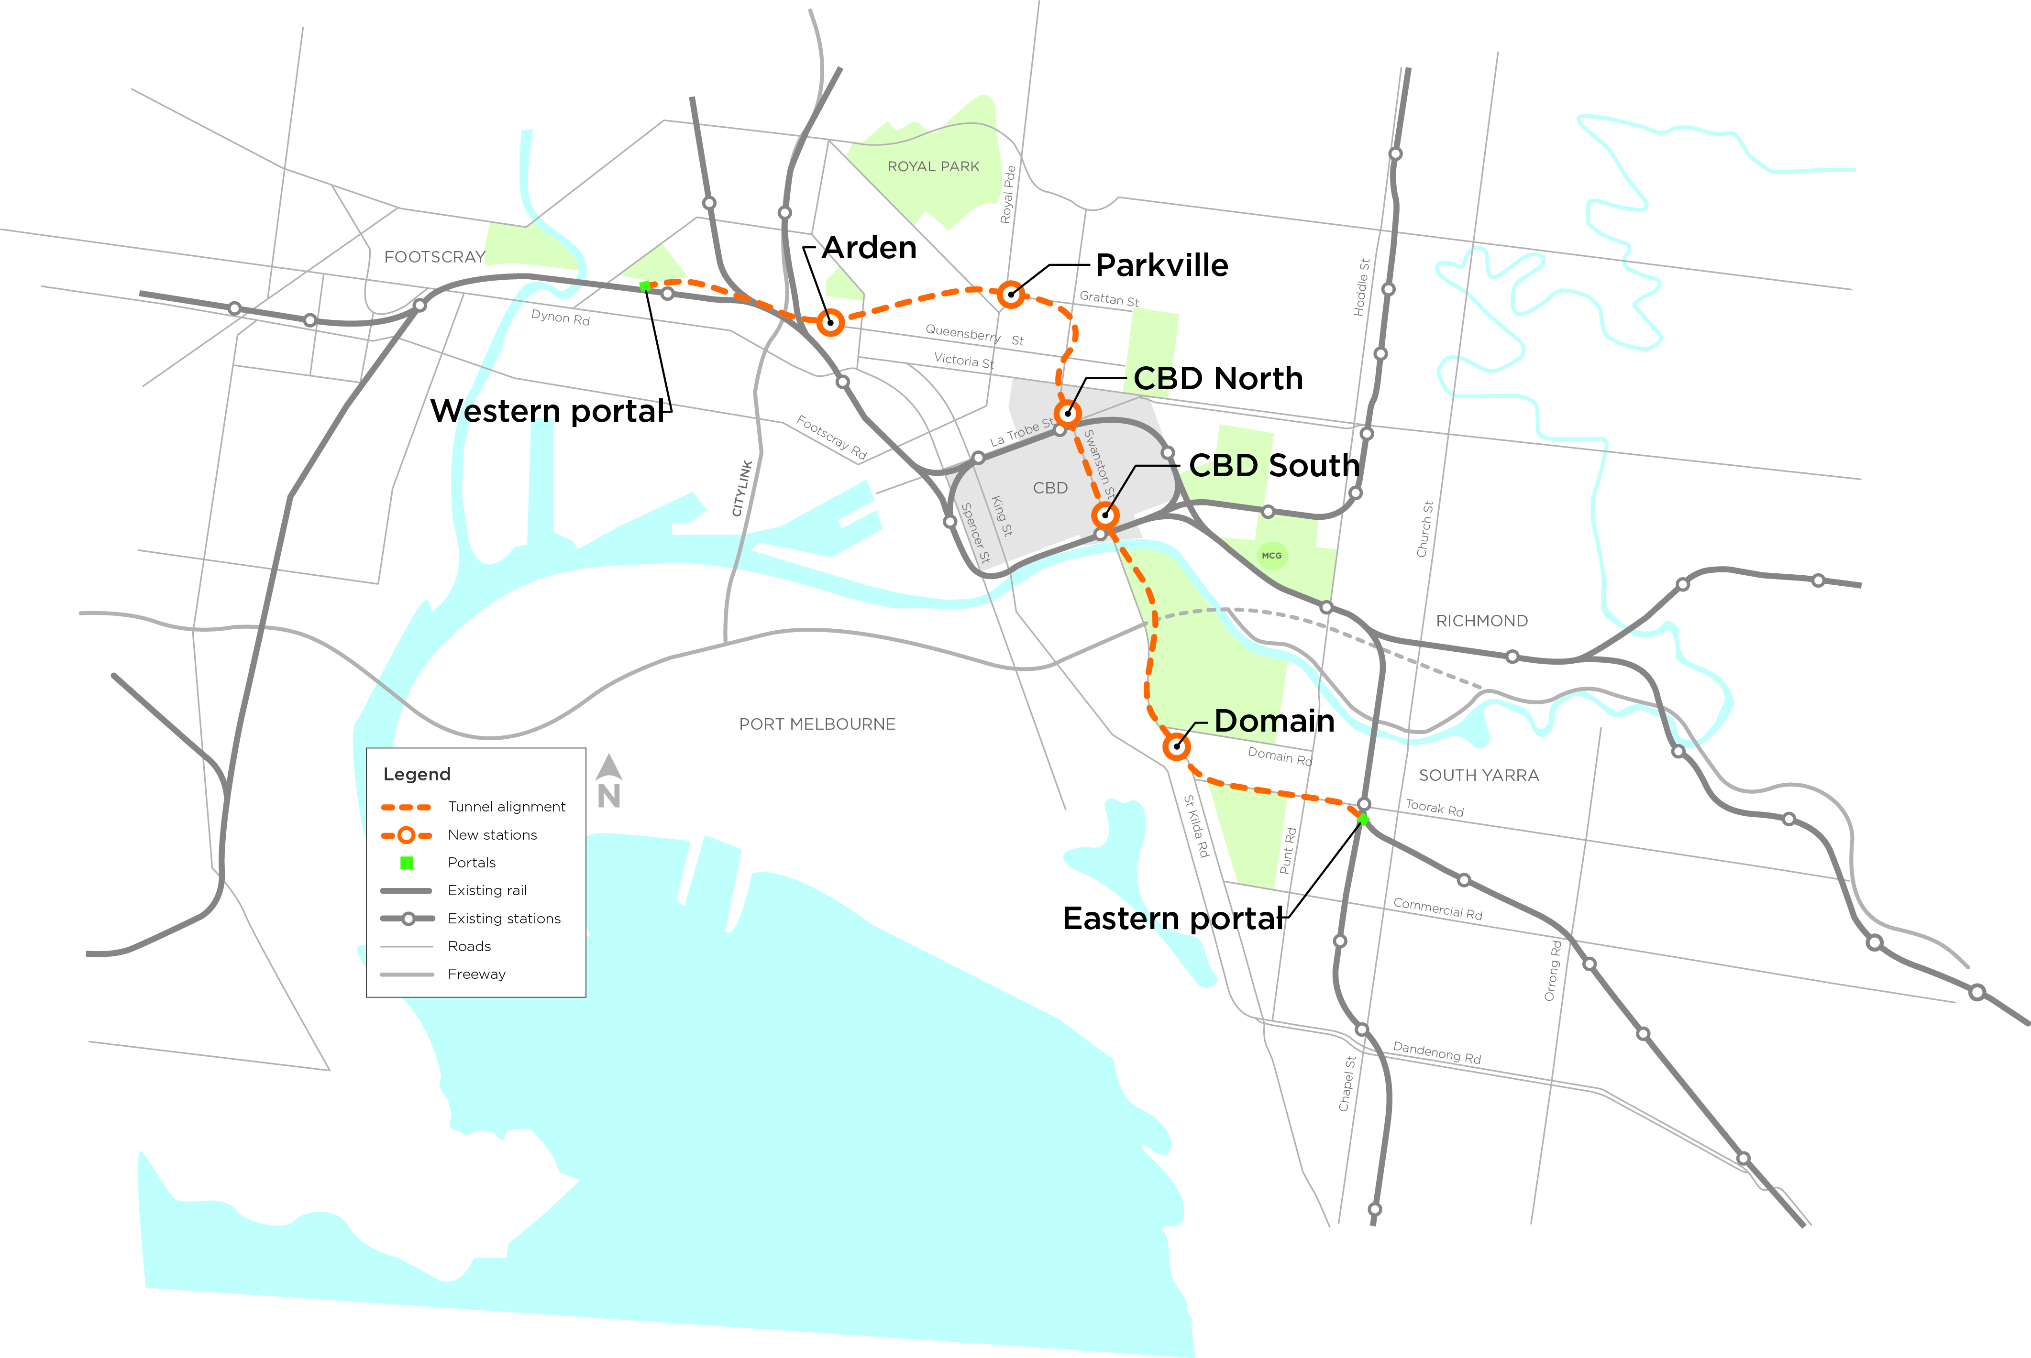

Excluded works
The works specified in Schedule 1 hereof are excluded from the declaration of “public works”.

Hon Richard Wynne MP
Minister for Planning
Date:
SCHEDULE 1
Excluded works
Enabling works in the following two categories:
- Design and investigation activities and works associated with designing the Project and assessing its impacts through the Environment Effects Statement process; and
- The following specified works:

Parkville
Utility Type | Existing Service description | Proposed service relocation
Electrical | CitiPower cables from the northern and eastern side of Grattan Street into Elizabeth Street and the University of Melbourne. | Electrical cables will be relocated within the Grattan Street corridor and Royal Parade. Affected electrical cables will be reconnected as required at the completion of construction.
Gas | APA gas lines running parallel to the proposed MMRP alignment within Grattan Street. | Gas main to be relocated south via Flemington Road, Haymarket Walk Berkeley Street, Pelham Street, with a new branch connection along Grattan Street.
 | A low pressure gas line that runs parallel to the MMRP alignment along the northern carriageway of Grattan Street for the full length of the new station. | Majority of main to be replaced by high pressure connections via new connection in Grattan Street.
Sewer | City West Water (CWW) sewer running parallel east to west along Grattan Street within area proposed for the Parkville station box. | Existing sewer to be relocated southwards, within Grattan Street corridor.
 | CWW sewers draining into the existing drainage infrastructure within the proposed Parkville station box sewer along Grattan Street from east and from Elizabeth Street and sewers from Berkeley Street from the south. | Existing sewer to be relocated southwards at flatter grade within Grattan Street corridor.
Storm water | City of Melbourne storm water drain laid east to west along Grattan Street on western side of connections from Royal Parade to the north. | Drain to be relocated southwards along Grattan Street corridor away from proposed Parkville station box.
 | City of Melbourne storm water drain connections along Royal Parade to the north connecting to Grattan Street within the proposed Parkville Station box. | New storm water drain connections will be established along Royal Parade to the north of the existing storm water drain along Grattan Street.
Telco | Optus/AAPT/VERN telecommunication cables cross from north to south side of Grattan Street within the proposed Parkville station box, continuing east of Royal Parade, and continuing down Berkeley Street. | Cables will be relocated via existing conduits along eastern side of Berkeley Street. Cables will also be relocated via new conduits along Flemington Road and across Elizabeth Street and Haymarket Walk.
Water | Existing water mains laid westwards along southern side of Grattan Street from trunk mains along Royal Parade within the proposed Parkville Station. | Existing water mains to be relocated southwards and along to the north of the proposed station box along Grattan Street corridor outside proposed Parkville station box.

CBD North
Utility Type | Existing Service description | Proposed service relocation
Storm water | Drain on south side of Franklin Street across Swanston Street within the proposed CBD North station box. | Drain to be relocated to new connection western side of Franklin Street to ensure ongoing connectivity during proposed construction of the CBD North station box.

CBD South
Utility Type | Existing Service description | Proposed service relocation
Sewer | Relocation of a City West Water minor trunk sewer within the north and south sides of Collins Street. | Flows diverted by new sewer laid along Collins Street, Russell Street and Flinders Lane connecting to the Melbourne Sewer in Flinders Street.

Domain
Utility Type | Existing Service description | Proposed service relocation
Electrical | CitiPower electrical cables along the east side of St Kilda Road and within St Kilda Road and along Domain Road within close proximity to the proposed Domain station box. | Existing cables to be re-routed via new conduits along Albert Road, Bowen Crescent, Bromby Street, Kingsway and Domain Street. Majority of re-routing will occur in manholes and under the road way.
Gas | Multinet Gas low pressure gas main running along the northern and southern edge of St Kilda Road for the full length of the proposed Domain station box. | New connection created to gas main across St Kilda Road close to Park Street
 | Low pressure gas main along the northern side of St Kilda Road across station box north of Domain Road. | New low pressure main around northern of station box, with onwards connection along Domain Road.

Gas (cont’d) | Low pressure gas main across the station box near Domain Road. | New short length low pressure main connection along St Kilda Road south-east of intersection with Domain Road, and a low pressure main across St Kilda Road south-east of station box close to Bromby Street junction.
 | Low pressure gas main along Albert Road. | Short length high pressure main along Albert Road on SW of station box.
 | Low pressure gas main connection along Bowen Crescent. | Short length high pressure main along northern end of Bowen Crescent.
 | A gas main running longitudinally under the existing tram tracks along the south side of Toorak Road between Toorak Road West and Park Street | Gas mains are relocated to the south side of Toorak Road West.
Storm water | Existing Melbourne Water storm water drain along St Kilda Road near Domain Road is within the proposed Domain station box. | Relocation into new drain around the north east of the proposed Domain station box.
 | Existing City of Melbourne storm water drain crossing St Kilda Road near Bowen Lane within the proposed Domain station box. | New drain installed along St Kilda Road to connect to the existing Bowen Crescent connection within the City of Port Phillip.
 | Existing City of Port Phillip storm water drain crossing St Kilda Road near Bowen Lane. | Existing infrastructure will be upgraded to handle anticipated additional flows to connect down Bowen Crescent to Bowen Lane drain.
Teleco | Telecommunication cables along east side of St Kilda Road within the proposed Domain station box. | A conduit bank will be installed around north-east corner of the proposed station box across and along Domain Road and then into St Kilda Road to connect with existing telecommunications conduits.
 | Telecommunication cables across south-eastern corner of proposed Domain Station box. | New conduits crossing St Kilda Road, and along southern side of Bowen Crescent to connect with existing telecommunications conduits.
Water | Existing South-East Water main across northern portion of station box. | New diversion main will be constructed around the Albert Road and connecting to new water infrastructure at Domain Road.

Eastern Portal
Utility Type | Existing Service description | Proposed service relocation
Electrical | CitiPower 66kV and 4.2kV HV feeders run along the east side of Osborne Street in close proximity to proposed works in the Eastern Portal. | Existing cables to be re-routed via new conduits along Fawkner Street, David Street, and Toorak Road.
 | CitiPower electrical cables and conduits feeders running along the west side of Osborne Street in close proximity to proposed works in the Eastern Portal. | Existing cables to be re-routed via new conduits along Fawkner Street, David Street, and Toorak Road.
Gas | Low pressure gas mains that run east side north along Osborne Street in close proximity to proposed works in the Eastern Portal. | Service to be replaced via existing high pressure gas main in Davis Street.
 | High pressure gas main along Osborne St from south in close proximity to proposed works in the Eastern Portal. | Service to be retained with new low pressure main along Fawkner Street and new high pressure main along Davis Street and laneways.
 | Low pressure gas mains that run west side north/south along Osborne Street in close proximity to proposed works in the Eastern Portal. | Service to be replaced via existing high pressure gas main in Davis Street.
 | Low pressure gas main east side south along Osborne Street in close proximity to proposed works in the Eastern Portal. | Service to be replaced via high pressure gas main in Davis Street.
Storm water | Storm water drains run parallel to the Sandringham Train Line with minor connections to Osborne St in close proximity to proposed works in the Eastern Portal. | Relocation of storm water drain to east of tunnel portal, via new manholes.
Telco | VicTrack telecommunication cables along eastern side of Osbourne Street may be affected by tunnel works in close proximity to proposed works in the Eastern Portal. | VicTrack cable to be relocated within the rail corridor.

Water | Water main and fire service water connections in Osborne Street, across the portal structure in close proximity to proposed works in the Eastern Portal. | Relocate water supply within Osborne Street.

