This version of Smarter bushfire protection measures for single dwellings (Generic) has been prepared for use with screen reader software. The printed publication may contain various photographs, captions and design features that have been necessarily omitted from this version. In other respects this document contains identical text to that in the PDF version of the document which is available at www.planning.vic.gov.au
September 2017

Smarter bushfire protection measures for single dwellings
Smarter bushfire protection measures for single dwellings have been preset in some townships and localities for a simpler and faster application process.
Using preset bushfire protection measures will make preparation and assessment of a planning permit application more straightforward.
Applicants will not need to obtain an individual Bushfire Attack Level (BAL) assessment or prepare a bushfire management statement. These applications will not need to be referred to the CFA and can be processed faster.
You do not have to use the preset bushfire protection measures. However an application that does not meet all of the bushfire protection measures in the Bushfire Management Overlay (BMO) schedule will be processed through the standard BMO process which includes obtaining an individual BAL assessment, preparing a bushfire management statement and referral to the CFA.
There are three steps.
STEP 1: Find out if your land is in a Bushfire Management Overlay schedule and if you need a permit.
STEP 2: Prepare a planning permit application that includes a plan showing the information and preset bushfire protection measures specified in the schedule.
STEP 3: Discuss with Council and then lodge your application.

STEP 1: Find out if your land is in a Bushfire Management Overlay schedule and if you need a permit
If your land has preset bushfire protection measures it will be included in a schedule to the BMO. Use Planning Maps Online or contact your council to find out if your land is in a schedule to the BMO and the schedule number. The schedule will be noted as BMO1, BMO2, BMO3, or BMO4. Obtain a copy of the schedule from Planning Schemes Online.
Note your BMO Schedule No.
Note the BAL.
Note the tree canopy separation.

Permit Exemptions
The Bushfire Management Overlay includes some exemptions from the need to obtain a planning permit. You should check if any of these apply. The most common exemptions include:
- For an existing dwelling, an alteration to the dwelling that is less than 50 per cent of the gross floor area of the dwelling.
- For other development, an alteration or extension to any existing building (except a dwelling or dependent person’s unit) that is less than 10 per cent of the gross floor area of the building.
- Buildings or works not used for accommodation (for example. shed, garage, or carport) with a floor area less than 100 square metres that is ancillary to a dwelling.

STEP 2: Prepare a planning permit application that includes a plan showing the information and preset bushfire protection measures specified in the schedule
The bushfire protection measures are detailed below.
Bushfire Protection Measure  Building Construction Standard | Condition  BAL required for dwelling BAL-12.5 |  |  |  |  | Checklist
Bushfire Protection Measure  Building Construction Standard | Condition  BAL required for dwelling BAL-19 |  |  |  |  | Checklist
Bushfire Protection Measure  Building Construction Standard | Condition  BAL required for dwelling BAL- 29 |  |  |  |  | Checklist
Bushfire Protection Measure  Defendable space | Condition  Defendable space is to be provided around the dwelling for:  - 30 metres around the dwelling  - If 30 metres cannot be provided onsite it must be provided to the property boundary  Defendable space is managed in accordance with the following requirements:  - Grass must be short cropped and maintained during the declared fire danger period.  - All leaves and vegetation debris must be removed at regular intervals during the declared fire danger period.  - Within 10 metres of a building, flammable objects must not be located close to the vulnerable parts of the building.  - Plants greater than 10 centimetres in height must not be placed within 3m of a window or glass feature of the building.  - Shrubs must not be located under the canopy of trees.  - Individual and clumps of shrubs must not exceed 5 sq. metres in area and must be separated by at least 5 metres.  - Trees must not overhang or touch any elements of the building.  - There must be a clearance of at least 2 metres between the lowest tree branches and ground level. |  |  |  |  | Checklist
Bushfire Protection Measure  Defendable space | Condition  The canopy of trees must be separated by at least 2 metres. |  |  |  |  | Checklist
Bushfire Protection Measure  Defendable space | Condition  The canopy of trees must be separated by at least 5 metres. |  |  |  |  | Checklist
Bushfire Protection Measure  Static water supply and fittings | Condition  Lot sizes (m²)  Less than 500 | Condition  Hydrant available  Not applicable | Condition  Capacity (litres)  2,500 |  | Condition  Fire authority fittings and access required  No | Checklist
Bushfire Protection Measure  Static water supply and fittings | Condition  Lot sizes (m²)  500-1,000 | Condition  Hydrant available  Yes | Condition  Capacity (litres)  5,000 |  | Condition  Fire authority fittings and access required  No | Checklist
Bushfire Protection Measure  Static water supply and fittings | Condition  Lot sizes (m²)  500-1,000 | Condition  Hydrant available  No | Condition  Capacity (litres)  10,000 |  | Condition  Fire authority fittings and access required  Yes (see below) | Checklist
Bushfire Protection Measure  Static water supply and fittings | Condition  Lot sizes (m²)  1,001 and above | Condition  Hydrant available  Not applicable | Condition  Capacity (litres)  10,000 |  | Condition  Fire authority fittings and access required  Yes (see below) | Checklist
Bushfire Protection Measure  Static water supply and fittings | Condition  Design requirements  Unless otherwise agreed in writing by the relevant fire authority, the water supply must:  - Be stored in an above ground water tank constructed of concrete or metal.  - Have all fixed above ground water pipes and fittings required for firefighting purposes made of corrosive resistant metal.  - Be provided with an outlet for occupant use.  Where a 10,000 litre water supply is required, the following fire authority fittings and access must be provided:  - Be readily identifiable from the building or appropriate identification signage to the satisfaction of the CFA.  - Be located within 60 metres of the outer edge of the approved building.  - The outlet/s of the water tank must be within 4 metres of the accessway and unobstructed.  - Incorporate a separate ball or gate valve (British Standard Pipe (BSP 65mm) and coupling (64mm CFA 3 thread per inch male fitting).  Any pipework and fittings must be a minimum of 65mm (excluding the CFA coupling). |  |  |  |  | Checklist
Bushfire Protection Measure  Access for fire fighting | Condition  Vehicle access (or part thereof) of a length specified below implements the design and construction requirements specified. |  |  |  |  | Checklist
Bushfire Protection Measure  Access for fire fighting | Condition  Length of access is…  Less than 30 metres |  |  | Condition  Requirements  Where fire authority access to the water supply is required, fire authority vehicles should be able to get within 4 metres of the water supply outlet.  There are no other design and construction requirements. |  | Checklist
Bushfire Protection Measure  Access for fire fighting | Condition  Length of access is…  Greater than 30 metres |  |  | Condition  Requirements  The following design and construction requirements apply:  - All weather construction  - A load limit of at least 15 tonnes  - Provide a minimum trafficable width of 3.5 metres  - Be clear of encroachments for at least 0.5 metres on each side and at least 4 metres vertically.  - Curves must have a minimum inner radius of 10 metres.  - The average grade must be no more than 1 in 7 (14.4%) (8.1°) with a maximum grade of no more than 1 in 5 (20%) (11.3°) for no more than 50 metres.  - Dips must have no more than a 1-in-8 (12.5% / 7.1º) entry and exit angle. |  | Checklist
Bushfire Protection Measure  Access for fire fighting | Condition  Length of access is…  Greater than 100 metres |  |  | In addition to the above requirements:  - A turning area for fire fighting vehicles must be provided close to the building by one of the following:  - A turning circle with a minimum radius of 8 metres  - A driveway encircling the dwelling  - The provision of other vehicle turning heads – such as T or Y head – which meet the specification of Austroad Design for an 8.8 metre Service Vehicle. |  | Checklist
Bushfire Protection Measure  Access for fire fighting | Condition  Length of access is…  Greater than 200 metres |  |  | In addition to the above requirements:  - Passing bays must be provided at least every 200 metres.  - Passing bays must be a minimum 20 metres long with a minimum trafficable width of six metres. |  | Checklist
Note: The length of access should be measured from a public road to either the building or the water supply outlet, whichever is longer.

Bushfire Management Plan
An application for a dwelling must be accompanied by a bushfire management plan that shows the preset bushfire protection measures.

Example of a Bushfire Management Plan
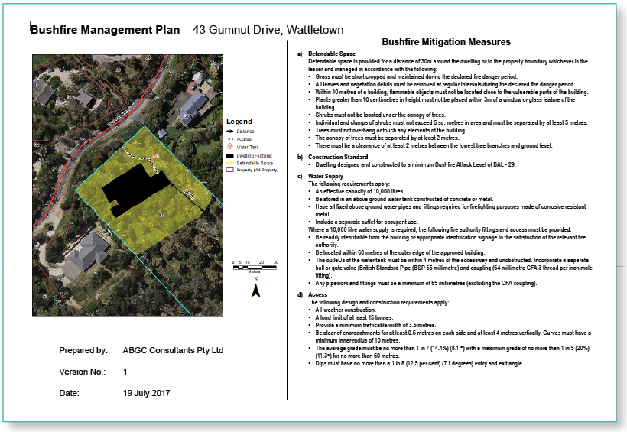
A template for applicants to use is available on the DELWP website.

STEP 3: Discuss with Council and then lodge your application
Before preparing the final documentation for your dwelling and lodging an application, complete the bushfire management plan checklist and discuss your proposal with a council planning officer.
Bushfire Management Plan Checklist  The location of the dwelling and all other buildings on the site | Checklist
Bushfire Management Plan Checklist  The area to be managed for defendable space | Checklist
Bushfire Management Plan Checklist  Location of any hydrants within 120 metres of building | Checklist
Bushfire Management Plan Checklist  Access to the property | Checklist
Bushfire Management Plan Checklist  The dwelling constructed in accordance with the required bushfire attack level | Checklist
Bushfire Management Plan Checklist  The location of the static water supply | Checklist
Bushfire Management Plan Checklist  The size of the static water supply (in litres) | Checklist
Bushfire Management Plan Checklist  The plan must include written conditions that implement the required bushfire protection measures in accordance with this fact sheet | Checklist

The council planning officer will check that the bushfire management plan meets all of the requirements specified in the BMO schedule. If it does, your application does not need to be referred to the CFA.
If Council approves a planning permit, the bushfire management plan is approved and becomes part of the planning permit.
If your application does not meet all of the bushfire protection measures required in the BMO schedule it will be assessed under the standard BMO process, including referral to the CFA.

© The State of Victoria Department of Environment, Land, Water and Planning 2017
This work is licensed under a Creative Commons Attribution 4.0 International licence. You are free to re-use the work under that licence, on the condition that you credit the State of Victoria as author. The licence does not apply to any images, photographs or branding, including the Victorian Coat of Arms, the Victorian Government logo and the Department of Environment, Land, Water and Planning (DELWP) logo. To view a copy of this licence, visit http://creativecommons.org/licenses/by/4.0/
ISBN 978-1-76047-739-4 (pdf/online)
Disclaimer
This publication may be of assistance to you but the State of Victoria and its employees do not guarantee that the publication is without flaw of any kind or is wholly appropriate for your particular purposes and therefore disclaims all liability for any error, loss or other consequence which may arise from you relying on any information in this publication.
Accessibility
If you would like to receive this publication in an alternative format, please telephone DELWP Customer Service Centre 136 186, email customer.service@delwp.vic.gov.au, via the National Relay Service on 133 677 www.relayservice.com.au .
This document is also available in Portable Document Format at www.delwp.vic.gov.au/planning

DOCUMENT ENDS

