CONTRACT REPORT
ARRB Group Ltd
www.arrb.com.au
ACN 004 620 651
ABN 68 004 620 651
- Research and Consulting
- Systems

Victorian Caravan Parks Road Design Guiding Principles

Project No:
by Simon Chia

for Department of Transport, Planning and Local Infrastructure

Victorian Caravan Parks Road Design Guiding Principles |  |  |  | ARRB Group Ltd  ABN 68 004 620 651  Victoria  500 Burwood Highway  Vermont South VIC 3133  Australia  P: +61 3 9881 1555  F: +61 3 9887 8104  info@arrb.com.au  Western Australia  191 Carr Place  Leederville WA 6007  Australia  P: +61 8 9227 3000  F: +61 8 9227 3030  arrb.wa@arrb.com.au  New South Wales  2-14 Mountain St  Ultimo NSW 2007  Australia  P: +61 2 9282 4444  F: +61 2 9280 4430  arrb.nsw@arrb.com.au  Queensland  123 Sandgate Road  Albion QLD 4010  Australia  P: +61 7 3260 3500  F: +61 7 3862 4699  arrb.qld@arrb.com.au  South Australia  Level 5, City Central,  Suite 507, 147 Pirie Street  Adelaide SA 5000  Australia  P: +61 8 7200 2659  F: +61 8 8223 7406  arrb.sa@arrb.com.au  International offices:  Xiamen, People’s Republic of China
for Department of Transport, Planning and Local Infrastructure
 |  | Reviewed
 | Project Leader
 |  | Simon Chia
 | Quality Manager
 |  | Peter Aumann
-009239
November 2014

Victorian Caravan Parks Road Design Guiding Principles

Draft - Version Control
ARRB Project No |  | Client Project No
Path | m:\luxmoore\company\word documents\2014\projects\009239 victorian caravan park road design guidelines\working\009239 - victorian caravan parks road design guidance - report finalv2.docx
Author | Simon Chia |  |  | PL | Simon Chia | QM | Peter Aumann
Milestone |  |  |  | Title
Version | Date |  | Technical/Quality Checks |  |  |  |  | By
1.00 | 19/09/14 |  | Initial Draft |  |  |  |  | SC
1.10 | 29/09/2014 |  | Format check |  |  |  |  | TJM
1.11 | 29/09/2014 |  | Spell checked |  |  |  |  | TJM
1.12 | 29/09/2014 |  | All tables and figures checked for source |  |  |  |  | SC
1.13 | 29/09/2014 |  | Library references and superseded references checked |  |  |  |  | JA
1.14 | 31/1012014 |  | Approved by Quality Manager |  |  |  |  | PA
1.15 | 29/10/2014 |  | Final checked |  |  |  |  | SC
1.16 | 13/10/2014 |  | Checked by Editor |  |  |  |  | DC
2.00 | 6/11/2014 |  | Release to client |  |  |  |  | SC
Comments

This document is produced by ARRB as a general guide. Its application is discretionary.
Practitioners may vary their practice according to local circumstances and policies.
ARRB believes this publication to be correct at the time of printing and does not accept
responsibility for any consequences arising from the use of information herein. Readers should
rely on their own skill and judgement to apply information to particular issues.
Contents

1 introduction 1
1.1 Background 1
1.2 Methodology 1
2 Crash Statistics 2
3 Literature Review 3
3.1 Operations 3
3.2 Pedestrians 3
3.2.1 Child pedestrians 4
3.3 Cyclists 7
3.3.1 Child cyclists 7
3.4 Low-Speed Run-Overs 8
3.5 Intersections 9
3.6 Conflict Separation 10
3.7 Sight Distance 10
4 CURRENT operationS 11
4.1 Site Visit 11
4.2 Desktop Assessment 16
4.3 Comments 17
5 Guiding Principles 19
6 Checklist tool 29
7 Other 30
References 31
Appendix A Checklist Tool 33

FIGURES
Figure 4.1: Looking north along internal road showing obscured footpath on the left 13
Figure 4.2: Looking south along internal road from pedestrian footpath showing limited visibility of oncoming vehicles 13
Figure 4.3: Looking north along internal road from pedestrian footpath showing clear visibility 14
Figure 4.4: Showing restricted visibility due to lack of setback from road 14
Figure 4.5: Showing restricted visibility to the right due to the building and vegetation 15
Figure 4.6: Showing restricted visibility due to bin enclosure and lack of opacity 15
Figure 4.7: Showing restricted visibility due to vegetation. 15
Figure 4.8: Example of a caravan park site that formed part of the desktop assessment 16
Figure 5.1: Footpath kerb extension 21
Figure 5.2: Pedestrian (zebra) crossing line markings 22
Figure 5.3: Example of a wombat crossing 22
Figure 5.4: Typical dimensions of a wombat crossing 23
Figure 5.5: Illustration of setback envelope to be kept clear of vehicles and objects that will obstruct sight distances 24
Figure 5.6: Intersection sight envelope to be kept clear of parked vehicles and objects that obstruct sight distances 24
Figure 5.7: Safe intersection sight distance (SISD) 25
Figure 5.8: Minimum sight lines for pedestrian safety 26
Figure 5.9: Examples of typical speed humps 27

introduction

Background
The Victorian Coroner recently recommended that the Victorian Department of Transport, Planning and Local Infrastructure (DTPLI) and the Victorian Caravan Parks Association Incorporated (VCPA) consider consulting with relevant road design experts to develop guidance on appropriate design principles for roads in Victorian caravan parks. The Coroner’s report and recommendation followed an incident in which a five-year-old boy was killed as a result of being struck by a vehicle travelling at very low speed in a caravan park in Victoria. The boy was riding a bicycle and, at the time of the accident, was unsupervised and not wearing a helmet. He cycled past a parked four-wheel drive (4WD) vehicle at an intersection of two access roads within the caravan park. The 4WD obscured the line of sight of both the five-year-old boy and the driver of an approaching vehicle.
In response to the Coroner’s recommendation, DTPLI engaged ARRB to assist in developing guiding principles for roads in new Victorian caravan parks, and which might also be applied when existing caravan parks are redeveloped. The work aims to provide recommendations on the context within which caravan park roads are situated and used to achieve the optimum balance between the needs and safety of all road users.
Based on these guiding principles, ARRB was also asked to develop a checklist tool for assessing road design in existing and new caravan parks which can be used by caravan park owners and managers to provide a safer road environment for their patrons as a self-regulating initiative. It is understood that DTPLI and VCPA are not seeking to have new regulatory requirements.

Methodology
To gain an understanding of current site layouts and operations, a site visit was undertaken to a typical caravan park and camping site, and a desktop assessment made of nine additional caravan park sites, as nominated by the Department of Environment and Primary Industries (DEPI) and the VCPA. This aimed to identify common themes which are likely to increase the risk of a crash within a caravan/camping park.
A search of the VicRoads crash statistics database and discussions with VCPA also formed part of the review process to identify any common themes among crashes that have occurred within caravan parks.
A literature review of research reports, standards, guidelines, policies and media publications was also undertaken to gather information and establish the recommendations and implementations of other jurisdictions and organisations in Australia and abroad in relation to road design practices applicable to caravan parks.
Based on the findings of the review and ARRB’s experience, a set of guiding principles for road design in new caravan parks has been developed, which may also be used when redeveloping existing caravan parks. The guiding principles address both road safety and design issues and provide measures that can be implemented to minimise crash risk within caravan parks.
An audit tool has been developed which summarises the guiding principles into an easy to use checklist format. Consistent with the Coroner’s recommendation, the audit tool may be used as a reference to improve existing caravan parks, or to assist in the design of new sites. However, for a more thorough consideration of potential risks and design solutions, a site specific road safety assessment may be required.

Crash Statistics
As outlined in the Coroner’s report, the Coroners Prevention Unit (CPU) provided research assistance into pedestrian fatalities in caravan parks in Victoria between January 2000 and August 2013, and into car parks within the same timeframe. The CPU did not find any instances of pedestrian fatalities involving vehicles in caravan parks in circumstances similar to the crash that was the subject of the Coroner’s report.
VicRoads records crash statistics which are made available to the public through CrashStats, their online crash database. Crash records are based on police records of crashes which have occurred on public roads. However, discussions with a senior VicRoads officer confirmed that no filtered set of data was available for caravan parks.
Based on discussions with Elizabeth White and James Kelly from the Victorian Caravan Parks Association on Thursday 9 October 2014, it is understood there is no evidence of significant crashes (fatal or serious injury) being reported within Victorian caravan parks. This however, does not mean crashes are not occurring within caravan parks.

Literature Review
The Coroner’s report identified that there are currently no road design guidelines specifically applicable to caravan parks. An investigation by ARRB of existing standards, guidelines, general documents and a search of ARRB’s library catalogue, the Australian Transport Index (ATRI), resulted in similar findings. Based on the common themes identified in the desktop assessment and site investigation, and drawing on ARRB’s experience, similarities were drawn with property driveways, shared areas and car parks. These similarities include pedestrian and vehicle interaction, presence of small children, and visibility and sight line issues.
This led to the further investigation and review of academic literature, guidelines, standards and other documents relating to driveways, car parks, child pedestrian and cyclist safety, and sight distances. The findings of the review are presented in the following section.

Operations
Based on information provided by VCPA, the majority of Victorian caravan parks were established in the 1950s and 1960s and only a few new caravan park have been developed in the last 30 years. However, Wills (2004) suggests that the use of caravan parks has changed dramatically in recent decades. Caravan parks were once predominantly holiday destinations; however there has since been a shift to a situation in which some caravan parks now cater for permanent residents as well as holiday visitors. This change in usage has previously prompted new legislation and regulations to be implemented. However, demand on caravan parks continues to change and planning and design methods need to continually evolve (Wills 2004).

Pedestrians
Given the high level of pedestrian activity within caravan parks, it is useful to identify key elements that may contribute to pedestrian fatalities. A study (Parliamentary Advisory Council for Transport Safety 2013) on pedestrian casualties in Great Britain commissioned by the Parliamentary Advisory Council for Transport Safety (PACTS), reviewed data from a web based data analysis tool (MAST Online) recorded during 2006 to 2011. The study outlines a number of noteworthy characteristics, which include:
- Most casualties (70% of children and 58% of adults) are not injured at or near a pedestrian crossing.
- More than three-quarters of collisions involving a pedestrian casualty (78%) have one or more contributory factors assigned to the pedestrians themselves. Of these factors, three-fifths are due to the pedestrian failing to look properly.
- The most represented contributory factors are:
- pedestrian failed to look properly (60%)
- pedestrian careless, reckless or in a hurry (25%)
- driver failed to look properly (20%)
- pedestrian failed to judge vehicle’s path or speed (18%)
- pedestrian or other crossed a road and was masked by a stationary vehicle (23%)
- The age at which pedestrians are most at risk is 12 years. (Parliamentary Advisory Council for Transport Safety 2013).
Although no literature on crashes in caravan parks could be found, residential driveways present a similar low-speed environment that can be combined with pedestrian paths, in particular children’s play areas, and some similarities can be drawn. Edwards & Paine (2003) report on a study by Dr Ann Williamson from the NSW Injury Risk Management Research Centre. This study, which examined household driveway fatalities, is based on coroners’ records which identify a key pattern associated with off-road fatalities. Over half of all off-road pedestrian fatal crashes, and two-thirds of all driveway fatal crashes, were found to have occurred when unsupervised children were left in a location thought to be safe by their parent or carer, but ultimately found their way into the path of a vehicle. The report draws attention to aspects including the:
- driveway gradient
- siting and design of the house in relation to the driveway and the street
- value of creating a safe area through the clear separation of designated vehicle manoeuvring routes/areas from child play areas (Edwards & Paine 2003).
Edwards & Paine also noted that encouraging the forward movement of vehicles, rather than reversing, may lead to a crash risk reduction.

Child pedestrians
Caravan parks are a popular holiday destination for families, many of which include small children. Kolderup (2001) identifies that:
children (aged 4-14 years) are at a disadvantage in traffic simply because of their size, development and experience, as well as older pedestrians (aged 60 years and older) and intoxicated pedestrians. (Kolderup 2001).
When considering a safe road environment for children it is important to understand the challenges and issues faced by this user group. Leden (1989) reports on a comprehensive field survey of about 14,000 schoolchildren between the ages of 6 and 16, undertaken in five Swedish towns, one Norwegian town and three Finnish towns. The report reveals that schoolchildren find intersections to be more troublesome than mid-blocks (where a mid-block is a road segment between intersections). The most common reasons which respondents gave in considering an intersection to be hazardous included: obstructed sight of oncoming vehicles (only a minor number of responses identified problems due to parked vehicles); high volumes of motor traffic; high vehicle speeds; vehicles coming from several directions; and lack of traffic signals. A significant finding was that five times as many collisions occurred between motor vehicles and cycling children than between motor vehicles and child pedestrians. Also important to note is that the vast majority of collisions involving motor vehicles and children occurred during leisure time or when children were alone.
A report by Westdijk (2001) highlights that crossing the road unexpectedly from behind an obstacle is reported as being the main cause of crashes for young pedestrians. In contrast to Leden (1989), Westdijk found that:
parked vehicles impede the view of young children just as they impede seeing these children in good time from moving vehicles. (Westdijk 2001).
This suggests that parked vehicles are more of an issue than was suggested by Leden (1989). Westdijk’s findings are also consistent with an earlier report by Jamieson (1980), who reviewed 243 crashes involving heavy vehicles, pedestrians and cyclists in the outer western suburbs of Sydney, to study the potential of traffic engineering and related environmental countermeasures. The review found that the most frequently identified countermeasure for reducing the risk of a pedestrian or cyclist crash was selective prohibition of on-street parking. Jamieson reports that the presence of parked vehicles on the carriageway contributed directly or indirectly to a total of 26 crashes, or 11% of the 243 crashes studied in-depth. Similarly, NSW police crash report figures for 1977 show that, from the category ‘Pedestrian running from behind vehicle’, there were 498 casualty crashes from a total pedestrian crash figure of 3,144 (about 1 in 6) (Jamieson 1980).
When considering the design of roads and the roadside environment within caravan parks, it is important to highlight the significance of a child’s height compared to adults, and how this significantly effects the conspicuity of child pedestrians. Table 3.1 provides average child height by age.
Table 3.1: Average child height by age
Age | Average height
2 years | 90 cm
4 years | 105 cm
6years | 120 cm
8 years | 135 cm
10 years | 145 cm
12 years | 157 cm
Source: Westdijk (2001).

Another important factor to consider when accommodating child pedestrians is their limited development, experience and awareness level. Table 3.2 provides an indication of age at which children are able or unable to undertake independently particular tasks in traffic (depending on the child’s development process).
Table 3.2: Indication of age at which children are able or unable to undertake independently particular tasks in traffic
Age indication | Crossing the road | Cycling
4–8 years | In residential streets, and then only with explicit instructions | Only in very safe areas for practice and play
9–12 years | Up to 10-11 years of age, long reaction time and possibility of spontaneous behaviour | Technique itself requires a lot of concentration and complex situations are dangerous
13 years and older | No problem | Complex traffic situations create a difficult situation for sound decision making
Source: Based on Westdijk (2001).

Westdjik suggests that despite the inability of children to behave in traffic according to the rules, from an early age they want to get out and explore their surroundings. The action radius for children can be estimated as follows:
- Children up to 3 years of age play close to home
- Children up to 6 years of age play at a distance of less than 100 m from home
- Children 6 to 12 years of age have a reach of play of 300–600 m (neighbourhood)
- Children from 10 years use the whole district as play area (800–1000 m)
- Children older than 12 years of age move throughout the entire municipality and beyond. (Westdijk 2001).
In order to accommodate the inexperience of child pedestrians, it is important that drivers of vehicles are able to anticipate not only what is happening on the road in front of them, but also on either side of it.
Westdjik suggests that ‘in all design stages it is important first to examine conflict-free solutions for pedestrians and cyclists’. Conflict-free means that no motor vehicles are able to cross the path of a pedestrian or cyclist. However, it is conceded that the provision of a conflict-free solution will not always be feasible. Where possible, it is recommended that children’s destinations and play areas be separated or located in an area where the potential for contact with vehicles is minimised.
Westdjik provides an excellent summary of the key issues which can be directly applied to caravan parks.
A very common cause of accidents involving children is their unexpected crossing of roads from behind obstacles. Irrespective as to whether the child ran across the street while playing or was seriously crossing but unfortunately took the wrong decision at the wrong time, it remains a fact that the driver failed to spot the child. An unimpeded view from road to pavement is an important factor in determining whether or not children are at play. A long row of parked vehicles obscures completely the possibility of seeing small children. It is therefore critical to provide a ‘transparent layout’. Some features of a ‘transparent layout’ are:
- Avoiding long rows of parked vehicles and the placing of (tall) flower pots, waste containers, billboards and the like.
- Establishment of collective parking areas at the perimeter of the neighbourhood/districts and a drastic reduction in the number of parking spaces along the edges of roads
- Grouped or diagonal parking instead of lengthways parking provides somewhat more parking area; the reduction to the number of parking spaces will in this way be less draconian than when lengthways parking spaces are eliminated completely.
- Where there are concentrations of groups of children (school, playground and the like) there must be an uninterrupted line of sight of 30 m to 40 m to the right and left of these facilities assuming that they are situated on a private access road, i.e. low-speed road. (Westdijk 2001).
It is also important to note that good visibility often encourages speeding. Westdijk (2001) suggests that children are three times as likely to be involved in a crash on 50 km/h roads as opposed to roads where a maximum speed of 30 km/h applies. This dilemma can be solved by physical measures that render speeding more or less impossible. (Westdjik 2001).
As identified in the Coroner’s report, the Victorian Parliamentary Road Safety Committee’s 2010 Report, Inquiry into Pedestrian Safety in Car Parks also offers similar measures which can be adopted in caravan park design from a pedestrian safety perspective. These include:
- Adequate sight lines (for both pedestrians and vehicles). The Committee stated: ‘Clear and adequate sight lines that are not blocked by physical structures, vegetation or other parked cars, allow pedestrians to see approaching vehicles and drivers to see pedestrians. The increased presence of 4WDs and Sports Utility Vehicles (SUVs) in the Victorian fleet is an area of concern.’
- Increased sight lines ‘can be achieved through the use of “end” or “kerbed islands” at the ends of parking rows. These open up sight lines, limit the encroachment of vehicles onto paths, aisles and circulation roads.’
- Separation of pedestrian and vehicles. The Committee stated: ‘Separation is particularly required for areas of high pedestrian activity, such as at the entrance of shops or around ticket payment machines. This is especially important when vehicle traffic is travelling directly towards pedestrian activity, requiring the vehicle to turn or stop before entering that area.’ Several engineering methods were discussed by which separation could be achieved, including pedestrian bollards, wheel stops and concrete barriers that physically prevent vehicles from encroaching on pedestrian paths. The report notes that the use of wheel stops or low concrete barriers is discouraged by the Institute of Transportation Engineers as they present a tripping hazard to pedestrians. The Committee instead suggested the use of extended raised walkways and kerbs to protect pedestrians without creating a hazard.
- Shared zones should be applied where physical separation between pedestrians and vehicles is not possible.
- Control of vehicle speed through the use of physical engineering controls.
- Standard signs and road marking. (Road Safety Committee 2010).
The Committee also encouraged the use of VicRoads standard signs and road markings, to be consistent with public roads, e.g. pedestrian crossings.

Cyclists
Cycling is an activity that can often occur within caravan parks, and it is therefore valuable to understand which road design elements may contribute to cyclist crashes. Tziotis (1993) found that 60% of cyclist crashes in Victoria occurred at intersections. Tziotis also found that some of the factors that may have contributed to the number of cyclist crashes included: poor road alignment; inadequate space for cyclists on the road network; poor road surfaces; poor visibility; poor conspicuity of the cyclist; and poor compliance of cyclists with traffic controls. (Tziotis 1993)
These findings further highlight the importance of maintaining adequate visibility of vehicles, pedestrians and cyclists within a caravan park.
Gattis, Levinson, Gluck, Barlow, Eck, & Hecker (2010) provide a number of design principles that should be considered to minimise the risk for cyclists when designing driveways. These include:
- the provision of horizontal and vertical alignments that offer sufficiently advanced views of the driveway or intersection.
- placing nothing along or within the roadside environment that blocks necessary sight lines.
- having no abrupt change in surface elevation that may create a bump for the cyclist where they could turn into or out of a driveway.
- not having grate openings that a bicycle tyre could drop into. (Gattis, Levinson, Gluck, Barlow, Eck, & Hecker 2010).

Child cyclists
As identified during the review of current site operations, small children cycling within caravan parks are considered one of the more vulnerable user groups. Children are often free to cycle around the caravan park and are exposed to motor vehicle traffic. It is beneficial to understand whether children are at greater risk at intersections as opposed to mid-blocks. Hutchinson, Kloeden and Long (2006) report on an investigation into pedal cycle crashes in South Australia based on the Traffic Accident Reporting System (TARS) database. The report presents the number of pedal cycle casualties aged between five and fifteen, in South Australia, from 2001 to 2004. The report also highlights findings on site circumstances, where about the same number of crashes occurred at junctions and not at junctions. This suggests that small children are vulnerable at both mid-blocks and intersections, and care needs to be taken when designing the road and roadside environment at any location.

Low-Speed Run-Overs
Given the low speed environment of caravan parks (typically 10 km/h speed limit) and interaction with children’s play areas, similarities can be drawn to low-speed run-over crashes in residential driveways.
Griffin, Watt, Wallis, Shields and Kimble (2011) present Queensland fatality data for low-speed run-over crashes involving children aged 0–15 years (from January 2004 to December 2008). The results included 15 deaths (12 boys and 3 girls) with almost half of the fatalities caused by four-wheel drive (4WD) vehicles. Large family sedans were involved in four fatalities, and heavy vehicles were involved in the remaining three fatalities. In nine of the fatal crashes, the vehicle involved was reversing. It is evident that larger vehicles and reversing movements are contributors to higher crash risk when children are present.
It is noted that a study (Hunter, Poulgrain and Campbell 2009) was undertaken by the University of Waikato (New Zealand) in 2005 into child driveway run-overs. The study included a review of existing literature, databases, the internet and educational resources and presented numerous options for preventing driveway run-overs. Hunter, Poulgrain and Campbell (2009) found that these options tended to fall into three main categories:
- modifying behaviour
- modifying the environment
- modifying vehicles.
In modifying behaviour, Hunter, Poulgrain and Campbell (2009) highlight the importance of the child’s carer/minder being vigilant at all times when the child is playing on a driveway or around vehicles, and notes that this is a crucial message recommended by researchers consistently and repeatedly (Hunter, Poulgrain and Campbell 2009). Hunter, Poulgrain and Campbell (2009) also suggest that behaviour modification is best achieved through education.
Hunter, Poulgrain and Campbell (2009) highlight that vehicle blind spots are a key issue with child driveway run-overs and advocate the necessity of visual aids, such as convex mirrors, and proximity detectors.
Hunter, Poulgrain and Campbell (2009) also present an investigation on the blind spots of 270 vehicles, showing less than 1% of the vehicles reviewed scored well enough to receive a maximum rating for being able to see a two-year-old behind the vehicle (Hunter, Poulgrain and Campbell 2009).
Hunter, Poulgrain and Campbell (2009) suggest that the most highly rated vehicles were 4WDs fitted with reversing cameras. Although it is outlined that the cost of cameras is still beyond the means of many families, Chambers (2007) suggests that the installation of rearward cameras and sensors can reduce the likelihood of crashes.
It is important to note that Hunter, Poulgrain and Campbell (2009) cautiously advise that, although alarms that beep while reversing a vehicle may warn the driver of impending problems, small children do not comprehend the dangers and can be attracted to the noise, effectively increasing the risks.
While the above emphasises the road safety issues associated with larger vehicles and vehicle blind spots, Hunter, Poulgrain and Campbell (2009) also identify the driveway blind spot, as opposed to the vehicle blind spot, as a problem. The driveway blind spot most commonly occurs when vehicles are required to undertake a 3-point turn to exit forward. Hunter, Poulgrain and Campbell (2009) suggest that the issue is with the turning manoeuvre associated with the driveway.
A common suggestion among previous researchers is the use of convex mirrors as a visual aid to eliminate the blind spot when turning or backing out (Cowley, Nicholls, Parkinson & Swain 2005).
Hunter, Poulgrain and Campbell (2009) support the regulatory requirement for all new vehicles to be fitted with reversing cameras, however as previously noted, the cost would be passed on to families and effective use is dependent on driver attentiveness. Rear sensors which confine the audible alert to the interior of the vehicle are also endorsed. Hunter, Poulgrain and Campbell (2009) also offer recommendations that include the distribution of educational pamphlets to remind the parents of toddlers and pre-schoolers about the dangers of driveways.
A Parliamentary Travelsafe Committee (2007) report on an investigation into child deaths and injuries from low-speed vehicle run-overs, offers similar findings, identifying that low-speed run-overs typically occur when a number of factors come together at a single moment. The three broad factors that contribute to these collisions include:
- behaviour of the children and their carers
- environmental factors, including housing and driveway design
- type of vehicle, especially those with poor rearward visibility.
The Parliamentary Travelsafe Committee also identified three broad areas where intervention strategies might have a preventative impact on these collisions:
- Changes to vehicle design to increase reversing visibility and decrease unintentional acceleration.
- Modifications to housing design, including separation of driveways and garages from play areas.
- Raising public awareness of the dangers of low-speed run-overs and methods to prevent them.
The report highlights that 4WDs, vans, trucks and farm machinery accounted for 51% of vehicles involved in run-over fatalities in Australia from 2000/01 to 2006/07. However, it also stated that all vehicles have blind spots where rearward visibility is lost to the driver.

Intersections
Kar and Blankenship (2009) discuss several operational issues at intersections identified in the Arizona Road Safety Assessment Program. The report identifies sight distance and visibility as one of the most commonly observed intersection operational issues in Arizona. However, these issues are applicable to any intersection. The report identifies other common road safety themes for intersections, including sight obstructions and poor visibility created by trees and vegetation, walls, embankments and horizontal and vertical curves. Kar and Blankenship recommend removing sight obstructions, replacing trees/vegetation with smaller shrubs, laying back embankments, lowering crest curves, closing side roads and installing intersection warning signs, to improve intersection operations.
Kar and Blankenship consider road safety audits (RSAs) as one of the most effective tools to proactively improve road safety situations. The authors define an RSA as a ‘formal safety performance examination of an existing or future roadway segment or intersection by an independent audit team’. An RSA can be very useful in identifying potential road safety issues and recommending suitable countermeasures to address the issues.

Conflict Separation
Ideally the best solution to reduce the risk of crashes is to remove the conflicts completely. Hunter, Poulgrain and Campbell (2009) suggest that crashes can be prevented by separating children’s play areas and driveways through preventative safeguarding of the environment. This includes fencing off particular areas to prevent access by pedestrians onto a road or road-related area, although it is recognised that some situations do not lend themselves to fencing because necessary access routes would be blocked. However, the design and layout of future caravan parks could consider separating or minimising vehicle movements within the site by providing car parking facilities away from the main caravan park area, and applying restrictions on how and when vehicles can be used within the caravan park.

Sight Distance
As identified during the site operation review, the conspicuity of pedestrians and cyclists needs to be maintained throughout a caravan park site to reduce the risk of vehicle conflict. Gattis, Levinson, Gluck, Barlow, Eck & Hecker (2010) define conspicuity as ‘the attribute of standing out to be noticed or observed’. Gattis, Levinson, Gluck, Barlow, Eck & Hecker also set out principles that should be considered when designing driveways. These principles include the provision of sufficient advanced views of a driveway or intersection, and not placing anything along or within the roadside environment that will restrict necessary sight distances between drivers, pedestrians and cyclists.

CURRENT operationS
Caravan parks typically operate as a shared area with a maximum speed limit of 10 km/h, where roads and road-related areas are commonly used by pedestrians, cyclists and motor vehicles. Some caravan parks apply 5 km/h (walking speed) limits. Users often occupy and share the same space with little physical separation particularly between pedestrians and vehicles.
In this type of low-speed environment, small children are the most vulnerable due to their lack of awareness, development, experience and height. Ideally the safest environment would be a conflict-free zone where vehicles are restricted, but in most cases this is not practical. Therefore, care needs to be taken, when designing and managing roads and the road environment, to provide drivers with adequate opportunity to react and avoid a collision with a pedestrian or cyclist. Relevant literature also emphasises the importance of supervising children and educating adults about the need for supervision of younger children, particularly in vehicle traffic areas.
Discussions with VCPA and caravan park representatives suggest that most caravan parks administer a one vehicle per site policy and restrict or prohibit visitor vehicles. ARRB understands that a small number of new caravan parks have built in Victoria in the last 30 years, however most sites were established more than 30 years ago and generally carry on previous road design and traffic management practices already established at the site.

Site Visit
A site inspection of a caravan park and adjacent camping park was undertaken on 28 August 2014 to gain an overall understanding of the operations in Victorian caravan and camping park sites. It is important to note that the purpose of the visit was not to undertake a site-specific assessment, but rather to identify elements which might be common throughout most Victorian caravan parks.
The sites generally operated as follows:
Holiday park with permanent cabins, powered sites and administrative/recreational facilities
- Gated entry and exit.
- Signed 10 km/h Shared Zone.
- Two-way flows (approximately 7 m wide main road [thoroughfare] and 6 m wide access roads).
- Individual parking areas for each cabin.
- No controlled parking for caravan/camping areas.
- No visitor vehicles allowed within the caravan park.
- One vehicle per site, i.e. per cabin, caravan etc.
Camping reserve with powered and unpowered sites and amenity areas
- Boom gate controlled entry and exit (boom gate was up during time of site inspection).
- No posted speed limit sign.
- Single main thoroughfare with two-way flow (approximately 6.5 m wide).
- No controlled parking area for camping reserve.
- No clear control or envelope for camping areas, i.e. it appears a tent or caravan can be placed anywhere within an allocated lot.
- No pedestrian paths or crossings.
The site inspection revealed that the caravan park owner/manager and patrons rely on self-regulation throughout the site. The current road design practices, speed limits and traffic calming measures are generally accommodating for most users. The road widths, layout and quality all appeared to be suitable. Devices such as speed limit signs, linemarking, speed humps and convex mirrors are also installed throughout the holiday park site.
However it is evident that some elements are not as accommodating for pedestrians, in particular small children. A number of key factors (in no particular order) that may increase crash risk include:
- Presence of shared areas where pedestrians, cyclists and vehicles often mix.
- Shortage of pedestrian facilities.
- A relaxed environment where pedestrians may not be as alert or cautious as usual, in particular having a more relaxed approach when supervising small children.
- Cabins/buildings built close to the edge of the road with very little setback, significantly reducing the sight lines to other traffic, including pedestrians and cyclists.
- High levels of low-speed reversing movements by vehicles into areas where children could be playing.
- Objects and vegetation at intersections reducing the level of conspicuity of pedestrians and cyclists.
- No design envelopes or control of parking for caravan or camping areas to maintain adequate sight lines of pedestrians, cyclists and vehicles, in particular at corners of intersections.
- Activity centres, e.g. the holiday park shop and recreational areas located at or near the main entry, which combine high pedestrian activity with high vehicle movements.
- A high number of children riding bicycles.
These items raise the issue of whether adequate provisions for sight lines and visibility are incorporated into road designs for pedestrians, cyclists and drivers.
An example of how the placement of objects or vegetation can significantly impact on the visibility of pedestrians is illustrated in Figure 4.1 and Figure 4.2. Figure 4.1 and Figure 4.2 show how the height, setback and opacity of the fence can significantly restrict sight lines for both the driver and pedestrian.
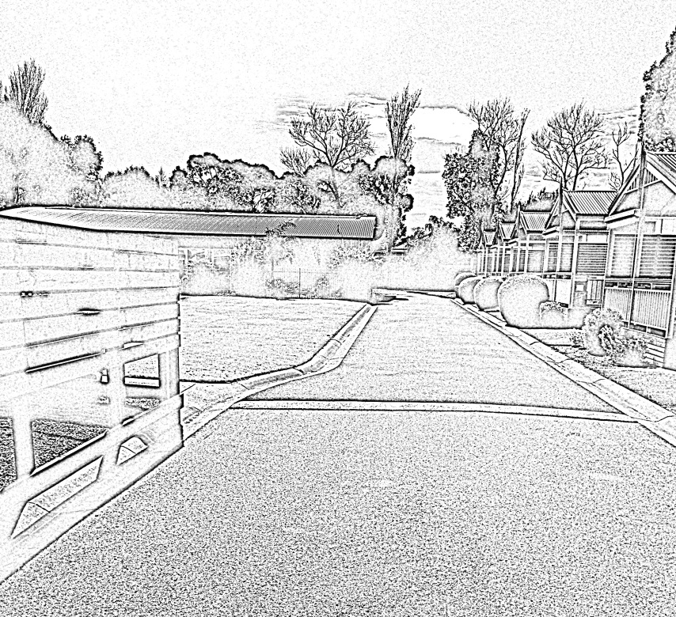
Figure 4.1: Looking north along internal road showing obscured footpath on the left
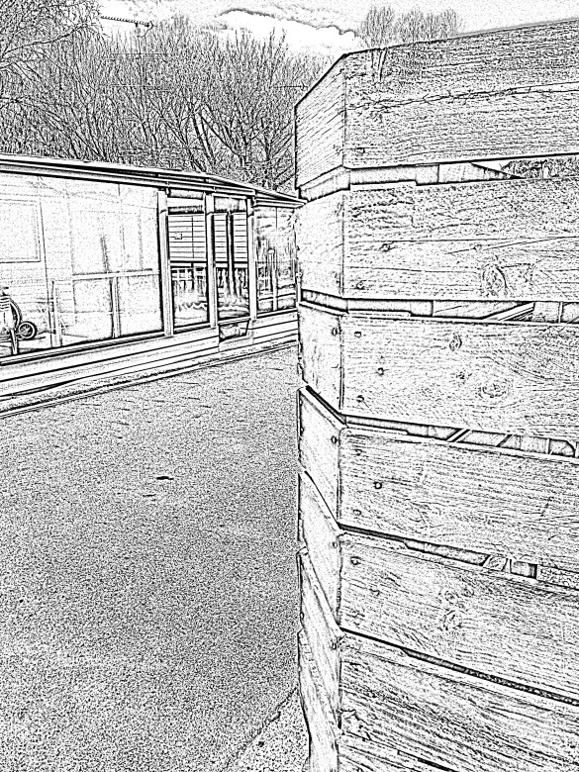
Figure 4.2: Looking south along internal road from pedestrian footpath showing limited visibility of oncoming vehicles
Figure 4.3 shows the visibility from the same footpath but looking in the opposite direction to Figure 4.2. This illustrates the importance of setbacks and maintaining sight lines for pedestrians and drivers.
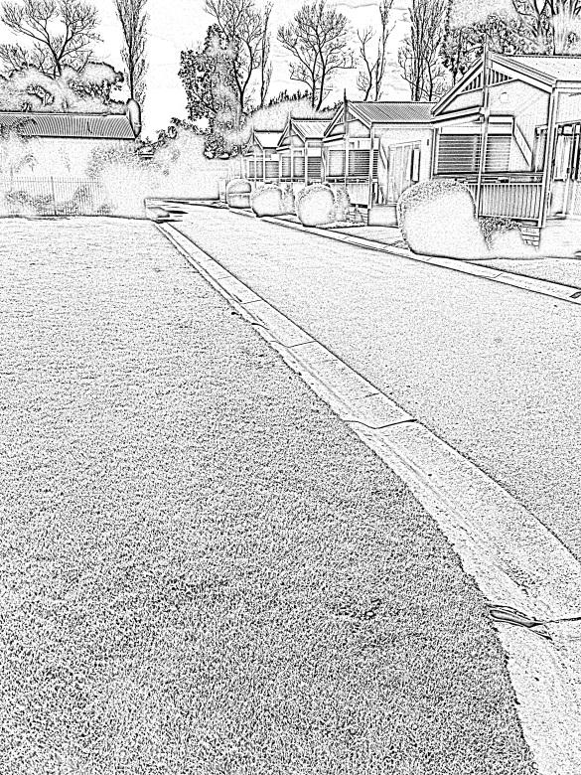
Figure 4.3: Looking north along internal road from pedestrian footpath showing clear visibility
A number of other similar scenarios where objects or vegetation limit driver and pedestrian visibility are shown in Figure 4.4 to Figure 4.7. In all these scenarios there is a path or area from which a pedestrian (in particular a small child) may emerge unexpectedly.
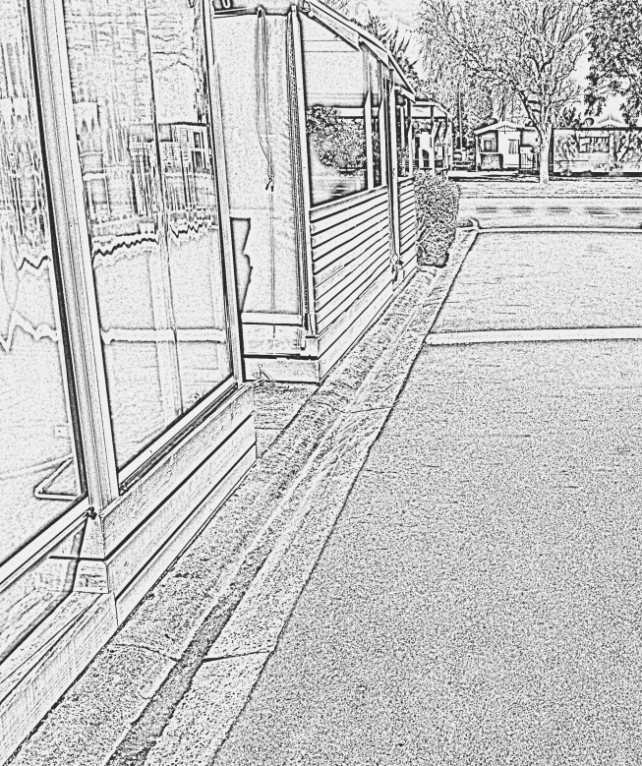 | 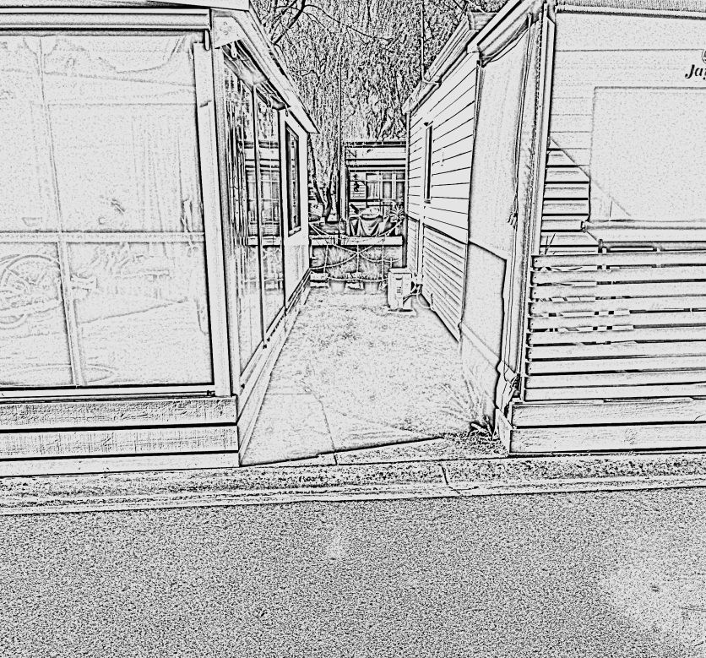
Figure 4.4: Showing restricted visibility due to lack of setback from road
Figure 4.5: Showing restricted visibility to the right due to the building and vegetation
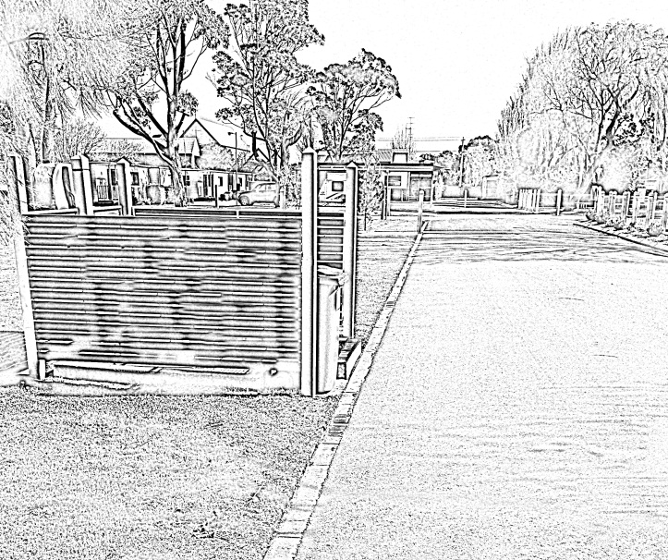
Figure 4.6: Showing restricted visibility due to bin enclosure and lack of opacity
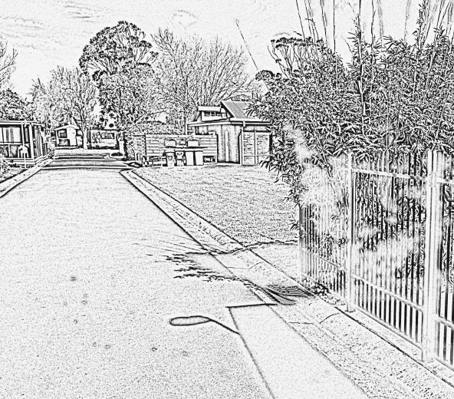 | 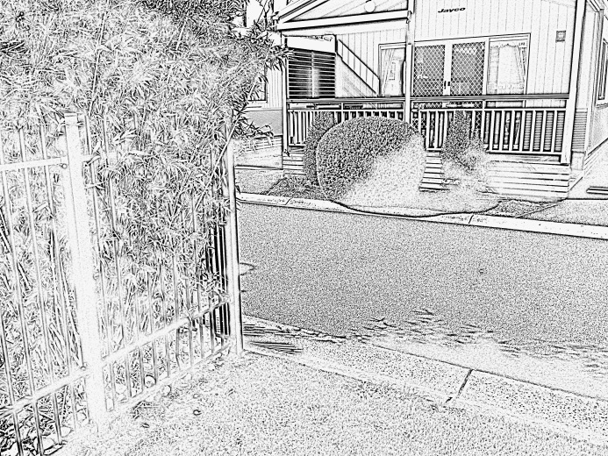
Figure 4.7: Showing restricted visibility due to vegetation.

Desktop Assessment
A desktop assessment based on aerial photos and maps of nine caravan parks (as provided by the Department of Environment and Primary Industries and VCPA) was undertaken to identify any common design or layout themes which present an increased road safety risk. The assessment considered the general road layout, road curvature, pedestrian paths, road width, traffic calming treatments and sight lines at the intersection of roads.
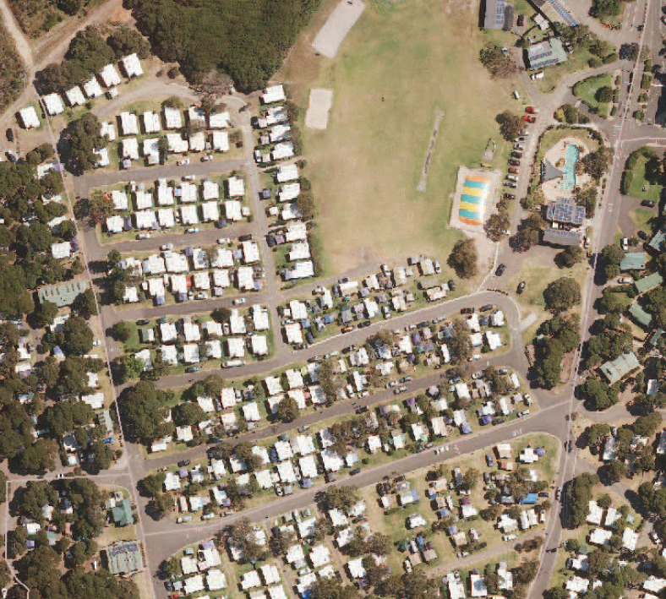
Source: Department of Environment and Primary Industries.
Figure 4.8: Example of a caravan park site that formed part of the desktop assessment
The assessment identified a number of potential hazards, which include:
- roadside vegetation which can obstruct sight lines
- cars parked along the edge of the road which can obstruct sight lines
- limited use of linemarking and signage
- limited provision of pedestrian facilities
- undefined parking areas
- unclear driveways.
Similar to the site visit, the desktop assessment identified the key issue as the limited provision of sight lines, which impacts on the conspicuity of pedestrians, cyclists and vehicles.

Comments
An important consideration is that, due to their size, younger children may not be as visible as other pedestrians. The height of children, which can be further reduced when on a bicycle, means that it only takes a small object within the roadside environment to obscure their presence. This, combined with a lack of development, experience and awareness, means that specific consideration must be given to small children when designing roads within caravan parks. Given the shared nature of caravan park activity areas and likelihood of small children being present, it would be prudent to provide a road environment that is accommodating to these vulnerable users.
Measures to reduce risk to drivers, pedestrians and cyclists are relatively common elements of road design and therefore can be readily adopted from various existing standards and guidelines. The visibility of small children is of specific concern and therefore the literature review in Section 3 aims to focus on this user group, although attention has also been given to the safety requirements of other caravan park users.
The design and layout of future caravan parks could consider options to separate movements within the site by providing car parking facilities away from the main caravan park area, and applying restrictions on how and when vehicles can be used within the park (e.g. specified pickup or drop off times or points).
Maintaining sight lines between drivers, pedestrians and cyclists is an important road design element that needs to be considered within caravan parks. The basic sight distance requirements are set out in the Austroads Guide to Road Design Part 4A. It is critical that anyone designing a roadway or driveway connection to a roadway must have an understanding of these basics. It is important that the designer ensures that walls, utility poles, vegetation, or other objects within the roadside environment do not block the lines of sight that a cyclist, driver, or pedestrian require to manoeuvre safely.
As noted, it is understood only a small number of new caravan parks have been developed in Victoria in the last 30 years. These new sites would have been subject to a development application processes through the relevant local government authority (Council), during which a review of the traffic operations would typically be undertaken. For significant developments such as a caravan park, Councils often request a traffic impact assessment be undertaken by a qualified traffic engineer and submitted as part of the application. One of the aims of the process is to identify and address road safety issues with the proposed development. The road design principles set out in this document would assist practitioners when designing or assessing a new caravan park as part of this process.
This raises the question of the extent to which current standards, guidelines and practices are being, and can be, applied within existing caravan park sites, and emphasises the value in assisting park owners and operators to identify hazards which need to be addressed. A road safety audit may be considered to review site specific operations of existing sites. A road safety audit is a formal examination of a proposed or existing road, in which an independent, qualified team reports on the site’s crash potential and safety performance.
Although not directly related to road design, the importance of supervising small children must not be overlooked. Park operators could implement campaigns or programs to educate patrons on the importance of child supervision.

Guiding Principles
A review of relevant guidelines, standards and other key documents was undertaken to identify current design principles which address the various road design issues noted as a result of the site assessments and literature review. These included:
- Australian Standard AS/NZS 2890.1:2004
- Austroads Guide to Road Design Part 3
- Austroads Guide to Road Design Part 4A
- Austroads Guide to Road Design Part 6
- Austroads Guide to Road Design Part 6A
- Austroads Guide to Road Design Part 6B
- Austroads Guide to Road Safety Part 3
- Austroads Guide to Road Safety Part 6
- Austroads Guide to Traffic Management Part 6
- Austroads Guide to Traffic Management Part 7
- Austroads Guide to Traffic Management Part 8
- Austroads Guide to Traffic Management Part 10
- Austroads Guide to Traffic Management Part 11.
Based on the site assessments and literature review, it is evident that the conspicuity of road users within caravan parks is a critical issue that needs to be addressed. This section presents a set of guiding principles which should be considered when designing roads and road-related areas within Victorian caravan parks.
It is important to note that these guiding principles and considerations are general in nature and each caravan park site will have unique characteristics. Caravan parks are a complex environment for road users and often operate in ways that are similar to a residential estate. However, the road space is commonly shared among a high number of vehicles, pedestrians and cyclists.
The guiding principles and considerations are:

Conflict-Free Zone
- Wherever possible consider separating pedestrian and cyclists from vehicle movements. If this is not possible, then other measures such as reducing vehicle speeds, establishing clear priority, fencing etc. should be considered.
- Restrict vehicle movements within caravan parks whenever possible to eliminate any conflict between vehicles and pedestrians/cyclists.
- Enforce a one vehicle per site policy, with strictly no visitor vehicles allowed within the caravan park. Parking for visitors should be provided within a separate dedicated parking area.

Road Design
- All roads and intersections must cater for road users including drivers, cyclists and pedestrians.
- Design of roads must be sensitive to the characteristics of the various road users and their vehicles.
- Ensure that users, especially strangers to the area, are not surprised by the location of an intersection, or the layout.
- The road should be designed so that users are not severely disadvantaged for making errors, nor rewarded for deliberately committing unsafe acts.
- Intersections should be located so that driver and pedestrian sight distance requirements are met.
- It is desirable that intersections are located on straight and generally flat sections of road.
- Avoid road grading that requires heavy braking such as steep inclines or declines.
- Paths should be provided along pedestrian desire lines or fencing/barriers should be installed to guide pedestrians along the preferred route and to separate them from vehicle traffic.
- Provide setbacks between road traffic lanes and paths wherever practicable to maintain adequate sight line provisions.
- Ensure that the placement of signs does not obscure pedestrians from motorists’ view.
- Any pedestrian crossing facilities should be located where there is a clear view between approaching motorists and pedestrians on the crossing or waiting to cross a roadway.

Landscaping
- Ensure that any landscaping does not interfere with sight lines for vehicles approaching, entering, or passing through an area where pedestrians and cyclists may be present.
- Low growing species of plants are preferable and the maintenance of all roadside vegetation is critical to ensure that sight lines are kept clear.

Traffic Management
- Driveways or parking areas should be located where conflicts with pedestrians and cyclists are minimised and where adequate sight distance to street traffic (including pedestrian and possible bicycle movements) is available.
- Park site layouts should be designed to promote forward movement of vehicles wherever possible.
- Pedestrian entrances and exits should be separate from vehicular ones.
- If separation is not feasible, formal crossing points should be established in areas where there is a high level of either vehicle or pedestrian activity.
- Crossing points should be positioned away from areas where there are high vehicle movements, i.e. main entry and exit, placed at right angles to the traffic flow, and provided at locations with adequate sight distance. Signs and pavement markings should be used to guide pedestrians to the crossing points.
- Install fencing and provide conspicuous crossing points at high pedestrian and cyclist activity areas that are located near concentrated vehicle movements e.g. the main entry and exit points of the caravan park.
- Provide a Stop control at intersections where safe intersection sight distance (SISD) is not provided.

Pedestrian and Cyclist Facilities
- Where parking occurs along a road, consider installing footpath extensions at pedestrian crossing points. The kerb extension is to be extended up to the car parking lane line and should be wide enough to ensure that parking is physically restricted on both sides of the crossing. This should be done to provide drivers with sufficient approach sight distance to pedestrians about to step onto the crossing (see Figure 5.1).
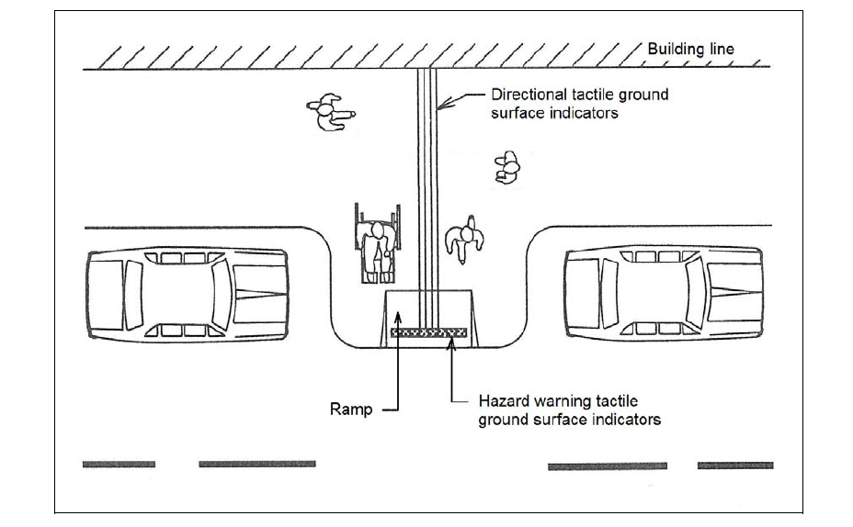
Notes:
Warning signs in advance of footpath extensions are not generally essential unless the signs are required for a regulated pedestrian crossing.
Any signing provided should be in accordance with the requirements of AS 1742.13 for similar road narrowing treatments.
Provide suitable delineation for these treatments (e.g. painting of the kerbs, pavement marking, retro-reflective pavement markers).
Drainage of the roadway adjacent to the footpath kerb extension needs to be considered and the kerb line shape should be compatible with the turning characteristics of the street sweeping equipment.
Source: Austroads (2009).
Figure 5.1: Footpath kerb extension
- Install fencing where possible to:
- reduce conflict points between vehicles and pedestrians/cyclists
- simplify decisions for drivers, pedestrian and cyclists
- direct pedestrians/cyclists to formal crossing points.
It is important to ensure that the height and opacity of any fencing installed maintain the required sight distances for motorists, pedestrians and cyclists, bearing in mind that the latter two groups are likely to include small children.
- Where there is a regular crossing point used by young or elderly pedestrians, consider installing a pedestrian crossing such as a zebra crossing (Figure 5.2). Where there is a need to facilitate regular pedestrian crossing movements and manage vehicle travelling speeds then consider installing a wombat crossing (includes a raised section of road) (Figure 5.3 and Figure 5.4). Zebra crossings are typically used for lower speed environments (e.g. ≤ 40 km/h) and Wombat crossings for 40 km/h speed zones or when speed management is necessary.
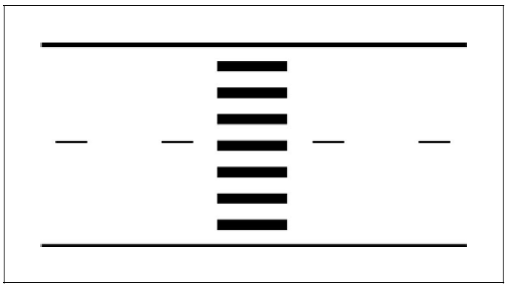
Source: Austroads (2009).
Figure 5.2: Pedestrian (zebra) crossing line markings
Source: Austroads (2008).
Figure 5.3: Example of a wombat crossing
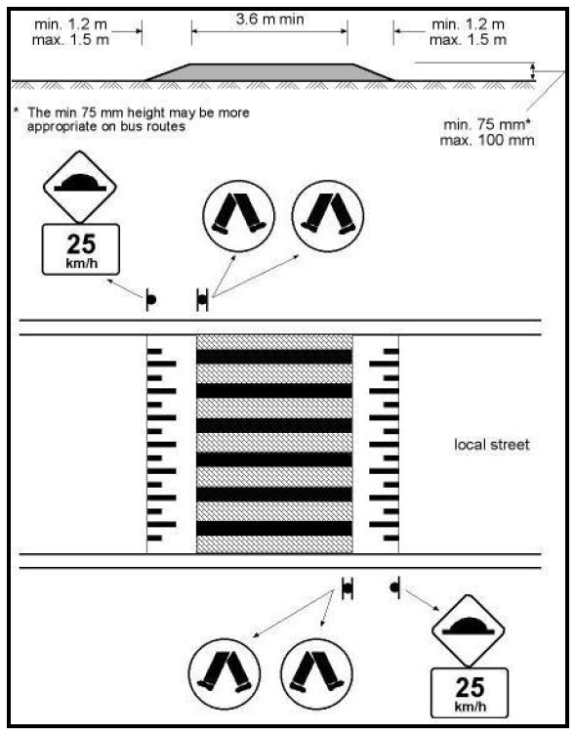
Source: Austroads (2008).
Figure 5.4: Typical dimensions of a wombat crossing

Parking
- Ensure that parked vehicles do not create a problem, e.g. act as a barrier or impede sight distance at roads.
- Parked vehicles can cause visual obstructions, especially for children, wheelchair occupants, or individuals of small stature. Parking must be set back from the road edge so that adequate pedestrian sight distances are maintained, in particular at intersections (see Figure 5.5, Figure 5.6 and Figure 5.8). The same applies to the location of any objects (e.g. tents) that may obstruct the view of pedestrians, in particular small children.
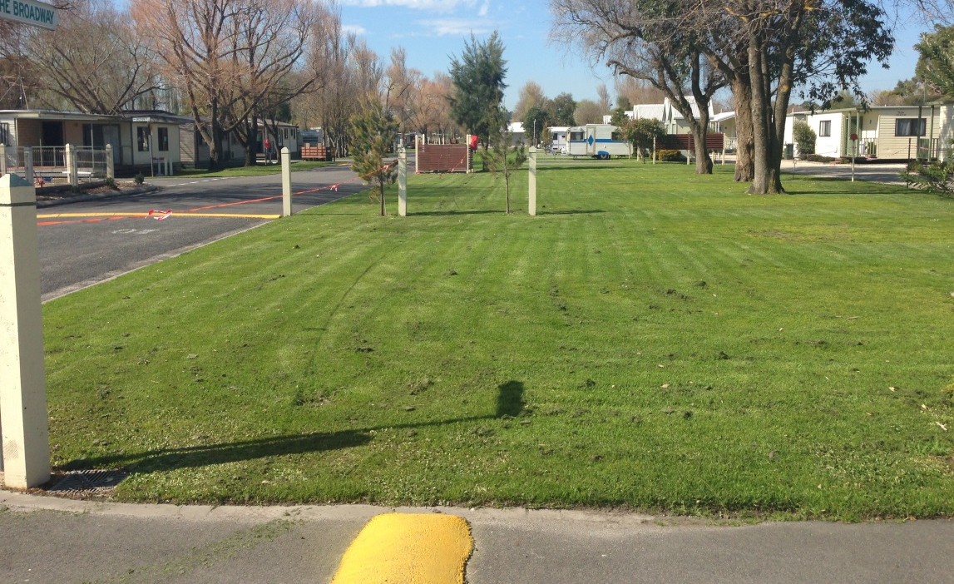
Note: Not to scale.
Figure 5.5: Illustration of setback envelope to be kept clear of vehicles and objects that will obstruct sight distances
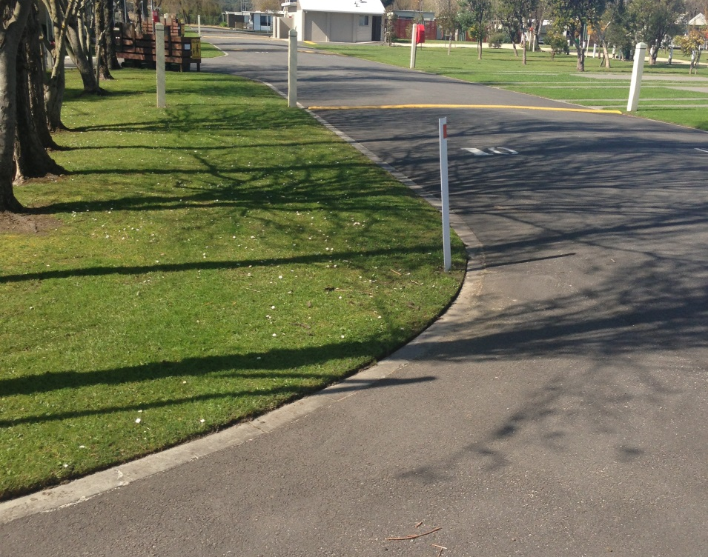
2.5m
2m
Note: Not to scale.
Figure 5.6: Intersection sight envelope to be kept clear of parked vehicles and objects that obstruct sight distances

Sight Distances
It is critical for the safety of all road users within a caravan park, that drivers are able to:
- recognise the presence of a road user in time to slow down or stop in a controlled and comfortable manner
- give way where required by law, or avoid a crash in the event of a potential conflict.
For a typical caravan park environment (10 km/h Shared Zone) the following sight distances should be met based on the requirements set out in the Austroads Guide to Road Design Part 4A and AS/NZS 2890.1:2004.
- SISD is the minimum level of sight distance to be provided for a driver on the minor road approach to react to a potential conflict and come to a stop. (See Figure 5.7)
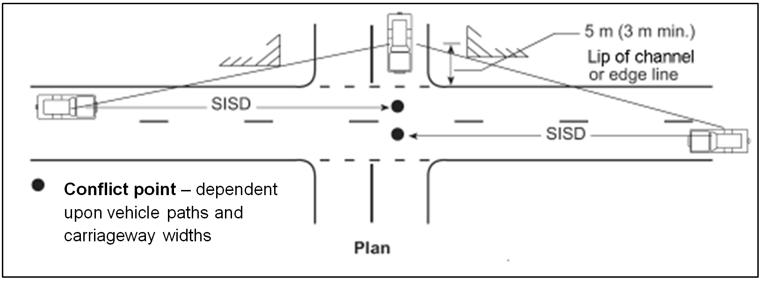
Source: Based on Austroads (2010).
Figure 5.7: Safe intersection sight distance (SISD)
- Sight distance to pedestrians must be maintained at the property line to ensure adequate visibility between vehicles leaving the area and pedestrians on the frontage road space. Any vehicles or objects within a caravan or camping area must be set back a minimum 2 m from the edge of road to maintain the minimum sight distance. (Figure 5.8)
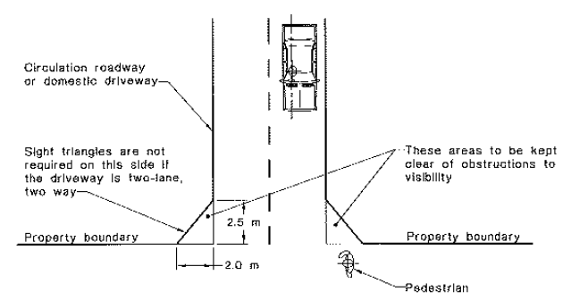
Source: AS/NZS 2890.1:2004.
Figure 5.8: Minimum sight lines for pedestrian safety
- Sight distances can be maximised by ensuring the following:
- Sight lines are not compromised by landscaping features such as long grasses, bushes or taller shrubs and trees. Any plant growth should not encroach into sight lines at a later date. All vegetation should be adequately maintained to preserve the sight lines.
- Use of setbacks to maintain sight lines and visibility, particularly at the point of entry and exit to the road.
- Fences or similar structures should be located and constructed in ways that will not obstruct sight lines between motor vehicle drivers, cyclists and pedestrians. Within a caravan park environment, it is important to recognise that sight lines should be established and maintained with particular attention to the safety of small children.
- The height and location of signs and other road furniture selected must maintain clear sight lines for both pedestrians and drivers. Care also needs to be taken to ensure that the line of sight between drivers and pedestrians is not obscured and that pedestrians, particularly small children, are not hidden behind traffic signs at critical locations.
- Roads have a straight rather than curved alignment on the immediate approaches to intersections. A suitable length of straight roadway ensures that sight distance lines give drivers the best opportunity to see the intersection and brake on a straight rather than a curved alignment. In addition, curved road alignments on the approach to an intersection often make it difficult for drivers to identify the location of intersections.
- The line of sight should not be impeded by any object such as street furniture (e.g. poles, mailboxes, telephone booths, trees, decorative planters) or parked vehicles. Minor obstructions, such as posts, poles and tree trunks less than 200 mm diameter within the sight line may be ignored.
- Sight distances at access points where vehicles are able to enter a road network should comply with the sight distance requirements for intersections, i.e. that approach sight distance (ASD), SISD, and minimum gap sight distance (MGSD) are achieved.
- Consider installing convex mirrors to assist with vehicle blind spot issues. It is important to note that the use of convex mirrors should not replace good road design practices. Convex mirrors should only be considered once all road design efforts have been exhausted to provide the required sight distances.

Speed Management
- It is recommended that a speed limit of10 km/h is applied by creating a Shared Zone where motorists and cyclists must give way to pedestrians while maintaining basic access for motor vehicles. All entry and exit roads to the zone must be signed.
- Where positive speed control is necessary, speed humps (or) cushions should be installed to slow traffic.
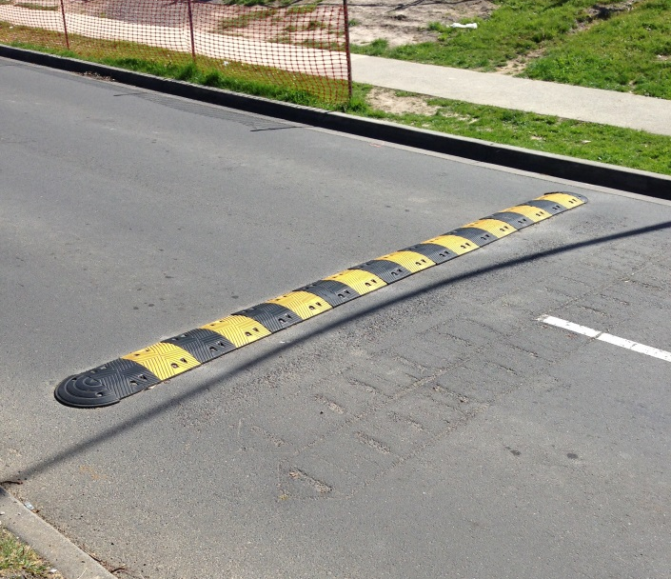 | 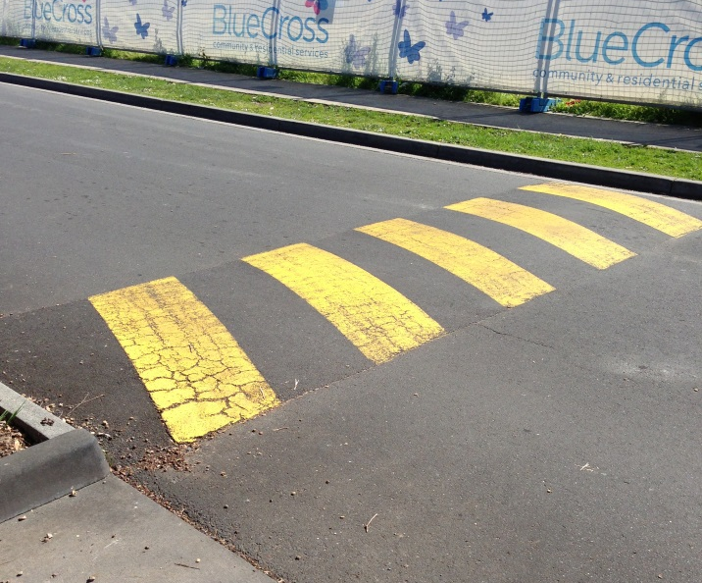
Figure 5.9: Examples of typical speed humps

Intersection Control
The application of Give Way and Stop signs are set out in AS 1742.2 (2009). It is not possible to describe all circumstances that arise at intersections. Give Way and Stop signs should generally be provided as follows:
- Give Way signs should be provided on minor (side) roads to establish clear priority.
- Give Way signs should be provided at any three-way intersection where the layout is such that it is not clear how or whether the T-intersection rule would operation, i.e. at a Y-intersection.
- Stop signs should be provided instead of Give Way signs on any controlled approach where intersection sight distance is below the distances suggested in the Austroads Guide to Road Design Part 4A. Stop signs should not be used where intersection sight distance is adequate for Give Way signs.
- In all other cases, Give Way signs are not required if the T-intersection rule operates satisfactorily and there is no requirement for Stop signs due to reduced intersection sight distance at these locations.

Signs
- Suitable signs should be used to direct caravan park road operations consistent with the AS/NZS 2890.1 and AS 1742 series in Australia. Smaller signs may be appropriate as operating speeds in caravan parks are generally low.

Line Marking
- Use pavement markings to delineate parking bays, pedestrian crossings, and pavement arrows consistent with AS 1742 and AS/NZS 2890.1.

Lighting
- Ensure that intersections and pedestrian crossings are provided with adequate lighting. Refer to AS/NZS 2890.1 and AS/NZS 1158.3.1 as a guide.

Checklist tool
A checklist style tool is provided in Appendix A to assist caravan park operators with the development of new Victorian caravan parks, and which might also be applied when existing caravan parks are redeveloped. This checklist may also provide general assistance to existing caravan park operators should they wish to improve road safety within their site and mitigate crash risk.

Other
It is suggested that, when designing a new site or redeveloping an existing caravan park, a qualified traffic engineer is engaged to provide advice on the road design layout, pedestrian and cyclist facilities, building and caravan/camping envelope, setback and sight distance requirements.
In addition to the guiding principles outlined in this report, it is suggested that the design process of a new or redeveloped caravan park should include at least one of the following:
- Detailed design road safety audit – to identify anything missed in previous design stages and provide a chance to alter the design on paper before construction commences.
- Pre-opening road safety audit – to check that the park has been built as designed and identify inter-relationship of elements that can look acceptable on plans but not on site (in 3-D). The site is driven, ridden and walked (as appropriate) by the audit team to ensure that the safety needs of all likely road users have been addressed.
- Existing use road safety audit – to attend to changes before they lead to crashes, as uses of the road and roadside can change over time, in particular landscaping growing and obscuring devices and sight lines.
Consideration could also be given to other elements that can improve road safety within caravan parks. These may include:
- Developing a campaign to educate and remind patrons on the importance of helmets for all cyclists, and for users of skateboards or scooters within the park, particularly by younger children.
- Highlighting safer driving practices, such as avoidance of reversing into shared access roads.

References
Austroads 2008, Guide to traffic management: part 8: local area traffic management, AGTM08-08, Austroads, Sydney, NSW.
Austroads 2009, Guide to road design: part 4: intersections and crossings: general, AGRD04-09, Austroads, Sydney, NSW.
Austroads 2010, Guide to road design: part 4A: unsignalised and signalised intersections, 2nd edn, AGRD04A-10, Austroads, Sydney, NSW.
Chambers, J 2007, Understanding and acting to prevent driveway injuries to children, Safekids, Auckland, New Zealand.
Cowley, N, Nicholls, M, Parkinson, H & Swain, D 2005, Preventing child pedestrian injuries and deaths arising from vehicle-child accidents in domestic driveways, University of Waikato, Hamilton, New Zealand.

Edwards, J & Paine, M 2003, ‘The off road toll: children at risk in driveways, yards and car parks’, Institute of Public Works Engineering Australia (IPWEA) New South Wales Division conference, 4th, 2003, Homebush Bay, IPWEA, NSW, 8 pp.
Gattis, J, Levinson, H, Gluck, J, Barlow, J, Eck, R & Hecker Jr., W 2010, Multimodal driveway design, Transportation Research Board, Washington, DC, USA.
Griffin, B, Watt, K, Wallis, B, Shields, L & Kimble, R 2011, ‘Paediatric low speed vehicle run-over fatalities in Queensland’, Injury Prevention, vol. 17, supplement 1, doi:10.1136/ip.2010.030304.
Hunter, J, Poulgrain, H & Campbell, M 2009, Accidental child driveway runovers: exploring Waikato data and the efficacy of existing responses, University of Waikato, Hamilton, New Zealand.
Hutchinson, T, Kloeden, C & Long, A 2006, Patterns of bicycle crashes in South Australia, report CASR028, University of Adelaide, Centre for Automotive Safety Research (CASR), Adelaide, SA.
Jamieson, R 1980, Road environment aspects of the Fairfield in depth crash study, research report 5/80, New South Wales Traffic Accident Research Unit, Rosebery, New South Wales.
Kar, K & Blankenship, M 2009, ‘Identifying and addressing intersection operational issues by conducting road safety assessments’, Institute of Transportation Engineers (ITE) technical conference and exhibit, 2009, Phoenix, Arizona, Institute of Transportation Engineers (ITE), Philadelphia, Pennsylvania, USA, 17 pp.
Kolderup, M 2001, ‘The importance of being seen in traffic’, Australasian road safety research, policing and education conference, 2001, Melbourne, Australia, Monash University, Clayton, Vic, 8 pp.
Leden, L 1989, The safety of cycling children: effect of the street environment, Technical Research Centre of Finland, Espoo, Finland.
Parliamentary Advisory Council for Transport Safety 2013, Stepping out, pedestrian casualties: an analysis of the people and circumstances, Parliamentary Advisory Council for Transport Safety, London, UK.
Parliamentary Travelsafe Committee 2007, ‘Investigation into child deaths and injuries from low speed vehicle run-overs’, report no. 50, Parliamentary Travelsafe Committee, Brisbane, Qld.
Road Safety Committee 2010, Inquiry into pedestrian safety in car parks, Parliament of Victoria, Melbourne, Vic.
Tziotis, M 1993, Evaluation of mid-block accident ‘Black Spot’ treatments, report no. 48, Monash University Accident Research Centre, Clayton, Vic.
Westdijk, E 2001, ‘Designing a safe residential environment for children’, Traffic safety on three continents, 12th, 2001, Moscow, Russia, Swedish National Road and Transport Research Institute, Linkoeping, Sweden, pp. 769-79.
Wills, R 2004, Design and planning of caravan parks, University of New South Wales, Sydney, NSW.
Standards Australia

AS/NZS 1158.3.1- 2005, Lighting for roads and public spaces: pedestrian area (category P) lighting: performance and design requirements.
AS 1742.2 - 2009, Traffic control devices: part 2: traffic control devices for general use.
AS/NZS 2890.1 - 2004, Parking facilities: part 1: off-street car parking.

- Checklist Tool
A checklist style tool which incorporates common issues with possible suggestions is provided below.
CHECKLIST: ROAD DESIGN – VICTORIAN CARAVAN PARKS
Issue | Yes | No | Suggestions
Will the road layout keep travel speeds at a safe level? |  |  | - Avoid layouts with long straight sections of road that allow motorists to travel at high speeds.  - Road humps (or cushions) can be used to slow down traffic speeds.
Has an appropriate speed limit been set and have signs been installed? |  |  | - The speed limit should not be greater than 10 km/h. Consider applying a 5 km/h shared zone.
Does the site layout discourage vehicles from reversing into areas where there may be small children? |  |  | - Site layout should be designed to allow motorists to travel in a forwards direction and eliminate or reduce the need to reverse.  - If reversing movements can’t be eliminated, then reversing areas should not be near areas where there may be small children.
Can users see over and past the landscaping at intersections, bends, accesses and pedestrian locations such as:  - safety fences or barriers?  - boundary fences?  - street furniture?  - parking facilities?  - signs?  - landscaping?  - parked vehicles?  - queued traffic? |  |  | - Provide adequate sight lines by:  - removing,  - relocating,  - changing the opacity; or  - lowering the height of  the object.
Are intersections free of any objects which could affect road safety? |  |  | - Remove or relocate objects.
Has vegetation been planted to avoid overhanging onto or above the road and creating a road safety hazard ? |  |  | - Relocate vegetation and ensure it is regularly maintained.
Does the road alignment such as crests and bends in the road restrict the sight of oncoming users (vehicles, pedestrians, cyclists etc.) and not allow sufficient time to avoid a collision? |  |  | - Avoid road designs where crests and bends will restrict sight lines. Where this can’t be avoided, consider:  - lowering the speed by applying a lower speed limit  - installing advanced warning signs; or  - implementing physical speed control measures.
Issue | Yes | No | Suggestions
Have adequate facilities been provided for pedestrians and are they safely located? |  |  | - Provide footpaths along busy pedestrian routes. Install pedestrian crossing facilities at busy crossing points.
Can pedestrians cross safely at:  - intersections?  - pedestrian crossings?  - kerb extensions?  - other locations? |  |  | - Provide crossing facilities at busy intersections or pedestrian crossing points. Crossing facilities should be marked or signed appropriately.
Is each crossing point satisfactory for:  - visibility, for each direction?  - all types of pedestrians, including:  - elderly?  - children?  - wheelchair users?  - lighting? |  |  | - Ensure that pedestrian crossing facilities are clearly visible to motorists.  - Where there is a height difference between the path and crossing point, a ramp should be provided.
Are pedestrian fences provided where needed (for example, to guide pedestrians or discourage parking)? |  |  | - Consider installing fences to guide pedestrians away from any potential vehicle conflict points. These fences should be see-through.
Are pedestrians deterred from crossing roads at unsafe locations? |  |  | - Consider installing fences to guide pedestrians away from any potential vehicle conflict points. These fences should be see-through.
Have the needs of cyclists been considered:  - at intersections?  - on cycle routes and crossings? |  |  | - Adequate signs and linemarking should be installed at intersections and crossings.  - Adequate visibility of cyclists should be provided at intersections.
Are bicycle facilities safely located in respect of vehicular movements and adequately signed? |  |  | - Bicycle facilities should not be located near areas where there are a high number of vehicles movements.
Are parking areas conveniently and safely located? |  |  | - Parking areas should be located away from the main caravan park area. The entry/exit should not be near busy pedestrian areas.
Is adequate space provided in parking areas for circulation and required sight distance? |  |  | - Parking areas should be designed to allow for vehicles to travel in a forwards direction. The need for reversing should be limited.  - Parking aisle widths should be wide enough so that a motorist has enough time to avoid a collision should a small child run out from behind a vehicle.  - The use of kerb outstands at the end of parking bay aisles should be considered to provide adequate sight distances at intersections.
Issue | Yes | No | Suggestions
 |  |  | - A speed limit of 10 km/h or less should be applied.
Are turning facilities for large vehicles provided in safe locations? |  |  | - Turning facilities for large vehicles should be provided to discourage reversing movements.
Has lighting been adequately provided where required? |  |  | - Install lighting at intersections and pedestrian crossing facilities if they are not visible at night.
Have necessary traffic signs and road markings been provided as part of the development? |  |  | - Signs and linemarking should be consistent with those used on the road network.  - Smaller signs can be used within the low speed environment.
Are signs appropriate to the driver's needs (for example direction signs, advisory speed signs, etc.)? |  |  | - Avoid the overuse of signs as this can create more confusion and be a distraction to the driver.
Are signs located where they can be seen and read in adequate time? |  |  | - Signs should be clearly visible and any vegetation maintained to ensure that it does not obstruct the sign.
Are signs located so that they do not block visibility:  - to/from access and intersecting roads?  - to/from pedestrians and important features on the road? |  |  | - Ensure that the placement of signs does not obstruct the visibility of the road users.
Will the signs and markings be clear in all conditions, including day/night, rain, fog, etc.? |  |  | - Check that the signs and linemarking can be sign in all conditions.
Is priority clearly defined at all intersection points within the car park and access routes? |  |  | - Ensure that adequate intersection controls have been implemented e.g. GIVE WAY, STOP etc.
Where possible has the separation of pedestrians and vehicles been considered? (especially at entrances and exits) |  |  | - Avoid locating busy pedestrian areas next to busy traffic areas.  - If a busy pedestrian area is next to a busy traffic area, then consider using physical controls such as fencing to prevent potential conflict points.
Has the separation of loading/unloading areas from vehicle traffic and pedestrian areas been considered? |  |  | - Avoid locating loading/unloading areas next to or near busy pedestrian areas.  - If a loading/unloading area is next to or near a busy pedestrian area, then consider using physical controls such as fencing to prevent potential conflict points.
Can all accesses be used safely by all road users (motorists, cyclists, pedestrians etc.)? |  |  | - Ideally, pedestrian and cyclist facilities should not be placed at vehicle access points.  - If high pedestrian or cycling activity
Issue | Yes | No | Suggestions
occurs near an access, then consider installing adequate warning signs or provide crossings which give priority to pedestrians or cyclists.
- Avoid placing objects near accesses that can obstruct the visibility of road users.
Are the traffic lanes wide enough to accommodate the necessary vehicle movements? |  |  | - The roads should be designed to accommodate large vehicles including caravans.
Have the appropriate vehicles been considered in the design of turning dimensions? |  |  | - The roads should be designed to accommodate the largest type of vehicle likely to use the roads.
Will emergency service vehicles be able to access and move around the site safely? |  |  | - The road widths and turning areas should be designed to accommodate emergency service vehicles.  - Ensure that objects or structures do not restrict emergency service vehicle access.
Will waste collection vehicles be able to access and move around the site safely? |  |  | - Road widths should be designed to accommodate waste collection vehicles.  - Provide turning areas to discourage waste collection vehicles from reversing.

