*Planning and Environment Act 1987*

Sections 46GJ and 46GZI

**MINISTERIAL DIRECTION ON THE PREPARATION AND CONTENT OF INFRASTRUCTURE CONTRIBUTIONS PLANS**

and

**MINISTERIAL REPORTING REQUIREMENTS FOR INFRASTRUCTURE CONTRIBUTIONS PLANS**

**PART A: MINISTERIAL DIRECTION ON THE PREPARATION AND CONTENT OF INFRASTRUCTURE CONTRIBUTIONS PLANS**

**Purpose and application**

1. This Direction applies to planning authorities in relation to the preparation and content of infrastructure contributions plans.
2. A planning authority must comply with this Direction if it prepares an infrastructure contributions plan.

**Commencement**

1. This Direction comes into effect on the day it is made.

**Definitions**

1. In this Direction:
2. ***Act*** means the *Planning and Environment Act 1987*;
3. ***allowable items*** means the plan preparation costs, works, services or facilities specified in this Direction or an Annexure to this Direction that may be funded through an infrastructure contributions plan;
4. ***allowable public purposes*** means the public purposes specified in this Direction or an Annexure to this Direction;
5. ***arterial road*** means a road that functions, or will function, as a high-capacity urban primary or secondary arterial road, regardless of any declaration under the *Road Management Act 2004*;
6. ***community and recreation construction*** means the construction or provision of community and recreation works, services or facilities;
7. ***development setting*** means any development setting described in an Annexure to this Direction;
8. ***Director of Housing*** means ‘Director of Housing’ as defined in the *Housing Act 1993* and the body corporate established under the *Housing Act 1993*.
9. ***drainage construction*** means the construction or provision of drainage works, services or facilities;
10. ***early delivery*** means delivery when the need is anticipated to arise, where that need arises ahead of the point at which sufficient funds will likely have been collected through levies to fund the item or accepted as works-in-kind;
11. ***GAIC*** meansgrowth areas infrastructure contribution;
12. ***GAIC contribution area*** means a contribution area for the purposes of Part 9B of the Act and has the meaning set out in section 201RC of the Act;
13. ***ICP plan area*** means the area specified in an infrastructure contributions plan as the area to which the plan applies;
14. ***Infrastructure Contributions Plan Guidelines*** means the document *Infrastructure Contributions Plan Guidelines* published by the Department of Transport and Planning as amended from time to time;
15. ***inner public purpose land*** means land in the ICP plan area of an infrastructure contributions plan that is specified in that plan as land to be set aside for public purposes;
16. ***non-government school*** has the same meaning as in section 1.1.3 of the *Education and Training Reform Act 2006*;
17. ***orderly development*** means logical progression of development on land that is capable of being provided with essential services and aligned to the delivery of infrastructure specified in the project staging in the infrastructure contributions plan;
18. ***outer public purpose land*** means land outside of the ICP plan area of an infrastructure contributions plan that is specified in that plan as land to be acquired for public purposes;
19. ***public purpose land*** meansany inner public purpose land or any outer public purpose land specified in the infrastructure contributions plan, or both;
20. ***public authority*** has the same meaning as in section 3 of the Act;
21. ***State infrastructure*** means those works, services and facilities that are specified in this Direction or an Annexure to this Direction as State infrastructure;
22. ***transport construction*** means the construction or provision of transport works, services or facilities.
23. If a term relating to the use of land is not defined in this Direction, the term has the same meaning as in the *Victoria Planning Provisions*.
24. Words and phrases used in this Direction have the meaning provided in the Act, unless the context requires otherwise.

**Application of an infrastructure contributions plan**

1. An infrastructure contributions plan may only be applied to land that is within a development setting specified in an Annexure to this Direction.
2. An infrastructure contributions plan that is applied to land that is affected by a development contributions plan cannot fund projects that are identified for funding through the existing development contributions plan.

**Types of land where an infrastructure contribution may be imposed**

1. Under an infrastructure contributions plan, an infrastructure contribution may only be imposed in respect of the development of land that is within a development setting specified in an Annexure to this Direction.

**Classes of development exempt from an infrastructure contribution**

1. An infrastructure contribution must not be imposed in respect of the development of land for:
2. a government school; or
3. a non-government school; or
4. housing provided by or on behalf of the Chief Executive Officer of Homes Victoria; or
5. a small second dwelling; or
6. emergency services; or
7. any other class of development, for the purposes of this clause, approved by the Minister.

**MONETARY COMPONENT**

**Allowable items**

1. An infrastructure contributions plan may only specify that allowable items may be funded from a standard levy or a supplementary levy (or a combination of both of those levies), in accordance with this Direction.
2. Unless this Direction or an Annexure to this Direction specifies otherwise, an allowable item does not include those works, services or facilities that a developer of land normally provides on or to the land in order to develop the land for urban purposes.

**Note:** The *Infrastructure Contributions Plan Guidelines* provide guidance on the works, services and facilities that are normally provided by developers in a development setting.

**Requirements for imposing a standard levy**

**Allowable items**

1. A standard levy may only be used to fund the following allowable items:
2. works, services or facilities that are listed as standard levy allowable items in the applicable Annexure to this Direction;
3. plan preparation costs provided that no more than 1% of the standard levy is used to fund those costs;
4. works, services or facilities that are listed as supplementary levy allowable items where the total standard levy rate is not required to be used to fund the standard levy allowable items, unless the applicable Annexure to this Direction specifies those supplementary levy allowable items must not be funded from a standard levy.

**Standard levy rates**

1. Subject to section 46GI(2)(b) of the Act, if an infrastructure contributions plan imposes a standard levy, the plan must specify as the standard levy rate:
2. if the plan is prepared in the financial year specified in an Annexure to this Direction, the relevant standard levy rate specified in the applicable Annexure to this Direction that accords with the class of development of land being levied; or
3. in each subsequent financial year, the relevant standard levy rate specified in the applicable Annexure to this Direction as indexed in accordance with the Annexure.

**Note:** An infrastructure contributions plan may specify a lower standard levy rate than the standard levy rate that would otherwise need to be specified in accordance with this clause if the requirements of section 46GI(2)(b) of the Act are met.

**Note:** The indexed standard levy rates will be published on the Department’s Internet site.

**Indexation method and timing to be specified in a plan for a standard levy**

1. If an infrastructure contributions plan imposes a standard levy, the plan must provide for the method and timing of indexation of the standard levy rate. The plan must provide that standard levy rate is indexed on 1 July of each financial year. The plan must provide a method of indexation that is consistent with the method of indexation set out in the applicable Annexure to this Direction. If no method of indexation is set out in the applicable Annexure, the infrastructure contributions plan must specify an appropriate method of indexation.

**Requirements for imposing a supplementary levy**

**Allowable items**

1. A supplementary levy may only be used to fund the following allowable items:
2. works, services or facilities that are listed as supplementary levy allowable items in the applicable Annexure to this Direction;
3. plan preparation costs if those costs are incurred in respect of works, services or facilities to be funded from the supplementary levy.

**Requirements for including a supplementary levy**

1. A planning authority may only include a supplementary levy in an infrastructure contributions plan if:
2. the works, services or facilities to be funded from the supplementary levy are, in the opinion of the planning authority, essential to the development of the ICP plan area;
3. the works, services or facilities to be funded from the supplementary levy are identified in a precinct structure plan or equivalent strategic plan applying, or to be applied, to the land; and
4. any other requirements specified in the applicable Annexure to this Direction are met.

**Requirements for estimating costs**

1. If an infrastructure contributions plan imposes a supplementary levy, the plan must specify:
2. unless otherwise specified in an Annexure to this Direction, the estimated cost of each of those works, services or facilities that are to be funded from the standard levy;
3. the estimated cost of each of those works, services or facilities that are to be funded from the supplementary levy as required by section 46GI(1)(r)(ii) of the Act; and
4. the proportion of the total of the costs referred to in paragraph (b) to be funded from the supplementary levy as required by section 46GI(1)(r)(iv) of the Act.

**Indexation method and timing to be specified in a plan for a supplementary levy**

1. If an infrastructure contributions plan imposes a supplementary levy, the plan must provide for the method and timing of annual indexation to be applied to the estimated cost of the works, services or facilities to be funded from the supplementary levy. The plan must provide that the estimated cost is indexed on 1 July of each financial year. The plan must provide for a method of indexation that is consistent with the method of indexation set out in the applicable Annexure to this Direction. If no method of indexation is set out, the infrastructure contributions plan must specify an appropriate method of indexation.

**LAND COMPONENT**

**Allowable public purposes**

1. Public purpose land may only be used or developed for the allowable public purposes specified in the applicable Annexure to this Direction.

**Method for calculating the estimated value of inner public purpose land**

1. For those parcels of land for which an estimate of value report is to be prepared, the valuer must determine the estimate of value in accordance with the procedure and method specified in the applicable Annexure to this Direction.

**Note:** If an infrastructure contributions plan imposes an infrastructure contribution that includes a land component, the planning authority must arrange for a valuer to prepare a report containing an estimate of the value of any inner public purpose land for each parcel of land in the ICP plan area where the parcel contribution percentage of the parcel is more than the ICP land contribution percentage for the class of development that may be carried out on that land.

**Notice to land owners of estimated value of inner public purpose land**

1. A notice provided to a land owner in accordance with section 46GO of the Act must contain any other information specified in the applicable Annexure to this Direction.

**Note:** The planning authority must give notice to the affected land owners in accordance with section 46GO of the Act when the infrastructure contributions plan is being prepared for approval and incorporation into the planning scheme.

**Method for calculating the estimated value of outer public purpose land**

1. If an infrastructure contributions plan imposes an infrastructure contribution that includes a land component, a valuer appointed by the planning authority must calculate the estimated value of any outer public purpose land on the same basis that the land will be valued at the time the land is acquired, being consistent with the principles in Part 4 of the *Land Acquisition and Compensation Act 1986*,unless a different procedure and method is specified in the applicable Annexure to this Direction.

**Method of adjustment of public purpose land values**

1. If an infrastructure contributions plan imposes an infrastructure contribution that includes a land component, the following must be adjusted at the time, and in accordance with the procedure and method, specified in the applicable Annexure to this Direction:
2. the estimated value of any inner public purpose land; and
3. the estimated value of any outer public purpose land to be acquired by a development agency.
4. If no timing, procedure or method of adjustment is specified, the infrastructure contributions plan must specify an appropriate time, procedure and method of adjustment.

**Calculation of land credit amounts and land equalisation amounts per parcel**

1. If an infrastructure contributions plan imposes an infrastructure contribution that includes a land component, the land credit amount or the land equalisation amount in respect of each parcel of land in the ICP plan area must be calculated in accordance with the method specified in the applicable Annexure to this Direction.

**Note:** Section 46GI(1)(i) of the Act provides that an infrastructure contributions plan must specify the land credit amount (where the parcel contribution percentage of the parcel is more than the ICP land contribution percentage) or land equalisation amount (where the parcel contribution percentage of the parcel is less than the ICP land contribution percentage) in respect of each parcel of land in the ICP plan area.

**Method of adjustment of land credit amounts and land equalisation amounts per parcel**

1. If an infrastructure contributions plan imposes an infrastructure contribution that includes a land component, the land credit amount or the land equalisation amount in respect of each parcel of land in the ICP plan area must be adjusted at the time and in accordance with the method specified in the applicable Annexure to this Direction.

**Note:** Section 46GI(1)(j) of the Act provides that an infrastructure contributions plans must specify the timing and method of adjustment to be applied to the land credit amounts and land equalisation amounts specified in the plan, including by way of indexation or any other method of adjustment.

1. If no timing or method of adjustment is specified, the infrastructure contributions plan must specify an appropriate time and method of adjustment.

**Exemption from compliance with this Direction**

1. The Minister may grant an exemption from the need to comply with some or all of this Direction in relation to a particular infrastructure contributions plan. An exemption may be granted subject to conditions.

**List of Annexures**

1. This Direction includes the following Annexures:

|  |  |
| --- | --- |
| Annexure 1 | Metropolitan Greenfield Growth Areas |
| Annexure 2 | Declared Activity Centre Areas |

|  |  |
| --- | --- |
| Commencement Details | |
| Originally Gazetted | 11 April 2025 |

**Annexure 1**

**METROPOLITAN GREENFIELD GROWTH AREAS**

**Development setting**

1. The development setting to which this Annexure applies is a Metropolitan Greenfield Growth Area.

**Definition of a Metropolitan Greenfield Growth Area**

1. A Metropolitan Greenfield Growth Area is land in metropolitan Melbourne that is:
2. a growth area declared under section 46AO of the Act; and
3. within an urban growth boundary; and
4. either:

* zoned under the planning scheme as an Urban Growth Zone and in respect of which a precinct structure plan applies; or
* subject of an amendment to the planning scheme to be zoned as an Urban Growth Zone and to incorporate a precinct structure plan applicable to the land in the planning scheme; and

1. within the area marked Metropolitan Greenfield Growth Area on the map contained in **Attachment 1** to this Annexure.

**MONETARY COMPONENT**

**Standard levy rates**

1. Table 1 sets out:
2. The standard levy rate that applies to the class of development of land listed in the Table.
3. For each standard levy rate, the amount of the levy that is allocated between the provision of:

* community and recreation construction; and
* transport construction.

1. The amount of standard levy payable in respect of a development of land is to be determined by applying the specified standard levy rate in Table 1 (expressed as an amount in $ per net developable hectare) to the net developable hectares in the parcel of land to be developed.
2. The standard levy rates in Table 1 apply until the end of the 2020/2021 financial year. The standard levy rates for each subsequent year are to be indexed in accordance with this Annexure.
3. For the purposes of Table 1, residential development includes the development of land in a town, neighbourhood or local activity centre for office, commercial, civic or retail development.

**Table 1: Standard levy rates for each class of development**

|  |  |  |  |
| --- | --- | --- | --- |
| **Class of development** | **Class of Infrastructure** | |  |
| **Community and recreation construction** | **Transport construction** | **Total standard levy rate** |
|  | | | |
|  | **All amounts in $ per net developable hectare** | | |
| Residential development | $91,050 | $126,713 | $217,763 |
| Commercial and Industrial development | $0 | $126,713 | $126,713 |

**Other requirements for including a supplementary levy**

1. The following requirements do not apply to including a supplementary levy in an infrastructure contributions plan to fund the provision of State infrastructure.
2. A planning authority may only include a supplementary levy in an infrastructure contributions plan if:
3. the estimated cost of plan preparation costs, works, services or facilities (other than State infrastructure) proposed to be funded through the plan will exceed the total amount that will be collected from the standard levy;
4. the estimated cost of the supplementary levy items that is unable to be funded from the standard levy will be equal to, or exceed, 10% of the total amount that will be collected from the transport construction component of a standard levy; and
5. any other requirements specified in this Annexure are met.

**Note:** The plan preparation costs, works, services or facilities may be partially funded from a standard levy and partially funded from a supplementary levy.

1. For the purposes of clause 8(a), the planning authority must:
2. estimate the cost of each of the allowable items proposed to be funded through the plan (other than State infrastructure), ensuring all items are being provided to a basic and essential standard;
3. accounting for any apportionment, determine the amount of the costs estimated in accordance with paragraph (a) proposed to be funded through the plan;
4. estimate the total amount that is likely to be collected from the standard levy; and
5. compare the amount determined in accordance with paragraph (b) to the amount estimated in accordance with paragraph (c).
6. For the purposes of clause 8(b), the planning authority must;
7. using the amount determined in accordance with clause 9(b) and the comparison made in accordance with clause 9(d), determine the amount of the estimated costs of the supplementary levy allowable items that is unable to be funded from the standard levy;
8. estimate the total amount that is likely to be collected from the transport construction component of the standard levy; and
9. compare the amount determined in accordance with paragraph (a) to the estimate made in accordance with paragraph (b).

**Requirement for estimating costs**

1. When estimating the costs of works, services or facilities, the planning authority should have regard to the *Benchmark Infrastructure and Costs Guide* and any related indexed costs published by the Victorian Planning Authority on its Internet site: **vpa.vic.gov.au**.

**Indexation method and timing of standard levy rates**

1. The standard levy rates for each class of infrastructure in each class of development specified in this Annexure must be indexed in accordance with clause 13 on:
2. 1 July 2021 for the 2021/2022 financial year; and
3. 1 July of each subsequent financial year.
4. The standard levy rates for each class of infrastructure in each class of development specified in this Annexure must be indexed in accordance with the formula set out in **Attachment 2** to this Annexure, using the following indices:
5. community and recreation construction - the Australian Bureau of Statistics Producer Price Index for Non-Residential Building Construction – Victoria (Catalogue 6427.0, Table 17, Output of the Construction Industries, subdivision and class index numbers);
6. transport construction - the Australian Bureau of Statistics Producer Price Index for Road and Bridge Construction – Victoria (Catalogue 6427.0, Table 17, Output of the Construction Industries, subdivision and class index numbers).

**Note:** The amount of the standard levy rate for each class of infrastructure will be rounded to the nearest whole number after indexation.

**Indexation method for items being funded from a supplementary levy**

1. If an infrastructure contributions plan imposes a supplementary levy, the estimated cost of each of the works, services or facilities to be funded from the levy (as appropriate) must be indexed in accordance with the formula set out in **Attachment 2** to this Annexure, using the following indices:
2. transport construction—the Australian Bureau of Statistics Producer Price Index for Road and Bridge Construction – Victoria (Catalogue 6427.0, Table 17, Output of the Construction Industries, subdivision and class index numbers);
3. any other item—the index determined by the planning authority.

**Cap on community and recreation construction**

1. The standard levy rate for residential development that may be used for community and recreation construction must not exceed:
2. in the 2020/2021 financial year—$91,050 per net developable hectare; and
3. in each subsequent financial year—for that financial year, the amount of the standard levy rate indexed in accordance with clauses 12 and 13.
4. Any of the total standard levy rate for residential development that may be used for the community and recreation construction (up to the capped rate referred to in clause 15) that is not used for community and recreation construction may be applied to transport construction.
5. The Minister may increase the amount specified in clause 15 in relation to a particular infrastructure contributions plan if:
6. the Minister is satisfied that the community and recreation construction to be funded from the increased amount is essential to the orderly development of the land in the ICP plan area; and
7. no supplementary levy is being imposed to fund transport construction; and
8. the total standard levy rate (comprising the amounts allocated to community and recreation and transport construction) is not increased.

**Allowable items**

1. An infrastructure contributions plan must only fund allowable items specified in this Annexure.

**Note:** Division 7 of Part 3AB sets out the procedure for dealing with any infrastructure contribution that has not been expended at the date on which an approved infrastructure contributions plan expires.

**Community and recreation construction allowable items**

1. Table 2 lists the allowable items for community and recreation construction that may be funded from a standard levy.
2. An allowable item listed in Table 2 includes any associated works, services or facilities that are reasonably required to ensure the item is suitable for its intended use.
3. The estimated cost of an allowable item for community and recreation construction may include a contingency amount for construction not exceeding 15% of the estimated project cost.

**Table 2: Community and recreation construction standard levy allowable items**

|  | Standard levy allowable item |
| --- | --- |
| **Community facilities** | The following single or multi-purpose community facilities that provide for a range of community activities and services:   * multi-purpose community facility * kindergarten * childcare and occasional care facility * playgroup facility * maternal and child health centre * library and learning centre * community arts and cultural facility * neighbourhood house * adult day care and activity group facility * youth services facility * delivered meals facility * business accelerator facility. |
| **Sports and recreation facilities** | The following multi-purpose or specialist sports and recreation facilities that provide for a range of activities and services:   * outdoor multi-purpose sports field, court and spaces * outdoor multi-purpose and/or specialist pavilion * football oval * soccer pitch * cricket oval * rugby field * tennis court * basketball court * netball court * bowling green * bocce court * baseball field * softball field * hockey field. |

**Transport construction allowable items**

1. A standard levy or a supplementary levy must not be imposed in respect of the development of land within a GAIC contribution area to fund transport construction on an existing declared State road. This does not include the construction of road intersections required to connect a new or upgraded council road to a declared State road, or walking and cycling infrastructure alongside or crossing a declared State road.
2. Table 3 lists the allowable items for transport construction that may be funded from a standard levy.

**Table 3: Transport construction standard levy allowable items**

|  |  |
| --- | --- |
|  | Standard levy allowable item |
| Arterial roads | Arterial roads consisting of two lanes in one carriageway in a road reservation with a width of either 34 metres or 41 metres.  This item includes:   * upgrading existing local roads to an arterial road standard; * new arterial roads; and * provision of walking and cycling infrastructure on each side of new or upgraded roads. |
| Intersections | Signalised intersections or roundabouts at the intersection of:   * arterial roads; or * an arterial road and a connector road.   This item includes provision of walking and cycling infrastructure. |
| Walking and cycling infrastructure | Off-road walking and cycling infrastructure (other than infrastructure normally provided by a developer). |
| Signalised pedestrian and cyclist crossings. |
| Bridges and culverts | Arterial road bridges, including underpasses, overpasses or similar. |
| Culverts. |

1. Table 4 lists the allowable items for transport construction that may be funded from a supplementary levy. All requirements in the Table for including a supplementary levy to fund the corresponding allowable item, in addition to any other requirement set out in this Direction or Annexure, must be met.

**Table 4: Transport construction supplementary levy allowable items**

| Supplementary levy allowable item | Requirements for including a supplementary levy |
| --- | --- |
| Arterial roads consisting of two lanes in one carriageway in a road reservation with a width of either 34 metres or 41 metres.  This item includes:   * upgrading existing local roads to an arterial road standard; * new arterial roads; and * provision of walking and cycling infrastructure on each side of new or upgraded roads. | The estimated cost of the item must exceed the road construction amount as a result of the topographical, geographical, environmental or physical conditions of the land on which the item will be constructed. |
| Signalised intersections or roundabouts at the intersection of:   * arterial roads; or * an arterial road and a connector road. | The estimated cost of the item must exceed the intersection construction amount as a result of the topographical, geographical, environmental or physical conditions of the land on which the item will be constructed. |
| Arterial road bridges.  This item includes overpasses, underpasses or similar. | The estimated cost of the item must exceed the bridge construction amount. |
| Pedestrian or cyclist bridges and accessways. | The item must provide access across a railway, arterial road, waterway corridor, major easement or other major obstacle. |
| Culverts. | The estimated cost of the item must exceed the culvert construction amount. |

1. In Table 4:
2. the ***road construction amount*** is:
3. for the financial year beginning on 1 July 2020, $5890 per linear metre of road; and
4. for the financial year beginning on 1 July 2021 and each subsequent financial year, the indexed road construction amount determined in accordance with clause 26 for that financial year;
5. the***intersection construction amount*** is:
6. for the financial year beginning on 1 July 2020, $8.56 million; and
7. for the financial year beginning on 1 July 2021 and each subsequent financial year, the indexed intersection construction amount determined in accordance with clause 26 for that financial year;
8. the***bridge construction amount*** is:
9. for the financial year beginning on 1 July 2020, $4 million; and
10. for the financial year beginning on 1 July 2021 and each subsequent financial year, the indexed bridge construction amount determined in accordance with clause 26 for that financial year;
11. the ***culvert construction amount*** is:
12. for the financial year beginning on 1 July 2020, $4 million; and
13. for the financial year beginning on 1 July 2021 and each subsequent financial year, the indexed culvert construction amount determined in accordance with clause 26 for that financial year;
14. The indexed road, intersection, bridge and culvert construction amounts are to be determined in accordance with the formula set out in **Attachment 2** to this Annexure using the Australian Bureau of Statistics Producer Price Index for Road and Bridge Construction – Victoria (Catalogue 6427.0, Table 17, Output of the Construction Industries, subdivision and class index numbers).
15. An allowable item listed in Table 3 or 4 includes any works, services or facilities that are reasonably required to provide that item, including:
16. the design, preparation, supervision and inspection of works, services or facilities, including relevant fees;
17. site preparation;
18. services relocations, installations and adjustments;
19. construction of pavement and kerb and channel;
20. drainage;
21. foundations, abutments and structures;
22. landscaping;
23. bus priority measures;
24. fencing, including guard fencing;
25. traffic control signs, line marking and street lighting;
26. temporary works, access restoration and ‘making good’ works;
27. the costs of securing native vegetation offsets or habitat compensation fees related to the provision of the item on land that is in public ownership at the time the infrastructure contributions plan is prepared; and
28. maintenance of:
    * landscaping for one year or two summers;
    * traffic signals on arterial roads for up to ten years; and
    * all other works for one year.
29. The estimated cost of a transport construction allowable item in tables 3 and 4 may include a contingency amount for construction. If the allowable item is a road or a road intersection or culvert, the contingency amount must not exceed 15% of the estimated cost of constructing the road or road intersection. If the allowable item is a bridge, the contingency amount must not exceed 20% of the estimated cost of constructing the bridge.

**Other supplementary levy allowable items**

1. Table 5 lists other allowable items that may be funded from a supplementary levy. All requirements in the Table for including a supplementary levy to fund the corresponding allowable item, in addition to any other requirement set out in this Direction or Annexure, must be met.

**Table 5: Other supplementary levy allowable items**

| Supplementary levy allowable item | Requirements for including a supplementary levy |
| --- | --- |
| Financing costs associated with the early delivery of works, services or facilities. | The early delivery of the works, service or facility must be essential to the orderly development of the ICP plan area.  The financing costs must be:   * incurred by the development agency responsible for providing the item; and * associated with either: * the early delivery of an allowable item; or * the early acquisition of public purpose land referred to in section 46GV(8) of the Act which is required for the early delivery of the allowable item. |
| Local and connector roads.  Intersections of non-arterial roads.  Local road and connector road bridges.  Pedestrian and cyclist bridges and accessways. | The item must be a works, service or facility that a developer of land normally provides on or to the land in order to develop the land for urban purposes.  The item must be constructed on, or adjoin, land in fragmented ownership and the fragmented ownership must make provision of the item by the developer difficult.  The relevant municipal council must have agreed to be the development agency for the item.  The estimated cost of the item must be fairly levied amongst the developers who will benefit from the delivery of the item. |
| Any other works, services or facilities (other than State infrastructure), including an allowable item listed in a table to this Annexure. | The Minister must agree that the item:   * is essential to the development of the ICP plan area; and * can be funded from a supplementary levy. |

**State infrastructure allowable items**

1. State infrastructure must not be funded from a standard levy.
2. Table 6 lists the allowable items for State infrastructure that may be funded from a supplementary levy. All requirements in the Table for including a supplementary levy, in addition to any other requirement set out in this Direction or Annexure, must be met.

**Table 6: State infrastructure supplementary levy allowable items**

| Supplementary levy allowable item | | Requirements for including a supplementary levy |
| --- | --- | --- |
| **Transport infrastructure** | Declared State roads, including intersections and bridges, and public transport infrastructure. | The item must be identified in a growth corridor plan or equivalent State or local strategic plan adopted by a Minister, government department or a planning authority.  The development of land in the ICP plan area must generate a need for the item.  The provision of State infrastructure through the infrastructure contributions plan complies with section 46GH of the Act.  A minister or public authority must have agreed to be the development agency for the item. |
| **Community facilities** | State education, health or emergency facilities. |
| **Other State works, services or facilities** | Any other State infrastructure that is essential to the development of the ICP plan area. |

**Note:** Under section 46GH of the Act, an infrastructure contributions plan must not impose an infrastructure contribution in relation to the development of land in the GAIC contribution area unless the development agency responsible for carrying out the works, services or facilities or for the plan preparation costs being funded from the levy is a municipal council.

**Requirements for estimating costs for State infrastructure allowable items**

1. If an infrastructure contributions plan imposes a supplementary levy for any State infrastructure, in addition to the matters set out in section 46GI(1)(r) of the Act, the plan must only specify the estimated cost of the State infrastructure allowable item to be funded from the supplementary levy if no other supplementary levy allowable item listed in Tables 4 or 5 is to be funded.

**LAND COMPONENT**

**Allowable public purposes**

If an infrastructure contributions plan specifies any inner public purpose land to be provided under the plan or outer public purpose land to be funded through the plan, the public purpose land and the purposes for which it may be developed must:

be in accordance with the relevant Precinct Structure Plan or equivalent strategic plan applying to the land; and

be consistent with this Direction.

**Note:** Division 7 of Part 3AB sets out the procedure for dealing with any infrastructure contribution that has not been expended at the date on which an approved infrastructure contributions plan expires.

1. Table 7 lists the allowable public purposes for which public purpose land may be used or developed.

**Table 7: Allowable public purposes**

| **Allowable public purpose** | **Permitted use or development of public purpose land** |
| --- | --- |
| **Public open space** | Local public open space including playgrounds, lighting, car parking, internal roads, bicycle paths, pedestrian paths, seating, landscaping, and BBQ and picnic facilities. |
| **Community and recreation facilities** | Construction of:   * any community facility or sports and recreation facility as set out in Table 2; or * an indoor recreation facility. |
| **Transport infrastructure** |  |
| Council arterial road reservations | Construction of an arterial road as set out in Table 3 or 4 in accordance with the ultimate design for its construction, including walking and cycling infrastructure. |
| Intersections with council arterial roads | Construction of an intersection as set out in Table 3 or 4 in accordance with the ultimate design for its construction, including walking and cycling infrastructure.  This may include land within a Public Acquisition Overlay if the land is required for a connection between the development and a council arterial road. |
| Intersections with declared State arterial roads | Construction of an intersection as set out in Table 3 or 4 in accordance with the ultimate design for its construction, including walking and cycling infrastructure.  This may include land within a Public Acquisition Overlay if the land is required for a connection between the development and a State arterial road. |
| Bridges and culverts | Construction of a bridge or culvert (and associated works) as set out in to in Table 3 or 4. |
| Developer-provided transport infrastructure | Construction of a:   * local or connector road; * local or connector road bridge; or * pedestrian or cyclist bridge or accessway,   if the road, bridge or accessway is:   * normally provided by a developer on or to the land in order to develop the land for urban purposes; * located on, or adjoining, land in fragmented land ownership; and * funded from a supplementary levy. |
| **Other infrastructure that is essential to the development of the ICP plan area** | Construction of other works, services or facilities (other than State infrastructure) funded from a supplementary levy. |

1. Table 8 lists the allowable public purposes for which public purpose land may be used or developed for State infrastructure.

**Table 8: State infrastructure allowable public purposes**

| **Allowable public purpose** | **Permitted use or development of public purpose land** |
| --- | --- |
| **Land outside a GAIC contribution area** |  |
| Transport infrastructure | Declared State roads, including intersections and bridges, and public transport infrastructure. |
| Community and recreation facilities | State education, health or emergency facilities.  Regional open space. |
| Other State infrastructure that is essential to the development of the ICP plan area | Construction of other State infrastructure that is essential to the development of the ICP plan area. |
| **Land inside a GAIC contribution area** |  |
| Intersections with State roads | Construction of an intersection if the land is required for connection between the development and a State road.  This includes land within a Public Acquisition Overlay. |

**Method for calculating estimated value of inner public purpose land**

1. For each parcel of land for which an estimate of inner public purpose land value report is to be prepared, the valuer engaged by the planning authority must:
2. determine the estimate of value of all the inner public purpose land identified in the parcel using the following assumptions:
3. the subject land is zoned for an urban purpose as identified in the relevant precinct structure plan or equivalent strategic plan and valued at its unencumbered, highest and best use within this context;
4. land in and around town centres identified in the relevant precinct structure plan or equivalent strategic plan will be assumed to be zoned for residential purposes;
5. if the highest and best use is residential, the relevant density per parcel is the average density (expressed as dwellings per net developable hectare) identified in the relevant precinct structure plan or equivalent strategic plan;
6. the subject land is accessible by road;
7. any GAIC (if within the GAIC area) has been paid; and
8. the subject land is at the development front;
9. calculate a $/hectare rate for all the inner public purpose land identified in the parcel.

**Example**: If there are 10 hectares of inner public purpose land on a parcel and the landowner is ‘overproviding’ 2 hectares of public purpose land. The valuer determines that the 10 hectares of inner public purpose land has an estimated valued of $1 million, which establishes a rate of $100,000 per hectare. The rate is then applied to determine the estimated value of the 2 hectares of ‘overprovided’ land. The estimated value of the overprovided public purpose land is $200,000 (2 hectares x $100,000 per hectare). The landowner will receive a land credit amount of $200,000 to account for the overprovision of public purpose land.

**Note**: If there are multiple areas of inner public purpose land in a parcel, the value of each area of inner public purpose land is estimated according to the methodology in this clause. The sum of the estimates of value is averaged to calculate a $/hectare rate for the inner public purpose land identified in that parcel.

**Example:** Parcel A includes 2.0 hectares for road widening (estimated at $600,000), 0.4 hectares for a community facility (estimated at $150,000) and 8.0 hectares for a sports field (estimated at $1,200,000). The total inner public purpose land (10.4 hectares) is divided by the total estimate of value of all inner public purpose land on that parcel ($1,950,000). For the purposes of this clause, the rate for the inner public purpose land identified in that parcel is $187,500 per hectare.

**Method for calculating land equalisation amounts**

1. For each parcel of land for which a land equalisation amount must be provided, the amount is to be calculated based on a rate per hectare applied to the area (in hectares) of inner public purpose land in that parcel that is less than the ICP land contribution percentage.

**Example**: If the land equalisation amount rate is $50,000 per hectare and a landowner underprovides inner public purpose land by 4 ha, the land equalisation amount payable by that landowner is $200,000.

1. The rate referred to in clause 37 is calculated by:
   * + 1. adding the sum of all land credit amounts payable in the ICP plan area and the estimated value of any outer public purpose land; and
       2. dividing the amount calculated for the purposes of paragraph (a) by the sum of the area of inner public purpose land (in hectares) for each parcel of land in the ICP plan area for which a land equalisation amount is payable that is less than the ICP land contribution percentage.

**Note**: The base rate of the land equalisation amount is based on the following formula:

LEA rate = Sum of Land Credit Amounts + estimated value of outer public purpose land

Total area in hectares of ‘under provided’ inner public purpose land across the ICP

**Example**:

Where:

* the sum of the land credit amounts payable under the ICP is $800,000
* the estimated value of outer public purpose land is $200,000
* the total area of inner public purpose land that is underprovided is 20 hectares

LEA rate = $800,000 + $200,000 = $50,000/ha

20 ha

**Method for calculating land credit amounts**

1. For each parcel of land for which a land credit amount must be paid the amount is calculated by applying the $/hectare rate for that parcel determined by clause 36 to the area (in hectares) of inner public purpose land within the parcel that is above the ICP land contribution percentage.

**Method of adjustment of estimated inner public purpose land values**

1. For those parcels of land for which an estimate of inner public purpose land value report has been prepared, a revised report must be prepared on 1 July of each subsequent third financial year after the commencement date of the infrastructure contributions plan.
2. For the purposes of clause 40, an estimate of inner public purpose land value report must be prepared in accordance with Division 4 of Part 3AB of the Act, using the methodology set out in clause 36.
3. Clause 40 does not apply to any inner public purpose land has been provided by a land owner in accordance with section 46GV of the Act.

**Method of adjustment of land equalisation amounts per parcel**

**Adjustment of land equalisation amount in the years when the estimated value of inner public purpose land is re-estimated**

1. For each financial year in which a revised estimate of inner public purpose land value report has been prepared for the purposes of clause 40, for each parcel of land for which a land equalisation amount must be provided, the amount must be adjusted using the methodology set out in clauses 37 and 38 using:
   * + 1. the land credit amounts adjusted in accordance with clauses 46; and
       2. the adjusted estimate of value of outer public purpose land in accordance with clauses 51 and 52.

**Indexation of land equalisation amount in the years when the estimated value of inner public purpose land is not re-estimated**

1. For each parcel of land in the ICP plan area for which a land equalisation amount must be provided, the land equalisation amount must be indexed on 1 July of each financial year in which a revised estimate of inner public purpose land value report is not prepared for the purposes of clause 40.
2. For the purposes of clause 44, the land equalisation amount for each parcel of land must be indexed using the relevant public land index prepared by Valuer-General Victoria for the Minister for the 12-month period occurring immediately before the beginning of the financial year in respect of which the indexed rate is being determined.

**Note:** The relevant public land index rate prepared the Valuer-General Victoria will be published on the Department’s Internet site.

**Method of adjustment of land credit amounts per parcel**

**Adjustment of land credit amount in the years when the estimated value of inner public purpose land is re-estimated**

1. For each financial year in which a revised estimate of inner public purpose land value report has been prepared for the purposes of clause 40, for each parcel of land for which a land credit amount is payable, the amount must be adjusted by applying the $/hectare rate for that parcel determined in accordance with clause 40 to the area (in hectares) of inner public purpose land within the parcel that is above the ICP land contribution percentage.

**Indexation of land credit amount in the years when the estimated value of inner public purpose land is not re-estimated**

1. For each parcel of land in the ICP plan area for which a land credit amount must be paid, the land credit amount must be indexed on 1 July of each financial year in which a revised estimate of inner public purpose land value report is not required for the purposes of clause 40.
2. Clauses 46 and 47 do not apply to any land credit amount that has been paid in accordance with section 46GW(2) of the Act. Where a land credit amount has been paid, the amount paid is used in the calculation of the adjusted land equalisation amounts for the purposes of clause 43.
3. For the purposes of clause 47 the land credit amount for each parcel of land must be indexed using the relevant public land index prepared by Valuer-General Victoria for the Minister for the 12-month period occurring immediately before the beginning of the financial year in respect of which the indexed rate is being determined.

**Note:** The relevant public land index rate prepared the Valuer-General Victoria will published on the Department’s Internet site.

**Method for calculating estimated value of outer public purpose land**

1. For outer public purpose land that is located within an existing approved development contributions plan, the estimated value of the outer public purpose land is taken to be the value of that land identified in that development contributions plan for that financial year.

**Note:** Clause 23 of this Direction applies to outer public purpose land that is not located within an existing approved development contributions plan.

**Method of adjustment of estimated outer public purpose land values**

1. If an estimate of value of outer public purpose land has been prepared, the estimate of value must be adjusted based on the methodology specified in Part 4 of the *Land Acquisition and Compensation Act 1986* on:
2. 1 July 2021 for the 2020/2021 financial year; and
3. 1 July of each subsequent financial year.
4. For outer public purpose land that is located within an existing approved development contributions plan, the adjusted estimated value of the outer public purpose land is taken to be the value of that land identified in that development contributions plan for that financial year.

**Section 18(1AB) of the Subdivision Act**

1. Section 18(1AB) of the *Subdivision Act 1988* applies to all land in an ICP plan area within the Metropolitan Greenfield Growth Area development setting.

**Annexure 1 - Attachment 1**

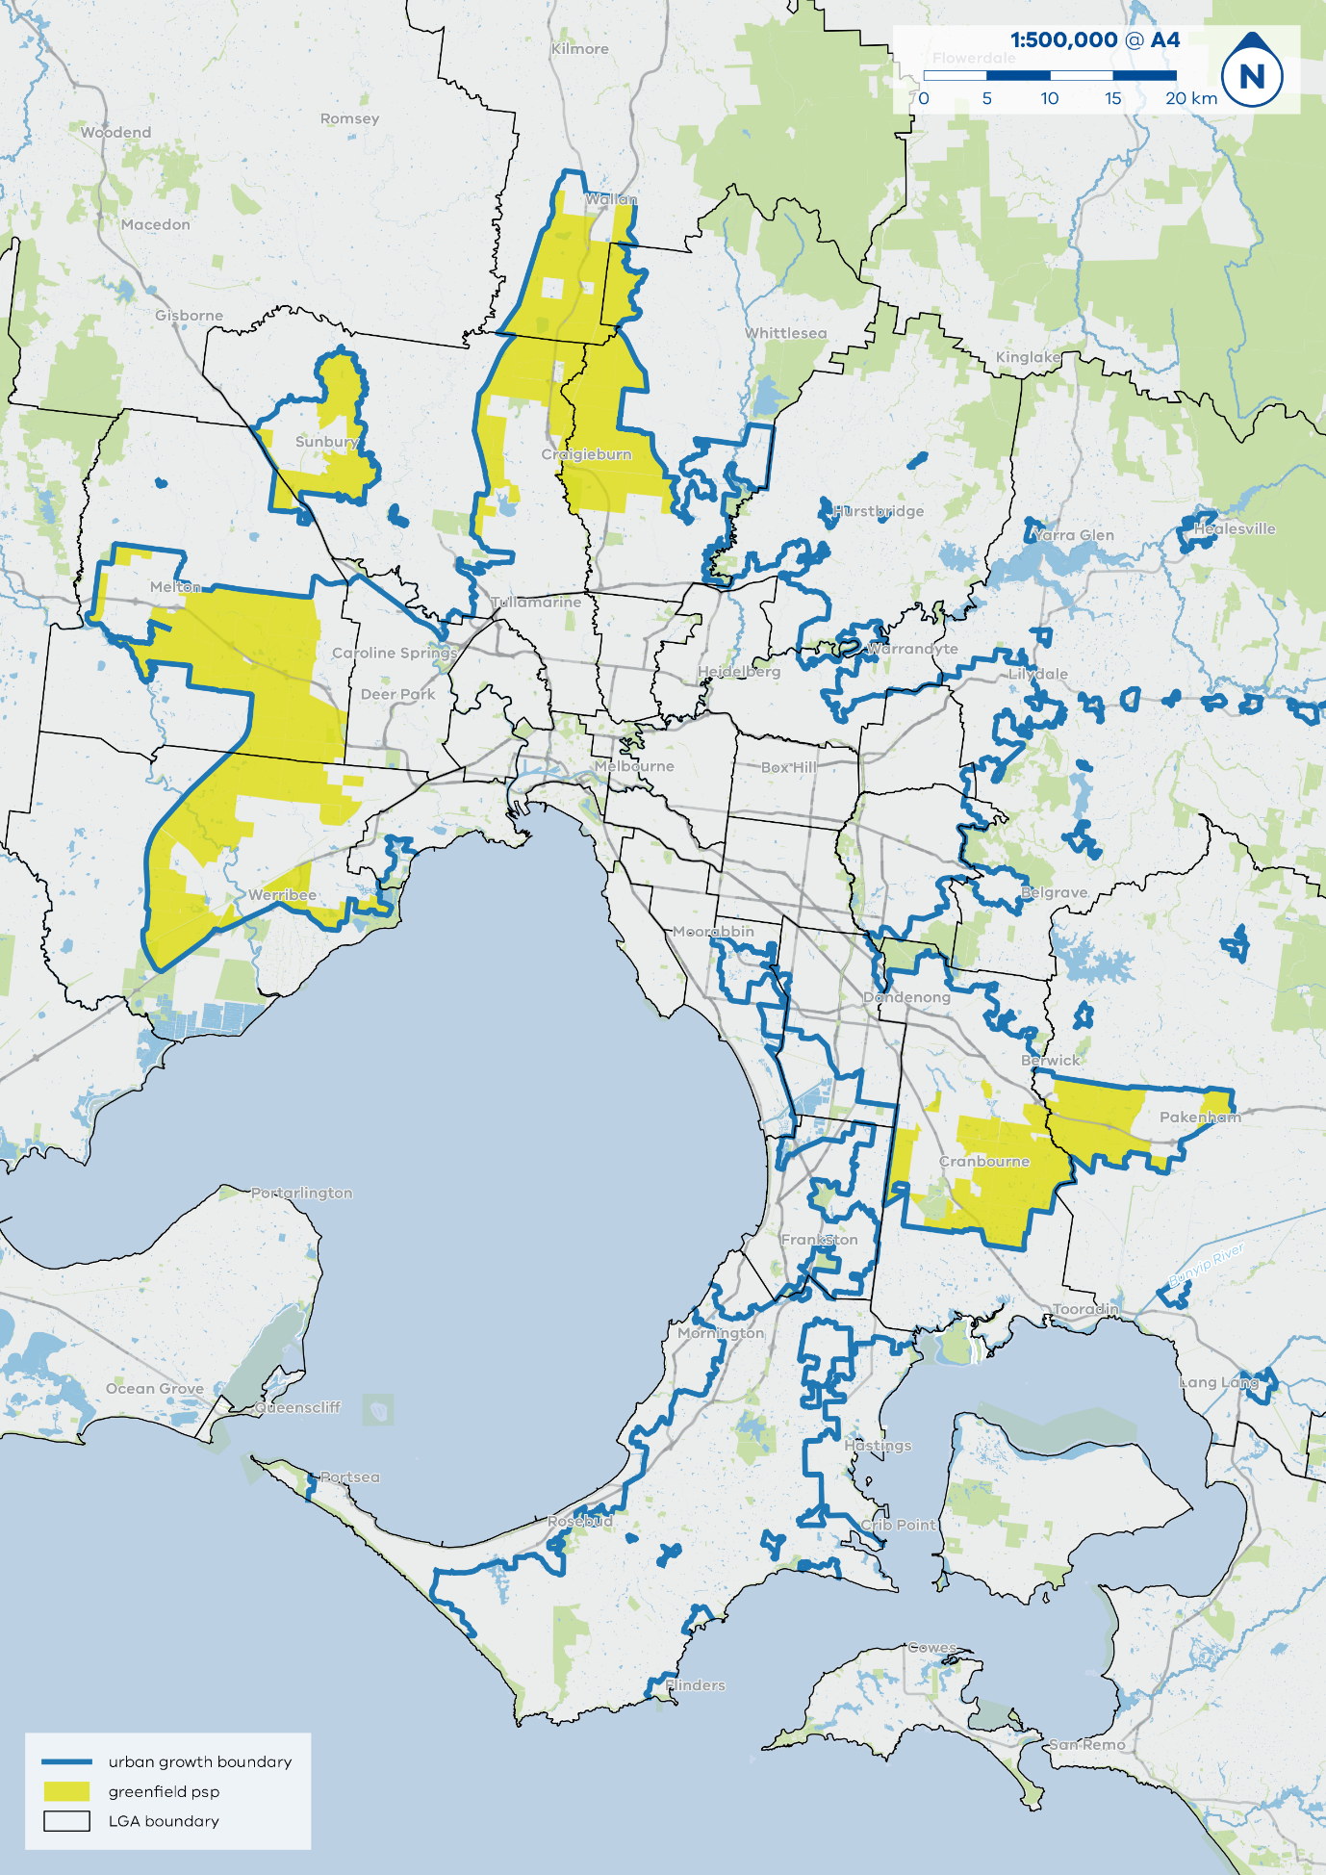

**Annexure 1 - Attachment 2**

**Formula for indexing rates, costs and amounts**

For the purposes of clauses 13, 14 and 26 , the formula is:

**IRCA = PRCA x A/B**

Where:

|  |  |
| --- | --- |
| IRCA | is the indexed rate, cost or amount being determined. |
| PRCA | is the rate, cost or amount for the previous financial year.  **Example**  For the purpose of indexing the community and recreation construction standard levy rate for residential development:  · for the financial year beginning on 1 July 2021, "PRCA" is the standard levy rate for the financial year beginning on 1 July 2020, which is $91,050; and  · for the financial year beginning on 1 July 2022, "PRCA" is the standard levy rate for the financial year beginning on 1 July 2021, which is the indexed standard levy rate determined in accordance with this formula for that financial year. |
| A | is the average of the applicable producer price index numbers for the latest full year available:   1. each of the September, December and March quarters occurring immediately before the beginning of the financial year in respect of which the rate is being indexed; and 2. the last June quarter in the financial year one year earlier than the financial year in respect of which the standard levy rate is being indexed. |
| B | is the average of the applicable producer price index numbers for the previous year available:  (a) each of the September, December and March quarters occurring in the financial year one year earlier than the financial year in respect of which the standard levy rate is being indexed; and  (b) the last June quarter in the financial year two years earlier than the financial year in respect of which the standard levy rate is being indexed.  **Example**  For indexing a standard levy rate for the financial year beginning on 1 July 2021:  · "A" is the average of the applicable producer price index numbers for the June quarter in the financial year beginning on 1 July 2019 and the September, December and March quarters in the financial year beginning on 1 July 2020;  · "B" is the average of the relevant index numbers for the June quarter in the financial year beginning on 1 July 2018 and the September, December and March quarters in the financial year beginning on 1 July 2019. |
|  |  |

**Annexure 2**

**DECLARED ACTIVITY CENTRE AREAS**

**Development setting**

1. The development setting to which this Annexure applies is a Declared Activity Centre Area.

**Definition of a Declared Activity Centre Area**

1. Declared Activity Centre Areas consist of the land within the infrastructure contributions plan boundaries specified on the maps contained in **Attachment 1** to this Annexure.

**Planning authority requirement**

1. An infrastructure contributions plan can only be prepared for a Declared Activity Centre Area by the Minister for Planning or the Victorian Planning Authority for inclusion in a planning scheme amendment for which the Minister for Planning or Victorian Planning Authority is a planning authority.

**Definitions**

1. In this Annexure:
   1. ***Building permit*** means a permit under the *Building Act 1993*.
   2. ***Planning permit*** means a permit under the *Planning and Environment Act 1987*.
   3. ***Exempt permit*** means a planning permit granted in relation to an application made before 1 January 2027.

**MONETARY COMPONENT**

**Development subject to an infrastructure contribution**

1. An infrastructure contributions plan which applies to a Declared Activity Centre Area must not impose an infrastructure contribution in relation to development associated with the following:
   1. An application for a planning permit made before 1 January 2027;
   2. An application for a building permit made before 1 January 2027;
   3. An application for a building permit for works authorised by an exempt permit;
   4. An application for a planning permit for subdivision of a building authorised by an exempt permit, or subdivision of land consistent with development authorised by an exempt permit.

**Standard levy rates**

1. An infrastructure contributions plan which applies to a Declared Activity Centre Area must only impose a standard levy in accordance with this Annexure.
2. Table 1 sets out the standard levy rate that applies to the class of development of land listed in the Table.
3. The amount of standard levy payable in respect of a development of land is to be determined by applying the specified standard levy rate in Table 1 (as indexed in accordance with clause 10) to each additional number of demand units included in the approved development of land.
4. A development which does not meet the threshold(s) specified in Table 1 must not be required to pay a contribution.

**Example:** If the development of land is the extension of the gross floor area of an existing supermarket by 50 square metres, no levy payment is required (as the threshold for commercial development is 100 square metres).

1. Where an infrastructure contributions plan is applied to the same land as an existing development contributions plan, the total amount of levies payable under the applicable development contributions plan in relation to an application for a permit for development or a building permit is to be deducted from the total amount of the local component of the levy payable under the infrastructure contributions plan in relation to the same development. Should the total levies payable under an existing development contributions plan exceed the total amount of the local component of the levies payable under an infrastructure contributions plan, then the total amount of the local component of the levies payable under the infrastructure contributions plan is reduced to nil for that permit application.

**Table 1: Standard levy rates for each class of development**

|  |  |  |  |  |  |
| --- | --- | --- | --- | --- | --- |
|  |  |  |  |  |  |
| **Class of development** | **Demand unit** | **Threshold** | **Total standard levy rate** | **Local component** | **State component** |
|  |  |  |  |  |  |
|  |  |  | **All amounts in $ per demand unit** |  |  |
| Residential development | Each additional dwelling or residential lot | 1 dwelling or residential lot | $0 | $0 | $0 |
| Commercial development | 1 additional square metre of leasable floor area | 100 square metres of leasable floor area | $0 | $0 | $0 |
| Industrial development | 1 additional square metre of leasable floor area | 200 square metres of leasable floor area | $0 | $0 | $0 |

**Supplementary levy**

1. An infrastructure contributions plan that applies to a Declared Activity Centre Area must not impose a supplementary levy.

**Allowable items**

1. An infrastructure contributions plan which applies to a Declared Activity Centre Area must only fund the allowable items specified in Table 2 of this Annexure.

**Note:** Division 7 of Part 3AB sets out the procedure for dealing with any infrastructure contribution that has not been expended at the date on which an approved infrastructure contributions plan expires.

1. Where an infrastructure contributions plan is applied to the same land as an existing development contributions plan, the infrastructure contributions plan must not fund the provision of infrastructure that services the same need as an item funded by the development contributions plan.

**Note:** Nothing in this clause prevents an ICP funding the augmentation of an item funded by a DCP in order to respond to additional need not funded by the DCP. For example, an ICP may include funding for an additional room for a maternal health centre otherwise funded by a DCP, provided the additional room is responding to an additional need.

**Table 2: Standard levy allowable items**

|  | Standard levy allowable item |
| --- | --- |
| **Works, services or facilities provided by or on behalf of a Minister or public authority (state component)** | * Roads, including the construction of bicycle and foot paths, and traffic management and control devices * Public transport infrastructure, including fixed rail infrastructure, railway stations, bus stops and tram stops * Drainage * Schools * Higher education * Health facilities * Emergency services * Justice and police services * Public realm improvements and street tree planning * Parks, including playgrounds, shelters, toilets, landscaping, earthworks, pathways, fencing and seating |
| **Works, services or facilities provided by or on behalf of a municipal council (local component)** | * Roads * Intersections * Footpaths and public realm upgrades * Active transport such as cycle paths and walking trails * Drainage * Recreation and community infrastructure, including early childhood education, maternal and child health facilities, community centres * Street tree planning * Parks, including playgrounds, shelters, toilets, landscaping, earthworks, pathways, fencing and seating |

1. An allowable item listed in Table 2 includes any works, services or facilities that are reasonably required to provide that item, including:
2. the design, preparation, supervision and inspection of works, services or facilities, including relevant fees;
3. site preparation;
4. services relocations, installations and adjustments;
5. construction of pavement and kerb and channel;
6. drainage;
7. foundations, abutments and structures;
8. landscaping;
9. bus priority measures;
10. fencing, including guard fencing;
11. traffic control signs, line marking and street lighting;
12. temporary works, access restoration and ‘making good’ works;
13. the costs of securing native vegetation offsets or habitat compensation fees related to the provision of the item on land that is in public ownership at the time the infrastructure contributions plan is prepared; and
14. maintenance of:
    * landscaping for two years;
    * traffic signals on arterial roads for up to ten years; and
    * all other works for one year.

**LAND COMPONENT**

1. An infrastructure contributions plan that applies to a Declared Activity Centre Area must not impose a contribution that includes a land component.

**Annexure 2 - Attachment 1**

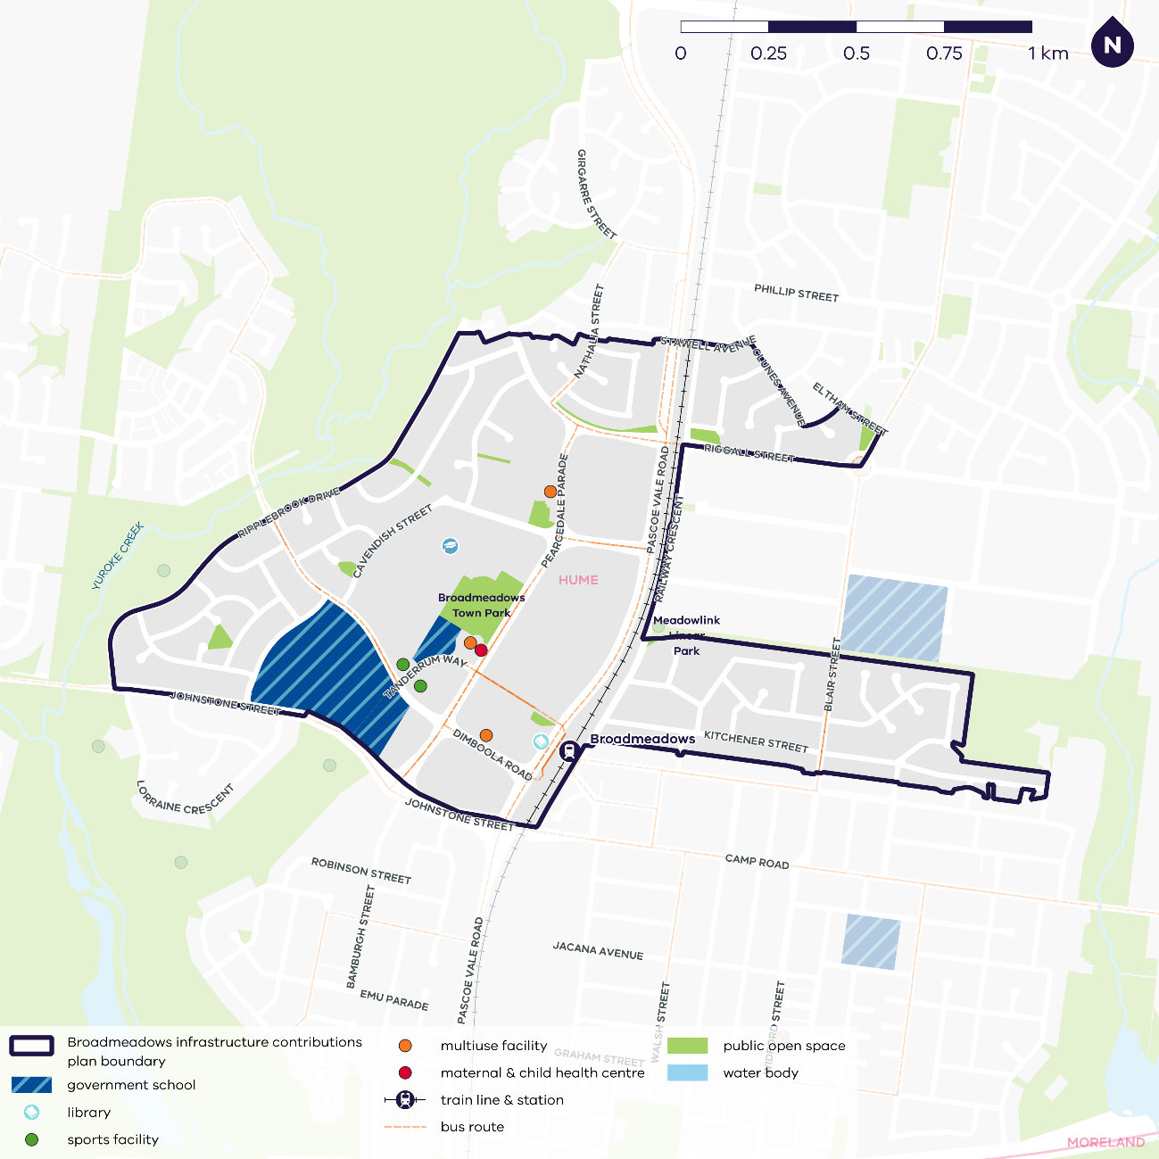

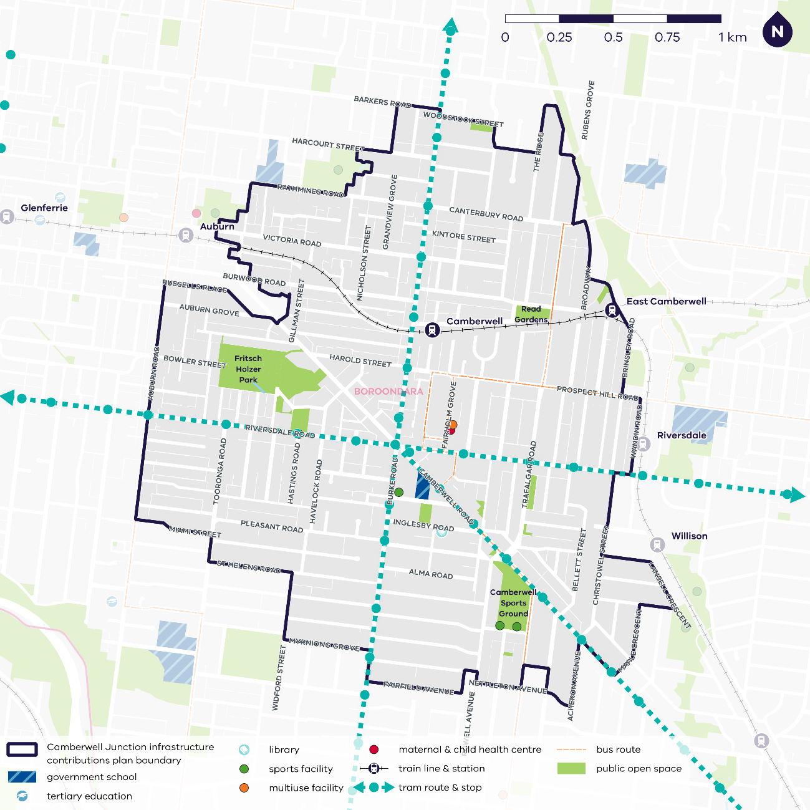

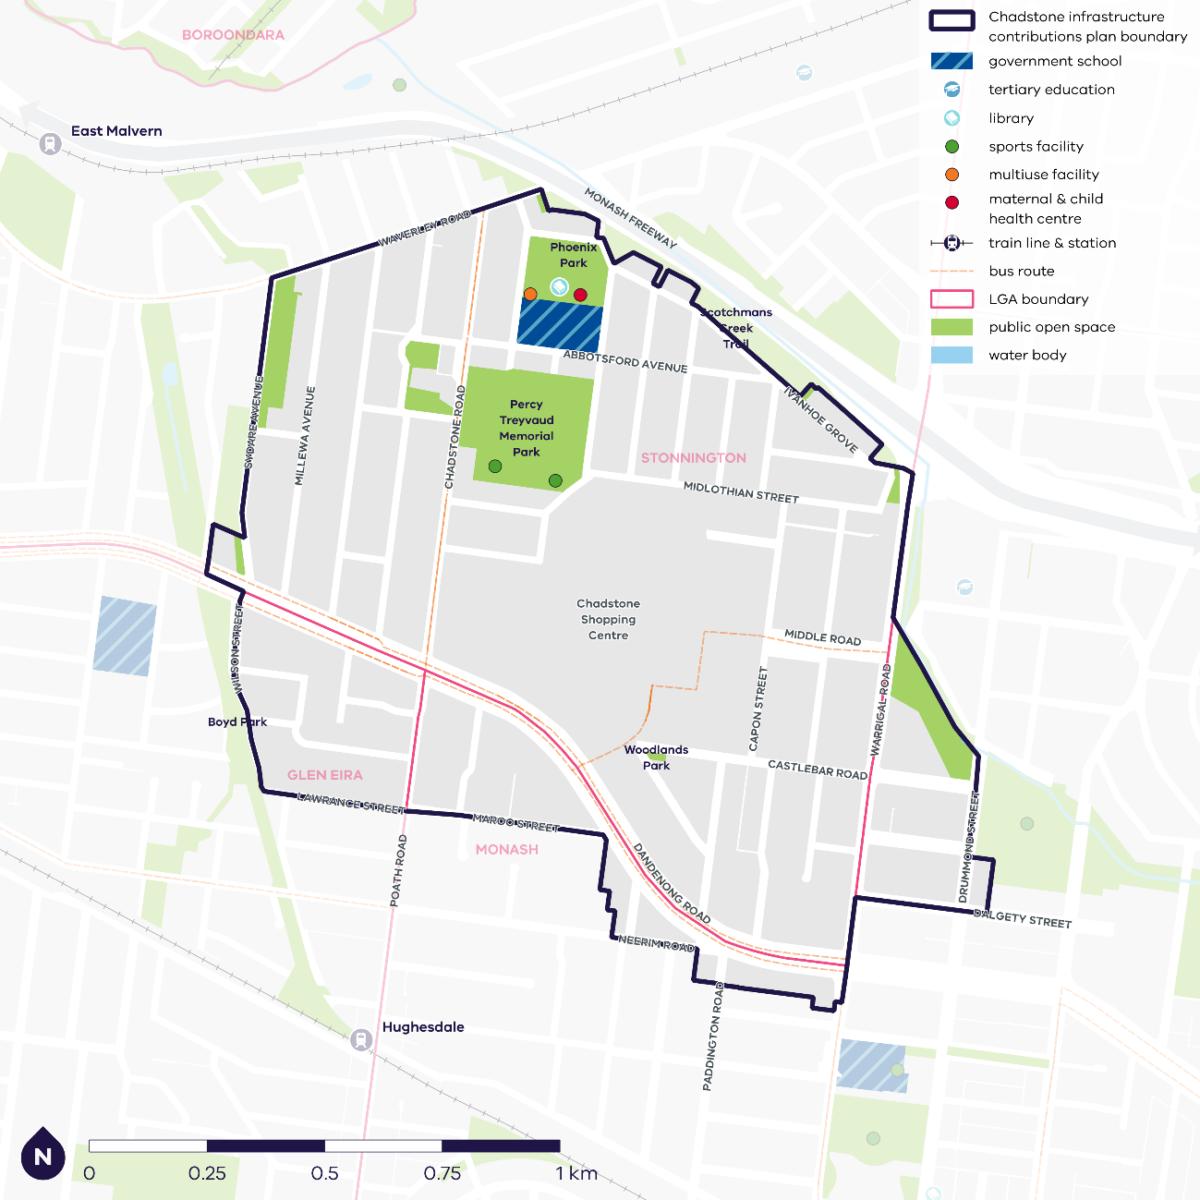

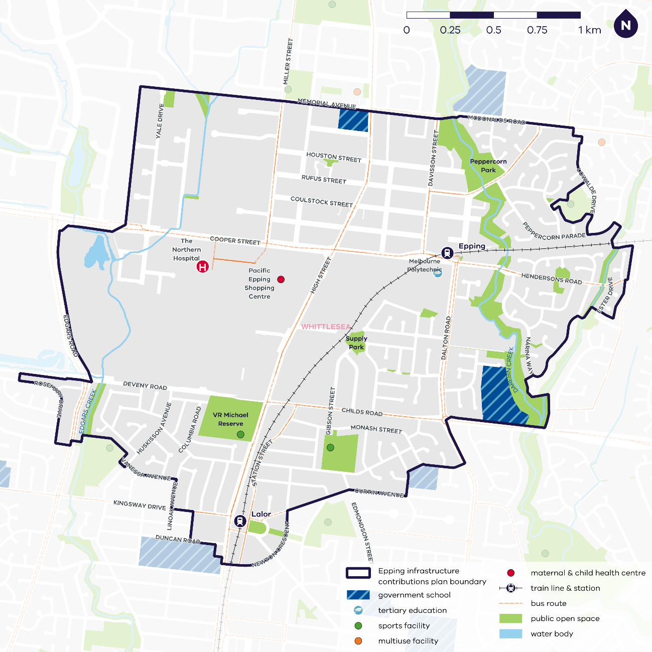

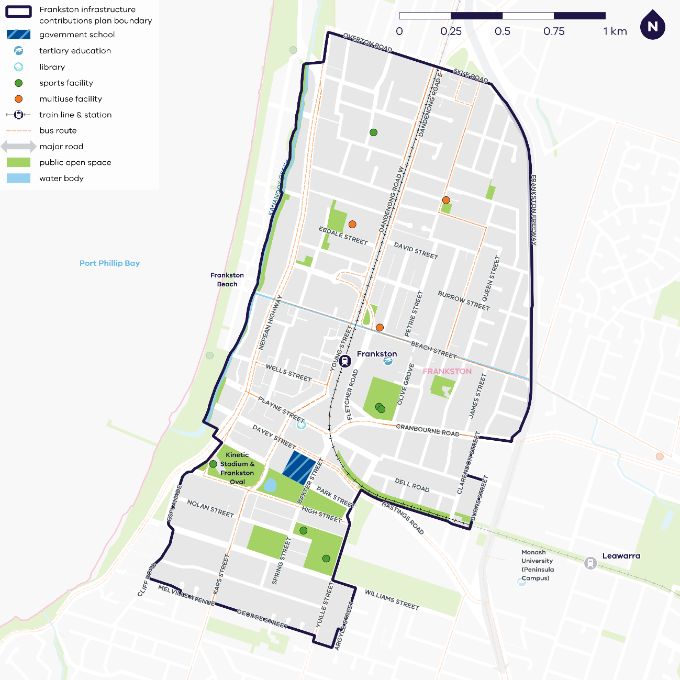

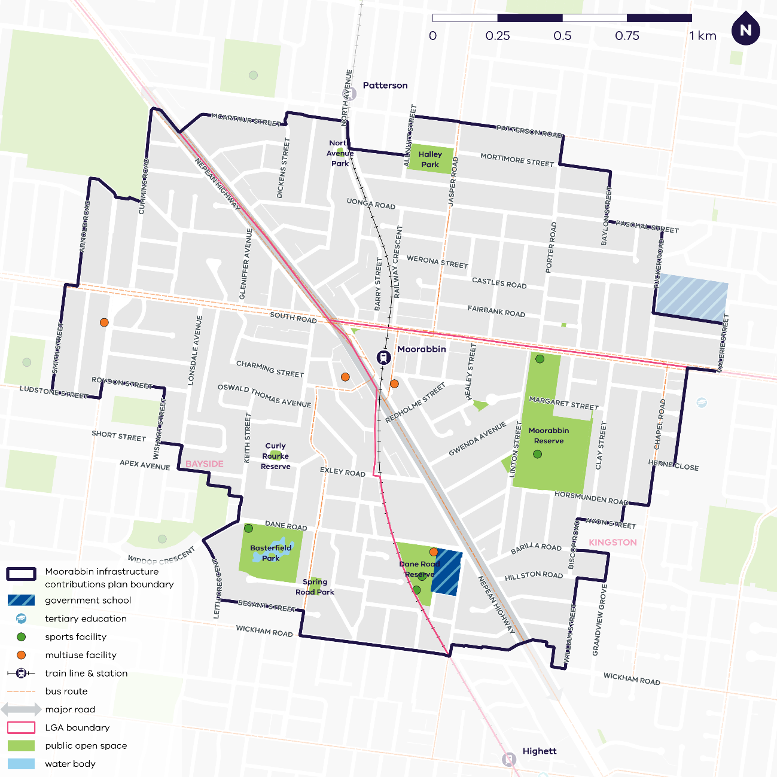

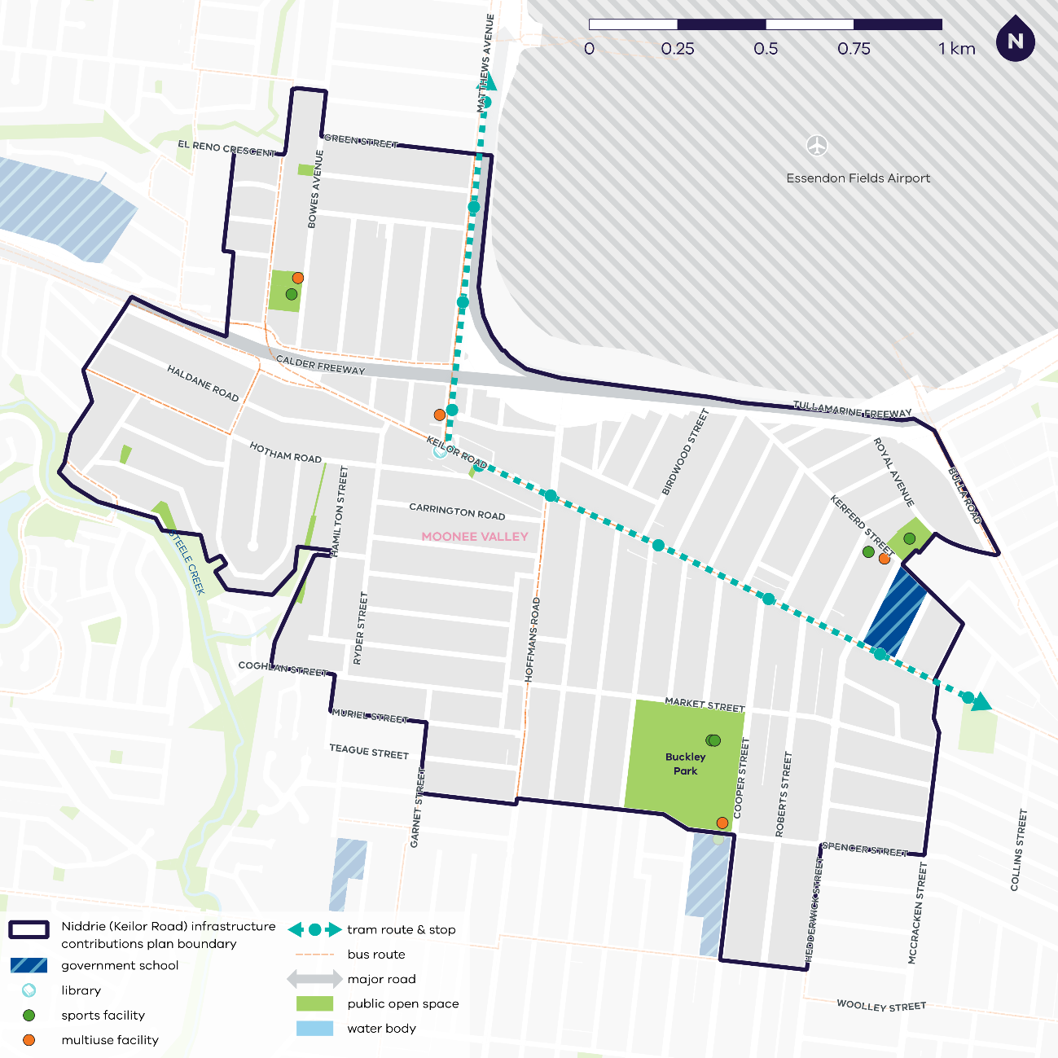

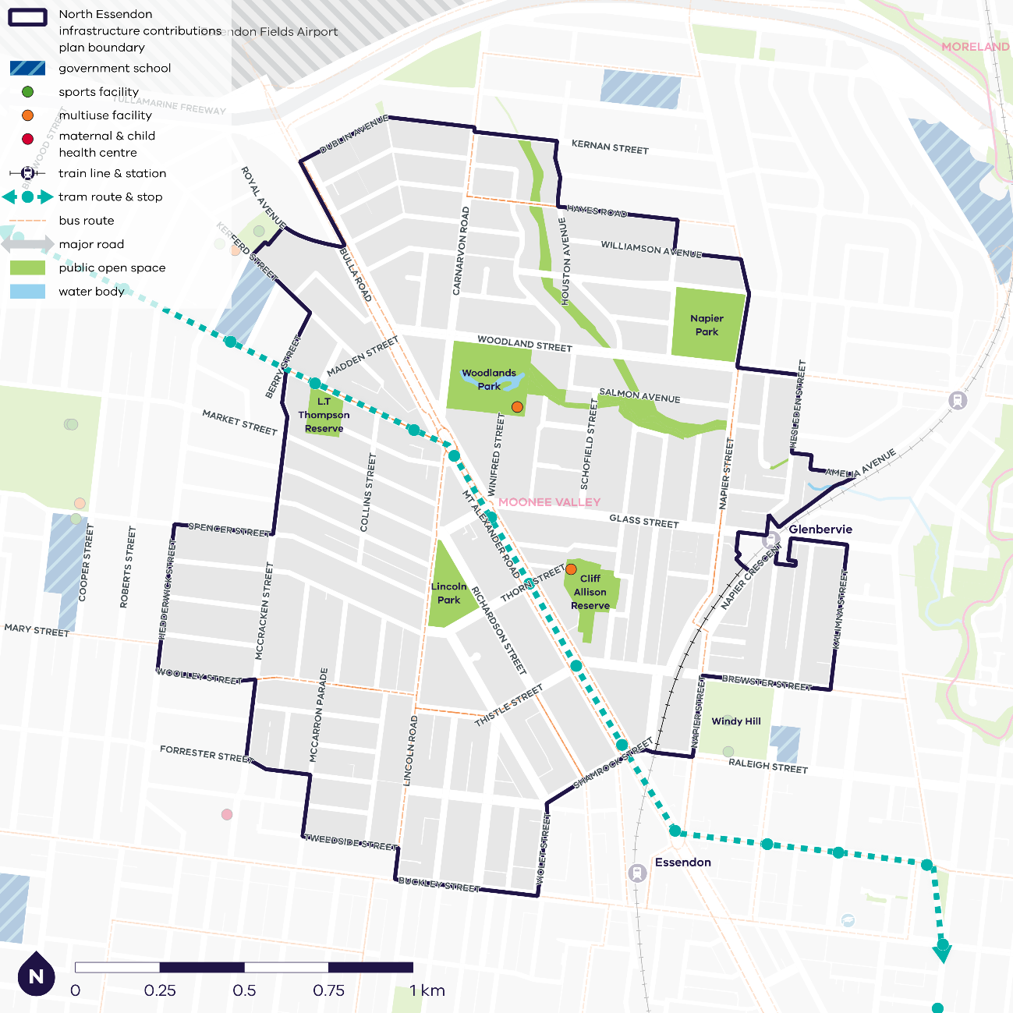

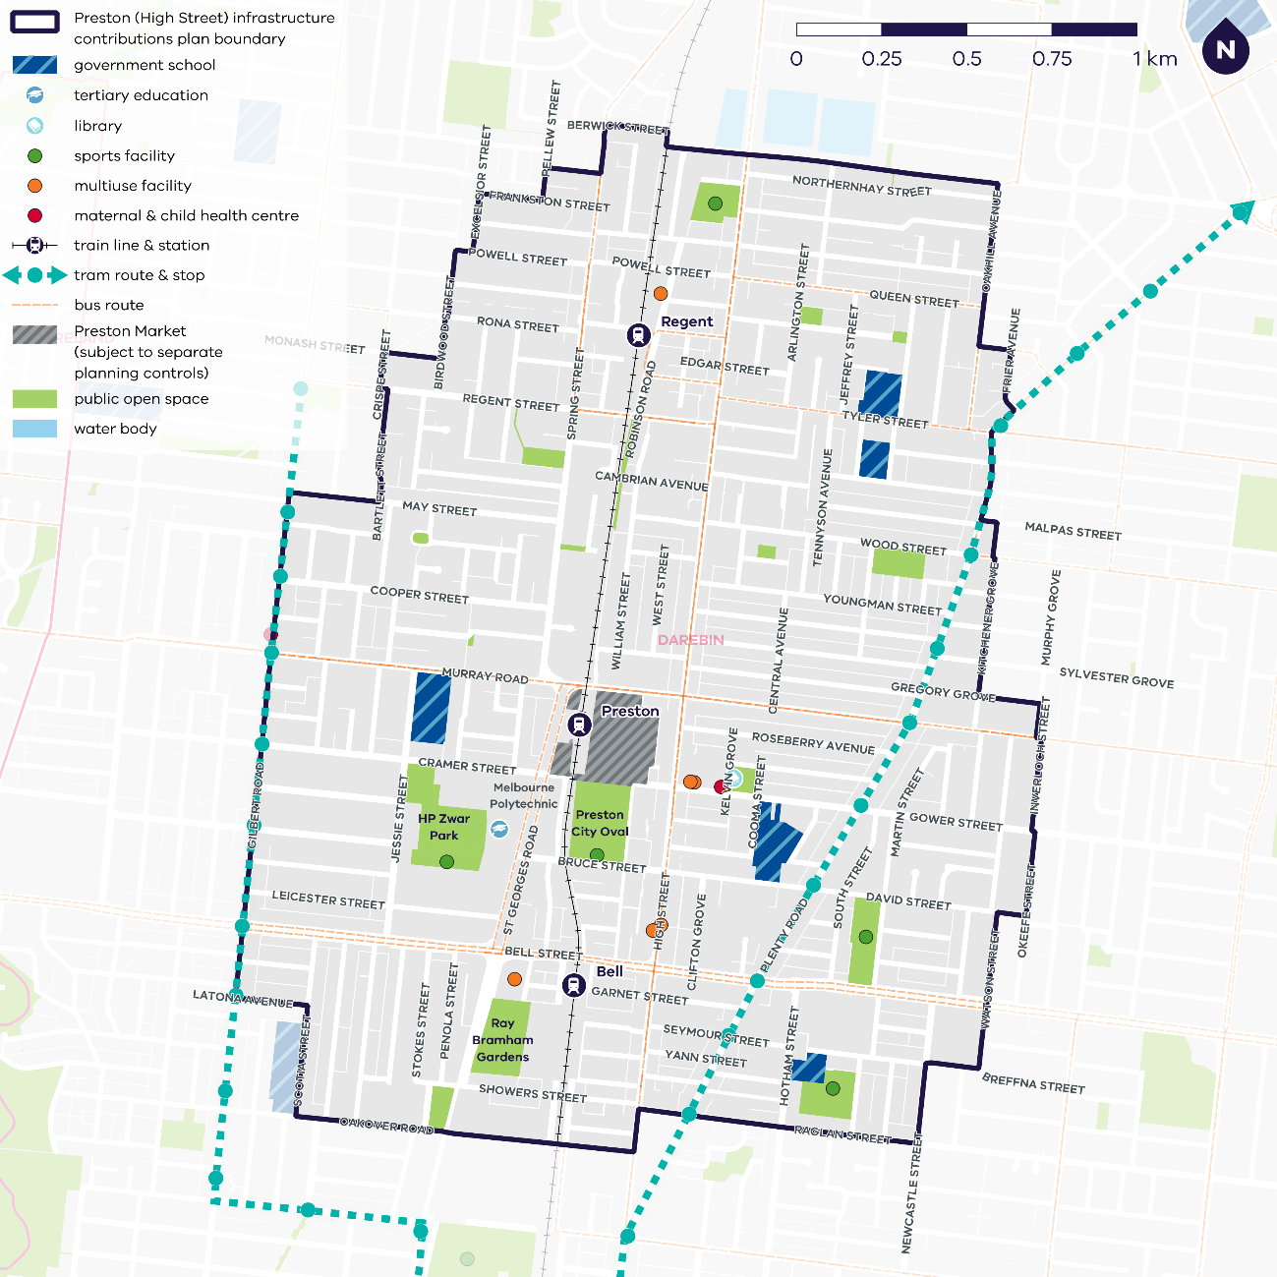

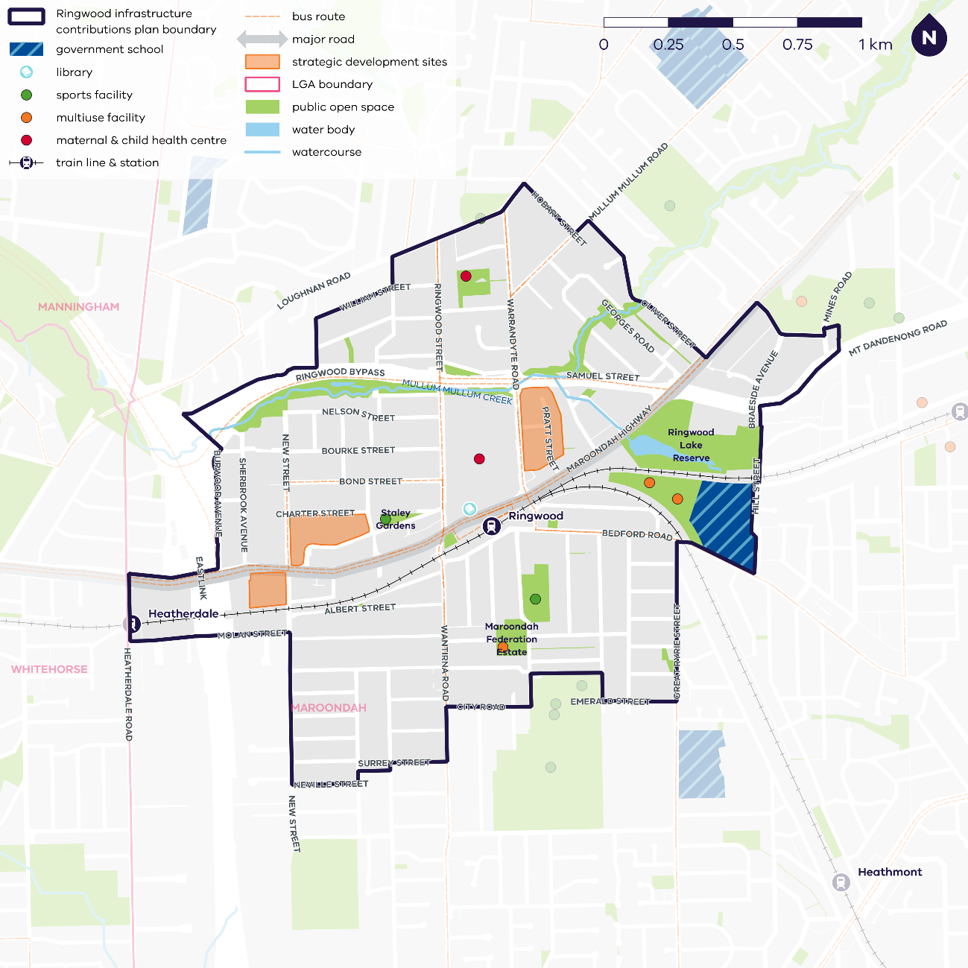

**Annexure 2 - Attachment 2**

**Formula for indexing rates, costs and amounts**

For the purposes of clause **Error! Reference source not found.**, the formula is:

**AIC = PIC x A**

Where:

|  |  |
| --- | --- |
| AIC | is the indexed rate, cost or amount being determined. |
| AIC local component | is AIC x (previous financial year’s local component/previous financial year’s AIC) |
| AIC state component | is AIC x (previous financial year’s state component/previous financial year’s AIC) |
| PIC | is the rate, cost or amount for the previous financial year.  **Example**  For indexing the standard levy rate:  · for the financial year beginning on 1 July 2025, "PIC" is the standard levy rate for the financial year beginning on 1 July 2024, which is $10,300; and  · for the financial year beginning on 1 July 2026, "PIC" is the standard levy rate for the financial year beginning on 1 July 2025, which is the indexed standard levy rate determined in accordance with this formula for that financial year. |

|  |  |
| --- | --- |
| A | is 1 plus the percentage specified in the relevant index for the March quarter occurring immediately before the beginning of the financial year in respect of which the rate is being indexed. |

|  |  |
| --- | --- |
|  |  |

**PART B: MINISTERIAL REPORTING REQUIREMENTS FOR INFRASTRUCTURE CONTRIBUTIONS PLANS**

**Purpose**

1. The purpose of this document is to set out the requirements of the Minister in relation to reports prepared by collecting agencies and development agencies in respect of infrastructure contributions plans.

**Application**

1. These requirements apply to the preparation of a report by a collecting agency or development agency under section 46GZI of the *Planning and Environment Act 1987* (the Act).

**Requirements**

1. A report must be prepared each financial year and given to the Minister for Planning within 3 months after the end of the financial year reported on.
2. If the collecting agency or development agency is a municipal council, the report must be included in the report of operations contained in the council’s annual report prepared under the *Local Government Act 1989*.

**Collecting agencies**

1. A collecting agency must report on:
2. any infrastructure contribution provided to the collecting agency in a financial year in accordance with Tables 1, 2 and 3 in the Annexure;
3. any works, services or facilities accepted by the collecting agency in part or full satisfaction of the monetary components of any infrastructure contributions in a financial year in accordance with Table 4 in the Annexure; and
4. any land credit amounts paid to persons in a financial year in accordance with Table 3 in the Annexure.

**Development agencies**

1. A development agency must report on:
2. the expenditure of any monetary components of infrastructure contributions received by the development agency in a financial year in accordance with Table 5 in the Annexure;
3. the use and development of any inner public purpose land that is part of the land component of any infrastructure contribution, which has vested in, been acquired by or been transferred to, the development agency in a financial year in accordance with Table 6 in the Annexure;
4. the use made by the development agency of any works, services or facilities referred to in clause 5(b) in a financial year in accordance with Table 7 in the Annexure;
5. the expenditure of any land equalisation amounts received by the development agency in a financial year in accordance with Table 8 in the Annexure; and
6. the use and development of any outer public purpose land acquired by the development agency in a financial year in accordance with Table 6 in the Annexure.

**Annexure**

**MINISTERIAL REPORTING REQUIREMENTS FOR INFRASTRUCTURE CONTRIBUTIONS PLANS**

### Table 1 – Total monetary component received in [*Insert Financial Year*]

|  |  |  |  |  |
| --- | --- | --- | --- | --- |
| Name of collecting agency | Name of ICP | Monetary component in levies received in [Insert Year] financial year ($) | Value of works, services or facilities accepted in satisfaction of the monetary component in [Insert Year] financial year ($) | Total monetary contribution received in [Insert Year] financial year ($) |
|  |  |  |  |  |
|  |  |  |  |  |
| **Total** |  |  |  |  |

### Table 2 – Inner public purpose land received in [*Insert Financial Year*]

|  |  |  |  |
| --- | --- | --- | --- |
| Name of collecting agency | Name of ICP | Land (or project ID) | Land (or project) description |
|  |  |  |  |
|  |  |  |  |

### Table 3 – Total land equalisation amount (LEA) received and land credit amount (LCA) paid in [*Insert Financial Year*]

|  |  |  |  |
| --- | --- | --- | --- |
| Name of collecting agency | Name of ICP | Total of any LEAs received in [Insert Year] financial year ($) | Total of any LCAs paid in [Insert Year] financial year ($) |
|  |  |  |  |
|  |  |  |  |
| **Total** |  |  |  |

### Table 4 – Works, services or facilities accepted under section 46GX of the Act in [*Insert Financial Year*]

|  |  |  |  |  |  |
| --- | --- | --- | --- | --- | --- |
| Name of collecting agency | Name of ICP | Project ID | Project description | Item purpose | Project value ($) |
|  |  |  |  |  |  |
|  |  |  |  |  |  |
| **Total** |  |  |  |  |  |

### Table 5 – Total monetary contributions expended by development agency in [*Insert Financial Year*]

|  |  |  |  |  |  |
| --- | --- | --- | --- | --- | --- |
| Name of development agency | Name of ICP | Project ID | Project description | ICP money expended ($) | Percentage of project delivered |
|  |  |  |  |  |  |
|  |  |  |  |  |  |
| **Total:** |  |  |  |  |  |

### Table 6 – Use and development of inner public purpose land or outer public purpose land which has vested in, been acquired by or been transferred to, the development agency in [*Insert Financial Year*]

|  |  |  |  |  |
| --- | --- | --- | --- | --- |
| Name of development agency | Name of ICP | Project ID | Project description | Use and development of land |
|  |  |  |  |  |
|  |  |  |  |  |

### Table 7 – Use of works, services or facilities accepted under section 46GX of the Act in [*Insert Financial Year*]

|  |  |  |  |  |
| --- | --- | --- | --- | --- |
| Name of development agency | Name of ICP | Project ID | Project description | Use of land |
|  |  |  |  |  |
|  |  |  |  |  |

### Table 8 –Expenditure of land equalisation amounts in [*Insert Financial Year*]

|  |  |  |  |  |
| --- | --- | --- | --- | --- |
| Name of development agency | Name of ICP | Project ID | Project description | Land equalisation amounts expended ($) |
|  |  |  |  |  |
|  |  |  |  |  |
| **Total:** |  |  |  |  |