Place-based policy checklist
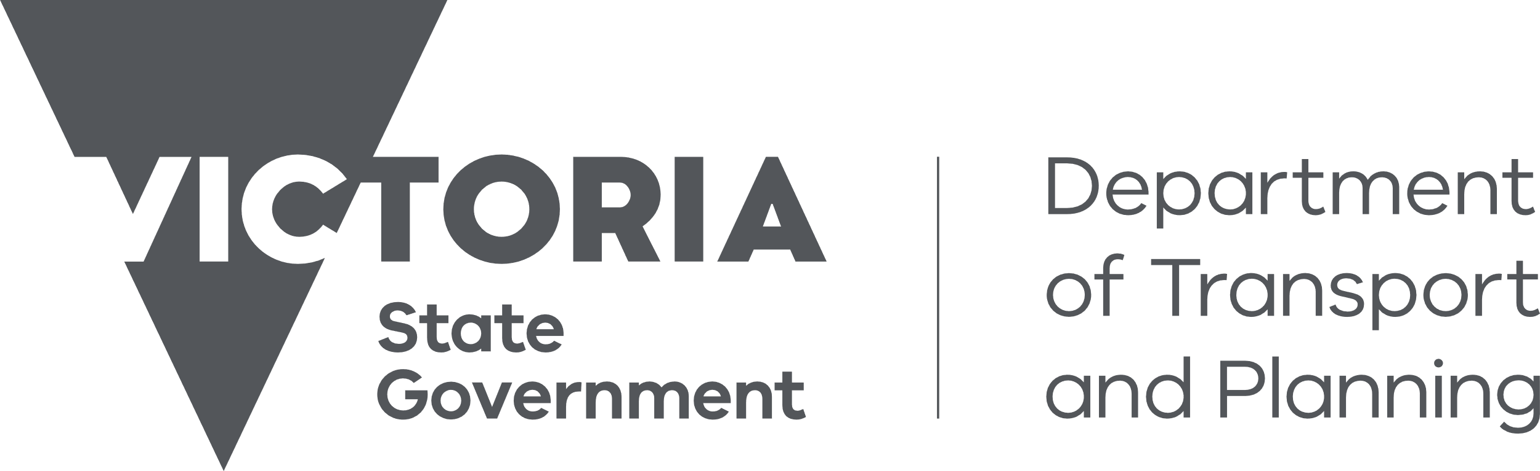

Checklist for including policy in Clause 11.03 – Planning for Places
Given the breadth of policies addressed in the PPF, most policy can be nested thematically within the PPF – including policies for specific places.
To qualify for inclusion in Clause 11.03, a policy must tick all of the following boxes:
Does the proposed policy apply to a specific place?  For example ‘Gumnut irrigation district’, not ‘Townships in the City of Gumnut’ which are a type of place, rather than a place. | ☐
Is there a common objective or common set of objectives for the place? | ☐
Does the proposed policy provide guidance specific to the place?  Generic content applied loosely to multiple places or precincts in one or more policies should be consolidated and positioned elsewhere in the PPF. | ☐
Does the proposed policy include content relating to multiple, interrelated issues?  Where there are interdependencies between multiple strategies a place-based policy may provide a more coherent strategic narrative. | ☐
Does the proposed policy result in a clearer and simpler representation of the policy than if it were thematically distributed across the PPF? | ☐
Do the proposed strategies provide detailed policy directions for the particular place?  High level strategic directions belong in the Municipal Planning Strategy. | ☐
Does the proposed policy exclusively comprise content for the place that is not already contained in a control?  Policy should not duplicate content in a control that applies to the place, such as a Design and Development Overlay. | ☐

See Chapter 6.4.4 for more information about applying a place-based policy.

