Outcome 6

MELBOURNE IS A SUSTAINABLE AND RESILIENT CITY
This generation of Victorians has a responsibility to protect the state’s natural environment for future generations.
Victoria's social, economic and environmental sustainability depends on the protection and conservation of Melbourne and the state’s biodiverse natural assets, or natural capital.
Natural capital includes geology, soil, air, water and all living things—and Melbourne depends on it to function. Examples of public benefits derived from healthy ecosystems include clean air and water, food, productive soils, natural pest control, pollination, flood mitigation, carbon sequestration and waste decomposition. These benefits are commonly referred to as ecosystem services.
Melbourne’s natural environment is also deeply valued and enjoyed by many people for recreation, cultural and spiritual reasons, and for the health and wellbeing benefits that come from being connected with nature. For thousands of years, generations of Aboriginal Victorians have relied on nature for their survival, prosperity and culture.
The city’s growth, in combination with climate change, is testing the resilience of Melbourne’s natural and built environment, causing habitat loss and biodiversity decline, higher urban temperatures, reduced rainfall, more frequent and extreme weather events, increased consumption of resources and more waste and pollution.
By 2050, Melbourne will need to be a more sustainable and resilient city that manages its land, biodiversity, water, energy and waste resources in a much more integrated way. To respond to the challenge of climate change and ensure Melbourne becomes more sustainable as it grows, a green economy needs to emerge—built around renewable energy, environmentally sustainable development and resource recovery.

Melbourne’s Plan

Direction 6.1 Transition to a low-carbon city to enable Victoria to achieve its target of net zero greenhouse gas emissions by 2050
It is widely acknowledged internationally that major industrialised countries need to reduce carbon emissions substantially by mid-century to keep global temperature increases within two degrees Celsius. This is why Victoria has committed to reduce its greenhouse gas emissions to net zero emissions by 2050. Figure 13 shows the main sources of Victoria’s greenhouse gas emissions.
To transition to a low-carbon city, Melbourne must reduce energy demand, improve energy efficiency and increase the share of renewable energy. Victoria has set a target of deriving 25 per cent of electricity generated by renewable sources by 2020—with that figure to increase to 40 per cent by 2025. Melbourne has the knowledge, skills and technologies to meet its building energy needs in a sustainable way, using a range of renewable energy resources such as solar photovoltaic systems, solar hot water, geothermal and biogas. At a local level, greenhouse gas emissions from energy consumption can be reduced through precinct-scale initiatives that combine renewable energy and energy efficiency solutions.
To encourage a wider application of distributed energy technologies, Plan Melbourne will embed renewable energy and energy efficiency considerations in the land-use planning system and precinct structure planning process.

Figure 13 Victoria's greenhouse gas emissions (2014)
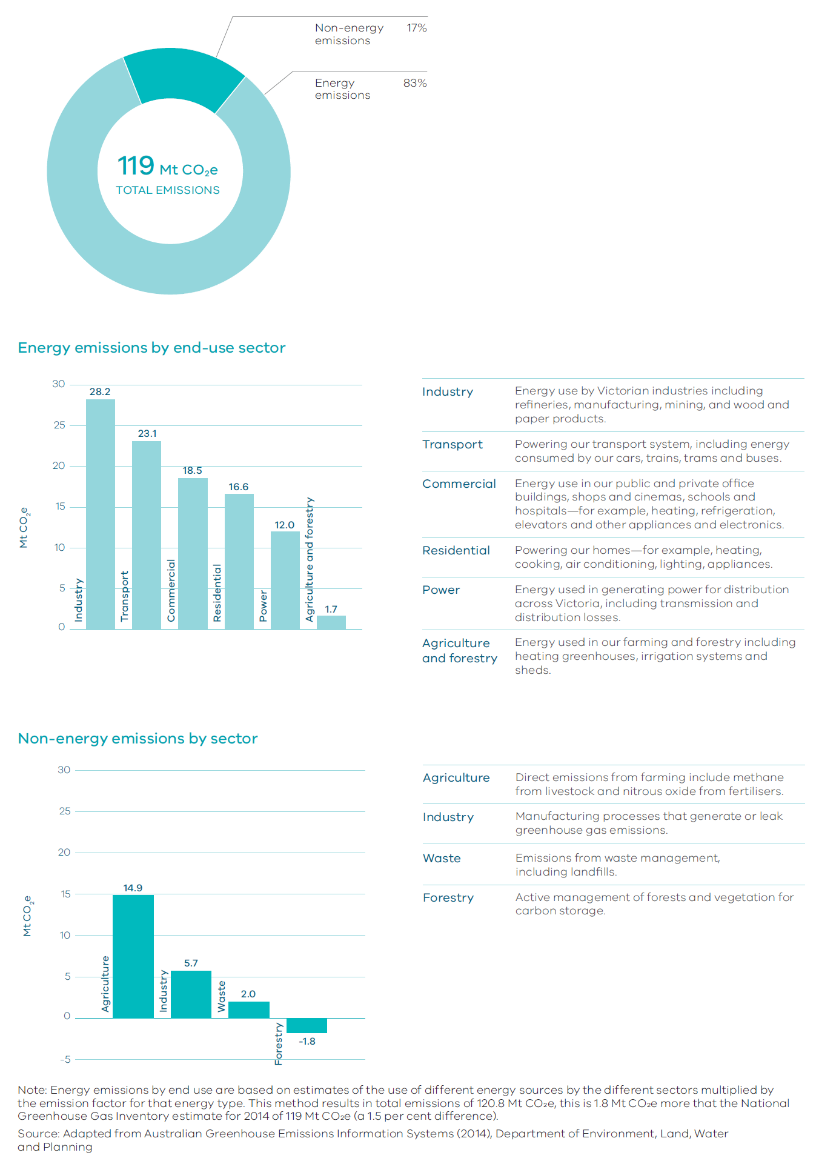

Policy 6.1.1 Improve energy, water and waste performance of buildings through environmentally sustainable development and energy efficiency upgrades
Energy use in buildings accounts for around a quarter of Australia’s greenhouse gas emissions. On Australia’s hottest days, air conditioners consume approximately 20 per cent of all electricity generated.
Environmentally sustainable development, including energy efficiency and renewable energy, can help deliver cost-effective environmental outcomes and major emissions reductions, improve health and comfort, and support a lower cost of living. Passive design measures—such as building orientation, layout, window design, thermal mass, shading and ventilation—can significantly reduce the need for active heating and cooling. Other measures that can be adopted to improve the environmental performance of new and existing buildings involve a mix of lighting, appliance and, in some cases, building shell upgrades. Figure 14 shows some of the measures that can be implemented to make a house more sustainable and efficient.
Many local councils are already incorporating environmentally sustainable development considerations into their planning processes. However, there is a need for a statewide approach to achieve greater consistency and simplicity.
Options to strengthen planning and building frameworks will be reviewed to determine the most cost-effective approach for lifting the efficiency of both new and existing building stock and requiring early consideration of sustainability in the planning, design and building process.

Figure 14 Resource efficient house
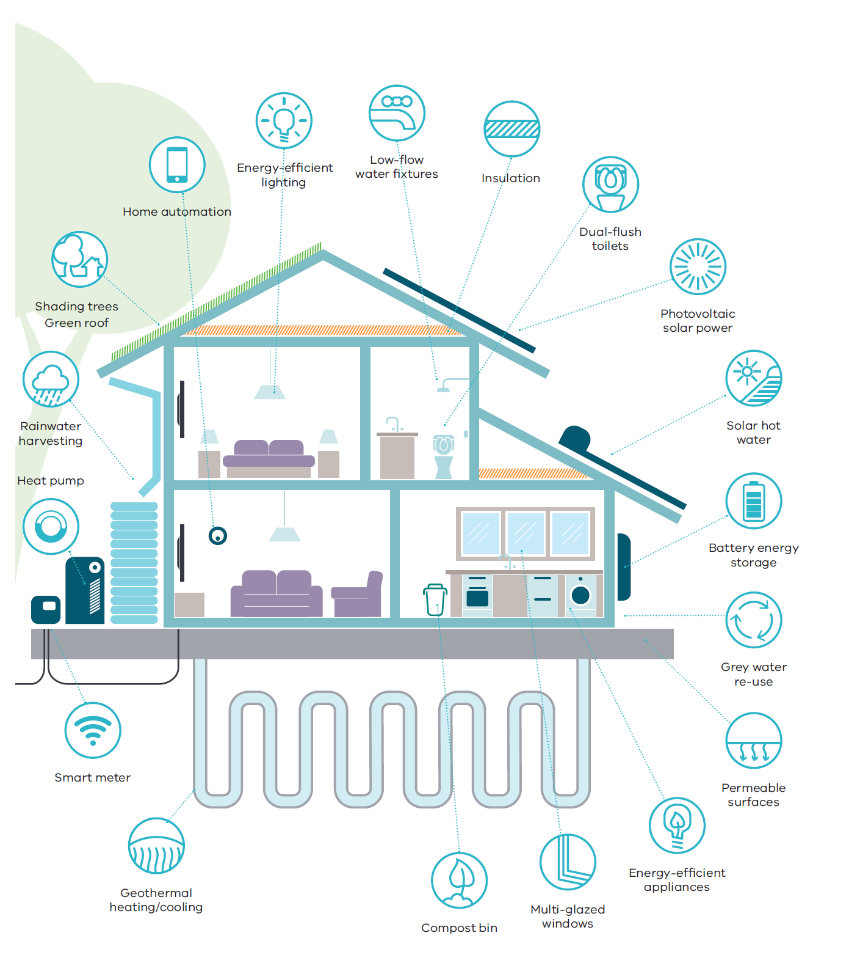
Source: Department of Environment, Land, Water and Planning

Policy 6.1.2 Facilitate the uptake of renewable energy technologies
Developing local energy solutions is important for addressing climate change, supporting job creation and economic development, reducing consumers’ energy bills and reducing reliance on the grid.
Falling technology costs and easier installation processes, particularly for solar photovoltaic systems, have helped facilitate growth in renewable energy. Rapid advances in battery storage technology will also accelerate the uptake of distributed energy generation.
The renewable energy industry will continue to create opportunities for individual households, neighbourhoods, cities and the state as a whole over the next 40 years.
To support the government’s targets for renewable energy generation, planning policy and controls will be strengthened to remove barriers and increase the uptake of renewable energy on a site-by-site and neighbourhood level. This will include giving consideration to renewable energy opportunities during the master planning of new communities and investigating opportunities for renewable energy initiatives in Melbourne’s green wedges and peri-urban areas.

Direction 6.2 Reduce the likelihood and consequences of natural hazard events and adapt to climate change
There is a need to ensure that people, the environment and the city’s infrastructure are all prepared for the impacts of climate change. By working together, Melbourne can build its resilience to acute shocks and stressors, ensuring capacity of communities and the systems and structures that support them to adapt and grow.
As Melbourne develops and populations increase, there is a risk that more people are likely to be exposed to natural hazards. Map 20 shows areas subject to key natural hazards.
Land-use planning and building provisions play a key role in reducing a community’s level of exposure to a natural hazard by influencing where and how development occurs.
New development should be located away from extreme risks. Where risk is unavoidable, such as in existing settlements, land-use planning should reduce risk and ensure planning controls do not prevent risk-mitigation or risk-adaptation strategies from being implemented.
The approach set out in Plan Melbourne runs parallel with actions developed as part of Victoria’s second climate change adaptation plan and builds on the work of local government and emergency management agencies to build safer and more resilient communities.
Map 20 Natural hazards
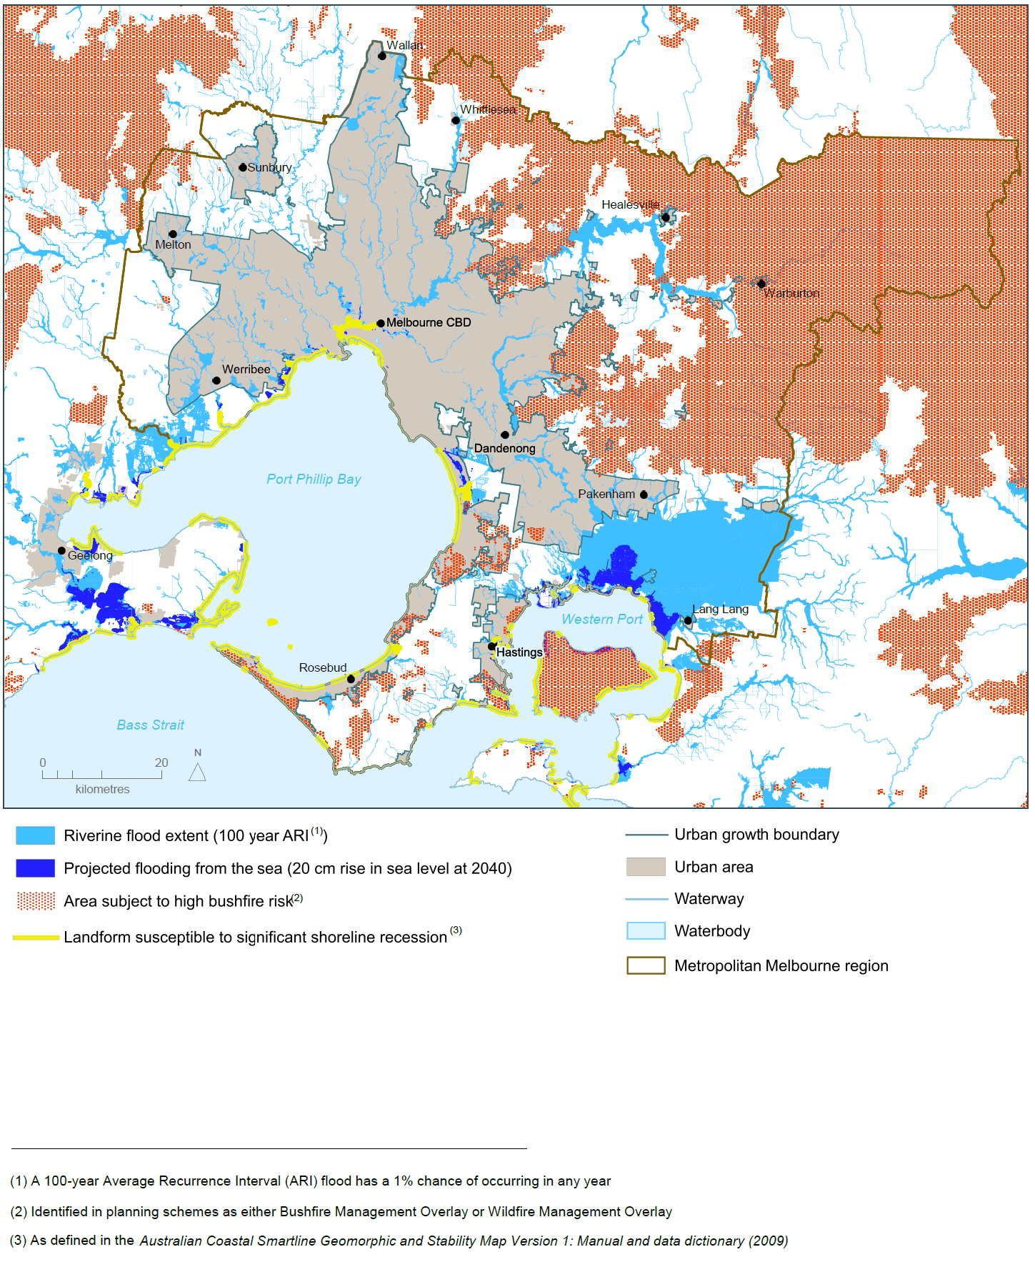
Source: Department of Environment, Land, Water and Planning

Policy 6.2.1 Mitigate exposure to natural hazards and adapt to the impacts of climate change
Following recent natural disasters there has been an increased focus on improving community resilience to natural hazards. Key approaches that have underpinned Victoria’s reforms include:
- building community resilience to deal with major shocks.
- adopting an all-communities, all-emergencies approach that recognises that communities are at the centre of decision-making.
- applying risk-assessment decision-making frameworks based on agreed methodologies to inform appropriate risk-mitigation measures.
- increasing strategic effort in planning for a disaster—thereby maximising risk avoidance and reduction.
Addressing risk mitigation through land-use planning is a key action in the Victoria Emergency Management Strategic Action Plan 2015–2018 and has been identified as a priority by the State Crisis and Resilience Council.
Although planning schemes already contain a range of responses to risks associated with most natural hazards, more can be done to improve community safety.
Strategic land-use planning to manage future growth must be strengthened and integrated with emergency management decision-making to reduce the likelihood, effect and consequences of natural hazards. At-risk areas will be identified using the best available climate change science and planning and building provisions will be updated to respond to those risks.

Policy 6.2.2 Require climate change risks to be considered in infrastructure planning
Major infrastructure projects must be sited, designed and constructed so that they can withstand a range of major shocks and help reduce the state’s carbon footprint.
The Victorian Government has amended the Emergency Management Act 2013 to help build the resilience of Victorian critical infrastructure. Supporting this change is the Critical Infrastructure Resilience Strategy. At a local level, many councils are integrating climate change considerations into their decision-making processes.
Strong supporting policy within the planning system will strengthen consideration of natural hazard risks on infrastructure.

Direction 6.3 Integrate urban development and water cycle management to support a resilient and liveable city
Plan Melbourne supports the implementation of Victoria’s water plan—Water for Victoria—by protecting water assets and influencing how development occurs across new and established urban areas.
Planning controls will be updated to require consideration of the whole water cycle early in the planning and design of new urban areas to improve the water performance of new buildings and precincts.
By considering the whole water cycle when planning for urban areas, we can improve wastewater management and recycling, support urban greening and cooling, protect waterways, minimise the impact of flooding and improve water security.

Policy 6.3.1 Reduce pressure on water supplies by making the best use of all water sources
Climate change will affect water security through reduced rainfall, increased evaporation, increased flood risk and increased risk of bushfires in forested water catchments.
The Victorian Desalination Project provides a rainfall-independent water source to supplement Melbourne’s drinking-water supply.
Greater resilience and adaptability in water supplies can also be provided through improved demand management and a more diverse supply of water.
Figure 15 shows the water supply mix in 2015, as well as the potential need for a more diverse mix of supply options in 2050 to meet projected water demand under different catchment inflow scenarios. It highlights the need to create climate-resilient sources of water.
Plan Melbourne supports the use of all water sources, including stormwater, rainwater and recycled water, to ensure the city remains liveable and sustainable and to reduce reliance on drinking-water supplies. This approach has a range of benefits—such as improving waterway health, reducing flood risk, effective management of wastewater, sustaining agricultural areas and supporting cooler and greener urban landscapes.
Planning provisions and the precinct structure planning process can be strengthened to promote innovative and cost-effective approaches to urban water cycle management that support better use of all water sources at the household scale as well as precinct-wide solutions.

Figure 15 Water supply scenarios to 2050
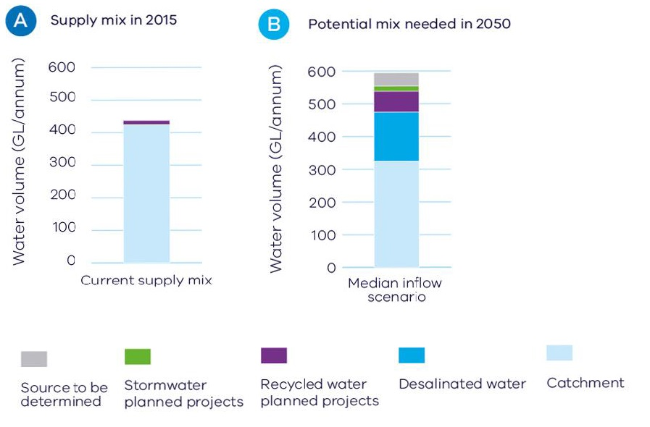
Source: Adapted from Water for Victoria

Policy 6.3.2 Improve alignment between urban water management and planning by adopting an integrated water management approach
Aligning water planning and land-use planning is fundamental to managing flood risk, protecting our waterways and efficiently sequencing water, sewerage and drainage infrastructure. Integrated water management forums will identify and prioritise places that would most benefit from the development of a place-based integrated water management plan. In metropolitan Melbourne, these forums will be based on five waterway catchments.
Melbourne needs to change the way urban areas are designed, built and maintained by applying integrated water management planning in all development. The earlier integrated water management is considered in urban planning, the better the outcomes for the environment and communities.

Policy 6.3.3 Protect water, drainage and sewerage assets
Parts of Melbourne’s drinking-water catchments and storages, such as the Mid-Yarra Catchment system and the Silvan and Cardinia reservoirs, are vulnerable to pollution and public health risks due to changes in land use and development.
Significant metropolitan water, drainage and sewerage infrastructure assets, including sewerage treatment plants, are under pressure from encroaching sensitive and incompatible land uses, including urban encroachment.
Land area buffers around these assets need to be appropriately managed to ensure these assets are protected from urban encroachment.

Direction 6.4 Make Melbourne cooler and greener
The urban heat-island effect is created by the built environment absorbing, trapping and, in some cases, directly emitting heat. This effect can cause urban areas to be up to four degrees Celsius hotter than surrounding non-urban areas. Figure 16 shows the urban heat-island profile of Melbourne.
Within the City of Melbourne alone, the urban heat-island effect is projected to result in health costs of $280 million by 2051.
Urban intensification will add to the urban heat-island effect unless offsetting measures are implemented. Greening the city can provide cooling benefits and increase the community’s resilience to extreme heat events. Temperature decreases of between one degree Celsius and two degrees Celsius can have a significant impact on reducing heat-related morbidity and mortality. Figure 17 summarises the wide range of benefits provided by urban greening.
To mitigate the impacts of increased average temperatures, Melbourne needs to maintain and enhance its urban forest of trees and vegetation on properties, lining transport corridors, on public lands, and on roofs, facades and walls. Other methods of cooling the city include the use of special heat-reflective coatings for dark building surfaces to reduce the amount of heat absorbed.
Figure 16 Urban heat-island profile of Melbourne
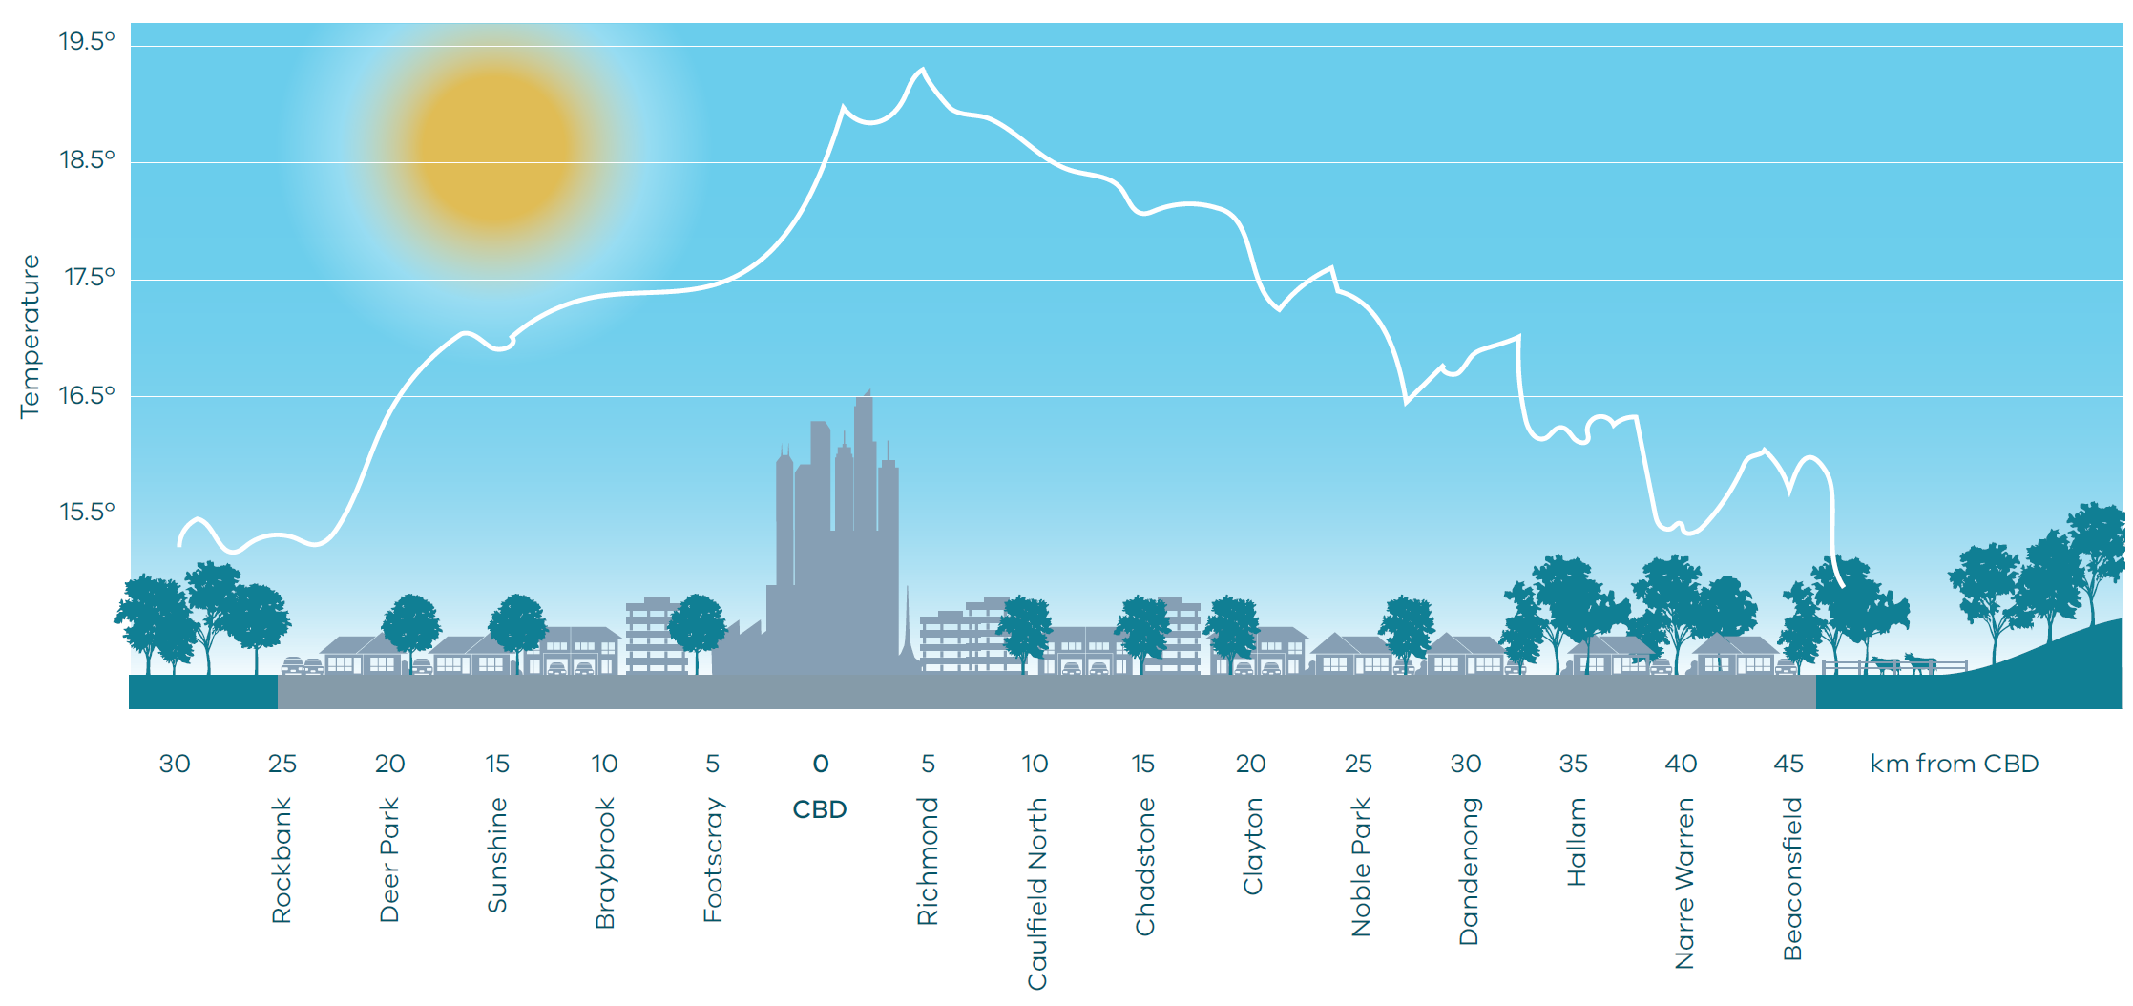
Source: Adapted from ‘Changing Urban Climate and CO₂ Emissions: Implications for the Development of Policies for Sustainable Cities’
Figure 17 Benefits of urban greening
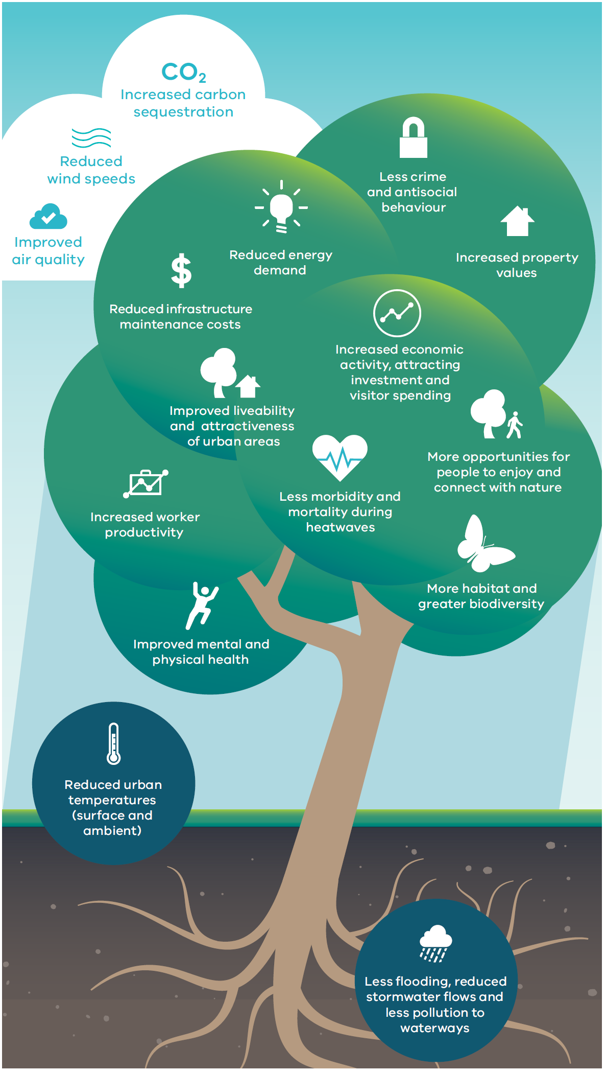
Source: Department of Environment, Land, Water and Planning

Policy 6.4.1 Support a cooler Melbourne by greening urban areas, buildings, transport corridors and open spaces to create an urban forest
A number of local councils are already promoting urban greening through actions such as developing urban forest strategies.
Greening must be integrated into planning frameworks and balanced with safety risk priorities. Too often, trees and greening are an afterthought in the planning and design of urban areas. In some cases, such as along transport corridors, concerns about the safety risks presented by trees can result in tree pruning and removal or the limitation of new plantings. In other cases, such as in established areas, tree canopy is lost through the process of replacing single dwellings and multi-dwelling redevelopment.
Residential development provisions must be updated to mitigate against the loss of tree canopy cover and permeable surfaces as a result of urban intensification.
The city must establish and maintain canopy trees along transport corridors, green buildings (roofs, facades and walls) and plant up open spaces—including parks, waterway corridors, school grounds and utility easements—together with the provision of a public open space network across Melbourne.
The drought from 1995 to 2009 (the Millennium Drought) highlighted the importance of water in providing a liveable, cooler, greener city. Adopting water-sensitive urban design will maximise alternative water use in vegetated areas and support the growth of healthy trees and vegetation.

Policy 6.4.2 Strengthen the integrated metropolitan open space network
Better planning, design and use of new and existing public open space is critical. Developing innovative approaches to access and making use of other types of public land, such as waterways, school grounds and utility easements, are also important parts of delivering an integrated open space network that responds to Melbourne’s projected population growth.
Open space provision must also be fair and equitable with the aim of providing access that meets the needs of all members of the community, regardless of age, gender, ability or a person’s location.
In Melbourne’s growth areas, new metropolitan parks will be delivered. Opportunities for additions to existing parks have also been identified through planning schemes.
A new metropolitan open space strategy will be developed to ensure Melbourne’s growing population is provided with, and has access to, quality open space. Map 21 shows Melbourne’s open space network.

Map 21 Open space
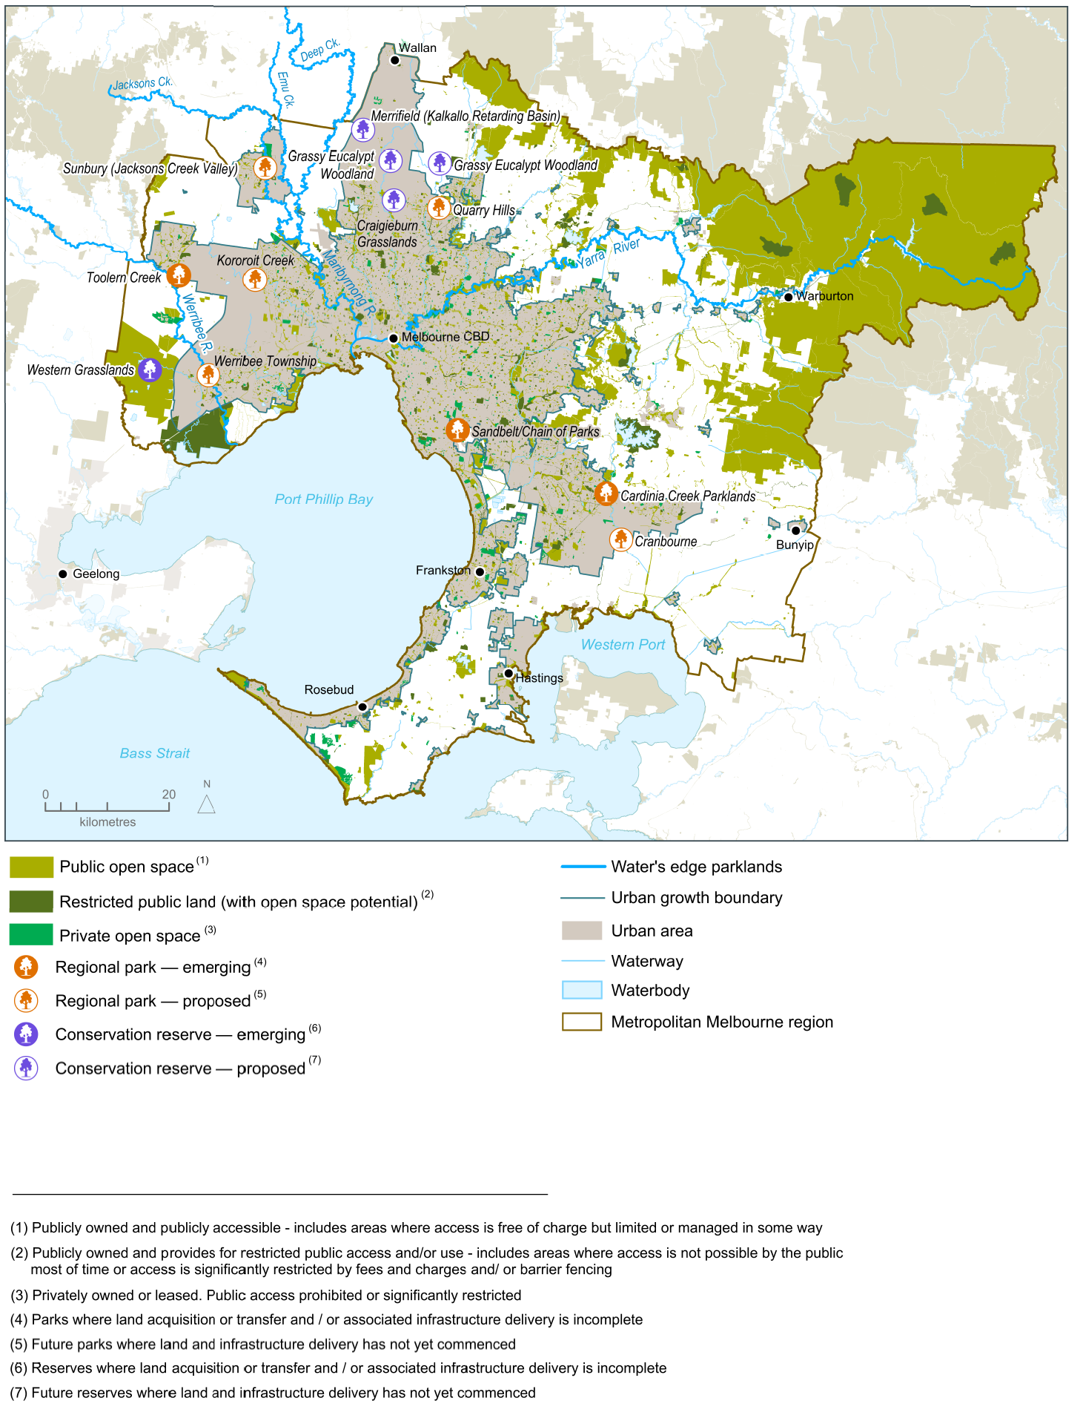
Source: Department of Environment, Land, Water and Planning

Direction 6.5 Protect and restore natural habitats
Melburnians are lucky to share their urban environment with an array of wildlife. However, as Melbourne grows, habitat loss and waterway degradation can pose a significant threat to native flora and fauna populations. As habitat becomes smaller and more fragmented through development, wildlife faces threats, such as lack of habitat to disperse to or barriers to dispersal.
There is a critical need to maintain and improve the overall extent and condition of natural habitats, including waterways. Natural habitats need to better protect native flora and fauna, enhance the community’s knowledge and acceptance of wildlife in areas they live, enhance access to nature and recreational opportunities across urban areas and make Melbourne an attractive place to live and visit. Map 22 shows Melbourne’s biodiversity conservation and natural features.
This direction should be read in conjunction with the Biodiversity Conservation Strategy for Melbourne’s Growth Corridors, which aims to manage the impacts of development for the next 30–40 years.

Policy 6.5.1 Create a network of green spaces that support biodiversity conservation and opportunities to connect with nature
Melbourne’s network of green spaces provides important areas of habitat for biodiversity conservation as well as opportunities for people to enjoy frequent contact with nature in urban environments. It includes a range of public and private green spaces, from parks and reserves to backyards and gardens as well as waterway and transport corridors that provide important green linkages. Existing green spaces need to be protected and new green spaces need to be created to improve landscape connectivity and resilience.
Government and community groups need to work in partnership to map Melbourne’s network of green spaces, investigate where the network could be improved and support the development of the metropolitan urban forest strategy.
Clearly articulating the spatial extent and management objectives of each part of the green network will guide land-use decision-making and investment as well as direct the conservation efforts of government departments and agencies, community groups and landholders.

Map 22 Biodiversity conservation and natural features
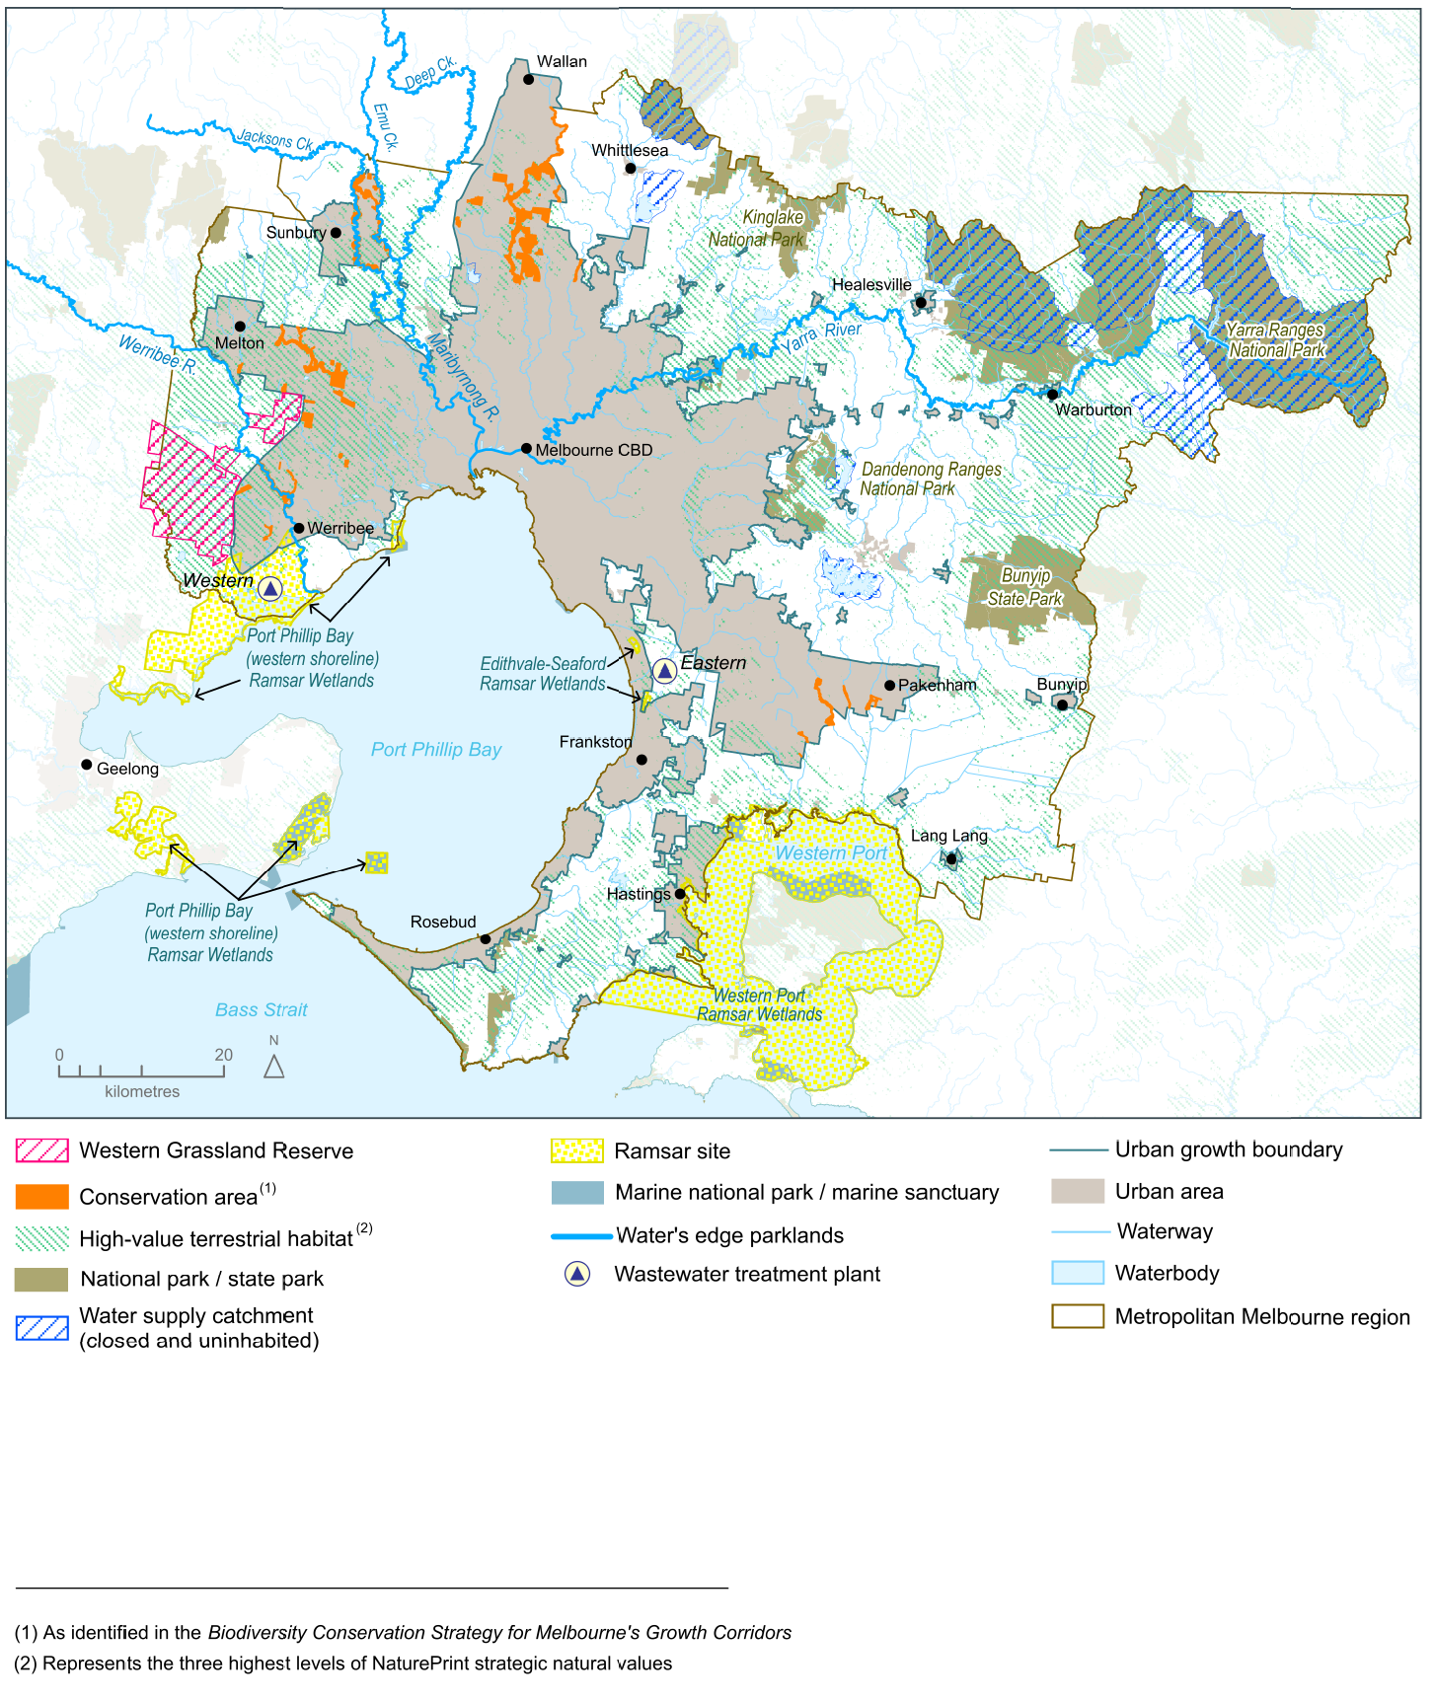
Source: Department of Environment, Land, Water and Planning

Policy 6.5.2 Protect and enhance the health of urban waterways
Melbourne has 8,400 kilometres of waterways—including the Yarra, Maribyrnong and Werribee rivers.
The impacts of climate change—combined with urban development from Melbourne’s growing population—influence the quantity, velocity and quality of urban stormwater run-off and pose a number of challenges for the health of Melbourne’s waterways.
Stormwater run-off from roads, roofs and pavements picks up pollutants (such as nutrients, heavy metals and litter) and discharges directly into our urban waterways and bays, impacting on water quality and ecosystem health and increasing flood risk. It is estimated that stormwater washes 37,000 tonnes of sediment and 1,400 tonnes of nutrients (such as nitrogen from fertiliser) into the Yarra River each year, as well as litter, heavy metals and pathogens.
Retaining stormwater in the landscape through water-sensitive urban design and stormwater harvesting is necessary to secure the health of the city’s waterways and bays. It will also reduce flood risks, improve landscapes and amenity, and create a greener city.
Objectives and performance standards within planning schemes must be strengthened to minimise the impacts of stormwater.

Policy 6.5.3 Protect the coastlines and waters of Port Phillip Bay and Western Port
Melbourne has more than 600 kilometres of coast, including Port Phillip Bay and Western Port.
This coastline includes places of significant environmental value (such as Ramsar sites) and places of significant social value (such as recreational beaches).
The State Environment Protection Policy (Waters of Victoria) provides the overarching framework for protecting and sustainably managing Victoria’s water environment, including setting environmental quality objectives.
A careful balance needs to be struck between supporting a variety of coastal land uses and minimising risks to ensure we do not love our beaches into decline. Planning will play an important role by focusing development in areas already developed or in areas with high resilience that can tolerate more intensive use and ensuring development effectively manages stormwater.

Direction 6.6 Improve air quality and reduce the impact of excessive noise
Melbourne’s air quality compares well with cities worldwide, but there are occasional days of poor air quality.
Air pollution is detrimental to human health, causing respiratory and cardiovascular disease and mortality, bronchitis, asthma, and exacerbation of chronic obstructive pulmonary disease. It is estimated to account for more deaths than the nation’s road toll.
Children are particularly susceptible to air pollution because their lungs and immune system are still developing. The elderly are also more likely to be adversely affected by pollution.
The Environment Protection Act 1970 allows for the establishment of standards for the management of air pollution emissions and noise through state environment protection policies and waste management policies. These standards must be upheld. After all, air quality is as important to public health as safe food or clean drinking water.
Air quality and noise impacts should be a fundamental consideration in the design and assessment of all new developments.

Policy 6.6.1 Reduce air pollution emissions and minimise exposure to air pollution and excessive noise
As urban renewal progresses, more people could be exposed to air and noise pollution in mixed-use areas, along major roads, at intersections, in popular entertainment areas and near industrial areas. In addition, predicted higher temperatures and more frequent bushfires and dust storms will add to the pressures on air quality.
The location of sensitive uses—such as childcare centres, schools, residential areas, aged-care facilities, hospitals and community facilities—require careful consideration and technical guidance early in the development application process.
Appropriate planning measures, building standards and urban design play a key role in minimising urban noise and air pollution and safeguarding community health and amenity.
Transport-oriented development and walkable neighbourhoods will assist in encouraging a mode shift away from cars and reducing vehicle emissions. Land-use interface issues and buffer distances between emission sources and sensitive uses must also be managed to mitigate exposure to air and noise pollution.

Direction 6.7 Reduce waste and improve waste management and resource recovery
Waste management and resource recovery is an essential community service that protects the environment and public health and recovers valuable resources.
By 2042, it is projected that waste volumes in metropolitan Melbourne will grow by 63 per cent to 16.5 million tonnes a year.
Melbourne needs to reduce the amount of waste it produces by avoiding, re-using and recycling waste. Infrastructure also needs to be located to ensure waste management and recovery is timely, efficient and cost effective.
The recovery of valuable resources from waste will create jobs and add value to the Victorian economy. It is estimated that recycling employs 9.2 people for every 10,000 tonnes of waste processed, compared to 2.8 people when the same amount of waste is sent to landfill.
Waste and resource recovery infrastructure planning must be effectively integrated with land-use planning to provide long-term certainty and to manage potential conflicts with incompatible nearby land uses.
Maintaining full operational capacity and output of waste and resource recovery facilities relies on a number of factors, such as securing and maintaining land separation distances. It is vital that facilities are sited, designed, built and operated to the highest standards so that the environment and public health benefits Victorians expect are achieved.

Policy 6.7.1 Improve the economic recovery of waste and reduce reliance on landfill
There are significant opportunities to grow this industry. For instance, Melbourne sends around 805,000 tonnes of food and garden waste to landfill each year. This breaks down and generates methane—a potent greenhouse gas—and causes odour issues for surrounding communities. Recovering this material could produce compost or energy. The government has set a target for Melbourne to have access to 600,000 tonnes of organic-processing capacity to manage municipal, commercial and industrial food-and-garden waste by 2026. There are also opportunities to recover more e-waste, plastic, polystyrene, timber, textiles and other materials.
There are also opportunities to provide integrated solutions to waste, water and energy issues such as converting waste to energy. There are already small-scale facilities in Victoria—including wastewater utilities, hospitals and agricultural-waste generators—producing their own electricity, steam and heating from their waste.
By 2026, the government wants 25 per cent of municipal residual waste collected through the Metropolitan Waste and Resource Recovery Group procurements to be recovered and managed through efficient, advanced technologies. This target is a major change for Melbourne as there are currently no residual facilities that accept municipal waste operating in the metropolitan region.
The Victorian Waste and Resource Recovery Infrastructure Planning Framework will be integrated into planning schemes to ensure that resource recovery facilities are appropriately planned for and located. This will help ensure the long-term viability of resource recovery infrastructure and ultimately facilitate the increased recovery of resources, reduce reliance on landfills, improve liveability, create jobs and reduce the environmental footprint of the city.

Policy 6.7.2 Improve waste and resource recovery systems to meet the logistical challenges of medium- and higher-density developments
Most high-rise residential and mixed-use developments, and some medium-density residential developments, lack appropriate waste and resource recovery infrastructure and services.
Owners’ corporations currently contract for the provision of waste services on an individual site basis. This often means all collected waste goes to landfill. The average diversion rate across multi-unit developments is 22 per cent—more than 10 per cent lower than general metropolitan household diversion rates.
This needs to change. The government has set a target for at least 95 per cent of all new multi-unit developments to accommodate resource recovery collections by 2026.
To achieve this target, waste and resource recovery infrastructure and waste service requirements need to be appropriately addressed within planning provisions for medium- and higher-density residential and mixed-use developments.

Policy 6.7.3 Protect waste management and resource recovery facilities from urban encroachment and assess opportunities for new waste facilities
Waste and resource recovery facilities need to remain fully operational and productive over the life of the investment. This relies, in part, on land and separation distances being secured, and on appropriate zoning of land within designated separation distances surrounding landfill sites and resource recovery sites.
Co-locating new waste-related infrastructure with complementary activities provides an opportunity to share existing separation distances and facilitate the integration of waste, water and energy management.
Waste-to-energy technologies are an example of advanced resource recovery infrastructure that can be co-located with complementary infrastructure.
Melbourne will create direct links between waste and resource recovery infrastructure planning and land-use planning. This will be achieved by applying clearer policy guidance to identify and protect waste and resource recovery sites and maintaining recommended separation distances with appropriate statutory measures to manage their off-site impacts.

The Allen Consulting Group, 2010, Report for the Australian Sustainable Built Environment Council, The Second Plank Update: A review of the contribution that energy efficiency in the buildings sector can make to greenhouse gas emissions abatement
Department of Economic Development, Jobs, Transport and Resources (2015), Victoria’s Renewable Energy Roadmap
Emergency Management Victoria (2015) Victorian Emergency Management Strategic Action Plan 2015-2018
Voogt, JA 2002, ‘Urban heat island’, in I Douglas (ed.), Encyclopedia of global environmental change, John Wiley and Sons, New York
AECOM, 2012, Economic Assessment of the Urban Heat Island Effect, prepared for City of Melbourne
Cities as water supply catchments, 2014, CRC for Water Sensitive Cities, Green cities and microclimate
A. Coutts, J. Beringer, and N. Tapper (2010) Changing Urban Climate and CO2 Emissions: Implications for the Development of Policies for Sustainable Cities, Urban Policy and Research
Jacobs and Hydronumerics (forthcoming publication), Integrated modelling for development of the new Port Phillip Bay Environmental Management Plan: Port Phillip Catchments to Bay Model Scenarios Report, Report prepared for Melbourne Water Dec 2015.
Draft Variation to the National Environment protection (Ambient Air Quality) Measure Impact Statement, Prepared for: National Environment Protection Council, July 2014
Begg, S., et al., The burden of disease and injury in Australia 2003, in AIHW cat. no. PHE 82.2007, Australian Institute of Health and Welfare: Canberra.
World Health Organization (2005) Effects of air pollution on children’s health and development – a review of the evidence
Metropolitan Waste and Resource Recovery Group, 2016, Metropolitan Waste and Resource Recovery Implementation Plan
Metropolitan Waste and Resource Recovery Group, 2016, Metropolitan Waste and Resource Recovery Implementation Plan
Metropolitan Waste and Resource Recovery Group, 2016, Metropolitan Waste and Resource Recovery Implementation Plan
Metropolitan Waste and Resource Recovery Group, 2016, Metropolitan Waste and Resource Recovery Implementation Plan
Metropolitan Waste and Resource Recovery Group, 2016, Metropolitan Waste and resource recovery Implementation Plan
GHD (2015) Multi-Unit Development Waste & Resource Recovery Research report, commissioned by the Metropolitan Waste and Resource Recovery Group
Metropolitan Waste and Resource Recovery Group, 2016, Metropolitan Waste and Resource Recovery Implementation Plan

