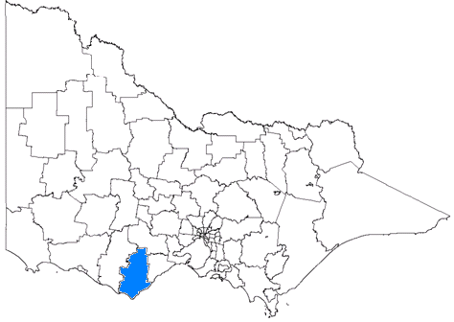
Colac-Otway LGA
0.5 projected annual population rate of change 2006 to 2026 (growth)
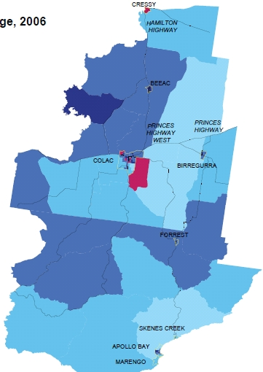
Localities with SEIFA RSD scores under the regional Victorian average of 986

Locality | SEIFA | Population (↑ growth, ↓ decline or = stable 2006 to 2001) | Individual income under $400 a week | Public Housing dwellings | Over 65 | Over 75 living alone | Disability | Single parent families | Developmentally vulnerable children | Aborigines and Torres Strait Islanders | Low English Proficiency | Households with no internet
Barwon South West | - | 365696 | 48.8 | 4.6 | 16.1 | 2.9 | 4.9 | 15.6 | 9 | 0.9 | 1.0 | 44.9
Regional Victoria | 986 | 1383233 | 50.0 | 4.8 | 16.0 | 2.7 | 5.0 | 15.4 |  | 1.2 | 0.7 | 46.1
Melbourne Metro | 1022 | 3744982 | 44.3 | 4.0 | 12.7 | 2.0 | 4.3 | 15.4 |  | 0.4 | 5.2 | 36.2
Victoria | 1000 | 5313053 | 45.8 | 4.2 | 13.6 | 2.2 | 4.5 | 15.4 | 10 | 0.7 | 4.0 | 39.0
Large towns population >3000
Colac | 947 | 10862 ↑ | 41.6 | 5.8 | 20.5 | 4.3 | 6.3 | 17.5 |  | 0.7 | 3.8 | 56.8
Small towns population <1000
** CAUTION using percentages from small populations (there may be high rates from small numbers in small populations)**
Beeac | 941 | 204 ↓ | 60.0 | 0.0 | 19.7 | 9.0 | 12.0 | 20.0 |  | 2.5 | 0.0 | 52.3
Forrest | 956 | 167 ↓ | 45.7 | 0.0 | 12.0 | 0.0 | 0.0 | 23.8 |  | 2.4 | 0.0 | 45.2
Birregurra | 978 | 464 ↑ | 39.2 | 0.0 | 14.9 | 4.3 | 2.2 | 17.5 |  | 0.9 | 0.0 | 46.4
Cressy | 818 | 123 | Data unavailable

Populations in Colac (2044) and Cressy (123) areas in this LGA contribute to the most disadvantaged 10% of the population in Australia (Table 1)

Disadvantaged areas in the Colac Otway LGA by the Index of Relative Socio-economic Disadvantage (SEIFA)
Colac-Otway contains one large and four small towns that score below the regional Victoria average on the Index of Relative Disadvantage. Around 39 to 60% of the population of these towns have low incomes and Colac and Beeac have higher than average proportion of people aged over 65 years, people with a disability and single parent families. Colac has a higher than average multicultural mix.
Context: Colac Otway LGA in general
LGA snapshot 3
% of children in their first year of school who were developmentally vulnerable on two or more domains * 2009 (DEECD 2010)

 | Number | %
Victoria | 61187 | 10%
Barwon South West | 3933 | 9%
Colac-Otway | 241 | 13%
Warrnambool | 406 | 11%
Moyne | 206 | 10%
Glenelg | 251 | 9%
Greater Geelong | 2 300 | 9%
Southern Grampians | 188 | 9%
Surf Coast | 341 | 5%
Corangamite | Not available
Queenscliff | Not available

* Five domains:
Physical health & wellbeing
Social competence & wellbeing
Emotional maturity
Language & cognitive skills
Communication skills & general knowledge
Education/employment
- 13% of children (241) across the LGA were found to be developmentally vulnerable in their first year of school of 2009 (LGA Snapshot 3, page 26)
- The LGA has an unemployment rate of 4.9% compared to 5.8% for Victoria (March 2010) – in the midrange of the 10 LGAs in Barwon South West (LGA snapshot 4, page 29)
- One in five (17%) of those aged between 15 and 19 are not engaged in work or further education or training (LGA snapshot 5, page 32)
- 24% of those employed are semi skilled or unskilled workers (LGA snapshot 6, page 35)
Access to services
The LGA is “moderately accessible” by the Accessibility and Remoteness Index (Figure 13)
Compared to the Barwon South West averages:
✓ More residents report their area has a wide range of community and support groups (71% compared to 69%, LGA snapshot 9, page 44)
✓ The area has a higher rate of low care aged care places (61 compared to 51 per 1000 population eligible)
✓ The area has a higher rate of high care aged care places (44 compared to 41 per 1000 population eligible)
✗ Fewer residents report their area has good facilities and services like shops, childcare, schools, libraries (75% compared to 83%, LGA Snapshot 7, page 38)
✗ Fewer residents report their area has easy access to recreational and leisure facilities (75% compared to 82%, LGA Snapshot 8, page 41)
✗ More households have no internet (52% compared to 45%, LGA Snapshot 11 page 50, Figure 14)
✗ More residents report they have experienced transport limitations (24% compared to 16%, LGA snapshot 10 page 47, Figure 15)

Corangamite LGA
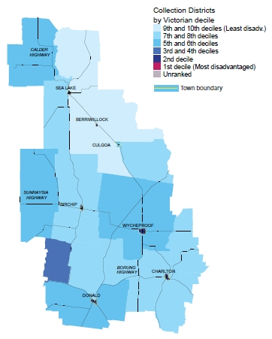
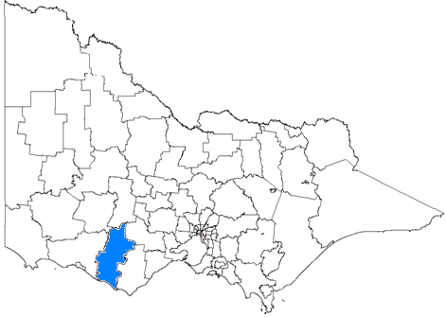
Production landscape predominantly agriculture (Figure 6)
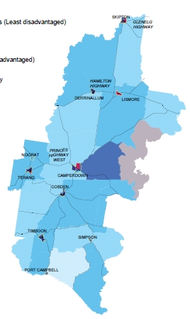
0.2 projected annual population rate of change 2006 to 2026 (growth)

Localities with SEIFA RSD scores under the regional Victorian average of 986
Locality | SEIFA | Population (↑ growth, ↓ decline or = stable 2006 to 2001) | Individual income under $400 a week | Public Housing dwellings | Over 65 | Over 75 living alone | Disability | Single parent families | Developmentally vulnerable children | Aborigines and Torres Strait Islanders | Low English Proficiency | Households with no internet
Barwon South West | - | 365696 | 48.8 | 4.6 | 16.1 | 2.9 | 4.9 | 15.6 | 9 | 0.9 | 1.0 | 44.9
Regional Victoria | 986 | 1383233 | 50.0 | 4.8 | 16.0 | 2.7 | 5.0 | 15.4 | - | 1.2 | 0.7 | 46.1
Melbourne Metro | 1022 | 3744982 | 44.3 | 4.0 | 12.7 | 2.0 | 4.3 | 15.4 | - | 0.4 | 5.2 | 36.2
Victoria | 1000 | 5313053 | 45.8 | 4.2 | 13.6 | 2.2 | 4.5 | 15.4 | 10 | 0.7 | 4.0 | 39.0
Large towns population >3000
Camperdown | 939 | 3163 ↑ | 45.6 | 5.8 | 22.6 | 5.1 | 6.6 | 18.7 | - | 0.3 | 0.0 | 54.4
Mid sized towns population between 1000-3000
Terang | 931 | 1833 ↑ | 43.4 | 3.1 | 25.7 | 6.9 | 6.6 | 20.8 | - | 0.5 | 0.0 | 58.5
Cobden | 940 | 1533 ↑ | 46.7 | 4.0 | 23.4 | 4.2 | 7.0 | 11.3 | - | 0.3 | 0.0 | 37.2
Small towns population <1000
Lismore | 831 | 286 ↑ | 56.3 | 6.6 | 35.3 | 6.5 | 10.9 | 20.5 | - | 1.0 | 0.0 | 63.3
Derrinallum | 926 | 233 ↓ | 55.7 | 2.9 | 31.8 | 5.8 | 6.5 | 6.9 | - | 0.0 | 0.0 | 64.4
Skipton | 930 | 480 ↓ | 55.6 | 2.6 | 33.0 | 3.4 | 7.5 | 13.2 | - | 1.4 | 0.0 | 62.7
Timboon | 963 | 870 ↑ | 39.5 | 2.1 | 21.4 | 5.0 | 2.9 | 13.1 | - | 0.3 | 0.0 | 54.6
** CAUTION using percentages from small populations (there may be high rates from small numbers in small populations)**
Populations in Camperdown (881) and Lismore (285) contribute to the most disadvantaged 10% of the population in Australia (Table 1)

Disadvantaged areas in the Corangamite LGA by the Index of Relative Socio-economic Disadvantage (SEIFA)
Corangamite contains one large, two mid-sized and four small towns that score below the regional Victoria average on the Index of Relative Disadvantage. Between 39 to 56% of these populations have low incomes and Camperdown and Lismore have higher than average public housing. There is a larger proportion of people aged over 65 in all areas and Camperdown, Terang and Lismore have a higher proportion of single parent families . Most areas have a limited multicultural mix.

Context: Corangamite LGA in general
LGA snapshot 4
Estimates of unemployment, ABS, March quarter 2010 (ABS 2010a)

Victoria | 5.8%
Glenelg | 7.3%
Greater Geelong | 6.1%
Warrnambool | 5.5%
Southern Grampians | 5.0%
Colac-Otway | 4.9%
Queenscliff | 3.7%
Moyne | 3.5%
Corangamite | 3.4%
Surf Coast | 3.4%

Early years/education/employment
- The LGA has an unemployment rate of 3.4% compared to 5.8% for Victoria (March 2010) (LGA snapshot 4, page 29)
- One in five (17%) of those aged between 15 and 19 are not engaged in work or further education or training (LGA snapshot 5, page 32)
- One in five of those employed are semi skilled or unskilled workers (21%) (LGA snapshot 6, page 35)

Access to services
The LGA is “accessible” by the Accessibility and Remoteness Index (Figure 13)
Compared to the Barwon South West averages:
✓ More residents report their area has a wide range of community and support groups (72% compared to 69%, LGA snapshot 9, page 44)
✓ The area has a higher rate of low care aged care places (65 compared to 51 per 1000 population eligible)
✓ The area has a higher rate of high care aged care places (45 compared to 41 per 1000 population eligible)
✗ Fewer residents report their area has good facilities and services like shops, childcare, schools, libraries (76% compared to 83%, LGA Snapshot 7, page 38)
✗ Fewer residents report their area has easy access to recreational and leisure facilities (79% compared to 82%, LGA Snapshot 8, page 41)
✗ More households have no internet (51% compared to 45%, LGA Snapshot 11 page 50, Figure 14)
✗ More residents report they have experienced transport limitations (18% compared to 16%, LGA snapshot 10 page 47, Figure 15)

Glenelg LGA
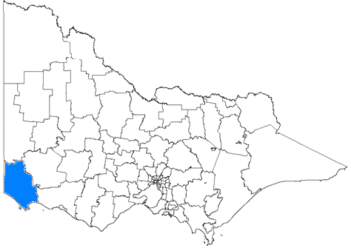
“Amenity” pressures landscape (Figure 8)
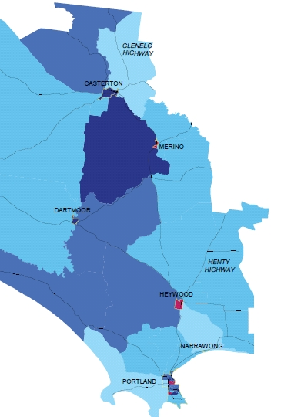
0.3 projected annual population rate of change 2006 to 2026 (growth)

Localities with SEIFA RSD scores under the regional Victorian average of 986
Locality | SEIFA | Population (↑ growth, ↓ decline or = stable 2006 to 2001) | Individual income under $400 a week | Public Housing dwellings | Over 65 | Over 75 living alone | Disability | Single parent families | Developmentally vulnerable children | Aborigines and Torres Strait Islanders | Low English Proficiency | Households with no internet
Barwon South West | - | 365696 | 48.8 | 4.6 | 16.1 | 2.9 | 4.9 | 15.6 | 9 | 0.9 | 1.0 | 44.9
Regional Victoria | 986 | 1383233 | 50.0 | 4.8 | 16.0 | 2.7 | 5.0 | 15.4 | - | 1.2 | 0.7 | 46.1
Melbourne Metro | 1022 | 3744982 | 44.3 | 4.0 | 12.7 | 2.0 | 4.3 | 15.4 | - | 0.4 | 5.2 | 36.2
Victoria | 1000 | 5313053 | 45.8 | 4.2 | 13.6 | 2.2 | 4.5 | 15.4 | 10 | 0.7 | 4.0 | 39.0
Large towns population >3000
Portland | 942 | 9819 | 40.9 | 6.5 | 16.0 | 2.9 | 5.3 | 18.1 | 9 | 2.0 | 1.3 | 49.0
Mid sized population between 1000-3000
Heywood | 873 | 1288 | 44.2 | 4.9 | 21.5 | 4.6 | 8.5 | 15.6 | - | 8.9 | 0.0 | 62.5
Casterton | 903 | 1658 | 52.2 | 0.6 | 29.3 | 5.1 | 8.4 | 17.2 | 8 | 1.1 | 0.0 | 64.5
Small towns population <1000
Merino | 875 | 205 | 54.4 | 0.0 | 20.1 | 3.1 | 2.5 | 24.1 | - | 0.0 | 0.0 | 42.7
Dartmoor | 902 | 216 | 44.8 | 5.3 | 14.0 | 3.8 | 4.6 | 13.1 | - | 2.8 | 0.0 | 53.8
** CAUTION using percentages from small populations (there may be high rates from small numbers in small populations)**
Populations in Portland (1730), Heywood (863) and Merino (220) contribute to the most disadvantaged 10% of the population in Australia (Table 1)
Disadvantaged areas in the Glenelg LGA by the Index of Relative Socio-economic Disadvantage (SEIFA)
Glenelg has ne large, two mid-sized and two small towns that score below the regional Victoria average on the Index of Relative Disadvantage. Around 41 to 54% of these populations have low incomes and all except Dartmoor have higher than average levels of public housing. Heywood, Casterton and Merino have a greater proportion of people aged over 65 and all towns but Dartmoor have a greater proportion of single parent families. All have greater than average multicultural mix.
LGA snapshot 5
% of young people aged 15 to 19 who are not engaged in school, work or further education/ training (ABS 2006)

Victoria | 17%
Glenelg | 22%
Queenscliff | 20%
Warrnambool | 18%
Greater Geelong | 18%
Colac-Otway | 17%
Corangamite | 17%
Southern Grampians | 17%
Moyne | 16%
Surf Coast | 15%

Context: Glenelg LGA in general

Early years/education/employment
- 9% of children (251) across the LGA were found to be developmentally vulnerable in their first year of school of 2009 (LGA Snapshot 3, page 26)
- The LGA has an unemployment rate of 7.3% compared to 5.8% for Victoria (March 2010) – the highest out of the 9 LGAs in Barwon South West (LGA snapshot 4, page 29)
- One in five (22%) of those aged between 15 and 19 are not engaged in work or further education or training (LGA snapshot 5, page 32)
- A quarter of those employed are semi skilled or unskilled workers (26%) (LGA snapshot 6, page 35)

Access to services
The LGA is “accessible” by the Accessibility and Remoteness Index (Figure 13)
Compared to the Barwon South West averages:
✓ More residents report their area has a wide range of community and support groups (71% compared to 69%, LGA snapshot 9, page 44)
✓ The area has a higher rate of low care aged care places (55 compared to 51 per 1000 population eligible)
= The same proportion of residents report their area has easy access to recreational and leisure facilities (82%, LGA Snapshot 8, page 41)
✗ The area has a lower rate of high care aged care places (32 compared to 41 per 1000 population eligible)
✗ Fewer residents report their area has good facilities and services like shops, childcare, schools, libraries (75% compared to 83%, LGA Snapshot 7, page 38)
✗ More households have no internet (49% compared to 45%, LGA Snapshot 11 page 50, Figure 14)
✗ More residents report they have experienced transport limitations (21% compared to 16%, LGA snapshot 10 page 47, Figure 15)

Greater Geelong LGA
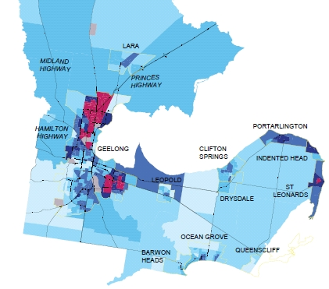
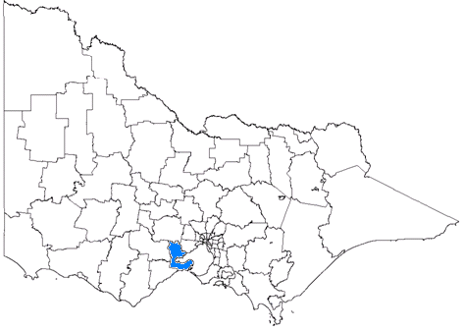
“Amenity” pressures landscape (Figure 8)
1.4 projected annual population rate of change 2006 to 2026 (growth)
Localities with SEIFA RSD scores under the regional Victorian average of 986
Locality | SEIFA | Population (↑ growth, ↓ decline or = stable 2006 to 2001) | Individual income under $400 a week | Public Housing dwellings | Over 65 | Over 75 living alone | Disability | Single parent families | Developmentally vulnerable children | Aborigines and Torres Strait Islanders | Low English Proficiency | Households with no internet
Barwon South West | - | 365696 | 48.8 | 4.6 | 16.1 | 2.9 | 4.9 | 15.6 | 9 | 0.9 | 1.0 | 44.9
Regional Victoria | 986 | 1383233 | 50.0 | 4.8 | 16.0 | 2.7 | 5.0 | 15.4 | - | 1.2 | 0.7 | 46.1
Melbourne Metro | 1022 | 3744982 | 44.3 | 4.0 | 12.7 | 2.0 | 4.3 | 15.4 | - | 0.4 | 5.2 | 36.2
Victoria | 1000 | 5313053 | 45.8 | 4.2 | 13.6 | 2.2 | 4.5 | 15.4 | 10 | 0.7 | 4.0 | 39.0
Large towns population >3000
- Norlane | 759 | 7947 | 54.0 | 23.0 | 19.1 | 3.4 | 7.8 | 34.2 | 18 | 1.7 | 20.5 | 67.4
- Whittington | 827 | 4227 | 48.6 | 18.3 | 12.6 | 2.7 | 6.0 | 30.2 |  | 1.7 | 7.7 | 57.1
- Corio | 876 | 15114 | 45.7 | 9.6 | 11.3 | 1.6 | 5.2 | 26.4 | 16 | 1.9 | 10.3 | 52.3
- Bell Park | 899 | 4651 | 47.1 | 2.8 | 19.5 | 3.7 | 6.2 | 18.7 | 14 | 0.7 | 26.6 | 57.2
- Newcomb | 915 | 4346 | 45.4 | 1.9 | 24.6 | 4.2 | 7.8 | 21.9 | 15 | 1.0 | 3.1 | 56.1
- Herne Hill | 949 | 3269 | 41.9 | 1.6 | 18.4 | 3.6 | 3.4 | 21.3 | 7 | 0.2 | 4.1 | 52.4
- Bell Post Hill | 964 | 4920 | 42.3 | 1.5 | 15.2 | 1.9 | 4.9 | 15.2 | 23 | 0.3 | 18.4 | 51.2
- St Albans Park | 980 | 4692 | 35.5 | 1.8 | 14.6 | 1.9 | 4.7 | 15.5 | 8 | 0.7 | 3.6 | 41.6
- Hamlyn Heights | 983 | 5838 | 41.3 | 1.0 | 19.5 | 4.0 | 4.7 | 17.0 | 12 | 0.5 | 8.0 | 47.3
Portarlington | 968 | 3023 | 48.2 | 0.0 | 33.2 | 5.4 | 6.7 | 11.7 | 0 | 0.6 | 5.8 | 54.6
Mid sized population between 1000-3000
- Breakwater | 907 | 1051 | 47.6 | 8.9 | 16.4 | 3.5 | 4.9 | 23.9 | - | 1.0 | 4.3 | 54.2
- Nth Geelong | 914 | 2670 | 41.1 | 7.7 | 32.2 | 3.8 | 11.3 | 23.5 | - | 0.5 | 18.0 | 55.0
St Leonards | 948 | 1620 | 49.0 | 0.0 | 33.2 | 4.4 | 6.6 | 14.0 | 22 | 0.4 | 8.5 | 60.1
- Thomson | 842 | 1605 | 50.0 | 23.6 | 23.0 | 5.5 | 7.0 | 31.4 | - | 0.5 | 1.3 | 62.1
Small towns population <1000
** CAUTION using percentages from small populations (there may be high rates from small numbers in small populations)**
Indented Head | 965 | 588 | 47.7 | 0.0 | 32.5 | 4.7 | 7.4 | 13.8 | - | 0.5 | 13.3 | 53.8
- Marshall | 973 | 843 | 43.7 | 0.0 | 45.7 | 12.4 | 15.5 | 9.5 | - | 0.7 | 7.1 | 62.1
- North Shore | 938 | 317 | 37.5 | 3.6 | 14.8 | 3.8 | 5.0 | 21.3 | - | 3.2 | 8.5 | 49.6
Populations in Corio Norlane (14928), Whittington (4651) and North Geelong (2142) contribute to the most disadvantaged 10% of postcodes in Australia (Table 1).
Disadvantaged areas in the Greater Geelong LGA by the Index of Relative Socio-economic Disadvantage (SEIFA)
Greater Geelong has 14 suburbs, one mid-sized town and one small town that score below the regional Victoria average on the Index of Relative Disadvantage. Around 38 to 54% of the population of these towns have low incomes and Norlane, Whittington, Corio, Breakwater, North Geelong and Thomson have higher than average public housing. Most of the areas have a greater proportion of people aged over 65 and single parent families. All have a higher multicultural mix.

Context: Greater Geelong LGA in general
LGA snapshot 6
Unskilled and semi skilled workers
(ABS 2006)

Victoria | 16%
Glenelg | 26
Colac-Otway | 24
Corangamite | 21
Greater Geelong | 18
Moyne | 18
Warrnambool | 18
Southern Grampians | 16
Surf Coast | 12
Queenscliff | 10

Education/employment
- 9% of children (2300) across the LGA were found to be developmentally vulnerable in their first year of school of 2009 (LGA Snapshot 3, page 26)
- The LGA has an unemployment rate of 6.1% compared to 5.8% for Victoria (March 2010) - the 2nd highest out of the 9 LGAs in Barwon South West (LGA snapshot 4, page 29)
- One in five (18%) of those aged between 15 and 19 are not engaged in work or further education or training (LGA snapshot 5, page 32)
- One in five of those employed are semi skilled or unskilled workers (18%) (LGA snapshot 6, page 35)

Access to services
The LGA is “moderately accessible” by the Accessibility and Remoteness Index (Figure 13)
Compared to the Barwon South West averages:
✓ The area has a higher rate of high care aged care places (44 compared to 41 per 1000 population eligible)
✓ More residents report their area has good facilities and services like shops, childcare, schools, libraries (86% compared to 83%, LGA Snapshot 7, page 38)
✓ Fewer households have no internet (44% compared to 45%, LGA Snapshot 11 page 50, Figure 14)
= The same proportion of residents say their area has easy access to recreational and leisure facilities (83% compared to 82%, LGA Snapshot 8, page 41)
= The same proportion of residents report they have experienced transport limitations (16%, LGA snapshot 10 page 47, Figure 15)
✗ Fewer residents report their area has a wide range of community and support groups (65% compared to 69%, LGA snapshot 9, page 44)
✗ The area has a lower rate of low care aged care places (50 compared to 51 per 1000 population eligible)

Moyne LGA

Production landscape predominantly agriculture (Figure 6)
0.6 projected annual population rate of change 2006 to 2026 (growth)

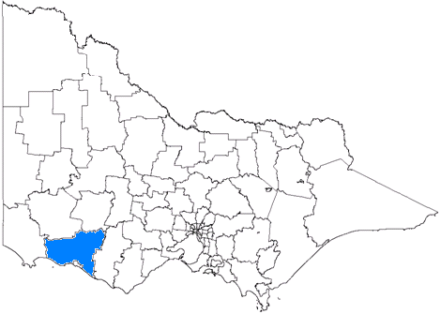
Localities with SEIFA RSD scores under the regional Victorian average of 986

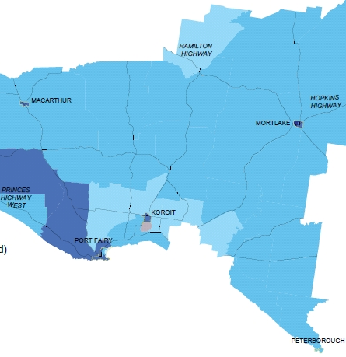 | SEIFA | Population (↑ growth, ↓ decline or = stable 2006 to 2001) | Individual income under $400 a week | Public Housing dwellings | Over 65 | Over 75 living alone | Disability | Single parent families | Developmentally vulnerable children | Aborigines and Torres Strait Islanders | Low English Proficiency | Households with no internet
Barwon South West | - | 365696 | 48.8 | 4.6 | 16.1 | 2.9 | 4.9 | 15.6 | 9 | 0.9 | 1.0 | 44.9
Regional Victoria | 986 | 1383233 | 50.0 | 4.8 | 16.0 | 2.7 | 5.0 | 15.4 | - | 1.2 | 0.7 | 46.1
Melbourne Metro | 1022 | 3744982 | 44.3 | 4.0 | 12.7 | 2.0 | 4.3 | 15.4 | - | 0.4 | 5.2 | 36.2
Victoria | 1000 | 5313053 | 45.8 | 4.2 | 13.6 | 2.2 | 4.5 | 15.4 | 10 | 0.7 | 4.0 | 39.0
Small towns population <1000
** CAUTION using percentages from small populations (there may be high rates from small numbers in small populations)**
Mortlake | 941 | 992 | 49.2 | 1.2 | 25.8 | 5.4 | 6.4 | 15.7 | 9 | 0.9 | 7.3 | 63.2
Macarthur | 952 | 260 | 46.8 | 0.0 | 28.4 | 7.2 | 4.7 | 11.6 | 13 | 2.3 | 0.0 | 60.7

No populations in Moyne contribute to the most disadvantaged 10% of the population in Australia (Table 1)
Disadvantaged areas in the Moyne LGA by the Index of Relative Socio-economic Disadvantage (SEIFA)
Moyne has two small towns that score below the regional Victoria average on the Index of Relative Disadvantage. Around 47 to 49% of these populations have low incomes and both have a higher proportion of people aged over 65. Mortlake has a larger proportion of single parent families and both towns have a higher than average multicultural mix.
LGA snapshot 7
Residents that feel their area has good facilities and services like shops, childcare, schools, libraries, 2008 (DPCD 2010a)

Barwon South West | 83%
Moyne | 73%
Surf Coast | 74%
Glenelg | 75%
Colac-Otway | 75%
Corangamite | 76%
Queenscliff | 81%
Southern Grampians | 82%
Greater Geelong | 86%
Warrnambool | 94%

Context: Moyne LGA in general

Early years/education/employment
- 10% of children (206) across the LGA were found to be developmentally vulnerable in their first year of school of 2009 (LGA Snapshot 3, page 26)
- The LGA has an unemployment rate of 3.5% compared to 5.8% for Victoria (March 2010) (LGA snapshot 4, page 29)
- 16% of those aged between 15 and 19 are not engaged in work or further education or training (LGA snapshot 5, page 32)
- Nearly one in five of those employed are semi skilled or unskilled workers (18%) (LGA snapshot 6, page 35)

Access to services
The LGA is “accessible” by the Accessibility and Remoteness Index (Figure 13)
Compared to the Barwon South West averages:
✗ The area has a lower rate of low care aged care places (47 compared to 51 per 1000 population eligible)
✗ The area has a lower rate of high care aged care places (34 compared to 41 per 1000 population eligible)
✗ Fewer residents report their area has a wide range of community and support groups (67% compared to 69%, LGA snapshot 9, page 44)
✗ Fewer residents report their area has good facilities and services like shops, childcare, schools, libraries (73% compared to 83%, LGA Snapshot 7, page 38)
✗ Fewer residents report their area has easy access to recreational and leisure facilities (69% compared to 82%, LGA Snapshot 8, page 41)
✗ More households have no internet (47% compared to 45%, LGA Snapshot 11 page 50, Figure 14)
✗ More residents report they have experienced transport limitations (18% compared to 16%, LGA snapshot 10 page 47, Figure 15)

Queenscliffe LGA
“Amenity” pressures landscape (Figure 8)
0.3 projected annual population rate of change 2006 to 2026 (growth)

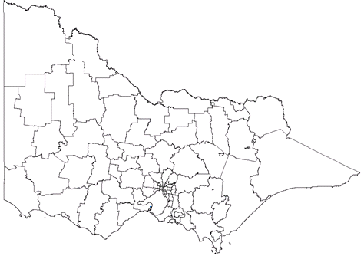
Localities with SEIFA RSD scores under the regional Victorian average of 986

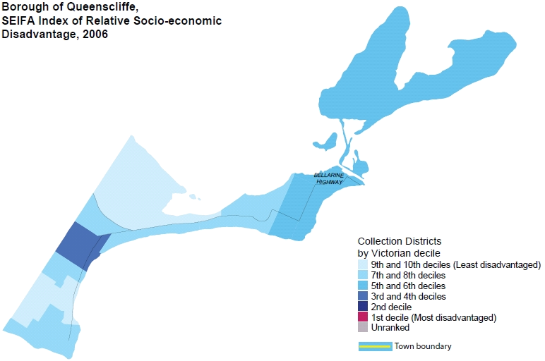

No populations in Queenscliffe contribute to the most disadvantaged 10% of the population in Australia (Table 1)
Disadvantaged areas in the Queenscliffe LGA by the Index of Relative Socio-economic Disadvantage (SEIFA)
Queenscliffe does not contain any areas that score below the regional Victoria average on the Index of Relative Disadvantage.

Context: Queenscliffe LGA in general
LGA snapshot 8
Residents that feel their area has easy access to recreational and leisure facilities, 2008 (DPCD 2010a)

Barwon South West | 82%
Moyne | 69%
Colac-Otway | 75%
Surf Coast | 78%
Corangamite | 79%
Glenelg | 82%
Greater Geelong | 83%
Southern Grampians | 84%
Queenscliff | 88%
Warrnambool | 92%

Early years/education/employment
- The LGA has an unemployment rate of 3.7% compared to 5.8% for Victoria (March 2010) (LGA snapshot 4, page 29)
- One in five (20%) of those aged between 15 and 19 are not engaged in work or further education or training (LGA snapshot 5, page 32)
- One in ten of those employed are semi skilled or unskilled workers (10%) (LGA snapshot 6, page 35)

Access to services
The LGA is “accessible” by the Accessibility and Remoteness Index (Figure 13)
Compared to the Barwon South West averages:
✓ More residents report their area has a wide range of community and support groups (77% compared to 69%, LGA snapshot 9, page 44)
✓ More residents report their area has easy access to recreational and leisure facilities (88% compared to 82%, LGA Snapshot 8, page 41)
✓ Fewer households have no internet (42% compared to 45%, LGA Snapshot 11 page 50, Figure 14)
= The same proportion of residents report their area has good facilities and services like shops, childcare, schools, libraries (81% compared to 83%, LGA Snapshot 7, page 38)
= The same proportion of residents report they have experienced transport limitations (17% compared to 16%, LGA snapshot 10 page 47, Figure 15)
✗ The area has a lower rate of low care aged care places (50 compared to 51 per 1000 population eligible)
✗ The area has a lower rate of high care aged care places (0 compared to 41 per 1000 population eligible)

Southern Grampians LGA
Production landscape predominantly agriculture (Figure 6)
0.1 projected annual population rate of change 2006 to 2026 (growth)

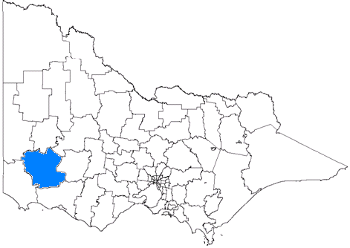
Localities with SEIFA RSD scores under the regional Victorian average of 986
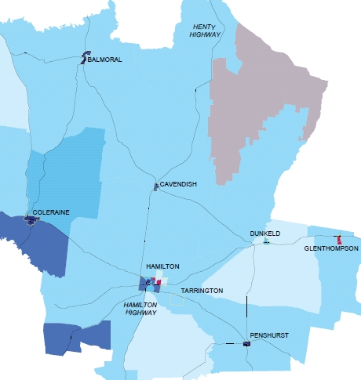

Locality | SEIFA | Population (↑ growth, ↓ decline or = stable 2006 to 2001) | Individual income under $400 a week | Public Housing dwellings | Over 65 | Over 75 living alone | Disability | Single parent families | Developmentally vulnerable children | Aborigines and Torres Strait Islanders | Low English Proficiency | Households with no internet
Barwon South West | - | 365696 | 48.8 | 4.6 | 16.1 | 2.9 | 4.9 | 15.6 | 9 | 0.9 | 1.0 | 44.9
Regional Victoria | 986 | 1383233 | 50.0 | 4.8 | 16.0 | 2.7 | 5.0 | 15.4 | - | 1.2 | 0.7 | 46.1
Melbourne Metro | 1022 | 3744982 | 44.3 | 4.0 | 12.7 | 2.0 | 4.3 | 15.4 | - | 0.4 | 5.2 | 36.2
Victoria | 1000 | 5313053 | 45.8 | 4.2 | 13.6 | 2.2 | 4.5 | 15.4 | 10 | 0.7 | 4.0 | 39.0
Large towns population >3000
Hamilton | 985 | 9388 | 39.7 | 5.0 | 20.4 | 4.8 | 5.7 | 15.0 | 10 | 0.8 | 0.7 | 51.9
Small towns population <1000
Glenthompson | 863 | 143 | 57.4 | 0.0 | 32.9 | 8.3 | 7.2 | 24.3 | - | 0.0 | 0.0 | 66.7
Penshurst | 910 | 461 | 54.6 | 1.6 | 26.3 | 7.2 | 11.2 | 13.2 | - | 0.9 | 0.0 | 62.3
Coleraine | 911 | 992 | 54.6 | 4.1 | 31.1 | 7.7 | 10.4 | 16.3 | - | 0.3 | 0.0 | 64.5
Balmoral | 933 | 188 | 36.8 | 5.1 | 19.2 | 2.3 | 7.4 | 16.3 | - | 2.1 | 0.0 | 56.4
** CAUTION using percentages from small populations (there may be high rates from small numbers in small populations)**

Populations in Glenthompson (139) contribute to the most disadvantaged 10% of the population in Australia (Table 1)
Disadvantaged areas in the Southern Grampians LGA by the Index of Relative Socio-economic Disadvantage (SEIFA)
Southern Grampians has one large and four small towns that score below the regional Victoria average on the Index of Relative Disadvantage. Around 37 to 57% of these populations have low incomes and Hamilton and Balmoral have higher than average levels of public housing. All areas have a larger proportion of people aged over 65 and Glenthompson, Coleraine and Balmoral have more single parent families. All areas but Glenthompson and Coleraine have higher than average multicultural mix.

Context: Southern Grampians Ranges LGA in general

Early years/education/employment
LGA snapshot 9
Residents that feel their area has a wide range of community and support groups, 2008 (DPCD 2010a)

Barwon South West | 69%
Greater Geelong | 65%
Moyne | 67%
Surf Coast | 68%
Colac-Otway | 71%
Corangamite | 72%
Glenelg | 74%
Queenscliff | 77%
Southern Grampians | 78%
Warrnambool | 86%

- 9% of children (188) across the LGA were found to be developmentally vulnerable in their first year of school of 2009 (LGA Snapshot 3, page 26)
- The LGA has an unemployment rate of 5.0% compared to 5.8% for Victoria (March 2010) (LGA snapshot 4, page 29)
- One in five (17%) of those aged between 15 and 19 are not engaged in work or further education or training (LGA snapshot 5, page 32)
- 16% of those employed are semi skilled or unskilled workers (LGA snapshot 6, page 35)

Access to services
The LGA is “accessible” by the Accessibility and Remoteness Index (Figure 13)
Compared to the Barwon South West averages:
✓ More residents report their area has a wide range of community and support groups (78% compared to 69%, LGA snapshot 9, page 44)
✓ Fewer residents report they have experienced transport limitations (13% compared to 16%, LGA snapshot 10 page 47, Figure 15)
= The same proportion of residents report their area has easy access to recreational and leisure facilities (84% compared to 82%, LGA Snapshot 8, page 41)
✗ The area has a lower rate of low care aged care places (50 compared to 51 per 1000 population eligible)
✗ The area has a lower rate of high care aged care places (37 compared to 41 per 1000 population eligible)
✗ Fewer residents report their area has good facilities and services like shops, childcare, schools, libraries (74% compared to 83%, LGA Snapshot 7, page 38)
✗ More households have no internet (50% compared to 45%, LGA Snapshot 11 page 50, Figure 14)

Surf Coast LGA
“Amenity” pressures landscape (Figure 8)
2.1 projected annual population rate of change 2006 to 2026 (growth)

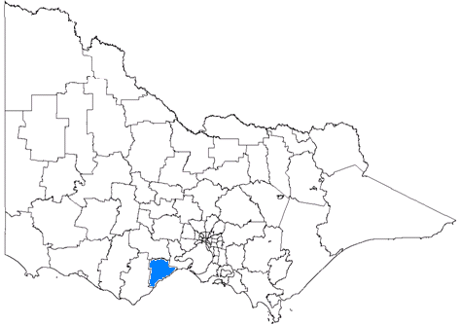
Localities with SEIFA RSD scores under the regional Victorian average of 986

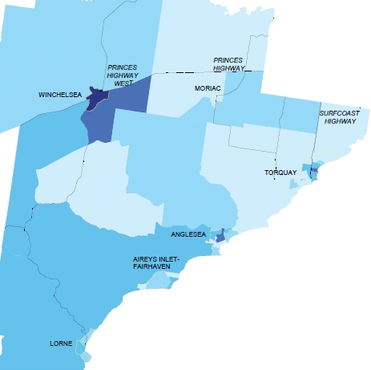

Locality | SEIFA | Population (↑ growth, ↓ decline or = stable 2006 to 2001) | Individual income under $400 a week | Public Housing dwellings | Over 65 | Over 75 living alone | Disability | Single parent families | Developmentally vulnerable children | Aborigines and Torres Strait Islanders | Low English Proficiency | Households with no internet
Barwon South West | - | 365696 | 48.8 | 4.6 | 16.1 | 2.9 | 4.9 | 15.6 | 9 | 0.9 | 1.0 | 44.9
Regional Victoria | 986 | 1383233 | 50.0 | 4.8 | 16.0 | 2.7 | 5.0 | 15.4 |  | 1.2 | 0.7 | 46.1
Melbourne Metro | 1022 | 3744982 | 44.3 | 4.0 | 12.7 | 2.0 | 4.3 | 15.4 |  | 0.4 | 5.2 | 36.2
Victoria | 1000 | 5313053 | 45.8 | 4.2 | 13.6 | 2.2 | 4.5 | 15.4 | 10 | 0.7 | 4.0 | 39.0
Mid sized population between 1000-3000
Winchelsea | 921 | 1334 | 46.4 | 6.1 | 22.0 | 4.0 | 7.9 | 15.1 | 8 | 1.0 | 2.3 | 53.4

No populations in Surf Coast contribute to the most disadvantaged 10% of the population in Australia (Table 1)
Disadvantaged areas in the Surf Coast LGA by the Index of Relative Socio-economic Disadvantage (SEIFA)
Surf Coast has one mid-sized town that scores below the regional Victoria average on the Index of Relative Disadvantage. Around 46% of the population of Winchelsea have low incomes. It also has higher than average levels of public housing, seniors and multicultural mix.

Context: Surf Coast LGA in general
LGA snapshot 10
People that experienced transport limitation in the last 12 months, 2007 (CIV 2007)

Barwon South West | 16%
Glenelg | 21%
Surf Coast | 18%
Moyne | 18%
Colac-Otway | 18%
Corangamite | 18%
Queenscliff | 17%
Warrnambool | 17%
Greater Geelong | 16%
Southern Grampians | 13%

Early years/education/employment
- 5% of children (341) across the LGA were found to be developmentally vulnerable in their first year of school of 2009 (LGA Snapshot 3, page 26)
- The LGA has an unemployment rate of 3.4% compared to 5.8% for Victoria (March 2010) – the lowest of the 9 LGAs in Barwon South West (LGA snapshot 4, page 29)
- 15% of those aged between 15 and 19 are not engaged in work or further education or training (LGA snapshot 5, page 32)
- One in ten of those employed are semi skilled or unskilled workers (12%) (LGA snapshot 6, page 35)

Access to services
The LGA is “moderately accessible” with some “Remote” areas by the Accessibility and Remoteness Index (Figure 13)
Compared to the Barwon South West averages:
✓ The area has a higher rate of high care aged care places (43 compared to 41 per 1000 population eligible)
✓ Fewer households have no internet (33% compared to 45%, LGA Snapshot 11 page 50, Figure 14)
= The same proportion of residents report their area has a wide range of community and support groups (68% compared to 69%, LGA snapshot 9, page 44)
✗ The area has a lower rate of low care aged care places (45 compared to 51 per 1000 population eligible)
✗ Fewer residents report their area has good facilities and services like shops, childcare, schools, libraries (74% compared to 83%, LGA Snapshot 7, page 38)
✗ Fewer residents report their area has easy access to recreational and leisure facilities (78% compared to 82%, LGA Snapshot 8, page 41)
✗ More residents report they have experienced transport limitations (18% compared to 16%, LGA snapshot 10 page 47, Figure 15)

Warrnambool LGA
“Amenity” pressures landscape (Figure 8)
1.1 projected annual population rate of change 2006 to 2026 (growth)

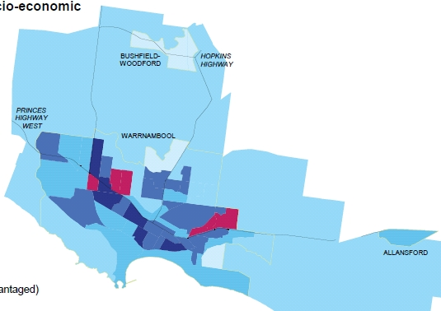
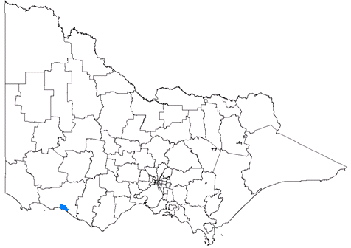
Localities with SEIFA RSD scores under the regional Victorian average of 986

Locality | SEIFA | Population (↑ growth, ↓ decline or = stable 2006 to 2001) | Individual income under $400 a week | Public Housing dwellings | Over 65 | Over 75 living alone | Disability | Single parent families | Developmentally vulnerable children | Aborigines and Torres Strait Islanders | Low English Proficiency | Households with no internet
Barwon South West | - | 365696 | 48.8 | 4.6 | 16.1 | 2.9 | 4.9 | 15.6 | 9 | 0.9 | 1.0 | 44.9
Regional Victoria | 986 | 1383233 | 50.0 | 4.8 | 16.0 | 2.7 | 5.0 | 15.4 |  | 1.2 | 0.7 | 46.1
Melbourne Metro | 1022 | 3744982 | 44.3 | 4.0 | 12.7 | 2.0 | 4.3 | 15.4 |  | 0.4 | 5.2 | 36.2
Victoria | 1000 | 5313053 | 45.8 | 4.2 | 13.6 | 2.2 | 4.5 | 15.4 | 10 | 0.7 | 4.0 | 39.0
Large towns population >3000
Warrnambool | 989 | 28145 ↑ | 39.9 | 6.0 | 15.6 | 3.1 | 4.0 | 17.7 | 13 | 1.3 | 3.5 | 49.3
Populations in Warrnambool (2495) contribute to the most disadvantaged 10% of the population in Australia (Table 1)

Disadvantaged areas in the Warrnambool LGA by the Index of Relative Socio-economic Disadvantage (SEIFA)
Warrnambool has one large that scores below the regional Victoria average on the Index of Relative Disadvantage. Around 40% of this population have low incomes and the town has higher than average public housing, single parent families and a higher multicultural mix.

Context: Warrnambool LGA in general
LGA snapshot 11
Households with no internet connection 2006 (ABS 2006)

Victoria | 39%
Barwon South West Region | %
Colac-Otway | 51.9%
Corangamite | 50.8%
Southern Grampians | 49.7%
Glenelg | 48.5%
Warrnambool | 48.2%
Moyne | 46.7%
Greater Geelong | 43.6%
Queenscliff | 42.4%
Surf Coast | 33.3%

Early years/education/employment
- 11% of children (406) across the LGA were found to be developmentally vulnerable in their first year of school of 2009 (LGA Snapshot 3, page 26)
- The LGA has an unemployment rate of 5.5% compared to 5.8% for Victoria (March 2010) (LGA snapshot 4, page 29)
- One in five (18%) of those aged between 15 and 19 are not engaged in work or further education or training (LGA snapshot 5, page 32)
- Nearly one in five of those employed are semi skilled or unskilled workers (18%) (LGA snapshot 6, page 35)

Access to services
The LGA is “accessible” by the Accessibility and Remoteness Index (Figure 13)
Compared to the Barwon South West averages:
✓ More residents report their area has a wide range of community and support groups (86% compared to 69%, LGA snapshot 9, page 44)
✓ More residents report their area has good facilities and services like shops, childcare, schools, libraries (94% compared to 83%, LGA Snapshot 7, page 38)
✓ More residents report their area has easy access to recreational and leisure facilities (92% compared to 82%, LGA Snapshot 8, page 41)
= The same proportion of residents report they have experienced transport limitations (17% compared to 16%, LGA snapshot 10 page 47, Figure 15)
✗ The area has a lower rate of low care aged care places (47 compared to 51 per 1000 population eligible)
✗ The area has a lower rate of high care aged care places (38 compared to 41 per 1000 population eligible)
✗ More households have no internet (48% compared to 45%, LGA Snapshot 11 page 50, Figure 14)

