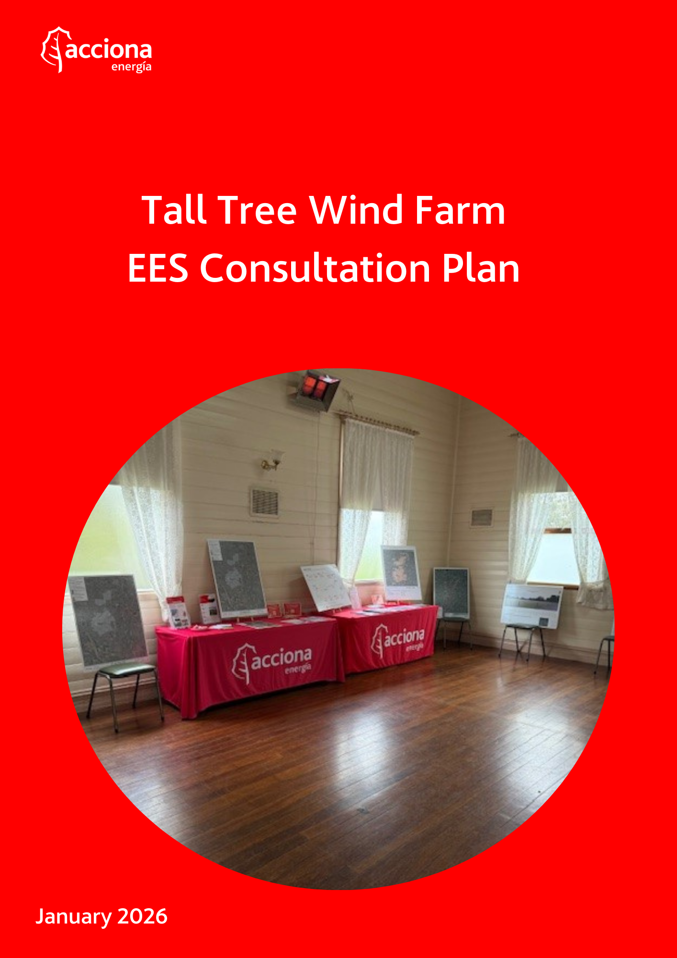
CONTROL
PREPARED BY | REVIewed BY | APPROVED BY
Ali Karmelich | ###Revisores | ###Aprobadores
18 December 2025 | ###FechaRevision | ###FechaAprobacion
[SIGNATURE] | [SIGNATURE] | [SIGNATURE]
The signed original is kept by ACCIONA#
RECORD OF CHANGES
REV. | DATE | DESCRIPTION
02 | Date | Brief descriptive text
CONTENTS
TITLE | PAGE
1. acknowledgement of country 4
2. introduction 4
2.1. Purpose 4
2.2. About Acciona Energía 4
3. project description 5
3.1. Context 5
3.2. About the project 5
4. communications and engagement approach 7
4.1. Engagement objectives 9
4.2. Communications and engagement activities and METHODS 9
4.3. How feedback is used 12
5. Project stakeholders 12
5.1. Host Landowners 15
5.2. Boundary and project site neighbours 15
5.3. Traditional Owners 15
5.4. Lethbridge AirPORT STakeholders 16
5.5. Hard to reach and vulnerable groups 16
6. Engagement program 16
6.1. Feasibility phase 18
6.2. EES engagement program 19
6.3. Engagement during construction 25
6.4. Engagement during operation 25
6.5. Engagement to support decommissioning 25
7. Management of records and enquiries 26
7.1. Stakeholder management database 26
7.2. Media enquiries 26
7.3. Personal information 26
8. Review and evaluation 26
8.1. Management of feedback and complaints 27
9. messaging 29
9.1. About the Project 29
9.2. The EES process 29
9.3. Consultation 29
10. DEFINITIONS 29
11. Appendix A: project Stakeholders 31
12. appendix b: examples of collateral 35

acknowledgement of country
In the spirit of reconciliation, ACCIONA Energía acknowledges the Traditional Custodians of the land our proposed project lies on, the Wadawurrung People, and recognizes their connections to land, sea and community. We pay our respects to their Elders past and present and extend those respects to all Aboriginal and Torres Strait Islander peoples.

introduction

Purpose
The Minister for Planning has determined that an Environment Effects Statement (EES) is required for the ACCIONA Energía Tall Tree Wind Farm under the Environment Effects Act 1978. As part of preparing the EES, the proponent is required to prepare and implement a consultation plan.
The Tall Tree Wind Farm EES Consultation Plan (this plan) guides all communication and engagement activities for the planning and approvals phase of the project. This plan is focused on the statutory preparation and exhibition of the EES and the independent inquiry process.
This plan outlines how we will:
- Update the community and stakeholders about the project
- Inform the public about the EES process and how they can provide feedback
- Seek targeted input from stakeholders during the preparation of the EES
- Consider feedback from stakeholders and community.

About Acciona energía
ACCIONA Energía, the world’s largest 100% renewable energy company without a fossil fuel legacy, has been operating in Australia for over two decades, and over 30 years worldwide.
In Australia, we not only develop, but also build, own and operate renewable energy assets. This unique approach demonstrates our long-term commitment to the regions where we work. We collaborate with landowners and regional communities to produce renewable energy, create jobs, and deliver a positive social impact.
Currently, we have 1,800MW of renewable energy installed or under construction across Queensland, Victoria, NSW and South Australia.
With a track record of successful projects across Australia and dedicated local teams, we deliver the best renewable energy projects in the country. Our projects and associated investments contribute directly to establishing Australia’s low-carbon economy, providing future job growth alongside social and economic benefits to regional and rural Australians.
We recognise that community engagement is crucial to ensuring the successful delivery of all projects, and it is also essential for the provision of positive outcomes for all the stakeholders we engage with – including State and Local Government, and local communities.

We are committed to active consultation with stakeholders from the early phases of the development of the wind farm to ensure community issues and opportunities form part of the planning and execution processes.
This plan underscores the importance of building and maintaining a robust social licence to operate. ACCIONA is committed to upholding the trust and confidence of its stakeholders.

project description

Context
The proposed Tall Tree Wind Farm will support Victoria’s transition to a renewable energy future. The project will strengthen Victoria’s electricity supply by generating approximately 360 MW of renewable energy.
The project will contribute to the Victorian Government’s targets of 95% renewable electricity by 2035 and net zero emissions by 2045. It will also support Victoria's target to reduce emissions by 75 – 80% below 2005 levels by 2035.

About the project
The Tall Tree Wind Farm is a proposed renewable energy project in the Central Highlands Renewable Energy Zone (REZ) in Central West Victoria. The site as shown in Figure 1 is in the Golden Plains Shire Council, south of Meredith, west of Lethbridge, and north of Teesdale. The site was chosen due to its strong wind resource, open and undulating terrain, nearby port access and proximity to a strong grid connection.

Figure 1: Project map
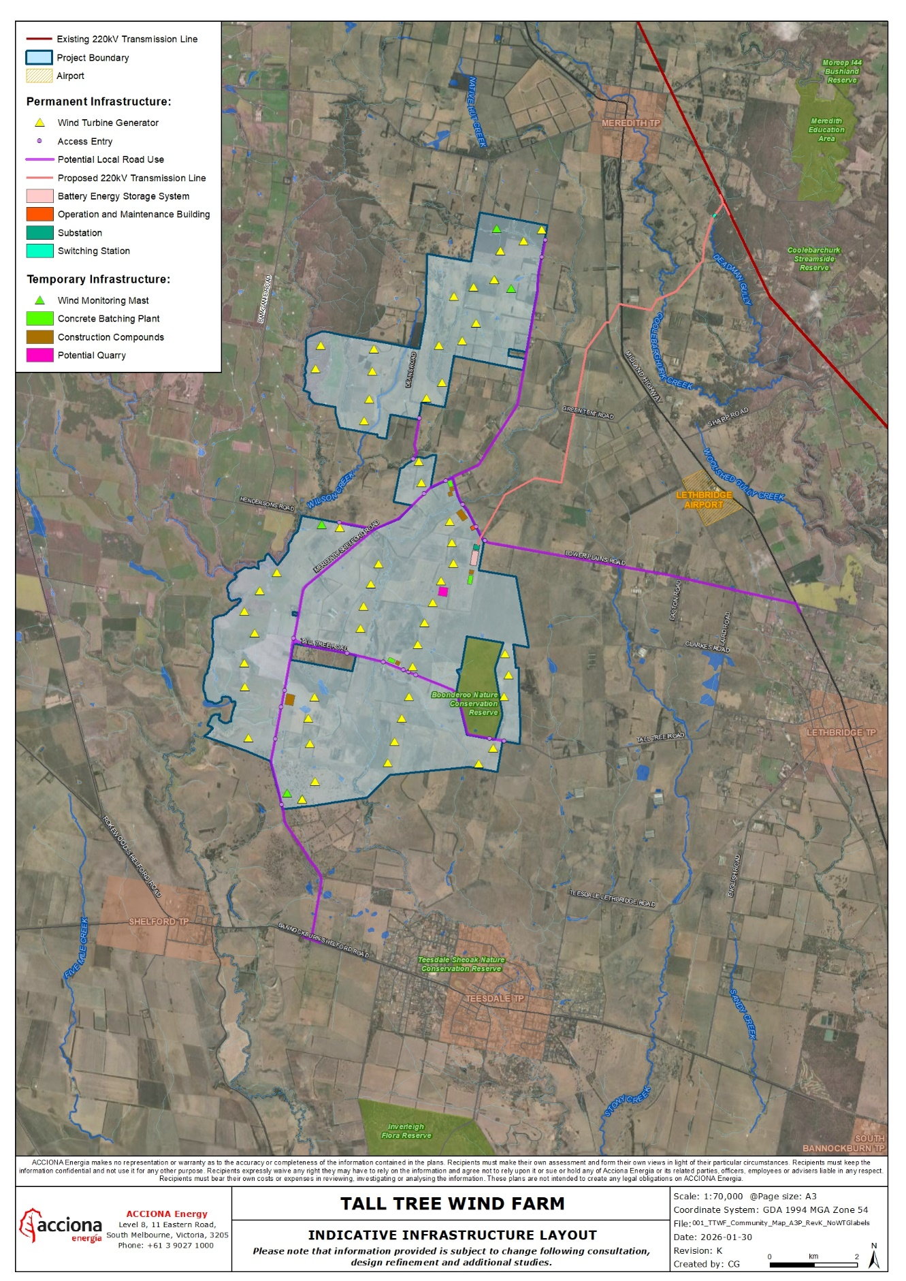
The project consists of two sections – the Wind Farm Area covering approximately 5,100 ha and the Transmission Corridor covering approximately 103 ha. The project is designed to include up to 53 wind turbine generators (WTGs) and associated infrastructure. The WTGs are proposed to have a hub height of up to 169m and a maximum blade tip height of 250.5m.
Additional ancillary infrastructure and developments will include access tracks, road upgrades, meteorological monitoring masts, borrow pit, one switchyard, one substation, one battery energy storage system (BESS) and operation and maintenance buildings, including a carpark and office facilities.
The final design and location of the components of the project, including infrastructure and final technology selection, will be subject to further detailed design and assessment.
It is estimated the project will take approximately two years to construct and will operate for at least 30 years. An indicative timeline is provided in Figure 2.
Figure 2: Project timeline
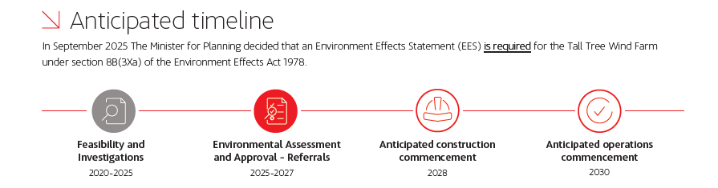

The project was referred to the Victorian Minister for Planning in July 2025. In September 2025, the Minister determined that an EES would be required to assess the potential effects of the project.
An Environment Protection and Biodiversity Conservation (EPBC) referral was also submitted to the Department of Climate Change, Energy, the Environment and Water (DCCEEW) in July 2025. The project was deemed a controlled action in October 2025 and will require assessment and approval under the EPBC Act before it can proceed. The proposed action will be assessed under a bilateral agreement under the Victorian Environment Effects Act 1978.

communications and engagement approach
ACCIONA Energía recognises the importance of community and stakeholder engagement to inform the planning and design of the project. This plan is focused on gathering, responding to and considering feedback from stakeholders and community to inform the preparation of the EES (including the approach to mitigating impacts) and encourage community and stakeholder participation in the EES process.
We are committed to consistent, targeted and meaningful engagement and this plan is guided by the principles in Table 1Error! Reference source not found..
This entails active consultation with stakeholders from the early phases of project development, through to operations and decommissioning to ensure community issues and opportunities form part of project planning and delivery. Engagement feedback during the preparation of the EES will be themed and analysed to assist in developing an understanding of potential mitigation measures.
We will operate in accordance with the International Association of Public Participation (IAP2) Core Values, the Clean Energy Council (CEC) Charter and relevant privacy acts and regulations. We will continue to work to address issues of concern to the community and interest groups throughout the project lifecycle. We understand that issues may arise in our engagement with local communities and stakeholders, and that there will be differences of opinion. We will be transparent, respectful and helpful in our interactions and expect our stakeholders to avoid unacceptable behaviour when engaging with our team.
We will ensure there is:
- A stringent record-keeping process for stakeholder and community interactions, and all commitments made
- An inclusive and transparent approach to our interactions with community members and stakeholders, ensuring a diverse range of channels, guided by their preferences
- Clear opportunities for community members and stakeholders to ask questions and provide feedback
- A process for feedback to be considered within project design and delivery
- Consideration of potential risks, issues and opportunities, through both informal and formal methods to ensure we work with the local community to achieve the best possible outcomes
- Development and agreement of mitigations at the earliest opportunity and capturing these in relevant management plans
- Clear communication of and adherence to the Acciona Energía Complaint Management Handling Procedure.
Table 1: Engagement principles
principle
Early engagement | To establish and build relationships with stakeholders, including the local council, First Nations, project neighbours, community members, and key stakeholders such as Lethbridge Airport, to identify risks and concerns.
Genuine engagement | By sharing timely information both online and in printed form, including layout and footprint details, impacts and benefits, while providing opportunities for consultation relevant to the level of impact and interest in the project and collaboration with potentially affected landholders and community members.
Local focus | With active listening to community feedback about the project, tailored engagement methods and pivoting when possible to accommodate the community’s needs

This plan and associated engagement program have also been guided by:
- Clean Energy Council’s Best Practice Charter
- Clean Energy Council’s Leading Practice Principles First Nations and Renewable Energy Projects (2024)
- Clean Energy Council’s Community Engagement Guidelines For the Australian Wind Industry (2018)
- Victorian Government Community Engagement and Benefit Sharing in Renewable Energy Development in Victoria (2021)
- IAP2 Public Participation Spectrum
- International Association for Impact Assessment’s Best Practice: Principles of Environmental Impact Assessment (1999)
- VicGrid’s Draft Community Engagement and Social Value Guidelines (2025)

Engagement objectives
During the preparation and exhibition of the EES our communication and engagement objectives are to:
- Build on engagement and feedback captured before the commencement of the EES process
- Build community and stakeholder awareness and understanding of the project, EES process and opportunities to participate
- Actively involve and consult stakeholders and community in the project’s development and planning to improve outcomes
- Encourage participation and seek input during the preparation of the EES, to identify issues of potential concern, obtain local insight and gain feedback on measures to address concerns
- Demonstrate how feedback is captured and considered in the development and assessment of the project.

Communications and engagement activities and METHODS
A range of activities and tools will be used to support engagement through the EES process. These will be designed to ensure stakeholders and community members have access to appropriate information and that feedback is captured and considered.
Some of these tools have already been used to engage with the community and stakeholders during early planning of the project. Examples of some collateral developed to date are included in Appendix B. We will continue to tailor tools and activities to the project phase to maximise engagement reach.
Table 2 outlines communication and engagement tools and activities that may be used during the EES process. These tools and materials will be adapted to help reach Culturally and Linguistically Diverse (CALD) communities and other hard to reach groups as required. We recognise that stakeholders prefer different engagement methods and online content can be difficult for some users to navigate and will seek to provide accessible content and a mix of online and face-to-face engagement to reach as many people as possible.
Table 2: Communication and engagement tools
Tool/activity | purpose
Advertisements | Print and digital advertising will be used to inform people about the project and feedback opportunities, including exhibition of the draft scoping requirements and EES. Advertisements will be placed in newspapers, newsletters and other community publications.
Community events | We will look for opportunities to attend and contribute to existing events such as markets and festivals. This provides further opportunities for community members to directly engage with project staff and ask questions in a casual one-on-one setting.
Community information sessions | These may be online and/or in-person drop-in sessions. They provide a forum for the project to provide information on specific topics, display and discuss EES documentation, and get direct feedback on community issues and concerns to inform project development. They also allow the community to directly engage with the project team and ask questions.
Digital tools | Online tools such as an interactive map and surveys
Engagement reports | Used to report back to stakeholders and community about feedback captured and how it has informed project planning and development.
Factsheets | Factsheets will be developed to share information on particular topics, distilling technical information into easy-to-understand language.
FAQs | Frequently Asked Questions document to enable consistent responses to common questions are regularly updated on the online community hub.
Feedback forms | Used to capture concerns, issues, and interests from community members attending information sessions and events.
Information hub | Should the project go ahead, we will establish a local project information hub once construction starts, providing a place for the community to view up-to-date information and engage with project staff. The information hub would be in a central and easily accessible location.  During the pre-construction and construction phases, the presence of project team members would be increased at the information hub to provide the community with face-to-face access to relevant subject matter experts.  Information relating to available jobs and supplier opportunities during the construction phase would be on display and interested applicants would be able to drop in resumes and register their interest in the project. The information hub would also be an important location to source information relating to community benefits.
Letters and emails | Tailored letters and emails are used for direct engagement with affected stakeholders. Letters will include relevant updates on the project and key details such as planning and construction milestones.
Maps and visual aids | Maps, and other visual aids showing project scope and other aspects will be created and used at information sessions and online. These will be updated as the project progresses.  Visual montages will be offered to boundary neighbours to help understand their unique visual impacts in relation to the project.
Media releases | Media releases will be issued to communicate milestones, opportunities and other key announcements. Copies will be provided to relevant media outlets. Major project milestones may also involve media events.
Meetings, briefings and workshops | Online and face to face meetings, briefings and workshops will be used to support engagement with key stakeholders such as host landowners, neighbours, community interest groups, local council, industry groups, Registered Aboriginal Parties and Traditional Owner groups.  These opportunities will allow us to provide current information about the project, the EES process and consultation, and for targeted conversations on specific areas of interest with technical experts. These sessions also provide an opportunity for the project to seek input on specific matters about the EES from stakeholders with local or specialist knowledge.
Mobile office | We will operate a regular mobile office during the EES process. These will rotate across nearby towns with a full schedule published. The doors will be open for anyone to come along and ask questions, and an appointment system will also be used to enable community members to book a time to discuss particular topics with relevant specialists.
Online Community Hub | An online community hub (https://community.acciona.com.au/talltree ) has been established since April 2023 as a single source of information that all stakeholders can access. The hub is regularly updated to ensure information is current. Elements of the hub include:  - An interactive map where users can map their comments/concerns and review those made by others  - Ask a question feature where users can post their questions and receive an answer from the project team. All questions and answers remain visible on the site.  - News feed so stakeholders can read the latest information and old posts  - Project timeline  - Videos of online sessions  - FAQ documents, factsheets  - Summary reports of past information sessions and slides
Online news | Project updates will be posted as news items on the Online Community Hub and will also be sent via email to subscribers, providing an opportunity to build on the existing subscriber base for ongoing communications.
Project flyers | Project flyers are used to advertise upcoming community engagement events, shared by direct mail and online.
Social media | We understand that different social media platforms appeal to different audiences, and we use a variety of platforms to interact with and keep the public informed about our projects. We will leverage all our social media platforms including Twitter, Facebook, YouTube, Instagram, and LinkedIn to increase awareness of the project and connect with our audiences.
Stakeholder and feedback database | We maintain a stakeholder and feedback database using Consultation Manager. This system captures stakeholder information and specific engagement details, ensuring that stakeholder feedback, concerns, and enquiries are recorded and addressed. The system is used to record all queries including those raised at community meetings and assign actions to relevant staff to ensure these are followed up promptly.
Surveys and questionnaires | These will be used to gather feedback from stakeholders and community as required and include online and physical handout questionnaires.
Wind farm tours | We will seek to provide site tours at other projects throughout the planning, approval, and construction stages to familiarise stakeholders with an operating wind farm. They can provide on the ground context and be targeted to address concerns of specific individuals or groups, or themed to reflect technical areas. If the project is approved and the Tall Tree Wind Farm becomes operational, tours of the wind farm will be available to the broader community.
1800 number and email | Free communication channels for stakeholders and community to contact the project team directly, provide feedback, and submit concerns/queries at any time.

How feedback is used
ACCIONA Energía will collect, record and consider all feedback captured before and during the EES engagement phase and demonstrate how it has been considered in the development of the EES.
The community and stakeholder engagement chapter in the EES will detail what feedback has been received and how it has been considered in the project’s development.
A consultation summary report will also be prepared, providing a summary of key elements of feedback received and outlining how that feedback has been considered and used in the ongoing development and planning of the Tall Tree Wind Farm.
Community and stakeholder feedback will inform various aspects of the project and preparation of the EES as outlined in Table 3.
Table 3: How feedback is used
Project phase | how feedback is used
Design | - Informs options development and assessments  - Considered in project scope refinement  - Informs project layout and design including number and location of wind turbine generators, transmission line easement route, and other project infrastructure
Planning and environmental assessment | - Enhances our understanding of the local environment, potential issues and opportunities  - Considered in prioritising and preparing impact assessments  - Considered in developing impact mitigation strategies  - Informs Environmental Management Framework, management measures and site management plans for construction, operation and decommissioning
Construction and operations | - Considered in construction methodology, timing and impact mitigation - this may include consultation on proposed transport routes  - Informs communication and engagement approach

Project stakeholders
Stakeholder identification and analysis is critical to developing a successful engagement approach. The term ‘stakeholder’ refers to any person, group or organisation with an interest in, or who is impacted by, the project.
Stakeholders and their interests may change over time and the engagement approach needs to be flexible and adapt as required to ensure effective engagement.
Key stakeholder groups for the Tall Tree Wind Farm project and their key areas of interest are shown in
Table 4. A list of individual stakeholders within these groups is provided in Appendix A.

Table 4: Stakeholder groups and interests
Group | Known/likely interest
Commonwealth Government | - National energy security and transition strategy  - Project objectives support government policies  - Environmental impact, biodiversity protection, and adherence to EPBC approval conditions  - Economic development, employment opportunities, community investment / programs.
State Government | - Project objectives support government policies  - Adherence to planning approvals process and permit conditions  - Facilitation of EES process and TRG meetings (DTP Independent Assessment Unit)  - Impacts from construction and operational activities – noise, dust, traffic management, land management, road maintenance, local ecology and biodiversity  - Decommissioning  - Economic development, employment opportunities, community investment / programs.  - Opportunities for skills development and investment in regional Victoria
Local Government | - Adherence to planning permit conditions  - Impacts from construction and operational activities – noise, dust, visual, traffic management, land management, road maintenance, local ecology and biodiversity  - Decommissioning  - Economic development, employment opportunities, community investment / programs  - Community Engagement
Industry | - Supply and contract opportunities, economic development  - Impacts from construction and operational activities – visual impacts, noise, dust, traffic management, road maintenance, land management,  - Decommissioning  - Employment and training opportunities
Community organisations | - Education opportunities, community investment / programs, community events  - Impacts from construction and operational activities – traffic management, land management, road maintenance
Advocacy and interest groups | - Impacts on and management of flora and fauna and local ecology/biodiversity.  - Reductions in emissions due to replacing fossil fuels with renewable energy  - Construction and operational activities, land management, environmental management  - Decommissioning.
Host landowners | - Impacts from construction and operational activities – visual impact, shadow flicker, fire risk, blasting, noise, dust, health impacts, traffic management, road maintenance, land management, decommissioning  - Property values  - Lease agreements  - Potential offset program opportunities  - Landscape plans  - Potential offset program opportunities
Boundary neighbours | - Impacts from construction and operational activities – visual impact, shadow flicker, fire risk, blasting, noise, dust, health impacts, local ecology and biodiversity, traffic management, road maintenance, land management, decommissioning  - Transmission line location  - Neighbour benefit scheme  - Property values  - Consultation approach  - Landscape plans
Neighbouring communities | - Impacts from construction and operational activities – noise, visual, fire risk, blasting, dust, traffic management, land management, local ecology and biodiversity, road maintenance, decommissioning  - Proximity to local townships  - Community benefit framework  - Employment opportunities, community investment / programs.
Lethbridge Airport | - Project location and turbine height  - Proximity to airport and buffer zone  - Turbulence impacts  - Pilot/aviation safety  - Impacts on the airport’s training area  - Firefighting practices  - Airport operations  - Risk assessments
First Nations & Traditional Owners | - Cultural heritage and land management.  - Cultural Values Assessment  - Cultural Heritage Management Plan  - Employment opportunities / indigenous procurement plan.
Emergency services | - Impacts from construction and operational activities – traffic management, land management, road maintenance  - Bushfire management  - Community investment / programs  - Training opportunities, safety demonstrations, safety plan
Utilities and infrastructure | - Electricity infrastructure, connection and supply
Media | - Construction and operational activities, environmental management, employment opportunities, local housing impacts, reductions in emissions, community relations,  - Community investment / programs
Education and training providers | - Education opportunities, community investment / programs  - Jobs, apprenticeships and traineeships  - Cadetships, research projects, scholarships, employee training programs
Project partners | - Supply and contract opportunities, economic development
Other infrastructure developers | - Wind farm and infrastructure footprint, community engagement

host Landowners
Engagement with host landowners has been ongoing since 2021 and has included letters, phone calls, emails, and one-to-one meetings. To date this engagement has included introducing the project and development timelines; discussion around agreements, access, and layout, providing project updates; and addressing emerging issues and concerns.
Due to the close and unique working relationship between host landowners and the project team, and to meet the individual needs of each host landowner, we tailor our engagement approach for each host landowner according to their personal preferences and needs.
We will continue to prioritise engagement with host landowners to ensure they are provided meaningful updates and can have their questions and concerns answered promptly by the project team.

Boundary and project site neighbours
Engagement with near neighbours (those within 2.5km of a turbine) has been ongoing since late 2022 and has included letters, phone calls, emails and meetings. At the request of some project boundary neighbours, the project team attended a meeting in September 2024 to discuss concerns unique to this stakeholder group. Boundary neighbours also requested details about the project’s transmission line. The transmission line route was subsequently published on the Online Community Hub in February 2025.
In late 2024, we released details of the proposed Neighbour Benefit Program to those within 2.5km of the proposed project.
We will continue to engage with boundary neighbours throughout the project lifecycle.

Traditional Owners

We recognise Traditional Owners as rights holders and engage with them in accordance with their their self-determined interests.
We are engaging with the Wadawurrung Traditional Owners Aboriginal Corporation (WTOAC). This engagement has been ongoing since early 2022 via meetings, phone calls and emails. Engagement has focused on introducing the project, project timelines, cultural heritage studies to inform the Cultural Values Assessment (CVA) and Cultural Heritage Management Plan (CHMP), potential partnership and employment opportunities, and communication and engagement preferences.
In early 2025, the Tall Tree project team participated in an On-Country cultural heritage training session facilitated by Wadawurrung Traditional Owners. This small but important step helps our staff to build knowledge and appreciation in valuing the spiritual and physical intrinsic connection that Traditional Owners have to the land and waters. It also reinforces the importance of working closely and respectfully with Wadawurrung in the development of the project.
We will continue proactively engaging with representatives from the WTOAC on Aboriginal and Cultural Heritage matters, future procurement opportunities and to co-design First Nations-related project benefits.

Lethbridge AirPORT STakeholders
We commenced engagement with Lethbridge Airport in September 2022 and subsequently with the airport owner and adviser in February 2023.
In response to feedback, we established a series of targeted stakeholder meetings to address the unique concerns of specific groups. To date, we have had five meetings with the Lethbridge Airport stakeholders (including the owner, hangar tenants and pilots). We also provided these stakeholders a document (the ‘aviation memo’) summarising the key findings of the Aviation Impact Assessment being prepared for the Project by specialist aviation consultants, and sought to respond to a number of concerns and queries that had been raised in previous engagement.

Hard to reach and vulnerable groups
We will work with local government and other service providers to identify hard to reach and vulnerable groups and develop approaches to ensure our engagement is inclusive and as accessible as possible. Such groups might include neurodiverse people, time-poor working population and time-poor parents of pre-school and school-aged children. English is the dominant language spoken in the region, indicating minimal need to broadly translate project collateral, however this need will be considered on a case-by-case basis.
We are committed to delivering an engagement program that is a mix of digital, written and in-person methods and tools to ensure as many people as possible are able to engage with the project and provide feedback.

Engagement program
ACCIONA Energía is undertaking a phased engagement program as outlined in Table 5.
Table 5: Phased engagement program
phase | project activities | engagement activities | how feedback informs the project
Feasibility  2021 to 2025 | Preliminary studies and land access agreements | Introduce and build awareness about the project  Seek information about existing environmental conditions and concerns.  Educate stakeholders on planning process and general wind farm information | Potential community and environmental impacts identified.  In response to early concerns and following discussions with landowners, we agreed to remove six turbines from the south-east corner of the project and reduce the proposed maximum turbine height by over 20 metres.  Early feedback informed development of the neighbour benefit program and broader community benefit sharing approach
Environmental assessment and approvals  2025 to 2027 | EES assessment and detailed design | Seek input and feedback on potential environmental and community impacts and project design.  Present findings of environmental and technical studies.  Inform community and stakeholders about the EES process and how they can provide feedback. | EES assessment and approvals process and decision.  Project design refinement.  Impact mitigation strategies.
Construction  Anticipated 2028 to 2030 | Preparation and approval of management plans  Construction of wind farm and associated infrastructure  Testing and commissioning | Inform community and stakeholders of EES outcome and approval conditions  Construction updates and impact mitigation  Development of community benefit sharing program | Community benefit sharing  Continuous improvements to construction engagement
Operations  anticipated from 2030 | Facility expected to be operational for at least 30 years | Inform community and stakeholders of facility opening  Inform public of adherence to environmental performance requirements  Collect and respond to inquiries and feedback related to operations and impacts | Minimise operational impacts on community and environment
Decommissioning  Expected after 30 years | Decommissioning Plan developed and operationalised | Develop Engagement Plan to support decommissioning  Inform community and stakeholders of decommissioning  Maintain 1800 helpline, email and complaints processes | Minimise decommissioning impacts on community and the environment

Feasibility phase
Engagement on the Tall Tree Wind Farm project commenced in 2021. Engagement during the feasibility phase (2021 to 2025) focused on raising awareness about the project and seeking early input from stakeholders and community.
Engagement activities included face-to-face, online and phone engagement with host landowners and near neighbours. Three rounds of community information sessions were also held with the broader community along with briefings with First Nations representatives and key stakeholders including Golden Plains Shire and Lethbridge Airport. This engagement provided an opportunity to introduce the project, establish relationships, gather early views on renewable energy projects in the area, and inform the iterative development of the community and stakeholder engagement strategy.
Figure 3 provides a snapshot of engagement activities during this phase.
Figure 3: Engagement activities during feasibility phase
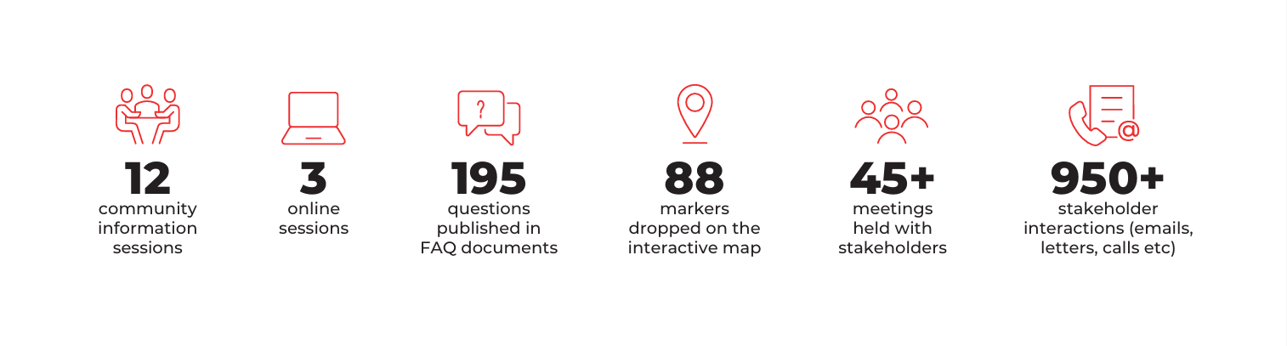
This phase of engagement identified key issues and questions about the following topics:
- Project location, layout and timelines
- Shadow flicker
- Fire risk and emergency services
- Decommissioning and recycling
- Economic impacts
- Blasting
- Noise and vibration
- Environmental and ecological concerns
- Aviation safety
- Transmission corridor
- Planning process
- Property values
- Health and neurodiverse communities
- Visual impacts
- Project design
- Community benefits
- Engagement approach

Ees engagement program
The engagement program to support the EES process is outlined in Table 6Table 6: EES engagement program. This includes the Feasibility phase outlined in the previous section and two further phases – ‘EES scoping and preparation’ and ‘Public exhibition and inquiry’.
Engagement during the EES scoping and preparation phase will be focused on supporting project design and the preparation of the EES. Stakeholders and community will have the opportunity to provide feedback on the draft EES scoping requirements, and the project team will seek input and feedback to inform technical studies and assessments. Table 7 outlines specific engagement focused on informing technical studies.
The focus of engagement during the public exhibition and inquiry phase will be to present the project and completed impact assessments and provide clear information about how prior feedback has been considered and reflected in the project design. A range of communication activities will be used to ensure stakeholders and community understand the EES exhibition and inquiry process and how they can make a submission.

Table 6: EES engagement program
phase | feasibility phase: 2021 to 2025 | ees scoping and preparation: late 2025 to early 2027 | public exhibition and inquiry: 2027
IAP2 Spectrum level of participation | Inform, consult | Inform, consult, involve | Inform, consult, involve
Engagement purpose | Raising awareness and seeking early input to technical studies | Supporting project design and planning process | Supporting EES public exhibition and inquiry
Tools and activities | - Community benefits questionnaire  - Community information sessions (online and/or in-person)  - Engagement reports  - Fact sheets and flyers  - Feedback forms  - FAQs  - Letters and emails  - Maps  - Meetings and briefings  - Online community hub  - Online news  - Social media  - Social pinpoint map  - Stakeholder and feedback database  - 1800 number and email | - Advertisements  - Community benefits questionnaire  - Community events  - Community information sessions (online and/or in-person)  - Engagement reports  - Fact sheets and flyers  - Feedback forms  - FAQs  - Letters and emails  - Maps and visual aids  - Media releases  - Meetings and briefings  - Mobile office  - Online community hub  - Online information videos  - Online news  - Social media  - Social pinpoint map  - Stakeholder and feedback database  - Wind farm tours  - 1800 number and email | - Advertisements  - Community events  - Community information sessions (online and/or in-person)  - Engagement reports  - Fact sheets and flyers  - FAQs  - Letters and emails  - Maps and visual aids  - Media releases  - Meetings and briefings  - Online community hub  - Online information videos  - Online news  - Physical information hub  - School engagement  - Social media  - Stakeholder and feedback database Wind farm tours  - 1800 number and email
How feedback has been/will be used | Feedback has informed:  - Future engagement  - Project design  - EES planning and impact assessment program | Feedback will inform:  - Future engagement  - Project design  - EES preparation including understanding of key issues and concerns to inform impact assessments and proposed impact mitigation strategies | Feedback will inform:  - Priority areas of interest to be included in future engagement  - Construction methodology and mitigation strategies  - Development of management plans for construction phase

Table 7: Indicative program of further engagement on EES technical studies
Note: Timings in this table relate to engagement specific to technical studies; broader engagement may have occurred at an earlier date.
Technical study | stakeholder | Activities | approximate timing
Biodiversity | Golden Plains Shire council  DEECA Grampians Region  DTP  Country Fire Authority  Parks Victoria | Site surveys, phone calls, meetings, emails, information sessions, webinar, website content and project newsletters. | Mid 2021 – September 2026
Aboriginal Cultural Heritage | WTOAC  First Peoples – State Relations | Site surveys with WTOAC, phone calls, meetings, emails | January 2022 – September 2026
Landscape and visual amenity | Golden Plains Shire Council  Boundary and project site neighbours  Host Landowners  Neighbouring Community | Site surveys, phone calls, meetings, emails, information sessions, webinar, website content and project newsletters | November 2024 – September 2026
Noise and vibration | EPA  Parks Victoria  Host Land owners  Boundary and project site neighbours | Noise monitoring, phone calls, meetings, emails, information sessions, webinar, website content and project newsletters | June 2025 – September 2026
Groundwater and groundwater dependent ecosystems | Southern Rural Water  Golden Plains Shire Council  Corangamite Catchment Management Authority | Phone calls, meetings, emails | February 2026 – September 2026
Bushfire Risk | State CFA  Host Land owners  Boundary and project site neighbours  Neighbouring Community  Golden Plains Shire Council | Phone calls, meetings, emails, information sessions, project newsletters | February 2026 – September 2026
Traffic and transport | DTP  VicRoads  Golden Plains Shire Council  Emergency Services  Parks Victoria  Host Land owners  Boundary and project site neighbours  Neighbouring Community | Site surveys, traffic monitoring, phone calls, meetings, emails, information sessions, project newsletters | February 2025 – September 2026
Aviation | Airservices Australia  Department of Defence  Avalon Airport  Ballarat Airport  Lethbridge Airport  Vic Ambulance  Vic CFA  Field Air Ballarat  Bureau of Meterology | Phone calls, meetings, emails, information sessions, project newsletters | August 2022 – September 2026
Social impact | Host landholders  Boundary and project site neighbours  Community members of Meredith, Teesdale, Shelford and Lethbridge  State and Federal Members of Parliament  Golden Plains Shire Council  Wadawurrung Traditional Owners Aboriginal Corporation  Department of Transport and Planning  Department of Energy, Environment and Climate Action  Emergency services, including the CFA HQ and local brigades  Lethbridge Airport  Local community organisations, businesses and schools | Phone calls, one-on-one discussions, dwelling visits, meetings, emails, information sessions, project newsletters | March 2026 – September 2026
Air quality | EPA | Phone calls, meetings, emails | February 2026 – September 2026
Surface Water | DEECA  DTP  EPA  Corangamite Catchment Management Authority  Golden Plains Shire Council | Phone calls, meetings, emails | February 2026 – September 2026
Land use and planning | Parks Victoria  Golden Plains Shire Council | Site survey, phone calls, meetings, emails | February 2026 – September 2026
Shadow Flicker | EPA  Host Land owners  Boundary and project site neighbours | Phone calls, meetings, emails, information sessions, project newsletters | November 2024 – September 2026
Electromagnetic interference | Bureau of Meteorology | Phone calls, meetings, emails | February 2026 – September 2026
Historical heritage | Golden Plains Shire Council  Heritage Victoria | Site survey, phone calls, meetings, emails | June 2025 – September 2026

Engagement during construction
The project will continue to engage stakeholders and community during the construction phase of the project, should it go ahead. This will include:
- Regular project updates
- Works notifications to advise community of upcoming construction activities and impacts
- Landowner engagement to support access for construction
- Community information sessions
- Local information hub
- Newsletters and factsheets
- 1800 helpline, email and online community hub
- Enquiries and complaints register

engagement during operation
The focus of engagement during the operational phase will be ensuring positive ongoing relationships with the local community and stakeholders. Activities would include:
- Continued implementation of the community benefit sharing program
- Investigation and development of local partnerships as appropriate, such as school/education programs
- Evaluation and reporting to communicate economic, social and environmental performance in the community
- Continuation of the Enquiries and complaints register, 1800 number, email and online community hub.

Engagement to support decommissioning
As part of the responsible management of all assets, we would develop a Decommissioning Plan ahead of the Tall Tree Wind Farm ceasing operations. Engagement with neighbours and key stakeholders remains a key activity before and through this phase.
An Engagement Plan would be developed alongside the Decommissioning Plan, to include the following:
- Continuation of the Enquiries and complaints register, 1800 number, email and online community hub.
- Collaboration with local council and key community groups to forward-plan for potential impacts on the socioeconomic status of the region.
- Informative communications on the approach to decommissioning, timing, impacts, and mitigation of environmental concerns.
- Support for onsite personnel to transition to other employment in the area.
- Support for community groups and grant recipients to sustain partnership programs and initiatives.

Management of records and enquiries

Stakeholder management database
ACCIONA Energía maintains a stakeholder and feedback database using Consultation Manager. This system captures stakeholder information and all communications and interactions, ensuring stakeholder feedback, concerns, and enquiries are recorded and addressed. The system is used to record all queries, including those raised at community meetings, and assign actions to relevant staff to ensure these are followed up promptly.

Media enquiries
We have developed a media strategy, including clear protocols for management of media enquiries. These protocols will be shared with our delivery partners to ensure a consistent approach to responding to media.

Personal information
ACCIONA Energía respects the privacy of all stakeholders and community members and is committed to protecting personal information. Information about how we collect, use, disclose and protect personal information is available in our Privacy Policy (https://community.acciona.com.au/privacy-policy).

Review and evaluation
The effectiveness of the engagement approach and activities outlined in this plan will be measured against the outcomes achieved against our engagement objectives as described in Table 8.
The tools used to measure achievements against our objectives include:
- Volume and nature of feedback from engagement activities including community information sessions, phone calls, emails, and meetings
- Website traffic, including page views and downloads
- Number and content of survey responses
- Media and social media monitoring
- Feedback forms collected at community engagement events.
Feedback received during the EES consultation and responses to this feedback will be recorded in EES documentation which will be reviewed by the Technical Reference Group (TRG).
This plan will also be reviewed and updated as required.
Table 8: Measuring effectiveness against the engagement objectives outlined in this plan
objective | what will be achieved
Build on engagement and feedback captured before the commencement of the EES process | - All feedback captured to date is considered in the preparation of the EES and project design
Build community and stakeholder awareness and understanding of the project, EES process and opportunities to participate | - Range of communication and engagement activities used to share information widely and ensure different audiences receive required information  - Community and stakeholders know how they can contact the project team  - Community and stakeholders understand how they can engage with the EES process and make submissions
Actively involve and consult stakeholders and community in the project’s development and planning to improve outcomes | - EES documentation reflects information gathered from community and stakeholders  - Project design reflects consideration of feedback gathered from community and stakeholders  - Impact mitigation strategies are informed by community and stakeholder feedback
Encourage participation and seek input during the preparation of the EES, to identify issues of potential concern, obtain local insight and gain feedback on measures to address concerns | - Effective stakeholder identification and mapping with engagement activities tailored to meet their engagement needs  - Multiple engagement opportunities to encourage attendance via mobile office, community information sessions and stakeholder meetings/briefings  - EES documentation addresses key issues of concern
Demonstrate how feedback is captured and considered in the development and assessment of the project. | - EES documentation includes transparent information on feedback captured  - EES documentation clearly demonstrates how feedback has been considered and informed project design and impact mitigation strategies

Management of feedback and complaints
ACCIONA Energía recognises the importance of a fair, transparent and responsive enquiries and complaints management approach.
Feedback, enquiries and complaints can be made through the following channels:
Toll free telephone number | 1800 283 550
Email | talltree@acciona.com
Online community hub | Community.acciona.com.au/talltree
Post | Level 8, 11 Eastern Road, South Melbourne, Vic, 3205

It is important to define complaints as distinct from negative project feedback, noting all enquiries, feedback and complaints will be captured in the stakeholder management database (Consultation Manager) and actioned and responded to as appropriate. Consultation Manager will be maintained through to the end of the decommissioning phase of the facility.
All feedback received during the preparation of the EES will also be captured through the process outlined earlier in this plan.
The project will manage complaints in accordance with the process shown in Figure 4Figure 4. Our complaint management procedure will ensure prompt allocation of responsibility, action, and feedback to the appropriate and responsible person. The core objective is to respond and provide resolutions to all complaints in a timely manner.
Contact details for the project are published on the online community hub, project materials such as letters and fact sheets, and made available at community information sessions and events.
Figure 4: Complaints management process

messaging
The following messaging will be used in communications with the community and stakeholders to ensure a consistent understanding of the project, the EES process, and our consultation approach. Messaging will be periodically updated as required.

About the Project
- The Tall Tree Wind Farm is a proposed renewable energy project located within the Central Highlands Renewable Energy Zone (REZ). It is located within the Golden Plains Shire, south of Meredith, west of Lethbridge, north of Teesdale in Central West Victoria.
- The site was chosen due to its strong wind resource, open and undulating terrain, nearby port access and proximity to a strong grid connection.
- The project will create up to 270 construction jobs and 10-12 jobs during its operation over its multi-decade lifespan.

the ees process
- The Minister for Planning has determined that an Environment Effects Statement (EES) is required to be prepared for the project.
- The EES will contain an assessment of the potential environmental, social and planning effects of the project.
- The matters to be addressed in the EES will be set out in scoping requirements issued by the Minister for Planning. The scoping requirements will be finalised following exhibition for public comment.
- A Technical Reference Group (TRG), including relevant government agencies and local councils, has been convened by the Department of Transport and Planning to advise on environmental and social issues throughout the EES assessment.
- We will engage with the community and stakeholders to prepare the EES.
- The completed EES will be exhibited for public comment, followed by an independent inquiry.
- The Minister for Planning will consider the inquiry report and then prepare a Minister’s Assessment to inform statutory approvals decisions for the project.

consultation
- Acciona Energía will continue to engage with the local community and stakeholders throughout the project lifecycle.
- During the preparation of the EES we will seek feedback on key project matters and there will be various opportunities for community and stakeholders to engage with the project team and provide feedback.

DEFINITIONS
TERM | DEFINITION
AEMO | Australian Energy Market Operator
BESS | Battery Energy Storage System
CALD | Culturally and Linguistically Diverse
CHMP | Cultural Heritage Management Plan
CVA | Cultural Values Assessment
DAFF | Department of Agriculture, Fisheries and Forestry
DCCEEW | Department of Climate Change, Energy, the Environment and Water
DEECA | Department of Energy, Environment and Climate Action
DITRDCSA | Department of Infrastructure, Transport, Regional Development, Communications, Sport and the Arts
DPC | Department of Premier and Cabinet
DTF | Department of Treasury and Finance
DTP | Department of Transport and Planning
EES | Environment Effects Statement
EPA | Environment Protection Authority
EPBC | Environment Protection and Biodiversity Conservation
ICN | Industry Capability Network
RDV | Regional Development Victoria
REZ | Renewable Energy Zone
TRG | Technical Reference Group
WTOAC | Wadawurrung Traditional Owners Aboriginal Corporation
WTGs | Wind Turbine Generators

Appendix A: project Stakeholders
Group | Stakeholder
Commonwealth Government | - Minister for Climate Change and Energy  - Minister for Infrastructure, Transport, Regional Development and Local Government  - Minister for Agriculture, Fisheries and Forestry  - Minister for the Environment and Water  - Minister for Regional Development, Local Government and Territories  - Local Members of Parliament  - Department of Climate Change, Energy, the Environment and Water (DCCEEW)  - Department of Infrastructure, Transport, Regional Development, Communications, Sport and the Arts (DITRDCSA)  - Department of Agriculture, Fisheries and Forestry (DAFF)  - Australian Energy Market Operator (AEMO)
State Government | - Minister for Climate Action; Energy and Resources; State Electricity Commission  - Minister for Environment  - Minister for Planning  - Minister for Regional Development  - Local Members of Parliament  - Department of Premier and Cabinet (DPC)  - Department of Treasury and Finance (DTF)  - Department of Energy, Environment and Climate Action (DEECA)  - Department of Transport and Planning (DTP)  - Parks Victoria  - Regional Development Victoria (RDV)  - Environment Protection Authority (EPA)  - Industry Capability Network (ICN)  - First Peoples-State Relations (within DPC)
Local Government | - Golden Plains Shire Council
Industry | - Local businesses  - Golden Plains Chamber of Commerce  - Accommodation providers
Community organisations | - Meredith Community centre  - Meredith Cricket Club  - Meredith History Interest Group  - Meredith RSL  - Lions Club of Meredith and District Lions Club  - Lethbridge Airport  - Scouts (Lethbridge)  - Footie Club (Lethbridge)  - Lethbridge Pilates  - Roos Cricket Club (Teesdale)  - Lions Club (Teesdale)  - Children Centre (Teesdale)  - Equestrian (Teesdale)
Advocacy and interest groups | - Local environmental interest groups  - Maude, Meredith and Districts Landcare Group  - RE-Alliance
Host landowners | - Wind farm host landowners  - Transmission host landowners
Boundary neighbours | - Directly adjoining landowners  - Properties within 2.5km of project boundary
Neighbouring communities | - Nearby towns of Lethbridge, Teesdale, Shelford, Meredith, Bannockburn
Lethbridge Airport | - Airport owner  - Hangar owners/tenants  - Pilots
First Nations | - Wadawurrung Traditional Owners Aboriginal Corporation
Emergency services | - Meredith and Bannockburn Police Stations  - CFA including:  - CFA HQ  - District 7  - Meredith  - Lethbridge  - Maude  - Teesdale  - Shelford  - Mount Mercer  - Bannockburn
Utilities and infrastructure | - AusNet  - Telstra  - Optus  - NBN Co
Media | - Radio Stations  - Newspapers  - Community Newsletters  - Community Facebook Groups  - Meredith and district news (community newsletter)  - Renew Economy
Education and training providers | - Meredith Primary School  - Meredith Kindergarten  - Garema Dumont  - Teesdale Primary  - St Mary Mackillop Primary School  - Lethbridge Primary School  - Lethbridge Park Public School  - Shelford Primary School  - Bannockburn P-12 College  - Work Readiness Training for Young People (through the Golden Plains Shire Council)  - Federation University Australia-Ballarat  - Asia-Pacific Renewable Energy Training Centre (APRETC)
Project partners | - Civil works suppliers, manufacturers, and other contractors
Other infrastructure developers | - Project developers

appendix b: examples of collateral

Project Map  Tall Tree Wind Farm Indicative Layout | 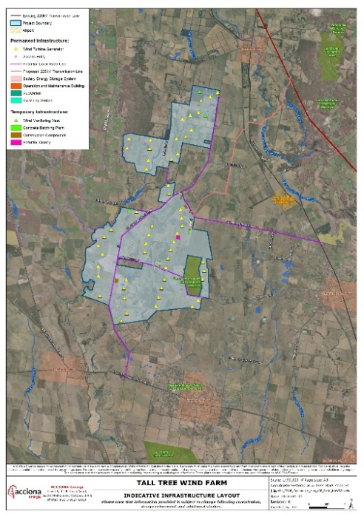
Project Factsheet  Tall Tree Wind Farm Factsheet | 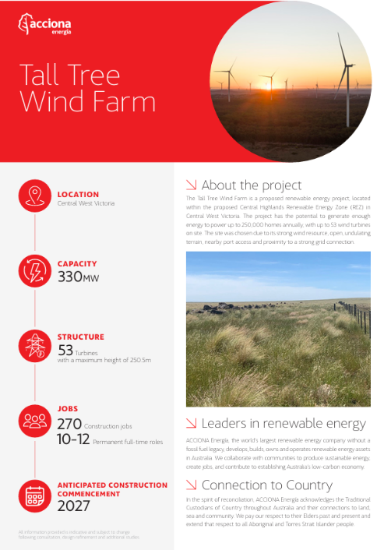
Project Email | talltree@acciona.com
Online Community Hub  Tall Tree Wind Farm | ACCIONA Energía Community | 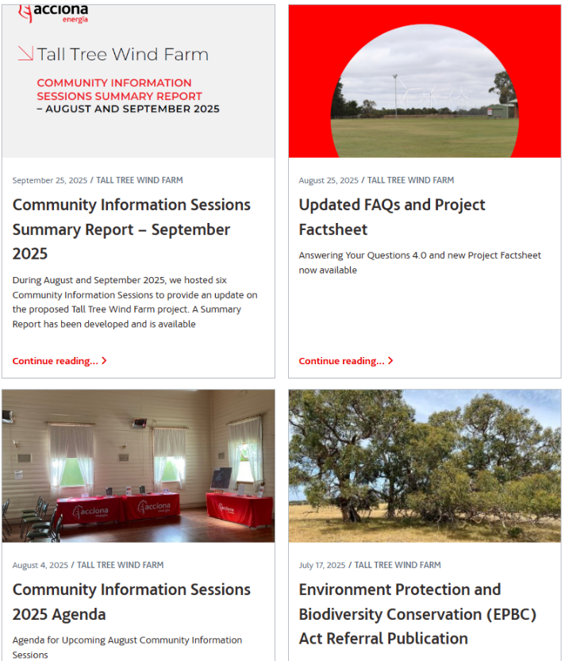
FAQ Document  Tall_Tree_Wind_Farm_-_Answering_Your_Questions_4.0.pdf | 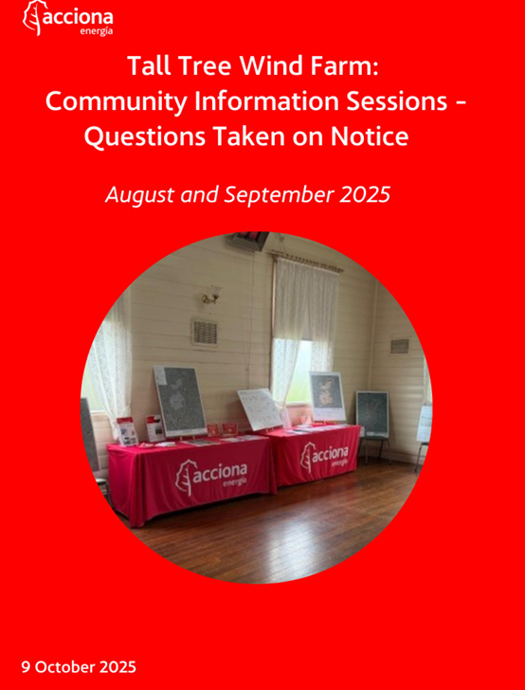
Community Information Summary Report  CIS summary Report September 2025 | 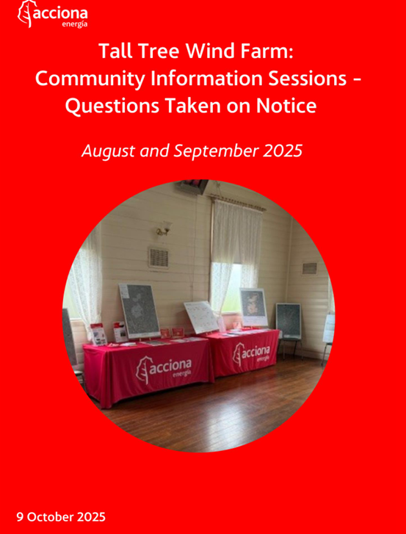
Online Information sessions  https://youtu.be/FDG4bsbwbWY?si=yJGEvbaYmwDVhmt- | 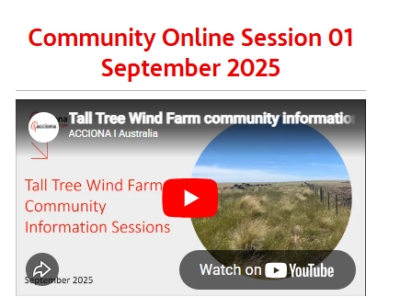
Information Session Flyer/Poster/AD | 