SCHEDULE 12 TO CLAUSE 43.04 DEVELOPMENT PLAN OVERLAY
--/--/2017
C170
New Schedule
Exhibition Version
31 July 2017
Shown on the planning scheme map as DPO12.
GRONN PLACE, BRUNSWICK WEST
This Schedule applies to land in PC367386 and Lots 2, 3, 4, 5, 7, 8, 9 and 10 LP33369 on Gronn Place and Kitchener Street, Brunswick West (referred to in this Schedule as ‘the site’). Refer to the boundaries shown on the Development Concept Plan included in this Schedule.
1.0 Requirement before a permit is granted
--/--/2017
C170
A permit may be granted for use or to subdivide land or to construct a building or to construct or carry out works that is not in accordance with the developmment plan.
A permit may be granted before a development plan has been approved for the following:
- The removal or demolition of any building that is carried out in accordance with a Construction Management Plan prepared in accordance with this Schedule;
- Earthworks and site preparation works that are carried out in accordance with a Construction Management Strategy and Arboricultural Assessment Report prepared in accordance with this Schedule;
- The construction of minor buildings or works that are carried out in accordance with a Construction Management Strategy prepared in accordance with this Schedule;
- Consolidation or subdivision of land; and
- Removal, variation or creation of easements or restrictions.
Before granting a permit the Responsible Authority must be satisfied that the permit will not prejudice the future use and integrated and orderly development of the site in accordance with the development plan requirements specified in this Schedule.
2.0 Conditions and requirements for permits
--/--/2017
C170
The following conditions and/or requirements apply to permits:
- Except for a permit granted before a development plan has been approved in accordance with Clause 1.0 of this Schedule, conditions that give effect to the provisions and requirements of the approved development plan;
- Prior to the commencement of any permitted demolition, buildings or works, a detailed Construction Management Strategy as relevant to that demolition or those buildings or works must be prepared to the satisfaction of the Responsible Authority. The plan must include, but not be limited to, the following:
  - Location of construction vehicle access and worker parking;
  - Protection of the amenity, access and safety of adjoining residents; and
  - Protection of trees on or adjacent to the site to be retained in accordance with an Arboricultural Assessment Report prepared in accordance with this Schedule.
3.0 Requirements for development plan
--/--/2017
C170

A development plan must include the following requirements.
General
The development plan must be prepared to the satisfaction of the Responsible Authority in consultation with Moreland City Council.
The development plan must seek to achieve the following objectives:
- To maximise the social, economic and environmental ‘return’ of public land assets and ensure the economic viability of the project.
- To deliver a sustainable and high quality development that contributes to the longevity of housing stock and reduces the cost of living.
- To create safe buildings and spaces throughout the site.
- To respond to the features of the site, such as context, aspect, topography and significant vegetation.
- To integrate with the surrounding area by responding to existing or preferred neighbourhood character, enhancing the public realm and existing networks and delivering ‘good neighbour’ outcomes.
- To balance issues of equity in the successful delivery of social and private housing that is ‘tenure blind’.
- To provide retail, commercial or community uses to meet an identified local need or stimulate local activity and participation.
- To prioritise pedestrian and bicycle access within the site.
- To establish legible access and address points for the site, buildings and spaces, including defining private, communal and public spaces.
- To foster social connections between residents and the wider community.
- To provide high levels of residential amenity and liveability.
- To provide landscaping and communal open space that is resilient and enhances the sense of place, sustainability and liveability of the site and local area.
- To deliver buildings and spaces that are accessible and practical for people of all abilities and adaptable to respond to the future needs of residents.
Land Use
The development plan should make provision for small scale retail, commercial or community uses to meet the needs of the local community provided these uses achieve the following criteria:
- Located at ground floor level;
- Fronting Albion Street, Peacock Street or the publicly accessible open space corridor; and
- Adequately manage potential amenity impacts on nearby residential properties.
Built Form
The development plan should show or make provision for:
- Highest built form in the centre of the site, towards the Tullamarine Freeway and where amenity impacts are minimised, with a transition down to lower built forms at residential interfaces.
- Buildings that do not exceed the building heights and that do not encroach within the following interface treatments provided in the table below.
Area  (refer to Development Concept Plan) | Building Height | Interface Treatment
1 | 3 storeys | Interface Treatment B
2 | 6 storeys | Interface Treatments C and D
3 | 8 storeys | Interface Treatments A, C and D
4 | 6 storeys | Interface Treatments C and D
5 | 6 storeys | Interface Treatments A and D
- Buildings that do not encroach within the following building setbacks:
  - Interface Treatment A (Direct Residential Interfaces) – 3m boundary setback and increased as required to protect existing trees to be retained or accommodate replacement canopy trees and to comply with Clause 32.04-9;
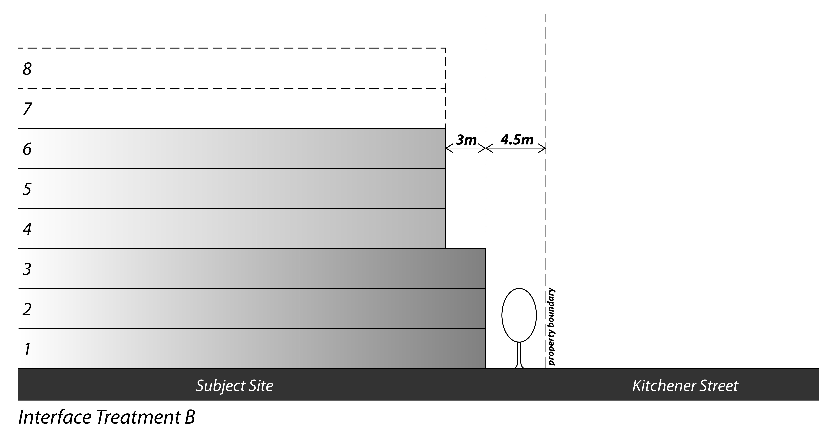
  - Interface Treatment B (Kitchener Street) – 4.5m street setback up to 3 storeys and an additional 3m setback above 3 storeys (as shown in the diagram below);

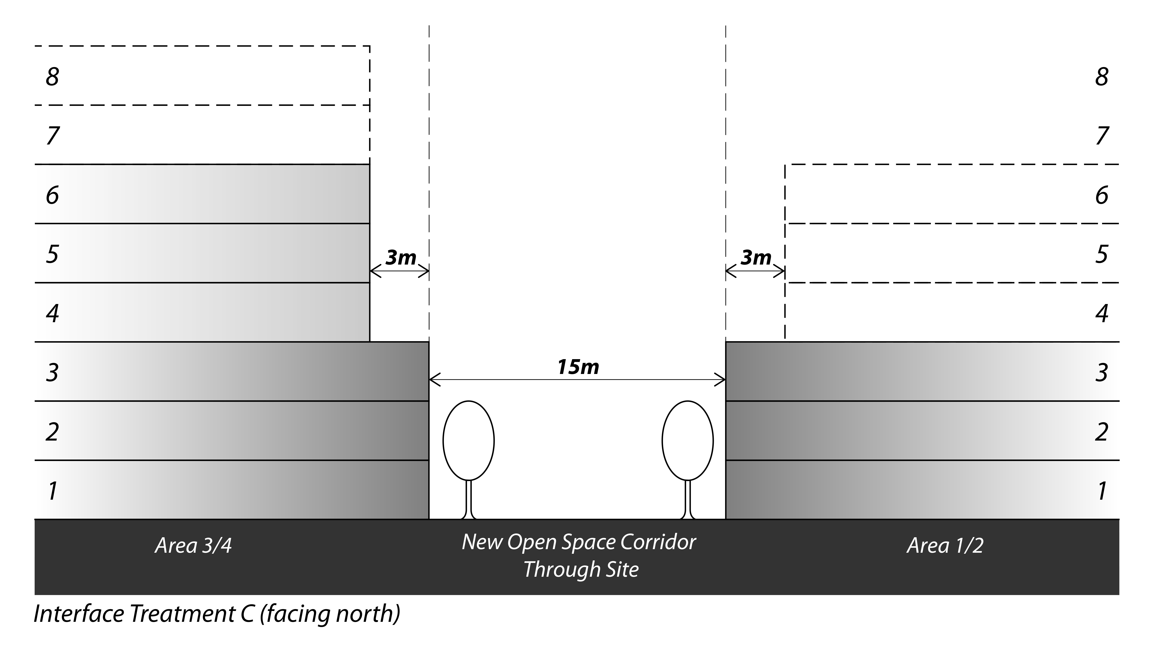
  - Interface Treatment C (New Open Space Corridor Through Site) – 3m setback for portions of buildings above 3 storeys (as shown in the diagram below); and
  - Interface Treatment D (Albion and Peacock Streets) – in accordance with Clause 55.03-1.
- Building envelopes that are adapted to:
  - Protect existing trees to be retained; and
  - Provide reasonable levels of sunlight to open space areas on 21 June.
- Active frontages to Albion, Peacock and Kitchener Streets, internal connections and open space areas, through the following:
  - Avoiding large expanses of blank wall, large service areas, garbage storage areas, car parking and co-located or continuous garage doors along ground floor frontages; and
  - Provision of individual entry doors to ground floor dwellings that have frontages to a road or internal connection.
- Where non-residential uses are proposed, provision of the following:
  - A minimum 4m floor to floor height;
  - An entrance and/or clear glazed window at the street frontages of each individual non-residential use; and
  - Weather protection at the street frontages of the non-residential uses.
- Visual bulk of buildings reduced through the placement of balconies and use of discontinuous forms, articulated facades and varied materials. Buildings and works such as architectural features, sunshades, screens and artworks may be constructed within setback areas, provided they demonstrate a positive contribution to the overall facade composition.
- The location of car parking spaces within basement levels or suitably concealed within buildings or behind features such as active podium frontages.
- Cohesive architectural design throughout the site, with the use of high quality, durable and low maintenance materials.
- Appropriate mitigation measures to minimise the adverse impacts on existing sensitive uses in proximity of the site.
- Appropriate noise attenuation measures to minimise noise impacts on proposed dwellings from the Tullamarine Freeway, Albion Street and any non-residential uses on the site.
Landscape and Open Space
The development plan should show or make provision for:
- A new publicly accessible open space corridor through the site between Albion and Peacock Streets generally located as shown on the Development Concept Plan. The corridor is to be a minimum 15m wide and may contains vehicle access to the site from each street.
- A new centrally located open space area accessible to all residents, generally located as shown on the Development Concept Plan. This area may form part of the communal open space required under Clause 55.07-2 or Clause 58.03-2.
- Retention of trees assessed in an Arboricultural Assessment Report prepared in accordance with this Schedule as having moderate or high retention value, unless it is demonstrated that their retention significantly affects the feasibility of development of the relevant precinct.
- Replacement of trees assessed in the required Arboricultural Assessment Report as having moderate or high retention value with trees that provide equivalent amenity value to residents and the public realm.
- Landscaped buffers at residential interfaces, consisting of exiting trees to be retained and/or replacement canopy trees.
- Additional street trees along the frontages of Albion, Peacock and Kitchener Streets, subject to agreement from Moreland City Council.
- New canopy trees along the new open space corridor and internal connections and within new open space areas.
Circulation
The development plan should show or make provision for:
- A legible vehicle circulation system within the site.
- Accessible car parking for residents, workers (if applicable) and visitors. Some or all of the existing car parking within Kitchener Street may be used for visitor parking subject to agreement from Moreland City Council.
- Accessible bicycle parking for residents and visitors, and bicycle servicing facilities.
- A pedestrian path along the new open space corridor between Albion and Peacock Streets.
Required documents, plans and reports
The following documents, plans and reports must form part of any development plan (as applicable if the development plan is approved in stages):
- A Site Context Analysis prepared in accordance with Clause 55.01 or Clause 58.01 of the Planning Scheme that includes, but is not limited to, the following:
- The urban context and existing conditions showing topography, the surrounding and on site land uses, buildings, noise sources, access points, adjoining roads, cycle and pedestrian network and public transport;
- Views to be protected and enhanced, including views of and from the site; and
- Key land use and development opportunities and constraints.
- Preliminary Architectural Plans that show the distribution and design of built form on the site in accordance with the Development Concept Plan included in this Schedule, including, but not limited to, the following:
- A design response to the Site Context Analysis in accordance with Clause 55.01 or Clause 58.01 of the Moreland Planning Scheme;
- Demolition works;
- Building envelopes including maximum building heights, building setbacks, and building depths;
- The relationship between proposed buildings and works and surrounding land uses and development, including the proposed built form edge and interface treatments to adjoining streets and adjoining residential properties;
- Conceptual elevations and cross-sections, indicating level changes across the site;
- Shadow diagrams;
- Images which show how the proposed built form will be viewed from the surrounding area, particularly the Albion Street corridor, Dunstan Reserve and adjoining residential properties;
- An indicative mix of dwelling types and sizes;
- The mix of land uses, including non-residential uses such as retail, commercial and community facilities;
- Vehicle access, circulation and parking locations;
- Pedestrian and bicycle access and circulation. The building footprints and internal connections shown on the Development Concept Plan are indicative only and further connections within the site and through the building envelopes should also be provided to ensure a highly permeable urban structure; and
- Open space area/s.
- An Integrated Transport and Traffic Management Plan that addresses, but is not limited to, the following:
- The range and scale of uses that will be anticipated on the site;
- The estimated population of residents, visitors and workers (if applicable);
- Estimated vehicle trip generation levels resulting from use and development within the site;
- Vehicle ingress and egress points and estimated levels of usage;
- The likely impacts of the proposed development on the arterial and local roads and any mitigating works required such as off-site traffic management treatments;
- An indicative layout of internal roads that:
  - Complements the form and structure of the surrounding network;
  - Recognises the primacy of pedestrian and bicycle access within the site;
  - Provides a high level of amenity and connectivity, whilst managing the movement of vehicles travelling through the site;
  - Are of sufficient width to accommodate footpaths and street trees;
- The location of on-site car parking for residents, visitors and workers (if applicable). The location of car parking spaces should be situated at basement level or suitably concealed within buildings;
- Provision for loading and unloading of vehicles and means of access to them, including waste, delivery and furniture removalist vehicles; and
- Provision of a safe and accessible pedestrian and bicycle network within the site and connecting to the external network.
- Green Travel Plan initiatives that can be adopted to reduce private car usage by residents, visitors and workers (if applicable), including a new resident awareness and education program and opportunities for the provision of a car share program;
- Provision for secure bicycle storage for residents and workers (if applicable), end of bicycle trip facilities for workers (if applicable) and short term bicycle parking for visitors;
- The views of VicRoads and Moreland City Council.
- An Arboricultural Assessment Report that addresses, but is not limited to, the following:
- Assessment of trees on or adjacent to the site, including retention value;
- Recommendations for the protection of trees to be retained to ensure long-term health, including designation of tree protection zones and structural root zones; and
- Recommendations for trees to replace any trees of moderate or high retention value required to be removed where replacement trees provide equivalent amenity value to residents and the public realm.
- A Landscape and Open Space Plan that addresses, but is not limited to, the following:
- Existing vegetation to be retained as assessed in an Arboricultural Assessment Report prepared in accordance with this Schedule;
- New canopy trees and landscaping within the public realm and communal areas / open space areas;
- Landscaping areas within private open spaces;
- Street trees along Albion, Peacock and Kitchener Streets and internal connections;
- A planting theme that complements existing trees to be retained on the site and the surrounding neighbourhood character;
- Delineation of communal and private open spaces and the treatment of these interfaces;
- Hard and soft landscaping treatments of the public realm and communal open spaces;
- Interface treatments between adjoining streets and residential properties, including boundary fences;
- Integration of sustainability and water sensitive urban design measures;
- Opportunities for communal gardens; and
- Maintenance responsibilities.
- An Ecologically Sustainable Development Plan that demonstrates how development on the site will achieve best practice standards and incorporate innovative initiatives on a precinct-wide scale. The Plan is to address the areas of energy efficiency, water resources, indoor environment quality, stormwater management, transport, waste management, innovation and urban ecology.
- A Services and Infrastructure Plan that addresses, but is not limited to, the following:
- An assessment of the existing engineering infrastructure servicing the site and its capacity to service the proposed development;
- A description of the proposed provision of all appropriate utility services to development parcels; and
- A stormwater drainage master plan, including the location of any on-site drainage retention facilities.
- An Environmental Site Assessment that addresses, but is not limited to, the following:
- A soil sampling and analysis program;
- The extent of any filling that has occurred on the site, including area, depth and fill material;
- The depth, quality and flow direction of groundwater at the site;
- The contamination status of soil on the site; and
- An assessment of risks for the proposed redevelopment of the site and recommendation for any required remediation.
- Where the development will be undertaken in stages, a Staging Plan that addresses, but is not limited to, the following:
- The delivery of infrastructure and shared facilities within each stage to ensure the orderly development of the site; and
- Site management, such as resident amenity, vehicle access and parking, pedestrian access and protection of existing buildings, infrastructure and vegetation.
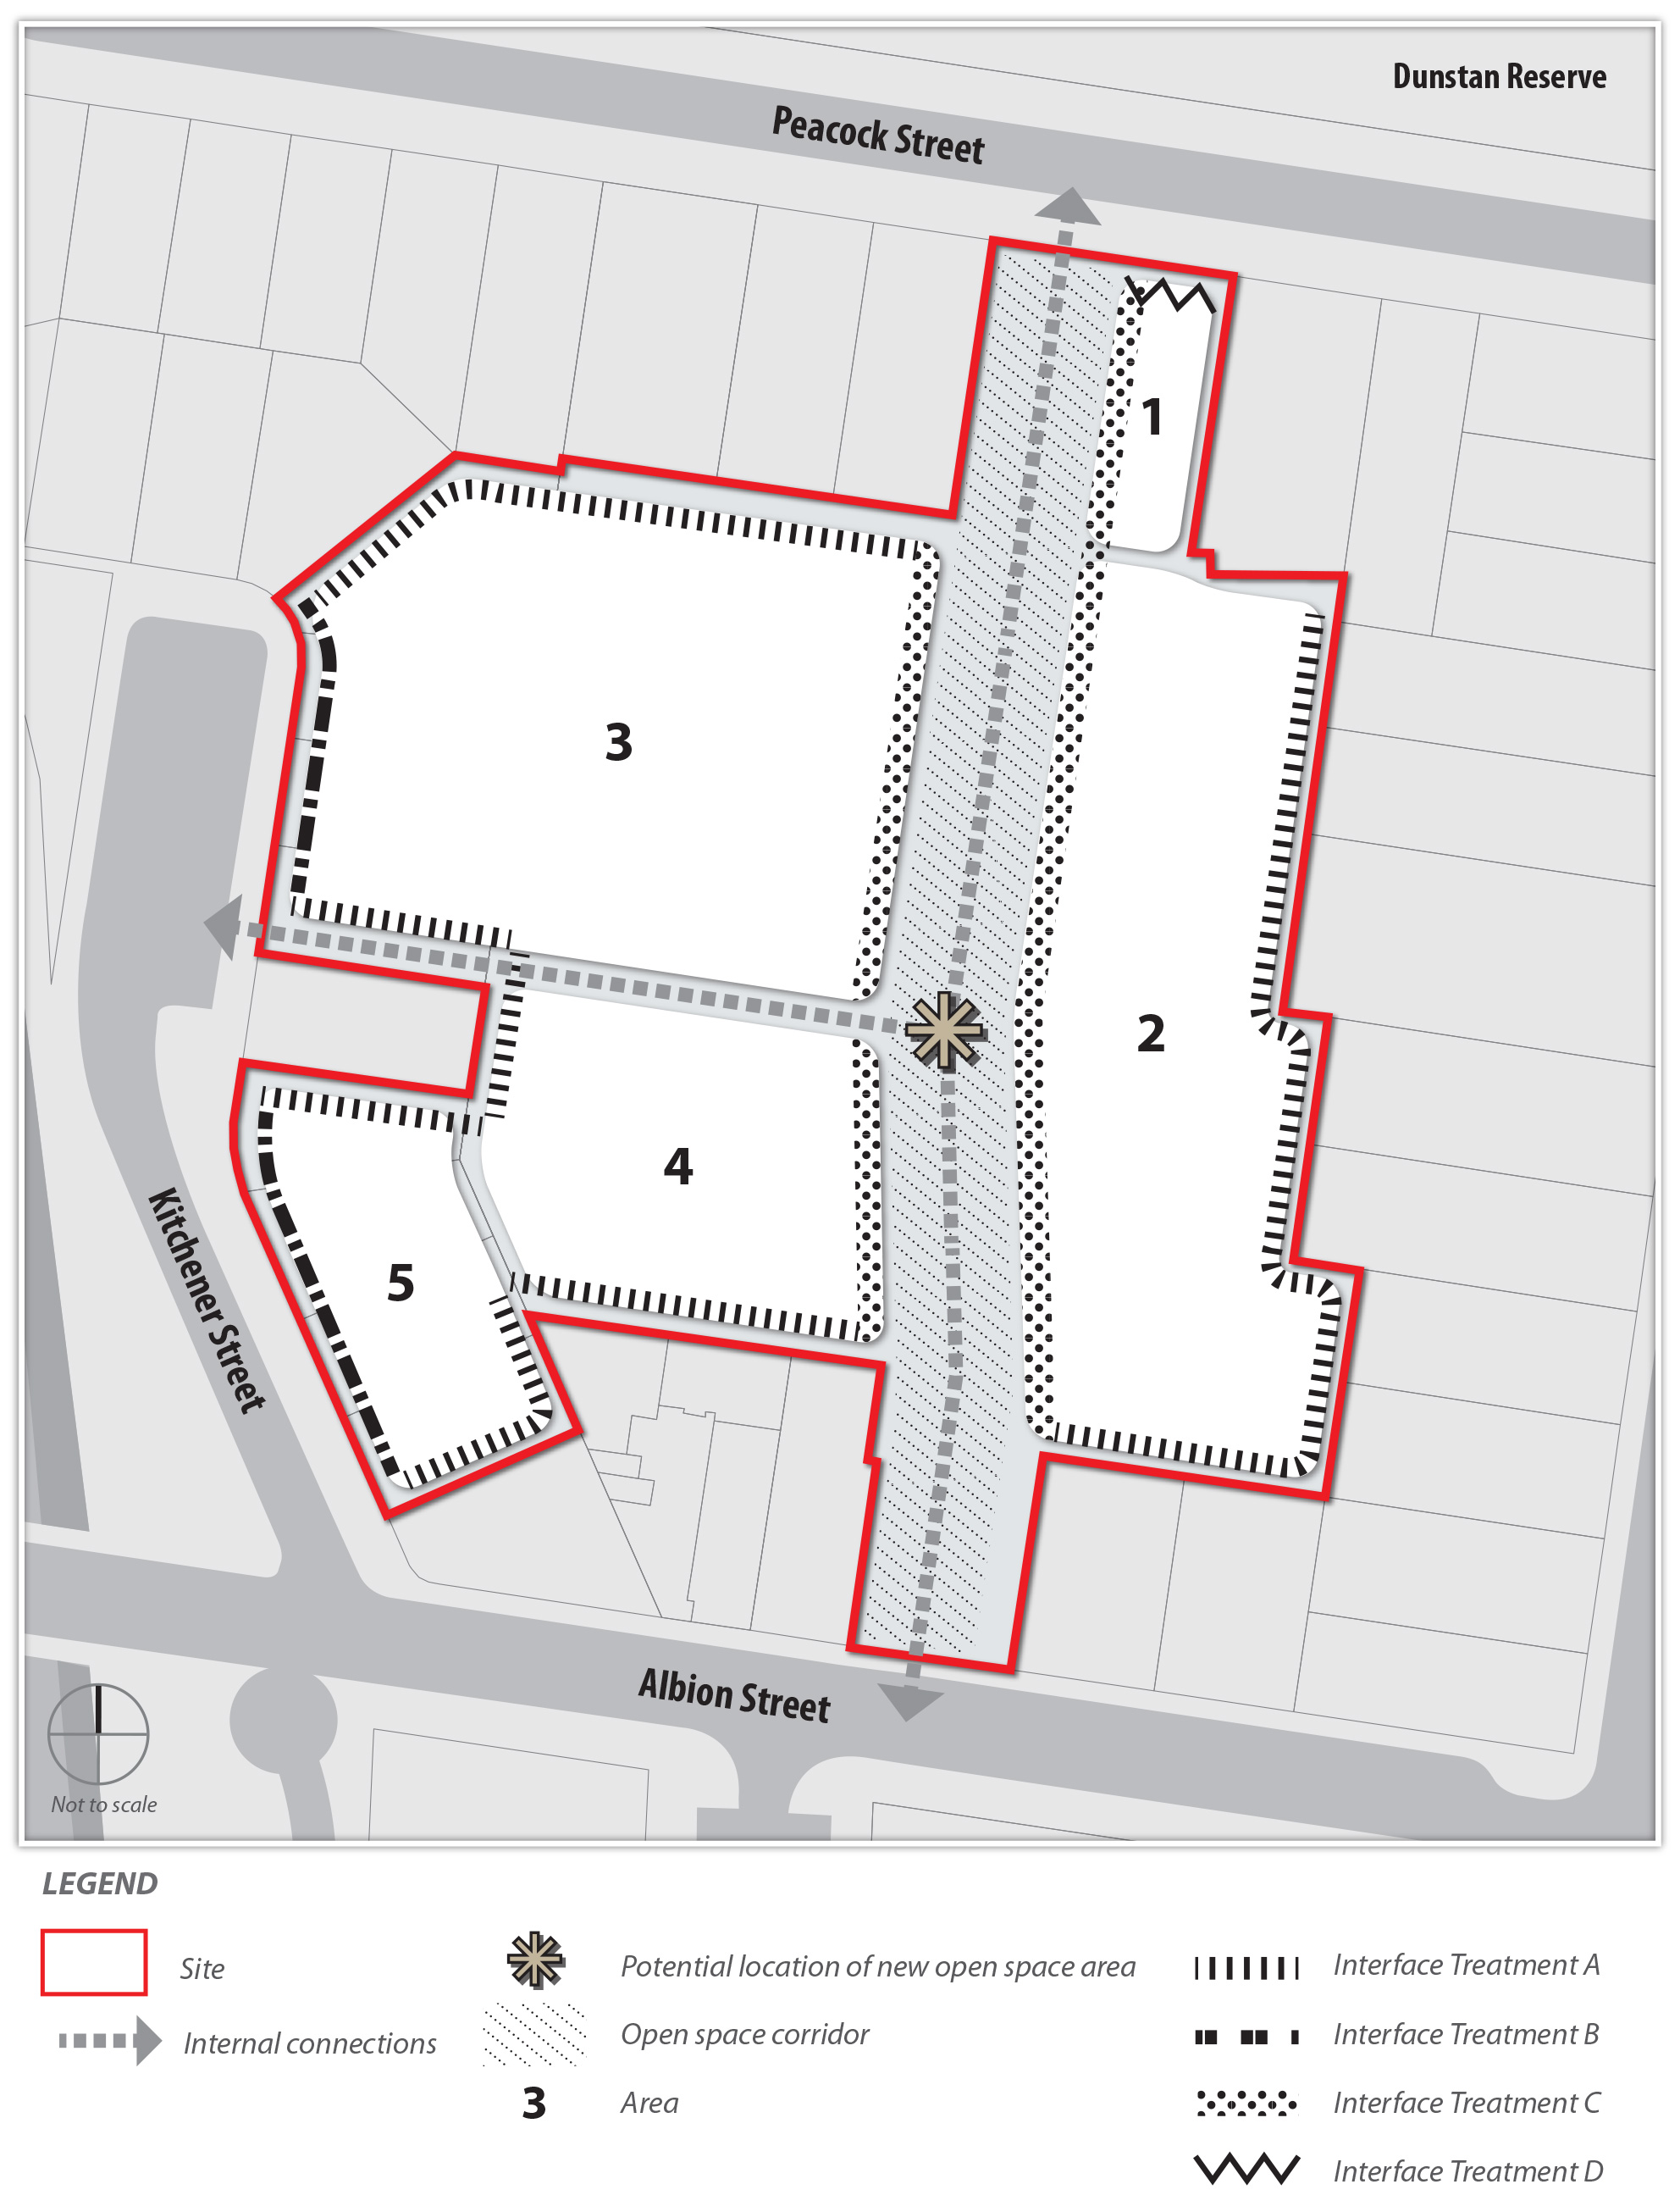
Development Concept Plan

