delwp.vic.gov.au

OCTOBER 2020

|  |
| --- |
| **Environment Effects Statement Scoping Requirements**  **Warburton Mountain Bike Destination**  *Environment Effects Act 1978* |

|  |  |
| --- | --- |
|  |  |

|  |
| --- |
| © The State of Victoria Department of Environment, Land, Water and Planning 2020  LogoThis work is licensed under a Creative Commons Attribution 4.0 International licence. You are free to re-use the work under that licence, on the condition that you credit the State of Victoria as author. The licence does not apply to any images, photographs or branding, including the Victorian Coat of Arms, the Victorian Government logo and the Department of Environment, Land, Water and Planning logo. To view a copy of the licence, visit [creativecommons.org/licenses/by/4.0](https://delwpvicgovau.sharepoint.com/sites/ecm_360/IAU_Quality_Mgmt_Sys/creativecommons.org/licenses/by/4.0).  Disclaimer This publication may be of assistance to you but the State of Victoria and its employees do not guarantee that the publication is without flaw of any kind or is wholly appropriate for your particular purposes and therefore disclaims all liability for any error, loss or other consequence which may arise from you relying on any information in this publication.  Accessibility  If you would like to receive this publication in an alternative format, please telephone the DELWP Customer Service Centre on 136186 or [customer.service@delwp.vic.gov.au](mailto:customer.service@delwp.vic.gov.au). This document is also available on the internet at [planning.vic.gov.au/environment-assessment/](https://www.planning.vic.gov.au/environment-assessment/)browse-projects. |

List of abbreviations

CHMP Cultural Heritage Management Plan

DELWP Department of Environment, Land, Water and Planning

EE Act *Environment Effects Act 1978*

EES Environment effects statement

EMF Environmental management framework

EPBC Act *Environment Protection and Biodiversity Conservation Act 1999*

FFG Act *Flora and Fauna Guarantee Act 1988*

km Kilometres

MNES Matters of national environmental significance

TRG Technical reference group

Contents

1. Introduction 1

1.1 The project 1

1.2 Minister’s requirements for this EES 1

2. Assessment process and required approvals 3

2.1 What is an EES? 3

2.2 The EES process 3

2.3 Accreditation of the EES process under the EPBC Act 4

3. Matters to be addressed in the EES 5

3.1 General approach 5

3.2 Content and style 5

3.3 Project description 6

3.4 Project alternatives 7

3.5 Applicable legislation, policies and strategies 7

3.6 Evaluation objectives 7

3.7 Environmental management framework 8

4. Assessment of specific environmental effects 9

4.1 Biodiversity and habitats 9

4.2 Water and catchment values 11

4.3 Social, economic, amenity and land use 12

4.4 Cultural heritage 14

Appendix A: Procedures and requirements 16

Introduction

In light of the potential for significant environmental effects, on 21 May 2020 the Minister for Planning determined under the *Environment Effects Act 1978* (EE Act) that Yarra Ranges Council (the proponent) is to prepare an environment effects statement (EES) for the proposed Warburton Mountain Bike Destination. The purpose of the EES is to describe the project, assess its potential effects on the environment[1] and assess alternative layouts, designs and approaches to avoid and mitigate effects. The EES will inform and seek feedback from the public and stakeholders. The Minister will issue an assessment of the project’s environmental effects to conclude the EES process and inform statutory decision-makers responsible for the project’s approvals.

These scoping requirementsset out the proposed specific matters to be investigated and documented in the EES for the Warburton Mountain Bike Destination. The scoping requirements were finalised following consideration of submissions received during the public exhibition of the draft scoping requirements in September 2020. While the scoping requirements are intended to cover all relevant matters, the EES will also need to address other issues that emerge during the EES investigations, especially those relevant to statutory decisions that will be informed by the assessment.

## The project

The Warburton Mountain Bike Destination project is centred around Warburton (Figure 1, overleaf). The project will see construction of 44 new mountain bike tracks totalling approximately 186 km. The tracks would occur in groups extending across the forested slopes of Mount Donna Buang, Mount Little Joe and Mount Tugwell, within the Yarra Ranges National Park and two state forests.

A new visitor’s hub (main track head) is proposed at the Warburton Golf Course, with the existing carpark to be upgraded to accommodate a nominal 177 cars, a new shelter, and four or five wash bays for mountain bikes. Three other track heads are proposed: a new area located on Mount Tugwell, off Mount Bride Road, will include a carpark, a bus turnaround bay, toilet and picnic area; another at Mount Donna Buang will include upgrades to the existing carpark, toilet and picnic area; and the third at Wesburn Park will establish parking and connecting tracks . The project will also build two bridges for bicycles to pass over the Yarra River and Old Warburton Road.

## Minister’s requirements for this EES

In light of the potential for significant environmental effects, the Minister decided that an EES is required to assess the project’s potential environmental effects. The Minister published procedures and requirements applicable to the preparation of the EES, in accordance with section 8B(5) of the EE Act (Appendix A). In the procedures and requirements, the Minister identified key environmental risks posed by the project and its alternatives (such as track realignments) to be addressed in the EES, namely:

* effects on biodiversity and ecological values, especially ecological communities and species listed under the *Flora and Fauna Guarantee Act 1988* (FFG Act) or the *Environment Protection and Biodiversity Conservation Act 1999* (EPBC Act);
* effects on surface water and groundwater hydrology and quality;
* effects on Aboriginal and historic cultural heritage values;
* effects on land uses;
* effects on land stability and erosion related to the construction and operation of the project;
* effects of project construction and operation on social amenity through changes in traffic, air quality, vistas or noise effects on nearby sensitive receptors (especially residents);
* positive and adverse socio-economic effects, at local and regional scales, potentially generated by the project, including impacts on the capacity of local community infrastructure; and
* potential cumulative effects in relation to any other existing or planned projects or tourism developments in the area.

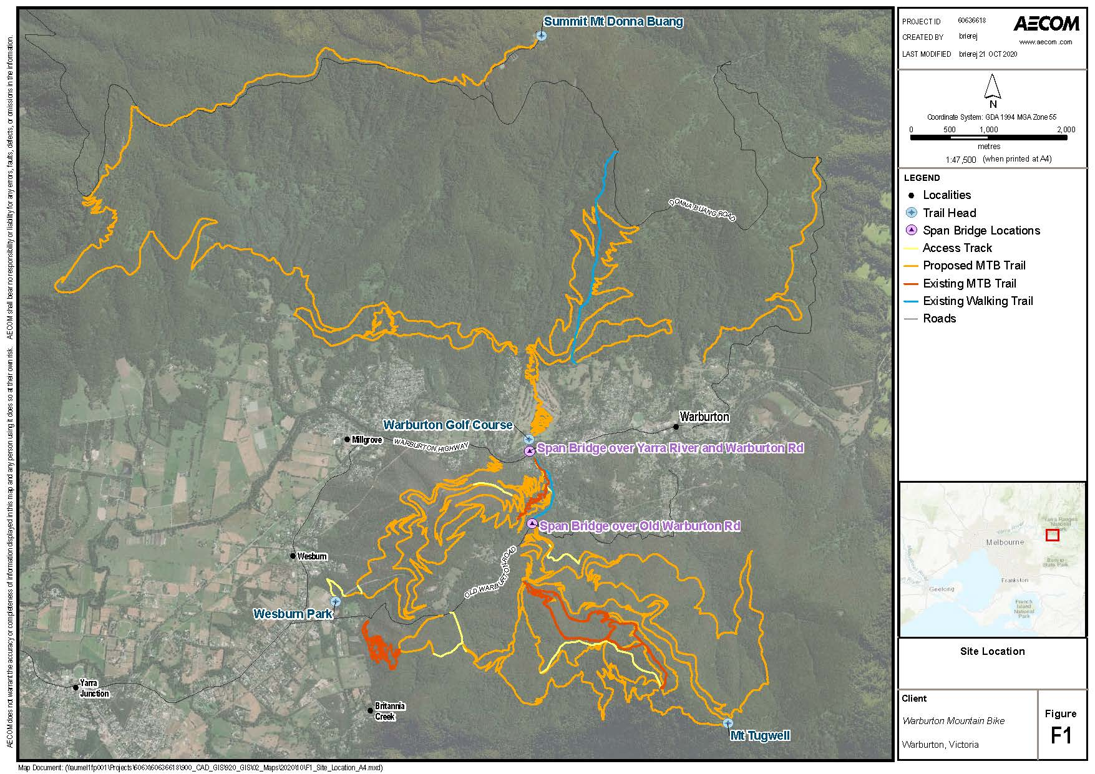These scoping requirements provide further detail on the matters to be in investigated in the EES as required by the *Ministerial guidelines for assessment of environmental effects under the Environment Effects Act 1978* (Ministerial Guidelines).

**Figure 1: Location of the project, with existing and proposed track alignments shown in orange and red (source: Yarra Ranges Council/Aecom, 2020).**

Assessment process and required approvals

## What is an EES?

An EES describes a project and its potential environmental effects. It should enable stakeholders and decision-makers to understand how the project works are to be designed, constructed and operated and the likely environmental effects of doing so. An EES has two main components.

1. The EES main report – an integrated, plain English document that assesses the potential impacts of the project and examines avoidance, mitigation or other measures to reduce the environmental effects. The main report draws on technical studies, data and statutory requirements such as specific limits for surface water and groundwater quality and waste discharge to the environment and should clearly identify which components of the scope are being addressed throughout.
2. The EES technical reports – specialist studies, investigations and analyses that provide the basis for the EES main report. These reports will be exhibited in full, as appendices to the main report.

## The EES process

The proponent is responsible for preparing an EES, including conducting technical studies and undertaking stakeholder consultation. The Department of Environment, Land, Water and Planning (DELWP) is responsible for managing the EES process.[2] The EES process has the following steps:

* preparation of a draft study program and draft schedule by the proponent (completed);
* preparation and exhibition of draft scoping requirements by DELWP on behalf of the Minister with public comments received during the advertised exhibition period (completed);
* finalisation and issuing of scoping requirements by the Minister (this document);
* review of the proponent’s EES studies and draft documentation by DELWP and a technical reference group;[3]
* completion of the EES by the proponent;
* review of the complete EES by DELWP to establish its adequacy for public exhibition;
* exhibition of the proponent’s EES and invitation for public comment by DELWP on behalf of the Minister;
* appointment of an inquiry panel by the Minister to review the EES and public submissions received, conduct public hearings and provide a report to the Minister; and finally
* following receipt of the inquiry report, preparation of an assessment on whether the project’s environmental effects are acceptable by the Minister for the consideration of statutory decision-makers.

### Technical reference group

DELWP has convened a technical reference group (TRG) of state government agencies and Wurundjeri Woi-Wurrung Cultural Heritage Aboriginal Corporation. The TRG will advise DELWP and the proponent on:

* applicable policies, strategies and statutory provisions;
* the scoping requirements for the EES;
* the design and adequacy of technical studies for the EES;
* the proponent’s public information and stakeholder consultation program for the EES;
* responses to issues arising from the EES investigations;
* the technical adequacy and completeness of draft EES documentation; and
* coordination of statutory processes.

### Consultation plan

The proponent is responsible for informing and engaging the public and stakeholders to identify and respond to their issues and keep them informed of the EES studies. Stakeholders include potentially affected parties, interested community organisations and government bodies. Under its consultation plan the proponent informs the public and stakeholders about the EES investigations and provides opportunities for input and engagement during the EES investigations. The consultation plan is reviewed and amended in consultation with DELWP and the TRG before it is published on the planning website.[4] The final consultation plan will:

* identify stakeholders;
* characterise public and stakeholders’ interests, concerns and consultation needs, local knowledge and inputs;
* describe consultation methods and schedule; and
* outline how public and stakeholder inputs will be recorded, considered and/or addressed in the preparation of the EES.

### Statutory approvals and the EES process

The project will require a range of approvals under Victorian legislation if it is to proceed. DELWP coordinates the EES process as closely as practicable with the approvals procedures, consultation and public notice requirements. In particular, the planning approvals process will be aligned with the EES process to remove duplication and ensure efficacy of public review.

The key approvals required under Victorian legislation are planning approval via a planning scheme amendment under the *Planning and Environment Act 1987*; a works on waterways permit under the *Water Act 1989*; approvals under the *National Parks Act 1975* and an approved cultural heritage management plan (CHMP) under the *Aboriginal Heritage Act 2006.* Additional approvals required include a ‘Permit to take protected flora from public land’ under the FFG Act and approval for amendment of the Yarra Ranges National Park Management Plan. Other approvals may be required and will be determined throughout the course of the EES.

## Accreditation of the EES process under the EPBC Act

The project was also referred to the Commonwealth under the EPBC Act. A delegate for the Commonwealth Minister for the Environment determined on 16 June 2020 that the project is a controlled action,[5] as it is likely to have a significant impact[6] on matters of national environmental significance (MNES), protected under Part 3 of the EPBC Act. The potentially impacted MNES are listed threatened species and communities (sections 18 and 18A).

The EES process is accredited to assess impacts on MNES under the EPBC Act through the Bilateral Assessment Agreement between the Commonwealth and the State of Victoria. The Commonwealth Minister or delegate will decide whether the project is approved, approved with conditions or refused under the EPBC Act, after having considered the Minister for Planning’s assessment under the EE Act.

Matters to be addressed in the EES

## General approach

Preparation of the EES should be consistent with the principles of a systems and risk-based approach to identification of issues for assessment. The EES needs to put forward a sound rationale for the level of assessment and analysis undertaken for any environmental effect or combination of environmental effects[7] arising from all components and stages of the project. The EES needs to provide an analysis of the significance of the potential effects of the project, with consideration of:

* the potential effects of each project phase on individual environmental assets – magnitude, extent and duration of change in the values of each asset;
* the likelihood of adverse effects, including those caused indirectly as a result of proposed activities, and associated uncertainty of predictions or estimates;
* proposed avoidance or mitigation measures to reduce predicted effects;
* likely residual effects and their significance, including significant residual impacts on MNES, assuming the proposed measures to avoid and mitigate environmental effects are implemented; and
* the proposed approach to managing and monitoring environmental performance and contingency planning.

## Content and style

Together with the Minister’s reasons for decision, the published procedures and requirements and the Ministerial Guidelines, the content of the EES and related investigations is to be guided by these scoping requirements. To facilitate decisions on required approvals, the EES should address statutory requirements associated with approvals that will be informed by the Minister’s assessment, including decision-making under the EPBC Act, *Planning and Environment Act 1987* and other applicable legislation. The EES should also address any other significant issues that emerge during the investigations.

Ultimately, it is the proponent’s responsibility to ensure that adequate studies are undertaken and reported to support the assessment of environmental effects and that the EES has effective internal quality assurance. Close consultation with DELWP and the TRG during the investigations and preparation of the EES will be necessary to minimise the need for revisions prior to authorisation of the EES for public exhibition.

The EES should provide a clear, objective and well-integrated analysis of the potential effects of the proposed project, including proposed avoidance, mitigation and management measures, as well as feasible alternatives. Overall, the main report should include:

* an executive summary of the potential environmental effects of the project, including potential effects on identified MNES;
* a description of the entire project, including its objectives, rationale, key elements, associated requirements for new infrastructure, resource use and use of existing infrastructure;
* a description of the approvals required for the project to proceed, and their relationship to relevant laws, policies, strategies, guidelines and standards;
* a description of feasible alternatives capable of substantially meeting the project’s objectives that may also offer environmental or other benefits (as well as the basis for a preferred alternative if nominated);
* descriptions of the existing environment, where this is relevant to the assessment of potential effects;
* appropriately detailed assessments[8] of potential effects of each phase of the project (and feasible alternatives) on environmental assets and values, relative to the “no project” scenario, together with an estimation of likelihood and degree of uncertainty associated with predictions;
* clear, active measures for avoiding, minimising, managing and monitoring effects, including a statement of commitment to implement these measures;
* predictions of residual effects of the project assuming implementation of proposed environmental management measures;
* any proposed offset measures where avoidance and other mitigation measures will not adequately address effects on environmental values, including the identified MNES;
* assessment of cumulative impacts with other existing and proposed developments in the region;
* documentation of the process and results of the consultation undertaken by the proponent during the preparation of the EES, including the issues raised by stakeholders, residents or the public and the proponent’s responses to these issues, in the context of the EES studies and the associated consideration of mitigation measures;
* evaluation of the implications for the project and feasible alternatives from the implementation of legislation and policy;
* evaluation against the principles and objectives of ecologically sustainable development; and
* conclusions on the significance of impacts on local, regional, state and federal matters.

The EES should also include an outline of a program for community consultation, stakeholder engagement and communications proposed for implementation during the construction and operation of the project, including opportunities for local stakeholders to engage with the proponent to seek responses to issues that might arise during project implementation.

The proponent may choose to prepare a website with interactive functionality to provide an alternative form of access to EES information, which may complement the conventional EES chapters and technical documents. Such an approach should be discussed with DELWP and should be integrated with the preparation of the EES package, including review by the TRG.

The proponent must also prepare a concise, graphical-based non-technical summary document (hard copy A4, no more than 25 pages) for free distribution to interested parties. The EES summary document needs to include details of the EES exhibition, public submission process and availability of the EES documentation.

## Project description

The EES is to describe the project in sufficient detail both to allow an understanding of all components, processes and development stages, and to enable assessment of their likely potential environmental effects. The project description is required to cover the following.

* Contextual information on the project, including its objectives and rationale, its relationship to statutory policies, plans and strategies, including the basis for selecting the proposed project location and implications of the project not proceeding.
* Land use activities (including beneficial and sensitive uses) in the project area and vicinity, supported by plans and maps drawn at an appropriate scale that show:
  + the location of relevant sensitive receptors;
  + the extent of Crown and private lands, existing land uses and waterways;
  + the proposed layout of the project’s tracks and associated infrastructure at trail heads and elsewhere; and
  + proposed access points.
* Information on the project’s operational life and decommissioning and rehabilitation arrangements where relevant.
* Information on expected visitation numbers during operations and how this is expected to vary over the year (including during mountain biking events).
* Other necessary works directly associated with the project, such as road upgrades and/or connections, and infrastructure and services relocation.
* Details of all the project components, including:
  + location, footprint, layout and access arrangements during site establishment, construction, operation and rehabilitation;
  + design, methods, staging and scheduling of the proposed construction works, including timing of construction of project components, and expected timing of rehabilitation of construction areas;
  + proposed process for on-ground siting of trails along final trail alignments, including how environmental aspects will be considered in this on-ground process;
  + function, operation and design principles and capacity of main components of works;
  + water requirements and proposed sources for construction and operational use;
  + necessary works directly associated with the project, such as an infrastructure and services provision;
  + proposed construction techniques and extent of areas to be disturbed during project establishment and construction, including total area expected to be cleared, requirements for traffic and floodwater management, dust and noise management;
  + estimated quantities and potential sources of primary construction materials;
  + solid waste or wastewater generation and management;
  + transport types and routes for construction activities;
  + power requirements for construction and proposed supply infrastructure;
  + lighting, telecommunications, safety and security requirements;
  + proposed hours of work and workforce requirements (total work force) during construction and operation; and
  + approach to be taken regarding project rehabilitation of areas temporarily disturbed during construction.

## Project alternatives

The EES needs to document the proponent’s process that led to the preferred alternative(s) and design presented in the EES. The EES should also document and explain the proponent’s assessment of feasible alternatives and their effects, including an explanation of how and why specific alternatives were selected for detailed evaluation within the EES. The EES needs to document the likely environmental effects of feasible alternatives, particularly where these offer a potential to minimise and/or avoid significant environmental effects whilst meeting the objectives of the project. The assessment of feasible alternatives and their effects is required to include:

* description of alternatives considered in the project design process, including alternative track alignments and locations of track heads and site access roads;
* identification of methods and environmental criteria for selection of preferred alternatives;
* assessment and comparison of the technical feasibility and environmental implications of alternative options considered;
* the basis for selecting the proposed project layout and design, particularly where trails and trailheads are located within areas of particularly high conservation value such as within the Yarra Ranges National Park;
* comparison of project benefits and impacts associated with the inclusion/exclusion of trails or trailheads within areas of particularly high conservation value; and
* description of how information arising during the EES process was used to refine the preferred track alignments and other project alternatives.

Where appropriate, the assessment of environmental effects of design and layout alternatives is to address the matters set out in the subsequent sections of this document. The depth of investigation of alternatives should be proportionate to their potential to minimise potentially significant adverse effects as well as meet project objectives.

## Applicable legislation, policies and strategies

In addition to the EE Act and the EPBC Act, the EES will need to identify relevant legislation, policies, guidelines and standards, and assess their specific requirements or implications for the project. Particular attention is drawn to the recent changes in the *Environment Protection Act 1970* which are expected to come into effect on 1 July 2021, and any subsequent updates to subordinate legislation.

The proponent will also need to identify and address other relevant policies, strategies, subordinate legislation and related management or planning processes that may be relevant to the assessment of the project. These include but are not limited to EPBC Act policy statements, management plans for parks and reserves, local government plans/strategies, conservation advices, threat abatement plans and recovery plans for nationally listed threatened species and communities.

## Evaluation objectives

Evaluation objectives are provided in Section 4 for each of the topics to be addressed in the EES. The evaluation objectives identify desired outcomes in the context of key legislative and statutory policies, as well as the principles and objectives of ecologically sustainable development and environment protection, including net community benefit. In accordance with the Ministerial Guidelines, they provide a framework to guide an integrated assessment of environmental effects and for evaluating the overall implications of the project.

## Environmental management framework

Inadequate environmental management of the project during project construction and operation will not realise the necessary environmental outcomes, statutory requirements or stakeholder confidence. Hence, the proponent will need to provide an environmental management framework (EMF) for the project within the EES. The EMF will articulate clear accountabilities for managing and monitoring environmental effects and risks associated with construction and operation phases of the project.

The EMF is required to describe the baseline environmental conditions to be used to monitor and evaluate the efficacy of applied environmental management and contingency measures, as well as the residual environmental effects of the project. The framework needs to include the following.

* The context of required approvals and consents, including any anticipated requirements for related environmental management plans, whether for project phases or elements.
* The existing or proposed environmental management system to be adopted.
* Proposed organisational responsibilities, accountabilities and likely resourcing arrangements for environmental management during construction and operation.
* A register of environmental risks associated with each phase of the project which is to be maintained during project implementation. This can be provided as an attachment to the EES.
* The environmental management measures proposed in the EES to address specific issues, including commitments to mitigate adverse effects and enhance environmental outcomes and timing of implementation. This consolidated list can be provided as an attachment to the EES. The measures presented could include a set of environmental protocols/thresholds that will be applied when identifying the final alignments of the tracks within the final corridors identified through the EES process.
* Arrangements for management of and access to baseline and monitoring data, to ensure the transparency and accountability of environmental management and to contribute to the improvement of environmental knowledge.
* The framework for management of illegal track building, other environmental incidents or emergencies.
* The monitoring program for each environmental aspect relevant to the project, including proposed objectives, indicators and monitoring requirements (including parameters, locations and frequency). Justification needs to be provided for any aspects where monitoring is not proposed. The EMF should consider the need for monitoring (at least):
  + biodiversity (including MNES) values;
  + noise, vibration, dust and emissions to air;
  + public health and safety;
  + runoff, erosion and sediment control;
  + solid and liquid waste;
  + Aboriginal cultural heritage values;
  + historic heritage values;
  + traffic and road management measures;
  + disruption of and hazard to existing infrastructure;
  + socioeconomic conditions and land use values;
  + landscape and visual values; and
  + project area rehabilitation.

The EMF will outline internal and external auditing and reporting requirements to review and continuously improve the effectiveness of environmental management and to ensure compliance with statutory conditions. The EMF will set the scope for later development and review of environmental management plans for construction and operation (including rehabilitation) phases of the project. Similarly, the EMF will outline a program for community consultation, stakeholder engagement and communications for the project, including opportunities for local stakeholders to engage with the proponent and a process for complaints recording and resolution.

Assessment of specific environmental effects

Preparation of the EES and the necessary investigation of effects should be proportional to the environmental risk, as outlined in the Ministerial Guidelines (p. 14). A risk-based approach should be adopted during the design of EES studies, so that a greater level of effort is directed at investigating and managing those matters that pose relatively higher risk of adverse effects.

The following structure sets out how the EES could document its assessment of effects for each evaluation objective.

1. **Identify key issues or risks** that the project poses to the achievement of the evaluation objective.
2. **Characterise the existing environment** to underpin impact assessments having regard to the level of risk. The environmental risk assessment by the proponent could guide the necessary data acquisition.
3. **Identify the potential effects** of the project on the existing environment (pre-mitigation).
4. **Present design and mitigation measures** that could substantially reduce and/or mitigate the likelihood, extent and/or duration of potential effects. All design and mitigation measures must apply the mitigation hierarchy with justification of why higher order measures cannot be applied.
   1. Avoidance: measures taken to avoid creating adverse effects on the environment from the outset, such as careful spatial or temporal placement of infrastructure or disturbance.
   2. Minimisation: measures taken to reduce the duration, intensity and extent of impacts that cannot be avoided.
   3. Rehabilitation/restoration: measures taken to improve a degraded environment following exposure to impacts that cannot be completely avoided or minimised.
   4. Offsets: measures taken to compensate for any residual, adverse impacts after full implementation of the previous three steps of the mitigation hierarchy.
5. **Assess the likely residual effects** of the project on the existing environment and evaluate their significance assuming implementation of design and mitigation measures.
6. **Propose performance criteria and management** to evaluate whether the project’s effects are maintained within permissible levels and propose contingency approaches if they are not.

The description and assessment of effects must not be confined to the immediate area of the project but must also consider the potential of the project to impact on nearby environmental values. In addition, the cumulative effect of the project in combination with other nearby projects/activities as well as threatening processes in the broader area/region needs to be assessed for significant adverse effects.

## Biodiversity and habitats

### Evaluation objective

*Avoid, and where avoidance is not possible, minimise potential adverse effects on native vegetation and animals (particularly listed threatened species and their habitat and listed ecological communities), as well as address offset requirements consistent with state and Commonwealth policies.*

### Key issues

* Direct loss of native vegetation (including large old trees) and any associated listed threatened flora and fauna species and communities known or likely to occur in or adjacent to the project works.
* Direct loss of, or degradation to, habitat for flora and fauna species listed as threatened under the EPBC Act, FFG Act and/or DELWP advisory lists, including aquatic species.
* Indirect loss of vegetation or decline in habitat quality, that may support any listed species or other protected fauna, resulting from increased access, hydrological or hydrogeological change, edge effects, habitat fragmentation, loss of connectivity, or other disturbance impacts arising from construction or operation, including noise, movement, vibration and lighting.
* Potential for indirect effects on biodiversity values including but not limited to those effects associated with changes in hydrology (including surface and groundwater changes), water quality (i.e. on water dependent ecosystems), contaminants and pollutants, environmental weeds, pathogens and pest animals including, but not limited to declared weeds, pathogens and pest animals under the *Catchment and Land Protection Act 1994*.
* Disruption to the movement of fauna between areas of habitat across the broader landscape.
* Cumulative impacts on biodiversity and habitat both within and outside Yarra Ranges National Park.
* The availability of suitable offsets in accordance with guidelines for the loss of native vegetation and habitat for threatened species and ecological communities which are listed under the EPBC Act and/or the FFG Act.

### Existing environment

* Describe the conservation areas/reserves in the vicinity of the project, including the biodiversity values of the Yarra Ranges National Park.
* Characterise the type, distribution and condition of native vegetation (including large old trees), terrestrial and aquatic habitat and habitat corridors or linkages that could be impacted by the project. This must include the quality and type of habitat impacted and quantification of the total direct and indirect impact areas from the proposed action and must be informed as appropriate by targeted surveys undertaken in accordance with the appropriate Commonwealth and/or DELWP survey guidelines.
* Identify the existence or likely presence of species listed under the EPBC Act, FFG Act and DELWP advisory lists, as well as environmental weeds, pathogens and pest animals.
* Characterise the listed threatened species, ecological communities and potentially threatening processes that are likely to be present. This characterisation is to be supported by seasonal or targeted surveys where necessary. Details of the scope, timing and method for studies or surveys used to provide information on the ecological values of the project area (and in other areas that may be impacted by the project) needs to be identified in consultation with DELWP. Records and other data from local sources should also be gathered and considered as appropriate.
* As appropriate, identify the different uses which EPBC Act, FFG Act and/or DELWP advisory lists species may make of different habitat areas that could be affected by the project at different times or life-cycle stages.
* Consider the potential for the project to impact on groundwater dependant ecosystems. Where there is potential for impacts, groundwater dependant ecosystems are to be characterised based on data, literature and appropriate surveys where required.
* Identify flora and fauna that could be affected by the project’s potential effects on air quality, noise or vibration, or could be disoriented or otherwise impacted by project lighting.
* Describe the existing threats present to biodiversity values, including:
  + removal of individuals or destruction of habitat;
  + historic or ongoing disturbance or alteration of habitat conditions (e.g. habitat fragmentation, severance of wildlife corridors or habitat linkages, changes to water quantity or quality, fire hazards, etc.);
  + threats of mortality of listed threatened fauna;
  + presence of or risk of introduction of any high threat weeds, pathogens and pest animals within and near the project area; and
  + initiating or exacerbating potentially threatening processes listed under the EPBC Act and/or FFG Act.

### Mitigation measures

* Identify potential and proposed design options and measures that could avoid, minimise, mitigate or manage significant direct and indirect effects on native vegetation (including large trees and hollow bearing trees) and other biodiversity values including any listed ecological communities or flora and fauna species and their habitat within or adjacent to the project area.
* Develop hygiene controls for bicycle, vehicle and machinery movement to minimise the spread of pathogens and weeds.
* Evaluate the feasibility and limitations of implementing mitigation measures proposed and describe and justify the level of uncertainty associated with whether they are expected to achieve their desired outcomes.

### Likely effects

* Assess likely direct and indirect effects of the project and feasible alternatives on native vegetation (including large old trees), ecological communities as well as fauna and flora species listed under the EPBC Act, FFG Act and/or DELWP advisory lists.
* Assessment of potential effects on species needs to take into account the likelihood of occurrence (habitat presence and condition) and the effectiveness of proposed avoidance and mitigation measures and also needs to consider relevant conservation or listing advices, action statements, recovery plans and threat abatement plans. Where surveys do not identify a listed species, but past records and/or habitat analysis suggest that it may occur locally, justification is to be provided if further investigations or further mitigation measures are not proposed.
* Assess potential impacts on the conservation values of Yarra Ranges National Park.
* Assess likely cumulative effects on biodiversity-related values that might result from the project in conjunction with other projects or actions taking place or proposed nearby, as well as with threatening processes in the broader region (e.g. bushfire impacts).
* Provide an assessment of residual effects of the project (assuming proposed mitigation measures have been implemented), including for all protected matters under the EPBC Act impacted by the project.

### Performance criteria

* Describe and evaluate proposed measures to manage the residual effects of the project on biodiversity values (including MNES) and prepare an offset strategy and offset management plan that sets out and includes evidence of the offsets that can be secured or are proposed to satisfy Commonwealth and Victorian offset policy or guideline requirements.
* Describe how the offset/s will be secured, managed and monitored, including management actions, responsibility, timing, performance measures and the specific environmental outcomes to be achieved.
* Proposed EPBC Act offsets must meet the requirements of the *EPBC Act Environmental Offsets Policy* (October 2012)[9].
* Describe and evaluate the approach to monitoring and the proposed contingency measures to be implemented in the event of adverse residual effects on flora, fauna and ecological community values requiring further management.
* Describe any further measures that are proposed to enhance biodiversity outcomes, to form part of the EMF (see Section 3.7).

## Water and catchment values

### Evaluation objective

*Maintain the functions and values of groundwater, surface water and floodplain environments and minimise effects on water quality and beneficial uses.*

### Key issues

* The potential for adverse effects on the functions, values and beneficial uses of surface water environments, such as interception or diversion of flows or changed water quality or flow regimes during construction and operation.
* Potential erosion, sedimentation and landform stability effects during construction and operation.
* The potential for adverse impacts on water-related values due to spills or other incidents during construction or operation.
* The potential for adverse effects on nearby and downstream water environments due to changed flow regimes, floodplain storage, run-off rates, water quality changes, or other waterway conditions during construction and operation, in the context of climate change projections.

### Existing environment

* Describe surface and groundwater conditions and their beneficial uses that could be affected by changed water quality, or water movement, due to the project.
* Identify and describe nearby waterways, wetlands and floodplains that could be affected by the project (e.g. local creeks, Yarra River and floodplains along the Yarra River).
* Describe local groundwater conditions, including the protected beneficial uses and values and identify any groundwater dependent ecosystems that could be affected by the project.
* Characterise the interaction between surface water and groundwater within the project and broader area.
* Assess the potential occurrence of contaminated or potential acid sulphate soils within the area where project works may occur.

### Mitigation measures

* Identify and evaluate aspects of project works and operations, and proposed design refinement options or measures, that could avoid or minimise significant effects on water and catchment environments.
* Describe further potential and proposed design options and measures that could avoid or minimise significant effects on beneficial uses of surface water, groundwater and downstream water environments during the project’s construction and operation, including response measures for environmental incidents.
* Describe available options for treatment or disposal of the various categories of solid and liquid wastes generated by the project.

### Likely effects

* Identify and evaluate effects of the project and alternatives on groundwater, surface water, waterways and floodplains near the project works, including the likely extent, magnitude and duration (short and long term) of changes to water quality, water level, temperature or flow paths during construction and operation, considering appropriate climate change scenarios and possible cumulative effects resulting in combination with other existing or proposed projects of actions.
* Assess potential erosion, sedimentation and landform stability effects of the project.
* Identify potential environmental effects resulting from the generation, storage, treatment, transport and disposal of solid and liquid wastes, including soil, from project construction and operation.

### Performance criteria

* Describe monitoring programs and appropriate monitoring activities to be implemented to ensure prompt detection of water and catchment effects associated with the project.
* Identify possible contingency actions to respond to foreseeable changes that may be identified through the monitoring program.

## Social, economic, amenity and land use

### Evaluation objective

*Minimise potential adverse social, economic, amenity and land use effects at local and regional scales.*

### Key issues

* Potential for project works and operations to affect business (including tourism) operations or other existing or approved land uses, including private and recreational land use (e.g. bushwalking).
* Positive and adverse socio-economic effects, at local and regional scales, potentially generated by the project, including potential for increased employment, traffic, tourism and visitation as well as pressures on existing housing and community infrastructure (including health services).
* Potential for dust emissions resulting from construction works and activities.
* Potential for project construction or operation to result in noise at residences adjacent to proposed tracks.
* Relocation or other impacts to existing infrastructure.
* Potential for temporary or permanent changes to use of or access to existing infrastructure and land in the project area and in its vicinity.
* Potential for impacts on reasonably foreseeable upgrades to public infrastructure.
* Potential for adverse impacts on visual or landscape values.

### Existing environment

* Describe the demographic and social character of residential communities and businesses near the project.
* Describe existing and reasonably foreseeable land uses within and adjacent to the proposed project area.
* Identify dwellings and any other potentially sensitive receptors (e.g. residential, commercial, industrial, recreational areas etc.) that could be affected by the project’s potential effects on air quality, noise or vibration levels, especially vulnerable receptors including children and the elderly.
* Appropriately characterise background levels of air quality (e.g. dust), noise and vibration near the project, including established residential areas and other sensitive receptors.
* Describe proposed transport routes during construction and operations (for employees, construction equipment and other project-related transportation). This should include description of existing roads and their ability to accommodate traffic generated by the project.
* Identify existing and reasonably foreseeable land uses and businesses occupying land to be traversed by, adjacent to, or otherwise affected by impacts from the project.
* Identify strategic plans specifying or encouraging land use outcomes for land to be occupied by the project.
* Identify visual and landscape values near the project, including public and private vantage points from which elements of the project may be visible.

### Mitigation measures

* Identify potential and proposed design responses and/or other mitigation measures to avoid, reduce and/or manage any significant effects for sensitive receptors during project construction and operation arising from air pollution, noise, vibration, traffic and lighting, in the context of applicable policy and standards.
* Identify options for mitigating impacts from project construction or operation on any potentially affected private land, businesses and community facilities.
* Describe and evaluate the proposed traffic management and safety principles to address changed traffic conditions during construction and operation of the project.
* Outline any required transport infrastructure works or upgrades required to address adverse impacts of the project construction and operation, including impacts on accessibility (e.g. access road construction and upgrades).
* Identify measures for mitigating or managing visual or landscape impacts of the project.
* Identify project design and management measures that will assist in reducing greenhouse gas emissions resulting from the construction and operation of the project.

### Likely effects

* Identify implications for communities, current land uses and businesses and immediately foreseeable changes in land use.
* Assess the expected positive and adverse socioeconomic effects, at the local and regional scales, potentially generated by the project, including impacts on employment, impacts of increased tourism/visitation and impacts on the capacity and costs of local housing and community infrastructure (including health services).
* Describe the likely extent and duration of any temporary disruption to existing land uses arising from project construction.
* Assess the potential for dust, noise, vibration, traffic, lighting and visual impacts at sensitive receptors adjacent to the project during project construction and operation (both with and in the absence of the proposed mitigation measures), with consideration of relevant standards. This needs to include consideration of changes to impacts during mountain biking events.
* Assess the potential for the project to result in increased traffic.
* Assess potential safety hazards to the public arising from project construction and operation (including safety risks associated with abandoned mine workings).
* Describe the bushfire hazard for the immediate project area and broader landscape conditions and undertake appropriate risk assessment that considers the potential for increased risk of bushfire to people, property and community infrastructure due to the project.
* Assess the potential for cumulative impacts on social, economic, amenity and land use values in conjunction with any other existing or planned projects and land uses including tourism developments in the area.

### Performance criteria

* Outline measures to monitor the success of commitments to mitigate or manage effects on social, economic, amenity and land use values during all phases of the project.
* Describe the approach to monitor effects and develop contingency measures to be implemented in the event of adverse residual effects on social, economic, amenity and land use values requiring further management.
* Describe any further measures that are proposed to enhance social outcomes, and either manage risks to landscape and recreational values, or enhance visual amenity outcomes both for residents living near the project and for visitors to the locality, to form part of the EMF (see Section 3.7).

## Cultural heritage

### Evaluation objective

*Avoid, or minimise where avoidance is not possible, adverse effects on Aboriginal and historic cultural heritage.*

### Key issues

* Destruction or disturbance of sites or places of Aboriginal or historical cultural heritage significance.
* Potential for indirect impacts on sites or places of Aboriginal or historical cultural heritage significance close to the project area.
* Potential impacts on intangible Aboriginal cultural heritage values associated with the project area and surrounds.

### Existing environment

* Review and assess previous studies, registers, geomorphology, landform and land use history to identify areas of known Aboriginal cultural heritage and model areas with the potential to contain Aboriginal cultural heritage.
* Review land use history, previous studies and registers to identify areas of known historical cultural heritage values and assess the potential for the Project to contain unregistered historical cultural heritage sites.
* Describe the extent, nature and significance of any Aboriginal cultural heritage sites or areas of sensitivity potentially impacted by the project area (including associated infrastructure or ancillary works) through consultation and investigations to the satisfaction of the Wurundjeri Woi Wurrung Cultural Heritage Aboriginal Corporation, ensuring adequate field assessments are conducted to verify the findings of any desktop studies.
* Identify and document any known and previously unidentified places and sites of historical cultural heritage significance within the project area and its vicinity, including any necessary field investigations to supplement past studies. Assessments are to be undertaken in accordance with the *Heritage Act 2017* and Heritage Victoria’s Guidelines for Conducting Archaeological Surveys (2014) or updates. Maps of site extents showing their proximity to proposed works are to be provided.
* Identify any known or previously unidentified intangible Aboriginal cultural heritage values associated with the project area.

### Mitigation measures

* Describe and evaluate potential and proposed design and construction mitigation methods to avoid adverse effects on Aboriginal and historical cultural heritage, and where avoidance is not possible, to minimise adverse effects.
* Develop a CHMP to the satisfaction of the Wurundjeri Woi Wurrung Cultural Heritage Aboriginal Corporation.
* Develop an archaeological management plan and chance finds procedure to manage historic heritage investigation/excavation etc.

### Likely effects

* Assess the potential direct and indirect effects of the project on Aboriginal cultural heritage values, and whether they can be avoided.
* Assess the potential direct and indirect effects of the project on sites and places of historical cultural heritage significance, having regard to the Guidelines for Investigating Historical Archaeological Artefacts and Sites (Heritage Victoria, 2015) or updates.
* Consider the potential for indirect impacts to cultural heritage sites located in proximity to the construction footprint which may result from increased public access and visitation to project areas.
* Assess the potential direct or indirect effects on any intangible Aboriginal cultural heritage values associated with the project area.

### Performance criteria

* Outline how implementation of proposed commitments to mitigate and manage residual effects on sites and places of historical heritage significance will be monitored, including site investigation and recording procedures.
* Outline how compliance with conditions of any required statutory approvals (i.e. consents/permits/ CHMP) will be managed and monitored.
* Outline and evaluate the need for additional management and/or monitoring measures, further to those presented in the draft CHMP, to manage risks of effects on sites and places of Aboriginal cultural heritage significance, as part of the EMF.

Appendix A: Procedures and requirements

Procedures and requirements under section 8B(5) of the *Environment Effects Act 1978* (approved by Minister for Planning on 21 May 2020).

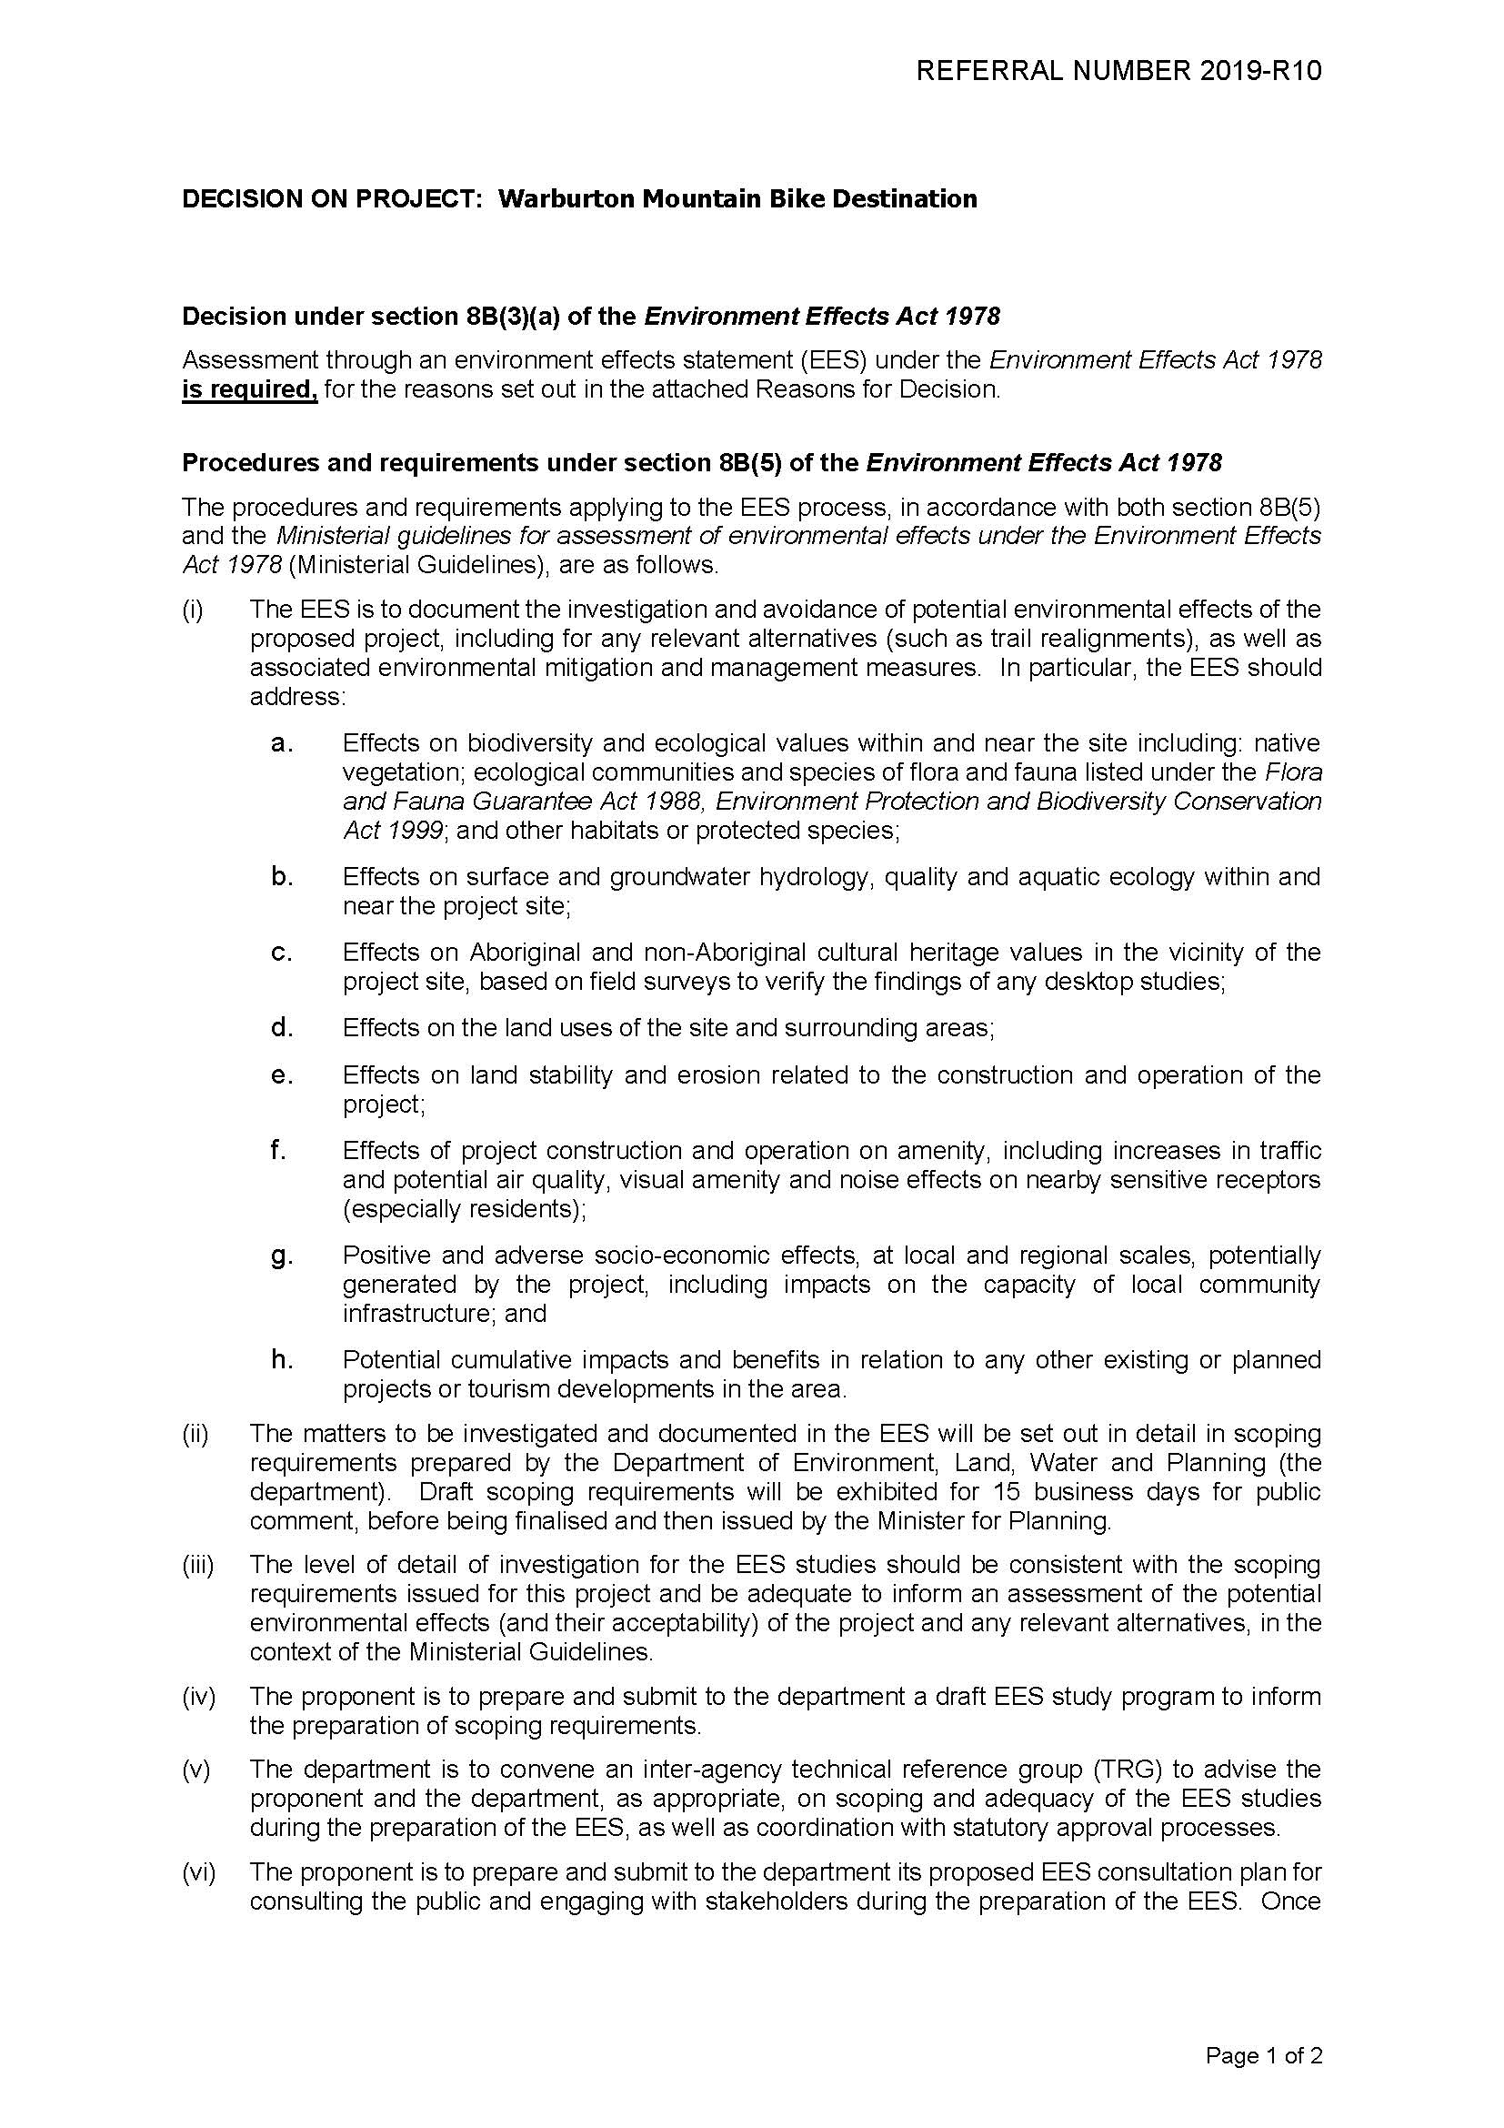

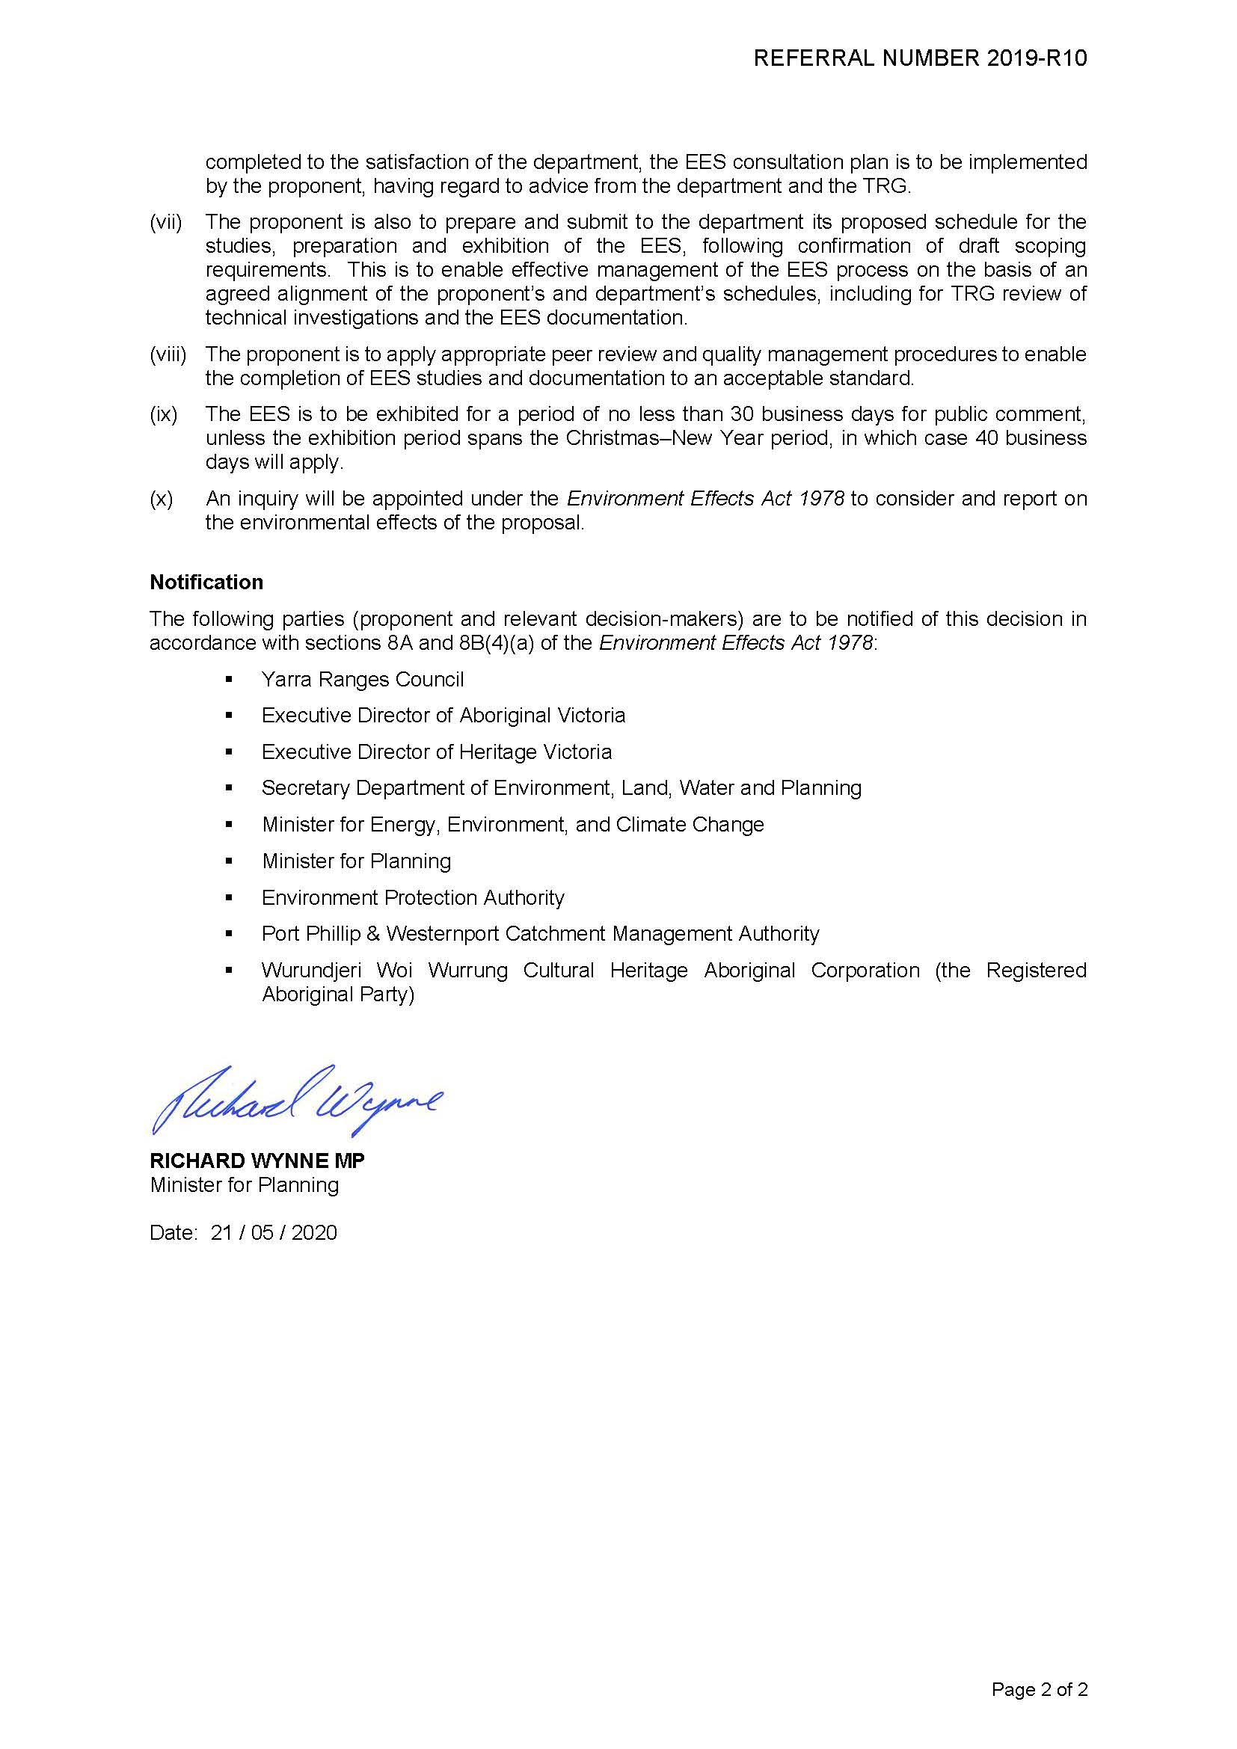

1. . For assessment of environmental effects under the EE Act, the meaning of ‘environment’ includes physical, biological, heritage, cultural, social, health, safety and economic aspects (Ministerial Guidelines, p. 2).
2. . Further information on the EES process can be found at planning.vic.gov.au/environment-assessment/what-is-the-ees-process-in-victoria.
3. . For critical components of the EES studies, peer review by an external, independent expert may be appropriate.
4. . [planning.vic.gov.au/](https://www.planning.vic.gov.au/environment-assessment/browse-projects/projects/warburton-mountain-bike-destination)
5. Under the EPBC Act, projects are considered actions. For the purposes of this document the term project also means action.
6. What are generally termed effects in the EES process correspond to impacts defined in Section 82 of the EPBC Act.
7. . Effects include direct, indirect, combined, facilitated, consequential, short and long-term, beneficial and adverse effects.
8. . Assessments must ensure they are representative of seasonal variations, if required.
9. [environment.gov.au/epbc/publications/epbc-act-environmental-offsets-policy](http://www.environment.gov.au/epbc/publications/epbc-act-environmental-offsets-policy)