Outcome 2

MELBOURNE PROVIDES HOUSING CHOICE IN LOCATIONS CLOSE TO JOBS AND SERVICES
Melbourne will need 1.6 million new homes over the next 35 years.
Issues that need to be addressed include: housing affordability, the types of housing available to cater for different household needs and lifestyles, and the provision of medium- and higher-density housing close to jobs and services. Another pressing issue is the growing number of homeless people and households waiting for public housing.
To grow strong and healthy communities, Melbourne must remain affordable and accessible. That will require building the types of dwellings people want and need in locations where they want to live.
Melbourne’s housing stock is made up mainly of detached housing. However, there has been a significant shift in the type of housing built across Melbourne in recent years, with an increase in the proportion of medium- and higher-density housing, particularly in middle-ring suburbs such as Doncaster and Box Hill.
Figure 6 Annual building approvals by selected type and location, metropolitan Melbourne (year ending March)
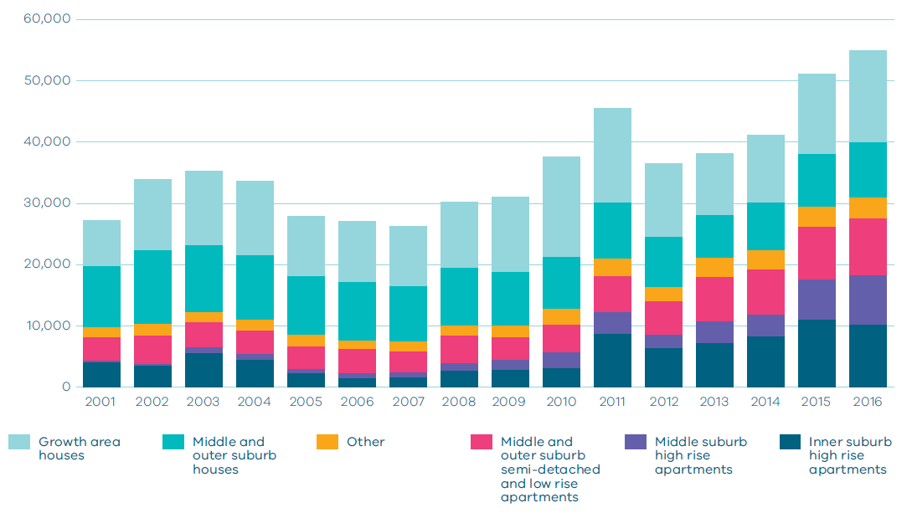
Source: DELWP analysis of ABS Building approvals, cat. no. 8731.0
For Melbourne to become more equitable and accessible, local residents need to have a choice of housing within their neighbourhood.
Growth needs to be planned and managed in a way that maintains the city’s liveability. Growth areas require public transport, schools, roads, hospitals and jobs. Middle-ring suburbs are well served with jobs and services and can provide greater housing choices in these locations, but development must be carefully managed. Areas in and around the central city offer significant urban renewal opportunities to develop as new places for people to live and work but need supporting community infrastructure and public spaces.
Metropolitan Melbourne has at least a 25-year supply of greenfield land available for residential development on its urban fringe. It is unsustainable to keep expanding Melbourne’s outer-urban growth areas. If the city continues to expand, the natural environment will be impacted, commute times to employment and services will grow longer, and socioeconomic disparities across the city will increase.
The new residential suburbs being created in growth areas are guided by the Precinct Structure Planning Guidelines. To ensure Melbourne does not recreate the ‘dormitory’ suburbs of the post-War boom the guidelines support planning for local jobs, local town centres rather than car-based shopping centres, better access by walking and bikes, and a healthy environment.
Melbourne will benefit from population growth—if plans are made and actions are taken. Without adequate planning, the city will become less affordable and liveable—risking social cohesion and economic growth.

Melbourne’s plan

Direction 2.1 Manage the supply of new housing in the right locations to meet population growth and create a sustainable city
The social, economic and environmental benefits of creating a more compact, sustainable city are profound. Some of the benefits of compact, higher-density neighbourhoods are as follows:
Social: It encourages positive social interaction and diversity, improves the viability of (and access to) community services and enables more (and better integrated) housing.
Economic: It enhances the economic viability of development, improves the economic viability of infrastructure delivery and utilises existing infrastructure.
Transport: It creates sustainable demand for more transport options—including public transport, walking and cycling—and can reduce overall travel time.
Environmental: It creates opportunities for efficient use of resources and materials, creates less pollution through the promotion of sustainable transport, preserves and helps fund the maintenance of public open space, creates new public open space, reduces overall demand for development land, and avoids expanding suburbs without supporting services.
Strategies need to be put in place that articulate clear goals and objectives for housing and:
- outline the needs of different household types
- provide a greater understanding of the range of housing needed
- provide a stronger understanding of opportunities and constraints
- identify preferred housing outcomes
- help clarify and communicate housing required across metropolitan Melbourne and its metropolitan regions
- address housing diversity, design, quality and energy efficiency
- seek to locate at least 65 per cent of new housing in established areas of Melbourne and no more than 35 per cent in growth areas in line with current levels of development and Victoria in Future projections.

Policy 2.1.1 Maintain a permanent urban growth boundary around Melbourne to create a more consolidated, sustainable city
Maintaining a permanent urban growth boundary sends a clear message about the long-term development priorities for Melbourne and Victoria. Those priorities include:
- reducing urban sprawl
- increasing metropolitan housing densities in the right places
- ensuring Melbourne’s established suburbs accommodate a greater share of Melbourne’s growth
- creating a more consolidated city of 20-minute neighbourhoods with good access to public transport and services
- protecting the values of non-urban land, opportunities for productive agricultural land and significant landscapes.
A permanent urban growth boundary will be maintained to contain Melbourne’s outward growth.

Policy 2.1.2 Facilitate an increased percentage of new housing in established areas to create a city of 20-minute neighbourhoods close to existing services, jobs and public transport
Victoria in Future projections indicate that around 65 per cent of all new dwellings will be in Melbourne’s established areas, with 35 per cent in growth area greenfield sites. Figure 7 provides likely housing distribution figures from 2015–2051 based on Victoria in Future 2016. It also provides an alternate aspirational scenario of housing distribution if 70 per cent of new housing was to be provided within Melbourne’s established areas.
To remain liveable and become more productive and sustainable, Melbourne must build on this current trend.
Since 2014 around 70 per cent of all new housing built has been in established areas.
Planning will be undertaken to ensure that the best parts of Melbourne are maintained and the benefits experienced in established inner and middle suburbs of Melbourne from compact, walkable neighbourhoods can also be realised in middle and outer areas.
This approach will support greater housing diversity and offer better access to services and jobs. It will also encourage the right mix of housing by enabling local residents to downsize or upsize without leaving their neighbourhood.

Figure 7 Housing distribution between established areas and growth area greenfields
Scenario 1 VIF 2016
Net Dwelling Additions 2015-51
Region  Inner Metro | Total  215,000 | Established 215,000 | Greenfields  0
Region  Western | Total  385,000 | Established 150,000 | Greenfields 235,000
Region  Northern | Total  355,000 | Established 175,000 | Greenfields 180,000
Region  Inner South East | Total  110,000 | Established 110,000 | Greenfields  0
Region  Eastern | Total  175,000 | Established 175,000 | Greenfields  0
Region  Southern | Total  310,000 | Established 185,000 | Greenfields 125,000
 | Total Melbourne 1,550,000  100% | Total Melbourne Established 1,010,000  65% | Total Melbourne Greenfields 540,000  35%
Scenario 2 Aspirational scenario
Net Dwelling Additions 2015-51
Region  Inner Metro | Total  230,000 | Established 230,000 | Greenfields  0
Region  Western | Total  365,000 | Established 160,000 | Greenfields 205,000
Region  Northern | Total  340,000 | Established 180,000 | Greenfields 160,000
Region  Inner South East | Total  125,000 | Established 125,000 | Greenfields  0
Region  Eastern | Total  190,000 | Established 190,000 | Greenfields  0
Region  Southern | Total  300,000 | Established 195,000 | Greenfields 105,000
 | Total Melbourne 1,550,000  100% | Total Melbourne Established 1,080,000  70% | Total Melbourne Greenfields 470,000  30%

NOTE: Housing distribution figures have been developed to show distribution between established areas and greenfield areas based on two scenarios. Scenario 1 is based on VIF 2016 projections which assume continuation of current trends. Scenario 2 shows an aspirational distribution based on achieving a 70/30 split of net dwelling additions. For the purpose of these figures, greenfield areas include land in a growth area council that is either currently under development or identified for future development.
Source: Department of Environment, Land, Water and Planning

Policy 2.1.3 Plan for and define expected housing needs across Melbourne’s regions
Planning for housing at a regional level will help identify planned residential change across Melbourne, including areas identified for residential growth, moderate housing growth and areas of limited change.
Metropolitan regions should facilitate a housing market that creates ongoing and substantial new housing opportunities near jobs, services and transport. Local governments need to consider housing policy and planning in the context of their own municipal boundaries as well as the broader housing objectives of their region.
Regional planning must make adequate provisions for future housing needs and ensure:
- defined housing change areas, as well as redevelopment sites and areas, are identified to support long-term housing growth, choice and diversity for a range of household types
- planning for residential change areas facilitates ongoing investment and creates relatively high levels of housing opportunity
- new development is directed to areas with appropriate infrastructure, and greater density is supported where it optimises the value of existing infrastructure
- a spectrum of minimal, incremental and high-change residential areas are allowed to balance the need to protect valued areas with the need to ensure choice and growth in housing markets across the metropolitan area
- information is collected and reported in relation to changes to household types, housing needs and population growth—thereby informing future planning decisions.

Policy 2.1.4 Provide certainty about the scale of growth in the suburbs
There is a need to provide greater certainty and facilitate long-term growth and housing choice in the right locations.
Local government and the community also need confidence that the built form objectives they sign up to will be adhered to.
The review of residential zones will give greater certainty to the community by strengthening mandatory height provisions and site coverage requirements in each of the residential zones.
In areas where greater change is expected—such as urban renewal precincts and mixed-use and activity centre areas—requirements to adhere to preferred heights will also be strengthened. This will be achieved by improving the way height in strategic locations is managed and decisions are made.
Managing residential development
The residential zones introduced in 2013 have been reviewed by the Managing Residential Development Advisory Committee and amended to better reflect the balance between protection of neighbourhood character and well designed developments. The new zones were the Neighbourhood Residential Zone, General Residential Zone and Residential Growth Zone. The underlying principles of the zones were sound, however the zones have been applied in different ways and through different processes across councils. The Managing Residential Development Advisory Committee found that the inconsistencies in the way the zones had been implemented resulted in a lack of clarity, transparency and consistency.
To provide greater consistency and certainty about growth in the suburbs and the built form outcomes being sought, the residential zones have been reviewed and updated to provide consistent and strengthened mandatory height controls and building coverage requirements. This will provide greater certainty to communities about the level of development that can occur and enable Melbourne to develop in a way that is sustainable and does not detract from the character of the suburbs.

Map 13 Metropolitan Melbourne regions
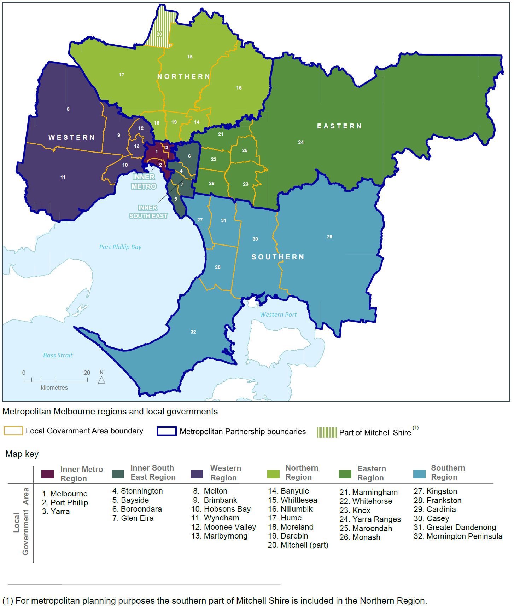
Source: Department of Environment, Land, Water and Planning

Direction 2.2 Deliver more housing closer to jobs and public transport
Locating medium- and higher-density development near services, jobs and public transport supports the objectives of consolidation and housing choice.
For this direction to be achieved, the standards of higher-density housing need to be raised.
There are significant opportunities for housing development in and around the central city. There are also opportunities for more medium- and higher-density development in middle suburbs close to jobs and services including:
- urban renewal precincts
- areas identified for residential growth
- areas identified for greyfield renewal
- areas designated as national employment and innovation clusters
- metropolitan activity centres and major activity centres
- neighbourhood activity centres—especially if they have good public transport connections
- areas near existing and proposed railway stations that can support transit-oriented development.
Encouraging mixed-use developments and greater housing diversity and density near employment and transport will create opportunity and choice for medium- and low-income households.

Map 14 Metropolitan and major activity centres
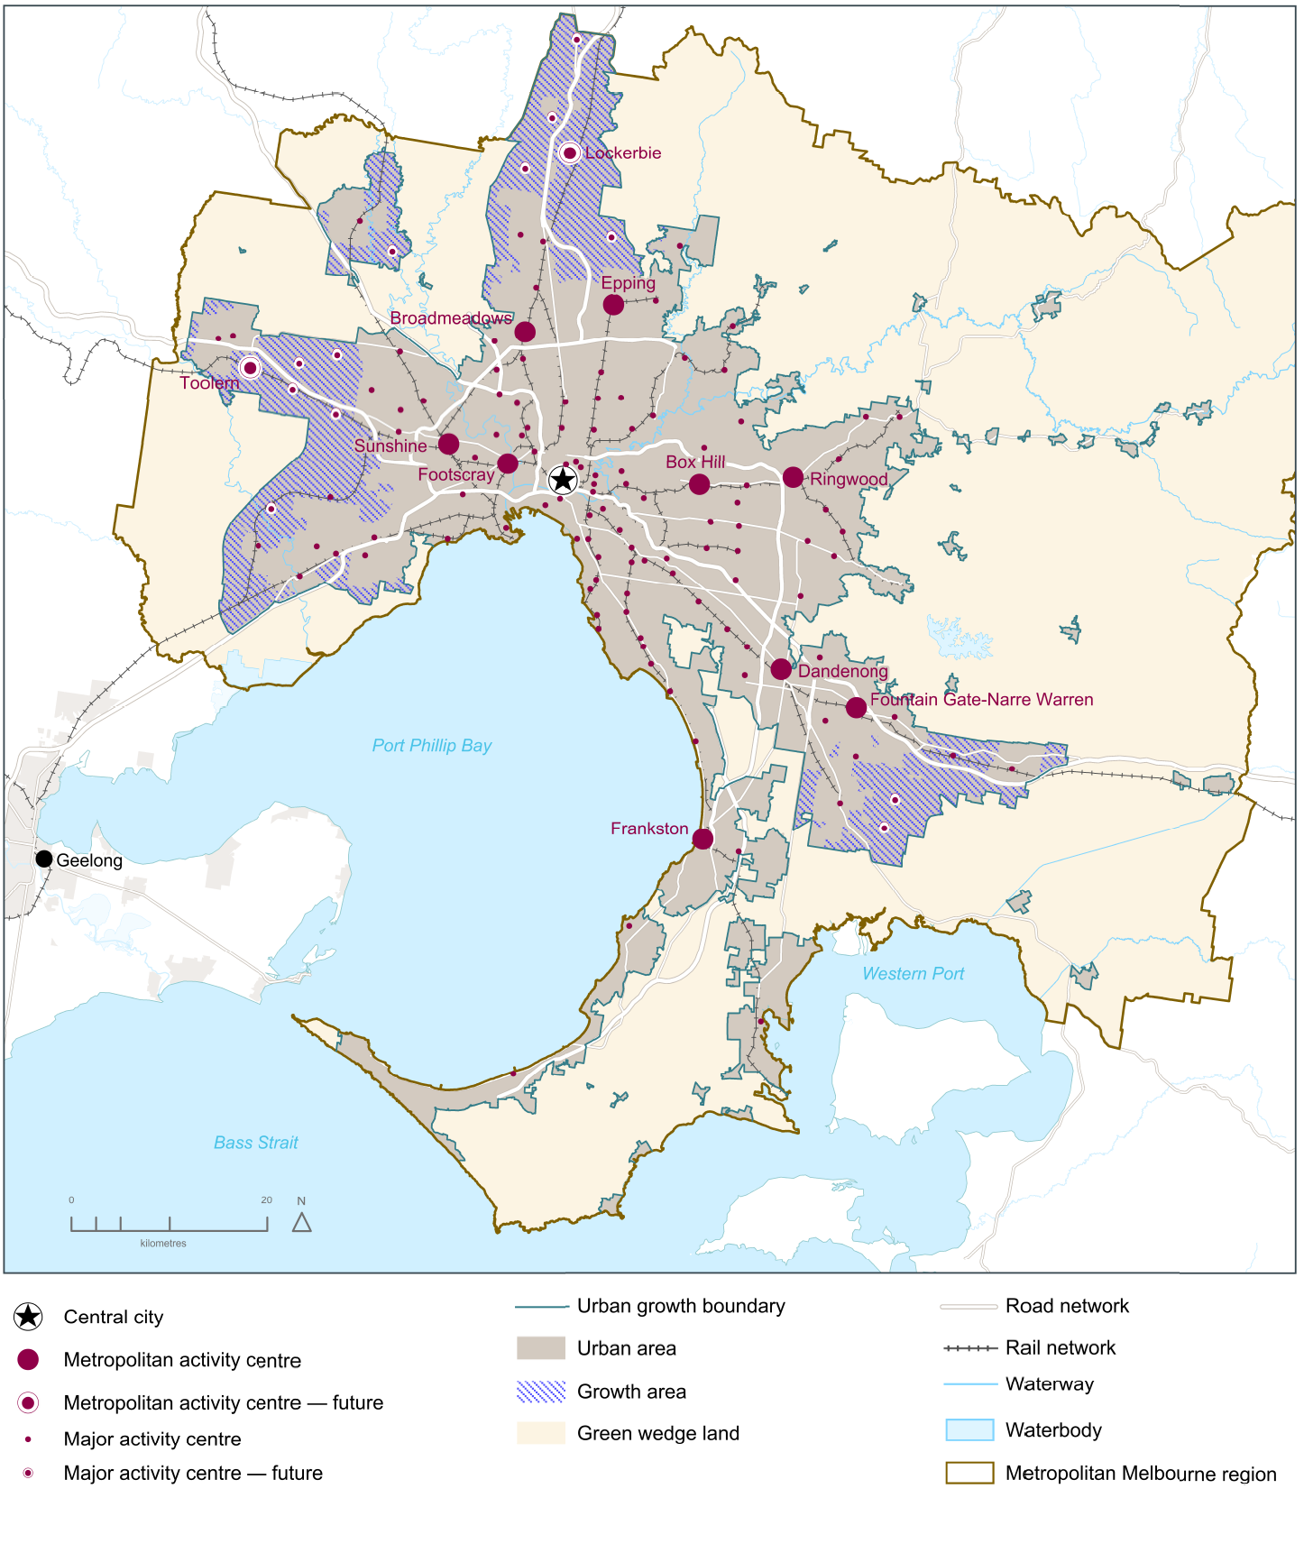
Source: Department of Environment, Land, Water and Planning

List of activity centres
Central City
- Melbourne
Metropolitan Activity Centres
- Box Hill
- Broadmeadows
- Dandenong
- Epping
- Footscray
- Fountain Gate-Narre Warren
- Frankston
- Ringwood
- Sunshine
Future Metropolitan Activity Centres
- Lockerbie
- Toolern
Major Activity Centres*
- Airport West
- Altona
- Altona North
- Ascot Vale-Union Road
- Balaclava
- Bayswater
- Bentleigh
- Berwick
- Boronia
- Brandon Park
- Braybrook-Central West
- Brighton-Bay Street
- Brighton-Church Street
- Brimbank Central
- Brunswick
- Burwood East-Tally Ho
- Burwood Heights
- Camberwell Junction
- Carlton-Lygon Street
- Carnegie
- Caroline Springs
- Casey Central
- Caulfield
- Chadstone
- Chelsea
- Cheltenham
- Cheltenham-Southland
- Chirnside Park
- Clayton
- Coburg
- Craigieburn
- Craigieburn Town Centre
- Cranbourne
- Croydon
- Deer Park
- Diamond Creek
- Doncaster East-The Pines
- Doncaster Hill
- Elsternwick
- Eltham
- Endeavour Hills
- Fitzroy-Brunswick Street
- Fitzroy-Smith Street
- Flemington-Racecourse Road
- Forest Hill Chase
- Gladstone Park
- Glen Waverley
- Glenhuntly
- Glenroy
- Greensborough
- Hampton
- Hampton Park
- Hastings
- Hawthorn-Glenferrie Road
- Heidelberg
- Hoppers Crossing
- Ivanhoe
- Karingal
- Kew Junction
- Keysborough-Parkmore
- Lilydale
- Malvern/Armadale
- Manor Lakes
- Maribyrnong-Highpoint
- Melton
- Melton-Woodgrove and Coburns Road
- Mentone
- Mernda
- Moonee Ponds
- Moorabbin
- Mordialloc
- Mornington
- Mount Waverley
- Mountain Gate
- Niddrie-Keilor Road
- Noble Park
- North Essendon
- Northcote
- Nunawading
- Oakleigh
- Officer
- Pakenham
- Point Cook
- Port Melbourne-Bay Street
- Prahran/South Yarra
- Preston-High Street
- Preston-Northland
- Reservoir
- Richmond-Bridge Road
- Richmond-Swan Street
- Richmond-Victoria Street
- Rosebud
- Rowville-Stud Park
- Roxburgh Park
- Sandringham
- South Melbourne
- South Morang
- Springvale
- St Albans
- St Kilda
- Sunbury
- Sydenham
- Tarneit
- Toorak Village
- Wantirna South-Knox Central
- Werribee
- Werribee Plaza
- Williams Landing
- Williamstown
Future Major Activity Centres
- Beveridge
- Clyde
- Clyde North
- Hopkins Rd
- Mickleham
- Plumpton
- Riverdale
- Rockbank
- Rockbank North
- Sunbury South
- Wallan
- Wollert
* Each of these centres has different development potential and is subject to local strategic planning.

Policy 2.2.1 Facilitate well-designed, high-density residential developments that support a vibrant public realm in Melbourne's central city
Directing population and housing growth into defined change areas will enable the Victorian Government to work with local governments, developers and stakeholders to create sustainable, liveable and attractive places that appeal to a range of households—including families with children and older- and single-person households.
A number of major urban renewal precincts have been identified in the central city (as shown on Map 4). Maximising development opportunities of these precincts will minimise the need to increase residential densities in other parts of the city. The sequencing of infrastructure within these precincts will maximise their development potential and provide timely services and amenities for residents.
There is a need to find ways to give the market some flexibility to maximise development opportunities. For instance, additional development rights could be granted in exchange for the provision of additional amenity in the central city and other key urban renewal and structure plan areas.

Policy 2.2.2 Direct new housing and mixed-use development to urban renewal precincts and sites across Melbourne
The redevelopment of urban renewal precincts and sites will create more diversity in the housing market—including opportunities for affordable and social housing—as well as more jobs and community services. Urban renewal precincts will be major sources of medium- and higher-density mixed-use development.
Additional urban renewal opportunities need to be identified through regional planning in partnership with the local government sector.
Local governments will be supported to deliver outcomes at identified local urban renewal precincts and sites, particularly if they have complex issues that need to be addressed such as site contamination.

Policy 2.2.3 Support new housing in activity centres and other places that offer good access to jobs, services and public transport
To support increased housing supply in established areas, it will be necessary to define locations best able to support increased densities.
Activity centres are usually well served with public transport and offer access to a range of services and facilities. Many activity centres can support additional housing growth and will need flexibility, particularly where there is a significant population and household growth forecast.
Activity centres with the greatest potential to attract investment and support more medium- and higher-density housing need to be identified. This should also include opportunities for the creation of new activity centres. Once identified, appropriate policies, provisions and guidelines must be developed and put in place to encourage and support planned growth.

Policy 2.2.4 Provide support and guidance for greyfield areas to deliver more housing choice and diversity
Greyfield sites are residential areas where building stock is near the end of its useful life and land values make redevelopment attractive. Melbourne has many residential areas that qualify as greyfield sites, particularly in established middle and outer suburbs.
These areas often have low-density, detached housing on suburban-sized allotments that have good access to public transport and services.
Up until now, the redevelopment of these areas has been generally uncoordinated and unplanned. That must change. Greyfield areas provide an ideal opportunity for land consolidation and need to be supported by a coordinated approach to planning that delivers a greater mix and diversity of housing and provides more choice for people already living in the area as well as for new residents.
Methods of identifying and planning for greyfield areas need to be developed. A more structured approach to greyfield areas will help local governments and communities achieve more sustainable outcomes.

Policy 2.2.5 Require development in growth areas to be sequenced and staged to better link infrastructure delivery to land release
Growth areas have a significant role to play in how Melbourne's growth is managed and provide affordable housing options to residents. As Figure 8 shows, Melbourne’s greenfield lots are the second cheapest among Australia’s capital cities. Comparative prices in Sydney are more than double Melbourne’s prices.
Melbourne’s growth areas have at least 25 years supply of greenfield residential land (undeveloped land on the fringe of the city). Of this, approximately 15 years land supply is ‘development ready’, being either zoned or having approved Precinct Structure Plans. Residential densities in recent years have increased from 15 dwellings per hectare to around 18 dwellings per hectare. If average densities continue to increase, this supply will last beyond 2050.
Although Melbourne’s greenfield housing market performs strongly, the models for coordinating the delivery of land supply and supporting infrastructure can be improved. Poorly managed releases of land can result in higher living costs for residents, as well as limiting access to workforce opportunities and education and health services.
An integrated approach to land-use and transport planning helps ensure infrastructure and essential services are delivered as areas develop. Initiatives such as growth areas infrastructure contributions to help fund substantial state infrastructure and improved transport services, including the Regional Rail Link and reservation for future transport corridors, can help deliver sustainable new communities.
In the future, planning and development of growth areas should:
- provide around 15 years supply of land approved for development
- over time, seek an overall increase in residential densities to more than 20 dwellings per hectare
- be sequenced to ensure new precincts are contiguous with previously approved precincts.
This approach will link infrastructure delivery to land release, ensuring residents in new communities receive the services and infrastructure they need sooner. Coordinated planning such as this will help create stronger, healthier communities.
Figure 8 Median lot price by market, September 2016

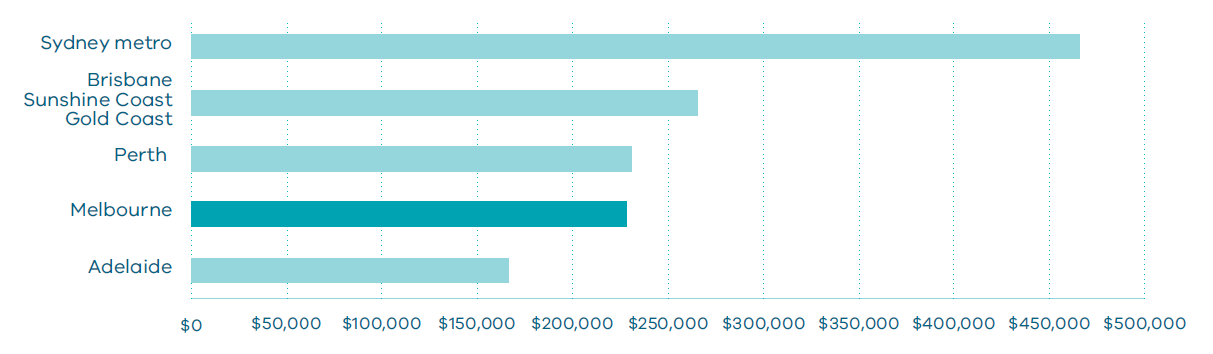
Source: National Land Survey Program (NLSP) by Charter Keck Cramer and Research 4.

Direction 2.3 Increase the supply of social and affordable housing
The planning system alone cannot address all of the issues related to the provision of social and affordable housing. A range of programs and measures across all levels of government are required, but it is important that the planning system makes it easier—rather than harder—to deliver social and affordable housing.
In recent years, housing prices have risen faster than incomes, making home ownership increasingly unattainable for many citizens. As a result, many households may remain in the private rental market indefinitely unless they are prepared to buy in locations with poorer access to services and jobs.
The most severe and chronic housing affordability problems are experienced by lower-income households in the private rental market, particularly those reliant on statutory incomes such as Centrelink. In addition, levels of homelessness have increased in Victoria, with more than 22,000 people recorded as homeless on Census night in 2011.
For Melbourne to remain liveable for all its citizens, the supply of social and affordable housing needs to be increased. A range of housing types need to be developed within suburbs across Melbourne—not just in outer areas—to improve local affordability for homeowners and renters.
What is affordable housing and what is social housing?
Affordable housing is housing that is appropriate for the needs of a range of very low to moderate income households, and priced (whether mortgage repayments or rent) so these households are able to meet their other essential basic living costs.
Social housing is a type of rental housing that is provided and/or managed by the government (public housing) or by a not-for-profit organisation (community housing). Social housing is an overarching term that covers both public housing and community housing.

Map 15 Lower-cost housing in metropolitan Melbourne 1995 and 2015
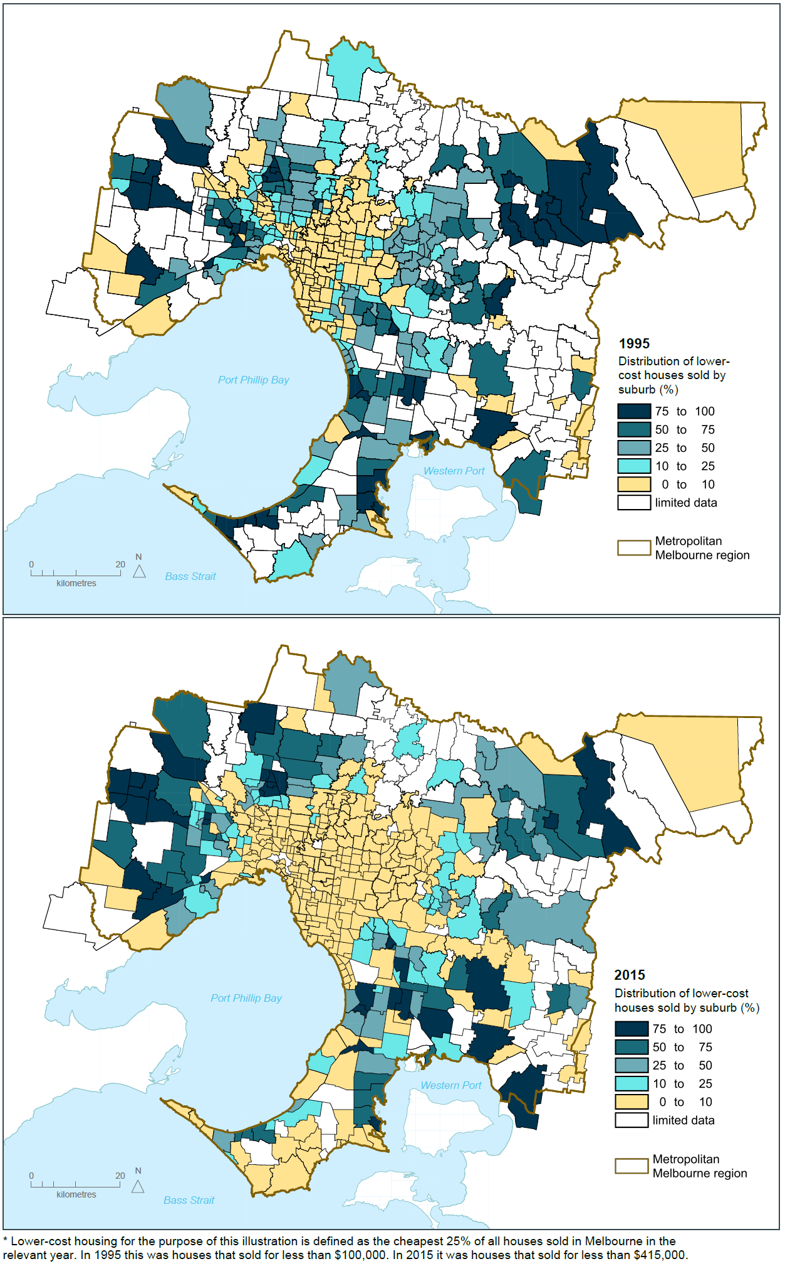
Source: Department of Environment, Land, Water and Planning

Policy 2.3.1 Utilise government land to deliver additional social housing
The Victorian Government holds valuable land assets that can contribute to the delivery of additional social and affordable housing.
The Victorian Government will increase the supply of social and affordable housing through identifying surplus government land suitable for housing. Sites identified as being surplus to government requirements need to be re-used in ways that deliver broad community benefits—such as boosting the supply and spread of social and affordable housing. Opportunities to increase overall supply through the regeneration of existing public housing also need to be identified.
The government is taking a strategic approach to accelerating the development of well-located surplus government land. A pilot program has been developed for a number of sites suitable for affordable housing. Other opportunities to leverage surplus government land to deliver social housing while maximising the opportunity to deliver planning uplift and certainty will be investigated, including local government land and surplus land held by other agencies.

Policy 2.3.2 Streamline decision-making processes for social housing proposals
Delays in approvals can result in additional holding costs and make social-housing developments harder to deliver.
Streamlined approval processes for the government and the community-housing sector can help facilitate the supply of social housing.
To support an increase in the supply of social housing, a new streamlined approval process will be developed for social-housing projects. This will facilitate faster delivery of social-housing projects with lower holding costs and greater planning certainty.

Policy 2.3.3 Strengthen the role of planning in facilitating and delivering the supply of social and affordable housing
There is a pressing need to increase the supply of social and affordable housing for households unable to afford market-rate housing.
The supply of social and affordable housing is largely dependent on the availability of subsidies to cover the gap between what very low income households can pay and the cost of providing housing. However, the land-use planning system can be reformed and strengthened to help support and facilitate the delivery of more social and affordable housing.
There are currently several planning-related barriers to the delivery of more social and affordable housing—including a lack of clarity in legislation and planning provisions on what constitutes affordable housing, and the absence of clear planning tools or mechanisms to require the provision of social or affordable housing as part of the planning process. Current approaches (such as requiring section 173 Agreements under the Planning and Environment Act 1987 or applying requirements through tools such as Development Plan Overlays) have been criticised for not being sufficiently robust and inequitably applied.
The planning system will be reformed to facilitate the delivery of more social and affordable housing. These reforms will clearly define social and affordable housing, create a clear head of power for affordable housing contributions, and clarify the role the planning system has to play in the delivery of new housing. Reforms will also include new planning provisions or tools to deliver social and affordable housing. These reforms will explore inclusionary zoning and mechanisms to capture and share value created through planning controls.
New provisions or tools will be developed in consultation with the community-housing sector, the residential-development industry and local government.

Policy 2.3.4 Create ways to capture and share value uplift from rezonings
There is an increasing need to encourage the development of more affordable housing, including the integration of social and affordable housing options within major urban renewal developments.
There is scope to capture some of the value created by the rezoning process for policy priorities such as social and affordable housing.
Urban renewal precincts and sites offer significant opportunities to deliver tangible broader public benefit through their rezoning for social or affordable housing, as well as local assets such as open space and community facilities.
Consideration needs to be given to developing a new requirement that when land is rezoned to allow for higher value uses, a proportion of the value uplift should be contributed to the delivery of broader public benefit outcomes such as social and affordable housing

Direction 2.4 Facilitate decision-making processes for housing in the right locations
Many sites identified for future housing face lengthy decision-making processes. This can make it time consuming to develop new housing, driving up housing costs.
Many sites across Melbourne have a legacy of environmental contamination as a result of the city’s industrial and manufacturing heritage. For some sites, the cost of remediation may limit re-use options.
Developments allowing more than a single dwelling can also be subject to lengthy assessment processes and appeals even if they are in areas where change is envisaged. Contested applications generally arise where performance-based requirements exist instead of clearer, more prescriptive requirements.
The uncertainty in the system needs to be reduced, particularly for development in areas defined for change and housing growth.

Policy 2.4.1 Support streamlined approval processes in defined locations
Attracting population and housing growth to the most suitable, well serviced areas will be assisted by providing clear approval processes for preferred areas and quality housing developments that appeal to a range of households on different incomes.
A streamlined, codified approval process will be developed and implemented for defined change areas. Under this process, proposals could be required to achieve a set of premium development standards related to dwelling design, open space and residential amenity and demonstrate delivery of good urban design outcomes for the locality.
A codified approval process will speed up decision-making in defined locations and provide local governments, the community and the housing sector with greater certainty. If a proposal does not meet the set standards for codified approval, then a normal approval process would apply.

Policy 2.4.2 Facilitate the remediation of contaminated land, particularly on sites in developed areas of Melbourne with potential for residential development
Policy frameworks and controls for managing contaminated environments must support safe redevelopment. They also need to allow for innovative approaches that maximise redevelopment opportunities for residential uses.
That is why the integration of land-use planning and environmental processes for assessment and remediation of contaminated sites must improve. The uncertainty of investigation and clean-up requirements for potentially contaminated land must also be reduced, so that land can be brought to market sooner.

Direction 2.5 Provide greater choice and diversity of housing
Housing diversity relates to the size, cost, number of bedrooms, character and age of dwellings. It also extends to other types of housing, such as low-cost rental aged care, supported accommodation for people with disability, rooming houses, student accommodation and social housing.
Creating greater choice and diversity of housing across the city has clear benefits—such as improved access to jobs, services and transport. For newly formed households, providing a diversity of housing may enable them to remain within a preferred location. For older couples, housing diversity may enable them to downsize to more compact accommodation within their neighbourhood.

Policy 2.5.1 Facilitate housing that offers choice and meets changing household needs
Melbourne needs a greater mix of housing. Alternate forms of housing, such as secondary dwellings, can offer opportunity for small-scale development in established areas—creating opportunities for extended families to live together or older couples to downsize.
Internal design can also increase the flexibility and adaptability of dwellings. For example, universal design ensures homes are accessible to people with disability—accessibility will become more important as the population ages. A flexible internal design can also help accommodate adult children remaining or returning home as well as the addition of elderly parents to a household.
The planning system will be amended to cater for different types of housing and accommodation.
Secondary dwellings
A number of states across Australia allow the development of a secondary dwelling.
A secondary dwelling—sometimes referred to as a granny flat or bedsitter—is an additional self-contained dwelling developed on the same land as a principal dwelling. It is limited in size and can be located within, beside, behind, below or above the principal dwelling.
A range of development standards are generally required to be met to be classified as a secondary dwelling, such as site area requirements, building heights and setbacks, landscaping and services. If development standards are met, a fast-track approval process applies.
In some areas, there are limitations on the secondary dwelling being occupied by persons who form one household with the principal dwelling.

Policy 2.5.2 Provide a range of housing types in growth areas
In growth areas, there needs to be a move away from uniform-sized housing lots towards providing both higher and lower densities within each precinct.
Planning for growth areas must deliver a variety of lot sizes and housing types. This can be achieved through both larger lots (to provide a sizeable backyard for those families that desire it), as well as options for townhouses, low-rise apartments, and aged-care housing close to shopping centres and community facilities.

City of Melbourne, 2013, Future Living: A discussion paper identifying issues and options for housing our community.
In Victoria allocations to public housing are around 2,500 per annum. The current waiting list is in excess of 34,000 households.
Australian Bureau of Statistics, 2012, Census of Population and Housing: Estimating Homelessness 2011.
In NSW a secondary dwelling can be independently rented out. In contrast, Logan City Council in Queensland requires a secondary dwelling to be occupied by persons who form one household with the primary dwelling.

