Residential Land
bulletin
ISSN 1035 9168 June Quarter 2010

Overview
■ In the June 2010 quarter Metropolitan Melbourne recorded the highest number of lots in subdivision plans for a quarter since recording began in 1996.
■ The number of residential lots released in the June quarter was strong at 8448, similar to the December 2009 quarter though below the June quarter 2009.
■ The number of dwelling approvals for the 2010 June quarter was the highest for any quarter recorded since September 2002.
7 quarter moving average
Lots in subdivision plans: The seven quarter moving average for lots in subdivision plans was 10,418 for the June 2010 quarter, up 3% from the previous seven quarter moving average. Both growth area municipalities and other municipalities showed increases in the seven quarter moving average from the previous seven quarter moving average, with a 2% and 4% increase respectively.
Lots released: The seven quarter moving average for Metropolitan Melbourne for lots released increased by 5% from the previous seven quarter moving average to 7,492 lots.
Dwelling approvals: The seven quarter moving average for dwelling approvals was 8,934, a 3% increase from the previous seven quarter moving average and the highest seven quarter moving average since the March 2003 seven quarter moving average.
Figure 1: Key land development indicators for metropolitan Melbourne – 7 quarter moving average

Source: Spatial Analysis and Research Branch Survey of Councils

Figure 2: Key land development indicators for metropolitan Melbourne by region – 7 quarter moving average
West
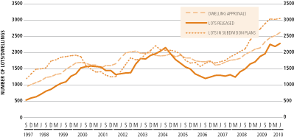
North
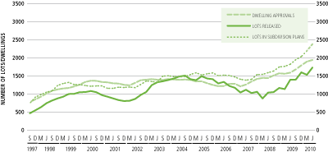
Inner
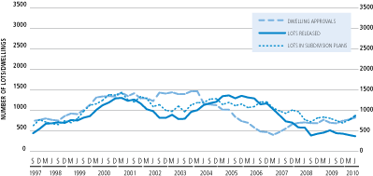
East
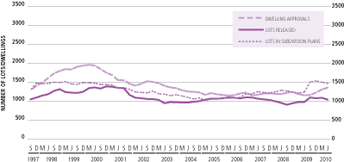
South
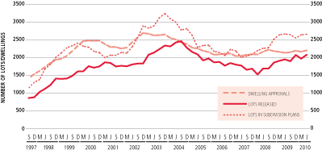
Source: Spatial Analysis and Research Branch Survey of Councils

Residential lots in subdivision plans (see table 1)
■ In the last four quarters there was a total of 43,041 lots in subdivision plans submitted to Metropolitan councils. This is a 3% increase from the previous four quarters. Of these 49% were located in growth areas and 51% were located in established areas.
■ There was a total of 11,595 lots in subdivision plans submitted to Metropolitan councils in the June 2010 quarter, a 6% increase from the previous quarter and the highest number of lots submitted for a quarter since recording began in 1996. This figure is likely to be slightly higher due to the data from the municipalities of Bayside and Whitehorse not being available at the time of printing.
■ The greatest percent increase from the previous quarter were the municipalities of Maroondah with 296 lots, Moonee Valley with 423 lots and Yarra with 326 lots. The greatest percent decrease from the previous quarter were the municipalities of Darebin with 102 lots, Port Phillip with 82 lots and Maribyrnong with 84 lots.
Residential lots released
(see table 4)
■ In the last four quarters there was a total of 28,741 residential lots released by Metropolitan councils, (down 2% from the previous four quarters).
■ There was a total of 8,448 lots released in the June 2010 quarter, a 44% increase from the previous quarter. This number is similar to that for the December 2009 quarter though below the June 2009 quarter.
■ 31% of lots released in the June quarter were located in the West, 30% were located in the South, 28% were located in the North, 8% were located in the East and 2% were located in the Inner municipalities.
Dwelling approvals
(see table 5)
■ In the last four quarters there was a total of 39,972 dwelling approvals. This is a 7% increase from the previous four quarters. Of these 46% were located in growth areas and 54% were located in established areas, a similar proportion to the previous four quarters.
■ Dwelling approvals for the June quarter increased to 10,363, a 7% increase from the previous quarter and the highest for any quarter since the 2002 September quarter. 30% of dwelling approvals were located in the West, 25% in the South, 19% in the North, 16% in the East and 10% in inner Melbourne.
■ The highest percent increase of dwelling approvals in local government areas from the previous quarter were Maribyrnong with 278, Maroondah with 180 and Yarra Ranges with 386. The greatest percent decrease in local government areas were Stonnington with 112, Whitehorse with 142 and Monash with 212.

Table 1: Residential lots in subdivision plans submitted to councils
Municipality | Number of Lots per Quarter
 | Jun  ‘09 | Sep  ‘09 | Dec  ‘09 | Mar  ‘10 | Jun  ‘10
Melbourne 513 154 256 631 1,031
Port Phillip 175 194 282 194 82
Yarra 127 232 223 86 326
Inner 815 580 761 911 1,439
Brimbank 159 281 330 224 124
Hobsons Bay 186 113 115 115 153
Maribyrnong 195 161 137 202 84
Melton 1,050 910 363 647 770
Moonee Valley 113 40 153 182 423
Wyndham 1,692 2,028 1,742 1,378 1,188
West 3,395 3,533 2,840 2,748 2,742
Bayside 27 86 319 N/A N/A
Cardinia 129 103 103 745 424
Casey 709 499 322 948 838
Frankston 473 355 349 191 412
Glen Eira 213 182 120 185 245
Greater
Dandenong 157 168 232 482 670
Kingston 133 180 296 198 199
Mornington
Peninsula 599 328 254 280 209
South 2,440 1,901 1,995 3,029 2,997
Banyule 110 99 69 63 131
Darebin 242 218 246 259 102
Hume 672 887 177 813 640
Moreland 264 333 246 496 413
Nillumbik 43 21 89 52 44
Whittlesea 877 1,374 1,328 1,312 1,625
North 2,208 2,932 2,155 2,995 2,955
Boroondara 321 237 80 82 156
Knox 88 82 101 57 113
Manningham 89 138 133 104 71
Maroondah 94 164 210 12 296
Monash 171 263 361 205 279
Stonnington 152 386 116 187 214
Whitehorse 112 170 143 453 N/A
Yarra Ranges 270 850 352 180 333
East 1,297 2,290 1,496 1,280 1,462
Growth area
municipalities 5,129 5,801 4,035 5,843 5,485
Established
municipalities 5,026 5,435 5,212 5,120 6,110
TOTAL
MELBOURNE 10,155 11,236 9,247 10,963 11,595
Source: Spatial Analysis and Research Branch Survey of Councils
N/A: Not Available
The data for 2008-09 for Stonnington has been revised since the June 2009 edition
Note: Growth area municipalities highlighted

Table 2: Water supply conditions accepted for residential lots
Municipality | Number of Lots per Quarter
 | Jun  ‘09 | Sep  ‘09 | Dec  ‘09 | Mar  ‘10 | Jun  ‘10
Melbourne 166 19 10 20 6
Port Phillip 3 2 2 N/A N/A
Yarra 4 9 18 10 N/A
Inner 173 30 30 30 6
Brimbank 172 348 287 257 49
Hobsons Bay 4 6 7 8 18
Maribyrnong 81 56 12 36 17
Melton 187 181 423 335 702
Moonee Valley 10 58 5 16 66
Wyndham 1,398 1,487 1,057 1,676 1,200
West 1,852 2,136 1,791 2,328 2,052
Bayside 4 10 6 7 N/A
Cardinia 180 479 262 63 N/A
Casey 436 669 384 58 N/A
Frankston 277 612 117 13 N/A
Glen Eira 4 8 6 21 N/A
Greater
Dandenong 101 5 183 34 N/A
Kingston 23 22 22 15 N/A
Mornington
Peninsula 114 93 81 42 N/A
South 1,139 1,898 1,061 253 N/A
Banyule 193 135 150 89 N/A
Darebin 194 N/A 415 160 N/A
Hume 375 641 541 330 133
Moreland 535 468 293 288 N/A
Nillumbik 58 412 357 252 N/A
Whittlesea 644 613 953 754 N/A
North 1,999 2,269 2,709 1,873 133
Boroondara 135 180 220 284 N/A
Knox 29 25 13 34 N/A
Manningham 93 78 77 64 N/A
Maroondah 140 142 202 119 N/A
Monash 113 142 165 205 N/A
Stonnington 23 17 106 36 N/A
Whitehorse 160 171 196 100 N/A
Yarra Ranges 135 122 207 119 N/A
East 828 877 1,186 961 N/A
Growth area
municipalities 3,220 4,070 3,620 3,216 2,035
Established
municipalities 2,771 3,140 3,157 2,229 156
TOTAL
MELBOURNE 5,991 7,210 6,777 5,445 2,191
Source: City West Wate and Western Water Note: Data from Yarra Valley Water and South East Water not available and data from previous quarters Bulletin incorrect. Please see correction on website.
Note: Growth area municipalities highlighted
Table 3: Certification of residential lots
Municipality | Number of Lots per Quarter
 | Jun  ‘09 | Sep  ‘09 | Dec  ‘09 | Mar  ‘10 | Jun  ‘10
Melbourne 2 0 0 2 0
Port Phillip 7 27 38 19 20
Yarra 90 49 225 33 86
Inner 99 76 263 54 106
Brimbank 192 326 116 113 444
Hobsons Bay 107 142 214 105 118
Maribyrnong 170 168 112 208 91
Melton 949 605 618 494 311
Moonee Valley 15 44 107 149 409
Wyndham 1,599 1,588 1,759 1,016 1,755
West 3,032 2,873 2,926 2,085 3,128
Bayside 25 0 0 N/A N/A
Cardinia 290 84 84 532 585
Casey 1,170 514 538 236 996
Frankston 419 470 401 351 315
Glen Eira 171 184 147 134 160
Greater
Dandenong 79 132 106 166 187
Kingston 95 163 203 144 147
Mornington
Peninsula 319 230 501 157 331
South 2,568 1,777 1,980 1,720 2,721
Banyule 171 44 52 31 57
Darebin 23 19 6 35 9
Hume 236 673 408 68 517
Moreland 289 402 282 191 200
Nillumbik 48 12 65 25 67
Whittlesea 753 1,200 1,061 1,281 1,327
North 1,520 2,350 1,874 1,631 2,177
Boroondara 102 203 87 60 60
Knox 96 103 122 72 98
Manningham 77 77 59 66 116
Maroondah 53 16 24 10 62
Monash 111 154 123 235 209
Stonnington 815 111 340 55 88
Whitehorse 49 46 129 41
Yarra Ranges 121 533 116 199 186
East 1,424 1,243 1,000 738 819
Growth area
municipalities 4,997 4,664 4,468 3,627 5,491
Established
municipalities 3,646 3,655 3,575 2,601 3,460
TOTAL
MELBOURNE 8,643 8,319 8,043 6,228 8,951
Source: Spatial Analysis and Research Branch Survey of Councils N/A: Not Available The data for 2008-09 for Stonnington has been revised since the June 2009 edition
Note: Growth area municipalities highlighted
Table 4: Residential lots released

Municipality | Number of Lots per Quarter
 | Jun  ‘09 | Sep  ‘09 | Dec  ‘09 | Mar  ‘10 | Jun  ‘10
Melbourne 644 317 4 168 35
Port Phillip 22 22 26 15 26
Yarra 10 95 227 42 135
Inner 676 434 257 225 196
Brimbank 206 314 379 43 124
Hobsons Bay 66 65 63 43 53
Maribyrnong 123 127 207 206 85
Melton 424 352 781 458 528
Moonee Valley 8 58 79 66 63
Wyndham 1,578 862 1,550 1,132 1,758
West 2,405 1,778 3,059 1,948 2,611
Bayside 30 13 2 N/A N/A
Cardinia 290 228 228 317 658
Casey 532 277 888 556 696
Frankston 250 136 457 200 364
Glen Eira 165 259 137 158 181
Greater
Dandenong 104 127 112 105 230
Kingston 82 170 244 142 149
Mornington
Peninsula 292 284 446 189 286
South 1,745 1,494 2,514 1,667 2,564
Banyule 101 50 136 73 55
Darebin 23 40 15 21 40
Hume 543 282 356 90 629
Moreland 292 326 334 198 220
Nillumbik 42 16 71 31 26
Whittlesea 1,619 484 998 782 1,437
North 2,620 1,198 1,910 1,195 2,407
Boroondara 123 136 66 96 119
Knox 94 130 90 82 76
Manningham 77 96 49 51 79
Maroondah 19 4 10 2 6
Monash 117 173 135 118 201
Stonnington 804 84 149 278 83
Whitehorse 138 93 84 83 N/A
Yarra Ranges 221 351 145 109 106
East 1,593 1,067 728 819 670
Growth area
municipalities 4,986 2,485 4,801 3,335 5,706
Established
municipalities 4,053 3,486 3,667 2,519 2,742
TOTAL
MELBOURNE 9,039 5,971 8,468 5,854 8,448
Source: Spatial Analysis and Research Branch Survey of Councils Note: Information for Wydham & Brimbank sourced from VICMAP Property
N/A: Not Available
Note: Growth area municipalities highlighted
Table 5: Dwelling approvals

Municipality | Number of Lots per Quarter
 | Jun  ‘09 | Sep  ‘09 | Dec  ‘09 | Mar  ‘10 | Jun  ‘10
Melbourne 404 665 528 251 435
Port Phillip 31 50 180 146 263
Yarra 56 206 224 220 288
Inner 491 921 932 617 986
Brimbank 374 483 347 337 321
Hobsons Bay 120 90 136 81 176
Maribyrnong 163 289 224 112 278
Melton 590 710 480 517 691
Moonee Valley 129 198 165 171 243
Wyndham 1,058 1,445 1,319 1,445 1,430
West 2,434 3,215 2,671 2,663 3,139
Bayside 157 111 87 129 155
Cardinia 411 457 464 442 423
Casey 648 623 704 719 713
Frankston 167 193 193 251 312
Glen Eira 139 141 198 191 218
Greater
Dandenong 109 138 283 203 224
Kingston 150 144 166 163 283
Mornington
Peninsula 270 313 309 288 251
South 2,051 2,120 2,404 2,386 2,579
Banyule 76 145 139 117 124
Darebin 285 191 222 357 293
Hume 358 575 567 362 425
Moreland 329 205 397 363 304
Nillumbik 42 64 56 40 62
Whittlesea 863 1,094 950 995 765
North 1,953 2,274 2,331 2,234 1,973
Boroondara 89 240 202 202 347
Knox 144 97 120 109 112
Manningham 104 165 235 102 195
Maroondah 80 141 283 74 180
Monash 206 190 279 331 212
Stonnington 92 262 119 601 112
Whitehorse 120 153 213 227 142
Yarra Ranges 156 171 149 176 386
East 991 1,419 1,600 1,822 1,686
Growth area
municipalities 3,928 4,904 4,484 4,480 4,447
Established
municipalities 3,992 5,045 5,454 5,242 5,916
TOTAL
MELBOURNE 7,920 9,949 9,938 9,722 10,363
Source: Australian Bureau of Statistics catalogue number 8731.2

Note: Growth area municipalities highlighted

Estates’ sales activity in Growth Area municipalities
Figure 3: Residential lots released and average lot size for estates in Growth Area municipalities, reported by councils in the June 2010 quarter
Note: Data is collected for estates releasing five or more dwellings and may not be a complete record of lots released.
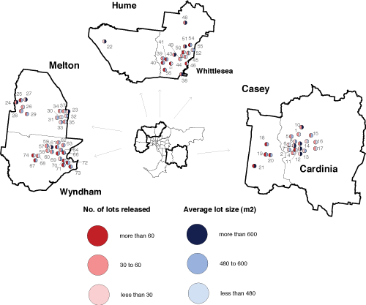

No. on map | Estate | Number of lots released | Average Lot Size (m²)
1 | Toomuc Meadows | 36 | 429
2 | Aspect | 86 | 432
3 | Devonia | 18 | 616
4 | Devonia | 43 | 433
5 | Arena Stage 3 | 51 | 544
6 | Devonia Park | 28 | 461
7 | Caversham Waters | 20 | 496
8 | Botanic Walk | 7 | 546
9 | Heritage Springs | 36 | 835
10 | Sovereign Hill | 49 | 653
11 | Blue Horizons | 24 | 694
12 | Arden | 10 | 655
13 | Henty Park | 21 | 557
14 | LP211076 | 25 | 400
15 | Cardinia Lakes | 57 | 566
16 | Fallingwater | 41 | 369
17 | Fallingwater | 49 | 379
18 | Eve Estate | 172 | 500
19 | Hunt Club Estate | 73 | 500
20 | Cascades on Clyde | 81 | 600
21 | Botanic Ridge Estate | 66 | 776
22 | Caterbury Hills 24 | 13 | 800
23 | Taylors Hill | 30 | 650
24 | Arnold’s Creek | 33 | 650
25 | Arnold’s Creek | 67 | 500
26 | Silverdale | 36 | 450
27 | Fleet Park | 14 | 800
28 | Riverina at Brookfield | 48 | 500
29 | Belle Gardens | 43 | 600
30 | The Grange | 16 | 450
31 | The Grange | 17 | 500
32 | The Grange | 21 | 600
33 | The Grange | 28 | 500
34 | 40 McCubbin Way | 32 | 200
35 | The Esplanade | 32 | 250
36 | The Esplanade | 23 | 250
37 | Taylors Hill | 34 | 400
38 | Chancellor (University Hill) | 57 | 629
39 | Lyndarum | 48 | 553
40 | Summerhill | 79 | 551
41 | Carlingford | 69 | 490
42 | Aurora | 178 | 421
43 | Palisades | 41 | 760
44 | Greengully | 35 | 455
45 | Riverdale on Plenty | 32 | 182
46 | Hawkestowe East/West | 95 | 450
48 | Plenty River Views | 33 | 1071
49 | Renaissance Rise | 49 | 473
50 | Mernda Villages | 176 | 420
51 | Cornells Hill | 60 | 672
52 | Plenty River | 57 | 436
53 | Vantage Point | 34 | 540
54 | Laurimar - Park | 203 | 492
55 | Mitchell's Run | 19 | 505
56 | Mosaic | 80 | 515
57 | Tarneit Rise | 57 | 495
58 | Ecoville | 42 | 419
59 | Reflections | 28 | 850
60 | The Reserve | 42 | 510
61 | Rose Grange | 70 | 540
62 | Botanical | 48 | 586
63 | The Grove | 60 | 520
64 | Westbourne Fields | 59 | 517
65 | Arndell | 102 | 563
66 | Williams Landing | 88 | 540
67 | Bluestone Green | 133 | 592
68 | Wyndham Springs | 33 | 424
69 | Karinya | 28 | 482
70 | Innisfail | 149 | 416
71 | Alamanda | 197 | 500
72 | Esperance | 150 | 509
73 | Saltwater Coast | 233 | 506
74 | Manor Lakes | 110 | 446
74 | Manor Lakes | 110 | 446
Source: Spatial Analysis and Research Branch Survey of Councils

Figure 4: Average lot size (m²) in Growth Area LGAs
Note: Data up to the March 2010 quarter includes sales within and outside of estates
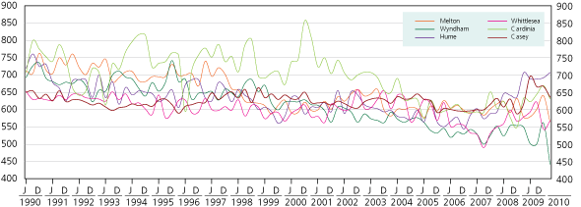
Figure 5: Number of lots sold in Growth Area LGAs
Note: Data only available up to December 2009 quarter as March 2010 quarter is incomplete
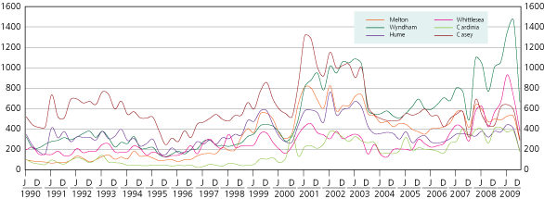

Figure 6: Median Vacant Lot Price in Growth Area LGAs
Note: Data available up to March 2010 quarter and is incomplete and subject to revision
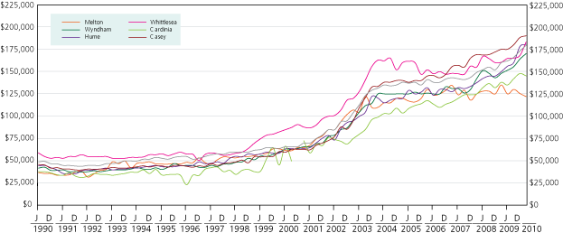

Source: Valuer-General

Figure 7: Percentage of lots sold in Growth Area estates
Note: December quarter based on October and November data only as aggregates not available for the month of December
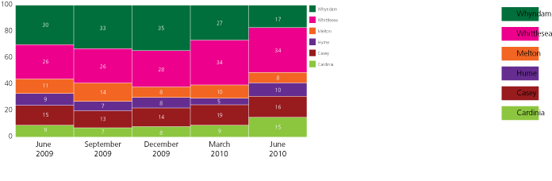

Source: Oliver Hume Research

Review of lots sold in growth area LGAs
Average lot size (m²) in growth area LGAs (see Figure 4)
The mean vacant lot size for all growth area municipalities was 557 m² in the March 2010 quarter. All mean vacant lot sizes reduced in growth area municipalities in the March 2010 quarter with the exception of Hume and Whittlesea. Vacant lot sizes in Hume remained the highest with a mean of 706 m2 and remained the lowest in Wyndham with a mean of 440 m².
Number of lots sold in growth area LGAs (see Figure 5)
Note: Note: Data only available up to December 2009 quarter as March 2010 quarter is incomplete. There can be a significant lag in the number of lots reportedly sold for each quarter as lot sales may be subject to conditions such as the completion of construction of a dwelling or the provision of utilities. These lots may then not be reported until subsequent quarters. The data reproduced here is revised every quarter. The total number of lots sold and recorded in the growth areas for the December 2009 quarter was 1,994.
Price of vacant lots in growth area LGAs (see Figure 6)
In the March 2010 quarter there was a $68,000 range between median prices of the six growth areas. Melton had the lowest median price of $122,000 and Casey had the highest with a median price of $190,000. This is consistent with the previous quarter.
The largest rate of increase from the previous quarter was the growth area of Whittlesea (up 9% from the previous quarter) and the lowest was Melton (down 3% from the previous quarter).
Percentage of lots sold in growth area estates (see Figure 7)
The proportion of lots sold in Wyndham for the June 2010 quarter decreased from 27% in the previous quarter to 17%. Whittlesea continued to have the highest proportion of lots sold for a growth area remaining at 34% for the June quarter, the same percentage as the previous quarter. The percentage of lots sold in Hume increased to 10% for the June 2010 quarter, up from 5 percent in the previous quarter.

Glossary
Residential lots are parcels of land intended for housing development. In fringe areas there would generally (but not in all cases) be one dwelling built on each lot. In established areas residential lots may be parcels of land created by subdividing larger properties or redeveloping land from other uses, often for multi-purpose construction. While technically still defined as residential lots, the latter may more usefully be considered as dwelling units. Only metropolitan Melbourne is included.
Residential lots in subdivision plans: Councils provide the number of residential lots which were submitted to them in subdivision plans where a planning permit is required for subdivision.
Water supply conditions accepted for residential lots: Water supply authorities provide the number of formal offers made by these authorities and accepted by land owners for the provision of water supply to residential lots in plans.
Certification of residential lots: Councils provide the number of residential lots for which certification has been given. Certification is given when a plan complies with the conditions of the planning permit or planning scheme provisions.
Residential lots released: Councils provide the number of lots which have been completed to the satisfaction of the Council and have been issued with a Statement of Compliance. At this point the subdivision requirements have been satisfied for roadworks, drainage, water supply and any other construction.
Dwelling approvals: The Australian Bureau of Statistics provide the number of “houses” and “other residential” dwellings approved for each municipality.
Note: Totals in Tables 1 – 5 exclude municipalities where data was not available.

Published by Spatial Analysis and Research, a branch in the Department of Planning and Community Development
1 Spring Street Melbourne
Victoria 3000
Telephone (03) 9208 3000
September 2010
© Copyright State Government of Victoria 2010
This publication is copyright. No part may be reproduced by any process except in accordance with the provisions of the Copyright Act 1968.
Authorised by the Victorian Government, Melbourne
Printed by Stream Solutions,
157 Spring Street, Melbourne
Designed by Judy Bennett Design
29 Yorkshire Street, Richmond
This publication may be of assistance to you but the state of Victoria and its employees do not guarantee that the publication is without flaw of any kind or is wholly appropriate for your particular purposes and therefore disclaims all liability for any error, loss or other consequences which may arise from you relying on any information in this publication.
Editor: Suzanne Slegers
Email: spatialanalysis.research@dpcd.vic.gov.au
Internet: www.dpcd.vic.gov.au/research/urbanandregional

