Inclusionary Housing Pilot 87-103 Manningham Street, Parkville
  - Information Sheet – August 2021

Inclusionary Housing Pilot Update
The Inclusionary Housing Pilot (IHP) is part of the Government’s housing strategy, Homes for Victorians, and will deliver up to 100 new social hosing homes across six surplus government land sites. It’s a new and innovative way of thinking about housing.
The sites will be developed by the private sector, in partnership with a community housing provider. The sites are being developed in close consultation with government and the relevant local council and will showcase leading mixed tenure and place making design

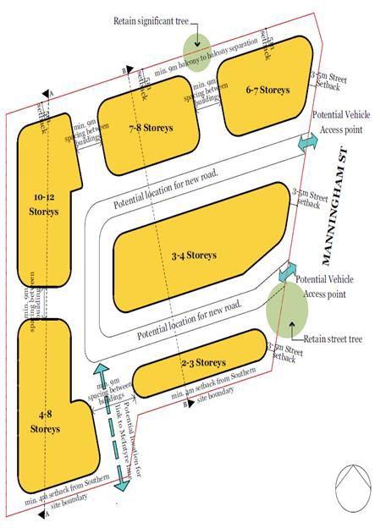
The site:
- contains a number of dwellings as well as areas of vegetation
- comprises a mix of one, two and three storey dwellings
- area is approximately 1.2ha.

Current planning controls
Zone | Residential Growth Zone (RGZ)
Overlay | Development Plan Overlay – Schedule 14 (DPO14)  Retains Design and Development Overlay – Schedule 66 (DDO66)
Particular provision | Minister for Planning is now responsible authority
Context | Minister for Planning is now responsible authority

The next steps
The Barnett Foundation as the selected bidder will now seek planning approval before construction can commence.

Contact information
If you have any questions about the Inclusionary Housing Pilot, contact 136 186 or email inclusionary.housing@delwp.vic.gov.au.

© The State of Victoria Department of Environment, Land, Water and Planning 2021  This work is licensed under a Creative Commons Attribution 4.0 International licence. You are free to re-use the work under that licence, on the condition that you credit the State of Victoria as author. The licence does not apply to any images, photographs or branding, including the Victorian Coat of Arms, the Victorian Government logo and the Department of Environment, Land, Water and Planning (DELWP) logo. To view a copy of this licence, visit http://creativecommons.org/licenses/by/4.0/l  Disclaimer  This publication may be of assistance to you but the State of Victoria and its employees do not guarantee that the publication is without flaw of any kind or is wholly appropriate for your particular purposes and therefore disclaims all liability for any error, loss or other consequence which may arise from you relying on any information in this publication. | Accessibility  If you would like to receive this publication in an alternative format, please telephone the DELWP Customer Service Centre on 136 186, email customer.service@delwp.vic.gov.au, or via the National Relay Service on 133 677 www.relayservice.com.au. This document is also available on the internet at www.delwp.vic.gov.au.

