Planning and Environment Act 1987

PLANNING SCHEME

AMENDMENT C148bawb

PLANNING PERMIT application PA2302141

EXPLANATORY REPORT

Who is the planning authority?
This Planning Scheme Amendment has been prepared by the Minister for Planning who is the Planning Authority for this amendment.
The Amendment and combined planning permit have been prepared at the request of Freeway Business Park Pty Ltd.

Land affected by the amendment
The amendment applies to 14-40 and 42-60 Wills Street and 98 King Street, Warragul (subject site). The land comprises four titles, formally known as:
- Lot 1 PS901914 (14-40 Wills Street, Warragul)
- Lot 2 PS901914 (14-40 Wills Street, Warragul)
- Lot 3 PS901914 (42-60 Wills Street, Warragul)
- Lot 4 PS901914 (98 King Street, Warragul).

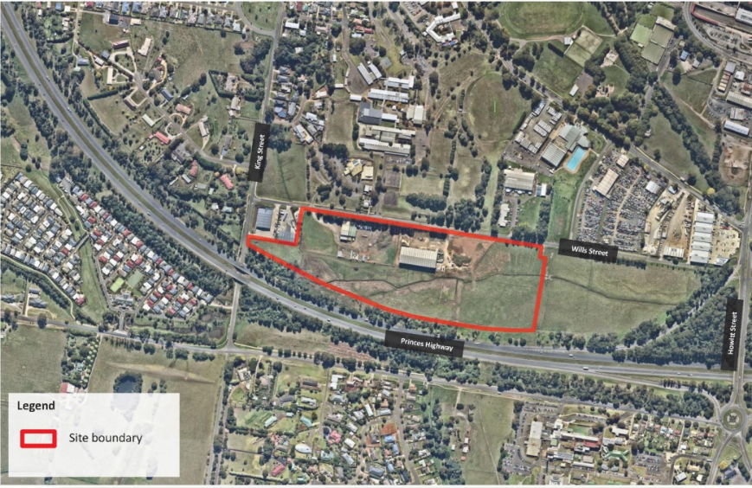
Figure 1 - Subject land identified with red line
A mapping reference table is attached at Attachment A to this Explanatory Report.

What the amendment does
The Amendment is made under Section 96A of the Planning and Environment Act 1987 and seeks to make the following changes to the Baw Baw Planning Scheme:
- Rezone land outside of a proposed drainage reserve from Urban Floodway Zone (UFZ) to the Industrial 1 Zone (INZ1);
- Introduce Design and Development Overlay Schedule 12 (DDO12) - Freeway Business Park;
- Apply Design and Development Overlay Schedule 12 - Freeway Business Park to the site.

What the planning permit does
The concurrent planning permit will:
- Subdivide Lot 3 PS901914 into 24 allotments;
- Provide for works to modify the alignment of Hazel Creek and retain the area within a drainage reserve;
- Provision of a new access loop road
- Construction of a shared pathway
- Removal of native vegetation (one River Red Gum tree).
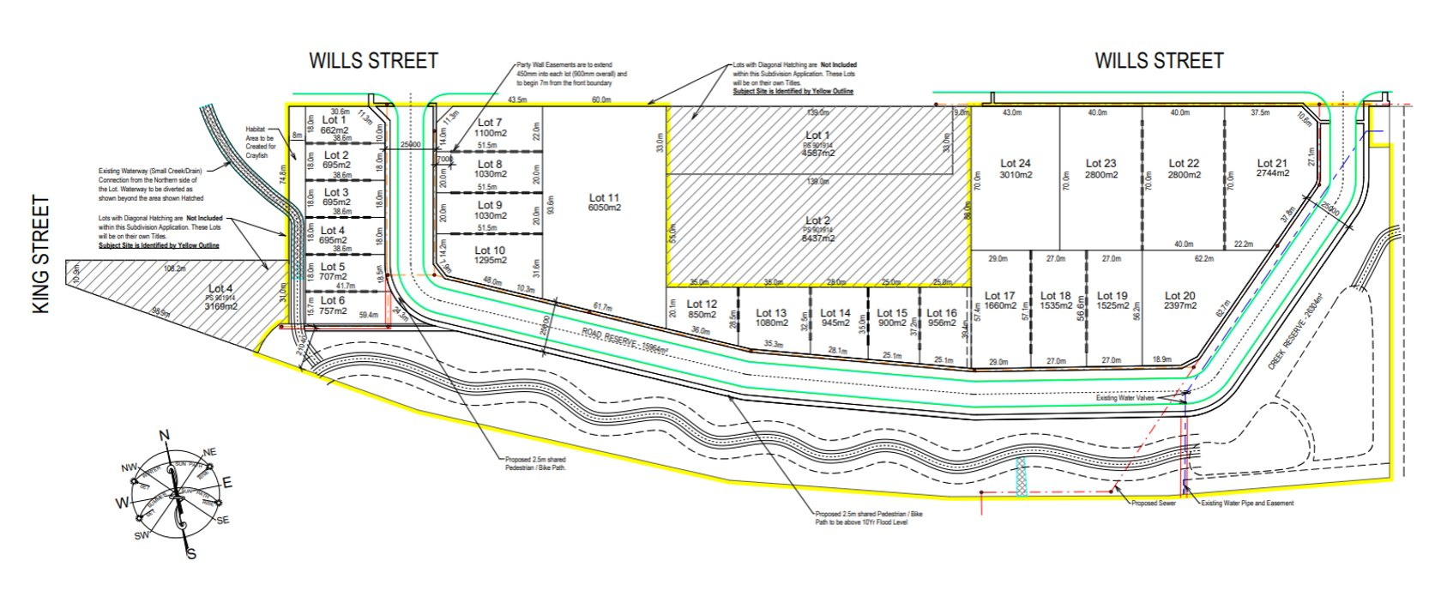
Figure 2 - proposed plan of subdivision and associated works

Strategic assessment of the amendment

Why is the amendment required?
The amendment is required to facilitate:
- The development of the Freeway Business Park, including the provision of an extended area of industrial land available, which will provide local investment and employment opportunities.
- Improvements to the drainage on the site.
- Remediationation and public access to the creek reserve.
- A combined amendment and planning permit process will ensure that the site is developed in a coordinated manner.
To allow the site to effectively function for future industrial uses and achieve the above improved drainage outcomes, it is also proposed to transform Hazel Creek to a constructed waterway, realigned along the boundary of the Princes Freeway. The site will also provide an 8m wide trapezoidal channel along its western boundary within Lot 3 to the drainage reserve, a split wetland straddling the aforementioned gas easement, and a clean-out of Hazel Creek to remove overgrown weeds and improve water flows.
The amendment will assist in addressing the need for additional industrial land in Warragul identified in the issues and options paper for the Baw Baw Economic Development Land Use Strategy, which identifies that there are currently no substantive zoned land parcels to support future expansion. The paper also identifies the subject site as a location for expanded industrial uses.
The amendment is supportive of the relevant State and local strategies and their visions for industry, natural ecosystems, and regional planning, as follows:
- The amendment allows the further consolidation of industrial land and future uses, in line with strategy 6.2 of the Baw Baw 2050 Community Vision.
- The amendment addresses the need to accommodate the Shire’s future growth as identified within the Economic Development Strategy 2018-2021. The rezoning will ensure that Warragul is able to attract new business and investment in an ideal central location close to the town centre, existing transportation links, and surrounding industrial and commercial uses

How does the amendment implement the objectives of planning in Victoria?

The objectives of planning in Victoria are:

(a) to provide for the fair, orderly, economic, and sustainable use, and development of land;

(b) to provide for the protection of natural and man-made resources and the maintenance of ecological processes and genetic diversity;

(c) to secure a pleasant, efficient, and safe working, living and recreational environment for all Victorians and visitors to Victoria;

(d) to conserve and enhance those buildings, areas or other places which are of scientific, aesthetic, architectural or historical interest, or otherwise of special cultural value;

(e) to protect public utilities and other assets and enable the orderly provision and co-ordination of public utilities and other facilities for the benefit of the community;

(f) to facilitate development in accordance with the objectives set out in paragraphs (a), (b), (c), (d) and (e);

(fa) to facilitate the provision of affordable housing in Victoria;

(g) to balance the present and future interests of all Victorians.
The amendment implements these objectives as follows:
- The removal of the Urban Floodway Zone from the developable portion of the land and application of the DDO12 will allow for the industrial development of the site to proceed in a coordinated and orderly manner, in accordance with the relevant state and local policy directions for Warragul.
- The amendment has considered natural and man-made resources and responded appropriately. Proposed Schedule 12 to the DDO contains Decision guidelines that will ensure the impacts of future use and development upon the site’s environmental values and biodiversity are minimised.
- The additional industrial land and improved accessibility to the waterway will provide a pleasant, efficient, and safe working, living and recreational environment for both current and future workers and visitors to the area.
- The proposal will allow for the orderly provision and coordination of services on site and makes efficient use of existing infrastructure services.
- The amendment will enable the future development of the site in a coordinated and orderly manner.
- The amendment will facilitate development in a strategically and physically advantageous location and ensure that the economic needs of Warragul and Baw Baw Shire are met.

How does the Amendment address any environmental, social, and economic effects?
Environmental
Hazel Creek is currently overgrown with weeds and possesses little value in its current state. The proposed DDO12, and the PSA specialist assessment recommended conditions will ensure that improvements are made to the waterway (including through revegetation with native species) and that the site’s environmental features are considered during the development of the developable land forming the site.
The proposal seeks to create new habitat areas for the Warragul Burrowing Crayfish and Dwarf Galaxias, taking an innovative approach that will serve as a demonstration project for Council.
The proposal to remove the single river red gum is required and unavoidable. Through the proposed replanting works shown of the Landscape Concept Plan and the proposed environmental works will create new habitat for native species and the proposal will ensure no net loss to biodiversity.
The Ecology Report prepared in support of the amendment (refer p.20 of report) assesses that an offset requirement of 0.042 general habitat units will be required to offset the removal.
Social
The amendment will result in a net community benefit by providing public access to Hazel Creek and improving the overall amenity of the subject site. It will also provide jobs close to public transportation and a major road network thereby reducing commuting times for workers at the facility.
Economic
The amendment will create additional industrial land in line with State and local policy directions for Warragul, as well as local investment and employment opportunities. This additional Industrial Land will aid in counteracting the lack of Industrial land in the state.

Does the amendment address relevant bushfire risk?

The land is not affected by the Bushfire Management Overlay; however, part of the land is within a Bushfire Prone Area. Care will be given in operation and construction of the site to ensure that no added Bushfire Risk is created.

How does the amendment support or implement the Planning Policy Framework and any adopted State policy?

The amendment has been assessed against and is consistent with the strategic considerations of Ministerial Direction - The Form and Content of Planning Schemes and Ministerial Direction No. 11 - Strategic Assessment of Amendments.

How does the amendment support or implement the Local Planning Policy Framework, and specifically the Municipal Strategic Statement?
Consistent with Clauses 11.01-1S, 11.01-1R, 11.02-1S, and 17.02-1S, the amendment provides for a modest increase of flat industrial land in an advantageous location close to existing transportation networks and infrastructure, promoting development and investment within an area of a key regional town in which natural hazards and environmental risks can be appropriately managed.
Further, consistent with Clauses 13.07-1S, the proposal directs additional industrial land to a highly appropriate location which will safeguard community amenity.
The technical assessments submitted in support of the proposed PSA provide details of how the objectives of Clauses 11.03-6S, 12.01-1S, 12.01-2S, 12.03-1S, 13.01-1S are met. The Giant Gippsland Earthworm (GGE) & Warragul Borrowing Crayfish (WBC) report prepared by Invert-Eco finds, for example, that the impacts of the amendment and future industrial development of the site on habitat loss can be appropriately mitigated via recommended design requirements.
The Warragul Burrowing Crayfish Translocation Proposal (October 2022) provides a Translocation Plan/Program to be undertaken with collaboration and support from Baw Baw Shire Council and the West Gippsland Catchment Management Authority. Further, it:
- Sets out the tasks and time frames for the relocation of the crayfish to occur.
- Nominates a translocation site that is in the south-east corner of the subject site (land to be set aside for wetland and drainage purposes).
- Provides guidelines for translocation site habitat design.
- Provides guidelines for trapping, handling, and releasing the crayfish.
- Provides a minimum five-year monitoring regime.
The Dwarf Galaxias Targeted Investigation prepared by Streamline Research states that ‘’(a)lthough the dwarf galaxias was not captured in this investigation, there is potential for the species to benefit from the Wills Street development ‘’ and ‘’(w)ith the right characteristics the newly created habitats may allow for the future establishment of dwarf galaxias, extending the existing range of the species in the Hazel Creek catchment’’.
The Ecology report by Paul Kelly & Associates finds that, overall, “the vegetation and habitat quality of the subject site is low and is dominated by cleared agricultural land and buildings.” The majority of the site’s native vegetation for example, has been modified by historic clearing, grazing and subsequent weed invasion. Further, vegetation of the roadside of Wills Street adjoining the site is planted and as such its removal does not require a permit pursuant to Clause 52.17-7. Again, this shows that environmental benefits should arise from the PSA and particularly through the creation of the drainage reserve and re-aligned waterway.
The proposal will not decrease the subject site’s bushfire resilience in response to Clause 13.02-1S. Future construction and development on site will be following the relevant building regulations.
The PSA will not cause any adverse impacts to surrounding properties because of the rezoning or the proposed transformation of Hazel Creek to a constructed waterway, in line with Clause 13.03-1S and 14.02-1S.
As noted in the Flood Modelling Report prepared by Incitus, the transformation to a constructed waterway will provide capacity to contain the 1% AEP flood flows that the site is currently subject to, providing flood free land for development. Further, the proposal will enhance the values associated with the waterway and downstream water quality through facilitating a compound form profile waterway with appropriate vegetation and the potential to incorporate habitat value.
Freeway Business Park Pty Ltd have sought the input of WGCMA (West Gippsland Catchment Management Authority) to ensure appropriate catchment management and coordination. WGCMA have indicated that they are willing to support the proposed PSA and transformation of Hazel Creek, subject to conditions set out in their written response (refer to the Stormwater Management Strategy for these).
The DDO Schedule includes consideration of subdivision, design, and sustainability outcomes to accord with Clauses 15.01-1S, 15.01-3S and 15.01-2S. The amendment also recognises the importance of the Princes Highway frontage from a design perspective and a safety and efficiency perspective (Clause 18.01-1S) as it does not seek direct access to the highway. It also locates a major private sector investment in a regional city on a major transport corridor to maximise the access and mobility of the Warragul community as per Clause 18.01-1S.
The proposal is compliant with Clause 15.03-2S. As found in the CHMP (Cultural Heritage Management Plan) prepared by Tim Stone, no Aboriginal cultural heritage has been identified in the activity area, and in accordance with Section 61 of the Aboriginal Heritage Act 2006, the proposed PSA will not harm Aboriginal cultural heritage in any way.
The proposed PSA responds to Clauses 17.01-1S, 17.02-1R, 17.03-1S, and 17.03-1R in complementing and facilitating future development of adjacent industrial land, supporting the business and economic development growth intentions for Warragul, and in presenting an opportunity to develop the land in a way that will achieve sensitive habitat and catchment management whilst enabling improved future urban design and landscaping outcomes.
Additionally, as noted in the Engineering Services Report prepared by Taylor Miller, the site is easily able to connect to electrical, gas, water, sewer, and telecommunications services, providing for the efficient use of existing infrastructure.
The proposal is consistent to Baw Baw’s Municipal Planning Strategy through:
- Protecting the Shire’s natural attributes including its native animal species.
- Directing most of the growth to Warragul.
- Supporting innovative, thriving, and sustainable local business and industry providing local employment.
- Supporting business investment and diversification of the Baw Baw economy
- Protecting and managing the environment in a sustainable manner considering the impacts of climate change and extreme events.
- Working with the community and stakeholders to manage the Shire’s environment and biodiversity values.

Does the amendment make proper use of the Victoria Planning Provisions?
The amendment makes proper use of the Victoria Planning Provisions. The UFZ should be removed from the developable land comprising the subject site given that the land within the northern part of the subject site is already within this zone, and the Freeway Business Park concept seeks to provide additional employment uses focusing on warehouses and industry uses. It is a logical extension of the existing zoning pattern to land that is contiguous with existing INZ1 land and will be separated from other nearby land uses by roads (Wills St and the Princes Highway).
Applying the Design and Development Overlay (DDO) with a bespoke Schedule 12 ‘’Freeway Business Park” to the developable land comprising the site will provide an appropriate control for the future development of the site through:
- Limiting building heights and providing a transition between the taller built form elements to the waterway and the residential land.
- Identifying the sensitive interface to the creek (and the highway beyond) where additional design treatments will need to be incorporated.
- Providing buildings and works requirements that will promote high quality design and improved appearance of individual site developments and the industrial site, when observed from within and from external vantages including Hazel creek, the residential area to the north and Princes Highway.

How does the amendment address the views of any relevant agency?

The amendment incorporates feedback received to date from the Baw Baw Shire Council, West Gippsland Catchment Management Authority, the former Department of Environment, Land, Water and Planning and former Department of Transport. Agency views will be considered as part of the section 20(5) consultation stage.

Does the amendment address relevant requirements of the Transport Integration Act 2010?
The proposal is in keeping with the objectives of the Transport Integration Act 2010 in facilitating preventing disruption both in the short or long term to transport systems, as well as complying with the requirement for development not to prevent future transport network expansion.

Resource and administrative costs
Costs associated with the planning scheme amendment process will be met by the proponent of this amendment.
The planning permit will be considered by the Minister for Planning as part of this combined planning scheme amendment and planning permit application. It is not anticipated that the future planning permit applications facilitated by the PSA will have a significant administrative burden on Baw Baw Shire Council.

Submissions
Any person who may be affected by the amendment may make a submission to the planning authority. Submissions about the amendment must be received by 5 PM 26 May 2023. A submission must be sent to: priority.projects@delwp.vic.gov.au.

ATTACHMENT A - Mapping reference table

Location | Land /Area Affected | Mapping Reference
- (14-40 Wills Street, Warragul)  - (14-40 Wills Street, Warragul)  - (42-60 Wills Street, Warragul)  - (98 King Street, Warragul) | - Lot 1 PS901914  - Lot 2 PS901914  - Lot 3 PS901914  - Lot 4 PS901914 | - 38°10'08.96" S, 145°55'23.18" E  - 38°10'08.12" S, 145°55'25.51" E  - 38°10'08.12" S, 145°55'25.51" E  - 38°10'08.12" S, 145°55'25.51" E

