Warburton Mountain Bike Destination:

EES Scoping Requirements process
Warburton Mountain Bike Destination EES – Final Scoping Requirements FAQs
November 2020

What is the purpose of the scoping requirements?
Yarra Ranges Council is preparing an environment effects statement (EES) for the Warburton Mountain Bike Destination Project, and the EES scoping requirements set out the matters that need to be investigated and documented within the EES.
Final EES scoping requirements have been approved by the Minister for Planning and are available on the DELWP website: https://www.planning.vic.gov.au/environment-assessment/browse-projects/projects/warburton-mountain-bike-destination
Why is an Environment Effects Statement (EES) required for the Project?
An EES is the most comprehensive and robust assessment process available and will provide for an integrated and transparent examination of the proposed project and its effects, which is necessary because of the array of potential effects, the substantial public interest and the different statutory approvals typically required for this type of major project.
The Minister for Planning determined under the Environment Effects Act 1978 that Yarra Ranges Council should prepare an EES for the Warburton Mountain Bike Destination Project in May 2020. In the procedures and requirements, the Minister identified key environmental risks that would need to be addressed in the EES, namely:
- effects on biodiversity and ecological values, especially ecological communities and species listed under the Flora and Fauna Guarantee Act 1988 (FFG Act) or the Environment Protection and Biodiversity Conservation Act 1999 (EPBC Act);
- effects on surface water and groundwater hydrology and quality;
- effects on Aboriginal and historic cultural heritage values;
- effects on land uses;
- effects on land stability and erosion related to the construction and operation of the project;
- effects of project construction and operation on social amenity through changes in traffic, air quality, vistas or noise effects on nearby sensitive receptors (especially residents);
- positive and adverse socio-economic effects, at local and regional scales, potentially generated by the project, including impacts on the capacity of local community infrastructure; and
- potential cumulative effects in relation to any other existing or planned projects or tourism developments in the area.
The EES documentation will need to include a detailed description of the proposed project and rigorous assessment of its potential effects on the environment and approaches to mitigation. The EES will inform the public and stakeholders, and seek feedback. Ultimately it enables the Minister to issue an assessment of the environmental effects of the project at the end of the process. The Minister’s assessment will inform statutory decision-makers responsible for the project’s approvals.
The project was also referred to the Commonwealth under the Environment Protection and Biodiversity Conservation Act 1999 (EPBC Act). A delegate for the Commonwealth Minister for the Environment determined on 16 June 2020 that the project is a controlled action, as it is likely to have a significant impact on matters of national environmental significance (MNES), protected under the EPBC Act. The EES process is accredited to assess impacts on MNES under the EPBC Act through the Bilateral Assessment Agreement between the Commonwealth and the State of Victoria. The potentially impacted MNES that the EES will examine are ‘listed threatened species and communities’.
What studies are Yarra Ranges Council doing to further identify any associated risks with the project?
In preparing the EES, Yarra Ranges Council are undertaking a range of technical investigations to assess the potential impacts of the project. These investigations include biodiversity, cultural heritage, land use and planning, surface and groundwater, socioeconomic and transport studies.
These studies will inform strategies to avoid, minimise or mitigate potential impacts which will form an important part of the EES documentation.
What are the final Scoping Requirements?
The set of matters to be investigated and documented in each EES are tailored to the project and its environmental risks. The draft scoping requirements for a project are prepared by the department on behalf of the Minister and then exhibited for 15 business days for comment by interested parties. The draft scoping requirements for the EES were informed by the proponent’s referral and draft EES study program, as well as advice from agencies represented on the Technical Reference Group (TRG) and advice from the Commonwealth Department of Agriculture, Water and the Environment.
The scoping requirements outline a broad scope of issues that must be addressed by Yarra Ranges Council in the EES. Assessment of effects as required by the scoping requirements must include discussion of all potential direct, indirect, on-site and off-site effects as result of the proposed project. Consistent with the Minister’s decision for requiring an EES, the final scoping requirements cover a range of matters that need investigation, including impacts on biodiversity and habitats, water and catchments, cultural heritage as well as social, economic, amenity and land use values.
The broad nature of the final scoping requirements will ensure that the specific concerns raised through submissions are addressed in the EES. Most issues and concerns raised in submissions were already encompassed within the draft scoping requirements. However, some minor refinements and editorial changes have been made to the scoping requirements to strengthen the clarity of issues and better reflect the local context, these changes included:
- Direct reference to consideration of potential employment benefits of the project was included to add emphasis on this aspect.
- The section on assessment of alternatives was updated to include additional focus on comparison of project benefits and impacts associated with the inclusion/exclusion of trails or trailheads within areas of particularly high conservation value.
- Additional emphasis added regarding the need to assess potential impacts on the availability and costs of local health services.
- Direct reference was added to consideration of the effects of the project on other recreational land uses (e.g. bushwalking).
- Specific reference to the need for the EES to provide maps/plans of trail heads was included to add emphasis on this aspect.
Was there public consultation for the draft scoping requirements?
An integral part of the EES process is the proponent engaging the public and stakeholders to identify and respond to their issues in conjunction with their EES studies.
Yarra Ranges Council has already commenced consultation with stakeholders and the community on the EES. Yarra Ranges Council has also prepared a consultation plan for the EES, outlining the opportunities and approaches for its community engagement during the preparation of the EES. The plan will be updated regularly and the latest version is available on the DELWP website: https://www.planning.vic.gov.au/environment-assessment/browse-projects/projects/warburton-mountain-bike-destination
Under its EES consultation plan the proponent needs to inform the public and stakeholders about the EES process and its associated investigations, ensuring it provides opportunities for input and engagement on these investigations.
Draft scoping requirements for the EES were exhibited for a period of 15 business days and closed 21 September 2020. Notice of the draft scoping requirements’ exhibition was publicised on the DELWP website and via advertisements in major and local newspapers.
A total of 255 submissions were received during the public exhibition period. The vast majority of the submissions were from individual members of the community, however a few submissions were received from organisations/associations including Warburton Advancement League, Warburton Adventure Co., local bicycle business and local accommodation providers. The proponent Yarra Ranges Council also made a submission.
The majority of submitters stated they were in favour of the project and highlighted various potential benefits of the project proceeding. Some submissions highlighted specific potential adverse impacts of the project which they considered should be covered in the EES and in doing so identified aspects of the draft EES scoping requirements that could be improved to cover them. Key issues and concerns most frequently raised in submissions included:
- General concerns about the impact of the project on biodiversity values, including impacts on forests, flora species and wildlife.
- Concerns regarding the potential for the project to increase traffic volumes and congestion in Warburton.
- Potential adverse impacts due to over-visitation of Warburton township and associated impacts on town culture.
- Dissatisfaction with the lack of maps / plans of the project that have been made available to the public to date, particularly in relation to detailed plans of the trail heads.
- Concerns about the potential for the project to increase bushfire risk in the area.
- Concerns regarding the potential impact of the project on housing availability and costs.
- Potential for adverse impacts on the Yarra Ranges National Park, and particularly sensitive environmental areas such as Mt Donna Buang.
- Concerns regarding the potential for the project to impact on other recreational activities such as bushwalking.
Most issues and concerns raised in submissions were already encompassed within the draft scoping requirements. However, some changes were made to the final scoping requirements in response to some specific issues raised. The final EES Scoping Requirements have now been issued by the Minister for Planning.
Submissions received have been provided to the proponent and the technical reference group to inform the ongoing development of the EES.
What happens now the Minister has issued the final scoping requirements?
The proponent will proceed with the necessary information-gathering and investigations to inform the EES. This is expected to take at least several months. It will conduct its studies and prepare the EES in close consultation with DELWP and a technical reference group consisting of lead statutory agencies and the Registered Aboriginal Party.
The proponent will also need to implement its EES consultation plan to engage the public and stakeholders about the EES process and its associated investigations, ensuring it provides opportunities for input and feedback on these investigations.
When the EES is ready, it will be reviewed by DELWP, and the Minister for Planning will decide whether to authorise the EES to be exhibited. If authorised, the EES will be advertised for public comment for a period of 30 business days. There will be further opportunities for public comment on the project’s environmental effects when the EES is exhibited.
The EES and the submissions received, together with the draft planning scheme amendment, will be referred to an inquiry to be appointed under the Environment Effects Act 1978.
An inquiry will consider all the information before it, having undertaken a formal hearing process and will report to the Minister, who will then make an assessment and provide it to decision-makers (including the Commonwealth with regard to the required approval under the Environment Protection and Biodiversity Conservation Act 1999).
After the Minister has made an assessment, the report of the inquiry and the Minister’s assessment will be published on the DELWP website.
When does Yarra Ranges Council expect to have an environmental effects statement released?
The EES is expected to be released in mid 2021 (timing to be confirmed), when it goes on exhibition for public comment. During this period Yarra Ranges Council will undertake planned engagement activities.
What is the Warburton Mountain Bike Destination Project?
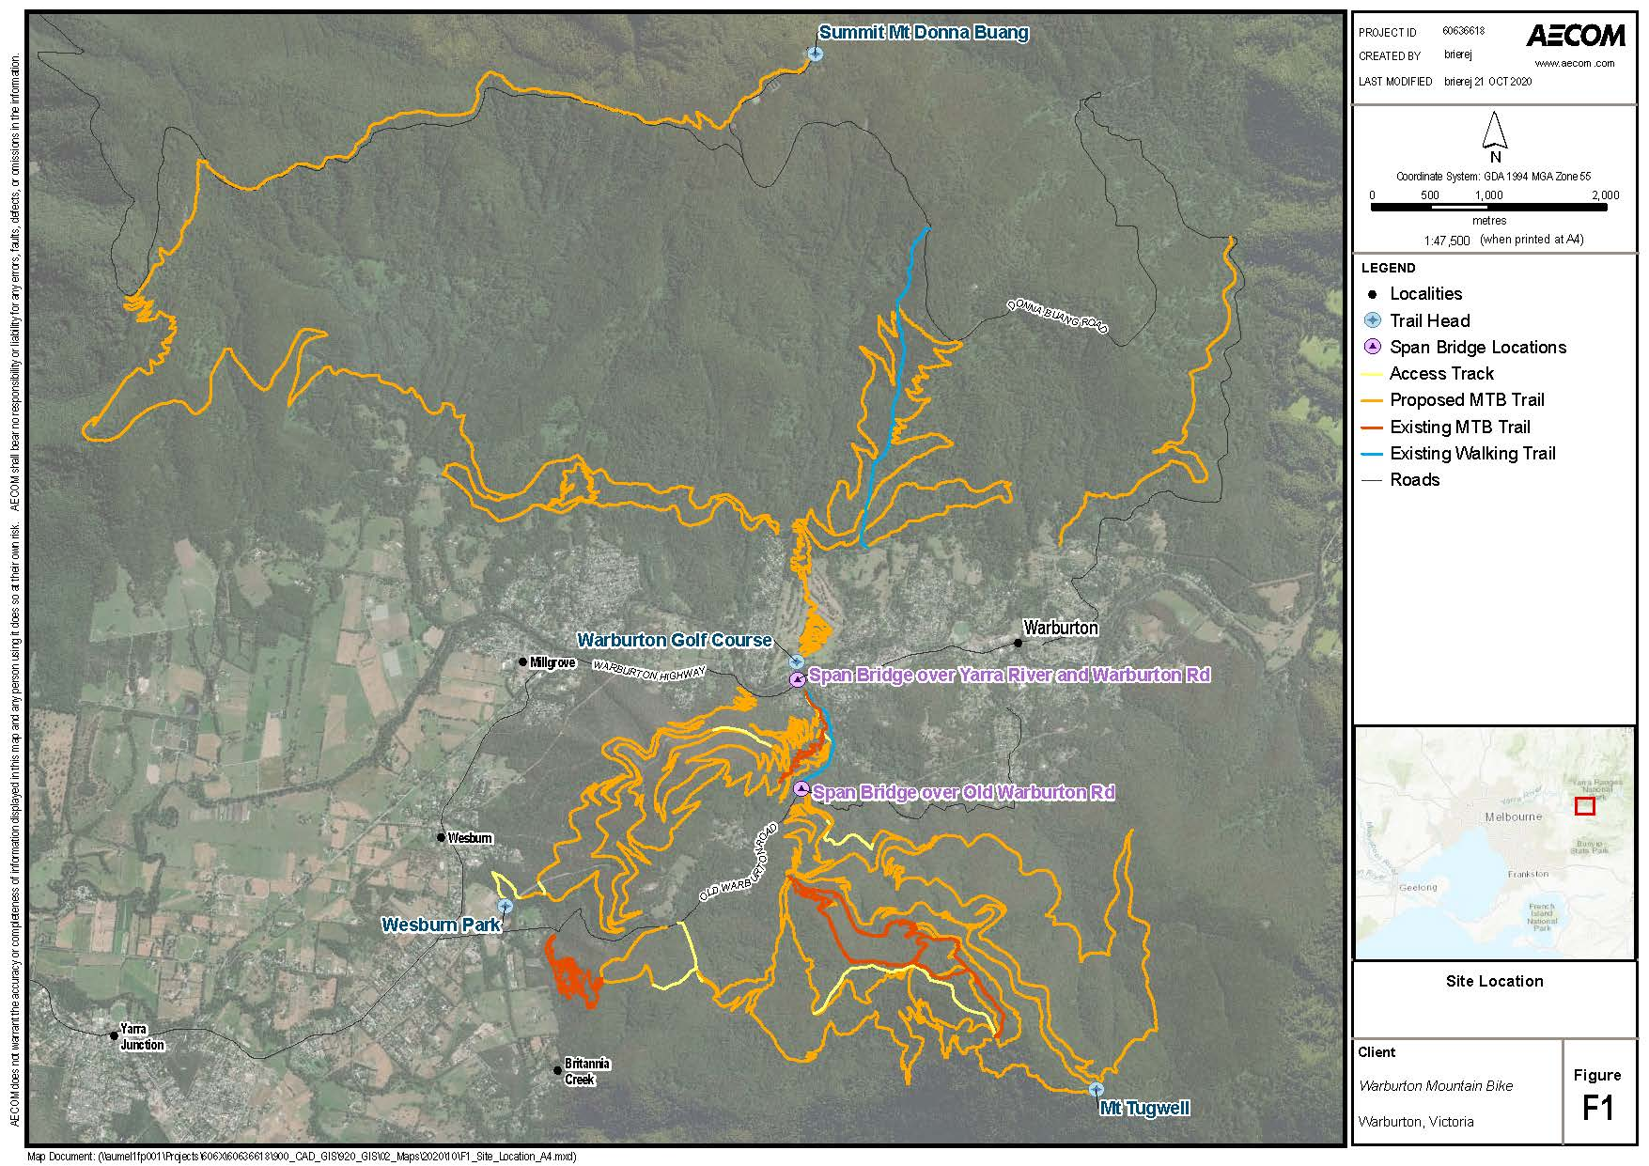
Yarra Ranges Council proposes to construct propose to construct 44 new mountain bike tracks totalling approximately 186 km in the area surrounding the township of Warburton (Figure 1). The tracks would occur in groups extending across the forested slopes of Mount Donna Buang, Mount Little Joe and Mount Tugwell, within the Yarra Ranges National Park and two state forests. A new visitor’s hub (main track head) is proposed at the Warburton Golf Course and three other track heads are proposed at Mount Tugwell, Mount Donna Buang and Wesburn Park. The project will also include two bridges for bicycles to pass over the Yarra River and Old Warburton Road.
Figure 1: Location of the project, with proposed and existing track alignments shown in orange and red respectively (source: Yarra Ranges Council/Aecom, 2020).

