delwp.vic.gov.au

August 2022

|  |
| --- |
| **Draft Scoping Requirements**  **Marinus Link**  **Environment Effects Statement**  *Environment Effects Act 1978* |

|  |  |
| --- | --- |
|  |  |

|  |
| --- |
| © The State of Victoria Department of Environment, Land, Water and Planning 2022  LogoThis work is licensed under a Creative Commons Attribution 4.0 International licence. You are free to re-use the work under that licence, on the condition that you credit the State of Victoria as author. The licence does not apply to any images, photographs or branding, including the Victorian Coat of Arms, the Victorian Government logo and the Department of Environment, Land, Water and Planning logo. To view a copy of the licence, visit [creativecommons.org/licenses/by/4.0](https://delwpvicgovau.sharepoint.com/sites/ecm_360/IAU_Quality_Mgmt_Sys/creativecommons.org/licenses/by/4.0).  Disclaimer This publication may be of assistance to you but the State of Victoria and its employees do not guarantee that the publication is without flaw of any kind or is wholly appropriate for your particular purposes and therefore disclaims all liability for any error, loss or other consequence which may arise from you relying on any information in this publication.  Accessibility  If you would like to receive this publication in an alternative format, please telephone the DELWP Customer Service Centre on 136186 or [customer.service@delwp.vic.gov.au](mailto:customer.service@delwp.vic.gov.au). This document is also available on the internet at [planning.vic.gov.au/environment-assessment/](https://www.planning.vic.gov.au/environment-assessment/)browse-project. |

**Queries about Marinus Link should be directed to the proponent:**Marinus Link

Telephone: 1300 765 275

Email: [team@marinuslink.com.au](mailto:team@marinuslink.com.au)  
Website: [www.marinuslink.com.au](https://urldefense.com/v3/__http:/www.marinuslink.com.au__;!!C5rN6bSF!X2XPDfq71A66w63qGxJJpFHyB1IvkoUWBiPUPnyPU-ToSzPR5RpgIYPYxwito8XyAeTbJU2bzRvnJTk$)

**Queries about the EES process and Scoping Requirements should be directed to the department:**Impact Assessment Unit  
Telephone: (03) 8392 5503  
Email: [environment.assessment@delwp.vic.gov.au](mailto:environment.assessment@delwp.vic.gov.au)

List of abbreviations

DCCEEW Department of Climate Change, Energy, Environment and Water (Cwlth)

DELWP Department of Environment, Land, Water and Planning

EES Environment effects statement

EIS Environmental impact statement

EISG Environmental Impact Statement Guidelines

EMF Environmental management framework

EPA Environment Protection Authority

EPBC Act *Environment Protection and Biodiversity Conservation Act 1999*

FFG Act *Flora and Fauna Guarantee Act 1988*

The project Marinus Link Project

The proponent Marinus Link Pty Ltd

TRG Technical reference group

Contents

1. Introduction 1

1.1 The project and setting 1

1.2 Minister’s requirements for this EES 5

1.3 Commonwealth requirements and alignment of assessment processes 5

2. Assessment process and required approvals 7

2.1 What is an EES? 7

2.2 The EES process 7

3. Matters to be addressed in the EES 9

3.1 General approach 9

3.2 Content and style 9

3.3 Project description and rationale 10

3.4 Project development and alternatives 11

3.5 Applicable legislation, policies and strategies 12

3.6 Evaluation objectives 12

3.7 Environmental management framework 12

4. Assessment of specific environmental effects 14

4.1 Biodiversity and ecological values 15

4.2 Marine and catchment values 17

4.3 Cultural heritage 18

4.4 Land use and socioeconomic 19

4.5 Environmental amenity, safety, and transport 20

4.6 Landscape and visual 21

Appendix A: Procedures and requirements 23

Introduction

In light of the potential for significant environmental effects, on 12 December 2021 the former Minister for Planning determined under the *Environment Effects Act 1978* that Marinus Link Pty Ltd (the proponent) is to prepare an environment effects statement (EES) for the proposed Marinus Link project (the project). The purpose of the EES is to provide a sufficiently detailed description of the project, assess its potential effects on the environment[1] and assess alternative project layouts, designs and approaches to avoid and mitigate effects. The EES will inform and seek feedback from the public and stakeholders. The Minister for Planning (the Minister) will issue an assessment of the project’s environmental effects under the Environment Effects Act to conclude the EES process. The Minister’s assessment will then inform statutory decision-makers for the project.

These *Draft* *Scoping Requirements for the Marinus Link Project Environment Effects Statement* set out the proposed specific matters to be investigated and documented in the EES. The draft scoping requirements presented here are for public review and comment. The Minister will issue the final scoping requirements for the EES following consideration of public comments received on this draft.

While the scoping requirements are intended to cover all relevant matters, the EES will also need to address other issues that emerge during the EES investigations, especially potential impacts and environmental issues relevant to statutory decisions that will be informed by the assessment.

## The project and setting

The project compromises construction and operation of twin circuit, 1,500 megawatt capacity undersea and underground electricity cables linking Tasmania and Victoria’s electricity grids. The project is located between Heybridge in northwest Tasmania and the Latrobe Valley in Victoria (Figure 1) .

Marinus Link will provide a second link between the Tasmanian and Victorian electricity grids enabling efficient energy trade, transmission and distribution from a diverse range of generation sources to where it is most needed.

In Victoria, the Marinus Link subsea cables would enter Victorian waters at 3 nautical miles (approximately 5.6 kilometres) offshore and traverse to an underground shore crossing at Waratah Bay (Figure 2). A transition station may be required at Waratah Bay as well as a land-sea cable joint. The buried cables continue northwest to the Tarwin River valley and then head northeast along and up the valley towards Mirboo North. The cables cross the Strzelecki Ranges from Driffield to Dumbalk between Mirboo North and Grand Ridge. The cables may connect to the Victorian electricity grid via a converter station at Driffield or continue eastwards through the Morwell River valley to a new converter station adjacent to the existing Hazelwood terminal station.

The key components of the project are (Figure 3):

* approximately 250 kilometres of undersea high voltage direct current cables;
* approximately 90 kilometres of underground high voltage direct current cables in Victoria; and
* converter stations in Tasmania and Victoria.

The project is proposed to be delivered in two stages (one circuit per stage) over 5-6 years The project will be designed for an operational life of at least 40 years.

The scope of the EES within the Victorian jurisdiction covers the proposed works from the three nautical mile limit of Victorian coastal waters to the greater Hazelwood area in the Latrobe Valley. Key project components proposed within the Victorian jurisdiction include (see Figure 2):

* subsea cables from the three nautical mile limit of Victorian coastal waters to a shore crossing at Waratah Bay;
* a transition station near the coast at Waratah Bay;
* underground cables continuing approximately 90 kilometres north-eastwards inland to the Latrobe Valley; and
* a converter station at Driffield or Hazelwood connecting to the Victorian electricity grid, potentially including a new switching station within the converter station site compound.

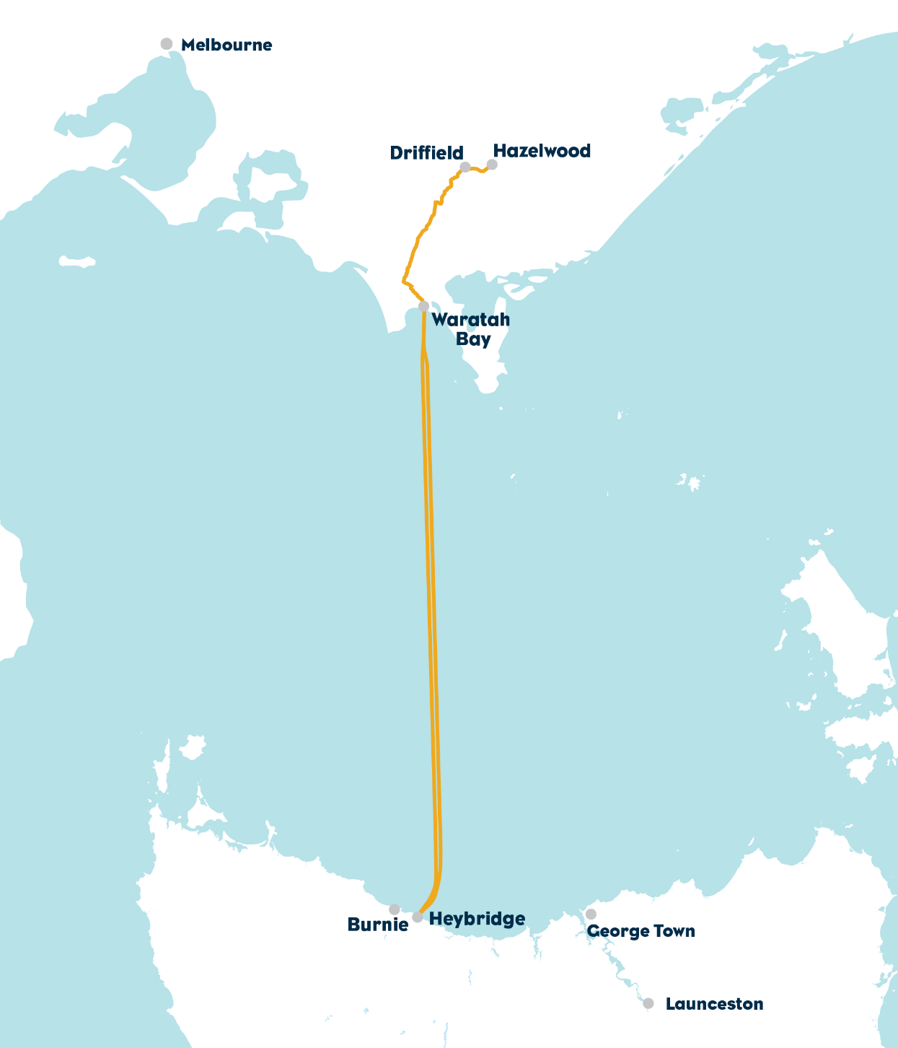

Figure 1: Project overview (Marinus Link Pty Ltd)

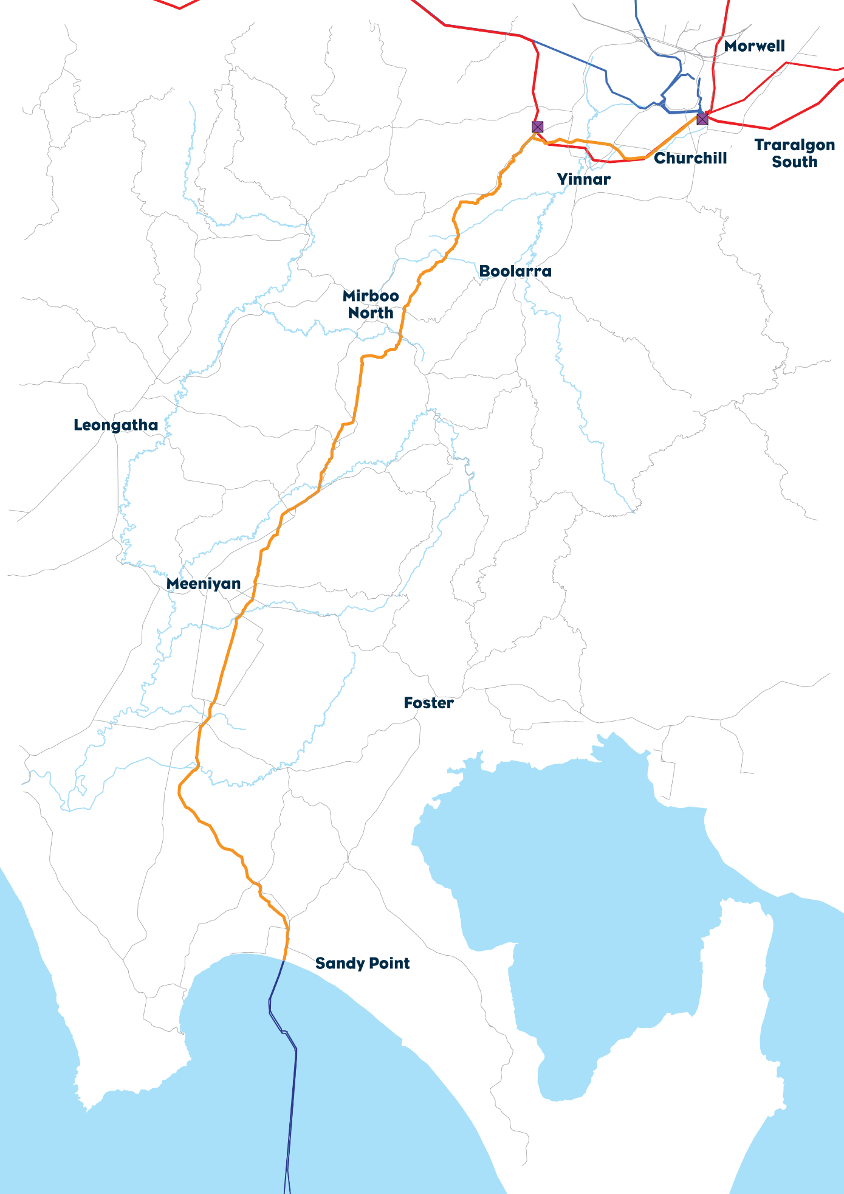

Figure 2: Regional setting and location of the project within Victoria (Marinus Link Pty Ltd)

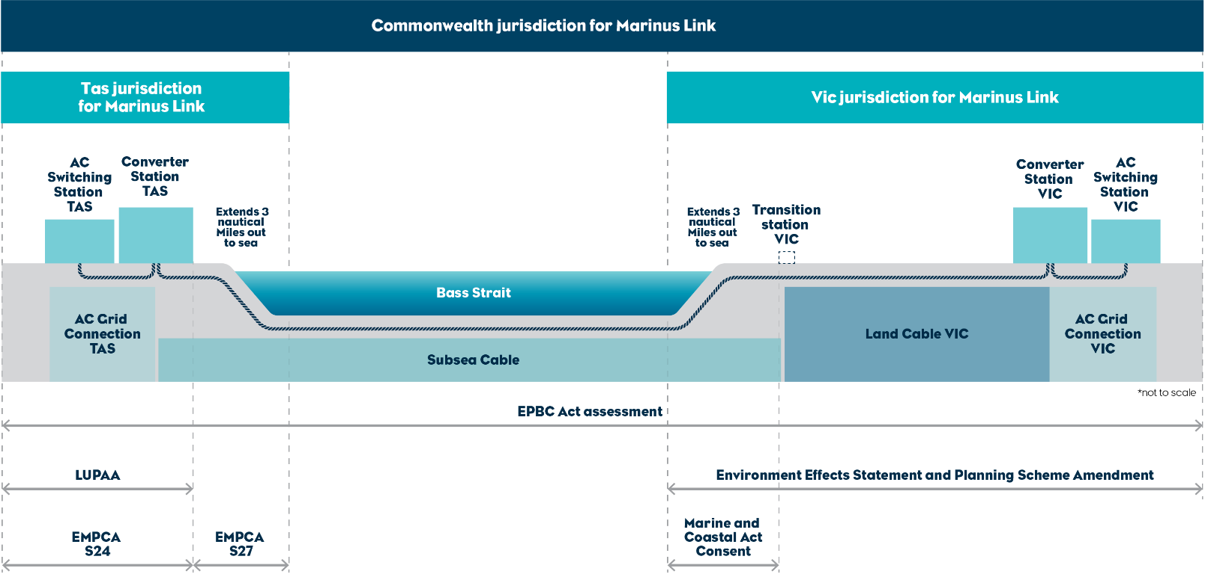

**Figure 3: Project components considered under applicable jurisdictions (Marinus Link Pty Ltd)**

## Minister’s requirements for this EES

The former Minister for Planning decided that an EES is required for the project, due to its potential for significant effects, in relation to the Victorian jurisdiction. The Minister published procedures and requirements applicable to the preparation of the EES, in accordance with section 8B(5) of the Environment Effects Act (Appendix A). This included the core requirement for “The EES is to investigate and document the potential environmental effects (direct and/or indirect) of the proposed project, including for any relevant alternatives, as well as associated environmental avoidance, mitigation and management measures. In particular, the EES needs to address:

* effects on biodiversity and ecological values within and near the project area including native vegetation, listed threatened communities and species (flora and fauna) under the *Flora and Fauna Guarantee Act 1988* and *Environment Protection and Biodiversity Conservation Act 1999*, such as through clearance, degradation or fragmentation of habitat;
* effects on freshwater and marine environments and related environmental values, including any changes to stream flows, water quality or sedimentation due to waterway crossings or installation of subsea cables;
* effects on Aboriginal cultural heritage values;
* effects on the socioeconomic environment including land use, at local and regional scales; and
* effects on existing landscape values.”

These draft scoping requirements provide further detail on the matters to be in investigated in the EES as required by the *Ministerial guidelines* for *assessment of environmental effects under the Environment Effects 1978* (Ministerial Guidelines).

## Commonwealth requirements and alignment of assessment processes

The project was also referred under the Commonwealth *Environment Protection and Biodiversity Conservation Act 1999* (EPBC Act) to the Commonwealth Minister for the Environment in October 2021. A delegate for the former Minister for the Environment determined on 4 November 2021 that the project is a controlled action requiring assessment and approval, as it is likely to have a significant impact on the following matters of national environmental significance, which are protected under Part 3 of the EPBC Act:

* listed threatened species and communities (sections 18 and 18A);
* listed migratory species (sections 20 and 20A); and
* Commonwealth marine areas (sections 23 and 24A).

As the project is located within and outside Victorian jurisdiction (in Commonwealth and Tasmanian jurisdictions), the Commonwealth cannot accredit the EES process as the sole means for assessing EPBC Act matters. As such, the former Commonwealth Minister for the Environment’s delegate determined the project will be assessed under the EPBC Act by an environmental impact statement (EIS).

The Victorian Department of Environment, Land, Water and Planning (DELWP) and Commonwealth Department of Climate Change, Energy, Environment and Water (DCCEEW) have agreed to coordinate the administration of the two assessment processes — i.e., the EES under the Victorian legislation and the EIS under the Commonwealth legislation — using administrative means to maximise alignment, particularly for some key stages in the processes, and remove duplication wherever possible. Technical studies, engagement with government agencies and development of the EES and EIS will be integrated, including public comment on draft scoping documents (EES/EIS) and assessment documentation (EES/EIS) and utilising a technical reference group established and chaired by DELWP to advise on the development of the EES/EIS.

DCCEEW and DELWP will also work with the Tasmanian Environment Protection Authority (Tasmanian EPA) to coordinate assessment processes where possible as a Tasmanian EIS is also required for the Tasmanian components of the project.

The proponent is intending to combine its documentation as much as possible, in order to prepare a single package of assessment documents to address requirements under the Victorian, Tasmanian and Commonwealth legislation.

The intention is for Marinus Link to prepare combined documentation (EES/EIS/EISG package) on the project and its effects on the environment (across all the jurisdictions). This consolidated manner of presenting information (across the jurisdictions) will assist stakeholders, to access and engage with the project and its issues and potential impacts, despite where they might reside or manifest. The integration of information on the project and its impacts would also help to minimise duplication. Interested stakeholders would be able to provide views and inputs on the project and its effects, which could be with respect to the project’s obligations under both or either of the Environment Effects Act and EPBC Act.

Assessment process and required approvals

## What is an EES?

An EES describes a project, it’s rationale/benefit and its potential environmental effects. It should enable stakeholders and decision-makers to understand how the project is proposed to be implemented and the likely environmental effects of doing so. An EES has two main components:

1. The EES main report – an integrated, plain English document that assesses the potential impacts of the project, examines avoidance, mitigation or other measures to reduce the environmental effects and assesses residual effects. The main report draws on technical studies, data and statutory requirements and policy relevant to the environment and should clearly identify which components of the scope are being addressed throughout.
2. The EES technical reports – specialist studies, investigations and analyses that provide the basis for the EES main report. These reports will be exhibited in full, as appendices to the main report.

Given the multi-jurisdictional nature of this project and the associated requirements, the EES main report and technical reports may be presented by the proponent in combination with other aspects to fulfill requirements under different jurisdictions together.

## The EES process

The proponent is responsible for preparing an EES, including conducting technical studies and undertaking appropriate stakeholder consultation. DELWP is responsible for managing the EES process[2]. The EES process has the following steps:

* preparation of a draft study program and draft schedule by the proponent;
* preparation and exhibition of draft scoping requirements by DELWP on behalf of the Minister with public comments received during the advertised exhibition period;
* finalisation and issuing of scoping requirements by the Minister;
* review of the proponent’s draft EES documentation by DELWP and a technical reference group;[3]
* completion of the EES by the proponent;
* review of the EES by DELWP to establish its adequacy for public exhibition;
* exhibition of the proponent’s EES and invitation for public comment;
* appointment of an inquiry panel by the Minister to review the EES and public submissions received, conduct public hearings and provide a report to the Minister; and
* preparation of an assessment of the project’s environmental effects by the Minister for the consideration of statutory decision-makers.

### Technical reference group

DELWP has convened a technical reference group (TRG) of Victorian and Commonwealth government agencies, the Tasmanian EPA, registered Aboriginal parties, regional authorities and local councils for this EES process to advise DELWP and the proponent on:

* applicable policies, strategies and statutory provisions;
* EES scoping requirements;
* the design and adequacy of EES technical studies;
* the proponent’s public information and stakeholder consultation program for the EES process;
* responses to issues arising from the EES investigations;
* the technical adequacy and completeness of draft EES documentation; and
* coordination of statutory processes.

### Consultation plan

The proponent is responsible for informing and engaging the public and stakeholders during the EES process, in order to inform them about the project, the EES process, EES studies, as well as identify and respond to their issues. Stakeholders include potentially affected parties, traditional owner groups, any interested community organisations/groups and government bodies.

Through its EES consultation plan the proponent needs to undertake effective engagement that enables the public and stakeholders to understand the EES investigations and the opportunities for engagement. The proponent needs to provide appropriate opportunities for input and feedback on the project and EES investigations.

The consultation plan is reviewed and amended in consultation with DELWP and the TRG before it is published on the Planning website.[4] The consultation plan will:

* identify stakeholders;
* characterise public and stakeholders’ interests, concerns and consultation needs, local knowledge and inputs;
* describe consultation methods and schedule; and
* outline how public and stakeholder inputs will be recorded, considered and/or addressed in the preparation of the EES.

### Statutory approvals and the EES process

The project will require a range of approvals under Victorian legislation if it is to proceed. DELWP coordinates the EES process as closely as practicable with the approvals’ procedures, consultation and public notice requirements.

The key approvals required under Victorian legislation are a planning approval under the *Planning and Environment Act 1987*, two approved Cultural Heritage Management Plans under the *Aboriginal Heritage Act 2006*, a consent to use and develop marine and coastal Crown Land under *the Marine and Coastal Act 2018* and a lease/licence under the *Crown land (Reserves) Act 1978*.

Other approvals may be required and will be determined throughout the course of the EES.

Matters to be addressed in the EES

While this section refers to ‘the EES’, it is understood that the proponent is proposing a single or combined package of assessment documents to address assessment requirements of the three jurisdictions. Therefore, it is envisaged that items specified in this section required for the EES will be presented within combined documentation.

## General approach

Preparation of the EES should be consistent with a systems approach and a risk-based approach when identifying issues for assessment. The EES needs to put forward a sound rationale for the level of assessment and analysis undertaken for any environmental effect or combination of environmental effects[5] arising from all components and stages of the project. The EES needs to provide an analysis of the significance of the potential effects of the project, with consideration of:

* the potential effects on individual environmental assets – including considering magnitude, extent, duration and significance of change in the values of each asset;
* the likelihood of adverse effects, including those caused indirectly as a result of proposed activities, and associated uncertainty of available predictions or estimates;
* proposed avoidance or mitigation measures to reduce predicted effects;
* likely residual effects and their significance assuming the proposed measures to avoid and mitigate environmental effects are implemented; and
* proposed approach to managing and monitoring environmental performance and contingency planning.

## Content and style

Together with the Minister’s reasons for decision, the published procedures and requirements and the Ministerial Guidelines, the content of the EES and related investigations is to be guided by these scoping requirements. To facilitate decisions on required approvals, the EES should address statutory requirements associated with approvals that will be informed by the Minister’s assessment, including decision-making under the Planning and Environment Act and other applicable legislation. The EES should also address any other significant issues that emerge during the investigations. Ultimately, it is the proponent’s responsibility to ensure that adequate studies are undertaken and reported to support the assessment of environmental effects arising from the project and that it implements effective internal quality assurance for EES documentation.

The EES should provide a clear, objective and well-integrated analysis of the potential effects of the proposed project, as well as relevant feasible alternatives, including proposed avoidance, mitigation and management measures. The EES main report should include:

* an executive summary;
* a description of the project, including its objectives, rationale, key elements, resource use, associated requirements for new infrastructure and use of existing infrastructure;
* a description of the proponent and its environmental performance credentials, including experience in developing and operating projects and its health, safety and environmental policies;
* a description of the approvals required for the project to proceed, and their relationship to relevant laws, policies, strategies, guidelines and standards;
* a description of feasible alternatives capable of substantially meeting the project’s objectives that may offer environmental or other benefits including the basis for any nomination of a preferred alternative;
* a description of the scope, timing[6] and method for studies or surveys used to provide information on the values of the project areas, as well as any records and other data from local sources gathered and considered as appropriate;
* descriptions of the existing and the predicted future environment (such as projected climate change scenarios), where this is relevant to the assessment of potential effects;
* appropriately detailed assessments of potential effects of the project (and feasible alternatives) on environmental assets and values, relative to the “no project” scenario, together with an estimation of likelihood and degree of uncertainty associated with predictions; clear, active measures for avoiding, minimising, managing and monitoring effects of the project;
* predictions of residual effects of the project assuming implementation of proposed environmental management measures;
* any proposed offset measures where avoidance and other mitigation measures will not adequately address effects on environmental values;
* assessment of cumulative impacts with other existing and proposed developments in the region;
* documentation of the process and results of the consultation undertaken by the proponent during the preparation of the EES, including the issues raised by stakeholders or the public and the proponent’s responses to these issues, in the context of the EES studies and the associated consideration of mitigation measures;
* evaluation of the implications of legislation and policy for the project and feasible alternatives;
* evaluation against the principles and objectives of ecologically sustainable development[7]; and
* conclusions on the significance of impacts on local, regional and state matters.

The EES should also include an outline of a program for community consultation, stakeholder engagement and communications for the construction and operational phases of the project, including opportunities for stakeholders to engage with the proponent to seek responses to issues that might arise.

The proponent may choose to prepare a website with interactive functionality to provide an alternative way of accessing EES information, which may complement the conventional EES main report and technical reports. Such an approach should be discussed with DELWP Impact Assessment Unit, DCCEEW and Tasmanian EPA and if integrated with the EES documentation, the digital information should be provided to the TRG for review.

The proponent must also prepare a concise, graphical-based non-technical summary document (hard copy A4, no more than 25 pages) for free distribution to interested parties. The EES summary document should include details of the EES exhibition, public submission process and availability of the EES documentation and any digital information.

## Project description and rationale

The EES is to describe the project in sufficient detail both to allow an understanding of all components, processes and development stages, and to enable assessment of their likely potential environmental effects. The project description should canvass the following:

* an overview of the proponent's environmental performance and track record, including experience in delivering similar projects, as well as organisation health, safety and environmental policies, and whether the proponent has been subject to any past or present proceedings under a Commonwealth, state or territory law for the protection of the environment or the conservation and sustainable use of natural resources;
* contextual information on the project, including the proponent’s objectives and rationale, their relationship to statutory policies, plans and strategies, including the basis for selecting the proposed project locations and implications of the project not proceeding;
* the project areas and vicinity, supported by plans and maps that show:
  + the location of relevant sensitive receivers;
  + the extent of Crown and private land, existing and planned land uses and waterways; and
  + the general layout of the proposed infrastructure, areas of disturbance, including access tracks, containment banks, laydown areas and borrow pits, proposed exclusion and buffer zones.
* the proposed operational life of the project;
* other necessary works directly associated with the project, such as road upgrades and/or connections, and infrastructure and services relocation, including visitor facilities;
* predictions of energy use and greenhouse gas emissions associated with the project;
* risks associated with projected climate change and resilience to these risks including consideration of the *Climate Change Act 2017*’s principles of risk management and standards for risk assessment e.g. AS/NZS ISO 31000:2009;
* description of the project's components (supported by visuals and diagrams), including:
* applicable standards and adopted specifications for infrastructure;
* location, footprint, layout and access arrangements during construction and operation;
* clearing or lopping of native vegetation for construction or operation;
* design and expected construction staging and scheduling;
* proposed construction methods and materials, and extent of areas to be disturbed during construction;
* solid waste, wastewater and hazardous material generation and management during construction and operation;
* rehabilitation of site works areas;
* proposed tenure arrangements to provide for access for maintenance or other operational purposes;
* lighting, safety, security, and noise requirements during construction and operation;
* hours of construction work, workforce requirements and a description of the expected duration of project components, including which components are temporary and which are permanent;
* approach to incorporate sustainability principles and practices into project development and delivery; and
* operational requirements including maintenance activities and decommissioning.

## Project alternatives

The EES needs to document the development process for the project, including methods for the identification and evaluation of alternatives, and the basis for the selection of the preferred alternative(s) examined in detail within the EES.

The process for the identification and evaluation of the project alternatives needs to include:

* description of alternatives considered in the project development and design process, including alternative cable routes and transition or converter station locations;
* identification of methods and environmental criteria for identifying alternatives, comparing them and for selecting preferred alternatives;
* assessment and comparison of the technical feasibility and environmental implications of alternative options considered, including alternative construction methods;
* the basis for selecting the preferred project layout and design, particularly where alignments are located in proximity to environmentally sensitive areas; and
* description of how information gathered during the EES process, including from consultation with stakeholders, was used to refine the preferred cable route and if required consider other project alternatives.

The EES needs to document the assessment of likely environmental effects of feasible alternatives, particularly where these offer a potential to avoid and/or minimise significant environmental effects whilst meeting the objectives of the project. In doing so, the assessment of environmental effects of relevant feasible alternatives (e.g. alignments, refinements and designs) needs to address the matters set out in section 4 of these scoping requirements, as appropriate.

Key aspects of the project for which the EES will need to demonstrate consideration, and where relevant assessment, of feasible alternatives, include:

* potential corridors and alignments for the onshore and offshore cable route, including criteria for excluding corridors and alignments from further consideration;
* siting of the proposed shore crossing at Waratah Bay, and for siting the transition, converter and switching stations, and any implications for the preferred cable route;
* construction methods, locations (e.g. ports) and timing of construction activities; and
* other feasible alternatives raised through feedback from the TRG, community or other stakeholders.

The depth of investigation of alternatives should be proportionate to their potential both to avoid and minimise potentially significant adverse effects and to meet project objectives.

The assessment of alternatives does not include evaluating alternatives *to* the project (such as other solutions that form part of the National Electricity Market), but rather alternatives for the project and its objectives.

## Applicable legislation, policies and strategies

In addition to the Environment Effects Act, the EES will need to identify relevant legislation, policies, guidelines and standards, and assess their specific requirements or implications for the project, particularly in relation to required approvals. Please note the recent changes in the:

* *Environment Protection Act 2017* which came into effect on 1 July 2021, and any subsequent updates to subordinate legislation; and
* *Flora and Fauna Guarantee Amendment Act 2019*, which came into effect on 1 June 2020, was amended to provide a modern and strengthened framework for the protection of Victoria’s biodiversity.

The proponent will also need to identify and address any other relevant policies, strategies, subordinate legislation and related management or planning processes that are relevant to the assessment of potential effects of the project.

## Evaluation objectives

Draft evaluation objectives are provided in Section 4 for each of the topics to be addressed in the EES. The draft evaluation objectives identify desired outcomes in the context of key legislative and statutory policies, as well as the principles and objectives of ecologically sustainable development, environment protection and net community benefit, where relevant. In accordance with the Ministerial Guidelines, they provide a framework to guide an integrated assessment of environmental effects and for evaluating the overall implications of the project.

## Environmental management framework

Competent management of environmental performance during project construction and operation is required to meet statutory requirements, achieve necessary environmental outcomes, protect environmental values and sustain stakeholder confidence. Hence, the proposed environmental management framework (EMF) in the EES should describe a transparent governance framework with clear accountabilities for complying with approvals and managing and monitoring the environmental effects and risks associated with the construction and operational phases. The entities responsible for development of and approval of environmental management plans should be specified.

The EMF should reference (or address) the baseline environmental conditions against which the evaluation of the residual environmental effects of the project will occur, as well as the efficacy of applied environmental management and contingency measures.

The framework should include:

* regulatory context and required approvals and consents, including any anticipated requirements for related environmental management plans, whether for project phases or elements;
* environmental management system to be adopted;
* organisational responsibilities and accountabilities for environmental management;
* an approach to environmental risk assessment and management, and register of environmental risks to be maintained during project implementation
* environmental performance requirements and management measures proposed in the EES to address specific issues, including commitments to mitigate adverse effects and enhance environmental outcomes;
* arrangements for management of, and access to, baseline and monitoring data, to ensure transparency and accountability and to contribute to the improvement of environmental knowledge;
* a proposed monitoring program including monitoring objectives, indicators and requirements (e.g., parameters, locations, frequency and auditing), and justification for any aspects where monitoring is not proposed;
* responsibilities and arrangements for engagement with stakeholders and communication of project information;
* complaints recording and resolution;
* auditing and public reporting of performance, including compliance with relevant statutory conditions and standards; and
* review of the effectiveness of mitigation measures and continuous improvement.

Commitments in the EES to mitigate adverse effects and enhance environmental outcomes should be clearly described in the EMF. The EMF should describe proposed objectives, indicators and monitoring requirements, where relevant, for:

* biodiversity values, including any mitigation or offsetting measures;
* landscape and visual amenity values;
* water values (including groundwater, waterway, wetland, and marine);
* noise and vibration;
* air quality during construction;
* solid and liquid waste, including potential acid sulphate soils;
* Aboriginal cultural heritage values;
* historic heritage values;
* soil stability including erosion and sediment control;
* bushfire risk and emergency management;
* disruption of, and hazards to, existing infrastructure;
* hazards and risks impacting the environment, including oil spills and weeds, pathogens and marine pests;
* electromagnetic fields;
* business and industry values, including agriculture, forestry, fisheries and tourism;
* socioeconomic values and land uses, including landowners, residents and visitors to neighbouring
* public land reserves;
* transport network function, particularly during construction, including managing temporary disruption; and changed accessibility; and
* rehabilitation of temporarily disturbed construction areas.

Assessment of specific environmental effects

As for Section 3, this section refers to ‘the EES’ while it is understood a single package of assessment documents is planned to address assessment requirements of the three jurisdictions. Items specified in this section required for the EES under the Environment Effects Act are expected to be presented within combined assessment documentation, consistent with the approach outlined in section 1.3.

Preparation of the EES and the necessary investigation of effects should be proportional to the environmental risks posed by the project, as outlined in the Ministerial Guidelines (p. 14). The Minister’s decision requiring an EES (Appendix A) articulates the primary matters/potentially significant effects that need to be examined in the EES. A systems and risk-based approach should be adopted during the design of EES studies, so that a greater level of effort is directed at investigating and managing those matters that pose relatively higher risk of adverse effects as outlined in the Ministerial Guidelines (p. 14). For those effects that can be demonstrated to have lower levels of risk of environment effects, the EES should describe and analyse these impacts at a level of detail commensurate with their level of environmental risk.

The matters to be investigated and documented within the EES are presented below, grouped by investigation theme. Each theme is presented with an evaluation objective. The following structure sets out how the EES should document its assessment of effects for each evaluation objective.

1. **Identify key issues and risks** that the project poses to the achievement of the evaluation objective.
2. **Characterise the existing environment** and identify relevant environmental values to underpin impact assessments, having regard to the systems and risk-based approach.
3. **Identify the potential effects** of the project on the environment (pre-mitigation) considering aspects such as magnitude, extent, duration, likelihood and significance.
4. **Present design refinement and mitigation measures** that could eliminate, substantially reduce and/or mitigate the potential effects. All design and mitigation measures must apply the mitigation hierarchy with justification of why higher order measures cannot be applied.
   1. Avoidance: measures taken to avoid creating adverse effects from the outset, such as careful spatial or temporal placement of infrastructure or disturbance.
   2. Minimisation: measures taken to reduce the duration, intensity and extent of impacts that cannot be completely avoided.
   3. Rehabilitation/restoration: measures taken to stabilise or restore an area after disturbance to achieve previous, improved or future land uses such as ecosystems following exposure to impacts that cannot be completely avoided or minimised.
   4. Offsets: measures taken to compensate for any residual, adverse impacts after full implementation of the previous three steps of the mitigation hierarchy.
5. **Assess the likely residual effects** of the project on the environment and evaluate their significance taking into account the likely effectiveness of the design and mitigation measures.
6. **Propose an approach to performance** that would include clear criteria, monitoring and evaluation of the measures implemented to mitigate effects as far as practicable and propose contingency approaches should they not be achieved.

The description and assessment of effects must consider the potential of the project to impact on nearby environmental values beyond the immediate project area, including areas downstream. In addition, the cumulative effects of the project in combination with other existing and planned activities in the broader area/region should be assessed for all significant adverse effects and considered in design of mitigation measures and monitoring programs.

## Biodiversity and ecological values

### Evaluation objective

*Avoid, and where avoidance is not possible, minimise adverse effects on terrestrial, aquatic and marine biodiversity and ecology, including native vegetation, listed threatened species and ecological communities, other protected species and habitat for these species, and to address offset requirements consistent with state policies.*

### Key issues

* Loss or degradation of native vegetation or other habitat values due to construction or operational maintenance requirements.
* Direct or indirect loss, disturbance and/or degradation of listed or other protected species and nearby habitat that may support listed or other protected flora, fauna or ecological communities.
* Potential initiation or exacerbation of listed potentially threatening processes under the FFG Act.
* Potential impacts on habitats within protected areas, such as national parks, state parks or other conservation reserves.
* Potential impacts on planted vegetation established through environmental programs.
* Potential for indirect effects on biodiversity values including those effects associated with changes in coastal processes, noise, vibration, electromagnetic fields, heat, vessel movements and water quality.
* Potential cumulative effects on listed threatened flora and fauna species, and their habitats, from the project in combination with other projects.
* The availability of suitable offsets for the loss of native vegetation and habitat for listed threatened species under the FFG Act.

### Existing environment

* Characterise the type, distribution and condition of biodiversity values within a suitable study area, comprising the project site and its environs, including native vegetation, terrestrial, aquatic and marine habitat and habitat corridors or linkages that could be impacted by the project.
* Identify planted or recovered vegetation established through environmental programs.
* Describe the biodiversity values that could be directly or indirectly affected by the project, including:
  + native vegetation and any ecological communities listed under the FFG Act; and
  + presence of, or suitable habitats for, protected flora and fauna species, in particular species listed under the FFG Act.
* Describe any existing threats to biodiversity values, including:
  + historical or ongoing disturbance or alteration of habitat conditions (e.g. habitat fragmentation, severance of wildlife corridors or habitat linkages, changes to water quantity or quality, fire hazards, etc.);
  + potentially threatening processes listed under the FFG Act; and
  + the presence of any declared weeds, pathogens and pest animals within and in the vicinity of the project area.
* Describe any trends observed in existing biodiversity values, including historical or ongoing increases or declines in populations or communities, including their reasons where known.
* Inform characterisation of the existing environment by relevant databases, literature (and published data), community observations (including citizen science and information from residents and landholders in or adjacent to the area of interest), appropriate targeted and/or seasonal surveys and modelling of the potential and actual presence of threatened species and communities consistent with DELWP survey guidelines, conservation advices and threatened species recovery plans or action statements. Where surveys do not identify a listed species or community, but past records and/or habitat analysis suggest that it may occur, a precautionary approach to the further investigation and assessment of its occurrence should be applied.

### Likely effects

* Assess the direct and indirect effects of the project including transport route upgrades and other ancillary activities, on native vegetation, listed ecological communities, and listed threatened and other protected flora species.
* Assess the direct and indirect effects of the project on listed threatened and other protected fauna species under the FFG Act and/or DELWP advisory lists or their habitats.
* Assess indirect loss of vegetation or habitat quality that may support any listed species or other protected fauna, resulting from changes to the local hydrology and marine processes, edge effects, habitat fragmentation, loss of connectivity, changed shipping activities or other disturbance impacts arising from construction or operation, above and below water, including from noise, vibration, changes in electromagnetic fields and lighting.
* Assess the direct and indirect effects of the project during construction and operation on biodiversity values, including:
* disturbance or alteration of habitat conditions (e.g., habitat fragmentation, severance of wildlife corridors or habitat linkages, displacement due to avoidance of project infrastructure, changes to water quantity or quality, fire hazards, etc.);
* disturbance through noise, vibration, electromagnetic fields and heat;
* disturbance through changed shipping activities due to the project;
* direct removal of individuals or destruction of habitat;
* threats of mortality of listed threatened or other protected fauna (including site and species specific risk-factors); and
* the presence and potential spread of any declared weeds, pathogens and pest animals within and in the vicinity of the project area.
* Assess the potential effects on listed threatened or other protected fauna species having considered any evidence from similar projects elsewhere, as well as being cognisant of unique values existing in this locale.
* Assess the potential impacts on habitat connectivity of listed or other protected species, both onshore and offshore, including migratory species.
* Assess the potential cumulative effects on listed threatened or other protected fauna species, and their habitats, from the project in combination with other projects that might have similar types of impacts.

### Mitigation measures

* Identify and describe potential alternatives, proposed design options and mitigation measures and their expected effectiveness in avoiding or reducing significant effects on any flora, fauna and ecological communities listed on the FFG Act or DELWP advisory lists or other protected species or protected area estate. Identify avoidance and/or mitigation measure that will be adopted.
* Identify staging or timing options for works that could help to avoid or minimise adverse effects on seasonal values (e.g., migratory species, breeding behaviour).
* Describe the application of the three-step approach to avoiding the removal of native vegetation, minimising impacts from removal of native vegetation that cannot be avoided and providing offsets to compensate for the biodiversity impact from the removal of native vegetation.
* Include an offset strategy and draft plan that sets out how the state offset requirements will be satisfied and includes evidence of the offsets proposed to be secured. Describe how the offset/s will be secured, managed and monitored, including management actions, responsibility, timing, performance measures and the specific environmental outcomes to be achieved.

### Performance

* Describe the approach to monitoring and evaluating the measures implemented to mitigate impacts on biodiversity, ecology and related environmental values and contingencies.

## Marine and catchment values

### Evaluation objectives

*Avoid and, where avoidance is not possible, minimise adverse effects on water (including groundwater, surface water, waterway, wetland, and marine) quality, movement and availability.*

### Key issues

* The potential for adverse effects on freshwater, coastal and marine ecosystems, including changes to marine and coastal processes as a result of construction, operation and decommissioning of infrastructure.
* The potential for adverse effects on the functions, and environmental values of surface water environments, such as interception or diversion of flows or changed water quality or flow regimes.
* The potential for adverse effects on the functions and values of groundwater due to the project’s shore crossing, cable trenching or other construction activities.
* The potential for adverse effects from disturbance of the seabed
* The potential for adverse effects on nearby and downstream water environments due to changed flow regimes, floodplain storage, run-off rates, water quality changes, or other waterway conditions, including in the context of climate change projections.
* The potential for disturbance of contaminated, saline, dispersive or acid sulphate soils.
* Potential effects to environmental values through spills, disturbance of contaminated materials or the introduction of or spread of invasive species.

### Existing environment

* Describe marine, estuarine, intertidal and freshwater waters and their environmental values that could be affected by the project, such as from changed water quality, or water movement.
* Characterise the area’s hydrodynamics and coastal processes.
* Characterise the local groundwater quality and behaviour, including the environmental values and any groundwater dependent ecosystems that might be affected by the project.
* Characterise geology, geomorphology, landforms and soils in the project area and identify potential locations where dispersive, acid sulphate, saline or potentially contaminated soils, or soils with other special characteristics that could be disturbed by the project.

### Likely effects

* Identify and evaluate potential effects of the project on groundwater, waterway, wetland, and marine waters, including with appropriate consideration of climate change scenarios and cumulative effects.
* Identify and assess potential effects of the project on soil stability, erosion and the exposure and disposal of contaminated or hazardous soils (e.g., acid sulphate soils).
* Identify potential effects resulting from the generation, storage, treatment, transport and disposal of solid and liquid wastes, including soil.
* Apply a systems-based assessment where appropriate, for example, integrated marine water quality, hydrodynamics, marine ecology and resource use studies.

### Mitigation

* Identify and evaluate aspects of project works and operations, and proposed design refinement options or measures, that could avoid or minimise significant effects on groundwater, waterway, wetland, estuarine, intertidal and marine waters.
* Describe further potential and proposed design options and measures that could avoid or minimise significant effects on groundwater, waterway, wetland, and marine waters during the project’s construction and operation, including response measures for environmental incidents.
* Describe potential and proposed design options and measures that could avoid or minimise significant effects on soil and land stability.
* Describe available options for the management of the various categories of solid and liquid wastes generated by the project including in relation to the waste hierarchy, that is avoidance, reuse, and then treatment and disposal.

### Performance criteria

* Describe the framework for monitoring and evaluating the measures implemented to mitigate impacts on water, soils and landforms and contingencies.

## Cultural heritage

### Evaluation objectives

*Avoid and, where avoidance is not possible, minimise adverse effects on Aboriginal and historic cultural heritage, including Traditional Owner values and uses.*

### Key issues

* Potential for adverse effects on Aboriginal cultural heritage values (including underwater Aboriginal cultural heritage, tangible and/or intangible), both known and unknown.
* Potential for adverse effects on historic cultural heritage values (including underwater cultural heritage and archaeology), both known and unknown.
* Potential for permanent loss of heritage values.

### Existing environment

* Review land use history, previous studies and relevant registers to identify areas with known or potential Aboriginal cultural heritage value (including underwater Aboriginal cultural heritage, tangible and/or intangible).
* Identify and characterise Aboriginal cultural heritage sites and areas of sensitivity potentially impacted by the project in consultation with registered Aboriginal parties and traditional owner groups.
* Review land and sea use history, previous studies, relevant registers and available seafloor survey data to identify and document known, potential and previously unidentified places, sites, objects and/or artifacts of historic cultural heritage significance potentially impacted by the project, including any areas of significant archaeological potential or value on land and underwater, in accordance with Heritage Victoria guidelines.

### Likely effects

* Assess the potential effects on Aboriginal cultural heritage.
* Assess the potential effects on sites and places of historic cultural heritage significance (including underwater heritage and archaeology) including mapping site extents in relation to proposed works. Assessments are to be undertaken in accordance with the *Heritage Act 2017*, the Commonwealth *Underwater Cultural Heritage Act 2018*, Heritage Victoria’s *Guidelines for Conducting Archaeological Surveys* (2020) or updates and other guidance documents.

### Mitigation

* Describe and evaluate proposed design, management or site protection measures that could avoid or mitigate potential adverse effects on known or unknown Aboriginal or historical cultural heritage values.
* Describe management and contingency measures with requirements for: an Archaeology Management Plan that addresses requirements of the Heritage Act and Commonwealth Underwater Cultural Heritage Act; a survey of all areas of proposed works to identify currently unrecorded sites; recommendations for any required site avoidance, mitigation or site investigation processes; and the development of an Unexpected Finds Protocol, conducted by a qualified and experienced historical archaeologist for the land components and maritime archaeologist for the coastal and underwater components.

### Performance

* Describe the framework for monitoring and evaluating the measures implemented to mitigate Aboriginal cultural heritage and historic heritage effects and contingencies.

## Land use and socioeconomic

### Evaluation objectives

*Avoid and, where avoidance is not possible, minimise adverse effects on land uses,* *social fabric of communities, and local infrastructure, businesses and tourism.*

### Key issues

* Potential disruption to existing and/or proposed land uses, with associated economic and social effects, including cumulative effects.
* Potential effects on social cohesion resulting from disruption of existing networks or effects on community services or facilities and recreational activities.
* Potential economic and social effects from the project, such as through disruption of business, industry (including agriculture, forestry and fisheries) or tourism.
* Spread of weeds or pathogens and restrictions on farming practices
* Reinstatement of land after construction to enable continuation of land use activities.
* Engagement with landowners and land managers.
* Potential economic and social benefits from the project.

### Existing environment

* Describe the project area and its environs in terms of land use (existing and proposed), residences, zoning and overlays, public and private land, properties affected and infrastructure that supports current and strategic patterns of economic and social activity.
* Describe agricultural and primary production activities (including industry types and supporting services).
* Describe the local community and social setting, including community services and facilities, recreational activities, businesses and industry within the area, such as agriculture, forestry, shipping and fisheries.
* Characterise tourism and recreational use of the project area and its surroundings, including water bodies, national parks and reserves.

### Likely effects

* Assess potential long and short-term effects of the project on existing and potential land uses and public infrastructure.
* Assess potential social impacts from the project, including through interference with current use of private and public land and community services and facilities in the area.
* Assess potential economic effects of the project, considering direct and indirect consequences on employment, local and regional economy and industries in the area, including agriculture, forestry, shipping and fisheries.
* Assess potential impacts from workforce requirements such as additional demand on housing and public services in the area.
* Assess potential impact on tourism and tourist attractions within the project area and surrounding natural reserves.

### Mitigation

* Demonstrate whether the project is consistent with relevant planning scheme provisions and other relevant policies.
* Outline measures to minimise potential adverse effects of the project and enhance benefits to the community, businesses, industry and land uses.

### Performance

* Describe the framework for monitoring and evaluating the measures implemented to mitigate socio-economic and land use effects and contingencies

## Amenity, safety and transport

### Evaluation objectives

*Avoid and, where avoidance is not possible, minimise adverse effects on community amenity, health and safety, with regard to noise, vibration, air quality including dust, the transport network, fire risk and electromagnetic fields.*

### Key issues

* Potential for adverse effects resulting from project-related noise, vibration or dust at sensitive receivers during construction and operation.
* Managing transport disruptions for residents, businesses and travellers.
* Potential damage to local and regional road surfaces along transport routes and increased risk to road safety on transport routes.
* Implications of the project for fire risk, including from any changes to fire management activities and fire ignition risks arising from the project.
* Risks to human health, including due to electromagnetic fields from the project.

### Existing environment

* Describe the existing approved or planned transport network in and around the project, including proposed construction transport route options, in terms of capacity, condition, accessibility and potentially sensitive users.
* Characterise background air quality and ambient noise near the project in established residential, farming, commercial and open space areas and at other sensitive land use and high amenity locations.
* Identify sensitive receptors that could be affected by noise, dust or electromagnetic fields.
* Characterise the fire risks and existing fire management activities in the project area and its surrounds.

### Likely effects

* Assess effects of construction activities on the transport network, including on safety, amenity and accessibility.
* Assess effects from road upgrades and/or connections, and infrastructure and services relocation.
* Predict likely air pollutant concentrations using an air quality assessment approach in accordance with Victorian Environment Protection Act and its regulations and associated publications.
* Predict greenhouse gas emissions associated with the project.
* Assess potential effects on noise, vibration and air quality amenity at sensitive receivers, considering Victorian Environment Protection Act and its regulations and associated publications.
* Assess the risk of the project causing a fire that affects land and assets.
* Assess the implications of the project for fire risk management or bushfire suppression activities.
* Identify potential effects of electromagnetic fields from the project on sensitive receptors.

### Mitigation

* Outline any required transport infrastructure works or upgrades required to address adverse impacts of the project construction and operation, including impacts on accessibility (e.g., access road construction and upgrades).
* Describe and evaluate the proposed transport management and safety principles to address changed traffic conditions.
* Describe and propose siting, design, mitigation and management measures to control air pollutants from construction activities.
* Describe approaches and measures to minimise greenhouse gas emissions associated with the project.
* Describe and evaluate both potential and proposed design responses and/or other mitigation measures (e.g., staging/scheduling of works) that could minimise noise and vibration.
* Describe and assess potential measures for avoiding, mitigating or managing impacts of electromagnetic fields, including on human health.
* Identify measures for avoiding, managing and minimising fire risks arising from the project, having regard to planning and other policy provisions.

### Performance criteria

* Describe the framework for monitoring and evaluating the measures implemented to mitigate environmental amenity, transport and safety effects and contingencies

## Landscape and visual

### Evaluation objectives

*Avoid and, where avoidance is not possible, minimise potential adverse effects on landscape and visual amenity.*

### Key issues

* Potential effects on significant landscape values and landforms in the vicinity of the project, especially national parks, state parks or other reserves and areas identified for their landscape values, such as within South Gippsland and LaTrobe Shire planning schemes.
* Potential for nearby residents or communities to experience significant effects to visual amenity from project infrastructure.

### Existing environment

* Characterise the landscape character, features and values of the project area and its environs.
* Identify public and private view sheds to and from the project and characterise visual values of the area, including dark skies.
* Identify viewsheds in which the project site is visible, including from nearby residences (where permitted), public lookouts, tourist attractions, roads and key vantage points.
* Identify existing built features within the landscape and their contribution to the existing landscape and visual setting relevant to the project.

### Likely effects

* Assess the landscape and visual effects of the project, including on public and private views. Use photomontages and other visual techniques to support the assessment.
* Assess the potential for cumulative impacts in the context of existing built infrastructure, as well as proposed or approved developments.

### Mitigation

* Outline and evaluate any potential design and siting options that could avoid and minimise potential effects on landscape and visual amenity of neighbouring residences and communities and additional management strategies that may further minimise potential effects.

### Performance

* Describe the framework for monitoring and evaluating the measures implemented to mitigate landscape and visual effects and contingencies.

Appendix A: Procedures and requirements

**Procedures and requirements under section 88(5) of the Environment Effects Act 1978**

The procedures and requirements applying to the EES process, in accordance with both section 8B(5) of the Act and the *Ministerial guidelines for assessment of environmental effects under the Environment Effects Act 1978* (Ministerial Guidelines), are as follows:

(i) The EES is to investigate and document the potential environmental effects (direct and/or indirect) of the proposed project, including for any relevant alternatives, as well as associated environmental avoidance, mitigation and management measures. In particular, the EES needs to address:

a. effects on biodiversity and ecological values within and near the project area including native vegetation, listed threatened communities and species (flora and fauna) under the Flora and Fauna Guarantee Act 1988 and Environment Protection and Biodiversity Conservation Act 1999, such as through clearance, degradation or fragmentation of habitat;

b. effects on freshwater and marine environments and related environmental values, including any changes to stream flows, water quality or sedimentation due to waterway crossings or installation of subsea cables;

c. effects on Aboriginal cultural heritage values;

d. effects on the socioeconomic environment including land use, at local and regional scales; and

e. effects on existing landscape values.

(ii) The matters to be investigated and documented in the EES will be set out more fully in scoping requirements prepared by the Department of Environment, Land, Water and Planning (DELWP). Draft scoping requirements will be exhibited for 15 business days for public comment, before final scoping requirements are issued by the Minister for Planning.

(iii) The proponent is to prepare and submit to DELWP a draft EES study program adequate to inform the preparation of scoping requirements.

(iv) The level of detail of investigation for the EES studies should be consistent with the scoping requirements and be adequate to inform an assessment of the significance and acceptability of environmental effects of the proposal and any relevant alternatives, in the context of the Ministerial Guidelines.

(v) DELWP will convene an inter-agency technical reference group (TRG) to advise DEL WP and the proponent, as appropriate, during the preparation of the EES on the scoping requirements, the design and adequacy of the EES studies, and coordination with statutory approval processes.

(vi) The proponent is to prepare and submit to DELWP its proposed EES consultation plan for engaging with the public and stakeholders during the preparation of the EES. Once completed to the satisfaction of DELWP, the EES consultation plan is to be implemented by the proponent, having regard to advice from DELWP and the TRG.

(vii) The proponent is also to prepare and submit to DELWP its proposed schedule for the completion of studies, preparation and exhibition of the EES, following confirmation of scoping requirements. This schedule is intended to facilitate the alignment of the proponent’s and DELWP’s timeframes, including for TRG review of EES technical studies and main report.

(viii) The proponent is to apply appropriate peer review and quality management procedures to enable the completion of EES studies and documentation to a satisfactory standard.

(ix) The EES is to be exhibited for a period of no less than 30 business days for public comment, unless the exhibition period spans the Christmas–New Year period, in which case 40 business days will apply.

(x) An inquiry will be appointed under the *Environment Effects Act 1978* to consider and report on the environmental effects of the proposal.

1. . For assessment of environmental effects under the Environment Effects Act, the meaning of ‘environment’ includes physical, biological, heritage, cultural, social, health, safety and economic aspects (Ministerial Guidelines, p. 2).
2. . Further information on the EES process can be found at planning.vic.gov.au/environment-assessment/what-is-the-ees-process-in-victoria.
3. . For critical components of the EES studies, peer review by an external, independent expert (or panel of experts) may be appropriate.
4. . <https://www.planning.vic.gov.au/environment-assessment/browse-projects/projects/marinus-link#overview>
5. . Effects include direct, indirect, combined, cumulative, short- and long-term, beneficial and adverse effects.
6. Surveys of assets, values and potential effects must be timed to ensure they take account of seasonal weather patterns of the area.
7. Ecologically sustainable development is defined within the Ministerial Guidelines, page 3.