Example Municipal Planning Strategy
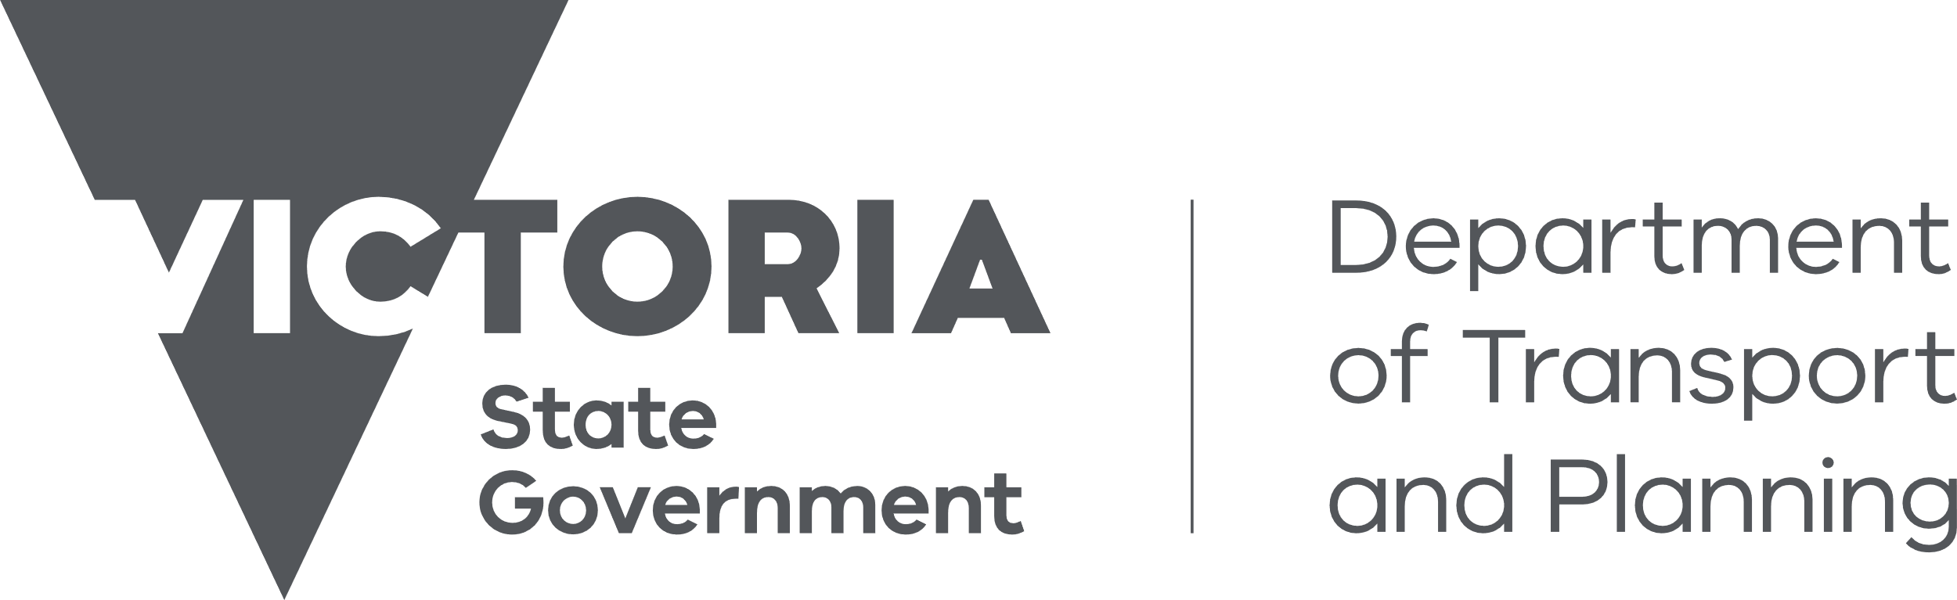

02 Municipal Planning Strategy

02.01 Context
Gumnut Shire is about 250 kilometres north-west of metropolitan Melbourne. It has an urban core, surrounding rural townships and a large agricultural base across approximately 170 square kilometres. The Gumnut City Town Centre is a major activity centre on the state’s northern transport corridor.
There are shared boundaries, connections and relationships with Leadbeater Shire to the north and Honeyeater Shire to the south.
The population of about 70,000 in 2016 is forecast to grow to about 100,000 by 2040, making Gumnut Shire one of Victoria’s fastest growing regional municipalities.
Gumnut Shire’s catchment extends beyond its borders and includes major retail, health and education facilities. People are attracted to Gumnut for its character and lifestyle as well as its employment and education opportunities.
Gumnut’s most important natural feature is the Westcotty River, a major tributary of the Murray River. The river environs include substantial areas of high-value biodiversity. The river and its surrounds make up a substantial portion of the western part of the Shire.
Gumnut Shire has a number of highly significant heritage buildings, structures, features, precincts, archaeological sites, cultural landscapes, trees, avenues and natural features. Gumnut’s natural heritage was formed over 500 million years ago, while its rich cultural heritage began over 40,000 years ago. Much of the remaining pre-contact heritage is concentrated in the area surrounding the Westcotty River.
The agricultural areas of Gumnut Shire are some of Victoria’s richest. Local farming activities deliver some of the highest value production per hectare in the state. Agriculture is also important to the shire’s rural character and identity and is a key driver for tourism in the shire. The popularity of the ‘farm to table’ movement has drawn people to Gumnut Shire because of its strong food and wine-based tourism industry. Service industries, including professional services, education, health, retail, cultural and government are all represented in Gumnut and have been growing strongly over the past decade.

Context Plan
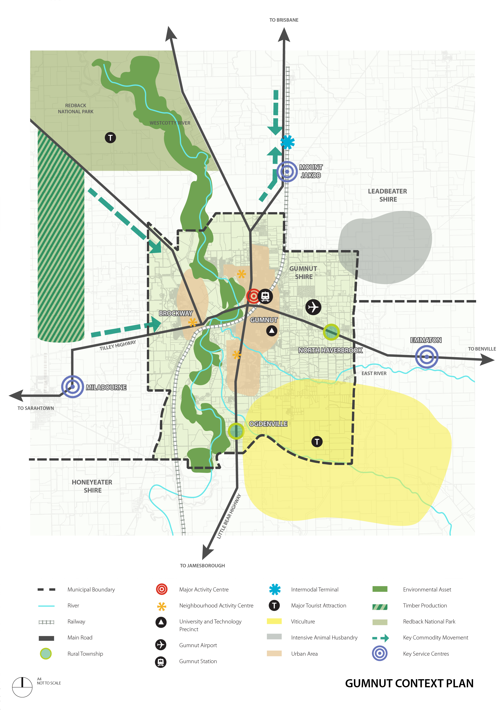

02.02 Vision
Gumnut Shire's Vision, derived from the Gumnut Shire Council Plan 2017, is to create a place that:
- Fosters economic prosperity by supporting our local businesses and industries and creates an environment in which they can thrive by:
  - Supporting agricultural, knowledge industry, tourism, service and industrial uses in the Shire.
  - Supporting and protecting the road, air and rail links to the region and the state.
- Is vibrant and sustainable, that we love to live and work in and has excellent connections, facilities and services by:
  - Protecting the existing rural character while also providing an attractive and liveable built environment in those parts of the Shire where development will intensify.
  - Creating an ecologically sustainable Shire.
  - Providing housing to accommodate the expected population growth.
  - Achieving a diversity of housing choices, housing affordability and a good standard of building design and amenity.
- Promotes our valued natural and built assets by:
  - Managing development so that it is responsive to the existing natural and built environment.
  - Safeguarding our valued environmental assets to ensure the health of ecological systems and the biodiversity they support.
  - Protecting, conserving and enhancing the Shire’s heritage resources.

02.03 Strategic directions

Settlement
Growth in Gumnut Shire is to be accommodated by consolidating existing urban form, expanding identified towns and providing greenfield development opportunities.
The Gumnut City Northern Growth Area is the primary greenfield development area. Urban consolidation is encouraged in and around Gumnut City’s three neighbourhood activity centres.
The townships of Brockway, Odgenville and North Haverbrook and their surrounding communities provide an attractive lifestyle choice in a rural setting. They represent a different style of living to the more urban form of Gumnut City.
The Gumnut Townships Development Plan 2010 sets out the preferred form for future development in Brockway, Ogdenville and North Haverbrook. While Ogdenville and North Haverbrook are identified for growth, residential development in Brockway will be limited to areas that are already zoned for residential use, recognising the constraints of native vegetation, landscape and heritage character.
Most of the population increase in Gumnut to 2040 is to be accommodated by directing growth to:
- Gumnut City Northern Growth area.
- Urban consolidation areas (including the Wombat Flats, Gumnut Central and Gumnut City North neighbourhood centres).
- The townships of Odgenville and North Haverbrook.

Activity centres
There is a strong network of activity centres providing shopping, employment, entertainment, social and community focal points throughout the Shire.
The Gumnut Shire activity centre hierarchy establishes the order (with respect to scale and function) of one centre compared to another. The spatial distribution and hierarchy of activity centres across Gumnut is shown on the Strategic Framework Plan.
The role and function of activity centres will be supported by:
- Reinforcing the primacy of the Gumnut City Town Centre as a key entertainment destination, service, industry and employment area and inner city living precinct.
- Encouraging uses that provide localised employment and service needs in the Wombat Flats, Gumnut Central and Gumnut City North Neighbourhood Centres.

Natural Environment
Much of the native vegetation that existed in the Shire before settlement has been removed or substantially modified. As a result remnant vegetation, particularly along the Westcotty River, serves an important role in preserving biodiversity, providing habitat and environmental benefits such as water quality control, ground water management and soil stabilisation. The urban break between Ogdenville and Gumnut City is significant in providing the one substantial east-west biodiversity corridor through the municipality.
The Shire seeks to protect biodiversity by:
- Retaining remnant vegetation throughout the municipality but particularly along the Westcotty River.
- Maintaining the urban break between Ogdenville and Gumnut City.

Amenity
Gumnut City’s residential areas are highly desirable due to their access to retail, entertainment, employment, community and recreational facilities. Many of these areas are also aesthetically significant with intact streetscapes. The Shire seeks to maintain residential amenity by:
- Directing non-residential uses to locate in either the Gumnut City town centre or the Wombat Flats, Gumnut Central and Gumnut City North neighbourhood centres.
- Supporting limited non-residential uses in residential areas, provided they serve a direct local need and minimise impacts on the amenity of an area.
- Directing industrial uses, particularly those with adverse amenity impact potential, to the Wombat Flats industrial precinct.

Agriculture
Agriculture is an important economic asset for the Shire and needs to be protected from encroaching, non-compatible uses. In particular, the subdivision or use of land in farming areas for dwellings is discouraged as this has the potential to remove productive agricultural land from supply and create land use conflicts with nearby farming properties.
Agriculture in the Shire will be protected by:
- Supporting the subdivision of land for or construction of a dwelling in the Farming Zone only where it can be demonstrated that the dwelling is reasonably required to support agricultural activity.

Built environment and heritage
Gumnut Shire contains many diverse urban and environmental features identified for preservation and enhancement in order to retain the character of the municipality.
Brockway township was one of the first post-contact settlements in the region and has an extensive and highly intact built heritage.
Vegetation throughout the Shire also provides scenic qualities and contributes to amenity and character.
Gumnut’s activity centres are a key element in promoting activity and social interaction with built form providing the physical basis for this.
Owing to its high-profile location at the southern entry point to Gumnut City, the Wombat Flats industrial precinct forms the primary gateway location for the urban areas of Gumnut.
The Shire will protect its distinctive built and natural environment by:
- Designing built form in activity centres to encourage interaction with the public realm and prioritise pedestrian amenity.
- Protecting, conserving and enhancing its heritage assets.
- Designing infill housing development in existing residential areas to respect existing neighbourhood character.
- Encouraging the retention of existing canopy trees.
- Supporting innovative and contemporary designs for housing in urban consolidation and greenfield development areas that complement the important natural, cultural and historic built form and landscape values of the Shire.
- Encouraging development in the Wombat Flats industrial precinct to achieve a high standard of urban design in order to:
- Create a gateway entry.
- Create a strong sense of place.
- Complement the abutting Wombat Flats neighbourhood centre.
- Provide a quality environment for workers and visitors.

Sustainability
Building design and the pattern of land use and development can contribute substantially to the overall sustainability of the Shire. Lowering the ecological footprint of new housing (and other development) is necessary to accommodate new residents and businesses while minimising impacts on the environment.
Sustainability in the Shire will be supported by:
- Encouraging subdivisions and development in greenfield areas to create a compact form and include facilities that promote sustainable modes of transport.
- Encouraging development throughout the Shire to incorporate environmentally sustainable design principles to reduce its ecological footprint.

Housing
Housing demand is high in Gumnut Shire due to the increasing number of new residents. The supply of housing being developed in Gumnut Shire is not matching the needs of a diverse population, particularly in relation to smaller households, the elderly and disabled persons.
The Shire seeks to accommodate housing demand by:
- Directing more compact dwellings, including apartments and townhouses, to locate in the Gumnut North, Gumnut Central and Wombat Flats neighbourhood centres where urban consolidation is encouraged
- Supporting the provision of lower cost accommodation, social housing and housing for people of all abilities around the Gumnut City town centre and the three neighbourhood centres.

Economic development
Gumnut Shire has a diverse local economy that is distributed across the primary, secondary and tertiary economic sectors. While agriculture remains a mainstay of the local economy, the Gumnut Airport and Brown Snake University (with its research and technology precinct) are significant economic contributors to both the Shire and the surrounding region. The Shire also has a role in transporting and processing timber from plantations in neighbouring municipalities.
The Wombat Flats industrial precinct is the main manufacturing centre for the Shire. The precinct has a focus on food manufacturing that responds to the high quality and availability of local produce. Businesses in the precinct are a major source of employment for the Shire.
Economic growth in the Shire will be supported by:
- Protecting the Brown Snake University and Technology Precinct from encroaching residential uses, other than where such uses will support the function of the precinct.
- Discouraging uses in or directly adjacent to the Wombat Flats Industrial precinct that are incompatible or would inhibit its function.
- Encouraging tourism uses that support and enhance local agriculture, particularly where they support the viability of smaller farms.

Transport
Gumnut Airport is a valuable asset for the Shire and the region. The airport links the Shire to Melbourne, other state capitals and regional centres. The railway line and Tilley Highway provide important transport links for moving both people and freight. Gumnut Railway Station is a key internodal terminal for the region.
The planned highway bypass will improve the amenity of Gumnut City by removing through traffic. The bypass will also increase the viability of transport links in the area by reducing the time taken to travel through Gumnut City.
As important assets for the Shire and the surrounding region, the Gumnut Airport & Tilley Highway bypass will be protected by:
- Maintaining and growing the recreational, emergency and charter use of the airport.
- Preventing the encroachment of land uses and forms of development that could restrict the future use of the airport or the function of the highway.

02.04 Strategic framework plan
