Outcome 7

REGIONAL VICTORIA IS PRODUCTIVE, SUSTAINABLE AND SUPPORTS JOBS AND ECONOMIC GROWTH
Regional Victoria will deliver choice and opportunity for all Victorians and help build effective networks to the global economy.
Today, regional Victoria is home to 25 per cent of Victoria’s population. By the census year of 2051, the population of Victoria’s regions is expected to grow from 1.5 million to 2.2 million, with Melbourne growing from 4.5 million to almost 8 million (refer to Figure 18). However, growth in regional Victoria will not be evenly spread. Between 2011 and 2031, regional Victoria’s largest local government areas by population—Greater Geelong, Greater Bendigo and Ballarat—are projected to account for 50 per cent of all population growth outside Melbourne. Growth in peri-urban areas beyond metropolitan Melbourne will attract about 32 per cent of regional Victoria’s population in the same period.
Overall, regional Victoria is growing but not as fast as Melbourne. If current trends continue, the proportion of Victorians living outside of Melbourne will decline. In some towns and regions, communities are actively looking for opportunities to reverse population decline in order to keep local businesses, services and community organisations. If regional Victoria is to share in the benefits of the population boom and take on a greater proportion of residential and jobs growth than is projected under the ‘business as usual’ scenario, then we need to plan for better connections to infrastructure and services. However, planning for growth in regional Victoria must be led locally and acknowledge the diverse range of opportunities and challenges that exist in different locations.
Figure 18 Estimated Resident Population (ERP) - Melbourne, regional cities, Melbourne's peri-urban areas and regional Victoria balance, 2011–2051
Population  Regional Victoria | 2011  1,417,000 | 2015  1,461,000 | 2031  1,749,000 | 2051  2,168,000 | Average annual % change 2011-2015  0.77% | Average annual % change 2015-2051  1.10%
Population  Regional cities (1) | 2011  716,000 | 2015  749,000 | 2031  933,000 | 2051  1,199,000 | Average annual % change 2011-2015  1.12% | Average annual % change 2015-2051  1.32%
Population  Peri-urban areas[2) | 2011  269,000 | 2015  286,000 | 2031  376,000 | 2051  502,000 | Average annual % change 2011-2015  1.48% | Average annual % change 2015-2051  1.58%
Population  Regional Victoria balance | 2011  432,000 | 2015  427,000 | 2031  441,000 | 2051  467,000 | Average annual % change 2011-2015  -0.28% | Average annual % change 2015-2051  0.25%
Population  Metropolitan Melbourne(3) | 2011  4,121,000 | 2015  4,480,000 | 2031  5,984,000 | 2051  7,918,000 | Average annual % change 2011-2015  2.11% | Average annual % change 2015-2051  1.59%
Population  Victoria | 2011  5,538,000 | 2015  5,941,000 | 2031  7,733,000 | 2051  10,086,000 | Average annual % change 2011-2015  1.77% | Average annual % change 2015-2051  1.48%
- Includes the Local Government Areas of Greater Geelong, Greater Bendigo, Ballarat, Greater Shepparton, Latrobe City, Wodonga, Warrnambool, Mildura, Wangaratta and Horsham.
- Includes the Local Government Areas of Bass Coast, Baw Baw, Golden Plains, Hepburn, Macedon Ranges, part of Mitchell outside the urban growth boundary, Moorabool, Murrindindi, South Gippsland and Surf Coast.
- Includes the 31 municipalities that make up metropolitan Melbourne, plus part of Mitchell Shire within the urban growth boundary.
Source: Victoria in Future 2016

Growing regional Victoria’s economy
Regional Victoria provides 30 per cent of the state’s exports. As traditional economic delineations change, regional Victoria and Melbourne’s economic linkages are becoming increasingly important.
The government has identified priority industry sectors with potential for remarkable growth. Collectively, these sectors have the potential to drive up to $70 billion in additional economic output by 2025 and create more than 400,000 new jobs for Victorians. Regional Victoria is well placed to benefit from future growth and export development in a number of these sectors.
Like most of the world, Victoria is moving towards becoming a low-carbon economy, which brings both big challenges and big opportunities. Regional Victoria is well positioned to take advantage of the significant job opportunities expected to emerge in the new energy industries that will drive the state’s transition to a net zero emissions economy. However, the government also recognises that challenges of transition are being felt particularly acutely at the frontline of the energy sector—for example in places such as the Latrobe Valley. Communities experiencing the challenges of economic transition are also looking to industries of the future, including knowledge-based services and advanced manufacturing and processing.
In 2015–16, Victoria’s food-and-fibre exports were valued at $11.9 billion, with 27 per cent of exports sent to China. Long-term growth in Asia is expected to accelerate demand for beef, lamb, wheat and dairy products as well as processed foods.
Tourism is another major economic driver for regional Victoria. The industry contributes $11.5 billion to the regional Victorian economy (GRP) and generates 114,400 jobs. It contributes 13.4 per cent of total GRP and 13.4 per cent of employment. Nature-based tourism visitors represented 70 per cent of all international overnight visitors to the state in 2013–14. Domestic nature-based visitors had approximately 4.3 million day trips to and within Victoria.
With new investment in infrastructure and improvements to marketing, product development and the visitor experience, there are huge opportunities for regional Victoria to increase its share of the tourism market.
International education has been Victoria’s largest services export industry for more than a decade, generating $5.6 billion for the state and supporting 30,000 jobs in 2014. Regional education providers can offer niche expertise and significant industry expertise in fields of global significance, such as food and agriculture, soil and water, energy and resources, and the environment.
The population services sector (such as the healthcare and social-assistance industries) is expected to drive strong employment growth in regional Victoria, particularly as a result of Victoria’s ageing population. The opportunities for growth in these industries has already been demonstrated with the establishment of the National Disability Insurance Scheme headquarters in central Geelong.

Planning for growth and change in regional Victoria
Victoria’s 10 regional cities—Greater Geelong, Greater Bendigo, Ballarat, Greater Shepparton, Latrobe City, Wodonga, Warrnambool, Mildura, Wangaratta and Horsham—are important urban settlements with diverse economies and strong communities that operate as service hubs for many smaller communities. Development of individual cities and towns should be in keeping with their character and balanced with the protection of the productive land, economic resources and biodiversity assets that are critical to the state’s economic and environmental sustainability.
Victoria’s Regional Statement clearly articulates that government investment and decision-making in regional Victoria will reflect the strategic priorities regional communities have identified for themselves—across economic, social and environmental issues. The nine new Regional Partnerships across the state provide the mechanism for this dialogue to occur. The approach taken by Plan Melbourne will be consistent with this approach, acknowledging regional differences and local and regional ambitions.

Victoria’s Plan

Direction 7.1 Invest in regional Victoria to support housing and economic growth
Investing in regional Victoria will support housing and economic growth and bring significant social and lifestyle benefits to regional communities.
The Victorian Government will:
- work with the nine Regional Partnerships and local governments to support the growth of housing and employment in regional cities and towns
- ensure the right infrastructure and services are available to support the growth and competitiveness of regional and rural industries and their access to global markets.

Policy 7.1.1 Stimulate employment and growth in regional cities
The government will continue to make improvements to infrastructure and services to stimulate employment and growth in the state’s 10 largest regional cities.
Building on the Regional Growth Plans and work undertaken by Regional Cities Victoria, this approach will require development strategies that reflect the individual growth opportunities and priorities of each regional city, including the identification of urban renewal and infill opportunities to optimise infrastructure investment and surplus government land.
Regional city railway stations and their surrounds need to be targeted for potential growth opportunities, including transit-oriented development and improved housing diversity in regional cities. Increased housing diversity is needed to encourage international students and young professionals to work, study and live in regional areas.
The Victorian Planning Authority, Regional Development Victoria and other key agencies will work with regional cities on the preparation of development strategies.

Policy 7.1.2 Support planning for growing towns in peri-urban areas
A number of towns in peri-urban areas have capacity for more housing and employment-generating development without impacting on the economic and environmental roles that surrounding non-urban areas serve. Those towns include Warragul–Drouin, Bacchus Marsh, Torquay–Jan Juc, Gisborne and Kyneton. Other towns identified by Regional Growth Plans as having potential for growth include Wonthaggi, Kilmore, Broadford, Seymour and Ballan.
Peri-urban towns can provide an affordable and attractive alternative to metropolitan living. However, strategies need to be developed for the timely delivery of state and local infrastructure to support growth and protect their significant amenity.
Most importantly, development in peri-urban areas must also be in keeping with local character, attractiveness and amenity. Growth boundaries should be established for each town to avoid urban sprawl and protect agricultural land and environmental assets.
Map 23 Victoria’s connected cities and regions
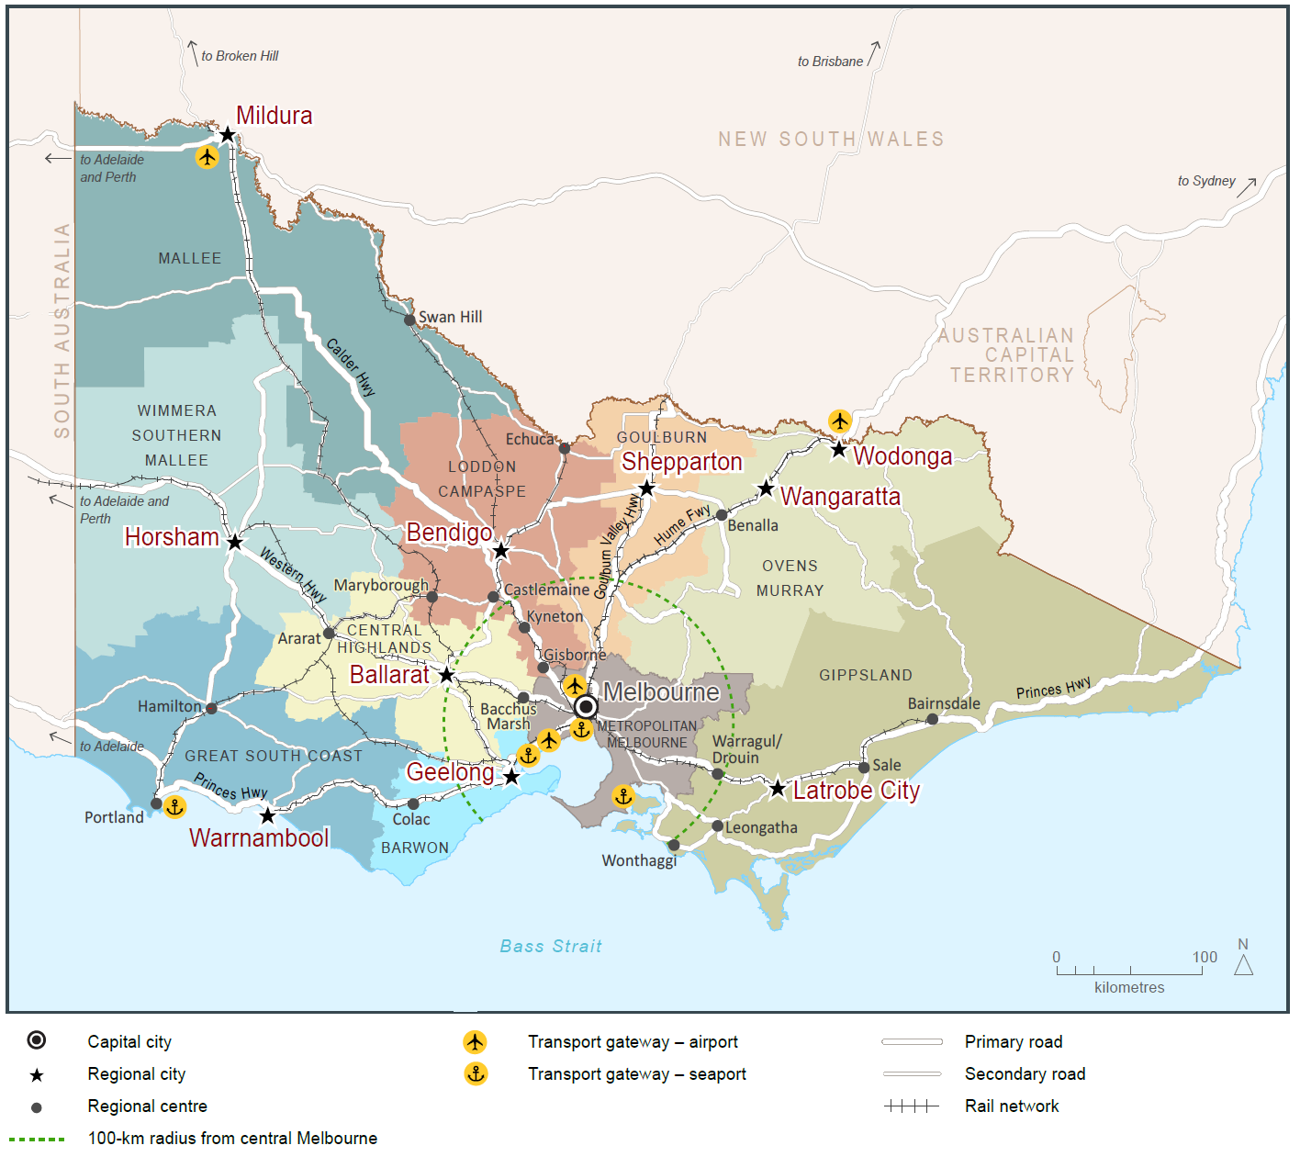
Source: Department of Environment, Land, Water and Planning

Direction 7.2 Improve connections between cities and regions
Regional cities and towns need to be connected by efficient and safe road and rail transport corridors.
Strong links, both within the regions to major hub destinations as well as back to Melbourne, make it easier to live and do business in regional areas.
Better public transport connections (including rail, long-distance coach, and school and town buses) are critical for the movement of people to jobs and services. The Regional Network Development Plan is the Victorian Government's long-term plan for transport investment in regional Victoria. It will deliver a modern commuter-style service for the growth areas of Geelong, Bendigo, Ballarat, Seymour and Traralgon, and service improvements to outer regional areas.
Victoria’s freight task is projected to triple by 2050—much of it is destined for Melbourne or export.
Infrastructure that connects rural producers to state-significant corridors—as well as the Port of Melbourne, Melbourne Airport and other regional ports—must be improved to support the economies of regional cities and regional industries.
Digital connectivity is fundamental to business and jobs growth and critical for accessing services. In particular, the health and education sectors highlight the potential of providing services online.

Policy 7.2.1 Improve transport and digital connectivity for regional Victoria
State-significant transport corridors connect regional cities to each other, to Melbourne and to key gateways such as Melbourne Airport.
Responses to growing transport demand in regional Victoria will be assessed and prioritised. All potential solutions and interventions will be reviewed to ensure the capacity of existing infrastructure is being optimised.
Improvements to public transport will enable a more integrated labour market with higher-income jobs to spread throughout Victoria. They will reduce inequity of access between regions, especially the regions that are more remote from Melbourne. Planning will identify infrastructure and service priorities to better link regional Victoria and Melbourne and support regional city growth.
Opportunities will be identified to leverage expansion of the digital economy to support increased regional economic and population growth. Improvements to digital connectivity will continue to be sought, working closely with the Federal Government.

Policy 7.2.2 Strengthen transport links on national networks for the movement of commodities
Victoria’s economy depends on its ability to move goods between state-significant places (such as regional cities and Melbourne) and to interstate and international markets.
Transport network planning must ensure that industries such as Victoria’s food and fibre industry remain viable and competitive. This should include identification of key freight corridors and interstate freight terminals.
For example, the Avalon corridor near Geelong contains nationally significant economic assets, including airport, road, rail and waste facilities. This corridor must be safeguarded for state infrastructure opportunities and complementary development in the future, as well as maintaining a settlement break between Melbourne and Geelong. Land-use buffers for infrastructure and Avalon Airport and areas of high biodiversity value, including Ramsar conservation areas, must be protected.

Department of Economic Development, Jobs, Transport & Resources (2015), Victorian Food and Fibre Export Performance Report 2015-16
Tourism Victoria (2015) Value of Tourism to Victoria’s regions 2013-14
Department of Economic Development, Jobs, Transport and Resources, International visitation – International Visitors Survey results, year ending March 2016, Tourism Victoria website
Victorian Government (2016) International Education Sector Strategy Accessibility If you would like to receive this publication in an alternative format, please telephone the DELWP Customer Service Centre on 136 186, email customer.service@delwp.vic.gov.au, or via the National Relay Service on 133 677 www.relayservice.com.au. This document is also available on the internet at www.delwp.vic.gov.au © The State of Victoria Department of Environment, Land, Water and Planning 2017 This work is licensed under a Creative Commons Attribution 4.0 International licence. You are free to re-use the work under that licence, on the condition that you credit the State of Victoria as author. The licence does not apply to any images, photographs or branding, including the Victorian Coat of Arms, the Victorian Government logo and the Department of Environment, Land, Water and Planning (DELWP) logo. To view a copy of this licence, visit http://creativecommons.org/licenses/by/4.0/ Printed by Impact Digital, Brunswick ISBN 978-1-76047-499-7 Print format ISBN 978-1-76047-500-0 Online (pdf / word) format Disclaimer This publication may be of assistance to you but the State of Victoria and its employees do not guarantee that the publication is without flaw of any kind or is wholly appropriate for your particular purposes and therefore disclaims all liability for any error, loss or other consequence which may arise from you relying on any information in this publication. DOCUMENT ENDS

