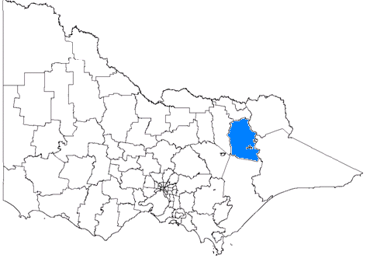
Alpine LGA
Production landscape some amenity (Figure 6)
Projected population change from 12574 in 2006 to 14152 in 2026 (growth)

Localities with SEIFA RSD scores under the regional Victoria average 986
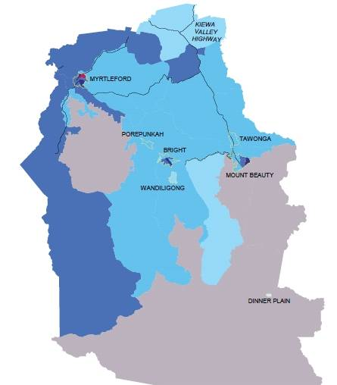
Locality | SEIFA | Population (↑ growth, ↓ decline or = stable 2006 to 2001) | Individual income under $400 a week | Public Housing dwellings | Aged over 65 | Over 75 living alone | Disability | Single parent families | Developmentally vulnerable children | Aborigines and Torres Strait Islanders | Low English Proficiency | Households with no internet
Hume | - | 266939 | 48.3 | 5.2 | 15.4 | 2.4 | 4.8 | 14.9 | 11 | 1.6 | 1.0 | 46.5
Regional Victoria | 986 | 1383233 | 50.0 | 4.8 | 16.0 | 2.7 | 5.0 | 15.4 | - | 1.2 | 0.7 | 46.1
Melbourne Metro | 1022 | 3744982 | 44.3 | 4.0 | 12.7 | 2.0 | 4.3 | 15.4 | - | 0.4 | 5.2 | 36.2
Victoria | 1000 | 5313053 | 45.8 | 4.2 | 13.6 | 2.2 | 4.5 | 15.4 | 10 | 0.7 | 4.0 | 39.0
Mid sized population between 1000-3000
Myrtleford | 927 | 2718 ↑ | 46.7 | 5.0 | 24.0 | 4.1 | 8.0 | 16.1 | 9 | 0.5 | 17.4 | 59.2
Mount Beauty | 973 | 1706 ↑ | 43.2 | 1.6 | 22.0 | 5.0 | 5.8 | 13.3 | - | 0.5 | 1.1 | 47.1

Populations in Myrtleford (611) contribute to the most disadvantaged 10% of the population in Australia (Table 1)

Disadvantaged areas in the Alpine LGA by the Index of Relative Socio-economic Disadvantage (SEIFA)
Alpine has two mid-sized towns that score below the regional Victorian average on the SEIFA Index of Relative Disadvantage. Around 43-48% of the population of these towns have low incomes but there is lower than average public housing. The mid-sized towns have a greater proportion of people aged over 65 and Myrtleford also has a larger proportion of single parent families and a higher than average multicultural mix.

Context: Alpine LGA in general
LGA snapshot 3
% of children in their first year of school who were developmentally vulnerable on two or more domains * 2009 (DEECD 2010)

 | Number | %
Victoria | 61187 | 10.0%
Hume | 336 | 10.6
Greater Shepparton | 101 | 12.7%
Wodonga | 63 | 13.5%
Mitchell | 45 | 9.2%
Moira | 40 | 12.0%
Wangaratta | 29 | 8.1
Benalla | 15 | 10.0
Indigo | 13 | 6.3
Strathbogie | 12 | 14.3
Alpine | 11 | 8.1
Towong | 7 | 10.8
Mansfield | No data available
Murrindindi | No data available

* Five domains:
Physical health & wellbeing
Social competence & wellbeing
Emotional maturity
Language & cognitive skills
Communication skills & general knowledge

Early years/education/employment
- In 2009, 8% of children across the LGA (11) were found to be developmentally vulnerable in their first year of school (LGA snapshot 3, page 26).
- The LGA has an unemployment rate of 4.4%, lower than the State average at 5.8% (March 2010, LGA snapshot 4, page 29)
- Nearly one in five (19%) of those aged between 15 and 19 are not engaged in work or further education or training (LGA snapshot 5, page 32)
- 21% of those employed are semi skilled or unskilled workers (LGA snapshot 6, page 35)

Access to services
The LGA is “moderately accessible” by the Accessibility and Remoteness Index (Figure 13)

Compared to the Hume averages:
✓ More residents report their area has easy access to recreational and leisure facilities (87% compared to 79%, LGA snapshot 8, page 41)
✓ The area has a higher rate of high care aged care places (56 compared to 41 per 1000 population eligible)
✓ Fewer households have no internet (46% compared to 47%, LGA snapshot 11, page 50, Figure 14)
✗ Fewer residents report their area has a wide range of community and support groups (66% compared to 70%, LGA snapshot 9, page 44)
✗ The area has a lower rate of low care aged care places (35 compared to 51 per 1000 population eligible)
✗ Fewer residents report their area has good facilities and services like shops, childcare, schools, libraries (78% compared to 79%, LGA snapshot 7, page 38)
✗ More residents report they have experienced transport limitations (22% compared to 20%, LGA snapshot 10, page 47, Figure 15)

Benalla LGA
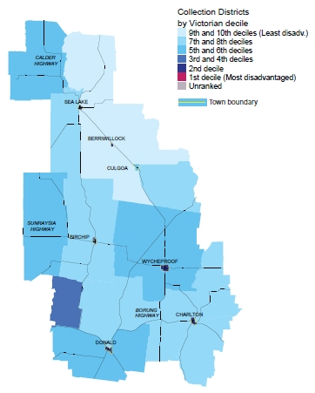
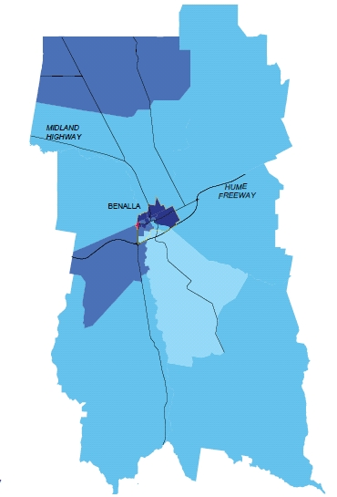
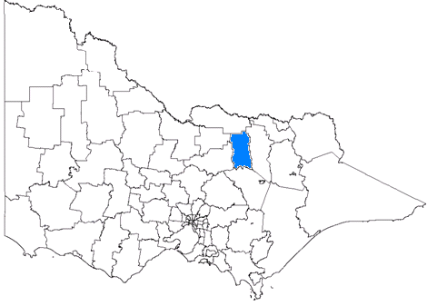
“Amenity” pressures landscape (Figure 8)
Projected population change from 13968 in 2006 to 15536 in 2026 (growth)

Localities with SEIFA RSD scores under the regional Victoria average 986

Locality | SEIFA | Population (↑ growth, ↓ decline or = stable 2006 to 2001) | Individual income under $400 a week | Public Housing dwellings | Aged over 65 | Over 75 living alone | Disability | Single parent families | Developmentally vulnerable children | Aborigines and Torres Strait Islanders | Low English Proficiency | Households with no internet
Hume | - | 266939 | 48.3 | 5.2 | 15.4 | 2.4 | 4.8 | 14.9 | 11 | 1.6 | 1.0 | 46.5
Regional Victoria | 986 | 1383233 | 50.0 | 4.8 | 16.0 | 2.7 | 5.0 | 15.4 | - | 1.2 | 0.7 | 46.1
Melbourne Metro | 1022 | 3744982 | 44.3 | 4.0 | 12.7 | 2.0 | 4.3 | 15.4 | - | 0.4 | 5.2 | 36.2
Victoria | 1000 | 5313053 | 45.8 | 4.2 | 13.6 | 2.2 | 4.5 | 15.4 | 10.0 | 0.7 | 4.0 | 39.0
Large towns population >3000
Benalla | 940 | 9124 ↑ | 44.3 | 7.1 | 22.3 | 4.4 | 6.2 | 18.5 | 9 | 1.1 | 2.8 | 54.5

Populations in Benalla (471) contribute to the most disadvantaged 10% of the population in Australia (Table 1)

Disadvantaged areas in the Benalla LGA by the Index of Relative Socio-economic Disadvantage (SEIFA)

Benalla has one large town that scores below the regional Victorian average on the SEIFA Index of Relative Disadvantage. Around 44% of its population has a low income and it has higher than average public housing, more people aged over 65 and more single parent families. It has a higher than average multicultural mix.
LGA snapshot 4
Estimates of unemployment, ABS, September 2009 (ABS 2010a)

Victoria | 5.8%
Greater Shepparton | 7.2%
Benalla | 6.4%
Moira | 5.6%
Wodonga | 5.5%
Wangaratta | 5.4%
Mitchell | 5.3%
Murrindindi | 4.6%
Strathbogie | 4.5%
Mansfield | 4.5%
Alpine | 4.4%
Indigo | 4.2%
Towong | 3.7%

Context: Benalla LGA in general

Early years/education/employment
- In 2009, 10% of children across the LGA (15) were found to be developmentally vulnerable in their first year of school (LGA Snapshot 3, page 26).
- The LGA has an unemployment rate of 6.4%, higher than the State average at 5.8% (March 2010, LGA snapshot 4, page 29)
- Nearly one in five (18%) of those aged between 15 and 19 are not engaged in work or further education or training (LGA snapshot 5, page 32)
- Nearly one quarter of those employed are semi skilled or unskilled workers (23%) (LGA snapshot 6, page 35)

Access to services
The LGA is “accessible” by the Accessibility and Remoteness Index (Figure 13)

Compared to the Hume averages:
✓ More residents report their area has good facilities and services like shops, childcare, schools, libraries (86% compared to 79%, LGA snapshot 7, page 38)
✓ More residents report their area has easy access to recreational and leisure facilities (85% compared to 79%, LGA snapshot 8, page 41)
✓ More residents report their area has a wide range of community and support groups (75% compared to 70%, LGA snapshot 9, page 44)
✗ The area has a lower rate of high care aged care places (37 compared to 41 per 1000 population eligible)
✗ The area has a lower rate of low care aged care places (48 compared to 51 per 1000 population eligible)
✗ More residents report they have experienced transport limitations (24% compared to 20%, LGA snapshot 10, page 47, Figure 15)
✗ More households have no internet (50% compared to 47%, LGA Snapshot 11, page 50, Figure 14)

Greater Shepparton LGA
Production landscape predominantly agriculture (Figure 6)
Projected population change from 59202 in 2006 to 71509 in 2026 (growth)

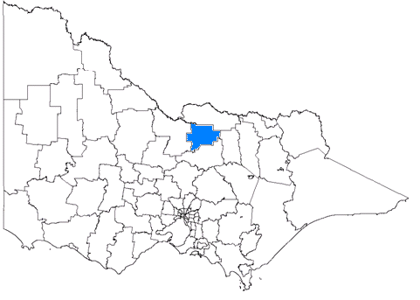
Localities with SEIFA RSD scores under the regional Victoria average 986
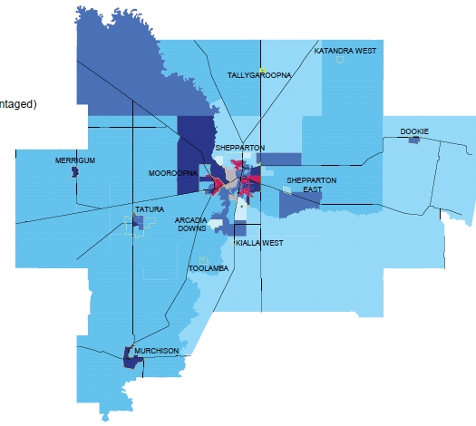  Locality | SEIFA | Population (↑ growth, ↓ decline or = stable 2006 to 2001) | Individual income under $400 a week | Public Housing dwellings | Aged over 65 | Over 75 living alone | Disability | Single parent families | Developmentally vulnerable children | Aborigines and Torres Strait Islanders | Low English Proficiency | Households with no internet
Hume | - | 266939 | 48.3 | 5.2 | 15.4 | 2.4 | 4.8 | 14.9 | 11 | 1.6 | 1.0 | 46.5
Regional Victoria | 986 | 1383233 | 50.0 | 4.8 | 16.0 | 2.7 | 5.0 | 15.4 | - | 1.2 | 0.7 | 46.1
Melbourne Metro | 1022 | 3744982 | 44.3 | 4.0 | 12.7 | 2.0 | 4.3 | 15.4 | - | 0.4 | 5.2 | 36.2
Victoria | 1000 | 5313053 | 45.8 | 4.2 | 13.6 | 2.2 | 4.5 | 15.4 | 10 | 0.7 | 4.0 | 39.0
Large towns population >3000
Shepparton-Mooroopna | 947 | 38787 ↑ | 38.5 | 6.4 | 14.3 | 2.4 | 4.6 | 19.5 | 16 -23 | 4.1 | 18.3 | 50.1
Mid sized population between 1000-3000
Tatura | 982 | 3534 ↑ | 40.3 | 2.3 | 19.5 | 2.9 | 4.6 | 14.3 | 7 | 1.4 | 17.0 | 51.6
Small towns population <1000
** CAUTION using percentages from small populations (there may be high rates from small numbers in small populations)**
Merrigum | 902 | 451 ↓ | 41.2 | 4.7 | 12.4 | 1.4 | 6.9 | 13.3 | - | 2.0 | 6.4 | 55.6
Murchison | 931 | 785 ↑ | 43.8 | 2.9 | 26.7 | 3.1 | 8.3 | 13.7 | 38 | 0.8 | 3.5 | 61.9

Populations in Mooroopna (3062) and Shepparton (6926) contribute to the most disadvantaged 10% of the population in Australia (Table 1)
Disadvantaged areas in the Greater Shepparton LGA by the Index of Relative Socio-economic Disadvantage (SEIFA)

Greater Shepparton has one large, one mid-sized and two small towns that score below the regional Victorian average on the SEIFA Index of Relative Disadvantage. Around 38-44% of these populations have low incomes and Shepparton-Maroopna has a higher proportion of public housing. There is a greater proportion of people aged over 65 living in Tatura and Murchison and a greater proportion of single parent families in Shepparton-Maroopna. All areas have a higher than average multicultural mix.
LGA snapshot 5
% of young people aged 15 to 19 who are not engaged in school, work or further education/ training
(PHIDI 2010 based on ABS 2006)

Victoria | 17.4%
Regional Victoria | 19.0%
Metro Melbourne | 16.7%
Greater Shepparton | 22.3%
Murrindindi | 19.9%
Wodonga | 19.8%
Moira | 19.6%
Wangaratta | 19.2%
Alpine | 18.9%
Benalla | 18.3%
Mitchell | 17.6%
Strathbogie | 16.3%
Mansfield | 16.1%
Towong | 15.3%
Indigo | 14.7%

Context: Greater Shepparton LGA in general

Early years/education/employment
- In 2009, 13% of children across the LGA (101) were found to be developmentally vulnerable in their first year of school (LGA Snapshot 3, page 26)
- The LGA has an unemployment rate of 7.2%, higher than the State average at 5.8% (March 2010, LGA snapshot 4, page 29)
- One in five (22%) of those aged between 15 and 19 are not engaged in work or further education or training (LGA snapshot 5, page 32)
- One fifth of those employed are semi skilled or unskilled workers (22%) (LGA snapshot 6, page 35)

Access to services
The LGA is “accessible” by the Accessibility and Remoteness Index (Figure 13)

Compared to the Hume averages:
✓ More residents report their area has good facilities and services like shops, childcare, schools, libraries (82% compared to 79%, LGA snapshot 7, page 38)
✓ Fewer residents report they have experienced transport limitations (13% compared to 20%, LGA snapshot 10, page 47, Figure 15)
✓ The area has a higher rate of high care aged care places (46 compared to 41 per 1000 population eligible)
✓ The area has a higher rate of low care aged care places (60 compared to 51 per 1000 population eligible)
= The same proportion of residents report their area has easy access to recreational and leisure facilities (79%, LGA snapshot 8, page 41)
= The same proportion of residents report their area has a wide range of community and support groups (70%, LGA snapshot 9, page 44)
✗ More households have no internet (48% compared to 47%, LGA Snapshot 11, page 50, Figure 14)

Indigo LGA
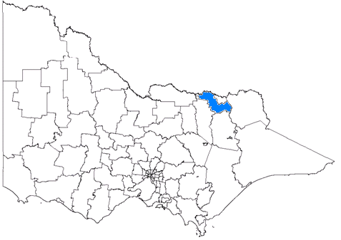
“Amenity” pressures landscape (Figure 8)
Projected population change from 15367 in 2006 to 17879 in 2026 (growth)

Localities with SEIFA RSD scores under the regional Victoria average 986
Locality | SEIFA | Population (↑ growth, ↓ decline or = stable 2006 to 2001) | Individual income under $400 a week | Public Housing dwellings | Aged over 65 | Over 75 living alone | Disability | Single parent families | Developmentally vulnerable children | Aborigines and Torres Strait Islanders | Low English Proficiency | Households with no internet
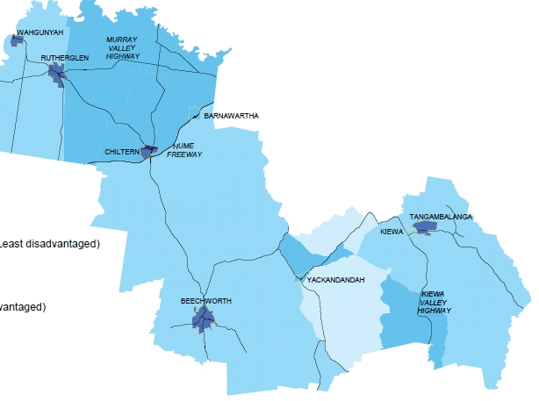  Hume | - | 266939 | 48.3 | 5.2 | 15.4 | 2.4 | 4.8 | 14.9 | 11 | 1.6 | 1.0 | 46.5
Regional Victoria | 986 | 1383233 | 50.0 | 4.8 | 16.0 | 2.7 | 5.0 | 15.4 | - | 1.2 | 0.7 | 46.1
Melbourne Metro | 1022 | 3744982 | 44.3 | 4.0 | 12.7 | 2.0 | 4.3 | 15.4 | - | 0.4 | 5.2 | 36.2
Victoria | 1000 | 5313053 | 45.8 | 4.2 | 13.6 | 2.2 | 4.5 | 15.4 | 10 | 0.7 | 4.0 | 39.0
Mid sized population between 1000-3000
Rutherglen | 967 | 1990 ↑ | 38.4 | 5.4 | 18.1 | 4.0 | 6.4 | 14.8 | 10 | 0.5 | 0.0 | 48.9
Beechworth | 978 | 2653 ↑ | 43.0 | 3.4 | 21.4 | 3.8 | 7.8 | 18.2 | 41 | 0.5 | 4.1 | 46.2
Small towns population <1000
** CAUTION using percentages from small populations (there may be high rates from small numbers in small populations)**
Wahgunyah | 981 | 810 ↑ | 36.2 | 1.9 | 16.3 | 3.5 | 3.0 | 10.1 | 0 | 1.0 | 0.0 | 50.3
Chiltern | 943 | 1066 ↑ | 41.1 | 1.2 | 14.2 | 2.7 | 5.1 | 19.9 | 12 | 0.3 | 0.0 | 51.5

No areas in this LGA contribute to the most disadvantaged 10% of the population in Australia (Table 1)

Disadvantaged areas in the Indigo LGA by the Index of Relative Socio-economic Disadvantage (SEIFA)

Indigo has two mid-sized and two small towns that score below the regional Victorian average on the SEIFA Index of Relative Disadvantage. Between 36-43% of these populations have low incomes and Rutherglen has higher than average public housing. All but Chiltern have a greater proportion of people aged over 65 and Chiltern and Beechworth have more single parent families. Only Beechworth has a higher than average multicultural mix.

Context: Indigo LGA in general
LGA snapshot 6
Unskilled and semi skilled workers
(PHIDI 2010 based on ABS 2006)

 | %
Victoria | 16%
Regional Victoria | 19%
Metro Melbourne | 15%
Moira | 24%
Strathbogie | 23%
Benalla | 23%
Greater Shepparton | 22%
Mitchell | 21%
Wangaratta | 21%
Alpine | 21%
Indigo | 20%
Wodonga | 20%
Murrindindi | 19%
Towong | 18%
Mansfield | 16%

Early years/education/employment
- In 2009, 6% of children across the LGA (13) were found to be developmentally vulnerable in their first year of school (LGA snapshot 3, page 26)
- The LGA has an unemployment rate of 4.2%, lower than the State average at 5.8% (March 2010, LGA snapshot 4, page 29)
- 15% of those aged between 15 and 19 are not engaged in work or further education or training (LGA snapshot 5, page 32)
- One in five of those employed are semi skilled or unskilled workers (20%) (LGA snapshot 6, page 35)

Access to services
The LGA is “accessible” by the Accessibility and Remoteness Index (Figure 13)

Compared to the Hume averages:
✓ More residents report their area has easy access to recreational and leisure facilities (81% compared to 79%, LGA snapshot 8, page 41)
✓ More residents report their area has a wide range of community and support groups (72% compared to 70%, LGA snapshot 9 page 44)
✓ The area has a higher rate of high care aged care places (50 compared to 41 per 1000 population eligible)
= The same proportion of residents report their area has good facilities and services like shops, childcare, schools, libraries (79%, LGA snapshot 7, page 38)
✗ More households have no internet (48% compared to 47%, LGA Snapshot 11, page 50, Figure 14)
✗ More residents report they have experienced transport limitations (29% compared to 20%, LGA snapshot 10, page 47, Figure 15)
✗ The area has a lower rate of low care aged care places (49 compared to 51 per 1000 population eligible)

Mansfield LGA
“Amenity” pressures landscape (Figure 8)
Projected population change from 7445 in 2006 to 10914 in 2026 (growth)

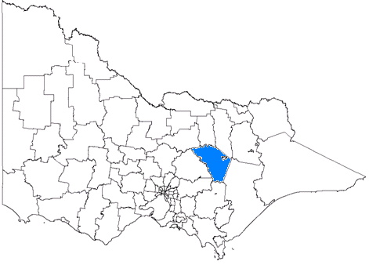
Localities with SEIFA RSD scores under the regional Victoria average 986

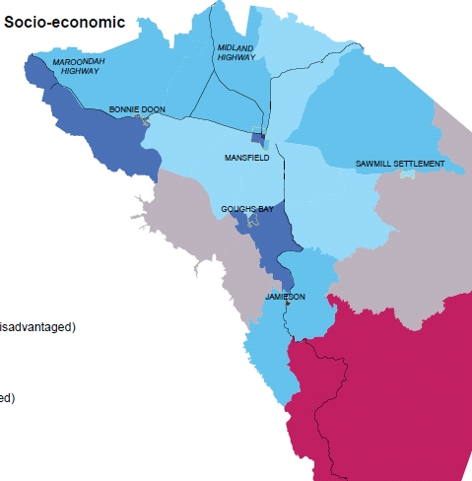  Locality | SEIFA | Population (↑ growth, ↓ decline or = stable 2006 to 2001) | Individual income under $400 a week | Public Housing dwellings | Aged over 65 | Over 75 living alone | Disability | Single parent families | Developmentally vulnerable children | Aborigines and Torres Strait Islanders | Low English Proficiency | Households with no internet
Hume | - | 266939 | 48.3 | 5.2 | 15.4 | 2.4 | 4.8 | 14.9 | 11 | 1.6 | 1.0 | 46.5
Regional Victoria | 986 | 1383233 | 50.0 | 4.8 | 16.0 | 2.7 | 5.0 | 15.4 | - | 1.2 | 0.7 | 46.1
Melbourne Metro | 1022 | 3744982 | 44.3 | 4.0 | 12.7 | 2.0 | 4.3 | 15.4 | - | 0.4 | 5.2 | 36.2
Victoria | 1000 | 5313053 | 45.8 | 4.2 | 13.6 | 2.2 | 4.5 | 15.4 | 10.0 | 0.7 | 4.0 | 39.0
Mid sized population between 1000-3000
Mansfield | 984 | 2846 ↑ | 38.6 | 5.8 | 19.7 | 4.6 | 6.3 | 18.0 | - | 0.8 | 1.7 | 51.2
Small towns population <1000
** CAUTION using percentages from small populations (there may be high rates from small numbers in small populations)**
Jamieson | 931 | 89 ↓ | 67.1 | 0.0 | 24.7 | 14.5 | 3.5 | 0.0 | - | 0.0 | 0.0 | 47.7

Populations in Jamieson (94) contribute to the most disadvantaged 10% of the population in Australia (Table 1)

Disadvantaged areas in the Mansfield LGA by the Index of Relative Socio-economic Disadvantage (SEIFA)

Mansfield has one mid-sized and one small town that score below the regional Victorian average on the SEIFA Index of Relative Disadvantage. Between 38- 67% of these populations have low incomes and Mansfield has higher than average public housing. Both towns have a greater proportion of people aged over 65 and Mansfield also has a greater proportion of single parent families and a higher than average multicultural mix.

Context: Mansfield LGA in general
LGA snapshot 7
Residents that feel their area has good facilities and services like shops, childcare, schools, libraries, 2008 (DPCD 2010a)

Hume | 79.4%
Wodonga | 91.3%
Benalla | 85.9%
Wangaratta | 85.6%
Greater Shepparton | 82.4%
Moira | 79.4%
Indigo | 79.0%
Alpine | 77.7%
Mansfield | 75.6%
Mitchell | 71.1%
Towong | 64.2%
Murrindindi | 62.2%
Strathbogie | 61.2%

Education/employment
- The LGA has an unemployment rate of 4.5%, lower than the State average at 5.8% (March 2010, LGA snapshot 4, page 29)
- 16% of those aged between 15 and 19 are not engaged in work or further education or training (LGA snapshot 5, page 32)
- 16% those employed are semi skilled or unskilled workers (LGA snapshot 6, page 35)

Access to services
The LGA is “moderately accessible” by the Accessibility and Remoteness Index (Figure 13)

Compared to the Hume averages:
✓ Fewer households have no internet (45% compared to 47%, LGA Snapshot 11, page 50, Figure 14)
✗ Fewer residents report their area has good facilities and services like shops, childcare, schools, libraries (76% compared to 79%, LGA snapshot 7, page 38)
✗ Fewer residents report their area has easy access to recreational and leisure facilities (73% compared to 79%, LGA snapshot 8, page 41)
✗ Fewer residents report their area has a wide range of community and support groups (64% compared to 70%, LGA snapshot 9, page 44)
✗ More residents report they have experienced transport limitations (25% compared to 20%, LGA snapshot 10, page 47, Figure 15)
✗ The area has a lower rate of high care aged care places (36 compared to 41 per 1000 population eligible)
✗ The area has a lower rate of low care aged care places (50 compared to 51 per 1000 population eligible)

