This version of Planning Advisory Note 65: Yarra River protection planning controls has been prepared for use with screen reader software. The printed publication contains various design features that have been necessarily omitted from this version. In other respects this document contains identical text to that in the PDF version of the document which is available at www.planning.vic.gov.au

Advisory Note 65
Yarra River protection planning controls

February 2017
This advisory note provides an overview of planning controls implemented into the Banyule, Boroondara, Manningham, Nillumbik, Stonnington and Yarra Planning Schemes through Amendments VC121 and GC46 to protect the Yarra River between Richmond and Warrandyte.
It includes the process, methodology and approach used to prepare stronger planning controls. It provides guidance and information to applicants and responsible authorities about preparing and assessing a planning permit application within the planning controls.
The Minister for Planning has introduced the following measures:
- a new ‘Yarra River Protection’ State Planning Policy (VC121) focused on the state significance of the Yarra River and the need to protect its landscape and environmental values.
- a new, consistently applied Design and Development Overlay (DDO) titled ‘Yarra River (Birrarung) Protection’ (GC48) to ensure that all development is appropriately sited and designed to avoid encroachment on the Yarra River and its environs.
- a new, consistently applied Significant Landscape Overlay (SLO) titled ‘Yarra River (Birrarung) Corridor’ (GC48) to ensure that the landscape and environmental values of the Yarra River are protected.

Why implement new planning controls?
The Victorian Government is committed to protecting the Yarra River by implementing stronger planning policy and controls to manage development pressures that threaten the values of the Yarra River.
The Yarra River’s natural landscape character and environment changes along its course with differing degrees of development, access, land use and management in each area.
A patchwork of previous planning controls found across six planning schemes provided a range of approaches to managing development pressures within the Yarra River corridor. Over time this has led to:
- inconsistent outcomes from one side of the river to the other
- limited or no development setbacks being established from the Yarra River
- building heights breaching the existing tree canopy making development highly visible
- the bulk and visual mass of buildings over powering the local natural landscape character
- vegetation removal impacting views of the natural landscape and environmental values of the corridor
- bold, striking colours on new buildings leading to high contrast and visual impact on views of the waterway corridor from public places.
The Department of Environment, Land, Water and Planning has worked in partnership with Banyule City Council, Boroondara City Council, Manningham City Council, Shire of Nillumbik, City of Stonnington, City of Yarra and Melbourne Water to review existing planning controls, and prepare and implement stronger planning controls to protect the Yarra River from inappropriate development.

How have the planning controls been prepared?
A detailed analysis of the natural landscape character and environmental values of the Yarra River between Punt Road, Richmond, and the outer urban area of Warrandyte was undertaken. The existing planning controls were then reviewed to determine opportunities to strengthen and/or address gaps in existing planning controls in order to protect the identified character and values that make the Yarra River corridor significant.
The analysis and conclusions which have informed Amendment GC48 are contained within the following two reports:
- Lower Yarra River Study (Richmond to Fairfield) – Recommendations Report
- Middle Yarra River Study (Ivanhoe to Warrandyte) – Recommendations Report
Both reports are referenced at clause 12 of the State Planning Policy Framework.
Broadly, these studies found that:
- There is opportunity to protect the natural landscape character and environmental values that in combination make the Yarra River a significant asset to Melbourne.
- There is a priority need to manage over- development and protect the remaining naturalistic landscape character of the Yarra River between Richmond and Fairfield.
- Consistent application of planning controls is needed across all six municipal areas to achieve long term protection aims.
- Stronger siting and design controls which include mandatory building height and setback requirements are needed to avoid new development encroaching on the Yarra River.
- A prohibition of development overshadowing the river and tougher vegetation removal controls are needed to support protection of the Yarra River’s natural landscape character.
Areas recommended for strengthened planning control management are based on a detailed assessment of land within close proximity to the Yarra River corridor. To determine their extent, the following approach was taken which defines the corridor (see figure 1) as one of three segments:
- the “Waterway Corridor” comprises the river itself, its banks and the immediate environs
- the “River Experience Corridor” encompasses foreground and middle ground landscape that is experienced from its banks, trails and public land
- the “Landscape Setting” comprises the wider setting of the river corridor, defined by landscape features such as ridgelines, vegetation density lines or urban interactions at the extremity of the viewshed.
To view these and other reports and learn more about the new planning controls for the Yarra River, please visit: planning.vic.gov.au/yarra-river-controls
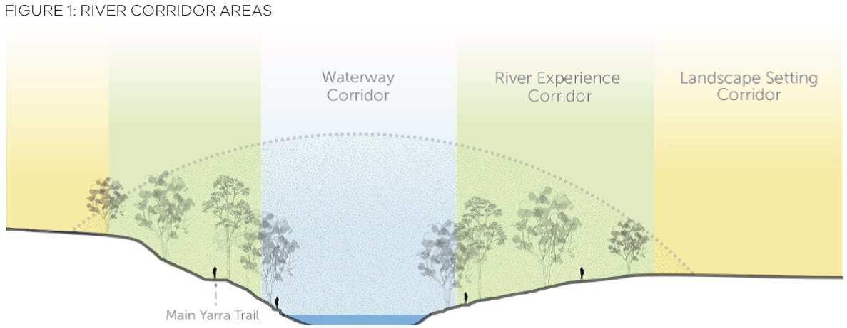

Stronger Planning Controls for the Yarra River

State Planning Policy Framework
On 21 December 2015, VC121 amended Clause 12 ‘Environment and Landscape Values’ of the State Planning Policy Framework giving effect to a reformed ‘Yarra River Protection’ policy. The policy provides a strengthened basis for the protection of the whole of the Yarra River corridor.
This policy established a clear objective to:
Maintain and enhance the natural landscape character of the Yarra River corridor in which the topography, waterway, banks and tree canopy are dominant features providing a highly valued, secluded, natural environment for the enjoyment of the public.
The policy also outlines key strategic objectives focused around the following four key principles:
- strengthening the river’s natural environment, heritage and overall health;
- maintaining a sense of place and landscape identity;
- retaining and enhancing people’s enjoyment of the river and its environment; and
- ensuring that development is designed and sited to maintain and enhance the river’s secluded and natural environment.

Managing built form
A new Design and Development Overlay (DDO) schedule titled ‘Yarra River (Birrarung) Protection’ has been applied to specific areas of private land immediately adjacent to, or within close proximity of, the Yarra River.
The extent of the DDO was determined through a local level assessment of the landscape and environmental characteristics which best reflect the area between the ‘Waterway Corridor’ and the ‘River Experience Corridor’ of the Yarra River. This area is highly visible from the water, public land, trails and key viewing locations within the Yarra River corridor and is where development is likely to have the greatest impact.
Each DDO schedule is constructed around the following key design objectives:
- Landscape protection - focus on ensuring development responds first and foremost to the protection of the landscape setting that it is located within.
- Siting and design - encourage buildings to be of appropriate scale, height, setback and avoiding contrasting with or dominating its local landscape environment.
- Site coverage and permeability - encourages development to be scaled appropriate to its location and landscape character.
A permit is required for all buildings including a fence (within the prescribed setback), subdivision and other works such as the construction of a swimming pool or tennis court associated with a dwelling.
Each DDO schedule has been tailored to meet local landscape requirements to ensure future development does not encroach on the landscape and environmental values of the Yarra River. A mix of mandatory and discretionary requirements are contained within each overlay. These include:
- fencing within prescribed setbacks should be low in scale, of timber post and rail or timber post and wire construction to ensure fencing does not dominate public views within the Yarra River corridor
- a prohibition on additional overshadowing of the banks and waters of the Yarra River, measured on 22 June between 11am and 2pm
- avoidance of additional overshadowing of public open space measured on 22 September between 11am and 2pm
- mandatory building height and setbacks (from the Yarra River) which responds to the local land use, built form character of an area and its relationship with the local natural landscape character
- allowance for replacement of existing buildings within prescribed setbacks, provided overall height is limited as prescribed in each schedule
- limitations on site coverage by built form which includes swimming pools and tennis courts to ensure that development remains subordinate to the natural landscape character of an area
- avoidance of the use of reflective colours and finishes in building materials to ensure development blends with the existing natural landscape.
All applications within 100 metres of the banks of the Yarra River must be referred to Melbourne Water as the Recommending Referral Authority to ensure that any potential impact that a development may have on the environmental and waterway values of the Yarra River is avoided. This could include assessment of the removal of riparian, or other vegetation, impacts on bank stability or erosion, impacts of direct or indirect run off on the riverine environment and impacts of excavation or other earthworks. This is in addition to the requirements for referral contained within a corresponding flood control that may exist on an allotment.

Managing vegetation and landscape
A revised or new Significant Landscape Overlay (SLO) schedule has been applied to all land irrespective of tenure from the Yarra River to an area identified within the “Landscape Setting Corridor”. This SLO replaces the previous eight planning controls which varied from municipality to municipality.
The area within the SLO represents the extent of the broader ‘Landscape Setting Corridor’ noted earlier which is generally defined by topographic features such as ridge or crest lines, the boundary between the urban environment and the natural environment of the corridor, the extent and dominance of corridor vegetation and canopy trees, which form a dominant feature of views of the corridor to and from public open space and the Yarra River itself.
The SLO manages the siting and design of buildings, removal of vegetation and earthworks within the broader Yarra River corridor setting. Each SLO schedule is built around the following key landscape character objectives:
- Landscape, environmental and cultural values – focus on ensuring the natural landscape character and vegetated quality are protected and retained.
- Protection of waterway and the riparian zone – focus is to ensure development does not interfere with or impede the waterway characteristics of the Yarra River.
- Public open space and access – ensures development on public land close to the Yarra River provides appropriate access and minimises built form impacts.
- Siting and design of built form – for all areas (beyond DDO application) seeks to ensure development is low scale and does not become visible within the overall corridor.
The SLO requires a permit for all buildings and works, to remove, destroy or lop vegetation above a prescribed size, and to construct a fence within 30 metres of the banks of the Yarra River or where it abuts public land. Permit exemptions have been provided for:
- construction of a building less than 6 metres in height;
- the undertaking of waterway maintenance works by, or on behalf of, a public land manager, municipality or public authority;
- removal of any non-native vegetation which does not contribute to the canopy environment of the Yarra River corridor or where there is a need to manage vegetation for health, appearance or for safety reasons.
The SLO must be read in conjunction with any DDO requirements affecting a particular allotment to ensure a holistic approach is taken.

Frequently Answered Questions

Why apply mandatory height and setback requirements?
Managing the location and overall height of buildings close to the Yarra River is important to avoid encroachment of built form on the natural landscape and environmental values of the Yarra River. Each mandatory control has been determined at a local level to ensure that the requirements are fit for purpose for a given location.

How are the banks and waterway of the Yarra River defined within the planning controls?
The ‘banks and waters’ of the Yarra river are defined by a Setback Reference Line (SRL) which is outlined on specified maps contained within each DDO schedule. The SRL is the closest parallel property boundary to the Yarra River and must be used to measure any required horizontal setbacks and overshadowing impacts (see Figure 2). You should consult your local council if you are unsure where the SRL is.

Why prohibit overshadowing of the banks and waterway of the Yarra River?
The Yarra River is a state significant natural asset and is enjoyed by all Melbournians. Overshadowing by buildings of its banks and waters may have a negative impact on vegetation growing along its banks, impact terrestrial and aquatic habitat and affect people’s enjoyment of its waters or public land surrounds.

How is overshadowing of public open space managed?
Overshadowing of public open space is a discretionary requirement measured on 22 September between 11am and 2pm in all controls. Ideally, no overshadowing of public open space should occur as this can have a negative effect on the environmental characteristics and enjoyment of public open space. The following issues (but not limited to) should be considered:
- The duration of the proposed overshadowing.
- The impact on existing or future growth of vegetation.
- Will shadow impact a recreational area, such as a playground, walking or cycling trail?
- Does the site being overshadowed have environmental or cultural values where solar access is critical to maintaining those values?
- Can a building be redesigned to rearrange its height and bulk to avoid overshadowing?

Can a requirement be varied with a permit?
All mandatory requirements listed in each schedule must be met and cannot be varied under any circumstance.
Only a discretionary requirement can be varied with a permit, these are listed within each planning control. An application to vary a discretionary requirement must demonstrate how the proposal will achieve the design objectives of the schedule to the satisfaction of the responsible authority.

What is natural ground level and how do I measure building height?
Both the Victoria Planning Provisions and the Building Code of Australia use ‘natural ground level’ as a standard approach to measuring the proposed height of all built form.
Building height is the vertical distance from natural ground level to the roof or parapet at any point. The measurement of height in all circumstances is from natural ground level which is determined by the natural level on a site at any point.
This can be determined through a site survey or, where this is difficult to determine because of disturbance, through use of detailed contour information current at the time of introduction of these controls or as considered appropriate by the responsible authority.
This information should be prepared by a suitably qualified surveyor and form part of any site and/or architectural drawings presented as part of an application.
This is an important principle for ensuring overall building height remains within mandatory limits set by relevant planning controls. Using different measures will lead to development being much taller than the controls allow and inappropriately impact the Yarra River corridor.

How are steeply sloping sites managed?
All controls contain a sloping site allowance for building height up to 9 metres. This allowance provides an additional 1 metre in height where the slope of the natural ground level measured at any cross section wider than 8 metres of the site of the building is 2.5 degrees or more.
It should be noted that a sloping site allowance has not been provided for heights above 9m as the additional height will impact on greater visibility of built form when viewed from public areas within the Yarr River corridor.

What are building setbacks and how are they measured?
A mandatory minimum setback line has been applied to all private land with direct access to the Yarra River or within close proximity. The minimum mandatory building setback line is defined in all controls as:
- a consistent ‘parallel distance’ measured horizontally from the Setback Reference Line (SRL); and/or
- a specific ‘contour level’ measured to Australian Height Datum standards.
A SRL has been identified for all areas where a building setback line is required. The SRL relates to the closest cadastral/property boundary running parallel to the river’s edge from which the setback line must be measured. Maps contained within each DDO identify the precie location of each SRL to be used.
In some circumstances the use of both a parallel distance and a contour level are used. In these instances the application of a ‘whichever is greater’ test will apply.
All setback lines should be identified and prepared by a suitably qualified surveyor issuing certified survey plans.
It is important that a suitably qualified surveyor issuing certified survey plans be used to determine accurately the topographic layout of the land to locate the minimum setback line.

Can greater setbacks be applied?
It is important to note that all mandatory setbacks are a minimum, behind which all new buildings must be sited. There may be other site specific factors which may require a greater setback to be achieved as determined by the responsible authority. This may include, but is not limited to:
- a site’s exposure to flood, bushfire, landslip and other risk factors
- additional street and/or side boundary setbacks required by other parts of the planning scheme (such as amenity or neighbourhood character provisions)
- the need to locate a building behind a more defined vegetation line or the need to protect existing vegetation
- other site specific issues such as the topographic nature of the site or the ability to dispose of waste water.
It is important that a suitably qualified surveyor issuing certified survey plans be used to determine accurately the topographic layout of the land to locate the minimum setback line.

Existing development within a mandatory setback
There are limited circumstances where new buildings would be acceptable within a minimum mandatory setback area. Where existing buildings are either partially or wholly located within a mandatory minimum setback area the following mandatory requirements have been established for applications to (partially or completely) replace an existing building. The replacement must not:
- exceed the maximum building height specified in the schedule from natural ground level;
- reduce the existing setback of the building from the Yarra River and public open space; and
- increase the existing gross floor area of the building.
The DDO provides discretion to the responsible authority to consider:
- opportunities for re-orientation of a building within the existing gross floor area where an increased setback can be achieved; and
- applications to construct a swimming pool, tennis court, and other ‘works’ such as landscaping or earthworks.
Within the above context, an applicant will be required to justify why any proposed buildings and works cannot be located behind the mandatory minimum setback line.

Why is a permit required for a fence?
A permit is required to construct a fence, within an identified setback area. An exemption is provided for simple rural post and wire and timber rail type fencing below 1.4 metres.
Where a permit is required, key considerations include the overall height of the fence, its visual permeability, and the level of contrast it may create within its local landscape environment. These requirements aim to ensure any proposed fencing does not have a negative visual impact on the Yarra River.

How is cut and fill considered?
Earthworks on an allotment to accommodate development will vary depending on its size, scale and location. Proposed earthworks should:
- avoid impacting the sensitive riparian environment of the banks of the Yarra River
- not significantly alter the landscape so as to change its natural appearance
- not be used to elevate buildings.
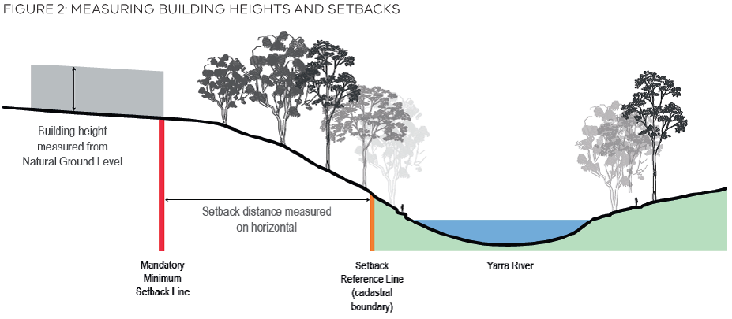

What type of information do I need if I apply for a permit?
Both the DDO and the SLO contain requirements for permit applications to be accompanied by appropriate information. The type of information needed will vary depending on the type of buildings and/or works proposed. The responsible authority will determine the information it requires to make a thorough assessment.
This may include, but is not limited to:
- a written assessment demonstrating how the proposal meets the objectives and requirements of the controls
- a survey plan, prepared and certified by a suitably qualified surveyor accurately showing proposed buildings and works against proposed mandatory height and setbacks measured to Australian Height Datum measured from natural ground level
- a visual impact assessment which may comprise of cross-sectional diagrams, photo montages or a viewshed analysis from agreed publicly accessible viewing points
- shadow diagrams for impact on public land, and impact on the banks and waterway of the Yarra River
- other design details such as a schedule of materials and finishes to ensure consideration of a building’s contrast with its environment is considered
- details relating to landscaping, earthworks (cut and fill) which may be required as part of the construction of a building or as part of the landscape design
- a written explanation justifying the removal of vegetation supported by a suitably qualified arborist assessing the proposed vegetation removal
- a description and accurate site plan denoting the position, height, number, trunk circumference, branch spread, and species of any vegetation to be removed and plan details of the location of proposed replanting.

Further information and useful links
More information about the Victoria’s planning systems is available online at: planning.vic.gov.au
To view Amendment GC48 and VC121, go to:
www.planning-schemes.delwp.vic.gov.au/updates-and-amendments
For more information about the Yarra River Planning controls and to access reports:
www.planning.vic.gov.au/yarra-river-controls

© The State of Victoria Department of Environment, Land, Water & Planning 2017
This work is licensed under a Creative Commons Attribution 4.0 International licence. You are free to re-use the work under that licence, on the condition that you credit the State of Victoria as author. The licence does not apply to any images, photographs or branding, including the Victorian Coat of Arms, the Victorian Government logo and the Department of Environment, Land, Water and Planning (DELWP) logo. To view a copy of this licence, visit http://creativecommons.org/licenses/by/4.0/
Disclaimer
This publication may be of assistance to you but the State of Victoria and its employees do not guarantee that the publication is without flaw of any kind or is wholly appropriate for your particular purposes and therefore disclaims all liability for any error, loss or other consequence which may arise from you relying on any information in this publication.
Accessibility
If you would like to receive this publication in an alternative format, please telephone the DELWP Customer Service Centre on 136186, email customer.service@delwp.vic.gov.au (or relevant address), or via the National Relay Service on 133 677 www.relayservice.com.au This document is also available on the internet at www.planning.vic.gov.au

DOCUMENT ENDS

