PUBLIC COMMENT INVITED
AGL Wholesale Gas Limited (AGL) (ABN 26 072 948 504) and APA Transmission Pty Ltd (APA) (ABN 84 603 054 404) have prepared an Environment Effects Statement (EES) for the Gas Import Jetty and Pipeline Project (the Project).
The EES, together with the draft Mornington Peninsula Planning Scheme amendment (PSA) C272, the EPA works approval application and the pipeline licence application are now available for public comment.
This notice is provided pursuant to the Environment Effects Act 1978 (Vic) (EE Act), the Environment Protection and Biodiversity Conservation Act 1999 (Cth) (EPBC Act), the Pipelines Act 2005 (Vic) and the Environment Protection Act 1970 (Vic).
Written submissions can be made starting Thursday 2 July 2020 and closing 11:59pm on Wednesday
26 August 2020.
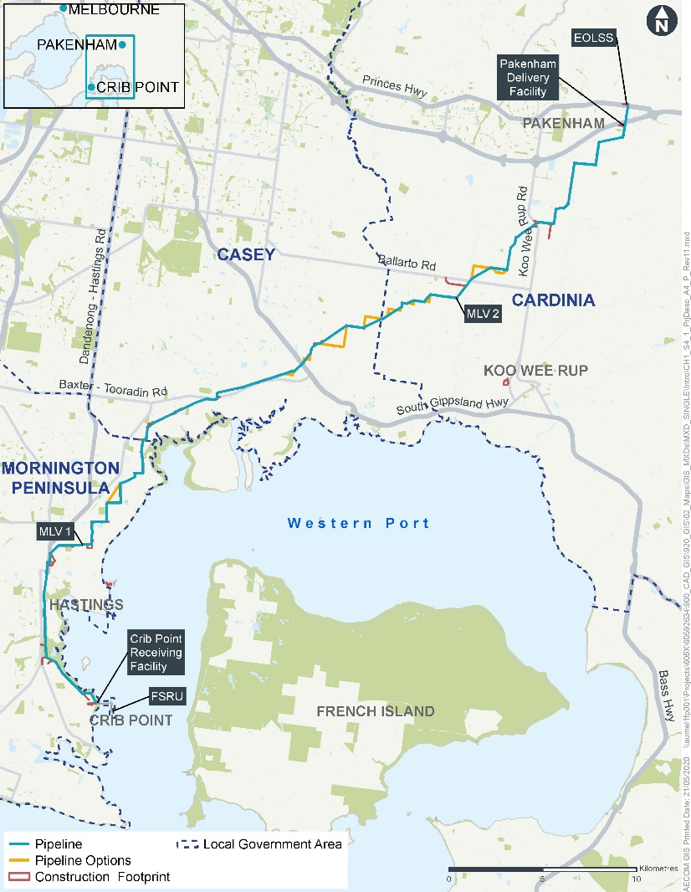
Project Description
The proposal for the Project includes two components:
- Gas Import Jetty Works comprising a floating storage and regasification unit (FSRU) at Crib Point Jetty, jetty infrastructure including marine loading arms and gas piping on the jetty, and the Crib Point Receiving Facility on land adjacent to the jetty.
- Pipeline Works consisting of an underground gas transmission pipeline approximately 57 kilometres long to transport gas from the Crib Point Receiving Facility to the Victorian Transmission System east of Pakenham, and associated infrastructure such as the Pakenham Delivery Facility to monitor and regulate the gas, two above-ground mainline valves to enable isolation of the pipeline in an emergency and a facility to enable in-line inspections of the pipeline.
A map of the pipeline corridor appears to the right.
If the Project gains all required approvals, construction is anticipated to begin early 2021 and finish in late 2022.
EES Process
On 8 October 2018, the Victorian Minister for Planning determined that an EES is required for the Project under the EE Act.
Read more about the EES process for the project at the Victorian Department of Environment, Land, Water and Planning (DELWP) website at
planning.vic.gov.au/environment-assessment/browse-projects/projects/crib-point
EPBC Act Process
On 28 November 2018, the Commonwealth Minister for the Environment and Energy determined that each component of the Project (the Gas Import Jetty Works and the Pipeline Works) are ‘controlled actions’ as they are likely to have a significant impact on Matters of National Environmental Significance (MNES), which are protected under the EPBC Act.
The Gas Import facility, Crib Point, Victoria (EPBC 2018/8298) controlled action is intended to be taken by AGL. The relevant provisions for this controlled action are wetlands of international importance (section 16 & section 17B), listed threatened species & communities (section 18 & section 18A), and listed migratory species (section 20 & section 20A).
The Crib Point to Pakenham Pipeline, Victoria (EPBC 2018/8297) controlled action is intended to be taken by APA. The relevant provisions for this controlled action are wetlands of international importance (section 16 & section 17B) and listed threatened species & communities (section 18 & section 18A).
The EES process is an accredited assessment process under the EPBC Act through a Bilateral Assessment Agreement that exists between the Commonwealth and State of Victoria. Therefore, this EES also considers MNES for the purposes of assessment of the controlled actions under the EPBC Act. You can make a submission on the matters assessed for the purposes of the relevant provisions under the EPBC Act, by making a submission on the EES.
After considering the Victorian Minister for Planning’s assessment under the EE Act, the Commonwealth Minister for the Environment will then make separate decisions as to whether to approve the controlled action applications for the proposed Gas Import Jetty Works and the Pipeline Works, respectively, under the EPBC Act.
Planning Scheme Amendment
The draft PSA including an explanatory report and supporting documents has been prepared. The draft PSA is included as Attachment VI to the EES. The draft PSA seeks to apply the Specific Controls Overlay and an Incorporated Document to facilitate the use and development of land for the Gas Import Jetty Works. It also seeks to rezone a portion of Crown Allotment (CA) 2040 from the Public Conservation and Resource Zone (PCRZ) to the Port Zone (PZ), and to extend the PZ to apply to all of CA 2085.

EPA Works Approval
The EPA has received an application for a works approval for the FSRU component of the Gas Import Jetty Works under the Victorian Environment Protection Act. The works approval application is included as Attachment VIII to the EES.
A copy of the works approval application and accompanying plans, specifications and other information can be inspected online at www.gasimportprojectvictoria.com.au
You may make a submission or provide comments about the works approval application by making a submission on the EES.
Pipeline Licence Application
A pipeline licence is required under the Pipelines Act 2005 (Vic) for the construction and operation of the pipeline included in the project. An application was made to the Minister for Energy, Environment and Climate Change in September 2018. The application was amended in June 2020.
The application, as amended, is included in the exhibited documents at Attachment IX to the EES.
Any person who may be affected by the grant of the pipeline licence may make a written submission to the Minister for Energy, Environment and Climate Change about the application for the licence by following the EES submission process.
All such submissions will also be treated as submissions on the EES.
How to Access the EES and Exhibited Documents
The EES, draft PSA, EPA works approval application and the pipeline licence application are now available to read and download at https://www.gasimportprojectvictoria.com.au/
You can request an EES information pack, free of charge. The pack contains:
- USB loaded with the complete EES, draft PSA, EPA works approval application and pipeline licence application
- Printed EES Summary Document
- Printed EES Map Book
- Printed information sheet on ‘How to Navigate the EES’.
For those who may have accessibility issues, or where electronic options are impractical, hard copies may be requested, free of charge.
Request an EES information pack or hard copy documents by phoning 1800 039 600 or emailing AGLcommunity@agl.com.au
Please note the EES is a long document and we encourage the use of electronic versions.

How to Make a Submission
Submissions on the EES, draft Planning Scheme amendment, works approval application and the pipeline licence application must be made in writing and received by 11:59pm on Wednesday 26 August 2020.
Each submission is a public document and will be treated as a submission on the EES and as relevant on the other exhibited documents.
Online submissions are preferred and can be lodged via the Victorian Government’s engagement website www.engage.vic.gov.au/crib-point-IAC
Hard copy submissions must be accompanied by a coversheet, available by calling the DELWP Customer Service Centre on 136 186. Each written submission must have its own coversheet and they cannot be copied.
All submissions must state the name and address of the person making the submission. Submissions will be treated as public documents and will be published on the Victorian Government’s engagement website. Therefore, your submission and your name will be made public.
The submission process is independently managed by Planning Panels Victoria.
Inquiry and Advisory Committee Process
The Minister for Planning will appoint a joint Inquiry and Advisory Committee (IAC) under the EE Act and the Planning and Environment Act 1987. The IAC will also be appointed as a panel under other applicable legislation. It will review the public submissions, the EES, the draft PSA, the EPA works approval application and the pipeline licence application. It will review and consider the environmental effects of the Project in accordance with Terms of Reference issued by the Minister for Planning.
After the exhibition period, the IAC will hold a Directions Hearing on Thursday 17 September 2020, where the necessary arrangements and timetable for the public hearing will be established.
The Public Hearing will commence on Monday 12 October 2020 and run for six to eight weeks (if required).
Information on the hearing process and timetable will be published as it becomes available at www.engage.vic.gov.au/crib-point-IAC
Members of the public and any other parties seeking to be heard at the public hearing are required to submit a written submission and indicate that they would like to be heard at the hearing.

Questions
Gas Import Jetty Works
Queries should be directed to AGL Wholesale Gas Limited
Senior Manager - Land and Approvals, AGL
Address: Locked Bag 14120 MCMC, Melbourne, VIC 8001
Phone: 1800 039 600
Email: AGLcommunity@agl.com.au
Pipeline Works
Queries should be directed to APA Transmission Limited
Licencing and Approvals Lead, APA Group
Address: Level 25, 580 George Street, Sydney, NSW 2000
Phone: 1800 531 811
Fax: 03 9797 5295
Email: cribpointpakenham@apa.com.au
EES Process
Impact Assessment Unit, DELWP
Phone: (03) 8392 5503 or 8392 5570
Email: environment.assessment@delwp.vic.gov.au
EPA Works Approval
Development Assessment Unit, EPA Victoria
Phone: 1300 372 842
Email: works.approvals@epa.vic.gov.au
Pipeline Licence Application
Pipelines Regulation, DELWP
Phone: 136 186
Email: pipeline.regulation@delwp.vic.gov.au
Inquiry and Advisory Committee Process
Planning Panels Victoria
Phone: 136 186

