# Outcome 3

# MELBOURNE HAS AN INTEGRATED TRANSPORT SYSTEM THAT CONNECTS PEOPLE TO JOBS AND SERVICES AND GOODS TO MARKET

Melbourne’s transport system needs the capacity to cope with an additional 10.4 million trips[1] a day by 2050—up from the current figure of 12.5 million trips a day.

To achieve that, Melbourne needs a huge, well planned investment that enables the city to grow whilst meeting the transport challenges.

Through the review of Infrastructure Victoria’s 30‑year strategy, plans for development of the transport network are being assessed and prioritised to overcome historic backlogs and provide for future needs as land use changes.

For Melbourne to continue to be a globally connected and competitive city with strong and healthy communities and higher social and economic participation, the share of trips by public transport, as well as active transport modes such as walking and cycling, must increase.

Melbourne needs one reliable, connected transport network where services are regular and easy to use, timetables are integrated, and major interchanges work better.

That means land use and transport needs to support and encourage convenient trip options so that more people can meet most of their needs locally and be less reliant on private vehicles.

Map 16 Existing rail and road transport infrastructure

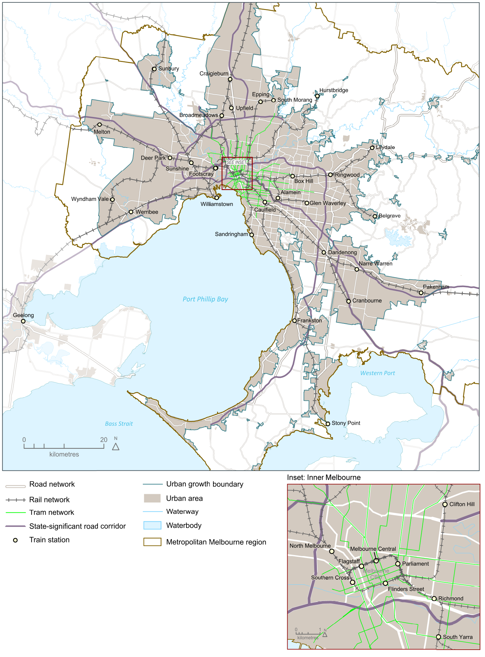

Source: Department of Environment, Land, Water and Planning

## Melbourne’s plan

## Direction 3.1 Transform Melbourne’s transport system to support a productive city

Melbourne’s transport networks link people to jobs and businesses to markets—making the city productive and liveable.

Major transport projects, or city-shaping projects, significantly influence the way in which the city develops.

The transport network will continue to be managed and developed in ways that balance access (including movements through and between places) with the creation of liveable communities. In doing so, improved road networks and effective public transport connections are needed to support growth in capacity.

### Policy 3.1.1 Create a metro-style rail system with ‘turn up and go’ frequency and reliability

Melbourne’s rail network must grow so it can continue to support the productivity of Melbourne and service the needs of a growing population. The Metro Tunnel, to be completed by 2026, is a critical step towards evolving the train network into a metro-style system.

A metro-style rail system will have a strong focus on passengers, delivering:

* simpler timetables with a ‘turn up and go’ frequency and consistent stopping patterns
* frequent services that facilitate easy interchange with other train lines as well as trams and buses
* separate train fleets, maintenance and stabling facilities for each line
* stand-alone, end-to-end lines that prevent service disruptions on one line from affecting other lines
* modern signalling technology to maximise the number of trains that can operate on each line
* high-capacity metro trains designed to minimise boarding and alighting times
* separated road and rail crossings.

Figure 9 Metro Tunnel wider benefits—capacity benefits over two-hour peak period

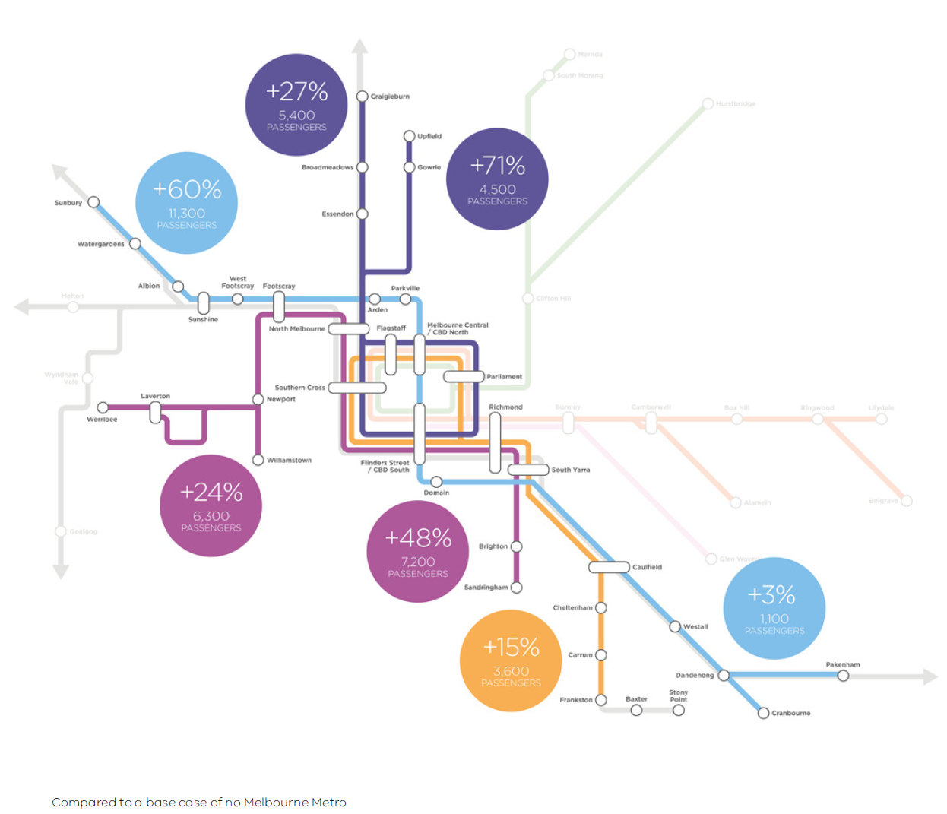

Source: Melbourne Metro business case

Map 17 Improvements to transport infrastructure – committed and potential

Improvements to transport infrastructure – committed and potential
Transport project — committed
• Metro Tunnel (rail)
• Mernda rail extension 
• Heidelberg-Rosanna rail duplication 
• Caulfield to Dandenong Level Crossing Removal and Line Upgrade 
• Ballarat rail upgrade project 
• CityLink-Tullamarine widening 
• M80 upgrade 
• Monash Freeway upgrade 
• Western Distributor
 Transport project — potential future
• Outer Metropolitan Ring / E6 reservation
• Beveridge Interstate Freight Terminal
• Western Interstate Freight Terminal


Source: Department of Environment, Land, Water and Planning

### Policy 3.1.2 Provide high-quality public transport access to job-rich areas

The efficiency and simplicity of the network, and the quality of connections between public transport modes can make a major difference to people’s willingness to use public transport and expand the range of jobs and services they access.

In many parts of the city, buses provide a high-quality transport service and are likely to play a greater role in the future. The best performing services are typically those where buses connect as part of an integrated public transport network. Where improvements to bus networks have already been delivered, there have been substantial increases in patronage. This approach will continue as the city develops and demand grows.

Priorities to improve the public transport system include modernising and strengthening the tram and bus network by:

* improving connections to the national employment and innovation clusters and urban renewal precincts—particularly those in the expanded central city and other job-rich areas—will increase business and employee work-choice location and improve business-to-business and business-to-consumer transactions
* extending tram lines, improving tram travel times, reliability and capacity to support major movements of people by gradually transforming to a light-rail system with increased right-of-way, more accessible, low-floor, high-capacity vehicles, and level-access stops
* progressively upgrading the bus network, with a focus on increased frequency, increased priority and right-of-ways and reliability, and improved travel times and connectivity
* providing more real-time information for users to enable better trip planning and improve user confidence, choice and satisfaction with the service.

### Policy 3.1.3 Improve arterial road connections across Melbourne for all road users

The arterial road network is the foundation of transport across our suburbs, supporting the movement of private vehicles, public transport, cycling, walking and freight.

The ongoing development and maintenance of the network will support national employment and innovation clusters, metropolitan activity centres, major activity centres and other areas with high or growing job densities.

The existing road network creates a number of challenges and constraints. Trade-offs between different road users are often required. For example, on arterial roads the primary focus will be supporting reliable and efficient movement and mitigating amenity impacts on nearby communities. However, roads that service more intense land use will prioritise walking, cycling and public transport. Figure 10 shows the concept of improved road use.

The removal of level crossings improves the efficiency and safety on the arterial road network. They can also create opportunities for urban renewal and development.

Figure 10 Improved road use

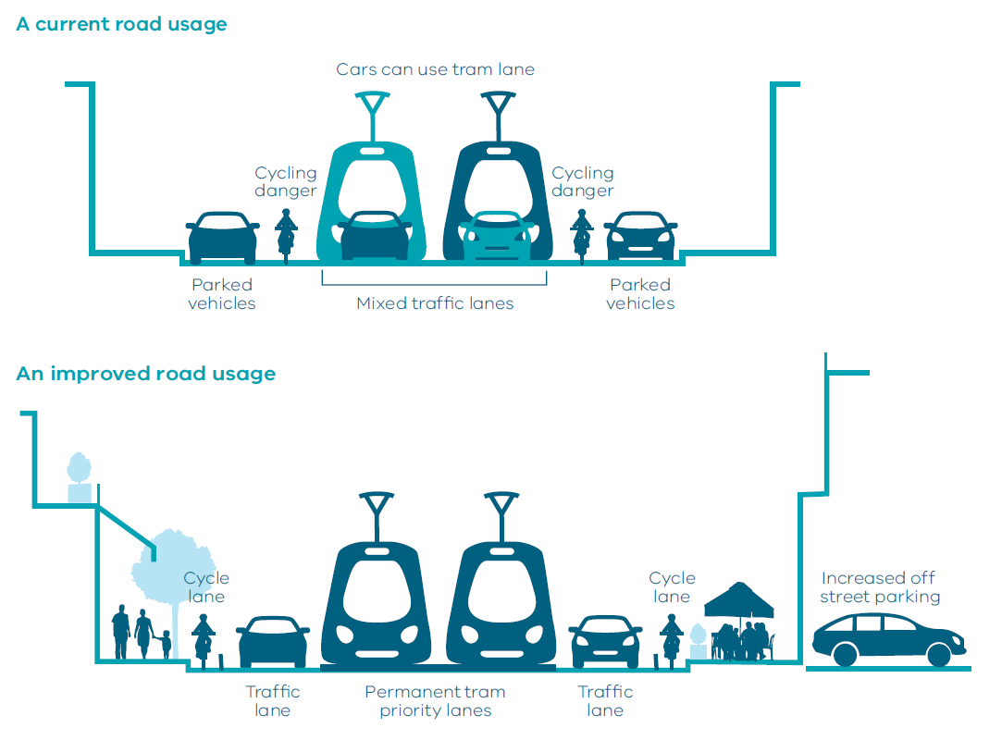

Map 18 Level crossing removals

Level crossing removal sites
• Aviation Road, Laverton 
• Buckley Street, Essendon 
• Cherry Street, Werribee 
• Ferguson Street, Williamstown 
• Furlong Road, St Albans 
• Kororoit Creek Road, Williamstown North 
• Main Road, St Albans 
• Melton Highway, Sydenham 
• Werribee Street, Werribee
• Bell Street, Coburg 
• Bell Street, Preston 
• Camp Road, Campbellfield 
• Glenroy Road, Glenroy 
• Grange Road, Alphington 
• High Street, Reservoir 
• Lower Plenty Road, Rosanna 
• Moreland Road, Brunswick
• Blackburn Road, Blackburn 
• Clayton Road, Clayton 
• Centre Road, Clayton 
• Heatherdale Road, Ringwood 
• Manchester Road, Mooroolbark 
• Maroondah Highway, Lilydale 
• Mountain Highway, Bayswater
• Scoresby Road, Bayswater
• Burke Road, Glen Iris 
• Centre Road, Bentleigh 
• Grange Road, Carnegie 
• Koornang Road, Carnegie 
• Murrumbeena Road, Murrumbeena 
• North Road, Ormond 
• McKinnon Road, McKinnon 
• Poath Road, Hughesdale 
• Toorak Road, Kooyong
• Abbotts Road, Dandenong South 
• Balcombe Road, Mentone 
• Chandler Road, Noble Park 
• Charman Road, Cheltenham 
• Clyde Road, Berwick 
• Corrigan Road, Noble Park 
• Edithvale Road, Edithvale 
• Eel Race Road, Carrum 
• Hallam Road, Hallam 
• Heatherton Road, Noble Park 
• Seaford Station Street/ Bondi Road, Bonbeach 
• Skye/Overton Road, Frankston 
• South Gippsland Highway, Dandenong 
• Station Street, Carrum 
• Seaford Road, Seaford 
• Thompsons Road, Lyndhurst

Source: Department of Environment, Land, Water and Planning

### Policy 3.1.4 Provide guidance and certainty for land-use and transport development through the Principal Public Transport Network and the Principal Freight Network

Principal transport networks, such as the Principal Public Transport Network (PPTN) and the Principal Freight Network (PFN), provide clarity for state and local governments and communities in land-use planning and decision-making.

The PPTN outlines the routes where high-quality public transport services are or will be provided. Increased diversity and density of developments is encouraged on the PPTN, particularly at interchanges, activity centres and where principal public transport routes intersect. This may also include maximising government land assets around transport nodes and on the PPTN.

The existing PPTN will be incorporated into planning schemes. There will be an ongoing consultation process with local government and other stakeholders to confirm future candidate routes.

The PFN will help direct land-use decisions to minimise uses that might conflict with areas expected to have intense freight activity, helping improve freight efficiency and minimise amenity impacts. The PFN will be updated, following a consultation and engagement process, and, subsequently, will be incorporated into planning schemes.

### Policy 3.1.5 Improve the efficiency of the motorway network

Motorways (including both freeways and toll roads) and heavy rail contribute to productivity and liveability by efficiently moving high volumes of people and goods over longer distances.

The motorway network supports productivity by:

* connecting and providing access to major seaports, airports, freight transport gateways, and other freight-generating areas
* providing state-significant links that connect and serve dispersed major suburban residential areas with key destinations and providing access to lower-density employment areas in Melbourne
* linking Melbourne with major regional cities, major interstate locations and other key locations that are important to the economy along major national and state corridors.

The motorway network supports liveability by providing strategic bypasses that minimise freight- and car-based traffic across Melbourne.

Optimisation of the existing motorway network will be achieved through the use of technology and new and upgraded connections, including consideration of how to fill the missing North East Link on the Metropolitan Ring Road.

### Policy 3.1.6 Support cycling for commuting

Cycling is a growing means of transportation around inner Melbourne. Journeys to work by bicycle almost doubled between 2001 and 2011[2]. This compares to an increase in journeys to work of 25 per cent[3] across all modes. It should be noted that the increase in bicycle commuting started from a small base.

Strategic cycling corridors have been identified and are progressively being developed as the key, direct cycling links across metropolitan Melbourne.

## Direction 3.2 Improve transport in Melbourne’s outer suburbs

The provision of transport services and infrastructure—such as arterial roads must—keep up with population growth in outer Melbourne. It is critical that land uses and transport are integrated to support each other. Increasing density of development, particularly around transport nodes, creates the critical mass essential to make a range of services viable.

### Policy 3.2.1 Improve roads in growth areas and outer suburbs

There will be ongoing development and maintenance of the arterial road network to support improved travel times, safety and reliability for people living in growth areas and outer suburbs, and businesses located in these areas. A focus will be ensuring access to the places where people work as well as services such as education, health care, shopping and recreation. There is a particular need for priority bus services that link destinations via the growth area road network.

The development of the arterial road network in growth areas and outer suburbs will ensure access for businesses to nearby national employment and innovation clusters, metropolitan activity centres, major activity centres and other areas with high or growing job densities.

### Policy 3.2.2 Improve outer-suburban public transport

Many outer suburbs need to be better served by public transport.

The sequencing of development in Melbourne's growth areas will be improved along with increasing the diversity and density of development along the PPTN and near stations. This helps enable the timely delivery of services.

The consultation program to update the PPTN will have a particular focus on Melbourne’s outer- suburban growth areas so that land use and development integrates with high-quality public transport. The government will plan and deliver high-quality public transport in line with the rate of development in outer areas.

## Direction 3.3 Improve local travel options to support 20-minute neighbourhoods

Local travel is different to journey-to-work travel. It relates to service, recreational and social activities—such as sport and shopping—as well as personal business and education. It occurs throughout the day, rather than just at peak times. It is important to ensure all residents, regardless of age and ability, can access the local services they need in their community.

Neighbourhood design and the development of destinations influence local travel, dictating how much people walk and cycle. Short neighbourhood daily trips enable people to have choices other than the private car.

### Policy 3.3.1 Create pedestrian-friendly neighbourhoods

Research shows that people walk more when they have access to pedestrian routes and connections that are safe, direct and pleasant to use. Improving the pedestrian environment in existing areas can be achieved by creating quality pedestrian links and short cuts. There is also a correlation between increased walking and increased public transport patronage.

High-quality pedestrian infrastructure like footpaths and crossings are also important to ensure communities, businesses and services are accessible to people with mobility limitations and to parents with prams.

Priority should be given to pedestrian movements in neighbourhoods. Continuous, high-quality walking routes need to be developed and streets need safe, pleasant and attractive walking routes. This approach will be particularly important in neighbourhood centres, but the needs of pedestrians should be a priority in all urban environments.

### Policy 3.3.2 Create a network of cycling links for local trips

The growth of cycling in suburban Melbourne is being encouraged and facilitated.

Cycling should be a more attractive option for short trips. Local infrastructure, such as cycle routes and bike parking, can support cycling in local streets, neighbourhoods and to public transport, as well as catering for longer-distance commuter and recreation trips.

Creating safer, bicycle-friendly environments will encourage groups currently under-represented—including women, families and school-age children—to consider cycling.

### Policy 3.3.3 Improve local transport choices

Improving local transport choices will help people meet most of their everyday needs within their local neighbourhoods. In the process, this policy helps create more inclusive communities. Initiatives include supporting safe, more innovative, flexible and demand-responsive forms of transport, particularly in locations with specific social needs or which are not connected by traditional bus services.

### Policy 3.3.4 Locate schools and other regional facilities near existing public transport and provide safe walking and cycling routes and drop-off zones

Decisions about the location of regional infrastructure, including schools, health and justice services, need to take into account how people access those facilities.

Site selection should align with the existing public transport network to ensure that wherever possible its use is maximised and local communities are connected to their nearest regional community infrastructure. The full cost of providing access to the site should be considered as part of the development of business cases.

This ensures proper integration between land use and transport and considers the safety and health of the community, particularly of children, at the earliest stage of planning. Examples of this integration include provision of safe walking and cycling routes and drop-off zones.

The government has set an education target for the proportion of students doing physical activity for an hour a day, five times a week, to grow by 20 per cent.[4] Walking and cycling to and from school is an excellent opportunity to increase the number of students incorporating physical activity into their daily lives.

## Direction 3.4 Improve freight efficiency and increase capacity of gateways while protecting urban amenity

Melbourne has a range of competitive advantages in freight and logistics, including a strong supply of well-priced industrial land, efficient and well-located freight precincts with good transport links, an efficient capital city port with capacity to grow, and a curfew-free international airport.

The Port of Melbourne is critical to Melbourne’s leadership in freight and logistics. Enhancements that support the Port of Melbourne, such as the Western Distributor and the port-capacity project, will play a vital role in the Victorian economy and ensure Victoria remains Australia’s freight and logistics capital.

Air freight is playing an increasing role in facilitating Melbourne’s trade, particularly for high-value, time-sensitive commodities such as fresh produce bound for growing Asian markets.

Melbourne must protect its curfew-free airport and support its expansion, support Avalon serving Geelong and western Melbourne, plan for a possible future airport to serve the long-term needs of south-east Melbourne and Gippsland, and provide efficient access to each airport.

### Policy 3.4.1 Support sufficient gateway capacity with efficient landside access

Victoria must secure adequate interstate terminal capacity, both in regional areas and metropolitan Melbourne, beyond 2050.

Further consideration will take into account all relevant advice (including from Infrastructure Victoria) on:

* evaluating the most appropriate site for a second container port that will be developed at the right time, in line with demand
* working with private sector proponents to facilitate necessary approvals and put in place appropriate land use controls for a potential future airport to serve the needs of south-east Melbourne and Gippsland.

Modest investment in the current interstate rail terminals located at Dynon in West Melbourne will improve their efficiency and extend their capacity for some years. However, in the medium term it is proposed to relocate this function away from the port and inner-city area in order to improve operational efficiency.

The proposed Western Interstate Freight Terminal will significantly improve the capacity of interstate freight transport connecting to and from Melbourne. It will allow the eventual creation of an interstate rail bypass of central Melbourne to relieve road and rail congestion pressures on the inner parts of the transport network.

The proposed Beveridge Interstate Freight Terminal is a freight, logistics and related-industry gateway. The site represents an ideal location for the facility, based on its location alongside the Melbourne–Sydney–Brisbane rail line, Hume Freeway and proposed Outer Metropolitan Ring Road.

Continuous improvement of the freight network is critical to the maintenance of an efficient and effective network. Projects such as the completion of the Dingley Road corridor, supporting the growing industrial area of Dandenong South, and the national employment and innovation cluster are important ongoing improvements. Long-term future projects, such as North East Link and the Outer Metropolitan Ring Road, may form part of the expanse of the freight network.

Melbourne’s airports are vital to the vibrancy and growth of the city. In coming decades, Avalon Airport will increase its role as an international and domestic passenger and freight gateway serving Melbourne, Geelong and western Victoria.

### Policy 3.4.2 Increase the volume of freight carried on rail

Interstate terminals enable freight to be transferred easily from rail to road or road to rail, using the most efficient mode for different parts of the freight journey.

The government will continue to work with the private sector to encourage initiation of interstate system services, including confirmation of preferred terminal sites, rail network connections and access, an efficient and reliable port interface, and the provision of adequate land zoned to allow high-volume freight customers to locate adjacent to interstate terminals.

### Policy 3.4.3 Avoid negative impacts of freight movements on urban amenity

The government will continue to work with industry to identify and prioritise key routes for protection and investment on the Principal Freight Network.

A more consistent and informed approach to land-use planning in freight precincts and corridors—such as protecting buffer zones—is required to protect residents from unacceptable amenity impacts.

As well as upgrading roads, innovative tools such as managed motorways have been used very successfully in the M1 and M80 Ring Road upgrades. These have incorporated a number of active traffic management tools such as ramp metering, lane-use management, variable speed limits and traveller information.

1. Victorian Integrated Survey of Travel and Activity 2016 and Victoria in Future 2016 population projections
2. Victorian Integrated Survey of Travel and Activity 2012–13
3. Victorian Integrated Survey of Travel and Activity 2012–13
4. Education State Targets, Department of Education and Training 2015.