Welcome to Issue 76 of Research Matters, the Department of Environment, Land, Water & Planning’s quarterly planning research bulletin, featuring DELWP research and analysis, news about recently released data, and research from other sources. If you have any questions or comments, you can contact us at:
forwardpolicy.research@delwp.vic.gov.au

Contents
p. 1 In this issue …
p. 2 Victoria hosts Australia New Zealand Population Workshop 2016
p. 3 A tale of two (or three) cities - differences in property price change between Australian cities
p. 5 Some ‘energising’ Christmas reading
In this issue …
With Christmas approaching, it is only proper that we begin our first article with a ‘dad joke’ from our fun-loving demographers. They recently hosted the annual Australia and New Zealand Population Workshop which brought together demographers, researchers and academics to discuss all things demographic. Highlights from the workshop are provided in the first article.
Keeping the cross-jurisdictional perspective, the second article in this edition of Research Matters examines housing price patterns in Melbourne, Sydney and Brisbane. Importantly, the article highlights that many of the reported price trends we hear about are not based on data that are truly comparable.
As a final nod to the festive season, we bring you a selected set of holiday reading recommendations on energy efficiency in urban design and building.

Victoria hosts Australia New Zealand Population Workshop 2016

Q. What do demographers talk about when they get together?
A. Matters of life and death.
In November our demographic research team hosted the annual Australia New Zealand Population Workshop (ANZPW) at the Dialogue Conference Centre in Melbourne. ANZPW is the annual get-together for public sector demographers - a great opportunity for all our analysts, researchers and modellers to share stories and workshop methods with their peers. Participants came from state planning departments and treasuries, Statistics New Zealand, the Australian Bureau of Statistics, Commonwealth Grants Commission, Geoscience Australia and Commonwealth Treasury, plus a couple of special guest academics.
Key themes involved trends and trajectories for the usual demographic factors: births; deaths; migration; household formation; and, occupancy. Presentations and discussion focused on ways in which these factors could be encapsulated in elegant and informative models and how the results might be communicated to users.

Highlights included:
- Tom Mulholland and Anna Piscicelli from Western Australian Government speaking on two aspects of fertility modelling, including a "Decomposition of the number of babies born over time and space" (no TARDIS involved);
- Kim Dunstan from New Zealand on the difficulty of setting modelling assumptions at the peak of a migration cycle (numbers of permanent and long-term arrivals to NZ are currently about 20% above previous 30-year highs);
- Angelique Parr from NSW on the 'technical difficulties' caused for modellers by council amalgamations and changes to LGA boundaries;
- our own Fiona McKenzie on the results of a survey into migration pathways of professionals working in Bendigo;
- an outline of a new study into temporary popu-lations from Jonathan Corcoran and Elin Charles-Edwards from University of Queensland; and,
- Mitchell Valentine, also from our team, on ways to update our data presentations using Tableau.
The next big event on the demographic calendar is the biennial Australian Population Association Conference in Sydney starting 29 November. Our demographers will be presenting on Melbourne's apartment boom and the impact this has had on the preparation of small area population projections.

A tale of two (or three) cities - differences in property price change between Australian cities

Not a week goes by without some media coverage of the differences in property prices between Australian cities. These are usually expressed in terms of dollar differences between cities or the short-term move-ments in median prices. The weakness of some of these comparisons is that they do not take into account the change in the composition of sales over time - the sales in one period measure different sales to another period. If in one quarter the sales of relatively cheap properties dominate the market and in the subsequent quarter there are more sales of relatively expensive properties, it may appear that house prices have increased even though the values of the individual properties may not have changed.
An often overlooked source of information that provides a robust and meaningful measure of property price change is the Australian Bureau of
Statistic’s Residential Property Price Indexes: Eight Capital Cities (cat. no. 6416.0). This stratifies dwelling sales by dwelling type, long term median price and suburb to take into account any changes in sales over time¹.
Figure 1 shows this data for Melbourne. It shows three indexes: an index for established houses (i.e. sales of second hand detached houses rather than new houses); sales of attached dwellings (i.e. flats, apartments, townhouses; and total sales of dwellings.
It shows that prices for all the different types of dwellings rose at about the same pace until about 2013, with particularly rapid rises from 2008 to 2010 and a flattening out of price rises from 2010 to 2013. Since 2013 prices of established houses have risen much faster than attached dwellings.

Figure 1: Melbourne property price indexes, June 2006 – June 2016 (2011-12=100)
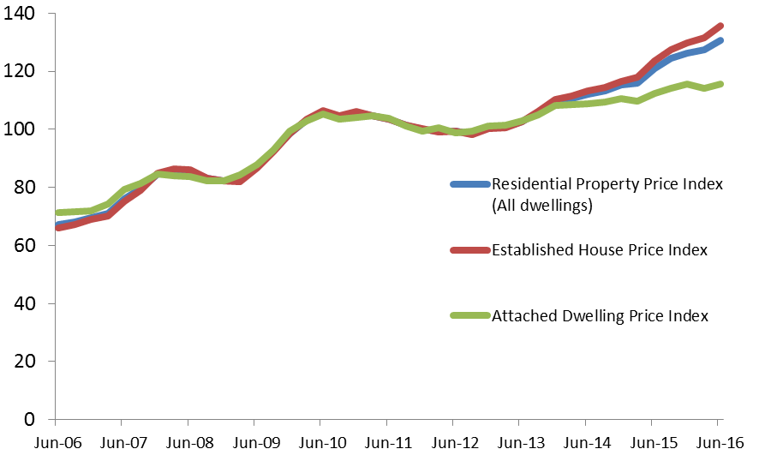
1. For detailed explanation of the methodology see: ABS Residential Property Price Indexes: Concepts, Sources and Methods, 2014 (cat. no. 6464.0)

The data also allow cities to be compared. It should be noted that the index does not compare differences in price between cities but differences in the change in price in each city over time.
When Sydney, Melbourne and Brisbane are compared some differences and similarities are apparent (Figure 2). Of the three cities prices in Melbourne increase the most in the period from 2006 to 2010. All cities saw a flattening out of prices from 2010 to about 2012. Since then prices have risen very strongly in Sydney, with relatively lower rises in Melbourne and Brisbane.
Price rises in Sydney have been most noticeable in established houses, which have risen by almost 60 per cent in five years, compared to a ‘relatively’ modest 35 per cent in Melbourne and 20 per cent in Brisbane over the same period.

Figure 2: Residential Property Price Index: Sydney, Melbourne Brisbane June 2006 – June 2016 (2011-12 = 100)
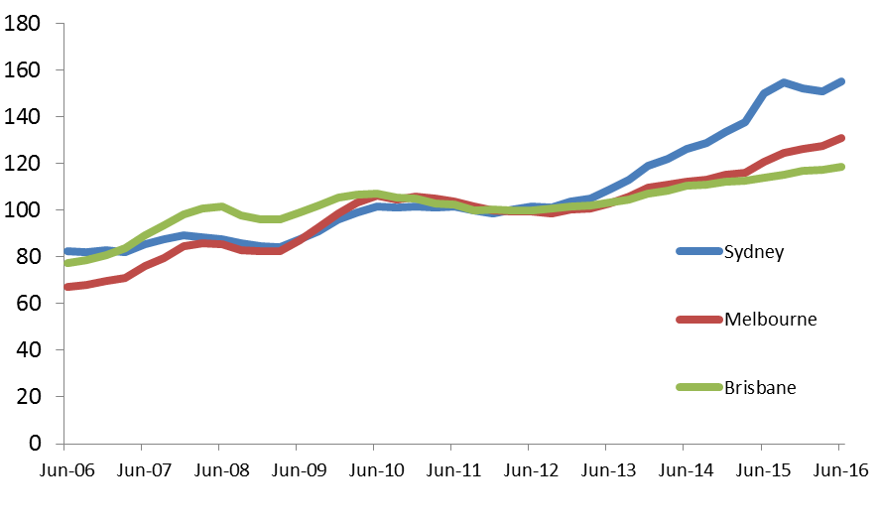
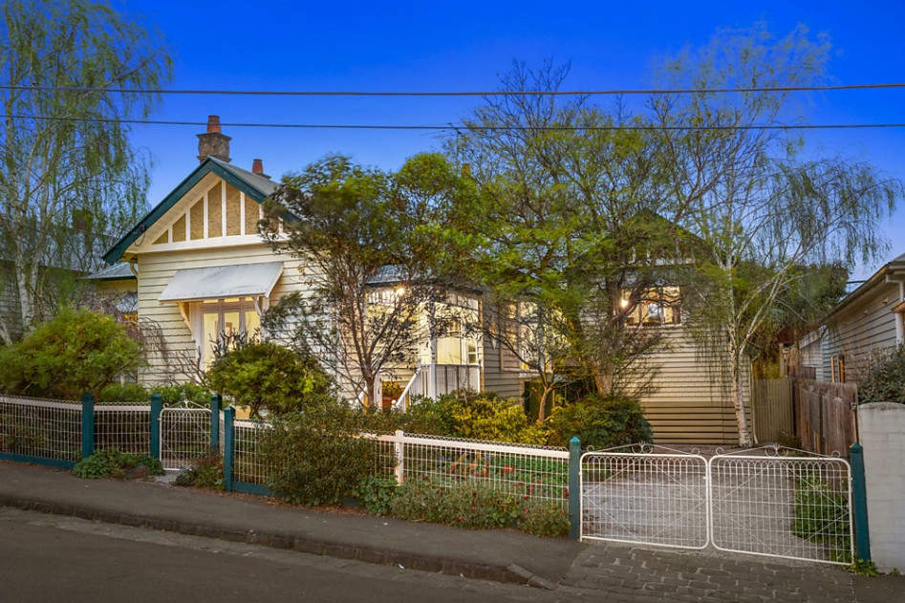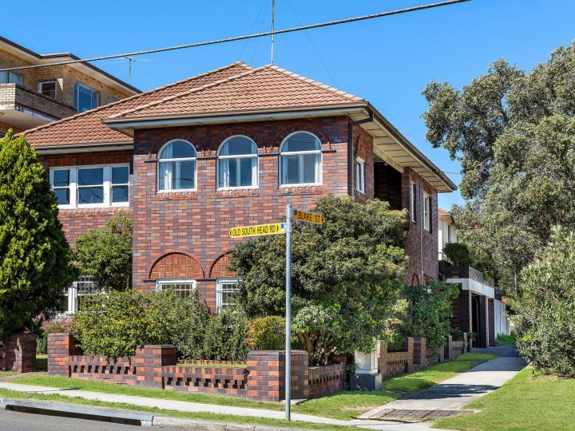

Some ‘energising’ Christmas reading

This Christmas, will you be thinking ‘energy’? Yours? That of the building you are in? The place outside the building? Here are recently published items for festive reflection.
_____________________________________
The challenge of shape and form
https://www.nhbcfoundation.org/wp-content/uploads/2016/10/NF-72-NHBC-Foundation_Shape-and-Form.pdf
This is a newly released report by the British NHBC (National House Building Council) Foundation. It goes beyond the usual list of factors affecting energy loss in buildings to consider the design form of the building. Shape and form of a building need to be considered before adding energy saving items like insulation and efficient services. The authors test five models of design using the Form Factor:
Total heat loss area of walls, roofs,
floors and opening (m²)

Habitable floor area of all storeys (m²)
They suggest that form may be at least as important as orientation in determining energy consumption. Furthermore, improving the Form Factor can be a low-cost or no-cost measure for many designers to adopt.
Thermal impact of a redeveloped area on localized urban microclimate: A case study in Rome
Battista, G., Carnielo, E. and De Lieto Vollaro, R. 2016
Energy and Buildings, 133(1): 446-454
This analysis explores the likely impacts on the urban heat island of a new commercial building complex that has been designed as infill in an existing suburb. The case study uses collected data on wind, temperature, humidity and intensity of solar radiation on the horizontal plane to model the impacts of the new complex. which will be set among existing buildings.
The modelling shows a potential increase in air temperature following construction of 2.5°C at 6am, 3.5° at noon and 3° at 6pm. Further modelling of applied treatments such as the use of cool materials on vertical and horizontal surfaces and vegetation produces some reduction in temperatures, but not to the existing conditions. The authors propose that this is due to the substantial increase in constructed surfaces preventing escape of warm air.
They also note that the benefits of countermeasures are more effective under the tree canopy.
Millennials, built form and travel insights from a nationwide typology of US neighborhoods
Ralph, K., Voulgaris, C., Taylor, B., Blumenberg, E. and Brown, A. 2016, Journal of Transport Geography, 57: 218-226
The authors identify seven distinct neighbourhood types based on characteristics of the built environment and transport network. Using a typology of travellers (drivers, long-distance trekkers, multimodals and carless) they look at the relationship between built environment and travel. From this they deduce the combined effects of: density; diversity; transience; stability; and accessibility on travel. They also consider the thresholds at which changes of urban pattern might elicit change in travel patterns. The authors raise the perennial question in any research on behaviour and the built environment: is a relationship causal (or at least contributional) or a matter of selective, a priori choice?
Their study population is millennials – young people aged 16-36 at the time of the survey in 2009. The analysis controls for socio-economic factors, an important aspect when the work starts to model likely behaviour change in moving from one area to another.
Eighty percent of the surveyed group were found to be predominately car drivers and one in five used public transport. Car-based travel decreased in a small number of denser neighbourhoods with good public transport and an abundance of jobs. For other parts of the urban area, the authors conclude that it would take a massive effort to adapt for the sake of reducing car use. However, they also find that built environment characteristics can reduce the amount of car travel.
Mapping embodied environmental impacts in the built environment
https://msd.unimelb.edu.au/mapping-embodied-environmental-impacts-in-the-built-environment
Lastly, it will be worth keeping a watch on the work being done by the University of Melbourne in a project whose aim is “to integrate building embodied energy, water, greenhouse gas emissions and materials into a graphical information system in order to inform future city planning and management decisions that will help reduce the environmental impact of the built environment”. They plan to have some outputs by the end of 2016.
The elephant in the scheme: planning for and around car parking in Melbourne 1929-2016
Taylor, E. & van Bemmel-Misrachi, R. 2017, Land Use Policy 60: 287-297.
Large car parking areas can contribute to urban heat islands and poor urban design outcomes. But to what degree can planners ameliorate the effects of car parking and what effect has past strategic planning had in this regard?
The RMIT-based authors report on a perceived decline of interest among planners in parking provision in a densifying Melbourne. They analyse nine metropolitan strategic plans for Melbourne between 1999 and 2016, offering many quotes from those schemes, to see what was said specifically about the role of car parking or more generally about transport, housing diversity or density.
They use a typology of area management versus site management, as well as whether parking has been considered as a public or a private good – that is, demand-based approaches versus predict-and-provide. They also examine whether turnover rates rather than number of parking spaces has been a part of policy and conclude that “strategic planning now plans around parking – the elephant in the scheme”.

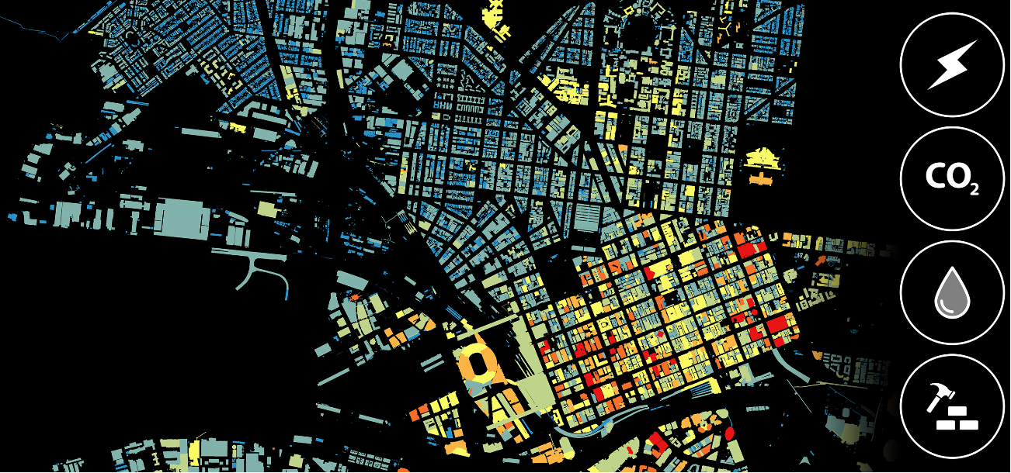
Embodied environmental impacts https://msd.unimelb.edu.au/mapping-embodied-environmental-impacts-in-the-built-environment

