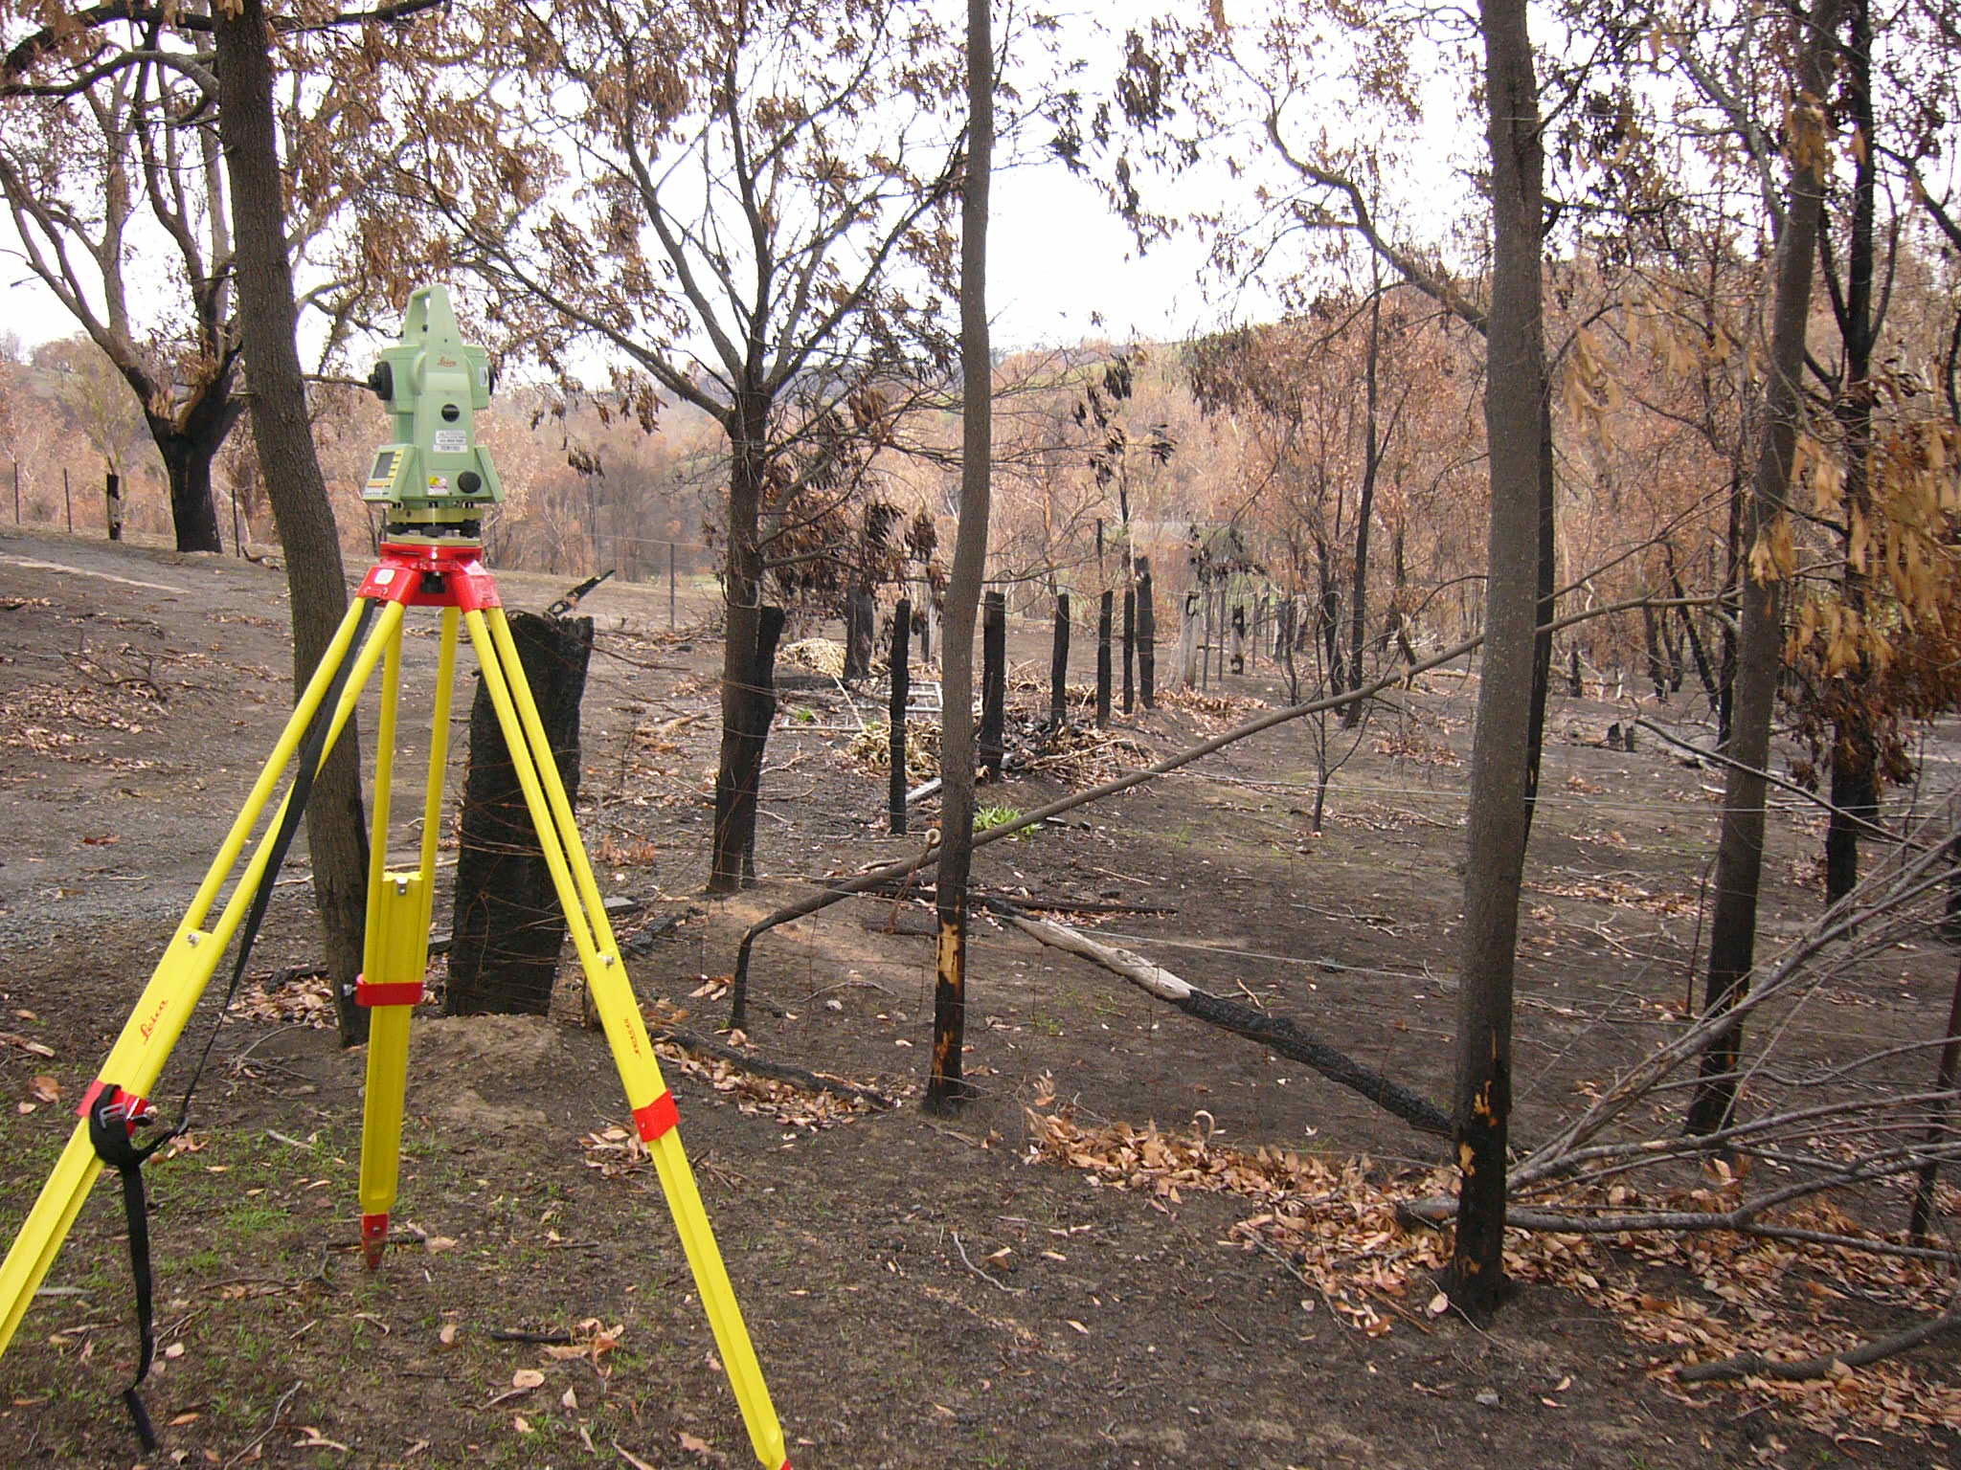
Land surveying helps determine the position of property boundaries and other site characteristics including features and levels.

Property boundaries
Following a bushfire, where boundary fences may have been destroyed it is important that title boundaries of properties be re-established and marked on the ground by a licensed land surveyor prior to any building and other works occurring near those boundaries. Only licensed land surveyors are authorised to perform title boundary surveys.

Why do I need a land survey?
There are a variety of reasons why you may need a land survey, including:
- Title boundary re-establishment
- Existing site and flood levels
- Engineering and civil works
- Easement dealings
- Feature, level and contour surveys

Landowners may need to engage a licensed land surveyor to re-establish private property boundaries including for planning permit applications and any other construction work as part of the design and building process.

Public land boundaries
The Office of Surveyor-General Victoria (SGV) is working with public land managers who are responsible for repairs to damaged or destroyed fences between private properties and public land including National Parks, State Parks and State Forests. The State Government has agreed to pay half the cost of the materials for these boundary fencing repairs, and SGV is providing advice on the land surveys required for that work.

Land surveys and advice
SGV is coordinating the surveying response to the bushfires including for private properties that have been affected.
SGV is compiling a list of local surveying firms and licensed land surveyors who are willing to provide residents with professional advice on specific surveys and perform title boundary surveys at a discounted rate, only covering costs or less.
If you are uncertain about what your land surveying needs are or would like to arrange a survey of your property boundaries, please contact Surveyor-General Victoria on (03) 9194 0282 or email to surveyor.general@transport.vic.gov.au
SGV will put you in contact with a licensed land surveyor who will be able to assist you.


Need more information?
Find out more about the government’s initiatives at dtp.vic.gov.au

