delwp.vic.gov.au

january 2019

|  |
| --- |
| *Environment Effects Act 1978*  Scoping requirements for the Gas Import Jetty and Pipeline Project Environment Effects Statement |

|  |  |
| --- | --- |
|  |  |

|  |
| --- |
| © The State of Victoria Department of Environment, Land, Water and Planning 2018  LogoThis work is licensed under a Creative Commons Attribution 4.0 International licence. You are free to re-use the work under that licence, on the condition that you credit the State of Victoria as author. The licence does not apply to any images, photographs or branding, including the Victorian Coat of Arms, the Victorian Government logo and the Department of Environment, Land, Water and Planning (DELWP) logo. To view a copy of this licence, visit <http://creativecommons.org/licenses/by/4.0/>  Disclaimer  This publication may be of assistance to you, but the State of Victoria and its employees do not guarantee that the publication is without flaw of any kind or is wholly appropriate for your purposes and therefore disclaims all liability for any error, loss or other consequence which may arise from you relying on any information in this publication.  Accessibility  If you would like to receive this publication in an alternative format, please telephone the DELWP Customer Service Centre on 136186, email [customer.service@delwp.vic.gov.au](mailto:customer.service@delwp.vic.gov.au),. This document is also available on the internet at [www.delwp.vic.gov.au](http://www.delwp.vic.gov.au) environment-assessment/ browse-projects. |

List of abbreviations List of Abbreviations

AGL AGL Wholesale Gas Limited

APA APA Transmission Pty. Limited

AH Act *Aboriginal Heritage Act 2006*

CHMP Cultural heritage management plan

C&LP Act *Catchment and Land Protection Act 1994*

CF&L Act *Conservation, Forests and Lands Act 1987*

CHMP Cultural heritage management plan

DEPI Department of Environment and Primary Industries

DELWP Department of Environment, Land, Water and Planning

EE Act *Environment Effects Act 1978*

EES Environment effects statement

EMF Environmental management framework

EMP Environmental management plan

EMS Environmental management system

EP Act *Environment Protection Act 1970*

EPBC Act *Environment Protection and Biodiversity Conservation Act 1999*

FFG Act *Flora and Fauna Guarantee Act 1988*

FSRU Floating storage and regasification unit

GDE Groundwater dependent ecosystem

km Kilometres

LNG Liquified natural gas

m Metres

M&C Act *Marine and Coastal Act 2018*

MNES Matters of national environmental significance

OH&S Act *Occupational Health and Safety Act 2004*

PASS Potential acid sulphate soils

P&E Act *Planning and Environment Act 1987*

PH&W Act *Public Health and Wellbeing Act 2008*

PoHDA Port of Hastings Development Authority

RM Act *Road Management Act 2004*

RAP Registered Aboriginal Party

SEPP State environment protection policy

TRG Technical reference group

Contents

1. Introduction 1

1.1 The project and setting 1

1.2 Minister’s requirements 3

2. Assessment process and required approvals 4

2.1 What is an EES? 4

2.2 The EES process 4

2.3 Accreditation of the EES process under the EPBC Act 6

3. Matters to be addressed in the EES 7

3.1 General approach 7

3.2 General content and style of the EES 7

3.3 Project description 8

3.4 Project alternatives 9

3.5 Applicable legislation, policies and strategies 9

3.6 Draft evaluation objectives 10

3.7 Environmental management framework 11

4. Assessment of specific environmental effects 12

4.1 Energy efficiency, security, affordability and safety 12

4.2 Biodiversity 13

4.3 Water and catchment values 15

4.4 Cultural heritage 16

4.5 Social, economic, amenity and land use 17

4.6 Waste management 18

5. Environmental management framework 20

APPENDIX A EE Act Decision 21

APPENDIX B Gas Import Facility EPBC decision 23

APPENDIX C Gas Pipeline EPBC decision 24

Introduction

In the light of the potential for significant environmental effects, on 8 October 2018 the Victorian Minister for Planning (the Minister) determined under the *Environment Effects Act 1978* that AGL Wholesale Gas Limited (AGL) and APA Transmission Pty. Limited (APA) (jointly acting as the proponent) must prepare an environment effects statement (EES) for the Crib Point Gas Import Jetty and Crib Point to Pakenham Pipeline project (the project). AGL is the primary proponent for the gas import jetty works, including the floating storage and regasification unit (FSRU) and AGL is the primary proponent for the Crib Point to Pakenham pipeline works.

The purpose of the EES is to provide a sufficiently detailed description of the proposed project, assess its potential effects on the environment and assess alternative project layouts, designs and approaches to avoid and mitigate effects. The EES will inform, and seek feedback from, the public and stakeholders and enable the Minister to issue an assessment of the environmental effects of the project under the Environment Effects Act. The Minister’s assessment will inform statutory decision-makers responsible for the project’s approvals.

The scoping requirements for the project set out the specific matters to be investigated and documented in the EES. The Minister issued the scoping requirements for the EES following consideration of public comments received on a draft which was available for public comment over a three-week period in November-December 2018.

## The project and setting

AGL and APA propose to establish a new facility for importing and regasifying liquefied natural gas (LNG) and supplying it to the gas transmission network. The proposal comprises the gas import jetty works, which include upgrade/modification works to the existing jetty owned and operated by the Port of Hastings Development Authority (PoHDA) at Crib Point, to provide for continuous mooring of the FSRU – a vessel with LNG storage and regasification capacity. LNG carriers (tankers approximately 300 m in length) will moor alongside the FSRU and transfer cargo to the FSRU. The proposal also comprises the pipeline works, which include treatment of the gas to meet Australian standards and subsequent transfer via a new pipeline to a location east of Pakenham where its pressure would be corrected, specifications checked and modified if necessary, and connected to the existing gas transmission network for commercial supply to customers. The locations of the project components are shown in Figures 1 and 2.

Aside from the FSRU, the gas import jetty works would also include ancillary topside jetty infrastructure including high pressure gas unloading arms and a high-pressure gas flowline, which will be mounted on the jetty and connected to a flange on land. Works for the pipeline would entail pipeline installation in an excavated trench, except where horizontal directional drilling would be used to avoid surface disturbance, such as at watercourses, major roads or other sensitive surface features. It would also include construction of above-ground pipeline facilities at Crib Point and Pakenham to check and correct gas specifications against commercial supply standards before delivering it into the existing gas pipeline network. The pipeline would extend for about 56 km and would occupy an operational easement generally about 15 m wide. Where available, it might share existing infrastructure easements.

Works for which statutory approvals already exist, including seabed levelling works near the jetty by the Victorian Regional Channels Authority and works being undertaken on the jetty by PoHDA, are not part of the project for the purposes of the EES, but should be described as necessary to establish the existing conditions for the project.

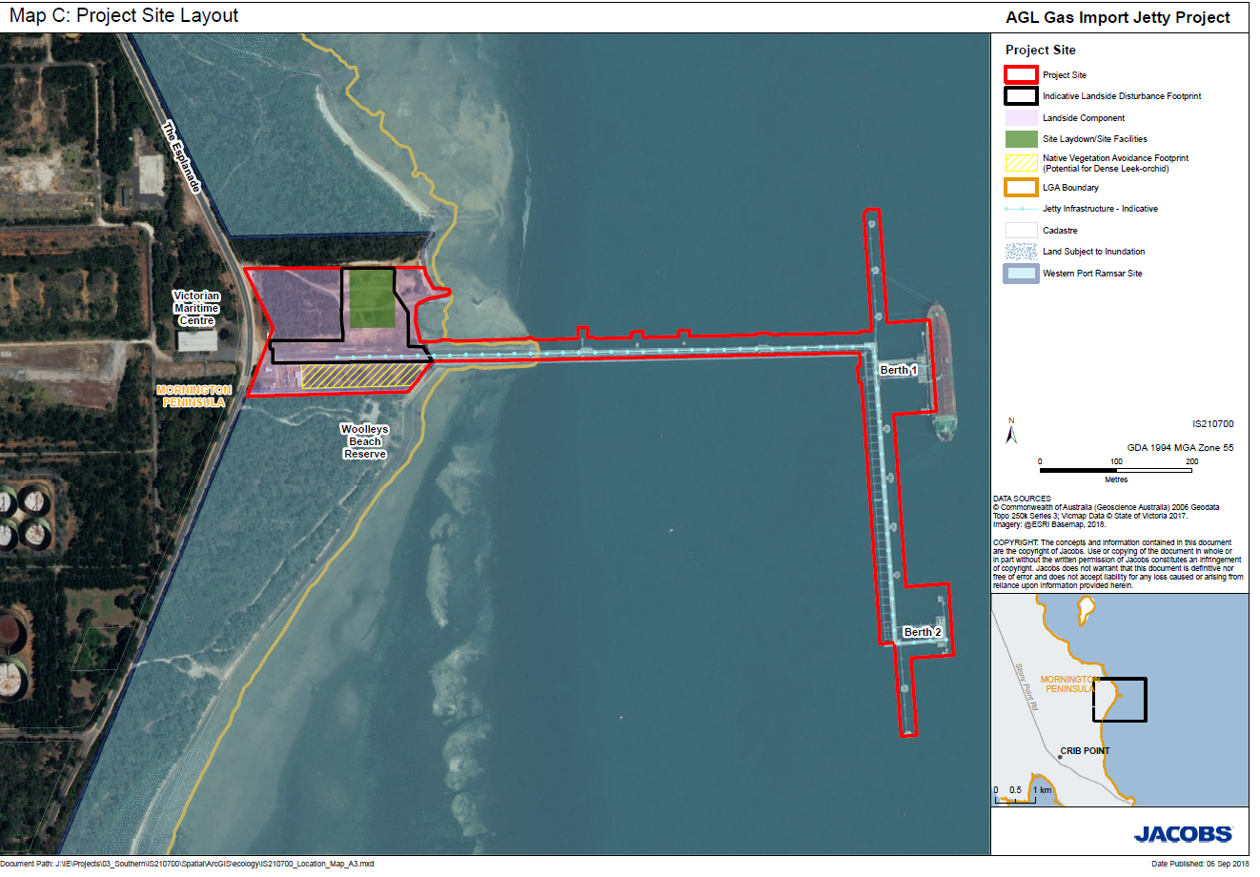

Figure 1: Gas import jetty works location, Crib Point.

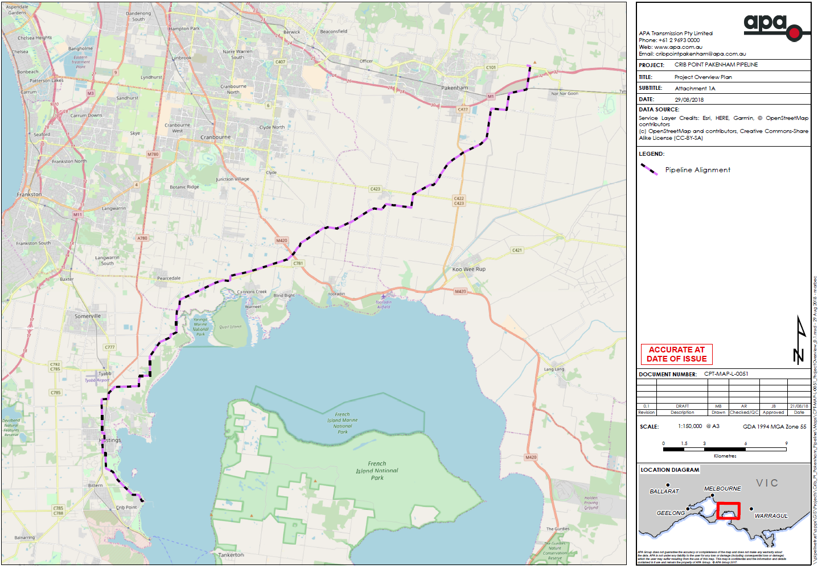

Figure 2: Location of proposed pipeline works between Crib Point and Pakenham.

## Minister’s requirements

The Minister’s decision to require an EES included the procedures and requirements applicable to its preparation, in accordance with section 8B(5) of the Environment Effects Act (Appendix A). These requirements included the following key matters for the EES to examine:

* effects on biodiversity and ecological values within and near the proposed pipeline and gas import facility at Crib Point, including potential impacts associated with the loss of native vegetation, indirect and direct impacts on the habitat for listed threatened species of flora and fauna, and risks to other ecological values and ecosystem services of conservation areas, nature parks, marine reserves and Ramsar sites in proximity to the proposal;
* effects from seawater intake to and cold water/residual chlorine discharges from the gas import jetty facility, including potential medium and long-term effects on the ecology of the North Arm of Western Port associated with changes to seawater quality and entrainment of larvae of marine species (threatened and non-threatened);
* effects from construction on surface water environments, including local waterways and the broader catchment, as well as groundwater (hydrology, quality, uses and dependent ecosystems), including risks associated with potential acid sulphate soils;
* effects on the landscape values and land-uses of the sites and surrounding areas, including the implications for any directly affected agriculture and the proposed rehabilitation of the pipeline corridor;
* effects on soil and land-uses from contamination during the construction and operation of the proposal;
* effects on Aboriginal and historic cultural heritage values;
* effects of project construction and operation on air quality and noise on nearby sensitive receptors (in particular residences);
* effects on socio-economic values, at local and regional scales, potentially generated by the project, including increased traffic movement and indirect effects of the project construction workforce on the capacity of local community infrastructure; and
* effects of waste (solid, liquid and gas) that might be generated by the project during construction and operation.

The scoping requirements provide further detail on the specific matters to be investigated in the EES in the context of *Ministerial guidelines for assessment of environmental effects under the Environment Effects Act 1978* (Ministerial Guidelines).

Assessment process and required approvals

## What is an EES?

An EES is prepared by the project’s proponent to describe the project and its potential environmental effects. An EES should enable stakeholders and decision-makers to understand how the project is proposed to be implemented and the likely environmental effects of doing so. An EES has two main components.

1. The EES main report – an integrated, plain English document that sets out an analysis of the potential impacts of the project. The main report draws on technical studies, data and statutory requirements such as specific limits for surface water and groundwater quality and waste discharge to the environment and should clearly identify which components of the scope are being addressed throughout.
2. The studies that inform the EES technical reports – expert investigations and analyses that provide the basis for the EES main report. They will be exhibited in full, as appendices to the main report.

The potential impacts that require technical studies are set out in Section 4.

## The EES process

The proponent is responsible for preparing the EES, including conducting technical studies and undertaking stakeholder consultation. The Department of Environment, Land, Water and Planning (DELWP) is responsible for managing the EES process[1]. This EES process has the following steps:

* preparation of a draft study program and draft schedule by the proponent (completed);
* preparation and exhibition of draft scoping requirements by DELWP on behalf of the Minister with public comments received during the advertised exhibition period (completed);
* finalisation and issuing of scoping requirements (this document) by the Minister;
* establishment of an inter-agency technical reference group[2] convened by DELWP (in place);
* commissioning and conduct of EES studies, including appropriate peer review, by proponent;
* review of the proponent’s EES studies and draft documentation by DELWP and the TRG;
* completion of the EES by the proponent;
* review of the complete EES by DELWP to establish its adequacy for public exhibition;
* exhibition of the proponent’s EES and invitation for public comment by DELWP on behalf of the Minister;
* appointment of an inquiry by the Minister to review the EES and public submissions received and provide a report to the Minister; and finally
* following receipt of the inquiry report, the Minister provides an assessment of the environmental effects of the project, including recommendations to decision-makers.

Further information on the EES process can be found on the planning website[3].

### Technical reference group

DELWP has convened a technical reference group (TRG), comprising representatives of selected state government agencies and departments and the councils, in whose area project works are proposed, to advise it and the proponent on:

* applicable policies, strategies and statutory provisions;
* the scoping requirements;
* the design and adequacy of technical studies;
* the proponent’s public information and stakeholder consultation program;
* responses to issues arising from investigations;
* the technical adequacy of draft EES documentation; and
* coordination of statutory processes.

### EES consultation plan

In addition to its public exhibition of the completed EES, the proponent is responsible for informing and engaging the public and stakeholders to identify and respond to their issues in conjunction with the EES studies. Stakeholders include potentially affected parties, the local community and interested organisations and individuals, as well as government bodies. Under its EES consultation plan the proponent will inform the public and stakeholders about the EES process and associated investigations and provide opportunities for input and engagement during the EES investigations. The EES consultation plan is reviewed and amended in consultation with DELWP and the TRG before it is published on the planning website. The EES consultation plan will:

* identify stakeholders;
* characterise public and stakeholders’ interests, concerns and consultation needs and potential to provide local knowledge and inputs;
* describe consultation methods and schedule; and
* outline how public and stakeholder inputs will be recorded, considered and/or addressed in the preparation of the EES.

### Approvals coordination with the EES process

If the project is to proceed, it will require a range of approvals under Victorian legislation. DELWP coordinates the EES process as closely as practicable with the approvals procedures, consultation and public notice requirements. Figure 3 outlines the steps in the EES process and the parallel coordination of statutory processes.

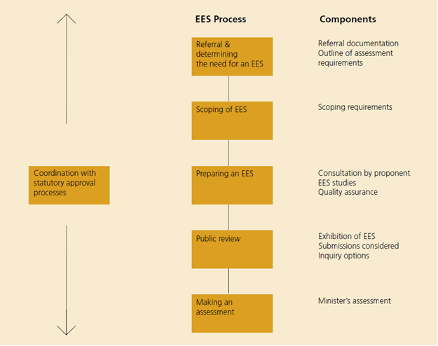

Figure 3: Coordination of statutory assessment and approvals processes

The key approvals required under Victorian legislation are a works approval under the *Environment Protection Act 1970*, a pipeline licence under the *Pipelines Act 2005* and an approved cultural heritage management plan (CHMP) under the *Aboriginal Heritage Act 2006*. Other approvals may also be required: exact approvals requirements will be clarified through the course of the EES.

## Accreditation of the EES process under the EPBC Act

AGL and APA also respectively referred the gas import facility works and the pipeline works to the Australian Government under the Commonwealth *Environment Protection and Biodiversity Conservation Act 1999* (EPBC Act). The delegate for the Commonwealth Minister for the Environment and Energy determined on 28 November 2018 that each component of the project (the gas import jetty works and the pipeline works) is a controlled action[4], as it is likely to have a significant impact[5] on matters of national environmental significance (MNES) which are protected under Part 3 of the EPBC Act (Table 1).

Table 1: Designated controlling provisions for project components.

|  |  |  |
| --- | --- | --- |
| EPBC Act controlling provision | Gas import jetty works | Pipeline works |
| Wetlands of international importance  (Sections 16 and 17B) | X | X |
| Listed threatened species and communities  (Sections 18 and 18A) | X | X |
| Listed migratory species  (Sections 20 and 20A) | X |  |

The EES is an accredited assessment process under the EPBC Act through a Bilateral Assessment Agreement that exists between the Commonwealth and Victoria. The Commonwealth Minister or delegate will decide whether the actions are approved, approved with conditions or refused under the EPBC Act, after having considered the Minister for Planning’s assessment under the Environment Effects Act.

Conclusions regarding the specified MNES protected under the EPBC Act should be summarised in a separate chapter or section of the EES, which should include reference information about where within the EES detailed information and discussion is provided.

Matters to be addressed in the EES

## General approach

The EES should assess the environmental effects[6] of all components and stages of the project. The assessment should include:

* the likelihood of adverse effects and associated uncertainty of available predictions or estimates;
* the potential effects on individual environmental assets – magnitude, extent and duration of change in the values of each asset – having regard to intended avoidance and mitigation measures and (if different) both maximum operational capacity and intended operational rates;
* further management measures that are proposed where avoidance and mitigation measures do not adequately address effects on environmental assets, including specific details of how the measures address policy;
* risk ratings of unintended but foreseeable events such as spills or other mishaps that could result from construction or operation of the project;
* the residual effects, including on MNES, that are likely to occur after all proposed measures to avoid and mitigate environmental effects are implemented;
* potential cumulative impacts arising in conjunction with the impacts of other projects or actions that may affect the same environmental asset or assets;
* the proposed approach to managing and monitoring environmental performance, including contingency planning; and
* an analysis of the acceptability of impacts on all MNES.

Further advice on the approach to be adopted in preparing the EES is provided in Section 4.

## General content and style of the EES

The content of the EES and related investigations is to be guided by these scoping requirements and the Ministerial guidelines. To facilitate decisions on required approvals, the EES should address statutory requirements associated with approvals that will be informed by the Minister’s assessment, including decision-making under the EPBC Act. The EES should also address any other significant issues that emerge during the investigations.

Ultimately it is the proponent’s responsibility to ensure that adequate studies are undertaken and reported to support the assessment of environmental effects and that the EES has effective internal quality assurance in place. Close consultation with DELWP and the TRG during the investigations and preparation of the EES will be necessary to minimise the need for revisions prior to authorisation of the EES for public exhibition.

The main EES report should provide a clear, objective and well-integrated analysis of the potential effects of the proposed project, including proposed avoidance, mitigation and management measures, as well as feasible alternatives. Overall, the main report should include the following:

* an executive summary of the potential environmental effects of the project, including potential impacts on identified MNES outlined in Section 4 below;
* an overview of each proponent, including experience in developing and operating projects as well as its health, safety and environmental policies and track record;
* a description of the entire project, including its objectives, rationale, key elements, associated requirements for new infrastructure and use of existing infrastructure;
* a description of the approvals required for the project to proceed, and its relationship to policies, strategies, guidelines and standards;
* a description of feasible alternatives capable of substantially meeting the project objectives that may also offer environmental or other benefits (as well as the basis for the choice where a preferred alternative is nominated);
* descriptions of the existing environment to the extent relevant to the assessment of potential effects;
* maps, plans, diagrams and technical information – maps and diagrams must be clearly annotated, in colour and high resolution, with features including EPBC matters clearly labelled;
* appropriately detailed assessments of potential effects of the project (and alternatives) on environmental assets and values, relative to the “no project” scenario, together with an estimation of likelihood and degree of uncertainty associated with predictions;
* intended measures for avoiding, minimising, managing and monitoring effects, including a statement of commitment to implement these measures;
* predictions of residual effects of the project assuming implementation of proposed environmental management measures;
* any proposed offset measures where avoidance and mitigation measures will not adequately address effects on environmental values, including the identified MNES, and discussion of how any proposed offset package meets the requirements of the EPBC Act Environmental Offsets Policy as it relates to MNES;
* responses to issues raised through public and stakeholder consultation; and
* evaluation of the implications of the project and alternatives for the implementation of applicable legislation and policy, including the principles and objectives of ecologically sustainable development and environmental protection.

The proponent must also prepare a concise non-technical summary document (hard copy A4, no more than 25 pages) for free distribution to interested parties. The EES summary document should include details of the EES exhibition, public submission process and availability of the EES documentation.

The EES may be supported by additional content on the proponent’s website, including graphical, video and interactive content as may be appropriate. Any web-based content intended to support and be viewed in conjunction with the EES should be clearly labelled as such and be subject to the same standards of accuracy, clarity and objectivity that apply to the EES documentation.

## Project description

The EES is to describe the project in sufficient detail both to allow an understanding of all components, processes and development stages, and to enable assessment of their likely potential environmental effects. The project description should canvass the following.

* Contextual information on the project, including its objectives and rationale, its relationship to statutory policies, plans and strategies, including the basis for selecting the proposed project site/corridor and implications of the project not proceeding.
* Land use activities (including beneficial and sensitive uses) in the project area and vicinity, supported by plans and maps where applicable.
* Details of all the project components, to the extent practicable, including:
  + location, footprint, layout and access arrangements, including laydown areas, equipment/machinery storage and stockpiling areas, during construction and operation;
  + proposed or foreseeable marine activities that may be necessitated by the project, such as seawater intakes and discharges and mixing zones;
  + design and expected construction staging and scheduling for the project;
  + proposed construction methods (to the extent relevant and practicable), temporary occupation of land, extent of areas to be disturbed during construction and infrastructure and service relocation;
  + solid waste, wastewater and hazardous material generation and management during construction and operation;
  + the visual appearance of proposed materials and finishes;
  + lighting, safety and security requirements during construction and operation; and
  + hours of construction work and operational activity.
* Information on the project’s operational life and any decommissioning and rehabilitation arrangements.
* Other necessary works directly associated with the project, such as road upgrades or connections, and infrastructure and services relocation.
* Approach to be taken to address visual and landscape impacts.

## Project alternatives

The EES should document the proponent’s consideration of feasible alternatives and include an explanation of how specific alternatives were shortlisted for evaluation within the EES. The EES should investigate and document the likely environmental, social and economic effects of the alternatives, particularly where these offer a potential to achieve beneficial environmental, social and economic outcomes and can meet the objectives of the project. The discussion of alternatives should include:

* documentation of the basis and rationale for the proposed project;
* an explanation of the selection of the FSRU approach in preference to a land-based alternative;
* an explanation of the rationale for selecting the proposed site for the FSRU;
* an explanation of the rationale for selection of the proposed mode of regasification from the range of available options including variations in the FSRU design and potential to use a combination of both closed and open loop systems;
* an explanation of selection process for the proposed pipeline route;
* identification and evaluation of design alternatives for any components of the project;
* environmental considerations, including a comparative description of the effects of each alternative on MNES; and
* discussion of short, medium and long-term advantages and disadvantages.

The effects of the preferred form of the project should be compared to those of other alternatives or to a “no project” base case. Where appropriate, the assessment of environmental effects of feasible design alternatives is to address the matters set out in the subsequent sections of this document. The depth of investigation of alternatives should be proportionate to their potential to minimise potential adverse effects as well as meet project objectives.

## Applicable legislation, policies and strategies

The EES will need to identify legislation, regulations, policies, guidelines and standards, and assess their specific requirements or implications for the project, particularly in relation to required approvals, including (but not limited to) the following.

### Commonwealth

* *Environment and Protection Biodiversity Conservation Act 1999*;
* *Maritime Transport and Offshore Facilities Security Act 2003* (under which the Office of Transport Security requires a maritime security plan);
* *Navigation Act 2012* (and Australian Maritime Safety Authority marine orders);
* *Occupational Health and Safety (Maritime Industry) Act 1993*;
* *Marine Safety (Domestic Commercial Vessel) National Law Act 2012* and marine orders;
* *National Law Act 2012* (if relevant); and
* *Native Title Act 1993*.

### Victorian

* *Environment Effects Act 1978*;
* *Environment Protection Act 1970* (EP Act) and *Environment Protection Amendment Act 2018*, Environment Protection (Industrial Waste Resource) Regulations 2009, State Environment Protection Policies (SEPPs) and related documents including SEPP (Waters), SEPP (Prevention and Management of Contamination of Land), SEPP (Ambient Air Quality), SEPP (Air Quality Management) and Environment Protection (Industrial Waste Resource) Regulations and SEPP N-1 (Control of Noise from Commerce, Industry and Trade) and *Noise from industry in regional Victoria*;
* *Pipelines Act 2005*;
* *Public Health and Wellbeing Act 2008* (PH&W Act);
* *Planning and Environment Act 1987* (P&E Act), and provisions in the Cardinia, Casey and Mornington Peninsula Planning Schemes;
* *Catchment and Land Protection Act 1994* (C&LP Act);
* *Conservation, Forests and Lands Act 1987* (CF&L Act)
* *Climate Change Act 2017*;
* *Occupational Health and Safety Act 2004* (OH&S Act) and regulations;
* *Marine and Coastal Act 2018* (M&C Act);
* *Crown Land (Reserves) Act 1978*;
* *Land Act 1958*;
* *Local Government Act 1989*;
* *Flora and Fauna Guarantee Act 1988* (FFG Act) and action statements for listed items;
* *Water Act 1989*;
* *Wildlife Act 1975*;
* *Fisheries Act 1995;*
* *Road Management Act 2004*;
* *Aboriginal Heritage Act 2006* (amended 2016) and Aboriginal Heritage Regulations 2018;
* *Traditional Owners Settlement Act 2010*;
* *Heritage Act 2017*;
* *National Parks Act 1975*;
* *Marine Safety Act 2010;*
* *Maritime Transport and Offshore Facilities Security Act 2003;* and
* *Port Management Act 1995;* and
* *Gas Safety Act 1997.*

The proponent will also need to identify and address other documents including international treaties or agreements, policies, strategies, subordinate legislation and related management or planning processes that may be relevant to the assessment of the project. These may include but are not limited to:

* EPBC Act policy statements, conservation advices, threat abatement plans and recovery plans for nationally listed threatened species and ecological communities and nationally listed migratory species;
* Guidelines for the Removal, Destruction or Lopping of Native Vegetation (2017);
* vegetation management strategies under the Cardinia, Casey and Mornington Planning Schemes;
* Protecting Victoria’s Environment – Biodiversity 2037;
* Healthy Waterways Strategy 2018-2028
* Australia’s obligations under the Ramsar Convention for the Western Port Ramsar site, including the implementation of the Western Port Ramsar Site Management Plan (2017)[7]; and
* any other plans, guidelines or standards for the protection or management of threatened species or communities or the management of listed potentially threatening processes.

## Draft evaluation objectives

Through an integrated assessment of the project against the evaluation objectives, the project will need to consider a balance of economic, social and environmental outcomes over the short and long-term. This should include information on the project purpose and design considerations associated with the preferred configuration for the project.

Table 1 includes draft evaluation objectives that identify desired outcomes in the context of potential project effects and legislation. During the development of the EES the proponent can consider refining the objectives and proposed evaluation framework, as well as develop specific assessment criteria to assist the evaluation of effects. The Minister may refine the evaluation objectives for the purposes of the Minister’s assessment.

The framing of the draft objectives reflects the key subject matters to be investigated for the EES, legislation and policies (Section 3.5), the objectives and principles of ecologically sustainable development and environmental protection, as well as environmental issues identified by the proponent in the referral documentation.

The level of effort applied to the investigation, management and mitigation of issues in the context of the draft evaluation objectives should be proportionate to the significance of potential adverse effects (Section 4). The proponent should consult closely with DELWP and the TRG throughout the preparation of the EES to ensure that the investigation of issues is undertaken soundly and appropriately targeted.

**Table 1: Draft evaluation objectives**

|  |  |
| --- | --- |
| Draft evaluation objective | Key legislation |
| **Energy efficiency, security, affordability and safety** – To provide for safe and cost-effective augmentation of Victoria’s natural gas supply in the medium to longer term. | Environment Effects Act, OH&S Act, PH&W Act, Marine Safety Act, Pipelines Act, Climate Change Act, Commonwealth marine legislation |
| **Biodiversity** – To avoid, minimise or offset potential adverse effects on native flora and fauna and their habitats, especially listed threatened or migratory species and listed threatened communities. | EPBC Act, FFG Act, Wildlife Act, CF&L Act, EP Act, M&C Act, C&LP Act |
| **Water and catchment values** – To minimise adverse effects on water (including groundwater, waterway, wetland, estuarine, intertidal and marine) quality and movement particularly as they might affect the ecological character of the Western Port Ramsar site. | EPBC Act, EP Act & SEPPs, Water Act, C&LP Act, M&C Act |
| **Cultural heritage** – To avoid or minimise adverse effects on Aboriginal and historic cultural heritage. | AH Act, Heritage Act, P&E Act, Traditional Owners Settlement Act, Native Title Act. |
| **Social, economic, amenity and land use** – To minimise potential adverse social, economic, amenity and land use effects at local and regional scales. | P&E Act, PHW Act, M&C Act |
| **Waste** – To minimise generation of wastes by or resulting from the project during construction and operation, including accounting for direct and indirect greenhouse gas emissions. | EP Act, C&LP Act, Climate Change Act |

## Environmental management framework

The EES will need to outline a transparent framework with clear accountabilities for managing and monitoring environmental effects and hazards associated with construction, operation, decommissioning and rehabilitation phases of the project to achieve acceptable environmental outcomes (see Section 5). The EES should explain the way in which it is proposed to integrate the EMF with the key statutory approvals for the project, to give its commitments regulatory weight.

Assessment of specific environmental effects

Preparation of the EES and investigation of effects should be consistent with the principles of a systems approach and proportional to the project risk, as outlined in the Ministerial Guidelines (p. 14). A risk-based approach should be adopted during the EES studies, so that a greater level of effort is directed at investigating and managing those matters that pose relatively higher risk of adverse effects (refer to Section 1.2). This section sets out specific requirements for the assessment of effects, using the following structure for each draft evaluation objective.

**Key issues or risks that the project poses to the achievement of the draft evaluation objective**. In addition to addressing the highlighted issues, the proponent should consider undertaking its own environmental risk assessment.

**Priorities for characterising the existing environment** to underpin predictive impact assessments having regard to the level of risk. Any risk assessment by the proponent could guide the necessary data gathering.

**Design and mitigation measures** that could substantially reduce and/or mitigate the risk of significant effects.

**Assessment of likely effects** through predictive studies or estimates of effects that are reasonably likely, as well as evaluation of their significance, having regard to their likelihood.

**Approach to manage performance** measures that are proposed to manage risks of effects, assuming that identified design and mitigation measures are applied, to achieve appropriate outcomes. This should inform the assessment of likely residual effects (assuming proposed measures are implemented) and consideration of environmental offsets where applicable.

Effects includes all potential direct, indirect, on-site and off-site environmental impacts resulting from the proposal. The description and assessment of effects must not be confined to the immediate area of the proposal but must also consider the potential of the proposal to impact on adjacent or other areas that could be affected, in the context of a systems-based approach. As well as areas likely to contain habitat for relevant species and communities, including conservation reserves, wetlands and parklands, study areas for each discipline must be defined with due consideration for the potential geographic and temporal range of effects.

## Energy efficiency, security, affordability and safety

### Draft evaluation objective

**Energy efficiency, security, affordability and safety** – To provide for safe and cost-effective augmentation of Victoria’s natural gas supply in the medium to longer term.

### Key issues

* Workforce, nearby operations and public safety risks associated with the construction or operation of the project, including risks associated with or compounded by potential external threats (e.g. bushfire).
* The rationale for the project in the context of energy security, efficiency and affordability.
* The capacity of the project to exert a beneficial influence on Victoria’s energy security and costs over the anticipated life of the project, relative to established legislative and policy imperatives.

### Priorities for characterising the existing environment

* Characterise the human environment near the project relative to safety buffer standards for surrounding current land uses and reasonably foreseeable land uses.
* Characterise Victoria’s existing and anticipated demand for natural gas relative to existing anticipated and emerging supply scenarios.

### Design and mitigation measures

* Describe proposed measures to minimise risk and ensure safety for workforce, nearby operations and the public during construction and operation of the project.
* Describe proposed measures to ensure the security and affordability of gas supply.
* Describe proposed measures to manage the potential impacts of treating the imported gas to meet local utility standards.

### Assessment of likely effects

* Assess the level of residual risk relative to standards applicable to the project, including the FSRU.

### Approach to manage performance

* Describe the monitoring program to form part of the EMF to identify any potential hazards in time for corrective action to be taken.
* Describe the framework for emergency response, including contingency planning for foreseeable possible public safety or environmental emergencies.
* Outline an operational monitoring regime to enable the project’s contribution to gas supply security and affordability, to be measured relative to forecasts.

## Biodiversity

### Draft evaluation objective

To avoid, minimise or offset potential adverse effects on native flora and fauna and their habitats, especially listed threatened or migratory species and listed threatened communities.

### Key issues

* Direct loss of native vegetation and any associated listed threatened flora and fauna species and communities known or likely to occur in or adjacent to the project works.
* Direct loss of, or degradation to, habitat for flora and fauna species listed as threatened or migratory under the EPBC Act, FFG Act and/or DELWP advisory lists, including but not limited to the following species:
  + Southern Right Whale (*Eubalaena australis*);
  + Humpback Whale (*Megaptera novaeangliae*);
  + Southern Brown Bandicoot *(Isoodon obseulus obesulus*);
  + Loggerhead Turtle (*Caretta caretta*);
  + Green Turtle (*Chelonia mydas*);
  + Leatherback Turtle (*Dermochelys coriacea*);
  + Australian Grayling (*Prototroctes maraena*);
  + Dwarf Galaxias (*Galaxiella pusilla*);
  + Growling Grass Frog (*Litoria raniformis*);
  + Australian Fairy Tern (*Sternula nereis nereis*);
  + (Far) Eastern Curlew (*Numenius madagascariensis*);
  + Curlew Sandpiper (*Calidris ferruginea*);
  + Sharp-tailed Sandpiper (*Calidris acuminata*);
  + Red Knot (*Calidris canutus*);
  + Great Knot (*Calidris tenuirostris*);
  + Greater Sand Plover (*Charadrius leschenaultia*);
  + Lesser Sand Plover (*Charadrius mongolus*);
  + Bar-tailed Godwit (*Limosa lapponica*);
  + Bar-tailed Godwit (Baueri) (*Limosa lapponica baueri*);
  + Northern Siberian Black-tailed Godwit (*Limosa limosa menzbieri*);
  + Red-necked Stint (*Calidris ruficollis*);
  + Double-banded Plover (*Charadrius bicinctus*);
  + Short-tailed Shearwater (*Ardenna tenuirostris*); and
  + Dense Leek-Orchid (*Prasophyllum spicatum*).
* Indirect loss of vegetation or habitat quality, that may support any listed species or other protected fauna, resulting from hydrological or hydrogeological change, edge effects, habitat fragmentation, loss of connectivity, or other disturbance impacts arising from construction or operation, including noise, vibration and lights.
* Potential for adverse effects on the ecological character and biodiversity values of the Western Port Ramsar site including, but not limited to, the species mentioned above and terrestrial and marine conservation reserves.
* Potential for indirect effects on biodiversity values including but not limited to those effects associated with changes in hydrology (including surface and groundwater changes), water quality (i.e. on water dependent ecosystems), contaminants and pollutants, environmental weeds, pathogens and pest animals including, but not limited to declared weeds, pathogens and pest animals under the C&LP Act.
* Potential for significant short and long-term impacts on marine biota due to entrainment of organisms in seawater for regasification or due to discharge of cooled seawater after use for regasification, including impacts resulting from reduced availability of food for other species, resultant hydrodynamic changes and other impacts such as long-term changes to populations and distribution.
* Potential for impacts resulting from increased shipping activity on cetaceans and other large marine animals, including acoustic impacts and potential collisions.
* Potential for significant impacts on the marine environment resulting from accidental or unintended leaks or spills arising from construction works or operational activities, including unintended introduction of exotic species (e.g. through ballast water).
* The availability of suitable offsets in accordance with guidelines for the loss of native vegetation and habitat for threatened species, ecological communities and migratory species which are listed under the EPBC Act and/or the FFG Act.

### Priorities for characterising the existing environment

* Characterise the distribution and quality of native vegetation and terrestrial, aquatic, intertidal and marine habitat and any wildlife movement in the area that could be impacted by the project or associated works. This must include the quality and type of habitat impacted and quantification of the total impact area and areas indirectly impacted from the proposed action and must be informed as appropriate by targeted surveys undertaken in accordance with the appropriate Commonwealth or DELWP survey guidelines, as well as.
* Identify the existing or likely presence of any protected species, and especially species listed under the FFG Act and DELWP advisory lists, as well as environmental weeds, pathogens and pest animals.
* Characterise the listed threatened and migratory species, other protected species, ecological communities and potentially threatening processes that are likely to be present, in the Western Port Ramsar site or in other wetlands nearby. This characterisation is to be informed by the literature and suitable available data (especially, where relevant, data <5 years old) and supported by seasonal or targeted surveys where necessary. Details of the scope, timing and method for studies or surveys used to provide information on the ecological values at the site (and in other areas that may be impacted by the project) should be outlined. Records and other data from local sources should also be gathered and considered as appropriate.
* As appropriate, identify the different uses which significant species may make of different habitat areas that could be affected by the project at different times or life-cycle stages.
* Identify and characterise any groundwater dependant ecosystems that may be affected by the project works. This characterisation is to be informed by data, literature and appropriate surveys.
* Identify the marine or intertidal fauna and flora that could be affected directly or indirectly by the FSRU, including but not limited to entrainment through pumping system, susceptibility to changed water temperature or susceptibility to discharges containing chlorine or other pollutants.
* Identify exotic marine organisms that are already present or established near the project.
* Identify flora and fauna that could be affected by the project’s potential effects on air quality, noise or vibration, or could be disoriented or otherwise impacted by project lighting.
* Describe the biodiversity values that could be affected by the project, including:
  + native vegetation and any ecological communities listed under the EPBC Act or FFG Act;
  + presence of, or suitable habitats for, native flora and fauna species, especially those listed under the EPBC Act, FFG Act, and DELWP advisory lists; and
  + use of the site and its environs for movement by EPBC Act, FFG Act, and DELWP advisory list listed fauna species, including migratory species, and other protected species.
* Describe the existing threats present to biodiversity values, including:
  + direct removal of individuals or destruction of habitat;
  + disturbance or alteration of habitat conditions (e.g. habitat fragmentation, changes to water quantity or quality, fire hazards, etc.);
  + threats of mortality of listed threatened fauna;
  + presence of or risk of introduction of any declared weeds, pathogens and pest animals within and near the project area; and
  + initiating or exacerbating potentially threatening processes under the EPBC Act or FFG Act.

### Design and mitigation measures

* Identify potential and proposed design options and measures that could avoid, minimise, mitigate or manage significant direct and indirect effects on native vegetation and any listed ecological communities or flora and fauna species and their habitat including the ecological character of the Western Port Ramsar site and habitat values within or adjacent to the pipeline alignment.
* Best practice guidelines and standards must be considered when designing mitigations, including those referred to in Section 3.5.

### Assessment of likely effects

* Assess likely direct and indirect effects of the project and alternatives on native vegetation, ecological communities and habitats for protected fauna and flora species, in particular any species listed under the EPBC Act, FFG Act or DELWP advisory lists.
* Assess likely direct and indirect effects of the project on the ecological character and habitat values of the Western Port Ramsar wetland site, including but not limited to effects of entrainment, potential introduction of exotic organisms, wastewater discharges, other waste streams, noise, vibration and light.
* Assess likely direct and indirect effects of the project and alternatives on protected fauna and their habitat, including threatened or migratory species listed under the EPBC Act, FFG Act or DELWP advisory lists, relative to existing hazards and risks and with regard to conservation or listing advices, action statements, recovery plans and threat abatement plans.
* Assess likely cumulative effects on biodiversity-related values that might result from the project in combination with other projects or actions taking place or proposed nearby.

### Approach to manage performance

* Describe and evaluate proposed measures to manage the residual effects of the project on biodiversity values, including an outline of an offset strategy that sets out and includes evidence of the offsets that can be secured or are proposed to satisfy Commonwealth and Victorian offset policy or guideline requirements.
* Describe and evaluate the approach to monitoring and the proposed contingency measures to be implemented in the event of adverse residual effects on flora, fauna and ecological community values requiring further management.
* Identify any further methods proposed to manage risks and effects on other biodiversity values and native vegetation, to form part of the EMF (see Section 5).

## Water and catchment values

### Draft evaluation objective

To minimise adverse effects on water (including groundwater, waterway, wetland, estuarine, intertidal and marine) quality and movement particularly as they might affect the ecological character of the Western Port Ramsar site.

### Key issues

* The potential for adverse effects on the functions, values and beneficial uses of surface water environments, especially the Western Port Ramsar site, such as interception or diversion of flows or changed water quality or flow regimes during construction and operation.
* The potential for adverse effects on the functions, values and beneficial uses of groundwater due to the project, on groundwater dependent ecosystems (GDEs) and the ecological character of the Western Port Ramsar site due to changes in groundwater levels, behaviour or quality.
* The potential for adverse impacts on water-related values due to spills or other incidents during construction or operation.
* The potential for adverse effects on nearby and downstream water environments due to changed flow regimes, floodplain storage, run-off rates, water quality changes, or other waterway conditions during construction and operation, in the context of climate change projections.
* The potential for adverse effects on biodiversity values of the Western Port Ramsar site.

### Priorities for characterising the existing environment

* Describe marine, estuarine, intertidal and freshwater waters and their beneficial uses that could be affected from changed water quality, or water movement, due to the project.
* Characterise the local groundwater quality and behaviour, including the protected beneficial uses and values and identifying any GDEs that might be affected by the project.
* Characterise the interaction between surface water and groundwater within the project and broader area.
* Detail and evaluate the hydrological/hydro-geological modelling techniques utilised.

### Design and mitigation measures

* Identify and evaluate aspects of project works and operations, and proposed design refinement options or measures, that could avoid or minimise significant effects on water, waterway or wetland environments.
* Describe further potential and proposed design options and measures that could avoid or minimise significant effects on beneficial uses of surface water, groundwater and downstream water environments during the project’s construction and operation, including response measures for environmental incidents.

### Assessment of likely effects

* Identify and evaluate effects of the project and alternatives on groundwater, surface water, waterways and wetlands near the project works, including the likely extent, magnitude and duration (short and long term) of changes to water quality, water level, temperature or flow paths during construction and operation, considering appropriate climate change scenarios and possible cumulative effects resulting in combination with other existing or proposed projects of actions.

### Approach to manage performance

* Describe any further methods that are proposed to manage risks of effects on groundwater and surface water and catchment values, as well as water quality, to form part of the EMF (see Section 5).
* Describe any further methods that are proposed to manage risks of effects as a result of nearby projects impacting on water inflow to water environments and catchment values, as well as water quality.
* Describe and evaluate the approach to monitoring and the proposed contingency measures to be implemented in the event of adverse residual effects on water quality and catchment values requiring further management.
* Describe and evaluate the approach to monitoring and the proposed ongoing management measures to be implemented to avoid adverse residual effects on the Western Port Ramsar site.

## Cultural heritage

### Draft evaluation objective

To avoid or minimise adverse effects on Aboriginal and historic cultural heritage.

### Key issues

* Potential for adverse effects on Aboriginal and historic (including underwater cultural heritage and archaeology) cultural heritage values.
* Potential for permanent loss of significant heritage values.

### Priorities for characterising the existing environment

* Review land use history, previous studies and registers to identify areas prospective for Aboriginal and historical cultural heritage values.
* Identify Aboriginal cultural heritage sites and values that could be affected by the project, in consultation with registered Aboriginal parties and traditional owner groups.
* Identify areas of Aboriginal cultural heritage sensitivity relevant to the project.
* Investigate the condition and sensitivity of identified sites and precincts.
* Document known and previously unidentified places and sites of historic cultural heritage significance within and adjoining the project area, in accordance with Heritage Victoria guidelines.

### Design and mitigation measures

* Describe and evaluate potential and proposed design and construction mitigation methods to address effects on Aboriginal and historic cultural heritage.

### Assessment of likely effects

* Assess potential effects on Aboriginal and historic cultural heritage resulting from the project and alternatives.
* Assess the potential effects on sites and places of historic and cultural heritage significance, having regard to Heritage Victoria guidelines.

### Approach to manage performance

* Identify further methods proposed to manage risks of effects on Aboriginal and historic cultural heritage values as part of the EMF (see Section 5)
* Prepare a cultural heritage management plan (CHMP).
* Outline and evaluate proposed additional measures to manage risks of effects on sites and places of Aboriginal cultural heritage significance, within the framework of a draft CHMP, and on sites and places of historic cultural heritage significance, as part of the EMF.

## Social, economic, amenity and land use

### Draft evaluation objective

To minimise potential adverse social, economic, amenity and land use effects at local and regional scales.

### Key issues

* Potential for project works and operations to affect business (including farming and tourism) operations or other existing or approved facilities or land uses.
* Potential for dust emissions resulting from construction works and activities, including dust from potentially contaminated soil.
* Potential for increases in noise and vibration levels during project construction or operation to affect amenity adversely in adjacent residential and parkland areas.
* Potential for project construction or operation to affect local air quality adversely.
* Potential for temporary or permanent changes to use of or access to existing infrastructure in the project area and in its vicinity.
* Potential for impacts on reasonably foreseeable upgrades to public infrastructure.
* Potential for impacts on recreational boating and other recreational activities from the project.
* Potential for adverse impacts on visual or landscape values.

### Priorities for characterising the existing environment

* Describe the demographic and social character of residential communities near the project.
* Identify dwellings and any other potentially sensitive receptors (e.g. community centres, open spaces, etc.) that could be affected by the project’s potential effects on air quality, noise or vibration levels, especially vulnerable receptors including children and the elderly.
* Monitor and characterise background levels of air quality (e.g. dust and greenhouse gas emissions from equipment), noise and vibration near the project, including established residential areas and other sensitive receptors.
* Identify existing and reasonably foreseeable land uses and businesses occupying land to be traversed by, adjacent to, or otherwise affected by impacts from the project.
* Identify strategic plans specifying or encouraging land use outcomes for land to be occupied by the project.
* Identify existing levels of recreational boating and other recreational activities in the vicinity of the Crib Point jetty and the channels used by commercial shipping to move to and from the jetty.
* Identify visual and landscape values near the project, including public and private vantage points from which elements of the project may be visible.

### Design and mitigation measures

* Identify potential and proposed design responses and/or other mitigation measures to avoid, reduce and/or manage any significant effects for sensitive receptors during project construction and operation arising from specified air pollution indicators, noise, vibration, traffic and lighting, in the context of applicable policy and standards and the anticipated increase in shipping traffic in Western Port resulting from the project.
* Identify options for mitigating impacts from project construction or operation on potentially affected businesses and community facilities including open space.
* Identify options for mitigating or managing visual or landscape impacts of the project.

### Assessment of likely effects

* Identify implications for communities, current land uses and businesses and immediately foreseeable changes in land use.
* Predict likely atmospheric concentrations of dust and other air pollution indicators at sensitive receptors near the FSRU or along the pipeline corridor, during project construction and operation, using an air quality impact assessment undertaken in accordance with SEPP environmental objectives.
* Assess likely noise, vibration, traffic, lighting and visual impacts at sensitive receptors adjacent to the project during project construction and operation (both with and in the absence of the proposed mitigation measures), relative to standards.
* Describe the likely extent and duration of temporary disruption to existing land uses arising from project construction.
* Describe potential impacts on public infrastructure including roads resulting from construction or operations activities.
* Describe potential impacts on recreational activities resulting from the project.
* Assess potential safety hazards to the public arising from project construction and operation.

### Approach to manage performance

* Measures to manage other potentially significant effects on amenity, environmental quality and social wellbeing (including access to open spaces) should also be addressed in the EES, including a framework for identifying and responding to emerging issues, as part of the EMF (Section 5).
* Describe any further measures that are proposed to enhance social outcomes, and either manage risks to landscape and recreational values, or enhance visual amenity outcomes both for residents living near the project and for visitors to the locality, to form part of the EMF (see Section 5).

## Waste management

### Draft evaluation objective

To minimise generation of wastes by or resulting from the project during construction and operation, including accounting for direct and indirect greenhouse gas emissions.

### Key issues

* Potential for adverse environmental or health effects from waste materials/streams generated from project works.
* Potential for emissions of greenhouse gases to result from the project, including embedded emissions due to construction materials and processes as well as direct and indirect emissions from construction and operation.
* Potential for discharge of cooled water or other pollutants including chlorine resulting from regasification.
* Potential for unplanned spills of product or other pollutants including bilge or ballast water that could contain exotic organisms.
* Potential for disturbance of contaminated soil or acid sulphate soil.

### Priorities for characterising the existing environment

* Identify the sensitivity of receiving waters to cooled seawater discharge or other polluting or toxic constituents of discharged water, including determining the geographical extent over which changed temperatures and contaminants may cause adverse environmental effects.
* Identify the potential occurrence of contaminated or potential acid sulphate soils within the area where project works may occur.

### Design and mitigation measures

* Describe available options for treatment or disposal of solid and liquid wastes generated by the project.
* Describe how the waste hierarchy will be applied to control and manage waste.
* Identify suitable off-site disposal options for waste materials.
* Describe measures proposed to be implemented to treat discharge seawater and to minimise the extent of the mixing zone.
* Identify options for reducing direct and indirect greenhouse gas emissions resulting from the construction and operation of the project.
* Describe measures to minimise the risk of spills including of water from vessels which might contain contaminants or exotic organisms.

### Assessment of likely effects

* Identify potential environmental effects resulting from the generation, storage, treatment, transport and disposal of solid waste, including contaminated or potential acid sulphate soil from project construction and operation.
* Quantify anticipated greenhouse gas emissions from the project relative to time.
* Identify potential impacts resulting from contaminants or water temperature change due to discharge of seawater used for regasification, regarding the ecological character of the Western Port Ramsar site, for example due to effects on plankton and larvae productivity and resultant changes in bird food resources.

### Approach to manage performance

* Describe proposed management approach for solid waste.
* Describe proposed measures to reduce, monitor and audit greenhouse gas emissions from the project.
* Describe proposed measures to reduce, monitor and audit discharges to water from the project.
* Describe measures for emergency and spill response.
* Describe contingency measures for responding to unexpected impacts resulting from waste management or discharges.

Environmental management framework

Inadequate management of environmental effects during project construction, operation and site reinstatement could result in a failure to meet statutory requirements or sustain stakeholder confidence.

The proponent needs to provide a transparent environmental management framework (EMF) for the project in the EES with clear accountabilities for managing and monitoring environmental effects and hazards associated with construction, operation, and site reinstatement phases of the project to achieve acceptable environmental outcomes. The EES should also explain how it is proposed to deliver the EMF commitments through key statutory approvals for the project, to give its commitments regulatory weight.

The EMF should describe the baseline environmental conditions to be used to monitor and evaluate the residual environmental effects of the project, as well as the efficacy of applied environmental management and contingency measures. The framework should include the following.

* The context of required approvals and consents, including any anticipated requirements for related environmental management plans, whether for project phases or elements.
* The proposed environmental management system to be adopted.
* organisational responsibilities and accountabilities for environmental management.
* A register of environmental risks associated with the project which is to be maintained during project implementation (including matters identified in preceding sections in these directions as well as other pertinent risks).
* The environmental management measures proposed to address specific issues, including commitments to mitigate adverse effects and enhance environmental outcomes.
* Contingency measures for response to environmental risks, should they eventuate.
* The proposed objectives, indicators and monitoring requirements, including for managing or addressing:
  + social outcomes and community engagement;
  + safety outcomes
  + biodiversity values, including offsets;
  + maintenance of the ecological character of the Western Port Ramsar site;
  + groundwater and surface water quality, surface water flow and groundwater regimes;
  + solid and liquid waste, including recycling and handling of potentially hazardous or contaminated waste, PASS and other excavated spoil;
  + noise, vibration, and emissions to air, including dust and greenhouse gases;
  + Aboriginal and historic cultural heritage values;
  + traffic during construction, including managing temporary disruption and changed accessibility;
  + disruption of and hazards to existing infrastructure;
  + maintenance of landscape values;
  + site reinstatement, including handling of topsoil; and
  + emergency management.
* Arrangements for management of and access to baseline and monitoring data, to ensure the transparency and accountability of environmental management and to contribute to the improvement of environmental knowledge.
* The procedures for monitoring compliance with approvals conditions and other committed environmental management measures and review of the effectiveness of the environmental management framework for continuous improvement.
* Procedures for auditing and reporting of performance including compliance with statutory conditions and standards.

The EMF should outline the management plans for construction, operation and rehabilitation phases of the project to achieve the objectives listed above. Equally, the EMF should detail a program for community consultation, stakeholder engagement and communications during the construction, operation and rehabilitation of the project, including opportunities for local stakeholders to engage with the proponent to seek responses to issues that might arise when the project is undertaken.

APPENDIX A EE Act Decision

**DECISION ON PROJECT: Gas Import Jetty Facility and Crib Point to Packenham Gas Pipeline**

**Decision under section 8B(3)(a) of the *Environment Effects Act 1978***

Assessment though an environment effects statement (EES) under the *Environment Effects Act 1978* **is required** for the reasons set out in the attached Notice of Reasons for Decision.

**Procedures and requirements under section 8B(5) of the *Environment Effects Act 1978***

The procedures and requirements applying to the EES process, in accordance with both section 8B(5) and the *Ministerial guidelines for assessment of environmental effects under the Environment Effects Act 1978* (Ministerial Guidelines), are as follows.

1. The EES is to document the investigation, avoidance and minimisation of potential environmental effects of the proposal and relevant alternatives, as well as associated environmental mitigation and management measures. The EES should address:
2. effects on biodiversity and ecological values within and near the proposed pipeline and gas import facility at Crib Point, including potential impacts associated with the loss of native vegetation, indirect and direct impacts on the habitat for listed threatened species of flora and fauna, and risks to other ecological values and ecosystem services of conservation areas, nature parks, marine reserves and Ramsar sites in proximity to the proposal;
3. effects from seawater intake to and cold water/residual chlorine discharges from the gas import jetty facility, including potential medium and long-term effects on the ecology of the North Arm of Western Port associated with changes to seawater quality and entrainment of larvae of marine species (threatened and non-threatened);
4. effects from construction on surface water environments, including local waterways and the broader catchment, as well as groundwater (hydrology, quality, uses and dependent ecosystems), including risks associated with potential acid sulphate soils;
5. effects on the landscape values and land-uses of the sites and surrounding areas, including the implications for any directly affected agriculture and the proposed rehabilitation of the pipeline corridor;
6. effects on soil and land-uses from contamination during the construction and operation of the proposal;
7. effects on Aboriginal and historic cultural heritage values;
8. effects of project construction and operation on air quality and noise on nearby sensitive receptors (in particular residences);
9. effects on socio-economic values, at local and regional scales, potentially generated by the project, including increased traffic movement and indirect effects of the project construction workforce on the capacity of local community infrastructure; and
10. effects of waste (solid, liquid and gas) that might be generated by the project during construction and operation.
11. The matters to be investigated and documented in the EES will be set out in detail in scoping requirements prepared by the Department of Environment, Land, Water and Planning (the department). Draft scoping requirements will be exhibited for 15 business days for public comment, before being finalised and then issued by the Minister for Planning.
12. The level of detail of investigation for the EES studies should be consistent with the scoping requirements issued for this project and be adequate to inform an assessment of the potential environmental effects (and their acceptability) of the project and any relevant alternatives, in the context of the Ministerial Guidelines.
13. The proponent is to prepare and submit to the department a draft EES study program to inform the preparation of scoping requirements.
14. The department is to convene an inter-agency technical reference group (TRG) to advise the proponent and the department, as appropriate, on scoping and adequacy of the EES studies during the preparation of the EES, as well as coordination with statutory approval processes.
15. The proponent is to prepare and submit to the department its proposed EES consultation plan for engaging with the public and stakeholders during the preparation of the EES. Once completed to the satisfaction of the department, the consultation plan is to be implemented by the proponent, having regard to advice from the department and the TRG.
16. The proponent is also to prepare and submit to the department its proposed schedule for the studies, preparation and exhibition of the EES, following confirmation of draft scoping requirements. This is to enable effective management of the EES process on the basis of an agreed alignment of the proponent’s and department’s schedules, including TRG review of technical investigations and the EES documentation.
17. The proponent is to apply appropriate peer review and quality management procedures to enable the completion of EES studies and documentation to an acceptable standard.
18. The EES is to be exhibited for a period of 30 business days for public comment, unless the exhibition period spans the Christmas–New Year period, in which case 40 business days will apply.
19. An inquiry will be appointed under the *Environment Effects Act 1978* to consider and report on the environmental effects of the proposal.

**Notification**

The following parties (proponent and relevant decision-makers) are to be notified of this decision in accordance with sections 8A and 8B(4) of the *Environment Effects Act 1978*.

* AGL Wholesale Gas Limited and APA Transmission Pty Limited (proponent)
* Minister for Energy, Environment and Climate Change
* Secretary of the Department of Environment, Land Water and Planning
* CEO of the Environment Protection Authority
* Mayor of Mornington Peninsula Shire Council
* Mayor of City of Casey
* Mayor of Cardinia Shire
* Executive Director Aboriginal Victoria
* Executive Director Heritage Victoria

**HON RICHARD WYNNE MP**

**Minister for Planning**

APPENDIX B Gas Import Facility EPBC decision

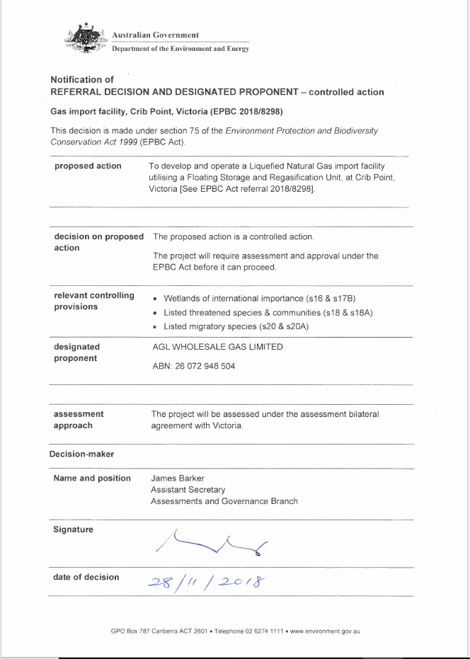

APPENDIX C Gas Pipeline EPBC decision

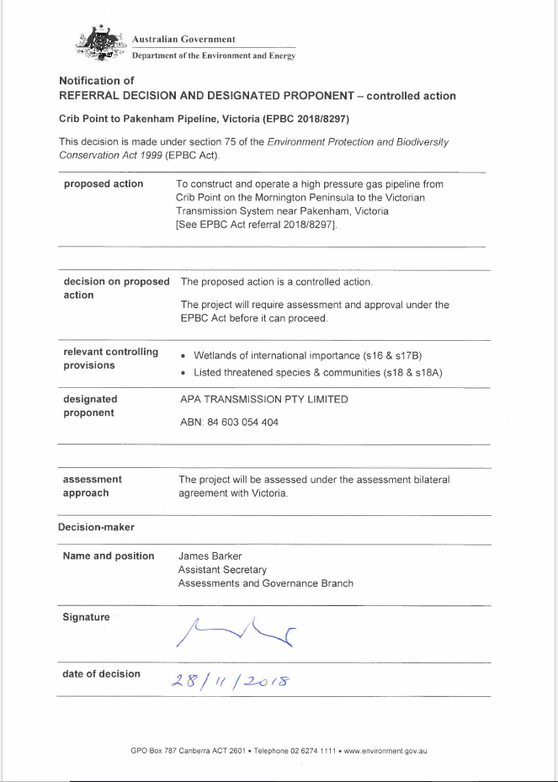

1. See [www.planning.vic.gov.au/environmental-assessment/what-is-the-ees-process-in-victoria](http://www.planning.vic.gov.au/environmental-assessment/what-is-the-ees-process-in-victoria).
2. For critical components of the EES studies, peer review by an external, independent expert may be appropriate.
3. https://www.planning.vic.gov.au/#environmental_assessment.
4. Under the EPBC Act, projects are considered actions. For the purposes of this document the term project also means action.
5. What are generally termed effects in the EES process correspond to impacts defined in Section 82 of the EPBC Act.
6. . Effects include direct, indirect, combined, cumulative, consequential, short and long-term, beneficial and adverse effects.
7. The 2017 Management Plan replaced the Western Port Ramsar Site Strategic Management Plan (Parks Victoria, 2003).