This version of the Activity Centre Zone Mapping Style Guide has been prepared for use with screen reader software. The printed publication contains design features that have been necessarily omitted from this version. In other respects this document contains identical text to that in the PDF version of the document which is available at www.delwp.vic.gov.au/planning .

ACTIVITY CENTRE ZONE MAPPING STYLE GUIDE

Guidelines for producing Framework Plans and Precinct Maps for the Activity Centre Zone

Introduction
The department has developed this guide to assist in the production of maps to be included in an Activity Centre Zone Schedule (ACZ Schedule). It provides guidance and explains what needs to be shown on the maps and how best to show it.
All maps relating to a planning scheme must be sufficiently accurate for their purpose and easy to understand. They should be clear, legible and attractive.
Maps should look similar and follow similar conventions for ease and accurate reference by a range of users.
A key aim of an ACZ Schedule map is to illustrate the intent and spatial implications of written provisions within the schedule.
Each ACZ Schedule must include:
- A Framework Plan – This map is located at Clause 1.0 of the ACZ Schedule and shows the entire centre and all precincts within the centre.
- Precinct Maps – Each precinct within the ACZ Schedule under Clause 5.0 has an individual Precinct Map, which also indicates sub-precincts.

Preparing maps – the basics

Map purpose
Maps to be included in an ACZ Schedule should be as simple, clear and concise as possible. A poor map can compromise clarity and mislead readers.
Structure plans often include multiple maps which demonstrate different things across a centre. Maps included within a structure plan may show a range of activities and uses, such as public spaces, movement and transport networks, built form, land use, key features and opportunities, and infrastructure. It is not necessary that all of these features be replicated into an ACZ Schedule Framework Plan or Precinct Maps.
As a rule, the ‘less is more’ principle should prevail. Every element on a map should be there for a particular purpose as unnecessary information will lead to ‘visual clutter’. Information presented on maps needs to be accurate because it will be used to assess planning permit applications.
The eye should be drawn immediately to the elements that convey the map’s main messages. The most important information should be brought to the foreground while other contextual information can be placed in the background.

Map base
The maps included in an ACZ Schedule relate specifically to the corresponding zone maps so they need to accurately reflect zone and title boundaries to enable decisions to be made in relation to the use of land.
The latest version of VicMap Property, the state digital cadastral base, should be used as the base for maps in ACZ Schedules. This can be accessed through the Victorian Government’s Land Channel at: http://www.land.vic.gov.au/

Map features

Map headings and titles
It is not necessary to include a map heading or title because the ACZ Schedule already has headings in the template.

Map legend and information elements
Each map must contain a separate legend located at the bottom. What appears on a map should be self-explanatory or be explained in a map legend. Maps should aim to show elements that appear on the map in the legend.

Map scale
A bar scale should be used to show the scale of the map instead of a written scale. This way any variations in map scale during reproduction, reduction or enlargement will also be reflected in the bar scale.

North point
All maps must show the correct orientation, therefore a north point is essential.

Map borders
A border must surround the map to clearly delineate the area included on the map.

Map formats and resolution
Principles contained in this guide can apply across a range of different software packages used to prepare maps.
Maps need to be developed in a suitable format so that they can be inserted into a Word document. Maps should be produced at A4 size or smaller to ensure legibility when resized in a Word document.
Maps should be created as JPEG files as these provide the best quality and compression for inserting into Word documents. Files should be saved at a resolution of between 150 dots per inch (dpi) and 300 dpi. This will ensure that the map in both the Word document and final PDF are of high quality when printed and displayed on screen and will also assist in reducing the overall file size.

Colour maps and black and white reproduction
Maps to be included in an ACZ Schedule should be prepared in colour. However, there may be instances where maps are photocopied in black and white. In these instances, there should be enough definition and distinction between map features to allow them to be read effectively in black and white. This can be achieved by choosing different line styles, end points, shading and symbols to represent different features on the map.

Colour accessibility
The department has developed guidelines to improve access to visual materials for people with colour blindness – Communicating Data with Colour.
The guidelines highlight the issues confronting people who are colour blind and outline practical methods for achieving colour accessibility in publications and online. It is a useful aid for graphic designers, cartographers and others who are required to use colour to convey visual information in an accessible way.
The guide lists a selection of tools that can be used to check whether visual data is colour accessible when preparing maps.
Further information is available on the department’s website at: http://www.delwp.vic.gov.au/planning/

Preparing associated zoning maps
The department provides a free zoning map preparation service to councils for planning scheme amendments.
Further information on this service is available at: http://www.delwp.vic.gov.au/planning/planning-schemes

Preparing maps – choosing features, styles and specifications
The following tips have been developed to assist with preparing maps for an ACZ Schedule. Remember, as a rule, ‘less is more’!

TIPS:
- Every element on the map should be there for a particular purpose so avoid unnecessary information or material.
- The information will be closely examined when assessing planning permit applications, so there needs to be a high degree of accuracy in relation to the information presented on the maps.
- The eye should be drawn immediately to the elements that convey the map’s main messages. The most important information should be brought to the foreground while other contextual information can be placed in the background.
- Make sure your maps have:
- a legend located at the bottom
- a bar scale
- a north point
- a border.
- Try to minimise confusion or similarity when choosing colours, line styles or fill types.
- Produce maps at A4 size or smaller to allow them to be easily inserted into a Word document.
- Minimise file size by saving maps as JPEG files with a resolution of between 150-300dpi.
- Ensure the map is able to be effectively reproduced in black and white.
Check that maps are colour accessible. This can be done easily with a range of tools outlined in Communicating Data with Colour.
The following pages outline suggested mapping features, styles and specifications developed to assist in the preparation of maps for ACZ Schedules.
All colour specifications are in RGB standard.

Standard map features
It is advised that you use the following styles and specifications to represent standard map features.
Feature  Activity Centre Boundary | Suggested specifications  Outline RGB Colour: 106, 139, 191  Outline Width: 4pt
Feature  Precinct and sub-precinct boundaries | Suggested specifications  Outline RGB Colour: 214, 114, 119  Outline Width: 3pt
Feature  Cadastre | Suggested specifications  Outline RGB Colour: 255, 255, 255  Fill Colour: 211, 210, 188  Outline Width: 0.5pt
Feature  Open space | Suggested specifications  Outline RGB Colour: 102, 153, 153  Foreground Pattern Colour: 102, 153, 153  Background Fill Colour: 163, 193, 178  Outline Width: 1pt
Feature  Heritage precincts | Suggested specifications  Outline RGB Colour: 112, 112, 112  Pattern Colour: 112, 112, 112  Outline Width: 1.5pt
Feature  Areas excluded from ACZ | Suggested specifications  Outline RGB Colour: 176, 176, 176  Foreground Pattern Colour: 192, 192, 192  Background Fill Colour: 224, 224, 224  Outline Width: 1pt
Feature  Water | Suggested specifications  Fill Colour: 176, 229, 255
Feature  Mask around activity centre boundary | Suggested specifications  White fill with 30% translucency
Feature  Train lines | Suggested specifications  Line Colour: 0, 0, 0  Line Width: 2pt
Feature  Bus routes | Suggested specifications  Line Colour: 103, 128, 153  Line Width: 3pt
Feature  Tram lines | Suggested specifications  Line Colour: 0, 0, 0  Line Width: 1 pt
Feature  Roads | Suggested specifications  Line Colour: 255, 255, 255  Line Width: 3pt
Feature  Train stations | Suggested specifications  Colour: 170, 0, 0  Size 10pt

Specific map features
The following points, polygons, arrows and lines can be used to identify a range of centre-wide features. While they are all represented here in black and white, colour can be used. Suggested colour combinations are provided on page 8.
Consider using different sizes to better distinguish features.

Points
When specific features need to be identified, it is best to identify them as points on the map. The following point styles can be used to identify features such as:
- Libraries
- Landmark buildings and key development sites
- Gateways
- Transport interchanges
- Viewsheds
- Places of interest.


Polygons
There may be instances where larger areas need to be identified on maps. The following polygon styles can be used to identify features such as:
- Proposed open space areas
- Station squares or plazas
- New or upgraded public urban space
- Pedestrian circulation spaces.
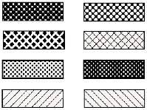

Arrows
Arrows can be used to demonstrate a range of features and activities and the following arrow styles can be used to identify features such as:
- Vehicle and pedestrian links
- Access points
- Key routes
- Views and view corridors.


Lines
Lines can identify a range of activities and features on your maps and can be manipulated by size and style to provide variation to distinguish between features. The following line styles can be used to identify features such as:
- Proposed new roads
- Principal traffic routes
- Cycle lanes and cycle friendly streets
- Shared paths
- Key pedestrian routes and spines
- Tree planting
- Streetscape enhancements and streetscape improvement priorities
- Focus for active street frontages.


Suggested Colours
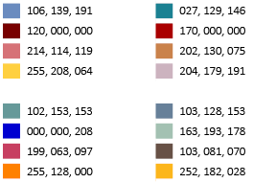

Fonts and text
The following text styles should be used for maps.
Feature  Precinct numbers & sub-precinct numbers | Suggested Font Styles  Image showing example of Precinct Number | Suggested Specifications  Font: Arial, bold  Size: 13  Text Colour: 132, 132, 132  Outline colour: 255, 255, 255
Feature  Road names | Suggested Font Styles  Image showing example of Road Name | Suggested specifications  Font: Arial, bold, all caps  Size: 9  Text Colour: 0,0,0  Outline colour: 255, 255, 255
Feature  Feature Labels | Suggested Font Styles  Image showing example of feature label | Suggested specifications  Font: Arial  Size: 6  Text Colour: 0,0,0
Feature  Train Stations | Suggested Font Styles  Image showing example of train stations | Suggested specifications  Font: Arial, bold, italic  Size: 6  Text Colour: 0,0,0  Outline colour: 211,210,188

Examples of Framework Plans and Precinct Maps

Framework Plans
The Framework Plan is a map showing the entire centre. As a minimum, the Framework Plan shows:
- The activity centre boundary
- Precinct boundaries
- Key opportunity and gateway sites and landmark buildings
- Key public transport routes, stations and interchanges
- Key open space areas and community facilities
- Key movement networks which cross precinct boundaries
- Any other relevant centre-wide features, such as views and vistas.
This plan should be clearly labelled and provide a legend.

TIPS:
- If using standard text from within a mapping program to insert text labels, they may need to be manually realigned to ensure they are clear on the map. Locate labels where they do not obscure other key features and ensure that street names are clear and are not obscured or cut off at the edge of maps.
- Ensure line features and boundaries can be clearly distinguished by offsetting them if necessary.
- As much as possible, try to orient plans in portrait instead of landscape.
- Place a translucent mask around the centre boundary to highlight features within the centre (refer to Standard map features at page 7).
- Don’t over-crowd the map, but ensure there is sufficient information.
- Show the entire extent for the centre, even if some of this land will not be subject to the ACZ.
Check that key features are clearly visible. In some instances it may be necessary for information to be brought to the foreground while other contextual information can be placed in the background.
Following are three examples of Framework Plans developed for inclusion in ACZ Schedules.

Examples of Framework Plans and Precinct Maps

Framework Plans
The Framework Plan is a map showing the entire centre. As a minimum, the Framework Plan shows:
- The activity centre boundary
- Precinct boundaries
- Key opportunity and gateway sites and landmark buildings
- Key public transport routes, stations and interchanges
- Key open space areas and community facilities
- Key movement networks which cross precinct boundaries
- Any other relevant centre-wide features, such as views and vistas.

This plan should be clearly labelled and provide a legend.

TIPS:
- If using standard text from within a mapping program to insert text labels, they may need to be manually realigned to ensure they are clear on the map. Locate labels where they do not obscure other key features and ensure that street names are clear and are not obscured or cut off at the edge of maps.
- Ensure line features and boundaries can be clearly distinguished by offsetting them if necessary.
- As much as possible, try to orient plans in portrait instead of landscape.
- Place a translucent mask around the centre boundary to highlight features within the centre (refer to Standard map features at page 5).
- Don’t over-crowd the map, but ensure there is sufficient information.
- Show the entire extent for the centre, even if some of this land will not be subject to the ACZ.
- Check that key features are clearly visible. In some instances it may be necessary for information to be brought to the foreground while other contextual information can be placed in the background.
Following are three examples of Framework Plans developed for inclusion in ACZ Schedules.

Example 1: Framework Plan for Doncaster Hill included within the Manningham Planning Scheme
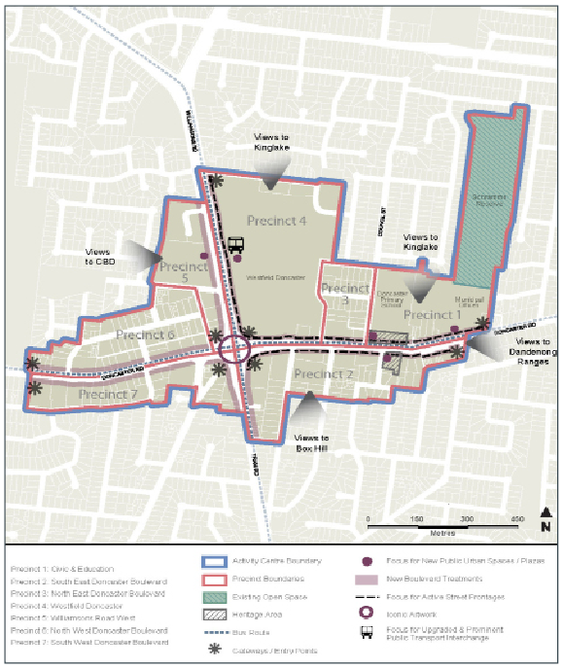

Example 2: Framework Plan for Moonee Ponds, Moonee Valley Planning Scheme (Am C100)
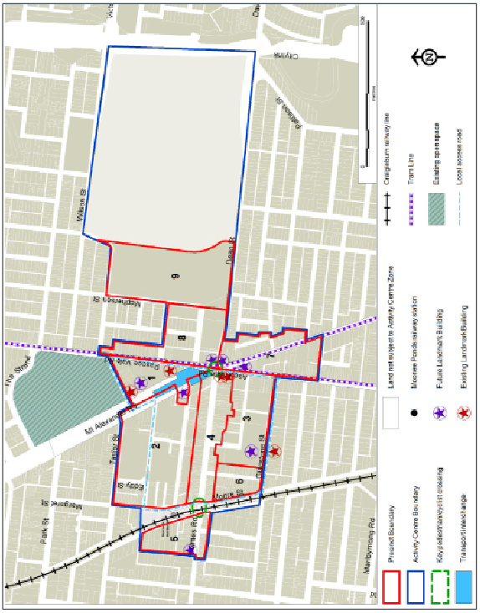

Example 3: Framework Plan for Cranbourne Town Centre, Casey Planning Scheme (Am C157)
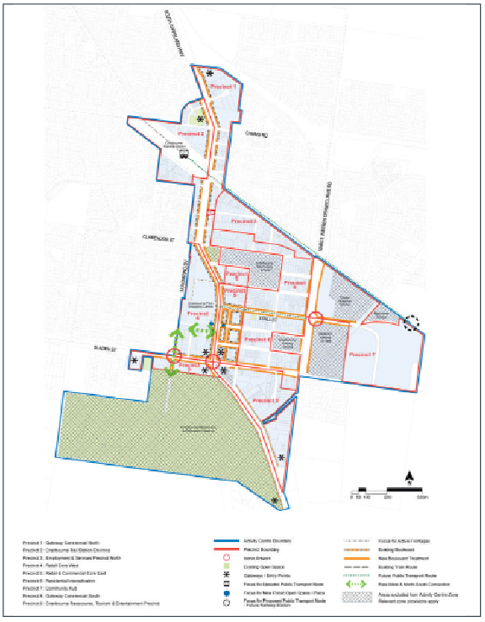

Precinct Maps
Precinct Maps provide greater detail as they relate specifically to individual precincts.
As a minimum, Precinct Maps show the following information as depicted on the Framework Plan:
- Key opportunity and gateway sites and landmark buildings
- Key public transport routes, stations and interchanges
- Key open space areas and community facilities
- Key movement networks which cross precinct boundaries.
In addition, the following information is included:
- Sub-precinct boundaries and numbers
- Areas within the precinct which have an alternate zoning (such as the Public Use Zone) and are not subject to the ACZ
- Heritage areas
- Key development sites
- Locations for proposed streetscape improvements
- New or improved pedestrian and bicycle routes and linkages
- Areas designed to provide a focus for active frontages
- Key views and vistas.
Other features which may be appropriate to include on Precinct Maps include:
- Any proposed public transport upgrades
- Any proposed road upgrades
- Preferred vehicle access points
- Areas where there may be opportunities for public art.

TIPS:
- Label sub-precincts with a number and letter, for example 2B.
- Where features extend into adjacent precincts, such as pedestrian links or transport routes, ensure they are not masked and extend clearly into the adjacent precinct(s) where appropriate.
- Place a translucent mask around the precinct boundary to highlight features within the precinct (refer to Standard map features at page 5).
- Ensure that precinct and sub-precinct boundaries follow cadastre boundaries. Where boundaries run along features such as roads, they should follow centre-lines.
- Sub-precinct boundaries should be determined based on delivering land use and built form outcomes sought in the precinct.
Ensure that information included on the Precinct Maps is not just a duplication of mapping from a structure plan, but assists with the consideration of a planning permit application and delivery of centre-wide objectives of the schedule.
Following are three examples of Precinct Maps developed for inclusion in ACZ Schedules.

Example 1: Precinct Map for Doncaster Hill included within the Manningham Planning Scheme
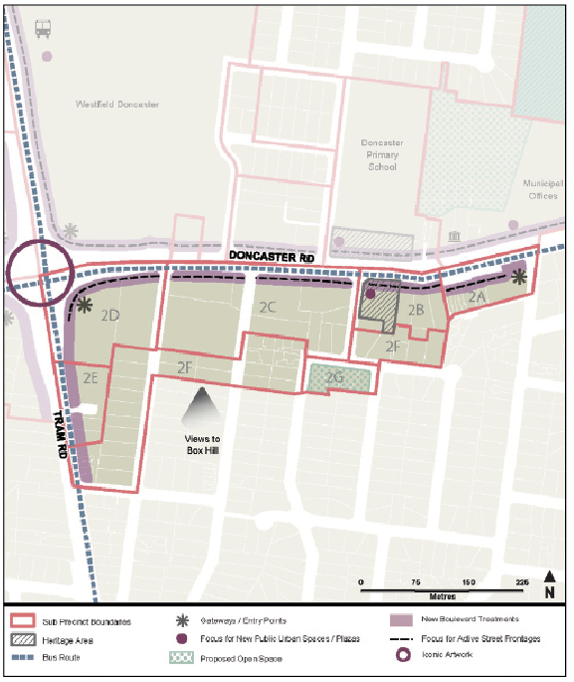

Example 2: Precinct Map for Moonee Ponds as exhibited by Moonee Valley City Council (Am C100)
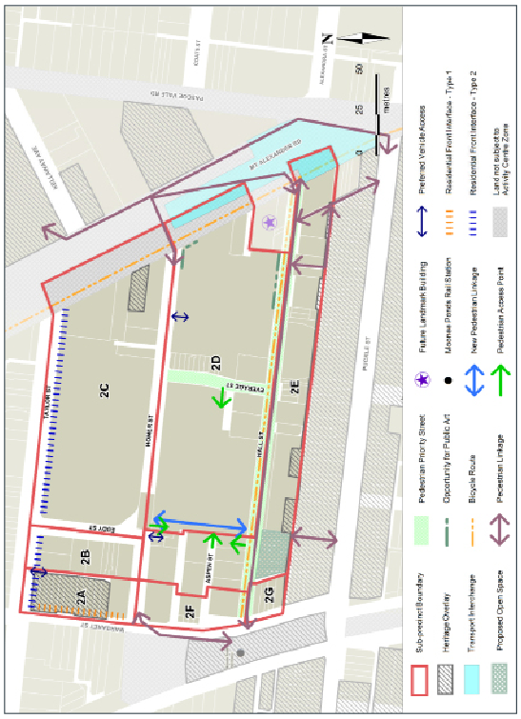

Example 3: Precinct Map for Cranbourne, Casey Planning Scheme (Am C157)
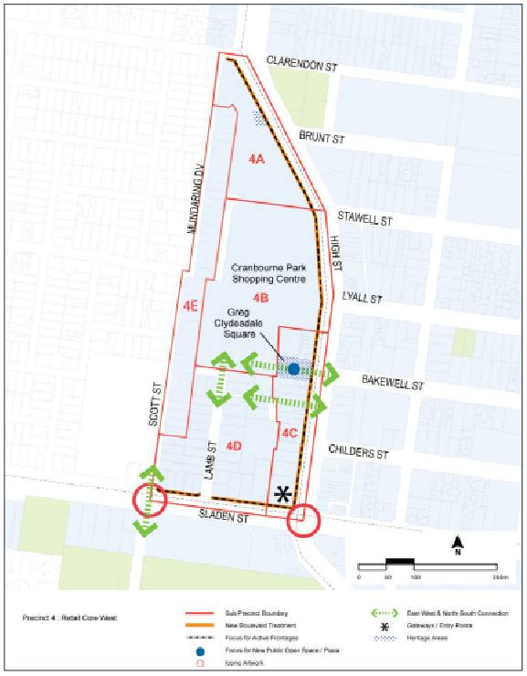

Getting further information
The department has developed a range of guidelines and resources to assist councils with planning for activities areas. These are available on the department’s website at:
http://www.delwp.vic.gov.au/planning/

Planning practice notes
A range of practice notes are available as follows:
- Planning Practice Note 56: Activity Centre Zone
- Planning Practice Notes 58: Structure planning for activities areas
- Planning Practice Note 60: Height and setback controls for activities areas.

Colour accessibility
The department’s guide Communicating Data with Colour outlines methods and tools to achieve colour accessibility for people who are colour blind.

Preparing maps
The latest version of VicMap Property can be accessed through the Victorian Government’s Land Channel at http://www.land.vic.gov.au/
For information on the preparation of zoning maps, visit the department’s ‘Map amendment requests’ webpage or email planning.mappingservices@delwp.vic.gov.au

© The State of Victoria Department of Environment, Land, Water and Planning 2015
This work is licensed under a Creative Commons Attribution 4.0 International licence. You are free to re-use the work under that licence, on the condition that you credit the State of Victoria as author. The licence does not apply to any images, photographs or branding, including the Victorian Coat of Arms, the Victorian Government logo and the Department of Environment, Land, Water and Planning (DELWP) logo. To view a copy of this licence, visit http://creativecommons.org/licenses/by/4.0/
ISBN 978-1-921940-32-3
Disclaimer
This publication may be of assistance to you but the State of Victoria and its employees do not guarantee that the publication is without flaw of any kind or is wholly appropriate for your particular purposes and therefore disclaims all liability for any error, loss or other consequence which may arise from you relying on any information in this publication.
Accessibility
If you would like to receive this publication in an alternative format, please telephone DELWP Customer Service Centre 136 186, email customer.service@delwp.vic.gov.au, via the National Relay Service on 133 677 www.relayservice.com.au . This document is also available in accessible Word format at
www.delwp.vic.gov.au/planning

DOCUMENT ENDS

