SCHEDULE 8 TO THE DEVELOPMENT PLAN OVERLAY
Modified Schedule

--/--/2017
C177

Shown on the planning scheme map as DPO8.
FLEMINGTON ESTATE
This Schedule applies to the Flemington estate, being 12-71 Holland Court, 120-130 Racecourse Road and 24-66 Victoria Street, Flemington (referred to in this Schedule as ‘the site’). Refer to the boundaries shown on the Development Concept Plan included in this Schedule.
1.0 Requirement before a permit is granted
--/--/2017
C177

A permit may be granted for use or to subdivide land or to construct a building or to construct or carry out works that is not in accordance with the development plan.
A permit may be granted before a development plan has been approved for the following:
- The removal or demolition of any building that is carried out in accordance with a Construction Management Plan prepared in accordance with this Schedule;
- Earthworks and site preparation works that are carried out in accordance with a Construction Management Strategy and Arboricultural Assessment Report prepared in accordance with this Schedule;
- The construction of minor buildings or works that are carried out in accordance with a Construction Management Strategy prepared in accordance with this Schedule;
- Consolidation or subdivision of land; and
- Removal, variation or creation of easements or restrictions.
Before granting a permit the Responsible Authority must be satisfied that the permit will not prejudice the future use and integrated and orderly development of the site in accordance with the development plan requirements specified in this Schedule.
2.0 Conditions and requirements for permits
--/--/2017
C177

The following conditions and/or requirements apply to permits:
- Except for a permit granted before a development plan has been approved in accordance with Clause 1.0 of this Schedule, conditions that give effect to the provisions and requirements of the approved development plan;
- Prior to the commencement of any permitted demolition, buildings or works, a detailed Construction Management Strategy as relevant to that demolition or those buildings or works must be prepared to the satisfaction of the Responsible Authority. The plan must include, but not be limited to, the following:
  - Location of construction vehicle access and worker parking;
  - Protection of the amenity, access and safety of adjoining residents; and
  - Protection of trees on or adjacent to the site to be retained in accordance with an Arboricultural Assessment Report prepared in accordance with this Schedule.
3.0 Requirements for development plan
--/--/2017
C177

A development plan must include the following requirements.
General
The development plan must be prepared to the satisfaction of the Responsible Authority in consultation with Moonee Valley City Council.
The development plan must seek to achieve the following objectives:
- To maximise the social, economic and environmental ‘return’ of public land assets and ensure the economic viability of the project.
- To deliver a sustainable and high quality development that contributes to the longevity of housing stock and reduces the cost of living.
- To create safe buildings and spaces throughout the site.
- To respond to the features of the site, such as context, aspect, topography and significant vegetation.
- To integrate with the surrounding area by responding to existing or preferred neighbourhood character, enhancing the public realm and existing networks and delivering ‘good neighbour’ outcomes.
- To balance issues of equity in the successful delivery of social and private housing that is ‘tenure blind’.
- To provide retail, commercial or community uses to meet an identified local need or stimulate local activity and participation.
- To prioritise pedestrian and bicycle access within the site.
- To establish legible access and address points for the site, buildings and spaces, including defining private, communal and public spaces.
- To foster social connections between residents and the wider community.
- To provide high levels of residential amenity and liveability in accordance with the objectives of the Better Apartments Design Standards.
- To provide landscaping and communal open space that is resilient and enhances the sense of place, sustainability and liveability of the site and local area.
- To deliver buildings and spaces that are accessible and practical for people of all abilities and adaptable to respond to the future needs of residents.
Land Use
The development plan should show or make provision for:
- Non-residential uses such as retail and commercial to meet the needs of the local community and located to fronting Racecourse Road, Debneys Park, internal roads and the new open space areas; and
- Community facilities in appropriate locations where they will be accessible to all residents of the Estate and the surrounding community where appropriate.
Built Form
The development plan should show or make provision for:
- Buildings should not exceed the building heights provided in the table below.
Precinct  (refer to Development Concept Plan) | Building Height
1 | 10 storeys
2 | 12 storeys
3 | 12 storeys
4 | 10 storeys
5 | 10 storeys
6 | 20 storeys
Existing residential Towers on the Estate: In the event that any or all of the existing high rise residential towers on the Estate are to be demolished, an amended development plan that addresses all requirements of this Schedule must be prepared.
- 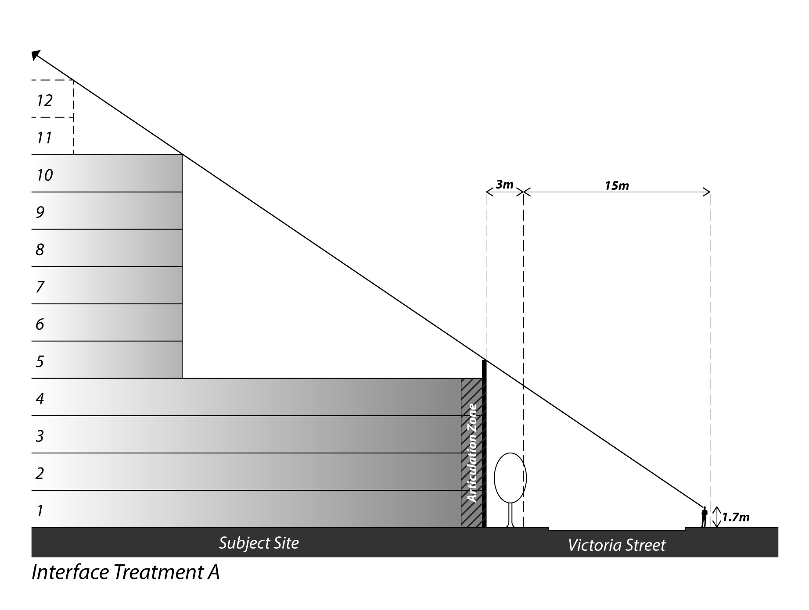The minimum building setbacks and other interface conditions in accordance with the diagrams below.
Interface Treatment A (Buildings fronting Victoria Street)
Interface Treatment B (Buildings fronting Debneys Park)
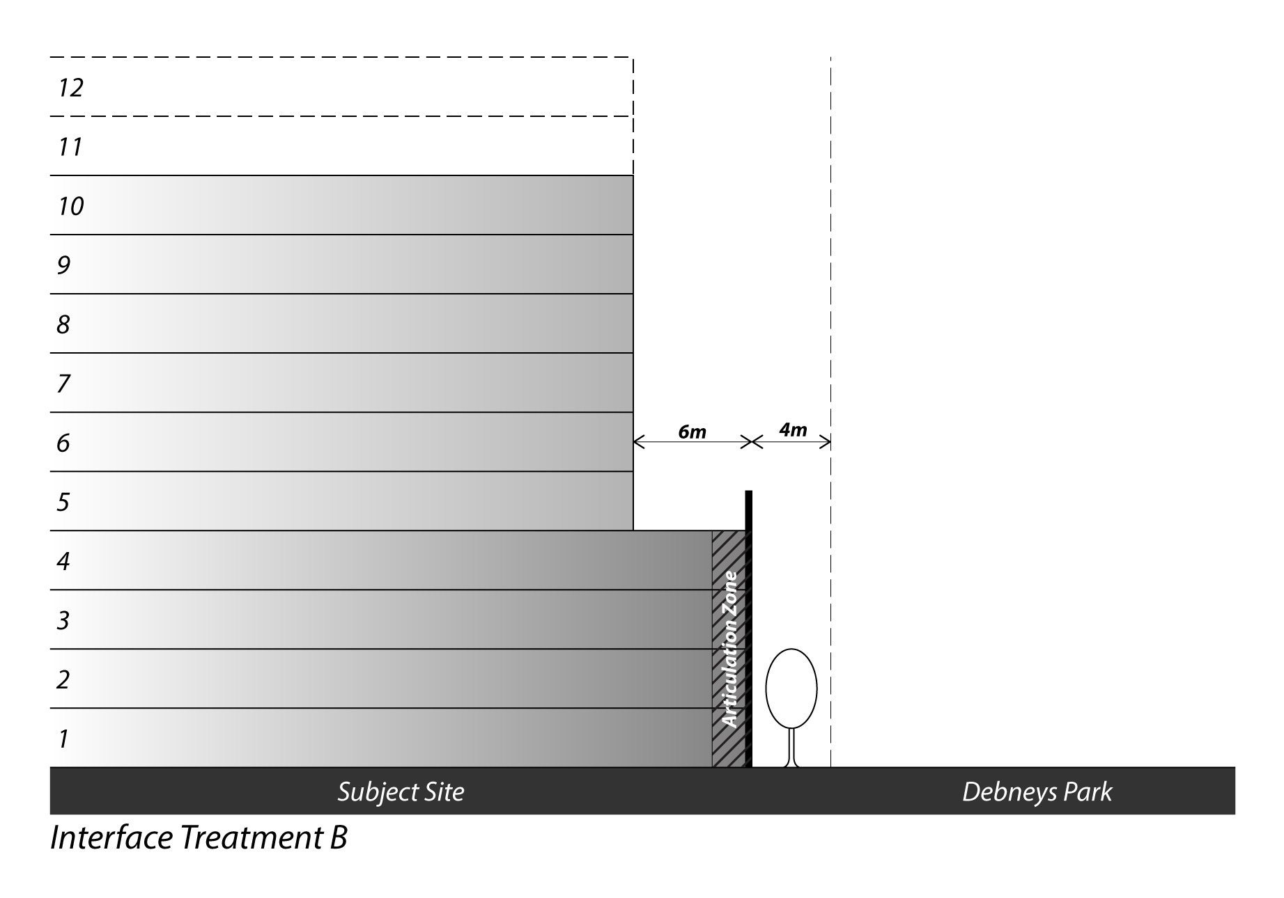

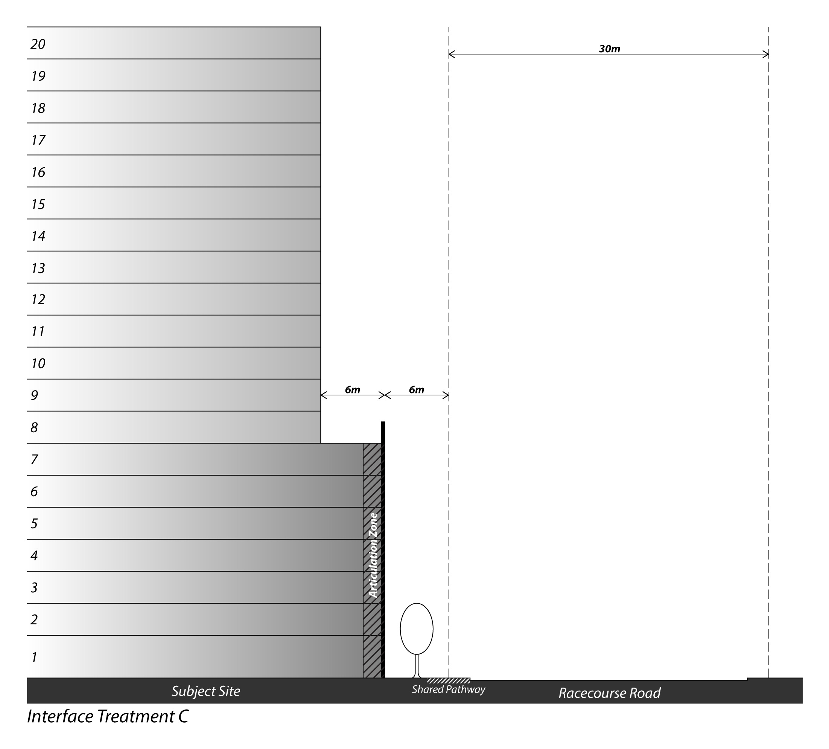Interface Treatment C (Buildings fronting Racecourse Road)
- A 20m minimum separation of new buildings from the existing residential towers on the site;

- Higher built form on internal street corners where it can be demonstrated that there are no negative impacts on surrounding open space or adjacent built form;
- For Precinct 1, a 3m minimum building setback from the southern boundary and a 4 storey built form transition to the Hopetoun Early Years Centre;
- Active frontages to Victoria Street, Racecourse Road, Debneys Park, internal roads, communal open space areas and internal connections, through the following:
  - Avoiding large expanses of blank wall, large service areas, garbage storage areas, car parking and co-located or continuous garage doors along ground floor frontages;
  - Positioning any non residential or community uses at ground level to front onto an external or internal road network; and
  - Provision of individual entry doors and foyers to ground floor dwellings that have frontages to a road or internal connection;
- For Precinct 6, provision of the following:
  - Setbacks from Racecourse Road greater than 6m as required to protect existing trees to be retained;
  - A minimum 4m floor to floor height at ground floor level;
  - An entrance and/or clear glazed window at the ground level street frontages of each individual non-residential use;
  - Weather protection at the street frontages of the non-residential uses;
- Visual bulk of buildings reduced through the placement of balconies and use of discontinuous forms, articulated facades and varied materials, particularly in the Activation Zones shown on the above sections. Buildings and works such as architectural features, sunshades, screens and artworks may be constructed within setback areas, provided they demonstrate a positive contribution to the overall facade composition;
- The location of car parking spaces within basement levels or suitably concealed within buildings or behind features such as active podium frontages;
- Cohesive architectural design throughout the site, with the use of high quality, durable and low maintenance materials;
- Orientation and overshadowing demonstrating how development within the proposed building envelopes can comply with the following requirements:
  - A minimum of 2 hours of sunlight available to at least 50% of the following spaces between 9:00am and 3:00pm on 21 June;
    - Defined communal outdoor open space areas around the existing residential towers;
    - The outdoor play area of the Hopetoun Early Years Centre;
    - The new open space areas on the site as defined on the development plan;
    - Defined communal outdoor open space areas associated with new buildings;
  - No increased overshadowing of the footpath on the southern side of Racecourse Road between 10:00am and 2:00pm on 22 September; and
- Appropriate levels of sunlight will be provided to other areas of the public realm on 22 September to ensure the future use, quality and amenity of the public spaces is not unreasonably compromised;
- Appropriate mitigation measures to minimise the adverse impacts on existing or potential future sensitive uses in proximity of the site; and
- Appropriate noise attenuation measures to minimise noise impacts on proposed dwellings from the Tullamarine Freeway, the Upfield Railway Line, Racecourse Road and any non-residential uses on the site.
Landscape and Open Space
The development plan should show or make provision for:
- A new 1,000sqm open space area, generally located as shown on the Development Concept Plan and containing significant trees to be retained;
- Retention of trees assessed in the required Arboricultural Assessment Report as having moderate or high retention value, unless it is demonstrated that their retention significantly affects the feasibility of development of the relevant precinct;
- Retention of the row of trees in Precinct 6 fronting Racecourse Road;
- Replacement of trees assessed in the required Arboricultural Assessment Report as having moderate or high retention value with trees that provide equivalent amenity value to residents and the public realm;
- New street trees along the Victoria Street frontage; and
- New canopy trees along internal roads and pedestrian connections and within new open space areas.
Circulation
The development plan should show or make provision for:
- A legible vehicle circulation system within the site, generally as shown on the Development Concept Plan and with the following external access points:
  - The existing signalised intersection onto Racecourse Road;
  - Holland Court, but with the Racecourse Road intersection redesigned to allow vehicle access by left-in left-out movements only or otherwise to the satisfaction of VicRoads;
  - The 2 existing vehicle access points to Victoria Street provided no significant increase in vehicle movements in order to maintain the existing function of the street;
- Car parking in each precinct for residents and visitors;
- Bicycle parking in each precinct for residents and visitors, and bicycle servicing facilities, located so as to promote usage and safety;
- An off-road bicycle path (shared with or separate from pedestrian path) along the Racecourse Road frontage of the site, to the satisfaction of VicRoads and Moonee Valley City Council; and
- A legible pedestrian circulation system within the site, particularly between external access points, building entries, car parking areas and communal open space areas, and linking with pathways within Debneys Park and along adjoining roads.
Required documents, plans and reports
The following documents, plans and reports must form part of any development plan (as applicable if the development plan is approved in stages):
- A Site Context Analysis prepared in accordance with Clause 58.0 or Clause 55.01 of the Planning Scheme that includes, but is not limited to, the following:
- The urban context and existing conditions showing topography, the surrounding and on site land uses, buildings, noise and odour sources, access points, adjoining roads, cycle and pedestrian paths and public transport;
- Views to be protected and enhanced, including views of and from the site; and
- Key land use and development opportunities and constraints.
- Preliminary Architectural Plans that show the distribution and design of built form on the site in accordance with the Development Concept Plan included in this Schedule, including, but not limited to, the following:
- A design response to the Site Context Analysis in accordance with Clause 58.0 or Clause 55.01 of the Planning Scheme;
- Demolition works;
- Building envelopes including maximum building heights, building setbacks to all interfaces, and building depths;
- The proposed built form edge and interface treatments to Victoria Street, Racecourse Road and Debneys Park and how this edge treatment responds to the character of existing streetscapes surrounding the site;
- Conceptual elevations and cross-sections, indicating level changes across the site;
- Shadow diagrams of both the existing conditions and proposed shadows, in accordance with the overshadowing criteria identified in this Schedule;
- Images which show how the proposed built form will be viewed from the Racecourse Road corridor and Debneys Park;
- The mix of dwelling types and sizes for each precinct;
- The mix of land uses, including non-residential uses such as retail, commercial and community facilities and the location of these uses to each building or precinct;
- Waste collection zones to each building and primary points of access of waste vehicles;
- Vehicle access, circulation and parking locations;
- Pedestrian and bicycle access and circulation. The building footprints and internal connections shown on the Development Concept Plan are indicative only and further connections within the site and through the building envelopes should also be provided to ensure a highly permeable urban structure;
- Open space areas surrounding the buildings and the proposed use and access; and
- The relationship between proposed buildings and works and surrounding land uses and development, including:
  - Existing residential towers to be retained on the site;
  - Existing residential properties on the opposite side of Victoria Street;
  - Debneys Park;
  - Debney Meadows Primary School and Hopetoun Early Years Centre;
  - Racecourse Road and the Arden-Macaulay Urban Renewal Area on the opposite side; and
  - CityLink and the Upfield Railway Line.
- An Integrated Transport and Traffic Management Plan that addresses, but is not limited to, the following:
- The range and scale of residential and non residential uses that will be anticipated on the site;
- The estimated population of residents, visitors and workers;
- Estimated vehicle trip generation levels resulting from use and development within the site;
- Vehicle ingress and egress points and estimated levels of usage;
- The likely impacts of the proposed development on the arterial and local roads and any mitigating works required such as off-site traffic management treatments;
- An indicative layout and hierarchy of internal roads that:
  - Complements the form and structure of the surrounding network;
  - Recognises the primacy of pedestrian and bicycle access within the site;
  - Provides a high level of amenity and connectivity through the site, whilst managing the movement of vehicles travelling through the site;
  - Are of sufficient width to accommodate footpaths and street trees;
- The location of on-site car parking for residents, visitors and staff, including that associated with the existing residential towers on the site. The location of car parking spaces should be situated at basement level or suitably concealed within buildings;
- Provision for loading and unloading of vehicles and means of access to them, including waste, delivery and furniture removalist vehicles; and
- The provision of a network of safe and accessible pedestrian and bicycle accessways through the site that:
  - Maintains access to the existing residential towers on the site; and
  - Connects with the surrounding area and adjoining pedestrian and bicycle paths and public transport stops within walking distance;
- Green Travel Plan initiatives that can be adopted to reduce private car usage by residents, workers and visitors, including a new resident awareness and education program and opportunities for the provision of a car share program;
- Provision for secure bicycle storage for residents and workers, end of bicycle trip facilities for workers and short term bicycle parking for visitors;
- The views of VicRoads and Moonee Valley City Council.
- An Arboricultural Assessment Report that addresses, but is not limited to, the following:
- Assessment of trees on or adjacent to the site, including retention value;
- Recommendations for the protection of trees to be retained to ensure long-term health, including designation of tree protection zones and structural root zones; and
- Recommendations for trees to replace any trees of moderate or high retention value required to be removed where replacement trees provide equivalent amenity value to residents and the public realm.
- A Landscape and Open Space Plan that addresses, but is not limited to, the following:
- Existing vegetation to be retained and the appropriate protection zones to allow for the retention;
- A planting theme which complements existing trees to be retained and the surrounding neighbourhood character, and that demonstrates water sensitive urban design outcomes;
- New canopy trees and landscaping within the public realm and communal areas / open spaces;
- Landscaping areas within private open spaces;
- Street trees along Victoria Street, Racecourse Road and internal roads;
- Delineation of public, communal and private open spaces and the treatment of these interfaces;
- Hard and soft landscaping treatments of the public realm and communal open spaces;
- Interface treatments between Victoria Street, Racecourse Road, Debneys Park and the Hopetoun Early Years Centre, including boundary fences;
- Integration of sustainability and water sensitive urban design measures;
- Opportunities for communal gardens; and
- Maintenance responsibilities.
- An Ecologically Sustainable Development Plan that demonstrates how development on the site will achieve best practice standards and incorporate innovative initiatives on a precinct-wide scale. The Plan is to address the areas of energy efficiency, water resources, indoor environment quality, stormwater management, transport, waste management, innovation and urban ecology.
- A Services and Infrastructure Plan that addresses, but is not limited to, the following:
- An assessment of the existing engineering infrastructure servicing the site and its capacity to service the proposed development;
- A description of the proposed provision of all appropriate utility services to development parcels;
- Preparation of a stormwater drainage master plan, including measures to ensure appropriate protection of the Merri Creek adjacent to the land; and
- The identification of the location of any on-site drainage retention facilities.
- An Environmental Site Assessment that addresses, but is not limited to, the following:
- The extent of fill that has occurred on the site, including area, depth and fill material;
- The presence and depth of groundwater at the site;
- Underground infrastructure that has contamination source potential;
- The contamination status of soil on the site; and
- If intrusive works are likely to occur during redevelopment works, an acid sulphate soil assessment.
- Where the development will be undertaken in stages, a Staging Plan that addresses, but is not limited to, the following:
- The delivery of infrastructure and shared facilities within each stage to ensure the orderly development of the site; and
- Site management, such as resident amenity, vehicle access and parking, pedestrian access and protection of existing buildings, infrastructure and vegetation.
- Timeframes for the commencement and completion of each stage and any management of overlap between stages

- An Acoustic Report is required to be prepared by a suitably qualified person(s) to the satisfaction of the Responsible Authority. The report must identify:
  - Whether the proposed use and development of the Estate is likely to be affected by noise from nearby uses or abutting roads and freeways;
  - The likely effect of non-residential uses on the site on the amenity of nearby residential uses; and
  - Methods to address the issues identified.

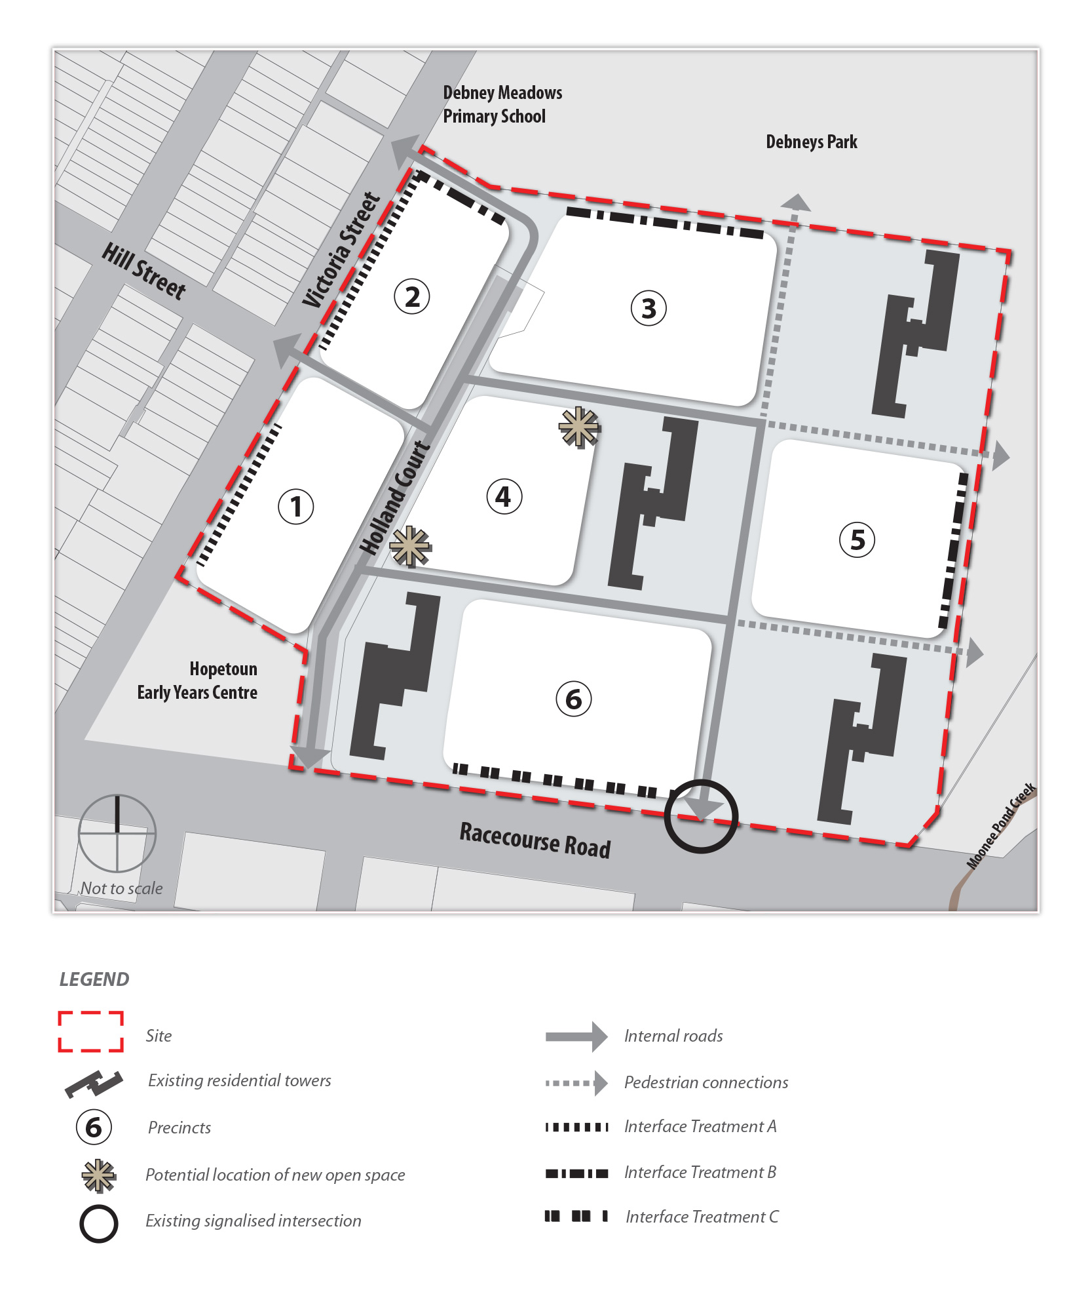Development Concept Plan

